Productivity Commission Review of the Workplace Relations Framework
Submission by David Hetherington
Executive Director, Per Capita

The Productivity Commission is holding an inquiry to find if there is a good case for sensible and fair changes to Australia’s workplace relations framework.

Given that the review is intended to ensure any changes will mean higher living standards, better pay and more jobs, we recommend that the Productivity Commission take careful note of how the existing framework has delivered higher living standards for Australian workers, particularly relative to other developed countries where real wages have stagnated despite ongoing GDP growth, driving greater inequality.

Already, we are seeing slowing wage growth despite the fact that labour productivity has been relatively strong. The full benefit of these productivity gains has not flowed through to workers, because the increasing power of firms relative to workers has meant that the bulk of these gains have flowed to profits. As a result, the wages share of national income has fallen to long-term lows. The outlook for Australian employees’ living standards is dimmer than it has been for a generation.

Given this outlook, we recommend that Australia maintains the fair and equitable employment conditions and protections that have sustained ongoing increases in living standards by ensuring that the benefits of labour productivity gains flow through to workers. In addition, Australian governments should invest significantly more in infrastructure, research, education and training as the path to productivity improvement.

---------

The benefits of the existing Framework for living standards

Perhaps the most impressive achievement during Australia’s long run of economic prosperity from the early 1990s to the early 2010s was that lower- and middle-incomes continued to rise steadily. This was in marked contrast to other developed economies, where incomes in the middle and at the bottom of the distribution have either not moved or fallen markedly.

Why were the gains distributed more fairly than in other countries?

There are well-established explanations as to why Australia has fared better, both in aggregate terms and in the fair distribution of its gains.

The simple answer is that Australia maintains a strong minimum wage and employee protection framework that allows workers to ensure they are able to secure a decent share of these gains. As the Centre for American Progress has written:

“Australia’s workers face the same global trends yet its switch to collective bargaining over and above a strong set of minimum conditions has helped workers keep more of their productivity gains in take-home earnings”.

Over the last two years, however, there has been a turnaround in Australia’s wage growth. In contrast to the healthy wage rises of the boom years, income growth for Australian wage earners is slowing rapidly. In the 2013-14, Australia experienced negative real wage growth for two consecutive quarters and the most recent data for the December 2014 quarter show the lowest nominal wage growth since the ABS started publishing the data in 1998
Figure 1: Average Real Wage Price Increases in Australia
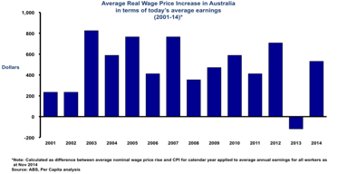
This is not due to declining productivity. In fact, labour productivity growth was considerably stronger than capital productivity growth during the period, providing the bulk of the gains in overall productivity.

Some Australian business leaders have recently lamented that Australia’s productivity performance has been poor and that our wages have been too high. These business leaders are wrong: the record tells us something different. Since 2000, real growth in output per hour (labour productivity) has considerably outpaced real hourly labour income (wages). (See Figure 2)

That is, there have been strong increases in labour productivity but these have not been fully reflected through matching increases in real wages. Any argument that Australian wage levels are too high because they do not reflect underlying productivity growth should be summarily rejected.

Figure 2: Decoupling in Australia
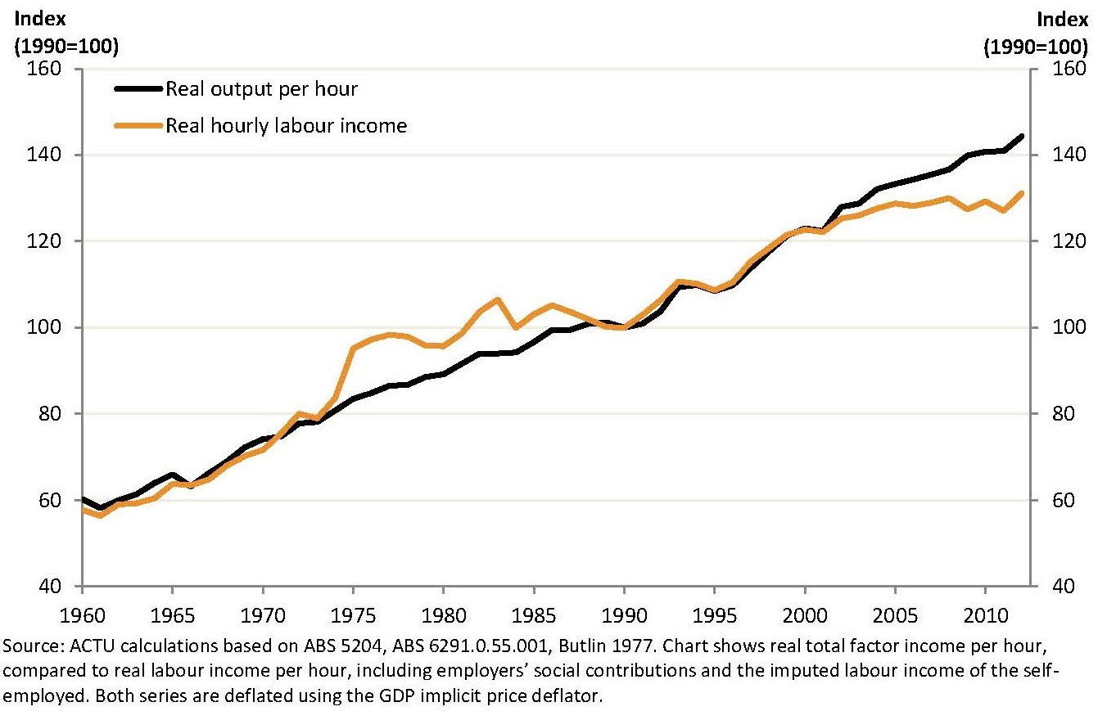

The answer for the declining wage growth is found in the relative power of capital and labour. Put simply, business is keeping the bulk of the gains of labour productivity improvement in the form of profits, rather than passing them on to workers, or investing in innovation, training or research.

This has been a primary cause of the rise in inequality in developed economies since the 1980s. Growth continues and national income rises, but the benefits flow to the top, not the middle or the bottom. Through good management, good luck and a strong workplace relations framework Australia has been a lucky (and partial) exception to this pattern. The cost for all Australians in terms of standard of living should be considered before dismantling the system.

Other dimensions of work affecting living standards

Increasing casualisation of the workforce and increased commuting are two issues effecting the living standards of employees, and are not explicitly addressed in the Terms of Reference of this review.

In 2002, the average Australian worker spent 3 hours 37 minutes per week travelling to and from work. By 2014, this figure had increased to 4 hours 50 minutes. This equates to an extra 56 hours of (unpaid) commuting time per year.

A second issue, the casualisation of the workforce, is also affecting quality of life for workers. Casualisation has increased dramatically over the last generation. From 1992 to 2009, the number of full-time casual employees almost doubled, and the number of part-time casual employees rose by more than half.

The key attribute of casualisation is the increased risk that a worker bears through lack of employment security. For some workers, the benefits of increased flexibility might offset this newfound lack of security, but for many, it’s not a welcome trade-off.

Both these issues put increased pressure on standards of living for employees and should be considered in any changes to the workplace relations legislation.

Our Recommendations

In his book, Dog Days: Australia after the boom (2013), Ross Garnaut argues that without difficult reform, Australia faces an inevitable correction in its income and wage levels, with real wages falling markedly to reflect the country’s changed economic circumstances and lack of reform over the last decade.

Garnaut is right. Nominal wage growth is slowing steadily, real wages have already had one period of contraction, and these patterns are likely to continue. Those who will suffer are not the top- and upper-middle income earners who derive a considerable share of their income from capital. They are middle- and lower-income workers who depend on wages, and fair and equitable workplace protections, to sustain their standards of living.

The path to productivity improvement lies in continued investment in infrastructure, research and development, education and training from both the public and private sector. Australia’s governments have been unwilling (rather than unable) to continue to invest in the roads, ports, bridges and housing needed to sustain labour productivity growth. Even worse, they are seeking to cut or freeze spending on science, schooling, TAFEs and universities. This combination of underinvestment in hard and soft infrastructure almost guarantees that labour productivity will continue to flag.

In addition, companies have been equally complicit in their reluctance to channel profits to innovation and investment, but instead seek to boost short-term profits and executive pay.

Australian governments must introduce greater spending on infrastructure, education, skills and innovation. They will need to make the hard case to the electorate that it may involve tax rises, but there is a compelling argument if the alternative is a slowly falling standard of living.

Moreover, to ensure that working Australians enjoy the full fruits of their labour, it is critical that we maintain the employment protections that have sustained living standards in this country for decades – a decent minimum wage, collective bargaining, minimum shift provisions, full superannuation entitlements for all workers and unfair dismissal provisions. These hard-won protections for workers should not be eroded.

The Productivity Commission’s review of Australia’s workplace relations framework should take careful note of how this framework has ensured that at least some of the productivity gains of Australian workers have been channelled into increased living standards across our society. It would be a travesty to dismantle the framework that has made this possible. The goal of the review is to ensure higher living standards, better pay and more jobs. The recommendations put forward here will ensure this by continuing to offer workplace protections, increase productivity and job creation through investment in infrastructure and innovation, and ensure wage growth commensurate with productivity increases.

About Per Capita

Per Capita is an independent progressive think tank dedicated to building a new vision for Australia based on fairness, prosperity, community and social justice.

Per Capita’s research is rigorous, evidence-based, and long-term in its outlook, considering the national challenges of the next decade rather than the next election cycle. We ask fresh questions and offer fresh answers, drawing on new thinking in science, economics and public policy. Our audience is the interested public, not just experts and practitioners. We engage all Australians who are keen to see the hard thinking done on the country’s future.

The initiative was born in 2005 when a group of individuals came together concerned about the quality of debate and leadership in the Australian political landscape, and decided to establish a think tank to present the economic and moral cases for progressive policy reform in Australia. A scoping study was undertaken by author and speechwriter Dennis Glover, and Per Capita was launched in April 2007 with Evan Thornley as the founding Chairman and David Hetherington as the founding Executive Director.

“Report of the Commission on Inclusive Prosperity”, Center for American Progress, 2015. [https://www.americanprogress.org/issues/economy/report/2015/01/15/104266/report-of-the-commission-on-inclusive-prosperity/]
“A Shrinking Slice of the Pie”, Matt Cowgill, ACTU, 2013. [http://www.actu.org.au/media/297315/Shrinking%20Slice%20of%20the%20Pie%202013%20Final.pdf]
“Off to Work: Commuting in Australia”, Michael Flood and Claire Barbato, The Australia Institute, 2005. [http://www.tai.org.au/documents/downloads/DP78.pdf]
Research by Regus, cited at News.com, “How much time to we spend commuting every year”, 29 September 2014. [http://www.news.com.au/finance/work/how-much-time-do-we-spend-commuting-every-year/story-fnkgbb6w-1227074204109]

