I A benchmark rate for ECEC assistance
The Commission has recommended adopting a ‘deemed cost’ or ‘benchmark rate’ as the basis for subsidising early childhood education and care services (chapter 15).
A benchmark rate is a form of fixed value subsidy, as the rate — dollars per hour of care — is fixed, regardless of the actual fee charged for the service a parent chooses. It provides an alternative to the current Child Care Rebate (CCR), for which the subsidy is a percentage of fees (meaning a parent choosing a more expensive service receives a higher dollar subsidy). The current Child Care Benefit (CCB) is also a type of fixed subsidy, but it differs from the benchmark rate recommended — principally, because the rate of CCB is unrelated to childcare fees or costs.
The adoption of a benchmark rate is a key feature of the Commission’s recommended reforms and funding approach outlined in chapter 15. Implementing a benchmark rate changes the incentives faced by service providers and users and helps to improve the return to the wider community from public expenditure on ECEC services.
This appendix discusses the arguments for adopting a benchmark rate and some of the risks and complexities involved in its design, including those raised by participants. Key considerations include:
- the basis for applying any loadings to a national benchmark rate
- whether there should be multiple benchmark rates to reflect systemic differences in the costs of delivering services to certain groups of users (or in certain locations)
- how a benchmark rate should be updated over time, such as to reflect market trends and to maintain its real value to families.

I.1 A benchmark rate and the subsidy paid to families

How would the benchmark rate affect the subsidy paid to families?
The amount of the subsidy for mainstream services received by families — that is, assistance provided in the form of the recommended Early Care and Learning Subsidy (ECLS) — is a direct function of the determined benchmark rate. Specifically, a benchmark rate represents an upper bound on ECLS paid to families, since the amount of a subsidy families receive for each child is equivalent to their family subsidy rate (which depends on household income) applied to the benchmark rate (figure I.1).

Figure I.1 The relationship between a benchmark rate and an Early Care and Learning Subsidy
For example, under the Commission’s proposal, ECLS for eligible families earning less than $60 000 per year would be 85 per cent of the benchmark rate (for each child in care), while eligible families with a household income of more than $250 000 would receive 20 per cent of this rate (chapter 15).
This means that families with the same household income and other relevant circumstances will generally receive the same dollar subsidy per hour of childcare, regardless of the fees charged at the service they have chosen — hence, improving horizontal equity.

Participant views on the benchmark rate approach
The inquiry draft report put forward two options for estimating a benchmark rate. The first approach involved benchmarking observed market prices — for example, a benchmark rate could be set according to the median market price or some other percentile along the distribution of fees charged — the ‘benchmark price’. The second approach involved identifying the efficient price of ECEC services by modelling the long-run cost of delivering a service that satisfies the National Quality Standard (NQS). The Commission’s draft report proposed implementing a benchmark rate by initially adopting an efficient price approach and moving to a benchmark price within three years.
Submissions from participants raised concerns about the impacts from adopting a benchmark rate on childcare affordability for users (subs DR567; DR689; DR875; DR614), and urged the Commission to ensure a benchmark rate considers differences in underlying cost across, for example, care types and locations (subs DR837; DR508; DR839; DR755). As shown in figure I.1, it is possible to apply adjustments to a single benchmark rate (or to set multiple benchmark rates) that reflect different user or service characteristics.
Several providers raised the issue of how a benchmark rate would affect the viability of some services, especially in remote areas and in the high cost central business areas of Sydney and Melbourne (sub. DR593; sub. DR574). For example, UTS Child Care expressed concern that inner city families, and NSW families in general, would face a higher gap than families in other locations unless:
… the deemed cost of care takes into account the higher cost of service provision in NSW, caused by higher land costs (especially in Sydney city, inner city and inner west where demand is highest and land is most expensive) and long standing higher qualifications and ratio requirements. (sub, DR593, p. 2)
The NSW Family Day Care Association was uncertain about the potential impact of a benchmark rate on demand for flexible care services, including weekend, overnight and 24 hour care services, since these generally attract higher fees to cover higher wage expenses (sub. DR597, p. 5). Some long day care centres were concerned about their ability to cover lumpy fixed costs and manage utilisation issues with the introduction of a benchmark rate. For example, Goodstart found that fixed costs vary by as much as $26 per child per day across its network, and because ‘fixed costs vary so significantly between centres it would be impossible to apply an efficient price (even if segmented by age and care type), without having a significant impact on affordability in the short run’ (sub. DR875 p. 10). Representatives of ECEC workers, such as Unions NSW, advocated for a benchmark rate to be indexed to award wages (sub. DR839, p. 3).
Many participants did not support the current situation whereby taxpayers help fund the additional cost of so-called ‘premium’ or ‘gold-plated’ services that occurs with the CCR. However, some participants questioned the prevalence of such ‘premium’ services in the childcare market. For example, Goodstart Early Learning suggested that premium services account for less than 2 per cent of services, and commented that when:
… considering options for setting and updating the deemed cost, we think the policy response should be proportionate to the problem it is trying to address, while ensuring the vast majority of families using standard, non-premium services (including the 643 centres in the Goodstart network) continue to receive adequate assistance to help with their childcare costs. For example, in assessing whether the median fee is an appropriate benchmark, Goodstart believes the Commission should consider whether effectively increasing out-of-pocket costs for up to 50 per cent of all families is proportionate to a problem in a very small proportion of the market. (sub. DR875 , p. 10)
In addition, many participants expressed a degree of scepticism that a benchmark rate would be set at an appropriate level to ensure the ‘gap’ for families would be affordable and that the supply of places would be unaffected. For example, Early Childhood Australia argued that if a benchmark rate was set too low it could result in:
… low utilisation and closures in some areas, particularly in locations with higher operational costs. The deemed cost should be set at a higher benchmark than the median price to improve affordability for families and support a smooth transition to the new system. (sub. DR906, p. 14)
Goodstart Early Learning argued that the benchmark rate should be set at 2.5 standard deviations above the average fee, rather than at the median fee (sub. DR875).
Generally, however, participants supported the principle of basing subsidies on the ‘reasonable cost’ of service providers meeting the NQS, although such support tended to be provisional on features of its design and implementation. For example, the Churches of Christ Care indicated it:
… supports the Commission’s recommendation to establish a deemed cost of delivering a reasonable standard of ECEC that includes a profit margin. (sub. DR574, p. 7)
Yet, such approval was contingent upon ‘thorough benchmarking activity across a range of service locations and population groups’ (sub. DR574, p. 7).
Similarly, an alliance representing Women’s organisations indicated it:
… supports the notion of a deemed cost model that is based on reasonable costs and a reasonable proportion of surplus or profit. We agree that it is a fairer use of public funds to subsidise reasonable costs than for subsidies to chase fees (current model). (Economic Security4Women, sub. DR621, p. 3)

I.2 Reasons for, and consequences of, using a benchmark rate
A benchmark rate for childcare and early education assistance provides a range of benefits to government childcare expenditure and the efficiency of childcare markets, but there is also potential for unintended consequences and transitional costs that need to be managed.

A benchmark rate supports better use of taxpayer funds
As outlined in chapter 14, compared with the current system of subsidies based on actual fees, a benchmark rate provides a means of ensuring the use of taxpayer funds for ECEC subsidies is more transparent and increases the net benefits of assistance to the community. This is achieved through taxpayers only paying for services (or service features) that are essential to satisfying the NQS and, therefore, are central to meeting the objectives of subsidies to ECEC — namely, workforce participation and child development. It is also achieved by not crowding-out private expenditure on ECEC services and, therefore, not paying for service features that do not clearly produce additional benefits.
In particular, by redefining the service (and ‘inclusions’ in services) that are subsidised, a benchmark rate reduces cost-shifting — that is, the transfer of costs — from parents to taxpayers. For example, a large number of services currently include the cost of meals in daily fees, meaning taxpayers partially bear such costs. However, because parents would face the cost of feeding their child even if they were not in childcare, it is unclear that directing taxpayer funds towards such costs produces additional benefits to the wider community. Similarly, many aspects of services that would be superfluous to what would be required to satisfy the NQS — for example, an ultra-convenient location — may be regarded by some parents as essential. These parents would not alter their choice or use of ECEC services with the introduction of a benchmark rate, which would no longer subsidise the incremental cost of a highly convenient location. In these cases, reduced cost shifting from parents to taxpayers:
- will not necessarily reduce upward pressure on overall childcare prices. Rather, the mechanism for that relates to how a benchmark rate alters incentives for service providers and users, which is discussed separately below
- could reduce the fiscal costs of childcare subsidies. Under the Commission’s recommendations, savings are redirected towards the subsidisation of childcare use that aligns more closely to government objectives (chapter 15).
A benchmark rate could also improve the equity of childcare assistance between families. Equity between families on different incomes could improve with a benchmark rate (in conjunction with means testing) as the assistance regime is more progressive than the current system. The current subsidy arrangements mean that families paying the most for services receive the highest benefits, and these tend to be (but are not always) families with higher incomes (figure I.2).
Equity between families on the same incomes could also improve under a benchmark price approach as families with the same household income and other relevant circumstances will receive the same dollar subsidy per hour of childcare, regardless of the fees charged at the service they have chosen. The exception to this, which is most likely to occur for low-income families who receive a high subsidy rate, is if a family uses a service that charges fees below the benchmark rate. In these cases, the ECLS the family receives could more than compensate for the fees charged. To avoid any such over payment, the Commission has recommended that the ECLS amount should not exceed the fees charged at the service a parent chooses (chapter 15).
As a result, in some circumstances, horizontal equity may not be achieved between two families with the same household income, since a family using a higher-fee service could receive a higher ECLS than a family using a low-fee service (but facing no out-of-pocket costs). However, the prevalence of this is likely to be very low.

… reduces upward pressure on prices and improves incentives
Over the last 10 years, childcare fees have increased at a rate of 7.2 per cent each year (chapter 9). This rate of growth exceeds that experienced for health and education services, which increased by an average of 5.4 and 6.0 per cent per annum respectively over the same period. Some of the increase in childcare fees reflects increased regulatory standards, but another source of price pressure is from subsidies — the fee-based nature of the CCR means that providers and parents may have weak incentives to contain costs and prices (chapter 9).
By improving the incentives of service providers and families, a benchmark rate will help to moderate any inefficient growth in childcare prices, including through strengthening competition among service providers and encouraging families to resist price increases. In particular, because parents would bear the full cost of any markup on prices (or weak control of costs that cause fees to rise) above a benchmark rate, providers will have stronger incentives to:
- compete to minimise costs, including by only passing-on cost increases (including those triggered by regulatory requirements) that similarly affect other providers within the local market, and bid down quality-adjusted prices
- adopt more cost-reflective pricing strategies, limiting the potential for childcare places to be misallocated among families — particularly between children of different ages at long day care centres, since the Commission found that extensive cross-subsidisation of fees meant most centres made losses on services for 0 to 2 year old children
- only improve service quality in ways that families are willing to pay for.
Waste from inefficient management of costs is hard to observe, and there is a shortage of productivity and efficiency analysis of the childcare sector. Productive inefficiency, or any ‘cost-padding’, is more likely to arise in situations where childcare markets are not highly competitive or where a large share of providers do not have strong commercial motives (chapter 9). While childcare markets are reasonably competitive, they also retain some flaws (chapter 9), which means that subsidies should be designed with the prospect of market imperfections in mind. To this end, a benchmark rate is more desirable than a subsidy based on a proportion of fees paid, since it strengthens the competitive discipline on service providers.
Likewise, a benchmark rate could reduce the capture of subsidies by providers, which can occur when there are entry barriers and limited supply responsiveness to increases in the demand for services. If this were occurring, then it would be reflected in higher profit margins. Generally, however, profit margins in the sector have remained low at less than 5 per cent, and a large number of not-for-profit providers operate with very small margins. However, a few larger for-profit providers have reported significantly higher profit in recent years (chapter 9 and appendix H).
A benchmark rate could also help to reduce the prevalence of providers’ inefficiently cross-subsidising fees across services (chapter 9). This is so because current fee-based subsidies are likely to be more conducive for providers charging a markup on fees for some parents in order to cross-subsidise fees for other parents. Conversely, a fixed value subsidy could amplify the competitive consequences of such pricing practices.
Further, because parents, not taxpayers, will be required to meet the full cost of any quality improvements beyond those required to satisfy the NQS, parents may re-evaluate the quality of the services they choose. This will dampen any incentive providers may currently have to ‘over-service’ in ways that allow them to increase parents’ fees. However, the prevalence of a, so-called, ‘premium’ long day care service is not high. The Commission found that fees for the majority of centres are tightly clustered with only 2 to 3 per cent of all long day care services charging more than $10 per hour in 2012. Goodstart Early Learning reached the same conclusion, observing:
… a long tail of very high priced providers (outliers) — which we consider reflects services with very high costs, premium services, or excessive profits. … Premium services are a very small proportion of the market — we estimate less than 2 per cent of the market. (DR875, pp. 9, 14).
A benchmark rate would not prevent parents from using services with a quality rating exceeding the minimum required to meet the NQS or with other service features adding to a service’s value.

… could improve affordability for some users and reduce it for others
For some families, affordability will improve under a benchmark price approach, but it could lessen affordability for others. A fixed dollar per hour subsidy for up to 100 hours of care per fortnight could substantially improve the affordability of care for those families who currently are limited in the assistance received by the annual cap on the CCR.
However, affordability concerns could arise if higher fees reflect systemic and unavoidable differences in the cost of delivering a basic service to a particular group of users. In such instances, the delivery of the service is efficient, but the subsidy based on a benchmark rate may render the service less affordable. This would undermine equity goals, particularly if lower income households are affected.
Several participants, including the Australian Community Children’s Services SA, raised concerns about families with low incomes or living in more disadvantaged communities who could be worse off with a benchmark rate (sub. DR567). Moreover, Goodstart Early Learning suggested that:
… above-median fees do not only occur in high-SEIFA markets; they are also observed in lower-SEIFA (decile 1-4) and mid-SEIFA (decile 5-6) areas. This suggests there are many low-income families living in markets with a higher cost of delivery and higher fees. (sub. DR875, p. 12)
Goodstart Early Learning also raised the concern that, with a benchmark rate set at the median fee, a family with an income of $50 000 living in Redfern (Sydney) would be required to pay a gap of $45 per day towards a headline fee of say $113 per day (sub. DR875, p. 12).
However, the Commission found that fees were typically lower in disadvantaged areas (chapter 9), which suggests that, on average, lower income households are likely to be better off under ECLS based on a benchmark rate compared with the current subsidy arrangements. Moreover, families who paid fees higher than the median tended to have higher household income (figure I.2). For example, in 2011-12, just over one-third of families reporting an annual income below $40 000 used services with fees above the median, while the equivalent figure for households earning more than $200 000 per year was nearly 80 per cent.

Figure I.2 Families paying fees that are higher than the median tend to have higher incomes
Source: Department of Education administrative data 2011-12.

… could become a floor price
Over time, a benchmark rate could become the floor price — that is, providers charging below the benchmark rate raise their fees, which would limit the lowest price for which services are available in the market. This is more likely if subsidy rates are relatively generous (low co-payments) and market competition is weak. As stated by an OECD publication, ‘co-payments may make users more cost-conscious’ (Joumard et al 2003, p. 148), which would increase competitive pressure on providers and limit the likelihood that the benchmark rate becomes the floor price. Chapter 9 found that competition varied across local childcare markets, with vigorous competition in many areas keeping prices in check, although there was limited potential for competition in markets with few providers.
Because the recommended ECLS would apply to the benchmark rate, the value of the ECLS received by parents will usually not fully cover the price charged and, in most cases, parents would be required to pay a copayment (or ‘gap’ payment).
In localised areas of relative socioeconomic disadvantage, a larger share of families will face very low gap payments, which could reduce their preparedness to push back against price increases, and therefore increase the potential for floor price issues. However, the prevalence of families who would receive free childcare under ECLS is estimated to be very low and is mostly among families with an annual income of less than $60 000. This means the vast majority of families will face some copayment towards their childcare costs. Moreover, even if the providers of services to families receiving free childcare were to raise their fees to the benchmark rate, they would expose themselves to push back from families who would start to face a gap payment.

In conclusion
In conclusion, a benchmark rate should improve both allocative and productive efficiency by:
- limiting opportunities for cost shifting from parents to taxpayers
- weakening the capacity for providers to increase prices
- reducing inefficient demand for premium childcare features.
However, because the benefits of adopting a benchmark rate are difficult to gauge with the information available, it is important to ensure the administration and transition costs are kept low. Likewise, affordability for families should be monitored, particularly among low-income families and other disadvantaged groups.

I.3 The design and estimation of a ‘benchmark rate’
Designing and implementing a benchmark rate presents a number of challenges. For example:
- defining the features of a service that governments should help fund can be complex, data intensive and impose burdens on providers
- some services have innately higher delivery costs (irrespective of how efficient a provider is at delivering them)
- there may be tension between the two main objectives of subsidies — child development and workforce participation — for example, a subsidy design that, for workforce participation purposes, facilitates the intensive use of services for most children aged 2 years and under could be detrimental to child development.
In addition, transitional considerations must be managed, since abrupt changes to price signals and the effective demand for services from parents could affect the:
- viability of some services, potentially affecting investment signals and supply responsiveness — for example, while the exit of services is a feature of a healthy market, excessive churn in service providers could raise system-wide costs of service delivery
- continuity of services for parents and children, particularly in areas where no substitute service is available.

Principles to guide the design and estimation of a benchmark rate
The Commission has developed principles to guide the design and implementation of a benchmark rate. These draw on the pricing framework adopted for the funding of public hospitals (Health Policy Solutions 2011; Independent Hospital Pricing Authority 2013) and include the following.
- Efficiency — price signals for users should be cost-reflective and providers should have incentives to innovate and minimise costs.
- Positive economic return on public investment — target the public benefits from additional labour supply and improvements to child development.
- Fairness and equity should be promoted to deliver a positive social return on public investment.
- Administrative ease — complexity and undue compliance and administrative costs should be avoided.
- Transparency — the objectives of a benchmark rate should be clearly outlined, and there should be an objective and transparent process to determine and update a benchmark rate over time.
- Adjustments to a benchmark rate (or the development of separate benchmark rates) should be based on evidence and consider user characteristics before provider-related factors.
- Stability — policy uncertainty can chill investment incentives for providers, which could lead to an under-supply of services from either an economic or social perspective.
- Minimise unintended consequences — avoid fiscal blowouts and, given the developmental needs of different aged children, the overuse of services.
Another important principle is the need to focus on the reasonable cost of delivering a service that meets the NQS. Although the principle of a reasonable cost is widely used, including in injury compensation schemes and for health and disability services, in practice, it can be open to interpretation. One way of implementing the concept is to link it to benefits and costs of services and the availability and cost of alternative services. For example, the National Disability Insurance Scheme has written into legislation that funding of support should represent:
… value for money in that the costs of the support are reasonable, relative to both the benefits achieved and the costs of alternative support. (The National Disability Insurance Scheme Act, s. 34 (c)).
A cruder way of interpreting ‘reasonable cost’ may be that which is accepted to be normal, and therefore representative of the middle, most common or other measures of central tendency that remove the effect of any outliers or skewness in the distribution of costs.
With these considerations in mind, steps to guide the design and estimation of a benchmark rate are outlined below.

Step 1: The choice of estimation instrument
As outlined earlier and in chapter 14, instruments to estimate a benchmark rate could include:
- a production cost model identifying an efficient price of service provision
- benchmarking of observed fees to identify a fee reflective of reasonable costs.
The use of either of the methods above (or a mix of both tools) to determine the funding of social services is widely adopted where governments either wholly or predominantly fund services on a per use basis — such as for public hospital, aged care, disability, Medicare and employment services (table I.1).

Table I.1 Examples of benchmark rate arrangements in other sectors
Sector or social service | Description
Disability (NDIS) services | The National Disability Insurance Agency sets a maximum price suppliers can charge (and be reimbursed) for nominated services, with prices initially including ‘headroom’ to attract service providers, encourage competition and allow existing providers to transition to a competitive market environment. Regulated prices are currently based on estimated service delivery costs and indexed annually. However, eventually, prices will be deregulated and determined by the market.
Public hospital services | The Independent Hospital Pricing Authority sets an efficient price per unit of hospital services, which is derived from service delivery costs, adjusted for patient characteristics, joint provision of services (multiple treatments) and hospital type (for example, whether the hospital also provides teaching services)
Medicare services | The Australian Government sets a schedule fee, which is not linked to market prices but may be reviewed periodically. Affordability is supported through a Medicare safety net, which provides a higher medical benefit for people with expenditure on eligible services that exceed a nominated annual threshold (indexed to the Consumer Price Index).
Veterans health services | The Department of Veterans Affairs administers a schedule of fees linked to the Medical Benefits Schedule for Medicare services, with various loadings (including with metropolitan and regional adjustments to the rate of payment).
Aged care services | An Aged Care Funding Instrument (ACFI) determines the level of funding for residents in aged care homes based on the assessed care needs of each individual. The Australian Government sets the maximum daily accommodation charge (for high care residents); the maximum basic daily fee for living expenses (which is set at 85 per cent of the single basic age pension); and daily care fees (which are based on the resident’s assessable income). Subsidies and supplements are indexed (annually or biennially) based on an indexation factor relevant to the underlying cost driver of each payment type (for example, care related or accommodation related).

Typically, an efficient price is used when transitioning away from the direct delivery of services by governments or when services are delivered by non-government providers, but have historically been directly purchased by governments through block-funding agreements. In such cases, a market for service delivery is generally not well established, so a benchmark price could embody considerable inefficiency until the market matures, competition increases and providers adapt their business practices. As stated by the newly established National Disability Insurance Agency when outlining its approach to funding support services:
On the basis of all evidence available to us the market is simply not mature enough to support deregulation at the moment, thus the release of a higher interim price [allowing headroom for competition] as providers transition their business models. … the very purpose of an efficient price is to move towards a more competitive market. (nd, pp. 7–8)
Even if a production cost model identified an efficient price for delivering ECEC services, the ongoing administrative and compliance costs to taxpayers of such an approach are likely to be onerous. This is so because there is a dearth of comprehensive information on Australian childcare suppliers and obtaining the necessary data would be particularly costly. Participants also acknowledged these drawbacks of adopting an efficient price approach. As stated by Goodstart Early learning:
Building up a set of accurate efficient prices based on individual cost components and updating it, would be very complex and require significant new data collection and validation. We believe it would need to be done by a new independent pricing authority in order to be credible, sufficiently accurate, and maintain its value over time. This would be costly for governments and would burden providers with more red tape for relatively limited benefit. (sub. DR875, p. 10)
Furthermore, those data costs would be ongoing because, in order to maintain the real value of subsidies to parents and avoid any distortion of market signals, an efficient price would need to be regularly updated to reflect changes in costs and technology.
Importantly, the complex analytical methods inherent in an efficient price would yield results that may be regarded as quite obscure by those most affected, thereby making the resultant subsidies difficult to explain and possibly more open to challenge.
Benchmarking of observed fees is likely to be a superior approach, principally because:
- competitive pressures are already established in childcare markets (chapter 9), which should provide some assurance that existing market prices are not grossly inefficient
- benchmarking of market prices is a far simpler task than the intensive process of identifying an efficient price, which would also require the establishment of a properly governed pricing authority for ECEC services
- market participants can easily understand the process by which a benchmark price is set. This supports transparency (without the need for revised institutional arrangements to instil confidence in the new regime), which minimises any perception of government interference in the market. As was raised by the Family Day Care Association: ‘The cost model approach allows the Australian Government overt influence which is likely to hinder necessary growth in the ECEC sector’ (sub. DR655, p. 8). In addition, the relative simplicity of a benchmark price should make its determination and subsequent revision less susceptible to challenge than the more complex efficient pricing approach.
Essentially, a benchmark price approach would identify a point along the distribution of observed market prices charged by service providers. A measure of central tendency is often used to identify a benchmark. For example, the median (the middle value in the ordered distribution of the fees providers charge) could be chosen, which may be appropriate when the distribution of fees is highly skewed, as is the case with childcare services (figure 9.13).
Alternatively, a lower fee could be chosen, such as the lowest quartile, if considered to be more representative of the fees charged by service that both meet the NQS and efficiently manage costs and revenues. Such an approach would increase pressure on providers to realise efficiencies. In addition, where there are ongoing concerns about the efficiency of providers’ costs and pricing practices, governments would still have the capacity to monitor costs and revenues across a sample of service providers. If desired, it is possible that existing sources could be used to produce high-level benchmarks of service costs and revenues, or to derive a simple constructed index of costs. Patchy, but relatively rich, financial information is already collected by, for example, the Australian Tax Office and the Australian Bureau of Statistics. But given the piecemeal nature of the information available, it would be fruitful to assemble the separate sources, and identify gaps where improved information is needed.
It is possible with a benchmark price that some families could be subsidised by more than the fees they pay. The incidence of this would tend to be concentrated among families using a service for which the fee is significantly lower than the benchmark rate, and particularly among lower-income families, who receive a high subsidy rate (chapter 15). To avoid this, the Commission has proposed that, in this situation, ECLS cannot exceed actual fees.
As already noted, a high incidence of families receiving a very high percentage of their fees subsidised could encourage the benchmark price to become the price floor, particularly in those childcare markets where competition is relatively weak. However, this would not affect a benchmark price that is based on, for example, the median fee. (This is a statistical property of a median fee (or any other percentile), since even if all service providers who currently set fees below the benchmark price were to increase their fees to the benchmark level, the middle fee in the ordered distribution of fees would remain unchanged.) In contrast, a benchmark price that is based on the average fee would increase with any such price floor effects.
Accordingly, as outlined in chapter 15, the Commission recommends adopting a benchmark price approach. It is recommended that the benchmark price be based on a median fee, but be reviewed as additional information emerges about reasonable costs and the pricing conduct and productive efficiency of the sector.

Step 2: Adjusting a benchmark price over time
Adjustments over time to a benchmark price could occur based on:
- methods of automatic indexation, which could be linked to, for example, historical childcare fees, award wages for ECEC workers or the CPI
- a pre-agreed escalation formula, with price increases based on the expected growth in ECEC worker wages, rents and other costs, with relative weightings based on cost shares representative of the sector.
Guardian Early Learning suggested annual escalation of a benchmark price according to a pre-agreed factor, weighted by rent expenses (15 per cent), wages (60 per cent) and operating costs (25 per cent), and with each cost category linked to a separate cost driver (sub. DR837, p. 4). They also proposed that wages be linked to award wage increments, rents annually adjusted by 3.5 per cent and operating expenses linked to the CPI.
In effect, a pre-agreed escalation formula would act as a long-term contract between the Australian Government, parents and service providers. However, there could be pressure to reopen such a ‘contract’, particularly when market conditions or regulations change, since the rate of escalation in the benchmark rate could vary significantly from changes in underlying costs. At any such reopening there is a potential that lobbying or the broader fiscal environment takes centre stage, which can increase investment risks and costs for providers. Nevertheless, adjustments to a benchmark rate may be necessary in such situations to avoid distorting market signals and undermining investment incentives, and to maintain affordability for parents.
Because the Australian Government already collects detailed information on fees, periodic benchmarking of fees provides a relatively simple and automatic method of adjusting a benchmark price over time, and suffers fewer downsides than alternatives. Most providers update their fees on an annual basis, which may be an appropriate frequency to update a benchmark price. Alternatively, fees could be updated more frequently if thought worthwhile to reflect movements in costs over time. For example, biennial updates could forestall the potential for widespread and premature increasing of fees by providers in anticipation of future cost increases, helping to overcome the sector’s concern that deferred adjustments to a benchmark rate would squeeze profit margins in the interim.
Nonetheless, if increases in market prices are found to be markedly out-of-step with efficient cost increases — because providers are earning above normal profits or are poorly managing costs — alternative methods could be adopted to adjust a benchmark price over time, including based on a simple constructed index of costs.

Step 3: The basis for adjusting a benchmark price to reflect cost differences
It may be appropriate to have multiple benchmark prices (or loadings to a benchmark price) if, for example:
- there is evidence of systemic differences in the costs of delivering services to certain groups of children, rather than being the result of inefficient practices among providers, and providers might discriminate against children for whom the cost of providing a service is higher than the benchmark rate
- cost differences are not the result of inconsistent regulatory, policy or institutional settings implemented by state and territory governments, including from differences in award wage rates or departures from NQS ratio and qualification requirements
- a parent’s choice of service would not be skewed towards higher cost services (for example, ultra-convenient services in the CBDs) were a benchmark price to reflect any cost differences.
These conditions for adjusting a benchmark price are broadly consistent with those adopted by the Independent Hospital Pricing Authority for the funding of Australian public hospitals. A key principle when developing the national efficient price for hospitals was that ‘all patient-related factors are considered and addressed before considering any provider-related factors’ (Health Policy Solutions 2011, p. 7). Such an approach for childcare services will improve supply side efficiency and ensure that the emphasis of taxpayer funding is on the value to society from the use of childcare services, regardless of the setting in which the service is being provided. Adjustments to a benchmark price could also be motivated by the equity goals of government, including to address affordability concerns discussed in section I.2. However, under the Commission’s recommended system of funding, means testing — that is, the use of household income as the basis for applying a subsidy rate to the benchmark rate — is the key mechanism for targeting the affordability of services for different families.
This section discusses the arguments for and against differentiating (or applying loadings to) a benchmark based on:
- the type of service — for example, in-home care and centre based care settings
- the type of organisation — for example, based on whether the provider is not-for-profit and therefore has access to tax concessions
- the geographic location of a service
- child age groups.

Service type
At this stage, differences in the price of in-home care and long day care are marginal. For example, over the 6-month period to the end of 2013, the median fee was $7.55 per hour at family day care services and $7.41 at long day care services for children aged 0 to 35 months (table 16.3). However, with the gradual unwinding of cross subsidies to parents of children aged 0 to 2 years in long day care, this could change substantially.
From a government’s perspective, ECEC services provided under some different care settings — for example, through a family day care arrangement or centre-based care setting — may be considered substitutes in terms of the community wide benefits each delivers. Both facilitate a parent’s paid employment and there is no evidence of differences in outcomes for child development. Moreover, both are regulated — although with quite different staff qualification and ratio requirements — under the National Quality Framework to provide high quality care for children and, for a given age of child, both aspire to achieve consistent outcomes for children irrespective of the type of service (chapter 7).
The argument that service types are substitutes may break down if robust evidence emerges about differences in the relative quality of care types and, therefore, the public benefits under different care settings. (This would be particularly so if studies were to discern enduring differences in developmental outcomes for children, not just differences in input quality). The inclusion of preschool services with early childhood teachers in long day care settings has the potential, in time, to further differentiate the child development outcomes of long day care services from home based care services for young children.
At this stage, however, evidence is inconclusive about the impacts on child development from the use of different care types (chapter 5). In the absence of strong and consistent evidence about the impacts of different care types on child development, especially for 0 to 2 year old children for which differences in the costs of home–based care and long day care are more pronounced, it is not clear that it is necessary to set a benchmark price according to service type. Of course, this could change if evidence emerges about the impacts of different care settings on child development.
Although cost structures or prices may vary between service types, it is important to ensure the use of scarce taxpayer funds for ECEC subsidies is cost-effective. This is consistent with the approach governments have adopted for the funding of health services, where there may be multiple ‘treatments’ or ‘procedures’ for a given health condition. (Generally, the scheduled fee to a provider or the payment to a hospital is based on the least costly method of restoring a patient’s health.)
Basing a benchmark rate on the fees for the most cost effective service option does not prevent families using services that are more expensive, since the private benefits to them (and their child) could justify the additional cost. However, taxpayer funds should avoid crowding-out such private incentives.
Were equity concerns to arise with such an approach, these could be addressed through targeted adjustments to the income tested subsidy rate.

Organisation type
There was a call from the Australian Childcare Alliance for the benchmark rate to vary based on whether the provider was a not-for-profit provider or not:
… where ACA sees unfairness in equating a deemed fee is the chasm between private and not for profit sectors. Privately owned services do not have the benefit of peppercorn rents, gaming and other grants, exemption from [Fringe Benefits Tax], Income Tax and Payroll Tax. ACA will disagree with a set deemed fee that ignores the subsidies and allowances afforded to the not for profit sector. Families cannot be discriminated against because of their choice of care provider. (sub DR823, p. 14)
The Commission’s recommendation to remove the income and fringe benefits tax exemptions for not-for-profit providers would largely address this concern. Moreover, it is no longer the case that peppercorn rents are routinely provided to not-for-profit providers, so any attempt to go down the path of differentiation in the subsidy based on the status of the provider would be fraught.

The location of a service
A number of service providers claimed that the costs of service delivery vary substantially across locations. For example, Total Childcare Solutions Australia asserted that:
Whilst the Commission may take a view that [there should be] a ‘Deemed’ fee for the provision of care across the board, there would never be an equitable solution to reach a deemed cost for the provision of care as it costs more to provide care in remote locations and regions where it is harder to staff. [Central Business District] locations are more expensive in their land and building costs. (sub. DR718, p. 4)
Undoubtedly, this is true, but systemic and significant differences in the cost of delivering services per child attending long day care were not borne out by the evidence available to the Commission (figure I.3). Even so, although a large number of centres experienced costs per attendance that were close to the average, there was variation across centres (figure I.4 to I.6).

Figure I.3 Average long day care costs, by location
$ per attendance within ARIA categories, 2013
a ‘Rent and property costs’ include rent, insurance, repairs and maintenances, gardening costs and utility expenses. Other costs are not shown, but include items such as cleaning expenses, equipment, consumables and administration expenses. As estimates are averages and based on a sample of centres, they may not be representative of all long day care centres.
Source: Productivity Commission calculations based on sector provided data (2013).

Figure I.4 Distribution of total costs across long day care centres
Per cent of centres, by average costs category and ARIA categorya
a Estimates are based on a sample of centres and may not be representative of all long day care centres.
Source: Productivity Commission calculations based on sector provided data (2013).

Figure I.5 Distribution of staff costs across long day care centres
Per cent of centres, by average cost category and ARIA categorya
a Estimates are based on a sample of centres and may not be representative of all long day care centres
Source: Productivity Commission calculations based on sector provided data (2013).

Figure I.6 Distribution of rent and property costs across long day care centres
Per cent of centres, by average cost category and ARIA categorya
a ‘Rent and property costs’ include rent, insurance, repairs and maintenance, gardening costs and utility expenses. As a fixed cost, rent cost per attendance is influenced by occupancy rates. This will cause rent per attendance to vary between centres with similar rents, but different attendances. As estimates are averages and based on a sample of centres, they may not be representative of all long day care centres.
Source: Productivity Commission calculations based on sector provided data (2013).

Rent and property costs
Many participants raised the issue of high fees and rental costs in the central business district (CBD) of Melbourne and Sydney, indicating that fees were too expensive, existing business are not viable or that places were not available in these locations. Total Childcare Solutions Australia provided the example of a centre operating in Sydney’s CBD, and indicated that:
… rent is $450,000 per annum, and rental bond is $450,000 + property outgoings $100,000 per annum. … The operator would like to close but would still be liable for the rental for the term of the lease. The operator remains to recover as much as possible and hopes that higher occupancy levels can be achieved to break even or better. … What would the Deemed cost do to a centre like this? (sub. DR718, p. 5)
High land costs are an inescapable characteristic of such areas and reflect competition from high-value land uses. There is no sound rationale to prioritise ECEC services above other land uses, including through restrictive planning and zoning policies, despite being suggested by some participants (chapter 7).
In general, there is no justification for taxpayers meeting the additional cost of, for example, ensuring the most convenient, high-cost service is available to parents when alternative services are generally available. (Especially given many parents employed in CBD areas have access to services located along their commute corridor, at the fringe of the CBD or closer to their home.)
Residents of central business areas may have fewer options to use alternative convenient facilities and account for roughly one-third of families using services in the CBD of Sydney (box 10.6). However, since inherently higher living expenses are often an accepted part of inner city living, and inner city residents typically have higher incomes, it is difficult to see why taxpayers should meet all additional childcare expenses for inner city families.
The Commission’s own analysis of the location, cost and price of childcare centres revealed:
- childcare services congregate at the fringe of CBDs, suggesting the market is efficiently trading off the demand for convenient services with the costs of supply (chapters 9 and 10)
- on a per child basis, rent and property costs within major city areas are only marginally higher than in regional areas (figure I.3)
- fees tend to be higher in the inner suburbs of Sydney and Melbourne, especially in the inner north and eastern suburbs of Sydney where hourly fees exceed $10 per hour, but household incomes are also higher in these locations (figure I.7)
- fees are relatively low in the inner suburbs of Brisbane, where family incomes are similar to other major cities, and also lower in Tasmania, although family incomes tend to be lower in Tasmania than in the major cities (figure I.8)
- fees a relatively high in Canberra compared with surrounding areas, but family incomes also tend to be higher in Canberra (figure I.9)

Figure I.7 Fees are higher in the inner suburbs of Melbourne and Sydney, but so are household incomes
Median household income ($ per week) and median hourly long day care fee, by Statistical Area Level 4
(a) Melbourne
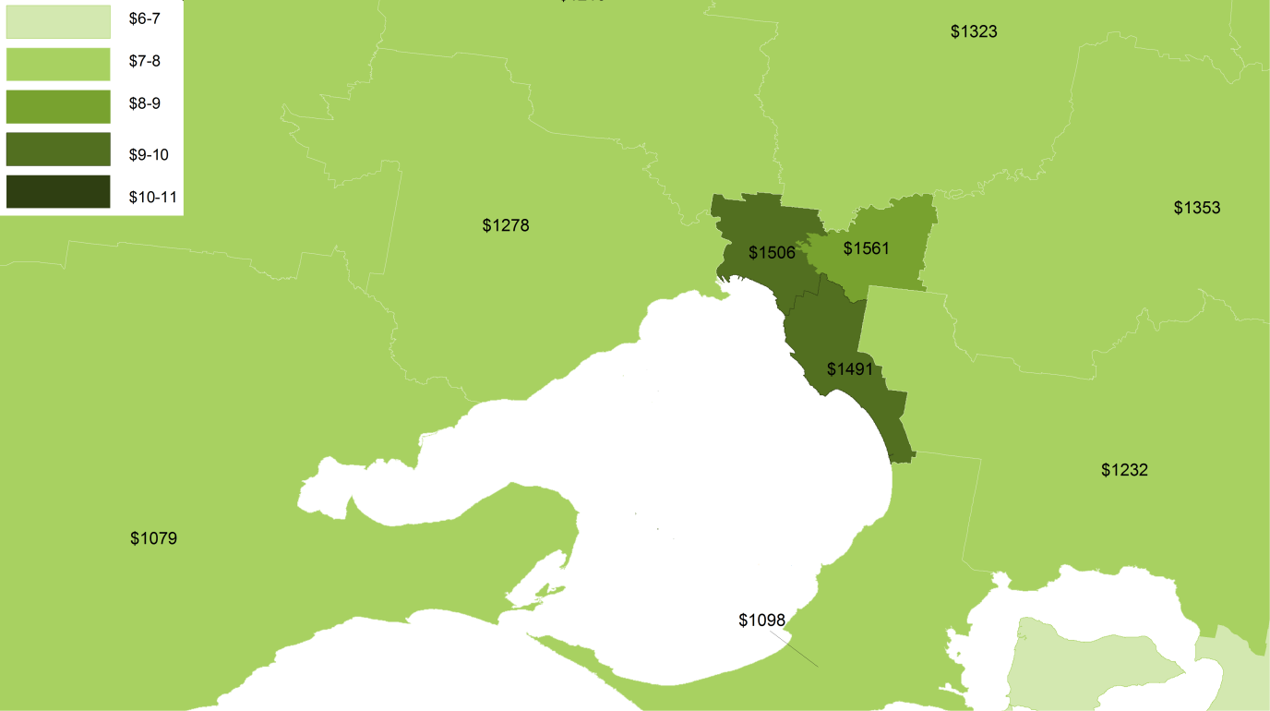
(b) Sydney
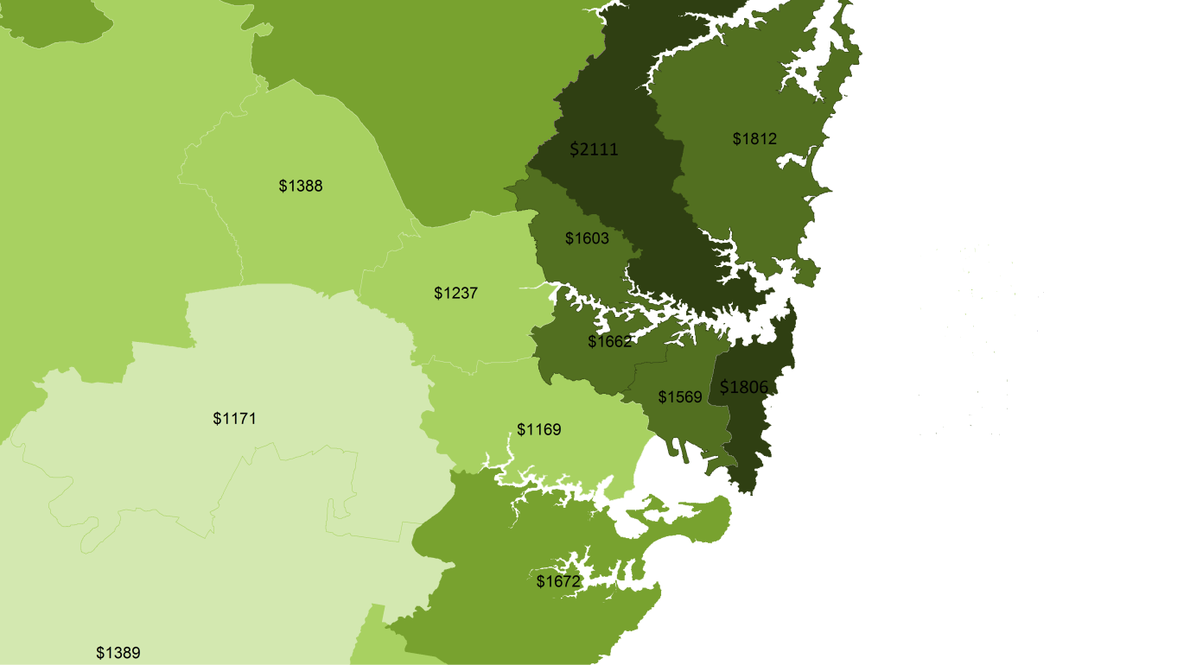

Source: ABS (2011) Census Data; Department of Education data for 2013-14.

Figure I.8 Brisbane and Tasmania have lower fees
Median household income ($ per week) and median hourly long day care fee, by Statistical Area Level 4
(a) Brisbane
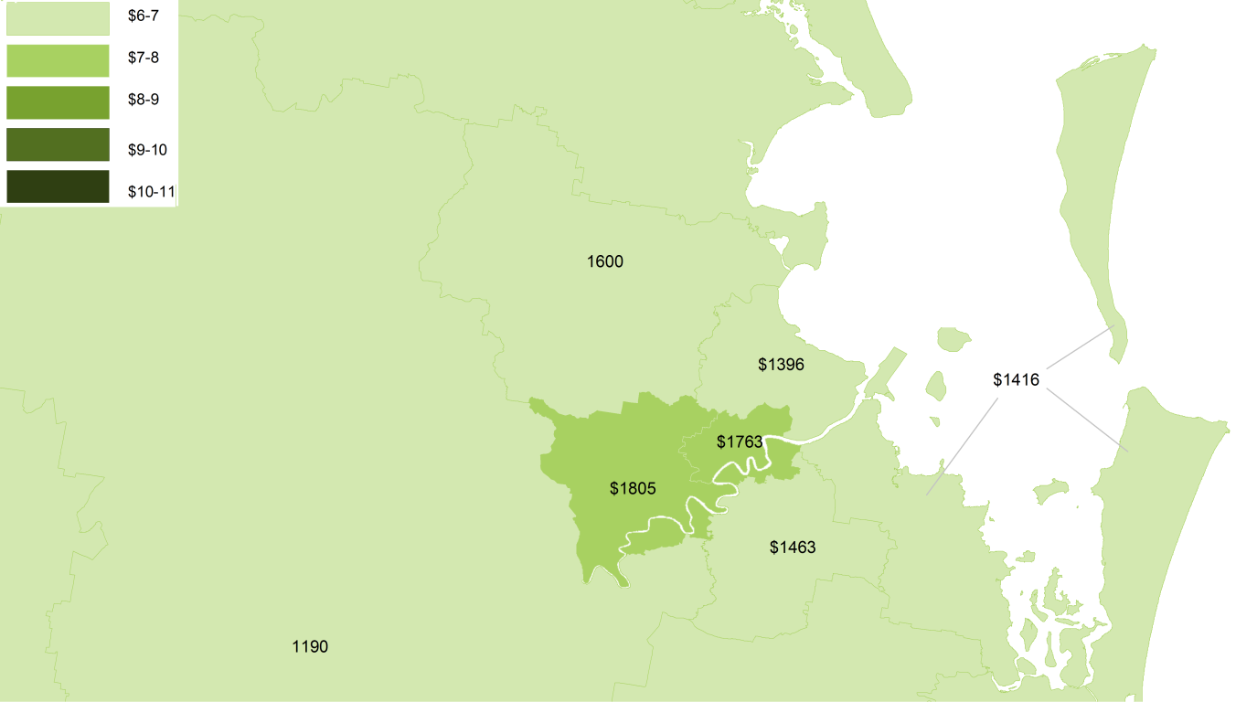
(b) Tasmania
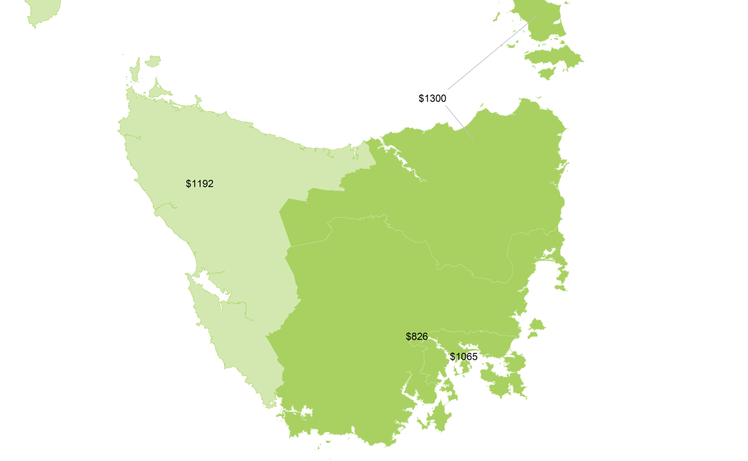

Source: ABS (2011) Census Data; Department of Education data for 2013-14.

Figure I.9 Fees are higher in Canberra than surrounding areas, but so are family incomes
Median household income ($ per week) and median hourly long day care fee (2013-14), by Statistical Area Level 4
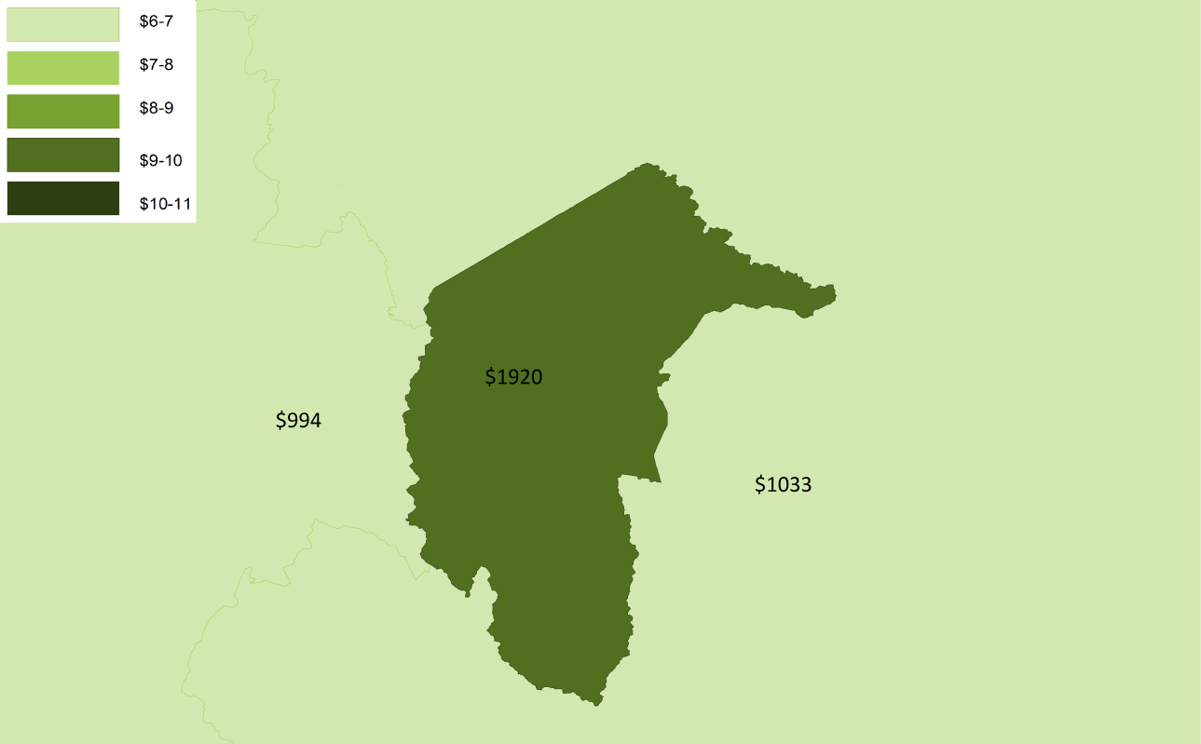

Source: ABS (2011) Census Data; Department of Education data for 2013-14.
Because parents can often access cheaper alternative services, the case for a different benchmark price for childcare services in inner city areas of major cities is not compelling. Moreover, given the objective of efficiency, a benchmark price should avoid recognising price differentials that reflect the pricing power of providers (or owners of factor inputs) in sub-markets. To this end, it has been reported that the profitability of childcare facility owners, such as Folkestone Education Trust, is increasing by strategic location of centres within the 15 kilometre radius of central business zone of major cities (Loussikian, 7 August 2014). In part, any increased profits could be efficient to attract the necessary capital investment for supply to respond to the growth in demand. However, it would still be important to avoid locking-in any quasi-rents on a permanent basis by applying a loading to a benchmark price.

Remote areas
Some services in remote areas also report higher costs of service delivery. The Commission has been unable to obtain detailed information to test such claims, but it is conceivable that, for centre-based care in particular, low utilisation of fixed costs could raise the costs of service delivery. Nonetheless, while some costs may be higher in remote areas compared with city areas, others may be lower, such as rent and property costs.
In some cases, there may be an argument to set a separate benchmark price (or apply a loading) that recognises any higher costs, particularly to meet the equity goals of government.
However, on occasion it is the characteristics of service users rather than the service location as such, that gives rise to higher costs. For example, costs may be higher in some remote areas not because services are remote but because Aboriginal or Torres Strait Islander children with additional needs dominate the use of such services.
After taking into account user-related sources of cost differences, it is less likely that any residual cost differences associated with a provider’s location will be statistically significant. Regardless, where any systemic cost differences remain, it is important to support value for money from taxpayer-funded assistance, including by ensuring innovative service delivery models or home-based care options are fully explored before devoting funds towards higher cost centre-based care arrangements. Apart from a family day care coordinator’s travel costs, the costs of a family day care service are generally not significantly higher in remote areas (appendix H).
Rather than applying a loading to the benchmark rate parents receive in certain locations, it may be appropriate to explore alternative funding approaches. Chapter 14 discusses the use of supply side funding, including block funding and grants in situations where the effective demand created by government assistance may be too low or variable over time to cover certain fixed costs of delivering services or where service users have additional or complex needs.

Age groups of children
Determining whether a benchmark price should vary with the age of child is particularly challenging, not only because cost differences can be large for different age groups of children (figure I.10), but also because:
- intensive childcare use can pose developmental risks for very young children (chapter 5)
- cross-subsidisation of fees between child age groups — that is, where cost differences are not reflected in fees — can be problematic for the design of a benchmark rate.

Figure I.10 Fees do not reflect costs differences between child age groups
Long day care fees and costs, by age of child
a Operating costs include centre-based direct staff costs and some non-staff costs (such as nappies), but exclude many fixed costs (such as rent, maintenance, utilities and any non-centre based administrative overhead costs). Factoring in these costs, which are roughly equivalent across age groups, would reduce differences in costs across age groups somewhat. It should be noted that nationally consistent staff-to-child ratio requirements only apply to the 0 to 2 years age group.
Source: Productivity Commission calculations based on Department of Education and sector provided data.
The cross-subsidisation of fees by providers is likely to be the result of both commercial and social motivations (chapter 9). Because of these factors, the possibility that cross-subsidies will be a persistent feature of the market, or would be slow to unwind, cannot be overlooked for the design of a benchmark price that, ideally, would provide a proxy for efficient costs.
An efficient price approach based on a production cost model (see step 1 above) could ensure a benchmark price reflects efficient costs, which would encourage the unwinding of cross-subsidies. As was acknowledged by Guardian Early Learning:
… the only way to remove this cross-subsidisation [between children under 3 years and children over 3 years] is for the ECLS to truly reflect the cost of providing care and early learning services to the different age groups. (sub. DR837, p. 3)
However, if the benchmark rate is based on supply costs then any continued cross subsidisation of fees by providers could actually worsen the cost reflectiveness of price signals, particularly for families receiving a high subsidy rate (box I.1). Moreover, if competition is relatively weak, it is possible that reflecting the much higher costs of long day care services for children less than 3 years old in a benchmark rate would make such services more viable for providers to offer, but not force them to alter price signals for families. For example, when arguing for a cost premium to be included in the benchmark price of nursery places, the largest not-for-profit provider, Goodstart Early Learning, said that doing so could allow them to ‘increase the supply for nursery places by making them more profitable’ (sub. DR875, p. 16).

Box I.1 The relationship between a benchmark rate and cross-subsidies
The impact of a benchmark rate on the cross-subsidisation behaviour of providers is ambiguous and any impacts are likely to vary depending on the method of estimating a benchmark rate.
In theory, an efficient cost model could reduce the capacity of providers to cross-subsidise higher cost services. For example, faced with bearing the full cost of cross subsidisation of 0 to 2 year old children in a centre (rather than having this mostly subsidised by taxpayers), parents of older children may have an incentive to switch to lower cost services which do not cross-subsidise as much. Nevertheless, providers may have weaker incentives to unwind cross-subsidies in situations where the child-based assistance is comparatively generous (such as for low-income families who receive a higher subsidy rate and users of services in lower cost locations). In addition, price signals could actually be less cost-reflective across child age groups than currently occurs (whereby prices are roughly even) if providers were to continue cross-subsidising fees.
If a benchmark price followed changes in the competitiveness of the market and pricing conduct of service providers, providers would be discouraged somewhat from cross-subsidising fees as parents would bear the full cost of any additional cross subsidisation not reflected in the benchmark price. However, the unwinding of cross-subsidies would be slow to materialise.
In summary, compared with current subsidies, a benchmark price would provide stronger incentives for providers to stop cross-subsidising fees, but it is likely that some allocative inefficiencies would continue in the short term. Although an efficient price approach could encourage providers to fully unwind cross-subsidies, there is a risk that the cost of allocative inefficiencies would be even higher than at present if the removal of cross-subsidies did not happen quickly.
A more appropriate (and far simpler) way to implement a benchmark price may be to follow observed trends in market prices. Although it could take time for cross-subsidies to unwind, such an approach is likely to be preferable given that avoiding abrupt changes to price signals would be important to manage the costs of the required market transition. Adjustment costs would include the required transformation of business models but also the disruption for the parents who currently benefit from such arrangements.
Accordingly, chapter 14 recommended estimating and setting a separate benchmark price for different age groups of children below school age in centre-based care — for example, children aged less than 3 years and children aged 3 years to school age. To the extent that competitive pressures could gradually force a differential in fees to emerge, benchmark prices would re-adjust. For school-aged children attending outside school hours care, a single benchmark price could be calculated for all school-aged children.

Step 4: How to adjust a benchmark price to reflect differences in costs
Step 3 considered what key factors we might want to adjust a benchmark price for in order to take into account a range of user and service characteristics. Step 4 explores how such an adjustment might be undertaken in practice by, for example:
- estimating multiple benchmark prices to capture any revealed fee differences between submarkets
- applying loadings to reflect estimated differences in service delivery costs.
Because a benchmark price follows market outcomes, the simplest approach to capture cost differences is to estimate multiple benchmark prices. This is the Commission’s preferred option to reflect differences in the costs of delivering childcare services (chapter 14), provided that sub-markets appear to function reasonably well, and are sufficiently deep and competitive.
However, restraint should be exercised in selecting the number of sub-markets chosen for which different benchmark prices would apply. This is because the greater the number of sub-markets chosen (and therefore the greater the number of benchmark prices), the greater the potential for complexity and distortions. For example, otherwise identical services could be located either side of a geographic boundary where two different benchmark prices apply.
As discussed in chapter 15, the provision of many services for children with additional needs and the provision of services in highly disadvantaged communities may not be sufficiently competitive and the services provided are difficult to standardise. In these cases, adjustments to a benchmark price may not be an appropriate way forward, as it is unclear that any observed differences in fees would reflect efficient cost differentials associated with either user or service characteristics.
A cost modelling approach may be a more appropriate method of adjusting a benchmark price to ensure the recommended ECLS does not result in providers withholding services for such children (either tacitly or more overtly). However, because undertaking modelling of costs could introduce significant complexity, it would be important that any cost differences are sufficiently large, statistically significant and unavoidable. Consideration of any such cost differences should also be consistent with the Australian Government’s objectives for subsidies.
However, because the delivery of services may be particularly complex and best achieved through specialisation, instead of applying adjustments to per child funding, supply-side funding approaches may be preferable. In particular, funding of providers rather than applying a loading to a child’s individual ECLS may offer a lower cost means of, for example, integrating a child with additional needs into a long day care centre. Recognising this, the Commission has recommended two programs — the Inclusion Support Program and the Community Early Learning Program — to support providers deliver services to children with additional needs (chapter 15).

The two terms were used interchangeably in the draft report, but to avoid confusion, a benchmark rate is the terminology adopted for the final report.
That is, up to the annual cap of $7500 per child in formal care.
In particular, by re-defining the service that taxpayers help to fund to be one consistent with the National Quality Standard, a benchmark rate will transfer income between families and taxpayers. Such re-definition of the service ensures public funding does not replace private expenditure.
Fee based subsidies, such as the CCR, do not alter the relative price of different quality formal services. Rather, they have an income effect, which may affect the quality of services demanded. There is limited evidence to show the extent of this in practice, but a US study by Blau and Hagy (1998) found any income effects that might increase demand for quality (including demand for convenient location) were small.
A copayment can be set as a fixed amount, it can vary in proportion to the price of services or it can reflect the residual between a fixed subsidy and the price of services. Under the Commission’s proposal for a benchmark rate, co-payments take the form of the latter and, in addition to depending on the benchmark fee gap, are determined by the family’s subsidy rate.
Depending on the design of a benchmark rate, subsidies for 0 to 2 year old children could either increase or decrease. An increase in the subsidy would bring into focus the potential for conflict between child development and workforce participation goals.
Costs can be modelled in a variety of ways — including using structural equation models of input-output relationships, using econometric frontier analysis methods, or nonparametric methods such as data envelopment analysis. Each of these cost-modelling approaches performs differently, with varying data requirements and levels of complexity.
A further option to set a benchmark rate could bear no relation to the cost or price of childcare services, but instead apportion an overall budget for spending on childcare subsidies based on the estimated demand for services. The basis for applying and updating such a benchmark rate would likely be subject to ongoing contention.
For example, a truncated mean or median could be chosen, with fees at the very high end of the distribution discarded (or trimmed) from the sample — such as those more than 2.5 standards deviations from the mean. Alternative choices could include using the lowest quartile, low outer trim, low extreme trim, ‘third lowest’ or the minimum observed price (Health Policy Solutions 2011, p. 44).
In addition, adjustments to a benchmark price may be required to reflect a variety of user characteristics, including the cost of delivering services for children with additional needs, many of whom have care and development needs that are more costly to support (figure I.1).
Of course, different markets might exist for these two service types, but that would be on the basis that parents view them differently. Some parents may prefer a home based care environment for their child, whereas others might prefer a centre-based arrangement.
To the extent that regulations apply differently across service types, there may be some basis to fund any resulting differences in quality. However, that would involve an adjustment on the basis of, for example, differences in the qualifications of childcare workers, not on the basis of the overall cost structure of the service model itself.

