May 2025

Economic policy making
in a more uncertain world
  - Richard Snape lecture
20 May 2025, Melbourne
Dr Jenny Gordon
The views expressed in this paper are those of the author and do not necessarily reflect the views of the PC.


The Productivity Commission acknowledges the Traditional Owners of Country throughout Australia and their continuing connection to land, waters and community. We pay our respects to their Cultures, Country and Elders past and present.

The Productivity Commission
The Productivity Commission (PC) is the Australian Government’s independent research and advisory body on a range of economic, social and environmental issues affecting the welfare of Australians. Its role, expressed most simply, is to help governments make better policies, in the long–term interest of the Australian community.
The PC’s independence is underpinned by an Act of Parliament. Its processes and outputs are open to public scrutiny and are driven by concern for the wellbeing of the community as a whole.
For more information, visit the PC’s website: www.pc.gov.au

© Commonwealth of Australia 2025

With the exception of the Commonwealth Coat of Arms and content supplied by third parties, this copyright work is licensed under a Creative Commons Attribution 4.0 International licence. In essence, you are free to copy, communicate and adapt the work, as long as you attribute the work to the PC (but not in any way that suggests the PC endorses you or your use) and abide by the other licence terms. The licence can be viewed at: https://creativecommons.org/licenses/by/4.0.
The terms under which the Coat of Arms can be used are detailed at: pmc.gov.au/government/commonwealth–coat–arms.
Wherever a third party holds copyright in this material the copyright remains with that party. Their permission may be required to use the material, please contact them directly.
An appropriate reference for this publication is:
Gordon, J 2025, Economic policy making in a more uncertain world, Richard Snape lecture, Melbourne, 20 May, Productivity Commission, Canberra
Publication enquiries:
Phone 03 9653 2244 | Email publications@pc.gov.au

Contents
Introduction 1
Governments are looking for a new economic paradigm 1
The old policy challenges for the neoliberal economic paradigm 2
The new policy challenges need a new economic paradigm 3
Power and the influence of multinational corporations 4
A system approach 7
Modelling complex systems is hard – but is an important part of
building understanding 8
System intersects should be a focus for building understanding 9
Rethinking neoliberal economic policy orthodoxy 10
Geopolitics is making the productivity intersects with national
security more challenging 12
Populist policy responses are not resolving the problems 13
The jury is out on industry policy 15
The policy challenges for Australia 16
Policy should aim for a broader and longer term view of productivity 17
Economics in uncertain times 18
A process to find answers rather than the answer 19

Professor Richard Hal Snape

Richard Snape was one of Australia’s most distinguished economists. He was Deputy Chair of the Productivity Commission and Emeritus Professor of Monash University, a Board Member of the Australian Research Council, Fellow of the Academy of the Social Sciences in Australia and a Distinguished Fellow of the Economic Society of Australia.
In 2003, the Productivity Commission began a series of lectures in memory of Richard. With Richard’s own interests and high standards in mind, the series has hosted lectures on important public policy issues from people including Nobel Prize winning economist Joesph Stiglitz, Pascal Lamy, Director–General of the World Trade Organization and Martin Wolf the chief economics commentator at the Financial Times.
Past lectures are available from: pc.gov.au/richard–snape


Dr Jenny Gordon
Dr Jenny Gordon is an Honorary Professor at ANU and a non–resident fellow at the Lowy Institute. Dr Gordon has served as Chief Economist at DFAT, Chief Economist at Nous Group and Principal Adviser at the PC. With a PhD in economics from Harvard University, Dr Gordon has also held fellowships at Oxford University and Harvard University.

Introduction
I would like to acknowledge the traditional owners of the land on which we meet, the Wurundjeri people of the Kulin Nation, and pay my respects to their elders past and present.
It is an honour to present the Snape lecture, following such a distinguished list of previous speakers. Richard Snape was appointed to the then Industry Commission in 1995, but his association with the Commission goes back further, reflecting the strong connections the Commission had to academia. Richard was one of the Australian economists who made their mark on economic theory, in no small part because Australia’s position in the world gave them a different perspective - particularly on trade and the impact of tariffs and other forms of protection. This work, demonstrating the costs to mining industries of manufacturing protection, and the costs to consumers of agricultural protection, was instrumental in reducing protection in Australia and across the world. The need to fight the open and free trade battle has emerged once again with Trump’s tariff policies. But this time the policy challenges are more foundational.
The multilateral institutions that maintained the ‘international rules based order’ have come under threat by US withdrawal, and China’s desire to make the rules in its own interests. Great power competition for economic and technology dominance (well underway from the Obama era, and accelerated by Trump I and Biden), risks polarising the world into spheres of influence. US policy chaos is posing risks to the stability of the global financial system. And neoliberal economic orthodoxy – embracing small government, shareholder value, and leaving the economy to the markets - has clearly failed segments of the population feeding populism and bad policy choices.

Governments are looking for a new economic paradigm
Jake Sullivan, Biden’s National Security Advisor, nicely summarised the problems that had been accumulating in the US:
But the last few decades revealed cracks in those foundations. A shifting global economy left many working Americans and their communities behind. A financial crisis shook the middle class. A pandemic exposed the fragility of our supply chains. A changing climate threatened lives and livelihoods. Russia’s invasion of Ukraine underscored the risks of overdependence.
Sullivan was good at symptom identification, less good at diagnosis of the causes, and the US’s role in those causes.
The Global Financial Crisis (GFC) should have been a wake-up call on the rising imbalances in: global savings and investment; domestic income and wealth distribution; the sources of environmental degradation and the destination of its costs; and shifting relative military and economic power. Lessons on the importance of macroeconomic stability took hold in Asia after the 1997-8 Asian Financial Crisis. But in the US, and in China, these lessons on the need for macroeconomic rebalancing did not get traction. Then the pandemic disrupted supply chains, and the reliance on China for at least one, if not many, parts of the supply chain raised red flags on national security. These concerns were not helped by China’s willingness to use trade sanctions to punish countries for things it did not like.
The US bipartisan ‘it’s China’s fault’, and under Trump ‘the world have been ripping the US off’ narrative has provided a politically useful distraction from addressing the growing domestic imbalances, as well as excusing the fiscal deficit. The reserve currency nature of the US dollar makes the US a special case, but other countries too have ‘kicked the can down the road’ on hard policy problems. The difference is that the US exceptionalism protected it from the market disciplines faced by countries dependent on trade and investment flows.
Unfortunately for the US, its exceptionalism did not provide protection from the costs of structural change. Trump, in his rush to blame China, is undermining this exceptionalism, and making it even harder for the US to protect its people from the costs of structural change and to share the benefits.
Adjusting to structural change is a problem that faces all countries – not just from opening markets to external competition in trade and investment, but from technology – automation, digitisation and AI – and from shifting demand as incomes rise, demographics change, as well as from the consequences of climate change. The localised costs of structural change are more acute where agglomeration economies make communities more reliant on one industry or natural asset. Governments need to prepare for and to manage the consequences of structural change. They also need to redistribute resources so children have an opportunity to thrive regardless of the income and social status of their parents. And they need to do this in an ever more fractious world, where ‘might is right’ is becoming a dominant paradigm.
The wrong problem diagnosis means the policy options for fixing the problem will not work. This is writ large in the US today, and Australia is not exempt to attractive misdiagnosis. We need to get the diagnosis right to design policies to correct the underlying causes as well as mitigate the symptoms.

The old policy challenges for the neoliberal economic paradigm
Markets sit within household production, society and the environment (figure 1).
Figure 1 – Market failure vs government failure
The three main objectives of neoliberal economic policy focused on the market part of this system. They are:
- facilitating equilibrium in the macroeconomy – largely balancing consumption and investment
- facilitating equilibrium in the microeconomy – with a focus on labour and product markets
- correcting material market failures – market power (natural monopoly a special case), externalities (public goods a special case), and asymmetric information (including mis and dis information).
How much government should intervene, and how much they should live with disequilibrium and market failure was debated in terms of the costs of government failure relative to costs of market failure.
Policy design tended to treat household production, society and environmental services as independent of market activity. But there is a lot of substitution. Household work and voluntary activities are slowly being replaced by market driven production. Part of this is urbanisation, part is women working outside the home, part is a decline in volunteer and community services, and part is governments shifting from direct delivery of services to contracting out, or subsiding private purchase of services. As markets do more it becomes more important that they function in the best interests of society and not just the owners of capital (including human and knowledge capital).
The neoliberal paradigm assumed we have sound institutions that are supported by society, and that these institutions (the rules and enforcement mechanisms) were immune to the application of power. The neoliberal paradigm assumed prices would guide demand and supply toward balance and disequilibrium was temporary and not disruptive. And there was an implicit assumption that free environmental services would turn up when the current ones were degraded.

The new policy challenges need a new economic paradigm
Rather than a market focus, new challenges need an institutions focus. Market – the trading system that discovers the price that matches demand and supply, facilitating exchange – are just one institution that governs how the economy functions. Other institutions establish and enforce social norms and others dictate how natural systems respond to pressures. We have established organisations that uphold these institutions, such as the political and judicial systems. Institutions sit within a system of household concerns, political pressures, and environmental pressures (figure 2).
Figure 2 – Institutions – the rules and norms – reflect and respond to household, political and environmental pressures
If we think about the system in these dimensions it focuses us on different imbalances.
- Savings-investment imbalances. Fundamental imbalances can be explained by differences in demographics and income levels, but these were expected to rebalance over time as populations age and incomes rise. What we did not see was the growing problem that US exceptionalism created by allowing the US to run an ongoing fiscal deficit, combined with the attractiveness of its investment market. The US external deficit was facilitated by China’s continued high saving rates, in large part in response to low social insurance, and government focus on investment as a driver of growth.
- Economic and security imbalances. Economic interconnection was assumed to bring security as trade removed incentives for invasion. What we did not see was the rise in willingness to use economic relationships as weapons to extract non-economic concessions. The US has long used financial sanctions against bad actors. But the costs of these sanctions were rising for other countries. China increasingly is using its economic heft to influence, if not coerce, the behaviour it its trading partners.
- Inequality and political instability. We were mostly blind to the political impacts of structural change and impact of technology where agglomeration economics concentrates costs (and benefits) of change on specific places and groups of workers. The US rust belt opioid crisis and deaths of despair fed US populism. Migration flows into Europe encouraged the rise of right wing parties, and was probably the driving factor for Brexit. In China the limits to their infrastructure and export driven growth strategy saw an expansion of CCP use of technology for social control and a crack down on the private sector to reassert CCP influence.
- Destabilising impacts of climate change. We did see climate change coming – but could not get collective action. Now insurance companies are making real the costs of inaction.

Power and the influence of multinational corporations
The magic in a market solution is premised on profit maximising entities facing ongoing competition to deliver least cost production to consumers. Under the neoliberal paradigm this translated to maximising shareholder value. Too often competition failed to erode the growing power of Multinational Corporations (MNCs). Power accumulates power, with the top 1% of companies control 97% of corporate assets (figure 3).
Figure 3 – The Power of multinational corporations and influence over public policy
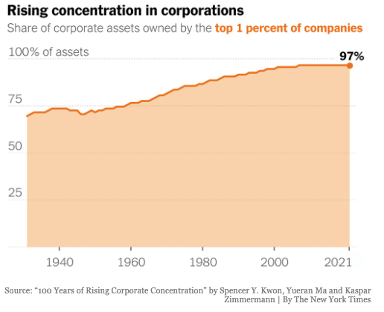
Source: ‘100 years of rising corporate concentration’ by Spencer Y. Kwon, Yueran Ma and Kaspar Zimmermann, The New York Times.
Pursuing shareholder value MNCs have played off countries and governments to make rules in their favour, undermining government’s ability to reduce market failures, and tipping the balance toward capital over labour (figure 4).
Figure 4 – US corporate profits as a share of GDP are at a record high
Source: The Daily Shot, 27 March 2025.
Even governments not captured by corporate interests have been influenced by the demands of MNCs. For example, Investor State Settlement Dispute (ISDS) clauses in Trade Agreements are being used to chill environmental reforms, and corporate (and top personal) tax rates have been progressively reduced, with pressure on governments to match the beggar thy neighbour approaches of Ireland and tax havens (figure 5).
Figure 5 – Corporate tax rates have been competed down
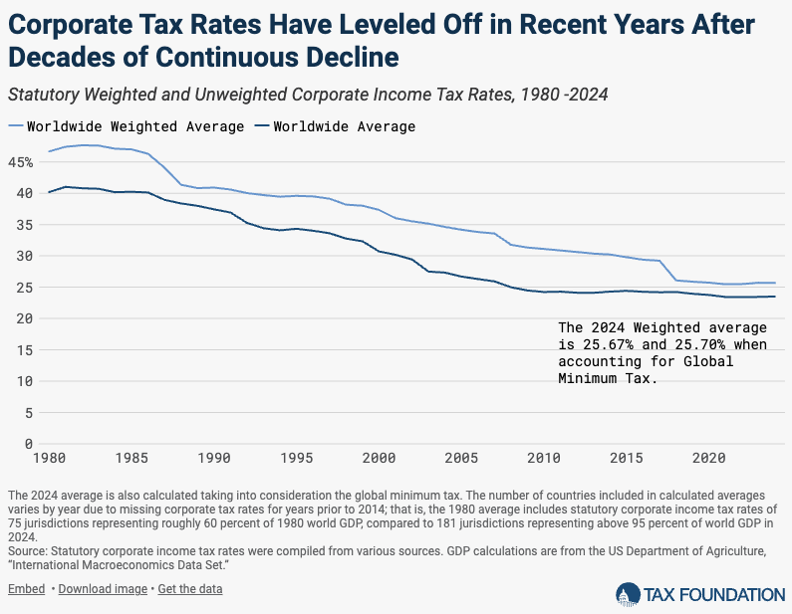
In some countries the rising power of large corporations is looking more and more like crony capitalism, where governments are captured by corporate interests. The Trump administration actions on cryptocurrency is a recent example of special interest advocacy dominating good policy process.
Policy makers and regulators face well entrenched resistance to policies that might affect short term profits, even if they will raise long term growth, making the task of better policy more difficult to achieve.

A system approach
The new economic paradigm will need to take account of the interactions between the overlapping systems that deliver productivity, social stability, national security, and environmental sustainability – four elements important for our wellbeing (figure 6).

Figure 6 – The interconnected systems – a simple wellbeing framework
These systems are linked. For example, productivity depends on technological progress, scale and agglomeration economies, the incentives inherent in competition, the free inputs from the environment, as well as from macroeconomic stability. These drivers of productivity link directly to national security through policies affecting trade and investment, international collaborations on R&D, access to talent though 2-way migration, and the effect of the external balance on political relationships.
Productivity also links to social stability through: human capital that enables adoption of better technology; through consumption that generates demand that affects scale; and through the transactions costs of doing business. This last link is important and multifaceted. At one level the link is direct, as community trust in institutions enables markets to function at lower costs of contract enforcement. Mistrust raises the costs of doing business as lack of trust requires more verification of the contract terms and their delivery. The second level of transaction costs comes with the correlation between loss of trust in government and poor policy choices. Politicians that seek to attract voters have an incentive to offer quick fixes to more fundamental problems. Populist policies tend to raise costs for little or no benefit, reducing productivity.
Social stability also links to the national security system if external unrest feeds into domestic unrest or the reverse. The attractiveness to politicians to ‘blame foreigners’, whether those in the country (migrants), or those outside (exporters and investors), for domestic issues affects social stability. This links all three systems – productivity, social stability and national security – through the problems of protectionism.
Trump is citing national security as the grounds for tariffs, along with replacing taxes and growing manufacturing. The consequences for the Australian economy are more about how China and other countries in the region will respond than the direct effect of US tariffs. Economists are good at modelling how tariffs work through the global economy – but less good at predicting what these tariffs will be. The predecessors of the Productivity Commission cut their teeth on modelling the impact of tariffs. These models provided persuasive for reforming economic policy. Trump’s team seem immune from this influence.
The Industry Assistance Commission played an important role in the development of Computer General Equilibrium (CGE) modelling. These models explained how tariffs (and industry subsidies, quotas etc) worked their way through an economy. The policy reform task was easier once the costs of tariffs were made transparent as the losers from tariffs, the agricultural and mining industries as well as consumers, swung behind reform. But politics is trumping economic modelling, so our models need to evolve.

Modelling complex systems is hard – but is an important part of building understanding
Today we need models that will help us track a far more complex dynamic system that links productivity, social stability, national security, and environmental sustainability. We need models that will help us understand how policy levers play out over time, and identify accumulating problems that will come to be costly to wellbeing so we can reverse course before a crisis forces change.
We need a deeper focus on designing systems that are self-correcting, and that facilitate decision making that balances competing interests. Today we need models or approaches that make the accounting more transparent on both populist policies and those that are not correcting growing imbalances. Stopping governments doing stupid stuff has to be a priority. It is a harder task to design alternative policies that will correct the underlying problems. A task made even harder in this more chaotic world.
Models work best when there is stability. Econometric estimates of parameters and trends in data are more reliable in a stable environment. New types of shocks (pandemic, Trump), structural change, social change, and unpredictable changes to the geopolitical environment can make history a poorer guide to the future. But there is still a lot we can do to understand relationships that help us diagnose the forces in systems that lead to virtuous and vicious feedback loops. We need to worry about reenforcing vicious feedback loops that erode productivity, disrupt social stability, undermine national security, and/or degrade the environment. Our models and empirical work should focus on identifying these feedback loops, understanding their dynamics – including speed, and working out intervention points that can slow or, more ideally, reverse these dynamics.

System intersects should be a focus for building understanding
It is often the intersects between the productivity, social stability, national security and environmental feedback loops that end up causing crises.
‘Slow burn’ intersects are the easiest for politicians to ignore and the hardest to build an evidence based case that we need to intervene before the problems become overwhelming. Crises – financial collapses, depressions, civil unrest, revolutions, and war are outcomes of unchecked reenforcing feedback loops. Yes – a crisis should not go to waste in reforming policies – but the human cost of crises is too great to see waiting for a crisis as the best solution.
So what are some slow burn feedback loops we should be thinking more about? The ones that matter most are in those that intersect across the four areas that matter most for wellbeing. Some of note (figure 7) are the:
- intersect between trade and investment flows that promote productivity growth and the weaponisation of these flows
- effect of inequality on political sentiment and rise of populism and decline in trust in government
- drag on productivity growth from the degradation of the environment and need to use more built inputs to replace previously ‘free’ inputs, and
- risk that climate refugees will pose to national security.
Figure 7 – ‘Slow burn intersects’ between the systems
We can and should be monitoring policies for whether they are contribution to reenforcing feedback loops making problems worse – not just in their specific wellbeing contribution but through the intersects with other things that matter for wellbeing.
Australian policy makers have not been blind to growing problems such as housing affordability, geographic concentration of unemployment, widening educational attainment, export dependence on China and commodities, risks of supply chain disruptions, and the need to decarbonise – but the roots of these problems in the slow burn feedback loops makes them hard to fix. More attention might have avoided more problems - they cannot be assumed away, so we should invest not just in fixing the root causes, but in avoiding adding to vicious reenforcing feedback loops.

Rethinking neoliberal economic policy orthodoxy
Neoliberal economic policies, summarised in the Washington Consensus 10 rules for economic growth, and US hegemony – their support for the international rules based order, and security blanket – delivered considerable benefits for many people in many countries post WWII. The share of the global population living in poverty has fallen steadily since the 1880s. Most notable is the vast majority of the Asian population that in 1975 were mostly living in poverty and by 2015 had moved above the poverty line. Africa has yet to follow the same trajectory (figure 8).
Figure 8 – The Washington Consensus open market policies reduced the share of the global population living in poverty
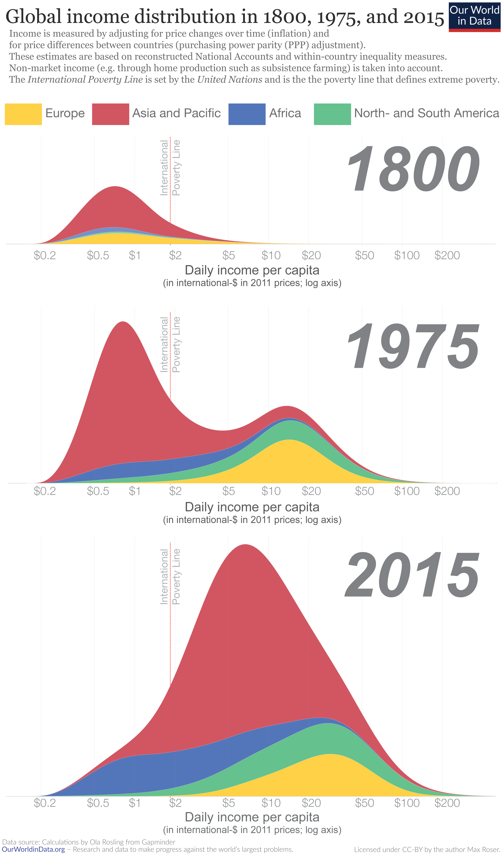
Source: Calculations by Ola Rosling from Gapminder, OurWorldin Data.org, CC-BY Max Roser.
The Hawke-Keating reforms in the 1980s and early 1990s followed neoliberal orthodoxy of open and free trade and capital markets, moving production to the private sector, and relying on competition to discipline market behaviour. Success of this economic policy orthodoxy is seen in the overall convergence in per capita income across countries from the 1990s to 2020. This convergence pattern is dominated by economic growth in many Asian countries because an underlying condition for the Washington Consensus to work was domestic institutions that could enforce the rules. The stability of the international rules based order provided the foundation for the global expansion in trade and investment that has so greatly benefited Australia.

Geopolitics is making the productivity intersects with national security more challenging
Pre-pandemic, this rules based international order was already under threat. The US reaction to the rising economic power of China was to try to isolate China and slow its growth. US efforts to form partnerships that excluded China started with the TransPacific Trade Partnership (TPPT) under President Obama. They continued with President Trump’s trade war and trade deal with China. The Biden administration tried to resurrect Obama’s efforts with the Indo-Pacific Economic Framework (IPEF). Biden also imposed bans on exports of high end chips to China, and 100% tariffs on Chinese EVs and solar technology in part due to security concerns and in part to stimulate domestic green technology industries. President Trump ramped up tariffs on China, stepped back on some such as laptops and iPhones, then imposed 145% tariffs. The agreement to pause these export killing tariffs for 90 days on 12 May still leaves many of China’s exports to the US facing 30% tariffs.
The slowdown in US support for international commerce started after the Global Financial Crisis (GFC). Whether declining US support for the World Trade Organisation (WTO) or their post GFC secular stagnation was causal in a slowing of growth in international trade and investment, or whether growth opportunities had peaked is an open question – likely a bit of both. But since 2020 the pattern has been rising divergence as poor countries get further behind while the US has soared ahead. The massive stimulus in developed countries in response to the COVID-19 pandemic, but particularly the US, along with the supply chain disruptions of the pandemic and Russia’s invasion of Ukraine led to an inflationary surge. This inflation, and the high interest rates adopted by central banks to bring it under control, added to populist pressures. But the declining support for the international rules-based order was already well underway – and not just from the US.
How did we get here after the post WWII Bretton Woods Institutions were designed to deliver stability?
- We relied on US leadership – to fund a large share of the Bretton Woods Institutions, and to support the overall rules enforcement. The US often exempted themselves from the rules but offered security and financial services (role of the USD as a reserve currency with deep liquid markets) in exchange. Nixon tested the relationship triggering the global inflation of the 1970s. Post the Asian Financial Crisis, the US pushed the International Monetary Fund (IMF) to raise financial stability requirements, but by 2007 the US had yet to be subject to IMF scrutiny as they put themselves last on the list. The accumulation of risk in the US mortgage backed security market might have been identified if they had faced an earlier review, and the GCF avoided.
- G7, G20, and UN agencies were unable to achieve cooperation on the management of global commons – most importantly greenhouse gas emissions. There were wins – such as the Montreal Protocol on CFCs. But cash strapped governments abandoned promises in the face of industry campaigns and loss of public support for causes such as emissions reduction and biodiversity preservation.
- Multinational Corporations used the pull power of their investment location decisions to exercise power over government policies. This led to a ‘race to the bottom’ on a range of regulations resulting in countries, developing countries in particular, getting lower tax revenue, more pollution, as well as the undermining of international approaches.
As Australia’s prosperity relies on trade, and our ability to grow is boosted by the ability to attract foreign investment (capital and knowledge), we have a big interest in a stable rules based international order. We lack the hard power or economic heft to drive this – so we need to form partnerships that together can be influential.

Populist policy responses are not resolving the problems
A common refrain from the supporters of neoliberal orthodoxy is that governments have gotten too big, imposing too many regulations and providing too much social support that disincentives work. This diagnosis ignores the social stability and environmental feedback loops. It leads to poor policies, such as Liz Truss’s massive tax cut that ‘would pay for itself’ in increased investment. The market judgement was clear that this would not work, and the lettuce lasted longer than Truss’s prime ministership.
One of the challenges for people who care about policy efficiency and effectiveness, is that real policy solutions involve losers and take time, so are a hard sell. Populist policies – like tariffs – have easy appeal. These policies use outrage as evidence and are designed around blame.
Brexit was sold on restoring British sovereignty over policy, inciting outrage over European Union rules, including those that did not exist, such as banning the British sausage. Brexit, it was argued, would reduce the costs to British jobs of immigration, and open up a whole new world of trade opportunities. A decade later Brexit has proved to be economically costly and has not addressed the more fundamental problems of low productivity and social discontent (figure 9).
Figure 9 – Impact of Brexit on UK growth
President Trump’s tariff policies are another clear case of an own goal. Trump’s tariff policies are destabilising markets – and eroding an important source of US exceptionalism, the willingness of foreigners to invest in the US, including in US Treasuries. For the first time US Treasuries and the USD have not benefited from the ‘flight to safety’ of global disruption. The USD index and the 10-year US Treasury yield moved together until April 4th, Trumps ‘liberation day’ (figure 10).
Figure 10 – The US dollar and US 10-year Treasury yield
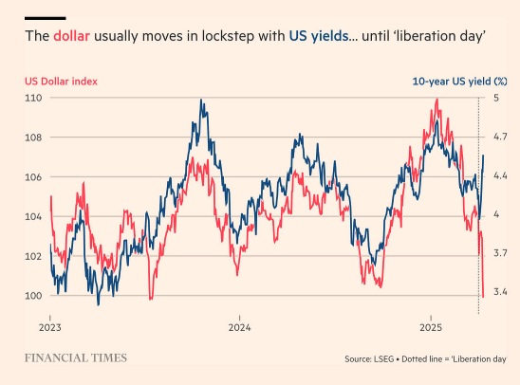

The jury is out on industry policy
In response to his listing of the symptoms of economic policy failure Jake Sullivan set out a ‘New Washington Consensus’. It is focused on industry policy. In the US this is the (poorly named) Inflation Reduction Act – aimed at promoting green technology development, and the CHIPS Act aimed at on-shoring high end chip manufacturing back to the US. These policies involved a lot of subsidies and tax concessions for domestic production.
Industry policies are now being promoted as a cure all – to boost productivity growth, improve supply chain security and create well-paid blue-collar jobs. But it is unclear how well these are working, even where the country has the scale to operate near the minimum cost point of the cost curve. The US might – but Australia does not.
Jury is out on industry policy – at least for the US. But there are some things we do know:
- Industry policy won’t bring back well-paid blue-collar jobs in any volume – bringing short term construction jobs at best.
- Countries with large domestic markets have more scope to reap economies of scale and economies of aggregation.
- Supported industries have to be exposed to competition to avoid too much market power – for small markets there is a trade-off between market power and economies of scale.
- Domestic production is unlikely to guarantee supply chain security – unless all links in the supply chain are on-shore. And the fewer supply sources the more vulnerable it is to domestic supply disruption risk.
- It is very hard to design incentives in the Goldilocks zone. So governments tend to overpay or risk the policy not delivering on supply.
- There is always a very real risk of program capture by vested interests.

The policy challenges for Australia
The risks for Australia lie in our imbalances as a commodity exporter, our security reliance on the US while our economic reliance is with China, the growing economic and social insecurity of our population, particularly the young, and the impacts of climate change and poor environmental management. Our situation makes us prone to external risks as well as from within.
The main external risks are:
- US protectionist policies and their consequences for China and the region
- the breakdown of WTO adherence and escalation of trade wars beyond the US
- concerns about the reliability of the US-security alliance
- concerns about the stability of the global financial system
- erosion of cooperation to manage the global commons – the atmosphere, oceans and space and pandemics.
Our domestic risks are mostly related to the need to address income and, more importantly, opportunity inequality. We also face risks from rising rates of natural disasters and the productivity eroding impacts of climate change. The structural fiscal deficit means that there is no money to throw at these problems. Reforms are badly needed. There are some risks that come from our external positions that we can do something about. These include the reducing reliance on commodities and China as a market, which needs a long term approach, and the reliance on liquid fuel imports for transport – where electrification of the fleet offers a solution.
There is not a lot Australia can do alone to address the international risks. But there is a lot more we can do if we can form coalitions of interest with other countries, where together there is sufficient economic heft to be influential.
To be taken seriously we have to demonstrate that we can address our own problems and are willing to do so. This was the key to the effectiveness of the Cairns Group – where Australia’s experience in reforming the highly protected and managed agricultural market provided the standing to argue for reducing protection in other countries. The last big multilateral reforms in trade were negotiated in the Uruguay round finalised in 1993. This agreement reduced protection in agriculture and in textiles and clothing, and formed the WTO with stronger dispute resolution systems. These efforts were a response to the US, and lesser extent the EC, threat of imposing tariffs and rising use of non-tariff barriers.
So what should the Australian government be focusing on? Markets need rules to work. Government’s job is to make rules that balance competing interests in a way that reflect the values of society. The balance involves trade-offs between: consumers and producers, employers and workers; investors and management, and resources now or in the future. Regulators must enforce the rules that come out of this balancing act at least cost - which will involve trading off the costs of making a mistake with the cost of enforcement, not least the speed at which decisions are made. As we live in a world of change the balance will keep shifting, and regulations and regulators need to shift with them to maintain balance.
The goal has to be dynamic stability – systems that can adapt to a changing economic, social, international and climate environment. Dynamic stability needs variety and contestation, there is no set and forget. It needs cooperation to set the rules for competition, and a process to evolve the rules as the external environment changes. It must enable variation and not force conformity so that there are alternative ways to solve problems as they emerge.

Policy should aim for a broader and longer term view of productivity
Productivity growth has stalled in Australia. But we are not alone. Despite the overall growth in US labour productivity, US manufacturing productivity growth has been flatlining since the early 2000s (figure 11).
Figure 11 – US manufacturing productivity
Source: Danial Lashkari and Jeremy Pearce, ‘The Mysterious Slowdown in U.S. Manufacturing Productivity’, Liberty Street Economics.
Productivity remains ‘almost everything’ to quote Paul Krugman. Ken Henry offered the 3Ps – Productivity, Population and Participation – as a useful identity to predict economic growth.
As the 2016 PC report on migration concluded we need a bipartisan population strategy that commits to investment to ensure that infrastructure keeps pace with population growth. Failure to do so has led to an imbalance with consequences for social stability.
Participation is mostly dictated by demography. But a healthier, better educated population, where families have social support, encourages higher rates of participation. According to AI aficionados we will need to rethink participation with the coming of AI to be as much about participation in the community, in household production, and in creative pursuits as in the paid workforce.
Of the three ‘Ps’ productivity is the most amenable to policy. But it is proving to be harder to influence using the standard neoliberal economic tools. This is because measured productivity is only a part of overall productivity – and it has stalled in many industries since early 2000s. Policy needs to target a wider measure of productivity.
We have a very narrow measure of productivity because statistics need rigour – a well-defined measure of the volume of inputs and outputs. But there is much that our measures miss.
Our productivity measures do not reflect the quality of life – the value that come from relationships and belonging to a community. Improvements in the care economy that make people feel more valued and improves their sense of agency raise wellbeing. If wellbeing is the metric rather than a volume measure of output, we would be reporting a productivity improvement from the National Disability Insurance Scheme, for example.
Our productivity measures only partly reflect the standard of living – as GDP is only a portion of the goods and services we consume. We consume environmental services such as clean air, water, green spaces, and low noise places. We consume household and volunteer goods and services as well as providing our labour to produce them. U-tube videos that instruct people how to fix their chair or make a cake raise the productivity – quality and quantity – of these household services. As more of these services are produced in the market economy and they grow as a share of economic activity this detracts from measured productivity because they are labour intensive.
Our productivity measures only partially reflect improvements in quality. The ‘artisan baker’ problem exemplifies this measurement problem. Our measures also reflect the education level of the workforce – so, for example, productivity falls when a childcare subsidy attracts marginally less productive workers into the labour force.
Finally, our measures ignore the ‘free’ inputs provided by the environment. Reaching the limits on the ocean’s waste disposal capacity, the declining greenfield sites left near cities, the exhaustion of soil nutrients in agricultural land, and exhaustion of the richest and closest mineral deposits, which are sensibly mined first, all detract from market productivity. There are also ‘free’ inputs from social stability, reflected in lower transaction costs in regulatory compliance. Driving is much safer and quicker where everyone usually follows an agreed set of rules.
Increasing productivity through minimising environmental degradation, promoting social stability, investing in raising participation in unpaid household and community work as well as paid work, and improving people’s ability to contribute are not reflected quickly in measured productivity statistics. The impacts are long term. But these outcomes do improve current as well as future wellbeing. This should be an important part of the Productivity Commission’s agenda.

Economics in uncertain times
There are no easy answers to driving productivity growth in developed economies. The old Washington Consensus is still a good prescription for developing countries if they can establish sound governance (a rule of law free of corruption). But the old Consensus ignored slow-burn problems.
Ideally we could build on the old Washington Consensus by addressing these slow burn problems to deliver a wider type of productivity growth – and one less prone to capture by a small share of the population. At an international level Australia should promote:
- cooperation on managing global commons, and balancing environmental services now with the future
- cooperation to make MNCs pay for their use of environmental services and a country’s services (its knowledge, human and built capital) – the OECD Global Minimum Tax is a good place to start, and
- show leadership in a commitment to maintaining a balance at home by managing the impacts of structural change on communities, investing in social stability, and preventing unsustainable use of the environment.
Policy reform is hard – it requires honest conversations with the public, rather than misleading ‘quick-fix’ policy offers. This makes economic policy making more about process than finding an answer in theory and assuming that the underpinning assumptions will hold. This does not mean that economic models are useless, or empirical analysis unnecessary – rather it means that they are part of the policy process – sometimes very influential, sometimes other models and empirics matter more, and all need to be informed by community values.
CGE modelling was great for analysing the impact of tariff reforms. Privatisation was great in breaking strangleholds of unions and entrenched management to expose government entities to market disciplines. But private utilities had an incentive to run their capital hard and turn to governments when underinvestment in capital and people hit service delivery. Contracting out service delivery was great at improving cost-effectiveness, at least at first. And giving cash subsidies directly to consumers improved their agency. But hoping that the recipients can impose market discipline and remove the risk for government was optimistic.

A process to find answers rather than the answer
We need to abandon our assumption that the assumptions that underpin our economic models hold. We need to be constantly testing whether our models – our theory of change – are still working and to be able to adapt, adjust, and reverse course. This requires a more humble approach to economic policy making. Which is why I offer an additional three ‘Ps’ (figure 12).
Figure 12 – An additional three Ps – Partnership, Pragmatism and Practice
They are:
- Partnership – to cooperate to get an agreed set of rules and processes (such as enforcement of rules). This is partnership at an external level - with countries in our region and others that want to promote a global system to support economic growth and development. But it is also partnership at home in the policy making process and in its implementation through greater engagement with civil society, greater openness to ideas and public discussion of policy options, and more resistance to special interests.
- Pragmatism – to make compromises – lose now to win in the future, win on one dimension and lose on another. The theory of why democracy matters can provide a guide – parties don’t want to entrench power unless they can do it quickly enough to ensure they are always the ones reelected. We need to design a system that avoids entrenchment of the incumbents. The incumbents will differ across issues, pragmatism is about working with partners on things that matter to them, but ensuring that they see the trade-offs that others need to make.
- Practice – to allow for experimentation and correction. Identifying consequential feedback loops can be hard – it is not easy to model complex systems in a changing environment. So we need to monitor and adjust continually – rather than resist change and allow pressure to build up that forces a change. We need to be more tolerant of mistakes, but able to correct them quickly.
The Productivity Commission processes have always given the PC a greater insight into values, and exposure to models and empirics well beyond the economic dimension. It is time to put this approach on steroids – not just to provide policy solutions to Government – but to argue the case for an ongoing learning policy process. This will need the PC to work with line agencies to train them on what to monitor, and how to build in self-correction mechanisms. It will require helping regulators work out how to assess the cost of making a mistake relative to the costs of stopping things from happening in fear of a mistake. It will require having an ongoing conversation with the Australian public and educating the media about the policy feedback loops and why they matter.
The Productivity Commission is a resource for Government to identify and argue for policy that addresses the slow-burn intersects and vicious feedback loops. Governments look to the 3 year election cycle, businesses look to the quarterly profits and stock prices – there is a desperate need for louder voices that care about the longer term. While in the long run I will be dead – I don’t want crises to the future of my children and my children’s children. In these chaotic times crisis might be the circuit breaker, having a policy process in place that follows the 6Ps is more likely to avoid future crises.

Remarks by National Security Advisor Jake Sullivan on Renewing American Economic Leadership at the Brookings Institution, 27 April 2023.
See for example, Demarais, A 2022, Backfire: how sanctions reshape the world against U.S. interests, Columbia University Press.
Case, A and Deaton, A 2020, Deaths of Despair and the Future of Capitalism, Princeton University Press.
For example, Clive Palmer is suing the West Australian government for $300b for the state government’s refusal of an iron ore licence, and is seeking $120b against Queensland for refusal to licence a coal mine and coal power plant, total claims now $420b. ISDS summary https://www.science.org/doi/10.1126/science.abo4637.
The Economist, 17–23 May 2025, Cryptocracy,
The importance of a stable society where people were able to access education, health care and other opportunities, and trust in the local rule of law as foundations for the Washington Consensus to be a successful recipe for economic growth should not be discounted.
Ravikumar, B, Chinagorom-Abiakalam, D, and Smaldone, A 2024, Convergence or Divergence? A look at GDP growth across richer and poorer countries, Federal Reserve Bank of St. Louis, https://www.stlouisfed.org/on-the-economy/2024/aug/convergence-divergence-gdp-growth-richer-poorer-countries.
Rogofff, K. 2025, Our dollar, your problem: an insider’s view of seven turbulent decades of global finance, and the road ahead, Yale University Press, traces the evolution of the dollar reserve system from inception to today.
Tariffs are not the only Trump policy eroding US exceptionalism. The destruction of USAID has eroded US soft power, as well as causing harm to many reliant on USAID programs, not least supporting antiretroviral treatment programs. The war against elite universities and the withdrawal of a large share of federal funding across all R&D programs is shaking confidence in the US research system that is the foundation of its leadership in innovation. Richard Baldwin gives a scary but compelling account of Trump’s tariff strategy (Baldwin, R 2025, The Great Trade Hack: How Trump’s trade war fails and global trade moves on, CEPR Publications). It is a Grievance Doctrine and a non-system system. Trump’s view is that the world has been ripping off the US forever and now is the time to get payback – by using access to US markets and security heft to extract tribute.
Productivity Commission 2016, Migrant intake into Australia, Commission Research Report, https://www.pc.gov.au/inquiries/completed/migrant-intake/report.
The Productivity Commission report on manufacturing productivity termed the phrase as a rising share of artisan loafs in bread output lowered measured productivity in the bread industry.
See Topp and Julys 2013, On productivity: The influence of natural resource inputs, Productivity Commission Staff research note.

