August 2025

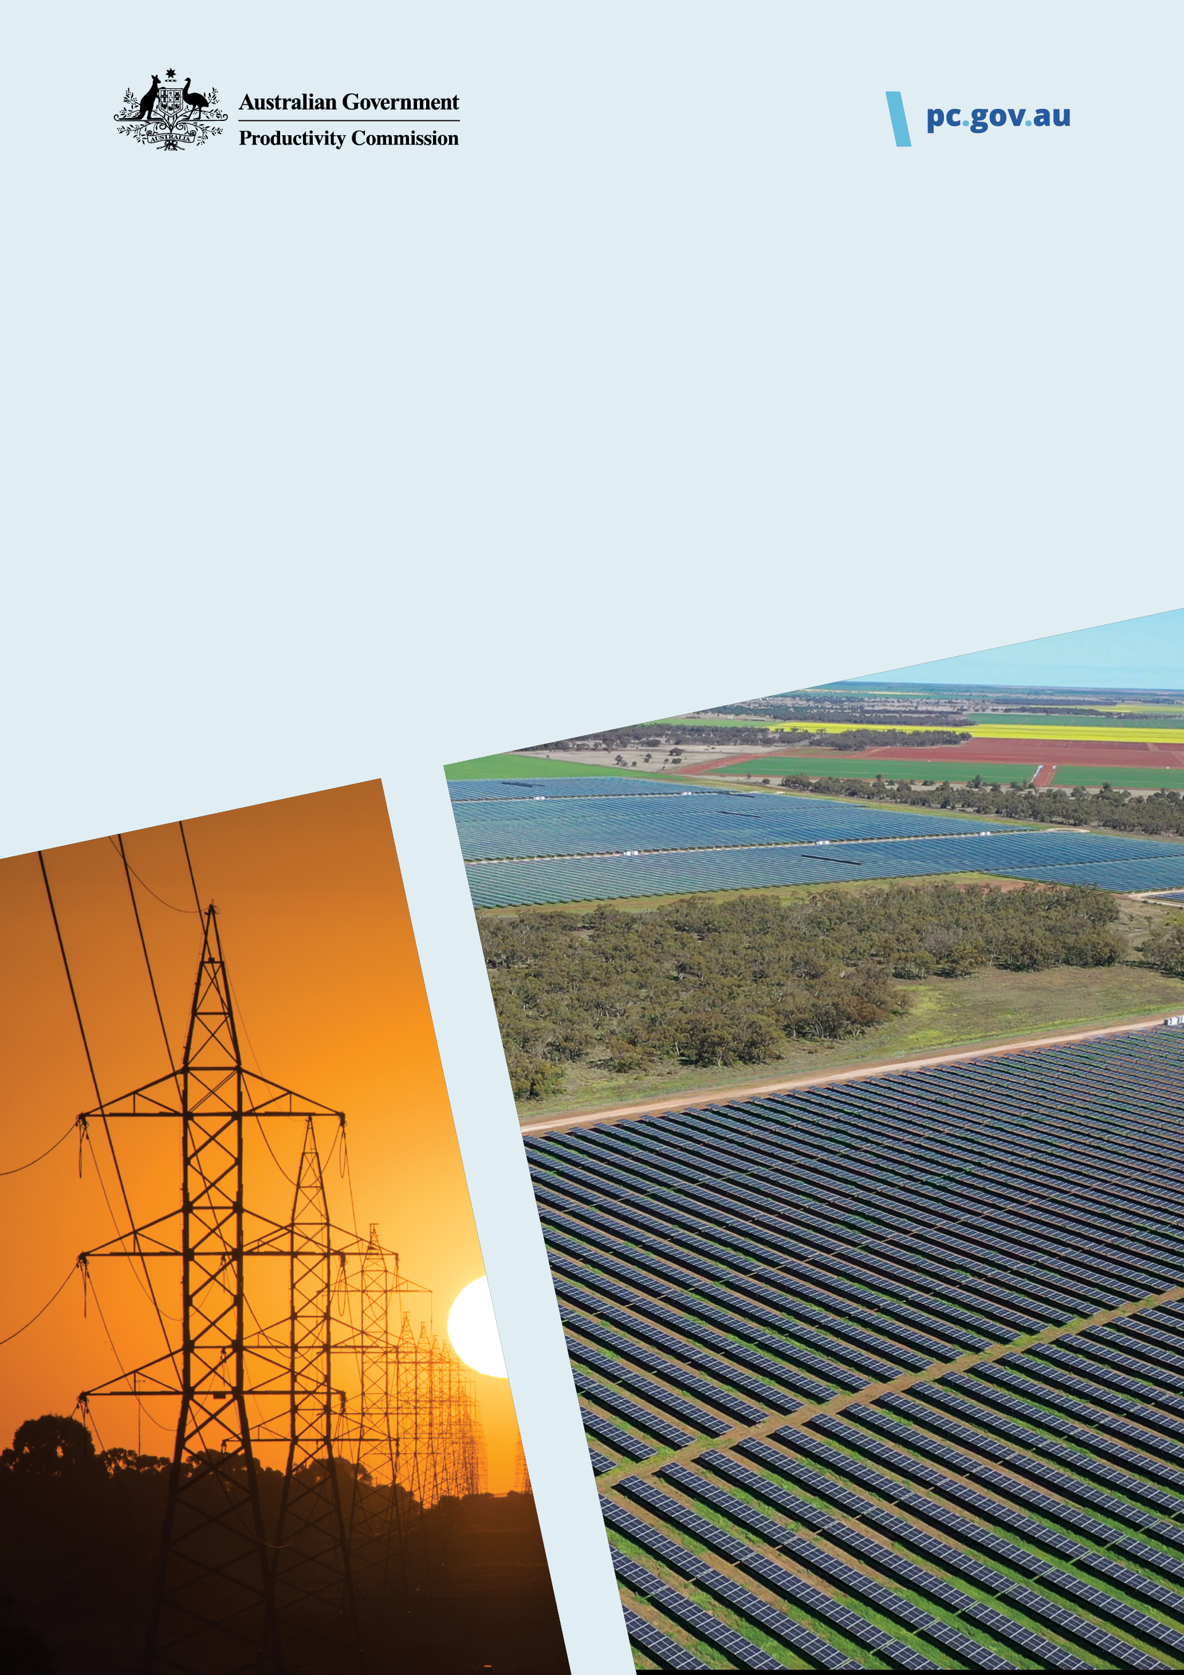

**Investing in cheaper, cleaner energy and the net zero transformation**

Interim report  
Executive summary

This is an interim report prepared for further public consultation and input. The PC will finalise its report after these processes have taken place.

|  |
| --- |
| The Productivity Commission acknowledges the Traditional Owners of  Country throughout Australia and their continuing connection to land,  waters and community. We pay our respects to their Cultures, Country and Elders past and present.  The Productivity Commission  The Productivity Commission (PC) is the Australian Government’s independent research and advisory body on a range of economic, social and environmental issues affecting the welfare of Australians. Its role, expressed most simply, is to help governments make better policies, in the long-term interest of the Australian community.  The PC’s independence is underpinned by an Act of Parliament. Its processes and outputs are open to public scrutiny and are driven by concern for the wellbeing of the community as a whole.  For more information, visit the PC’s website: www.pc.gov.au  © Commonwealth of Australia 2025  CC By logo  With the exception of the Commonwealth Coat of Arms and content supplied by third parties, this copyright work is licensed under a Creative Commons Attribution 4.0 International licence. In essence, you are free to copy, communicate and adapt the work, as long as you attribute the work to the PC (but not in any way that suggests the PC endorses you or your use) and abide by the other licence terms. The licence can be viewed at: https://creativecommons.org/licenses/by/4.0.  The terms under which the Coat of Arms can be used are detailed at: www.pmc.gov.au/government/commonwealth-coat-arms.  Wherever a third party holds copyright in this material the copyright remains with that party. Their permission may be required to use the material, please contact them directly.  An appropriate reference for this publication is: Productivity Commission 2025, *Investing in cheaper, cleaner energy and the net zero transformation*, Interim report, Canberra, August  Publication enquiries:  Phone 03 9653 2244 | Email publications@pc.gov.au |

|  |  |  |  |  |
| --- | --- | --- | --- | --- |
| Opportunity for comment  The Productivity Commission thanks all participants for their contribution to this inquiry and now seeks additional input for the final report.  You are invited to examine this interim report and comment on it by written submission to the PC, preferably in electronic format, by 15 September 2025.  Further information on how to provide a submission is included on the website: www.pc.gov.au/inquiries/current/net-zero  The PC will prepare the final report after further submissions have been received, and it will hold further discussions with participants.  Commissioners   |  |  | | --- | --- | | Barry Sterland | Commissioner | | Martin Stokie | Commissioner | |

Executive summary

**Reducing emissions from greenhouse gases is an important national priority.** It comes with costs, but these can be minimised with careful policy design, freeing up resources for more productive activities and enabling gains in productivity and living standards.

To achieve net zero at least cost, Australia needs consistent and comprehensive incentives to reduce emissions. Governments should fill policy gaps, remove overlaps and ensure incentives are neutral towards which technologies can achieve reductions, and in which states and territories. Priorities for action include:

* introducing enduring, broad‑based market settings in the electricity sector to reduce emissions after 2030
* expanding the Safeguard Mechanism to include more industrial facilities
* new, technology‑neutral policy settings to incentivise reductions in emissions from heavy vehicles.

The cost‑effectiveness of policies should be regularly assessed, and policy settings amended as needed to ensure they are consistent with an efficient emissions‑reduction pathway.

**It takes too long to develop energy infrastructure.** Faster approvals would reduce emissions, lower costs for developers, attract investment and make energy cheaper than otherwise – supporting productivity growth.

Governments can do much without compromising either the energy transition or the environment. Overdue reforms to national environmental laws – to introduce national environmental standards, facilitate regional planning, make offsetting more efficient and clarify engagement requirements – are a priority. The *Environment Protection and Biodiversity Conservation Act 1999* should also be changed to allow decision‑makers to consider the fact that a project is important to Australia’s clean energy transition.

Regulatory resources should be focused on assessing important energy projects. A well‑resourced strike team within the Department of Climate Change, Energy, the Environment and Water with strong clean energy capability should be dedicated to high‑priority national projects, and a Coordinator‑General should work within and across governments to break through roadblocks and keep approvals on track.

**Australia faces significant climate‑related risks regardless of future emissions reductions.** Over the longer term, boosting our resilience to climate perils has the potential to lower the costs of disaster recovery. Productivity benefits will also flow from a healthier population, and our quality of life will improve.

Housing warrants specific policy attention. Large organisations likely have strong incentives and capacity to invest in resilience, and some face obligations regarding disclosure of the risks they face and how they are addressing them. The Australian Government can support household action by leading the development of a publicly accessible database of all climate hazards, and an outcomes‑based resilience rating system for housing and guidance on how to act. All levels of government have an interest in making our housing more resilient. They should work together to agree on quantifiable goals for improving housing resilience over the coming decades, and targeted policies to achieve those goals.

To support economy‑wide adaptation, the Australian Government should legislate for the Climate Change Authority to take on responsibility for monitoring, evaluation and learning in adaptation policy.

Draft recommendations

Reducing the cost of meeting emissions targets

|  | Draft recommendation 1.1  Reducing emissions in the electricity sector after 2030 |
| --- | --- |
| Governments should prioritise introducing enduring, broad‑based market settings in the electricity sector beyond 2030. The settings should:   * create nationally consistent incentives for lowest‑cost clean energy, irrespective of generation technology or jurisdiction * embed investment incentives to ensure reliability and system security are maintained.   Governments should also phase out any jurisdictional‑ and technology‑specific incentives over time. | |
|  | |

|  | Draft recommendation 1.2  The Safeguard Mechanism should cover more industrial facilities and carbon leakage provisions should be improved |
| --- | --- |
| The Australian Government should lower the Safeguard Mechanism threshold so that it covers more industrial facilities. The Safeguard Mechanism review scheduled for 2026‑27 should determine the new threshold but favour broadening the scheme as much as possible. The review should also consider whether the lower threshold would introduce inefficiencies such as uneven coverage in some sectors, and whether it would be appropriate to phase in the inclusion of new facilities. If the review identifies no major countervailing considerations, reducing the threshold from 100,000 tonnes to 25,000 tonnes of carbon dioxide equivalent per year would be reasonable.  If the Australian Government introduces a border carbon adjustment, it should phase out trade‑exposed baseline‑adjusted status for Safeguard Mechanism facilities that would otherwise be exposed to competition from imports from countries without domestic policies to reduce emissions. | |
|  | |

|  | Draft recommendation 1.3  Introduce an emissions‑reduction incentive for heavy vehicles and phase‑out policy overlaps for light vehicles |
| --- | --- |
| The Australian Government should introduce a new emissions‑reduction incentive to cover heavy vehicles. The incentive should be as technology‑neutral as possible, meaning that it should create the same incentive to reduce emissions by switching from fossil fuels to electric vehicles, low‑carbon liquid fuels or any other method to reduce emissions.  Now that the Australian Government has implemented the New Vehicle Efficiency Standard, it should phase‑out the exemption of electric vehicles from the Fringe Benefits Tax, and state and territory governments should phase‑out the exemption of electric vehicles from vehicle stamp duty and registration discounts. | |
|  | |

|  | Draft recommendation 1.4  Apply frameworks to achieve emissions targets at least cost and improve transparency |
| --- | --- |
| The Australian, state and territory governments should improve the transparency of emissions‑reduction policies by consistently including estimates of their cost‑effectiveness in impact analyses. Those estimates should routinely be assessed against agreed national carbon values.  The Australian Government should:   * task an independent agency with relevant expertise with developing national carbon values. These values – estimates of the implied carbon prices needed to meet Australia’s emissions targets – should be used consistently as policy benchmarks across government and in regular reporting on the cost‑effectiveness of emissions‑reduction policies * design and evolve policy settings to be broadly aligned with these carbon values.   To support achieving net zero in 2050 at as low a cost as possible, the Australian Government should:   * develop a framework for extending emissions‑reduction incentives to new sectors. The costs associated with any new policies to reduce emissions in areas like agriculture and household gas should align with the target‑consistent carbon values * continue work to ensure ACCUs are high integrity and seek to integrate ACCUs into every national emissions‑reduction policy in the long term so hard‑to‑abate emitters face consistent incentives. | |
|  | |

Speeding up approvals for new energy infrastructure

|  | Draft recommendation 2.1  Reform national environment laws |
| --- | --- |
| The Australian Government should reform environment laws to expedite approvals for clean energy projects and better protect the environment. The reforms should:   * introduce national environmental standards * facilitate regional planning, particularly within renewable energy zones, with stricter statutory deadlines for assessing projects in ‘go zones’ * provide accessible, high‑quality information about the environment and past assessment decisions * make offsetting arrangements more efficient, such as by enabling developers to meet their offset obligations by contributing to an Australian Government offsets fund * set clear expectations about engagement with local communities and Aboriginal and Torres Strait Islander people. | |
|  | |

|  | Draft recommendation 2.2  Set up a specialist ‘strike team’ for priority projects |
| --- | --- |
| The Department of Climate Change, Energy, the Environment and Water should set up a strike team focused on priority renewable energy projects. The strike team should:   * be adequately resourced to ensure all priority projects can be efficiently assessed under the Environment Protection and Biodiversity Conservation Act 1999 (Cth) * integrate environmental and clean energy expertise * be issued with clear expectations, tools and escalation procedures * work with state and territory counterparts to reduce duplication and share information and expertise. | |
|  | |

|  | Draft recommendation 2.3  Establish a Coordinator‑General for priority projects |
| --- | --- |
| The Australian Government should establish an independent Clean Energy Coordinator‑General for priority renewable energy projects. The Coordinator‑General should:   * track the progress of all approvals needed to start construction * investigate and help resolve delays * report on progress to the Energy and Climate Change Ministerial Council * provide advice based on objective criteria about the composition of the National Renewable Energy Priority List. | |
|  | |

|  | Draft recommendation 2.4  Consider the energy transition in approval decisions |
| --- | --- |
| The *Environment Protection and Biodiversity Conservation Act 1999* (Cth) should be amended to require the minister to consider the needs of the energy transition when deciding whether to approve an energy project that will have a significant impact on a matter of national environmental significance. | |
|  | |

Addressing barriers to private investment in adaptation

|  | Draft recommendation 3.1  Set up a climate risk information database covering all climate hazards |
| --- | --- |
| The Australian Government should coordinate with relevant federal, state and territory organisations to support development of a central climate-risk information database to cover all climate hazards in different parts of Australia. The database should enable the public, builders, developers, insurers, government planners and policymakers to get granular and accessible climate risk information. | |
|  | |

|  | Draft recommendation 3.2  Develop a nationally consistent climate resilience rating system for housing |
| --- | --- |
| The Australian Government should lead development of a nationally consistent climate resilience star rating system for housing.   * The rating system should be outcome-based, with ratings reflecting potential damages from climate hazards. Ratings should account for location-specific climate hazards and the characteristics of a property. * The rating system should be complemented by supporting material so that households, builders and insurers can easily identify upgrades that would improve a property’s resilience. * Development of the rating system and supporting material should build on work undertaken in this area and learn lessons from the development of the world-leading Nationwide House Energy Rating Scheme (NatHERS). | |
|  | |

|  | Draft recommendation 3.3  Governments should agree on a series of actions to improve housing resilience over time |
| --- | --- |
| The Australian Government should lead work with the states, territories and local governments to agree on a series of actions that will improve the resilience of our housing stock over the coming decades. Older housing in high-risk areas will need the greatest focus.   * This work should be anchored around time-specific and outcome-based goals for household-level resilience, taking into account climate damages and the effects of heat. The goals will form the basis for a shared understanding of how agreed actions will improve resilience. * Actions should only be taken where benefits exceed costs based on high quality impact assessments. They should be staged in line with the expected pace of climate change and coordinated with public investment to achieve measurable improvements in precinct resilience. | |
|  | |

|  | Draft recommendation 3.4  Give the Climate Change Authority responsibility for monitoring, evaluation and learning regarding adaptation policy |
| --- | --- |
| The Australian Government should legislate for the Climate Change Authority to take responsibility for monitoring, evaluating and learning to inform governments and the public about progress in adapting to climate change, and whether policies are effective. Progress reports should be published every two years and include recommendations about how to improve adaptation policy. | |
|  | |