PROBLEMATISATIONS OF SUICIDE WITHIN AUSTRALIAN HEALTH POLICY – A WPR ANALYSIS OF THE FIFTH NATION MENTAL HEALTH AND SUICIDE PREVENTION PLAN

by

Nicholas Hensing

Supervisor: Chris Horsell

A Research Project submitted in partial fulfilment of the requirements for the

Bachelor of Social Work (Honours)

in

UniSA: Justice & Society

University of South Australia.

The University of South Australia,

St Bernard’s Road

Magill SA 5072

19/06/2024

# (i) Acknowledgements

I would like to acknowledge that this research was written and conducted on the lands of the Kaurna people.

I would like to thank my supervisor Chris Horsell for being an amazing supervisor and for his continued support and guidance throughout every step of this project.

I would like to thank Cassandra for being an incredible best friend, for her constant support throughout through the good, bad and weird, and for always helping me be sure of myself.

I would like to thank Michele Jarldorn for her amazing work as the social work honours coordinator, and for being a source of support throughout this research.

I would like to thank Cenz Lancione for helping me realise my strong interest in policy and introducing me to the WPR approach.

I would like to thank both Mick Piotto and Alison Hunter for their support throughout the placement completed alongside this research and allowing me to debrief about the honours project during our supervision sessions and classes.

I would like to thank my mother, father and brother for their consistent support at home allowing me to focus so closely on the project.

I would like to thank my friends Cameron, James, Liam, Melanie, Josh, Charlie, Damien and David for their support while completing this research and listening to be talk endlessly about this project.

I would like to thank my cats Jack, Minette and Gingin for being the perfect companion animals, and helping me get through each day.

I would lastly like to thank all my friends from the Adelaide Pokemon TCG community for giving me a space to relax away from the honours project.

# (ii) Abstract

Suicide as a global social issue has been rising consistently each year, reflected by the increasing number of attempts and deaths by suicide (WHO, 2018, 2023). Australia is no exception to this. Concerns regarding the increased prevalence of suicidality in the Australian context have been recognised in the development of the *5th National Mental Health and Suicide Prevention Plan* (2017 [NMHSPP]). This thesis is positioned within a tradition of critical social analysis underpinned by the view that proposed policy solutions aimed to solve social problems construct or problematises social issues in specific ways. From this view, there is a specific problematisation that shapes how suicide is viewed and discussed. Bacchi’s ‘What’s the Problem Represented to be’ (WPR) approach was chosen due to the effective utilisation of problematisation analysis in other social work suicide prevention policy analyses. The medical model continues to hold dominance over how suicide is addressed, with many aspects working to place the problem of suicide onto the individual. This effectively ignores the contextual factors which can contribute to suicide. Alongside this, there are challenges within the consultation process which often leaves some cohorts unheard. These factors all suggest that the action of suicide is viewed as the problem, not the context surrounding these suicides.

# (iii) Declaration of original work

Research Project Title: Problematisations of suicide within Australian health policy – A WPR analysis of the Fifth National Mental Health and Suicide Prevention Plan.

Candidate's name: Nicholas Hensing

I declare that this Research Project is the result of my own research, that it does not incorporate without acknowledgement any materials previously published, written or produced by another person except where due reference is made in the text.

Sign: NHensing

Date: 19/06/2024

Table of Contents

(i) Acknowledgements 1

(ii) Abstract 2

(iii) Declaration of original work 3

Part I: Social Work Research Project 1 6

How is the Problem of Suicide Represented within the 5th National Mental Health & Suicide Prevention Plan: Enhanced Proposal 6

Background statement 6

Policy responses to suicide as a social issue 7

Mental health and suicide 10

Neoliberal influence on policy construction 11

Medicalisation within mental health and suicide prevention policy 13

Responsibilisation within mental health and suicide prevention policy 18

Research question 22

Research aims 23

Methodology 24

The WPR Approach as a theoretical framework 26

Attached Policies 32

Researcher positioning and ethics 34

Part II: Social Work Research Project 2 35

Problematisations of suicide within Australian health policy – A WPR analysis of the Fifth National Mental Health and Suicide Prevention Plan. 35

Neoliberal influence on policy construction 35

Medicalisation within mental health and suicide prevention policy 38

Responsibilisation within mental health and suicide prevention policy 39

Research question 40

Methodology 41

The WPR Approach as a theoretical framework 43

Attached Policies 47

What is the problem of suicide represented to be within the 5th NMHSPP? 48

What presuppositions or assumptions underpin this representation of suicide? 56

How has this representation of suicide come about? 59

Where are the silences in the NMHSPP’s representation of suicide? 61

Implications for social work 67

Areas for further research 68

Conclusion 69

Reference List 70

Appendices 85

Appendix A 85

Appendix B 86

Appendix C 86

Appendix E 87

Appendix F 87

Appendix G 88

Appendix H 89

Appendix I 91

Appendix J 97

Appendix K 101

# Part I: Social Work Research Project 1

## How is the Problem of Suicide Represented within the 5th National Mental Health & Suicide Prevention Plan: Enhanced Proposal

### Background statement

Suicidality as a global social issue has been rising consistently each year, reflected by the increasing number of attempts and completions of suicide (WHO, 2018, 2023). Australia is no exception to this. Prevalent social issues often warrant a policy response, with suicide being addressed in the Australian context through the *5th National Mental Health and Suicide Prevention Plan* (2017 [NMHSPP]). However, policy responses construct specific representations of social issues through their plans to address that issue. Resulting from this, suicide has a specific representation (or problematisation) that shapes how it is viewed and discussed. While not inherently problematic, this can become so when government policy responses ignore core aspects that contribute to the prevalence of suicide.

Bacchi’s ‘What’s the Problem Represented to be’ (WPR) approach has been chosen as a guiding framework to study these problematisations in three key areas. The WPR approach was chosen due to the effective utilisation of this framework in other social work policy analyses. From a personal standpoint, I also connect with this framework, due to the focus on highlighting hidden and ignored representations.

### Policy responses to suicide as a social issue

The National Suicide Prevention Strategy was created by the World Health Organisation ([WHO], 2018), recognising suicide as an important and significant global issue. The National Suicide Prevention Strategy gives direction to nations on approaching suicide prevention and intends to promote consistency across nations (WHO, 2018). Suicide within an Australian context impacts a significant proportion of the population, highlighted through the increasing number of suicide attempts, completed suicides, or knowing someone with these experiences (See Appendix A) (Australian Institute of Health and Welfare [AIHW], 2022a; Bourke, 2003). The Fifth National Mental Health & Suicide Prevention Plan (NMHSPP) was developed based on the WHO’s advice to address the complex mental health and suicide-related challenges Australians face (AIHW, 2023; Department of Health and Aged Care [DHAC], 2017, 2021). In Australia, suicide prevention has become a policy priority reflected in the creation and implementation of the NMHSPP (DHAC, 2017, 2021). The NMHSPP provides a template for each Australian state to create state-based suicide prevention plans providing flexibility for the context of each state’s priority (Australian Government, 2023; SA Health, 2017; Northern Territory Department of Health [NTDH], 2018).

The NMHSPP is informed by data collected about suicide, suicide attempts, and deaths by suicide by the National Mental Health Commission (NMHC), a nationwide commission established in 2012 tasked with gathering evidence and advice on the effectiveness of current mental health policies and services (AIHW, 2023; DHAC, 2017). The NMHC argues the importance of taking a holistic view of mental health, with focus being on mental wellbeing and its importance to the individual, their family and community (Australian Government, 2023; Pierce et al., 2014). The NMHC gives space to environmental contexts, discussing the importance of education, housing and employment as key factors contributing to improved mental health (Australian Government, 2023; Khoury et al., 2023; National Centre for Epidemiology and Population Health [NCEPH] 2011). As the peak informing body to the NMHSPP, the NMHC is also tasked with using information gathered during consultations to inform the creation of mental health policies and plans within Australia (Australian Government, 2023; DHAC, 2021). The creation of the NMHSPP is a recognition by the Australian Government of the increase in both suicides and attempted suicides within Australia, and acknowledgement that suicide is a significant issue within Australia (AIHW, 2023; DHAC, 2017; Whiteford et al., 2002).

Authors of both academic and grey literature understand the importance of social policy responses to suicide as a social issue (DHAC, 2017; Fitzpatrick, 2018; SA Health, 2017). Fitzpatrick (2018) highlights government policy responses provide a framework to address suicide (Bell, 2006; Pierce et al., 2014). Government literature supports this by emphasising that a coordinated response to suicide prevention is necessary, due to the severity of suicide (DHAC 2017; Fitzpatrick, 2018; SA Health, 2017). Contemporary suicide prevention policy across Australia currently situates suicide and the subsequent prevention as primarily a mental health concern, leading to prevention policy addressing mental ill health foremost (DHAC, 2017). As the NMHSPP is the key informing document for mental health and suicide prevention policy within Australia, this text will be the focus of this research.

### Mental health and suicide

While suicide prevention was discussed within the previous 4 plans, the 5th NMHSPP is the first time suicide prevention has become a namesake and core part of the plan (DHAC, 2017). This essentially addresses suicide prevention and other mental health issues together, linking these issues together (DHAC, 2017, 2021). The decision to address suicide within the NMHSPP can be indicative of suicide being viewed as primarily a mental health issue (DHAC, 2017; Marzetti et al., 2022).

Within the NMHSPP, it was reported that 89% of Australians know someone who has undertaken a suicide attempt, and a further 85% who have completed a suicide (DHAC, 2017, 2021). Rates of suicide have been statistically recorded since 1907, with age-standardised rates falling consistently between 10 to 15 per 100,000 people, sparsely falling outside of that range (AIHW, 2022). Over the past 20 years, suicide rates have been slowly increasing; it is estimated that around 3000 people per year have committed suicide each year since 2018, with the past 5 years having over 3000 people commit suicide within Australia each year (Australian Bureau of Statistics [ABS], 2021; DHAC, 2021). Statistics surrounding deaths by suicide are collected by the NMHC, with this data being closely monitored to help develop future mental health and suicide prevention programs and plans (ABS, 2021; DHAC, 2021).

### Neoliberal influence on policy construction

One of the most prominent underlying themes in the literature has been the impact of neoliberal thinking on mental health and suicide prevention policies (Oaten et al., 2022; Oster et al., 2023). Neoliberalism has been a dominant ideological influence in Australia since the 1990s and has influenced policy development within Australia (Cain, 2018). Conceptually neoliberalism has been contested, with debates surrounding the level of influence this ideology has within Australia (Cain, 2018; Peck, 2012; Weller & O’Neill, 2014). The general consensus however is that ideologically, neoliberalism places focus on individual responsibility and reducing government spending (Azevedo et al., 2019; Peck, 2012). Government spending reduction is used to transfer the allocation of resources and responsibility to the market, with this position reflected in social and public policies (Azevedo et al., 2019; Peck, 2012). Teghtsoonian (2009) argues that neoliberal thought is responsible for mental illness and suicidality being situated inside the individual, which extends to include suicidality (Oaten et al., 2022). In part, this can be attributed to the medicalisation of medicalisation, as suicide has been inseparably linked with mental health and illness by this process (Cui et al., 2019; Oaten et al., 2022; Teghtsoonian, 2009). This focus on individual responsibility ignores both contextual factors and systemic issues faced by an individual (Cain, 2018; Eskin & Baydar, 2022; Spolander et al., 2014).

Social work literature highlights how social determinants of health are not effectively addressed within neoliberal-influenced policies and programs (Shand et al., 2020; Oaten et al., 2022; Wang & Wu, 2021). The social determinants of health include the impact of social and economic factors on both the mental and physical health of an individual (AIHW, 2022b; Wang & Wu, 2021; WHO 2017). These factors relate to basic human needs including housing, safety, and food security (Friel, 2021; WHO, 2017). The neoliberal focus on individual responsibility however ignores the critical social determinants of health relating to employment, formal education, and income (AIHW, 2022b; Fitzpatrick, 2018; Friel, 2021). Income and employment are the core social determinants that impact access to other determinants (Australian Council of Social Service [ACOSS], 2022; Friel, 2021; Kerr et al., 2017). Without adequate income, an individual may experience immense struggle accessing housing, food, and education, in turn creating an intolerable living environment (AIHW 2018; WHO, 2017). Fitzpatrick (2018) argues that these social determinants of health are inadequately addressed throughout contemporary mental health policy as a way to increase the responsibility individuals must take for their own mental health (Juhlia et al., 2016; Kerr et al., 2017). Throughout the literature, this concept has been labelled as responsibilisation (Juhlia et al., 2016; Oaten et al., 2022).

### Medicalisation within mental health and suicide prevention policy

Mental health policy in Australia has been subject to increasing processes of medicalisation (Aho, 2008; Cui et al., 2019). Suicide is not exempt from the process of medicalisation and is often represented as a problem of mental illness (Button, 2016; Gray, 2016; Wray, 2011). Numerous studies have found that suicidality is most often seen as a symptom of mental illness, as exampled in the work of Jaworski (2014) identifying that suicide is discussed as the most severe symptom of depression within the DSM-V (Gray, 2016; Obegi, 2021; Sanati, 2009). Gray (2016) argues this inclusion within the DSM-V restricts how suicide can be conceptualised (Jaworski, 2014; Tierney, 2010). Pridmore (2011) highlights that psychological perspectives on suicide remain the dominant understanding and while in recent years some psychological perspectives have taken a more holistic look at suicide, the focus still remains on the individual (Bernard et al., 2021; Chatard & Selimbegovic, 2011; Kitanaka, 2008). More holistic perspectives of why suicide occurs are necessary, as they contextualise suicidality within a broader framework (Gray, 2016; Ho, 2014; Ventegodt & Merrick, 2005). This separation allows questioning of why an individual is experiencing suicidality, rather than how can their suicidality be ‘fixed’ efficiently (Ho, 2014; Ventegodt & Merrick, 2005). The lack of holistic understanding is problematic when suicide is subject to medicalisation as alternative perspectives on suicide lose visibility, constructing suicide solely as a result of mental illness (Chatard & Selimbegovic, 2011; Foucault, 2003; Pridmore, 2011; Oaten et al., 2022).

Cui et al. (2019) using the WPR approach, argue that mental health policies in Hong Kong and New South Wales construct the concept of a mentally ill individual, through their respective mental health policies. Within Hong Kong, mental health policy has a deficit focus, assuming that mental illness is a disease, which is closely linked with medical perspectives (Cui et al., 2019; Foucault, 2003; Oute et al., 2022). Throughout history, disease has been linked solely with physical ill health, which has always been addressed by the medical sector (Cui et al., 2019; Foucault, 2003; Oaten et al., 2022). When mental illness is linked with disease it leads to a similarly medicalised response focused on curing an individual’s mental illness (Aho, 2008; Cui et al., 2019; Henderson & Fuller, 2011). Cui et al. (2019) highlighted that this disease model has been met with a level of resistance by Australian service users, resulting in a focus on trauma as a cause of mental illness. Trauma-informed approaches while more holistic than the medical approach, still have the individual as the primary focus ignoring environmental context and placing the individual as the sole focus (Button, 2016; Cui et al., 2019; Oute et al., 2022). Placing mental illness inside the individual, and viewing this from a medical-deficit lens is a core feature seen throughout many contemporary mental health services (Aho, 2008; Cui et al., 2019; Oute et al., 2022).

Mental health services focus on identifying individual deficits within their service users, which can be demonstrated through the usage of the biopsychosocial assessment (Aho, 2008). Oute et al. (2022) conclude in their WPR analysis of dual diagnoses (See Appendix B) that biopsychosocial assessments focusing on individual deficits worked to situate both disability and mental illness inside the individual. This is a representation underpinned by medicalised discourse assuming that mental wellness can be measured like physical health (Oster et al., 2023; Oute et al., 2022; Teghtsoonian, 2009). This representation makes the social determinants of health and collaborative services unquestioned within the individuals struggles (Friel et al., 2021; Oute et al., 2022; Oster et al., 2023). The analysis of mental health service provision provides background into both how mental health challenges are addressed and shows how the WPR approach is an appropriate research method for this area (Cui et al., 2019, Oster et al., 2023; Oute et al., 2022).

Through the process of medicalisation, suicide has become an area mental health services prioritise (Marzetti et al., 2022; Oaten et al., 2022). Marzetti et al. (2022) highlight the way this medicalised view of suicide became dominant, a point shared within previous work addressing the social construction of suicide (Foucault, 2003; Pridmore, 2011). Foucault (2003) pushed back against the medicalisation of suicide, arguing suicide is a form of resistance against oppressive powers, rather than a medical issue, which he highlighted as the dominant representation (Pridmore, 2011). Oaten et al. (2022) and Marzetti et al. (2022) used the WPR approach to investigate key elements and goals present in the UK suicide prevention policies. Following this Marzetti et al. (2022) analysed how these goals came about by exploring the underlying wider influences that shape the policy directions. Both authors concluded that a medicalised lens was present throughout UK suicide prevention documents, with the core policy focus on curing or fixing people’s suicidality. This dominant perspective of suicide existing as a mental health problem becomes problematic when other complex factors that impact suicidality are ignored. Suicide itself is too broad to be represented from one perspective, highlighting the need for this medical perspective to be challenged (Francavilla, 2020; Marzetti et al., 2022; Pridmore, 2011).

While the medical focus has strong implications for policy direction, the implications for direct practice are equally as significant. Alt2su has recognised the increased medical focus on direct suicide interventions, and work towards alternate ways of addressing suicidality (Alt2su, 2023; Rhodanthe et al., 2019). The core assumption at the centre of Alt2su’s practice is challenging the immediate assumption that suicidal thoughts are always connected to poor mental health (Alt2su, 2023). While not stating there is no connection between suicidality and mental health, they challenge the immediate assumption that suicide always stems from mental ill health (Jerzmanowska et al., 2022; Rhodanthe et al., 2019). This works to normalise the experience of suicidality, upholding this as a human experience, rather than an alarming medical experience (Jerzmanowska et al., 2022; Rhodanthe et al., 2019). Alt2su de-pathologises suicide through peer support connections, by running support groups and ensuring their space remains non-clinical (Alt2su, 2023; Jerzmanowska et al., 2022). In practice, this looks like a clear, supported discussion of members experiences without any threats of unwanted interventions from outcome-focused services (Alt2su, 2023; Jerzmanowska et al., 2022). This holds significant value for directly pushing back against the medicalisation of suicide on an individual level, with this having direct implications for individuals’ lives.

### Responsibilisation within mental health and suicide prevention policy

The medicalisation of mental health parallels the emergence of responsibilisation, a process that occurs when the risks people are exposed to are perceived as individual choice, leading to individual management of those risks (Elden, 2007; Juhlia et al., 2016). However, these same risks were once managed by the government and community who would cooperate in addressing contextual factors that allowed these risks to exist (Elden, 2007; Juhlia et al., 2016). A responsibilisation agenda within the mental health space is evident in research undertaken by Baum et al. (2016), who argue responsibilisation occurs when a governments response to poor mental health consists of ways to help an individual manage their own mental health (McPherson & Oute, 2021). This is seen throughout contemporary mental health policy focusing on increasing individual’s capacity to rely on their own resources and privatising the public health sector (Baum et al., 2016). This leads to the assumption that everyone has reliable support in their lives, and the ability to access private-sector support services (Parker-Harris et al., 2012; Prince et al., 2006; Sinclair et al., 2022).

Responsibilisation is evident throughout the healthcare sector in many different ways (Juhlia et al., 2016; Rahman et al., 2014; Oaten et al., 2022). The inverse care law posits that individuals with the highest healthcare needs are the least likely to receive healthcare (Hart, 1971; Rahman et al., 2014). The inverse care law suggests the responsibility of accessing healthcare is placed with the individual once again, including any barriers to healthcare (Rahman et al., 2014; Woolfenden et al., 2020). This is often the case for people living in rural and remote areas, where many schemes to increase service accessibility make it easier for people to come to a specific service, rather than a service going where the needs are (Anderson et al., 2016; Kavanagh et al., 2023). Focus is often placed upon increased accessibility due to the fiscal viability, however, this is less effective at reaching the individuals who need help (Anderson et al., 2016; Kavanagh et al., 2023). Hjelmeland (2016) suggests that government responses should be supported by strong, government-run services, and plans to reach those that have trouble accessing support. This would acknowledge the role government services play within the mental health space (Howell, 2015; McPherson & Oute, 2021; Prince et al., 2006).

Oaten et al. (2022) using the WPR approach found that suicide prevention as it currently exists has a core focus on stopping suicides through risk management practices and conceptualising suicidality as an individual deficit. Their findings show that suicide prevention has become increasingly informed by the discourse of responsibilisation (Oaten et al., 2022). This is demonstrated by increased data surveillance of which groups experience higher rates of suicidality to manage risk in these areas more effectively (Baril, 2020; Bell, 2006). The WHO (2018) discuss data surveillance as a necessary aspect of any effective suicide prevention plan, to inform further predictions on which population cohorts are at risk of suicide (DHAC 2017; NTDH, 2018; SA Health, 2017). The emphasis on data surveillance is argued to be strongly linked with the risk management approach that both mental health services and prevention policy focus on (Oaten et al., 2022; Wray et al., 2011).

Across many articles, risk reduction was a common focus with authors highlighting the underpinning rationale of risk is helping an individual become more responsible, self-managed, and mentally healthy (Henderson & Fuller, 2011; Gambino, 2019; Oaten et al., 2022; Oute et al., 2022). The rationale stems from the assumption that people can be ‘fixed’, and this needs to be achieved as efficiently as possible to lessen the extent they have to rely on services (Gambino, 2019; Oute et al., 2022). The assumption highlights the hegemony of neoliberal rationalities informing the focus on self-governance (Henderson & Fuller, 2011; Oster et al., 2023).

Risk management approaches assume that suicide is a problem to be solved, leading prevention policy to focus on solving suicide as a mental health problem (Hjelmeland, 2016; Marzetti et al., 2022; Oaten et al., 2022). Conceptually, risk management is concerned with how to minimise and mitigate risk, and while this may seem like a neutral process, Ceyhan (2012) suggests that managing risk is a significant driver behind neoliberal social policy (Parker-Harris et al., 2012; Schrecker, 2016). Neoliberal ideologies have allowed risk management to become central to mental health policy, shifting responsibility from government, services, and organisations back onto the individual for their experiences of distress (Ceyhan, 2012; Eskin & Baydar, 2022; McNamara, 2012; Stalker, 2003). This ultimately works to absolve the government of responsibility when working with service users (Ceyhan, 2012; Eskin & Baydar, 2022; Oaten et al., 2022). Shin et al. (2021) conclude that risk management practices in their current state place focus on the action of suicide itself, framing suicide as a problem of individual choice (Bell, 2006; Hjelmeland, 2016).

### Research question

Using the WPR approach to examine the problematisation of suicide is a relatively new development. Despite extensive searching in social work and policy journals, only three articles were found, all published between 2020-2022 (Francavilla, 2020; Marzetti et al., 2022; Oaten et al., 2022). Aside from these three articles, the WPR approach has not been utilised within the field of suicide (Francavilla, 2020; Marzetti et al., 2022; Oaten et al., 2022). Specifically, the WPR approach has not been used to examine Australian suicide prevention policy, providing the opportunity to ask ‘How is the problem of suicide represented within the 5th National Mental Health and Suicide Prevention Plan?’. This policy was chosen as it is currently the key informing document for all Australian prevention policies. This research fills a gap in the literature by undertaking critical examinations of representations of suicide within this prevention plan, and as a result, the wider Australian context.

### Research aims

To answer the research question, three specific aims have been chosen.

* Analyse how the problem of suicide is represented within the NMHSPP itself, including analysis of attached policies that the NMHSPP has influenced.
* Examine assumptions within the policy environment that allowed this representation to become the dominant one.
* Investigate the consultation process, seeing which key groups were not consulted. This will also allow investigation into the non-dominant representations of suicide.

The outcome of this study is to provide a critical analysis of the NMHSPP, by highlighting alternative ways of viewing suicide that the policy does not promote. This outcome will highlight the dominant and non-dominant discourses that have influenced the direction of the plan. If possible, this thesis may be used as a submission during the creation of the 6th National Mental Health & Suicide Prevention Plan (AASW, 2021). This will contribute to the overall knowledge base of critical suicidology. For social work, this works as both an advocacy piece for future NMHSPPs and for highlighting the necessity of a social work perspective in the policy space.

### Methodology

The research method chosen for this study is a policy discourse analysis, examining the problematisation of suicide within the 5th NMHSPP. This specific document provides the main framework which other government initiatives use to guide the development of further suicide prevention strategies (DHAC, 2017, 2021). Therefore, the 5th NMHSPP plays a significant role in the social construction of suicide in an Australian context (Fitzpatrick, 2022).

Poststructuralism as an analysis framework questions structures by examining language discourse through how dominant structures uphold their perspectives as truth (Baring, 2015). Resulting from this, other perspectives of issues lose visibility (Baring, 2015; Jones et al., 2018). As governments hold power over language and discourse surrounding social issues, their policy response creates a particular representation of that issue (Bacchi, 2016; Bacchi & Goodwin, 2016). Poststructuralist analysis is appropriate for this research question, facilitating interrogation of the language used to construct and uphold the current representation of suicide (Bacchi & Goodwin, 2016).

Alongside poststructuralism, this analysis will also be informed by a social constructivist lens. Social constructionist analysis focuses on how concepts are viewed by societies dominant standpoint (Burr & Dick, 2017). To gather a nuanced understanding of how suicide is represented in the NMHSPP, it is necessary to examine what underlying ideologies shape the construction of both suicide and suicide prevention (Pierce, 2014). Applying a social constructivist lens will assist in analysing how suicide and suicide prevention are constructed by Australian society (Pierce, 2014; Burr & Dick, 2017). This will also allow attention to be given to alternative social constructions of suicide, by analysing how the dominant construction takes attention away from the non-dominant constructions (Bacchi, 2016; Pierce, 2014).

### The WPR Approach as a theoretical framework

The WPR approach used in this thesis is a poststructuralist policy analysis framework, arguing that policies themselves create the problem, through the way they are addressed (Bacchi, 2016, p.2). Bacchi’s (2012, p.21) ‘What’s the Problem Represented to be’ (WPR) approach provides a framework for policy analysis by questioning 6 key areas about a specific policy or policy proposal (See Appendix C). All 6 questions will be utilised, however, greater emphasis will be placed on questions 1, 2 and 4 (See Appendix D). This is due to their contribution to answering the overall research question. Questions 3, 5 and 6 (See Appendix E) will be discussed briefly as they contribute less to answering the aims of this analysis.

Question 1 in the context of this research asks ‘What is the problem of suicide represented to be within the 5th NMHSPP?’. To effectively answer the question of suicide representation, four key areas have been chosen for examination. The first aspect is the linking of mental health and suicide, questioning why these issues are addressed in the same policy document and how this contributes to the dominant representation of suicide (Bacchi, 2016, p.3). The second section examines the underlying 11 elements of suicide prevention (See Appendix F) which inform the suicide prevention strategy (DHAC, 2017). Examination of the 11 elements will contribute to understanding the ideological influences underpinning the plan and how the government has constructed suicide as a particular type of social problem (Bacchi, 2016, p.10). The third key area explores how the government measures change, and their goals for this plan (See Appendix G). Focusing on the government’s desired outcomes highlights which aspects of suicide the government is most concerned about (Bacchi, 2016, p.10). The representation being upheld within these goals and the rationale they stem from ultimately construct how the issue of suicide exists in Australia (Bacchi, 2016, pp.5-7; Marzetti et al., 2022). Finally, the role of a proposed suicide prevention subcommittee within the Mental Health Drug and Alcohol Principal Committee (MHDAPC) (See Appendix H) will also be examined (Bacchi, 2016, p.11). This subcommittee has a direct impact on service provision with people experiencing suicidality, meaning it is necessary to explore how they propose suicidality is addressed (DHAC, 2017; Bacchi & Goodwin, 2016, pp.20-21). Furthermore, examining the subcommittee’s allocation of funds provides tangible evidence of both government suicide prevention priorities (Bacchi & Goodwin, 2016, p.20, 25).

Question 2 asks ‘What presuppositions or assumptions underpin this representation of suicide?’. This question will be used to examine the ideologies and discourses that facilitate this specific representation of suicide (Bacchi, 2012, p.22). As highlighted in the background section, the discourse of responsibilisation and the employment of a medical model underpin how suicide prevention is addressed (Francavilla, 2020; Marzetti et al., 2022; Oaten et al., 2022). Furthermore, the wider ideological influences driving these policies will also be examined (Bacchi, 2012, p.22; Bacchi & Bonham, 2014, p.177). Previously highlighted in this paper is the dominance of neoliberalism throughout Australian health policy, which suggests neoliberalism will be the main ideology facing scrutinisation (Cain, 2018; Cui et al., 2019; Henderson & Fuller, 2011). Interrogating these underlying ideological influences is necessary because the existence of specific problematisations is promoted when they align with the ideological narrative of policy makers (Bacchi & Bonham, 2014, p.177; Bacchi & Goodwin, 2016, p.25). These problem representations place the population into a binary, usually consisting of those with versus those without (Bacchi & Goodwin, 2016, p.21; Riemann, 2023, p.156). Furthermore, this binary can bring attention to how individuals experiencing suicidality are viewed by the government.

Question 4 asks ‘Where are the silences in the NMHSPP’s representation of suicide?’. Within the context of this analysis, this means examining both who has not been consulted and what aspects of suicidality are left unproblematised in the policy (Bacchi, 2012, p.22). Social work research focuses on giving voice to those who historically and currently are not listened to, highlighting these chronically undervalued perspectives (AASW, 2020, p.7; Francavilla, 2020). Given this, this section will focus on who has not been consulted through the development of the NMHSPP. Highlighting underrepresented voices is necessary as the voices of those oppressed are often the voices of those who experience higher rates of suicidality, meaning their contributions should be sought out for policy development (AASW, 2020, p.7; Bacchi, 2012, p.22; Martin, 2000). When this does not happen, it is essentially another policy imposed onto a population cohort that likely misses key contextual issues. The Australian context of this research provides an important avenue to explore, being the consultation of First Nations Australia who have historically been silenced and undervalued (Adelson, 2005; Elliott-Farrelly, 2004; Silburn, et al., 2014; Tatz, 2005). An additional area of analysis includes the perspectives of front-line working professionals within the area of suicide prevention, due to their vast wealth of knowledge and experience (Anders, 2021; Singh et al., 2022). Ultimately, the consultation process and its accessibility will be examined as to whether it effectively captures the voices of those contributing.

Examining unproblematised aspects of the representation of suicide within the NMHSPP will be a significant area of focus within the analysis. The analysis of the dominant representation of suicide will highlight what is left unproblematised in the NMHSPP. Investigation of what is left unproblematised will occur by identifying what is not said within the NMHSPP, and cross-examining this with stakeholder discussions (Bacchi, 2016, pp.5-6; Bacchi & Goodwin, 2016, p.65). Analysis of the unproblematised aspects will further inform discussion regarding alternatives to viewing the problem or suicide (Bacchi & Bonham, 2014, p.174). Having a clear understanding of both the dominant representation and unproblematised aspects of suicide, allows for a clear picture of what the NMHSPP may acknowledge, should these unproblematised aspects become problematised (Bacchi & Bonham, 2014, pp.174-175).

Question 3 will trace the genealogy of both suicide prevention, and how suicide is problematised within Australia (Bacchi, 2012, p.23). This includes historical mental health and suicide prevention plan documents that contributed to the creation of the 5th NMHSPP. This section will be brief, as to enhance the discussion during questions 1, 2 and 4.

Questions 5 & 6 will be limited in their exploration, with little weight to the current aims of the research question. Question 5 is suited to further research on the Australian representation of suicide, suicide prevention and its impacts on the micro level (Bacchi, 2016, p.22). Question 6 traditionally focuses on the communication of the representation to individuals (Bacchi, 2012, p.23). These questions require significant time, and article space for an effective exploration, which is currently not possible within the scope of this research question and honours limitations.

### Attached Policies

The prime focus of this thesis is how suicide is represented in the 5th NMHSPP, however it is also important to acknowledge that this policy does not exist in isolation. The NMHSPP has influenced the creation of further federal and state suicide prevention policies, both of which similarly uphold the dominant construction of suicide. To gather a cohesive look at Australian federal prevention policy, four key federal policy documents have been chosen, which are as follows.

* *National Suicide Prevention Strategy for Australia’s Health System: 2020–2023* (2020).
* *Prevention, Compassion, Care: National Mental Health and Suicide Prevention Plan* (2021).
* *National Mental Health and Suicide Prevention Agreement* (2020).
* *National Suicide Prevention Adviser Final Advice* (2021)*.*

While there is an extensive list of policies, reports and plans that could be discussed due to the constraint of the honours project, these four policy documents were chosen. The rationale behind choosing these four documents stems from how frequently they appear in contemporary Australian suicide prevention discussions (DHAC, 2017, 2021). As these documents were all influenced by the NMHSPP, analysis of these will further show how suicide is problematised across policies in different areas. This in itself will allow a more comprehensive picture of how suicide is problematised within the NMHSPP.

### Researcher positioning and ethics

While this study is exempt from an ethics application, there are still many ethical boundaries to uphold. As suicide is a triggering and stigmatised topic, I must maintain a respectful, and professional approach and ensure the appropriate use of language is upheld avoiding placing blame on the individual (AASW, 2020, pp.12-13). This analysis should argue a social work understanding of suicide, that is non-pathologising, as this pathologisation of suicide directly challenges my social work values (AASW, 2020, pp.9-10).

This research is important to me because of the lived consequences of inadequate suicide response. I strongly believe that suicide response policies should acknowledge and address the importance of having strong support in many areas that address life quality, such as housing, communities, and adequate financial assistance (Khoury et al., 2022; Jones et al., 2018). As someone who has been impacted on a personal level by suicide, and statistically likely to be impacted by it in the future, I personally connect highly with advocacy in this area.

# Part II: Social Work Research Project 2

## Problematisations of suicide within Australian health policy – A WPR analysis of the Fifth National Mental Health and Suicide Prevention Plan.

### Neoliberal influence on policy construction

Neoliberalism has been a dominant ideological influence in Australia since the 1990s and has influenced policy development within Australia (Azevedo et al., 2019; Cain, 2018; Peck, 2012). Neoliberalism is a contested concept, with debates surrounding the level of influence this ideology has within Australia (Cain, 2018; Peck, 2012; Weller & O’Neill, 2014). There is some consensus that core elements of neoliberal thinking include placing focus on individual responsibility, free market provision of services and reducing government spending (Azevedo et al., 2019; Peck, 2012). Government reductions in spending are used to transfer the allocation of resources and responsibility to the market, with this position reflected in social and public policies (Azevedo et al., 2019; Peck, 2012). Teghtsoonian (2009) argues that neoliberal thought is responsible for mental illness and suicidality being individualised (Oaten et al., 2022). In part, this can be attributed to the medicalisation of suicide due to being inseparably linked with mental health and illness by this process (Cui et al., 2019; Oaten et al., 2022; Teghtsoonian, 2009). This focus on individual responsibility ignores both contextual factors and systemic issues faced by an individual (Cain, 2018; Eskin & Baydar, 2022; Spolander et al., 2014).

Social work literature highlights how social determinants of health are not effectively addressed within neoliberal-influenced policies and programs (Shand et al., 2020; Oaten et al., 2022; Wang & Wu, 2021). The social determinants of health include the impact of social and economic factors on both the mental and physical health of an individual (AIHW, 2022b; Wang & Wu, 2021; WHO 2017). These factors relate to basic human needs including housing, safety, and food security (Friel, 2021; WHO, 2017). The neoliberal focus on individual responsibility however ignores the critical social determinants of health relating to employment, formal education, and income (AIHW, 2022b; Fitzpatrick, 2018; Friel, 2021). Income and employment are the core social determinants that impact access to other determinants (Australian Council of Social Service [ACOSS], 2022; Friel, 2021; Kerr et al., 2017). Without adequate income, an individual may experience immense struggle accessing housing, food, and education, in turn creating an intolerable living environment (AIHW 2018; WHO, 2017). Fitzpatrick (2018) argues that these social determinants of health are inadequately addressed throughout contemporary mental health policy as a way to increase the responsibility individuals must take for their own mental health (Juhlia et al., 2016; Kerr et al., 2017). Throughout the literature, this concept has been labelled as responsibilisation (Juhlia et al., 2016; Oaten et al., 2022).

### Medicalisation within mental health and suicide prevention policy

Suicidality as a global social issue has been rising consistently each year, reflected by the increasing number of attempts and deaths by suicide (WHO, 2018, 2023). Australia is no exception to this. Mental health policy in Australia has been subject to increasing processes of medicalisation (Aho, 2008; Cui et al., 2019). Suicide is not exempt from the process of medicalisation and is often represented as a problem of mental illness (Button, 2016; Gray, 2016; Wray, 2011). Pridmore (2011) highlights that psychological perspectives on suicide remain the dominant understanding and while in recent years some psychological perspectives have taken a more holistic look at suicide, the focus still remains on the individual (Bernard et al., 2021; Chatard & Selimbegovic, 2011; Kitanaka, 2008). More holistic perspectives of why suicide occurs are necessary, as they contextualise suicidality within a broader framework (Gray, 2016; Ho, 2014; Ventegodt & Merrick, 2005). Holistic understandings of suicide allow questioning of why an individual is experiencing suicidality, rather than how can their suicidality be cured efficiently (Ho, 2014; Ventegodt & Merrick, 2005). The lack of holistic understanding is problematic when suicide is subject to medicalisation as alternative perspectives on suicide lose visibility, constructing suicide solely as a result of mental illness (Chatard & Selimbegovic, 2011; Foucault, 2003; Pridmore, 2011; Oaten et al., 2022).

### Responsibilisation within mental health and suicide prevention policy

The medicalisation of mental health parallels the emergence of responsibilisation, a process that occurs when the risks people are exposed to are perceived as individual choice, leading to individual management of those risks (Elden, 2007; Juhlia et al., 2016). However, these same risks were once managed by the government and community who would cooperate in addressing contextual factors that allowed these risks to exist (Elden, 2007; Juhlia et al., 2016). A responsibilisation agenda within the mental health space is evident in research undertaken by Baum et al. (2016), who argue responsibilisation occurs when a governments response to poor mental health consists of ways to help an individual manage their own mental health (McPherson & Oute, 2021). This is seen throughout contemporary mental health policy focusing on increasing individual’s capacity to rely on their own resources and privatising the public health sector (Baum et al., 2016). This leads to the assumption that everyone has reliable support in their lives, and the ability to access private-sector support services (Parker-Harris et al., 2012; Prince et al., 2006; Sinclair et al., 2022).

### Research question

Using the WPR approach to examine the problematisation of suicide is a relatively new development. Despite extensive searching in social work and policy journals, only three articles were found, all published between 2020-2022 (Francavilla, 2020; Marzetti et al., 2022; Oaten et al., 2022). Specifically, the WPR approach has not been used to examine Australian suicide prevention policy, providing the opportunity to ask ‘How is the problem of suicide represented within the *5th National Mental Health and Suicide Prevention Plan?* (NMHSPP)’. This policy was chosen as it is currently the key informing document for all Australian prevention policies. This research fills a gap in the literature by undertaking critical examinations of representations of suicide within this prevention plan, and as a result, the wider Australian context.

### Methodology

The research method chosen for this study is a policy discourse analysis using the WPR approach to examine the problematisation of suicide within the 5th NMHSPP. This specific document provides the main framework which other government initiatives use to guide the development of further suicide prevention strategies (DHAC, 2017, 2021). Therefore, the 5th NMHSPP plays a significant role in the social construction of suicide in an Australian context (Fitzpatrick, 2022).

Post-structuralist theory provides a lens through which to scrutinise ways in which language operates to construct particular meanings about reality (Bacchi & Goodwin, 2016; Baring, 2015). Often times, there are multiple meanings about a reality, with one meaning being dominant (Baring, 2015; Jones et al., 2018). As governments hold power over language and discourse surrounding social issues, their policy responses create the dominant representation of that issue (Bacchi, 2016; Bacchi & Goodwin, 2016). Poststructuralist analysis is appropriate for this research question, facilitating interrogation of the language used to construct and uphold the current representation of suicide (Bacchi & Goodwin, 2016).

Alongside poststructuralism, this analysis will also be informed by a social constructivist lens. Social constructionist analysis focuses on how concepts are viewed by societies dominant standpoint (Burr & Dick, 2017). To gather a nuanced understanding of how suicide is represented in the NMHSPP, it is necessary to examine what underlying ideologies shape the construction of both suicide and suicide prevention (Pierce, 2014). Applying a social constructivist lens will assist in analysing how suicide and suicide prevention are constructed by Australian policymakers (Pierce, 2014; Burr & Dick, 2017). This will also allow attention to be given to alternative social constructions of suicide, by analysing how the dominant construction takes attention away from the non-dominant constructions (Bacchi, 2016; Pierce, 2014).

### The WPR Approach as a theoretical framework

Bacchi’s (2012, p.21) ‘*What’s the Problem Represented to be’* (WPR) used in this thesis is a poststructuralist policy analysis framework, arguing that policies frame social problems in specific ways, by how they address the problem (Bacchi, 2016, p.2). The WPR approach provides a framework for policy analysis by asking 6 key questions about a specific policy or policy proposal (See Appendix C). Questions 1-4 will be utilised, however, greater emphasis will be placed on questions 1, 2 and 4 (See Appendix D). This is due to their contribution to answering the overall research question. Questions 3 (See Appendix E) will be discussed briefly as this contributes less to answering the aims of this analysis.

Question 1 in the context of this research asks ‘*What is the problem of suicide represented to be within the 5th NMHSPP?*’. To effectively answer the question of suicide representation, four key areas have been chosen for examination. The first aspect interrogates the way in which mental health and suicide are linked, questioning why these issues are addressed in the same policy document and how this contributes to the dominant representation of suicide (Bacchi, 2016, p.3). The second section examines the underlying 11 elements of suicide prevention (See Appendix F) which inform the suicide prevention strategy (DHAC, 2017). The third key area explores how the government measures change, and their goals for this plan (See Appendix G). Focusing on the government’s desired outcomes highlights which aspects of suicide the government is most concerned about (Bacchi, 2016, p.10). Finally, the role of a proposed suicide prevention subcommittee within the Mental Health Drug and Alcohol Principal Committee (MHDAPC) (See Appendix H) will also be examined (Bacchi, 2016, p.11).

Question 2 asks ‘*What presuppositions or assumptions underpin this representation of suicide?*’. This question will be used to examine the ideologies and discourses that facilitate this specific representation of suicide (Bacchi, 2012, p.22; Bacchi & Bonham, 2014, p.177). Interrogating these ideological influences is necessary as specific problematisations are promoted when they align with policy makers’ narratives (Bacchi & Bonham, 2014, p.177; Bacchi & Goodwin, 2016, p.25). How suicide is represented places the population into a binary, largely relating to those experiencing suicidality vs those who are not (Bacchi & Goodwin, 2016, p.21; Riemann, 2023, p.156). How this binary is expressed brings attention to how individuals experiencing suicidality are targeted by the NMHSPP.

Question 3 will trace the genealogy of both suicide prevention, and how suicide has and continues to be problematised within Australia (Bacchi, 2012, p.23). This includes historical mental health and suicide prevention plan documents that contributed to the creation of the 5th NMHSPP. This section will be brief, as to enhance the discussion during questions 1, 2 and 4.

Question 4 asks ‘*Where are the silences in the NMHSPP’s representation of suicide?*’. Within the context of this analysis, this means examining both who has not been consulted and what aspects of suicidality are left unproblematised in the policy (Bacchi, 2012, p.22). Social work research focuses on giving voice to those who historically and currently are not listened to, highlighting these chronically undervalued perspectives (Australian Association of Social Workers [AASW], 2020, p.7; Francavilla, 2020). Given this, this section will focus on who has not been consulted through the development of the NMHSPP. Highlighting underrepresented voices is necessary as the voices of those oppressed are often the voices of those who experience higher rates of suicidality, meaning their contributions should be sought out for policy development (AASW, 2020, p.7; Bacchi, 2012, p.22; Martin, 2000). Ultimately, the consultation process and its accessibility will be examined as to whether it effectively captures the voices of those contributing.

Examining unproblematised aspects of the representation of suicide within the NMHSPP will be a significant area of focus within the analysis. The analysis of the dominant representation of suicide will highlight what is left unproblematised in the NMHSPP. Investigation of what is left unproblematised will occur by identifying what is not said within the NMHSPP, and cross-examining this with stakeholder discussions (Bacchi, 2016, pp.5-6; Bacchi & Goodwin, 2016, p.65). Analysis of the unproblematised aspects will further inform discussion regarding alternatives to viewing the problem or suicide (Bacchi & Bonham, 2014, p.174).

### Attached Policies

The prime focus of this thesis is how suicide is represented in the 5th NMHSPP, however it is also important to acknowledge that this policy does not exist in isolation. The NMHSPP has influenced the creation of further federal and state suicide prevention policies, both of which similarly uphold the dominant construction of suicide. To gather a cohesive look at Australian federal prevention policy, four key federal policy documents have been chosen, which are as follows.

* National Suicide Prevention Strategy for Australia’s Health System: 2020–2023 (2020).
* Prevention, Compassion, Care: National Mental Health and Suicide Prevention Plan (2021).
* National Mental Health and Suicide Prevention Agreement (2020).
* National Suicide Prevention Adviser Final Advice (2021).

While there is an extensive list of policies, reports and plans that could be discussed due to the constraint of the honours project, these four policy documents were chosen. The rationale behind choosing these four documents stems from how frequently they appear in contemporary Australian suicide prevention discussions (DHAC, 2017, 2021). As these documents were all influenced by the NMHSPP, analysis of these will further show how suicide is problematised across policies in different areas. This in itself will allow a more comprehensive picture of how suicide is problematised within the NMHSPP.

### What is the problem of suicide represented to be within the 5th NMHSPP?

The general consensus about the action of suicide views suicide as a horrible, individual action one takes when they are extremely mentally unwell (DHAC, 2017; SA Health, 2017; Shand et al., 2020). Resulting from this popular perception, suicide is viewed as an occurrence that happens to people experiencing high levels of mental distress (DHAC, 2017; Shand et al., 2020). As a social issue, suicide is constructed as an issue that lies within an individual who is mentally unwell (DHAC, 2017; Ho, 2014; Pridmore, 2011). Within the NMHSPP, suicide is similarly constructed as an individual, mental health issue exemplified through the policy’s funding plans.

Funding plans within policies are important as areas the government view as more important, will receive more funding (Department of Finance [DoF], 2024; SA Health, 2022). The level of funding an area receives provides tangible evidence surrounding what the government views as the core issues present within a policy (DoF, 2024; SA Health, 2022). The mental health and suicide prevention sector recently received $2.3 Billion* in funding as “The personal toll (of mental illness) on the lives of individuals, and their families and carers is immense. It also has a profound effect on our society, health and social services, and economy” (DHAC, 2021, p.3). 62.8% of the funding has been allocated to ‘treatment’, which in the NMHSPP is defined as “clinical care and evidence-based clinical interventions” (DHAC, 2017, p.24). Furthermore, this 62.8% or $1.45 billion of the funding will be allocated to primary health networks (PHN) to “commission a suite of stepped care interventions in their catchment including access to free counselling for people with a diagnosed mental illness, through to self-referral low-intensity mental health supports” (DHAC, 2020, p.5).

The goal of improved treatment focuses on “improving the quality of clinical care and evidence-based clinical interventions, especially for individuals who present to hospital following a suicide attempt” (DHAC, 2017, p.24). Treatment can be argued as a rational response to suicide attempts, as these treatments are often evidenced based (Bergström, 2023; Pridmore, 2011). However, the word *treatment* is imbedded within medical processes exemplified through *clinical care* and *clinical interventions* being at the forefront of treatment plans (DHAC, 2017; Pridmore & Pridmore, 2016). Treatment throughout the NMHSPP and attached policies discusses medical interventions to reduce instances of suicide attempts, through targeting individual’s mental health (DHAC, 2017, 2020, 2021). A focus on treatment problematises suicide from a medical lens in the context of service delivery addressing suicidality as either a mental illness or resulting from. An example of this is the “Better Access Scheme, which, via a GP-led mental health treatment plan, facilitates up to 10 sessions with a mental health clinician” (DHAC, 2020, p.25) despite the earlier acknowledgement that “Suicide has been treated with a medicalised model, a very clinical model and that’s not what people are needing or asking for in every instance” (DHAC, 2020, p.24). Increasing access to mental health clinicians indicates the government perceives suicide prevention as an area primarily for clinicians to treat individuals until they are no longer suicidal (Marzetti et al., 2021; Pridmore & Pridmore, 2016). This treatment often looks like building individuals’ resilience until they are able to handle their own mental health difficulties (Fisher & Jones, 2024; McNamara, 2013; Oute et al., 2022). As a result, many suicide prevention treatments are short term interventions that achieve this resilience building and ensures key performance indicators (KPI’s) are met. This approach however does not address factors outside of an individual’s control such as unsustainable living environment, lack of adequate income and the rise of right-wing politics (Cain, 2018; Fisher & Jones, 2024; Kerr et al., 2017). A treatment focus positions suicide within a mental health space, problematising suicide as an issue situated inside the individual (McNamara, 2013; Oute et al., 2022; Teghtsoonian, 2009).

A further 13% of the $2.3 billion funding has been allocated to suicide prevention, which works to, guarantee Australian’s have access to prevention and early intervention services (DHAC, 2017, 2020). The rationale for this stems from “working towards zero suicides” (DHAC, 2021, p.11) through “funding aftercare for every Australian discharged from hospital following a suicide attempt” (DHAC, 2021, p.12) and trialling aftercare services for anyone who has attempted suicide or experienced suicidal distress that may not have presented to a hospital (DHAC, 2017, 2021). The emphasis on aftercare as a primary suicide prevention response also works to medicalise and in turn, further frame suicide as a mental health issue within the NMHSPP (DHAC, 2017; Marzetti et al., 2021). Aligning with the treatment focus is aftercare, based upon clinical care practices to help support an individual after a suicide experience (Fitzpatrick & River, 2018; Wright et al., 2021). Aftercare within the NMHSPP solely supports clinical methods, ignoring holistic methods of aftercare which some individuals prefer (DHAC, 2017; Wright et al., 2021). Addressing suicidality as primarily a mental health issue frames it within the biopsychosocial model that underpins the delivery of mental health services (Cui et al., 2019; Huda, 2020; Oute et al., 2022).

The biopsychosocial model is the dominant health model used throughout Australian healthcare and works by viewing an individual’s biological, psychological and social factors within their lives (Aho, 2018). This model however often falls back to viewing and addressing an individual’s deficits (Aho, 2018; Oute et al., 2022). This lens works to position mental health issues inside an individual (Oute et al., 2022). In clinical settings mental health issues are often framed as individualised issues, with suicide similarly aligned due to the relationship between mental health and suicide (Aho, 2008; DHAC, 2017; Oute et al., 2022). While there is some level of agency in any experience of suicidality, the focus on individual deficits minimises the impact that macro level systemic factors can have on an individual (Eskin & Baydar, 2022; Fitzpatrick, 2018). The minimisation of systemic factors becomes problematic when an individual’s suicidality stems directly from systemic disparities, which the biopsychosocial model cannot address (Eskin & Baydar, 2022). These systemic disparities are deeply embedded within Australian society, exemplified through the current Australian housing crisis (Daniel et al., 2023). No amount of individualised clinical care from services will help an individual manage their suicidality when their suicidality stems from continual systemic failures (Fitzpatrick, 2018).

Similarly, to the medical discourse, the risk management discourse also works to situate suicide as an individual issue (Anderson et al., 2016; Bell, 2006). Risk management within the NMHSPP is evident through improving the “quality and timeliness of data on suicide and suicide attempts” (DHAC, 2017, p.24) being at the forefront of the NMHSPP’s action plans. An example is data collection is used to “improve data on care and outcomes following suicide attempts” (DHAC, 2017, p.26) as this data is used “for future information development” (DHAC, 2017, p.26). These action plans tie in with the concept of surveillance (Oaten et al., 2022). Conceptually, surveillance works to identify which cohorts are at the highest risk of dying by suicide, informing where targeted suicide prevention programs need implementation (Bell, 2006; Oaten et al., 2022). As a result, data surveillance being core to the NMHSPP’s frames suicide as a predictable, observable phenomenon, by the assumption that a level of suicidality will exist within individuals from these cohorts (Bell, 2006; Oaten et al., 2022). The way in which cohorts are targeted upholds this, placing the responsibility of suicide prevention with individuals, demonstrated by the NMHSPP “ensuring that communities have the capacity to respond to crises with appropriate interventions” (DHAC, 2017, p.24) and “establishing public information campaigns to support the understanding that suicides are preventable” (DHAC, 2017, p.24). The government moving the responsibility of suicide prevention off themselves and onto at-risk communities is shown by equipping communities with the capacity to respond to suicidality, without any further plans for collaborative work (Ceyhan, 2012; Oaten et al., 2022). Through both data surveillance and responsibilisation practices being core to the NMHSPP’s action plans, suicide is ultimately framed as a problem that lies within individuals and their communities to address.

Data surveillance practices cannot effectively capture the context within which suicides occur, often leading to important context being lost (Oaten et al., 2022). Monitoring solely suicide attempts and deaths by suicide works to identify which cohorts may experience higher rates of suicidality but ignores why these higher rates occur (Oaten et al., 2022; Yip et al., 2012). Focusing on suicide rates upholds the core goal of the NMHSPP to “work towards zero suicides” (DHAC, 2021, p.11), focusing only on the outcome of suicide reduction (DHAC, 2017). Means restriction is an outcome driven feature of the NMHSPP where the focus lies with “reducing the availability, accessibility and attractiveness of the means to suicide” (DHAC, 2017, p.24) by working to reduce the options that a person can use to suicide (DHAC, 2017, 2021). Means restriction being given significant attention within the NMHSPP problematises the action of suicide itself. This problematisation works to frame suicide itself as the core issue, not the underlying reasons that suicidality exists, as mentioned earlier in this analysis (Fitzpatrick, 2018; Oaten et al., 2022; Shand et al., 2020). Without exploring the underlying reasons why suicides occur within their contexts, it is possible that suicide will not be properly understood in policy. When the action of suicide is viewed as the sole problem, and not a possible result of multiple systemic failures, the underlying reasons why deaths by suicides occur are lost.

Throughout the analysis of this section, four core aspects that influence how suicide is problematised within the NMHSPP have been identified.

* Suicidality within policy is viewed as a deficit, needing medical interventions.
* Suicide is a problem that lies within the individual.
* Suicide is a predictable phenomenon, that can be measured by monitoring to see which cohorts are at risk.
* The action of suicide is seen as the important issue, not the underlying reasons suicidality exists.

These core aspects frame the question of suicide prevention itself as one of *how can we stop people from committing suicide*, rather than *why are suicides happening at an increasing rate*. Policies however cannot be divorced from the wider political environment they exist within, meaning it is potentially indicative of the wider political focus.

### What presuppositions or assumptions underpin this representation of suicide?

Throughout the NMHSPP and attached policies, there is an ongoing assumption that suicide is a problem of individual responsibility. The plans within the NMHSPP assume individuals should have some control over the suicidality they are experiencing, their reactions to their environment, with problems arising when this control is lost (Anderson et al., 2016). This assumption ties in with the plans to target individuals’ resilience within the NMHSPP. If the assumption is that people are not able to control their reactions to their environment, increasing their resilience until they can control their reactions makes rational sense. This becomes problematic however as teaching an individual to cope with their environment will not protect them from harm and can work to further internalise suicidality within that person, causing them to feel at fault for not coping (Cain, 2018; Francavilla, 2020). Suicide prevention being viewed as an individual responsibility places individuals within a binary of suicidal vs not suicidal.

Individual responsibility within the plan can be tied back to the increase in neoliberal influences within Australian policy (Weller & O’Neill, 2014). Examples of key elements of neoliberal governance include the increased use of risk management assessments and tools of surveillance to prevent (Oaten et al., 2022; Weller & O’Neill, 2014). Within the suicide prevention space, the government undertakes the role of gathering data on suicides, and creating policies that address barriers to accessing healthcare. These roles are underpinned by the neoliberal assumption that the role of government is to promote private services that individuals can access to meet their needs (Peck, 2012). The assumptions relate to neoliberalism through upholding both the market provision of healthcare services, and the individual’s responsibility to access these services (Azevedo et al., 2019; Peck, 2012). An example of this is medical model dominance over service delivery where PHN’s are diminishing the visibility of other services that have alternate ways to address suicide prevention (Page et al., 2023). If funding were split between PHN’s and other alternative suicide prevention organisations those organisations could gain visibility. Viewing the government solely as policymakers and data surveillants minimises their role in addressing the environmental factors that they write about but leave unaddressed within the NMHSPP’s action plans (DHAC, 2017).

A further focus within the NMHSPP places emphasis on the role of community within the suicide prevention space (DHAC, 2017). Throughout the NMHSPP and PCC, there is discussion about utilising the community within the suicide prevention space. There are 2 linked assumptions that occur when discussions centre around “equipping communities to be able to respond to suicides” (DHAC, 2017, p.24) those being the assumption that some communities cannot respond to suicide, and the government knows best regarding strengthening those community responses. Discussions around strengthening communities’ response to suicide falls back to increasing the awareness of suicides as being preventable, driving the assumption that the issue is lack of knowledge. This underplays the knowledge communities have surrounding their own context, and what contributes to suicides within those communities (McDermott & Marzetti, 2023; Suicide Prevention Australia [SPA], 2021). The governments assumes that they know how to strengthen the community responses. This may stem from the lack of consultation from these communities, as making a submission to the MHC has multiple barriers inducing a hidden privilege of being able to create a submission (AASW, 2021; SPA, 2021; Silburn, 2014). Furthermore, governments assuming communities are unequipped to respond to suicide stems from lack of knowledge highlighting that specific communities are going unheard (McDermott & Marzetti, 2023; SPA, 2021).

### How has this representation of suicide come about?

Australia was one of the first countries to introduce a targeted suicide prevention plan in 1996-2000, called the *Living is for everyone: A framework for prevention of suicide in Australia* (2000; 2007). While this initially focused on youth suicide, policymakers soon realised that this was a more extensive issue and began researching suicides across all ages. Alongside the second National Mental Health Plan (1998) there was recognition that both mental health and suicides were becoming more prominent social issues (Singh & McGorry, 1998). Previous National Mental Health Plans have increasingly focused on suicide prevention within each publication (Department of Health and Aging [DHA], 2009; Singh & McGorry, 1998; Whiteford & Buckingham, 2005; Whiteford et al., 2002). The 3rd National Mental Health Plan (NMHP) faced criticism for being superficial within their responses, including the plans approach to suicide prevention (Rosen, 2006; Whiteford & Buckingham, 2005). The medical and risk management approaches also started to become a focal point within the 3rd NMHP (DHA, 2008). This has further influenced the 2 successive national plans, as risk management is still at the core of their response. This can be seen in the 3rd plan prioritising gathering evidence about mental health research for use in multiple spaces echoing the plan to “improve data collections and combined evaluation efforts to build the evidence base in ‘what works’ in relation to preventing suicide and suicide attempts” (DHAC, 2017, p.25) in the 5th plan (Rosen, 2006). While there has always been an aspect of mental health being linked with suicide, it can be argued that the creation of the 3rd plan is where this connection was solidified.

Recently however there has been more discussion from governments and service workers about how wider social factors including housing, food security, unsafe living environments, isolation and covid-19 can impact on an individuals will to live (AASW, 2021). However, the discussion around this often falls back to what the individual is lacking, falling in line with the deficit focus, rather than how these social disparities are deeply entrenched within Australian society (AASW, 2021; Anglicare, 2016).

### Where are the silences in the NMHSPP’s representation of suicide?

When a social issue is problematised within policy responses, that issue takes on a specific representation that marginalises other possible representations of the issue (Bacchi, 2016). As suicide has been problematised as an individual mental health issue that can be addressed through risk management and resilience building focused policies, structural issues are left unproblematised. Housing, food security and social connections while acknowledged as protective factors against suicide in the foreword of the NMHSPP, these aspects are essentially absent when discussing actions the government is taking against suicide. These aspects are being silenced within the actions of the NMHSPP, which can be argued as problematic. These factors are inarguably core to an individual’s safety (Friel et al., 2021; WHO, 2017). Not addressing these factors may be an acknowledgement from government that these social disparities are harder to address than the individual deficits. Resilience building is also a rational focus that often will not be challenged or questioned by the majority of people, as these approaches are largely evidenced based (Howell, 2015; McNamara, 2013).

The consultation process itself works through individuals and organisations creating submissions to send to the Mental Health Commission (Mental Health Commission [MHC], 2024). These submissions inform the creation of suicide prevention policy, however this process favours those who have the privilege of being able to create a submission, which leaves many people and cohorts unheard (MHC, 2024). The process of making a submission to the MHC involves creating a document to submit online, which can contain lived experience perspectives, organisational statements, and reflections on current policies (MHC, 2024). While submissions are valuable, problems arise when policymakers rely on this as their main method of data collection. This submissions process upholds the assumption that individuals who wish to make a submission, have the time, energy, and knowledge to do so. This creates silences within the NMHSPP, as perspectives are often missed without direct consultation, especially from communities who cannot access technology (SPA, 2021). Tech literacy is an important, underdiscussed aspect of privilege that significantly impacts on the ability to share lived experiences, exemplified through the use of the MHC’s submissions portal (SPA, 2020, 2021). There is a correlation between lack of access to technology and health disadvantages, including being more susceptible to suicide (Saeed & Masters, 2021; WHO, 2022). This means silenced communities are where the NMHSPP should have the highest impact, but often have the least input (AASW, 2021; Anglicare, 2016).

While direct consultation often does occur, whether or not the information gained from these consultations are taken on board is an entirely different matter. However, reactions from stakeholders in these areas can highlight alternative ways of addressing the policy problem of suicide (Anglicare, 2016; SPA 2020, 2021). This can be seen through Anglicare’s submission to the MHC, where they discussed that the response to First Nations Australians suicide was particularly weak within the NMHSPP (Anglicare, 2016). Echoed throughout the First Nations Australians community is the need for Aboriginal peoples’ voices to be at the heart of Aboriginal suicide prevention (Anglicare, 2016; SPA, 2021). However, throughout the plan, there is very little acknowledgement of the importance of First Nations Australian voices, with most of the plans relying on the same risk management and medical approach. This is despite the acknowledgement that the experience of suicide for First Nations people in Australia is different, due to the high levels of intergenerational trauma and ongoing discrimination, largely at the hands of the same services the government is increasing accessibility to (Anglicare, 2016; Silburn et al., 2005; SPA, 2021; Tatz, 2005). While the government say Aboriginal suicide is different, there has been little effort within the NMHSPP to address it any differently. Aboriginal voices are silenced throughout the NMHSPP, apparent through the lack of action to place more power within the hands of ACCHO’s and expand their reach.

Similarly, those from CALD, LGBTQIA+ and youth communities are only discussed throughout the NMHSPP as facing a higher risk of suicide, without any mention of voices from those communities, and what suicide prevention means to them (AASW, 2021; Anglicare, 2016; SPA, 2021). The nexus of policy analyses and LGBTQIA+ suicide has gained traction as a research space in the UK (Marzetti et al., 2022, 2023, 2024; McDermott & Marzetti, 2023). While this cannot be covered within an honours project due to word constraints, this is ethically imperative to highlight as possible areas for further research. However, unlike this research a blended model of policy analysis, and seeking out voices from those communities will be most appropriate to highlight what is silenced.

From the helping perspective frontline healthcare workers often have the most experience with direct suicide prevention (DHAC, 2017, 2020). These workers are essentially the street level bureaucrats, as they are the ones implementing the policy directives from the NMHSPP on the individual level. Unlike previously discussed cohorts however, there is a wealth of submissions made by healthcare workers and organisations that the MHC has access to (AASW, 2021; Australian Medical Association [AMA], 2016; SPA 2020). These submissions are underutilised, leading to a lack of healthcare worker perspectives in the NMHSPP. This is demonstrated by the *how will we know things are different* section within the NMHSPP (DHAC, 2017). The improvements sound rational within the policy, there is no mention of initiating discussions with workers on the frontlines to see if they feel there has been an effective system change, and reduction in suicides. As the workers are the individuals enacting out the policy directives, they have the knowledge on how well these plans are working for them and their service users. Alongside this, there is some discussion among individuals working within healthcare settings calling for less medical approaches to have space within PHN’s (South Western Sydney PHN [SWSPHN], 2023). While this reduction of medical approaches is mentioned in the pre-discussion, there is no action related to this within the NMHSPP (Anglicare, 2016; MHA, 2021; SPA, 2021). Currently, it seems that healthcare workers are silenced throughout the NMHSPP, with no further plans to incorporate their voice within future plans, which is similarly echoed within the other policies analysed (DHAC 2017, 2020, 2021). The closest mention of healthcare workers within contemporary suicide prevention policy is within the NSPS service highlights, which instead of workers perspectives, it highlights service perspectives and the work they do (DHAC, 2020). When worker discussions occur within the NMHSPP, it always connects to the importance of having workers with lived experience within mental health systems (DHAC, 2017, 2021).

Lived experience from the cohorts discussed often provides deep, rich information when incorporated (Gilbert & Stickley, 2012; Sartor, 2023). However, some lived experiences being more visible than others can uphold the belief that *if they can recover, you can also recover*, which while possible, this also disregards differences in social circumstance. While many places note that no two lived experiences are entirely the same, some commonalities between experiences can arise and create assumed knowledge of what survivors of suicide live through. This can stem from how the notion of lived experience has become influenced by the neoliberal perspective of lived experience (Eriksson, 2023). Many of the lived experience stories promoted by organisations are success stories about how that individual overcame their struggles to succeed, which while important, does work to take away space from people who have valuable experiences, but are still experiencing hardship (Eriksson, 2023; Sunkel & Sartor, 2022). Within the NSPS, this can be seen through the promotion of The Way Back Support Service, while services like Alt2SU have no space within this policy document (Alt2SU, 2023; DHAC, 2020; Jerzmanowska et al., 2022). The difference between these services is that Alt2SU places focus upon the individual, their current story and giving them a space to debrief to the fullest extent, while The Way Back Support Service focuses on developing safety plans and “linking people to clinical care during elevated periods of risk” (DHAC, 2020, p.39). While both services do important work, the trend of risk-focused clinical services being promoted over services that let individuals simply tell their story silences more holistic types of suicide prevention. This can further add to the co-opting of lived experiences leading to further silences within the NMHSPP as the voices of those who struggle with traditional suicide prevention services are lost.

### Implications for social work

Policy advocacy is an aspect of social work that is becoming less prevalent, but more important within a country dominated by neoliberal based policies, that can exasperate systemic inequities (AASW 2020, 2021). A critical social work perspective highlights the pervasive and damaging impact of neoliberal thinking on social work including policy and the delivery of mental health services (AASW 2020, 2021). Throughout the NMHSPP, the field of suicide prevention has been significantly impacted by neoliberal discourse, as there are very limited non-clinical options highlighted by governments. Core to social work is valuing and viewing the potential within each individual. While suicide does have the makings of a systemic issue, the impact that each individual attempt or death by suicide has on the individual and community level is permanent, devastating and cannot be ignored.

### Areas for further research

The WPR approach is comprised of 6 questions, with question 5 and 6 being absent from this analysis, due to limitations within this honours project. However, question 5 may suit further research analysing the impacts of the Australian representation of suicide on the individual and community level (Bacchi, 2016). A focus on the individual level would also be supported with reaching out to specific communities where appropriate and possible, allowing for accounts of individuals experiences to be at the forefront of that analysis.

The 5th NMHSPP was chosen for this policy analysis due to the potential for strengthening the connection between the mental health and suicide prevention space. Further analysis of the other attached policies however could provide further depth of how representations discussed here are impacting upon other suicide prevention policy. This thesis can also work as an advocacy piece within a submission to the MHC, working to further highlight the necessity of collaborative consultation practices, and the benefit of non-clinical approaches to suicide prevention.

### Conclusion

Suicide as a social problem has been subject to both medicalisation and responsibilisation, with the NMHSPP demonstrating this through funding and action plans. This medicalised, individual focus takes space away from non-clinical ways that suicide can be viewed. The underlying assumptions surrounding individual and community responsibilities within the suicide prevention space support this, as the onus often falls back on the individual and community to address. Alongside this, the running assumption that communities lack the knowledge to respond to suicide echoes that community perspectives are not being heard. The consultation process being reliant on technology literacy, alongside the lack of action from government to effectively consult cohorts further perpetuates suicide as an individual issue. Furthermore, the NMHSPP bids to stop suicide and not explore why suicides are occurring. This works to silence the role of systemic disparities, and how they contribute to the lives lost to suicide.

# Reference List

Adelson, N. (2005). The embodiment of inequity: Health disparities in Aboriginal Canada. *Canadian Journal of Public Health*, *96*(S2), S45–S61. <https://doi.org/10.1007/BF03403702>

Aho, K. (2008). Medicalizing mental health: A phenomenological alternative. *The Journal of Medical Humanities*, *29*(4), 243–259. <https://doi.org/10.1007/s10912-008-9065-1>

Alt2SU. (2023). *About alternatives to suicide.* Alt2SU. <https://alt2su-nsw.net/about/>

Anders, R. L. (2021). Engaging nurses in health policy in the era of COVID‐19. *Nursing Forum (Hillsdale)*, *56*(1), 89–94. <https://doi.org/10.1111/nuf.12514>

Anderson, L., Spanjol, J., Jefferies, J. G., Ostrom, A. L., Baker, C. N., Bone, S. A., Downey, H., Mende, M., & Rapp, J. M. (2016). Responsibility and well-being: Resource integration under responsibilization in expert services. *Journal of Public Policy & Marketing*, *35*(2), 262–279. <https://doi.org/10.1509/jppm.15.140>

Anglicare. (2016). *Anglicare Australia response to: Fifth National Mental Health Plan draft for consultation.* Anglicare. <https://www.aph.gov.au/DocumentStore.ashx?id=0662a3f8-aedb-4a06-9550-e96ef6b4048f&subId=464155>

Australian Association of Social Workers. (2020). *The code of ethics*. Australian Association of Social Work. <https://www.aasw.asn.au/document/item/13400>

Australian Association of Social Workers. (2021). *Inquiry into Mental Health and Suicide Prevention Select Committee on Mental Health and Suicide Prevention*. Australian Association of Social Work. <https://www.aph.gov.au/DocumentStore.ashx?id=a8a0eafe-a6e8-43c4-84c5-912eb1d7b254&subId=705501>

Australian Council of Social Services. (2022) *Poverty in Australia.* Australian Council of Social Services. <https://povertyandinequality.acoss.org.au/poverty/>

Australian Institute of Health and Welfare. (2018). *Suicide & self-harm monitoring: Social and economic factors and deaths by suicide.* Australian Government. <https://www.aihw.gov.au/suicide-self-harm-monitoring/data/behaviours-risk-factors/social-factors-suicide>

Australian Institute of Health and Welfare. (2022a). *Suicide & self-harm monitoring: Data.* Australian Government. <https://www.aihw.gov.au/getmedia/fef61104-dbe5-4f91-bdb2-fc50f7c55177/Suicide-self-harm-monitoring-Data.pdf.aspx?inline=true>

Australian Institute of Health and Welfare. (2022b). *Suicide & self-harm monitoring: Summary.* Australian Government. <https://www.aihw.gov.au/suicide-self-harm-monitoring/summary>

Australian Institute of Health and Welfare. (2023). *Suicide & self-harm monitoring: Suicide by socioeconomic areas.* Australian Government. <https://www.aihw.gov.au/suicide-self-harm-monitoring/data/behaviours-risk-factors/suicide-by-socioeconomic-areas>

Azevedo, F., Jost, J. T., Rothmund, T., & Sterling, J. (2019). Neoliberal ideology and the justification of inequality in capitalist societies: Why social and economic dimensions of ideology are intertwined. *Journal of Social Issues*, *75*(1), 49–88. <https://doi.org/10.1111/josi.12310>

Bacchi, C. (2012). Introducing a 'what's the problem represented to be?' approach to policy analysis. In *Analysing Policy*. Pearson Australia Pty Ltd.

Bacchi, C. (2016). Problematizations in health policy. *SAGE Open*, *6*(2), 1–16. <https://doi.org/10.1177/2158244016653986>

Bacchi, C. (2021). *Do we really need WPR?. Carol Bacchi.* <https://carolbacchi.com/2021/07/31/title-do-we-really-need-wpr/>

Bacchi, C., & Bonham, J. (2014). Reclaiming discursive practices as an analytic focus: Political implications. *Foucault Studies*, *17*, 173–192. <https://doi.org/10.22439/fs.v0i17.4298>

Bacchi, C., & Goodwin, S. (2016). *Poststructural Policy Analysis*. Palgrave Macmillan US.

Baril, A. (2020). Suicidism: A new theoretical framework to conceptualize suicide from an anti-oppressive perspective. *Disability Studies Quarterly*, *40*(3). <https://doi.org/10.18061/dsq.v40i3.7053>

Baring, E. (2015). Intellectual history and poststructuralism. In *A Companion to Intellectual History* (pp. 48–60). John Wiley & Sons, Ltd. <https://doi.org/10.1002/9781118508091.ch4>

Baum, F., Freeman, T., Sanders, D., Labonté, R., Lawless, A., & Javanparast, S. (2016). Comprehensive primary health care under neo-liberalism in Australia. *Social Science & Medicine (1982)*, *168*, 43–52. <https://doi.org/10.1016/j.socscimed.2016.09.005>

Bell, C. (2006). Surveillance strategies and populations at risk: Biopolitical governance in Canada’s national security policy. *Security Dialogue*, *37*(2), 147–165. <https://doi.org/10.1177/0967010606066168>

Bergström, T. (2023). From treatment of mental disorders to the treatment of difficult life situations: A hypothesis and rationale. *Medical Hypotheses*, 176, 1-7. <https://doi.org/10.1016/j.mehy.2023.111099>

Bernard, G., Ball, M., Ritchie, R. (2021). *Therapy in the absence of psychopathology and neoliberalism.* <https://www.researchgate.net/profile/Bernard-Guerin/publication/352401583_Therapy_in_the_absence_of_psychopathology_and_neoliberalism/links/60c87d17299bf108abd9da09/Therapy-in-the-absence-of-psychopathology-and-neoliberalism.pdf>

Bourke, L. (2003). Toward understanding youth suicide in an Australian rural community. *Social Science & Medicine (1982)*, *57*(12), 2355–2365. <https://doi.org/10.1016/S0277-9536(03)00069-8>

Burr, V., & Dick, P. (2017). Social constructionism. In *The Palgrave Handbook of Critical Social Psychology* (pp. 59–80). Palgrave Macmillan UK. <https://doi.org/10.1057/978-1-137-51018-1_4>

Button, M. E. (2016). Suicide and social justice: Toward a political approach to suicide. *Political Research Quarterly*, *69*(2), 270–280. <https://doi.org/10.1177/1065912916636689>

Cain, R. (2018, January 30). *How neoliberalism is damaging your mental health*. The Conversation. <https://theconversation.com/how-neoliberalism-is-damaging-your-mental-health-90565>

Ceyhan, A. (2012). Surveillance as biopower. In *Routledge handbook of surveillance studies* (pp. 38–45). Routledge. <https://doi.org/10.4324/9780203814949.ch1_1_c>

Chatard, A., & Selimbegović, L. (2011). When self-destructive thoughts flash through the mind: Failure to meet standards affects the accessibility of suicide-related thoughts. *Journal of Personality and Social Psychology*, *100*(4), 587–605. <https://doi.org/10.1037/a0022461>

Commonwealth of Australia. (2020). *National Mental Health and Suicide Prevention Agreement*. Australian Government. <https://federalfinancialrelations.gov.au/sites/federalfinancialrelations.gov.au/files/2022-03/nmh_suicide_prevention_agreement.pdf>

Commonwealth of Australia. (2021) *National Suicide Prevention Adviser – Final Advice*. Australian Government. <https://www.mentalhealthcommission.gov.au/getmedia/5055eb07-71fa-4ca3-981c-5c978ade126e/Executive-Summary>

Cui, J., Lancaster, K., & Newman, C. E. (2019). Making the subjects of mental health care: a cross‐cultural comparison of mental health policy in Hong Kong, China and New South Wales, Australia. *Sociology of Health & Illness*, *41*(4), 740–754. <https://doi.org/10.1111/1467-9566.12851>

Daniel, L., Baker, E., Beer, A., & Bentley, R. (2023). Australian rental housing standards: institutional shifts to reprioritize the housing-health nexus.*Regional Studies, Regional Science*. Routledge. <https://doi.org/10.1080/21681376.2023.2190406>

Department of Finance. (2024). *The Budget Process.* Australian Government. <https://www.finance.gov.au/government/federal-budget/budget-process>

Department of Health and Aged Care. (2017). *The Fifth National Mental Health and Suicide Prevention Plan*. Australian Government. <https://www.mentalhealthcommission.gov.au/getmedia/0209d27b-1873-4245-b6e5-49e770084b81/Fifth-National-Mental-Health-and-Suicide-Prevention-Plan>

Department of Health and Aged Care. (2017). *The Fifth National Mental Health and Suicide Prevention Plan: Implementation Plan*. Australian Government. <https://www.mentalhealthcommission.gov.au/getmedia/7641fccf-4338-47a1-83af-f94c73d0aac2/Fifth-National-Mental-Health-and-Suicide-Prevention-Plan_Implementation-Plan>

Department of Health and Aged Care. (2020). *National suicide prevention strategy for Australia’s health system: 2020–2023*. Australian Government. <https://www.health.gov.au/sites/default/files/2022-12/national-suicide-prevention-strategy-for-australia-s-health-system-2020-2023.pdf>

Department of Health and Aged Care. (2021). *Prevention Compassion Care: National Mental Health and Suicide Prevention Plan*. Australian Government. <https://www.health.gov.au/sites/default/files/documents/2021/05/the-australian-government-s-national-mental-health-and-suicide-prevention-plan-national-mental-health-and-suicide-prevention-plan.pdf>

Department of Health and Aging. (2000; 2007). *Living is for everyone: A framework for prevention of suicide in Australia*. Australian Government. <https://lifeinmind.org.au/splash-page/docs/LIFE-framework-web.pdf>

Department of Health and Aging. (2009). *Fourth National Mental Health Plan*. Australian Government. <https://www.aph.gov.au/~/media/wopapub/senate/committee/clac_ctte/completed_inquiries/2008_10/suicide/submissions/sub202f_pdf.ashx#:~:text=The%20Fourth%20Plan%20emphasises%20the,in%20the%20greatest%20way%20possible>

Elden, S. (2007). Rethinking governmentality. *Political Geography*, *26*(1), 29–33. <https://doi.org/10.1016/j.polgeo.2006.08.001>

Elliott-Farrelly, T. (2004). Australian Aboriginal suicide: The need for an Aboriginal suicidology? *Australian e-Journal for the Advancement of Mental Health AeJAMH*, *3*(3), 138–145. <https://doi.org/10.5172/jamh.3.3.138>

Eriksson, E. (2023). A Market of Lived Experience—User Involvement and the Commodification of Personal Experiences of Mental Illness. *International Journal of Environmental Research and Public Health*, 20(14), 6427-. <https://doi.org/10.3390/ijerph20146427>

Eskin, M., & Baydar, N. (2022). Do neoliberal values provide a fertile soil for suicidal ideation? *Journal of Affective Disorders*, *314*, 349–356. <https://doi.org/10.1016/j.jad.2022.07.034>

Fisher, J., & Jones, E. (2024). The problem with resilience. *International Journal of Mental Health Nursing*, 33(1), 185–188. <https://doi.org/10.1111/inm.13220>

Fitzpatrick, S. J. (2018). Reshaping the ethics of suicide prevention: Responsibility, inequality and action on the social determinants of suicide. *Public Health Ethics*, 11(2), 179–190. <https://www.jstor.org/stable/26654070>

Fitzpatrick, S. J. (2022). The moral and political economy of suicide prevention. *Journal of Sociology (Melbourne, Vic.)*, *58*(1), 113–129. <https://doi.org/10.1177/14407833211001112>

Fitzpatrick, S. J., & River, J. (2018). Beyond the Medical Model: Future Directions for Suicide Intervention Services. *International Journal of Health Services*, 48(1), 189–203. <https://doi.org/10.1177/0020731417716086>

Foucault, M. (2003), *The Birth of the Clinic* (3rd ed), Routledge, London.

Francavilla, V. (2020). *Indigenous Youth Mental Health in Canada: A WPR Approach to Canada’s (In) Action in Response to Suicide Crises*. <http://hdl.handle.net/10315/39521>

Friel, S., Baum, F., Goldfeld, S., Townsend, B., Buesst, C., & Keane, L. (2021). How Australia improved health equity through action on the social determinants of health. *Medical Journal of Australia*, S7–S11. <https://doi.org/10.5694/mja2.51020>

Gambino, M. (2019). Risk assessment in an age of neoliberalism: John Monahan’s the clinical prediction of violent behavior (1981). In *Preventing Mental Illness* (pp. 171–186). Springer International Publishing AG. <https://doi.org/10.1007/978-3-319-98699-9_8>

Gilbert, P., & Stickley, T. (2012). “Wounded Healers”: the role of lived-experience in mental health education and practice. *The Journal of Mental Health Training, Education, and Practice*, 7(1), 33–41. <https://doi.org/10.1108/17556221211230570>

Gray, M. (2016). Pathologizing indigenous suicide: Examining the inquest into the deaths of C.J. and C.B. at the Manitoba Youth Centre. *Studies in Social Justice*, *10*(1), 80–94. <https://doi.org/10.26522/ssj.v10i1.1327>

Hart, J. T. (1979). The inverse care law, *The Lancet*, *297*(7696), 405–412. <https://doi.org/10.1016/S0140-6736(71)92410-X>

Henderson, J., & Fuller, J. (2011). “Problematising” Australian policy representations in responses to the physical health of people with mental health disorders. *The Australian Journal of Social Issues*, *46*(2), 183–203. <https://doi.org/10.1002/j.1839-4655.2011.tb00213.x>

Hjelmeland, H. (2016). A critical look at current suicide research. *Critical suicidology: Transforming suicide research and prevention for the 21st century*, 31-55.

Ho, A. O. (2014). Suicide: Rationality and responsibility for life. *Canadian Journal of Psychiatry*, *59*(3), 141–147. <https://doi.org/10.1177/070674371405900305>

Howell, A. (2015). Resilience as enhancement: Governmentality and political economy beyond ‘Responsibilisation’. *Politics (Manchester, England)*, *35*(1), 67–71. <https://doi.org/10.1111/1467-9256.12080>

Huda, A. S. (2021). The medical model and its application in mental health. *International Review of Psychiatry (Abingdon, England)*, 33(5), 463–470. <https://doi.org/10.1080/09540261.2020.1845125>

Jaworski, K. (2012). The visibility of difference: gender and suicide in psy-knowledge. In *The visibility of difference: gender and suicide in psy-knowledge* (pp. 95-111). Inter-Disciplinary Press.

Jerzmanowska, N., Franks, S., Tseris, E., & Finlayson, C. (2022). *Alternatives to suicide research project: Exploring the experiences and impacts of a peer-based approach to responding to suicidal distress.* Alt2su.<https://alt2su-nsw.net/wp-content/uploads/2023/10/Alt2Su-Research-Report-August-2022-Released-Sept-2023.pdf>

Jones, M., Ferguson, M., Walsh, S., Martinez, L., Marsh, M., Cronin, K., & Procter, N. (2018). Perspectives of rural health and human service practitioners following suicide prevention training programme in Australia: A thematic analysis. *Health & Social Care in the Community*, *26*(3), 356–363. <https://doi.org/10.1111/hsc.12532>

Juhlia, K., Raitakari, S., & Hall, C. (Eds.). (2016). *Responsibilisation at the margins of welfare services*. Routledge.

Kavanagh, B. E., Corney, K. B., Beks, H., Williams, L. J., Quirk, S. E., & Versace, V. L. (2023). A scoping review of the barriers and facilitators to accessing and utilising mental health services across regional, rural, and remote Australia. *BMC Health Services Research*, *23*(1), 1–23. <https://doi.org/10.1186/s12913-023-10034-4>

Kerr, W. C., Kaplan, M. S., Huguet, N., Caetano, R., Giesbrecht, N., & McFarland, B. H. (2017). Economic recession, alcohol, and suicide rates: Comparative effects of poverty, foreclosure, and job loss. *American Journal of Preventive Medicine*, *52*(4), 469–475. <https://doi.org/10.1016/j.amepre.2016.09.021>

Khoury, B., Geoffroy, M.-C., Orri, M., & Gendron, N. (2023, March 29). *Suicide prevention: Protective factors can build hope and mitigate risks*. The Conversation. <https://theconversation.com/suicide-prevention-protective-factors-can-build-hope-and-mitigate-risks-198474>

Kitanaka, J. (2008). Diagnosing suicides of resolve: psychiatric practice in contemporary Japan. *Culture, Medicine and Psychiatry*, *32*(2), 152–176. <https://doi.org/10.1007/s11013-008-9087-1>

Martin, J. F. (2000). Policy consulting and public policy. *Australian Journal of Public Administration*, *59*(1), 24–35. <https://doi.org/10.1111/1467-8500.00137>

Marzetti, H., Oaten, A., Chandler, A., & Jordan, A. (2022). Self-inflicted. Deliberate. Death-intentioned. A critical policy analysis of UK suicide prevention policies 2009-2019. *Journal of Public Mental Health*, *21*(1), 4–14. <https://doi.org/10.1108/JPMH-09-2021-0113>

McNamara, P. M. (2013). Adolescent suicide in Australia: Rates, risk and resilience. *Clinical Child Psychology and Psychiatry*, *18*(3), 351–369. <https://doi.org/10.1177/1359104512455812>

McPherson, S., & Oute, J. (2021). Responsibilisation of caregivers in depression: the limitations of policy-based evidence. *Social Theory & Health*, *19*(4), 347–361. <https://doi.org/10.1057/s41285-020-00136-y>

Mental Health Australia. (2016). *Submission: Draft Fifth National Mental Health Plan.* Mental Health Australia. <https://mhaustralia.org/sites/default/files/docs/mental_health_australia_submission_on_draft_fifth_mental_health_plan.pdf>

National Centre for Epidemiology and Population Health. (2011). *Suicide and Suicide Prevention in Australia Breaking the Silence.* NCEPH<https://nceph.anu.edu.au/files/breaking_the_silence_secured.pdf>

National Mental Health Commission. (2023). *National Mental Health Commission: About*. Australian Government. <https://www.mentalhealthcommission.gov.au/About>

Northern Territory Department of Health. (2018). *Northern Territory Suicide Prevention Strategic Framework 2018-2023.* Northern Territory Government. <https://digitallibrary.health.nt.gov.au/prodjspui/bitstream/10137/7055/1/Northern%20Territory%20Suicide%20Prevention%20Strategic%20Framework%202018-2023.pdf>

Oaten, A., Jordan, A., Chandler, A., & Marzetti, H. (2022). Suicide prevention as biopolitical surveillance: A critical analysis of UK suicide prevention policies. *Critical Social Policy*. <https://doi.org/10.1177/02610183221142544>

Obegi, J. H. (2021). Is suicidality a mental disorder? Applying DSM-5 guidelines for new diagnoses. *Death Studies*, *45*(8), 638–650. <https://doi.org/10.1080/07481187.2019.1671546>

Oster, C., Dawson, S., Kernot, J., & Lawn, S. (2023). Mental health outcome measures in the Australian context: what is the problem represented to be? *BMC Psychiatry*, *23*(1), 24–24. <https://doi.org/10.1186/s12888-022-04459-0>

Oute, J., Bjerge, B., & Davidson, L. (2022). What are dually diagnosed patients’ problems represented to be in mental health? A WPR analysis of the multistability purpose of digital health records. *Sociology of Health & Illness*, *44*(8), 1361–1380. <https://doi.org/10.1111/1467-9566.13518>

Page, A., Pirkis, J., Bandara, P., Oostermeijer, S., Hall, T., Burgess, P. M., Harris, M., & Currier, D. (2023). Early impacts of the ‘National Suicide Prevention Trial’ on trends in suicide and hospital admissions for self-harm in Australia. *Australian and New Zealand Journal of Psychiatry*, 57(10), 1384–1393. <https://doi.org/10.1177/00048674231166330>

Parker-Harris, S., Owen, R., & Gould, R. (2012). Parity of participation in liberal welfare states: human rights, neoliberalism, disability and employment. *Disability & Society*, *27*(6), 823–836. <https://doi.org/10.1080/09687599.2012.679022>

Peck, J. (2012). *Constructions of Neoliberal Reason*. Oxford University Press UK.

Pierce, J., Siddiki, S., Jones, M., Schumacher, K., Pattison, A., & Peterson, H. (2014). Social construction and policy design: A review of past applications. *Policy Studies Journal*, *42*(1), 1–29. <https://doi.org/10.1111/psj.12040>

Pridmore, S. (2011). Medicalisation of suicide. *The Malaysian Journal of Medical Sciences*, *18*(4), 78–83. <https://www.ncbi.nlm.nih.gov/pmc/articles/PMC3328934/>

Pridmore, W., & Pridmore, S. (2016). Suicide is not the exclusive domain of medicine. *American Journal of Medical Research*, 3(1), 174–187. <https://doi.org/10.22381/AJMR3120166>

Prince, R., Kearns, R., & Craig, D. (2006). Governmentality, discourse and space in the New Zealand health care system, 1991–2003. *Health & Place*, *12*(3), 253–266. <https://doi.org/10.1016/j.healthplace.2004.09.003>

Rahman, F. R., Maharaj, V., Yates, R., Beeley, C., Moore, I., Rose, A., & Counsell, A. (2014). Addressing the inverse care law: the role of community paediatric services. *Perspectives in Public Health*, *134*(2), 85–92. <https://doi.org/10.1177/1757913913516089>

Rhodanthe, L., Wishart, E., & Martin, R. (2019). *All I need is someone to talk to: Evaluating discharged suicide peer support.* Trans Folk of WA. <https://www.transfolkofwa.org/wp-content/uploads/2023/04/EvaluatingDISCHARGEDSuicidePeerSupport.pdf>

Riemann, M. (2023). Studying problematizations: The value of Carol Bacchi’s ‘what’s the problem represented to be?’ (WPR) Methodology for IR. *Alternatives: Global, Local, Political*, *48*(2), 151–169. <https://doi.org/10.1177/03043754231155763>

Rosen, A. (2006). Australia’s national mental health strategy in historical perspective: beyond the frontier. *International Psychiatry: Bulletin of the Board of International Affairs of the Royal College of Psychiatrists*, 3(4), 19–21. <https://doi.org/10.1192/S1749367600004987>

Ryan, E. P., & Oquendo, M. A. (2020). Suicide Risk Assessment and Prevention: Challenges and Opportunities. *Focus (American Psychiatric Publishing)*, 18(2), 88–99. <https://doi.org/10.1176/appi.focus.20200011>

SA Health. (2017). *South Australian Suicide Prevention Plan 2017-2021.* Government of South Australia. <https://naracoortedistrictsspn.com/wp-content/uploads/2019/06/SouthAustralianSuicidePreventionPlan_June2018_Final.pdf>

SA Health. (2022). *Funding Allocation Methodology for South Australian Public Hospitals.* South Australian Government. <https://www.sahealth.sa.gov.au/wps/wcm/connect/public+content/sa+health+internet/resources/funding+allocation+methodology+for+south+australian+public+hospitals+2022-23> – SA Health, 2022

Saeed, S. A., & Masters, R. M. (2021). Disparities in Health Care and the Digital Divide. Current Psychiatry Reports, 23(9), 61-67. <https://doi.org/10.1007/s11920-021-01274-4>

Sanati, A. (2009). Does suicide always indicate a mental illness? *London Journal of Primary Care*, *2*(2), 93–94. <https://doi.org/10.1080/17571472.2009.11493259>

Sartor, C. (2023). Mental health and lived experience: The value of lived experience expertise in global mental health. *Global Mental Health*, 10, e38–e38. <https://doi.org/10.1017/gmh.2023.24>

Schrecker, T. (2016). Neoliberalism and health: The linkages and the dangers. *Sociology Compass*, *10*(10), 952–971. <https://doi.org/10.1111/soc4.12408>

Shand, F., Yip, D., Tye, M., Darwin, L. (2020). *The impact of social determinants on suicide and how policy settings can help.* Black Dog Institute. <https://www.blackdoginstitute.org.au/wp-content/uploads/2020/09/What-Can-Be-Done-To-Decrease-Suicide_Chapter-2-Social-Determinants.pdf>

Shin, H. D., Price, S., & Aston, M. (2021). A poststructural analysis: Current practices for suicide prevention by nurses in the emergency department and areas of improvement. *Journal of Clinical Nursing*, *30*(1-2), 287–297. <https://doi.org/10.1111/jocn.15502>

Silburn, S., Robinson, G., Leckning, B., Henry, D., Cox, A., & Kickett, D. (2014). Preventing suicide among aboriginal Australians. *Working Together. Canberra: Government of Australia*. <https://www.telethonkids.org.au/globalassets/media/documents/aboriginal-health/working-together-second-edition/wt-part-2-chapt-9-final.pdf>

Sinclair, A., Fernandes, C., Gillieatt, S., & Mahboub, L. (2022). Peer work in Australian mental health policy: What 'problems' are we solving and to what effect(s)? *Disability & Society*, *ahead-of-print*(ahead-of-print), 1–26. <https://doi.org/10.1080/09687599.2022.2160926>

Singh, B. S., & McGorry, P. D. (1998). The Second National Mental Health Plan: an opportunity to take stock and move forward. *Medical Journal of Australia*, 169(8), 435–437. <https://doi.org/10.5694/j.1326-5377.1998.tb126840.x>

Singh, R. S., Landes, S. J., Resnick, S. G., Abraham, T. H., Maieritsch, K. P., Pollack, S. J., & Kirchner, J. E. (2022). Engaging frontline workers in policy development to support the implementation of measurement-based care: Lessons learned from a field-based workgroup. *Frontiers in Health Services*, *2*, 1–10. <https://doi.org/10.3389/frhs.2022.929438>

South Western Sydney PHN. (2023). *SWSPHN Co-design Report: Suicide Prevention.* Australian Government. <https://swsphn.com.au/wp-content/uploads/2024/01/Suicide-Prevention-co-design-report-2023.pdf>

Spolander, G., Engelbrecht, L., Martin, L., Strydom, M., Pervova, I., Marjanen, P., Tani, P., Sicora, A., & Adaikalam, F. (2014). The implications of neoliberalism for social work: Reflections from a six-country international research collaboration. *International Social Work*, *57*(4), 301–312. <https://doi.org/10.1177/0020872814524964>

Stalker, K. (2003). Managing risk and uncertainty in social work: a literature review. *Journal of Social Work*, 3(2), 211–233. <https://doi.org/10.1177/14680173030032006>

Suicide Prevention Australia. (2020). *Submission on the National Suicide Prevention Adviser’s Initial Findings.* Suicide Prevention Australia. <https://www.suicidepreventionaust.org/wp-content/uploads/2020/09/Submission-on-the-National-Suicide-Prevention-Adviser_s-Initial-Findings.pdf>

Suicide Prevention Australia. (2021). *Submission to the Select Committee on Mental Health and Suicide Prevention Inquiry.* Suicide Prevention Australia. <https://www.suicidepreventionaust.org/wp-content/uploads/2021/05/SPA_Submission-to-the-Select-Committee-on-Mental-Health-and-Suicide-Prevention-2021_Fnl.pdf>

Sunkel, C., & Sartor, C. (2022). Perspectives: involving persons with lived experience of mental health conditions in service delivery, development and leadership. *BJPsych Bulletin*, 46(3), 160–164. <https://doi.org/10.1192/bjb.2021.51>

Tatz, C. (2005). *Aboriginal suicide is different A portrait of life and self-destruction* (2nd ed.). Aboriginal Studies Press.

Teghtsoonian, K. (2009). Depression and mental health in neoliberal times: A critical analysis of policy and discourse. *Social Science & Medicine (1982)*, *69*(1), 28–35. <https://doi.org/10.1016/j.socscimed.2009.03.037>

Tierney, T. F. (2010). The governmentality of suicide: Peuchet, Marx, Durkheim, and Foucault. *Journal of Classical Sociology: JCS*, *10*(4), 357–389. <https://doi.org/10.1177/1468795X10379677>

Ventegodt, S., & Merrick, J. (2005). Suicide from a holistic point of view. *The Scientific World Journal*, *5*, 759–766. <https://doi.org/10.1100/tsw.2005.93>

Wang, G., & Wu, L. (2021). Social determinants on suicidal thoughts among young adults. *International journal of environmental research and public health*, *18*(16), 87-88. <https://doi.org/10.3390/ijerph18168788>

Weller, S., & O’Neill, P. (2014). An argument with neoliberalism: Australia’s place in a global imaginary. *Dialogues in Human Geography*, *4*(2), 105–130. <https://doi.org/10.1177/2043820614536334>

Weller, S., & O’Neill, P. (2014). An argument with neoliberalism: Australia’s place in a global imaginary. *Dialogues in Human Geography*, 4(2), 105–130. <https://doi.org/10.1177/2043820614536334>

Whiteford, H., Buckingham, B., & Manderscheid, R. (2002). Australia’s national mental health strategy. *British Journal of Psychiatry*, *180*(3), 210–215. <https://doi.org/10.1192/bjp.180.3.210>

Whiteford, H., Buckingham, B., & Manderscheid, R. (2002). Australia’s National Mental Health Strategy. *British Journal of Psychiatry*, 180(3), 210–215. <https://doi.org/10.1192/bjp.180.3.210>

Woolfenden, S., Galea, C., Badland, H., Smithers Sheedy, H., Williams, K., Kavanagh, A. M., Reddihough, D., Goldfeld, S., Lingam, R., Badawi, N., & O’Connor, M. (2020). Use of health services by preschool-aged children who are developmentally vulnerable and socioeconomically disadvantaged: testing the inverse care law. *Journal of Epidemiology and Community Health (1979)*, *74*(6), 495–501. <https://doi.org/10.1136/jech-2019-213384>

World Health Organisation. (2017). *Social determinants of health*. World Health Organisation. <https://www.who.int/health-topics/social-determinants-of-health#tab=tab_1>

World Health Organisation. (2018). *National suicide prevention strategies: progress, examples and indicators*. World Health Organisation. <https://www.who.int/publications/i/item/national-suicide-prevention-strategies-progress-examples-and-indicators>

World Health Organisation. (2022). *Digital health not accessible by everyone equally, new study finds*. World Health Organisation. <https://www.who.int/azerbaijan/news/item/21-12-2022-digital-health-not-accessible-by-everyone-equally-new-study-finds>

World Health Organisation. (2023). *Suicide*. World Health Organisation. <https://www.who.int/news-room/fact-sheets/detail/suicide>

Wray, M. (2011). Suicide: Foucault, history, and truth [Review of *Suicide: Foucault, History, and Truth*]. *American Journal of Sociology*, *117*(3), 982–984. University of Chicago Press. <https://doi.org/10.1086/662098>

Wright, A. M., Lee, S. J., Rylatt, D., Henderson, K., Cronje, H.-M., Kehoe, M., & Stafrace, S. (2021). Coordinated assertive aftercare: Measuring the experience and impact of a hybrid clinical/non-clinical post-suicidal assertive outreach team. *Journal of Affective Disorders Reports*, 4, 1-9. <https://doi.org/10.1016/j.jadr.2021.100133>

Yip, P. S., Caine, E., Yousuf, S., Chang, S.-S., Wu, K. C.-C., & Chen, Y.-Y. (2012). Means restriction for suicide prevention. *The Lancet (British Edition)*, 379(9834), 2393–2399. <https://doi.org/10.1016/S0140-6736(12)60521-2>

# Appendices

## Appendix A

Deaths by suicide in Australia

(AIHW, 2022a)

## Appendix B

Terminology clarification

Dual diagnoses refers to individuals who are living with a physical health disability, while living with a diagnosed mental illness (Oute et al., 2022)

## Appendix C

WPR approach questions

1. What’s the ‘problem’ represented to be in a specific policy or policy proposal?

2. What presuppositions or assumptions underpin this representation of the ‘problem’?

3. How has this representation of the ‘problem’ come about?

4. What is left unproblematic in this problem representation? Where are the silences? Can the ‘problem’ be thought about differently?

5. What effects are produced by this representation of the ‘problem’?

6. How/where has this representation of the ‘problem’ been produced, disseminated and defended? How has it been (or could it be) questioned, disrupted and replaced?

Appendix D

WPR approach tailored questions - Primary

1. What is the problem of suicide represented to be within the 5th NMHSPP?

2. What presuppositions or assumptions underpin this representation of suicide?

4. Where are the silences in the NMHSPP’s representation of suicide? Where are the silences? Can suicide be thought about differently?

## Appendix E

WPR approach tailored questions - Secondary

3. How has this representation of suicide come about?

5. What effects are produced by this representation of suicide?

6. How/where has this representation of suicide been produced, disseminated and defended? How has it been (or could it be) questioned, disrupted and replaced?

## Appendix F

11 Elements of suicide prevention

What will we do?

Consistent with the WHO’s *Preventing suicide: A global imperative*, the Fifth Plan commits all

governments to a systems-based approach which focuses on the following 11 elements:

**1. Surveillance**—increase the quality and timeliness of data on suicide and suicide attempts.

**2. Means restriction**—reduce the availability, accessibility and attractiveness of the means to suicide.

**3. Media**—promote mi plementation of media guidelines ot support er sponsible er porting of suicide

in print, broadcasting and social media.

**4. Access to services**—promote increased access to comprehensive services for those vulnerable to

suicidal behaviours and remove barriers to care.

**5. Training and education**—maintain comprehensive training programs for identified gatekeepers.

**6. Treatment**—improve hte quality of clinical care and evidence-based clinical ni terventions,

especially of r nidividuals who present ot hospital of llowing a suicide attempt.

**7. Crisis intervention**—ensure that communities have the capacity to respond to crises with

appropriate interventions.

**8. Postvention**—improve er sponse ot and caring of r ht ose affected by suicide and suicide attempts.

**9. Awareness**—establish public ni formation campaigns ot support ht e understanding ht at suicides

are preventable.

**10. Stigma reduction**—promote the use of mental health services.

**11. Oversight and coordination**—utilise institutes or agencies to promote and coordinate research,

training and service delivery in response to suicidal behaviours.

(DHAC, 2017)

## Appendix G

How governments measure change

**Measuring change**

Effective suicide prevention strategies aim to contribute to a reduced rate of suicide (PI 19) in the

Australian community. The Fifth Plan also aims to see a further reduction in the rare occurrence of

suicide deaths within inpatient mental health units (PI 20).

Several other indicators are important in planning and monitoring suicide prevention strategies. More

effective care during high-risk periods will be reflected in increased rates of follow-up for people seen

in emergency departments after a suicide attempt (PI 21) or people discharged from hospital after care

for a mental health condition (PI 16).

Improved data on care and outcomes following suicide attempts is a priority for future information

development. The commitments in the Fifth Plan will support the development of better identification

of suicide attempts in routine health data collections and better measurement of integrated care and

follow-up after suicide attempts. Priority will be given to using data linkage to report on rates of suicide

in the high-risk period following discharge from hospital.

Providing effective care and support for mental health conditions, including depression, is one essential

strategy for preventing suicide. Better measures of access to and effectiveness of treatment and

support services are therefore needed, particularly for people at high risk. Enhanced measures are also

required to accurately measure the rate of suicide amongst people receiving community mental health

care and support.

(DHAC, 2017)

## Appendix H

Mental Health Drug and Alcohol Principal Committee role and responsibilities

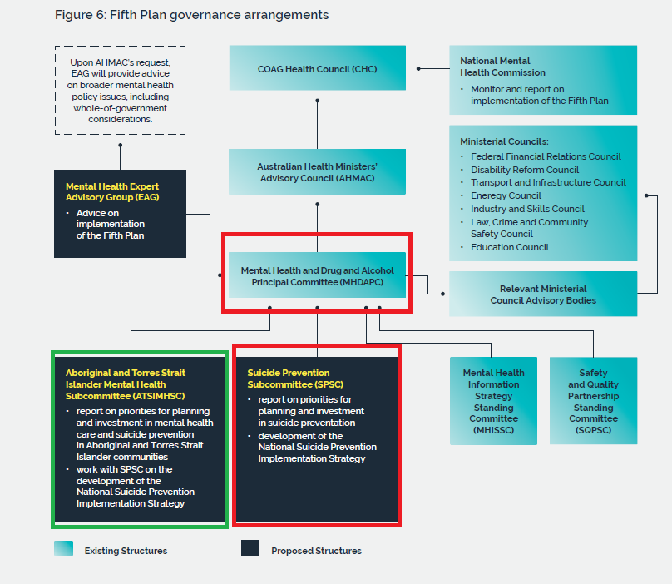

* Red border committees will have most focus
* Green border committees also need examination, but potentially less

**Action 3 Governments will** establish a new Suicide Prevention Subcommittee of MHDAPC,

as identified in the Governance section of this Fifth Plan, to set future directions for planning

and investment.

The Fifth National Mental Health and Suicide Prevention Plan 25

**Action 4 Governments will,** through the Suicide Prevention Subcommittee of MHDAPC, develop a

National Suicide Prevention Implementation Strategy that operationalises the 11 elements above,

taking into account existing strategies, plans and activities, with a priority focus on:

**•** providing consistent and timely follow-up care for people who have attempted suicide or are at risk

of suicide, including agreeing on clear roles and responsibilities for providers across the service

system

**•** providing timely follow-up support to people affected by suicide

**•** improving cultural safety across all service settings

**•** improving relationships between providers, including emergency services

**•** improving data collections and combined evaluation efforts in order to build the evidence base on

‘what works’ in relation to preventing suicide and suicide attempts.

(DHAC, 2017)

## Appendix I

WPR rough planning – Whiteboard – Primary questions

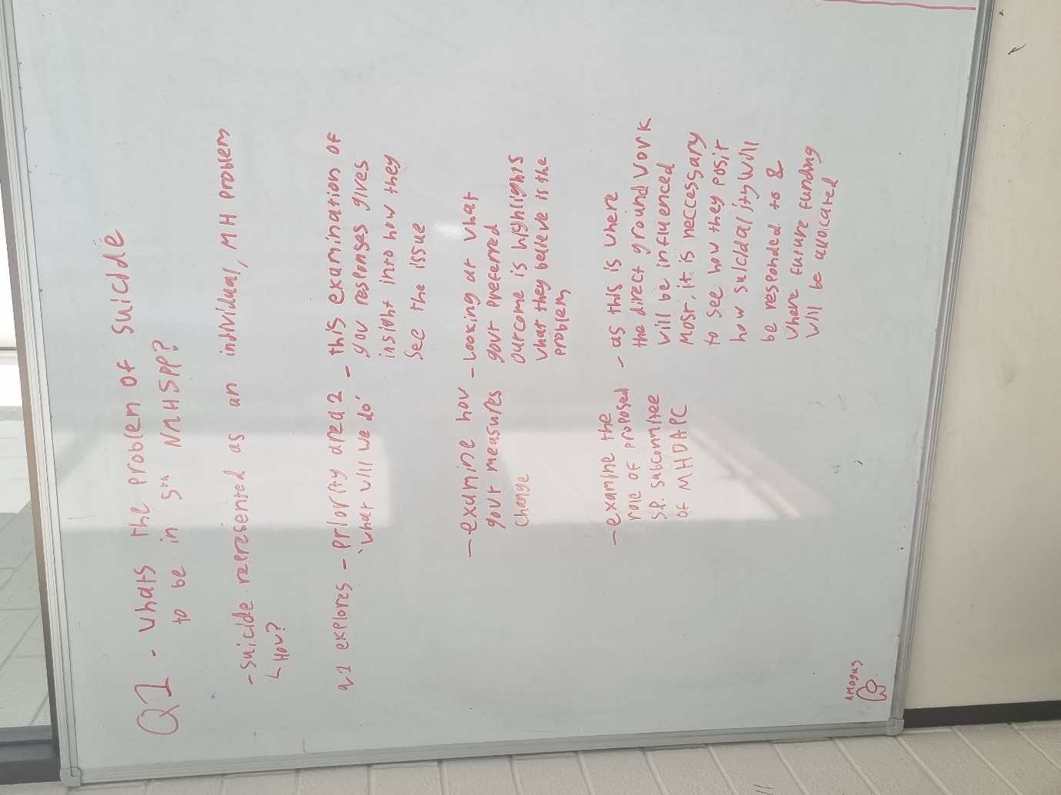

Question 1

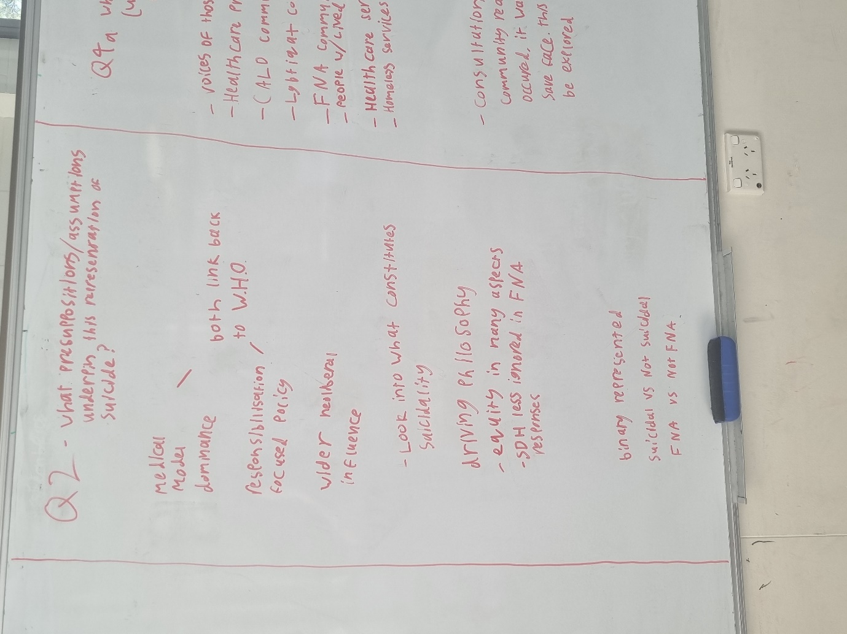

Question 2

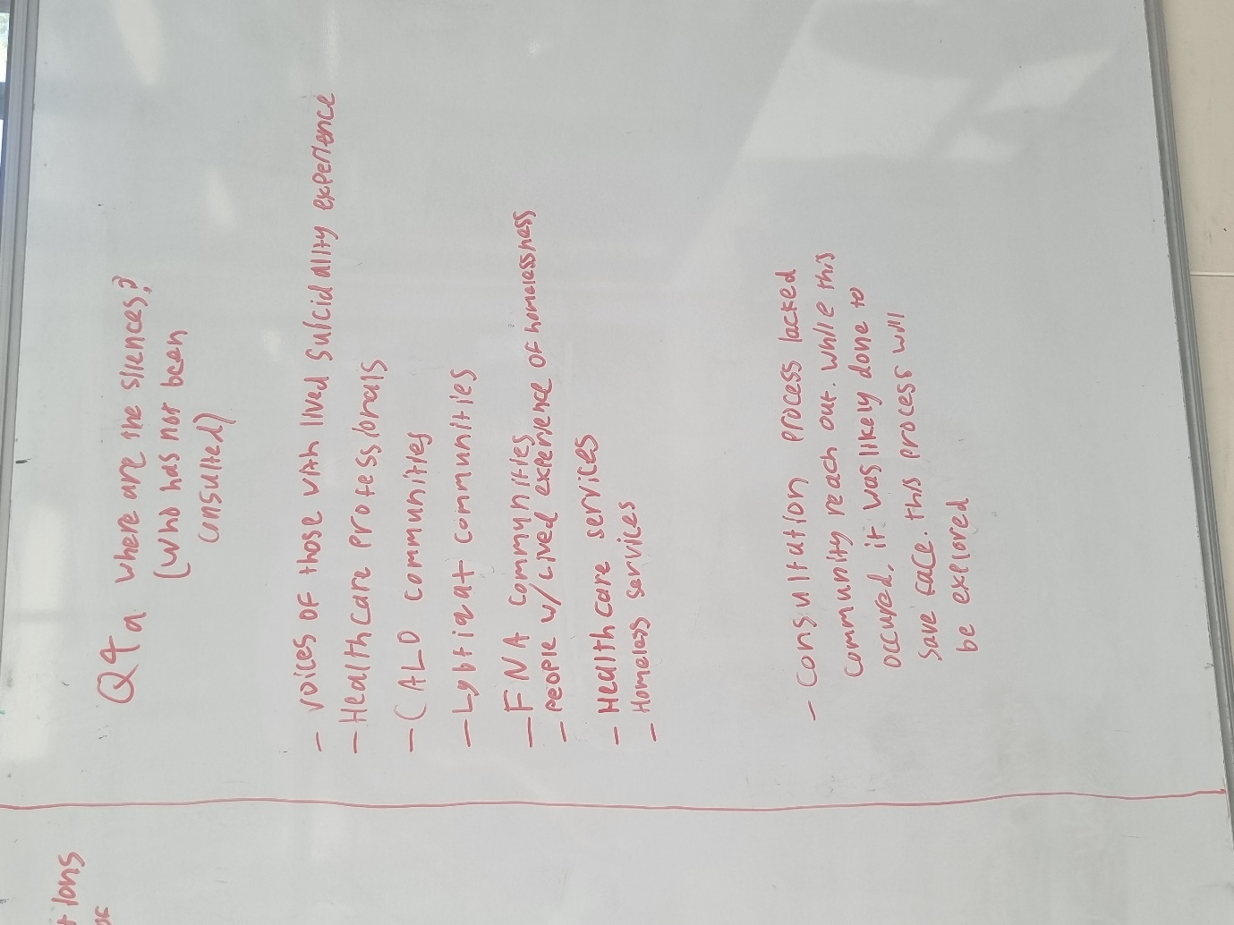

Question 4a

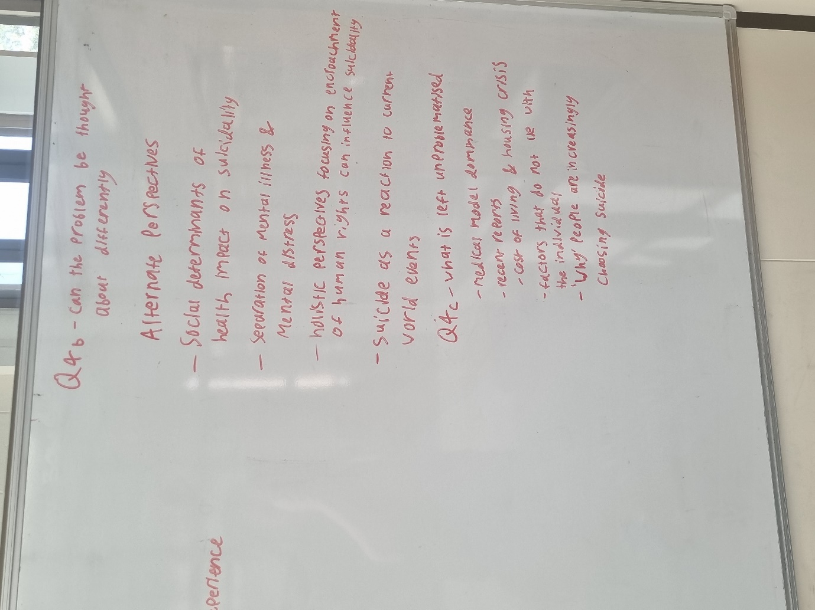

Question 4b & 4c

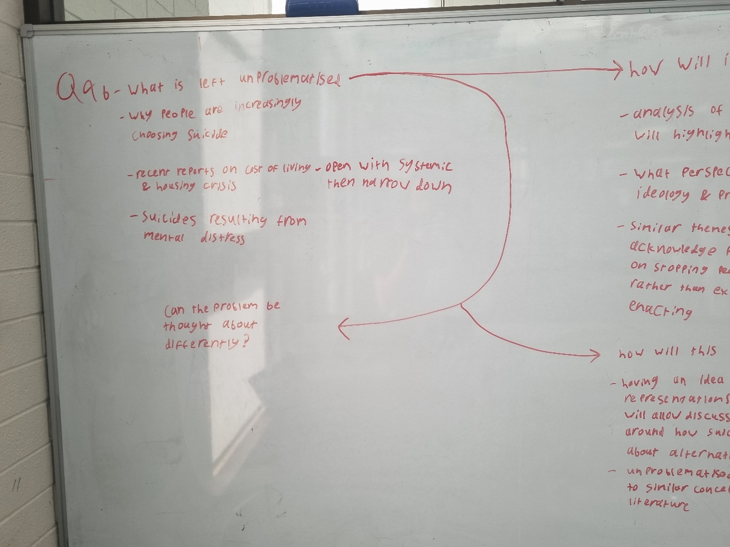

Question 4b revisited part 1

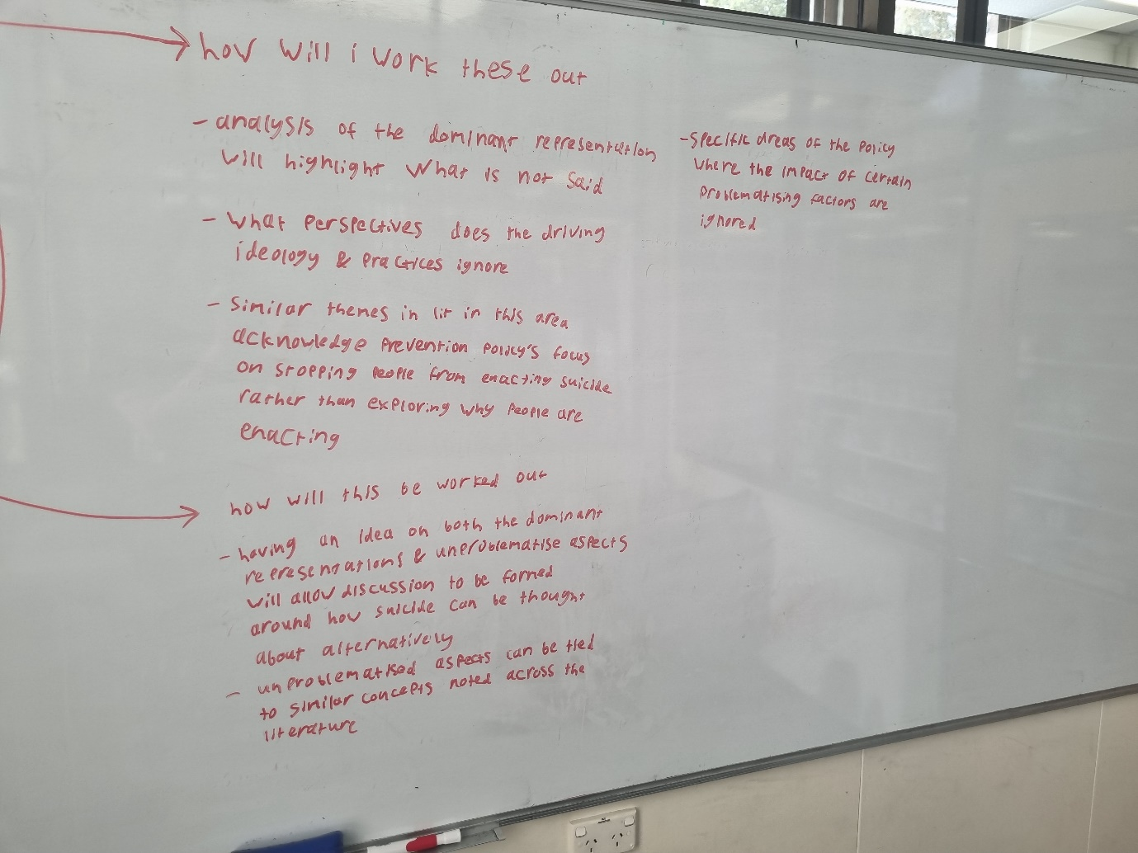

Question 4b revisited part 2

## Appendix J

WPR rough planning – Whiteboard – Secondary questions

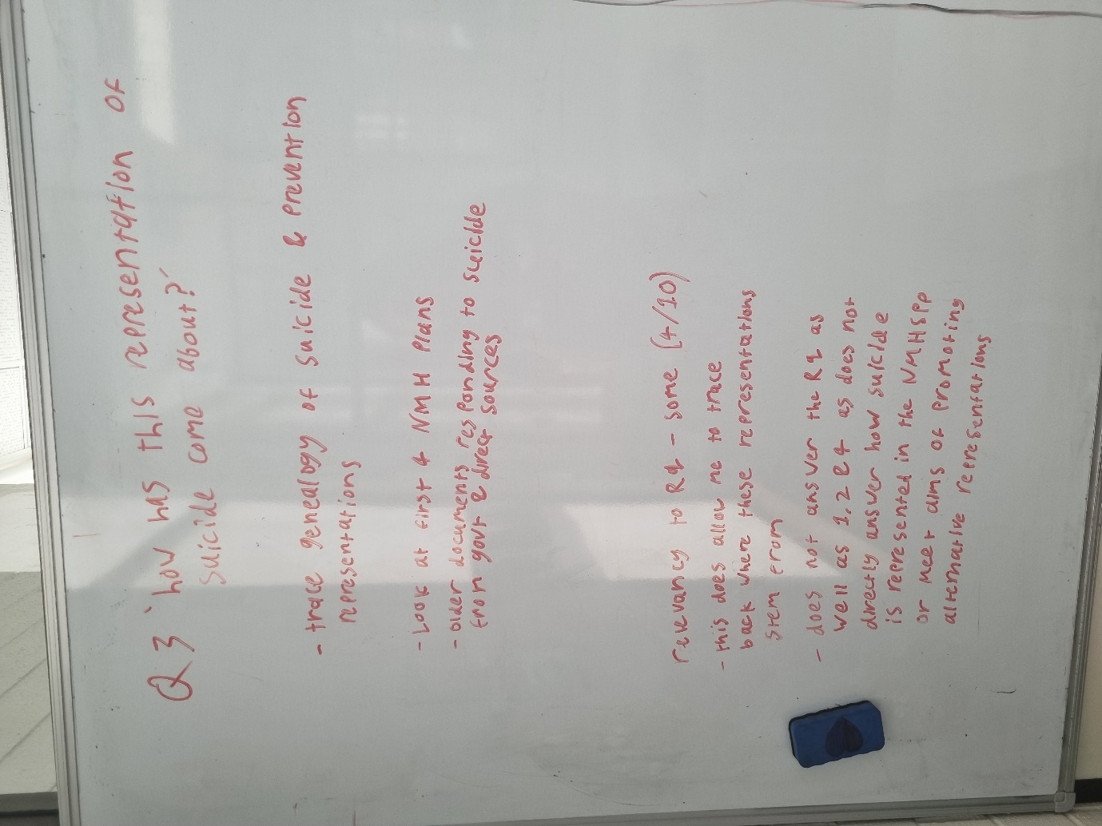

Question 3

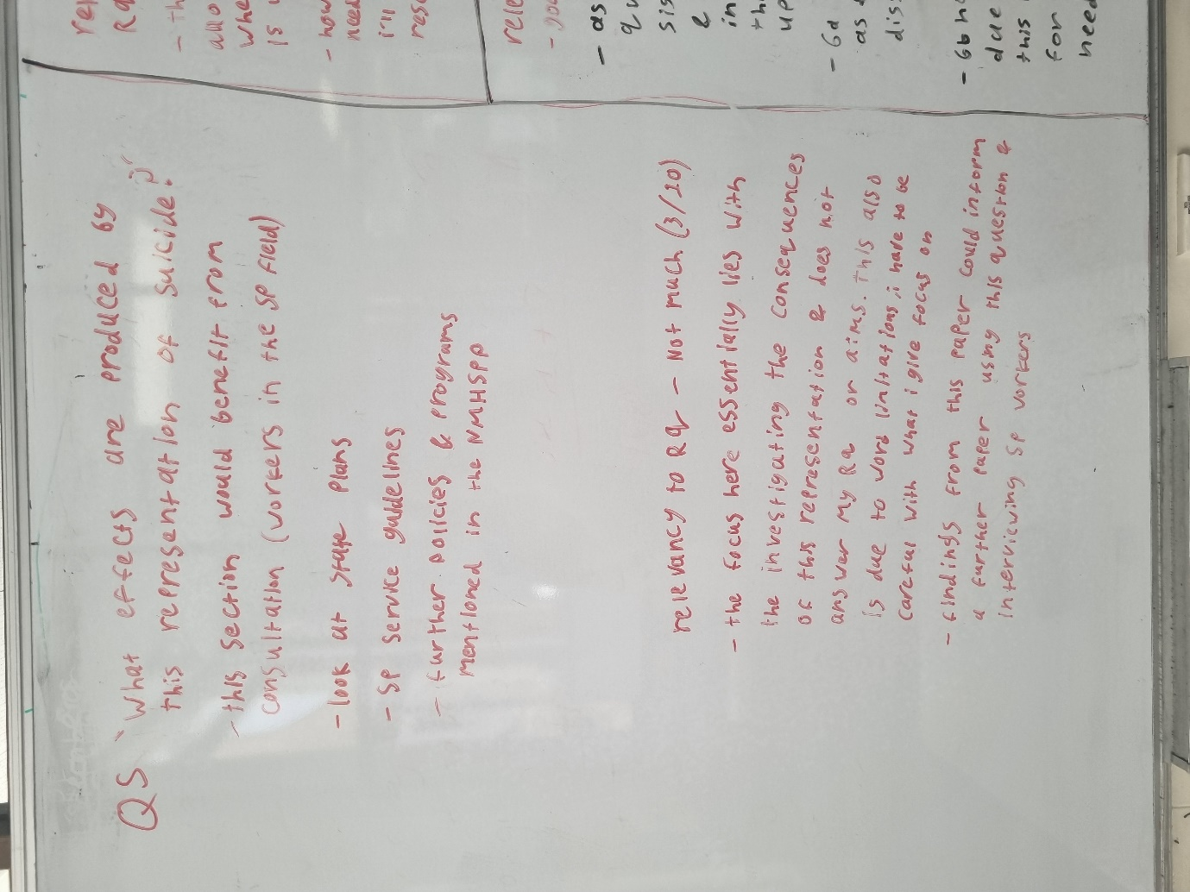

Question 5

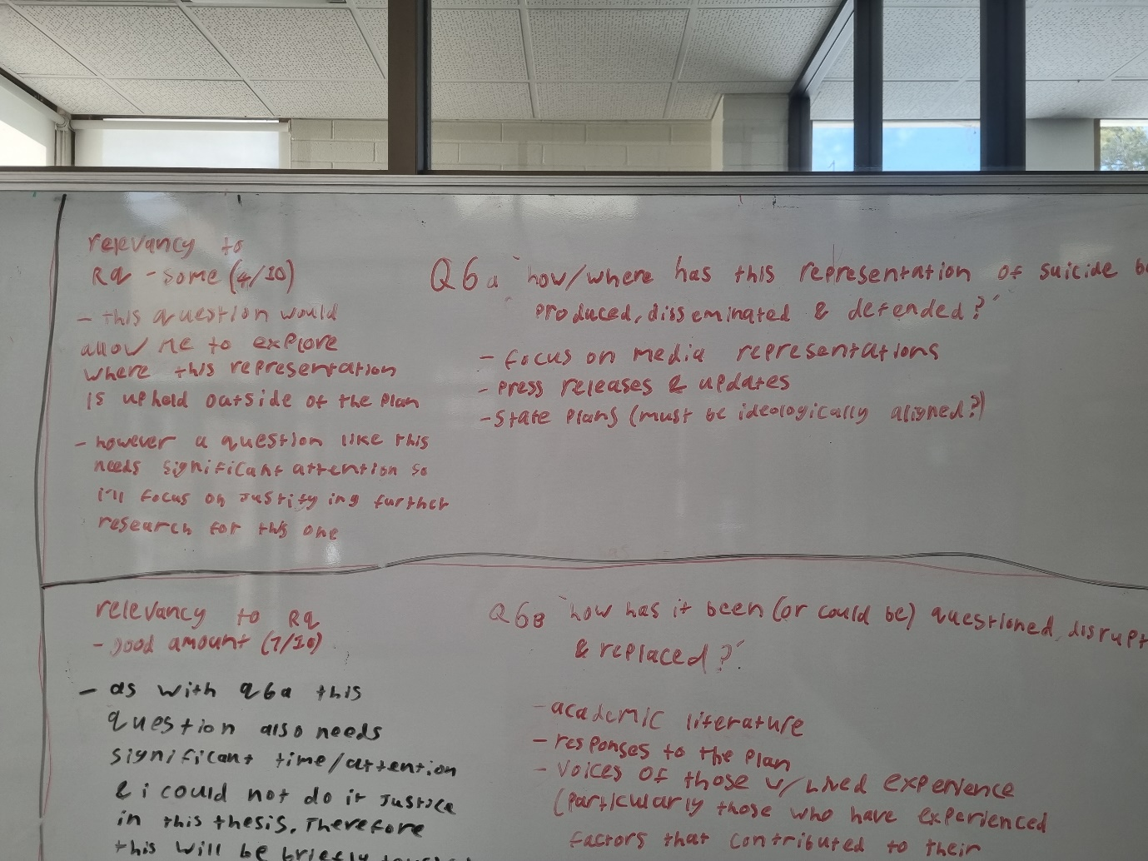

Question 6a

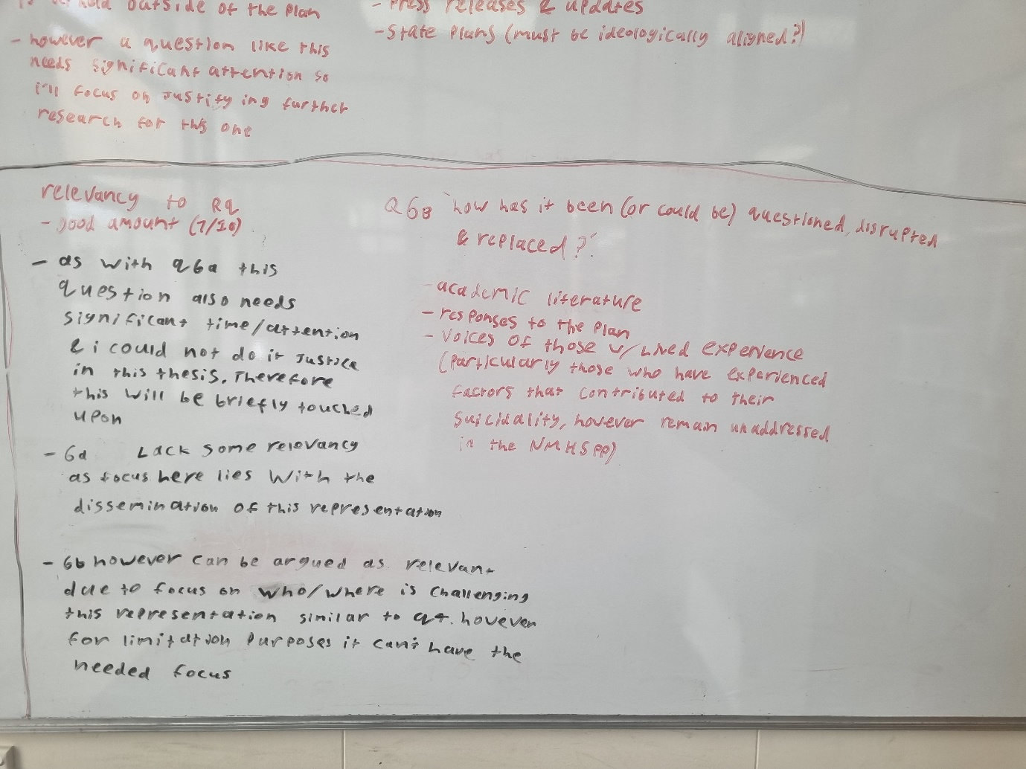

Question 6b

## Appendix K

Narrowing and rationale of attached policies – Whiteboard

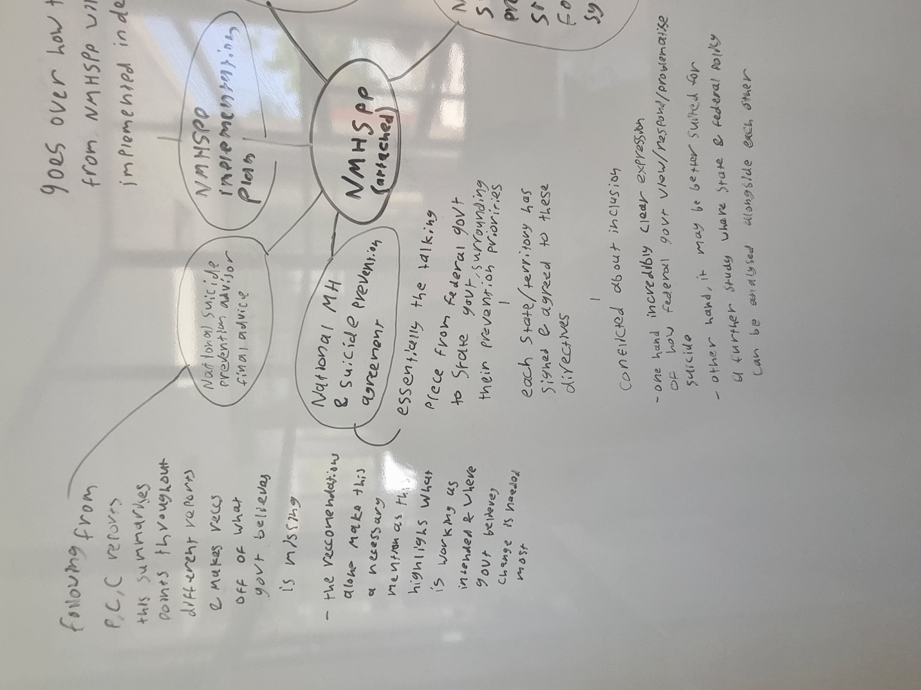

*National Suicide Prevention Strategy for Australia’s Health System: 2020–2023* (2020).

*National Mental Health and Suicide Prevention Agreement* (2020).

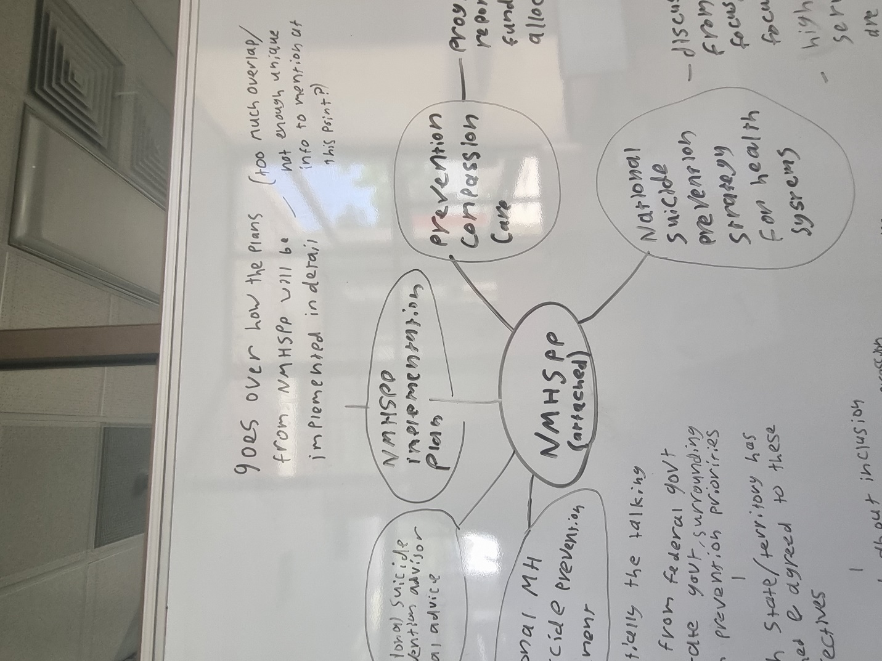

*National Mental Health and Suicide Prevention Plan: Implementation Plan* (2017).

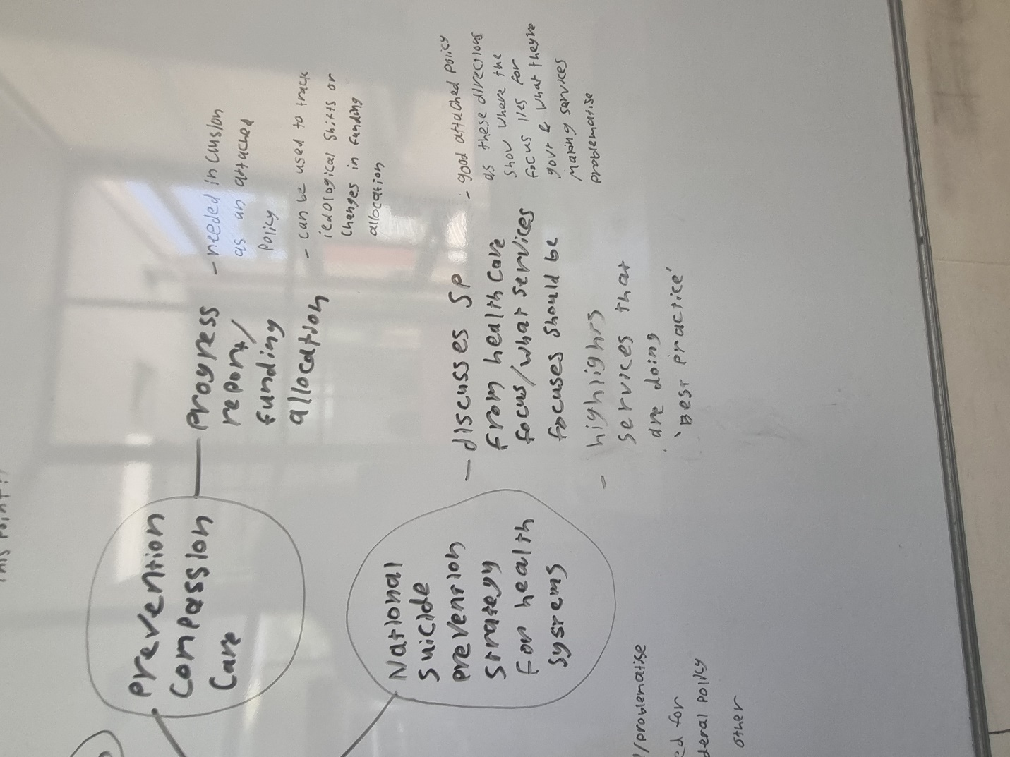

*National Suicide Prevention Strategy for Australia’s Health System: 2020–2023* (2020).

*Prevention, Compassion, Care: National Mental Health and Suicide Prevention Plan* (2021).