

Driving productivity growth – in conversation with Danielle Wood
Danielle Wood, PC Chair
Address to the Committee for Economic Development
of Australia



What we will cover

- Stalling productivity: the what, the why and the how?

- What can governments do?
  - improving regulatory decision-making
  - harnessing data and digital technology
  - investing in prevention

It’s productivity that drives improvements in living standards
Index = 100 in 1960, 1960 - 2024

300

250

200

Real wages

GDP per capita

Productivity

150

100
1960 1980 2000 2020
Notes: Consumer wages shown. Producer wages demonstrate a similar trend. See Productivity Commission 2023, Productivity growth and wages – a forensic look, PC 3
Productivity Insights, Canberra, September, for more information. Source: Productivity Commission 2025, Growth mindset: how to boost Australia’s productivity, Canberra.

Productivity isn’t just about more money or more ‘stuff’

The benefits of productivity growth over time



Direct results since 1960

Real income growth
3-fold increase in GDP per capita, and almost a 3-fold increase in average wages

More goods and services
Consumption of almost all household
goods and services up around 3-fold

Better goods and services
3% p.a. quality-driven increase in healthcare productivity in some sectors since 2011. Goods have also improved

More leisure time
Average worker spends 5 fewer hours per week at work

Indirect outcomes (correlates)






Reduced poverty
3-4-fold reduction in share of population living in absolute poverty since 2001

Longer, healthier lives
Life expectancy increased by 11 years (females) and 13 years (males) since 1960

Safer lives
Nearly 3-fold reduction in per-capita annual crime rate since 1990

More satisfied lives too
Countries with higher productivity levels report higher life satisfaction

Source: Productivity Commission 2025, Growth mindset: how to boost Australia’s productivity, Canberra. 4

We’ve been on a wild ride lately
Labour productivity (index, 2024 = 100), between June 2004 and March 2025
105

100

2015-2019 average
Productivity ‘bubble’

95

90

85

80

2004 2006 2008 2010 2012 2014 2016 2018 2020 2022 2024

Source: Productivity Commission 2025, Growth mindset: how to boost Australia’s productivity, Canberra. 5

Our productivity growth is at its slowest rate in 60 years

Average labour productivity growth

2.50%

2.00%

1.50%

1.00%

0.50%
2.4 2.3

1.1

2.2

59-year average (1.6%)

1.3

0.4

0.00%
1965 to 1975 1975 to 1985 1985 to 1995 1995 to 2005 2005 to 2015 2015 to 2024 *

Source: Productivity Commission 2025, Growth mindset: how to boost Australia’s productivity, Canberra. 6

Generation-on-generation income growth has stalled for Aus

Average individual disposable income by birth decade and age
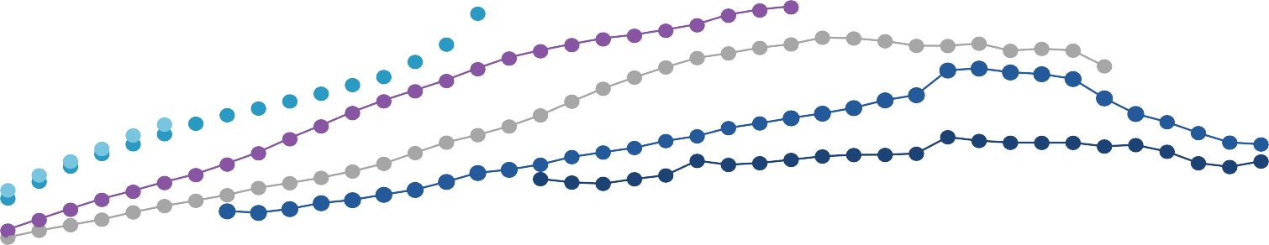
$80,000
1970s
1960s
1980s
1990s
1950s
1940s

$60,000

$40,000

$20,000

0
25 30 35 40 45 50 55 60 65

Age of birth cohort
Source: Productivity Commission estimates using ALife. 7

This is not just an Australian phenomenon

Labour productivity growth in OECD countries, %
4.0
3.0
2.0
1.0
0.0
-1.0
Ireland Turkey Iceland Israel Australia Denmark
US
Switzerland
Spain New Zealand
Austria Portugal Sweden Japan Germany France
UK
Finland Belgium Netherlands
Italy Norway Luxembourg
Greece
Average
-2.0
1990 to 2005 2005 to 2019

Note: Includes only the 24 longest standing OECD countries. The historical average annual growth rate for Austria is calculated between 1995 and 2005 due
to data limitations. Source: Productivity Commission 2025, Growth mindset: how to boost Australia’s productivity, Canberra. 8



Why did productivity growth slow?

Shift to less capital-intensive industries
– the march of the services sector
Reduced boost from technological change
Low investment
Reduction in economic dynamism
Lack of policy reform / declining emphasis over decades

9

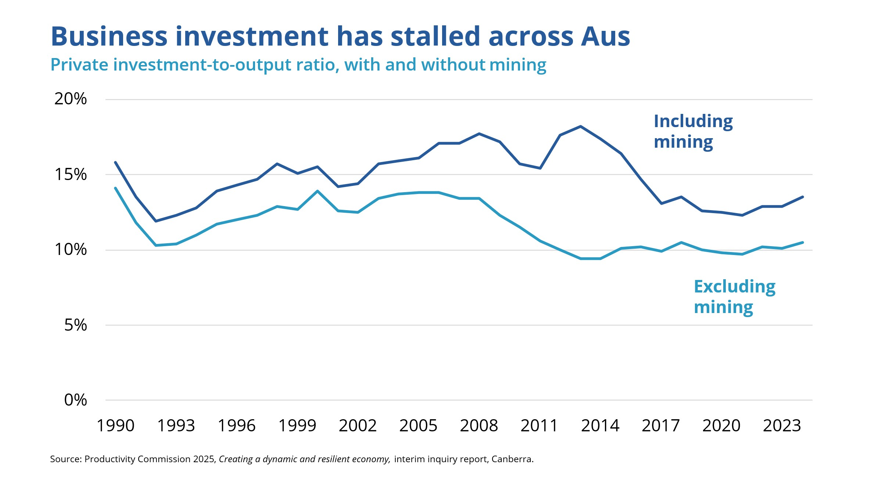
Business investment has stalled across Aus

Private investment-to-output ratio, with and without mining, chain volume measures

Note: Non-mining measure excludes mining value add to GDP. Source: Productivity Commission 2024, Why are Investment Hurdle Rates so High? Risk or Market Power?, staff working paper, Canberra, Figure 1.

What we will cover

- Stalling productivity: the what, the why and the how?

- What can governments do?
  - improving regulatory decision-making
  - harnessing data and digital technology
  - Investing in prevention

Governments hold many levers to growth



Governments don’t hold all the cards when it comes to economic growth, but policy
decisions do matter –
Governments support the enablers of growth like research, education and training, and population health
Governments shape incentives to work and invest through taxes and
regulatory settings
As major funders and providers of services such as infrastructure and care, governments set the pace of productivity growth across large parts of the economy






The five pillars of productivity reform: our working list
Support business investment through corporate tax reform |  |  | Reduce regulatory burden through new leadership approach for government and the public service
Reduce the cost of meeting emissions targets |  | Speed up approvals for new energy infrastructure |  |  | Encourage adaptation by addressing barriers to private investment
Right size regulatory approach to AI | Unlock benefits of consumer data |  |  | Reduce burden through outcomes-based approach to privacy regulation |  | Enhance reporting efficiency, transparency and accuracy through digital financial reporting
Improve curriculum resources and ed-tech to boost school student outcomes |  | Boost lifelong learning by recognising prior learning/credit and providing better workplace training incentives |  |  |  | Fit-for-purpose occupational entry regulations
More consistent quality and safety regulation to support a more cohesive care economy |  |  | Collaborative commissioning of health services to improve health outcomes |  | A national framework to support government investment in prevention

Creating a dynamic and resilient economy

Investing in cheaper, cleaner energy and the net zero transformation

Harnessing data and digital technologies

Building a skilled and adaptable workforce

Delivering quality
care more efficiently

13




Improving regulatory decisions

It’s gotten harder to do business in Australia since the
early 2000s, especially compared to other countries
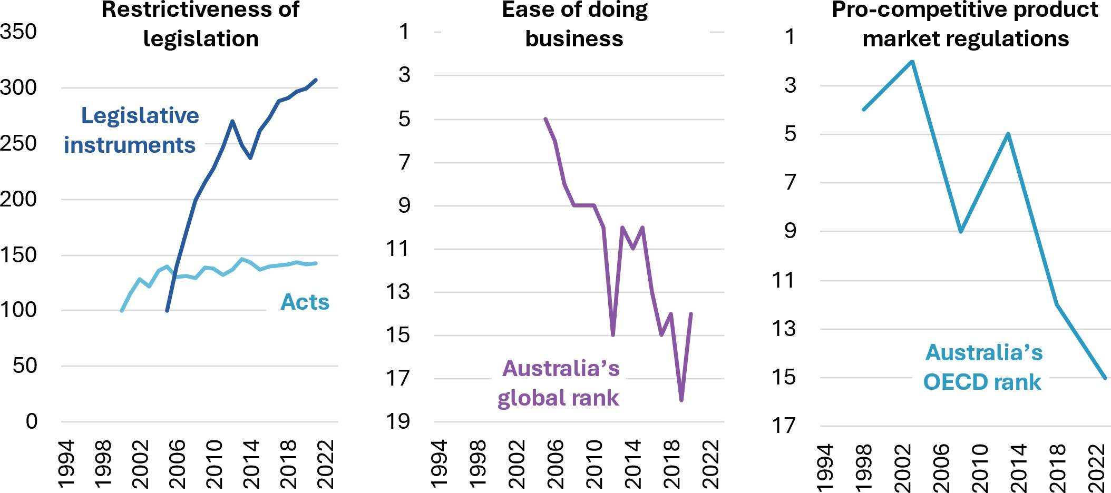
Notes: ‘Restrictiveness of legislation’ is defined as the number of restrictive clauses such as ‘if’, ‘but’, ‘except’ in federal acts of parliament and legislative instruments. ‘Acts’ series is
indexed to 2000 and legislative instruments series is indexed to 2005. Ease of doing business series measures Australia’s global ranking for ease of doing business, and ‘Pro-
competitive product market regulations’ is Australia’s rank among 28 OECD countries on the OECD’s Product Market Regulation indicators. A falling rank for Australia suggests Australia
is performing less well on these measures compared to other countries. Source: World Bank (2005, 2020, 2024) and QuantGov (n.d.).c

Regulatory failure comes in many forms

Band-aid regulation | Regulation that does not address underlying cause of the problem
Duplicate/inconsistent regulation | Multiple regulations that impose repetitive or inconsistent requirements on a business
Overly prescriptive  regulation | Regulation that specifies processes rather than outcomes, constraining adaptation
Overly risk-averse  regulation | Regulation that aims to eliminate all risk at the expense of a disproportionate regulatory burden
Regulatory delay | Where regulators do not make timely decisions
 Cumulative burden | Where multiple regulations together create a disproportionate  burden, even if each individual regulation is justifiable in isolation

Good regulatory governance requires leadership from ministers and parliament
Role for ministers
Specify appetite for risk and that regulators and policymakers should consider growth
and dynamism
Ministerial statements of
expectations
Modelled on budget process methods, with support from central agencies
Enhanced cabinet scrutiny of
regulatory proposals
Embed principles of good regulation
Commit to concrete reforms to reduce regulatory burden
Consider overall quantitative targets for regulatory burden – but should be appropriate
Whole of government statement on regulation, agreed by cabinet
Role for others
Central agencies to give more guidance and support to regulators and policymakers and expect greater accountability
Independent statutory commissioner to oversee the Office of Impact Analysis Senate scrutiny committees to consider impact analysis quality
PC to undertake regular stream of sectoral regulatory reviews
Support for regulatory stewardship
Stronger scrutiny, review and
evaluation



Harnessing data and digital technology

Productivity growth via technology requires two things:
innovation and take up

Decomposition of multifactor productivity (MFP), market sector excl. mining, index, log scale
0.35
New ideas and technology frontier
Use of new technology and ideas
0.30
0.25
0.20
log(index)
0.15
0.10
0.05
0.00
1995 1997 1999 2001 2003 2005 2007 2009 2011 2013 2015 2017 2019 2021 2023

Financial year ending

Note: ‘New ideas and technology frontier’ series is the multifactor productivity frontier. ‘Use of new ideas and technology’ series is actual multifactor productivity in Australia. See PC 2025, Annual Productivity Bulletin 2025 for more details. Data source: Productivity Commission estimates based on ABS (Australian System of National Accounts, 2023-24, Estimates of Industry Multifactor
Productivity).


AI could be a productivity game changer for the Australian economy

AI is already changing Australian workplaces

Inquiry participants told us they use AI for:
- Teaching and training tools
- Writing software code
- Identifying cyber threats and maintaining cyber security
- Responding to customer inquiries
- Making scheduling and admin work easier

We found examples of it being used in many industries:
- Alerting bank customers of potential scams, and identifying if customers have been coerced
- Drafting legal material and research
- Sorting avocados
- Prioritising deliveries and routes
- Cataloguing Aboriginal rock art
- Inspecting coastlines for fishing net waste

The productivity benefits of AI for Australia are uncertain, but could be large –
perhaps 4% boost to labour productivity growth over the next decade

Govts can lead the way on digital tech and AI




As regulators…
As service providers…
Improving digital uptake in healthcare (e.g. electronic medical records) could save the health system $5b per year
Greater consistency in use of edtech & AI in schools could ease teacher workloads and reduce variation in teaching quality
Adopting technology-neutral regulatory approaches creates space for people and businesses to adopt new ideas while meeting requirements

Making the best use of data (e.g. through mandated digital reporting & consumer access to data) improves information available to consumers and businesses
As exemplars of best practice…
The way public servants and agencies use new tech in day-to-day functioning of government can set standards for other sectors – e.g. responsible AI use

Going digital saves time and expense for people and businesses subject to regulatory requirements

Supporting training will be important as AI augments (many) and automates (some) roles
The distribution of Australia’s workforce according to the exposure of their occupation to Gen AI

Automation

Level of exposure: High Medium Low and very low
4% of workers are in occupations that are highly exposed to automation due to AI

Augmentation
31% of workers are in occupations that are highly exposed to augmentation due to AI

0% 20% 40% 60% 80% 100%
Source: Jobs and Skills Australia 2025, Our Gen AI Transition, Final Overarching Report, Australian Government, Canberra, Table 1.



Delivering quality care more efficiently
D

The care economy will continue to grow

The care economy as a percent of Gross Domestic Product and share of the labour market
20%
Projections
Labour
GDP
18%
16%
14%
12%
10%
8%
6%
4%
2%
0%
2002–03 2012–13 2022–23 2032–33 2042–43 2052–53 2062–63
Note: GDP calculations are on a Gross Value-Added basis, which produces lower estimates on the size of the care economy than an Expenditure-based approach. Source: PC estimates based on Commonwealth of Australia (IGR) data.

Care sectors will increase pressure on government budgets

Composition of Commonwealth government spending over time, as a share of GDP

7.0%
6.0%
5.0%
4.0%
3.0%
2.0%
1.0%
0.0%
Top three future spending pressures

Health Aged Care NDIS Interest Defence Infra-
structure

Age Pension

Income support

2021-22
2060-61

Education Other

Note: Other payments in this chart includes a range of payments such as funding for the Australian Public Service, superannuation, official development assistance, law and order, the arts, community development and tourism. It excuses GST payments and state government contributions to the NDIS. Age Pension category includes Service Pensions. Income support category excludes Age Pension payments. Source: Treasury 2021, Intergenerational Report, Commonwealth of Australia, Chart 7.4.

Care sectors have lower measured productivity
Labour productivity, index (March 2014 = 100)

Other sectors

Care sectors

See Productivity Commission 2025, Productivity before and after Covid-19, Research paper, Canberra, June, for more information Source: PC estimates using ABS 2024, Australian National Accounts: National Income, Expenditure and Product, June 2024 and ABS 2024, Labour Account Australia, June 2024

Sometimes productivity brings quality gains, not savings
Relative healthcare productivity by country, quality adjusted, 2010 to 2019
Iceland

Australia’s quality-adjusted health productivity grew by 3% a year in the six years to 2017-18
Australia
Japan Estonia
New Zealand Singapore Sweden Switzerland
Italy Israel
United Kingdom Netherlands Denmark Cyprus
0.8 0.85 0.9 0.95 1

Relative productivity

Note: Estimates are for selected parts of the health sector. Not all country names shown. See source for details. Source: Productivity Commission estimates, Productivity Commission 2024,
Advances in measuring healthcare productivity, Research Paper, Canberra.

Benefits of prevention
Health
More than a third of Australia’s health burden is preventable through a reduction in modifiable risk factors
Child maltreatment
Child maltreatment is widespread and is linked to risky adult behaviours
Disability
Some forms of disability like foetal alcohol syndrome and diabetes complications are preventable
Homelessness
Long-term homelessness and associated issues can often be prevented with early action
- Prevention generates economic and social benefits
- Many preventive actions are cost-effective and reduce overall costs to govt

Barriers lead to underinvestment in prevention
Benefits and costs are misaligned
Benefits from prevention can be spread across policy areas and tiers of government
Short term thinking
Prevention benefits can take years to show but costs are upfront Budget processes impede cross-portfolio or long-term gains
Evaluation gaps
It is hard to track long-term impacts & linked data can be hard to access
Without better tools to show what works, cost-effective programs risk being overlooked.

PC’s recommendations will support investment in prevention

PC will recommend a new approach to
preventative interventions that aims to:
- Ensure government receives independent

Costs
Expenditure with and without preventative intervention

Current

advice on preventative interventions
- Provide a more systematic method for funding preventative interventions that will support investment across government silos
- Improve assessment and evaluation to make sure governments are properly informed
Upfront cost of prevention

Current spending
trajectory
Avoided future costs

Time


chair@pc.gov.au

