From community voice to community control:
the evolution of Connected Beginnings

Key points
- Navigating partnerships across portfolios demands deliberate effort and sustained coordination. This helps align roles, foster mutual understanding and reconcile different ways of working, leading to better decisions and outcomes.
- Strong partnerships with the community-controlled sector require early investment in building rapport, trust and sound governance structures. Secondment arrangements can fast-track trust and capacity building with the sector.
- Taking a relational approach to grant administration is crucial. Direct administration of grants can provide greater flexibility to build relationships which go beyond the traditional funder-grantee arrangements and provide bespoke support.
- Tailored guidelines and frameworks can support both organisation and community readiness to transition services from mainstream organisations to the community-controlled sector.
- Site selection processes can be enhanced by combining strengths-based data with sustained community engagement and shared governance with community partners. This supports more informed, culturally appropriate and transparent decision-making.
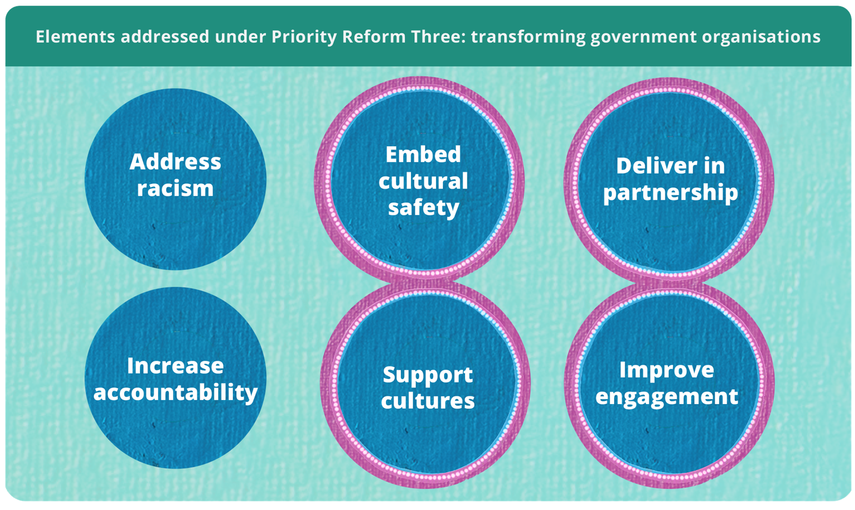

Strong partnerships are foundational to place-based approaches
Place-based approaches take considerable time and effort from all involved to establish, and have both strengths and challenges when delivering in practice. Success requires government to foster genuine shared decision-making with communities, through equal partnerships (ANZSOG and Victoria State Government 2023, p. 14).
The evolution of Connected Beginnings since 2016 shows the value of investing in strong partnerships between the community-controlled sector and government, and strengthening governance arrangements to build trust and enable shared decision-making (Inside Policy 2023, pp. 6–7). With strong advocacy and leadership from the community-controlled sector, Connected Beginnings provides an example of an established program that continues to transform and improve over time to align with the Priority Reforms of the National Agreement on Closing the Gap (National Agreement) (Inside Policy 2023, p. 6).

The transformation journey
Over the past 10 years, Connected Beginnings has significantly evolved (figure 1). Cultural authority is no longer a principle of the program – it is the foundation.
The National Agreement was a key enabler for evolving the program and provided the authorising environment for a formal partnership between program funders – the Australian Government Department of Education (Education) and the Australian Government Department of Health, Disability and Ageing (Health) – and peak bodies from the community-controlled sector - SNAICC National Voice for our Children (SNAICC) and the National Aboriginal Community Controlled Health Organisation (NACCHO) (Program Partners) (Inside Policy 2023, p. 39).
Figure 1 – Evolution of Connected Beginnings^{a,b}
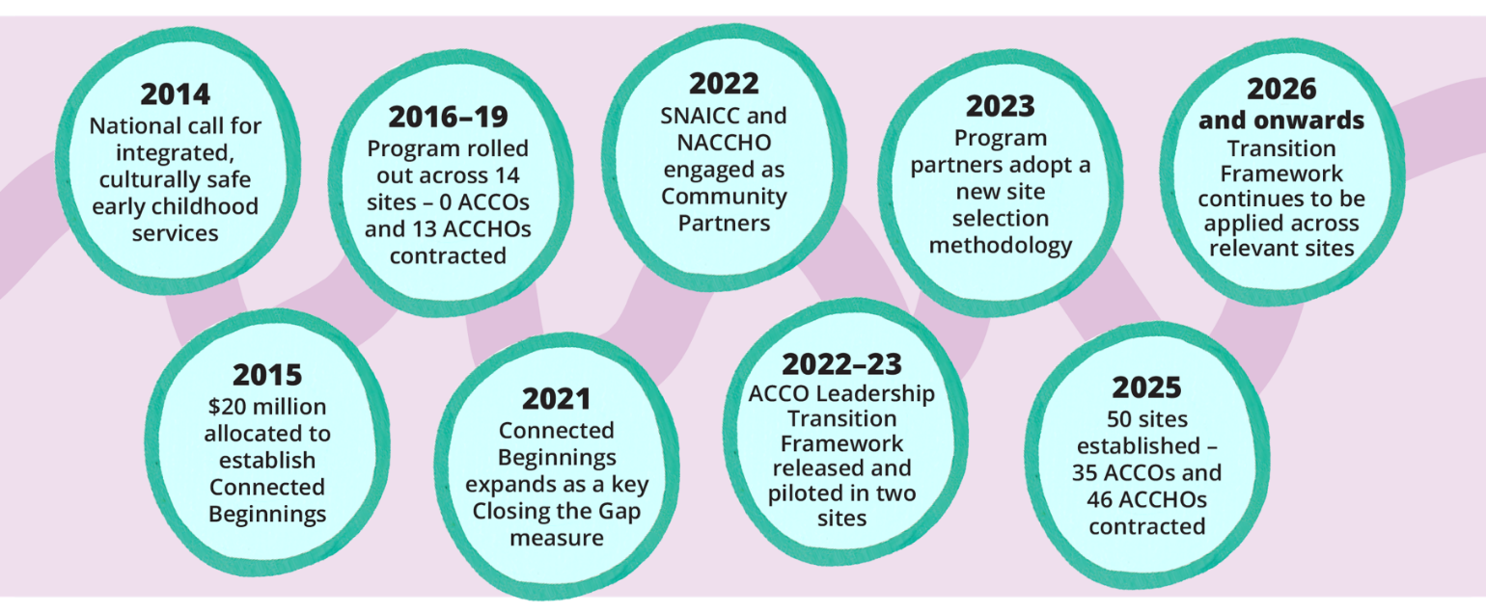
a. Aboriginal and Torres Strait Islander Community Controlled Organisation (ACCO).
b. Aboriginal and Torres Strait Islander Community Controlled Health Organisation (ACCHO).
Source: Australian Healthcare Associates (2019); Inside Policy (2023).
Jointly funded by Education and Health since 2016, Connected Beginnings is a place-based grants program that brings together early childhood education, health and family support services (figure 2). It improves school readiness by supporting integrated, culturally safe and community-led services (Inside Policy 2023, p. 19).
Figure 2 – Connected Beginnings operationsª
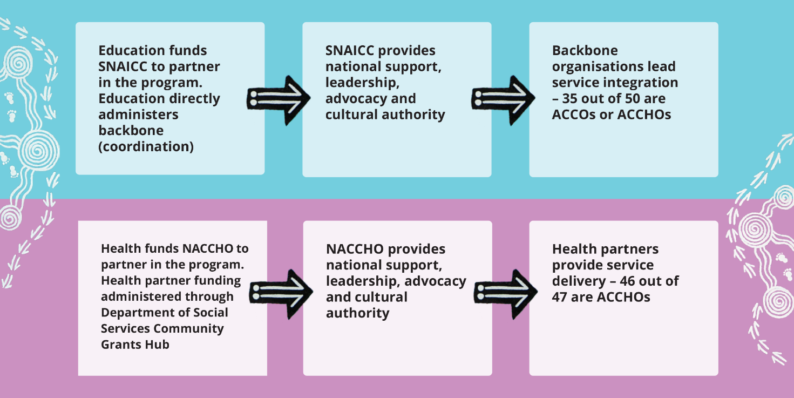
a. Backbone funding refers to grant money provided to an organisation that plays a central coordination role across services and families. Backbone organisations generally do not deliver services but provide strategic coordination, logistical support, or engagement activities to support families access culturally safe services.
Source: Inside Policy (2023); SNAICC and Australian Department of Education (2022).
Governance is shared between communities and government, in line with Priority Reform One of the National Agreement. Engaging local ACCOs and ACCHOs to deliver the program supports local leadership and decision-making (Inside Policy 2023, p. 6). Promoting community governance ensures the program is responsive to community needs and priorities.
Governance mechanisms at the program level include the Connected Beginnings Advisory Group, operational and management meetings and forums between Program Partners. Governance mechanisms at the site level include Cultural Leadership Tables, Community Advisory Groups, community meetings and service-oriented forums to ensure services are working collectively to address gaps families may be facing (Inside Policy 2023, pp. 61–62, 85).

Shifting from community voice to community control

Establishing and strengthening partnerships across sectors
When Connected Beginnings began in 2016, governments made decisions that engaged community voice but did not prioritise community control. Aboriginal and Torres Strait Islander voices were informally considered and reflected within the initial design of the program. A ‘Critical Friends’ group, featuring SNAICC as a strong voice, marked a more structured approach to embedding these perspectives, though not yet within the context of a formal partnership.
The announcement of Connected Beginnings as a key Closing the Gap measure was an opportunity for government to strengthen the program and better align their partnership settings with the Priority Reforms of the National Agreement. This triggered a change within Education and Health to engage SNAICC and NACCHO as Community Partners.
While Education worked closely with SNAICC, and Health with NACCHO for many years outside the program, this was the first formal cross-sector partnership between all parties. Relational work was key. A commitment to collaboration, improvement, transparency, active listening and providing fearless advice transformed old relationship settings into a stronger partnership (Lavarch et al. 2025, p. 145).
In 2022, a secondment arrangement between Education and SNAICC enabled staff to sit side by side to operationalise the Community Partner contract. This was particularly valuable in building internal capacity and developing culturally safe communications systems.
This partnership has since informed every stage of the investment cycle – from influencing the composition of the Advisory Group to progressing transparency and inclusivity in community decision-making – resulting in a more appropriate and responsive program with cultural governance at the core.
Navigating the responsibilities of multiple Australian Government agencies – each with distinct priorities, budget cycles and allocations, governance structures and operating models – can be complex. These challenges can reinforce sector silos and impact service delivery. At the community level, unequal funding and inconsistent partnership arrangements between health and backbone organisations can create a sense of devalue and disconnect, impacting local transparency and accountability.
Program Partners are continuously working to address these challenges by aligning responsibilities, goals and timelines across sectors wherever possible. A co-designed roles and responsibilities document is used for overarching governance of the program and updated to improve collaboration and decision-making between partners.

A flexible, relational approach to grant administration
For place-based approaches, where the focus is on community readiness and building shared outcomes, taking a relational, flexible approach is crucial (Victoria State Government 2020, pp. 34, 39).
To support this, Education argued from the start that there were exceptional circumstances precluding them from administering backbone funding through the Australian Government's Department of Social Services (DSS) Community Grants Hub. This includes significant time working with community to determine which organisation has the trust, cultural authority, expertise and capacity to apply for funding, the high level of support for grant recipients, and the expertise required to assess applications. Internal administration has enabled Education to work at the pace and direction of community and build strong, direct relationships with backbone organisations.
Health partner funding is administered through the DSS Community Grants Hub. Communication with health partners often occurs through DSS Funding Arrangement Managers. NACCHO’s engagement in the program has supported connection between health partners and Health (Inside Policy 2023, p. 46).

Transitioning funding to the community-controlled sector
Health partner funding has consistently prioritised the community-controlled sector, with 46 of the 47 health sites sitting in ACCHOs. However, prior to the program’s expansion, backbone funding favoured larger mainstream organisations, and given the focus on school readiness, often sat within or adjacent to schools (Inside Policy 2023, p. 43; SNAICC and DoE 2022, p. 3). These organisations had limited to no cultural authority or embedded ways of Aboriginal and Torres Strait Islander knowing, doing and being (SNAICC and DoE 2022, p. 3).
To rectify this and support Aboriginal and Torres Strait Islander self-determination, in 2021 the Australian Government committed to transitioning backbone roles to ACCOs or ACCHOs where there is support for the transition from the community (NIAA 2021, p. 29). SNAICC and Education led a national co-design process with Connected Beginnings communities to develop the ACCO Leadership Transition Framework (SNAICC and DoE 2022, pp. 2–3). The Framework sets out when and how roles will transition to ACCOs, guided by community readiness and support (SNAICC and DoE 2022, p. 2; NIAA 2023, p. 5). It centres cultural governance and community voice, ensuring the program is locally led and culturally grounded (SNAICC and DoE 2022, p. 12). Involving the health partner and other ACCHOs and ACCOs in the area during transition discussions can support shared governance between Community Partners.
NACCHO and Health play a key role in reviewing and endorsing transition recommendations, supporting shared decision-making across Program Partners. At times, unequal resourcing between Program Partners and expectations to provide genuine and considered responses to recommendations within short timelines can impact endorsements.

Strengthening site selection processes
Historically, Connected Beginnings sites were determined based on national level data sets – often Australian Early Development Census (AEDC) and Australian Bureau of Statistics (ABS) data – and discussions with Australian and state and territory governments on priorities (Australian Healthcare Associates 2019, p. 23). This data could unintentionally promote a deficit view by framing communities in terms of their challenges rather than strengths. Site selection processes also often failed to consider the capacity of those locations to deliver service integration in a culturally appropriate way, for example by not prioritising ACCOs or ACCHOs in the site selection process.
With leadership from SNAICC and NACCHO, site selection processes have improved to recognise and build on community strengths. Shifts have taken place to select sites not only considering administrative data, but toward a strengths-based approach, prioritising community voice, cultural governance and readiness (NIAA 2023, p. 8). The updated process often involves extensive community consultation to identify area need, existing relationships and the capacity of organisations – particularly ACCOs and ACCHOs – to meaningfully engage in the program. This has encouraged governments to engage more fully and transparently with community – often through SNAICC or NACCHO – resulting in a more culturally informed, relevant and appropriate selection.

The impact on the ground
Engaging SNAICC and NACCHO as Community Partners has been instrumental to embedding cultural safety and responsiveness to every element of the program. Their involvement not only reflects governments’ will, readiness and commitment to support community-led approaches, but also ensures that Aboriginal and Torres Strait Islander voices are central to decision-making and service design (Inside Policy 2023, p. 36). Connected Beginnings sites report better community collaboration, leadership and capacity to drive culturally safe service integration because of the work of SNAICC and NACCHO as Community Partners (Inside Policy 2023, pp. 80, 118).

References
ANZSOG and Victoria State Government (Australia and New Zealand School of Government and Victoria State Government) 2023, Place-based approaches: A guide for the Victorian Public Service.
Australian Healthcare Associates 2019, Evaluation of the Connected Beginnings program: Final report, Commissioned by the Australian Government Department of Health and Department of Education.
Dart, J 2018, Place-based evaluation framework: A guide for evaluation of place-based approaches in Australia, Commissioned by the Queensland Government Department of Communities, Disability Services and Seniors (DCDSS), the Australian Government Department of Social Services (DSS), and Logan Together.
Inside Policy 2023, Connected Beginnings mid-term evaluation: Final report, Commissioned by the Australian Government Department of Education and the Department of Health and Aged Care.
Lavarch, L, Coombes, L, Gray, K, Anthony, C and Nolan-Smith, S 2025, Independent Aboriginal and Torres Strait Islander-led Review of Closing the Gap, Jumbunna Institute for Indigenous Education and Research.
NIAA (National Indigenous Australians Agency) 2021, Closing the Gap: Commonwealth implementation plan.
—— 2023, Sector Strengthening Plan Action Updates – 2023, Annual Report.
SNAICC and DoE (Australian Government Department of Education) 2022, Kids come first: framework to facilitate the culturally safe transition of connected beginnings leadership and backbone functions from non-Indigenous organisations to Aboriginal community controlled organisations.
Victoria State Government 2020, A framework for place-based approaches.

Place-based delivery approach is a ‘collaborative, long-term approach to build thriving communities delivered in a defined geographical location. This approach is ideally characterised by partnering and shared design, shared stewardship, and shared accountability for outcomes and impacts’ (Dart 2018, p. 1).

