CSIRO Indigenous Science and Engagement Program:
building capability to engage and partner well

Key points
- Embedding Aboriginal and Torres Strait Islander leadership and governance at the organisation, unit and project level supports an Indigenous lens on policies, practices and processes that drive changed ways of working.
- Creating pathways to develop and support Aboriginal and Torres Strait Islander talent can help increase representation across the research and development sector.
- Good practice in Indigenous research collaboration means showing up without pre-set ideas. This means working together to co-design research that meets the priorities, interests, and aspirations of Aboriginal and Torres Strait Islander communities.
- Embedding Free, Prior and Informed Consent (FPIC) and Indigenous Cultural and Intellectual Property (ICIP) principles in all phases of research builds researcher capability and protects community interests.
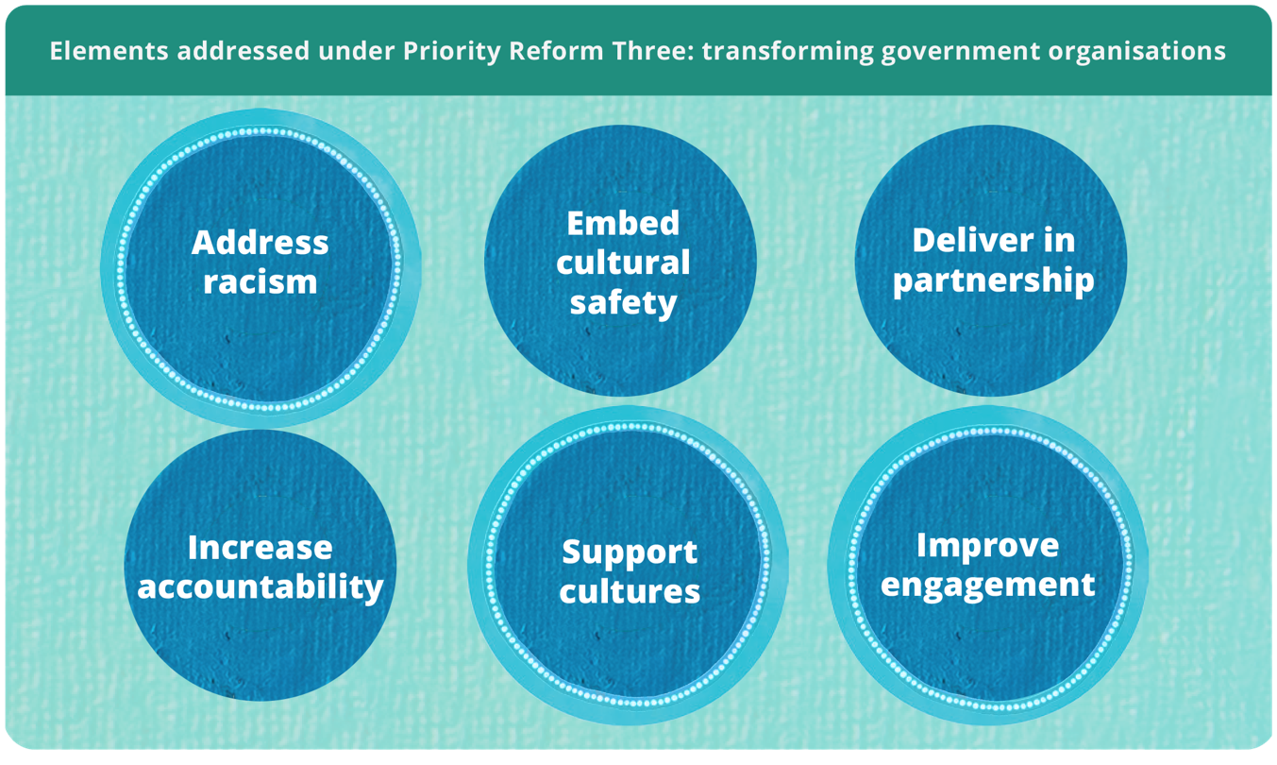

Supporting Aboriginal and Torres Strait Islander knowledges requires transforming research systems
Australia’s National Science Statement coordinates science policy, leadership and investment across governments to support innovation, economic growth and improved quality of life (DISR 2024b). A key research priority supporting the statement is elevating Aboriginal and Torres Strait Islander knowledge systems to drive innovation and ensure communities lead and benefit from research that impacts them (DISR 2024a). This requires embedding Aboriginal and Torres Strait Islander knowledges and perspectives across Australia’s science and research system. For the over 30 Australian government departments, agencies and regulators with a science capability, this means transforming research governance, funding, practices and workforce development to protect and elevate Aboriginal and Torres Strait Islander knowledges (Australian Government, Australia’s Chief Scientist 2024; DISR 2024a).
The way science is organised, governed and funded can encourage an approach to research that centres the interests of the scientist and reinforces siloed ways of working within established academic disciplines (DISR 2024b, p. 5). This privileges certain knowledges, knowledge holders and knowledge systems and discourages research collaboration and translation for community benefit (Woodward et al. 2020, p. 108). This case study shows how the Commonwealth Scientific and Industrial Research Organisation (CSIRO) is changing its ways of working to centre the knowledge and priorities of Aboriginal and Torres Strait Islander people, communities and organisations. CSIRO shows how government funded research institutes, in alignment with the National Agreement on Closing the Gap (the National Agreement), can value and support Aboriginal and Torres Strait Islander science and scientists.

Research with Aboriginal and Torres Strait Islander people must centre on community priorities and benefits
In 2019, at CSIRO, a group of Aboriginal and Torres Strait Islander scientists, along with non-Indigenous colleagues, saw a gap in the way research with Aboriginal and Torres Strait Islander communities was approached. They co-developed with an external Indigenous reference group, the case that CSIRO needed to move from a ‘science push’ approach where research is directed by a scientist’s key area of capability or scientific expertise, to an approach centred on community priorities and benefits. They proposed CSIRO leverage its unique position, capabilities, and infrastructure across science and industry to design a cross-cutting organisational approach to recognising, prioritising and responding to Aboriginal and Torres Strait Islander communities’ knowledge and interests.
Following the scientists’ successful pitch, the Indigenous Science and Engagement Program (ISEP) was established in 2021, with funding of $26 million over 5 years (2021–2026), to deliver a strategic, organisation-wide approach to partnering with Aboriginal and Torres Strait Islander communities and organisations (CSIRO 2024b, p. 13). ISEP shows the commitment of senior leaders to investing in transformed processes using internal funding and resources. In addition to core internal funding, ISEP activities have also been resourced through diverted funding, which required senior leaders to review CSIRO expenditure and make trade-offs from other business areas to prioritise investing in Aboriginal and Torres Strait Islander science capability.
To inform ISEP’s work, CSIRO engaged in deep listening, both internally and externally, to understand the tangible things CSIRO could do to value and support Indigenous science. Ideas shared in these engagements were used to develop a strategic approach to reform CSIRO’s research governance, engagement, funding, communications, and workforce to build capability to support Aboriginal and Torres Strait Islander-led and driven research solutions.

Embed Aboriginal and Torres Strait Islander knowledges through leadership and advisory groups
As outlined in the National Agreement, governance and leadership by Aboriginal and Torres Strait Islander people is critical to identifying and addressing systems that disadvantage Aboriginal and Torres Strait Islander communities, knowledges or perspectives (Australian Government 2020). To achieve this, CSIRO established Aboriginal and Torres Strait Islander leadership and advisory functions at each level of its governance structure to influence, review and dig deeper into their internal processes, practices and procedures. At the senior leadership level, Dr Chris Bourke, a Gamillaroi man and Director of CSIRO’s Indigenous Science and Engagement team is also the first Aboriginal member of CSIRO’s Leadership Team. In 2023, CSIRO appointed the first Indigenous scientist to its board: Professor Alex Brown from the Yuin Nation.
In 2013 the Indigenous Advisory Group (IAG) was formed to ensure CSIRO’s research and engagement addresses the challenges and aspirations of Aboriginal and Torres Strait Islander communities (CSIRO 2021, p. 6). The IAG provides CSIRO leadership with essential perspectives and understandings of the cultural, social and economic issues facing Aboriginal and Torres Strait Islander communities (CSIRO 2024c). The IAG has been instrumental in guiding the launching of initiatives like the Indigenous Research Grants and Graduate programs; programs that are designed to increase Aboriginal and Torres Strait Islander participation in science and research (CSIRO 2024c, p. 17).
In addition to the IAG at the organisational level, currently 40% of CSIRO’s Research Units have advisory groups with Aboriginal and Torres Strait Islander representation with relevant expertise (CSIRO 2024b, p. 22). Embedding Aboriginal and Torres Strait Islander representation within research advisory groups enables Indigenous voices, perspectives, and insights to inform CSIRO’s research work, particularly as it pertains to research collaborations and engagement with Aboriginal and Torres Strait Islander communities. This contributes to the development of the Unit’s cultural capability, which sets the tone for culturally respectful, appropriate, and safe engagement with Aboriginal and Torres Strait Islander people as both participants and collaborators.

Employment pathways support development of Aboriginal and Torres Strait Islander scientists
Strong Aboriginal and Torres Strait Islander leadership and governance relies on amplifying Indigenous voices, ensuring self-determination and creating a culturally safe and empowering workplace pathway for scientists and future scientists. Recognising this, CSIRO appointed an Indigenous Employment Lead in 2021 to:
- provide strategic direction and support for Aboriginal and Torres Strait Islander employment
- strengthen cultural safety across the organisation
- build pathways for leadership and career progression.
The Lead updated CSIRO’s Indigenous Employment Strategy to position CSIRO as an employer of choice for Aboriginal and Torres Strait Islander people, to strengthen retention, leadership and cultural safety across the organisation (CSIRO 2024a). This positions CSIRO as a national leader in Indigenous STEM capability and builds a pipeline that enables Aboriginal and Torres Strait Islander people to drive innovation for the nation.
The Indigenous Employment Lead works in close partnership with ISEP leadership to help shape CISRO Indigenous science capability. Together, they ensure Aboriginal and Torres Strait Islander scientists and research scientists are supported not only through employment pathways, but also through frameworks that recognise and elevate Indigenous Knowledges alongside Western science.
Aboriginal and Torres Strait Islander people bring unique capabilities to lead innovation for the nation drawing on Indigenous Knowledges that can shape new approaches to science, technology and community impact. However, Western systems of recognition often privilege doctorate qualifications as the gateway to senior roles, creating barriers for many Aboriginal and Torres Strait Islander people to obtain leadership positions. To address this, CSIRO, established the Research Development Graduate Program and Pre-Doctoral Fellowship program. This program provides Aboriginal and Torres Strait Islander participants with structured employment while undertaking Honours or Higher Degrees by Research (HDR). The Graduates and Fellows are allocated dedicated time to progress their studies while contributing to research-related activities as part of their teams.
Since its inception, the programs have engaged 40 Indigenous university graduates and supported 25 participants to undertake an Honours, Masters or HDR program as part of their placement with CSIRO (CSIRO, personal communication, 26 September 2025). Through these initiatives, CSIRO provides opportunities to increase the representation and leadership of Aboriginal and Torres Strait Islander scientists and research scientists for the nation.
The impact of this work can be seen in the growth of CSIRO’s Indigenous workforce. Since June 2021, Aboriginal and Torres Strait Islander staff have increased by 95% to make up 2.54% of the current workforce as at 30 June 2025 (CSIRO, personal communication, 26 September 2025).

Research grants must enable relationship building
Traditionally, research grants are structured to fund fully scoped research projects, with little opportunity to develop trust and build meaningful relationships with Aboriginal and Torres Strait Islander communities. The Indigenous Research Grants Program (IRG) was internally developed to guide and encourage CSIRO researchers to build relationships with Aboriginal and Torres Strait Islander communities and deliver research that addresses their priorities. All aspects of the program are Indigenous-led, from design and implementation to assessment and ongoing management. In its first year, the IRG Program completed three grant rounds, approving over 30 applications and allocating $6 million in funding (CSIRO 2024b, p. 40).
It is an expectation that an IRG project will be further scoped and co-designed with Aboriginal and Torres Strait Islander communities or organisations. These partnerships range across small-, medium- and large-scale multidisciplinary projects (CSIRO 2024b, p. 40). For example, one type of funding provided by the IRG Program is ‘exploratory funding’, which can be used by researchers to travel to communities to develop relationships and understand their needs. The prioritisation of benefit is also embedded within IRG funding applications; the CSIRO researchers are required to show through their budget and project plans how the benefit of research will stay with communities and how this reflects community’ priorities. At the time of application, researchers must have endorsement from communities confirming their support to work with the researcher.
IRG funding also supports capability building for Aboriginal and Torres Strait Islander businesses and communities. The funding enables businesses and communities to work on their own terms when partnering with CSIRO to develop critical projects that build skills, apply solutions, and create long-term economic opportunities that extend beyond the life of the funding. An independent review conducted in 2023 found that the program exemplifies best practice for grants where Aboriginal and Torres Strait Islander people are integral as participants and business partners. The review highlighted the program’s potential for far-reaching positive impacts on Indigenous science and engagements with CSIRO (CSIRO 2024b, p. 40).

Formal principles guiding research with Aboriginal and Torres Strait Islander communities build capability and protect community interests
CSIRO supports scientists to develop the skills, knowledge, attitudes and practices that enable respectful and effective engagement with Aboriginal and Torres Strait Islander communities and supports Aboriginal and Torres Strait Islander communities to partner meaningfully with CSIRO.
The elements of Free, Prior and Informed Consent (FPIC) are embedded at each stage of CSIRO’s research collaborations and partnerships, ensuring that communities set the terms of their engagement with CSIRO. FPIC is not merely informing and obtaining consent. It is about effective and meaningful participation to ensure the best decision-making for sustainable outcomes – this is especially important given that a focus of Aboriginal and Torres Strait Islander-led science is to have ongoing, long-term benefits for community (AIATSIS 2020).
The ISEP team are also focused on the delivery of CSIRO’s Reconciliation Action Plans. This includes building the capabilities of CSIRO people through CSIRO’s Cultural Capability Framework and ensuring CSIRO’s internal policies, systems and processes respond to the needs of Aboriginal and Torres Strait Islander people. In 2023, ISEP led the development of CSIRO’s Indigenous Cultural and Intellectual Property (ICIP) Principles which are now part of CSIRO governance processes.
To support science that is centred around community, ICIP Principles are also embedded through each stage of CSIRO’s research process. The principles are intended to support Aboriginal and Torres Strait Islander control, decision-making, governance, participation and collaboration in research. ISEP regularly reports to the IAG on performance against these principles. CSIRO works closely with research collaborators to ensure the principles reflect evolving standards for managing and protecting ICIP, and that engagement with communities aligns with best practice.
Intentionally building in space and time throughout the stages of engagement and partnership to include FPIC and ICIP ensures that partnerships are founded in mutual trust, respect and inclusion and are led by Aboriginal and Torres Strait Islander communities.

Changing the course in line with Priority Reform Three
CSIRO’s transformation journey, led by ISEP, has significantly reshaped research practices across the organisation. Through ISEP, CSIRO has moved beyond ad-hoc engagement to a model of established internal hubs, curated resources, and targeted education to embed Aboriginal and Torres Strait Islander perspectives into a wide variety of science partnerships funded by the organisation. These initiatives are not peripheral – they’re central to incorporating an Aboriginal and Torres Strait Islander lens across CSIRO’s standard operating procedures.
ISEP shows what it can look like when agency is given back to Aboriginal and Torres Strait Islander people and communities to set research priorities, lead decision-making, and define success on their terms.
This underscores the urgent need for all mainstream government organisations to align their practices with their commitments under the National Agreement. Doing so will support equitable inclusion in research policy, funding and design to deliver long-term economic benefit and outcomes to community.

References
AIATSIS 2020, Engaging with Traditional Owners.
Australian Government 2020, Closing the Gap, Priority Reform Three – Transforming Government Organisations, July.
Australian Government, Australia’s Chief Scientist 2024, Government Scientists Group.
CSIRO 2021, Reconciliation Action Plan December 2021 – December 2023.
—— 2024a, Aboriginal and Torres Strait Islander employment strategy.
—— 2024b, Indigenous Collaboration and Partnerships 2023-24.
—— 2024c, Stretch Reconciliation Action Plan, October.
DISR (Department of Industry Science and Resources) 2024a, Australia’s National Science and Research Priorities, 12 August.
—— 2024b, Australia’s National Science Statement, 12 August.
Woodward, E, Hill, R, Harkness, P and Archer, R 2020, Our Knowledge Our Way in caring for Country, NAILSMA and CSIRO.

ISEP changed their name on 29 July 2024 to ‘Indigenous Science and Engagement Office’ as part of the internal CSIRO Enterprise Services Reforms.

