NSW Closing the Gap budget submission:
a case study in co-developing budget proposals

Key points
- Aboriginal and Torres Strait Islander people are best placed to identify the needs and priorities of their communities, but budget decisions are largely made by governments.
- Working in partnership with Aboriginal and Torres Strait Islander people and organisations through shared governance structures, governments can share decision-making in budget development.
- With appropriate support, Aboriginal and Torres Strait Islander people and organisations can participate as equal partners in developing and prioritising business cases for budget submission.
- Budget processes present limits to shared decision-making that require active and sustained support from ministers, secretaries, and agency staff to create an authorising environment for collaborative budget development.
- To encourage collaborative policy and budget design processes as business-as-usual, governments should consider co-developing shared decision-making structures, updating submission guidance and increasing transparency in funding decisions and outcomes.
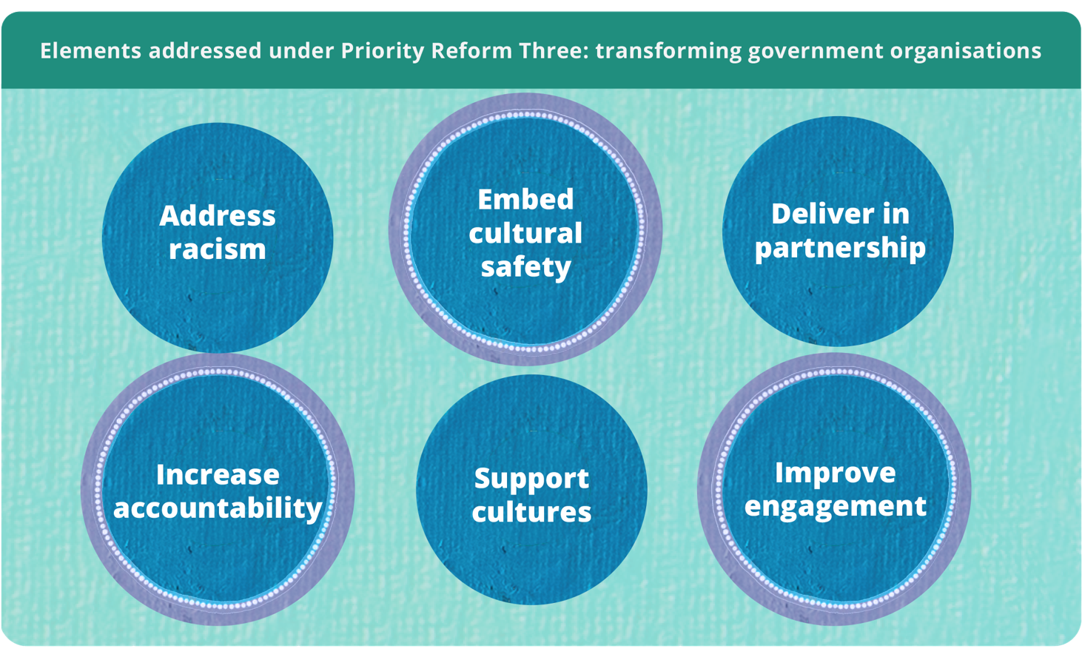

The need for collaborative policy design to inform budget decisions
Implementing the Priority Reforms of the National Agreement on Closing the Gap (the National Agreement) requires resolving a key tension. Aboriginal and Torres Strait Islander people are best placed to identify the needs and priorities of their communities yet funding decisions are made in internal, often confidential government processes and committees (PC 2024, p. 12). While community input is possible, final funding decisions ultimately rest with governments.
Alive to this challenge, the NSW Government, together with the NSW Coalition of Aboriginal Peak Organisations (NSW CAPO), has pursued a significantly different way of working under the National Agreement. Using Closing the Gap governance structures developed through their partnership, the NSW Premier’s Department (NSW PD) and NSW CAPO, with technical support from NSW Treasury, came together to co-design a Closing the Gap cross-portfolio submission approach for the 2022-23 NSW Budget. This resulted in $188.6 million in funding for 28 initiatives co-designed by NSW CAPO members and relevant agencies.
This model demonstrates how governments can adopt a coordinated partnership approach, embedding Aboriginal and Torres Strait Islander voices into policy design before proposals entered government budget processes. Aboriginal Affairs NSW (AANSW) and NSW CAPO revisited this model for a second cross-portfolio submission to the 2025-26 budget, with refinements made to the approach from lessons learnt from the 2022-23 process. To support collaborative processes like these across agencies, NSW Treasury introduced a suite of guidance under the First Nations Budget Model in 2024.

The policy design process was community initiated and
co-designed
The 2022-2024 NSW Closing the Gap Implementation Plan agreed to by NSW Government and NSW CAPO set out how both parties planned to meet commitments under the National Agreement (NSW Government 2022, pp. 26-127). In recognition of the need to work collaboratively to reflect the needs and priorities of Aboriginal and Torres Strait Islander communities, NSW PD and NSW CAPO agreed to develop a cross-portfolio Closing the Gap submission for the 2022-23 NSW Budget. The Minister for Aboriginal Affairs sponsored the approach and NSW Treasury provided technical guidance and support. Bringing together initiatives under a cross-portfolio submission helped advance Closing the Gap priorities. Developing the budget submission in partnership aligned the process with Priority Reform One and Priority Reform Three of the National Agreement.
Budget processes can be complex to navigate and aligning community input within government timeframes poses challenges. One challenge encountered in the 2022-23 NSW Budget cycle was the work of designing and implementing a new policy design process in less than six months (figure 1). This placed considerable demands on the time and resources for all involved and limited opportunities for deep engagement and decision-making. Even with the prior experience of the first iteration, this was also an issue for the 2025-26 budget submission. A key takeaway from this was to start submission planning earlier, allowing for at least a 10-month collaboration window rather than a six-month window.
Figure 1 – Timeline of the cross-portfolio Closing the Gap 2022-23 budget bidª
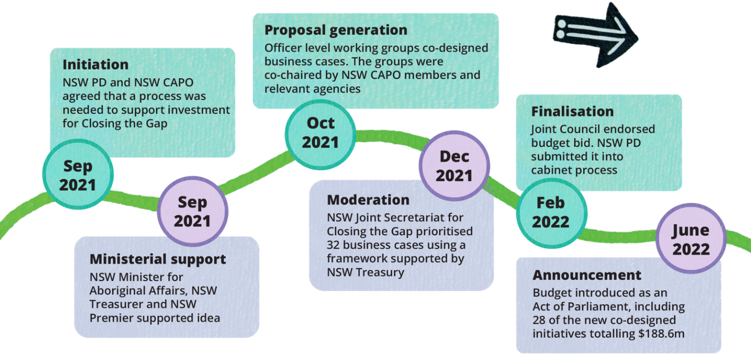
a. The process to feed into the 2025-26 budget followed a similar timeline.
Source: NSW Government (2023); NSW Treasury (personal communication, 5 August 2025).

Transformative changes aligned with Priority Reform Three

True co-design requires supporting partners to navigate government processes
In 2022-23, existing Closing the Gap governance structures in NSW were used to bring NSW CAPO members and relevant government departments together to develop and prioritise policy and program ideas for funding (figure 2). For the 2025-26 budget cycle, the process matured. Policy area-specific and officer-level working groups were replaced with five sector committees (Aboriginal Affairs NSW 2025). This ensured the membership contained the appropriate level of seniority. It also reduced siloes, bringing together related agencies and better suiting NSW CAPO partners. Sector committee co-chairs were also tasked with moderation and prioritisation processes.
A prioritisation framework was developed to ensure all business cases supported new ways of working in line with the NSW Government’s Priority Reform commitments. As a tool, it provided a transparent way of short-listing business cases based on how closely they aligned with the National Agreement. For the 2025-26 process, a probity advisor was present to oversee the policy prioritisation process, and the Prioritisation Framework was updated to include more detailed criteria. This ensured that business cases would comply with NSW Treasury evidence requirements.
While bringing together expertise from all parties is important, developing effective budget submissions requires specific skills and knowledge. For both the 2022-23 and 2025-26 processes, the lead agency (NSW PD and AANSW respectively) worked closely with NSW CAPO and its members to help navigate government processes and timeframes. In addition, NSW Treasury provided support in the form of presentations, guidance packs, business case templates and advice to support both NSW CAPO members and government staff to build understanding of the budget process and evidence requirements. These supports helped strengthen the capability of community partners to engage in the policy design process.
Figure 2 – Governance and supports for shared decision-making for 2025-26 budget
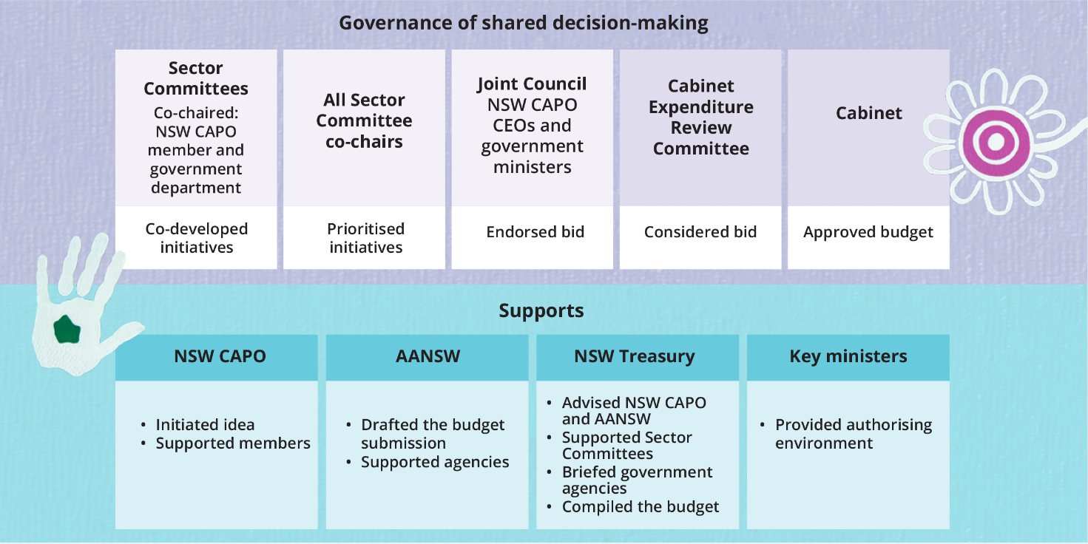
Source: Aboriginal Affairs NSW (pers. comm., 23 June 2025).

Budget processes present limits to shared decision-making that must be proactively managed
While NSW CAPO and the NSW Government made considered efforts at each stage of policy design to share leadership and decision-making, budget decisions are ultimately made by Cabinet, based on recommendations by the Cabinet Expenditure Review Committee. This highlights the tension between commitments to shared decision-making and the realities of government budget processes.
Support from ministers and secretaries provided an enabling authorising environment. Leadership from central agency teams – NSW Treasury, AANSW and the broader Premier’s Department, and the Cabinet Office – was key to the success of the collaborative policy development process in both the 2022-23 and 2025-26 cycles.
Collaborative working groups and effective communication are valuable for building support among senior government officials and ministers, helping to secure buy-in for new ways of working. However, as with any new process, there are barriers to navigate. To work through some of these, the 2025-26 process introduced measures to strengthen clarity, transparency and accountability. Partners set clearer expectations that only proposals developed through NSW’s Closing the Gap governance structures would be considered for the Closing the Gap budget submission. This helped distinguish Closing the Gap initiatives from other Aboriginal and Torres Strait Islander-specific funding proposals. Governance arrangements were also tightened to ensure all bids had co-sponsorship from both NSW CAPO and the NSW Government.
In addition, within the constraints of Cabinet-in-confidence, AANSW took an active role in keeping NSW CAPO informed, facilitating ministerial meetings ahead of Expenditure Review Committee discussions and sharing outcomes prior to public announcement. This shows that even within the constraints of government decision-making processes there are opportunities to strengthen transparency, accountability and collaboration with Aboriginal and Torres Strait Islander partners.

This experience has laid the foundation for a more collaborative budget
This case study demonstrates how governments can modify budget proposal development to align with the Priority Reforms. This is an ongoing transformation which relies on coordination and commitment over time rather than isolated trials. It benefits from the strengthened capacity, relationships and trust between the NSW Government and NSW CAPO that has developed through sharing power over policy and budget development.
The experience and learnings from these processes provide a foundation for future shared decision-making. NSW CAPO and NSW Government are now exploring how to develop an ongoing approach to partnership-based budget submissions, with the aim of embedding these practices into business-as-usual processes going forward.
To encourage this way of working across agencies, NSW Treasury officials are developing and implementing a ‘First Nations budget model.’ It intends to embed the Priority Reforms in the budget process. Under this model, several areas of change are underway.
- Evidence requirements. A NSW First Nations Investment Framework guides departments and agencies in working with Aboriginal and Torres Strait Islander people and communities to design, appraise and evaluate initiatives (NSW Treasury 2024b). The Framework provides guidance to agencies on embedding partnership-based approaches for policy design and lifting the quality and appropriateness of evidence.
- Budget processes and advice. First Nations Impact Assessments have been introduced in NSW for new policy proposals that are specific to, or have a significant or disproportionate impact on, Aboriginal and Torres Strait Islander people or communities (NSW Treasury 2024c). These assessments consider the extent to which Aboriginal and Torres Strait Islander voices have been included in the policy design and development. This informs the likely effectiveness of the proposal and supports more informed decision making.
- Transparency and reporting. NSW Treasury is delivering on its Closing the Gap commitment to better identify and more effectively report on Aboriginal and Torres Strait Islander-relevant expenditure. This includes improving data collection for the Indigenous Expenditure Report and publishing a map of capital expenditure in Local Aboriginal Land Council regions (NSW Treasury 2024a). These initiatives align with Priority Reforms Two, Three and Four by strengthening accountability to Aboriginal and Torres Strait Islander communities and building an evidence base for improved policymaking.

References
Aboriginal Affairs NSW 2025, NSW Closing the Gap Governance.
NSW Government 2022, 2022–2024 NSW implementation plan for Closing the Gap, NSW Government.
—— 2023, Submission to the Australian Government Productivity Commission review of the National Agreement on Closing the Gap, no. 32, Productivity Commission.
NSW Treasury 2024a, 2023-24 NSW Indigenous Expenditure Report, NSW Treasury.
—— 2024b, First Nations investment framework summary TPG24-28, NSW Treasury.
—— 2024c, TPG24-26 policy and guidelines: First Nations impact assessment policy, NSW Treasury.
PC (Productivity Commission) 2024, Review of the National Agreement on Closing the Gap, Study report, vol. 1, Canberra.

At the time, and until changes were made in mid-2023, the Premier’s Department was part of the Department of Premier and Cabinet. For consistency it is referred to as Premier’s Department throughout this document.

