Investing in transformative co-design processes:
South Australian Continuity of Care Protocols Program

Key points
- Genuine co-design can transform systems when agencies invest in relationships, formalise shared decision-making, and value lived experience and cultural authority.
- Building strong, trusted relationships is as important as securing funding or establishing appropriate governance.
- Funding partners to engage with their communities to develop and test reforms enables localised approaches and integration of cultural knowledge.
- Partnering at every stage of the commissioning cycle supports sustainable capacity building.
- Defining co-design with partners and formalising agreed ways of working upfront keeps government officials from slipping back to business-as-usual approaches. Delivering on these commitments builds the trust needed for genuine partnership.
- Effective co-design improves system coordination by deepening relational networks across sectors and fostering active community engagement.
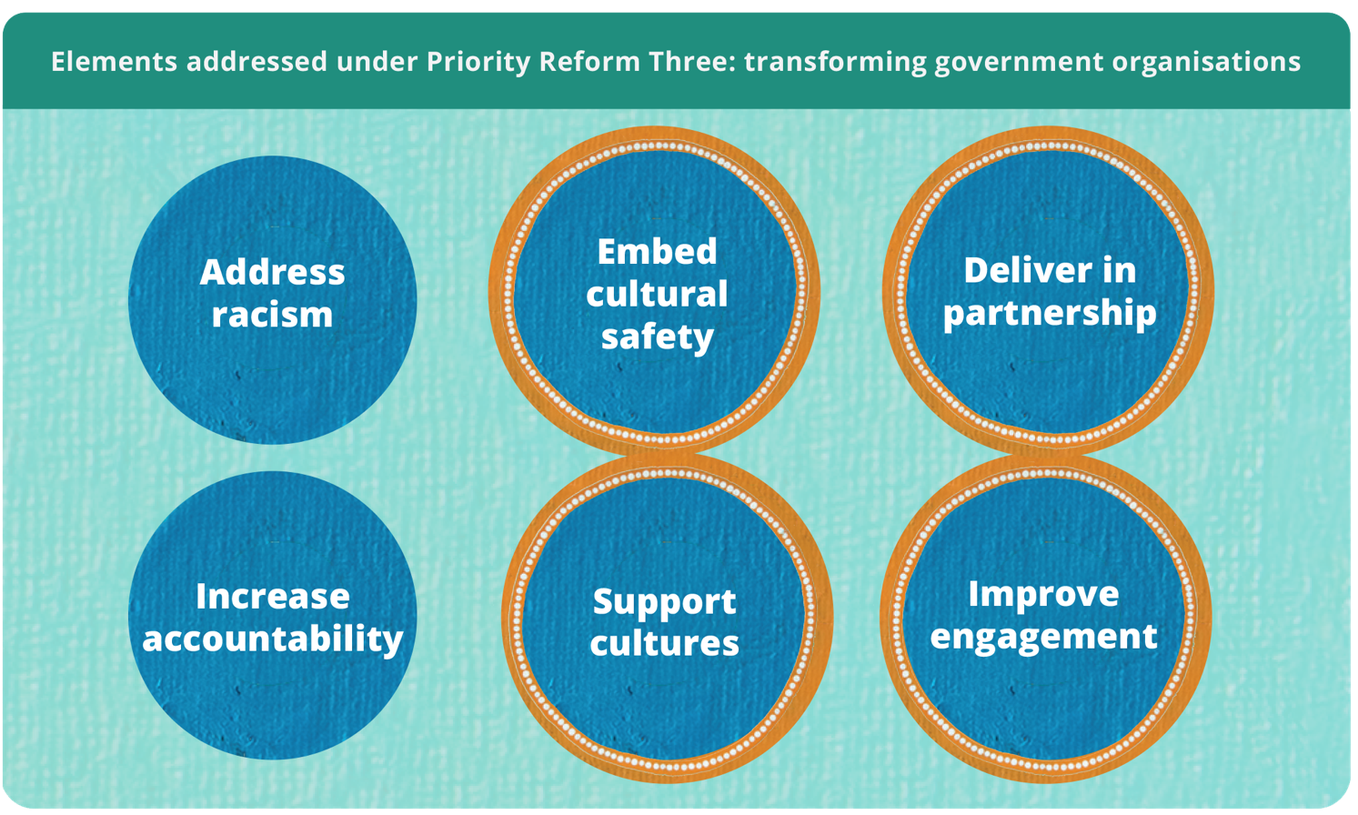

Co-design requires transformed ways of working
Good examples of policy and program co-design processes with Aboriginal and Torres Strait Islander people can be hard to find. The Productivity Commission’s first review of the National Agreement of Closing the Gap (2020) highlighted that governments have not yet fully grasped how to pursue the transformation of mainstream government organisations and services called for under Priority Reform Three (PR3) (PC 2024, p. 60). A practical place to start is by co-designing services and programs with the people they intend to reach.
This case study shows that when agencies invest in a relational approach and consciously embed shared decision-making into their practices, good co-design outcomes follow. At the centre of this case is a respect for lived experience and cultural knowledge and a commitment to working in partnership. It offers key learnings for public servants seeking to improve their design practices with partners.

Recognising the need and responding with purpose
The South Australian health system has historically struggled to meet the needs of Aboriginal mothers and families, leading to discontinuities of care (SAHMRI 2022, pp. 8, 9). In 2022, the Aboriginal Health Branch within the South Australian Department for Health and Wellbeing (DHW) was allocated $5 million to address the state’s priority of improving Aboriginal child and maternal health. Research highlighted a lack of trust, fragmented service delivery and institutional racism as key challenges across the South Australian health system (Health Performance Council [South Australia] 2020, pp. 5, 11; SAHMRI 2022, pp. 29, 60, 121). This directed DHW towards a need to improve coordination and continuity of care for Aboriginal children aged 0-4 and mothers of Aboriginal babies as the result of an inequitable and culturally unsafe health system.
With the support of the South Australian Health Minister, DHW prioritised a statewide co-design process to develop continuity of care protocols (CCPs) and associated reforms in partnership with Aboriginal community-controlled health organisations (ACCHOs), national peak bodies and local health networks (LHNs) (figure 1). Beyond service redesign, the funding aimed to support cultural and structural reform, build long-term relationships and improve system capacity within the South Australian health system. Co-design was an intentional response to PR3 to deliver services in partnership and improve engagement with Aboriginal and Torres Strait Islander people.
Figure 1 – Continuity of Care Protocols Program co-design theory of change
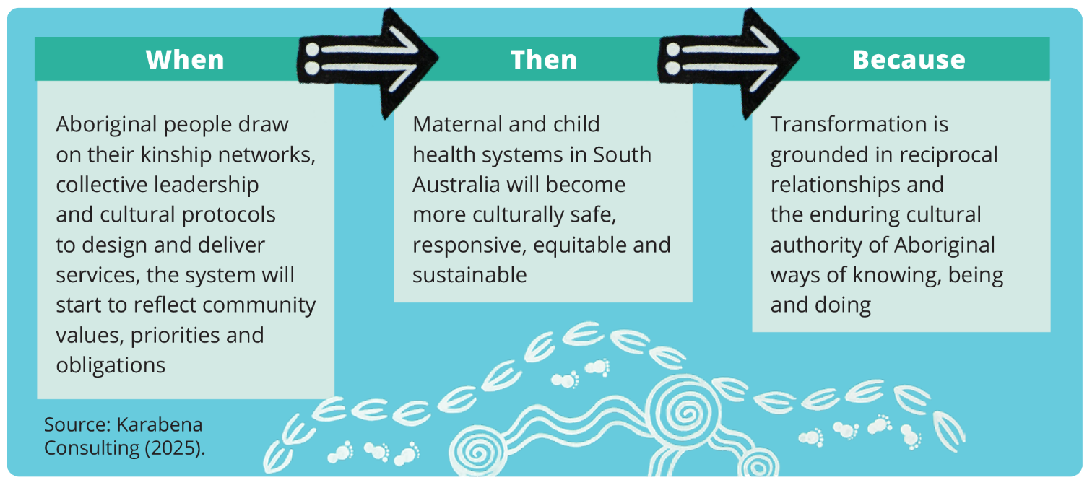
The process involved an initial research phase before moving into co-design. The co-design process involved three phases, from the drafting of protocols to testing in preparation for implementation (figure 2).
Figure 2 – Continuity of Care Protocols (CCP) co-design processª
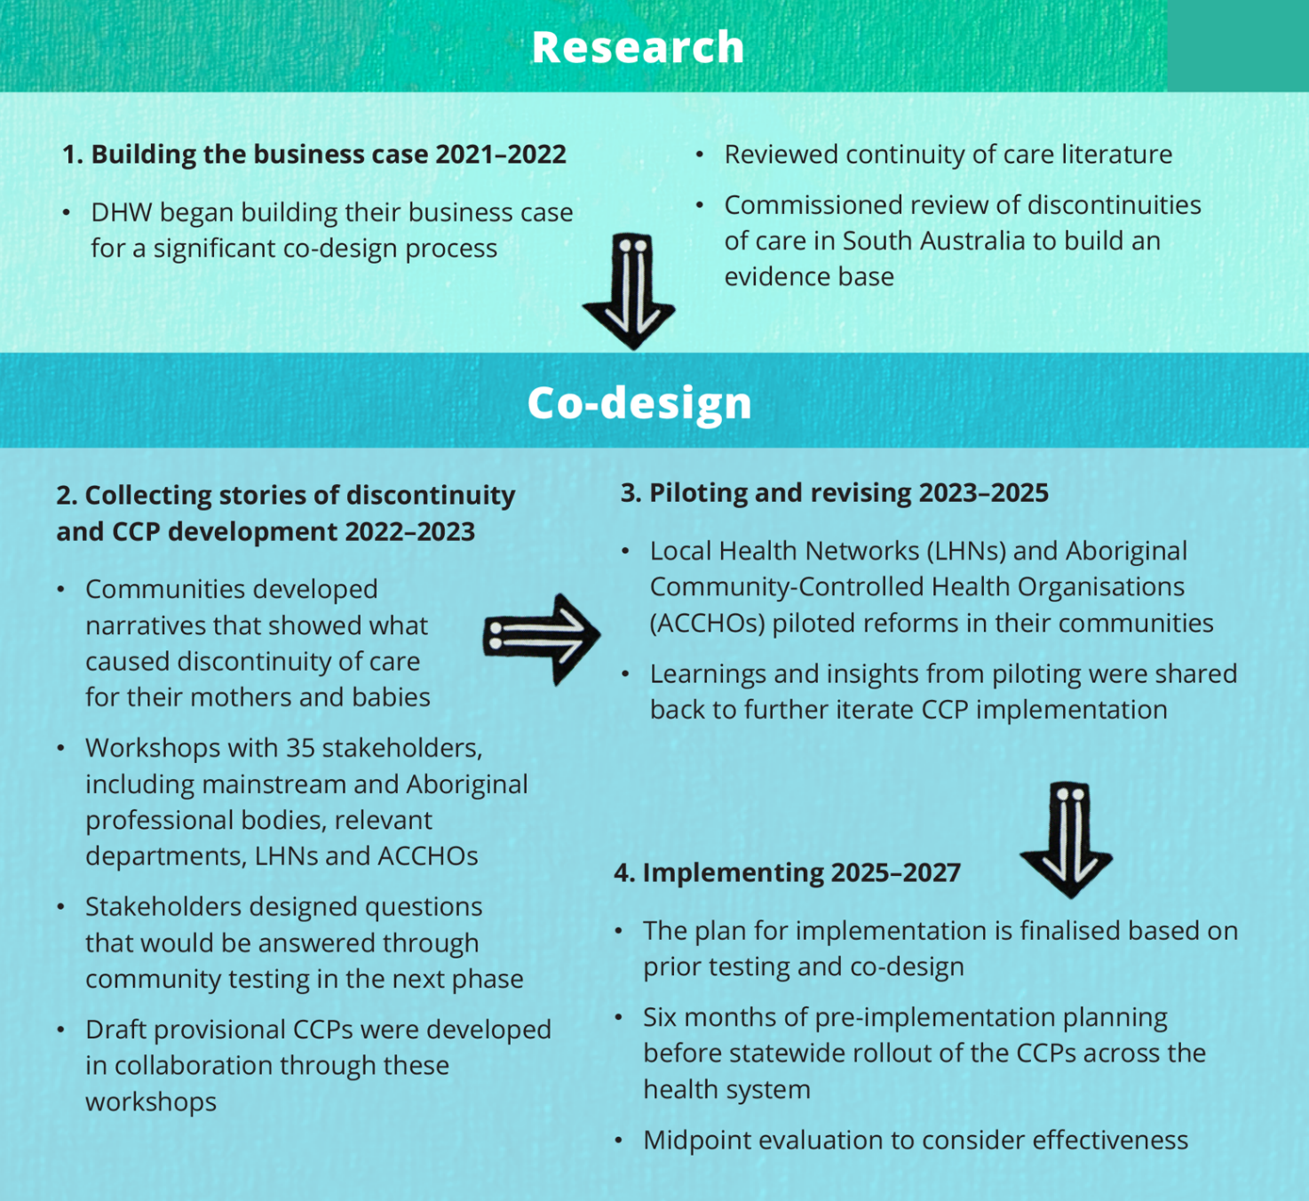
a. At the end of the second phase, a series of testing networks were established. Networks were made up of LHNs and ACCHOs and were used to test key reforms with their communities.
Source: Adapted from DHW (2025).

Transformative action aligned with PR3

Prioritising Aboriginal leadership ensures shared decision-making is grounded in culture
Clear governance is key to making co-design and its outputs effective and sustainable (Karabena Consulting 2024, p. 9). It helps balance power, ensures the right people are in the room to advance effective reform, and enables local decision-making.
During the CCP development phase, DHW worked with over 35 national and state-based stakeholders to develop a set of questions that would form the basis of reforms tested within Child and Maternal Health CCP networks. The 35 stakeholders were consulted during this time to inform the development of provisional CCPs.
After this phase concluded, DHW identified five out of the 10 South Australian LHNs, together with ACCHO representatives from the South Australian West Coast ACCHO Network, Nunkuwarrin Yunti of South Australia, and Pangula Mannamurna Aboriginal Corporation, to partake in the co-design process. These organisations were selected to ensure protocols were tested in a variety of settings, based on maternal and child population data, level of remoteness, and where partnerships existed between LHNs and ACCHOs. These same organisations were funded to test reforms with their community and formed the membership of the seven working groups, each led by an Aboriginal chairperson. Sector experts involved included:
- The National Association of Aboriginal and Torres Strait Islander Health Workers and Practitioners (NAATSIHWP)
- The Congress of Aboriginal and Torres Strait Islander Nurses and Midwives (CATSINaM)
- The Australian Indigenous Doctor’s Association (AIDA)
- The Aboriginal Health Council of South Australia (AHCSA).
The program, including the working groups, were intentionally designed to enable sustainability. Through the leadership and decisions of the seven working groups, reforms were aimed at improving the system while ensuring Aboriginal leadership and culture were embedded at every level.
In the CCP Program, enabling shared decision-making initially proved challenging. Seven working groups were authorised to make decisions on the design of the program, but final sign-off still sat with the Steering Group. The Steering Group was made up of system leaders from across sectors, including partner organisations. Members were recommended by the Chief Aboriginal Health Officer and by key stakeholders involved in the development phase. This structure posed a risk to co-design as Steering Group members had the opportunity to overrule working group decisions, which were based on community insights. The risk was managed by having consistent membership between the working groups and Steering Group. This was often in the form of working group chairpersons or the DHW Program Manager who had oversight of all working groups. As a result, decisions presented to the Steering Group were contextualised and understood. DHW acknowledged that while the approach to power sharing was not perfect, it provided an opportunity for learning and improvement in shared decision-making.

A relational approach to commissioning supports capacity-building and a focus on outcomes
A relational approach that values and enables partner expertise is foundational for co-design (Karabena Consulting 2025b, p. 10). This means embedding partnership at each phase of the commissioning process: co-designing agreements, building partner capacity, developing meaningful reporting templates and managing progress together. In this case, partner organisations were contracted to engage with their communities to understand where challenges existed in accessing continuous care, test and pilot key reforms, share community feedback in working groups and endorse decisions that reflected their community’s experiences.
The contracting process emphasised a relational approach over a transactional one. DHW spent two months co-designing an approach with partners prior to the piloting phase starting. This time was spent identifying which of the testing questions partners were going to explore with their communities. Once focus areas were identified, officials from DHW provided their partners with control over how they participated and their agreement design. They started by asking partners ‘what do you need?’ rather than pushing a template approach. Partners recognised and valued the shift in government practice – from being told what resources they would receive to being asked what is needed.
DHW also asked whether partners would like to participate in the working groups as a member, lead or a chairperson. Where particular expertise was recognised, DHW invited individuals to contribute as a chairperson. Partners ultimately controlled the role they had in the process and led talks on the resources they needed and what mattered most to their community. Partners also defined their own measures of success centred on participation (Karabena Consulting 2025a, p. 8). While some outcomes informed program monitoring and evaluation, others were relational in nature, reflecting shared goals rather than contractual obligations.
Together, these measures signalled a shift away from compliance-based performance indicators towards culturally meaningful outcomes, including increased trust, continuity of care and emotional and cultural safety. For DHW, this required them to slow down, listen and let go, marking a significant cultural shift within government. Agreements also included responsibilities for DHW, providing accountability for the commitment to work as partners to co-design reforms. Reporting templates were co-designed, turning agreements into tools for shared responsibility rather than compliance. Flexible agreements reduced metrics of activity-based funding and instead moved to shared accountability based on an agreed set of shared outcomes.
Guided by senior Aboriginal leaders within, DHW staff took a patient, side-by-side approach to progressing the design of the CCP Program. Staff supported partners to navigate government processes, develop project plans and manage underspends. Consistent with this partnership approach, progress discussions were seen as a collaborative effort and focused on what could be achieved together. This reinforces shared accountability and a commitment to walking alongside partners every step of the way. Partners reflected that DHW understood the need to ‘be uncomfortable, slow down and do the right thing, not the easiest thing’ (Karabena Consulting 2025b, p. 10).

Building and maintaining a culture of co-design grounded in Aboriginal methodology
For Aboriginal partners, co-design is a natural way of working (Karabena Consulting 2025b, p. 11). For governments, clear and shared definitions are needed. DHW and partners define co-design as ‘coming to Community from the start to identify issues, solutions and ways of working together. It’s not about government doing something for and to community. It’s an Aboriginal way of working’ (DHW 2025). The practice of co-design was firmly grounded in Aboriginal ways of knowing, being and doing. Cultural practices including Yarning, Dadirri, art and ceremony were central to the design process and embedded at every stage. DHW’s definition provides clarity and trust by reinforcing that co-design is more than partnership – it is about grounding it in Aboriginal methodology.
Without a shared definition, co-design can mean different things to people (Karabena Consulting 2024, p. 2). Early in the CCP Program, DHW staff saw that government voices were unintentionally dominating, limiting space for community leadership. To address this, DHW actively checked in with quiet working group members to understand why they weren’t speaking. A relational approach was taken to reassure members that their contributions were valued, remind them of the expertise they bring, and to encourage knowledge sharing. The trusted relationships built were a key enabler of success in this process and considered just as important as governance and contracts. However, even with strong relationships in place, the practicalities of how roles and responsibilities were shared were not always well defined. In response, partners created a ‘Ways of Working’ document to embed co-design into actions, ensuring that Aboriginal voices were amplified at every level. This included a commitment to Aboriginal and Torres Strait Islander chairpersons for all working groups and clear processes for shared decision-making. These practices strengthened cultural leadership within the system and marked an important shift from talking about co-design to actively practicing it. The document helps keep government accountable from slipping back into a business-as-usual approach.

Co-design is reshaping the South Australian health system
Co-designing the CCP Program has been called a ‘quiet revolution’ (Karabena Consulting 2025b, p. 11). What began as a response to gaps in care for mothers and Aboriginal babies has grown into a model of ongoing co-design that will be embedded into future maternal and child health policy planning and investment frameworks in South Australia (Karabena Consulting 2025b, p. 13).
In 2024, DHW commissioned an independent evaluation of the co-design process. Crucially, evaluation scope and brief were also co-designed with partners to focus on their areas of interest, reinforcing accountability and trust amongst partners. The evaluation has been an important tool for DHW staff and partners to reflect on strengths and areas for improvement within the co-design process. The evaluation found that the design process has helped to build a connected network of senior leaders from community, ACCHOs, mainstream health services, government and peak bodies across South Australia. The evaluation also found that the co-design process has increased the level of coordination across the state that will endure beyond the program, while also strengthening cultural leadership, agency and voice. Partners now see an opportunity for embedding and expanding this design model into other parts of the South Australian health system (Karabena Consulting 2025b, p. 13).
While broader health outcome data is still emerging, early results show promise. Aboriginal mothers and families have expressed feeling heard and empowered through CCPs shaped by cultural knowledge holders (Karabena Consulting 2025b, p. 11). The case shows how a series of deliberate steps taken in partnership can lay the groundwork for long-term, Aboriginal-led, systemic transformation.

References
DHW 2025, ‘Interview on the South Australian Continuity of Care Protocols Program’.
Health Performance Council [South Australia] 2020, Institutional racism – audit of South Australia’s local health networks.
Karabena Consulting 2024, South Australia Department of Health and Wellbeing Maternal and Child Health Evaluation Co-Design and Data Dictionary: A Living Document.
—— 2025a, Co-Design Program Logic.
—— 2025b, Outcomes Report: End-of-Phase Forum – Aboriginal-led Co-Design in Maternal and Child Health, South Australia, June.
PC (Productivity Commission) 2024, Review of the National Agreement on Closing the Gap, Study Report, vol. 1, Canberra.
Reid, R, Haggerty, J and McKendry, R 2002, Defusing the Confusion: Concepts and Measures of Continuity of Healthcare, March.
SAHMRI (South Australian Health and Medical Research Institute) 2022, Systems change to improve Aboriginal and Torres Strait Islander maternal and child health continuity of care in South Australia.

Continuity of care is defined by how a person experiences their care over time as coherent and connected, resulting from effective information flow, strong interpersonal relationships, and well-coordinated services (Reid et al. 2002).

