Source: ABS (2025c) Australian National Accounts: National Income, Expenditure and Product, September 2025.

Update from Alex Robson
Deputy Chair, Productivity Commission

Update from Alex Robson, Deputy Chair, Productivity Commission
While we are beginning to see green shoots of improvement, labour productivity is still much lower than we would like it to be.
Labour productivity increased by 0.2% in the September quarter and by 0.8% over the year to September 2025. The good news is we have now observed four consecutive quarters of labour productivity growth since last September. But the bad news is the growth is quite small – 0.8% since last September still means growth is less than half its long-term average. This kind of increase won’t give us the long-term benefits we know are possible from productivity growth.
Digging a little deeper, we can see that labour productivity in the market sector has grown by 1.0% over the past 12 months, while labour productivity in the non-market sector has shrunk by 0.3%. The non-market sector, broadly defined as those industries that are dominated by government involvement, has tended to have lower growth in labour productivity than the market sector. However, new data released by the ABS last quarter suggests that this has not always been the case.
In this bulletin’s feature article, research economists Archana Subramaniam and Billy Morton find that, unfortunately, unpacking these numbers does not reveal a lost secret to non-market sector labour productivity growth. Instead, it highlights the challenges of measuring productivity in the non-market sector.
This uncertainty doesn’t reduce the need for reform in the non-market sector. In the interim report of our Delivering quality care more efficiently inquiry, we presented three productivity-enhancing policy reform areas for the care economy (a large portion of the non-market sector): reforming quality and safety regulation to support a more cohesive care economy; embedding collaborative commissioning to increase the integration of care services; and creating a national framework to support government investment in prevention.
However, policymakers should not evaluate the performance of the non-market sector on its productivity record alone. As Archana and Billy explain: ‘to fully observe [productivity] gains, we’ll need better measures that account for quality and outcomes. In the meantime, policymakers need to understand and communicate the data limitations, consider complementary measures of success in the non-market sector and conduct rigorous cost-benefit analysis to pursue good policy – even if the benefits don’t always show up directly in the national accounts.’

Labour productivity in the non-market sector: can we learn from the past?
By Archana Subramaniam and Billy Morton, Research Economists
The non-market sector is made up of industries that are dominated by government involvement – public administration and safety, education and training, and health care and social assistance. Measured labour productivity in the non-market sector has been stagnant for a number of years, contributing to our overall productivity malaise (Kehoe and Karp 2025; Wilson 2025). The recent sharp decline in non-market sector productivity has shifted the spotlight to this sector.
However, new data from the ABS shows that in contrast to the recent experience, labour productivity has in the past grown at a healthy pace in the non-market sector – by 11% between 1995 and 2000, and by 6% in the next ten years before stagnating (figure 1).
Unfortunately, unpacking these numbers does not reveal a lost secret to non-market labour productivity growth. Instead, it reminds us that in the non-market sector, caution is required when it comes to interpreting the numbers. Policy reform in the non-market sector remains vital, but existing measures of non-market sector productivity are not always a reliable guide to good policy.
Figure 1 – Non-market labour productivity has grown in the past
Annual non-market labour productivity, 1995–2024
Source: PC estimates using ABS (2025b, 2025d).

Measurement challenges in the non-market sector
The non-market sector is essential to society but tends to have lower measured labour productivity than industries in the market sector. This is because the sector is usually relatively labour-intensive, subject to fewer competitive pressures, provides many services at zero cost to the user, is often owned, organised or heavily regulated by government, and can often prioritise broad social objectives. To dig a bit deeper into what is driving changes in non-market sector productivity, it helps to look at each industry separately (figure 2).
Figure 2 – Two key industries supported non-market labour productivity growth
Industry decomposition of non-market labour productivity growth over 5-year intervals
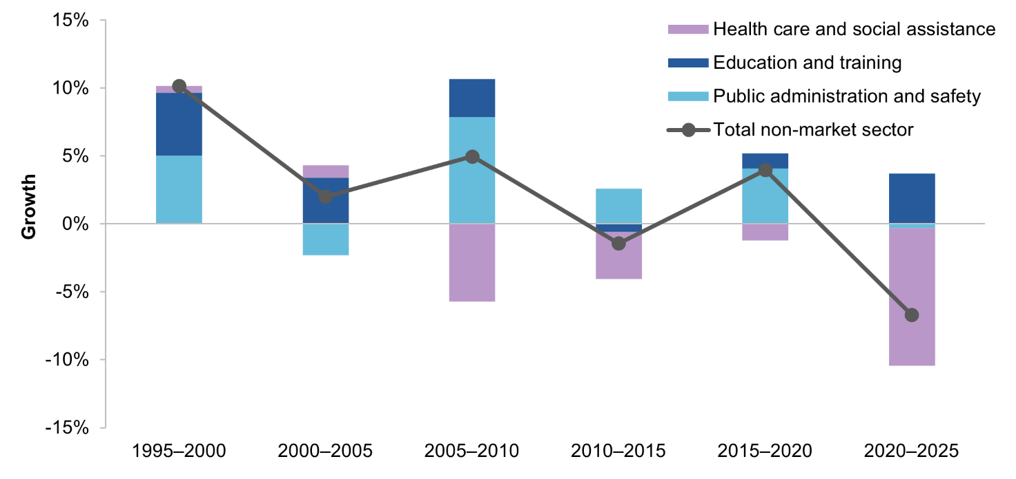
Source: PC estimates using ABS (2025b, 2025d).
To make meaningful policy decisions, we need to be confident the data is showing us what we expect to see. But the measurement challenges in the sector are significant enough to give us pause.
Firstly, it is important to understand the value of output in the non-market sector. In the market sector, we measure the value of output by multiplying market prices by quantity produced. But prices don’t have the same meaning in the non-market sector, as government support can keep them artificially low (often zero). It means our measure of the value of output can be flawed – and it is difficult to know how productive an industry is when we don’t have a good idea of the value of how much is being produced.
Second, in the non-market sector improvements in quality are often not reflected in measured productivity data. This really matters when we think about the role of reforms, as many policy changes likely have meaningful quality impacts that aren’t being fully captured in the productivity data. For example, introducing a mandatory minimum number of minutes staff need to spend with each resident in residential aged care was intended to improve service quality by increasing the staff time available to residents. But without accounting for the quality of service, this will look like the sector is becoming less productive, as output remains unchanged while hours worked increase. Similar considerations arise in the school education sector with respect to student-teacher ratios.
Third, people cannot opt out of consuming certain non-market sector goods and services, like national security or public policy development. When outputs are ‘collectively consumed’ in this way, their value become even harder to measure, as there may be no volume or quantity indicators that can be used to compare increased output levels over time.

The data highlights further gaps in understanding
Our analysis illustrates the difficulties of interpreting non-market sector productivity data. While measured non-market sector productivity growth grew significantly in the late-90s and between 2005–2010 (figure 2), we can’t exactly say why.

Public administration and safety was the key driver of productivity growth – but there is not much we can learn
One difficulty with interpreting historical growth is that it was mostly driven by productivity growth in the public administration and safety sector. Not only can we not reliably measure the price of outputs in this sector, we also cannot measure their quantity. This is partly because many of the services in this industry, like policy making and emergency services, are collectively consumed. But there are deeper conceptual issues at play as well. Are lawmakers more productive if they pass more laws? Are fire services more productive if they put out more fires, if they prevent more fires or something else?
In some cases, private sector comparators may provide objective yardsticks to measure productivity and performance in certain parts of this sector (for example, public sector consultancies). However, such comparators may not be widely available in other parts of the sector (such as fire and emergency services).
On the one hand, it is likely that the market-oriented reforms of the 1990s produced efficiency gains in this sector. The establishment of the Council of Australian Governments in 1992 led to the introduction of financial management frameworks into the Australian public service and regular output and outcome reporting. Additionally, the role of central agencies was reduced, with individual departments and agencies assuming greater responsibility (Halligan 2013). These reforms aimed to increase competition, decentralisation, and efficiency across the public service, which may have contributed to productivity improvements.
On the other hand, the lack of quantity measures mean that we cannot conclude with any confidence that these reforms necessarily led to changes in measured productivity without further detailed analysis.

Reforms may have driven productivity growth in education and training
In contrast, measures of quantity in parts of the education and training sector allow us to trace some of the measured productivity growth between 1995 and 2005 to specific significant reforms. These improvements relate to improved efficiency in service delivery but do not capture changes in quality.
The Dawkins reforms (announced in 1988) were framed as an attempt to transition Australia’s higher education system towards ‘mass education’. The reforms encouraged greater efficiency by enhancing competition, and taking advantage of economies of scale as the enrolments ballooned (Dawkins and Department of Employment, Education and Training 1988; DoE 2001, p. 5, 2008, p. 6). The supply of places was further expanded by the introduction of full fees for international students, which meant universities were incentivised to offer more places and enrolments of international students increased more than 5-fold from 1995 to 2005 (PC estimate based on DoE (2001, p. 36, 2008, p. 6)).
The formation and rollout of a national vocational education and training (VET) system in the 1990’s may have also been a factor in this industry’s measured labour productivity growth. A national intergovernmental agreement for VET, the Australian National Training Authority agreement, was formed in 1992 and sought to bring greater alignment between state and territory systems. At this time, VET rapidly moved towards a market-oriented, industry-led system (Dumbrell 2004).
These reforms – which increased competition and enrolments – are likely to have led to more efficient delivery of university and VET, helping to raise measured productivity.

Reforms in healthcare and social assistance industry may have led to a decline in labour productivity – but this doesn’t mean they were bad reforms
The lessons we can learn from the healthcare and social assistance industry differ again. While measured labour productivity may be declining (by 2.8% since 2010), these figures need to be considered alongside the sector’s evolving demands and unmeasured changes to care quality.
The healthcare industry has been the single biggest contributor to Australia’s measured productivity decline. In the past 30 years, the industry has expanded rapidly but this growth has not been matched by an equivalent rise in measured output. But there are two caveats to these statistics.
First, it is worth noting that the expansion of this sector has been critical in meeting the changing care needs of the Australian population. Over this period, our population has continued to age, female labour force participation has increased (contributing to demand for childcare), chronic disease has become more common and demand for health and social assistance services has risen. The expansion of the healthcare and social assistance industry is not unique to Australia. As countries become wealthier, they tend to demand more and better healthcare and social assistance services. Even as the labour-intensive nature of the industry means that these services become more costly in relation to goods and services produced elsewhere in the economy, societal demand continues to rise – reflecting the higher value that people place on such services.
Second, the quality measurement challenge is pronounced in the healthcare sector. Policy such as minimum aged care minutes or ECEC ratios prioritise improving service quality and consumer safety over output. By failing to include these in measured output, reforms in this area look a lot worse than they are. For example, the PC found that when adjustments are made for quality changes, multifactor productivity for a subset of health conditions (that accounted for about one third of healthcare spending) is estimated to have grown by an annual rate of 3% between 2011-12 and 2017-18 (PC 2024).
The sector’s productivity can be improved through good policy. The PC’s recent interim report on Delivering quality care more efficiently presented three productivity-enhancing policy reform areas: reforming quality and safety regulation to support a more cohesive care economy; embedding collaborative commissioning to increase the integration of care services; and creating a national framework to support government investment in prevention (PC 2025).

Proceed with caution
Ultimately, the lesson for policy makers is that we cannot evaluate the non-market sector on its productivity record alone. Productivity growth in the non-market sector remains an important goal to pursue – policies that deliver better outcomes with greater efficiency will benefit taxpayers and help people access better and more non-market services. But to fully observe these gains, we’ll need better measures that account for quality and outcomes. In the meantime, policymakers need to understand and communicate the data limitations, consider complementary measures of success in the non-market sector (for example, outcomes reported in the Report on Government Services (SCRGSP 2024)), and conduct rigorous cost-benefit analysis to pursue good policy – even if the benefits don’t always show up directly in the national accounts.

References
ABS (Australian Bureau of Statistics) 2025a, A primer on labour productivity, https://www.abs.gov.au/articles/primer-labour-productivity (accessed 5 December 2025).
—— 2025b, Australian National Accounts: National Income, Expenditure and Product, June 2025.
—— 2025c, Australian National Accounts: National Income, Expenditure and Product, September 2025, Australian Bureau of Statistics, https://www.abs.gov.au/statistics/economy/
national-accounts/australian-national-accounts-national-income-expenditure-and-product/latest-release (accessed 3 December 2025).
—— 2025d, Labour Account Australia, June 2025.
Dawkins, J and Department of Employment, Education and Training 1988, Higher education: a policy statement, July, Australian Government Public Service, Canberra, https://nla.gov.au/nla.obj-2518053881 (accessed 28 November 2025).
DoE (Department of Education) 2001, Higher Education Students Time Series Tables Selected Higher Education Statistics 2000, https://www.education.gov.au/higher-education-statistics/resources/time-series-data-1949-2000 (accessed 5 December 2025).
—— 2008, Students: 2008 Summary of Higher Education Statistics, https://www.education.gov.au/higher-education-statistics/resources/time-series-data-2003-2008 (accessed 5 December 2025).
Dumbrell, T 2004, Resourcing vocational education and training in Australia, National Centre for Vocational Education.
Halligan, J 2013, ‘Reform of Public Sector Governance in Australia’, presented at Towards a comprehensive reform of public governance, Lisbon.
Kehoe, J and Karp, P 2025, ‘Government and NDIS jobs boom drags down productivity, Treasurer Jim Chalmers warned’, Australian Financial Review, https://www.afr.com/policy/
|economy/productivity-dragged-down-by-government-ndis-jobs-boom-20250715-p5mf4f (accessed 25 November 2025).
PC (Productivity Commission) 2024, Advances in measuring healthcare productivity, Research paper, Canberra.
—— 2025, Delivering quality care more efficiently, Interim report, August.
SCRGSP (Steering Committee for the Review of Government Service Provision) 2024, Report on Government Services 2024, Productivity Commission, Canberra.
Wilson, J 2025, Research Note: Unpacking Australia’s poor productivity performance, https://www.australianindustrygroup.com.au/resourcecentre/research-economics/economics-intelligence/2025/unpacking-australias-poor-productivity-performance/ (accessed 25 November 2025).

© Commonwealth of Australia 2025
An appropriate reference for this publication is: Productivity Commission 2025, Quarterly productivity bulletin – December 2025, PC productivity insights, Canberra.
Publication enquiries: phone 03 9653 2244 | email : publications@pc.gov.au
www.pc.gov.au

In some parts of the non-market sector, the ABS uses relative production costs in an attempt to measure changes in quality but this can fail to capture changes to quality and outcomes (ABS 2025a; PC 2024, pp. 8–9).

