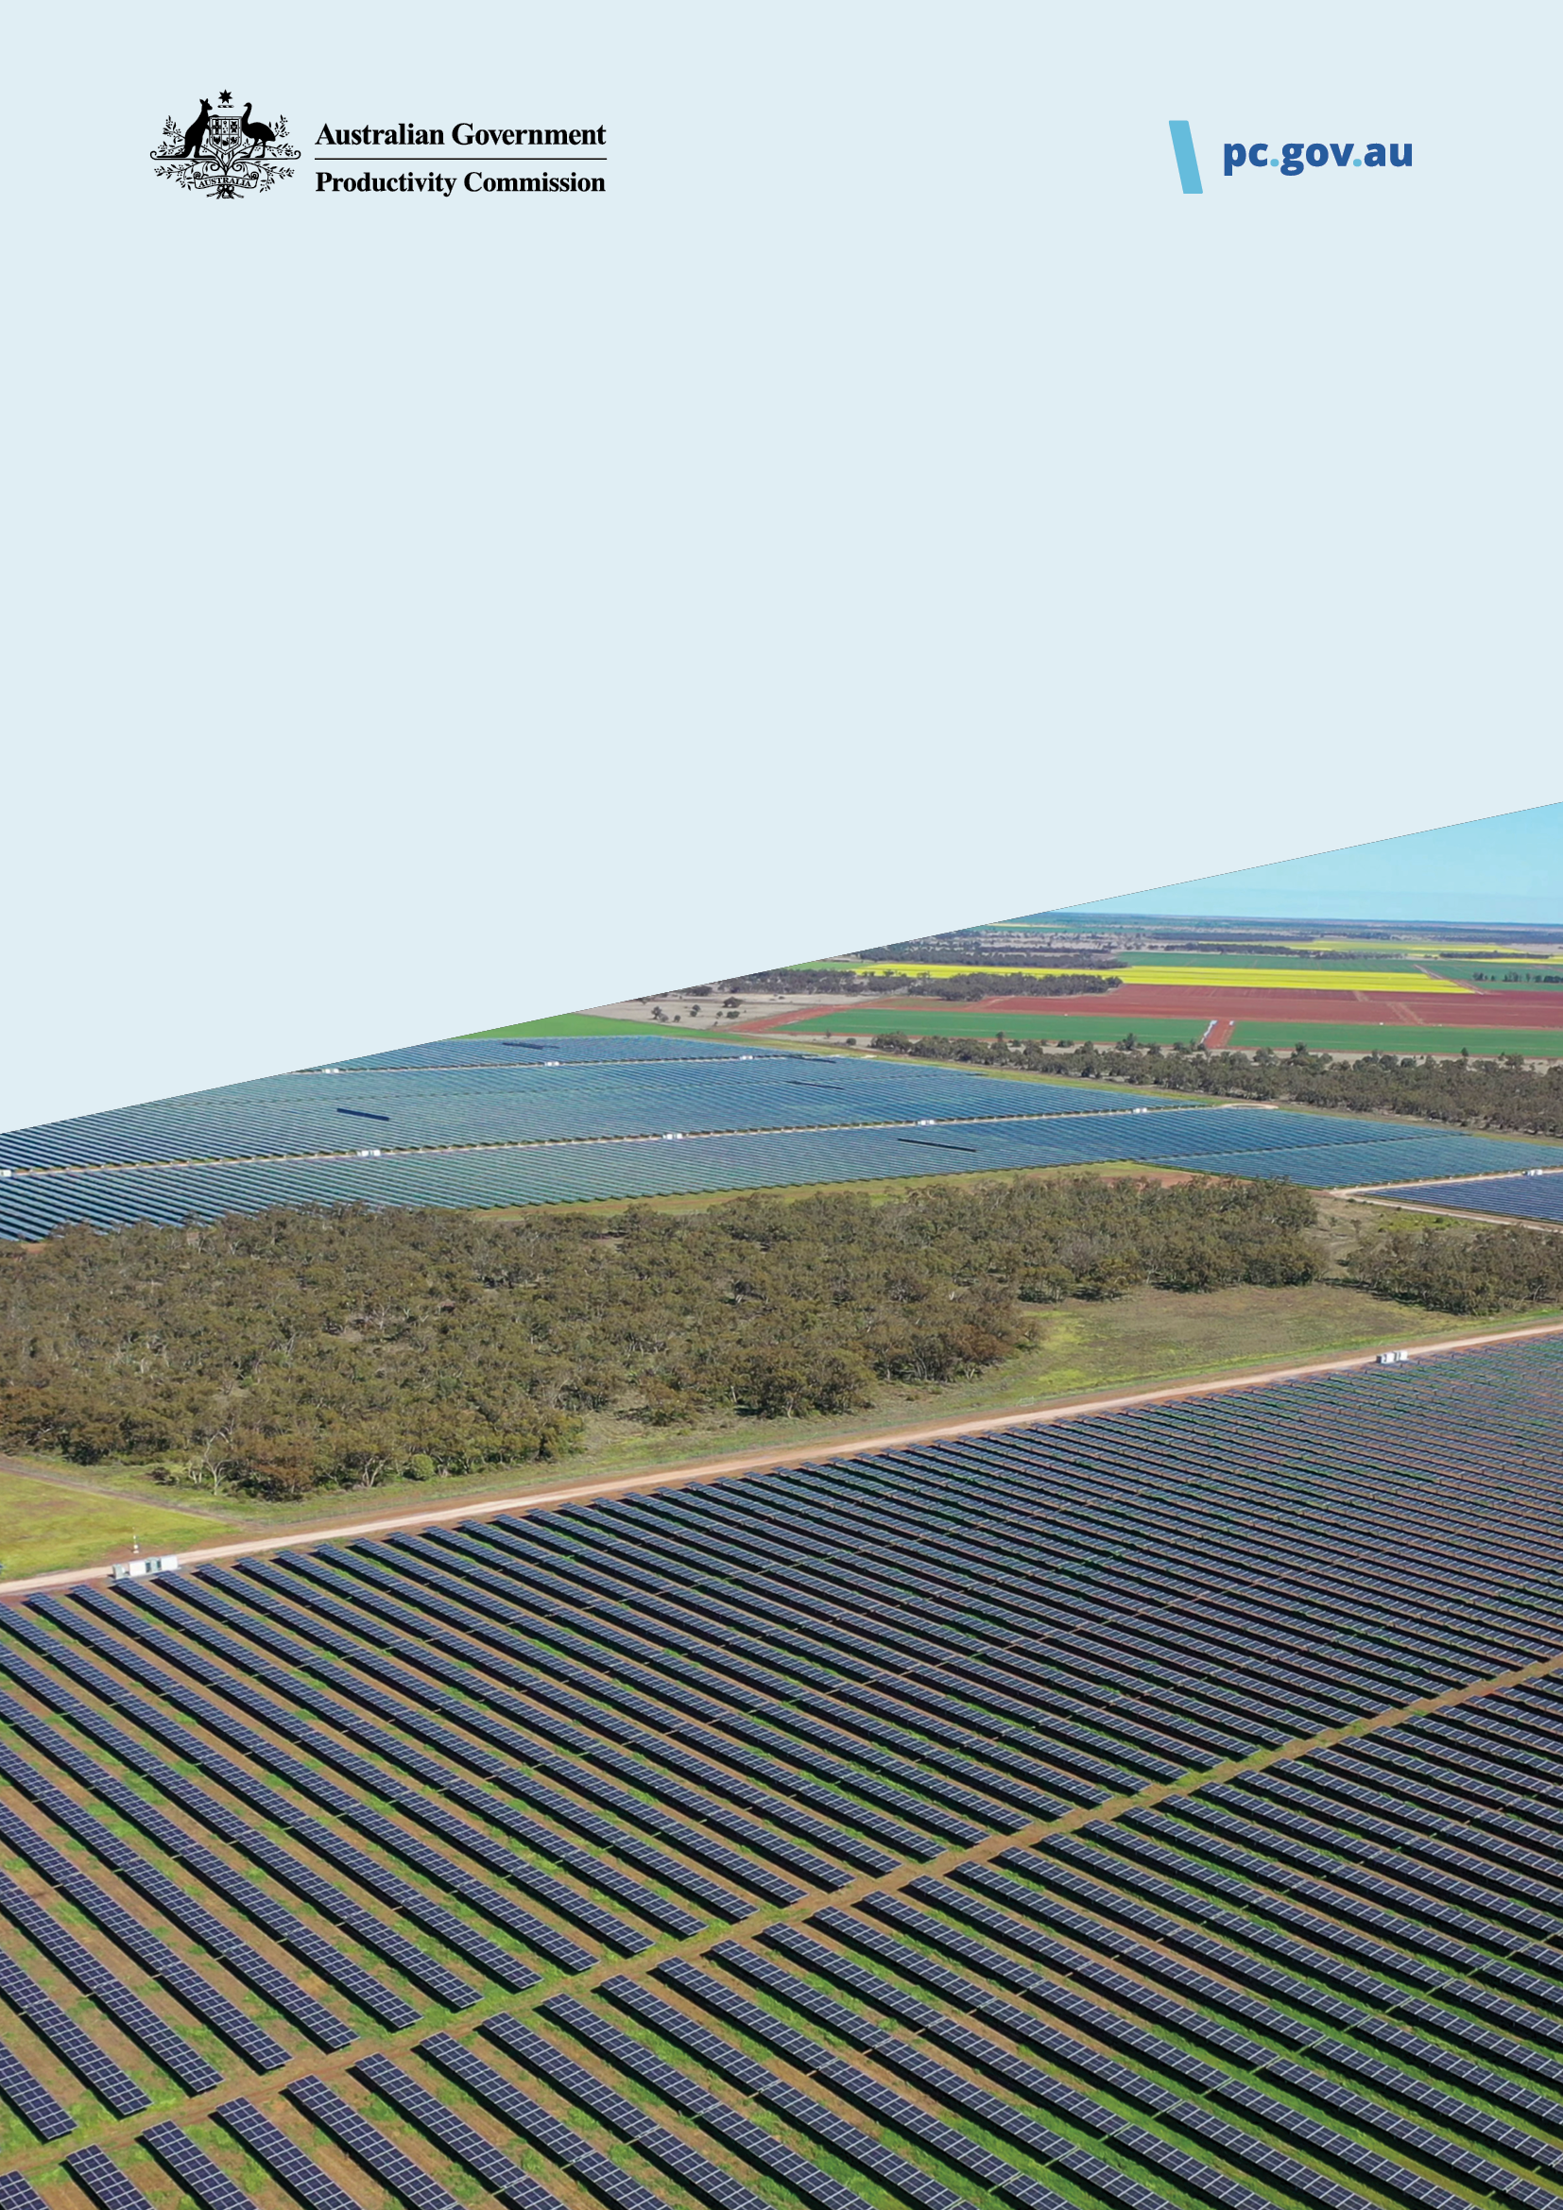
Pillar 5
Investing in cheaper, cleaner energy and the net zero transformation
Consultation questions | May 2025

Contents
Investing in cheaper, cleaner energy and the net zero transformation 3
Why is investing in cheaper, cleaner energy and the net zero transformation important? 3
What are the pillars of productivity? 3
Reduce the cost of meeting carbon targets 5
Our approach 5
Speed up approvals for new energy infrastructure 6
Our approach 6
Encourage adaptation by addressing barriers to private investment 7
Our approach 7
Have your say on investing in cheaper, cleaner energy and the net zero transformation 8
Section 1. About you and/or your organisation 8
Section 2. Reduce the cost of meeting carbon targets 10
Section 3. Speed up approvals for new energy infrastructure 11
Section 4. Encourage adaptation by addressing barriers to private investment 12

Investing in cheaper, cleaner energy and the net zero transformation
We are looking at a range of reforms that will deliver cheaper, cleaner and reliable energy and help us adapt to the risks posed by a changing climate.
We are asking you for feedback on our approach so far to Pillar 5: Investing in cheaper, cleaner energy and the net zero transformation.
After reviewing the ideas submitted through Australia’s Productivity Pitch and undertaking our own research and stakeholder consultation, we have identified three policy reform areas to explore further.
For each reform area, we will:
- recommend specific reforms
- seek to quantify their benefits (where possible) and
- suggest how the reforms can be implemented.
Reduce the cost of meeting carbon targets  More efficient and consistent emissions-reduction signals will help avoid unnecessary costs while meeting Australia’s net-zero goals. | Speed up approvals for new energy infrastructure  Faster approvals for new energy infrastructure will help ensure we meet our climate targets with reliable and cheaper energy along the way. | Encourage adaptation by addressing barriers to private investment  Investment in high-value adaptation measures will support Australians to manage the physical risks of climate change. Resilient housing will be a focus.

Why is investing in cheaper, cleaner energy and the net zero transformation important?
Access to cheaper, cleaner and reliable energy benefits everyone and is essential for a productive and prosperous net-zero economy. Cleaner energy supports low-cost decarbonisation options across all sectors.
It is important that our policy settings help us to achieve the net-zero transformation as efficiently and cost-effectively as possible.
As Australia pursues emissions reduction, timely and efficient investment in adapting to the effects of climate change will support our quality of life and prevent costly rebuilds.

What are the pillars of productivity?
In 2024, the Australian Government asked us to identify the highest priority reform areas under 5 pillars of productivity:
- Creating a more dynamic and resilient economy
- Building a skilled and adaptable workforce
- Harnessing data and digital technology
- Delivering quality care more efficiently
- Investing in cheaper, cleaner energy and the net zero transformation.
We will deliver practical and implementable policy ideas across the 5 pillars at the end of 2025.

Sub-page – Policy reform area

Reduce the cost of meeting carbon targets
Australian, state and territory governments have a wide range of policies to meet the net-zero emissions target by 2050. More consistent and efficient emissions signals would help us reach net zero cheaper, supporting growth in productivity and the economy.
Enduring, broad-based market mechanisms are the best way for governments to reduce carbon emissions. Governments have made progress on adjusting policy settings towards this goal (for example, through reform of the Safeguard Mechanism), but the efficiency and consistency of these signals can be improved. Further improvements would support better investment decisions and help avoid unnecessary costs for taxpayers and consumers.
Our 2011 analysis of domestic and international emissions-reduction policies demonstrated that the cost-effectiveness of these measures can vary widely. More recently, we estimated that some policies in Australia cost less than $100 per tonne of carbon dioxide emitted, while others may cost as much as $20,000 per tonne (PC 2023). Focusing on lower-cost policies would bring the costs of transition down.

Our approach
In this inquiry, we are building on previous research and undertaking new analysis to understand the cost-effectiveness of different policies being used to achieve net-zero emissions.
Our focus is on the policy signals to reduce emissions across the industrial, electricity and transport sectors given the rapid changes occurring in energy and electrification technologies. Collectively, these three sectors produce 78% of Australia’s gross emissions.
We will make practical recommendations to help governments increase the efficiency of emissions-reduction signals and align these signals over time.
We will ensure this inquiry complements the National Electricity Market wholesale market settings review; the Net Zero Plan and the electricity and energy, transport, industry, and resources sector plans; and the upcoming reviews of the Safeguard Mechanism and the New Vehicle Efficiency Standard.
Sub-page – Policy reform area

Speed up approvals for new energy infrastructure
Building new energy infrastructure is critical to the energy transition, to the broader economy and to delivering reliable, affordable energy for consumers. It is necessary both to meet climate targets and to ensure reliable supply, particularly as coal plants retire.
In the coming years, Australia needs to install millions of panels for solar farms, thousands of wind turbines and thousands of kilometres of transmission lines.
These and other energy projects must comply with important environmental standards, cultural heritage laws, and other planning requirements. But slow, complex and overlapping approvals processes can cause significant and costly delay. For example, pre-construction planning and approvals for solar and onshore wind projects can take four to five years to complete (Clapin and Longden 2024).
Efforts are being made across multiple levels of government to speed up timelines but more needs to be done.

Our approach
In this inquiry, we are considering how projects can be approved faster, without unduly compromising regulatory standards.
We are also considering how to build community trust and support for new energy infrastructure, such as through improved benefit-sharing arrangements.
The PC will seek to complement rather than duplicate recent reviews and other work underway, such as the Samuel Review (2020), the Community Engagement Review (2023), the First Nations Clean Energy Strategy (2024), and other initiatives such as the NSW Renewable Energy Planning Framework and the National Renewable Energy Priority List.
We will identify recommendations previously made by the PC and others that should be implemented as a priority and highlight best practice and new opportunities.

Sub-page – Policy reform area

Encourage adaptation by addressing barriers to private investment
Climate change represents a rising risk to Australia’s environment, communities and industries (DCCEEW 2024). Ensuring that governments, businesses and households invest efficiently in adapting to the effects of climate change will support our quality of life and prevent costly rebuilds.
Treasury has estimated that the hit to labour productivity alone from the direct impact of higher temperatures could cumulatively lower Australia’s GDP by between $135 billion and $423 billion by 2063, relative to a scenario in which temperature rises are lower (Treasury 2023).
Governments are taking actions to understand and build resilience to physical climate risks (for example, through the forthcoming National Adaptation Plan). But this is an area where the policy problem is growing over time, and it will require consideration and action from all parts of society.

Our approach
Where people live and the way their homes are built will directly impact how Australians are affected by climate change, and there are opportunities to adapt. There is evidence that upgrades to improve resilience to cyclones, bushfires, flooding and heat deliver net benefits (Finity Consulting 2018, NIBS 2019, Sustainability Victoria 2022). Better adaptation can reduce the risks of damage from natural disasters, meaning peoples’ lives are less disrupted and we avoid costly rebuilds. It can also improve the comfort of buildings, contributing to better health, greater quality of life and higher productivity.
Households might find it difficult to make well-informed decisions about investing in climate resilience. People may lack trusted and easily accessible information on the risks they face and worthwhile climate resilience investments. The changing nature, long time horizons and innate uncertainty around physical climate risks all make decision making more challenging. And there are public good aspects to the climate resilience and risk exposure of housing, meaning that individuals do not experience all the benefits and costs of their action or inaction.
For these reasons, we will be focusing our research on what should be done to address barriers to investment in adaptation on housing. Policy approaches used to improve the resilience of Australia’s housing stock over time will likely be of use in other parts of the built environment.
We are mindful that climate adaptation is an ongoing area of action for all levels of government, and the PC will seek to complement rather than duplicate this work.

Sub-page – Consultation page with online form

Have your say on investing in cheaper, cleaner energy and the net zero transformation

Section 1. About you and/or your organisation

Contact information

Name

Email

Phone

Postcode

May we contact you about your response?
- Yes
- No
If yes:

How would you prefer we contact you?
- Email
- Phone
- Other (please specify)

Attribution

Whose views does your response represent? (Please include the full names of applicable individuals, groups or organisations).
This can be the name of one or more individuals (including yourself), or the name of one or more organisations. Ensure that you have permission to attribute the submission to all individuals/organisations named.

Do any of the attributed parties identify as Aboriginal or Torres Strait Islander/are any identified organisations an Aboriginal and/or Torres Strait Islander organisation?
- Yes
- No
- Prefer not to say
Under the National Agreement on Closing the Gap, an Aboriginal and Torres Strait Islander organisation (other than an Aboriginal and Torres Strait Islander community-controlled organisation):
- is a business, charity, not-for-profit organisation, incorporated under Commonwealth, state or territory legislation
- has at least 51% Aboriginal and/or Torres Strait Islander ownership and/or directorship and is operated for the benefit of Aboriginal and Torres Strait Islander communities.

Consent

Do the attributed parties consent to the PC publishing your response on our website and referring to it in our reports?
- Yes, with attribution
- Yes, without attribution
- No, do not publish my response or refer to it in your reports
We will only publish your response if it meets our community guidelines. We are unable to refer to unpublished responses within our report.
For further information on how we handle your information visit our Privacy Policy and Information Policy.

Guidelines and policies agreement
- I have read and agree to the above guidelines and policies.

Providing supporting documents (optional)
At this stage of the inquiry, we are only accepting and reviewing supporting documents that meet the following criteria:
- They contain data, charts and supporting information relevant to the policy areas and questions we are asking in this round of consultation
- The attributed participant(s) hold the copyright for the information contained in the documents
- The documents don’t include any personal or identifying information.
There will be an opportunity to provide submissions on our policy reform ideas when we release our interim report.

Will you be providing any documents to support your response?
- Yes
- No
How to provide a supporting document
Once you have submitted your response via the ‘Submit’ button below, you will receive a confirmation email from us. Please reply to this confirmation email with your supporting documents attached.
For accessibility reasons, we prefer Microsoft Word documents.
Once we receive your supporting documents, we will review them alongside your response. If your contributions meet our community guidelines, and you have provided consent, we will publish them to engage.pc.gov.au within 14 days.

We are seeking responses to questions on three policy reform areas
Which policy reform areas would you like to respond to?
- Reduce the cost of meeting carbon targets
More efficient and consistent emissions-reduction signals will help avoid unnecessary costs while meeting Australia’s net-zero goals.
- Speed up approvals for new energy infrastructure
Faster approvals for new energy infrastructure will help ensure we meet our climate targets with reliable and cheaper energy along the way.
- Encourage adaptation by addressing barriers to private investment
Investment in high-value adaptation measures will support Australians to manage the physical risks of climate change. Resilient housing will be a focus.

Section 2. Reduce the cost of meeting carbon targets
Enduring, broad-based market mechanisms are the best way for governments to reduce carbon emissions and governments have made progress on adjusting policy settings towards this goal.
But more work is needed to make emissions-reduction signals across sectors and jurisdictions more efficient and consistent to support better investment decisions. Some policies to reduce emissions also have a higher cost for governments per tonne of carbon avoided compared to other approaches.

What could be done to improve the cost-effectiveness and alignment of policies to reduce emissions across the industrial, electricity and transport sectors?
[long text]
In your response, please:
- outline your views on near-term priorities with supporting evidence
- provide examples of different emissions-reduction signals working together to reduce emissions or where misaligned signals produce adverse outcomes.
More work is needed to make emissions-reduction signals across sectors and jurisdictions more efficient and consistent. Incomplete application of an emissions-reduction signal to a sector would mean that the parts that are covered may bear higher costs than they otherwise would, distorting investment decisions. The objective of filling any gaps would not necessarily be to achieve a higher level of emissions reduction, but to achieve a given level at lower overall cost.

Are there gaps in the emissions-reduction policies in the industrial, electricity and transport sectors which should be addressed?
[long text]
In your response, please:
- outline your views on near-term priorities with supporting evidence.
- provide examples of adverse outcomes because of policy gaps or reasons why filling these gaps could create adverse outcomes.
More work is needed to make emissions-reduction signals across sectors and jurisdictions more efficient and consistent. Multiple emissions-reduction signals for the same activity risks ‘too much’ pressure to reduce emissions for that activity. It can also increase the overall cost of abatement.

Are there any duplicative emissions-reduction policies in the industrial, electricity and transport sectors which could be streamlined?
[long text]
In your response, please:
- outline your views on near-term priorities with supporting evidence
- provide examples of different signals working together to reduce emissions or where duplicative signals produce adverse outcomes.

Section 3. Speed up approvals for new energy infrastructure
Large energy infrastructure projects must comply with important environmental standards, cultural heritage laws, and other planning requirements. But slow, complex and overlapping approvals processes can cause significant and costly delay. The claim is often made that the approvals process takes too long, but what does the evidence show? We welcome data and illustrative case studies about the extent of the problem and which parts of the process are problematic.

Are planning and approvals processes for large energy infrastructure taking too long? If so, what causes the most delay?
[long text]
Many reforms have been proposed in the past to expedite planning and approvals. We are interested in identifying concrete, tangible reforms that will make the most difference.

How can planning and approvals processes be sped up without unduly compromising regulatory standards?
[long text]
In your response, you might want to:
- provide supporting evidence
- talk about examples from other countries.
Given the urgency of the net-zero transition, some countries have introduced legislative processes and administrative features to specifically streamline approvals of clean energy, treating them differently to other types of infrastructure projects.

Should clean energy projects be treated differently to other projects for the purpose of environmental and other approvals? If so, how?
[long text]
The impacts of infrastructure projects are not spread evenly – some communities are affected more than others. Working with these communities and securing their support is vital.

What can be done to build local community support for new energy infrastructure projects?
[long text]
For example, how might benefit-sharing arrangements be improved?
This inquiry is about finding implementable reforms to boost the country’s productivity in the net-zero transformation. We are interested in any evidence showing the productivity benefits of faster approvals for energy projects. For example, how much might developers save and how might this affect the cost of energy for consumers?

Please outline any evidence showing the productivity benefits of faster approvals for energy projects.
[long text]

Section 4. Encourage adaptation by addressing barriers to private investment
Where people live and the way their home is built will directly impact how Australians are affected by climate change. We are interested in ways in which the resilience of housing might be improved.

What are the barriers and enablers impacting decisions by owner-occupiers, landlords and developers about how housing is built and updated over time so that it is resilient to the effects of climate change?
[long text]
Households might find it difficult to make well-informed decisions about investing in climate resilience. People may lack trusted and easily accessible information on the risks they face and worthwhile climate resilience investments. We are interested in the ways that information might be improved to support good decision-making.

What information do people need to make decisions about where to live, how to build and how to upgrade their homes to appropriately factor in climate change?
[long text]
In your response, you might want to:
- detail best practice examples in Australia or elsewhere
- outline strategies that might help people access and act on information
- talk about the reasons why some people voluntarily invest in resilience and the types of investments they make
- talk about the cost or availability of insurance or finance and how they provide signals for making climate-resilient investments
- outline any changes you think should be made.
Upgrades to housing can improve resilience to cyclones, bushfires, flooding and heat. We are interested in hearing about the most cost-effective retrofitting solutions to improve housing resilience in Australia, including analysis of their financial costs and broader social or environmental benefits.

What are the most cost-effective retrofitting options for improving the resilience of Australia’s existing housing stock? What are their costs and benefits?
[long text]
New housing and some renovation activities are required to meet the National Construction Code, and resilience will be an objective of the body that updates the Code from mid-2025. States and territories give legal effect to the code and can also regulate how housing is built in other ways.

What role might minimum standards play in ensuring the resilience of Australia’s housing stock?
[long text]
Governments directly impact where and how housing is built through their planning and zoning systems. We are interested in how those systems are factoring in climate change.

The impacts of climate change are being factored into the regulation of where and how houses are built in different ways around Australia. What does leading practice look like? Where is there room for improvement? Are there lessons we can learn from other countries?
[long text]

