
GST Distribution Reforms
Submission



17.02.2026

The voice for
local government


No one understands the challenges and opportunities facing Victoria in the 21st century better than local councils. From rapidly evolving technology to social changes, shifting economies to environmental pressures, our local communitiesand the governments that represent them–are at the forefront of multiple transformations happening simultaneously.
As the peak body for the Victorian local government sector, the Municipal Association of Victoria (MAV) offers councils a one-stop shop of services and support to help them serve their communities.

ACKNOWLEDGEMENT OF COUNTRY
We acknowledge the traditional custodians of the land on which we live. We recognise their continuing connection to land, waters and culture and pay our respects to their Elders past, present and emerging.
Disclaimer and Copyright
This submission has been prepared by the Municipal Association of Victoria (MAV). The MAV is the statutory peak body for local government in Victoria, representing all 79 municipalities within the state. © Copyright MAV
The Municipal Association of Victoria supports the Victorian Government’s call to restore an equitable GST distribution. The distortion of the allocation formula legislated in 2018-19 should be revoked. Failing that, the No Worse Off guarantee should be made permanent.

The changes were not adequately understood by those proposing or enacting them. Initially these changes were estimated to distort distribution by $3.5 billion over 4 years (the quantum of the No Worse Off guarantee). This is now projected to exceed $60 billion – in service of enhancing the share of the state with an own-source revenue-raising capacity far exceeding any other.

Alternatively, cessation of the No Worse Off guarantee would result in significant harm to all states other than Western Australia.
Removing billions of dollars of distributed revenue from Victoria would necessarily reduce the State’s capacity to support local government.
We are particularly concerned this would disproportionately affect small rural shires. The degree to which these councils are dependent on state grants has been increasing over the last decade – standing at 18.5% for 2023-24.
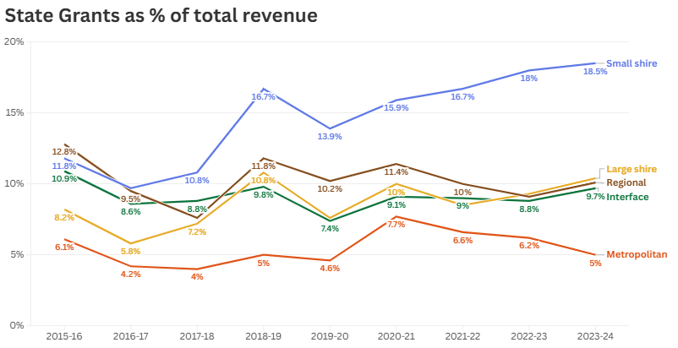
Source: MAV, Data Source; Victorian Local Government Grants Commission Expenditure and Revenue Surveys
These shires are also the least able to absorb an impact. Cost of delivering services is often greatest, the capacity to raise rates is lower due to lower household incomes, and opportunities to develop alternative revenue do not exist at scale.

In terms of the services potentially most impacted, based on the same data set this would include:

Council functions most dependent on state grants
Area | Function | Example activities
Family & Community Services | Education | - Pre-prep / Kindergarten  - Teacher-supervised play centres  - Adult education
Family & Community Services | Community Health | - Maternal and Child Health  - Community health clinics  - Immunisation
Family & Community Services | Families & Children | - Play centres (not supervised by teachers)  - Creches and day care
Family & Community Services | Community Housing | - Aged and disabled person’s units (excluding residential care facilities)
Business & Economic Services | Non-road transport | - Council operated airports and ferries
Family & Community Services | Community Welfare Services | - Youth and migrant centres and services  - Neighbourhood houses  - Welfare administration
Aged & Disabled Services | Community Care Services | - Care for people living independently including home care, personal care, and respite care  - Adult day centres and day programs  - Delivered and centre-based meals  - Assessment and care management
Source: MAV, Data Source; Victorian Local Government Grants Commission Expenditure and Revenue Surveys

Already we have seen many councils reduce service delivery, or exit the service entirely, in response to ill-considered Commonwealth reforms to home-care funding. With revenue constrained both statutorily (through the rate cap) and the capacity of communities to pay, reduction in support would necessitate reduction in service levels across numerous areas.

Outside of direct revenue transfers, there would be major impacts to Victorian councils and their communities from a reduction in service delivery by the Victorian Government.

One of the primary bottlenecks of the Victorian planning system is where external referrals are required to state entities. Typically, these entities do not see their role as a referral authority as part of core business. Further budget pressures would likely see them reduce their statutory planning resources even further, increasing the delays to respond to a referral and potentially diminishing the expertise being applied.

Many councils have had longstanding agreements with the Victorian Government to maintain, for a fee, assets outside of their control, such as road reserves of state roads. Over time the funding provided has not kept pace with the cost of undertaking these activities, leading to councils subsidising the State. Increasingly councils are finding it impossible to justify continuing these inequitable arrangements.

We anticipate both the exacerbation of existing funding shortfalls, and the appearance of new ones, as one of the impacts of a reduction in Victoria’s GST distribution.

MAV would be pleased to provide clarification on any information in this submission.

For further information, please contact .

Municipal Association of Victoria
Level 5, 1 Nicholson Street, East Melbourne VIC 3002
PO Box 24131, 6 Southern Cross Lane, Melbourne VIC 3000
Telephone: 03 9667 5555 Email: inquiries@mav.asn.au
www.mav.asn.au

