11 March 2026

Fare Comparison Evidence
Purpose
This document provides sample fare comparisons to demonstrate pricing outcomes currently observed between Sydney and Toowoomba, compared with alternative departure options and international leisure routes.
As a retail travel agency, we regularly assess fare structures across domestic and international routes.
Virgin Australia currently provides no commission on domestic fares.
Qantas provides approximately 1 percent commission on the base fare (pre-tax) domestically.
Accordingly, the pricing examples below reflect underlying airline fare levels rather than agency commission structures or booking fee impacts. Elevated regional fares do not translate into meaningful intermediary revenue. The disparity illustrated is driven by airline pricing decisions at source.
At the same time, major carriers have reported strong post-pandemic profitability while maintaining constrained service frequency and limited network expansion on certain regional routes.
Where airlines operate with limited competition and high market concentration, pricing power sits almost entirely with the carrier. Regional businesses and consumers have little negotiating leverage and limited alternatives.
The examples below are based on publicly available fares at the time of search and are intended to illustrate structural pricing differences rather than isolated promotional anomalies.

The “Cheaper to Drive” Case
On the dates examined, departing from Brisbane produced a total cost saving of approximately $71.74 for a single traveller and $410.27 for a family of four, despite requiring a 250 km return drive.
WTB-SYD return fare
Single Passenger
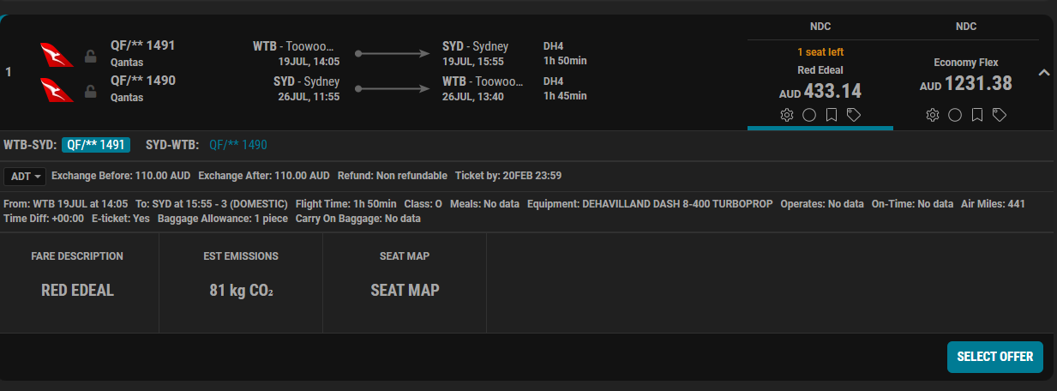
Family, 2A and 2C
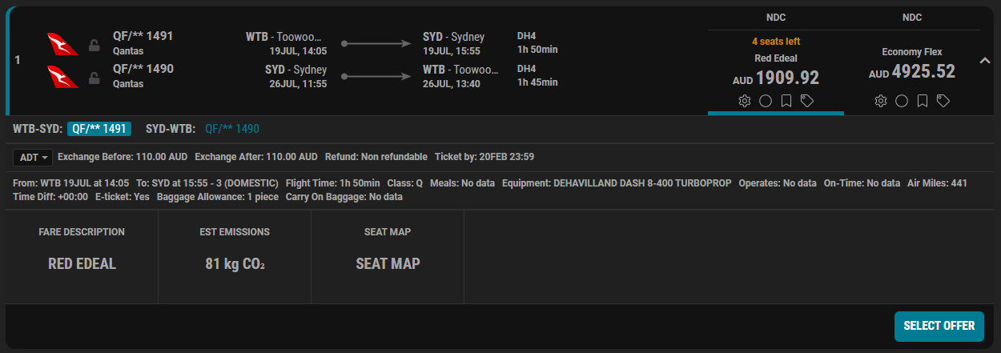
Fuel Cost return to WTB airport ex City: $4.10 | Parking Cost WTB Airport: $85 for the 7 days
Cost Single: $522.24
Cost Family: $1914.02

BNE-SYD return fare - Single Passenger
Virgin
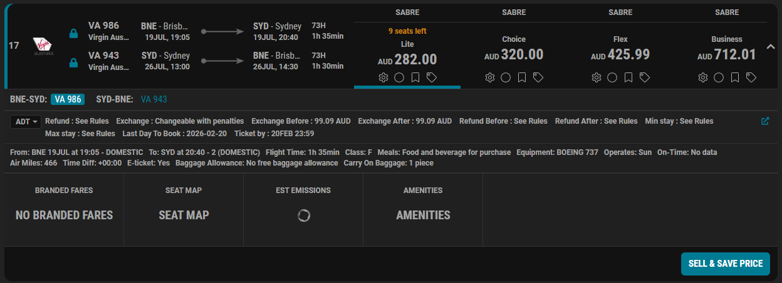
Jetstar
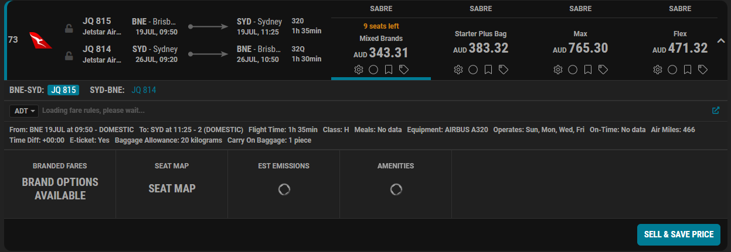
Qantas
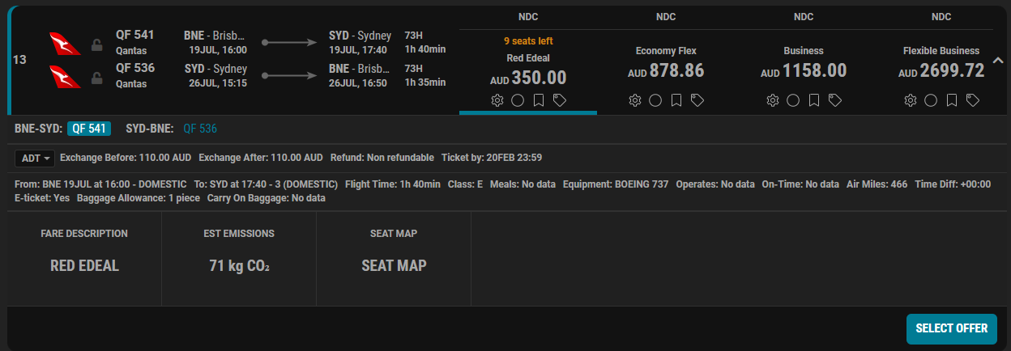
Fuel Cost return BNE: $25.50 | Parking Cost BNE Airport: $105-225
Total BNE Cost with checked bags: $450.50 - $600.50
BNE-SYD return fare - Family, 2A and 2C
Virgin
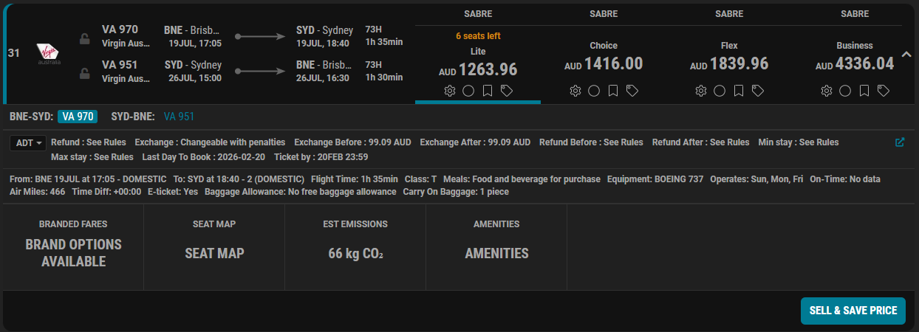
Jetstar
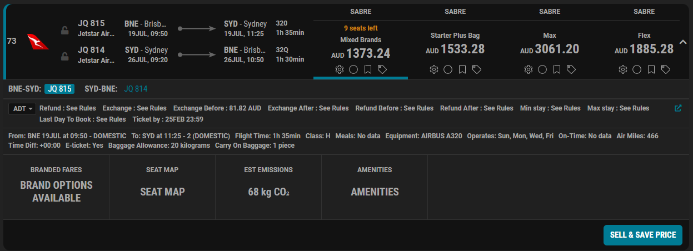
Qantas
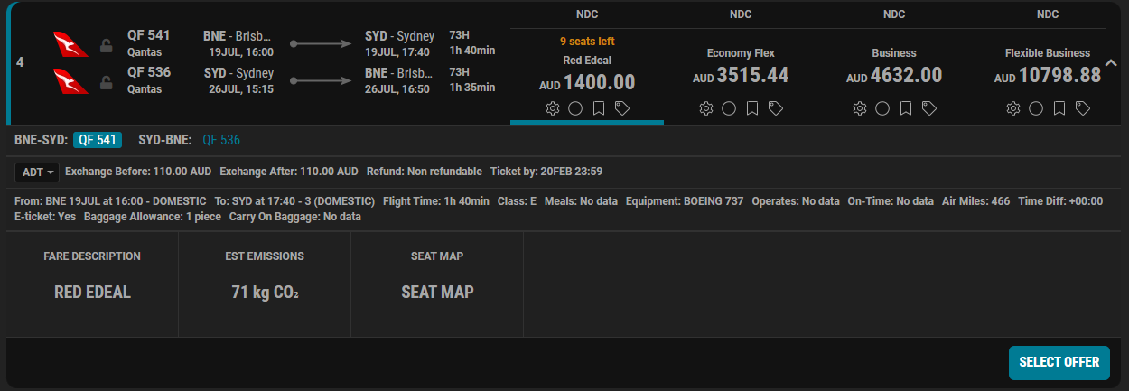
Fuel Cost return BNE: $25.50 | Parking Cost BNE Airport: $105-225
Total BNE Cost with checked bags: $1503.75 - $1666.50
International Comparison
SYD-WTB return fare – 2 Adults
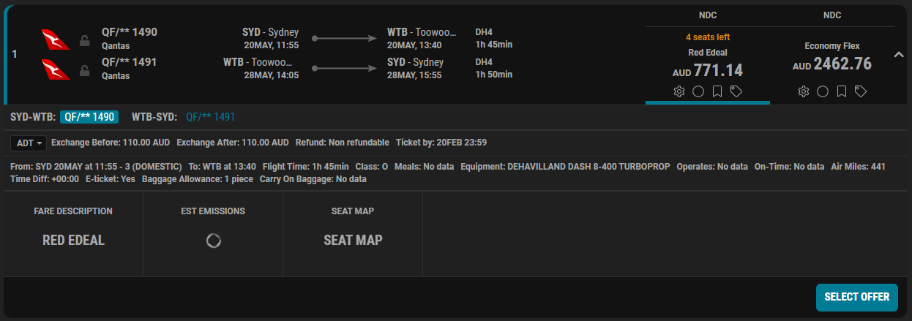
SYD-DPS return fare – 2 Adults
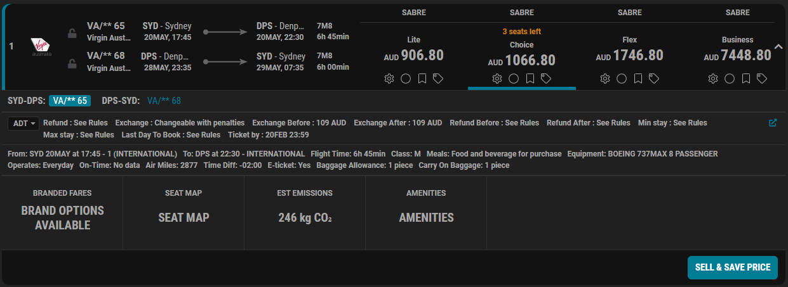
Observation
The short domestic regional return fare of AUD 771.14 represents approximately 85 percent of the cost of a return international service to Denpasar priced at AUD 906.80.
The Denpasar service covers significantly greater distance, longer flight time, higher fuel burn, international airport charges and border processing costs, yet is priced only approximately AUD 135 higher than the regional domestic return fare.
This comparison illustrates the disproportionate pricing of certain regional sectors relative to longer, competitive international routes.

Trunk Route Comparison – 2 Adults
SYD-WTB return
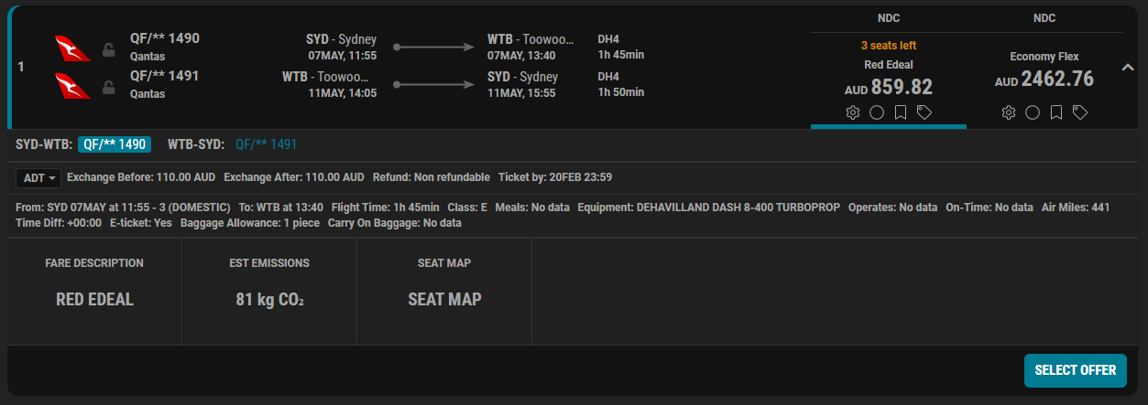
SYD-MEL return
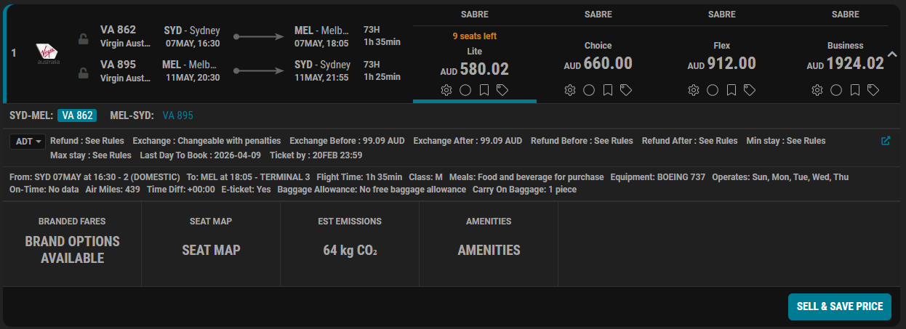
SYD-BNE return
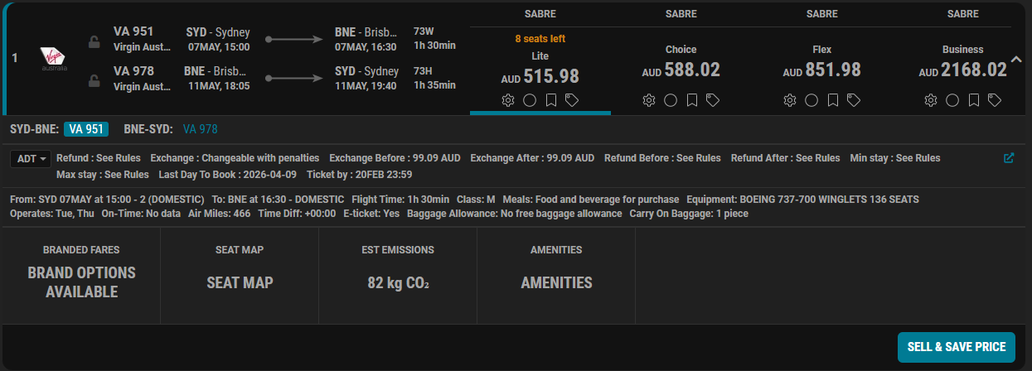

SYD-PER return
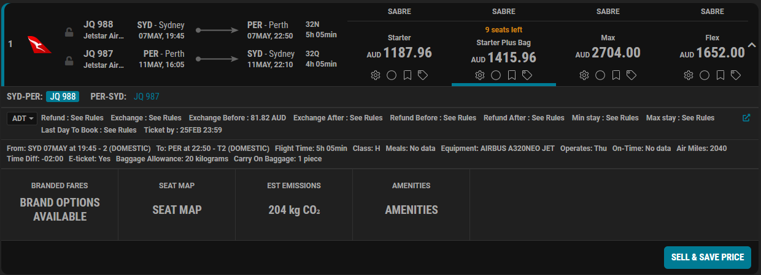
Observations
- The Sydney to Toowoomba return fare of AUD 859.82 exceeds the Sydney to Melbourne return fare by approximately AUD 280 despite similar flight duration.
- The Sydney to Toowoomba return fare exceeds the Sydney to Brisbane return fare by approximately AUD 344, again on a shorter or comparable sector.
- The Toowoomba fare is approximately 72 percent of the cost of a Sydney to Perth return, despite Perth being more than three times the flight duration and significantly greater distance.
- The Toowoomba service operates at materially lower frequency than the trunk routes compared above.
These examples demonstrate that pricing on certain regional routes is materially higher than highly competitive trunk routes of similar or substantially greater distance.
Summary of Pricing Patterns Observed
Across the examples provided:
- Short regional sectors are priced materially higher than comparable trunk routes
- Regional fares can approach or exceed international leisure fares
- Limited frequency restricts competitive discipline
- Passengers are financially incentivised to substitute road transport for direct regional aviation
These outcomes indicate structural pricing imbalance rather than isolated anomalies.

