The Horizontal Fiscal Equalisation (“HFE”) carried out via the goods and services tax (“GST”) distribution system is but a very small slice (7.2% in 2023-24) of the financial transfers from Western Australia to other states via Commonwealth revenue raising and spending.

Each year, the Western Australian Department of Treasury estimates the net redistribution across States that occurs through Commonwealth revenue raising and spending. For each State, the redistribution is measured as the difference between the Commonwealth revenues generated in that State (including GST) and the Commonwealth expenditures for the benefit of that State (including GST grants and the State’s share of the Commonwealth deficit).

Overall, in 2023-24 it is estimated that the Commonwealth derived $112 billion in revenue from Western Australia, while expenditure for the benefit of the State (including the State’s share of the Commonwealth deficit) totalled $73 billion, yielding a net contribution from Western Australia to other states of $39 billion, or $13,324 per capita
($24,276 per employed worker).

The consistent, structural burden of financial transfers on Western Australia is clearly depicted in Figure 1 below. As seen in the chart, it is clearly not limited to mining booms and strong commodity prices – the imbalance is merely worse during such periods.

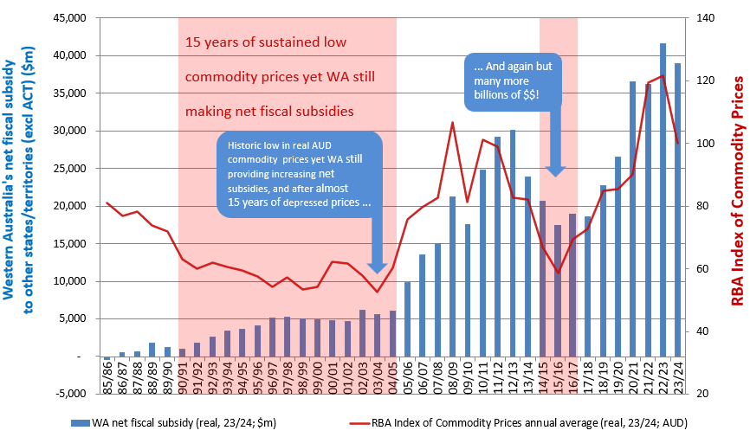

Figure 1: Western Australia’s net fiscal subsidy to other states
Sources:
- WA net fiscal subsidy: Data sourced from Government of Western Australia, Department of Treasury and Finance (http://www.treasury.wa.gov.au/uploadedFiles/Fiscal_Subsidies_96-7.pdf and budget papers found at http://www.ourstatebudget.wa.gov.au/Previous-Budgets/ refer to Economic and Fiscal Outlook/Overview).
- RBA index of commodity prices: Data sourced from: https://www.rba.gov.au/statistics/frequency/commodity-prices/2026/icp-0126.html.
- All source data from items 1 and 2 above is nominal. Chart data has then been adjusted for inflation using the simple annual average of GCPIAG data from ‘Consumer Price Inflation – G1’ from the RBA (https://www.rba.gov.au/statistics/tables/#inflation-expectations).

Western Australia’s net contributions to the Federation have totalled $391 billion is since 2000-01, when the GST
was introduced.

To put this in context, New South Wales, the only other net contributor, contributed $6.0 billion ($712 per capita) in 2023-24. On a per capita basis, Western Australia’s net contribution was more than 19 times that of NSW. All other states and the Northern Territory were net recipients, overwhelmingly funded from WA (87%).

Western Australia’s net contributions to the Federation adds up to almost $280 billion over the last decade and $180 billion over the last 5 years in real terms.

Moreover, Western Australia’s falling relativity to other states in respect of net fiscal contributions to other states commenced well before the GST was introduced in 2000-01. Net financial transfers from WA have been going on for over 40 years, possibly much longer, and includes a sustained, major commodities downturn in the late 90s and early 2000s. Even then, WA was consistently one of the largest if not the largest contributor on a gross basis, and overwhelmingly the largest net contributor on a per capita basis (roughly double the contribution of NSW on a per capita basis).

In WA’s case there seems to be little chance of even a one-off annual balance in the decades ahead under the status quo, and no chance of average symmetry over commodity cycles.

Conclusion

I suggest that the Productivity Commission complete, or recommend the completion of, further, robust studies in respect of these generally unaccounted for and unnoticed (yet more correct and comprehensive) measures on horizontal fiscal equity for each state – essentially quantifying the total effective financial transfers between Australian states.

WA’s fiscal contribution to other states via the GST is only the tip of the iceberg.

Contact Damien Kelly if you would like more information or discussion.

Further information regarding calculation by WA Treasury of the net redistribution across States via the Commonwealth is set out in Appendix A to the ‘GST Distribution Review – WA Submission’ (Oct 2011) (https://treasury.gov.au/sites/default/files/2019-03/wa_gov.pdf).
Number of employed workers in WA (1,607,400) sourced from: Australian Bureau of Statistics, https://www.abs.gov.au/statistics/labour/employment-and-unemployment/labour-force-australia/jun-2024#states-and-territories - ‘States and Territories’ - ‘June 2024 - Seasonally adjusted’, ‘Employed people’ – Western Australia.

