Safeguard submission into import of fabricated structural steel

1. Business Overview
This section introduces your business and provides context for your submission.
- Company name: Westys Steel Fabrication
- Location of operations: Melbourne, Victoria:
- Size of business
- Number of employees: Direct employees = generally around 25. currently 15
- Approximate annual production volume: 800-1200t

We specialise in complex architecturally designed buildings, for example Sorrento Ferry Terminal, Ruyton Girls School Kew - Performing Arts centres, Epping Hunter Gatherer shopping centre, etc.. Our experience enables us to deliver these projects with exceptional outcomes. Therefore, until mid 2025, we have largely been shielded from ‘unsustainable’ import prices, whereas our local competitors have suffered a decreased workload of over 50%, over a duration of months.

Products manufactured with relevant tariff code classifications.
7308900052
7308900064
7308900065
7308900060
7308900057
7308900054
7308900055

- Exposure to import competition
- Approximate percentage of revenue exposed to direct import competition: 80%
- Key customer segments:
1. Commercial Construction.
2. Residential [New & Renovation].

2. Evidence of an Import Surge
This section addresses whether imports have increased in absolute or relative terms and whether they compete directly with your products.
- Market observations
- Have you observed increased import penetration in your product category? YES.
- Over what period? 10 years, however the last 12-24 months has been substantially increasing directly & indirectly.
- Lost contracts or market share. Please provide examples where possible and attach supporting documents where available, such as tender summaries or internal reports.
- Contract/project description: Kew Recreation Centre
- Approximate value: $2-3m.
- Date: 2021
- Competing product origin (if known): Uknown
- Approximate price difference: Unknown.
- Pricing impacts
- Have you experienced sustained price undercutting? YES. Increasing over years. Approximately 50% of our tendered commercial work , we are tendering against minimum of 1-2 offshore companies. The gap in price in the last 12 months is 50%. It isn’t sustainable.
- Estimated percentage price gap relative to imports: 50%
- Duration of price pressure: increasing over 10+ years
- Other information:
- Changes in order volumes. Tendering “seasons” are now sporadic on a monthly basis.
- Shifts in customer procurement behaviour. Many of our customers are now being pushed by property developers & government departments for offshore steel fabrication quotes which is driven by cost only with no regard to the quality of imported product, or the safe erection of these structures. It is for this reason that obtaining tender summaries from builders with this information is difficult.
- Evidence of import-led price setting. As mentioned above, obtaining this information from builders is a privacy & timing issue with current tenders & live projects. We could obtain this with Key partners should it be required in the future, once live projects are underway.

3. Evidence of Injury

This section should indicate or demonstrate serious injury or threat of serious injury attributable to import pressure.
- Financial impacts: Further to our business overview, and business diversification, our financial data up to EOFY 2025, doesn’t reflect implications of the surge of imported fabricated steelwork. However, we have prepared a graph which does demonstrate the impact on our business which became plainly obvious from August 2025 to present. The surge in imported fabricated steelwork has lead to our tender win ration to plummet, resulting in a drastic decrease of production as per the below graphs. Margin compression will drastically increase as the volume of production continues to decrease. However, the business viability will drastically decrease in the next 1-2 years without intervention.
Revenue, production, margins, workforce, ATO tax revenue, employee wages & superannuation, are forecast to decrease by a further 30% in 2026 (with further workforce reduction inevitable this year).

- With the pressure from offshore fabrication pricing, our tender win ratio has plummeted.
Trends in revenue over the past 3–5 years: Please find attached historical revenue forecast to EOY 2026.
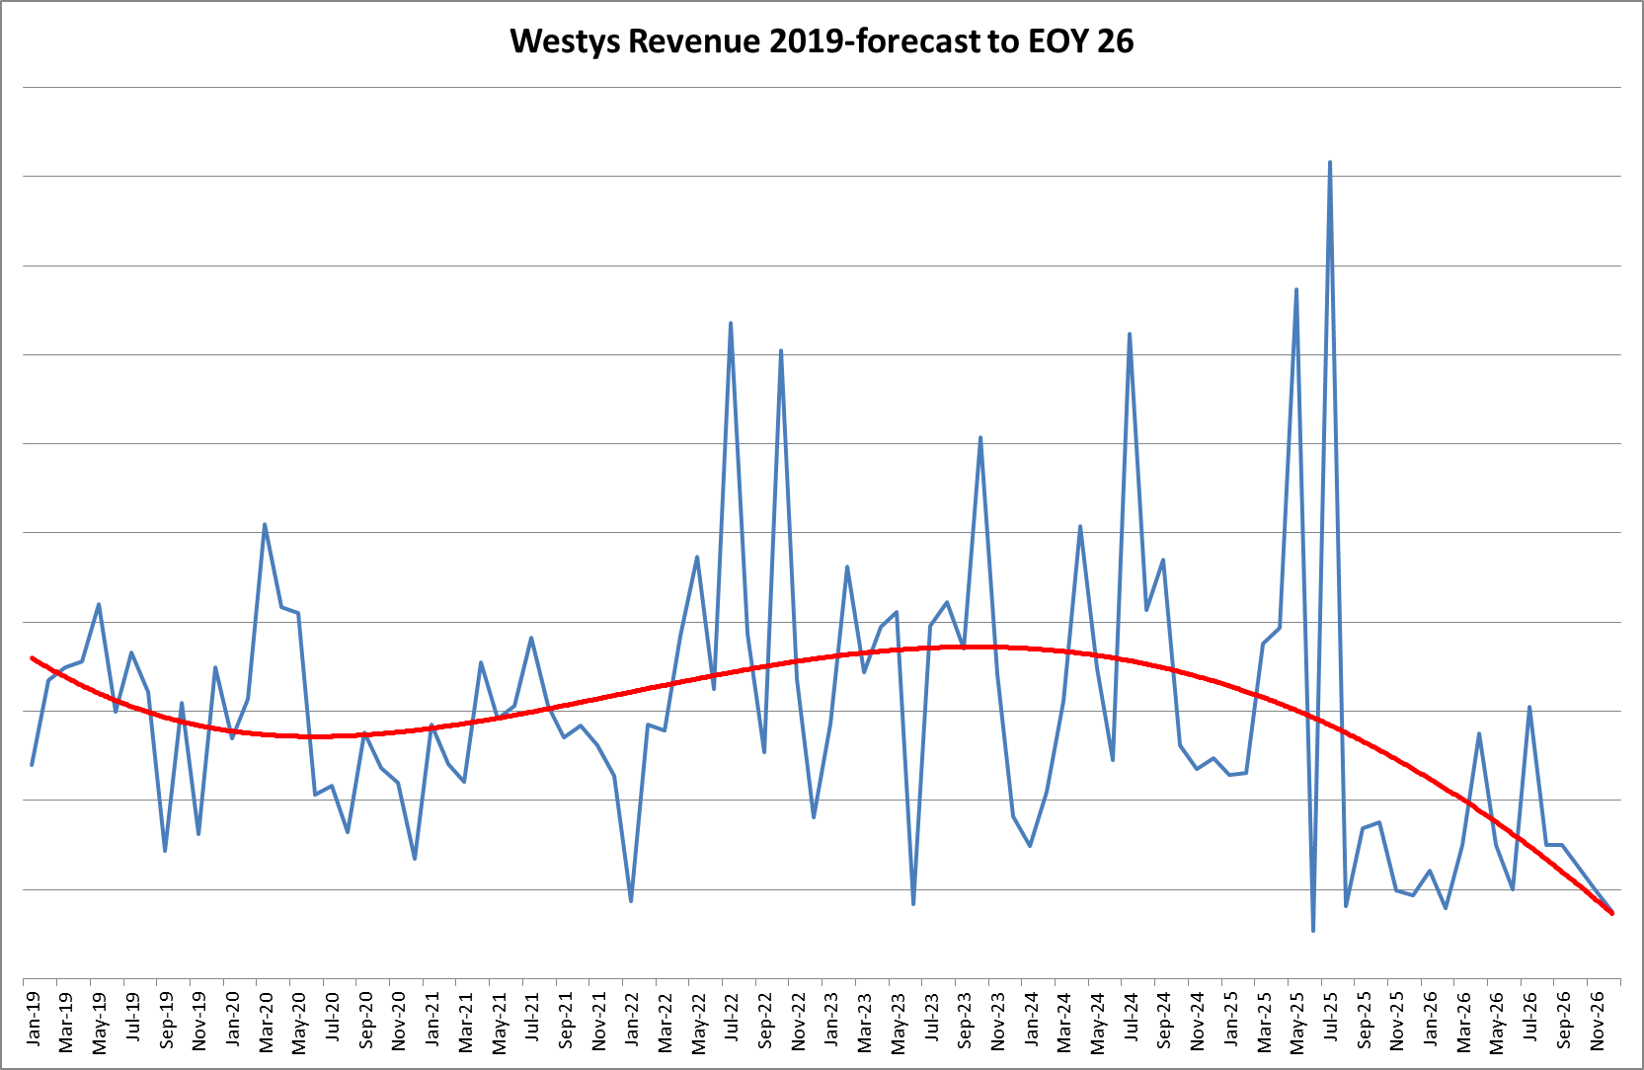

- Evidence of margin compression attributable to import competition: The margin compression is reflected by massive decrease in production as per attached graph. Business strategies like diversification will not significantly increase business viability. Australian Businesses operating with a local workforce, under applicable HR laws and ATO will not compete with offshore entities.
- Production and utilisation
- Change in production volumes and capacity since 2019 have largely been hidden due to our business growth, & diversification since 2013. We believe that with less pressure from offshore, our business growth could have increased by another 30%.

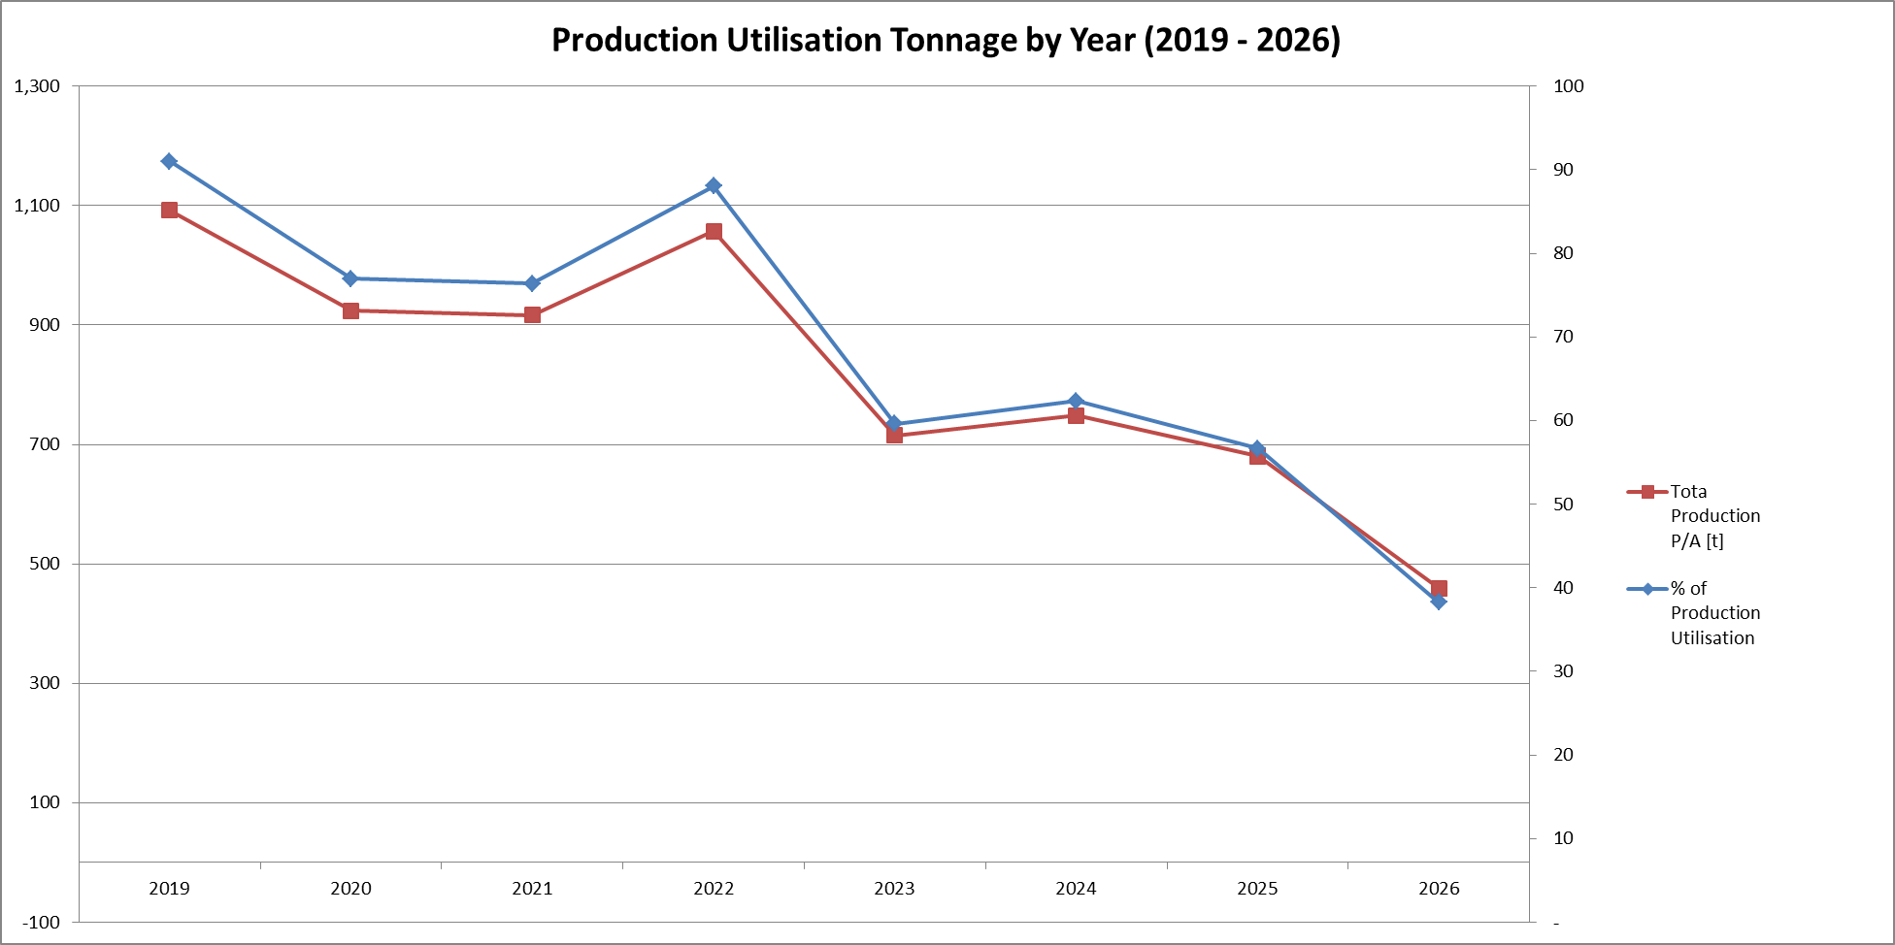

- Employment impacts
- Number of employees reduced (if any): 2019-2025 total on premises direct & indirect employees fluctuated between 22-28.
- Since Jan 2025 total on premises direct & indirect employees has dropped to 15.
- Region/location of employment:
- Roles affected: Sales Staff, Boiler makers, Labourers, Truck Drivers. Particular attention with regards to boiler makers who traditional learn through fabrication, and then migrate to site installation, and site welding.
- Hiring freezes or deferred recruitment: All positions are only replaced on as needs basis.
- Investment impacts
- Capital expenditure deferred or cancelled: This simply hasn’t been entertained in the last decade due to long term prospects.
- Estimated value of postponed investments: $1m.
- Projects placed on hold: a further $500K minimum.
- Explanation: Briefly explain why the injury identified above is linked to import surges rather than broader macroeconomic conditions.
While production levels fluctuate year to year, over the past 5 years, the volume of tenders remain largely similar. However, the win to loss ratio is significantly decreasing, and anecdotally all local prices are being pressured by offshore quotes received by builders at tender. The imported quotes drive down the perception of ‘what it is worth’. Some local fabricators try and compete, but fundamentally, local businesses cannot compete with offshore prices. We believe this is leading to pay rates & entitlements being eroded by some entities within the steel manufacturing sector who choose to avoid complying with relevant national employment standards & awards, etc..
Developers & builders are sourcing overseas products & offshore fabricated steel due to lower costs. These are typically prevalent in larger projects and tier 1 builders. However, as these larger fabricators try to maintain work due to import pressure they are now looking at smaller size projects which in turns filters down to smaller businesses.

4. Productivity Implications
If a temporary safeguard measure were imposed, how would your business respond? Providing examples where available:
- To what extent is your business currently constrained in its ability to make productivity improvements – for example capital investment and/or operational improvements?
Totally: There is absolutely no ability to consider any investment / operational improvements other than; a combination of limited diversification & downsizing and maintain aging equipment.
- If a safeguard measure (a temporary measure to provide “breathing space” for industry) is imposed, what would your business consider doing/adjusting?
Hypothetically, a 50% tarriff on pre-surge levels, may only allow us continue to operate at our current margins [lowest historically], for the life of this “temporary measure”.

5. Structural Implications
This section addresses broader economic consequences as the PC will assess whether the imposition of a safeguard measure, is in the public interest.
- Skills and workforce
- Are experienced or specialised employees being lost? Yes. As all fabrication business downsize, skilled boiler makers are let go. Some will find alternative work, some will move industries. Combined with a continued loss of training apprentices due to unsustainable market conditions, the number of experienced employees will decrease in decades to come. This may force some smaller businesses, staff, and even end consumers to try their hand at steel fabrication in an effort to continue operations. We have already seen this as a direct result of Covid.
- How difficult would it be to rebuild this capability? We have seen a recent push due to Covid workforce shortages, with many school leavings starting apprenticeships. Rebuilding a workforce depends on federal/state governance.
- Estimated time to rehire and retrain equivalent staff: 1-5 years.
- Particular attention with regards to boiler makers who traditionally learn through fabrication workshops, migrating to site installation, and site welding. We believe that many of the existing site boiler makers are fixing offshore fabricated steelwork. This is leaving builders no choice but to have unqualified persons attempts structural welding of steelwork, including residential house steel being welded by any unqualified people.
- Business viability
- Has import pressure affected long-term viability of specific product lines? Yes. The long term viability of the business is now officially threatened.
- Risk of exit from certain markets: Yes.
- Supply chain implications
- Role of your firm in domestic supply chains:
- Consequences if domestic capacity contracts: Head contractors are left with no choice but to import. This results in greater risks to quality of product, contractual & legal exposure due to international law, greater risk profile to end client. Long term quality issues and increase risk of building collapse is also of concern.
- Regional impact
- Regional economic importance of your operations: Our Pakenham facility provide access to skilled boilermakers from regional Gippsland currently outside Melbourne metropolitan areas. Decreased workforce will reduce these opportunities.
- The current social acceptance that cheapest is ok, needs to be revaluated. There will always be cheaper options, but the process of product & service analysis, versus cost is being ignored.
- Cheapest seemed to be viewed as an emerging entity, country, or technology driving cost reductions, but now we see a lot of cheaper alternatives, but many are not an acceptable product. We are now seeing this first hand, in fabricated structural steel erected in our schools, warehouses, and government buildings, for example, the recent collapse of Kew recreation Centre!

