Submission to the Productivity Commission

Impact of Imported Fabricated Steel on Australian Steel Fabricators

Western Australia 6065
Date: 20/04/2026

Table of Contents
1. Introduction and Context 3
Business Impacts and Revenue Trajectory 4
2. Nature of the Imported Fabricated Steel Market 5
3. Impacts on Local Steel Fabricators 6
Competitive Disadvantage and Price Undercutting 6
Loss of Work Volume and Industry Capability 6
Employment and Skills Impacts 6
Quality, Compliance, and Risk Transfer 7
4. Broader Economic and Strategic Implications 7
Reduced Domestic Value Capture 7
Supply Chain Resilience 7
5. Considerations for Policy and Reform 8
Equivalent Standards and Obligations 8
Procurement Policy Settings 8
Trade Compliance and Monitoring 8
Support for Industry Capability 8
6. Conclusion 9
7. APPENDIX A 10
Examples of Projects we lost over the past 12-18 months and can be easily done by local fabricators 10

Introduction and Context
This submission outlines the significant and ongoing impacts of imported fabricated steel on Australian steel fabricators, with particular emphasis on small and medium-sized enterprises operating in Western Australia. Local steel fabrication businesses are essential contributors to Australia’s construction, infrastructure, mining, and manufacturing sectors. They underpin regional employment, skills development, and the resilience of domestic supply chains.

In recent years, Australian fabricators have faced increasing competitive pressure from imported fabricated steel, frequently manufactured in jurisdictions with substantially lower labour costs, reduced safety and environmental obligations, and varying levels of government support. While open and competitive trade can deliver broad economic benefits, the current scale, structure, and pricing of fabricated steel imports are creating material structural disadvantages for local producers. These disadvantages threaten the long-term sustainability and capability of Australia’s domestic steel fabrication industry.

This submission outlines the impacts of imported fabricated steel on local fabricators, identifies systemic market distortions, and proposes policy considerations to support fair, transparent, and sustainable competition.

Established in 2012, the company employs 46 staff and has made significant capital investments in advanced CNC machinery and robotic welding systems, is well positioned to deliver structural steel and metal works across the Commercial, Healthcare, Education, Infrastructure, Industrial, Resources, and Defence sectors throughout Western Australia.

Accreditations
- SCA-CC3
- SSA-L2B
- ISO 9001
- ISO 45001
- ISO 3834-2

Local Engagement
The business sources steel exclusively from local mills and suppliers, engages local subcontractors for painting and galvanising services, and awards rigging packages to Western Australian rigging companies. We are also committed to apprentice training and workforce development, continuously investing in the next generation of skilled tradespeople.

xxxxxx xxxxxx xxxxxxxxx
- xxxxxxx xxxx xxxxxxx xxxx x xxxxxxxxx, xx
xxxxxxxxxxxxx xxx xxxxxx xxxxxxxxxxxxx xxxxx
xxxxxxxxxxxxx xxxxx: xxxx,xxx,xxx.xx + xxx
- xx xxxx xx xxx xxxxxxx xxxxxxxx xxxxxxxxxxxxx x xxxxx x
xxxxxxxxxxxxx xxx xxxxxx xx xxxxxxxxx xxxxx
xxxxx xxxxxxx xxxxx: xxxxx,xx.xx x xxx
- xxx xxxxxxxxxx, xxxxx xxx xxxxxx.
xxxxxxxxxxxxx xxx xxxxxx xx xxxxxxxxxx xxxxx.
xxxx xxxxxxxx xxxxx xxxxxxxxxxxxx x xxx
- xxxxxxx xxxxxxxx xxxx xxxxxx xxxxxxx xxxx …xxx
xxxxxxx xxxxxxxxxx xx xxxxxxxx xxx xxxxxxxxxxxxxxxxxxxxxxxxxxxxxxxx

Business Impacts and Revenue Trajectory
Between 1 July 2025 and 31 March 2026, the company experienced a noticeable decline in project award volumes commencing in October 2025, coinciding with the completion of major PTA METRONET works in Western Australia. This reduction in revenue has significantly constrained the company’s ability to maintain a continuous workflow for its workforce, including access to overtime traditionally required to balance labour planning.
To avoid redundancy, has undertaken non-productive in-house works while actively pricing tenders, solely to maintain employment continuity.
As a result of the current revenue outlook:
- Graduating apprentices cannot be replaced due to the absence of medium-to-large project opportunities.
- Plans to increase the workforce from 46 to 58 by June 2026 have been placed on hold.
- Planned investment in additional robotic assembly technology has been deferred.
- If the revenue trajectory continues to decline, workforce reductions may become unavoidable, representing an extremely difficult and undesirable outcome.
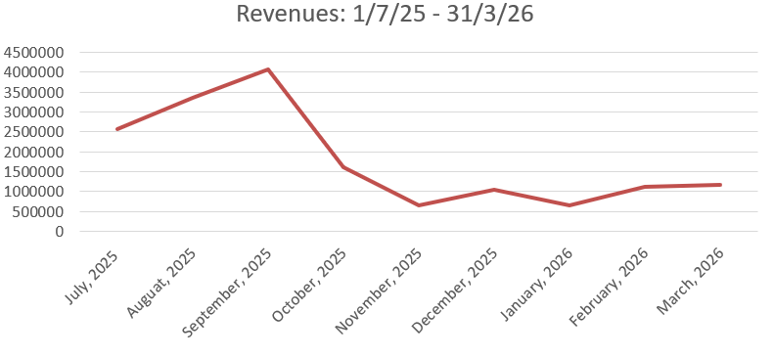

Nature of the Imported Fabricated Steel Market
Imported fabricated steel now directly competes with locally fabricated products across commercial, infrastructure, mining, and industrial projects. These imports typically arrive as fully fabricated structures, assemblies, or modules rather than as raw steel inputs.
Key characteristics of this market include:
- Significantly lower labour and compliance costs in offshore manufacturing jurisdictions.
- Limited transparency regarding overseas production standards, quality assurance processes, and worker safety.
- Circumvention of the domestic value-adding process, reducing local economic participation.
- Government tax incentives and export support measures in originating countries.
Local fabricators are therefore required to compete against imported products that are not subject to equivalent regulatory, industrial relations, environmental, safety, or taxation frameworks, creating a fundamentally uneven competitive environment.

Impacts on Local Steel Fabricators

Competitive Disadvantage and Price Undercutting
Australian steel fabricators operate under stringent workplace health and safety obligations, environmental requirements, industrial relations frameworks, and certification regimes. While these standards serve vital public and economic interests, they significantly increase the cost base of local fabrication.
Imported fabricated steel is often supplied at prices that are not sustainably achievable by Australian fabricators, even when operating efficiently. These price discrepancies reflect structural cost distortions and, in some cases, foreign government subsidies or non-market practices rather than genuine productivity advantages.

Loss of Work Volume and Industry Capability
The increasing acceptance of imported fabricated steel leads to:
- Reduced order books and lower capacity utilisation.
- Inability to invest in workforce development, plant upgrades, and technology.
- Progressive erosion of in-house engineering, detailing, and fabrication capability.
Over time, this undermines Australia’s sovereign industrial capability and increases exposure to supply chain disruptions, currency fluctuations, and geopolitical risk.

Employment and Skills Impacts
Steel fabrication supports long-term skilled employment, including tradespeople, engineers, supervisors, estimators, and support staff. Reduced workload directly impacts:
- Employment levels, particularly in outer metropolitan and regional areas.
- Apprenticeship and trainee intake.
- Retention of skilled labour, with permanent loss of capability once workers leave the industry.

Quality, Compliance, and Risk Transfer
Local fabricators adhere to Australian Standards, certification requirements, inspection regimes, and traceability obligations. Imported fabricated steel does not always face equivalent independent verification prior to installation, resulting in:
- Increased quality and compliance risks.
- Greater reliance on re-inspection, remediation, and rework.
- Transfer of delivery risk from offshore suppliers to Australian contractors and asset owners.

Broader Economic and Strategic Implications

Reduced Domestic Value Capture
The importation of fabricated steel transfers a significant portion of project value offshore, reducing:
- Domestic economic multiplier effects.
- Engagement of local suppliers and subcontractors.
- Tax revenue derived from higher-value manufacturing activity.
Local fabrication ensures a substantially higher proportion of project expenditure remains within the Australian economy.

Supply Chain Resilience
Recent global disruptions have highlighted the vulnerability of extended international supply chains. A sustainable domestic steel fabrication sector enhances Australia’s capacity to respond to:
- Infrastructure demand fluctuations.
- Emergency repairs and asset upgrades.
- Defence and nationally significant projects requiring secure and dependable supply chains.
Reliance on offshore fabrication weakens these resilience outcomes.

Considerations for Policy and Reform
This submission does not advocate protectionism, but rather the establishment of fair, transparent, and comparable competitive conditions. The following matters warrant consideration by the Productivity Commission:

Equivalent Standards and Obligations
Imported fabricated steel should demonstrably comply with requirements equivalent to Australian standards, including:
- Independent third-party certification.
- Transparent fabrication and quality assurance processes.
- Verifiable material traceability.
- Compliance with the Modern Slavery Act.
- Equivalent taxation exposure.
- Equivalent forms of government support or assistance.

Procurement Policy Settings
Public and government-funded projects should assess:
- Whole-of-life costs rather than upfront pricing alone.
- Economic, employment, and skills impacts of procurement decisions.
- Appropriate local content or local industry participation thresholds.

Trade Compliance and Monitoring
Enhanced monitoring of fabricated steel imports to address:
- Dumping or subsidised products.
- Misclassification of goods to avoid regulatory scrutiny.
- Non-compliance with safety, quality, or certification requirements.

Support for Industry Capability
Targeted measures to support domestic competitiveness, including:
- Investment incentives for automation and advanced fabrication technologies.
- Skills development and apprenticeship funding aligned to fabrication trades.
- Support for export development where feasible.

Conclusion
The growing volume of imported fabricated steel presents a material and ongoing threat to Australia’s steel fabrication industry. Without balanced and considered policy intervention, Australia risks the gradual erosion of a strategically important manufacturing capability, with lasting consequences for employment, skills retention, economic resilience, and national interest.

A competitive domestic steel fabrication sector can coexist with open trade, provided competition is fair, transparent, and aligned with Australia’s regulatory, economic, and social objectives. This submission urges the Productivity Commission to consider the cumulative impacts outlined above and to recommend policy settings that support a strong, sustainable, and competitive Australian steel fabrication industry.

APPENDIX A

Examples of Projects we lost over the past 12-18 months and can be easily done by local fabricators
Example 1: Goldfields Art Centre

Vietnamese Fabricator showcasing the project on its website
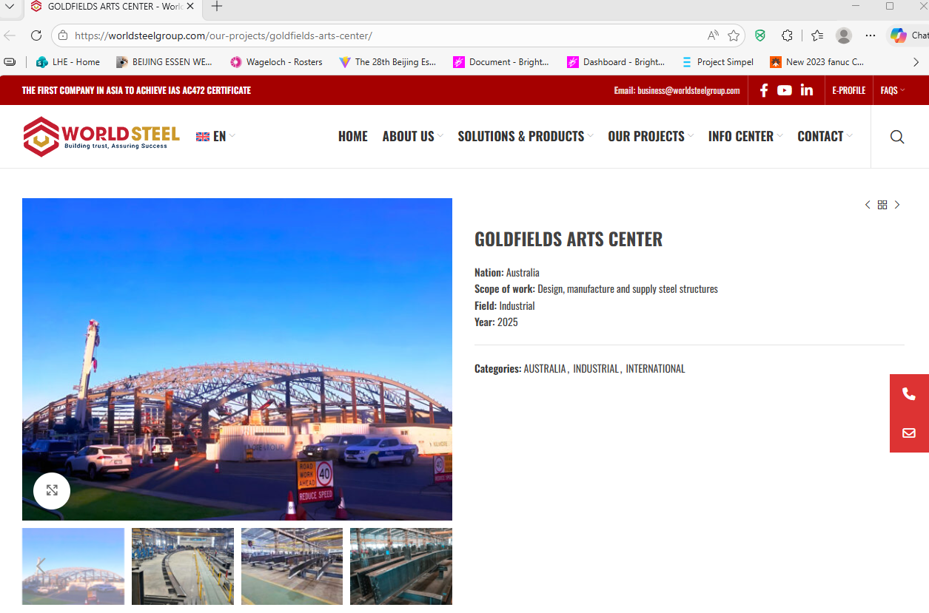

Australian Builder posts on LinkedIn

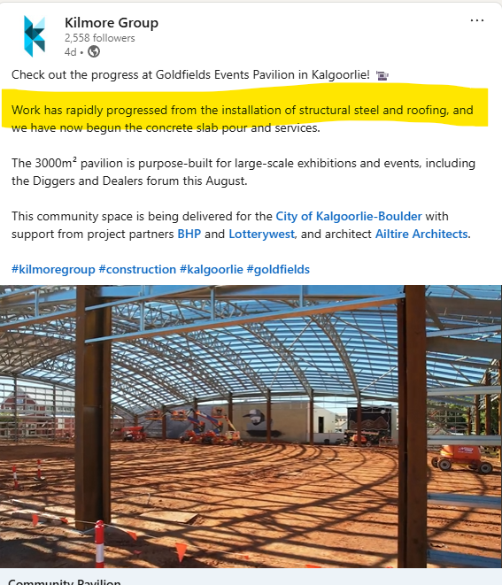

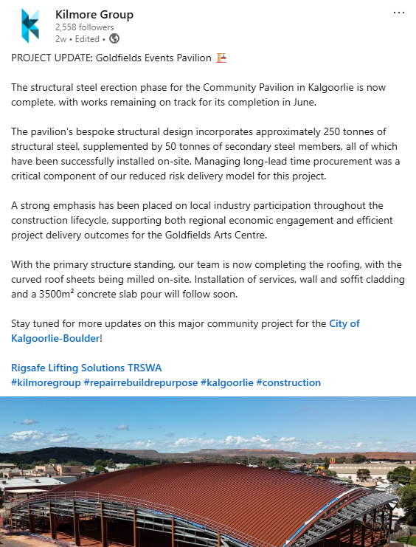

Example 2: Brockman 4 MEM Workshop Expansion - NPI Facilities (Rio Tinto)
Structural Steel value: $4,685,000
Our price was competitive from a locally fabricated steel perspective. However, the client/builder (Decmil) elected to procure the steel from overseas.

Example 3: Project Cleaver, Mandurah, WA
Structural Steel Value: $2,846,890.00
The builder (TSL Projects) planned from day one to outsource the steel from Vietnam, however engaged with local fabricators to get insights into technical clarifications.

