Safeguard submission into import of fabricated structural steel made by Rajesh Sharma

1. Business Overview
This section introduces your business and provides context for your submission.
- Company name: Gonzalez Steel Pty Ltd
- Location of operations: Beresfield NSW 2322
- Size of business
- Number of employees: 70 to 120
- Approximate annual production volume: 6000 to 7000 tons
- Products manufactured with relevant tariff code 7308.10.00, 7308.20.00, 7308.90.00
▪ 7308100001 – Bridges and bridge-sections of iron or steel.
▪ 7308900052 – Columns, pillars, posts, beams, girders, bracing, gantries, brackets, struts, ties and similar structural units, hot rolled, of iron or steel (excl. those of HTISCs 7308100001, 7308200002, 7308300003 and 7308400004).
▪ 7308900053 – Same as above, roll formed, plated or coated with zinc or aluminium-zinc alloys, less than 1.2mm thick, of iron or steel (excl. hot rolled and HS 730810 to 730840).
▪ 7308900054 – Same as above, roll formed, plated or coated with zinc or aluminium-zinc alloys, greater than or equal to 1.2mm thick, of iron or steel (excl. hot rolled and HS 730810 to 730840).
▪ 7308900055 – Same as above, roll formed, of iron or steel (excluding hot rolled; plated or coated with zinc or aluminium-zinc alloys; and HS 730810 to 730840).
▪ 7308900056 – Same as above, of iron or steel (excluding roll-formed structures and those of HTISCs 7308100001, 7308200002, 7308300003 and 7308400004).
▪ 7308900057 – Steel grating, stairways and treads (excluding those of HTISCs 7308100001, 7308200002, 7308300003 and 7308400004).
▪ 7308900060 – Handrails and stanchions, of iron or steel (excluding those of HTISCs 7308100001, 7308200002, 7308300003 and 7308400004).
▪ 7308900062 – Guard rails and road barriers, of iron or steel, prepared for use on bridges and roads.
▪ 7308900063 – Sectional components, of iron or steel, prepared for use in towers and lattice masts.
▪ 7308900064 – Lintels, of iron or steel, prepared for use with doors and windows.
▪ 7308900065 – Structures and parts of structures and plates, rods, angles, shapes, sections, tubes and the like, prepared for use in structures, of iron or steel (excluding those of HTISC 7308100001).

- Exposure to import competition
- Approximate percentage of revenue exposed to direct import competition: almost 30 to 40 % and is unpredictable it is client based and the budgets and govt funding for the project values that put the pressures on the builders to push for import
- Key customer segments: most govt projects , large govt and private projects examples paramatta powerhouse museum, Aldi warehouse in Bradford city WSA, Woollies warehouse in Bradford city WSA, and the list goes on there is no control all goes on for the better values at the cost of local revenue and jobs while the committees like these will take years to arrive at a workable conclusion and then need to set the watch dog process in place that is almost never monitored.

2. Evidence of an Import Surge
This section addresses whether imports have increased in absolute or relative terms and whether they compete directly with your products.
- Market observations
- Have you observed increased import penetration in your product category? Yes
- Over what period? It is on going just see the report and the report a yar behind as seen here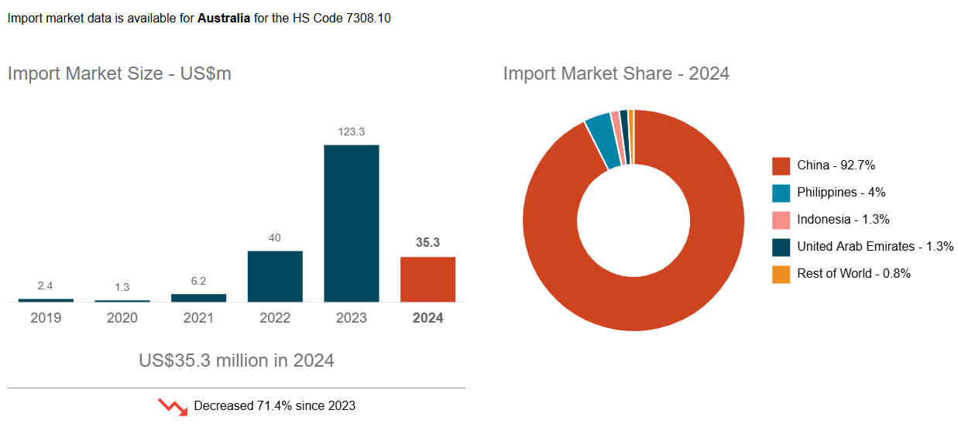

- Lost contracts or market share. Please provide examples where possible and attach supporting documents where available, such as tender summaries or internal reports.
- Contract/project description: Aldi warehouse
- Approximate value: 45 million
- Date: in the year 2025
- Competing product origin (if known):
- Approximate price difference: not even priced in Australia will be around 10 million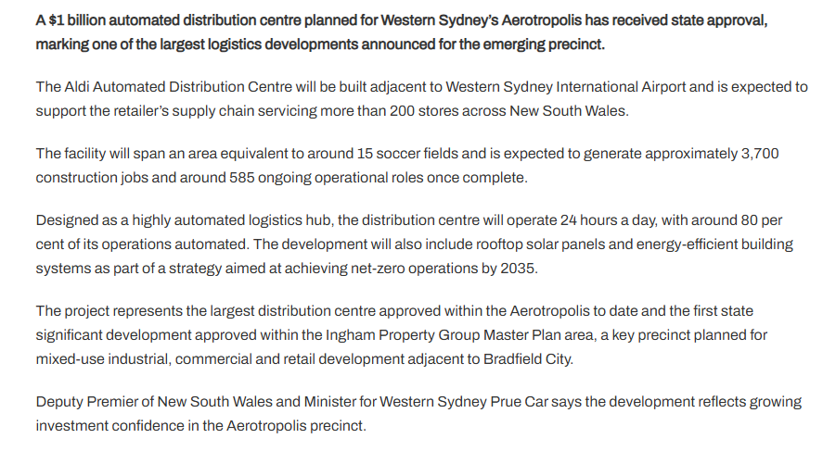 Structural Steel: Comparable high-bay ALDI projects of this scale (approx. 100,000 sqm) typically require between 7,500 and 8,000 tonnes of structural steel. We can see this in next years report for the imports in 2025 if captured,
- 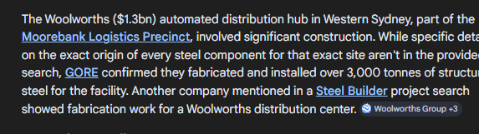
- 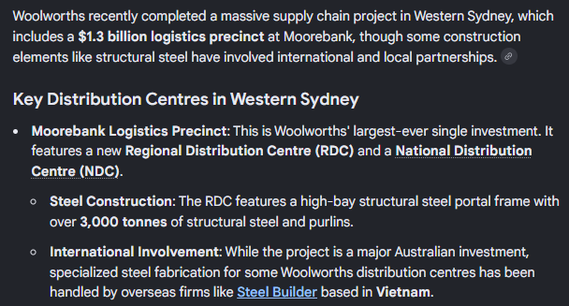
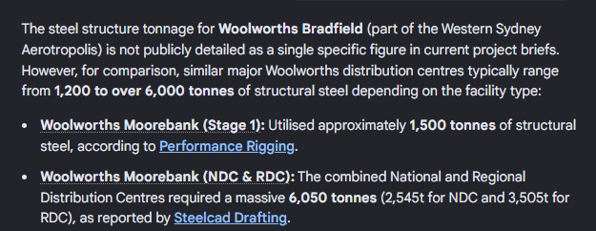
- The figures are suppressed as it was noted that this facility in Bradfield will need over 10 to 12 thousand tons of steel and this is for 2025 -26.

- Pricing impacts
- Have you experienced sustained price undercutting? Many fabricators just import part of the steel from offshore and mix with their local fabrications to just keep their turnover going and business running. Some businesses have made alliance with offshore suppliers for such deals where they get part of the work done overseas.
- Estimated percentage price gap relative to imports: almost 30 to 40% at time
- Duration of price pressure: all year round
- Other information:
- Changes in order volumes: at time when there is not enough work for local companies mixing the offshore supplies in the mix has an effect of loss of work for the companies that are dedicated to the make it local moto and providing local employment, and local tax revenue. There seem to be no incentive for them while there is no deterrent for the ones that do the mix and match to stay above the water and keep turning around there is one such company that went bankrupt four to five time and on his every return with the new company name he was successfully getting new large govt projects
- Shifts in customer procurement behaviour: the customer is dollar based and always looks for cost savings, where that comes from is not his concern as far he can make more profit that is the only thing that matters, and there is nothing wrong with that because we allow the unfair competitions and leave it uncontrolled with no repercussions.
- Evidence of import-led price setting: if the year-by-year figures and the graph above does not ring alarm bells not sure what else will just see the year 2025 import data when it comes and that will get some attention to as who is approving these imports or there is don’t care attitude at all levels as the imports can be brought in without its accountability as far that it generates revenue plus more it just keep coming in the name of free trade agreements .

3. Evidence of Injury
This section should indicate or demonstrate serious injury or threat of serious injury attributable to import pressure.
- Financial impacts: Attach financial information where possible. Remember that this is a public submission.
Evidence of injury to the Australian steel industry from imported steel—particularly fabricated structural steel (FSS)—includes a significant surge in import volumes, a 12% drop in domestic production (2023-2024), and substantial undercutting of local prices by 15% to 50%. As of early 2026, this has resulted in widespread business closures, reduced capacity utilization, and significant job losses, prompting a federal safeguard investigation
Key Evidence of Injury (2024-2026):
- Surge in Import Volumes: Fabricated structural steel imports increased by 38.7% between 2020 and 2024, reaching over 539,000 metric tons. Imports of fabricated steel increased from 450,000 tonnes to 700,000 tonnes annually by early 2026.
- Import Share of Domestic Market: Imported fabricated structural steel's share of the Australian market rose from 15% in 2020-21 to 26% in 2022-23.
- Price Undercutting: Imported steel is consistently priced 15% to 50% lower than the cheapest local offering, making it impossible for local fabricators to compete on price, particularly in the portal frame market.
- Reduced Capacity Utilization: Approximately 80% of surveyed steel fabrication businesses are operating at less than 80% capacity—the threshold for break-even profitability—with some operating below 50%.
- Business Closures and Job Losses: In Western Sydney alone, more than a dozen steel fabrication businesses closed in the 18 months preceding November 2025. A Quee

- Trends in revenue over the past 3–5 years:
Local revenue losses in the steel industry, particularly within Australia, are experiencing a severe downward trend driven by a surge in cheap imported fabricated steel, with reports indicating 86% of local manufacturers have reduced profit margins due to imports priced 15% to 50% lower than local offers. This, combined with falling demand for local products, has led to significant capacity underutilization—some falling from 90% to just 27%—and accelerated business closures in early 2026
- Trends in gross margins or EBITDA margins: as reported in Trading Economics EBITDA margins in Australia are experiencing widespread compression as of late 2025 and early 2026, driven by a structural trend where rising wage costs and input pressures are outpacing revenue growth. While corporate profits in Australia grew by 3.8% annually in Q4 2025, suggesting a slight stabilization at the end of the year, this followed a period of stagnation and intense margin pressure
- Evidence of margin compression attributable to import competition: reports from Australian Bureau of Statics reports Widespread Compression: For many businesses, particularly in manufacturing and small-to-medium enterprises (SMEs), margins have declined due to inflationary costs. Mining, despite being the largest contributor to earnings, mining EBITDA saw significant declines (-15.4%) in 2023-24, indicating a cooling from previous highs, although it remains highly profitable compared to other sectors.
- Manufacturing: Mid-sized manufacturers have seen EBITDA margins compress to roughly 9% in FY25 due to cost pressures.

- Production and utilisation
- Change in production volumes: Construction: Volume growth has been constrained, with construction MFP falling 2.8% in 2024–25, driven by a 3% rise in hours worked to complete projects with little to no growth in output.
- Capacity utilisation rate (current vs historical average):
As of March 2026, the capacity utilisation rate in Australia decreased to 73.70%, down from 78.90% in February 2026, according to Australia Capacity Utilization - Trading Economics. This metric measures how much of Australia’s potential industrial production is being used, with a long-term average around 81%. Key data from Capacity Utilisation Rate: sa: Australian Industry Index - CEIC indicates a high of 84.1% in early 2023
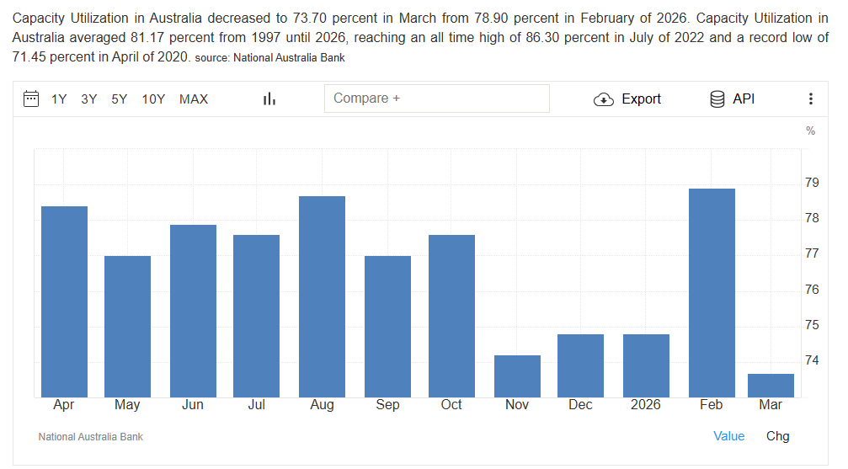
- Employment impacts
As reported in parliament of Australia report. Employment Trends
- Job Loss Risk: A 2015 estimate stated that a potential shutdown could have caused 10,000 jobs in losses and a $3.3 billion loss to the regional gross product, demonstrating the high-risk nature of the industry.
- Recent Trends: Employment in some areas, such as iron and steel forging, has continued to decline (-1.6% annually between 2020 and 2025).

- Number of employees reduced (if any): we have cut the shop labour from 100 to 60
- Region/location of employment: shifts to overseas with the imports
- Roles affected: the trade in shop fabrication, Boiler makers, labours and welders.
- Hiring freezes or deferred recruitment: waiting for new contract
- Investment impacts
- Capital expenditure deferred or cancelled:
As Reported by Austrade international, International Competition & Dumping: Investment is pressured by imported steel, with increasing imports dampening local production competitiveness. In the PMs report he noted Import Competition: Continued reliance on lower-cost imported steel threatens local market share, causing pressure on domestic fabricators.

- Estimated value of postponed investments:
- Projects placed on hold:
- Explanation: Briefly explain why the injury identified above is linked to import surges rather than broader macroeconomic conditions.
The basic reason for the injury to local industry from the imports is the massive difference in the wage structure of the countries sending these imports. If talk about the level plain field the one key factor that is always overlooked is the wage rate.
If we compare 45 to 75$/Hr to 8 to 10 $/hr non what automated process we add to our production the others can add the same and stay ahead and that has been consistently happening over the years and has reached a saturation point where all our automation is also owned by the these countries and in some cases of much better quality and of lot higher volume production. And there are no smarter ways left to match the imports unless these are valued at equal labour cost inputs as well.

4. Productivity Implications
If a temporary safeguard measure were imposed, how would your business respond? Providing examples where available:
- To what extent is your business currently constrained in its ability to make productivity improvements – for example capital investment and/or operational improvements?
See the note above
- If a safeguard measure (a temporary measure to provide “breathing space” for industry) is imposed, what would your business consider doing/adjusting?
There is no temporary measure that will save the industry the skill is dying and so is the interest of the businesses to keep hitting their heads against the walls with no resolve and it faces the same outcome as the bonds singlets and undies if we can’t make these here the chances of steel industry diminishing has been written on the wall already.

5. Structural Implications
This section addresses broader economic consequences as the PC will assess whether the imposition of a safeguard measure, is in the public interest.
- Skills and workforce
- Are experienced or specialised employees being lost?
Not only lost it is becoming harder to engage new and young talent as they see how their elders had been drifting from one to another company to keep the food on the family table. Companies cannot guarantee jobs security, so Gen Z are looking for stable govt jobs with less headaches and easy work.
- How difficult would it be to rebuild this capability? Without some serious measures this industry is doomed and will be vanished from Australian in the next 10 years.
- Estimated time to rehire and retrain equivalent staff: A. hard to get and B. no wiling ness of the young ones to get in the industry has always seen this skill being supplemented by Temp visa and offshore labour hire.
- Business viability
- Has import pressure affected long-term viability of specific product line
Continuous closures of the steel making industry to the point that it also now owned by a offshore company should give clear indications where it is al heading to and very son we may be relying on total import just as we rely on our refined petrol that we export and bring back refined as we are either naïve that we can’t see the evident results of the years of the down fall in the industry. Poor planning and lack of foresight is the key reason Australia do not have any major manufacturing industry. We even sell our hard-earned new patents in the pharmaceuticals to other countries to benefit in billions while we slave hours of hard labour in their research.

- Risk of exit from certain markets: the risk is for total closure in 10 years.
- Supply chain implications
- Role of your firm in domestic supply chains:
Fabrication and supply of all major and minor infrastructure govt or private projects
- Consequences if domestic capacity contracts: heavy reliance on imports at the sacrifice of quality
- Regional impact
- Regional economic importance of your operations:
We a major supplier of fabricated steel in our region along with few others
Job losses will be imminent
Loss of tax dollars and tax revenue.
More Burdon on the unemployment benefits and its costs.
Increase in crime rates to make ends meet.

