Embedding the Priority Reforms in grant design and assessment: The Closing the Gap Health Infrastructure Program

Key points
- The National Agreement on Closing the Gap provides a strong mandate for shared decision-making. Government agencies can support this by formalising partnerships, allowing sufficient time to develop relationships and new ways of working, and sharing data with the community-controlled sector to inform decision-making.
- Legislative and policy settings, including the Public Governance, Performance and Accountability Act 2013 and Commonwealth Grant Rules and Guidelines 2017, support co-design and shared decision-making.
- An external probity advisor can support agencies in designing new governance settings, protocols and processes to share decisions with the community-controlled sector. A focus on what is possible, rather than what has been done before, is crucial.
- Taking a relational approach to working with the community-controlled sector supports continuous policy and program improvement. This enables integration of sector knowledge in grant design that supports appropriate assessment criteria, equitable processes and decisions reflecting lived experience.
- Support for grant applicants, including grant writing assistance, tailored feedback and open communication channels with grant administrators, can strengthen capability and competitiveness of community-controlled organisations over grant rounds.
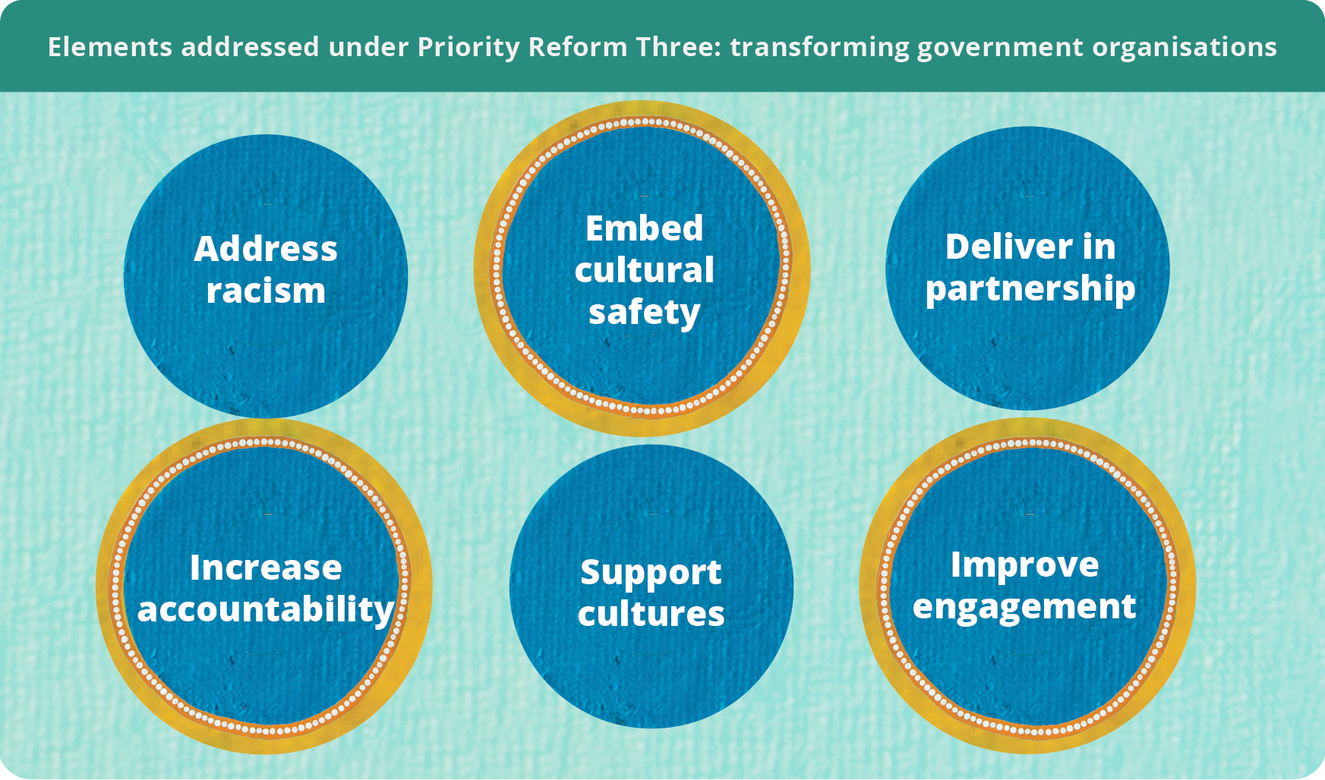


Transforming processes through co-design and shared decision-making
Co-design and shared decision-making recognise the wealth of knowledge Aboriginal and Torres Strait Islander people hold and ensure policy, programs and services reflect this knowledge (SNAICC 2025, p. 4).
Government structures and cultures often challenge these approaches because they are rooted in rigid, self-reinforcing systems that centralise decision-making authority (Blomkamp 2018). Under Priority Reform Three of the National Agreement on Closing the Gap (the Agreement), governments must transform their organisations to enable transparency in decisions, culturally safe processes and services, and improved engagement. Co-design and shared decision-making can facilitate this transformation by identifying where processes need to change and by bringing in the perspectives of people with lived experience. This strengthens the other Priority Reforms by helping governments better understand what barriers are preventing reforms from working and how these can be addressed.
The Closing the Gap Health Infrastructure Program (the Program) shows how governments can change their ways of working to embed partnership, co-design and shared decision-making within existing grant frameworks. The Public Governance, Performance and Accountability Act 2013 (PGPA Act) and the Commonwealth Grant Rules and Guidelines 2017 are sufficiently flexible to support these approaches (PC 2025, p. 2). The PGPA Act (section 17) establishes a positive duty on government officials to encourage cooperation with others to achieve common objectives. Long-standing working relationships and engaging independent probity advice can support program partners to meet this positive duty though shared decision-making. This in turn supports the incorporation of sector knowledge in decision-making so that programs and policies are more culturally informed and responsive to community needs (PC 2024, p. 63).

Setting the foundations for the Closing the Gap Infrastructure Program
The National Aboriginal Community Controlled Health Organisation (NACCHO) and the Australian Government’s Department of Health, Disability and Ageing (the department) have a long history of working together. Strengthened during earlier crises, including the syphilis outbreak and COVID-19, the organisations see their relationship as a foundation for genuine collaboration, marked by flexibility and responsiveness. Their relationship consistently demands the department reflect on its ways of working in line with the Priority Reforms.
NACCHO is a mature organisation, with a strong ability to influence government policy. Recognising a need in the sector, in 2019 NACCHO conducted a national survey of Aboriginal Community Controlled Health Services (ACCHS) to help quantify health infrastructure shortfalls. The survey identified a significant shortfall, of approximately $1 billion, highlighting the need for further investment (NACCHO 2022, p. 42).
In August 2021, the Australian Government announced a $254.4 million, 4-year investment to address seriously deteriorating or non-existent health infrastructure in the ACCHS sector (NACCHO 2022, p. 42). The investment is divided between the Major Capital Works Program and the Service Maintenance Program, collectively known as the Closing the Gap Health Infrastructure Program. Grant opportunities under the Program are open to ACCHSs delivering comprehensive primary health care to Aboriginal and Torres Strait Islander people. Applicants engage in a 2-step application process: first an expression of interest (EOI), then an invitation to apply (ITA).
Grant applicants can draw on supports like grant-writing assistance, with unsuccessful applicants offered tailored feedback to support them in the next round (figure 1).
Figure 1 – Grant opportunity process
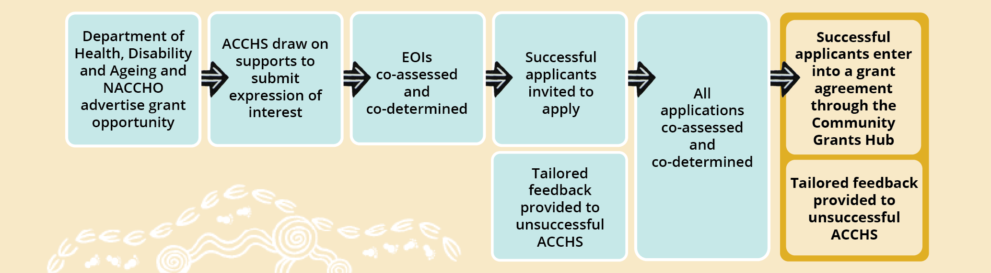
As a key Closing the Gap measure, partners designed the Program to align with the Priority Reforms. NACCHO and the department have equal roles in the design and assessment of the Program (figure 2). This supports transparent and informed decision-making processes and contributes to strengthening the community-controlled sector.
Figure 2 – Design, assessment and decision-making roles and responsibilities
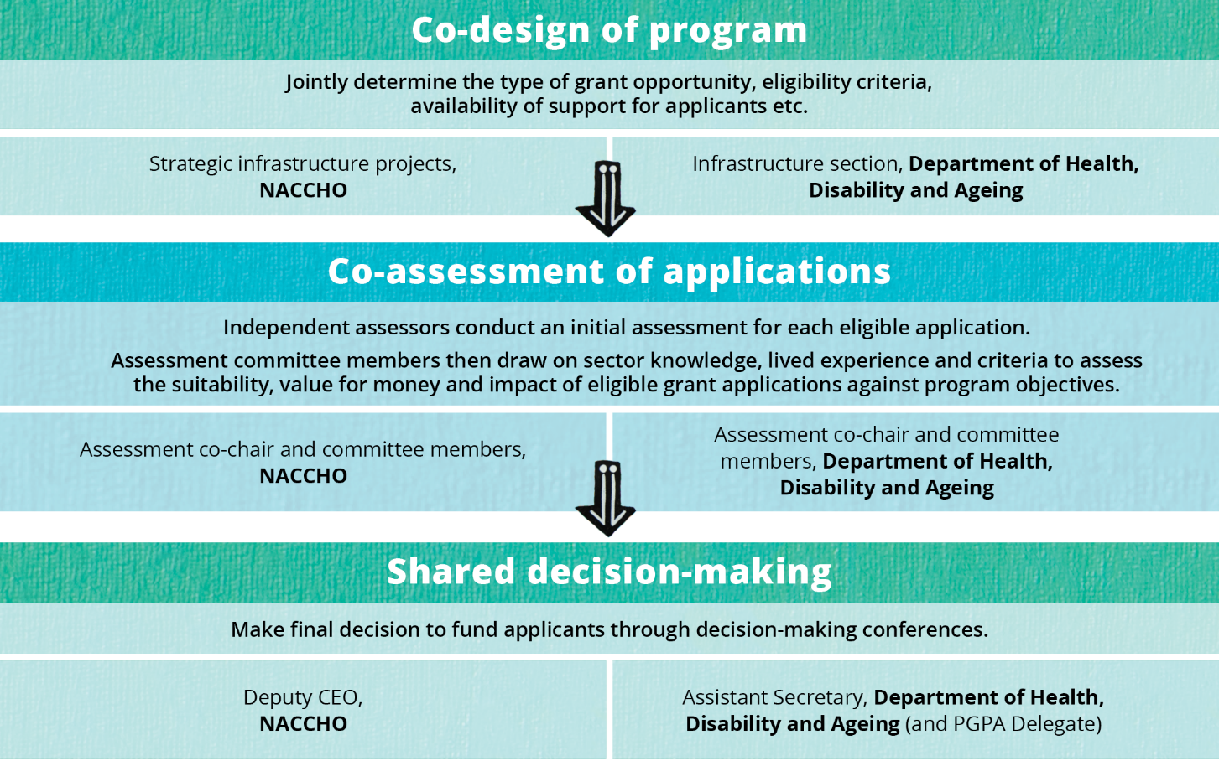

Navigating co-design and shared decision-making

Creating an authorising environment to embed the Priority Reforms in partnership
Successful co-design and shared decision-making require a commitment of time and effort from all involved. While shared decision-making approaches had been increasingly implemented through other programs administered by the department, partners agree the signing of the Agreement provided the authority and confidence to formalise and strengthen this way of working. Equally important was a genuine commitment from both partners to implement the Priority Reforms throughout the Program.
To allow time to navigate co-design together, the department built flexibility into their policy proposal. This involved dedicating time to engage with NACCHO prior to the delivery of a grants program, with grant funding intentionally deferred until year two. During this time, staff from the department and NACCHO worked to develop a trusted relationship to enable frank and honest conversations about scope, division of roles and responsibilities and assessment approaches. Ways of working shifted from a model where proposals were developed by the department for NACCHO’s endorsement, to a collaborative approach where proposals were developed jointly from the outset. NACCHO feels the department genuinely listened, valued their feedback and supported proposed changes.

Engaging external probity advisors to enable shared decision-making
During the design phase, the department engaged an independent external probity advisor to maximise the potential of shared decision-making, ensuring alignment with relevant legislation, policies and guidelines. The advisor played a key role in designing fit-for-purpose arrangements and managing issues such as impartiality and confidentiality without undermining collaboration. Partners reflect that the advisor’s focus on ‘the art of the possible’, rather than precedent and business-as-usual processes, enabled genuine shared decision-making.
This was particularly important given NACCHO’s dual roles as peak body representative and co-decision-maker in the Program. While NACCHO does not benefit directly from the grant opportunity, partners understood the likelihood of conflicts of interest (real or perceived), especially as not all eligible applicants are members of NACCHO. The probity advisor worked with NACCHO to develop a probity plan and a staff training program delivered in conjunction with department staff. The need to disclose and manage conflicts of interest is continuously reinforced. Further, the advisor observed some early assessment meetings to ensure recommendations and decisions made were consistent with published criteria and accurately recorded (O’Connor Marsden & Associates Pty Limited 2024, p. 3).

Transforming grant processes to strengthen the community-controlled sector

Facilitating grant writing support for community-controlled organisations
Grant writing support can enable equitable access to funding and strengthen the community-controlled sector. It can reduce barriers to accessing funding and biases in decision-making (O’Connor Marsden & Associates Pty Limited 2024, p. 3).
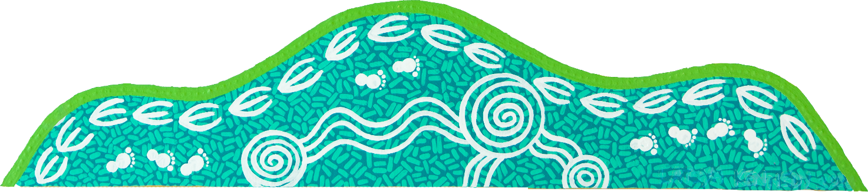
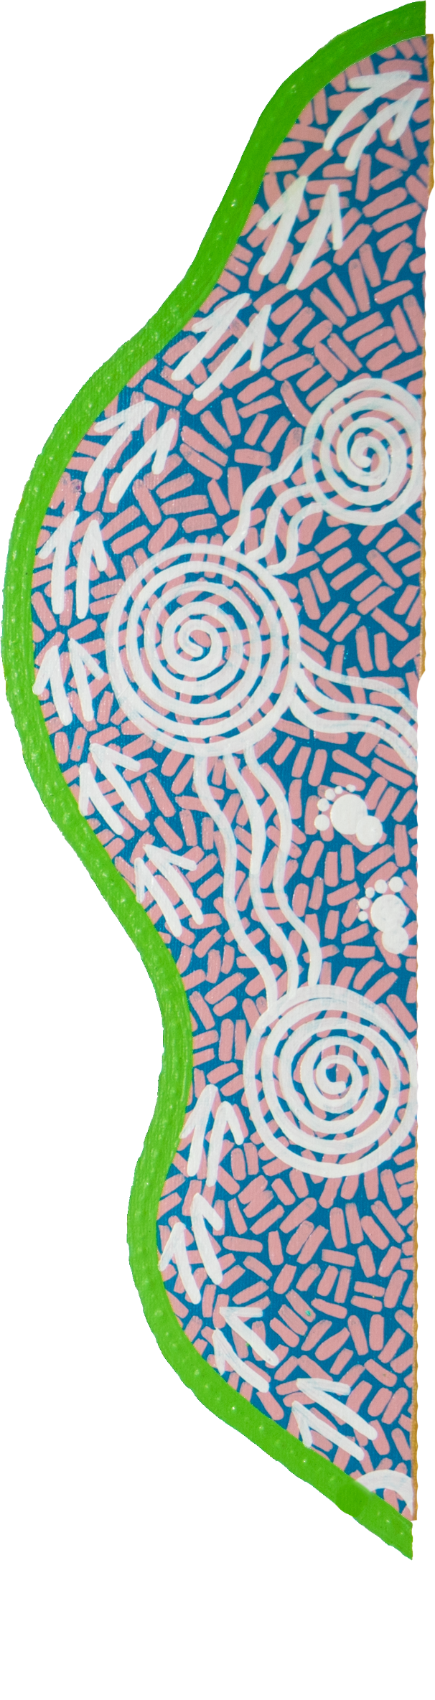
Following discussions between partners, the department procured NACCHO to establish a panel for grant writing support. The department recognises NACCHO is best placed to identify culturally competent panel organisations to provide this support. NACCHO also has the reach to promote this opportunity through targeted webinars and facilitate contact between ACCHSs and their chosen provider. This delivery model provides a level of separation between NACCHO and applicants during the application process, supporting confidence in the impartiality of the service.
Grant writing support is available to ACCHSs that do not consistently have access to staff who can write a competitive grant application. It has been used in different ways across the EOI and ITA stages, from helping organisations navigate the scope of a proposal to conducting a final review of draft applications.
Partners believe the support makes a difference to the quality of writing and how ACCHSs bring out the key points in an application. For example, the pressure to be competitive and show ‘construction readiness’ in an application can contribute to applicants underestimating costs. One way to manage this through grant writing support is by encouraging applicants to be realistic about costings, delivery timelines and project scopes.
Additional funding to help cover planning costs can further support equitable access to grant opportunities, particularly for smaller ACCHSs that could not cover these costs upfront. Partners are working with the sector to develop opportunities for needs assessments to address this.

Co-assessing and co-approving applications to reflect sector experience
Co-assessment and co-approval of grant applications embeds self-determination, cultural safety and fairness by moving decision-making closer to communities. NACCHO’s involvement in key stages of the assessment process supports funding decisions that reflect sector knowledge and lived experience.
During the assessment of the first grant round, some independent assessors made assumptions that were inconsistent with lived experience. This included overlooking the operating environment of certain ACCHSs and their inability to access rental markets. To address this, NACCHO’s executive briefed the assessors on sector context and experience. NACCHO and the department also agreed the assessment committee will review every application regardless of whether they are initially ruled suitable or not.
The use of decision-making conferences is another shift from business-as-usual approaches to the approval of grants. Unlike standard processes whereby the decision-maker or delegate is provided a list of recommendations, decision-making conferences bring together the assessment committee co-chairs with decision-makers to support the decision-making process with real-time interrogation of assumptions
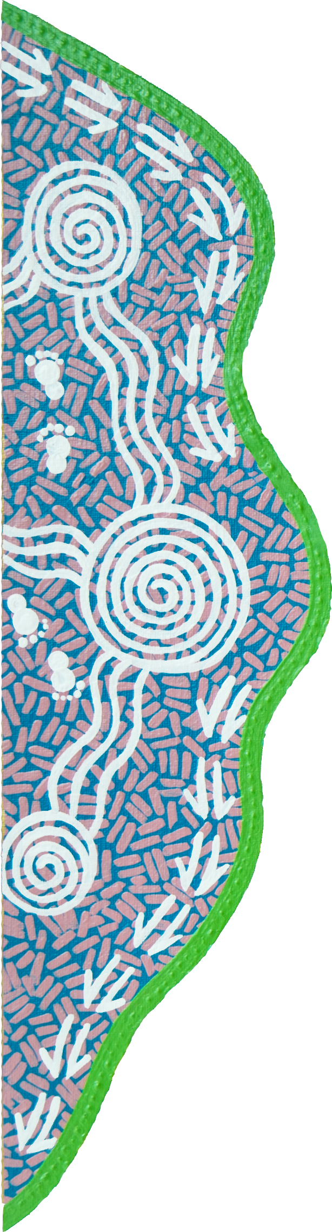
and rationale. They provide a forum for greater discussion and validation, ensuring the assessment committee’s recommendations are clear and defensible. On occasion, the conferences have been used to draw the committee’s attention to sector context or considerations. Despite being a more resource-intensive process, this is an important quality assurance mechanism ensuring funding decisions support policy objectives.

Tailored feedback for unsuccessful applicants to build capability
To support applicants to improve their applications for future grant opportunities, the department and NACCHO offer feedback interviews to all unsuccessful applicants. Interviews are tailored to each applicant, identifying the type of information that would have strengthened their application. Where eligible applicants had not previously accessed grant writing support, they were strongly encouraged to do so. The department reflected that where applicants have taken feedback onboard and reapplied, they often go on to be successful in subsequent rounds.
NACCHO noted these interviews can be challenging from a relational perspective, as NACCHO has to explain why its member organisations are not receiving funding. However, they are considered important in reinforcing accountability to the sector, particularly in the context of highly oversubscribed grant rounds where not all suitable applications can be funded in the first instance.

Leveraging the benefits of co-design across the grant lifecycle
This case demonstrates the value of working with peak Aboriginal and Torres Strait Islander bodies, such as NACCHO, in the design and assessment of grant programs. Early and meaningful involvement of peak bodies helps ensure program settings, assessment criteria and funding decisions are grounded in lived experience.
The department has begun embedding this way of working beyond the Program, including by sharing lessons learned on co-design approaches. This has contributed to changes in process across the Alcohol and Other Drugs Branch, Targeted Health Programs Branch, and Lung Cancer Screening and Cancer Infrastructure Branch, among others.
Extending co-design into the grant establishment and management stages could help ensure delivery requirements and milestones reflect the operational context of ACCHSs. For example, milestones tied to short-term budget cycles often don’t reflect the longer-term agreements required to deliver large infrastructure projects, particularly in regional and remote areas. Ongoing involvement of peak bodies could help anticipate and address these issues, supporting more efficient and effective delivery that better aligns with operational realities.
As of April 2026, 25 of 88 infrastructure projects have been completed. The Australian Government has committed to continuing to address the infrastructure need with an additional $144.1 million investment in the Program over the next two years (Albanese and McCarthy 2026).

References
Albanese, A and McCarthy, M 2026, New investments build on progress in Closing the Gap, Media release, https://www.pm.gov.au/media/new-investments-build-progress-closing-gap (accessed 29 April 2026).
Blomkamp, E 2018, ‘The Promise of Co-Design for Public Policy’, Australian Journal of Public Administration, vol. 77, no. 4, pp. 729–743.
NACCHO (National Aboriginal Community Controlled Health Organisation) 2022, NACCHO Annual Report 2021-22.
O’Connor Marsden & Associates Pty Limited 2024, Probity Report: Indigenous Australians’ Health Program (IAHP) Infrastructure measures, 8 October.
PC (Productivity Commission) 2024, Review of the National Agreement on Closing the Gap, Study report, Vol. 2, Canberra.
—— 2025, Priority Reform Three: Transforming government organisations, Guidance note and case studies Canberra.
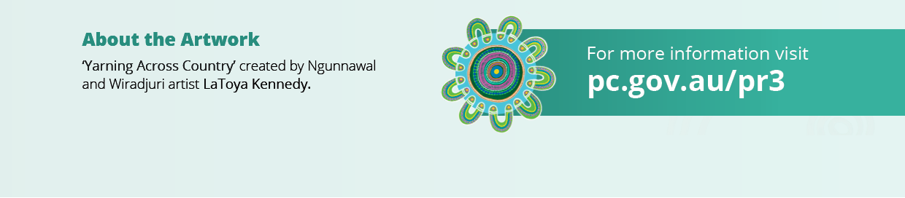
SNAICC (SNAICC – National Voice for our Children) 2025, Creating Structural Change Through Shared Decision-Making: Guidance for Government and Aboriginal and Torres Strait Islander Organisations.

