Safeguard submission into import of fabricated structural steel

- Business Overview

Company name: (Redacted)
Location of operations: Workshop Based in Northern Queensland; & covers projects across all of regional Queensland.
Size of business:
Annual turnover: $15-20M
Number of employees: 50
Approximate annual production volume: Approximately 2,500–4,000 tonnes of fabricated structural steel per annum, depending on project mix and contract pipeline.

Products manufactured with relevant tariff code classifications. The Appendix provides further details on each of these codes.
The company manufactures and installs fabricated structural steel products including:

Structural steel frames and assemblies
Beams, columns, and trusses (7308900052)
Plate and welded structural components (7308900065)

Mining, infrastructure, and industrial steelwork packages
Steel grating, stairways and treads (7308900057)
Handrails and stanchions, of iron or steel (7308900060)
Sectional components, of iron or steel, prepared for use in towers and lattice masts.(7308900063)
Structures and parts of structures and plates, rods, angles, shapes, sections, tubes and the like, prepared for use in structures, of iron or steel (7308900065)

Exposure to import competition - Approximate percentage of revenue exposed to direct import competition:
Approximate percentage of revenue exposed to direct import competition:
Estimated 50–70%, particularly in larger commercial, mining, and infrastructure projects where imported fabricated steel is actively considered.

Key customer segments:
Mining and resources sector
Commercial construction contractors
Infrastructure and government projects
Industrial clients -processing plants, maintenance, repairs

- Evidence of an Import Surge
Market observations
Observed increased import penetration:
Yes
Imported fabricated structural steel has increased significantly, particularly from China, Vietnam and Southeast Asia.
Imports are increasingly being supplied as fully fabricated, pre-painted, and pre-drilled components, directly competing with Australian fabrication businesses.
Over what Period:
Noticeable escalation over the past 3–5 years, with acceleration post-COVID due to pricing pressure and supply chain shifts.
Lost contracts or market share. Please provide examples where possible and attach supporting documents where available, such as tender summaries or internal reports.
Contract/project description:
Multiple structural steel packages for commercial and mining projects in North Queensland lost to offshore-fabricated alternatives supplied via Australian intermediaries.
Approximate value:
Individual projects ranging from $375K to $5M, with cumulative lost opportunities estimated at $5M+ annually.
Date:
Ongoing across 2022–2025
Competing product origin (if known):
Primarily China and Vietnam
Approximate price difference:
Typically 30%–40% lower than local fabrication pricing

Pricing impacts
Have you experienced sustained price undercutting?
Yes
Estimated percentage price gap relative to imports:
Consistently 30%–40% below domestic fabrication costs
Duration of price pressure:
Persistent over the past 3+ years, intensifying recently
Other information:
Changes in order volumes
Increased volatility, with fewer large-scale fabrication contracts secured locally
Shifts in customer procurement behaviour
Greater willingness to source offshore
Increased use of imported “kit” steel packages
Procurement decisions increasingly driven by lowest upfront cost rather than lifecycle value
Evidence of import-led price setting
Imported steel pricing is now frequently used as the benchmark in tender negotiations, forcing domestic suppliers to match unsustainable price levels

- Evidence of Injury

Financial impacts:
Trends in revenue over the past 3–5 years:
Revenue has remained relatively stable but with increased volatility and reduced growth, despite strong market demand.
The Company has identified at least 11 projects between 2021 and 2026 where fabricated structural steel was sourced internationally instead of domestically.
These projects represent an estimated $22-$23 million in lost local economic activity, including:
Fabrication: approximately $6.9 million
Materials supply: approximately $7.4 million
Installation: approximately $3.5 million
Surface treatment: approximately $3.2 million
Workshop detailing and engineering: approximately $2.1 million
This demonstrates that import competition is not limited to fabrication alone, but results in the loss of entire project value chains, including steel, engineering, labour, coatings, bolts/materials, transport, hire equipment and installation.
These projects were capable of being delivered by The Company and the domestic supply chain, but were instead supplied by imported fabricated steel primarily due to price undercutting.
Trends in gross margins or EBITDA margins:
Noticeable margin compression, particularly on competitively tendered projects.
Evidence of margin compression attributable to import competition:
Reduced profitability on secured work.
Increased instances of projects being declined due to unviable pricing.
Direct correlation between import competition and reduced bid margins.

Production and utilisation
Change in production volumes:
Fluctuating volumes with periods of underutilisation
Capacity utilisation rate (current vs historical average):
Historical: ~80–90%
Current: ~60–75% depending on project pipeline
Employment impacts
Number of employees reduced (if any):
Some workforce reductions and reliance on casual/contract labour instead of permanent hires
Region/location of employment:
Based in North QLD & operates throughout Northern & Central Queensland
Roles affected:
Boilermakers
Welders
Workshop support staff and Riggers
Hiring freezes or deferred recruitment:
Yes – cautious hiring and delayed recruitment due to uncertain workload. Not replacing workers who have left.
Investment impacts
Capital expenditure deferred:
Yes.

Estimated value of postponed investments:
$1M–$3M in postponed equipment and facility upgrades.

Projects placed on hold or delayed:
Workshop expansion.
Automation and productivity upgrades.
Additional fabrication capacity.

Explanation: Briefly explain why the injury identified above is linked to import surges rather than broader macroeconomic conditions.
The injury experienced by The Company is directly linked to increased import competition, rather than broader macroeconomic conditions.
Demand for structural steel remains strong; however:
Imported fabricated steel is displacing domestic production, not supplementing it.
Pricing pressure is import-driven, not demand-driven.
Domestic firms are losing work despite adequate capability and capacity.

- Productivity Implications

To what extent is your business currently constrained in its ability to make productivity improvements due to:
The business is constrained in its ability to invest in productivity improvements due to:
Reduced margins limiting reinvestment capacity.
Uncertainty in securing future work.
Inability to justify capital expenditure in a highly price-competitive environment

If a safeguard measure (a temporary measure to provide “breathing space” for industry) is imposed, what would your business consider doing/adjusting?
If temporary safeguards were introduced, The Company would:
Increase capital investment in automation and efficiency improvements.
Expand workshop capacity and throughout.
Invest in training and upskilling workforce.
Improve project delivery systems and digital fabrication processes.
Pursue larger and more complex domestic projects.
This would strengthen long-term competitiveness and reduce reliance on protection over time.

- Structural Implications

Skills and workforce
Are experienced or specialised employees being lost?
Loss of skilled workers:
Yes – risk of losing experienced boilermakers and welders to other industries.
How difficult would it be to rebuild this capability?
High – skilled trades are already in short supply.
Estimated time to rehire and retrain equivalent staff:
1–3 years to recruit and train equivalent capability.
Business viability
Has import pressure affected long-term viability of specific product lines?
Large-scale fabrication projects.
Complex structural packages.
Risk of exit from certain markets:
Potential withdrawal from certain market segments if conditions persist.
Supply chain implications
Role of your firm in domestic supply chains:
The Company plays a key role in:
Regional construction supply chains.
Supporting local contractors and project delivery.
Consequences if domestic capacity contracts:
If domestic capacity contracts:
Increased reliance on imports.
Reduced local capability.
Higher long-term project risks (quality, delays, compliance).

Regional impact
Regional economic importance of your operations:
Regional impact:
Significant employer in Northern & Central Queensland and expenditure in all regional Queensland.
Supports regional economic activity through: Direct employment, purchase through local suppliers.
Local procurement
Contribution to infrastructure and resource sector projects.
Loss of domestic fabrication capability would have material negative impacts on regional economies.

Annexure A – Summary of Lost Projects
Projects identified | 11
Time period | 2021–2026
Estimated price undercut | 30–40%
Primary import origins | China, Vietnam, SE Asia
Impact | Loss of local fabrication and supply chain activity

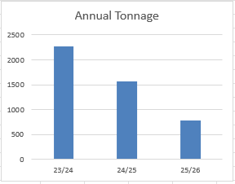

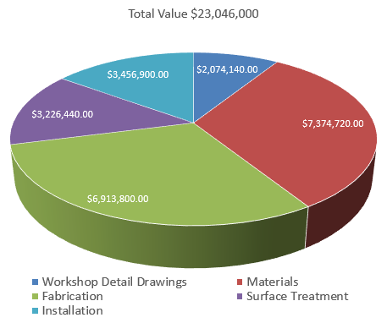

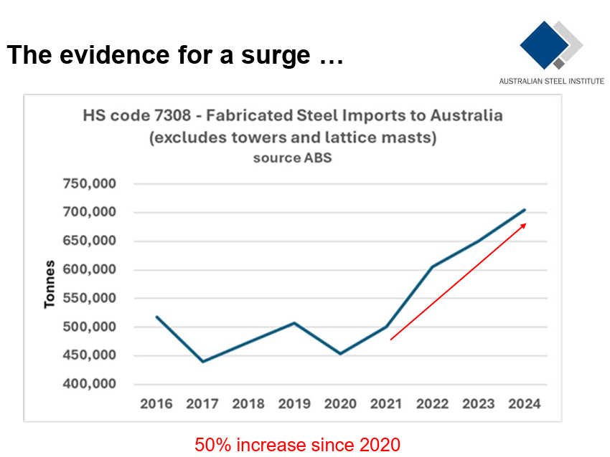

Annexure B – Project-Level Evidence (High Impact)
Project Name (Project names have been removed-will be supplied to officials if required) | Estimated Value ($) | Tonnage | Outcome
Project 01 | $5M | 400T | Lost to import
Project 02 | $2.5M | 200T | Lost to import
Project 03 | $3.7M | 300T | Lost to import
Project 04 | $1.2M | 100T | Lost to import
Project 05 | $2.5M | 200T | Lost to import
Project 06 | $1.2M | 100T | Lost to import
Project 07 | $1.9M | 150T | Lost to import
Project 08 | $1.2M | 100T | Lost to import
Project 09 | $1.4M | 110T | Lost to import
Project 10 | $1.2M | 100T | Lost to import
Project 11 | $375K | 30T | Lost to import

