

Submission to the Productivity Commission inquiry into housing supply regulation

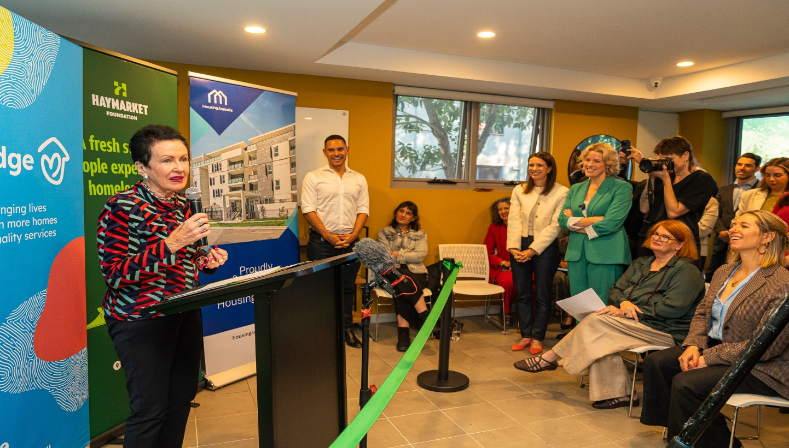
City of Sydney Lord Mayor Clover Moore AO at the opening of the Haymarket Foundation’s Bridge Housing project in Sydney, 3 May 2026. Image courtesy Lord Mayor Clover Moore Facebook.

Background
The Council of Capital City Lord Mayors (CCCLM) is a peak body that advocates for the interests of Australia’s capital cities. Providing national leadership and a strong voice to advance the needs of our capital cities are key priorities for the CCCLM.
The CCCLM comprises the Lord Mayors of Adelaide, Brisbane, Darwin, Hobart, Melbourne, Perth, Sydney and the ACT Chief Minister.
The CCCLM operates on a consensus basis and focuses on areas of shared interest across Australia’s capitals, including:
- economic drivers and infrastructure investment
- housing and homelessness
- climate and sustainability; and
- city safety and community cohesion.
Enquiries to: eo@lordmayors.org

Introduction
Demand for housing, affordability pressures and population growth in our cities continue to amplify already-existing housing challenges.
While our Council of Capital City Lord Mayors (CCCLM) group represents the interests of the seven capital city local government areas (LGAs) and the ACT Government, for Canberra, the housing challenges in our cities spread across metropolitan footprints.
Our submission focuses on points two and three of your inquiry scope around land availability and policy measures.
With reference to point one, approvals, we note most of our members are subject to rigorous performance requirements through relevant state planning legislation.
Key points
- Councils have an important role in tackling the housing crisis – we need more cross-jurisdictional cooperation to tackle the housing crisis, including more funding for enabling infrastructure, as well as a focus on supporting coordinated planning and transit-oriented development.
- More focus on policy measures to support the economic viability of high and medium-density development is needed – particularly for ‘difficult’ sites and social and affordable housing in our urban cores.
- Skills, capacity and investment – skills shortages and other capacity constraints in the construction sector have been well-documented. We need more targeted and well-funded programs from the Australian Government to address these challenges, including supporting the pipeline of apprentices.

Every level of government has a role in tackling the housing crisis
Capital City Councils and housing supply
Capital city councils continue to play an active and constructive role in supporting housing supply. Across our member local government areas (LGAs), more than 16,000 dwellings were approved in 2024–25, including approximately 3,900 new houses and over 12,300 apartments and other dwelling types. This demonstrates the central role cities perform in accommodating population growth and increasing housing supply. The majority of population growth will continue to occur in urban Australia.
City LGAs, like all councils, operate within statutory approval timeframes established under state planning legislation. The Planning Institute of Australia has highlighted the distinction between approvals and construction commencements:
“Tens of thousands of homes across the country already have planning approval but have not progressed to construction. This is not a short-term anomaly. It reflects sustained pressure in later stages of the housing production process.
High construction costs, labour shortages, infrastructure servicing delays, financing constraints and broader market risk all weigh heavily on whether approved projects proceed. Even developments that are fully approved and technically compliant can stall if the economics no longer stack up or key inputs are unavailable.”
(Planning Institute of Australia, 2026).
Notwithstanding these constraints, capital cities continue to approve significant volumes of housing. Brisbane recorded the highest number of dwelling approvals in 2024–25 (over 7,200 dwellings), followed by Melbourne (3,903) and Sydney (1,751). The total value of approved residential building across capital city LGAs exceeded $11.3 billion, underscoring a substantial pipeline of development.
Precincts such as Newstead in Brisbane, Green Square in Sydney, and Docklands in Melbourne demonstrate that high-density housing can coexist with liveable and sustainable communities. These examples reflect the benefits of long-term planning, cross-jurisdictional cooperation, and strong partnerships with the development sector.
Housing supply as a shared responsibility
Housing policy spans all three levels of government, as illustrated by the Australian Housing and Urban Research Institute (see Appendix A). While some LGAs have been criticised for constraining development, our members strongly support increased housing supply.
In land-constrained, inner-city areas, much of the required densification has already occurred, with limited greenfield land remaining. This is particularly evident in established areas of Australia’s largest cities, though it is acknowledged that this is not universally the case across all “inner ring” suburbs.
Local government is well positioned to plan for and support the growth of local communities; however, the sector operates within constrained resources. By comparison, state governments possess broader legislative authority and greater financial capacity to address housing challenges, as illustrated in Appendix A.
State governments play a key role in establishing strategic direction for housing, informed by infrastructure planning and the delivery of services such as transport and utilities. Incorporating local government decision-making into this process supports more effective outcomes, as it enables strong infrastructure coordination, meaningful community engagement, and high-quality design that contributes to liveable places.
Large-scale residential developments, such as Sydney’s Green Square, demonstrate the value of leadership by local government in partnership with state agencies. This project underscores the importance of long-term strategic planning, cross-jurisdictional collaboration, and comprehensive community consultation. Developments of this scale typically extend beyond the timeframe of initiatives such as the National Housing Accord and require sustained planning horizons.
A range of state government initiatives aimed at supporting increased housing supply are already in place. Programs such as the Queensland Government’s Scheme Supply Fund and the New South Wales Government’s Faster Assessments Incentive Program are practical, readily implementable measures that recognise the important role local governments play in advancing housing outcomes.
Enabling infrastructure to unlock housing supply
Targeted infrastructure investment by the Federal and State Governments is essential to unlocking housing supply.
Members report substantial costs associated with developing brownfield sites in capital cities. For example, remediating former industrial land or converting ageing commercial buildings—such as 1970s-era structures—into residential uses can be prohibitively expensive, despite their strategic locations.
In one instance, a member of CCCLM sought funding through the Australian Government’s Housing Support Program to deliver flood mitigation infrastructure that would have enabled up to 3,700 additional dwellings in a central business district. The application was unsuccessful.
It is widely accepted that enabling infrastructure—whether funded by the Commonwealth or the states—is critical to advancing housing projects. Such funding should be prioritised in metropolitan areas, where the bulk of population growth and housing demand is concentrated.
Recommendations
- Increased enabling infrastructure funding from the Australian Government is required to unlock housing projects. While the $2 billion announced in the May Budget is welcome, it is insufficient to meet national demand across eight major cities and 51 regional cities.
- Improved data sharing and analysis of developable land should be prioritised, with progress on commitments made at the November 2025 Treasurers’ meeting.

Supporting Medium- and High-Density Housing in our cities
Most capital cities have established strategies to facilitate medium- and high-density housing in appropriate locations, including:
- Brisbane’s Housing Supply Action Plan
- City of Adelaide’s Housing Strategy
- City of Hobart’s proposed Housing Action Plan
These strategies work in tandem with state frameworks to promote housing supply.
However, despite a substantial pipeline of approved projects, many developments are not proceeding to construction. Industry stakeholders consistently cite post-pandemic construction cost increases, labour shortages, and challenging project economics as key barriers.
Developer finance and project viability
Further examination of development finance mechanisms is warranted, particularly the New South Wales Pre-Sale Finance Guarantee initiative. Early indications suggest this program is assisting projects to reach construction.
Given the capital-intensive and long-term nature of high-density developments, compared to greenfield housing, targeted interventions may be required to bridge viability gaps.
The Commission should consider “tipping point” mechanisms that could support approved projects progressing to completion. Federal intervention in financing markets is not without precedent, as demonstrated by institutions such as the Regional Investment Corporation, Export Finance Australia, and the Northern Australia Infrastructure Facility.
Recent changes to tax settings may also affect investor sentiment, even where incentives such as negative gearing for new properties remain.
Social and affordable housing
There is growing community acceptance that social and affordable housing is a necessary component of urban development. LGAs are increasingly expected to proactively partner with social housing providers (SHPs) to facilitate such outcomes.
Local governments have contributed through mechanisms including:
- Provision of council-owned land
- Special rating arrangements
- Planning incentives
Recent projects include:
- The Common Ground facility in Perth (supported by City Deals funding)
- Melbourne’s “Make Room” supported housing initiative

- Rt Hon Jane Lomax-Smith AM, Lord Mayor City of Adelaide, at Common Ground Adelaide, March 2026. Image courtesy Housing Choices South Australia Facebook.
Planning reforms have also reduced barriers. For example, the Australian Capital Territory announced in December 2025 that third-party appeal rights would not apply to public and social housing developments, aligning with other jurisdictions.
While the Housing Australia Future Fund (HAFF) is a positive initiative, current funding structures may incentivise providers to prioritise less-complex developments. Members report that well-located sites are sometimes overlooked due to challenges such as site remediation, limited footprint, or access constraints, despite their strong strategic value. The tight and rigid timeframe criteria associated with HAFF and other Commonwealth programs do not support more difficult projects being supported through these processes.
Recommendations
- Policies that support the progression of approved projects to construction should be a priority, including broader adoption of pre-sale finance mechanisms.
- Social and affordable housing program design can sometimes limit options to support ‘more complex’ projects. Programs should ensure that funding structures do not discourage complex but high-value urban projects.
- The Productivity Commission should provide updated advice on policy responses to construction sector challenges, including input costs, workforce shortages, and industry capacity constraints.

Appendix A
Housing policy responsibilities by level of government

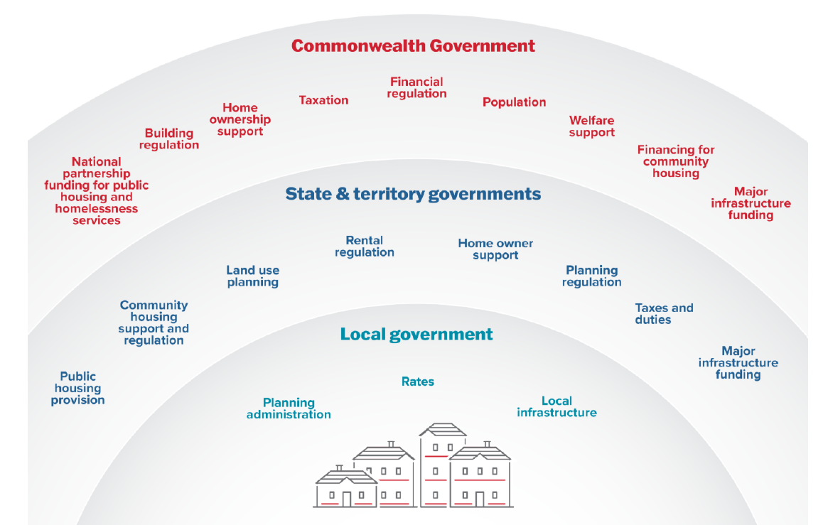

Source: AHURI Australian Housing and Urban Research Institute, Submission to the Senate Standing Committee Inquiry into the worsening rental crisis in Australia, https://www.ahuri.edu.au/analysis/brief/understanding-housing-policy-levers-commonwealth-state-and-territory-and-local-government.

Australian Bureau of Statistics (2026), Building Approvals Data. https://www.abs.gov.au/statistics/industry/building-and-construction/building-approvals-australia/jan-2026#key-statistics
Planning Institute of Australia (2026), Building approvals don’t tell the complete housing story. https://www.planning.org.au/pia/news-resources/articles/latest-updates/national/building_approvals_housing_story.aspx.
Australian Bureau of Statistics (2026), Building Approvals Data. https://www.abs.gov.au/statistics/industry/building-and-construction/building-approvals-australia/latest-release.
Australian Institute of Health and Welfare (2025), Profile of Australia’s population. https://www.aihw.gov.au/reports/australias-welfare/profile-of-australias-population.

