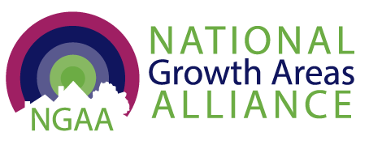

Submission

to the Productivity Commission Inquiry into Housing Supply Regulation

June 2026
  - Contents

About National Growth Areas Alliance 7
Growth areas are nationally significant city regions 7
Australia’s housing supply relies on growth areas 8
NGAA response to the Inquiry’s terms of reference 10
1. Approval processes: Growth areas are meeting or exceeding their approvals targets 11
2. Land supply: Lack of enabling infrastructure is the main constraint on land supply 15
3. Processes and frameworks: Growth areas require a dedicated long-term, place-based investment framework 20
Supporting Evidence 23
National Growth Areas Alliance Member Councils 23

Acknowledgement of Country
We acknowledge the Aboriginal and Torres Strait Islander peoples as the Traditional Custodians of the lands across Australia on which we work and live.
We pay our respects to Elders past, present, and emerging, and extend that respect to all Aboriginal and Torres Strait Islander peoples. We recognise their rich culture and their enduring connection to Country and the role this plays in shaping sustainable communities.

The NGAA is hosted by the City of Casey, Narre Warren, Victoria.

Contact
Bronwen Clark
Chief Executive Officer
National Growth Areas Alliance
[Redacted]
[Redacted]

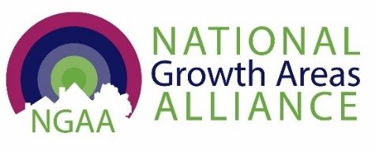

15 June 2026

Administrative Officer
Housing Supply Regulation
Productivity Commission
GPO Box 1428
Canberra City ACT 2601

Lodged online at https://www.pc.gov.au/inquiries-and-research/housing-supply/make-submission/

Dear Sir/Madam
NGAA Submission to the Productivity Commission Inquiry into Housing Supply Regulation
The National Growth Areas Alliance (NGAA) welcomes this opportunity to provide a submission to the Productivity Commission’s Inquiry into Housing Supply Regulation to identify regulations that most affect housing and provide a prioritised list of reforms to support faster and simpler approvals and make more land available and ready to build more homes.
The National Growth Areas Alliance (NGAA) is the peak body for local governments in Australia’s fast-growing, outer metropolitan regions. These 29 local government areas (LGAs) are home to over 6.2 million residents and 470,953 businesses, forming the nation’s newest communities and urban centres across our five largest capital cities.
Member councils of the NGAA are united by the shared experiences of grappling with population growth rates at double the national average, significant greenfield urban development and the challenges of long-term under-investment in strategic transport and social infrastructure. Despite these challenges growth areas communities are making a significant contribution to Australia’s productivity, resilience and well-being.
Our submission highlights the importance of growth area councils to delivering Australia’s current and future housing supply. Australia’s 29 Growth Areas represent just 5% of the nation’s 537 councils but are expected to deliver at least 26% of new housing under the National Housing Accord targets, without commensurate infrastructure. That’s around another 300,000 homes by 2029 targeted for areas which are already experiencing growth at twice the average national growth rate.
The NGAA understands that the impetus of this inquiry is to address concerns that housing targets are not being met because the cost of regulation is delaying the approval processes and impacting housing affordability and construction productivity. However, the NGAA also notes that, while the PC has estimated the aggregate cost of housing regulation it has yet to quantify its benefits, nor have the costs of deregulation been considered. In the rush to deliver housing sooner, the federal and state governments run the risk of repeating the mistakes of the past by simply removing regulations rather than evaluating and consolidating them to ensure housing suitability, safety, quality and liveability are not compromised.
While the Commonwealth and state governments set the parameters for growth, it is local government that is largely responsible to ensure the safety and quality of new housing and the resilience and liveability of places where residential development is located.
Our submission is grounded in the view that local government remains underutilised and underestimated in its capacity to plan and manage growth to create liveable, thriving places and support the wellbeing of their communities. However, a lack of a nationally coordinated approach to growth and a reliance on short-term, inconsistent and insufficient federal and state funding programs means growth area councils cannot fully meet their responsibilities as stewards of place for people and businesses who call their areas home.
Therefore, NGAA argues, in relation to the terms of reference for the inquiry and specific areas of regulation, that:
1. Approval processes are not the primary cause of delays in meeting housing supply targets in growth areas. Our 2025 report, Beyond Bricks: Delivering the Housing we need sooner in Australia’s Growth Areas, shows that Growth Area councils are consistently meeting or beating state-based performance measures for Development Assessment (DAs). Growth Areas have consistently managed over 50,000 dwelling completions per year since 2016, a total of 515,934 new homes, or about a third of Australia’s new housing stock.
NGAA members argue that delays in meeting housing supply targets in growth areas are often a result of insufficient funding for enabling infrastructure and/or poorly coordinated forward planning and infrastructure investment across state-controlled utilities (such as water and power).
2. Availability and use of land for housing (for example, land release, land-use controls).
Growth areas are doing the heavy lifting in land release for housing. Detached housing in greenfield residential development is expected to provide up to two thirds of housing supply under the National Housing Accord. The Urban Development Industry of Australia (UDIA) in their latest State of the Land 2026 report shows a 10% lift in greenfield sales for detached housing, while there has been declines in new multi-unit transactions.
Despite the increase in greenfield land, the UDIA 2025 National Housing Pipeline report UDIA report confirms that infrastructure sequencing remains one of the most powerful determinants of delivery timing with 33% of detached greenfield survey yield requires enabling infrastructure funding commitment to proceed. Trunk water and sewer infrastructure are the most prevalent bottlenecks nationally while regional and state road infrastructure is the second largest constraint.
It is also important to note that residential land sales data reflects greenfield lot sales zoned ‘residential’, irrespective of whether the purchaser is a household or developer. Developers will seek rezoning of their land holdings and will release land for sale when it is likely to be most profitable to do so.
Local government, on the other hand, is legislated to undertake local strategic planning to determine the suitability of land for zoning for residential and other development in line with state planning schemes and objectives. These local plans should be utilised in determining land use rezoning. Land that has been identified for infrastructure, commercial or industrial uses or protection for natural, cultural heritage or reducing hazards should not be rezoned for residential development where future economic, environmental and social objectives will be compromised.
Local government requires adequate resources to develop and update their local strategic and precinct plans. State governments should adequately fund councils, especially small emerging growth councils, for strategic planning where greenfield development is to be expedited.
3. Processes and frameworks to deliver new and utilise existing housing infrastructure (for example, growth infrastructure planning, developer contributions model).
The NGAA argues for greater recognition of the importance of ‘place’ as a critical factor in housing supply and impacting productivity. We stress that there needs to be acknowledgement of the challenges of metropolitan growth areas, amplified by population rates at double the national average.
NGAA supports LGNSW and Committee for Sydney’s calls for loans to councils, especially for small emerging growth councils, for early delivery of strategic transport and community infrastructure and test this concept for national roll out.
Addressing the challenges of growth through the equitable resourcing and infrastructure investment in outer metropolitan growth areas is critical to delivering housing while building thriving, liveable and resilient communities, that will contribute to improving Australia’s productivity.
The NGAA recommends that the Australian government:
Recommendation 1. Adopt a national classification for high growth areas as designated urban expansion corridors and apply this classification to strategically distribute funding programs proportionally and geographically, aligned to housing targets.
Recommendation 2. Prioritise urgent enabling infrastructure delivery and redirect any unallocated housing and infrastructure funding to high-growth areas where development is aligned with local government strategic planning, approvals are already met and enabling infrastructure is the only barrier to supply.
3. Resource growth areas equitably and adequately by establishing a dedicated long-term, place-based investment framework aligned to a national settlement strategy, state planning schemes and local strategic plans that:
- realigns federal housing and infrastructure funding programs for immediate use in high-growth areas, recognising need for upfront enabling infrastructure (utilities like sewer, water, energy, roads, communications);
- prioritises funding for strategic transport and social infrastructure in line with population projections and in close collaboration with local government
- coordinates investment in digital communications infrastructure to support local businesses and stimulate innovation.
NGAA urges that the Productivity Commission classify growth areas as nationally significant metropolitan regions, vital to the effective functioning of Australia’s largest capital cities, and to the economies of their neighbouring regional areas.
Growth areas require dedicated, long-term infrastructure investment and whole of government coordination to help manage their projected growth to fully realise their potential contribution to Australia’s future productivity.
Realigning funding for upfront enabling infrastructure delivery in development ready sites in Australia’s growth areas will help meet the national housing targets sooner, delivering the housing we need and the future we want for our communities.
We look forward to an opportunity to discuss these issues further with the Commission.
Yours sincerely,

Bronwen Clark
Chief Executive Officer
National Growth Areas Alliance

About National Growth Areas Alliance
The National Growth Areas Alliance (NGAA) is the peak body for local governments in Australia’s fast-growing outer metropolitan regions. We advocate to State and Federal governments for improved policies and equitable funding for growth area councils, to create resilient, liveable and thriving places and communities.
Member councils of the NGAA are united by the shared experiences of grappling with population growth rates at double the national average, delivering and servicing large scale greenfield residential development while expanding and invigorating existing centres and stimulating investment and enterprise. They face the challenges of long-term under-investment in vital infrastructure to provide equitable access to education and employment opportunities and community services and facilities that together help to create liveable places, thriving economies and resilient communities.

Growth areas are nationally significant city regions
There are 29 growth area Local Government Areas (LGAs) located in the outer metropolitan areas across Australia’s five largest capital cities of Sydney, Melbourne, Brisbane, Perth and Adelaide. These regions are home to more than 6.2 million residents, forming the nation’s newest and fastest growing communities. Growth Areas have experienced roughly double the average annual population growth between 2016 and 2021 compared to annual growth for Australia.
The combined population of growth areas represents 22% of Australia’s population. Our communities are young and diverse. One in four Australian children are born in growth areas, and 29% of residents speak a language other than English at home.
Growth areas house 2.4 million resident workers, 18% of Australia’s workforce, and have distinct strengths in sectors central to national productivity. Compared with the national average, they have higher employment shares in construction, manufacturing, and transport/logistics. These industries underpin supply chains, freight movement, and essential services that benefit the entire economy.
Collectively, growth areas support 1.6 million jobs and 470,953 businesses, contributing $713.5 billion in annual economic output. Manufacturing alone accounts for $164.3 billion, while health care and social assistance employ nearly 244,000 people, making it the largest employment sector. This combination of workforce scale, industry diversity and ongoing population growth positions growth areas as engines of future national productivity. These dynamics have also supported ongoing construction activity to meet demand for housing, commercial precincts and industrial development.
Growth Area councils vary in size depending on how long they have been on their continuum of growth, ranging from small, recently emerging growth areas (with under 50,000 population and changing rapidly from rural to urban land use) to large, long established growth areas transforming into major metropolitan centres, with populations over 350,000, larger than Canberra.

Australia’s housing supply relies on growth areas
Australia’s 29 growth areas - just 5% of the nation’s 537 councils – are expected to deliver at least 26% of new housing under the Housing Accord targets, without commensurate infrastructure. That’s around another 300,000 homes by 2029 in areas which are already experiencing growth at twice the average national growth rate.
Growth area councils have approved a total of more than 320,000 dwellings in the last five years. That is around half of all dwellings approved across the five capital cities where they are located. Their share of new residential approvals nationwide has risen from 30% in 2018–19 to 35% in 2024–25.
The combination of high numbers of dwelling approvals on top of rapid population growth clearly distinguishes growth area councils from inner metropolitan areas in the five largest capital cities as shown in Figure 1. These factors signal substantial future ‘growth upon growth’ for these LGAs. Small, emerging growth areas like Serpentine-Jarrahdale in Western Australia, Mount Barker in South Australia, Mitchell Shire in Victoria and Wollondilly in New South Wales, councils also contend with large geographic areas, significant rural lands and protecting natural areas and connecting separated townships.
The NGAA understands that the impetus of this Productivity Commission (PC) inquiry into housing supply regulation is to address concerns that housing targets are not being met because the cost of regulation is delaying the approval processes and impacting housing affordability and construction productivity. However, the NGAA also notes that, while the PC has estimated the aggregate cost of housing regulation it has yet to quantify its benefits, nor have the costs of deregulation been considered.
In the rush to deliver housing sooner, the federal and state governments run the risk of repeating the mistakes of the past by simply removing regulations rather than evaluating and consolidating them to ensure housing suitability, safety, quality and liveability are not compromised. While the Commonwealth and state governments set the parameters for growth, it is local government that is largely responsible to ensure the safety and quality of new housing and the resilience and liveability of places where residential development is located.
The way the next wave of housing supply is delivered will determine the productivity, liveability and sustainability of our cities and the wellbeing of our newest communities for generations. While the private sector can build homes, especially detached houses, relatively quickly, roads, transport and community can take decades to be delivered.
It is for this reason that the NGAA advocates for a more strategic approach to planning and resourcing growth areas to ensure equitable outcomes for our new communities in outer metropolitan areas.
Recommendation 1. Adopt a national classification for high growth areas as designated urban expansion corridors and apply this classification to strategically distribute funding programs proportionally and geographically, aligned to housing targets.

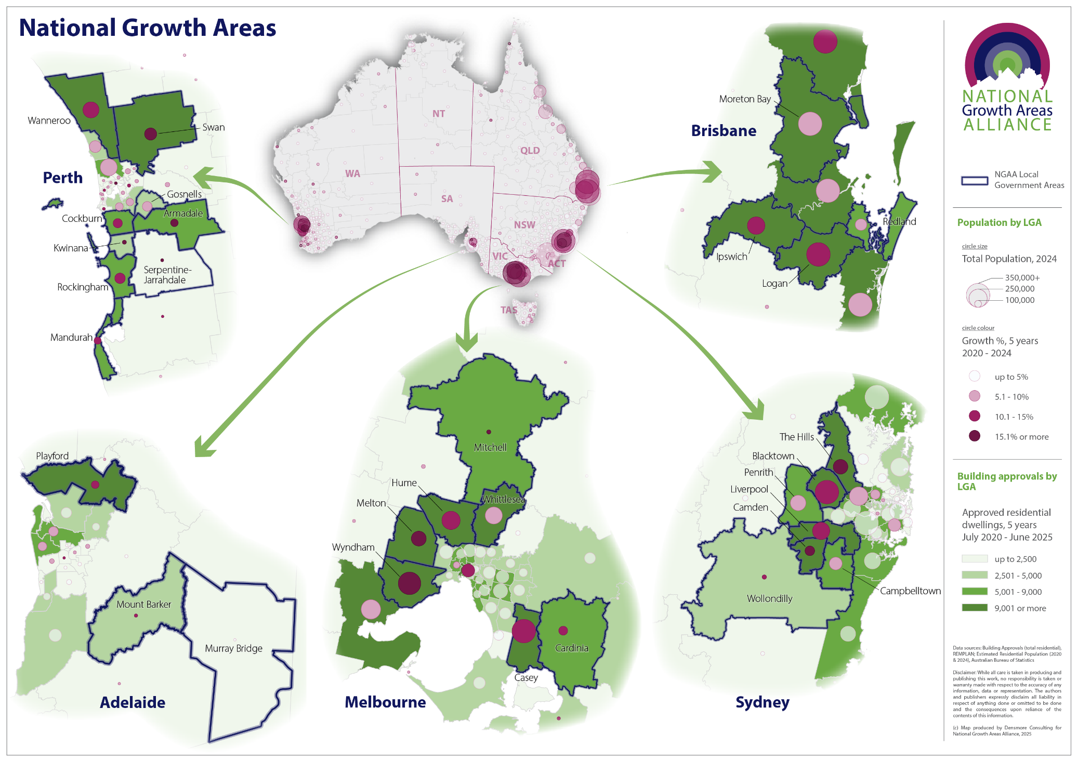
Figure 1 National Growth Areas: Population, growth rates and dwelling approvals by Local Government Areas (LGAs)

NGAA response to the Inquiry’s terms of reference
Council approval processes are not the primary cause of delays in meeting housing supply targets in growth areas. Our 2025 report, Beyond Bricks: Delivering the Housing we need sooner in Australia’s Growth Areas, shows that growth area councils are consistently meeting or beating state-based performance measures for Development Assessment (DAs), and delivering housing at pace. The main constraint on housing supply in growth areas in many cases is the need for enabling infrastructure.
The NGAA considers land reservation for environmental, social, economic and transport and other special purposes, including future readiness infrastructure, such as for renewable energy and battery storage, digital technology and communications (data centres, mobile communication towers) and or managing severe weather conditions (flood, fire, storm surge) as good planning rather than constraints.
Many of these planning concerns and constraints can be identified and addressed where there is alignment between state-level and local strategic planning. However, across the states there are differing functional responsibilities between the state and local government in relation to the role of Local Planning Strategies.
Better coordination between state agencies and alignment with local government planning processes can help streamline approvals. There needs to be an appropriate checking mechanism to ensure that planning objectives are aligned and identified issues addressed before progressing to application process and a diverse range of homes are built but all at an acceptable standard, otherwise we risk repeating the mistakes of the past and creating sub-standard housing for the future.
Close collaboration with councils by state government agencies and targeted investment for enabling infrastructure and funding programs that look beyond 4-year cycles (in particular, for transport infrastructure and major roads) will help build greater certainty and confidence.
These core issues in relation to the PC’s Inquiry terms of reference are described in more detail with case studies from NGAA members in the following sections.

1. Approval processes: Growth areas are meeting or exceeding their approvals targets
Growth Area councils are meeting or beating targets for Development Assessment (DA) completions. Growth Area councils approved over 64,000 dwellings last financial year, taking the total to more than 320,000 dwellings in the last 5 years. That is around half of all dwellings approved across the five capital cities where they are located (Figure 2).
Figure 2 Dwelling approvals in five capital cities 2020-2025

Source: Australian Bureau of Statistics, Building Approvals, 2024-25, released 7 August 2025
Growth Areas have consistently managed over 50,000 dwelling completions per year since 2016 without commensurate infrastructure investment. That’s over half a million homes, or a third of all new dwellings built in Australia over the last decade.
Figure 3 Estimated dwelling completions in Growth Areas 2016-2025

Source: ABS Building Activity, Estimated dwelling completions in Growth Areas, data compiled by REMPLAN 2025 for NGAA.

1. Which regulatory reforms should governments prioritise to get more homes built more quickly?
NGAA member councils argue that delays in meeting housing supply targets in growth areas are more related to factors other than council approval processes, such as construction costs, insufficient funding for enabling infrastructure and/or poorly coordinated state government forward planning and infrastructure investment across state-controlled utilities (such as water and power). Better alignment between state and local government planning and infrastructure resourcing is needed to deliver more housing sooner.

Case study: City of Gosnells, Western Australia where approved developments are being delayed because of a shortage of labour and high construction costs
There is a mismatch between the LGAs where state government has set housing targets and where they directly support housing supply. In the established growth area of City of Gosnells in Western Australia, the state has set a target of a target of 31,000 additional dwellings to be built under the National Housing Accord.
Land is available and developments have been approved but, they are not being built because of a shortage of labour and high construction costs. In outer metropolitan areas, multi-unit development is currently unviable as construction costs exceed the price point for sales. State government could make multi-unit development in growth areas more viable by releasing affordable, well located, State government owned-land and providing infrastructure or reducing infrastructure costs according to housing target areas.
More homes more quickly could be achieved if financially viable locations, such as inner suburbs, were left to market forces and government instead supported high target areas that are currently unviable. For example, DevelopmentWA has committed to developing 2,700 multi-unit dwellings in Subiaco, a sought-after inner suburb of Perth with a State Government dwelling target of 6,000 additional homes. This is almost half (44%) of the housing target for their LGA. In contrast, in Gosnells, (with a target of 31,000 dwellings but lower viability for commercially built multi-unit developments) DevelopmentWA has to date committed to only building 32 dwellings (barely 0.1% of their LGA housing target).

Case Study: City of Cockburn, Western Australia, where state and local government structure planning need better alignment
It is important to ensure residential land which advances into regulatory process has already gone through the strategic level assessments. Core issues that have impacts on land requirements and costs to various stages of delivery, which are well understood at the local level, need to be properly considered.
For example, there are areas under investigation for residential development flagged as having environmental constraints or needing to form part of a key road network in a strategic level document at metropolitan or subregional level. While a process of district level planning has been undertaken yet often those very matters are pushed into the next phase for landowners to resolve. This gives a false impression of developable land, if land needed for roads and other necessary purposes are not fully considered, and ultimately causes frustrations to all parties.
For example, in August 2023, the Western Australian Government identified an area of approximately 580 hectares of land near the Jandakot Airport and within the City of Cockburn, the Jandakot-Treeby Planning Investigation Area, as suitable for urban expansion. The WA Government then commissioned a Jandakot -Treeby District Structure Plan. While roads within the investigation area are considered impacts on other regional roads are not being included in the District Structure Plan assessment thoroughly despite the network clearly being shown in Perth and Peel @3.5 million and sub-regional strategy.

2. Which steps of the housing regulatory approvals process are the most onerous, time consuming and costly? Why? How could the burden be reduced without compromising regulatory objectives?
The process to develop new planning schemes can be long and laborious. On the one hand, local government has on the ground knowledge of land use constraints and opportunities and regularly engage with their communities, on the other state governments have responsibilities for metropolitan wide growth management and planning. In some jurisdictions, state processes can be onerous and time-consuming. For smaller councils, however, resource constraints can be the major barrier.

Case Study: City of Gosnells, Western Australia, where state government approvals have been a main obstacle to realising residential development opportunities
The City of Gosnells’ local planning scheme (LPS24), which provided for high density zoning around train stations, took almost 10 years to move through the approval process with documentation being with the State Government for much of this time.
As one specific example, the City of Gosnells has been in discussion with the Department of Planning, Lands and Heritage for over a decade to subdivide and redevelop a proportion of Hester Park in Langford. The proposal will provide for 206 lots in an accessible location (17km from the Perth CBD) and result in a significant improvement to the riverside park, all of which could be delivered by the city with authorisation from the Department. A legal agreement to progress the development has now been with the Department for consideration for over a year. The original Hester Park Regional Revitalisation Project went out for community consultation, on behalf of the city and the Western Australian Planning Commission, in October 2014.

Case Study: Rural City of Murray Bridge, South Australia, where State government has streamlined the land sub-division process
The Rural City of Murray Bridge (RCMB), South Australia, is identified for significant growth under the Greater Adelaide Region Plan and Council is seeking to ensure that such growth is well planned for and can be delivered in a timely and effective manner. In South Australia, the SA Planning Portal and Planning and Design Code is providing streamlined approval processes and standardised policies and zones.
However, the length of time between obtaining a land division approval and being able to deliver a house on the ground can be up to 2 years. Therefore, the holdup is not necessarily with the planning approval or Council, but the time taken for applicants/developers to provide information, receive information from external agencies, and then the processes required after receiving the approval – detailed design and engineering, construction of infrastructure, survey and titles issued. Council has undertaken its own mapping of the typical land division timeline, as shown in Figure 4, below.
Figure 4 Rural City of Murray Bridge Land Division Process Timeline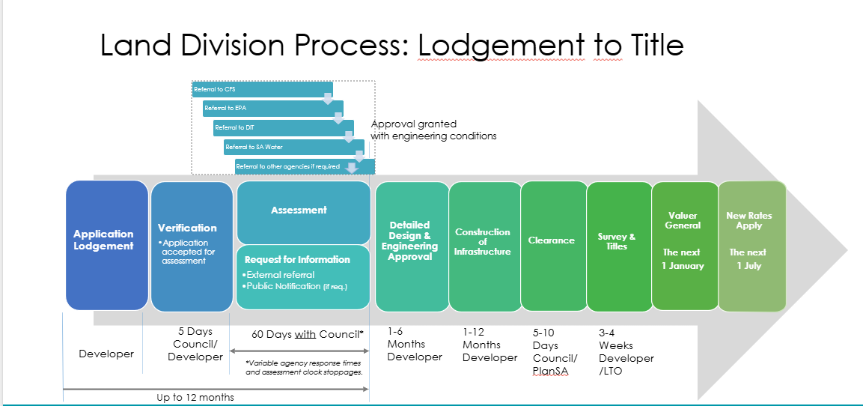
Source: Rural City of Murray Bridge, 2026
RCMB takes the view that a greater emphasis is needed on infrastructure provision rather than approval process with more adequate resourcing for engineering.
Further examples of the need for enabling infrastructure in growth areas councils to accelerate land supply are provided in the next section.

3. Which recent reforms to approvals (e.g. fast-track pathways, coordination bodies, AI assistance) have been the most and least effective in increasing new housing supply? Why?
To address the shortage of labour and cost of materials that is limiting housing supply, a cost saving mechanism, such as state funded infrastructure should be considered. Innovations in building materials and pre-approved modular/prefabricated designs (with a big caveat that standards need to be met), can also be effective in increasing new housing supply because they help make some projects more financially viable.
In South Australia the state government has introduced Infrastructure Schemes within its planning legislation to ‘guarantee’ essential services and coordinate basic infrastructure in major growth areas. The first scheme under this legislation was only implemented in 2025/26 so it is too early to comment on the effectiveness of this approach, as it is a new mechanism, it shows promise in its approach with collaboration between councils and the Department for Housing and Urban Development to establish a Basic Infrastructure Scheme for some residential growth areas.

2. Land supply: Lack of enabling infrastructure is the main constraint on land supply
The most immediate barrier to housing supply on developable land in greenfield sites is the need for funding or commitment to deliver enabling infrastructure first: power, water, sewer and regional roads.
Growth areas are doing the heavy lifting in supporting land release for housing. Detached housing in greenfield residential development is expected to provide up to two thirds of housing supply under the National Housing Accord. The Urban Development Industry of Australia (UDIA) in their latest State of the Land 2026 report shows a 10% lift in greenfield sales for detached housing, while there has been declines in new multi-unit transactions.
Despite the increase in greenfield land, the UDIA 2025 National Housing Pipeline report UDIA report confirms that infrastructure sequencing remains one of the most powerful determinants of delivery timing with 33% of detached greenfield survey yield requires enabling infrastructure funding commitment to proceed. Trunk water and sewer infrastructure are the most prevalent bottlenecks nationally while regional and state road infrastructure is the second largest constraint.
The key impediment to providing housing is the ability to access key infrastructure such as water and sewer. Key enabling infrastructure is not keeping up with the rate of growth and therefore is preventing new areas to open. Whilst this is not strictly a regulatory issue, the enabling condition for housing has the potential to inhibit the passage of new housing projects. Regulatory frameworks need to help ensure enabling infrastructure/services are costed, coordinated, and funded before development begins.
Solutions could include:
- mechanisms/schemes that establish clearly staged, master-planned housing rollout
- alignment of land releases more closely with local enabling infrastructure capacity
- greater transparency of spatial data that helps identify when land will be serviced ready for housing development
- more efficient solutions for the underpinning engineering services needed to determine requirements for enabling infrastructure

Calls for funding for enabling infrastructure have been reiterated by the UDIA and LGNSW and by Queensland’s Suburban Futures. The NGAA welcomes the 2026 federal budget announcement of $2 billion for enabling infrastructure for housing but stresses that it will be important that these funds are directed to the high growth areas where planning and approvals are already secured.
The following case studies illustrate where enabling infrastructure for sewer, water, and energy could unlock thousands of new homes nationally.
Recommendation 2. Prioritise urgent enabling infrastructure delivery and redirect any unallocated housing and infrastructure funding to high-growth areas where development is aligned with local government strategic planning, approvals are already met and enabling infrastructure is the only barrier to supply.

Case Study: Unlocking housing in Mundijong development area in the Shire of Serpentine-Jarrahdale, WA
The Shire of Serpentine Jarrahdale is an emerging growth area in south-eastern Perth has almost 10,000 lots that have been approved but are unable to be developed due to lack of critical enabling infrastructure.
The Urban Development Institute of Australia (UDIA WA) report (Growth Areas Infrastructure Requirements Report) 2024, identified Mundijong as part of a key growth area requiring critical infrastructure to unlock land for housing. Funding for an infill sewer, hills-based water tank, and upgrades to Mundijong Road are urgently needed to enable vital opportunities for housing. As an immediate priority, the Scott Road sewer pump station is urgently needed to enable 7,000 dwellings to be delivered. An allocation of $12 million for the Scott Road Pump Station is included in the WA Water Corporation plans but funding needs to be brought forward due to developers’ inability to pre-fund the works, which could be reimbursed on completion of construction.
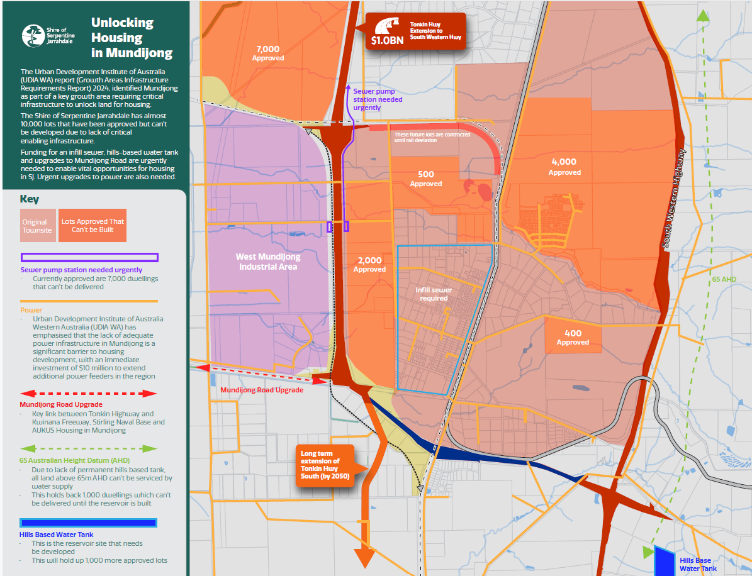

4. Which specific zoning and land-use controls most limit the supply of new housing? What benefits of these controls should be considered? How does this vary across Australian jurisdictions or regions?
Any land-use controls have been identified through strategic planning processes for a reason. Zoning and land use controls protect both amenity and environmental features and are determined regarding local community consultation.
It is important to note that land supply is also a market-driven process. Residential land sales data reflects greenfield lot sales zoned ‘residential’, irrespective of whether the purchaser is a household or developer. Developers will seek rezoning of their land holdings and will release land for sale when it is likely to be most profitable to do so.
Local government, on the other hand, is legislated to undertake local strategic planning to determine the suitability of land for zoning for residential and other development in line with state planning schemes and objectives. These local plans should be utilised in determining land use rezoning. Land that has been identified for infrastructure, commercial or industrial uses or protection for natural, cultural heritage or reducing hazards should not be rezoned for residential development where future economic, environmental and social objectives will be compromised.

Case Study: Stormwater management in Riverstone East, Blacktown City Council, NSW
Blacktown City Council is one of Australia’s largest growth areas, with a population of 430,460 forecast to grow to 572,860 by 2046. The NSW State government is investigating sites to develop a further 50,000 dwellings around Blacktown’s existing train stations at the same time Council is progressing development previously planned in Stage 1 and 2 of Riverstone East Precinct, part of the Riverstone Schofield north-west development area, which, when complete, is planned to add approximately 20,000 new residential dwellings.
The Riverstone East Precinct Stage 3 plan was finalised by the State government with rezoning in May 2025. The plan allows for up to 3,600 new homes on flood-free land with 5% of properties allocated for affordable housing, a mix of low, medium and higher, density residential buildings and open space and preservation of high-value vegetation.
Blacktown City Council is actively undertaking stormwater management projects to protect and improve water quality, as well as conserve, restore and enhance the City’s biological diversity and ecosystem health. In addition to this, water sensitive urban design (WSUD) and integrated water cycle management is incorporated into new developments to help reverse waterway degradation caused by stormwater. Council is seeking to apply these high-standard water management approach to the Riverstone East precinct, but without additional funding from state and federal government developers face unaffordable upfront costs, and council faces unfunded maintenance burdens. With additional government funding to implement WSUD plan, the precinct development is likely to be delayed while council and state government and developers create alternative drainage solutions.

5. How important are land release arrangements (including subdivision and titling) in limiting housing supply in an area, relative to other zoning and land-use controls?
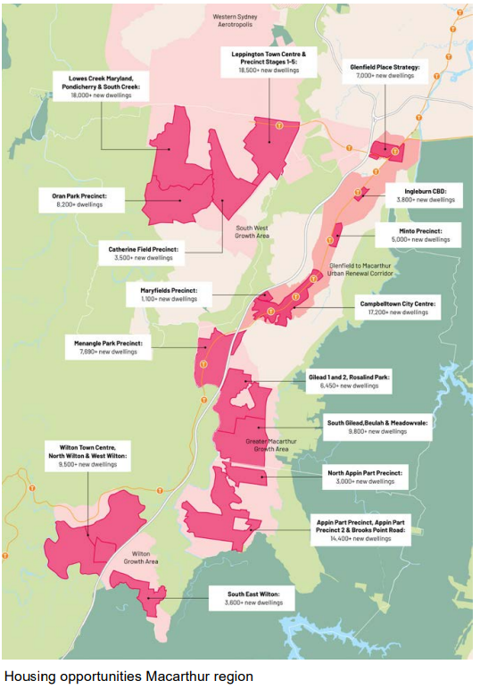
What is important in land release arrangements is that there is a rolling supply of land that is managed through strategic planning processes. This requires ensuring servicing of the land is delivered in lock step with subdivision activation. Without coordinated sequencing of land release and servicing the result is either lengthy delays on housing supply or inadequately serviced land for home buyers as in the case of Wollondilly Shire Council where around 700 households have moved into new homes not connected to sewer and have to rely on an interim trucking solution for wastewater removal, and capacity for future dwellings is nearly exhausted.

Case Study: Greater Macarthur Growth region – Wollondilly Shire, NSW
The Greater Macarthur Growth Region has the capacity to deliver 120,000 new homes if accompanied by supporting infrastructure. This is 10% of Australia’s national housing supply target, and 32% of NSW’s contribution under the National Housing Accord. Wollondilly Shire Council is seeking urgent support to address a significant shortfall in sewer infrastructure in the Wilton Growth Area. The delay of long-planned upgrades to the Bingara Gorge Sewage Treatment Plant is expected to halt delivery of approximately 12,000 already-rezoned housing lots. A longer-term wastewater solution, the Upper Nepean Advanced Water Recycling Facility, is planned for delivery by 2032. Council has also raised concerns about the timeframe for delivery of water and sewer infrastructure for the nearby Appin development, where approximately 13,000 homes are planned.
Local governments, especially small and emerging growth areas, require adequate resources to develop and update their local strategic plans. State governments should adequately fund councils, especially small emerging growth councils, for strategic planning where greenfield development is to be expedited.

Case Study: Laratinga Water Recovery Plant is needed in the Rural City of Mount Barker, South Australia
Mount Barker District Council, east of Adelaide is dynamic emerging area, designated for growth under the Greater Adelaide Regional Plan. With a population of 44,772 residents in 2024, the community is projected to grow to 64,838 by 2046 - a 45% increase that will outpace many other regions in the South Australia. Mt Barker Regional Council has a licence from the EPA to operate the Mount Barker Wastewater Treatment Plant (WWTP), the largest wastewater business in South Australia outside of SA Water, managing essential services for a rapidly expanding population. They receive no government funding to support these operations. State and federal investment is needed to upgrade and expand wastewater infrastructure to provide sustainable wastewater management that meets community expectations and environmental standards.
Council has previously obtained Planning Consent Approval for a new WWTP (Laratinga Water Recovery Plant (LWRP)) on the existing Springs Road site. The project aims to mitigate adverse impacts of residential development on the Mount Barker Creek by constructing the new plant in compliance with the Environmental Improvement Plan, which will have the capability to operate within a range of water quality outcomes to minimise pollutant concentrations within discharges to Mount Barker Creek and to optimise operational costs for recycled water production. The Council has been advocating for $48 million in co-funding for this essential infrastructure. Council has applied for funds through the Housing Support Program but has yet to be informed of the outcome.

3. Processes and frameworks: Growth areas require a dedicated long-term, place-based investment framework
A dedicated, long-term, place-based funding approach for growth areas is needed to protect infrastructure investments from political shifts, supporting better alignment between population and housing and providing greater planning certainty for government, the development industry and communities.
A 2024 review of international best practices in urban infrastructure funding for NGAA, including examples from the United Kingdom, Canada, Germany, the Netherlands and the United States of America, highlighted the importance of longevity in funding programs: all had multi-year funding frameworks that provide stability for large-scale projects and ensure consistent investment across political cycles. As stated in the report (page 26),
‘Australia has a valuable opportunity to adopt a federally driven funding program that addresses place-based infrastructure requirements, with objective criteria to ensure resources are equitably distributed’.
Local government has long played a proactive role in shaping local housing outcomes. Yet, their knowledge and expertise have been undervalued, particularly in their capacity to engage with their local communities and undertake detailed analysis of infrastructure needs in their local area that are essential components of good urban policy and planning decisions.
For example, with their expert knowledge of their communities and environments, local governments play a crucial role in supporting their communities in preparing for and recovering from natural disasters, for building resilience to climate change and other shocks. At the same time local government have legislated responsibilities for developing detailed planning strategies, including housing strategies, structure plans and delivery plans, that can be ignored by state governments when they so choose.
Significant increases in housing supply can be achieved with more labour, greater productivity in the building sector and reduced cost of building materials. None of these factors are quick fix solutions. However, by realigning Federal housing and infrastructure funding programs for immediate use in high-growth areas where housing is already approved, recognising need for upfront enabling infrastructure, some of the upfront costs that are inhibiting housing supply can be ameliorated. Such direct actions can be evaluated as a first step in establishing a dedicated long-term, place-based investment framework for well managed urban growth.
Recommendation 3. Resource growth areas equitably and adequately by establishing a dedicated long-term, place-based investment framework aligned to a national settlement strategy, state planning schemes and local strategic plans.

6. How do development contributions and contributions frameworks affect project feasibility and new housing supply?
The NGAA agrees with the view expressed in the PC’s call for submissions paper that the frameworks and processes that determine developer contributions can add to costs and uncertainty for developers and that poor infrastructure planning or a lack of coordination of different infrastructure can add to the time and costs of new housing projects, potentially reducing feasibility and supply.
Often developer contributions are determined late in the development process, complicating informed financial investment. While immediate enabling infrastructure can be more easily determined, often there is no clarity about responsibilities for funding infrastructure that is needed as a corollary of development and resulting population growth, such as infrastructure upgrades to existing road networks, regional transport or telecommunications infrastructure or social infrastructure
These considerations impact the area of developable land and significantly impacts the lot yield which is needed to formulate the development contributions plan. Ultimately it affects what the estimated rate for developer contributions might be and if it is financially sustainable to all parties, including the local government. In Western Australia, it is local governments who are expected to the fund the shortfall for infrastructure not covered by developer contributions.
In some jurisdictions, funding for some social infrastructure like sport and recreational facilities, as well as arts, cultural and community infrastructure like libraries, are not covered by developer contributions and there are no standardised requirements for provision or funding allocations by state or federal government agencies. As a result, there are significant deficits in social infrastructure provision in growth areas compared to inner metropolitan areas, as shown in the Australian Urban Observatory’s City Liveability Scorecards for Growth Areas (see below). These social infrastructure deficits diminish liveability and impact wellbeing for communities in growth areas.
RMIT’s Australian Urban Observatory (AUO) ‘City Liveability Scorecards for Growth Areas’
The AUO City Liveability Scorecards use data from 10 indicators—such as access to social infrastructure, walkability, public transport access, open space, and housing affordability—to show how liveability varies by suburb within major cities. Analysis of growth areas in five capital cities shows inner city areas score higher on liveability, while outer suburbs in growth areas generally score lower, especially when compared to non-growth areas. The analysis shows that:
- Residents in growth areas face a 37% accessibility gap in public transport.
- Growth areas have 68% less access to sports and leisure facilities (Liveability indicator score: 0.07 vs. 0.23).
- Access to arts and cultural facilities in growth areas is 44% lower (Liveability indicator score: 0.49 vs. 0.87)
- Access to health care facilities in growth areas is 48% lower (Liveability indicator score: 1.25 vs. 2.42).
- Growth areas score 21% lower for access to education facilities (Liveability indicator score: 1.99 vs. 2.53).
A simple solution would be to determine a set formula for developer contributions towards local social infrastructure, which would provide developer certainty and allow local government to determine the priorities in consultation with their communities.
NGAA supports LGNSW and Committee for Sydney’s calls for providing forward funding growth councils, especially for small emerging growth councils, for enabling infrastructure and for early delivery of strategic transport and community infrastructure that can be recouped as development progresses. Options such as loans to councils could be tested in growth areas for national roll out.

7. What other regulations relating to housing-enabling infrastructure should be a priority for reform to increase new housing supply?
Across the jurisdictions there are differing functional responsibilities between the State and Local Government. The PC could consider whether the current functional responsibilities in each jurisdiction support or hinder the planning system or duplicate responsibilities. Ultimately, however, the most effective means to increase housing supply in growth areas is closer collaboration between state and local government and greater coordination across agencies.
The first step is to classify growth areas as nationally significant metropolitan regions, vital to the effective functioning of Australia’s largest capital cities, and to the economies of their neighbouring regional areas.
Secondly, realigning funding for upfront enabling infrastructure delivery in development ready sites in Australia’s growth areas will help meet the national housing targets sooner, delivering the housing we need and the future we want for our communities.
Thirdly, growth areas require dedicated, long-term infrastructure investment and whole of government coordination to help manage their projected growth to fully realise their potential contribution to Australia’s future productivity.
The NGAA recommends that a dedicated long-term, place-based investment framework be established, that is aligned to a national settlement strategy, state planning schemes and local strategic plans that:
(i) realigns federal housing and infrastructure funding programs for immediate use in high-growth areas, recognising need for upfront enabling infrastructure (utilities like sewer, water, energy, roads, communications);
(ii) prioritises funding for strategic transport and social infrastructure in line with population projections and in close collaboration with local government;
(iii) coordinates investment in digital communications infrastructure to support local businesses and stimulate innovation.

Supporting Evidence
This submission is underpinned by research by NGAA and leading urban researchers:
- Australian Urban Observatory, (2024) Growth Areas Liveability Scorecards, Melbourne: RMIT Centre for Urban Research and National Growth Areas Alliance.
- National Growth Areas Alliance (2025) Beyond Bricks: Delivering the housing we need sooner in Australia’s Growth Areas
- National Growth Areas Alliance (2024) From Deficit to Equity: Investment solutions for today’s infrastructure needs and tomorrows Housing in outer metropolitan growth areas.
- NGAA and Australian Centre for Housing Research (2025) New Geographical Classification System for National Growth Areas NGA25: Discussion Paper, University of Adelaide.
- Kroen A, Dodson J, Butt A. (2022) The benefits and challenges of Australian Government investment in infrastructure in outer suburban growth areas: final report. Melbourne: RMIT Centre for Urban Research and National Growth Areas Alliance.
- Morrison N, Gatarin G, and Strickling M (2024) International Best Practices in Infrastructure Funding: Lessons for Australia’s Outer Metropolitan Growth Areas, Urban Transformations Research Centre, Western Sydney University, Parramatta.
- Urban Development Institute of Australia (UDIA) State of the Land 2026 report and UDIA National Housing Pipeline®, UDIA National, Brisbane.
And guided by leadership and expert advice from NGAA member councils:

National Growth Areas Alliance Member Councils
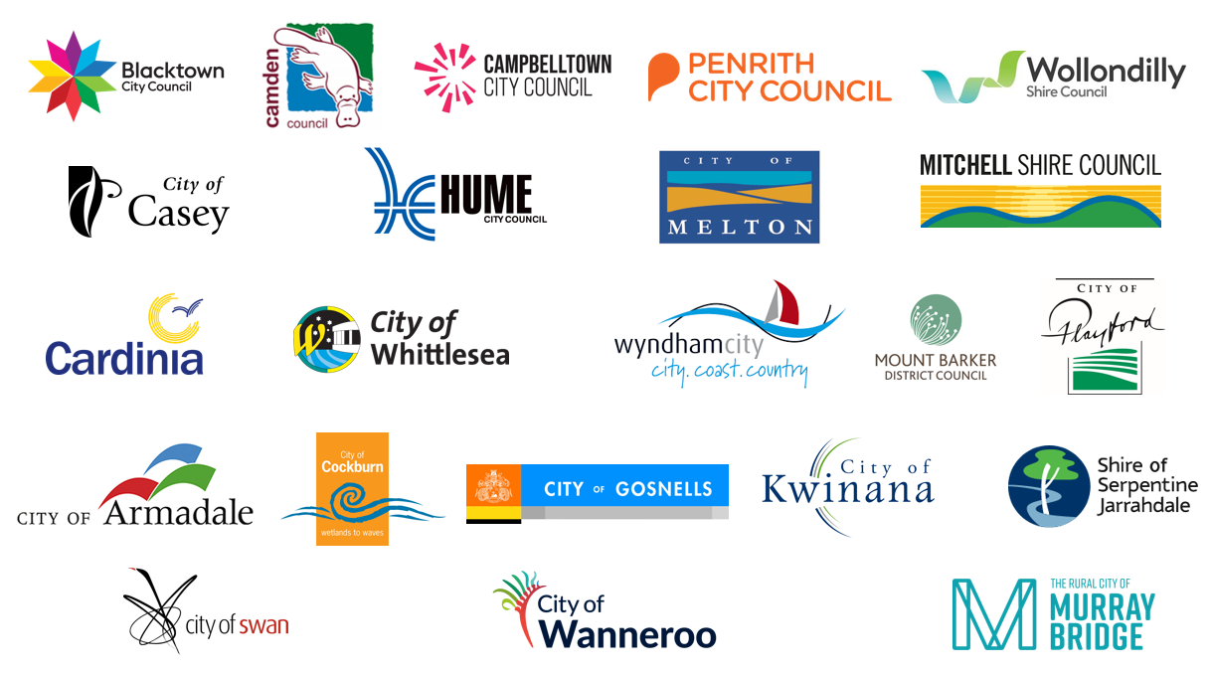

Productivity Commission 2025, Creating a more dynamic and resilient economy, Inquiry report no. 109, Canberra
National Housing Supply and Affordability Council 2026, State of the Housing System 2026, Canberra
.id informed decisions, 2023, Economic State of Australia’s Growth Areas
Productivity Commission 2025, Creating a more dynamic and resilient economy, Inquiry report no. 109, Canberra
ABS Data compiled by NGAA from REMPLAN Region Explorer
National Housing Supply and Affordability Council 2026, State of the Housing System 2026, Canberra
Morrison N, Gatarin G, and Strickling M (2024) International Best Practices in Infrastructure Funding: Lessons for Australia’s Outer Metropolitan Growth Areas, Urban Transformations Research Centre, Western Sydney University. https://doi.org/10.26183/tmc6-gg23

