REV 6 Tracking Environmental Change – the need for Environmental Information
Celia Hay 21/07/2026
Bachelor of Applied Science
Master of Applied Science (Geographic Information Systems)

Abstract
How do we obtain information from environmental monitoring results that enables us to track environmental change, detection-compliance or missing information, in addition to how do we make direct comparison with water standards and legal requirements, such as limits for compliance monitoring, to establish a factual basis for making meaningful decisions about environmental protection?
Wang and collaborators state in their 2026 article, "A persistent limitation across AI applications in water pollution management is the lack of alignment with formal regulatory instruments such as effluent discharge permits or ambient water quality standards. While many models focus on optimising pollutant detection, forecasting contaminant levels, or improving treatment processes, their outputs often remain disconnected from regulatory thresholds or enforcement mechanisms” (Wang et al., 2026, p. 9)

‘Persistent issues with data quality, availability, and standardisation pose significant barriers. Inconsistent, fragmented, or low-quality datasets diminish the accuracy and reliability of AI models” (Wang et al., 2026, p.13).

This article proposes a method, a Framework, to do this: analyse monitoring results to obtain meaningful information that enables tracking of environmental change, detection of noncompliance or missing information, and production of results on which to make decisions to protect the environment.
The Framework consists of two central registries with links to the original environmental information systems where measurements are stored.
- A Program Registry containing each program’s sample plans detailing the monitoring requirements. The sample plan contains the intrinsic properties of a program, including the locations and parameters being monitored, as well as the measurement frequency. The ongoing monitoring status can be included if monitoring has ceased, stating the start and finish dates. The system where the program datasets are stored is also linked to this registry
• An Indicator Registry linking parameters across programs; the same monitored parameter can be assigned different, valid synonyms (names) by different programs. Each parameter tracked by the central framework can be assigned a unique identifier based on the CASNO, so parameters in one program are linked to the same parameters in other programs, regardless of the parameter synonym used.
The Framework consists of the Indicator Registry and Program Registry and is stored centrally. However, the environmental data required by each program can be stored in the original organisation’s internal systems. The Indicator Register links parameter synonyms used by different organisations for the same parameter, so working with information and datasets from different organisations does not require a strong chemistry background.
Similarly, water standards and legal limits can be linked to information created with parameters via the Indicator Registry.

Introduction
This framework arose from a practical problem: determining whether environmental monitoring datasets submitted by multiple organisations were complete before they were accepted into an environmental information system. Solving this problem required more than storing measurements. It required a common framework that described the relationships among monitoring programs, environmental parameters, and the data they produced. This paper argues that these relationships are not merely administrative metadata but are fundamental to the creation of environmental information.

If we are to make full use of AI in monitoring and protecting the environment, we need to be aware of its limitations. The paper ‘From data to policy: a systematic review of AI in water regulation and compliance’ (Wang et al., 2026) gives us an insight into some of the limitations
"A persistent limitation across AI applications in water pollution management is the lack of alignment with formal regulatory instruments such as effluent discharge permits or ambient water quality standards. While many models focus on optimising pollutant detection, forecasting contaminant levels, or improving treatment processes, their outputs often remain disconnected from regulatory thresholds or enforcement mechanisms” (Wang et al., 2026, p. 9)

‘Persistent issues with data quality, availability, and standardisation pose significant barriers. Inconsistent, fragmented, or low-quality datasets diminish the accuracy and reliability of AI models” (Wang et al., 2026, p.13).

The Framework for merging information to provide environmental information that complements AI use is one of the objectives of the proposed Merge system presented in this article.
To manage the environment and climate change, we need accurate data on changing environmental conditions. This report examines a method for generating environmental information for longitudinal monitoring. This report aims to demonstrate how a simple central Framework can integrate with numerous environmental information systems that store data from this type of monitoring, thereby enabling an overview of the extent of monitoring, identifying dataset completeness, and mapping all datasets.
Environmental measurements need to be examined in context to be meaningful. The proposed Framework not only compares monitoring data from each individual program to provide useful environmental information but also allows an overview of cumulative results to be examined, detecting changes that may not be apparent from individual program results.
However, many people, including scientists, do not fully grasp what constitutes useful information. Using Gregory Bateson's definition of information, “a difference which makes a difference,
This paper aims to demonstrate that environmental information can be extracted from monitoring results that not only verify their completeness but also provide context for determining the significance of any change. The environmental change resulting from the cumulative effects of various organisational systems whose programs are included in the Program Registry can also be examined.
The Framework allows for determining the properties of all datasets, including;
- The number of programs and each program’s purpose
- The spatial locations where monitoring occurs for all programs
- The parameters and frequency measured for all programs and locations (with parameter synonyms linked so all parameters are included regardless of the synonyms used)
- The water depths measured or the methods used to determine the depth
Statistical summaries of the data
- The first and last measurements taken for all programs and locations
- Ongoing monitoring status
- Gaps in datasets - where measurements are missing
Data Summaries for water datasets often include the location and the dates of the first and last measurements. An ongoing status: If monitoring is ongoing or has ceased, it would complete the overview.
Creating the contextual structures that give data meaning, enabling information from different sources to be consistently interpreted, integrated, and compared.
The challenge lies not in gathering environmental data, but in interpreting measurements from various independent monitoring programs collectively. To address this issue, we need a shared conceptual framework instead of viewing each monitoring program as a separate activity.

Merge: Creating Environmental Information
Industrial enterprises use tools such as critical path analysis to identify the tasks that must be completed to achieve the planned objective. The critical tasks are then divided into subtasks, and the necessary resources are allocated to complete them within the required time. Success or failure is self-evident: the objective is achieved as planned, or it is not.
The common framework proposed in this paper is more than an administrative structure. It reflects a general principle: new environmental information emerges by combining related information from independent monitoring activities into a coherent whole
Such an approach is severely limited if applied in its entirety to protecting the environment. The reason is that the success of environmental protection cannot be judged solely by meeting the monitoring requirements of individual programs. Completing the subtasks in each program does not provide the necessary environmental information to assess whether the environment is being successfully protected. However, the information obtained by merging the data from each program will be much more appropriate for judging whether the environment is being successfully protected. To merge data from programs, as mentioned above, requires an Indicator Registry to address parameter synonyms and a Program Registry to ensure that all appropriate available data is included in a Merge. A standard data file format is required and should be mandated.
Longitudinal monitoring (see definition on page 9) of intrinsic properties is recorded in sample plans. For example, compliance water-quality monitoring sample plans are stored as monitoring schedules to meet the permit's legal requirements. These plans set out the monitoring location, including the spatial coordinates, the parameters to be monitored, and, in the case of deep water, the water depths at which samples are to be taken. These plans outline the intrinsic properties of the collected data to meet the requirements.
Merging the compliance water data collected in accordance with the monitoring schedule provides context for the data and its emergent properties. Merge creates a logical structure that allows us to both detect emergent properties and reveal missing data and non-compliance with program requirements.
For example, see the map below for Tas EPA Mercury Passage Monitoring -From the public domain on the EPA Tas Website.

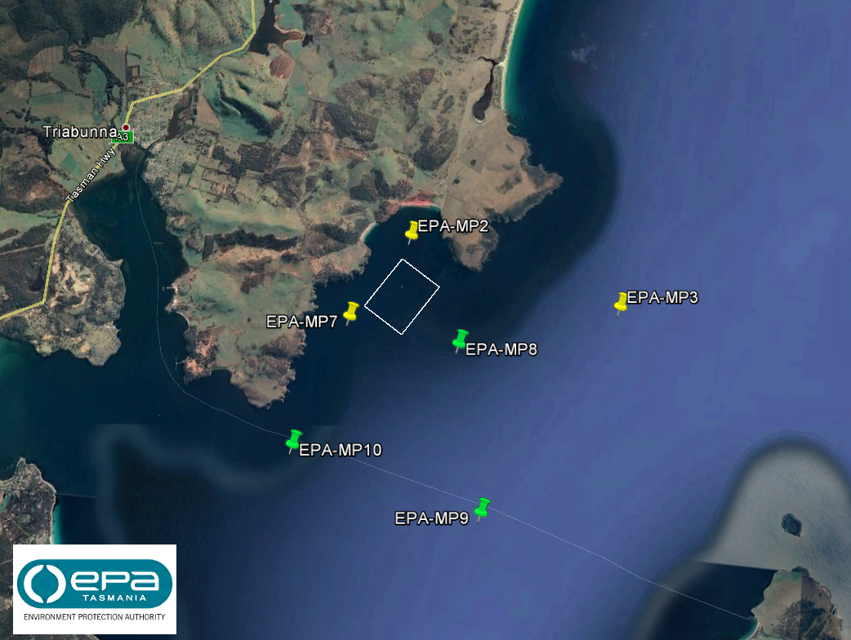

This monitoring schedule outlines the expected monitoring activities. When combined with the sample results submitted under the legal requirements, it provides the context needed to determine:
• whether all required samples have been collected,
• whether the correct parameters have been monitored,
• whether sampling has occurred at the required frequency,
• whether approved sampling methods have been followed, and
• whether regulatory compliance can be assessed.
Merge does not create elementary information. It recursively constructs higher-order informational structures from which Emergent Properties become apparent. Emergent properties are new insights that arise when information from different parts of a system is combined.
By linking other contextual information, for example, for compliance monitoring, the information could include the premises monitored and their properties, such as Chemicals of Concern (CoC), and locations such as discharge points, impacted sites, and reference sites. Other emergent properties, such as exceedances, arise from comparing an observed discharge result for a Premise with the legal limit in the permit.
The Program Registry provides a central hub for all program monitoring plans across organisations and government departments. It enables users to view locations on a map alongside other contextual data such as those set by ANZECC, which define acceptable levels for natural and semi-natural water resources and permissible limits for different types of recreational water use.
Higher-order concepts can be created, abstractions that condense large amounts of low-level data. For example, compliance compares water quality monitoring against legal requirements and summarises the results like a report card.
Higher-order concepts such as Judgments (decisions) and interpretations, currently reported in and associated with legal instruments, could be represented and displayed using this structure, including regulations, Policies, Permits, and Environmental Protection Notices (EPNs).
When there is a requirement by Federal or State governments—such as for assessments of regulated activities, legal obligations for monitoring, or monitoring with a federal grant—there should also be a requirement that the program’s monitoring plan be added to the Program Register.
Following a similar framework, the same framework can be extended to establish a Model Registry that tracks scientific models, including links to the programs that provide data to those models via the Program Register/ Indicator Registry.

Harmonisation of Programs data
The intrinsic properties of the sample plan, with the parameters ’synonyms linked to a common parameter, create a basic framework for homogenization. This information allows the program's measurement data to be compared with other programs’ data without obtaining the data or having a strong chemistry background to identify the parameter synonyms for the same parameter.
On the next page is the sample EPA-MP2 plan from the Tas EPA monitoring program for the Mercury Passage map.
- This information is all that is needed to compare the program’s data from this location; the entire dataset for the measurement taken at this location by this program need not be obtained.
- It is also all that is needed to transform the measurement data into a standard format.

Monitoring Program EPA-MP
Description: Tas EPA monitoring program for Mercury Passage. Commenced in August 2017 prior to the Okehampton Lease becoming operational.
──────────────────────────────────────────────
Monitoring Site
Location Code: EPA-MP2
Location Name: Mercury Passage
Location: Okehampton Bay
Coordinates: -42.523277, 147.977842
Datum: GDA94
──────────────────────────────────────────────
Required Monitoring
Matrix: Water
Method: Field (FLD)
Frequency: Monthly
──────────────────────────────────────────────
Parameters
✓ Dissolved Oxygen
✓ Temperature
✓ Salinity
✓ DO Saturation (%)
✓ Turbidity
──────────────────────────────────────────────
Water Depths
Sample Action: Lab
Required Depths: field readings to be taken at the surface, then every metre to 10m, and then at 5-metre intervals to the bottom
──────────────────────────────────────────────
Additionally, statistics
- Date of first measurement
- Date of last measurement
- Ongoing monitoring status

Environmental Information Framework
Creating environmental information that tracks changes in environmental conditions involves establishing a data structure and a central hub to manage long-term monitoring programs and to provide a framework for integrating information into a standard format. So data from different programs can be analysed together after homogenisation (see Synthetic data in the next section)

Types of environmental information
- Measurements of the environmental conditions; the results of a measurement of an environmental parameter from which we can obtain useful information. The measurement results are scientific observations of the material world.
- Program’s Monitoring Plans (Intrinsic Properties): The monitoring plans of programs for which measurements are taken. The program’s monitoring plan specifies the locations, sampled parameters, and the sampling frequency and duration. These properties allow Programs to be mapped and compared without obtaining the program’s data.
- Indicator Registry (Master Data): Parameters are a core concept in environmental monitoring; consequently, parameters are used across multiple datasets, information and systems. To overcome the problem of parameters having multiple valid names (synonyms). Master Data, a central registry, can be created to link parameters, allowing data and information to be tracked for a specific parameter across systems, regardless of the synonym used.

Other components
- Standard File Format: A documented ‘Standard File Format’ for the exchange of environmental data between systems with the parameter synonyms linked to a common parameter on the central Indicator Registry.
- A downloadable database (in Access) – to allow for structural flexibility in emergencies and research. So new information can be added to the existing system.
Also prevents data from becoming stuck in the cloud on a commercial database

- Standard Lab File -The government should consider creating a lab file format that links lab results to the Indicator Register. This would enable lab clients to request results in that format, with parameter names already linked to the register. Implementing this system would facilitate the adoption of the Indicator Register.
Since many environmental measurements (results) come from laboratory samples, it makes sense for trained chemists to link these measurements to the Indicator Registry when the samples are analysed and the results are produced.
Note: the lab file format needs to include information such as Method No to allow data to be homogenised if required.

Original information taken from the public domain on the EPA Tas Website
See Water Quality Data Elements | EPA Tasmania for Program and Site Metadata Template Excel workbook to capture a program’s sample plan.
Backed up on the Wayback machine for the website -
https://epa.tas.gov.au/Documents/Program%20and%20Site%20Metadata%20Template.xlsx
Also, following a similar framework, it is possible to set up a Model Registry that tracks scientific models, including links to the programs that provide data to those models via the Program Register Indicator Registry.

Synthetic data
Homogenising data from different programs to create synthetic datasets will be easier because it provides a central location for identifying available datasets and receiving data in a standard file format. Additionally, the program plan for each monitoring initiative will be accessible. Homogenisation involves eliminating discrepancies, such as variations in sensitivity, that can occur between monitoring programs for several reasons. These reasons may include differences in sampling frequency or measurement methods, which may have varying levels of sensitivity, such as the limit of reporting (the minimum value that can be detected in a measurement).
This report does not go into the process of Homogenisation, but a simple example of why this is necessary is the Difference in sampling frequencies between 2 programs. One program is sampled daily, while another is sampled monthly. If the data is combined, the daily-sampled programs will influence the results more than the monthly samples. Therefore, the data must be weighted by sample frequency before comparison.
The Framework could be extended to include synthetic datasets, but it would need to address how to identify the original program for individual measurements.

Definitions
Term | Definition
Empirical Measurement | The process of assigning numbers to attributes or properties (parameters) of objects in the material world
Data element | The smallest element of digital data, where the parameter name or measurement value is stored
Parameter | A core element of environmental management and research. Properties of the environment that are measured to determine environmental conditions
Parameter Synonyms | Different valid names for the same parameter
CASNO | The Chemical Abstracts Service (CAS) Registry Number is a unique, universal numerical identifier assigned to chemical compounds. It provides a standardised, error-reducing method to identify chemical parameters.  Most environmental parameters are chemical, and most measurements are obtained through laboratory analysis.
Environmental Digital Data | Storing the results of measurements as digital data made up of data elements
Context | What explains the significance of new information
Information | Difference that makes a difference
Redundancy | The definition of Information is “differences that make a difference”. If a difference is to be meaningful, it cannot be random. There needs to be something common between the things that differ, a redundancy that gives the difference meaning. Redundancy is created by structure and consistent terminology (e.g., unique names for Parameters).
Environmental Digital Information | Environmental digital data that is organised to provide context, allowing differences that make a difference to be identified, such as changes in environmental conditions.
Arbitrary Information | Arbitrary information is information whose meaning and organisation are established by human convention rather than by the intrinsic properties of the material world. An example is the legal requirements in permits.
Reductionism | Reductionism is the approach of explaining complex phenomena by reducing them to simpler components if understanding the parts is sufficient to explain the whole.
Materialism | Materialism is the assumption that physical observations and material processes can completely explain information, knowledge, and understanding.
Merge | Merge is the recursive process of combining existing representations within their relevant contexts to construct higher-order informational structures from which new concepts, relationships, emergent properties, judgments, and decisions can be represented.
Emerging Properties | Emergent properties are new insights that arise when context is created by aggregating information from different parts of a system. For example, exceeding the discharge limit can be determined by linking water monitoring at a discharge point to the legal limits.
Concept | Concepts are high-level abstractions that condense large amounts of low-level data. For example, compliance, as a concept, could be derived from this framework, which compares compliance with water quality monitoring against legal requirements and summarises the results.
Standard File Format | A Standard File Format is a formally defined and widely agreed-upon structure for storing and encoding data in a computer file, enabling different software systems to read, interpret, and exchange the same information reliably.  In this report, with the same set of parameters stored in the Master Data (the indicator Register)
Harmonisation | Harmonisation is the process of aligning data, terminology, standards, and structures so that information from different sources can be consistently interpreted and used together.
Homogenisation | Homogenisation is the process of removing discrepancies, such as differences in sensitivity, that arise between monitoring programs for various reasons, including differences in sampling frequency or in measurement methods, which may have varying levels of sensitivity, such as the limit of reporting (the minimum value that can be detected in a measurement).
Synthetic datasets | Refers to artificially generated data that mimics the statistical properties and patterns of real-world data.
Intrinsic Properties | Intrinsic properties are characteristics that belong to an entity by its own nature and exist independently of human observation, interpretation, or convention.
Registry | A registry is a central list of data elements shared across multiple systems and databases, enabling unified coding. So, information for that specific data element can be tracked across systems.
Master Data | Central list of data elements that are common to different parts of the systems, used for linking the systems together via the common data elements.  In environmental systems, the parameters are the most essential; however, they can have more than one valid name (synonyms)
Indicator Registry | In this report, the Indicator Register is a list of unique codes for environmental parameters, based on CASNO, that allows tracking of information and data for a specific parameter across various systems, regardless of the parameter's synonyms.
Program Monitoring Plan | The program’s monitoring plan specifies the sites, sampled parameters, and the sampling frequency and duration.
Monitoring Locations (in longitudinal studies) | Locations where measurements are taken, often at regular intervals, to detect environmental change
Program Registry | Unlike a typical Registry, such as the Indicator Registry, this Registry stores information on historical and current environmental monitoring by storing the Program Monitoring plans. That allows tracking of environmental monitoring whose results are stored in various external systems and databases.
Compliance Monitoring | Compliance monitoring is the systematic collection and integration of environmental observations with regulatory and contextual information to determine whether regulatory obligations have been met.
Compliance | Compliance is a higher-order abstract concept that emerges from integrating environmental observations with their regulatory, operational, and organisational context. It cannot be determined from a single measurement alone but requires the recursive construction of higher-order informational structure.
Discharge Point | A discharge point is a defined monitoring location where an authorised discharge leaves a facility and enters the receiving environment.
Reference Point | A reference point is an identified monitoring location that provides the environmental context against which observations from discharge points can be interpreted and compliance or environmental impacts assessed.
Impacted Location | An impacted location is a monitoring site where the effects of a discharge on the receiving environment are expected to occur or are assessed.
Information Processing (Aggregation) | This report presents an information process for aggregating environmental data from multiple databases and systems into a single data file. The process is based on information in the Program Monitoring Plan, stored in the Program Registry.  There can also be links to other information, such as legal limits for discharge points.
Map-like interface GIS | Software that can display monitoring sites in a variety of program monitoring sample plans in the Program Register, in their spatial context.
Measure of Success | In biometrics, the study of biological information, a sign serves as a cue for decision-making. This article suggests that tracking environmental changes could indicate the success of environmental management more effectively than performance measures such as completed reports
Information flexibility | Information flexibility is the ability of information to be consistently interpreted, integrated, reused, and combined across different systems, purposes, and contexts without loss of meaning.

Indicator Registry
All information requires redundancy, see definition, and data elements need to be coded. The most vital data element for accurate coding is the use of environmental parameters as indicators of environmental change.
The term ‘parameter’ is quite broad. That is, parameters typically consist of just a name and a unit that describe not only the substance being measured but also other information, such as whether the sample has been filtered and, for laboratory results, the specific analysis method used. The analytical method used for a laboratory sample can be significant because it may influence the name of the measured parameter. For example, the parameter Total Organic Carbon (TOC) was replaced by Non-Purgable Organic Carbon (NPOC) after the laboratory detection limit increased from 0.1 mg/L to 0.3 mg/L. The reported indicator did not change.
The US EPA substance definition for an indicator refers only to chemical, biological, and physical properties. Even if you describe only the indicator measured, there can still be many valid names (synonyms) for the same indicator; for example, Methyl benzene can also be reported as Toluene, Toluol, Phenylmethane, and Benzene, methyl. These synonyms can be linked to a single substance, Benzene, with the CAS Number 71-41-2. This is what makes coding parameters so difficult.
To clarify the ‘term’ parameters, a formal data model for the concept of parameters could be developed. To assist a common understanding of the information that makes up a parameter, including analysis method, Chemical Abstract Service(CAS) number, and method standard of Limit of Report (LoR), etc. See an example of a parameter data model on the next page.
To ensure proper coding of parameters with multiple synonyms, an Indicator Register should be established alongside the Program Register as Master Data. This guarantees that programs with different synonyms for the same parameter are assigned the correct code. (Could also have a Biological Registry based on the APHIA_IDs)
Unique codes for individual parameters can be based on the Chemical Abstracts Service (CAS) numbers. The US EPA Substance Registry Services (SRS) website (link provided below) is an example of a registry. Allowing searches of U.S. legal statutes and information systems that regulate or track a particular indicator, regardless of the synonym or parameter used.
https://ofmpub.epa.gov/sor_internet/registry/substreg/searchandretrieve/substancesearch/search.do
Another example of an Indicator Register in an Excel spreadsheet based on CAS Number published by the Tas EPA.
Water Quality Data Elements | EPA Tasmania

Saved on the Wayback machine website for the https://epa.tas.gov.au/Documents/Indicator%20Register.xlsx

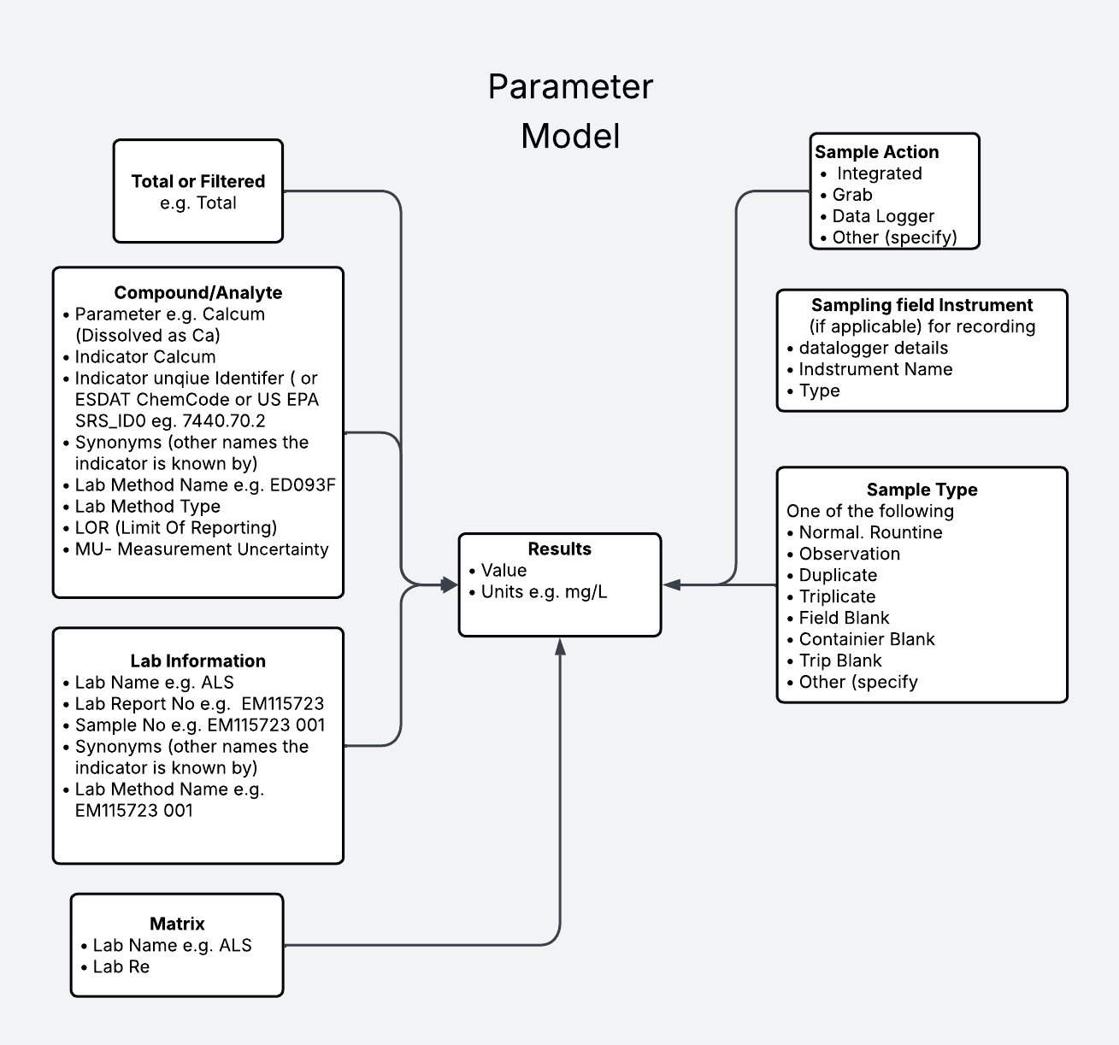

Program Registry
The main purpose of a sample plan in monitoring is to ensure systematic measures are taken to produce valid results. In longitudinal studies, consistent measurement of water quality parameters at regular intervals allows for comparisons to detect changes.
For long-term monitoring of large landscapes, sampling locations are widely distributed to assess ecosystem health, typically showing minimal contextual variation. In small-scale compliance monitoring, however, locations are chosen based on differing characteristics.
For compliance, common sampling locations include:
- **Discharge point**: Where regulated discharge enters the environment.
- **Reference point**: An unaffected area, often upstream.
- **Impacted location**: An area affected by the discharge; distance from the discharge point is important.
A graph shows monthly Total Nitrogen measurements taken at various distances downstream from a sewage plant discharge into Cox's Creek. The plan requires monthly sampling at these locations to assess the discharge's impact on the creek.
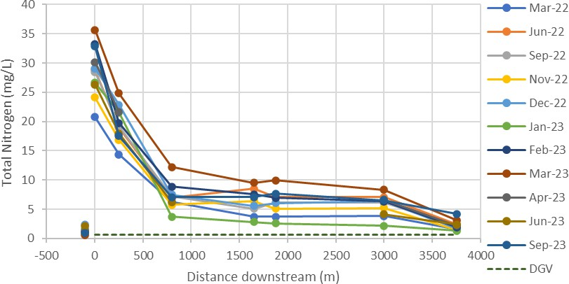
Note: Nitrogen was significantly elevated along the full length of Cox’s Creek and into Cox’s Rivulet downstream to the effluent discharges. Note the Reference Point is -100m upstream and is considerably lower

Code | Description |  | Type |  | Distance D/S (m)
SDT01S04 | Scottsdale STP Effluent |  | Effluent |  | 0
SDT01S06 | Cox’sCreek250mD/Sof STP |  | Impact |  | 250
SDT01S07 | Cox’sCreekJunctionwithMinor Stream |  | Impact |  | 800
SDT01S08 | Cox’sCreekBurnside Rd |  | Impact |  | 1650
SDT01S09 | Cox’sCreekDownstreamofSimmons Dairy |  | Impact |  | 1875
SDT01S10 | Cox’sCreekU/SofCox'sRivulet Junction |  | Impact |  | 3000
SDT01S11* |  | Cox'sCreek-Moore'sDamNearPumpInlet |  | Impact |  | 3500
SDT01S12 |  | Cox’sRivuletBrokettsRdBridge |  | Impact |  | 3750
SDT01S13 |  | Cox’sRivulet100mUSJunctionwithCoxCreek |  | Reference |  | 100U/S

Taken from Scottsdale Sewage Treatment Plant Effluent Discharge to Cox’s Creek – receiving environment monitoring report 2022-2023 published on the Tas EPA website

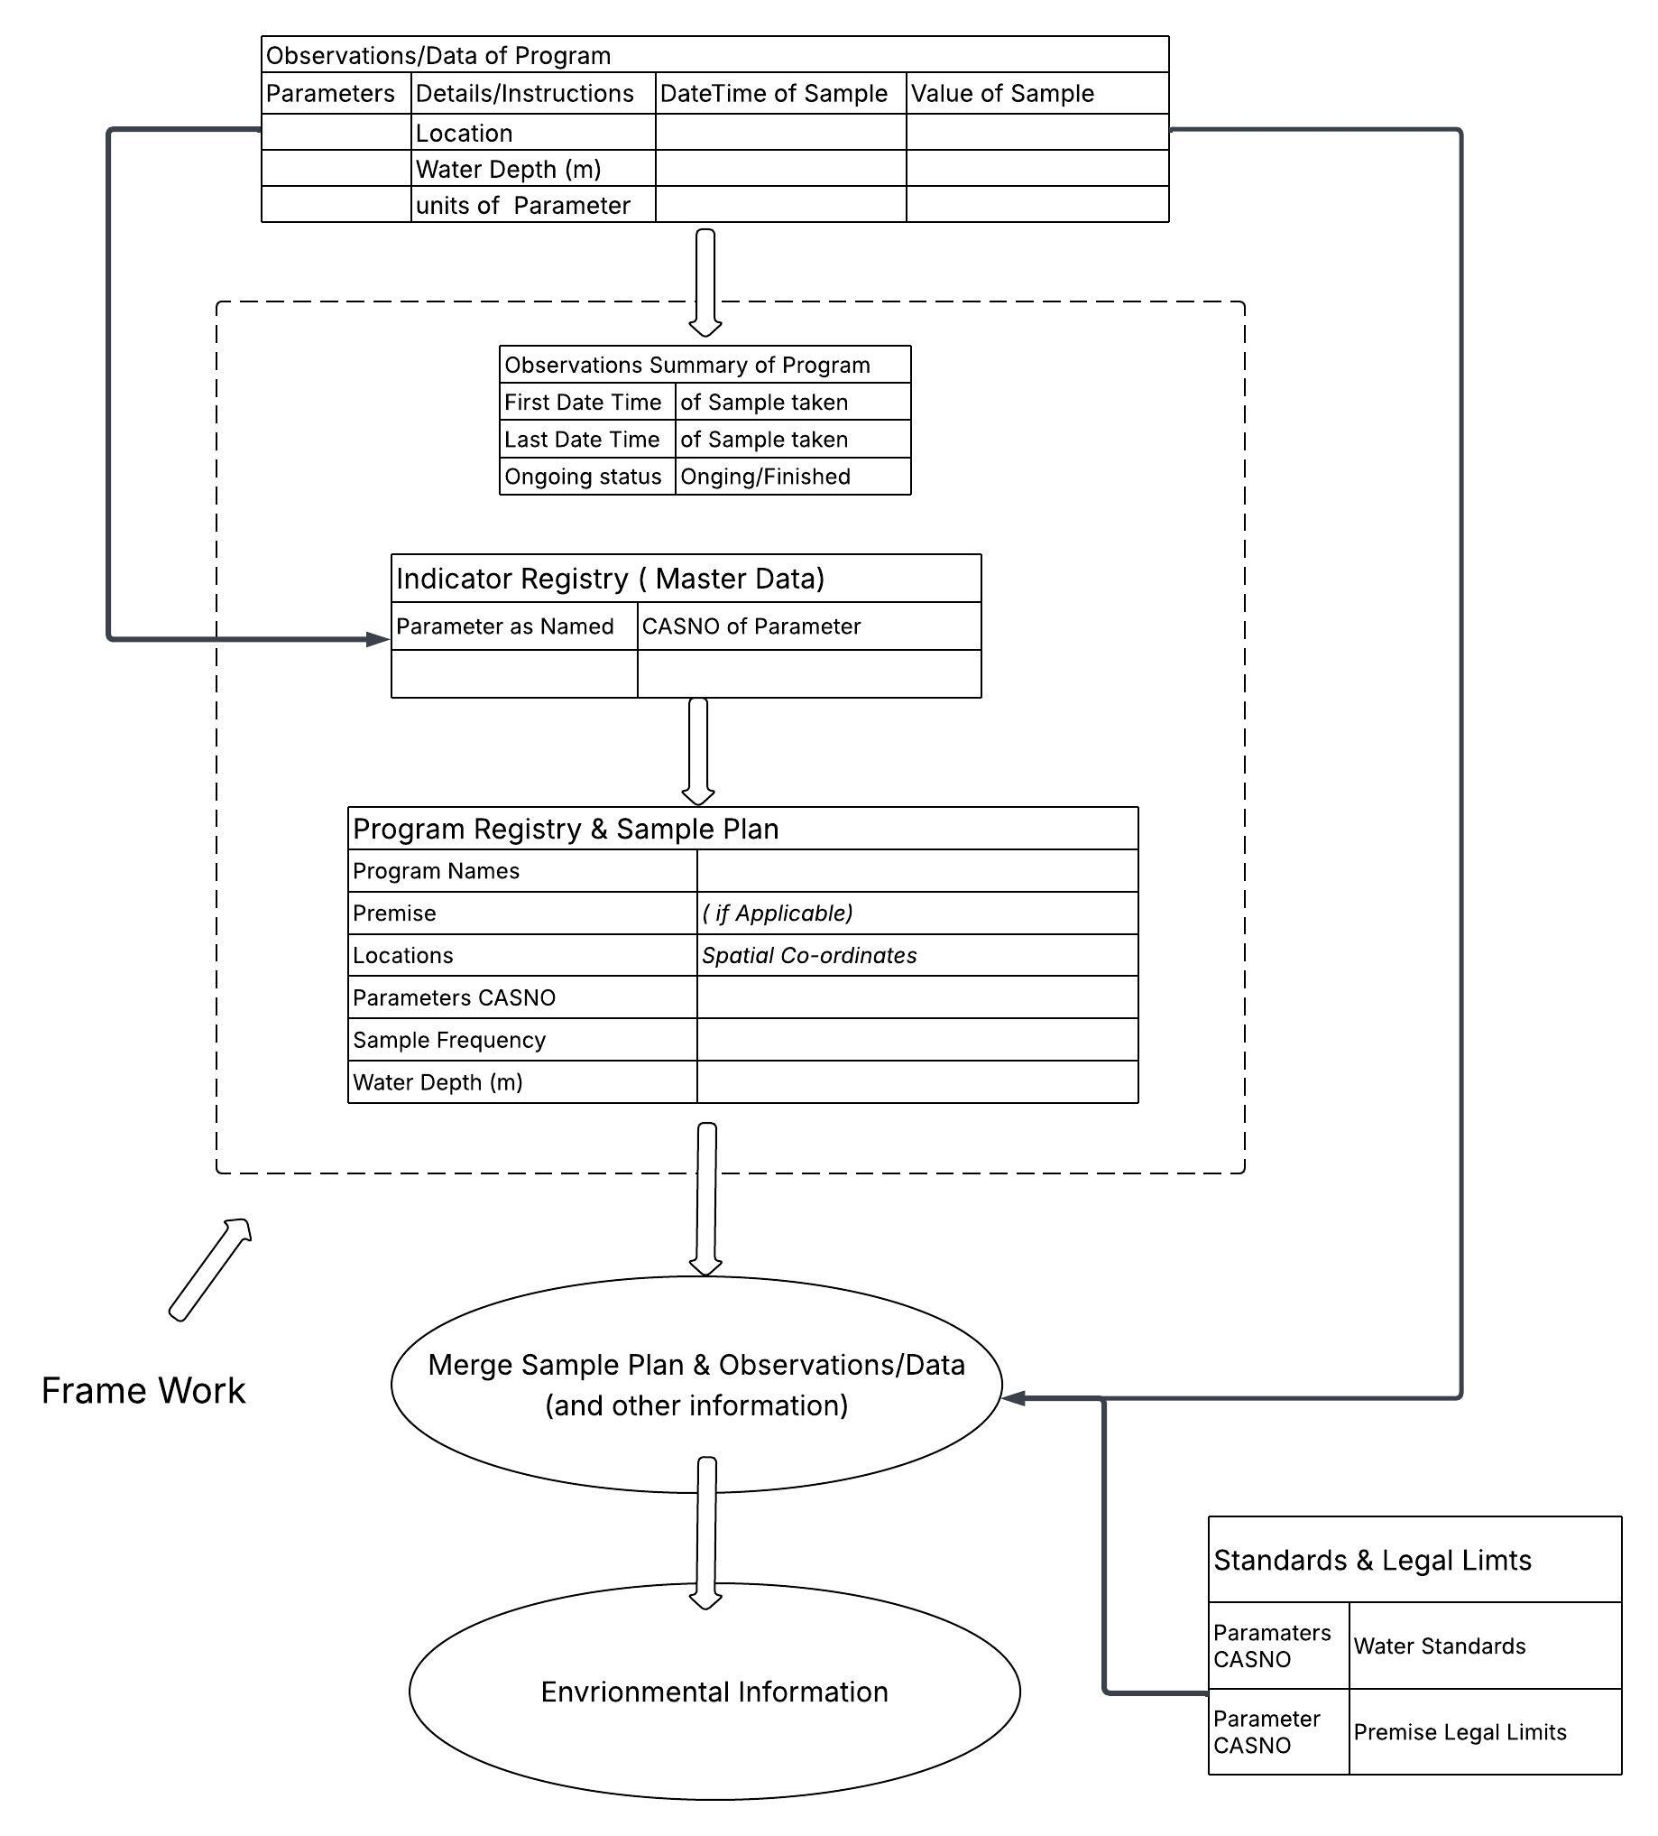

Conclusion
To effectively manage environmental change, we need environmental information that makes all monitoring and emerging properties transparent. The framework suggested in this report allows basic properties of the programs' data to be accessed, tracked, and compared without obtaining the programs' actual data. So, the data can remain with the organisation that collected it, which can be responsible for its management and for ensuring that the dataset maintains its quality and integrity.
The framework allows the following to be determined by all programs in systems linked to the central framework
- The total number of programs and each program’s purpose
- The spatial locations where monitoring occurs for all programs
- The parameters measured for all programs and locations (with parameter synonyms linked so all parameters are included regardless of the synonyms used)
- The first and last measurements taken for all programs and locations, as well as the ongoing status
- Gaps in datasets - where measurements are missing
The above information could be mapped in a GIS interface. If a program is selected, the data will be provided in a standard file format with a standard set of parameters from the framework’s central parameter register (the Indicator Registry), regardless of the parameter synonyms used in the original dataset.
There is a deeply held belief that the basis of all thought and knowledge lies in the material world. “That all knowledge can be built upon first principles, axioms and deduction or logical reasoning”, Bob Doyle, Metaphysics, p. 44. However, Noam Chomsky proposes that merge is the fundamental operation of human thought. The framework suggested in this report for creating environmental information is based on merging data from different tasks.
Merge creates a framework for a common understanding of detailed interpretation, the detection of emerging properties, and the determination of what is known and what is unknown, such as dataset completeness. Is the first step for better integration between datasets.
More importantly, the success of environmental management should be measured beyond setting goals, completing tasks, and tracking spending. Science faces a ‘tick and flick’ problem—where producing reports and completing projects are often seen as signs of success. By creating a system that continuously converts environmental monitoring data and sample plans into reliable information, we can assess success by measuring actual changes in environmental conditions against efforts to mitigate environmental harm, including legal requirements and limits.
Merge creates new hierarchical informational structures by recursively combining existing representations. The difference between the framework suggested in this report and Artificial Intelligence (AI) lies in their respective levels of logical transparency. Registries provide a clear understanding of the underlying logic, allowing humans to verify the processes involved. They maintain a change log, making their logic defensible in court. In contrast, AI relies on neural networks and training data, which makes its decision-making process less transparent. While AI can effectively complete various tasks, the reasoning behind its actions is often unclear. Additionally, the training data used in AI can contain unknown biases, and the logic of AI systems is generally not defensible in a legal context.
The framework provides an overview of compliance data and its completeness, aligns the data with regulatory requirements and water standards, and would improve the effectiveness of AI.
Bibliography
Ahl, V., & Allen, T. F. H. (1996). Hierarchy theory: A vision, vocabulary, and epistemology. Columbia University Press.
Bateson, G. (1988). Mind and nature: A necessary unity. Hampton Press. (Original work published 1979)
Chomsky, N. (2015). What kind of creatures are we? Columbia University Press.
Connell, D. W. (1993). Water pollution: Causes and effects in Australia and New Zealand (3rd ed.). University of Queensland Press.
Doyle, B. (2016a). Great problems in philosophy and physics solved? Information Philosopher Press.
Doyle, B. (2016b). Metaphysics: Problems, paradoxes, and puzzles, solved? Information Philosopher Press.
Harries-Jones, P. (2016). Upside-down gods: Gregory Bateson’s world of difference. Fordham University Press.
Information Philosopher. (n.d.). E. J. Lowe. Retrieved January 23, 2026, from https://www.informationphilosopher.com/solutions/philosophers/lowe/
Information Philosopher. (n.d.). Information Philosopher. Retrieved January 23, 2026, from https://www.informationphilosopher.com/
Khan Academy. (n.d.). Information theory. Retrieved January 23, 2026, from https://www.khanacademy.org/computing/computer-science/informationtheory
McNeil, D. H. (1995). A survey of applied systemology. System Research, 12(2), 75–92.
McNeil, D. H. (2004). What’s going on with the topology of recursion? Retrieved via the Wayback Machine from http://www.library.utoronto.ca:80/see/SEED/Vol4-1/McNeil.htm
Meadows, D. H. (2008). Thinking in systems: A primer. Chelsea Green Publishing.
Meridian University. (n.d.). How positivism shaped our understanding of reality. Retrieved January 23, 2026, from https://meridianuniversity.edu/content/how-positivism-shaped-our-understanding-of-reality
Mitchell, M. (2019). Artificial intelligence: A guide for thinking humans. Viking.
Strengholt, P. (2020). Data management at scale: Best practices for enterprise architecture. Apress.
Tasmanian Environment Protection Authority. (n.d.). Indicator register. https://epa.tas.gov.au/Documents/Indicator%20Register.xlsx – (Backed up on the way back machine website)
Tasmanian Environment Protection Authority. (n.d.). Program and site metadata template. https://epa.tas.gov.au/Documents/Program%20and%20Site%20Metadata%20Template.xlsx (Backed up on the way back machine website)
Tasmanian Environment Protection Authority. (n.d.). Water data format from external databases. https://epa.tas.gov.au/Documents/Water%20Data%20Format%20from%20External%20Databases.pdf (Backed up on the way back machine website)
Tasmanian Environment Protection Authority. (n.d.). Water quality data elements. https://epa.tas.gov.au/environment/water/water-quality-data-elements(Backed up on the way back machine website)
U.S. Environmental Protection Agency. (n.d.). Substance Registry Services (SRS): About. https://cdxapps.epa.gov/oms-substance-registry-services/about-srs
Wang, Y., Wilchek, M., & Batarseh, F. A. (2026). From data to policy: A systematic review of AI in water regulations and compliance. npj Clean Water, 9, Article 33. https://doi.org/10.1038/s41545-026-00446-0
Wicquart, J., Gudka, M., Obura, D., Logan, M., Staub, F., Souter, D., & Planes, S. (2022). A workflow to integrate ecological monitoring data from different sources. Ecological Informatics, Vol 68.
Zellmer, A. J., Allen, T. F. H., & Kesseboehmer, K. (2006). The nature of ecological complexity: A protocol for building the narrative. Ecological Complexity, 3(3), 171–182.

