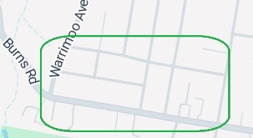
PARKWAYS HOUSING DEVELOPMENTS
Concept: Convert zoning of complete blocks next to major roads to allow a mixture of higher density, build to rent, first home buyers, retirees & elderly residences. This utilises existing infrastructure in an improved manner and improves housing. EG ↗
Imagery © 2026, Map data © 2026 Google

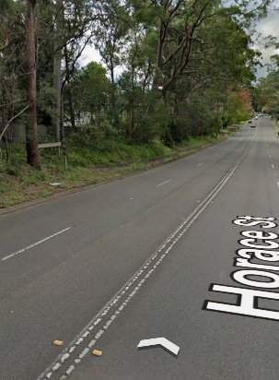
Example look: Horace Street through to Eastern Arterial Road St Ives used to be free flowing traffic with two lanes on either side. Now parked cars and trailers have ruined traffic flow. This damages productivity and increases driving danger as cars need to change lanes. Whereas the western side of that road (per picture on right) has homes behind with a bike track flowing through the trees. Converting all such roads in major cities and towns to “parkways” increases availability of homes and productivity and is close to existing transport. Adding e-bike paths to zones creates efficiencies and reduces dangers related to vehicles that can reduce emissions.
Image capture: May 2024 © 2026 Google

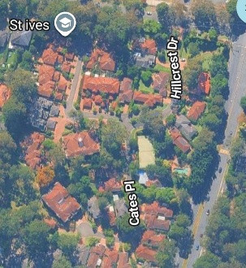
Example development: The image on the right is also in St Ives. The development is a mixture of free standing homes, duplexes and apartments in a private road next to Mona Vale Rd, with no impediment of passing traffic. The Parkways concept repeats this across all major roads. This concept has the opportunity to create communities. Apart from just homes the residents will reflect our society. 1 bedroom flats for elderly and 1st home buyers, small homes for young families, empty nesters, single mums etc plus 3-4 bedroom option with ownership that allows all levels of wealth to live in areas they know. Mixing ages / demographics avoids sterile enclaves.
Imagery © 2026, Map Data © 2026 Google

Politics: The federal government has an ability to set a 20 year vision backed by financial incentives and operational realities. Rather than letting the market manage this, the government could create an agency with property professionals who will buy the properties at fair market prices. Thus, sales agent commission will be saved. They can also work positively with the state governments to abandon stamp duty on the acquisition of the next property by the seller. CGT concessions can also be added. Total concessions would save typical sellers 10’s of thousands of $. The catch is that in 20 years the concessions disappear, and compulsory acquisition of final properties in logical blocks will occur.
As the owner of many properties the above property professionals manage the rentals like a landlord. Behind the scenes, these teams are designing great communities for when the government sells the land to developers. That land will be amalgamation of whole street blocks where access is not via the main road. As the land will have been re-zoned, the government will make money, however profits should not be the main game. On the main road’s side of the development trees can be planted – which look great and green our cities. The e-bike lanes help reduce rider danger and pollution. Indented bus stops can be added that allow traffic to keep flowing. All add up to positives for society.
There are a lot of opportunities for a win-win here. High rise is great for some, but not all. Sending everyone away from employment in new land subdivisions is creating longer term problems. All Australian cities and towns have infrastructure closer to their hub that will support many more residents. Without ruining these suburbs, these parkway developments allow the block next to the main road to have increased density with a cross section of housing and affordability styles. The quiet roads and shared gardens of these developments assists to create a true sense of community.

