September 2026

Review of the National Agreement on Closing the Gap 2026
  - Call for submissions
The PC has released this paper to assist individuals and organisations to prepare submissions. It contains and outlines:
• the scope of the review
• the PC’s procedures
• matters about which the PC is seeking comment and information
• how to make a submission.

Acknowledgment of Country

The Productivity Commission acknowledges the Traditional Owners of Country throughout Australia and their continuing connection to land, waters and community. We pay our respects to their Cultures, Country and Elders past and present.

About us
The PC is the Australian Government’s independent research and advisory body on a range of economic, social and environmental issues affecting the welfare of Australians. Its role, expressed most simply, is to help governments make better policies, in the long-term interest of the Australian community.
The PC’s independence is underpinned by an Act of Parliament. Its processes and outputs are open to public scrutiny and are driven by concern for the wellbeing of the community as a whole.
For more information visit our website: www.pc.gov.au.

Call for submissions
The PC has released this paper to assist individuals and organisations to prepare submissions to the inquiry. It contains and outlines:
- the scope of the review
- the PC’s procedures
- matters about which the PC is seeking comment and information
- how to make a submission (see attachment C).
Participants should not feel that they are restricted to comment only on matters raised in the paper. The PC wishes to receive information and comment on issues which participants consider relevant to the review’s terms of reference.

Key dates
Receipt of terms of reference | 28 August 2026
Due date for submissions | 26 October 2026
Release of draft report | April 2027
Final report to Government | August 2027
Contact details
Phone | 02 6240 3228
Freecall | 1800 020 083
Email | ctg.review.2026@pc.gov.au
Website | www.pc.gov.au/ctg-review-2026

Contents
About the 2026 PC review 1
The National Agreement on Closing the Gap 1
What has the PC been asked to do? 3
A proposed approach to the review 6
How are parties progressing commitments under the Agreement? 8
How have actions supported progress towards Agreement objectives? 14
A. Terms of reference 19
B. Questions to guide submissions 21
C. How to make a submission 26
How to prepare a submission 26
How to lodge a submission 27
References 28


About the artwork

The artwork titled ‘Pathways of Accountability and Change’ was created for the Productivity Commission’s visual identity for the second review of progress under the National Agreement on Closing the Gap.
The artwork was created by Aboriginal artist Lani Balzan and represents the shared journey toward meaningful change through the Review of the National Agreement on Closing the Gap 2026.

About the artist
Lani Balzan is an Aboriginal artist and graphic designer specialising in designing Indigenous canvas art, graphic design, logo design, Reconciliation Action Plan design and document design.
Lani is a proud Aboriginal woman from the Wiradjuri people of the three-river tribe. Her family originates from Mudgee but she grew up all over Australia and lived in many different towns starting her business in the Illawarra NSW and recently relocating to Mid-North Queensland.

In 2016 Lani was announced as the 2016 NAIDOC Poster Competition winner with her artwork ‘Songlines’. This poster was used as the 2016 NAIDOC theme across the country.
Lani has been creating art Aboriginal art since 2013 and has continued success across the country. One of her biggest goals and inspirations with creating Aboriginal art is to develop a better connection to her culture and to continue to work towards reconciliation; bringing people and communities together to learn about the amazing culture we have here in Australia.

About the 2026 PC review

The National Agreement on Closing the Gap
In 2020, all Australian governments and the Coalition of Aboriginal and Torres Strait Islander Peak Organisations (Coalition of Peaks) signed the National Agreement on Closing the Gap (the Agreement). Its objective is ‘to overcome the entrenched inequality faced by too many Aboriginal and Torres Strait Islander people so that their life outcomes are equal to all Australians’ (clause 15).
The central pillars of the Agreement are its 4 Priority Reforms, which describe the changes needed to redefine the way governments work with Aboriginal and Torres Strait Islander people (table 1). Implementation of the Priority Reforms is intended to accelerate improvements in socio-economic outcomes (SEOs) for Aboriginal and Torres Strait Islander people. The Agreement contains 17 SEOs and 19 associated targets (figure 1).
Table 1 – The Agreement details specific actions to achieve Priority Reform outcomes
Outcomes | Actions
Priority Reform 1 – Formal partnerships and shared decision-making  Aboriginal and Torres Strait Islander people are empowered to share decision-making authority with governments through formal partnerships. | Review, build on and strengthen existing partnership arrangements with Aboriginal and Torres Strait Islander people (clause 36).  Establish a joined-up approach to 5 policy priority areas (clause 38).  Establish 6 new place-based partnerships (clause 39).
Priority Reform 2 – Building the community-controlled sector  There is a strong and sustainable Aboriginal and Torres Strait Islander community-controlled sector delivering high-quality services to meet the needs of Aboriginal and Torres Strait Islander people. | Identify sectors for joint national strengthening effort every 3 years through Sector Strengthening Plans (clause 49).  Review expenditure and implement measures to increase the proportion of services delivered by Aboriginal and Torres Strait Islander organisations (clauses 55a and 55b).
Priority Reform 3 – Transforming government organisations  Governments, their organisations and institutions are accountable for Closing the Gap, are culturally safe and responsive to the needs of Aboriginal and Torres Strait Islander people, including through the services they fund. | Implement transformation elements in mainstream institutions and agencies (clause 59).  Share and publish engagement approaches that give effect to the transformation elements (clause 63).
Priority Reform 4 – Shared access to data and information at a regional level  Aboriginal and Torres Strait Islander people have access to, and the capability to use, locally relevant data and information to set and monitor the implementation of efforts to close the gap, their priorities and drive their own development. | Implement data and information sharing elements (clause 72).  Establish community data projects in 6 locations across Australia (clauses 74 and 75).
Figure 1 – Progress towards the Agreement’s socio-economic targets has been mixed
Closing the Gap dashboard data, July 2026
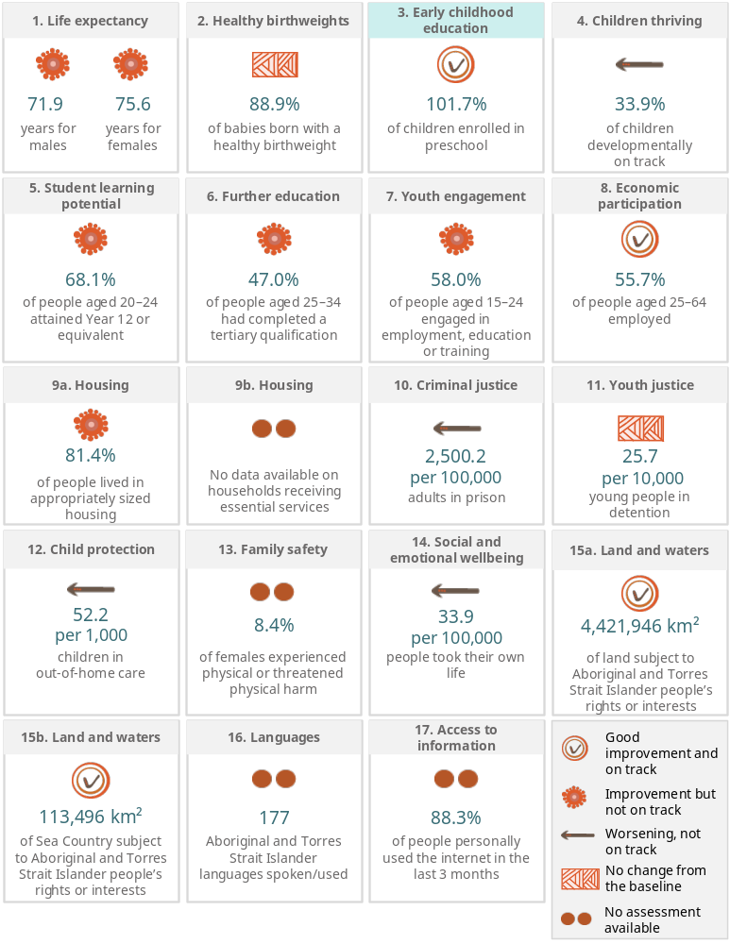
Preschool enrolment rates (Target 3) exceed 100% for the national figure and some jurisdictions because the numerator and denominator come from different data sources and are based on different assumptions. This is explained further in the Closing the Gap Annual Data Compilation Report (PC 2026).

What has the PC been asked to do?
The Agreement requires the PC to undertake a comprehensive review of progress every 3 years, which complement independent Aboriginal and Torres Strait Islander-led reviews (clause 121). The PC published its first review of progress in 2024 (PC 2024), followed by the Aboriginal and Torres Strait Islander-led review in 2025 (Lavarch et al. 2025). We are now starting the second review and will publish the final report shortly after it is provided to government in August 2027 (figure 2).
Figure 2 – Timeline of the PC review
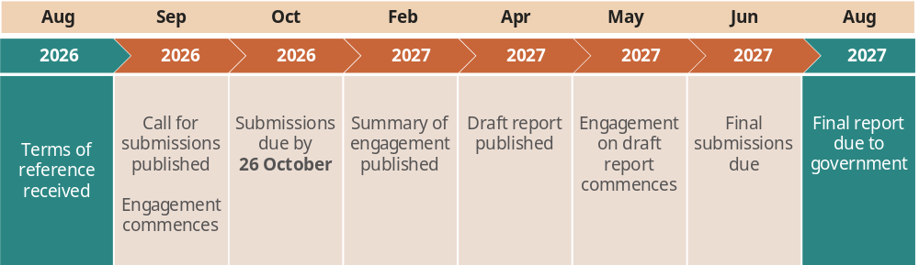
In the terms of reference for this review, the Australian Government has asked the PC to:
- analyse progress on Closing the Gap against the 4 Priority Reforms and 17 SEOs in the Agreement
- examine the factors contributing to progress, including funding allocations
- identify successful approaches, partnerships and delivery models that have demonstrated positive impact
- inform ongoing implementation by highlighting areas of improvement and where additional effort is required.
The full terms of reference can be found in appendix A.
How you can contribute to the review
The PC would like to hear your experiences and views on:
- progress against commitments made in the Agreement
- how actions to achieve progress could be improved
- the proposed approach to the review.
The following pages include background information and questions, reflecting the way we are planning to conduct the review. A list of all questions in the paper is included in appendix B. These questions are not intended to limit what information you share with us. We welcome all input on the Agreement, its implementation and this review. Submissions or discussions you have with us do not need to address all the questions.
We acknowledge that many people and organisations have made submissions and other contributions to previous reviews of the Agreement (box 1). You are welcome to direct the PC to previous contributions where still relevant.
To honour the diverse methods of knowledge sharing in Aboriginal and Torres Strait Islander cultures, the PC will accept:
- written submissions
- brief comments
- oral storytelling
- video narratives
- art-based contributions with a written or oral story.
Where possible, please include examples, case studies, data or research to support the views in your submission. We are particularly interested in hearing about specific government policies or programs that are making a strong contribution or posing a barrier to progress towards the Agreement’s objectives.
Submissions are requested by 26 October 2026 (figure 2). To make a submission or brief comment, please visit: www.pc.gov.au/inquiries-and-research/closing-the-gap-review-2026/make-submission. More information on how to make a submission can be found at appendix C.
If you want to speak with us, including to make an oral submission, you can call us on 02 6240 3228. You can also email us at ctg.review.2026@pc.gov.au.

Box 1 – How does this research relate to other reviews of the Agreement?
The current review builds on 2 previous reviews: the first PC review, published in February 2024, and the first independent Aboriginal and Torres Strait Islander-led review, published in June 2025, which captured Aboriginal and Torres Strait Islander people’s lived experiences of the Agreement’s implementation. These reviews reached similar conclusions, highlighting limited system-level transformation, weak accountability and ongoing challenges in genuine power-sharing.
Past reviews called for stronger governance and strategy to enable system reforms
The Agreement aims to support self-determination to give Aboriginal and Torres Strait Islander people a say in the policies and programs affecting them. Previous reviews did not find evidence of the strategic transformation in the way governments work in order to achieve this goal. While there were pockets of positive change, governments had not transformed at the scale required, and there was no clear plan for system-level reform.
The reviews found power was not consistently shared and partnerships were often not working as they should. Racism, including institutional racism, was a major barrier to progress. Accountability mechanisms lacked independence, consequences for inaction, clear responsibilities and monitoring and evaluation to motivate meaningful change. Independent mechanisms to monitor progress had yet to be established across all jurisdictions.
Key recommendations from the PC review
- Power needs to be shared. Governments need to enable shared decision-making and trust that doing so will enable better outcomes for Aboriginal and Torres Strait Islander people. Actions included clarifying the purpose of Priority Reform 1 as enabling self-determination, having regular meetings between Ministers and peak bodies, providing adequate resourcing to implement the Agreement and working with community-controlled organisations as strategic partners.
- Indigenous Data Sovereignty needs to be recognised and supported. This is central to the purpose of Priority Reform 4 and should be explicitly acknowledged in the Agreement. Actions included establishing a Bureau of Indigenous Data to support Indigenous Data Governance.
- Mainstream government systems and culture need to be fundamentally rethought. Actions focused on enabling systemic change and embedding components of the Agreement into funding and contracting rules, cabinet and budget processes and public sector employment requirements.
- Stronger accountability is needed to drive behaviour change. Actions included establishing the independent mechanisms, advancing progress through other National Agreements and requiring every government organisation to include a statement on Closing the Gap in their annual report.
The Joint Council on Closing the Gap (Joint Council) agreed to the 4 key recommendations and to 15 of the 16 recommended actions. The remaining action to establish a Bureau of Indigenous Data will be considered by the Data Policy Partnership, established in 2025.
Key recommendations from the Aboriginal and Torres Strait Islander-led review
- Parties need to initiate a dialogue to align their visions. Joint Council should initiate a dialogue grounded in truth-telling, cultural respect and a commitment to establishing the right relationship. This should result in a clearly articulated, co-owned vision to guide decision-making.
- Systemic and structural changes are needed to drive transformation within governments. Governments must address cultural load and recognise that Aboriginal and Torres Strait Islander worldviews are distinct from Western worldviews.
- Funding systems need to be reformed. Adequate, equitable and sustained resourcing will support Aboriginal and Torres Strait Islander organisations to deliver on their responsibilities.
- The existing roadmap on monitoring and accountability needs to be implemented. Accountability processes should reflect genuine partnership and be guided by community-led measures of success.
- The community-controlled sector should lead a self-evaluation. This will support shared strategy, capacity and capability building, and cross-sector collaboration.
- How information is communicated needs to be improved by all parties. Communication should be regular, accessible, provided in ways preferred by community and inviting engagement.
- Indigenous Data Sovereignty and Governance principles should be actioned. The principles are needed across the entire data lifecycle.
- Additional areas should be examined for inclusion in the Agreement. Areas of immediate importance should be included in the Agreement, including climate change and care for Elders and older people.
- Opportunities should be considered to strengthen the Agreement. The Agreement should include greater visibility of Stolen Generation survivors and stronger links between the policy and placed-based partnerships.
In May 2026, the majority of Joint Council members agreed to implement 11 Partnership Actions in response to recommendations from the Aboriginal and Torres Strait Islander-led review. Members committed to working through the remaining Partnership Actions to find an agreed approach to this work as soon as possible.
Source: Joint Counil (2025, 2026b, 2026a); Lavarch et al. (2025); PC (2024).

A proposed approach to the review
This review will assess progress made against the Agreement in recent years and make recommendations on how to strengthen implementation of Agreement commitments, in line with the priorities of Aboriginal and Torres Strait Islander communities. We will provide practical guidance to parties on ways to focus reform efforts and achieve sustainable change.
Our approach to the review is grounded in Indigenous research methodology principles (box 2). We will seek to centre Aboriginal and Torres Strait Islander ways of knowing, being and doing and the lived experiences of Aboriginal and Torres Strait Islander people.

Box 2 – Grounding our review in Indigenous research methodology principles
Indigenous research methodologies are grounded in the knowledge systems, worldviews and lived experiences of Aboriginal and Torres Strait Islander peoples. Using these methodologies ensures research is conducted in ways that are culturally meaningful, ethical and supportive of self-determination (Martin 2003; Rigney 1999).
Indigenous research methodologies are as diverse as the cultures practicing them. However, researchers identified common principles across methodologies grounded in relationality, respect, reciprocity, responsibility and relevance (Chilisa 2020; Kirkness and Barnhardt 2001; Pidgeon 2019; Pidgeon and Riley 2021; Roy 2023). Our methodology for the review is grounded in these principles.
Relationality
Relationality means building genuine relationships and trust. Our engagement prioritises ongoing two-way communication, enabling participants to ask questions and be involved in decisions about how conversations will run. Where possible, engagement takes place face-to-face and on Country, recognising the importance of place and relationships in Indigenous ways of knowing.
Reciprocity
Reciprocity recognises people give time, knowledge and lived experience by participating in the review, and our review must give something back in return. This includes a commitment to making evidence-based policy recommendations that will improve outcomes. We offer to share back engagement summaries alongside interim and final reports. These materials provide information to support reflection, advocacy and community-led decision-making.
Relevance
Relevance means the research focuses on what matters to Aboriginal and Torres Strait Islander people. Our priorities in this review have and will continue to be shaped through our engagement with Aboriginal and Torres Strait Islander people and organisations, building on findings from the Aboriginal and Torres Strait Islander-led review and the first PC review of the Agreement. We will engage and report back in ways that are culturally meaningful. In addition to the PC’s standard engagement process, we are offering Yarning Circles, oral submissions and art-based submissions as engagement options. We will also report on our research in accessible ways, including fact sheets and videos.
Responsibility
Responsibility means taking an ethical approach to our research and engagement. We have clear processes for free, prior and informed consent, as well as protocols to manage distress and to support cultural, psychological and emotional safety for participants and staff. The engagement approach also respects Indigenous Data Sovereignty by giving participants control over their information, including opportunities to review, amend or withdraw their contributions.
We submitted our research plan and protocols to the Australian Institute of Aboriginal and Torres Strait Islander Studies (AIATSIS) Human Research Ethics Committee for an independent ethical review. In January 2026 AIATSIS approved our research as compliant with their code of ethics and the National Statement on Ethical Conduct in Human Research (REC-0621) (AIATSIS 2020; NHMRC 2023).
Respect
Respect is about honouring the importance of people, knowledges, culture and Country. We value Indigenous ways of knowing and treat people’s knowledge and experiences with care. We will use strengths-based language and recognise the diversity of Aboriginal and Torres Strait Islander experiences. We will acknowledge the contributions of Aboriginal and Torres Strait Islander participants, partners and staff. During engagements in communities, we will follow local cultural protocols. This includes protecting culturally sensitive information shared with us.
We will assess how parties are progressing their commitments under the Agreement, including actions taken to implement the Priority Reforms, their effect on Agreement outcomes and factors affecting progress (figure 3). This encompasses:
- actions taken to meet commitments under each of the 4 Priority Reforms
- the effectiveness of current governance arrangements and accountability in enabling this.
We will also examine how actions support Agreement objectives. This includes considering how efforts to implement the Priority Reforms have enabled:
- shared decision-making with Aboriginal and Torres Strait Islander people, organisations and communities on the design, implementation and evaluation of policies and programs
- community-led efforts to close the gap
- progress towards the SEOs.
Figure 3 – The review’s proposed methodology
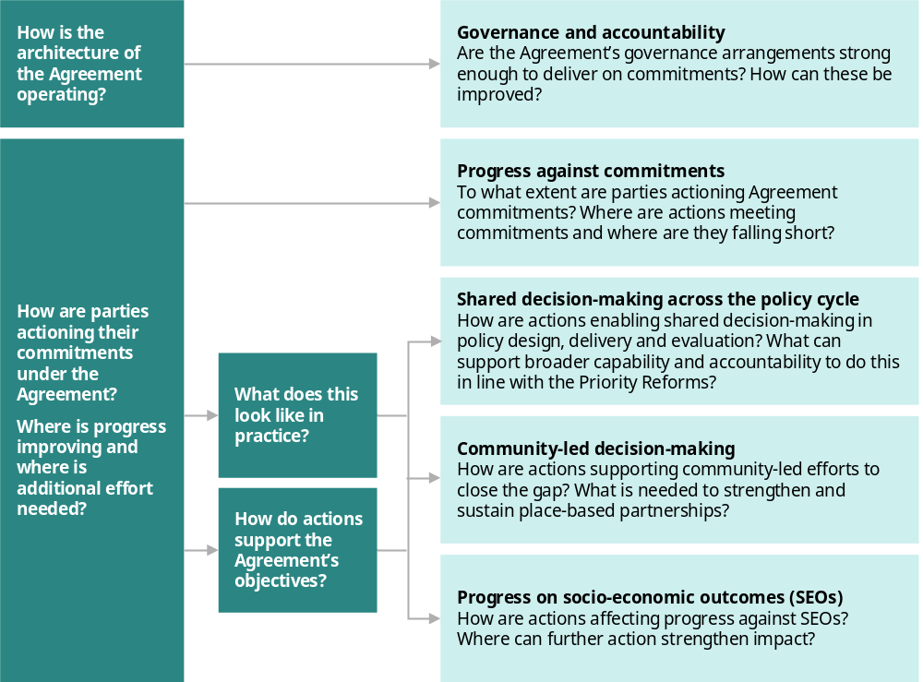

How are parties progressing commitments under the Agreement?

Have parties strengthened governance and accountability?
The Agreement is ambitious, calling for an unprecedented structural shift in the way governments work with Aboriginal and Torres Strait Islander people. It is also the first national agreement that includes a non-government party as a signatory – the Coalition of Peaks. Achieving the Agreement’s objectives requires strong governance and accountability mechanisms and adequate resourcing to ensure all parties can fulfill their responsibilities.
Governance of the Agreement is led by the Joint Council on Closing the Gap (Joint Council), which provides national leadership and coordination, oversees implementation and monitors progress. The Joint Council is supported by the Partnership Working Group (PWG), which provides operational support by developing policy advice and assisting delivery of the Joint Council’s work plan. Together these bodies form the core governance structures for the Agreement (figure 4).
Figure 4 – Governance of the Agreement
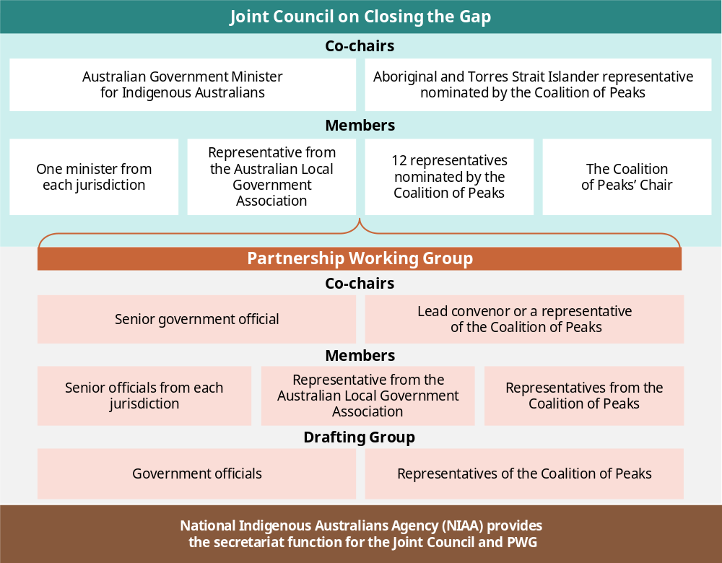
Unlike other intergovernmental agreements, the Agreement does not involve funding transfers from the Australian Government to the states and territories. Instead, the implementation of the Agreement is resourced through joint funding pools, jurisdictional budgets and other intergovernmental agreements. Parties have committed to mobilising all avenues and opportunities available to meet the objectives of the Agreement (clause 16) and providing adequate funding to support Aboriginal and Torres Strait Islander parties to partner with governments (clause 33).
This review will assess the effectiveness of the Agreement’s key governance bodies in coordinating action and making and implementing shared decisions. Particular attention will be given to whether governance arrangements are supporting effective relationships between governments, the Coalition of Peaks, Aboriginal and Torres Strait Islander organisations and communities. We are interested in how trust, shared responsibility, reciprocity, transparency and shared decision-making operate in practice.
We will assess whether governance arrangements create meaningful opportunities for Aboriginal and Torres Strait Islander people to influence decisions, shape priorities, hold governments accountable and participate in determining what success looks like. We will also examine whether accountability mechanisms support learning, adaptation and sustained relationship-building over time.
We will also review jurisdictions’ progress in implementing PC recommendations to improve accountability and resourcing under the Agreement. This includes progress made to establish independent mechanisms to support and monitor progress, embed Agreement commitments across other intergovernmental agreements and strengthen public reporting (box 1).

Questions about the governance of the National Agreement on Closing the Gap
1. Effective relationships
How effective are the governance bodies established to oversee progress towards the Agreement?
- How do Joint Council, the PWG and other governance bodies support effective relationships between governments, Aboriginal and Torres Strait Islander organisations and communities? Where are these relationships working well, and what contributes to their success?
- To what extent do governance arrangements build trust, respect and shared responsibility among parties?
2. Shared decision-making in Agreement governance
To what extent do governance arrangements enable genuine shared decision-making?
- How much influence do Aboriginal and Torres Strait Islander representatives have over priorities, decisions and resource allocation? How do governance bodies hear and respond to community priorities, concerns and feedback?
- How are disagreements negotiated and resolved?
- Are all parties held accountable for commitments made through governance processes?
- What would strengthen shared authority and mutual accountability?
3. Accountability to communities
How are governance bodies accountable to Aboriginal and Torres Strait Islander people and communities?
- How are decisions communicated back to communities?
- What would strengthen accountability to community-level priorities and aspirations?
4. Independent mechanisms
What is affecting progress towards establishing independent mechanisms to support and monitor transformation?
- What lessons can be learned from existing independent oversight arrangements?
- What conditions are necessary for these mechanisms to be viewed as credible and legitimate by Aboriginal and Torres Strait Islander people and organisations?
5. Embedding the Agreement
How could the Priority Reforms be better integrated into broader governance systems?
- How could governments embed obligations for partnership, shared decision-making and accountability into future national agreements and policy frameworks?
- What governance practices would encourage longer-term relationship building and sustained implementation?

How are parties sharing decision-making through formal partnerships (Priority Reform 1)?
Priority Reform 1 seeks to empower Aboriginal and Torres Strait Islander people to share decision-making authority with governments to achieve progress towards closing the gap. Policy and place-based partnerships established under the Agreement aim to share real decision-making authority with community-controlled organisations, ensuring priorities, service design and accountability are set on Country, rather than solely within government.
This review will consider how partnership arrangements are influencing decisions, services and systems to transform the ways governments work with Aboriginal and Torres Strait Islander organisations and communities to improve life outcomes. This includes considering whether current partnership settings are enabling shared decision-making as a step towards self-determination, and what practical steps governments can take to improve the way they operate.

Questions about shared decision-making through formal partnerships
1. Building successful partnerships
What lessons can be drawn from partnerships established under the Agreement?
- To what extent do partnership arrangements reflect genuine power-sharing? Where do partnership arrangements fall short of their intended purpose?
- How have relationships between government and Aboriginal and Torres Strait Islander partners changed over time? What has helped build trust, legitimacy and shared ownership?
- What would strengthen the ability of partnership arrangements to support self-determination?
2. Partnership decisions and influence
- How are policy and place-based partnerships embedding shared decision-making?
- How are diverse Aboriginal and Torres Strait Islander voices included in decision-making processes?
- How can policy and place-based partnerships coordinate with and learn from other partnerships and advisory bodies?

How are parties building the community-controlled sector (Priority Reform 2)?
Priority Reform 2 seeks to build strong, sustainable community-controlled sectors that meet the needs of Aboriginal and Torres Strait Islander people. To do this, parties have committed to joint national sector strengthening efforts and increasing the proportion of services delivered by Aboriginal community-controlled organisations (ACCOs).
In this review, we will assess efforts to increase the proportion of services delivered by Aboriginal and Torres Strait Islander organisations, including by supporting service transition and prioritising ACCOs in funding decisions (clause 55). This includes policies to preference ACCOs in the delivery of programs or services for Aboriginal and Torres Strait Islander people and communities (clause 55a) and allocate a ‘meaningful proportion’ of new funding to ACCOs for initiatives intended to service the broader Australian population (clause 55b).
Joint national sector strengthening efforts, as detailed in sector strengthening plans (SSPs), intend to enable effective funding transitions to ACCOs. The effectiveness of SSPs depends on strong governance to promote ongoing accountability and alignment with other efforts, including through policy partnerships (PC 2024, p. 54). This review will analyse how SSPs are being implemented across jurisdictions and whether these efforts are contributing to strong sectors.

Questions about building the community-controlled sector
1. Prioritising funding and supporting service transition
How are governments and ACCOs working together to reform funding arrangements and support service transition?
- What aspects of funding arrangements strengthen or undermine reciprocity, trust and shared accountability between governments and ACCOs?
- How are governments and their partners reforming systems and processes to prioritise funding for ACCOs and build transition pathways?
- Are there examples where actions are effectively supporting ACCOs to take on a higher proportion of service delivery? What can we learn from them?
2. Sector strengthening
- How are governments and the community-controlled sector working together to strengthen the capacity, workforce, leadership and sustainability of Aboriginal and Torres Strait Islander organisations?
- What lessons can be drawn from implementing the first set of sector strengthening plans under the Agreement?
- How are parties monitoring the outcomes of sector strengthening efforts? What accountability mechanisms are needed to support continuous learning and improvement?
- Who determines what success looks like? How are ACCOs involved in developing measures, monitoring performance and interpreting results?

How are government organisations transforming to meet the needs of Aboriginal and Torres Strait Islander people (Priority Reform 3)?
Priority Reform 3 seeks to transform government organisations to better serve Aboriginal and Torres Strait Islander people. It calls on governments to fundamentally change their ways of working to embed cultural safety, address institutional racism, share power and increase transparency. Transformation of this kind involves deep and enduring changes to the culture, systems and processes of government organisations and to the behaviours and incentives motivating their staff and leadership.
This review will assess government efforts to transform, with emphasis on addressing structural and institutional racism and promoting cultural safety. This includes actions to build public sector capability to implement the Agreement, improved development and implementation of policy and programs to better meet the needs of communities, and systemic efforts to transform mainstream organisations.

Questions about transforming government organisations
1. Cultural safety and responsiveness
What actions are governments taking to address institutional racism and improve cultural safety and responsiveness in government organisations and the services they fund?
- Are there examples where communities have experienced meaningful improvements in their interactions with governments and funded services? What can we learn from these?
- How are Aboriginal and Torres Strait Islander people involved in defining and designing what culturally safe services and institutions look like?
2. Delivering in partnership and increasing transparency
How are governments working with communities to design and deliver mainstream services in partnership?
- What changes have strengthened trust between communities and government institutions? What can be learned from these examples to inform broader system reform?
- What systems would improve transparency around funding and decision-making?

How are government organisations enhancing shared access to data and information (Priority Reform 4)?
Priority Reform 4 commits governments to sharing data and changing how they collect and use data to better meet the needs of Aboriginal and Torres Strait Islander people. This includes enabling Aboriginal and Torres Strait Islander people to use data to facilitate progress in priority areas determined by communities.
Aboriginal and Torres Strait Islander people require more than just access to existing data held by governments (PC 2024, p. 63). They should be empowered to make decisions about what data they need, and how data about them is collected, accessed and used. The first PC review recommended a suite of actions to support and recognise Indigenous data sovereignty, which is the right of Indigenous people to exercise ownership over Indigenous data. These included amending the Agreement to include a commitment to Indigenous data sovereignty under Priority Reform 4 and establishing a Bureau of Indigenous Data.
The Joint Council agreed to amend the Agreement to include Indigenous data sovereignty. The Data Policy Partnership was established in 2025 to consider options for a national independent data body. While parties work through PC recommendations, the focus of this review will be on assessing the actions jurisdictions are taking to enable more transparent and effective data sharing and to embed Indigenous data sovereignty and Indigenous data governance into data systems. This includes assessing how this is working through community data projects set out in the Agreement (clause 74).

Questions about shared access to data and information
1. Access and use of data
How have governments improved the availability and accessibility of data that is relevant to Aboriginal and Torres Strait Islander people and communities?
- Are communities able to access and use data in ways that support local decision-making? What supports or hinders this?
2. Collection and governance of data
- How are parties working with Aboriginal and Torres Strait Islander people and communities to determine what data is collected and shared? What does this look like in practice?
- How are parties working to incorporate Indigenous Data Governance into government data collection and management? How might these approaches be strengthened?

How have actions supported progress towards Agreement objectives?
The implementation of the Priority Reforms should lead to fundamental changes in the way policy is designed, implemented and evaluated. We will seek to identify actions taken to change the way governments operate across the policy cycle, support community-led solutions and achieve the Agreement’s SEOs. This will help us develop practical recommendations for improvement.

How have actions enabled shared decision-making in policy design, delivery and evaluation?
To identify practical changes in policy development and delivery, we will consider how the Priority Reforms are being implemented across the policy cycle (figure 5). This will support an assessment of whether governments are changing the way they work with Aboriginal and Torres Strait Islander people in line with the Agreement’s intent and the Priority Reforms.
Figure 5 – The Australian policy cycle stages
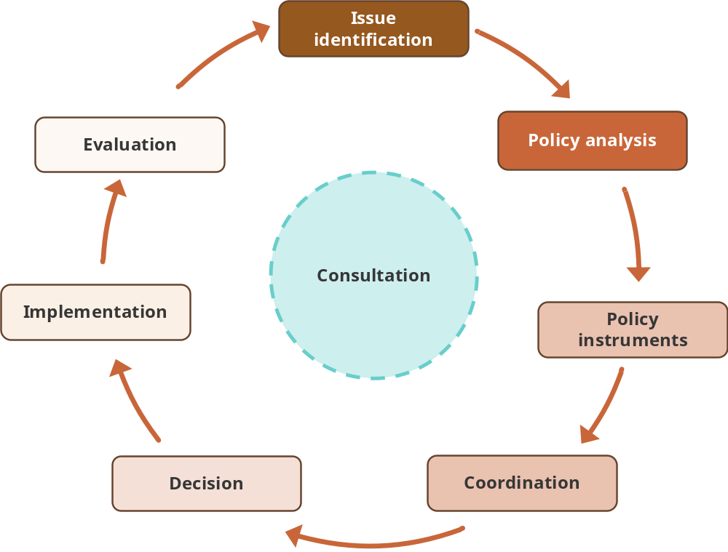
The Australian policy cycle is a framework that describes policy processes using 8 key stages. While policy development and implementation do not always follow these stages, it is a useful framework for understanding key engagement and decision points. Government agencies will need to transform the way they work through each aspect of the policy cycle to meet the intent of the Priority Reforms.
Source: APSA (2022).
Through this approach, the PC will assess agency actions and outcomes at different stages of the policy cycle. This will allow the review to identify what transformative action aligned with the Priority Reforms looks like, as well as consider mechanisms to enable broader adoption of good practice at each policy cycle stage.
We will seek to identify programs and policies that highlight good practice at different stages of the policy process, show different ways of enabling shared decision-making and reflect diverse operating contexts. Looking across a diverse range of government actions will help identify system-wide enablers and barriers and highlight where changes to policy processes are most needed to better support Priority Reform implementation.

Questions about how governments are developing and delivering policy with Aboriginal and Torres Strait Islander people
1. Engaging and sharing decisions across the policy cycle
How should government agencies engage and share decisions across the development, delivery and evaluation of policies, programs and services?
- What approaches are being used to involve Aboriginal and Torres Strait Islander communities in decision-making across the policy cycle?
- What changes are needed to government systems and processes to enable and support this?
- Where have you seen good examples of genuine engagement, co-design or co-governance? What supported their success?
2. Building capability to deliver the Agreement
What is needed to build public service capability to deliver the Agreement?
- How can governments better support staff to engage and work in partnership with Aboriginal and Torres Strait Islander people and organisations?
- What approaches support mutual learning and joint capability-building between government agencies and the community-controlled sector?

How have actions supported community-led efforts to close the gap?
Community-led decision-making enables sustainable solutions, grounded in local resources, cultural authority and knowledge, and responsive to local needs.
Parties to the Agreement committed to strengthening community-led decision making (clause 28). This included establishing 6 place-based partnerships (clause 39) and 6 community data projects to support use of location-specific data (clause 74). These commitments aim to ensure community knowledge and experience is reflected in policy to speed up progress towards closing the gap. Previous reviews found progress on these commitments has been promising but slow and, in some cases, under resourced.
This review will make an updated assessment of progress. We are also interested in what approaches to community-led decision-making are working, why they are effective and what factors enable or constrain their implementation. We are planning to learn more about these approaches through visits to communities with local decision-making arrangements in place.
There are many agreements, partnerships, alliances and mechanisms supporting community-led decision-making across Australia. We are interested in learning about these approaches and how they support shared decision-making, responsive services and stronger outcomes.

Questions about how parties are enabling community-led efforts to close the gap
1. Place-based partnerships
What has been the impact of place-based partnerships?
- How have these arrangements strengthened local authority, ownership and decision-making? How have they affected outcomes for Aboriginal and Torres Strait Islander people and communities?
- What factors have contributed to success or limited progress?
- What resourcing and system supports (including funding, staffing, technical capability, data access and administrative flexibility) are needed to maintain and strengthen place-based partnerships over time?
2. Community authority
How can place-based partnerships and community data projects strengthen community influence over policies, programs and services?
- How can governments better support locally determined priorities and solutions?
- How should accountability operate between communities, governments and other partners?
3. Local governance
What role does local government play in community-led initiatives?
- How do relationships between local government, communities and other Agreement parties affect outcomes?
- What governance arrangements create stronger local accountability and collaboration?

How have actions facilitated progress towards SEOs?
The Priority Reforms are intended to accelerate progress towards the 17 SEOs included in the Agreement. The PC’s Closing the Gap Dashboard and Annual Data Compilation Report monitor progress against the 19 national targets underpinning the 17 SEOs and provide contextual data and information (PC 2025b, 2025a). As at July 2026, one target has been met, 7 targets are showing improvement, 2 reflect no change from the baseline and 4 are worsening. There is insufficient data to assess progress in 3 targets (figure 1).
The Priority Reforms identify the key system enablers required to progress towards the targets. These enablers include factors such as workforce capability, funding models, governance arrangements and infrastructure. This review will examine how actions across multiple layers of the system interact to meaningfully influence outcomes.
At the national level, parties have established a range of shared decision-making mechanisms to coordinate action, including policy partnerships; agreements between governments and Aboriginal and Torres Strait Islander organisations; and clauses within other intergovernmental agreements that support progress towards the targets. We will consider the policy architecture established under the Agreement to enable progress and assess how effectively these mechanisms are operating.
Policy partnerships are a central element of the Agreement, intended to give Aboriginal and Torres Strait Islander people and organisations formal shared decision-making power in key sectors. The objective of policy partnerships is to support implementation of the Priority Reforms and policy-specific strategies to close the gap (clause 31). The review will explore the design and operation of policy partnerships, alongside other shared decision-making mechanisms. We will consider how:
- all parties are implementing the Agreement, including whether implementation is sustained, adequately resourced and applied at scale
- whether jurisdictional approaches enable or restrict progress
- how reforms are being interpreted and delivered at the regional and local level, including the extent to which they align with national, state and local priorities.
Sustained progress towards closing the gap will require improvements across all of 17 SEOs. Nonetheless, given the breadth of the 17 SEOs, the review will explore a subset of outcomes in depth. These outcomes should be understood as a sample for deeper analysis, rather than a set of priority areas.
There are a number of ways to select a subset of outcomes. For this review, we are focusing on prevention, by examining outcomes affecting children and young people. This reflects a growing evidence base and policy emphasis on early childhood in recognition that improving outcomes early in life can have compounding effects over time (DSS 2024a, 2024b; Moore et al. 2025).

Questions about how actions will impact on the SEOs and targets
1. System enablers and barriers
What are the most significant enablers or barriers affecting progress towards the socio-economic outcomes?
- What changes are needed to improve impact?
2. The role of the Agreement
To what extent are partnership and sector strengthening initiatives contributing to improved outcomes?
- What are examples of successful approaches and what can we learn from them?
3. From reform to outcomes
How are governments and regional or local partners translating reform commitments into action?
Are the socio-economic outcomes and targets appropriately defined and measured?
Are Aboriginal and Torres Strait Islander organisations and communities able to determine how outcomes are pursued?
- What accountability mechanisms are there for improving outcomes? Are they helping or hindering progress?
- What governance and partnership arrangements appear most effective in improving outcomes?

A. Terms of reference
I, the Hon Jim Chalmers MP, Treasurer, pursuant to Parts 2 and 4 of the Productivity Commission Act 1998, hereby request that the Productivity Commission undertake a review of progress on Closing the Gap.

Background
The goal of the National Agreement on Closing the Gap (the Agreement) is to overcome the entrenched inequality faced by too many Aboriginal and Torres Strait Islander people so that their
life outcomes are equal to all Australians. The Agreement was developed in partnership between
Aboriginal and Torres Strait Islander representatives and all Australian governments and commits governments to working in full and genuine partnership with Aboriginal and Torres Strait Islander people in developing and implementing policies that impact First Nations people and communities and aim to close the gap.
The Agreement is built around four Priority Reform areas and 17 socioeconomic outcomes. The socioeconomic targets measure the life experiences of Aboriginal and Torres Strait Islander people.
The Priority Reform outcomes are:
- Strengthening and establishing formal partnerships and shared decision-making
- Building the Aboriginal and Torres Strait Islander community-controlled sector
- Transforming government organisations so they work better for Aboriginal and Torres Strait
Islander people
- Improving and sharing access to data and information to enable Aboriginal and Torres Strait
Islander communities to make informed decisions.
Parties to the Agreement agreed that the Productivity Commission will undertake a comprehensive review of progress every three years. The review will provide an analysis of progress on Closing the Gap against the priority reforms, targets, indicators and trajectories, and examine the factors contributing to progress, including by drawing on evaluation and other evidence. Parties have committed to undertaking actions if the review indicates that achievement of any of the targets that are set out in the Agreement is not on track.

Scope of the inquiry
The review will assess how effectively the Agreement is supporting improved life outcomes for Aboriginal and Torres Strait Islander peoples. In undertaking the review, the Productivity Commission should:
- have regard to all aspects of the Agreement and consider the progress, implementation efforts and annual reports of all parties, including jurisdictional progress by the Commonwealth and states and territories
- assess progress against the four Priority Reform areas and 17 socioeconomic outcomes, including identifying successful approaches, partnerships and delivery models that have demonstrated positive impact
- draw on available evidence and evaluation findings, to assess impact, deliverables and outcomes, and progress towards developing measures for the Priority Reforms targets and indicators and outstanding data under socioeconomic targets
- assess whether commitments under the Agreement that relate to prioritising and reporting on funding and resourcing to First Nations community-controlled sectors are being met, and whether they are driving changes in the way investments are made and improved outcomes against the Priority Reforms
- assess whether new and existing funding – both dedicated and mainstream – is being effectively mobilised to achieve the objectives of the Agreement.
The review is to have regard to and complement – not duplicate – the previous findings of the first Productivity Commission review of progress on the National Agreement, published on 7 January 2024, and the Independent Aboriginal and Torres Strait Islander-led Review, published on 21 June 2025.
The Productivity Commission should provide recommendations on how to improve, hasten and strengthen implementation of existing commitments in the Agreement. Where necessary to support implementation of existing commitments, the Productivity Commission should provide recommendations on potential changes to the Agreement and its targets, indicators and trajectories, and on data improvements.

Process
The Productivity Commission is to consult broadly. This includes with Aboriginal and Torres Strait Islander people, communities and organisations, and with local, state, territory and Commonwealth governments. Input and engagement should also be invited through submissions and other relevant approaches.
The Productivity Commission should publicly release a draft report and provide its final report to the Joint Council on Closing the Gap within 12 months of receipt of these terms of reference. The final report will also be published.
The Hon Jim Chalmers MP
Treasurer

[Received 28 August 2026]

B. Questions to guide submissions
The PC would like to hear your experiences and views on:
- progress against commitments made in the Agreement
- how actions to achieve progress could be improved
- the proposed approach to the review.
We have included a list of questions below on issues that are particularly relevant to our research. These questions are not intended to limit what information you share with us. We welcome all input on the Agreement, its implementation and this review. You do not need to answer every question. Where possible, please include examples, case studies, data or research to support the views in your submission.
We acknowledge that many people and organisations have made submissions and other contributions to previous reviews of the Agreement. You are welcome to direct the PC to previous contributions where still relevant.
Information on how to make a submission can be found at appendix C.

Questions about the governance of the National Agreement on Closing the Gap

1. Effective relationships
How effective are the governance bodies established to oversee progress towards the Agreement?
- How do Joint Council, the PWG and other governance bodies support effective relationships between governments, Aboriginal and Torres Strait Islander organisations and communities? Where are these relationships working well, and what contributes to their success?
- To what extent do governance arrangements build trust, respect and shared responsibility among parties?

2. Shared decision-making in Agreement governance
To what extent do governance arrangements enable genuine shared decision-making?
- How much influence do Aboriginal and Torres Strait Islander representatives have over priorities, decisions and resource allocation? How do governance bodies hear and respond to community priorities, concerns and feedback?
- How are disagreements negotiated and resolved?
- Are all parties held accountable for commitments made through governance processes?
- What would strengthen shared authority and mutual accountability?

3. Accountability to communities
How are governance bodies accountable to Aboriginal and Torres Strait Islander people and communities?
- How are decisions communicated back to communities?
- What would strengthen accountability to community-level priorities and aspirations?

4. Independent mechanisms
What is affecting progress towards establishing independent mechanisms to support and monitor transformation?
- What lessons can be learned from existing independent oversight arrangements?
- What conditions are necessary for these mechanisms to be viewed as credible and legitimate by Aboriginal and Torres Strait Islander people and organisations?

5. Embedding the Agreement
How could the Priority Reforms be better integrated into broader governance systems?
- How could governments embed obligations for partnership, shared decision-making and accountability into future national agreements and policy frameworks?
- What governance practices would encourage longer-term relationship building and sustained implementation?

Questions about shared decision-making through formal partnerships

1. Building successful partnerships
What lessons can be drawn from partnerships established under the Agreement?
- To what extent do partnership arrangements reflect genuine power-sharing? Where do partnership arrangements fall short of their intended purpose?
- How have relationships between government and Aboriginal and Torres Strait Islander partners changed over time? What has helped build trust, legitimacy and shared ownership?
- What would strengthen the ability of partnership arrangements to support self-determination?

2. Partnership decisions and influence
- How are policy and place-based partnerships embedding shared decision-making?
- How are diverse Aboriginal and Torres Strait Islander voices included in decision-making processes?
- How can policy and place-based partnerships coordinate with and learn from other partnerships and advisory bodies?

Questions about building the community-controlled sector

1. Prioritising funding and supporting service transition
How are governments and ACCOs working together to reform funding arrangements and support service transition?
- What aspects of funding arrangements strengthen or undermine reciprocity, trust and shared accountability between governments and ACCOs?
- How are governments and their partners reforming systems and processes to prioritise funding for ACCOs and build transition pathways?
- Are there examples where actions are effectively supporting ACCOs to take on a higher proportion of service delivery? What can we learn from them?

2. Sector strengthening
How are governments and the community-controlled sector working together to strengthen the capacity, workforce, leadership and sustainability of Aboriginal and Torres Strait Islander organisations?
- What lessons can be drawn from implementing the first set of sector strengthening plans under the Agreement?
- How are parties monitoring the outcomes of sector strengthening efforts? What accountability mechanisms are needed to support continuous learning and improvement?
- Who determines what success looks like? How are ACCOs involved in developing measures, monitoring performance and interpreting results?

Questions about transforming government organisations

1. Cultural safety and responsiveness
What actions are governments taking to address institutional racism and improve cultural safety and responsiveness in government organisations and the services they fund?
- Are there examples where communities have experienced meaningful improvements in their interactions with governments and funded services? What can we learn from these?
- How are Aboriginal and Torres Strait Islander people involved in defining and designing what culturally safe services and institutions look like?

2. Delivering in partnership and increasing transparency
How are governments working with communities to design and deliver mainstream services in partnership?
- What changes have strengthened trust between communities and government institutions? What can be learned from these examples to inform broader system reform?
- What systems would improve transparency around funding and decision-making?

Questions about shared access to data and information

1. Access and use of data
How have governments improved the availability and accessibility of data that is relevant to Aboriginal and Torres Strait Islander people and communities?
- Are communities able to access and use data in ways that support local decision-making? What supports or hinders this?

2. Collection and governance of data
- How are parties working with Aboriginal and Torres Strait Islander people and communities to determine what data is collected and shared? What does this look like in practice?
- How are parties working to incorporate Indigenous Data Governance into government data collection and management? How might these approaches be strengthened?

Questions about how governments are developing and delivering policy with Aboriginal and Torres Strait Islander people

1. Engaging and sharing decisions across the policy cycle
How should government agencies engage and share decisions across the development, delivery and evaluation of policies, programs and services?
- What approaches are being used to involve Aboriginal and Torres Strait Islander communities in decision-making across the policy cycle?
- What changes are needed to government systems and processes to enable and support this?
- Where have you seen good examples of genuine engagement, co-design or co-governance? What supported their success?

2. Building capability to deliver the Agreement
What is needed to build public service capability to deliver the Agreement?
- How can governments better support staff to engage and work in partnership with Aboriginal and Torres Strait Islander people and organisations?
- What approaches support mutual learning and joint capability-building between government agencies and the community-controlled sector?

Questions about how parties are enabling community-led efforts to close the gap

1. Place-based partnerships
What has been the impact of place-based partnerships?
- How have these arrangements strengthened local authority, ownership and decision-making? How have they affected outcomes for Aboriginal and Torres Strait Islander people and communities?
- What factors have contributed to success or limited progress?
- What resourcing and system supports (including funding, staffing, technical capability, data access and administrative flexibility) are needed to maintain and strengthen place-based partnerships over time?

2. Community authority
How can place-based partnerships and community data projects strengthen community influence over policies, programs and services?
- How can governments better support locally determined priorities and solutions?
- How should accountability operate between communities, governments and other partners?

3. Local governance
What role does local government play in community-led initiatives?
- How do relationships between local government, communities and other Agreement parties affect outcomes?
- What governance arrangements create stronger local accountability and collaboration?

Questions about how actions will impact on the SEOs and targets

1. System enablers and barriers
What are the most significant enablers or barriers affecting progress towards the socio-economic outcomes?
- What changes are needed to improve impact?

2. The role of the Agreement
To what extent are partnership and sector strengthening initiatives contributing to improved outcomes?
- What are examples of successful approaches and what can we learn from them?

3. From reform to outcomes
How are governments and regional or local partners translating reform commitments into action?
Are the socio-economic outcomes and targets appropriately defined and measured?
Are Aboriginal and Torres Strait Islander organisations and communities able to determine how outcomes are pursued?
- What accountability mechanisms are there for improving outcomes? Are they helping or hindering progress?
- What governance and partnership arrangements appear most effective in improving outcomes?


C. How to make a submission

How to prepare a submission
Submissions may range from a short letter with your views on a topic to a much longer document about a range of issues. You are welcome to submit:
- a written document
- an artwork or other visual with a written description
- an audio or video file.
Where possible, you should provide evidence, such as relevant data and documentation, to support your views.
We may be able to help you create a submission. Contact the Closing the Gap Review team by phone 02 6240 3228 or email ctg.review.2026@pc.gov.au.

How will my submission be used?
- Submissions will help us understand the issues and come up with recommendations. We may include quotes from your submission in our reports or presentations.
- Public submissions will be published on the PC’s website and will stay there indefinitely into the future. As a public document, it may be used by the PC or others for other reasons.
- We may not put your submission on our website if it is offensive, could falsely harm someone’s reputation, or is not about the review topic.
- You can withdraw your submission before 26/02/2027 for the draft report or 02/07/2027 for the final report.

Who owns the submission?
- You will keep ownership (copyright) of your submission.
- Please do not send us material that you do not have copyright of (for example newspaper articles). You should just reference or link to this in your submission.

Can I make a confidential submission?
Please contact us for further information and advice before submitting confidential material.
- As this is a public review, we aim to place all submissions on the PC's website for others to read.
- However, if there is a good reason, we can treat a submission or part of a submission as confidential. This means we will not publish it (or that part) and will not reference it in our reports.
- If you would like a submission or an attachment to be treated in confidence, you must clearly mark it as 'IN CONFIDENCE' and make it a separate attachment to non-confidential material.
- We may ask for a non-confidential summary or the reasons why a summary cannot be provided.
- Please note that there are situations in which we may have to hand over or publish confidential material. This includes if someone asks for it as part of a valid Freedom of Information request or if a court or government body uses certain powers to ask for it. Confidential submissions are also archived with the National Archives of Australia and can be accessed by the public after 20 years. See our Information Policy for more details: www.pc.gov.au/about/governance/information-policy/.

How is my privacy protected?
- Please do not include personal details (such as home and email address, signatures, phone numbers) within your submission files unless necessary. We will remove all personal details from your submission before it is published on the website.
- You can choose not to include your name when making a submission.
- We will only use your details for the reason you gave them to us. Read our privacy policy for more information.
- If you think there has been a breach of your privacy you can write to the Office of the Australian Information Commissioner, GPO Box 5218, Sydney NSW 2001 or call 1300 363 992.

Technical tips
- The PC prefers to receive submissions as a Microsoft Word (.docx) files. PDF files are acceptable if produced from a Word document or similar text-based software. You may wish to search the Internet on how to make your documents more accessible or for the more technical, follow advice from Web Content Accessibility Guidelines (WCAG) 2.1: https://www.w3.org/TR/WCAG21/
- Do not send password protected files.
- Track changes, editing marks, hidden text and internal links should be removed from submissions.
- To minimise linking problems, type the full web address (for example, https://www.referred-website.com/folder/file-name.html).

How to lodge a submission
Submissions should be lodged using the online form on the PC’s website. Submissions lodged by post should be accompanied by a submission cover sheet, available from the PC’s website.
Online* | www.pc.gov.au/inquiries-and-research/closing-the-gap-review-2026/make-submission/
Post* | Closing the Gap Review 2026  Productivity Commission  GPO Box 1428  Canberra City ACT 2601
Phone | Please contact the Project Support Officer on 02 6240 3228
* If you do not receive notification of receipt of your submission to the PC, please contact the Project Support Officer.

Due date for submissions
Please send submissions to the PC by 26 October 2026.

References

AIATSIS (Australian Institute of Aboriginal and Torres Strait Islander Studies) 2020, AIATSIS code of ethics for Aboriginal and Torres Strait Islander research.
APSA (Australian Public Service Academy) 2022, Policy cycle: A ‘good process’ test for making public policy.
Chilisa, B 2020, Indigenous research methodologies, 2nd edn, SAGE.
DSS (Department of Social Services) 2024a, The Early Years Strategy 2024-2034.
—— 2024b, Why children and their early years matter, Australian Government.
Joint Council (Joint Council on Closing the Gap) 2025, Joint Council response to the Productivity Commission’s recommendations in the review of the National Agreement on Closing the Gap final report 2024.
—— 2026a, Response to the Aboriginal and Torres Strait Islander-led review of the National Agreement on Closing the Gap.
—— 2026b, Sixteenth meeting of the Joing Council on Closing the Gap.
Kirkness, V and Barnhardt, R 2001, ‘First Nations and higher education: the four R’s - respect, relevance, reciprocity, responsibility’, in Ruth Hayhoe and Julia Pan (eds), Knowledge across cultures: A contribution to dialogue among civilizations, Comparative Education Research Centre, University of Hong Kong.
Lavarch, L, Coombes, L, Gray, K, Anthony, C and Nolan-Smith, S 2025, Independent Aboriginal and Torres Strait Islander-led Review of Closing the Gap, Jumbunna Institute for Indigenous Education and Research.
Martin, K (Booran Mirraboopa) 2003, ‘Ways of knowing, being and doing: A theoretical framework and methods for Indigenous and Indigenist re‐search’, Journal of Australian Studies, vol. 27, no. 76, pp. 203–214.
Moore, T, Imms, C, Luscombe, D, Bonyhady, B, Dimmock, K, Deane, K, D’Aprano, A and Kakoschke-Moore, S 2025, National best practice framework for early childhood intervention.
NHMRC (National Health and Medical Research Council) 2023, National statement on ethical conduct in human research.
PC (Productivity Commission) 2024, Review of the National Agreement on Closing the Gap - Study report - Volume 1.
—— 2025a, Closing the Gap Annual Data Compilation Report, July, Canberra.
—— 2025b, Closing the Gap Information Repository - Productivity Commission, Closing the Gap Information Repository - Productivity Commission, https://www.pc.gov.au/closing-the-gap-data/dashboard (accessed 7 February 2025).
—— 2026, Closing the Gap Annual Data Compilation Report, July, Canberra.
Pidgeon, M 2019, ‘Moving between theory and practice within an Indigenous research paradigm’, Qualitative Research, vol. 19, no. 4, pp. 418–436.
—— and Riley, T 2021, ‘Understanding the application and use of Indigenous research methodologies in the social sciences by Indigenous and non-Indigenous scholars’, International Journal of Education Policy and Leadership, vol. 17, no. 8.
Rigney, L-I 1999, ‘Internationalization of an Indigenous anticolonial cultural critique of research methodologies: A guide to Indigenist research methodology and its principles’, University of Minnesota Press, Wicazo Sa Review, vol. 14, no. 2, pp. 109–121.
Roy, N 2023, ‘The use of Indigenous research methodologies in counselling: Responsibility, respect, relationality, and reciprocity’, First Peoples Child & Family Review, vol. 17, no. 1, pp. 3–19.

The Agreement defines a ‘meaningful proportion’ as one that takes into account the number and capacity of Aboriginal and Torres Strait Islander organisations and the service demands of Aboriginal and Torres Strait Islander people (clause 55b).

