Co-designing legislative reform: Queensland First Nations Health Equity

Key points
- Establishing a governance body for co-design with a well-considered mix of geographic representation, lived experience, professional expertise and organisational maturity sets the foundation for diverse perspectives and capabilities to inform decision-making.
- Continuously testing, refining and closing feedback loops helps ensure the proposed reforms are grounded in, and accurately reflect the voices, experiences and perspectives of Aboriginal and Torres Strait Islander people, communities and organisations.
- Fostering early and ongoing engagement between community, policy teams, partners and legislative drafters supports consistency between policy intent and statutory drafting.
- Drafting detailed, measurable requirements with clear and enforceable obligations in regulation translates policy intent to support practical implementation and the durability of reforms within the broader legislative framework.
- Embedding genuine, shared governance, transparent accountability and community-led oversight promotes consistent, system-wide change.
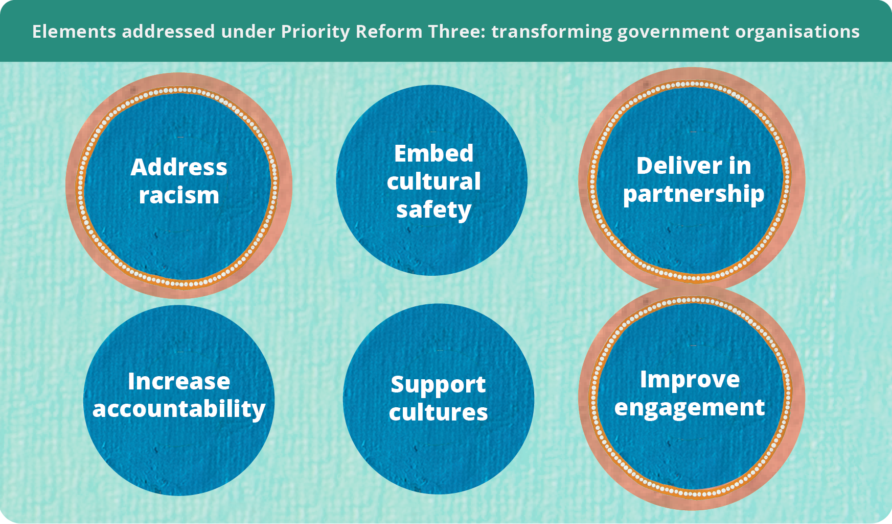



Co-designing legislative reform to address institutional racism
In 2017, an independent report commissioned by the Queensland Anti-Discrimination Commission and Queensland Aboriginal and Islander Health Council (QAIHC) highlighted the ‘unacceptable’ level and extent of institutional racism across the public health system (Marrie and Bukal Consultancy Services 2017, pp. 12, 17). The report found many Aboriginal and Torres Strait Islander health policies already existed within the public health system but lacked enforceable accountability mechanisms. The report recommended reinforcing these policies through stronger governance, monitoring and legislative or regulatory accountability in Hospital and Health Services (HHSs) to ensure implementation.
Prompted by this report and bolstered by Aboriginal and Torres Strait Islander voices, the Queensland government supported reforms to achieve health equity in Queensland Health. Health equity adopts a social justice and human rights-based approach to health and healthcare access by responding to differences between groups of people and what they need to attain their full health potential (QAIHC and Queensland Health 2021, p. 9). This approach attempts to strengthen the environment that enables all parts of the healthcare system to deliver culturally safe and responsive healthcare (Queensland Health 2024, p. 40).
This case study shows how Queensland Health, in partnership with QAIHC, co-designed legislation to mandate engagement with local communities on priorities and approaches for culturally safe and responsive mainstream health services.
It takes an in-depth look at the co-design process that led to the Hospital and Health Board (Health Equity Strategies) Amendment Regulation 2021 (figure 1). Part of a broader suite of reforms, the regulation details requirements for First Nations Health Equity Strategies to be developed by all Queensland HHSs. It outlines who must be involved, how partnerships should operate, how health services should be co-designed and key performance expectations. These requirements are unique as they are legally enforceable because they sit in legislation, rather than being included in department policy.

Figure 1 – The First Nations Health Equity legislative reforms were shaped through sustained community advocacy and collaborative policy development over time
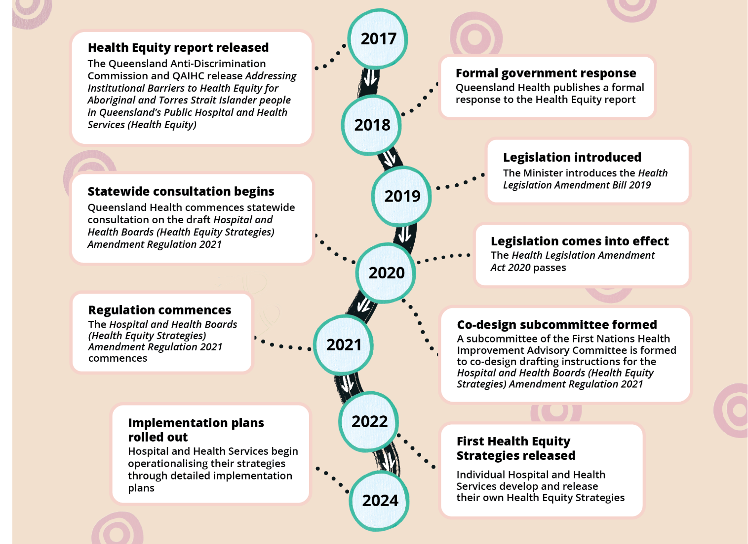
Source: QAIHC and Queensland Health (2021, pp. 25–26); Queensland Health (2025).

Co-design enables legislation responsive to those affected
Legislative drafters are often given short, late-stage drafting instructions with limited opportunity to engage with the underlying policy issues or the people affected. Co-design brings policy makers, drafters and stakeholders together earlier to collaboratively define the problem and shape workable solutions.
Co-designing legislation with Aboriginal and Torres Strait Islander people is an important undertaking to bridge the gap between First Nations’ knowledge systems, lived experience and public policy development. Done authentically, co-design can inform the way policy instruments align with the needs and aspirations of the people they affect and contribute to lasting change (Apolima Fono et al. 2025, p. 476).

Establishing a representative governance body from the outset
To oversee the co-design of the drafting instructions, a dedicated working group was established under the First Nations Health Improvement Advisory Body. The governance body was co-chaired by QAIHC and Queensland Health, reflecting a commitment to shared decision-making. Membership was deliberately structured to achieve broad geographic representation and to bring together professional expertise, lived experience and institutional authority. This ensured oversight of the process was grounded in the priorities and lived experiences of Aboriginal and Torres Strait Islander people, while also enabling system partners to build capability and progress reform collectively.
Membership included four HHS board members from geographically diverse regions, including the Torres Strait Islands and Cape York, as well as 3 First Nations HHS board members and 3 First Nations Health Leads. Broader system representation was also embedded through the inclusion of Primary Health Networks, The Healing Foundation, First Nations health consumers, and key statutory agencies such as the Queensland Human Rights Commission, the Health Ombudsman, and Health and Wellbeing Queensland.

Adopting a structured, iterative co-design process
The group began developing drafting instructions to test with broader stakeholders. The working group structured the work into 4 components, each delivered through a 2-week cycle. A key lesson from this stage of the process was the importance of establishing clear dispute resolution mechanisms at the outset, including resolution through mediation provided by the Chief First Nations Health Officer, to support transparent and constructive decision-making (Queensland Government 2024).
For each component, the group co-developed content before refining proposals internally and testing draft elements, including who the key stakeholders were and timeframes for engagement, with the Parliamentary Counsel. Feedback was sought on both the rationale and the drafting approach, with issues resolved and collective agreement reached before progressing to the next component. Deliberations were supported through structured engagement methods, including virtual focused discussions in smaller groups. Insights from these sessions were reported back to the full group, with drafters consolidating and refining the material before further testing. This staged approach enabled steady progress while maintaining quality and alignment.
This process culminated in the development of a consultation paper to support engagement on health equity design principles (QAIHC and Queensland Health 2021).

Engaging early and often to align policy intent and drafting
The consultation paper supported in-person engagement across the state with all Aboriginal and Torres Strait Islander Community-Controlled Health Organisations (ATSICCHOs), community members and the HHSs and the QAIHC leadership forum in January 2021. This statewide consultation phase concluded in 2021 and ensured the proposed reforms were informed by direct feedback from system leaders and Aboriginal and Torres Strait Islander stakeholders (QAIHC nd).
A key strength of this process was the active involvement of the main legislative drafter in consultation discussions. This enabled the drafter to directly hear stakeholder perspectives, understand areas of concern and nuance and reflect this context in the drafting of the legislation and explanatory notes. Early and continuous engagement between policy, partners and drafting officers strengthened alignment between policy intent and legislative expression.
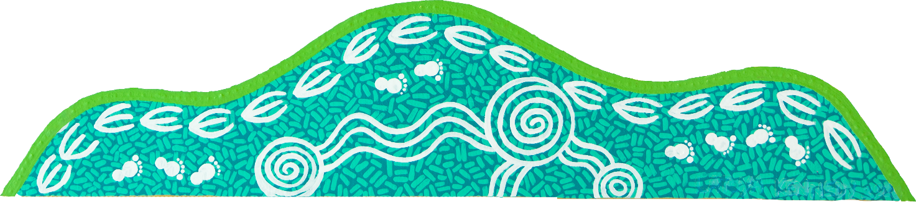

Queensland Health and QAIHC conducted the consultation in a trauma-informed manner, recognising the historical and contemporary impacts of legislation on Aboriginal and Torres Strait Islander peoples. In practice, this involved explaining the purpose of the regulation was to legally bind the hospital and health services, not Aboriginal and Torres Strait Islander people. Discussions were deliberately focused on the development of the proposed regulatory framework, while operational issues were noted for further consideration during implementation. This approach supported constructive engagement while maintaining clarity about the purpose and scope of the reform.

Drafting detailed, measurable requirements to support implementation
Feedback from the working group and the community indicated the regulation needed to be drafted with clear, specific and enforceable requirements to ensure health equity strategies were practical, measurable and capable of supporting meaningful change. The working group and legislative drafters made a deliberate decision, to move beyond high-level or aspirational statements and instead articulate detailed obligations to support accountability and implementation.
Through consultation, legislative compliance was recognised as a critical lever. Embedding specific requirements in regulation strengthens agencies’ ability to secure resources, as funding requests tied to statutory obligations carry weight.
The regulation therefore requires Hospital and Health Services to develop health equity strategies that:
- outline how key performance indicators will be achieved and evaluated against measurable indicators, strengthening accountability for outcomes
- detail partnerships and consultation arrangements, including collaboration with ATSICCHOs, QAIHC, the Chief First Nations Health Officer, and Health and Wellbeing Queensland
- ensure accessibility of services and increase First Nations workforce representation, including targets for workforce representation commensurate with the population, and
- deliver culturally safe and responsive health services, with an emphasis on sustainability, reinforcing the expectation that funding transitions from supplementary to core allocations over time.
Strategies must also align with relevant legislation and policy frameworks. Strategic cross-referencing in Acts and regulations enhances coherence and reinforces the strength of the legislative framework. Where matters could not be included directly in the legislation, they were reinforced through explanatory notes for the legislation or Health Service Directives, which carry legal authority under the Hospital and Health Boards Act 2011 (Queensland Government 2021b, 2024).


The regulation prescribes consultation requirements, including engagement with First Nations staff, service users and other specified stakeholders. By identifying who must be consulted, rather than relying on generic consultation obligations, the framework recognises large institutions respond most consistently to clear statutory requirements. Provisions also supported co-design, mediation and escalation processes, including timeframes for feedback, to reduce the risk of tokenistic engagement.
A key lesson is the importance of balancing prescription with flexibility. While overly broad principled statements are difficult to evaluate and limit accountability, excessive prescriptiveness may constrain local adaptation. Regulations can provide detailed operational requirements while retaining greater flexibility than primary legislation, as they can be amended by the government rather than requiring parliamentary amendment. Selecting the appropriate legislative vehicle is an important strategic consideration when designing reform.

Defining institutional racism supports systemic responses
Significant consultation was undertaken, in both the eight-week drafting instructions process and then again as part of broader consultation, to define key terms for inclusion in the legislation. This included ‘institutional racism,’ the first time the term had been incorporated into the Queensland statute book. The explicit inclusion of ‘institutional racism’ reflected a deliberate policy choice to directly address systemic barriers to health equity. Given the diversity of interpretations and sensitivities associated with the term, explanatory notes were carefully developed to clarify legislative intent and provide guidance on its application (Queensland Government 2021b, p. 8).
The explanatory notes established a shared conceptual foundation that is both diagnostic – identifying the systemic nature of racism – and regulatory, informing how HHSs are expected to interpret and respond to institutional racism through their Health Equity Strategies. In practice, this has translated into strategies that explicitly target organisational culture and service design with a focus on cultural safety, anti-racism initiatives and co-designed models of care (CQ HHS 2022, pp. 12, 13; NW HHS 2022, p. 41).

Strong governance and accountability are key to implementation
The inclusion of clear definitions within the legislative and policy architecture was intended to provide HHSs with a structured framework for action, while also equipping Aboriginal and Torres Strait Islander consumers and community-controlled organisations with a basis for holding services accountable. However, early critiques of implementation suggest that, while there have been localised improvements, the scale and consistency of change required to achieve system-wide transformation have not yet been realised (QAIHC 2023, p. 4).

The legislation calls for shared governance of the strategies in each HHS (figure 2). However, there are ongoing concerns regarding the sufficiency of investment in the ATSICCHO sectors and the extent to which these organisations are empowered with genuine authority and oversight across the implementation and evaluation process (QAIHC 2023, p. 4).
While shared governance is a stated principle of the reform, its practical embedding remains uneven, with variability in how decision-making power is distributed and exercised across HHS partnerships. The role of the Chief First Nations Health Officer and Queensland Health in providing system-level oversight and mediating disagreements where consensus cannot be reached at the HHS level is intended as a safeguard, but in practice introduces challenges regarding clarity of authority, potential power imbalances, and the risk of undermining the intent of locally driven, co-designed governance (Queensland Government 2024).
Figure 2 – The governance of Health Equity Strategies aims to embed Aboriginal and Torres Strait Islander participation across strategic, operational and local decision-making
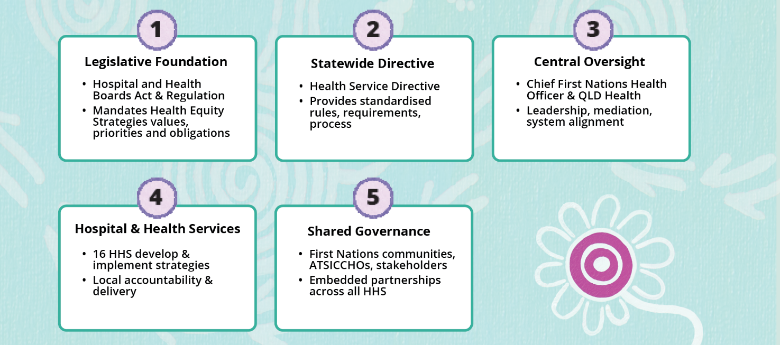
Source: Queensland Government (2011, s. 40; 2021a, s. 8; 2024).
Accountability mechanisms remain emergent. While requirements for data collection and reporting are embedded within the framework, their effectiveness depends on the accessibility, transparency and local relevance of that data. Strengthening data sharing and development at both state and local levels is critical to enabling communities and ATSICCHOs to monitor progress against Closing the Gap targets and broader system reform objectives. Some HHSs, such as Children’s Health Queensland, demonstrate more developed approaches to community-facing reporting and performance tracking, indicating how accountability could be operationalised more consistently across the system (Children’s Health Queensland 2025).
The implementation of health equity strategies is undergoing evaluation, which will be critical in assessing the extent to which the regulatory intent, particularly in addressing institutional racism, is being realised in practice (QAIHC and Queensland Health 2024).

Reflecting on the impact of Health Equity Reform
By legally requiring all HHSs to develop and implement Health Equity Strategies in partnership with First Nations communities, the legislation strengthens accountability and attempts to embed the concept of health equity within health system governance. This is important because co-design with First Nations communities and partnerships with Aboriginal Community Controlled Health Organisations can improve cultural safety, service accessibility and trust in healthcare systems (Davy et al. 2016, p. 5). This way of working between Queensland Health and QAIHC shows how future development of policies can be made richer and stronger by mandating a platform for all parties to be heard.
In June of 2026, media reporting brought renewed public attention to concerns about Aboriginal and Torres Strait Islander representation in public office in Queensland. The reports alleged Queensland Health had not maintained Aboriginal and/or Torres Strait Islander representation on the Metro North and Metro South Hospital and Health Boards, despite legislative requirements for at least one Aboriginal and/or Torres Strait Islander board member (ABC News 2026). These boards are responsible for guiding the delivery of health services to approximately 2.4 million people across South-East Queensland, including Metro South, which serves the largest Aboriginal and Torres Strait Islander population in the state. Queensland Health reported recruitment processes are underway to fill these positions. At the time of publication 19 (14%) of Hospital and Health Board members across 13 of the 16 boards are First Nations members (Queensland Health, pers comm., 27 August 2026).
These reported experiences do not diminish the value of the legislation or the principles of co-design. Rather they underscore the importance of mechanisms that embed shared decision-making, establish expectations for accountability, and provide a basis for assessing whether policy and practice remain aligned with legislative intent. While legislation and co-design alone cannot ensure sustained implementation, they remain among the strongest mechanisms for embedding First Nations voices in policy and service design.
Variability in resources, leadership commitment and community involvement across health services may limit consistent implementation. Furthermore, while the legislation attempts to address institutional racism and culturally safe care, health inequities are strongly influenced by broader structural systems such as housing, education and socio-economic disadvantage, which extend beyond healthcare (Markwick et al. 2014, p. 2). Health equity legislation alone cannot fully address health inequities without broader social policy changes. While the legislative amendments provide a strong policy foundation for advancing health equity, their long-term effectiveness will depend on sustained commitment, rigorous evaluation and genuine, equitably and sustainably resourced partnerships with Aboriginal and Torres Strait Islander communities.

References
ABC News 2026, ‘Qld government accused of campaign to remove Aboriginal people from health roles’, 16 June, https://www.abc.net.au/news/2026-06-17/aboriginal-leaders-accuse-government-of-project-invisibility/106803276 (accessed 2 July 2026).
Apolima Fono, M, Chapman, F, Parter, C, Knight, J, Sherriff, S, Vita, C and Gwynne, K 2025, ‘A culturally grounded framework for co-designing policy with Aboriginal and Torres Strait Islander peoples’, Policy Design and Practice, vol. 8, no. 4.
Central Queensland Hospital and Health Service 2022, Aboriginal and Torres Strait Islander Health Equity Strategy 2022–2025.
Children’s Health Queensland 2025, Aboriginal and Torres Strait Islander Health Equity Strategy Impact Report 2022–2025.
Davy, C, Kite, E, Aitken, G, Dodd, G, Rigney, J, Hayes, J and Emden, JV 2016, ‘What keeps you strong? A systematic review identifying how primary health-care and aged-care services can support the well-being of other Indigenous peoples’, Australasian Journal on Ageing.
Markwick, A, Ansari, Z, Sullivan, M, Parsons, L and McNeil, J 2014, ‘Inequalities in the social determinants of health of Aboriginal and Torres Strait Islander People: a cross-sectional population-based study in the Australian State of Victoria’, International Journal for Equity in Health, vol. 13, no. 1.
Marrie, A and Bukal Consultancy Services 2017, Addressing Institutional Barriers to Health Equity for Aboriginal and Torres Strait Islander People in Queensland’s Public Hospital and Health Services, Report to the Anti-Discrimination Commission Queensland.
North West Hospital and Health Service 2022, North West Health Equity Strategy 2022–2025.
Queensland Aboriginal and Islander Health Council 2023, Learnings from Health Equity - Queensland Aboriginal and Islander Health Council submission to Productivity Commission.
—— nd, Making Tracks towards health equity with Aboriginal and Torres Strait Islander peoples, https://www.qaihc.com.au/resources/making-tracks-towards-health-equity-with-aboriginal-and-torres-strait-islander-peoples (accessed 2 July 2026).
—— and Queensland Government 2024, Making Tracks Together: Queensland’s Statewide First Nations Health Equity Strategies Monitoring and Evaluation Framework.
—— and Queensland Health 2021, Making Tracks towards health equity with Aboriginal and Torres Strait Islander peoples – working together to achieve life expectancy parity by 2031.
Queensland Government 2011, Hospital and Health Boards Act 2011, Qld.
—— 2021a, Hospital and Health Boards (Health Equity Strategies) Amendment Regulation 2021, Qld.
—— 2021b, Hospital and Health Boards (Health Equity Strategies) Amendment Regulation 2021 Explanatory Notes.
—— 2024, First Nations health equity strategies | Health service directive, Queensland Health, https://www.health.qld.gov.au/system-governance/policies-standards/health-service-directives/first-nations-health-equity-strategies (accessed 25 March 2026).
Queensland Health 2024, HEALTHQ32 First Nations First Strategy 2032.

—— 2025, Making tracks – our journey, Queensland Health, https://www.health.qld.gov.au/research-reports/reports/departmental/chief-first-nations-health-officer-report/why-health-equity-reform/making-tracks-our-journey (accessed 10 June 2026).

The Queensland Anti-Discrimination Commission was renamed the Queensland Human Rights Commission in 2019.
Institutional racism is racism which is structural in political and social institutions.
The explanatory notes characterise institutional racism as arising where racist beliefs, attitudes or values are embedded within the operations or policies of an institution, resulting in direct or indirect discrimination that limits rights and contributes to inherited disadvantage (Queensland Government 2021). This is consistent with the definition set out in the 2017 Health Equity report (Marrie and Bukal Consultancy Services 2017), which provided the impetus for these reforms.

