Response to the Productivity Commission’s interim report on housing supply regulation

September 2026



Preface

This submission responds to the Productivity Commission’s request for comments on its interim report on housing supply regulation.
The Centre for Independent Studies (CIS) is a leading independent public policy think tank in Australia. It has been a strong advocate for free markets, personal choice and limited government for 50 years. The CIS is independent and non-partisan in both its funding and research, does no commissioned research nor takes any government money to support its public policy work.
We strongly support the thrust of the interim report. The central issues facing the inquiry were addressed in our initial submission and we do not repeat that discussion here. Instead, the first part of our submission discusses points of agreement and disagreement with interim report. Part 2 comments on other submissions.
We would be happy to expand on the points made below or in our earlier submission, or to otherwise assist the Commission.

Peter Tulip
Chief Economist
Centre for Independent Studies
16 September 2026

Strengths and limitations of the Interim Report

The PC gets the big picture right.
There has been a lot of research on housing regulation recently, both in Australia and overseas. The interim report provides a good statement of that research. Specifically:
“Australia doesn’t build enough homes in the areas where people want to live. This has made housing unaffordable in many parts of the country. Increasing housing supply would help put downward pressure on prices and support more people to live in housing that meets their needs …
Land-use controls prevent housing being built, or limit the form it can take. Relaxing these controls would have the greatest effect on housing supply of all our reform directions.”
These conclusions are consistent with a large body of robust evidence and reflect the consensus among housing researchers. Moreover, they are important points to make and reiterate. They imply large changes in policy. They are poorly understood by the pubic and by many commentators on housing policy.
Experience suggests these conclusions will be criticised by planning academics who are unfamiliar with recent economic research. The critics can be expected to repeat misunderstandings that have been answered (without response) many times. Given that, part 2 of this submission comments on some other submissions received by academics.

Those broad conclusions and the research that underpins them do not provide a precise guide to action.
It is widely agreed we need to allow more building. But what? Where? How? What are the pros and cons of the varying approaches being followed by state governments? Are they enough? Which is best?
The PC poses the right questions about the important details and priorities that still need to be decided. The agenda framed by these questions should be a top priority for housing research, especially that funded by governments. The CIS does not know the answers to many of these questions, which leads to our most important criticism of the interim report.

The PC’s interim report does not consider a proper process for answering these questions.
The evidentiary basis for housing policy is inadequate, and this requires institutional change.
We do not have decent estimates of site-level feasibility. The Grattan Institute, the NSW Productivity and Equality Commission, YIMBY Melbourne and the CIE have made great advances, but their estimates are crude and they disagree on details. So policy makers do not have a reliable basis to choose between alternative paths toward increasing density. In the absence of good feasibility estimates, policy-makers create unnecessary fear and ill will and waste scarce bandwidth promoting housing that will not be built.
Implicit in the PC’s interim report is that consultation with industry and commissioning some research can answer some of these questions. However, as discussed below, the necessary data is often unavailable. More importantly, this is an ongoing issue. Initial estimates need to be subject to external scrutiny and revision, especially as there is substantial disagreement within the industry on some key parameters. For example, quantity surveyors disagree on whether low-rise apartments or townhouses of equivalent space are more costly. Builders’ quotes for construction vary widely. And, even if estimates that commanded widespread agreement could be produced, they would lose relevance over time. They need to be tested against experience and revised.
If we want evidence-based housing policy, then we need a body to collect and interpret that evidence on an ongoing basis. We lack that.
Data is inadequate. One important and readily rectifiable gap is development approvals and lodgements. NSW has recently started publishing counts of these. That is very helpful in providing early indications of construction activity. Other states and territories should do likewise.
We do not know which pathways to construction work. The NSW government is boosting housing supply via transport-oriented development, low and mid-rise housing, the Housing Delivery Authority, State-led rezoning, targets for councils and other overlapping policies. Other states have policies with different names. We don’t know which of these, if any, are leading to more housing. For example, NSW publishes declarations, lodgements and development approvals for HDA State Significant Developments but not for other specific pathways. Lagging states might wish to copy the more successful policies in the leading states, but that information is very hard to obtain.
It is not clear that individual states have an incentive to be transparent on this. Apart from the (small but positive) administrative cost, publication of data makes weaknesses evident and facilitates criticism. So external pressure is needed.
More fundamentally, there is a need for public education. Misunderstanding of housing research and evidence is widespread, as can be seen from the submissions to this inquiry. Unfortunately, few will read the Productivity Commission’s reports. Those who do will often misrepresent the arguments and sow confusion, as happened with the previous PC housing inquiry (Pawson and others, 2022). Without a more active explanation of the need for reform, and engagement in public discussion, good policy will not be implemented.
There are large economies of scale in constructing and verifying these estimates. So it would be efficient for a national body to do them. In fact, this falls within the remit of the National Housing Supply and Advisory Council (NHSAC). However the council does not have a ‘build mindset’. Council members lack expertise in forecasting or economic modelling. The council’s efforts at public education have been misleading. So it needs an overhaul.
It is telling that the useful research and modelling of these issues have been done outside the Commonwealth-funded housing establishment, with no Commonwealth support. The structure is not providing useful policy-relevant research and needs to change.
We discuss this further in Section 2.3 of our initial submission.

Federal incentive payments should be based on outcomes

The Interim Report suggests the federal government might provide incentives for states to implement best practice in land use reform. Danielle Wood (2026), the senior Commissioner of this Inquiry, has advocated National Competition Policy (NCP) payments. We discussed this issue in section 3.2 of our initial submission, but given the popularity of this proposal, a restatement seems useful.
We agree NCP payments for land use reform would be a major improvement in federal government policy. Local councils say that financial assistance under Stream 1 of the Housing Support program has been invaluable in master-planning for more housing. Moreover, Commonwealth endorsement of good policy provides education and encouragement, which financial support amplifies. However, the overseas experience of process-related incentive payments has been mixed.
Canada’s Housing Accelerator Fund (HAF) is a C$4.4 billion incentive program under which municipalities receive funding in return for agreed housing-supply action plans. It is intended to generate about 112,000 additional permitted dwellings by 2028, relative to baseline. Large/urban municipalities were required to commit to allowing at least four dwellings per residential lot as-of-right. Recommended reforms also included removing parking minimums, permitting greater density around transit, allowing missing-middle housing and simplifying development approvals. This has spurred broad housing reforms in Toronto, Edmonton, Calgary, London and many other municipalities.
However, the policy is controversial. The Conservative Party of Canada, which strongly agrees that zoning makes housing unaffordable, nevertheless opposes the HAF. With local and provincial (state) governments actively engaged in planning, adding a third federal level of bureaucracy seems excessive.
The poor performance of process-based payments in the US is discussed by Furth and Hamilton, 2018.
Most payments should be outcome-based rather than process-based. As the Grattan Institute (2022 p19) argues:
The Federal Government should offer incentive payments based on clear and achievable targets – such as the number of additional homes built per 1,000 additional people in the state. Payments should be linked to housing outcomes, rather than specific planning system reform milestones, in order for state and territory governments to have agency to undertake reforms in a way that suits their individual circumstances. Land use planning systems are complex. The precise rules that limit development varies from state to state, although the effects are similar. State governments will have better information about how best to alleviate barriers to new housing construction, including overcoming local opposition.
If you pay for plans, you will get plans. If you pay for completions, people get somewhere to live.

Response to other submissions
The consensus among researchers is that zoning restrictions have large effects on the price of housing. That consensus is disputed by some submissions to this inquiry. Their disagreements are disjoint — there is no clear single objection — which may be telling. In the hope of advancing (or, at least, clarifying) the discussion, here are some responses.

Submission 66 by Tim Helm and Cameron Murray (Fresh Economic Thinking)
Murray and Helm note that zoning restrictions limit higher density housing in certain areas and effectively cap the number of dwellings that can occupy that space. However, they argue that does not reduce the market-level quantity of housing — because builders will build elsewhere.
In principle, a restriction has negligible overall effect if perfect substitutes remain available. It has large effects if the available substitutes are poor. Helm and Murray assume, without evidence, Australian cities are in the first category but the second is actually more realistic. Restrictions apply broadly, so building elsewhere is difficult and involves large costs. YIMBY Melbourne estimates that more than three-quarters of all residential land across Australian capital cities is highly restricted. The proportion in inner suburbs is higher. Apartments and townhouses are prohibited on most urban land. Where they are allowed, they have already been built.
To build more housing it is necessary to either change the zoning or go to the suburban fringe or beyond. Housing on the outskirts is a poor substitute for the locations people actually want.
The degree of substitutability between restricted and unrestricted land can be gauged by the premium buyers are willing to pay. For a detached house in Sydney, that is measured in millions of dollars. Site values increase by several hundred thousand dollars for every extra apartment that is allowed. If good substitutes were available, as Murray and Helm assert, developers would not be paying a fortune for permission to build more.
The Helm/Murray argument is essentially ‘you can’t build in Sydney, but that shouldn’t bother you because you can build in Tibooburra’.
They may dispute that characterisation on the grounds that building in Sydney is possible. Typically, that involves changing the zoning (which defeats their point). In some cases, zoning plans permit higher density. For example, 3-storey buildings might be permitted on sites currently occupied by 2-storey buildings. However, that development does not cover the value of the existing structure and is not financially feasible. The NSW Productivity and Equality Commission provides estimates:
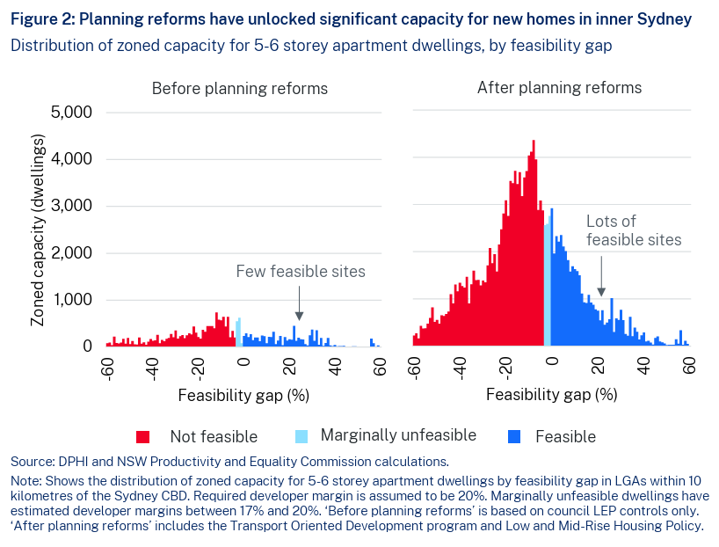

Helm and Murray emphasise land banking. They seem to think it is an alternative explanation for why housing is expensive. On the contrary, it is complementary to zoning. Speculation requires scarcity. Developers only withhold land from development if they think it will be even more valuable in future. That could be because zoning restrictions on competing land bind even tighter or because the landowner finally gets permission for more density. Either way, zoning restrictions cause land banking.

Submission 104 by Andrea Sharam, Ali Zolghadr, Louise Dorignon & Ron Wakefield of RMIT University
The RMIT submission criticises the interim report for exaggerating the importance of planning restrictions. This is a misunderstanding. The interim report, and the research on which it is based, does not say that planning restrictions are more important than other factors, simply that they are one factor. We focus on restrictions for two reasons. First, they are a factor we control. Second, there is substantial evidence indicating that the cost of these restrictions outweighs the benefits.
The RMIT submission says that assuming planning regulations are a constraint on housing supply “is often incorrect”. This is a straw man argument. No-one claims the restrictions bind everywhere. In fact, there is a rapidly growing body of work quantifying where restriction bind and where they do not, most notably the recent feasibility estimates by the Grattan Institute and the NSW Productivity and Equality Commission (see the chart in Section 2.1). Planning constrains some building, especially in the most desirable locations, while in many other areas density is not financially feasible.
The RMIT research points to many factors that make construction financially infeasible. Unfortunately, market failures are not specified so an appropriate policy response is unclear. The policy recommendations of the submission do not discuss trade-offs or why benefits would exceed costs. For example, poor quality management is undoubtedly a problem with housing supply. But it is a problem in every industry. The solution is not obvious. Similarly, if larger firms are more efficient than smaller firms, why don’t they merge? If some impediment can be identified, that might guide policy. Otherwise, it seems reasonable to assume the researchers have overlooked an unavoidable cost.
In Submission 3, Glen Searle of the University of Sydney argues that planning is not responsible for holding back housing supply. His evidence is the RMIT research finding that planning approval accounts for a quarter or less of total apartment development time. It is noteworthy that the RMIT researchers do not make this argument. Searle’s mistake is to assume that the main problem with planning restrictions is their administrative cost. As the Interim Report notes, the much bigger problem is the restriction of supply — the ban, not the burden.

Submission 63 by Peter Phibbs
We confess difficulty following the logic or seeing the relevance of much of this submission. It contradicts itself. The concluding sentence complains about public opposition to high density although the previous sentence said this building would not happen.
Phibbs criticises the economic research on zoning as “absurd”, “bizarre” and “religious” but most of his arguments are actually discussed in detail in that literature, where they are assessed against the data. Phibbs provides a lot of name-calling but little argument and even less evidence.
He argues that amalgamation slows down upzoning. Yes, that is a central reason why the NSW government has told councils to plan for 30 years’ feasible capacity.
He argues that upzoning increases land prices and it is “weird” that economists ignore this. But this is a central feature of textbook models (For Australian versions, see Richards, Kulish and Gillitzer; 2011 Section 3.2, or Ben Wynn Jones, 2026). Upzoning increases some land prices but reduces the price of floorspace, as supply expands. Research focusses on the price of floorspace (or the number of dwellings) because that is the measure relevant to affordability and welfare. Phibbs’ misunderstanding seems to be based on the view that the higher prices on land rezoned for townhouses will “make townhouses difficult to develop” (p7 and the conclusion). That misunderstands the direction of causation. Developers only bid up those prices because they plan to build townhouses. No-one has an incentive to bid up the price to levels where development is unprofitable.
Professor Phibbs leads his submission with a criticism of research by Kendall and Tulip of the RBA. (Full disclosure: The CIS Chief Economist, Peter Tulip, was co-author). This paper concluded zoning has large effects because the average cost of land for detached houses greatly exceeds the marginal cost. Australian research has moved on since these estimates, to focus on apartments which are more relevant to policy. Nevertheless, a broader issue is relevant.
Phibbs says the “silliness of the argument is reflected in the fact that work has never been published in a peer reviewed journal.” His respect for peer review is not shared by others. But if we were to evaluate arguments by publication status, the conclusions would be the opposite to Phibbs! Kendall and Tulip use the same approach, and obtain similar results, as publications in the Journal of Urban Economics, Journal of Housing Economics, Journal of Law & Economics, Economic Journal and many other leading journals. Google scholar citation counts of these papers are in the thousands. Whereas the publications Phibbs cites are obscure and ignored.
The more serious point is that the approach has been very thoroughly vetted. It is the leading approach used in the international research literature for quantifying the effects of zoning.
The results are in line with a wide variety of other data sets and empirical approaches. For surveys and summaries see Gyourko and Molloy (2015), Caplan (2024), Hamilton (2021), Been, Ellen, and O’Regan (2018, 2023), Furman (2015), Manville, Lens and Monkkonen (2020), Phillips, Manville and Lens (2021), Glaeser and Gyourko (2018), Schuetz (2022), Phillips (2020), Schleicher (2021), Gray (2022), Erdmann (2019), Beyer (2022), Gleeson (2023), Barr (2023) and Hilber and Vermeulen (2015, Section 2). If Phibbs had a legitimate criticism that overturned this well-established body of research, he could publish it in a top journal. However, his arguments and those in the papers he cites are not taken seriously in these surveys. That is because they reflect simple mistakes. For example, his point about amalgamations doesn’t apply if there is a distribution of plot sizes. And it is contradicted by estimates using vacant land, where even larger effects are found (Gyourko and Krimmel, 2021).
Previous Productivity Commission reports have made the mistake of claiming that evidence is “contested”. That is true of all policy issues faced by the Commission. The weight of expert opinion deserves some respect, as does the ability of research to stand up to critical scrutiny. Most importantly, the Commission needs to assess the quality of competing research.

