Priority Reform Three

Transforming government organisations
  - Guidance and case studies | September 2026

Acknowledgement of Country

The Productivity Commission acknowledges the Traditional Owners of Country throughout Australia and their continuing connection to land, waters and community. We pay our respects to their Cultures, Country and Elders past and present.

About us
The PC is the Australian Government’s independent research and advisory body on a range of economic, social and environmental issues affecting the welfare of Australians. Its role, expressed most simply, is to help governments make better policies, in the long-term interest of the Australian community.
The PC’s independence is underpinned by an Act of Parliament. Its processes and outputs are open to public scrutiny and are driven by concern for the wellbeing of the community as a whole.
For more information, visit the PC’s website: www.pc.gov.au

© Commonwealth of Australia 2025

With the exception of the Commonwealth Coat of Arms and content supplied by third parties, this copyright work is licensed under a Creative Commons Attribution 4.0 International licence. In essence, you are free to copy, communicate and adapt the work, as long as you attribute the work to the PC (but not in any way that suggests the PC endorses you or your use) and abide by the other licence terms. The licence can be viewed at: https://creativecommons.org/licenses/by/4.0.
The terms under which the Coat of Arms can be used are detailed at:
www.pmc.gov.au/government/commonwealth-coat-arms.
Wherever a third party holds copyright in this material the copyright remains with that party. Their permission may be required to use the material, please contact them directly.
An appropriate reference for this publication is:
Productivity Commission 2026, Priority Reform Three: Transforming government organisations, Guidance note and case studies, Canberra, June.
Publication enquiries:
Phone 03 9653 2244 | Email publications@pc.gov.au

Contents
About the artist and artwork story 1
Acknowledgements 2
Transforming government organisations under the National Agreement
on Closing the Gap 3
About the research project 4
Guidance: What public servants can do to transform now 5
Case studies
From community voice to community control:
the evolution of Connected Beginnings 14
Investing in transformative co-design processes:
South Australian Continuity of Care Protocols Program 20
NSW Closing the Gap budget submission:
a case study in co-developing budget proposals 27
CSIRO Indigenous Science and Engagement Program:
building capability to engage and partner well 32
Embedding the Priority Reforms in grant design and assessment:
The Closing the Gap Health Infrastructure Program 38

Co-designing legislative reform: Queensland First Nations Health Equity 45

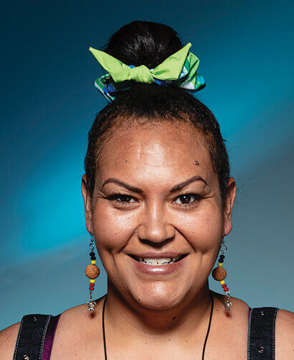
About the artist
Yuma (hello in Ngunnawal language),
My name is LaToya and I’m a proud Ngunnawal and Wiradjuri woman – my grandmother is Ngunnawal from Yass, and my grandfather is Wiradjuri from Cowra, both small country towns Central West NSW. I was born on Wiradjuri Country in Cowra, grew up on Ngunnawal Country in Canberra and I now reside on beautiful Dharawal Country in Wollongong NSW; my connections extend across Wiradjuri, Ngunnawal and Dharawal Countries.
Artist: LaToya Kennedy
My art represents the strong, continuing connections and unique relationships that I have with my country, land and community, and the respect that I have for my culture and traditions. I get my inspiration from my surroundings, recreating elements of Country and telling stories through symbolic representation. I also draw inspirations from my ancestors who have walked this land before us, and who have managed and maintained this land for tens of thousands of years.
Djan yimaba (thank you in Ngunnawal language).
LaToya Kennedy
Aboriginal Artist Kalari Art
26 August 2025

Artwork story: Yarning Across Country
‘Yarning Across Country‘ represents the Productivity Commission's work to share information on Priority Reform implementation under the first review of the National Agreement on Closing the Gap (CtG). It reflects their commitment to providing practical guidance, to support governments to improve their ways of working in the long-term interest of Aboriginal and Torres Strait Islander people.
This artwork is based around CtG > Priority Reform 3 (PR3) > Transforming Government Organisations.
The PC is the Australian Government’s independent research and advisory body on economic, social and environmental issues affecting the welfare of Australians.
This artwork has been created with a vision of telling a story about the PC sharing knowledge, stories and vital information across government agencies, sparking change in policies and procedures to change how they work with communities all over Australia.
This artwork depicts the strong connections and support pathways across the country; and represents transition and accountability between government agencies and First Nations people.
The large meeting place represents PC's main office in Naarm (Melbourne) on Wurundjeri Woi-wurrung Country. Journey pathways connecting to the smaller pink meeting places represent government agencies and community.
The people symbols sitting on the journey pathways represent government staff and communities, and are working together to improve internal processes, initiatives and actions to create positive outcomes for Aboriginal and Torres Strait Islander people.


Yarning Across Country, LaToya Kennedy.
The handprint, footprints and animal tracks represent our elders, ancestors, culture and country; and represent us on our journey keeping song, dance and culture alive with a spiritual connection to our ancestors and The Dreaming.
This artwork demonstrates connections and unique relationships that Aboriginal and Torres Strait Islander people have with the country and land; and respect for our traditions and culture.
LaToya Kennedy

Acknowledgements
The Productivity Commission acknowledges that Aboriginal and Torres Strait Islander people are the first storytellers of this land and Traditional Owners of Country on which we now live and work. We recognise their continuing connection to lands, waters, communities and cultures. We pay our respects to Aboriginal and Torres Strait Islander cultures, and to Elders past and present.
Aboriginal and Torres Strait Islander people should be aware that this research series may contain the names of people who have since passed away.
The Productivity Commission thanks staff from the Coalition of Peaks, Aboriginal Community-Controlled Organisations and government agencies who generously shared their stories and insights to develop this research series.

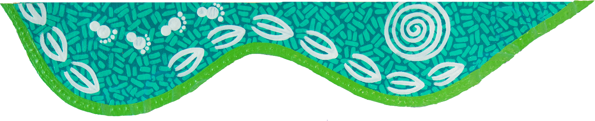
Transforming government organisations under the National Agreement on Closing the Gap
The National Agreement on Closing the Gap (2020) commits all governments to a different way of working with Aboriginal and Torres Strait Islander people through four Priority Reform areas.
Priority Reform Three: Transforming Government Organisations (PR3) is about changing the way government agencies and institutions work so they are accountable, culturally safe, and responsive to the needs of Aboriginal and Torres Strait Islander people.
Systemic and structural barriers in mainstream institutions – such as racism, unconscious bias, and culturally unsafe practices – contribute to poor outcomes for Aboriginal and Torres Strait Islander people.
To address this, all government organisations have committed to:
- identify and eliminate racism
- embed and practice meaningful cultural safety
- deliver services in partnership with Aboriginal and Torres Strait Islander organisations, communities and people
- increase accountability through transparent funding allocations
- support Aboriginal and Torres Strait Islander cultures
- improve engagement with Aboriginal and Torres Strait Islander people.
Priority Reform Three applies to all agencies and staff, not just those working in Aboriginal and Torres Strait Islander policy. It means considering cultural safety, equity, and partnership in everything we do –whether we’re working on budget proposals, designing policy or programs, managing implementation activities, or delivering services.


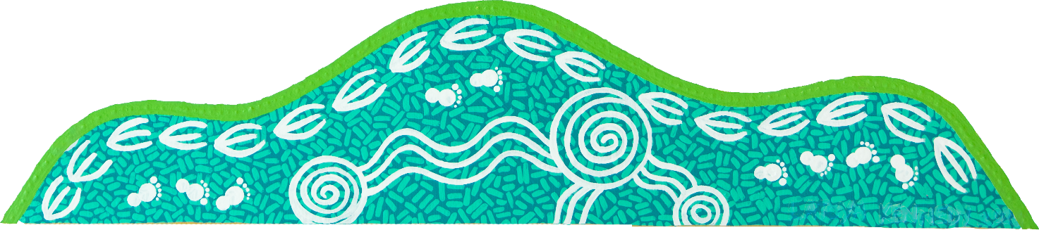

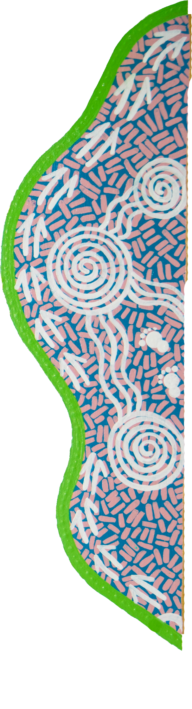
About the research project
The Productivity Commission’s (PC) first review of the National Agreement on Closing the Gap found that transformation under PR3 had barely begun. The review found a notable absence of whole-of-government or whole-of-organisation strategies for driving and delivering transformation in line with the commitment intended under PR3 (PC 2024, p. 5). Instead, most government activity had centred around cultural capability uplift and workforce strategies to increase Aboriginal and Torres Strait Islander employment (PC 2024, p. 8). While such work is important, it is insufficient on its own.
The commitment governments have made under PR3 requires more than piecemeal initiatives – it requires organisation-wide strategies developed with Aboriginal and Torres Strait islander people that reset government systems, culture and decision-making processes, which have largely failed to reflect the priorities, cultures and knowledges of Aboriginal and Torres Strait Islander people (PC 2024, p. 55). To support and activate this change, the PC is highlighting pockets of good practice within government to share knowledge on what transformative action looks like and what it takes to achieve it. With the support of agencies and their partners implementing change, the PC has developed case studies and practical guidance for public servants to draw on to learn, adapt and implement. This is an ongoing project, with new case studies and guidance added over time on the PC website. The PC worked closely with the Coalition of Peaks Secretariat to plan and design the research project. Together, we identify and review case studies based on the criteria that the policy, initiative or program:
- was developed in partnership with Aboriginal and Torres Strait Islander people, organisations or communities
- is aligned with the Priority Reforms and socio-economic outcome areas of the National Agreement on Closing the Gap
- has learnings that can be adopted and scaled across governments.
For each case study, we work closely with representatives from the organisations involved to shape the scope of the case study, interview structure and questions, and the final case studies.

References
PC (Productivity Commission) 2024, Review of the National Agreement on Closing the Gap, Study report, Vol 1.
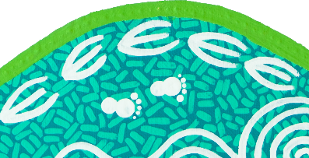

Guidance:
What public servants can do to transform now
The Australian Public Service (APS) has a responsibility to implement the Priority Reforms under the National Agreement on Closing the Gap (the National Agreement) (Coalition of Peaks and Australian Governments 2020). The Priority Reforms aim to improve life outcomes through changes in the relationship between governments and Aboriginal and Torres Strait Islander people that enable greater self-determination. The reforms recognise that without shifting government systems, cultures and decision-making processes, socio-economic outcomes for Aboriginal and Torres Strait Islander people will not improve (PC 2024a, p. 27).
Priority Reform Three of the National Agreement (PR3) commits public servants to shift business-as-usual structures, systems, processes and practices to adopt new ways of working that are grounded in listening, learning and acting in genuine partnership with Aboriginal and Torres Strait Islander communities (Joint Council on Closing the Gap 2020 cls. 58-68). Yet within these commitments, public servants often express hesitation as to how to meet their commitments within their respective legislative obligations and authorising environments (PC 2024b, p. 60).
This guide:
- draws on case studies of good practice to identify transformative action already sanctioned within Commonwealth legislative frameworks
- provides practical advice to support public servants in understanding their capability to drive transformation
- highlights six examples of change underway across government to show how to embed culturally informed, collaborative approaches that lead to better outcomes and stronger relationships with Aboriginal and Torres Strait Islander communities (PC 2024a, pp. 28, 49):

1. Sharing decision-making
2. Taking a relational approach to grant administration
3. Co-developing budget bids
4. Allocating time for collaborative design
5. Prioritising funding through grant programs
6. Monitoring and evaluating using community-defined success measures.

You can share decision-making within the scope of the Public Governance, Performance and Accountability Act 2013 (PGPA Act)
Under section 17 of the PGPA Act, the Accountable Authority for each Government Department has a positive duty to encourage their officials to co-operate with others to achieve common objectives.
While government bodies operate under different governance structures, all government officials can meet this positive duty by engaging in shared decision-making processes with Aboriginal and Torres Strait Islander organisations and communities. Doing so enables the pooling of expertise, builds trust with Aboriginal and Torres Strait Islander communities and ensures that policy solutions are culturally informed and responsive to community needs (PC 2024b, p. 63).
Shared decision-making processes, supported by strong governance, can also enhance probity compliance (ECCDPP 2025, p. 14). For example, a governance framework that has transparent, consensus-based shared decision-making embedded in its design can minimise individual bias and influence on decisions (ECCDPP 2025, p. 14).

Why should you consider doing this?
Shared decision-making is an outcome under the National Agreement, as well as a key element required under Priority Reform One of the National Agreement (PR1). Its implementation is critical, as programs that are designed and governed by Aboriginal and Torres Strait Islander people have been found to be more effective in incorporating Indigenous knowledges and practices, leading to greater program effectiveness, community acceptance and buy-in (Murrup-Stewart et al. 2025, p. 6; SNAICC 2022, p. 8). This, in turn, contributes to quality of expenditure, greater sustainability and achievement of outcomes.

What might this look like in practice?

Sharing decisions at every stage of the program or policy cycle from design and implementation right through to evaluation
This could be achieved through an:
- overarching program or policy design reference group, or joint governance mechanism which operates by consensus, with decisions only proceeding when supported by all parties (DSS 2021b, p. 8; ECCDPP 2025, p. 10)
- expert joint grant or advisory panel, that ensures the voices of Aboriginal and Torres Strait Islander representatives are weighed equally, if not greater, to government (PC 2024b, p. 117). Panel representation should be appointed and decided by Aboriginal and Torres Strait Islander partners, rather than government (Coalition of Peaks 2023).

Establishing shared decision-making panels to provide collective recommendations to the financial delegate on the expenditure of public funds (noting the final decision remains with the delegate)
Such panels require strong governance arrangements to ensure probity risks are identified and managed effectively, without unnecessarily restricting consideration of cultural knowledge and the broader operating environment.

For example, the Early childhood Care and Development Policy Partnership (ECCDPP) was established as a mechanism under PR1 as a shared decision-making forum between all Australian governments and Aboriginal and Torres Strait Islander representatives.
The ECCDPP’s purpose is to develop recommendations to improve early childhood outcomes for Aboriginal and Torres Strait Islander children and families. The ECCDPP is co-chaired by Education and SNAICC, who also operate a co-secretariat for the Partnership (DoE, personal communication, 4 September 2025).
Connected Beginnings is an example where the Department of Education (Education) and the Department of Health, Disability and Ageing (Health) transitioned to shared decision-making processes to achieve the aim of improving health, development and education outcomes for Aboriginal and Torres Strait Islander children. Under the program, SNAICC – National Voice for our Children (SNAICC) – and the National Aboriginal Community Controlled Health Organisation (NACCHO) – are engaged as Community Partners to oversee key aspects of the Program.

Engaging an independent probity advisor
An independent probity advisor can support all parties to feel confident in meeting PGPA Act requirements while undertaking shared decision-making. At the federal level, DSS has a probity advisor available through the Grants Hub to assist in this area (DSS 2021a).

You can take a relational approach to the administration of grants
Taking a relational approach to the administration of grants involves a transition away from short-term, transactional and output-based funding to longer-term relational and outcomes-focused funding (PC 2020a, p. 20). It involves working collaboratively with Aboriginal and Torres Strait Islander partners or communities to focus on community-led priorities and solutions (PC 2020a, p. 13), enabling decisions to be shared with those who are closest to understanding the needs and opportunities on the ground (PC 2020a, pp. 38, 246, 263).

Why should you consider doing this?
Taking a relational approach to grant administration supports grants processes to be more culturally informed, responsive and accessible (PC 2020a, p. 236). It supports the commitment under PR1 to enable self-determined resource allocation in line with local community-defined priorities and aspirations (SNAICC 2022, pp. 29–30).

What might this look like in practice?

Resource an Aboriginal or Torres Strait Islander partner to administer the grant program in partnership with the government
For example, the Australian Government Department of Health, Disability and Ageing resourced NACCHO to deliver the First Nations Australian Health Program – Major Capital Works in partnership with the government. Under this program, NACCHO co-designed the program parameters and structure, grant opportunity guidelines, assessment plans and decision-making processes and timeframes, as well as co-chairing the assessment committee (NIAA 2023, p. 18).
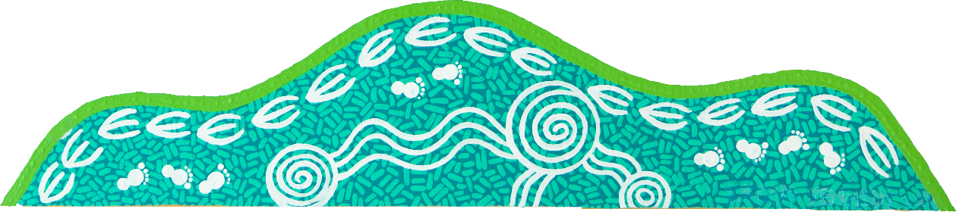

Work at the pace of the Aboriginal and Torres Strait Islander community’s timelines
In the design phase, this could be done by asking for a longer policy authority window, allowing adequate time to build relationships and trust and adjusting timelines based on community advice (CAAC 2021, p. 25). In the grant administration phase this may be done by setting longer application windows that build in flexible start dates and extension clauses that support Aboriginal decision-making processes (PiC 2023, p. 39), Sorry Business or cultural and seasonal events.

Administer grants directly
At the federal level, your agency or department can put a request to your minister to obtain a temporary deferral or permanent exemption from the requirement to use the Community Grants hub to deliver a grant program (Department of Finance 2025).
For example, Connected Beginnings is a place-based grant program that has a component directly administered by the Department of Education rather than the Community Grants Hub. The direct administration of grants within this program has allowed greater flexibility to build relationships which go beyond the traditional funder-grantee arrangements and provide bespoke support.

You can co-develop budget bids with Aboriginal and Torres Strait Islander partners
Co-developing budget bids with Aboriginal and Torres Strait Islander partners on policy and program initiatives that impact their communities creates a pathway for self-determined prioritisation of investment.

Why should you consider doing this?
Involving Aboriginal and Torres Strait Islander partners from the outset of a budget process will ensure that funding proposals are shaped by those who best understand local needs and aspirations (NSW Government 2022, p. 56), meeting the commitment of genuine partnership under PR1 of the National Agreement. Additionally, co-developing budget bids with Aboriginal and Torres Strait Islander partners is a practical step forward in the type of transformation committed to under PR3, as it can lead to improved engagement and increased transparency in funding allocations (PC 2024b, p. 267).

What might this look like in practice?
Review and update Cabinet and Budget processes so that all submissions demonstrate the impact of new policy proposals on Aboriginal and Torres Strait Islander people, and how the policy proposal aligns with, and has been developed in accordance with, the Priority Reforms (PC 2024b, p. 242).
For new budget measures with a significant emphasis on improving outcomes for Aboriginal and Torres Strait Islander people, Accountable Authorities could adopt internal measures requiring staff to explain how early engagement or partnership with Aboriginal and Torres Strait Islander people has informed the policy or program development (NIAA 2024, p. 4).
For the 2022-23 and 2025-26 New South Wales budget, NSW’s Premier’s Department and NSW Coalition of Aboriginal Peaks Organisation (NSW CAPO) led a process to co-design a Close the Gap budget proposal with NSW CAPO members and relevant agencies, with support and advice from NSW Treasury. Following the co-design process, and within the constraints of Cabinet-in-confidence, NSW’s Premier’s Departments took an active role in keeping NSW CAPO informed, facilitating ministerial meetings ahead of Expenditure Review Committee discussions and sharing outcomes prior to public announcement.

You can allocate sufficient time for collaborative design processes when drafting new policy proposals
For government expenditure that is focussed on improving outcomes for Aboriginal and Torres Strait Islander people, engagement is essential (PC 2024b, p. 266).
New policy proposals should be informed by priorities identified in partnership with Aboriginal and Torres Strait Islander people (PC 2024b, p. 266). Where it is not feasible to undertake a collaborative process prior to drafting a new budget proposal, public servants should ensure the proposal allocates sufficient time and resources to ensure co-design occurs to scope a full program or policy design once funds are agreed.

Why should you consider doing this?
Priority Reform Two of the National Agreement (PR2) is about Aboriginal and Torres Strait Islander people and communities being able to exercise the right to self-determination over the design and delivery of services and programs that impact their lives (PC 2024b, p. 62), however, time constraints often prevent genuine collaboration efforts (PC 2024b, pp. 31, 36).
Accounting for co-design processes within a new policy proposal helps address potential time barriers of the budget cycle. It ensures that the design and implementation of initiatives aimed at improving outcomes for Aboriginal and Torres Strait Islander people occurs with them, rather than for them – consistent with the Priority Reforms of the National Agreement.

What might this look like in practice?
- Developing internal thresholds for recommending different levels of co-design, in line with the Engagement Institute’s Spectrum of Public Participation, proportionate to policy and program budget and risk.
- Proposing costings for design staff and a design travel budget in the first 12 months of a new policy proposal prior to implementation.
South Australia’s Continuity of Care Protocols Program is an example of government prioritising a collaborative design process for funding intended to improve outcomes for Aboriginal and Torres Strait Islander people. The Department of Health and Wellbeing (DHW) accounted for a 12-month scoping process to collect stories of people’s experience with health services which informed the co-designed draft protocols. DHW and partners then moved into a three-year piloting and implementation phase. They also funded Aboriginal and Torres Strait Islander partners to participate as equal partners in the co-design process.
Commonwealth Scientific and Industrial Research Organisation’s (CSIRO’s) Indigenous Research Grants Program provides another example of where collaboration is factored into project design. In applying for funding, applicants must show how they will co-design and determine research priorities with Aboriginal and Torres Strait Islander communities.

You can prioritise funding to Aboriginal and Torres Strait Islander organisations through grant programs
PR2 of the National Agreement focuses on building the community-controlled sector. Clause 55(a) of the National Agreement commits governments to implement funding prioritisation policies that preference Aboriginal and Torres Strait Islander organisations, particularly community-controlled organisations. One way to meet these commitments is to design and administer grant opportunities that prioritise funding to Aboriginal community-controlled organisations (ACCOs).

Why should you consider doing this?
A lack of cultural safety, racism and fear are commonly reported by Aboriginal and Torres Strait Islander people as key barriers to accessing essential services that are a basic human right (AHRC 2024, p. 13; DoH 2021, p. 5).
Providing culturally safe services is essential in setting the foundation for strong social and emotional wellbeing among Aboriginal and Torres Strait Islander communities (Truong and Miller 2024). ACCOs have an established record of delivering culturally safe, effective services and are trusted leaders in their communities (Ong et al. 2012, p. 2; SNAICC 2022, p. 8; VACCHO 2025, p. 2).
Despite this, ACCOs continue to remain disadvantaged by competitive grant processes that favour larger, non-Indigenous organisations, are poorly aligned with the holistic, culturally grounded ways ACCOs support families, and include heavy compliance and reporting requirements that strain their limited resources (SNAICC 2022, pp. 29–33). Prioritising ACCOs in grant processes enables officials to back Aboriginal and Torres Strait Islander-led solutions and build on the unique strengths and expertise of the community-controlled sector.

What might this look like in practice?

Implement funding prioritisation to ACCOs within internal policies and practices, such as Grant Opportunity Guidelines.
This prioritisation can occur across open competitive, non-competitive and closed grant rounds (NIAA 2023, p. 4). For example, this could be done by:
- restricting eligibility of application to ACCOs, or
- designing assessment criterion to align with placing higher value on organisations that are best placed to serve Aboriginal and Torres Strait Islander people.
The Department of Social Services’ Improving Multi-disciplinary Responses Program offers a practical example of prioritising funding to Aboriginal and Torres Strait Islander organisations. Through a targeted competitive grant opportunity, $44 million was made available to Aboriginal and Torres Strait Islander organisations and ACCO’s to support design, implementation and evaluation of multidisciplinary responses projects.
Connected Beginnings is an example of an existing program that historically directed the majority of its backbone funding to mainstream organisations, often local schools. Through the implementation of its Leadership Transition Framework – which provides guiding principles for communities, ACCOs and mainstream organisations – the program is working to transition backbone grant funding to ACCOs, prioritising funding to the sector.

You can monitor and evaluate programs based on Aboriginal and Torres Strait Islander community-defined measures of success
To achieve better policy outcomes, what Aboriginal and Torres Strait Islander people value, their expertise and lived experiences must be reflected in what is evaluated and how evaluation is undertaken (PC 2020b, p. 10).
Aboriginal and Torres Strait Islander people are best placed to identify factors that may support or challenge an evaluation, and can ensure that the design, data collection and reporting processes are aligned with local priorities and needs (Muir, S and Dean, A 2017, p. 4).

Why should you consider doing this?
Adopting Aboriginal and Torres Strait Islander community-defined measures of success is fundamental to supporting self-determination (PC 2020b, p. 14) – it ensures communities have ownership over defining and measuring outcomes that truly matter to their communities.
Additionally, culturally appropriate evaluation methods support the implementation of Priority Reform Four of the National Agreement, as it facilitates the collection of locally relevant data, a gap that local communities continue to face to enable informed decision-making within their communities (PC 2024b, pp. 69, 231).

What might this look like in practice?

Ensure your evaluation is planned and budgeted for during the policy and program design and development phase
This includes allocating time and resources for people impacted by a policy or program to be able to lead or engage effectively in an evaluation (PC 2020b, pp. 16, 25).

Establish an evaluation steering committee with majority or full Aboriginal and Torres Strait Islander representation
This steering committee can assist in developing evaluation questions, choosing methods and suitable indicators, providing guidance on culturally safe evaluation, and developing a stakeholder engagement plan (PC 2020b, p. 23).
Commission independent reviews and evaluations led by culturally appropriate consortia of evaluation specialists
For example, in publishing a request for tender, you can seek the services of a multi-disciplinary team involving evaluators from the local community where the program or policy is being delivered (PC 2013, p. 241). The requirement for local voices to be involved in an evaluation process can also be made as an explicit eligibility criterion for evaluation and design team tenders that are put to market. Additionally, your tender can include the requirement for evaluators to undertake capacity strengthening with ACCOs, where desired, to build experience in capturing the impact of their work in a way that is both meaningful to them and government.

Listen to the advice provided by external independent evaluators and use these evaluations to change course when things are not working
South Australia’s Continuity of Care Protocols Program provides an example of agreements and evaluations developed based on partner definitions of success.
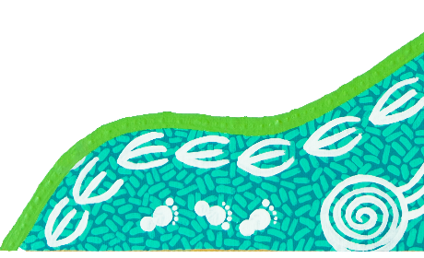
The PC’s Guide to Evaluation under the Indigenous Evaluation Strategy provides a whole-of-government framework for government agencies to use when selecting, planning, conducting and using evaluations of policies and programs affecting Aboriginal and Torres Strait Islander people.
The Australian Centre for Evaluation supports the APS in improving the quality and use of evaluation evidence in policy design and decision-making. It develops evaluation policy and guidance, including resources on culturally appropriate evaluations.

References
AHRC (Australian Human Rights Commission) 2024, An Anti-Racism Framework: Voices of First Nations Peoples, November.
CAAC (Central Australia Aboriginal Congress) 2021, A guide for health researchers working with Aboriginal people in central Australia, Central Australian Aboriginal Congress, Alice Springs.
Coalition of Peaks 2023, Priority Reform One, Coalition of Peaks, https://www.coalitionofpeaks.org.au/
priority-reform-one (accessed 11 August 2025).
—— and Australian Governments 2020, 3. Objective and Outcomes, https://www.closingthegap.gov.au/
national-agreement/national-agreement-closing-the-gap/3-objective-and-outcomes (accessed 9 July 2025).
Department of Finance (Australian Government) 2025, The Grants Process, https://www.finance.gov.au/government/
managing-commonwealth-resources/commonwealth-grants-rmg-410/grants-process (accessed 9 July 2025).
DoH (Victorian Government Department of Health) 2021, Aboriginal and Torres Strait Islander Cultural Safety Framework.
DSS (Australian Government Department of Social Services) 2021a, Grant Opportunity Toolkit.
—— 2021b, Partnership Agreement: Safe and Supported: The National Framework for Protecting Australia’s Children 2021–2031, Australian Government Department of Social Services.
ECCDPP (Early Childhood Care and Development Policy Partnership) 2025, ECCDPP Probity Framework, Australian Government Department of Education.
Muir, S and Dean, A 2017, Evaluating the outcomes of programs for Indigenous families and communities, Child Family Community Australia Practice Resource, Australian Institute of Family Studies.
Murrup-Stewart, C, Truong, M and Joshi, A 2025, Aboriginal and Torres Strait Islander perspectives on what works in social and emotional wellbeing programs, March, Australian Institute of Family Studies.
NIAA (National Indigenous Australians Agency) 2023, Closing the Gap Grants Prioritisation Guide.
—— 2024, First Nations Impacts Framework: Version 2.
NSW Government 2022, 2021-2022 NSW Closing the Gap Annual Report, p. 56.
Ong, KS, Carter, R, Kelaher, M and Anderson, I 2012, Differences in primary health care delivery to Australia’s Indigenous population: A template for use in economic evaluations, BCM Health Services Research.
PC (Productivity Commission) 2013, Better Indigenous policies: the role of evaluation, Roundtable proceedings, Canberra.
—— 2020a, Expenditure on children in the Northern Territory, Study report, Canberra.
—— 2020b, Indigenous Evaluation Strategy, Canberra.
—— 2024a, Review of the National Agreement on Closing the Gap, Study report, Vol. 1, Canberra.
—— 2024b, Review of the National Agreement on Closing the Gap, Study report, Vol. 2, Canberra.
PiC (PWC’s Indigenous Consulting) 2023, Co-Design Lessons Learned Report: National Indigenous Australians Agency, PwC’s Indigenous Consulting.
SNAICC (SNAICC – National Voice for our Children) 2022, Stronger ACCOS, Stronger Families, Final report.
Truong, M and Miller, H 2024, Resources to support culturally safe service delivery to Aboriginal and Torres Strait Islander peoples, Australian Institute of Family Studies.
VACCHO (Victorian Aboriginal Community Controlled Health Organisation) 2025, The Victorian ACCO Model.

Priority Reform Three
Guidance and case studies - Transforming government organisations

Case studies

From community voice to community control:
the evolution of Connected Beginnings

Key points
- Navigating partnerships across portfolios demands deliberate effort and sustained coordination. This helps align roles, foster mutual understanding and reconcile different ways of working, leading to better decisions and outcomes.
- Strong partnerships with the community-controlled sector require early investment in building rapport, trust and sound governance structures. Secondment arrangements can fast-track trust and capacity building with the sector.
- Taking a relational approach to grant administration is crucial. Direct administration of grants can provide greater flexibility to build relationships which go beyond the traditional funder-grantee arrangements and provide bespoke support.
- Tailored guidelines and frameworks can support both organisation and community readiness to transition services from mainstream organisations to the community-controlled sector.
- Site selection processes can be enhanced by combining strengths-based data with sustained community engagement and shared governance with community partners. This supports more informed, culturally appropriate and transparent decision-making.
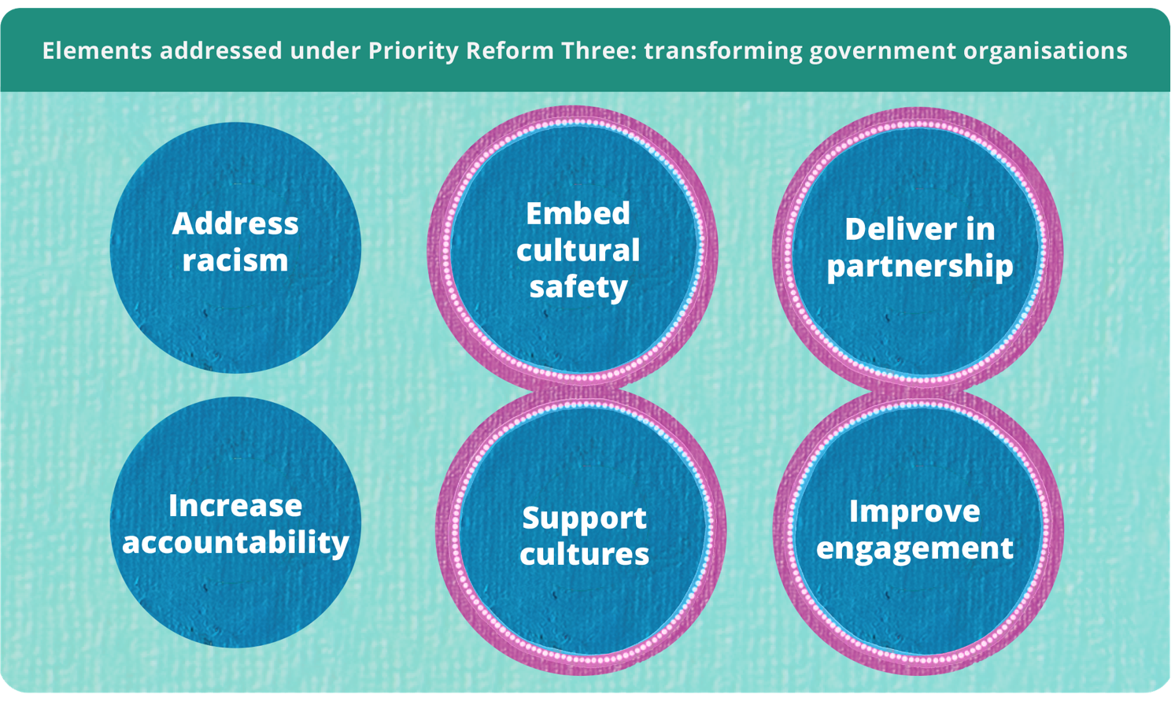

Strong partnerships are foundational to place-based approaches
Place-based approaches take considerable time and effort from all involved to establish, and have both strengths and challenges when delivering in practice. Success requires government to foster genuine shared decision-making with communities, through equal partnerships (ANZSOG and Victoria State Government 2023, p. 14).
The evolution of Connected Beginnings since 2016 shows the value of investing in strong partnerships between the community-controlled sector and government, and strengthening governance arrangements to build trust and enable shared decision-making (Inside Policy 2023, pp. 6–7). With strong advocacy and leadership from the community-controlled sector, Connected Beginnings provides an example of an established program that continues to transform and improve over time to align with the Priority Reforms of the National Agreement on Closing the Gap (National Agreement) (Inside Policy 2023, p. 6).

The transformation journey
- Over the past 10 years, Connected Beginnings has significantly evolved (figure 1). Cultural authority is no longer a principle of the program – it is the foundation.
- The National Agreement was a key enabler for evolving the program and provided the authorising environment for a formal partnership between program funders – the Australian Government Department of Education (Education) and the Australian Government Department of Health, Disability and Ageing (Health) – and peak bodies from the community-controlled sector – SNAICC National Voice for our Children (SNAICC) and the National Aboriginal Community Controlled Health Organisation (NACCHO) (Program Partners) (Inside Policy 2023, p. 39).
Figure 1 – Evolution of Connected Beginnings^{a,b}
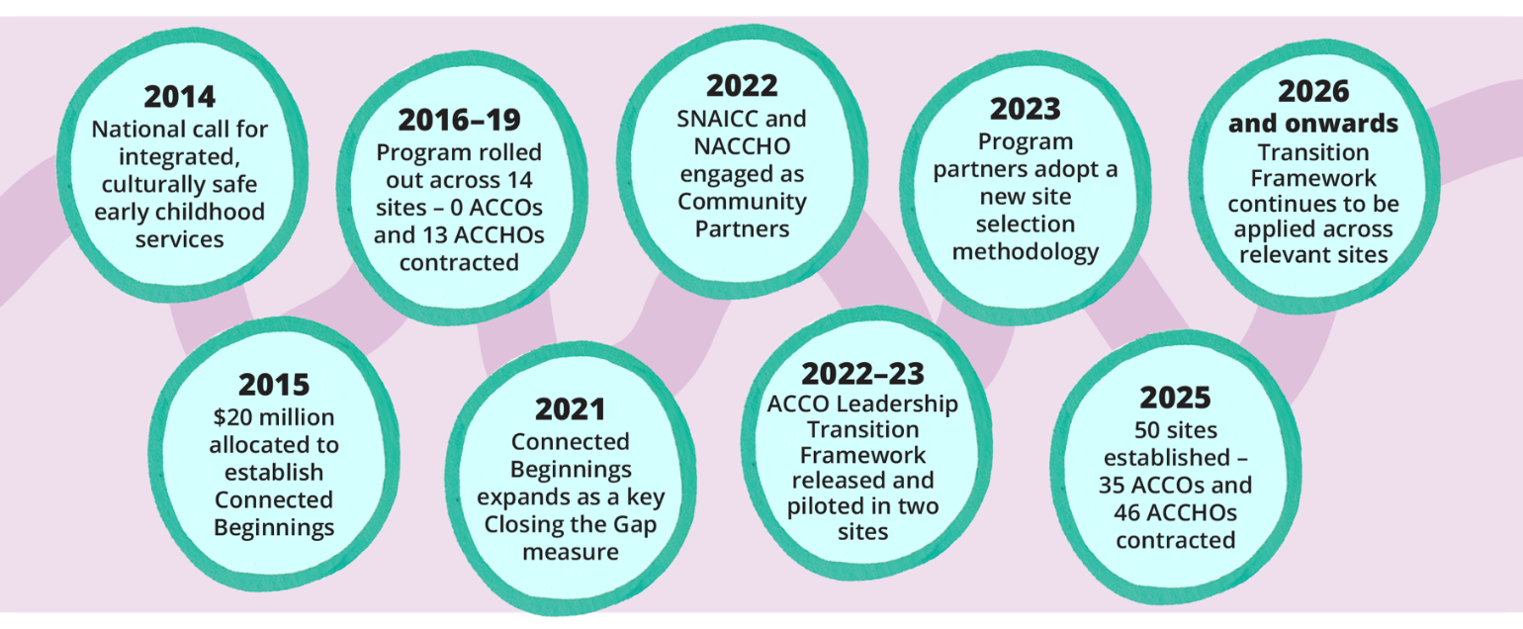
a. Aboriginal and Torres Strait Islander Community Controlled Organisation (ACCO).
b. Aboriginal and Torres Strait Islander Community Controlled Health Organisation (ACCHO).
Source: Australian Healthcare Associates (2019); Inside Policy (2023).
Jointly funded by Education and Health since 2016, Connected Beginnings is a place-based grants program that brings together early childhood education, health and family support services (figure 2). It improves school readiness by supporting integrated, culturally safe and community-led services (Inside Policy 2023, p. 19).
Figure 2 – Connected Beginnings operationsª
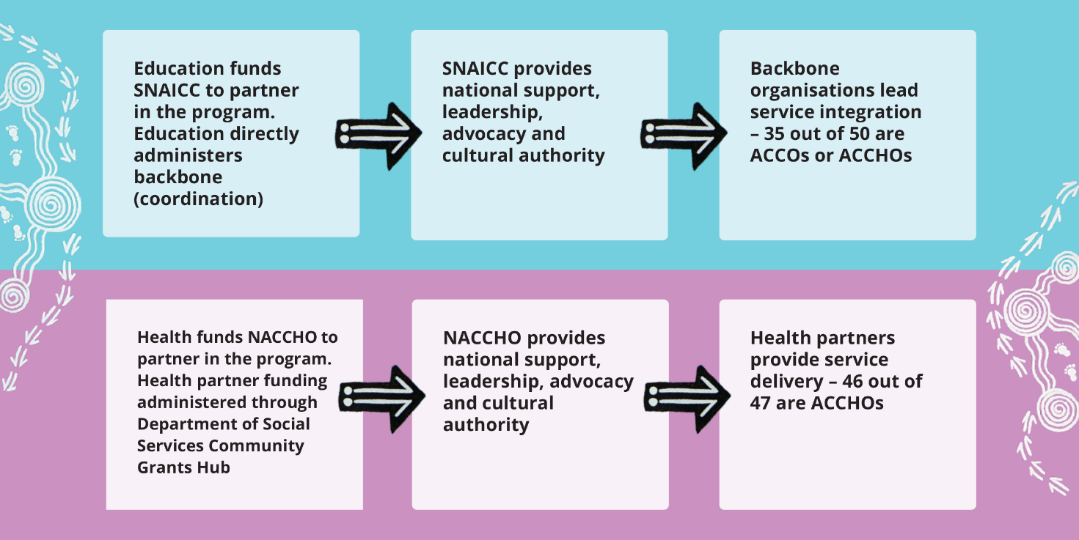
a. Backbone funding refers to grant money provided to an organisation that plays a central coordination role across services and families. Backbone organisations generally do not deliver services but provide strategic coordination, logistical support, or engagement activities to support families access culturally safe services.
Source: Inside Policy (2023); SNAICC and Australian Department of Education (2022).
Governance is shared between communities and government, in line with Priority Reform One of the National Agreement. Engaging local ACCOs and ACCHOs to deliver the program supports local leadership and decision-making (Inside Policy 2023, p. 6). Promoting community governance ensures the program is responsive to community needs and priorities.
Governance mechanisms at the program level include the Connected Beginnings Advisory Group, operational and management meetings and forums between Program Partners. Governance mechanisms at the site level include Cultural Leadership Tables, Community Advisory Groups, community meetings and service-oriented forums to ensure services are working collectively to address gaps families may be facing (Inside Policy 2023, pp. 61–62, 85).

Shifting from community voice to community control

Establishing and strengthening partnerships across sectors
When Connected Beginnings began in 2016, governments made decisions that engaged community voice but did not prioritise community control. Aboriginal and Torres Strait Islander voices were informally considered and reflected within the initial design of the program. A ‘Critical Friends’ group, featuring SNAICC as a strong voice, marked a more structured approach to embedding these perspectives, though not yet within the context of a formal partnership.
The announcement of Connected Beginnings as a key Closing the Gap measure was an opportunity for government to strengthen the program and better align their partnership settings with the Priority Reforms of the National Agreement. This triggered a change within Education and Health to engage SNAICC and NACCHO as Community Partners.
While Education worked closely with SNAICC, and Health with NACCHO for many years outside the program, this was the first formal cross-sector partnership between all parties. Relational work was key. A commitment to collaboration, improvement, transparency, active listening and providing fearless advice transformed old relationship settings into a stronger partnership (Lavarch et al. 2025, p. 145).
In 2022, a secondment arrangement between Education and SNAICC enabled staff to sit side by side to operationalise the Community Partner contract. This was particularly valuable in building internal capacity and developing culturally safe communications systems.
This partnership has since informed every stage of the investment cycle – from influencing the composition of the Advisory Group to progressing transparency and inclusivity in community decision-making – resulting in a more appropriate and responsive program with cultural governance at the core.
Navigating the responsibilities of multiple Australian Government agencies – each with distinct priorities, budget cycles and allocations, governance structures and operating models – can be complex. These challenges can reinforce sector silos and impact service delivery. At the community level, unequal funding and inconsistent partnership arrangements between health and backbone organisations can create a sense of devalue and disconnect, impacting local transparency and accountability.
Program Partners are continuously working to address these challenges by aligning responsibilities, goals and timelines across sectors wherever possible. A co-designed roles and responsibilities document is used for overarching governance of the program and updated to improve collaboration and decision-making between partners.

A flexible, relational approach to grant administration
For place-based approaches, where the focus is on community readiness and building shared outcomes, taking a relational, flexible approach is crucial (Victoria State Government 2020, pp. 34, 39).
To support this, Education argued from the start that there were exceptional circumstances precluding them from administering backbone funding through the Australian Government's Department of Social Services (DSS) Community Grants Hub. This includes significant time working with community to determine which organisation has the trust, cultural authority, expertise and capacity to apply for funding, the high level of support for grant recipients, and the expertise required to assess applications. Internal administration has enabled Education to work at the pace and direction of community and build strong, direct relationships with backbone organisations.
Health partner funding is administered through the DSS Community Grants Hub. Communication with health partners often occurs through DSS Funding Arrangement Managers. NACCHO’s engagement in the program has supported connection between health partners and Health (Inside Policy 2023, p. 46).

Transitioning funding to the community-controlled sector
Health partner funding has consistently prioritised the community-controlled sector, with 46 of the 47 health sites sitting in ACCHOs. However, prior to the program’s expansion, backbone funding favoured larger mainstream organisations, and given the focus on school readiness, often sat within or adjacent to schools (Inside Policy 2023, p. 43; SNAICC and DoE 2022, p. 3). These organisations had limited to no cultural authority or embedded ways of Aboriginal and Torres Strait Islander knowing, doing and being (SNAICC and DoE 2022, p. 3).
To rectify this and support Aboriginal and Torres Strait Islander self-determination, in 2021 the Australian Government committed to transitioning backbone roles to ACCOs or ACCHOs where there is support for the transition from the community (NIAA 2021, p. 29). SNAICC and Education led a national co-design process with Connected Beginnings communities to develop the ACCO Leadership Transition Framework (SNAICC and DoE 2022, pp. 2–3). The Framework sets out when and how roles will transition to ACCOs, guided by community readiness and support (SNAICC and DoE 2022, p. 2; NIAA 2023, p. 5). It centres cultural governance and community voice, ensuring the program is locally led and culturally grounded (SNAICC and DoE 2022, p. 12). Involving the health partner and other ACCHOs and ACCOs in the area during transition discussions can support shared governance between Community Partners.
NACCHO and Health play a key role in reviewing and endorsing transition recommendations, supporting shared decision-making across Program Partners. At times, unequal resourcing between Program Partners and expectations to provide genuine and considered responses to recommendations within short timelines can impact endorsements.

Strengthening site selection processes
Historically, Connected Beginnings sites were determined based on national level data sets – often Australian Early Development Census (AEDC) and Australian Bureau of Statistics (ABS) data – and discussions with Australian and state and territory governments on priorities (Australian Healthcare Associates 2019, p. 23). This data could unintentionally promote a deficit view by framing communities in terms of their challenges rather than strengths. Site selection processes also often failed to consider the capacity of those locations to deliver service integration in a culturally appropriate way, for example by not prioritising ACCOs or ACCHOs in the site selection process.
With leadership from SNAICC and NACCHO, site selection processes have improved to recognise and build on community strengths. Shifts have taken place to select sites not only considering administrative data, but toward a strengths-based approach, prioritising community voice, cultural governance and readiness (NIAA 2023, p. 8). The updated process often involves extensive community consultation to identify area need, existing relationships and the capacity of organisations – particularly ACCOs and ACCHOs – to meaningfully engage in the program. This has encouraged governments to engage more fully and transparently with community – often through SNAICC or NACCHO – resulting in a more culturally informed, relevant and appropriate selection.

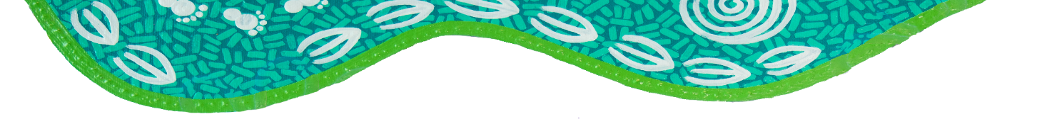
The impact on the ground
Engaging SNAICC and NACCHO as Community Partners has been instrumental to embedding cultural safety and responsiveness to every element of the program. Their involvement not only reflects governments’ will, readiness and commitment to support community-led approaches, but also ensures that Aboriginal and Torres Strait Islander voices are central to decision-making and service design (Inside Policy 2023, p. 36). Connected Beginnings sites report better community collaboration, leadership and capacity to drive culturally safe service integration because of the work of SNAICC and NACCHO as Community Partners (Inside Policy 2023, pp. 80, 118).

References
ANZSOG and Victoria State Government (Australia and New Zealand School of Government and Victoria State Government) 2023, Place-based approaches: A guide for the Victorian Public Service.
Australian Healthcare Associates 2019, Evaluation of the Connected Beginnings program: Final report, Commissioned by the Australian Government Department of Health and Department of Education.
Dart, J 2018, Place-based evaluation framework: A guide for evaluation of place-based approaches in Australia, Commissioned by the Queensland Government Department of Communities, Disability Services and Seniors (DCDSS), the Australian Government Department of Social Services (DSS), and Logan Together.
Inside Policy 2023, Connected Beginnings mid-term evaluation: Final report, Commissioned by the Australian Government Department of Education and the Department of Health and Aged Care.
Lavarch, L, Coombes, L, Gray, K, Anthony, C and Nolan-Smith, S 2025, Independent Aboriginal and Torres Strait Islander-led Review of Closing the Gap, Jumbunna Institute for Indigenous Education and Research.
NIAA (National Indigenous Australians Agency) 2021, Closing the Gap: Commonwealth implementation plan.
—— 2023, Sector Strengthening Plan Action Updates – 2023, Annual Report.
SNAICC and DoE (Australian Government Department of Education) 2022, Kids come first: framework to facilitate the culturally safe transition of connected beginnings leadership and backbone functions from non-Indigenous organisations to Aboriginal community controlled organisations.
Victoria State Government 2020, A framework for place-based approaches.

Investing in transformative co-design processes:
South Australian Continuity of Care Protocols Program

Key points
- Genuine co-design can transform systems when agencies invest in relationships, formalise shared decision-making, and value lived experience and cultural authority.
- Building strong, trusted relationships is as important as securing funding or establishing appropriate governance.
- Funding partners to engage with their communities to develop and test reforms enables localised approaches and integration of cultural knowledge.
- Partnering at every stage of the commissioning cycle supports sustainable capacity building.
- Defining co-design with partners and formalising agreed ways of working upfront keeps government officials from slipping back to business-as-usual approaches. Delivering on these commitments builds the trust needed for genuine partnership.
- Effective co-design improves system coordination by deepening relational networks across sectors and fostering active community engagement.
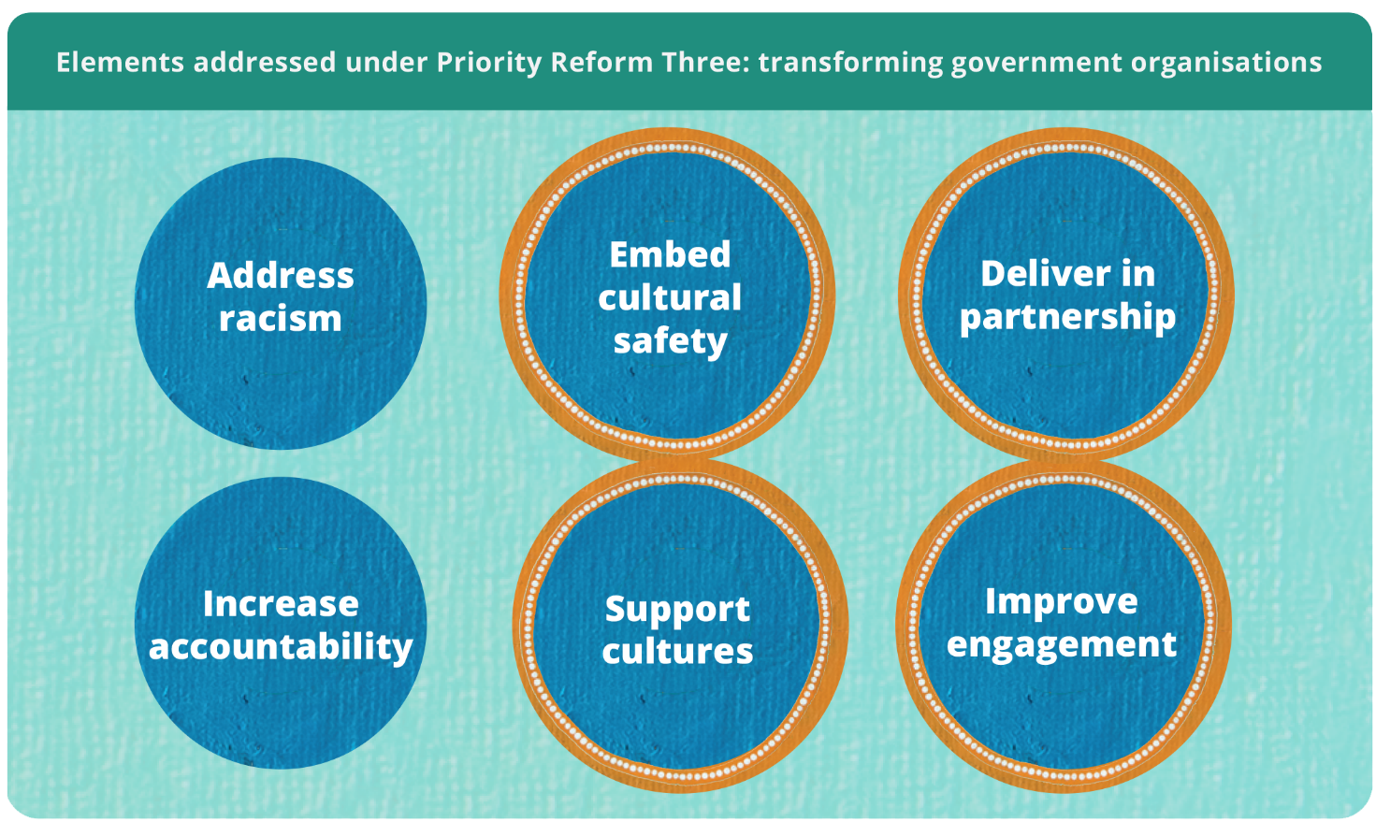

Co-design requires transformed ways of working
Good examples of policy and program co-design processes with Aboriginal and Torres Strait Islander people can be hard to find. The Productivity Commission’s first review of the National Agreement of Closing the Gap (2020) highlighted that governments have not yet fully grasped how to pursue the transformation of mainstream government organisations and services called for under Priority Reform Three (PR3) (PC 2024, p. 60). A practical place to start is by co-designing services and programs with the people they intend to reach.
This case study shows that when agencies invest in a relational approach and consciously embed shared decision-making into their practices, good co-design outcomes follow. At the centre of this case is a respect for lived experience and cultural knowledge and a commitment to working in partnership. It offers key learnings for public servants seeking to improve their design practices with partners.

Recognising the need and responding with purpose
The South Australian health system has historically struggled to meet the needs of Aboriginal mothers and families, leading to discontinuities of care (SAHMRI 2022, pp. 8, 9). In 2022, the Aboriginal Health Branch within the South Australian Department for Health and Wellbeing (DHW) was allocated $5 million to address the state’s priority of improving Aboriginal child and maternal health. Research highlighted a lack of trust, fragmented service delivery and institutional racism as key challenges across the South Australian health system (Health Performance Council [South Australia] 2020, pp. 5, 11; SAHMRI 2022, pp. 29, 60, 121). This directed DHW towards a need to improve coordination and continuity of care for Aboriginal children aged
0–4 and mothers of Aboriginal babies as the result of an inequitable and culturally unsafe health system.
With the support of the South Australian Health Minister, DHW prioritised a statewide co-design process to develop continuity of care protocols (CCPs) and associated reforms in partnership with Aboriginal community-controlled health organisations (ACCHOs), national peak bodies and local health networks (LHNs) (figure 1). Beyond service redesign, the funding aimed to support cultural and structural reform, build long-term relationships and improve system capacity within the South Australian health system. Co-design was an intentional response to PR3 to deliver services in partnership and improve engagement with Aboriginal and Torres Strait Islander people.
Figure 1 – Continuity of Care Protocols Program co-design theory of change
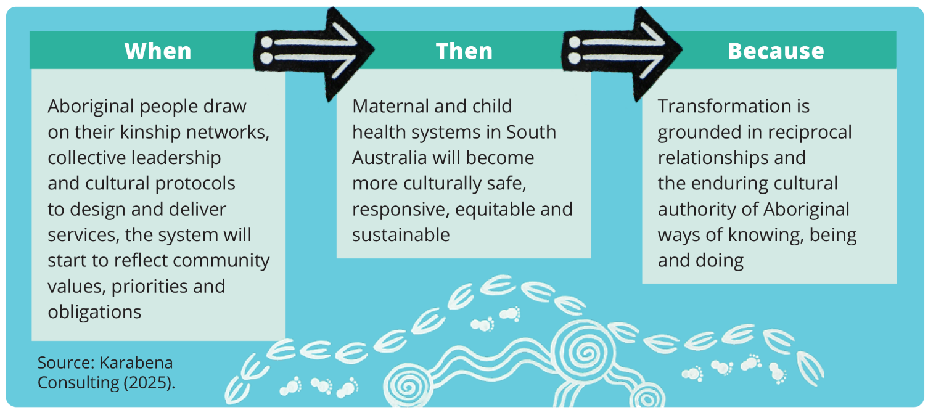
The process involved an initial research phase before moving into co-design. The co-design process involved three phases, from the drafting of protocols to testing in preparation for implementation (figure 2).
Figure 2 – Continuity of Care Protocols (CCP) co-design processª
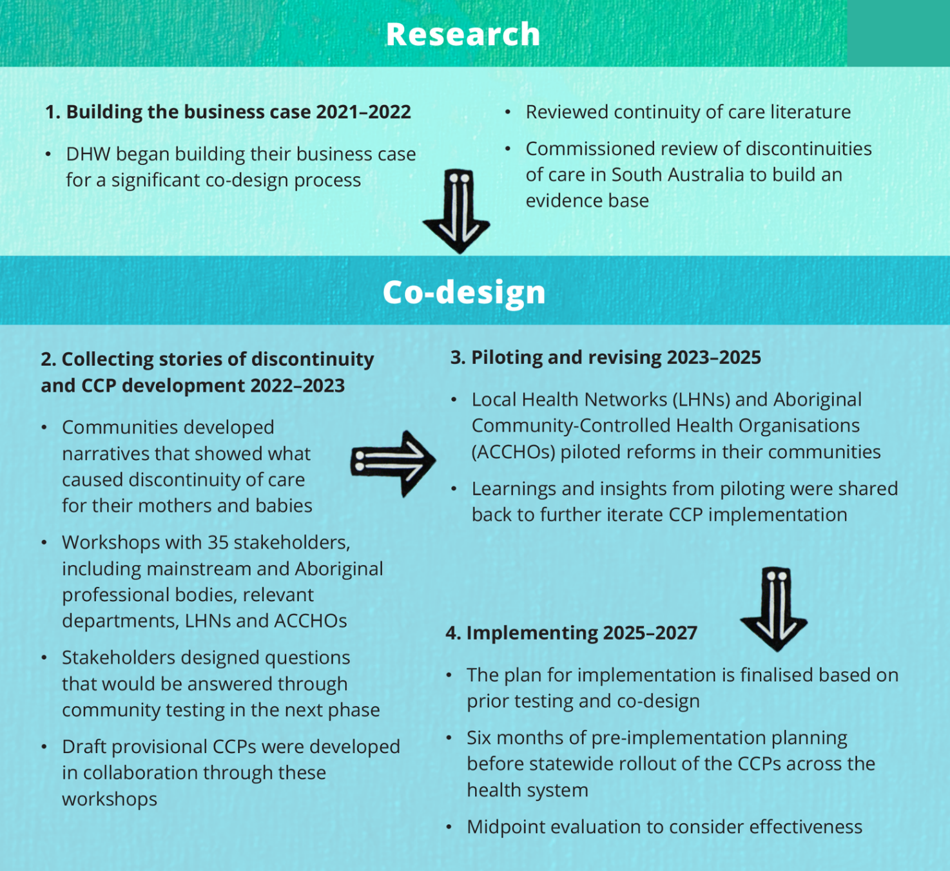
a. At the end of the second phase, a series of testing networks were established. Networks were made up of LHNs and ACCHOs and were used to test key reforms with their communities.
Source: Adapted from DHW (2025).

Transformative action aligned with PR3

Prioritising Aboriginal leadership ensures shared decision-making is grounded in culture
Clear governance is key to making co-design and its outputs effective and sustainable (Karabena Consulting 2024, p. 9). It helps balance power, ensures the right people are in the room to advance effective reform, and enables local decision-making.
During the CCP development phase, DHW worked with over 35 national and state-based stakeholders to develop a set of questions that would form the basis of reforms tested within Child and Maternal Health CCP networks. The 35 stakeholders were consulted during this time to inform the development of provisional CCPs.
After this phase concluded, DHW identified five out of the 10 South Australian LHNs, together with ACCHO representatives from the South Australian West Coast ACCHO Network, Nunkuwarrin Yunti of South Australia, and Pangula Mannamurna Aboriginal Corporation, to partake in the co-design process. These organisations were selected to ensure protocols were tested in a variety of settings, based on maternal and child population data, level of remoteness, and where partnerships existed between LHNs and ACCHOs. These same organisations were funded to test reforms with their community and formed the membership of the seven working groups, each led by an Aboriginal chairperson. Sector experts involved included:
- The National Association of Aboriginal and Torres Strait Islander Health Workers and Practitioners (NAATSIHWP)
- The Congress of Aboriginal and Torres Strait Islander Nurses and Midwives (CATSINaM)
- The Australian Indigenous Doctor’s Association (AIDA)
- The Aboriginal Health Council of South Australia (AHCSA).
The program, including the working groups, were intentionally designed to enable sustainability. Through the leadership and decisions of the seven working groups, reforms were aimed at improving the system while ensuring Aboriginal leadership and culture were embedded at every level.
In the CCP Program, enabling shared decision-making initially proved challenging. Seven working groups were authorised to make decisions on the design of the program, but final sign-off still sat with the Steering Group. The Steering Group was made up of system leaders from across sectors, including partner organisations. Members were recommended by the Chief Aboriginal Health Officer and by key stakeholders involved in the development phase. This structure posed a risk to co-design as Steering Group members had the opportunity to overrule working group decisions, which were based on community insights. The risk was managed by having consistent membership between the working groups and Steering Group. This was often in the form of working group chairpersons or the DHW Program Manager who had oversight of all working groups. As a result, decisions presented to the Steering Group were contextualised and understood. DHW acknowledged that while the approach to power sharing was not perfect, it provided an opportunity for learning and improvement in shared decision-making.

A relational approach to commissioning supports capacity-building and a focus on outcomes
A relational approach that values and enables partner expertise is foundational for co-design (Karabena Consulting 2025b, p. 10). This means embedding partnership at each phase of the commissioning process: co-designing agreements, building partner capacity, developing meaningful reporting templates and managing progress together. In this case, partner organisations were contracted to engage with their communities to understand where challenges existed in accessing continuous care, test and pilot key reforms, share community feedback in working groups and endorse decisions that reflected their community’s experiences.
The contracting process emphasised a relational approach over a transactional one. DHW spent two months co-designing an approach with partners prior to the piloting phase starting. This time was spent identifying which of the testing questions partners were going to explore with their communities. Once focus areas were identified, officials from DHW provided their partners with control over how they participated and their agreement design. They started by asking partners ‘what do you need?’ rather than pushing a template approach. Partners recognised and valued the shift in government practice – from being told what resources they would receive to being asked what is needed.
DHW also asked whether partners would like to participate in the working groups as a member, lead or a chairperson. Where particular expertise was recognised, DHW invited individuals to contribute as a chairperson. Partners ultimately controlled the role they had in the process and led talks on the resources they needed and what mattered most to their community. Partners also defined their own measures of success centred on participation (Karabena Consulting 2025a, p. 8). While some outcomes informed program monitoring and evaluation, others were relational in nature, reflecting shared goals rather than contractual obligations.
Together, these measures signalled a shift away from compliance-based performance indicators towards culturally meaningful outcomes, including increased trust, continuity of care and emotional and cultural safety. For DHW, this required them to slow down, listen and let go, marking a significant cultural shift within government. Agreements also included responsibilities for DHW, providing accountability for the commitment to work as partners to co-design reforms. Reporting templates were co-designed, turning agreements into tools for shared responsibility rather than compliance. Flexible agreements reduced metrics of activity-based funding and instead moved to shared accountability based on an agreed set of shared outcomes.
Guided by senior Aboriginal leaders within, DHW staff took a patient, side-by-side approach to progressing the design of the CCP Program. Staff supported partners to navigate government processes, develop project plans and manage underspends. Consistent with this partnership approach, progress discussions were seen as a collaborative effort and focused on what could be achieved together. This reinforces shared accountability and a commitment to walking alongside partners every step of the way. Partners reflected that DHW understood the need to ‘be uncomfortable, slow down and do the right thing, not the easiest thing’ (Karabena Consulting 2025b, p. 10).

Building and maintaining a culture of co-design grounded in Aboriginal methodology
For Aboriginal partners, co-design is a natural way of working (Karabena Consulting 2025b, p. 11). For governments, clear and shared definitions are needed. DHW and partners define co-design as ‘coming to Community from the start to identify issues, solutions and ways of working together. It’s not about government doing something for and to community. It’s an Aboriginal way of working’ (DHW 2025). The practice of co-design was firmly grounded in Aboriginal ways of knowing, being and doing. Cultural practices including Yarning, Dadirri, art and ceremony were central to the design process and embedded at every stage. DHW’s definition provides clarity and trust by reinforcing that co-design is more than partnership – it is about grounding it in Aboriginal methodology.
Without a shared definition, co-design can mean different things to people (Karabena Consulting 2024, p. 2). Early in the CCP Program, DHW staff saw that government voices were unintentionally dominating, limiting space for community leadership. To address this, DHW actively checked in with quiet working group members to understand why they weren’t speaking. A relational approach was taken to reassure members that their contributions were valued, remind them of the expertise they bring, and to encourage knowledge sharing. The trusted relationships built were a key enabler of success in this process and considered just as important as governance and contracts. However, even with strong relationships in place, the practicalities of how roles and responsibilities were shared were not always well defined. In response, partners created a ‘Ways of Working’ document to embed co-design into actions, ensuring that Aboriginal voices were amplified at every level. This included a commitment to Aboriginal and Torres Strait Islander chairpersons for all working groups and clear processes for shared decision-making. These practices strengthened cultural leadership within the system and marked an important shift from talking about co-design to actively practicing it. The document helps keep government accountable from slipping back into a business-as-usual approach.

Co-design is reshaping the South Australian health system
Co-designing the CCP Program has been called a ‘quiet revolution’ (Karabena Consulting 2025b, p. 11). What began as a response to gaps in care for mothers and Aboriginal babies has grown into a model of ongoing co-design that will be embedded into future maternal and child health policy planning and investment frameworks in South Australia (Karabena Consulting 2025b, p. 13).
In 2024, DHW commissioned an independent evaluation of the co-design process. Crucially, evaluation scope and brief were also co-designed with partners to focus on their areas of interest, reinforcing accountability and trust amongst partners. The evaluation has been an important tool for DHW staff and partners to reflect on strengths and areas for improvement within the co-design process. The evaluation found that the design process has helped to build a connected network of senior leaders from community, ACCHOs, mainstream health services, government and peak bodies across South Australia. The evaluation also found that the co-design process has increased the level of coordination across the state that will endure beyond the program, while also strengthening cultural leadership, agency and voice. Partners now see an opportunity for embedding and expanding this design model into other parts of the South Australian health system (Karabena Consulting 2025b, p. 13).
While broader health outcome data is still emerging, early results show promise. Aboriginal mothers and families have expressed feeling heard and empowered through CCPs shaped by cultural knowledge holders (Karabena Consulting 2025b, p. 11). The case shows how a series of deliberate steps taken in partnership can lay the groundwork for long-term, Aboriginal-led, systemic transformation.

References
DHW 2025, ‘Interview on the South Australian Continuity of Care Protocols Program’.
Health Performance Council [South Australia] 2020, Institutional racism – audit of South Australia’s local health networks.
Karabena Consulting 2024, South Australia Department of Health and Wellbeing Maternal and Child Health Evaluation Co-Design and Data Dictionary: A Living Document.
—— 2025a, Co-Design Program Logic.
—— 2025b, Outcomes Report: End-of-Phase Forum – Aboriginal-led Co-Design in Maternal and Child Health, South Australia, June.
PC (Productivity Commission) 2024, Review of the National Agreement on Closing the Gap, Study report, vol. 1, Canberra.
Reid, R, Haggerty, J and McKendry, R 2002, Defusing the Confusion: Concepts and Measures of Continuity of Healthcare, March.
SAHMRI (South Australian Health and Medical Research Institute) 2022, Systems change to improve Aboriginal and Torres Strait Islander maternal and child health continuity of care in South Australia.

NSW Closing the Gap budget submission:
a case study in co-developing budget proposals

Key points
- Aboriginal and Torres Strait Islander people are best placed to identify the needs and priorities of their communities, but budget decisions are largely made by governments.
- Working in partnership with Aboriginal and Torres Strait Islander people and organisations through shared governance structures, governments can share decision-making in budget development.
- With appropriate support, Aboriginal and Torres Strait Islander people and organisations can participate as equal partners in developing and prioritising business cases for budget submission.
- Budget processes present limits to shared decision-making that require active and sustained support from ministers, secretaries, and agency staff to create an authorising environment for collaborative budget development.
- To encourage collaborative policy and budget design processes as business-as-usual, governments should consider co-developing shared decision-making structures, updating submission guidance and increasing transparency in funding decisions and outcomes.
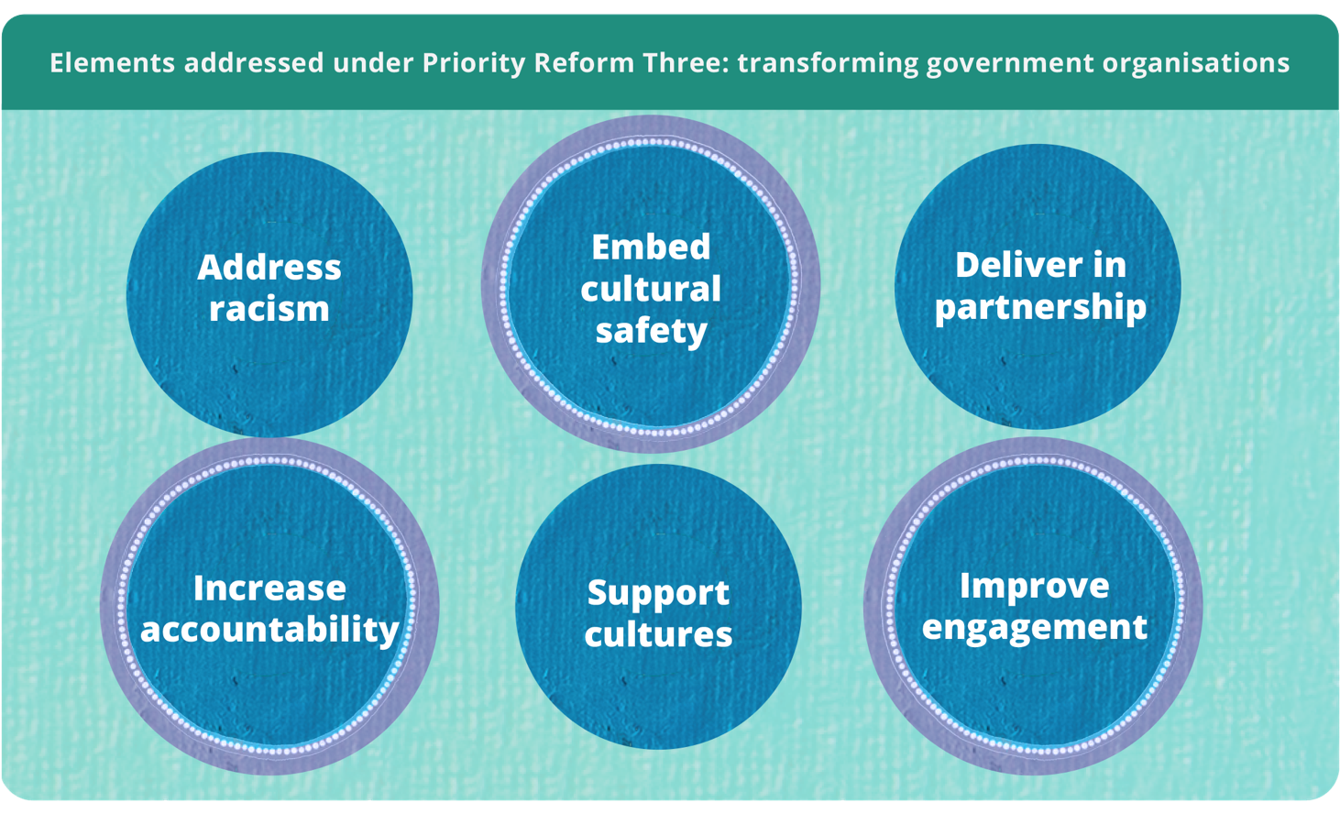

The need for collaborative policy design to inform budget decisions
Implementing the Priority Reforms of the National Agreement on Closing the Gap (the National Agreement) requires resolving a key tension. Aboriginal and Torres Strait Islander people are best placed to identify the needs and priorities of their communities yet funding decisions are made in internal, often confidential government processes and committees (PC 2024, p. 12). While community input is possible, final funding decisions ultimately rest with governments.
Alive to this challenge, the NSW Government, together with the NSW Coalition of Aboriginal Peak Organisations (NSW CAPO), has pursued a significantly different way of working under the National Agreement. Using Closing the Gap governance structures developed through their partnership, the NSW Premier’s Department (NSW PD) and NSW CAPO, with technical support from NSW Treasury, came together to co-design a Closing the Gap cross-portfolio submission approach for the 2022-23 NSW Budget. This resulted in $188.6 million in funding for 28 initiatives co-designed by NSW CAPO members and relevant agencies.
This model demonstrates how governments can adopt a coordinated partnership approach, embedding Aboriginal and Torres Strait Islander voices into policy design before proposals entered government budget processes. Aboriginal Affairs NSW (AANSW) and NSW CAPO revisited this model for a second cross-portfolio submission to the 2025-26 budget, with refinements made to the approach from lessons learnt from the 2022-23 process. To support collaborative processes like these across agencies, NSW Treasury introduced a suite of guidance under the First Nations Budget Model in 2024.

The policy design process was community initiated and
co-designed
The 2022-2024 NSW Closing the Gap Implementation Plan agreed to by NSW Government and NSW CAPO set out how both parties planned to meet commitments under the National Agreement (NSW Government 2022, pp. 26-127). In recognition of the need to work collaboratively to reflect the needs and priorities of Aboriginal and Torres Strait Islander communities, NSW PD and NSW CAPO agreed to develop a cross-portfolio Closing the Gap submission for the 2022-23 NSW Budget. The Minister for Aboriginal Affairs sponsored the approach and NSW Treasury provided technical guidance and support. Bringing together initiatives under a cross-portfolio submission helped advance Closing the Gap priorities. Developing the budget submission in partnership aligned the process with Priority Reform One and Priority Reform Three of the National Agreement.
Budget processes can be complex to navigate and aligning community input within government timeframes poses challenges. One challenge encountered in the 2022-23 NSW Budget cycle was the work of designing and implementing a new policy design process in less than six months (figure 1). This placed considerable demands on the time and resources for all involved and limited opportunities for deep engagement and decision-making. Even with the prior experience of the first iteration, this was also an issue for the 2025-26 budget submission. A key takeaway from this was to start submission planning earlier, allowing for at least a 10-month collaboration window rather than a six-month window.
Figure 1 – Timeline of the cross-portfolio Closing the Gap 2022-23 budget bidª
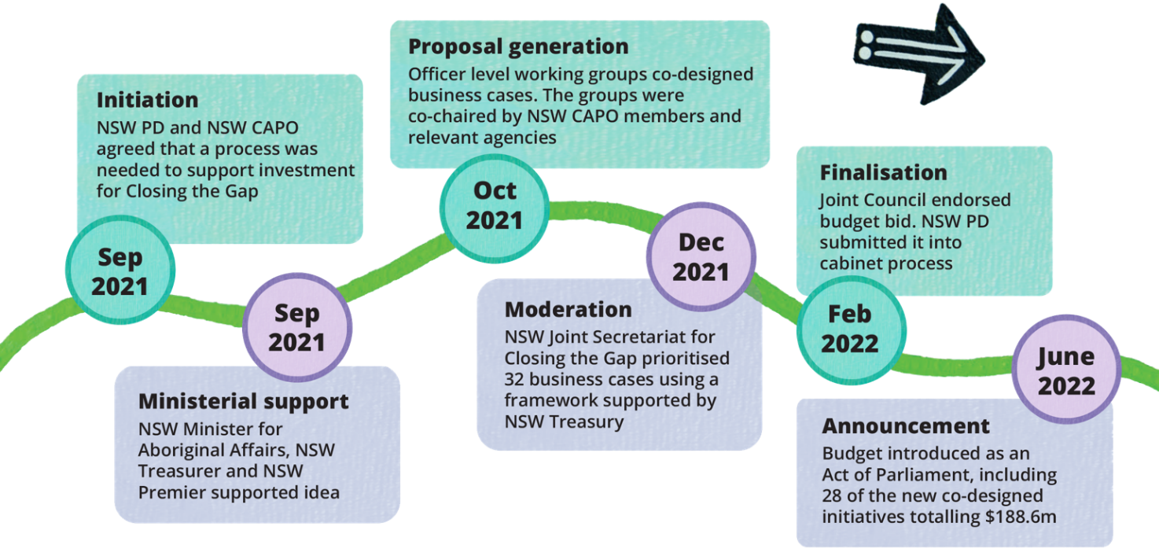
a. The process to feed into the 2025-26 budget followed a similar timeline.
Source: NSW Government (2023); NSW Treasury (personal communication, 5 August 2025).

Transformative changes aligned with Priority Reform Three

True co-design requires supporting partners to navigate government processes
In 2022-23, existing Closing the Gap governance structures in NSW were used to bring NSW CAPO members and relevant government departments together to develop and prioritise policy and program ideas for funding (figure 2). For the 2025-26 budget cycle, the process matured. Policy area-specific and officer-level working groups were replaced with five sector committees (Aboriginal Affairs NSW 2025). This ensured the membership contained the appropriate level of seniority. It also reduced siloes, bringing together related agencies and better suiting NSW CAPO partners. Sector committee co-chairs were also tasked with moderation and prioritisation processes.
A prioritisation framework was developed to ensure all business cases supported new ways of working in line with the NSW Government’s Priority Reform commitments. As a tool, it provided a transparent way of short-listing business cases based on how closely they aligned with the National Agreement. For the 2025-26 process, a probity advisor was present to oversee the policy prioritisation process, and the Prioritisation Framework was updated to include more detailed criteria. This ensured that business cases would comply with NSW Treasury evidence requirements.
While bringing together expertise from all parties is important, developing effective budget submissions requires specific skills and knowledge. For both the 2022-23 and 2025-26 processes, the lead agency (NSW PD and AANSW respectively) worked closely with NSW CAPO and its members to help navigate government processes and timeframes. In addition, NSW Treasury provided support in the form of presentations, guidance packs, business case templates and advice to support both NSW CAPO members and government staff to build understanding of the budget process and evidence requirements. These supports helped strengthen the capability of community partners to engage in the policy design process.
Figure 2 – Governance and supports for shared decision-making for 2025-26 budget
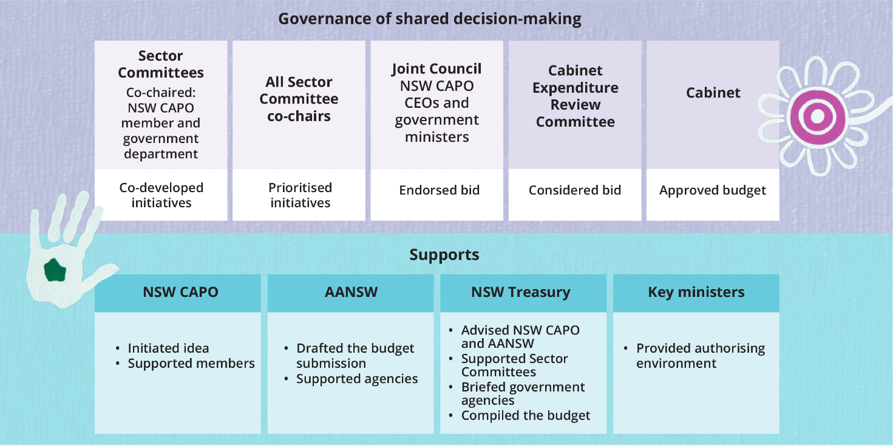
Source: Aboriginal Affairs NSW (pers. comm., 23 June 2025).

Budget processes present limits to shared decision-making that must be proactively managed
While NSW CAPO and the NSW Government made considered efforts at each stage of policy design to share leadership and decision-making, budget decisions are ultimately made by Cabinet, based on recommendations by the Cabinet Expenditure Review Committee. This highlights the tension between commitments to shared decision-making and the realities of government budget processes.
Support from ministers and secretaries provided an enabling authorising environment. Leadership from central agency teams – NSW Treasury, AANSW and the broader Premier’s Department, and the Cabinet Office – was key to the success of the collaborative policy development process in both the 2022-23 and 2025-26 cycles.
Collaborative working groups and effective communication are valuable for building support among senior government officials and ministers, helping to secure buy-in for new ways of working. However, as with any new process, there are barriers to navigate. To work through some of these, the 2025-26 process introduced measures to strengthen clarity, transparency and accountability. Partners set clearer expectations that only proposals developed through NSW’s Closing the Gap governance structures would be considered for the Closing the Gap budget submission. This helped distinguish Closing the Gap initiatives from other Aboriginal and Torres Strait Islander-specific funding proposals. Governance arrangements were also tightened to ensure all bids had co-sponsorship from both NSW CAPO and the NSW Government.
In addition, within the constraints of Cabinet-in-confidence, AANSW took an active role in keeping NSW CAPO informed, facilitating ministerial meetings ahead of Expenditure Review Committee discussions and sharing outcomes prior to public announcement. This shows that even within the constraints of government decision-making processes there are opportunities to strengthen transparency, accountability and collaboration with Aboriginal and Torres Strait Islander partners.

This experience has laid the foundation for a more collaborative budget
This case study demonstrates how governments can modify budget proposal development to align with the Priority Reforms. This is an ongoing transformation which relies on coordination and commitment over time rather than isolated trials. It benefits from the strengthened capacity, relationships and trust between the NSW Government and NSW CAPO that has developed through sharing power over policy and budget development.
The experience and learnings from these processes provide a foundation for future shared decision-making. NSW CAPO and NSW Government are now exploring how to develop an ongoing approach to partnership-based budget submissions, with the aim of embedding these practices into business-as-usual processes going forward.
To encourage this way of working across agencies, NSW Treasury officials are developing and implementing a ‘First Nations budget model.’ It intends to embed the Priority Reforms in the budget process. Under this model, several areas of change are underway.
- Evidence requirements. A NSW First Nations Investment Framework guides departments and agencies in working with Aboriginal and Torres Strait Islander people and communities to design, appraise and evaluate initiatives (NSW Treasury 2024b). The Framework provides guidance to agencies on embedding partnership-based approaches for policy design and lifting the quality and appropriateness of evidence.
- Budget processes and advice. First Nations Impact Assessments have been introduced in NSW for new policy proposals that are specific to, or have a significant or disproportionate impact on, Aboriginal and Torres Strait Islander people or communities (NSW Treasury 2024c). These assessments consider the extent to which Aboriginal and Torres Strait Islander voices have been included in the policy design and development. This informs the likely effectiveness of the proposal and supports more informed decision making.
- Transparency and reporting. NSW Treasury is delivering on its Closing the Gap commitment to better identify and more effectively report on Aboriginal and Torres Strait Islander-relevant expenditure. This includes improving data collection for the Indigenous Expenditure Report and publishing a map of capital expenditure in Local Aboriginal Land Council regions (NSW Treasury 2024a). These initiatives align with Priority Reforms Two, Three and Four by strengthening accountability to Aboriginal and Torres Strait Islander communities and building an evidence base for improved policymaking.

References
Aboriginal Affairs NSW 2025, NSW Closing the Gap Governance.
NSW Government 2022, 2022–2024 NSW implementation plan for Closing the Gap, NSW Government.
—— 2023, Submission to the Australian Government Productivity Commission review of the National Agreement on Closing the Gap, no. 32, Productivity Commission.
NSW Treasury 2024a, 2023-24 NSW Indigenous Expenditure Report, NSW Treasury.
—— 2024b, First Nations investment framework summary TPG24-28, NSW Treasury.
—— 2024c, TPG24-26 policy and guidelines: First Nations impact assessment policy, NSW Treasury.
PC (Productivity Commission) 2024, Review of the National Agreement on Closing the Gap, Study report, vol. 1, Canberra.

CSIRO Indigenous Science and Engagement Program:
building capability to engage and partner well

Key points
- Embedding Aboriginal and Torres Strait Islander leadership and governance at the organisation, unit and project level supports an Indigenous lens on policies, practices and processes that drive changed ways of working.
- Creating pathways to develop and support Aboriginal and Torres Strait Islander talent can help increase representation across the research and development sector.
- Good practice in Indigenous research collaboration means showing up without pre-set ideas. This means working together to co-design research that meets the priorities, interests, and aspirations of Aboriginal and Torres Strait Islander communities.
- Embedding Free, Prior and Informed Consent (FPIC) and Indigenous Cultural and Intellectual Property (ICIP) principles in all phases of research builds researcher capability and protects community interests.
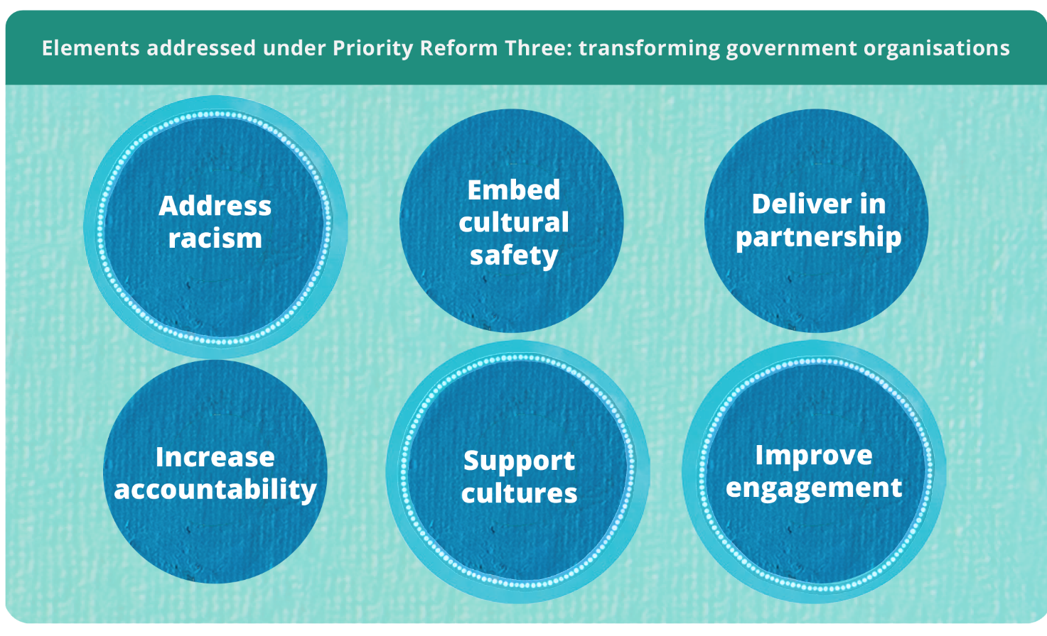

Supporting Aboriginal and Torres Strait Islander knowledges requires transforming research systems
Australia’s National Science Statement coordinates science policy, leadership and investment across governments to support innovation, economic growth and improved quality of life (DISR 2024b). A key research priority supporting the statement is elevating Aboriginal and Torres Strait Islander knowledge systems to drive innovation and ensure communities lead and benefit from research that impacts them (DISR 2024a). This requires embedding Aboriginal and Torres Strait Islander knowledges and perspectives across Australia’s science and research system. For the over 30 Australian government departments, agencies and regulators with a science capability, this means transforming research governance, funding, practices and workforce development to protect and elevate Aboriginal and Torres Strait Islander knowledges (Australian Government, Australia’s Chief Scientist 2024; DISR 2024a).
The way science is organised, governed and funded can encourage an approach to research that centres the interests of the scientist and reinforces siloed ways of working within established academic disciplines (DISR 2024b, p. 5). This privileges certain knowledges, knowledge holders and knowledge systems and discourages research collaboration and translation for community benefit (Woodward et al. 2020, p. 108). This case study shows how the Commonwealth Scientific and Industrial Research Organisation (CSIRO) is changing its ways of working to centre the knowledge and priorities of Aboriginal and Torres Strait Islander people, communities and organisations. CSIRO shows how government funded research institutes, in alignment with the National Agreement on Closing the Gap (the National Agreement), can value and support Aboriginal and Torres Strait Islander science and scientists.

Research with Aboriginal and Torres Strait Islander people must centre on community priorities and benefits
In 2019, at CSIRO, a group of Aboriginal and Torres Strait Islander scientists, along with non-Indigenous colleagues, saw a gap in the way research with Aboriginal and Torres Strait Islander communities was approached. They co-developed with an external Indigenous reference group, the case that CSIRO needed to move from a ‘science push’ approach where research is directed by a scientist’s key area of capability or scientific expertise, to an approach centred on community priorities and benefits. They proposed CSIRO leverage its unique position, capabilities, and infrastructure across science and industry to design a cross-cutting organisational approach to recognising, prioritising and responding to Aboriginal and Torres Strait Islander communities’ knowledge and interests.
Following the scientists’ successful pitch, the Indigenous Science and Engagement Program (ISEP) was established in 2021, with funding of $26 million over 5 years (2021–2026), to deliver a strategic, organisation-wide approach to partnering with Aboriginal and Torres Strait Islander communities and organisations (CSIRO 2024b, p. 13). ISEP shows the commitment of senior leaders to investing in transformed processes using internal funding and resources. In addition to core internal funding, ISEP activities have also been resourced through diverted funding, which required senior leaders to review CSIRO expenditure and make trade-offs from other business areas to prioritise investing in Aboriginal and Torres Strait Islander science capability.
To inform ISEP’s work, CSIRO engaged in deep listening, both internally and externally, to understand the tangible things CSIRO could do to value and support Indigenous science. Ideas shared in these engagements were used to develop a strategic approach to reform CSIRO’s research governance, engagement, funding, communications, and workforce to build capability to support Aboriginal and Torres Strait Islander-led and driven research solutions.

Embed Aboriginal and Torres Strait Islander knowledges through leadership and advisory groups
As outlined in the National Agreement, governance and leadership by Aboriginal and Torres Strait Islander people is critical to identifying and addressing systems that disadvantage Aboriginal and Torres Strait Islander communities, knowledges or perspectives (Australian Government 2020). To achieve this, CSIRO established Aboriginal and Torres Strait Islander leadership and advisory functions at each level of its governance structure to influence, review and dig deeper into their internal processes, practices and procedures. At the senior leadership level, Dr Chris Bourke, a Gamillaroi man and Director of CSIRO’s Indigenous Science and Engagement team is also the first Aboriginal member of CSIRO’s Leadership Team. In 2023, CSIRO appointed the first Indigenous scientist to its board: Professor Alex Brown from the Yuin Nation.
In 2013 the Indigenous Advisory Group (IAG) was formed to ensure CSIRO’s research and engagement addresses the challenges and aspirations of Aboriginal and Torres Strait Islander communities (CSIRO 2021, p. 6). The IAG provides CSIRO leadership with essential perspectives and understandings of the cultural, social and economic issues facing Aboriginal and Torres Strait Islander communities (CSIRO 2024c). The IAG has been instrumental in guiding the launching of initiatives like the Indigenous Research Grants and Graduate programs; programs that are designed to increase Aboriginal and Torres Strait Islander participation in science and research (CSIRO 2024c, p. 17).
In addition to the IAG at the organisational level, currently 40% of CSIRO’s Research Units have advisory groups with Aboriginal and Torres Strait Islander representation with relevant expertise (CSIRO 2024b, p. 22). Embedding Aboriginal and Torres Strait Islander representation within research advisory groups enables Indigenous voices, perspectives, and insights to inform CSIRO’s research work, particularly as it pertains to research collaborations and engagement with Aboriginal and Torres Strait Islander communities. This contributes to the development of the Unit’s cultural capability, which sets the tone for culturally respectful, appropriate, and safe engagement with Aboriginal and Torres Strait Islander people as both participants and collaborators.

Employment pathways support development of Aboriginal and Torres Strait Islander scientists
Strong Aboriginal and Torres Strait Islander leadership and governance relies on amplifying Indigenous voices, ensuring self-determination and creating a culturally safe and empowering workplace pathway for scientists and future scientists. Recognising this, CSIRO appointed an Indigenous Employment Lead in 2021 to:
- provide strategic direction and support for Aboriginal and Torres Strait Islander employment
- strengthen cultural safety across the organisation
- build pathways for leadership and career progression.
The Lead updated CSIRO’s Indigenous Employment Strategy to position CSIRO as an employer of choice for Aboriginal and Torres Strait Islander people, to strengthen retention, leadership and cultural safety across the organisation (CSIRO 2024a). This positions CSIRO as a national leader in Indigenous STEM capability and builds a pipeline that enables Aboriginal and Torres Strait Islander people to drive innovation for the nation.
The Indigenous Employment Lead works in close partnership with ISEP leadership to help shape CISRO Indigenous science capability. Together, they ensure Aboriginal and Torres Strait Islander scientists and research scientists are supported not only through employment pathways, but also through frameworks that recognise and elevate Indigenous Knowledges alongside Western science.
Aboriginal and Torres Strait Islander people bring unique capabilities to lead innovation for the nation drawing on Indigenous Knowledges that can shape new approaches to science, technology and community impact. However, Western systems of recognition often privilege doctorate qualifications as the gateway to senior roles, creating barriers for many Aboriginal and Torres Strait Islander people to obtain leadership positions. To address this, CSIRO, established the Research Development Graduate Program and Pre-Doctoral Fellowship program. This program provides Aboriginal and Torres Strait Islander participants with structured employment while undertaking Honours or Higher Degrees by Research (HDR). The Graduates and Fellows are allocated dedicated time to progress their studies while contributing to research-related activities as part of their teams.
Since its inception, the programs have engaged 40 Indigenous university graduates and supported 25 participants to undertake an Honours, Masters or HDR program as part of their placement with CSIRO (CSIRO, personal communication, 26 September 2025). Through these initiatives, CSIRO provides opportunities to increase the representation and leadership of Aboriginal and Torres Strait Islander scientists and research scientists for the nation.
The impact of this work can be seen in the growth of CSIRO’s Indigenous workforce. Since June 2021, Aboriginal and Torres Strait Islander staff have increased by 95% to make up 2.54% of the current workforce as at 30 June 2025 (CSIRO, personal communication, 26 September 2025).

Research grants must enable relationship building
Traditionally, research grants are structured to fund fully scoped research projects, with little opportunity to develop trust and build meaningful relationships with Aboriginal and Torres Strait Islander communities. The Indigenous Research Grants Program (IRG) was internally developed to guide and encourage CSIRO researchers to build relationships with Aboriginal and Torres Strait Islander communities and deliver research that addresses their priorities. All aspects of the program are Indigenous-led, from design and implementation to assessment and ongoing management. In its first year, the IRG Program completed three grant rounds, approving over 30 applications and allocating $6 million in funding (CSIRO 2024b, p. 40).
It is an expectation that an IRG project will be further scoped and co-designed with Aboriginal and Torres Strait Islander communities or organisations. These partnerships range across small-, medium- and large-scale multidisciplinary projects (CSIRO 2024b, p. 40). For example, one type of funding provided by the IRG Program is ‘exploratory funding’, which can be used by researchers to travel to communities to develop relationships and understand their needs. The prioritisation of benefit is also embedded within IRG funding applications; the CSIRO researchers are required to show through their budget and project plans how the benefit of research will stay with communities and how this reflects community’ priorities. At the time of application, researchers must have endorsement from communities confirming their support to work with the researcher.
IRG funding also supports capability building for Aboriginal and Torres Strait Islander businesses and communities. The funding enables businesses and communities to work on their own terms when partnering with CSIRO to develop critical projects that build skills, apply solutions, and create long-term economic opportunities that extend beyond the life of the funding. An independent review conducted in 2023 found that the program exemplifies best practice for grants where Aboriginal and Torres Strait Islander people are integral as participants and business partners. The review highlighted the program’s potential for far-reaching positive impacts on Indigenous science and engagements with CSIRO (CSIRO 2024b, p. 40).

Formal principles guiding research with Aboriginal and Torres Strait Islander communities build capability and protect community interests
CSIRO supports scientists to develop the skills, knowledge, attitudes and practices that enable respectful and effective engagement with Aboriginal and Torres Strait Islander communities and supports Aboriginal and Torres Strait Islander communities to partner meaningfully with CSIRO.
The elements of Free, Prior and Informed Consent (FPIC) are embedded at each stage of CSIRO’s research collaborations and partnerships, ensuring that communities set the terms of their engagement with CSIRO. FPIC is not merely informing and obtaining consent. It is about effective and meaningful participation to ensure the best decision-making for sustainable outcomes – this is especially important given that a focus of Aboriginal and Torres Strait Islander-led science is to have ongoing, long-term benefits for community (AIATSIS 2020).
The ISEP team are also focused on the delivery of CSIRO’s Reconciliation Action Plans. This includes building the capabilities of CSIRO people through CSIRO’s Cultural Capability Framework and ensuring CSIRO’s internal policies, systems and processes respond to the needs of Aboriginal and Torres Strait Islander people. In 2023, ISEP led the development of CSIRO’s Indigenous Cultural and Intellectual Property (ICIP) Principles which are now part of CSIRO governance processes.
To support science that is centred around community, ICIP Principles are also embedded through each stage of CSIRO’s research process. The principles are intended to support Aboriginal and Torres Strait Islander control, decision-making, governance, participation and collaboration in research. ISEP regularly reports to the IAG on performance against these principles. CSIRO works closely with research collaborators to ensure the principles reflect evolving standards for managing and protecting ICIP, and that engagement with communities aligns with best practice.
Intentionally building in space and time throughout the stages of engagement and partnership to include FPIC and ICIP ensures that partnerships are founded in mutual trust, respect and inclusion and are led by Aboriginal and Torres Strait Islander communities.

Changing the course in line with Priority Reform Three
CSIRO’s transformation journey, led by ISEP, has significantly reshaped research practices across the organisation. Through ISEP, CSIRO has moved beyond ad-hoc engagement to a model of established internal hubs, curated resources, and targeted education to embed Aboriginal and Torres Strait Islander perspectives into a wide variety of science partnerships funded by the organisation. These initiatives are not peripheral – they’re central to incorporating an Aboriginal and Torres Strait Islander lens across CSIRO’s standard operating procedures.
ISEP shows what it can look like when agency is given back to Aboriginal and Torres Strait Islander people and communities to set research priorities, lead decision-making, and define success on their terms.
This underscores the urgent need for all mainstream government organisations to align their practices with their commitments under the National Agreement. Doing so will support equitable inclusion in research policy, funding and design to deliver long-term economic benefit and outcomes to community.

References
AIATSIS (Australian Institute of Aboriginal and Torres Strait Islander Studies) 2020, Engaging with Traditional Owners.
Australian Government 2020, Closing the Gap, Priority Reform Three – Transforming Government Organisations, July.
Australian Government, Australia’s Chief Scientist 2024, Government Scientists Group, www.chiefscientist.gov.au/advice/government-scientists-group.
CSIRO 2021, Reconciliation Action Plan December 2021 – December 2023.
—— 2024a, Aboriginal and Torres Strait Islander employment strategy.
—— 2024b, Indigenous Collaboration and Partnerships 2023-24.
—— 2024c, Stretch Reconciliation Action Plan, October.
DISR (Department of Industry Science and Resources) 2024a, Australia’s National Science and Research Priorities, 12 August.
—— 2024b, Australia’s National Science Statement, 12 August.
Woodward, E, Hill, R, Harkness, P and Archer, R 2020, Our Knowledge Our Way in caring for Country, NAILSMA and CSIRO.

Embedding the Priority Reforms in grant design and assessment: The Closing the Gap Health Infrastructure Program

Key points
- The National Agreement on Closing the Gap provides a strong mandate for shared decision-making. Government agencies can support this by formalising partnerships, allowing sufficient time to develop relationships and new ways of working, and sharing data with the community-controlled sector to inform decision-making.
- Legislative and policy settings, including the Public Governance, Performance and Accountability Act 2013 and Commonwealth Grant Rules and Guidelines 2017, support co-design and shared decision-making.
- An external probity advisor can support agencies in designing new governance settings, protocols and processes to share decisions with the community-controlled sector. A focus on what is possible, rather than what has been done before, is crucial.
- Taking a relational approach to working with the community-controlled sector supports continuous policy and program improvement. This enables integration of sector knowledge in grant design that supports appropriate assessment criteria, equitable processes and decisions reflecting lived experience.
- Support for grant applicants, including grant writing assistance, tailored feedback and open communication channels with grant administrators, can strengthen capability and competitiveness of community-controlled organisations over grant rounds.
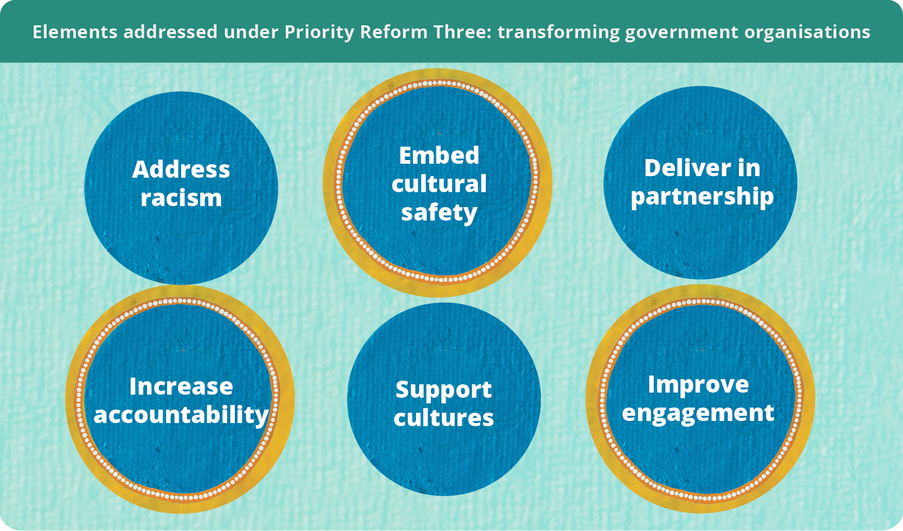
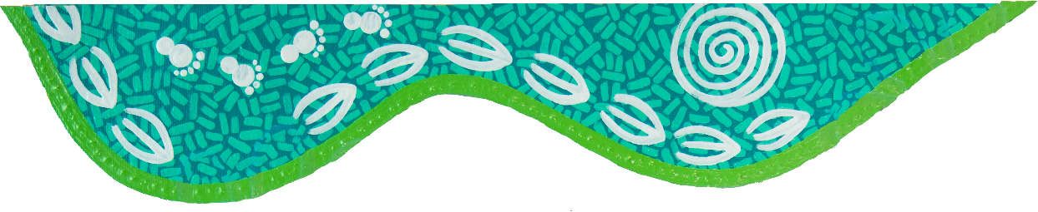

Transforming processes through co-design and shared decision-making
Co-design and shared decision-making recognise the wealth of knowledge Aboriginal and Torres Strait Islander people hold and ensure policy, programs and services reflect this knowledge (SNAICC 2025, p. 4).
Government structures and cultures often challenge these approaches because they are rooted in rigid, self-reinforcing systems that centralise decision-making authority (Blomkamp 2018). Under Priority Reform Three of the National Agreement on Closing the Gap (the Agreement), governments must transform their organisations to enable transparency in decisions, culturally safe processes and services, and improved engagement. Co-design and shared decision-making can facilitate this transformation by identifying where processes need to change and by bringing in the perspectives of people with lived experience. This strengthens the other Priority Reforms by helping governments better understand what barriers are preventing reforms from working and how these can be addressed.
The Closing the Gap Health Infrastructure Program (the Program) shows how governments can change their ways of working to embed partnership, co-design and shared decision-making within existing grant frameworks. The Public Governance, Performance and Accountability Act 2013 (PGPA Act) and the Commonwealth Grant Rules and Guidelines 2017 are sufficiently flexible to support these approaches (PC 2025, p. 2). The PGPA Act (section 17) establishes a positive duty on government officials to encourage cooperation with others to achieve common objectives. Long-standing working relationships and engaging independent probity advice can support program partners to meet this positive duty though shared decision-making. This in turn supports the incorporation of sector knowledge in decision-making so that programs and policies are more culturally informed and responsive to community needs (PC 2024, p. 63).

Setting the foundations for the Closing the Gap Infrastructure Program
The National Aboriginal Community Controlled Health Organisation (NACCHO) and the Australian Government’s Department of Health, Disability and Ageing (the department) have a long history of working together. Strengthened during earlier crises, including the syphilis outbreak and COVID-19, the organisations see their relationship as a foundation for genuine collaboration, marked by flexibility and responsiveness. Their relationship consistently demands the department reflect on its ways of working in line with the Priority Reforms.
NACCHO is a mature organisation, with a strong ability to influence government policy. Recognising a need in the sector, in 2019 NACCHO conducted a national survey of Aboriginal Community Controlled Health Services (ACCHS) to help quantify health infrastructure shortfalls. The survey identified a significant shortfall, of approximately $1 billion, highlighting the need for further investment (NACCHO 2022, p. 42).
In August 2021, the Australian Government announced a $254.4 million, 4-year investment to address seriously deteriorating or non-existent health infrastructure in the ACCHS sector (NACCHO 2022, p. 42). The investment is divided between the Major Capital Works Program and the Service Maintenance Program, collectively known as the Closing the Gap Health Infrastructure Program. Grant opportunities under the Program are open to ACCHSs delivering comprehensive primary health care to Aboriginal and Torres Strait Islander people. Applicants engage in a 2-step application process: first an expression of interest (EOI), then an invitation to apply (ITA).
Grant applicants can draw on supports like grant-writing assistance, with unsuccessful applicants offered tailored feedback to support them in the next round (figure 1).
Figure 1 – Grant opportunity process
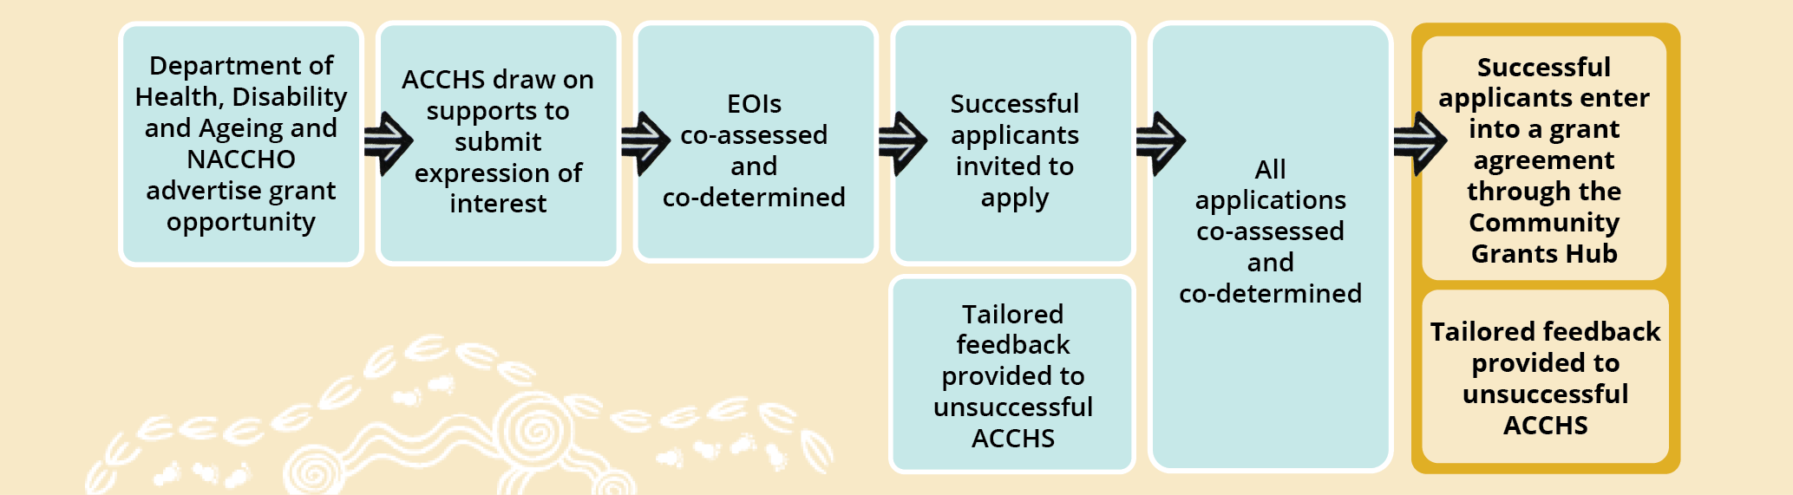
As a key Closing the Gap measure, partners designed the Program to align with the Priority Reforms. NACCHO and the department have equal roles in the design and assessment of the Program (figure 2). This supports transparent and informed decision-making processes and contributes to strengthening the community-controlled sector.
Figure 2 – Design, assessment and decision-making roles and responsibilities
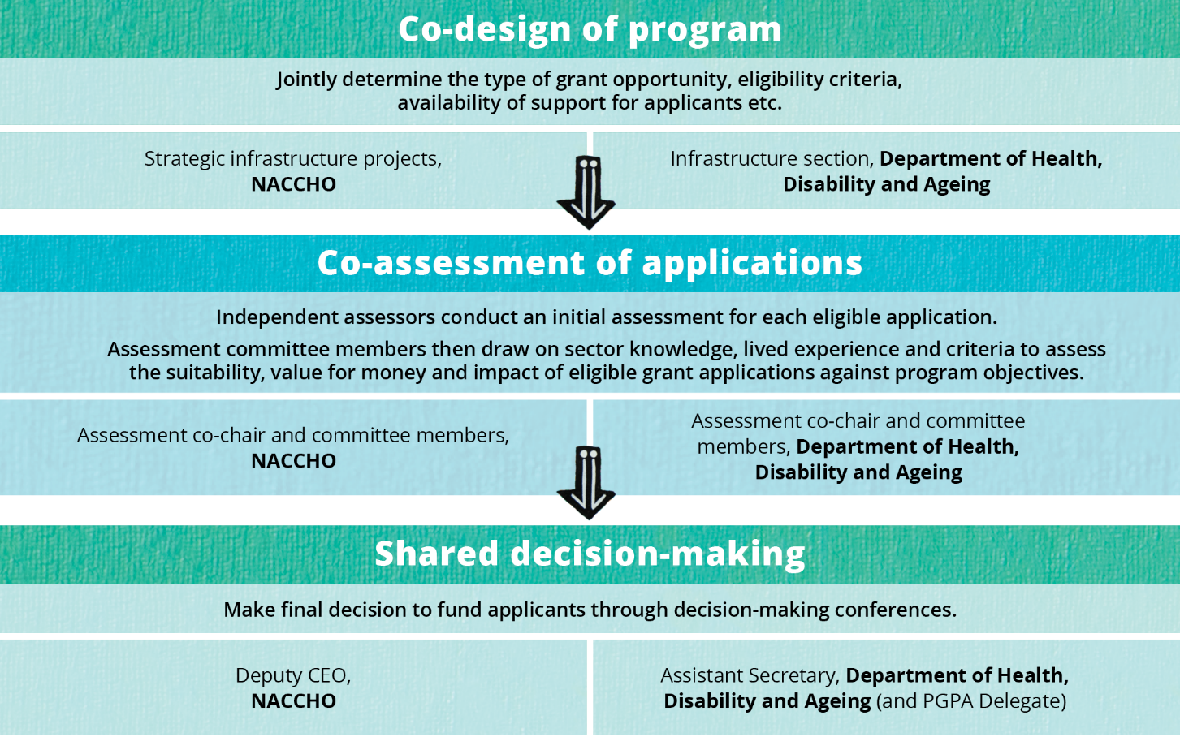

Navigating co-design and shared decision-making

Creating an authorising environment to embed the Priority Reforms in partnership
Successful co-design and shared decision-making require a commitment of time and effort from all involved. While shared decision-making approaches had been increasingly implemented through other programs administered by the department, partners agree the signing of the Agreement provided the authority and confidence to formalise and strengthen this way of working. Equally important was a genuine commitment from both partners to implement the Priority Reforms throughout the Program.
To allow time to navigate co-design together, the department built flexibility into their policy proposal. This involved dedicating time to engage with NACCHO prior to the delivery of a grants program, with grant funding intentionally deferred until year two. During this time, staff from the department and NACCHO worked to develop a trusted relationship to enable frank and honest conversations about scope, division of roles and responsibilities and assessment approaches. Ways of working shifted from a model where proposals were developed by the department for NACCHO’s endorsement, to a collaborative approach where proposals were developed jointly from the outset. NACCHO feels the department genuinely listened, valued their feedback and supported proposed changes.

Engaging external probity advisors to enable shared decision-making
During the design phase, the department engaged an independent external probity advisor to maximise the potential of shared decision-making, ensuring alignment with relevant legislation, policies and guidelines. The advisor played a key role in designing fit-for-purpose arrangements and managing issues such as impartiality and confidentiality without undermining collaboration. Partners reflect that the advisor’s focus on ‘the art of the possible’, rather than precedent and business-as-usual processes, enabled genuine shared decision-making.
This was particularly important given NACCHO’s dual roles as peak body representative and co-decision-maker in the Program. While NACCHO does not benefit directly from the grant opportunity, partners understood the likelihood of conflicts of interest (real or perceived), especially as not all eligible applicants are members of NACCHO. The probity advisor worked with NACCHO to develop a probity plan and a staff training program delivered in conjunction with department staff. The need to disclose and manage conflicts of interest is continuously reinforced. Further, the advisor observed some early assessment meetings to ensure recommendations and decisions made were consistent with published criteria and accurately recorded (O’Connor Marsden & Associates Pty Limited 2024, p. 3).

Transforming grant processes to strengthen the community-controlled sector

Facilitating grant writing support for community-controlled organisations
Grant writing support can enable equitable access to funding and strengthen the community-controlled sector. It can reduce barriers to accessing funding and biases in decision-making (O’Connor Marsden & Associates Pty Limited 2024, p. 3).
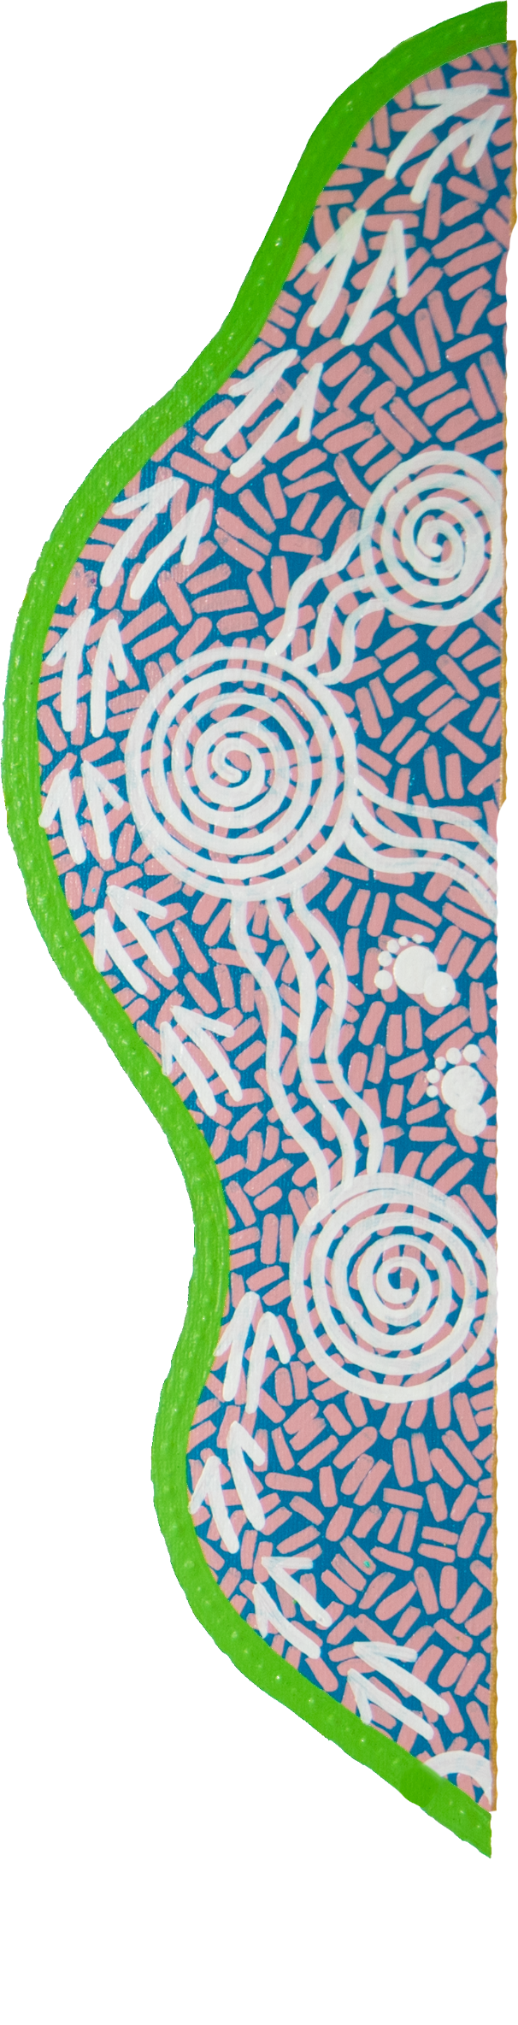
Following discussions between partners, the department procured NACCHO to establish a panel for grant writing support. The department recognises NACCHO is best placed to identify culturally competent panel organisations to provide this support. NACCHO also has the reach to promote this opportunity through targeted webinars and facilitate contact between ACCHSs and their chosen provider. This delivery model provides a level of separation between NACCHO and applicants during the application process, supporting confidence in the impartiality of the service.
Grant writing support is available to ACCHSs that do not consistently have access to staff who can write a competitive grant application. It has been used in different ways across the EOI and ITA stages, from helping organisations navigate the scope of a proposal to conducting a final review of draft applications.
Partners believe the support makes a difference to the quality of writing and how ACCHSs bring out the key points in an application. For example, the pressure to be competitive and show ‘construction readiness’ in an application can contribute to applicants underestimating costs. One way to manage this through grant writing support is by encouraging applicants to be realistic about costings, delivery timelines and project scopes.
Additional funding to help cover planning costs can further support equitable access to grant opportunities, particularly for smaller ACCHSs that could not cover these costs upfront. Partners are working with the sector to develop opportunities for needs assessments to address this.

Co-assessing and co-approving applications to reflect sector experience
Co-assessment and co-approval of grant applications embeds self-determination, cultural safety and fairness by moving decision-making closer to communities. NACCHO’s involvement in key stages of the assessment process supports funding decisions that reflect sector knowledge and lived experience.
During the assessment of the first grant round, some independent assessors made assumptions that were inconsistent with lived experience. This included overlooking the operating environment of certain ACCHSs and their inability to access rental markets. To address this, NACCHO’s executive briefed the assessors on sector context and experience. NACCHO and the department also agreed the assessment committee will review every application regardless of whether they are initially ruled suitable or not.
The use of decision-making conferences is another shift from business-as-usual approaches to the approval of grants. Unlike standard processes whereby the decision-maker or delegate is provided a list of recommendations, decision-making conferences bring together the assessment committee co-chairs with decision-makers to support the decision-making process with real-time interrogation of assumptions
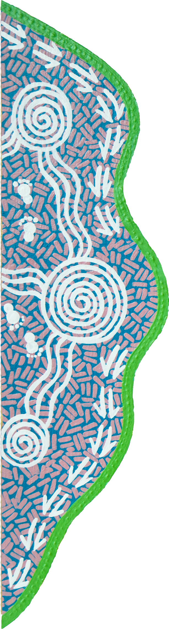
and rationale. They provide a forum for greater discussion and validation, ensuring the assessment committee’s recommendations are clear and defensible. On occasion, the conferences have been used to draw the committee’s attention to sector context or considerations. Despite being a more resource-intensive process, this is an important quality assurance mechanism ensuring funding decisions support policy objectives.

Tailored feedback for unsuccessful applicants to build capability
To support applicants to improve their applications for future grant opportunities, the department and NACCHO offer feedback interviews to all unsuccessful applicants. Interviews are tailored to each applicant, identifying the type of information that would have strengthened their application. Where eligible applicants had not previously accessed grant writing support, they were strongly encouraged to do so. The department reflected that where applicants have taken feedback onboard and reapplied, they often go on to be successful in subsequent rounds.
NACCHO noted these interviews can be challenging from a relational perspective, as NACCHO has to explain why its member organisations are not receiving funding. However, they are considered important in reinforcing accountability to the sector, particularly in the context of highly oversubscribed grant rounds where not all suitable applications can be funded in the first instance.

Leveraging the benefits of co-design across the grant lifecycle
This case demonstrates the value of working with peak Aboriginal and Torres Strait Islander bodies, such as NACCHO, in the design and assessment of grant programs. Early and meaningful involvement of peak bodies helps ensure program settings, assessment criteria and funding decisions are grounded in lived experience.
The department has begun embedding this way of working beyond the Program, including by sharing lessons learned on co-design approaches. This has contributed to changes in process across the Alcohol and Other Drugs Branch, Targeted Health Programs Branch, and Lung Cancer Screening and Cancer Infrastructure Branch, among others.
Extending co-design into the grant establishment and management stages could help ensure delivery requirements and milestones reflect the operational context of ACCHSs. For example, milestones tied to short-term budget cycles often don’t reflect the longer-term agreements required to deliver large infrastructure projects, particularly in regional and remote areas. Ongoing involvement of peak bodies could help anticipate and address these issues, supporting more efficient and effective delivery that better aligns with operational realities.
As of April 2026, 25 of 88 infrastructure projects have been completed. The Australian Government has committed to continuing to address the infrastructure need with an additional $144.1 million investment in the Program over the next two years (Albanese and McCarthy 2026).

References
Albanese, A and McCarthy, M 2026, New investments build on progress in Closing the Gap, Media release, https://www.pm.gov.au/media/new-investments-build-progress-closing-gap (accessed 29 April 2026).
Blomkamp, E 2018, ‘The Promise of Co-Design for Public Policy’, Australian Journal of Public Administration, vol. 77, no. 4, pp. 729–743.
NACCHO (National Aboriginal Community Controlled Health Organisation) 2022, NACCHO Annual Report 2021-22.
O’Connor Marsden & Associates Pty Limited 2024, Probity Report: Indigenous Australians’ Health Program (IAHP) Infrastructure measures, 8 October.
PC (Productivity Commission) 2024, Review of the National Agreement on Closing the Gap, Study report, Vol. 2, Canberra.
—— 2025, Priority Reform Three: Transforming government organisations, Guidance note and case studies Canberra.
SNAICC (SNAICC – National Voice for our Children) 2025, Creating Structural Change Through Shared Decision-Making: Guidance for Government and Aboriginal and Torres Strait Islander Organisations.

Co-designing legislative reform: Queensland First Nations Health Equity

Key points
- Establishing a governance body for co-design with a well-considered mix of geographic representation, lived experience, professional expertise and organisational maturity sets the foundation for diverse perspectives and capabilities to inform decision-making.
- Continuously testing, refining and closing feedback loops helps ensure the proposed reforms are grounded in, and accurately reflect the voices, experiences and perspectives of Aboriginal and Torres Strait Islander people, communities and organisations.
- Fostering early and ongoing engagement between community, policy teams, partners and legislative drafters supports consistency between policy intent and statutory drafting.
- Drafting detailed, measurable requirements with clear and enforceable obligations in regulation translates policy intent to support practical implementation and the durability of reforms within the broader legislative framework.
- Embedding genuine, shared governance, transparent accountability and community-led oversight promotes consistent, system-wide change.
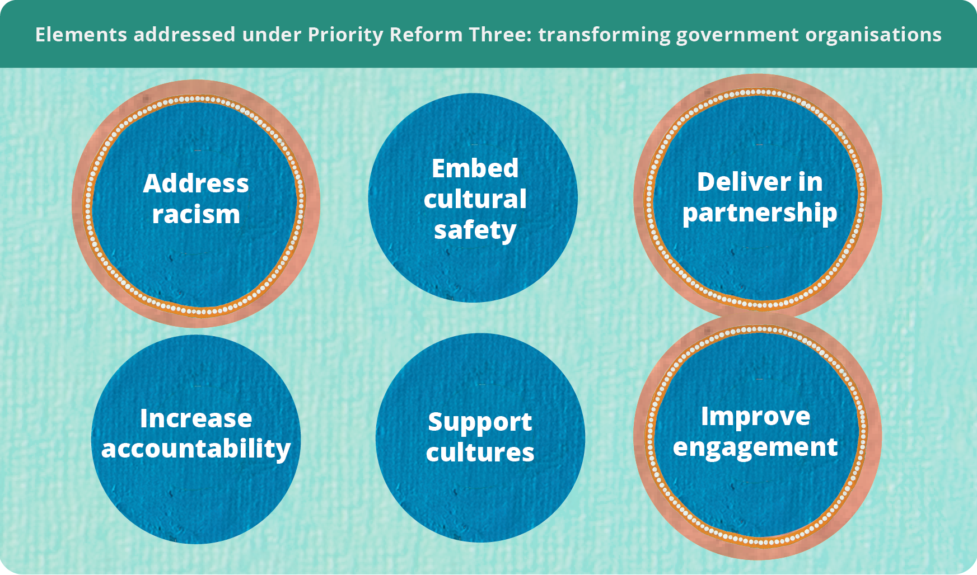

Co-designing legislative reform to address institutional racism
In 2017, an independent report commissioned by the Queensland Anti-Discrimination Commission and Queensland Aboriginal and Islander Health Council (QAIHC) highlighted the ‘unacceptable’ level and extent of institutional racism across the public health system (Marrie and Bukal Consultancy Services 2017, pp. 12, 17). The report found many Aboriginal and Torres Strait Islander health policies already existed within the public health system but lacked enforceable accountability mechanisms. The report recommended reinforcing these policies through stronger governance, monitoring and legislative or regulatory accountability in Hospital and Health Services (HHSs) to ensure implementation.
Prompted by this report and bolstered by Aboriginal and Torres Strait Islander voices, the Queensland government supported reforms to achieve health equity in Queensland Health. Health equity adopts a social justice and human rights-based approach to health and healthcare access by responding to differences between groups of people and what they need to attain their full health potential (QAIHC and Queensland Health 2021, p. 9). This approach attempts to strengthen the environment that enables all parts of the healthcare system to deliver culturally safe and responsive healthcare (Queensland Health 2024, p. 40).
This case study shows how Queensland Health, in partnership with QAIHC, co-designed legislation to mandate engagement with local communities on priorities and approaches for culturally safe and responsive mainstream health services.
It takes an in-depth look at the co-design process that led to the Hospital and Health Board (Health Equity Strategies) Amendment Regulation 2021 (figure 1). Part of a broader suite of reforms, the regulation details requirements for First Nations Health Equity Strategies to be developed by all Queensland HHSs. It outlines who must be involved, how partnerships should operate, how health services should be co-designed and key performance expectations. These requirements are unique as they are legally enforceable because they sit in legislation, rather than being included in department policy.

Figure 1 – The First Nations Health Equity legislative reforms were shaped through sustained community advocacy and collaborative policy development over time
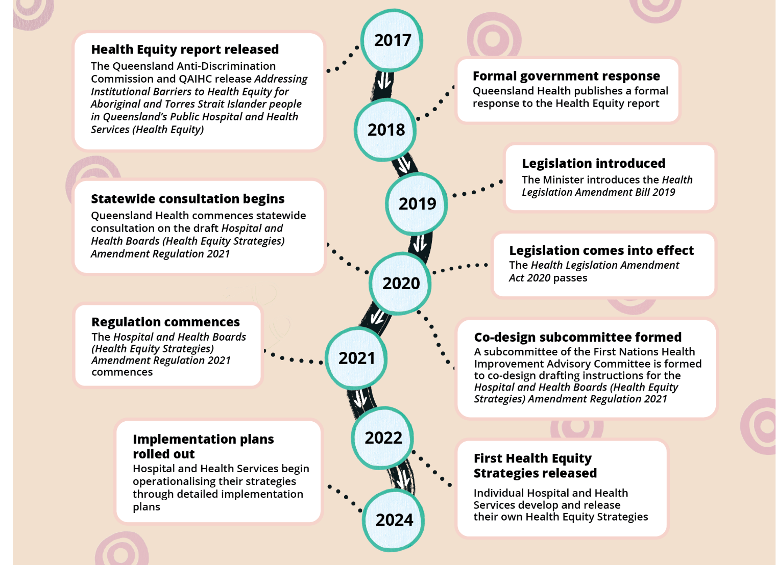
Source: QAIHC and Queensland Health (2021, pp. 25–26); Queensland Health (2025).

Co-design enables legislation responsive to those affected
Legislative drafters are often given short, late-stage drafting instructions with limited opportunity to engage with the underlying policy issues or the people affected. Co-design brings policy makers, drafters and stakeholders together earlier to collaboratively define the problem and shape workable solutions.
Co-designing legislation with Aboriginal and Torres Strait Islander people is an important undertaking to bridge the gap between First Nations’ knowledge systems, lived experience and public policy development. Done authentically, co-design can inform the way policy instruments align with the needs and aspirations of the people they affect and contribute to lasting change (Apolima Fono et al. 2025, p. 476).

Establishing a representative governance body from the outset
To oversee the co-design of the drafting instructions, a dedicated working group was established under the First Nations Health Improvement Advisory Body. The governance body was co-chaired by QAIHC and Queensland Health, reflecting a commitment to shared decision-making. Membership was deliberately structured to achieve broad geographic representation and to bring together professional expertise, lived experience and institutional authority. This ensured oversight of the process was grounded in the priorities and lived experiences of Aboriginal and Torres Strait Islander people, while also enabling system partners to build capability and progress reform collectively.
Membership included four HHS board members from geographically diverse regions, including the Torres Strait Islands and Cape York, as well as 3 First Nations HHS board members and 3 First Nations Health Leads. Broader system representation was also embedded through the inclusion of Primary Health Networks, The Healing Foundation, First Nations health consumers, and key statutory agencies such as the Queensland Human Rights Commission, the Health Ombudsman, and Health and Wellbeing Queensland.

Adopting a structured, iterative co-design process
The group began developing drafting instructions to test with broader stakeholders. The working group structured the work into 4 components, each delivered through a 2-week cycle. A key lesson from this stage of the process was the importance of establishing clear dispute resolution mechanisms at the outset, including resolution through mediation provided by the Chief First Nations Health Officer, to support transparent and constructive decision-making (Queensland Government 2024).
For each component, the group co-developed content before refining proposals internally and testing draft elements, including who the key stakeholders were and timeframes for engagement, with the Parliamentary Counsel. Feedback was sought on both the rationale and the drafting approach, with issues resolved and collective agreement reached before progressing to the next component. Deliberations were supported through structured engagement methods, including virtual focused discussions in smaller groups. Insights from these sessions were reported back to the full group, with drafters consolidating and refining the material before further testing. This staged approach enabled steady progress while maintaining quality and alignment.
This process culminated in the development of a consultation paper to support engagement on health equity design principles (QAIHC and Queensland Health 2021).

Engaging early and often to align policy intent and drafting
The consultation paper supported in-person engagement across the state with all Aboriginal and Torres Strait Islander Community-Controlled Health Organisations (ATSICCHOs), community members and the HHSs and the QAIHC leadership forum in January 2021. This statewide consultation phase concluded in 2021 and ensured the proposed reforms were informed by direct feedback from system leaders and Aboriginal and Torres Strait Islander stakeholders (QAIHC nd).
A key strength of this process was the active involvement of the main legislative drafter in consultation discussions. This enabled the drafter to directly hear stakeholder perspectives, understand areas of concern and nuance and reflect this context in the drafting of the legislation and explanatory notes. Early and continuous engagement between policy, partners and drafting officers strengthened alignment between policy intent and legislative expression.
Queensland Health and QAIHC conducted the consultation in a trauma-informed manner, recognising the historical and contemporary impacts of legislation on Aboriginal and Torres Strait Islander peoples. In practice, this involved explaining the purpose of the regulation was to legally bind the hospital and health services, not Aboriginal and Torres Strait Islander people. Discussions were deliberately focused on the development of the proposed regulatory framework, while operational issues were noted for further consideration during implementation. This approach supported constructive engagement while maintaining clarity about the purpose and scope of the reform.

Drafting detailed, measurable requirements to support implementation
Feedback from the working group and the community indicated the regulation needed to be drafted with clear, specific and enforceable requirements to ensure health equity strategies were practical, measurable and capable of supporting meaningful change. The working group and legislative drafters made a deliberate decision, to move beyond high-level or aspirational statements and instead articulate detailed obligations to support accountability and implementation.
Through consultation, legislative compliance was recognised as a critical lever. Embedding specific requirements in regulation strengthens agencies’ ability to secure resources, as funding requests tied to statutory obligations carry weight.
The regulation therefore requires Hospital and Health Services to develop health equity strategies that:
- outline how key performance indicators will be achieved and evaluated against measurable indicators, strengthening accountability for outcomes
- detail partnerships and consultation arrangements, including collaboration with ATSICCHOs, QAIHC, the Chief First Nations Health Officer, and Health and Wellbeing Queensland
- ensure accessibility of services and increase First Nations workforce representation, including targets for workforce representation commensurate with the population, and
- deliver culturally safe and responsive health services, with an emphasis on sustainability, reinforcing the expectation that funding transitions from supplementary to core allocations over time.
Strategies must also align with relevant legislation and policy frameworks. Strategic cross-referencing in Acts and regulations enhances coherence and reinforces the strength of the legislative framework. Where matters could not be included directly in the legislation, they were reinforced through explanatory notes for the legislation or Health Service Directives, which carry legal authority under the Hospital and Health Boards Act 2011 (Queensland Government 2021b, 2024).

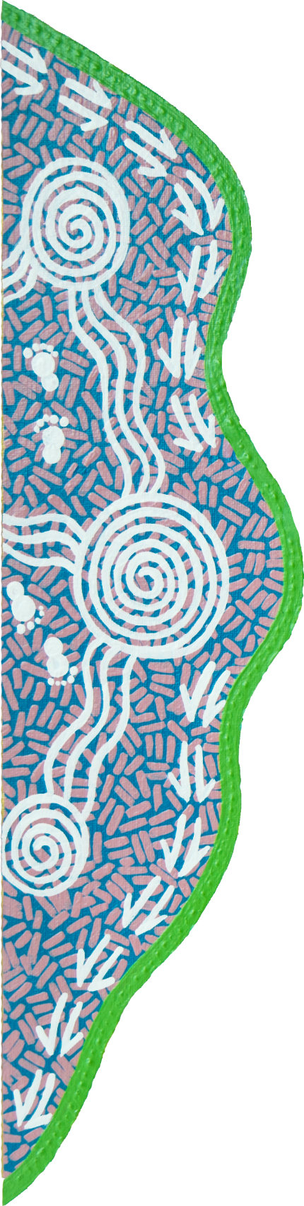
The regulation prescribes consultation requirements, including engagement with First Nations staff, service users and other specified stakeholders. By identifying who must be consulted, rather than relying on generic consultation obligations, the framework recognises large institutions respond most consistently to clear statutory requirements. Provisions also supported co-design, mediation and escalation processes, including timeframes for feedback, to reduce the risk of tokenistic engagement.
A key lesson is the importance of balancing prescription with flexibility. While overly broad principled statements are difficult to evaluate and limit accountability, excessive prescriptiveness may constrain local adaptation. Regulations can provide detailed operational requirements while retaining greater flexibility than primary legislation, as they can be amended by the government rather than requiring parliamentary amendment. Selecting the appropriate legislative vehicle is an important strategic consideration when designing reform.

Defining institutional racism supports systemic responses
Significant consultation was undertaken, in both the eight-week drafting instructions process and then again as part of broader consultation, to define key terms for inclusion in the legislation. This included ‘institutional racism,’ the first time the term had been incorporated into the Queensland statute book. The explicit inclusion of ‘institutional racism’ reflected a deliberate policy choice to directly address systemic barriers to health equity. Given the diversity of interpretations and sensitivities associated with the term, explanatory notes were carefully developed to clarify legislative intent and provide guidance on its application (Queensland Government 2021b, p. 8).
The explanatory notes established a shared conceptual foundation that is both diagnostic – identifying the systemic nature of racism – and regulatory, informing how HHSs are expected to interpret and respond to institutional racism through their Health Equity Strategies. In practice, this has translated into strategies that explicitly target organisational culture and service design with a focus on cultural safety, anti-racism initiatives and co-designed models of care (CQ HHS 2022, pp. 12, 13; NW HHS 2022, p. 41).

Strong governance and accountability are key to implementation
The inclusion of clear definitions within the legislative and policy architecture was intended to provide HHSs with a structured framework for action, while also equipping Aboriginal and Torres Strait Islander consumers and community-controlled organisations with a basis for holding services accountable. However, early critiques of implementation suggest that, while there have been localised improvements, the scale and consistency of change required to achieve system-wide transformation have not yet been realised (QAIHC 2023, p. 4).

The legislation calls for shared governance of the strategies in each HHS (figure 2). However, there are ongoing concerns regarding the sufficiency of investment in the ATSICCHO sectors and the extent to which these organisations are empowered with genuine authority and oversight across the implementation and evaluation process (QAIHC 2023, p. 4).
While shared governance is a stated principle of the reform, its practical embedding remains uneven, with variability in how decision-making power is distributed and exercised across HHS partnerships. The role of the Chief First Nations Health Officer and Queensland Health in providing system-level oversight and mediating disagreements where consensus cannot be reached at the HHS level is intended as a safeguard, but in practice introduces challenges regarding clarity of authority, potential power imbalances, and the risk of undermining the intent of locally driven, co-designed governance (Queensland Government 2024).
Figure 2 – The governance of Health Equity Strategies aims to embed Aboriginal and Torres Strait Islander participation across strategic, operational and local decision-making
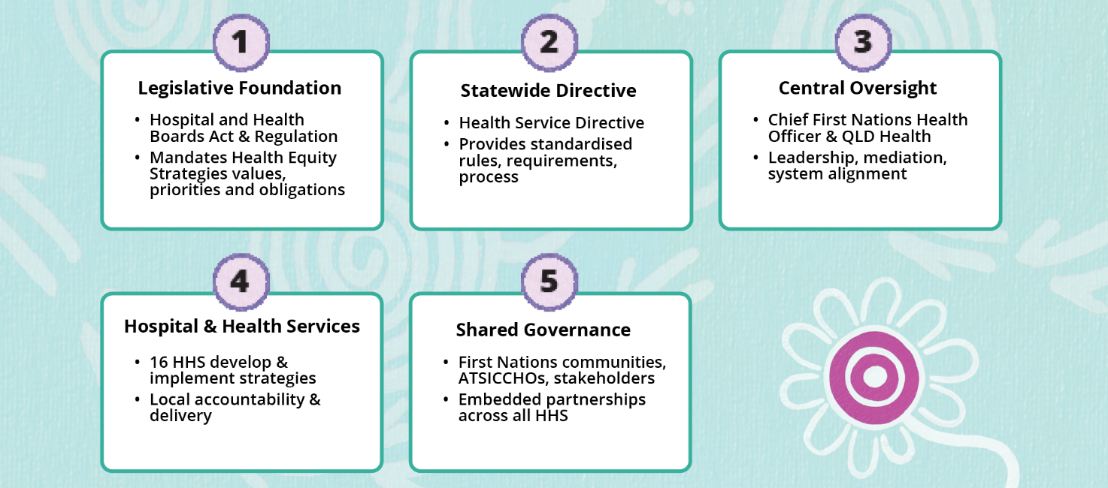
Source: Queensland Government (2011, s. 40; 2021a, s. 8; 2024).
Accountability mechanisms remain emergent. While requirements for data collection and reporting are embedded within the framework, their effectiveness depends on the accessibility, transparency and local relevance of that data. Strengthening data sharing and development at both state and local levels is critical to enabling communities and ATSICCHOs to monitor progress against Closing the Gap targets and broader system reform objectives. Some HHSs, such as Children’s Health Queensland, demonstrate more developed approaches to community-facing reporting and performance tracking, indicating how accountability could be operationalised more consistently across the system (Children’s Health Queensland 2025).
The implementation of health equity strategies is undergoing evaluation, which will be critical in assessing the extent to which the regulatory intent, particularly in addressing institutional racism, is being realised in practice (QAIHC and Queensland Health 2024).

Reflecting on the impact of Health Equity Reform
By legally requiring all HHSs to develop and implement Health Equity Strategies in partnership with First Nations communities, the legislation strengthens accountability and attempts to embed the concept of health equity within health system governance. This is important because co-design with First Nations communities and partnerships with Aboriginal Community Controlled Health Organisations can improve cultural safety, service accessibility and trust in healthcare systems (Davy et al. 2016, p. 5). This way of working between Queensland Health and QAIHC shows how future development of policies can be made richer and stronger by mandating a platform for all parties to be heard.
In June of 2026, media reporting brought renewed public attention to concerns about Aboriginal and Torres Strait Islander representation in public office in Queensland. The reports alleged Queensland Health had not maintained Aboriginal and/or Torres Strait Islander representation on the Metro North and Metro South Hospital and Health Boards, despite legislative requirements for at least one Aboriginal and/or Torres Strait Islander board member (ABC News 2026). These boards are responsible for guiding the delivery of health services to approximately 2.4 million people across South-East Queensland, including Metro South, which serves the largest Aboriginal and Torres Strait Islander population in the state. Queensland Health reported recruitment processes are underway to fill these positions. At the time of publication 19 (14%) of Hospital and Health Board members across 13 of the 16 boards are First Nations members (Queensland Health, pers comm., 27 August 2026).
These reported experiences do not diminish the value of the legislation or the principles of co-design. Rather they underscore the importance of mechanisms that embed shared decision-making, establish expectations for accountability, and provide a basis for assessing whether policy and practice remain aligned with legislative intent. While legislation and co-design alone cannot ensure sustained implementation, they remain among the strongest mechanisms for embedding First Nations voices in policy and service design.
Variability in resources, leadership commitment and community involvement across health services may limit consistent implementation. Furthermore, while the legislation attempts to address institutional racism and culturally safe care, health inequities are strongly influenced by broader structural systems such as housing, education and socio-economic disadvantage, which extend beyond healthcare (Markwick et al. 2014, p. 2). Health equity legislation alone cannot fully address health inequities without broader social policy changes. While the legislative amendments provide a strong policy foundation for advancing health equity, their long-term effectiveness will depend on sustained commitment, rigorous evaluation and genuine, equitably and sustainably resourced partnerships with Aboriginal and Torres Strait Islander communities.

References
ABC News 2026, ‘Qld government accused of campaign to remove Aboriginal people from health roles’, 16 June, https://www.abc.net.au/news/2026-06-17/aboriginal-leaders-accuse-government-of-project-invisibility/106803276 (accessed 2 July 2026).
Apolima Fono, M, Chapman, F, Parter, C, Knight, J, Sherriff, S, Vita, C and Gwynne, K 2025, ‘A culturally grounded framework for co-designing policy with Aboriginal and Torres Strait Islander peoples’, Policy Design and Practice, vol. 8, no. 4.
Central Queensland Hospital and Health Service 2022, Aboriginal and Torres Strait Islander Health Equity Strategy 2022–2025.
Children’s Health Queensland 2025, Aboriginal and Torres Strait Islander Health Equity Strategy Impact Report 2022–2025.
Davy, C, Kite, E, Aitken, G, Dodd, G, Rigney, J, Hayes, J and Emden, JV 2016, ‘What keeps you strong? A systematic review identifying how primary health-care and aged-care services can support the well-being of other Indigenous peoples’, Australasian Journal on Ageing.
Markwick, A, Ansari, Z, Sullivan, M, Parsons, L and McNeil, J 2014, ‘Inequalities in the social determinants of health of Aboriginal and Torres Strait Islander People: a cross-sectional population-based study in the Australian State of Victoria’, International Journal for Equity in Health, vol. 13, no. 1.
Marrie, A and Bukal Consultancy Services 2017, Addressing Institutional Barriers to Health Equity for Aboriginal and Torres Strait Islander People in Queensland’s Public Hospital and Health Services, Report to the Anti-Discrimination Commission Queensland.
North West Hospital and Health Service 2022, North West Health Equity Strategy 2022–2025.
Queensland Aboriginal and Islander Health Council 2023, Learnings from Health Equity - Queensland Aboriginal and Islander Health Council submission to Productivity Commission.
—— nd, Making Tracks towards health equity with Aboriginal and Torres Strait Islander peoples, https://www.qaihc.com.au/resources/making-tracks-towards-health-equity-with-aboriginal-and-torres-strait-islander-peoples (accessed 2 July 2026).
—— and Queensland Government 2024, Making Tracks Together: Queensland’s Statewide First Nations Health Equity Strategies Monitoring and Evaluation Framework.
—— and Queensland Health 2021, Making Tracks towards health equity with Aboriginal and Torres Strait Islander peoples – working together to achieve life expectancy parity by 2031.
Queensland Government 2011, Hospital and Health Boards Act 2011, Qld.
—— 2021a, Hospital and Health Boards (Health Equity Strategies) Amendment Regulation 2021, Qld.
—— 2021b, Hospital and Health Boards (Health Equity Strategies) Amendment Regulation 2021 Explanatory Notes.
—— 2024, First Nations health equity strategies | Health service directive, Queensland Health, https://www.health.qld.gov.au/system-governance/policies-standards/health-service-directives/first-nations-health-equity-strategies (accessed 25 March 2026).
Queensland Health 2024, HEALTHQ32 First Nations First Strategy 2032.
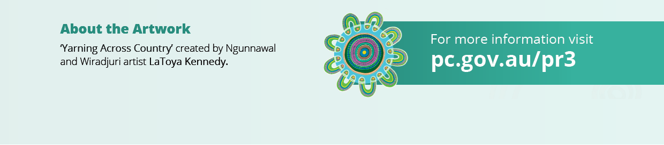
—— 2025, Making tracks – our journey, Queensland Health, https://www.health.qld.gov.au/research-reports/reports/departmental/chief-first-nations-health-officer-report/why-health-equity-reform/making-tracks-our-journey (accessed 10 June 2026).

Place-based delivery approach is a ‘collaborative, long-term approach to build thriving communities delivered in a defined geographical location. This approach is ideally characterised by partnering and shared design, shared stewardship, and shared accountability for outcomes and impacts’ (Dart 2018, p. 1).
Continuity of care is defined by how a person experiences their care over time as coherent and connected, resulting from effective information flow, strong interpersonal relationships, and well-coordinated services (Reid et al. 2002).
At the time, and until changes were made in mid-2023, the Premier’s Department was part of the Department of Premier and Cabinet. For consistency it is referred to as Premier’s Department throughout this document.
ISEP changed their name on 29 July 2024 to ‘Indigenous Science and Engagement Office’ as part of the internal CSIRO Enterprise Services Reforms.
The Queensland Anti-Discrimination Commission was renamed the Queensland Human Rights Commission in 2019.
Institutional racism is racism which is structural in political and social institutions.
The explanatory notes characterise institutional racism as arising where racist beliefs, attitudes or values are embedded within the operations or policies of an institution, resulting in direct or indirect discrimination that limits rights and contributes to inherited disadvantage (Queensland Government 2021). This is consistent with the definition set out in the 2017 Health Equity report (Marrie and Bukal Consultancy Services 2017), which provided the impetus for these reforms.

