Annual Stakeholder Survey 2025–26

Results

Overview
As part of the Productivity Commission’s commitment to improving communications and engagement, we conduct an Annual Stakeholder Survey. The survey responses help us to understand the views and experiences of a selection of our stakeholders and provide us with valuable insights that we can use to drive improvements.
Between 2 June and 18 June 2026 we undertook the Annual Stakeholder Survey 2025–26. This is the third consecutive year we have undertaken an annual survey, following a shift from a 3-year cycle.
We invited around 6,000 stakeholders who engaged with our work in FY2025–26 to participate in the survey. We received 606 responses and 40% (n=242) provided qualitative comments.
Respondents were asked to identify their sector and industry (figure 1). Consistent with previous years, not-for-profit and government stakeholders were most common.
Figure 1 – Audience breakdown by sector
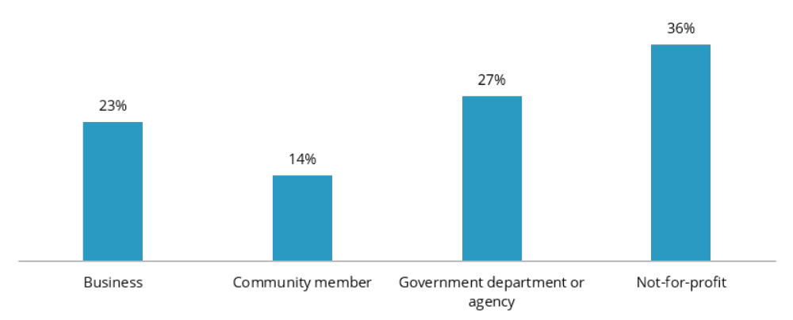
We also asked respondents what industry they worked in. The top 5 industries were:
- Health Care and Social Assistance (20%)
- Professional, Scientific and Technical Services (11%)
- Public Administration and Safety (11%)
- Education and training (8%)
- Manufacturing (8%).
The survey included 8 statements which we asked respondents to rate their level of agreement with (table 1).
Table 1 – Percentage (%) of respondents who agreed or strongly agreed with each statement
Statement | 2025–26 | 2024–25 | Target*
The PC generates research, analysis and advice that is robust, evidence-based and independent. | 75% | 76% | 80%
The PC’s publications, reports and papers are engaging and easy to read. | 66% | 59% | 80%
The PC provides enough opportunities to engage with and provide input into its work. | 58% | 61% | 90%
The PC provides enough time for meaningful consultation and engagement. | 58% | 61% | 90%
The PC considers implementation issues and risks in its advice and recommendations. | 55% | 53% | N/A
The PC is a trusted, credible and authoritative leader in economic and public policy discussions in Australia. | 76% | 78% | N/A
The PC’s work is shaped and informed by diverse government, stakeholder and community views and perspectives. | 61% | 64% | N/A
The PC delivers timely, rigorous and impactful research, analysis and advice that drives positive change. | 59% | 57% | N/A
* Targets are included where these questions relate to key performance indicators from the PC’s Portfolio Budget Statement.
Consistent with last year, stakeholders generally responded more positively to statements about our research and analysis and less positively to statements about our engagement and communications. At a sector level, government and not-for-profits responded more positively than businesses and community members.

Qualitative feedback
At the end of the survey, respondents were invited to provide open-text feedback. These comments were analysed using a structured coding approach. Note, this coding was assisted through the use of AI. Comments were assigned to one or more of 5 parent themes (figure 2).
Figure 2 – Qualitative feedback breakdown by theme (%)
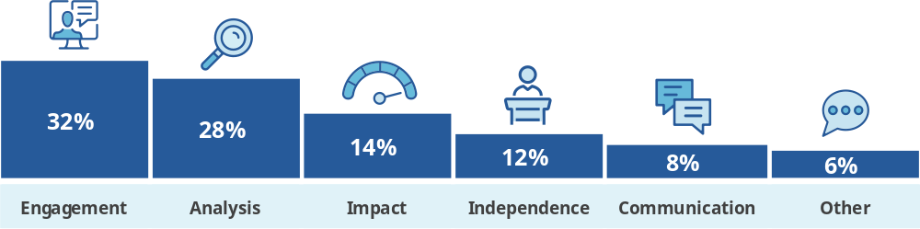
The feedback reflected that stakeholders generally value the PC’s work. Key areas identified for improvement included feedback on how stakeholder inputs influence PC recommendations and more accessible communications products.

