Early childhood education and care system in rural, regional and remote communities
Productivity Commission submission
In 2024, the Productivity Commission concluded its inquiry into early childhood education and care (ECEC). The inquiry heard from many participants about the barriers families face when seeking quality, affordable ECEC services in regional, rural and remote parts of Australia, and the challenges services encounter when operating in these areas. The PC made findings and recommendations relevant to the inquiry undertaken by the Education and Employment References Committee. These are summarised below. The PC would be pleased to provide further information as needed.

Geography compounds access barriers
The PC inquiry found families in regional, rural and remote communities are less likely to have access to affordable, quality ECEC, compared to those in capital cities. Most children in regional and remote Australia live in areas where for every spot in centre-based day care, there are three or more children under 5 years of age whose families may wish to access services (PC 2024, p. 305).
ECEC can support children to flourish, complementing the critical role of families and of other early childhood development policies and services. Attending ECEC can help prepare children for school and improve their outcomes across many areas, including in adolescence and adulthood (PC 2024, p. 7).
Conversely, a shortage of accessible, quality ECEC may have detrimental effects for children. Outside major cities, children are more likely to be developmentally vulnerable; research has shown quality ECEC can be particularly important in supporting the development of children who experience disadvantage or vulnerability (PC 2024, p. 7).
Access challenges can also affect parents’ labour force participation. Families without other sources of support need the certainty of secure ECEC provision (that is, that a service will continue to be available if numbers fall below a viable level) before taking on paid work. Secure ECEC also has the broader benefit for communities of attracting workers to other sectors – for example, health practitioners – who also rely on access to services (PC 2024, p. 318).
For families with young children, the lack of centre-based day care services is ameliorated to some extent by access to family day care services and preschools (figure 1). For those with older children, who need care outside of school hours, the geographic disparities are more pronounced. Only one in 4 schools in outer regional areas offer outside school hours care, compared to 3 in 4 schools in major cities (PC 2024, p. 298).
Figure 1 – ECEC availability varies widely across Australia
Ratio of number of approved ECEC places to 0–5 population
CBDC = centre-based day care; FDC = family day care; PSK = dedicated preschool. The first map shows the ratio of the number of CBDC approved places to the population of children aged 0–5 years. The second map shows the number of CBDC, family day care and dedicated preschool places to the population of children aged 0–5 years. Grey areas have no child population. These are typically national parks. Population data is from the 2021 Census. The number of ECEC places is at Q4 2022.
Source: adapted from PC 2024, figure 5.11.

The link between remoteness and affordability is complex
ECEC affordability in regional, rural and remote Australia varies by service type and jurisdiction. There are many factors affecting affordability; for example, fees in regional areas may be lower than in major cities, in part because not-for-profit providers are more common and, on average, charge lower fees. On the other hand, ECEC wages might be higher in regional and remote areas, which may result in higher fees (PC 2024, p. 363).
Out-of-pocket costs vary substantially by region (figure 2 and 3). Survey data shows concerns about ECEC affordability were slightly more pronounced in regional and rural areas relative to metropolitan areas. Parents using ECEC in regional Australia were relatively more likely than those in metropolitan areas to believe ECEC costs have risen substantially in recent years (PC 2024, p. 365).
Figure 2 – Mean out-of-pocket expenses are highest in metropolitan and remote areas
Mean hourly out-of-pocket expenses by remoteness, December quarter 2023
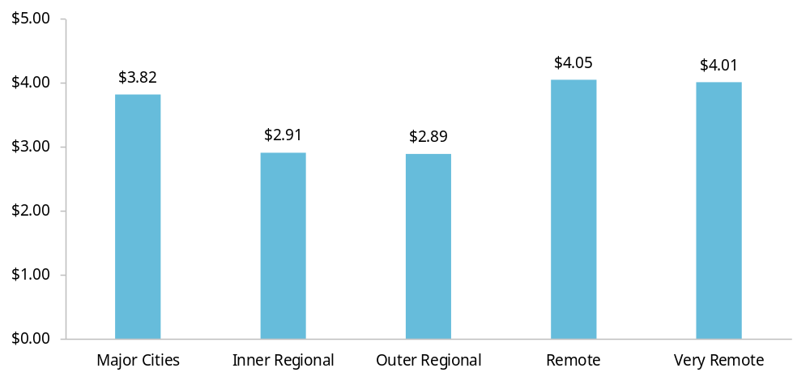
This analysis excludes cases where charged fees were zero.
Source: PC 2024, figure 6.8; PC estimates based on Department of Education (DoE) administrative data (unpublished).
Figure 3 – The association between out-of-pocket expenses and remoteness varies by jurisdiction
Mean hourly out-of-pocket expenses, by jurisdiction and remoteness, December quarter 2023
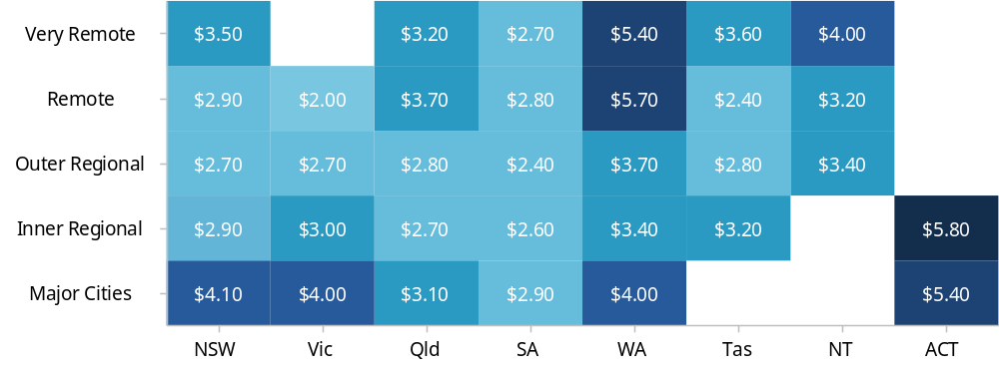
Blank tiles mean no cross-classifications between jurisdiction and remoteness level. This analysis excludes cases where charged fees were zero.
Source: adapted from PC 2024, figure 6.9; PC estimates based on DoE administrative data (unpublished).

The expansion of ECEC outside major cities has been slow
The expansion of ECEC over the past 15 years has been concentrated in major cities. Between 2013 and 2023, the bulk of new ECEC services has been established by for-profit providers and these enterprises rarely expand outside of major cities and inner regional areas (figure 4). As a result, the market share of the not-for-profit sector is about 50% in outer regional areas and over 75% in remote areas. Almost all the growth in services between 2013 and 2023 in remote areas was delivered by the not-for-profit sector (PC 2024, p. 290).
Many regional and remote communities are ‘thin markets’: demand is dispersed, low or variable, while the costs of buildings, staffing and operation are high. In these areas, market forces alone do not lead to the establishment of services that can meet the needs of all children and families. Very remote communities with small populations may never sustain centre-based care and require other delivery models (PC 2024, pp. 312–313).
The PC found the Community Child Care Fund (CCCF), which offers grants to ECEC providers to establish or expand services, only partly meets the needs of communities in persistently thin markets (PC 2024, p. 318).
Figure 4 – Not-for-profit ECEC provision is important in remote regions
Change in number of CBDC services by remoteness and provider type, between Q3 2013 and Q1 2023 | CBDC market shares by remoteness and provider type, Q1 2023
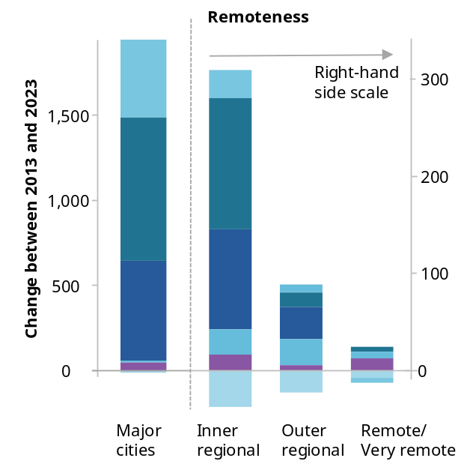 | 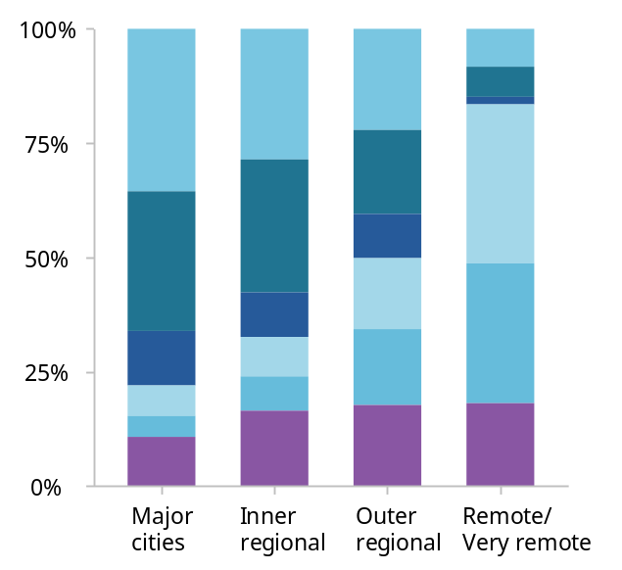
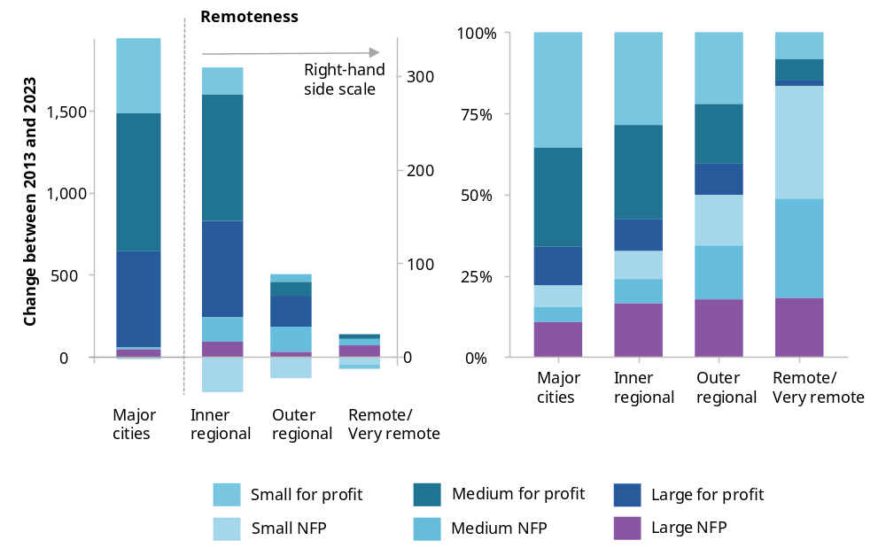
NFP = not-for-profit. A small provider is defined as operating one service, a medium sized provider operates 2 to 24 services, and a large provider operates 25 or more services. Government, catholic and independent schools, and other unclassified provider types are excluded as they have smaller shares of the sector.
Source: adapted from PC 2024, figure 5.9, based on ACECQA 2023.

The ECEC system creates barriers to access for Aboriginal and Torres Strait Islander children
ECEC funding policies can exacerbate access issues for Aboriginal and Torres Strait Islander children and families. The administrative complexity of the system creates challenges for families as well as Aboriginal community-controlled organisations (ACCOs) providing ECEC. The ECEC system is often unable to meet the needs of Aboriginal and Torres Strait Islander children and families.
ACCOs are well placed to deliver culturally safe, integrated services because of their community ties, cultural expertise, Aboriginal and Torres Strait Islander workforce and holistic models. Families often prefer these services. However, ACCOs report funding challenges arising from limited scale, rural and remote operating costs, workforce support needs and funding models that do not reflect integrated service delivery (PC 2024, pp. 456–461).
Beyond ACCOs, mainstream ECEC services need to support cultural safety because of the contribution it can make to the cultural wellbeing, identity, school readiness and ongoing ECEC participation of Aboriginal and Torres Strait Islander children (PC 2024, p. 68).

Specific solutions are required to ensure access to quality ECEC in regional, rural and remote Australia

Funding universal access to ECEC in persistently thin markets
The PC found that to achieve the goal of universal access to ECEC, all children aged 0–5 should be able to access at least 30 hours or three days of quality ECEC for 48 weeks each year where families wish to participate (PC 2024, p. 278).
Many local markets, in particular in regional, rural and remote Australia, cannot support universal access. There are almost no markets outside major cities where centre-based day care availability is sufficient to meet this threshold. The addition of family day care and preschool places improves availability significantly in parts of Australia, but these types of services have limitations in terms of the age groups they cater for in the case of preschool, and their ability to support larger groups of children in the case of family day care.
To address this, the PC recommended the Australian Government establish an ECEC Development Fund, to offer financial support to communities and providers to expand ECEC access. Aspects of the fund may be particularly relevant to regional, rural and remote communities. These include:
- capital grants or low-interest loans where operating costs can be covered by existing funding mechanisms, but infrastructure cannot
- ongoing block grants for capital and operating costs where demand is too low or variable for viability, with periodic review
- competitive tendering or commissioning where communities cannot secure a provider, open to centre-based, day care and mobile models suited to local need (PC 2024, pp. 325–326, recommendation 5.2).
Since the PC report was published, the Australian Government has established a $1 billion Building Early Education Fund, which provides capital funding to build new, and expand existing, ECEC services in areas of need, including the outer suburbs and regional Australia. While this represents an important investment, it may not address the needs of communities in ‘thin markets’, where ongoing operational support may be required to ensure the sustainability of services. In future, the Government will consider using the Fund to build, own and lease services in areas of low supply (DoE 2026b).
In addition, the PC recommended governments should consider funding arrangements for ACCOs delivering ECEC and other integrated early years services through a process of shared decision-making. Consistent with Priority Reform 1 of the National Agreement on Closing the Gap, the Early Childhood Care and Development Policy Partnership is the most appropriate forum for this process to take place (PC 2024, p. 464, recommendation 7.7).

Expanding flexible delivery models
The PC found family day care can be part of the solution to ensuring families have access to quality ECEC in markets where there might be low and/or variable demand, including regional, rural and remote areas. This is because it has lower establishment costs, can support local employment and may provide non-standard hours for shift and seasonal workers.
The PC noted expansion of family day care had been limited. In part, this was due to probity and integrity concerns raised by the Australian Government Department of Education. The Department introduced a Capability Trial to test approaches to improve the family day care model and offered incentives to educators to operate in regional areas (PC 2024, pp. 326–327).
The trial is expected to conclude at the end of 2026 (DoE 2026e).

Embed national stewardship to address access gaps
The PC recommended an ECEC Commission be established to support effective system stewardship. An ECEC Commission would monitor market health, workforce outcomes, access and quality, and would strengthen accountability for outcomes, including governments’ efforts to address availability gaps (p. 619, recommendation 10.2). The PC also recommended a new national agreement to coordinate Australian, state and territory responsibilities and create a policy environment that would support universal access to ECEC (p. 616, recommendation 10.1).
These governance arrangements are expected to enable greater access to quality ECEC across Australia – including regional, rural and remote communities. In July 2026, Education Ministers agreed to explore the development of a potential early education and care commission to strengthen the ECEC system (DoE 2026d).

Addressing affordability challenges
The PC made a number of recommendations to improve ECEC affordability. These include:
- removing the activity test for the Child Care Subsidy (CCS)
- raising the subsidy rate for families with annual adjusted taxable income at or below $80,000 to 100% of the fee, up to and including the hourly rate cap
- tapering down the CCS rate from 100% by one percentage point for every $5,000 above an adjusted taxable income of $80,000
- increasing the Higher Child Care Subsidy rate to 100% for families with an annual adjusted taxable income at or below $140,000, tapering down from 100% by one percentage point for every $5,000 above an adjusted taxable income of $140,000, with families with an adjusted taxable income of $580,000 and above being ineligible (PC 2024, p. 398, recommendation 6.1).
Many families living in regional and remote areas would benefit from these changes, including through cheaper ECEC. In particular, the removal of the activity test for the Child Care Subsidy would improve ECEC accessibility for families facing irregular, seasonal or limited employment, which can occur more often in regional, rural and remote communities (PC 2024, pp. 385–393).
Since the PC report was published, the Australian Government introduced the 3 Day Guarantee. Beginning January 2026, all families eligible for CCS have access to at least 72 hours of subsidised child care per fortnight (3 days per week), regardless of their activity (DoE 2026a).
The Australian Government has retained the top subsidy rate of 90%, but the income eligibility threshold has been updated. In 2026–27, families earning up to $88,520 a year are eligible for a 90% subsidy rate, and their subsidy rate decreases by 1 percentage point for every $5,000 of income a family earns. Families earning above $538,520 are not eligible for subsidies (DoE 2026c).
The PC further recommended that the Australian Government should review family day care and in home care hourly rate caps, so they better reflect operating costs, consider a separate cap for non-standard hours and index the cap using an approach that better tracks ECEC delivery costs. This is particularly relevant where flexible models are essential to regional and remote access (PC 2024, pp. 399–402, recommendation 6.3).
Since the PC report was published, the Australian Government increased family day care and in home care hourly rate caps in line with CPI.
Beyond changes to the Child Care Subsidy, the PC also recommended extending the Assistance for Isolated Children Distance Education Allowance to preschool programs delivered by distance education for a period of three years. An evaluation of the extension should be used to decide whether to make this change permanent (PC 2024, pp. 404–406, recommendation 6.6).

Strengthening the workforce and supporting quality improvement
Some of the challenges faced by all ECEC providers are more pronounced in regional, rural and remote communities.
Workforce availability is the most significant of these challenges. Compared to providers in major cities, those in regional, rural and remote areas are more likely to hold staffing waivers (meaning they operate without complying with the National Quality Framework staffing requirements due to persistent shortages), although this varies significantly by jurisdiction (ACECQA 2026).
The PC (2024) made a number of recommendations to better support the ECEC workforce, including:
- setting national workforce goals linking pay and conditions, workforce supply and career pathways to the universal-access objective. The ECEC Commission should publicly report on progress towards these goals (p.145, recommendation 3.1)
- improving pathways and tailored support for Aboriginal and Torres Strait Islander people to obtain ECEC qualifications, recognising cultural knowledge and experience (p. 202, recommendation 3.9)
- enabling more student placements in Aboriginal and Torres Strait Islander ECEC services (p. 202, recommendation 3.10)
- improving access to professional development, including providing financial support for the workforce to undertake professional development activities (p. 206, recommendation 3.11).
A qualified workforce is critical to lifting ECEC quality standards – which are generally lower in regional, rural and remote communities, compared to major cities (PC 2024, p. 486). The PC also recommended strengthening service quality through greater transparency around regulator capacity and activity, increased funding available to regulators, and greater powers to deal with under performance (PC 2024, p. 475, recommendations 8.1, 8.3, 8.5, 8.6).

A better approach to inclusion support
Children in regional, rural and remote regions are more likely to experience developmental vulnerability and may benefit from dedicated support within ECEC services. But the PC found inclusion support funding, meant to enable this, is not distributed in line with developmental vulnerability and current arrangements are slow and inefficient. ECEC services in regional and remote areas may find it difficult to support children living with disability due to the shortcomings of inclusion support mechanisms as well as workforce challenges. The data strongly suggests the children who would most benefit from an inclusive ECEC experience are more likely to be missing out on additional support (PC 2024, pp. 78–79).
The PC recommended strengthening the approach to inclusion support. This includes:
- increasing and indexing the subsidy for an additional educator, removing weekly-hour limits, permitting other appropriately qualified inclusion professionals, and allowing immediate support while documentary evidence is obtained (PC 2024, pp. 92–93, recommendation 2.2)
- replacing the current narrow approach with an enhanced needs-based Inclusion Fund that addresses disability and complex needs, broader mainstream inclusion requirements, trauma and physical accessibility (PC 2024, pp. 111–114, recommendation 2.3).

References
ACECQA (Australian Children’s Education and Care Quality Authority) 2023, NQF snapshot Q1 2023, May, Sydney.
—— 2026, NQF Snapshot - Waivers, https://snapshots.acecqa.gov.au/Snapshot/waivers.html (accessed 23 September 2026).
DoE (Department of Education) 2026a, 3 Day Guarantee, https://www.education.gov.au/early-childhood/providers/
child-care-subsidy/3-day-guarantee (accessed 23 September 2026).
—— 2026b, Building Early Education Fund, https://www.education.gov.au/early-childhood/about/
building-early-education-fund (accessed 23 September 2026).
—— 2026c, Child Care Subsidy, https://www.education.gov.au/early-childhood/providers/
child-care-subsidy (accessed 23 September 2026).
—— 2026d, Exploring an early education and care commission, https://www.education.gov.au/early-childhood/
about/strategy-and-evaluation/exploring-early-education-and-care-commission (accessed 23 September 2026).
—— 2026e, Family Day Care Capability Trial, https://www.education.gov.au/early-childhood/about/
service-types/family-day-care/capability-trial (accessed 23 September 2026).
PC (Productivity Commission) 2024, A path to universal early childhood education and care, Inquiry report no. 106, vol. 2, Supporting papers, Canberra.

PC submission to the Senate’s Education and Employment References Committee inquiry on the State of Australia's early childhood education and care system in rural, regional and remote communities.
In 2023–24, families with incomes up to and including $80,000 per year, were eligible for a 90% CCS rate, with the rate tapering down by 1 percentage point for every $5,000 of income above $80,000, reaching 0% at $530,000 (PC 2024, p. 344).

