Submission to Federal Productivity Commission Interim report into Housing Supply Regulation

“The list of creative ways people have for reaching conclusions they wish to reach and dismissing conclusions they find threatening is amazing.” David Dunning

The NSW home building industry is in dire shape. In 2023 53% of new strata buildings had serious defects, including waterproofing, fire safety and structural defects. More recent reports show little improvement. Large building companies have collapsed with little warning. The latest is Bathla Group, but it joins a string of high-profile collapses including Toplace, Dyldam, St Hilliers, Rork Projects and Clarke Homes. In Financial Year 2024–25 1,567 NSW construction companies entered insolvency — more than 40% of the national total. The causes of these collapses are varied, but rising materials costs, cash flow and financial mismanagement are leading causes. Well publicised physical building collapses, such as two recent collapses at the same site in Wattle Street Ultimo, add to public concerns on the operations of the development industry

Unsurprisingly, public confidence in the purchase of new dwellings is also low. High-profile building failures such as Mascot Towers, Opal Tower and the Vicinity Complex add to an array of issues facing home purchasers. In 2022, the NSW Building Commission engaged McCrindle to benchmark consumer confidence in the residential apartment sector in NSW. The results suggested less than 30% of potential purchasers were confident in purchasing a new apartment.

The issues with defective buildings impact on strata schemes, with many being significantly impacted by the cost and disruption caused by urgently needed remedial building works. The NSW Building Commissioner has worked hard on improving building standards. However, some parts of the development industry have worked hard on undermining these improvements and Operation Rosny by the NSW ICAC has exposed some of the underhand techniques used.

Rather than examining the root causes of the very real issues facing the building industry, the Productivity Commission has chosen instead to focus on planning in general and heritage in particular. It has done so utilising vested interest disguised as research. The Commission has uncritically accepted a view espoused by the development industry that it requires less constraints. Private certification, an idea propounded by the development industry, has led to a massive decline in building standards. Given the current mess, recommending giving the development industry less constraints would seem to be a very ill-timed move. It is probably well to remember that our current heritage approach is a direct result of public dissatisfaction with the development of the 1960s and 1970s.

The Interim Report by the Productivity Commission demonstrates a limited understanding of the workings of the planning process and a feeble grasp of the mechanics of the heritage assessment process. Despite 70 references to “heritage” in the document, there is not a single mention of the Burra Charter, the foundational document upon which all Australian heritage legislation is based. This is perhaps unsurprising because not a single expert on heritage has been consulted. The only reference to “heritage assessment” is part of a throw-away insult from the Master Builder’s Association, not a body noted for its interest in or support of heritage assessment.

Indeed, the Productivity Commission sagely reports the views of Dr Peter Tulip and accepts his views uncritically. I examined Dr Tulip’s 2026 report on heritage for the CIS and found a reference to Murray Street, Croydon as “another unimpressive suburban street” in the “Malvern Hill Estate Conservation Area”. He includes a Google street view, suggesting that he has not even been there. Naturally, he doesn’t realize that his view includes the house of John Theodore Pridham, who succeeded William Farrer as Australia’s premier wheat breeder. Pridham received the Farrer memorial medal in1944 while living in this house and has an entry in the Australian Dictionary of Biography. Had Dr Tulip turned his Google street view by 90 degrees he would have been looking down Brady Street, where no doubt he would not have recognized the largest group of pre-WW1 concrete houses in Australia. Had he turned his street view the other way down Murray Street he might (or might not) have noticed the Federation-era houses designed by architects Woodford & Graham and Morrow & De Putron, or the Federation-era church designed by architect Alfred G. Newman, with a collection of stained glass designed by John Radecki, probably the best stained glass artist working in NSW in the interwar years.

Elsewhere in the Malvern Hill Heritage Conservation Area we may see the following architect-designed Federation-era buildings:
• Lynton, 16 David Street, designed by Charles Summerhayes for Mrs E Miatt, 1916
• Kaleena, 3 Dickinson Avenue, designed by Joseland & Vernon for James Booth, 1909
• Larissa (later Llandilo), 13 Dickinson Avenue, designed by Donald Esplin for E Johnston, 1912
• Pahiatua, 15 Dickinson Avenue, designer unknown, built for J J Joyce, 1911
• Halton, 20 Dickinson Avenue, designed by Buchanan & McKay for Mrs A Bailey,1914
• Methodist Rectory, 3 Malvern Avenue, designed by Kent, Budden & Greenwell, 1913
• Alola, 11 Malvern Avenue, designed by George Durrell for Charles Simpson, 1910
• Calluna, 15 Malvern Avenue, designed by Kent, Budden & Greenwell for Charles Von De
Heyde, 1912
• Kooinda, 18 Malvern Avenue, designed by Jack Smart for W Millgrove, 1914
• Kalon, 20 Malvern Avenue, designed by Henry Eli White for Mrs K Catts, 1920
• Claremont, 21 Malvern Avenue, designed by Hassall & Stockham for William Boanas, 1911
• Koora, 24 Malvern Avenue, designed by Peddle & Thorp for A W Taylor, 1919
• The Wyche, 30 Malvern Avenue, designed by William Kenwood for A Croll, 1911
• Wayside, 32 Malvern Avenue, designed by Kent Budden & Greenwell for N. Thompson, 1913
• Corinna, 34 Malvern Avenue, designed by Morrow & De Putron for Harry Cranston, 1917
• Tonga, 1A Murray Street, designed by Morrow & De Putron for Miss C.B. Smith, 1913
• Hartley, 17 Murray Street, designed by Woodford & Graham for Arthur John Lee, 1912
• Cicester, 110 Thomas Street, probably designed by Donald Esplin for A McDonald, 1915

In Malvern Hill we might also see the houses where Sir Bertram Stevens (ADB entry), the longest uninterrupted premier of NSW prior to Neville Wran, spent the entirety of his political career, the hall he campaigned from and the church where he worshipped and where his state funeral was held. The house where Major General “Fighting Charlie” Cox lived and died in (another ADB entry) and the home of Lieutenant Colonel Patrick Fallon. Of course we also have The Strand, described by Godden Mackay Logan as a “rare and highly intact example of a planned Federation-era commercial precinct, notable for its scale, integrity and single-owner development history”, with more architect-designed buildings by NSW Public Works, Spencer and Spencer and Charles A Christian. Not to mention that Malvern Hill also contains the oldest known surviving Plymouth Brethren chapel in NSW.

Dr Tulip then proceeds to complain that heritage listed properties in Ku-ring-gai have been devalued by the Transport Oriented Development zones. This is despite arguing exactly the opposite regarding high-rise impact on prices in 2021. The conclusion Dr Tulip reaches would appear to depend on the point being made. Note, Dr Tulip does not examine those properties just outside the boundaries of the TOD zone, which will also be impacted by high-rise, but unable to sell for inflated TOD zone prices. Dr Tulip seems unwilling to grasp that the Transport Oriented Development Zone created a windfall for those who can sell at a high price, whilst those who cannot sell for an inflated price will bear the costs. The issue is not heritage, rather it is the imposition of arbitrary “winners and losers”. This entire point is moot however, as the State Government has now withdrawn the Ku-ring-gai TOD zones. They were merely a political wedge tactic to be used against a Liberal dominated council. This enabled the State Labor Government to portray themselves as champions of “affordable housing” ranged against the “silvertails” of Ku-ring-gai. The same kind of approach is currently being used in Woollahra, despite the obvious absurdity of Woollahra being considered affordable.

The Productivity Commission report apparently accepts without question that the Auckland Unitary Plan “has successfully increased housing supply”. 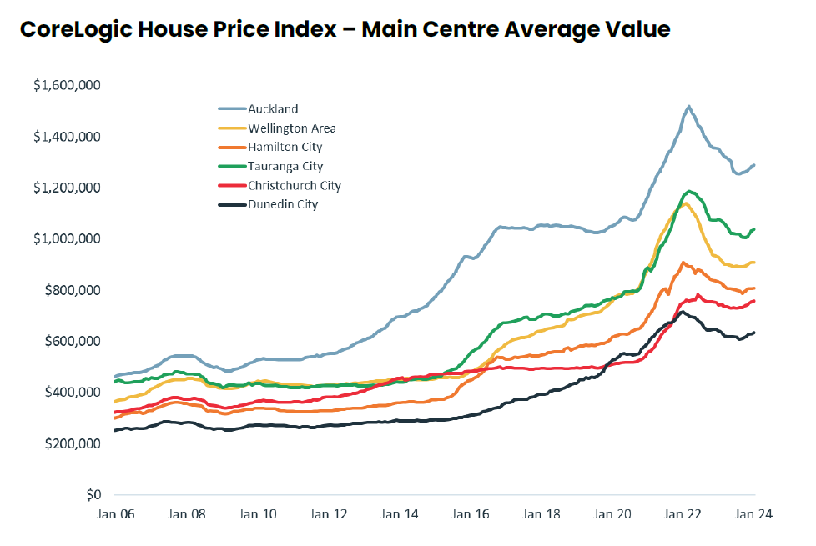
Yet an examination of house price trends in New Zealand does not show Auckland becoming significantly cheaper than Wellington, for example. Indeed, whilst Auckland’s prices flattened between 2015 and 2020 this was followed by a steep increase. Auckland’s policies are not some kind of miracle cure. It would appear that other factors (e.g. interest rates and taxation policies) matter more than planning policies. Also, while there was an increase in townhouse construction in Auckland, a report prepared by Auckland Council 10 years after the commencement of the policy showed that the townhouses constructed under the new planning policy had poor building quality including poor insulation, and that occupation rates for the townhouses were lower than the occupation rates for detached houses replaced by townhouses.

Co-author of Unskilled and unaware of it: how difficulties in recognizing one's own incompetence lead to inflated self-assessments, J Pers Soc Psychology, 1999 77(6):1121-34.
Strata Defects Survey Report, Published by the Office of the Building Commissioner, November 2023, Page 2.
Reform of Heritage Legislation, Peter Tulip, Centre for Independent Studies, 2026, page 11.
All this and much more may be found in my book “The Model Suburb” A History of the Malvern Hill Estate, which was published in 2025. Dr Tulip could have chosen to examine the publication to come to an understanding of the significance of the Malvern Hill Estate. Instead he remains resolutely ignorant even of the concept of significance.
Reform of Heritage Legislation, Peter Tulip, Centre for Independent Studies, 2026, page 7.
Does high-rise development damage neighbourhood character?, Peter Tulip, Zachary Lanigan, Centre for Independent Studies, 2021, page 12.
https://www.rnz.co.nz/news/regions/529228/some-newly-built-auckland-homes-too-hot-council-study-shows

