Submission to the Productivity Commission inquiry into Housing Regulations in Australia

Summary: the interim report’s recommendations are a recipe for lower living standards:

- The interim report’s recommendations advocate for a housing market that resembles that of the nineteenth century, when housing was unaffordable and overcrowding rampant
- The Commission does not seem to recognise that detached houses are the most popular and preferred form of dwelling, and that upzoning will likely make them more expensive when they already carry a significant price premium
- The report’s recommendations will result in the most affordable detached houses being knocked down and replaced with family-unfriendly units
- The interim report does not adequately consider alternative theories and factors determining house prices. Though this is partly constrained by the terms of reference, accepts the ideology of pro-upzoning economists too uncritically without adequately considering other views
- The interim report makes insufficient consideration of the role of urban growth restriction and the difficulty of developing new greenfields land, despite the fact that Australia’s housing affordability was best when growth was mostly greenfields
- The interim report only considers one model – urban intensification – without considering its tradeoffs and any alternatives, even though no city has produced affordability through infill alone and density has many downsides
- Claims about the effects of parking requirements are misleading, based on misconceptions, and overstate any benefits of reducing them. Instead of removing minimums, requirements for basement (rather than podium) parking should be scrapped
- The interim report’s recommendations will lead to lower quality dwellings, with a ‘pay less, get less’ market where price falls are heavily influenced by market composition rather than genuine declines
  - The report specifically makes recommendations that would reduce dwelling quality, without adequately considering why these may be bad tradeoffs
  - The Commission does not realise that some of the regulations they are asking to be removed may be welfare enhancing
- The universal three storey concept should be removed. It is based more in YIMBY aesthetic preferences than evidence, and has major downsides. Even with two stories large increases in density are possible in many Australian suburbs

In short, what the Commission’s recommendations entail is the end of the ‘Australian Dream’. Supply of detached houses will become increasingly constrained. New owners will not enjoy the backyards and space that their parents did, and many of them will live in smaller dwellings than their parents as well, and due to a reduced proportion of detached houses will be unable to obtain a suitable house to raise a family. The long-term negatives will be significant.
Table of Contents
Submission to the Productivity Commission inquiry into Housing Regulations in Australia 1
Summary: the interim report’s recommendations are a recipe for lower living standards 1
1: Australia achieved high levels of affordability and ownership under a regulatory regime opposite to what the Commission recommended in the preliminary report 2
2: The premise of the report ignores Australia being a world-leader in dwelling construction 4
3: The interim report relies on one flawed concept of how land markets work, without considering alternatives 6
4: Even given the terms of reference, both the Commission and upzoning advocates have failed to correctly weight the importance of the financial system 10
5a: Demand subsidies 12
5: Upzoning can even lead to higher land prices 12
6: House pricing is not a ‘layer cake’ – prices of components adjust 14
6a: Aside: parking requirements 15
7: The housing market is heterogenous: missing middle and apartments are not a replacement for detached houses 16
8: The evidence given in favour of upzoning rarely considers dwelling quality and the resultant tradeoffs – it will result in affordable detached houses being replaced by units 18
9: The interim report inadequately accounts for the effects of urban ‘sprawl’ containment 21
A lot of YIMBYism is about aesthetic and lifestyle preference – whereas density has real problems that zoning prevents 23
10: Land banking is real 26
11: Migration cannot be ignored 26
12: A tale of two countries: New Zealand and Canada 30
In conclusion 32

1: Australia achieved high levels of affordability and ownership under a regulatory regime opposite to what the Commission recommended in the preliminary report:

Australia achieved a high rate of housing ownership without ‘pro-density’ policies. In fact, during the period where Australia’s homeownership rate lifted post-WWII, there was a major de-densification, with people moving out of the city centres into newly built low-density suburbs.

- The Commonwealth Housing Commission recommended one-quarter of an acre as the ‘ideal’ block size, in practice block sizes of over 650 square metres were standard in new developments from post-WWII until urban intensification became the predominant ideology in the 1990s
  - This put a sharp density limit on new housing i.e. it was zoning without being called such. New housing supply was achieved largely by greenfield development.
  - In comparison, modern privately determined block sizes tend to be much smaller to maximise profitability (often with larger houses, essentially maximising value per area).
- The living area footprints of the houses built on those blocks were typically small - around 110 square metre for three bedrooms, rising to 129 sqm by 1969, compared to more than 200 sqm today. This meant cheap houses with much open space, which gave room for extensions or developing other functional spaces, as well as encouraging an active, outdoor lifestyle.
- Around 10% (and sometimes more) of houses were built directly by governments as part of public housing schemes, and were then often onsold to the residents at prices below the market rate
  - i.e. the government was actively undercutting the private market – whereas some upzoning advocates have recommended specifically against this kind of action.
- Rent controls were widely implemented during WWII and though ruled illegal at the Federal level in 1948, were maintained on some properties at state level until the late 1950s
- Mortgage lending was heavily regulated, with loans typically limited to 2.5 times the servicing income and most lending being done by building societies rather than banks, both constrained in the amounts they could lend.
- Mortgage lending was deliberately tilted to favour owner-occupiers:
  - Investors typically had to put up a 30% deposit, compared to 20% for owner-occupiers, and had to provide greater proof of ability to pay
- The result was that the number of investor-owned houses actually fell between 1935 and 1960, despite the total housing supply increasing significantly
  - This did not have negative impacts on either of the ability of people to rent or to own
- Even after the sales to occupants social housing proportion was much higher than it now is (this is due to a very low rate of social housing construction in recent years).

In short, Australia’s high rates of home ownership were not produced by pro-density, deregulating policies. Quite the opposite – housing was highly regulated and had sharp practical density limits. According to the theories promoted by pro-upzoning economists, this should have greatly worsened affordability. However, this did not happen.

The interim report ignores the conditions under which high housing ownership in Australia was actually achieved and recommends policies that more closely resemble the dwelling markets in the 19th century. During this period, there was generally less greenfield development, due to the limits imposed by railways and walking (compared to cars) and there was little in the way of regulations that prevented denser housing, Development was almost entirely private, sold at the market rate. In this time housing in large cities like in America and Europe was usually very unaffordable, with ownership rates being very low, and the quality was extremely poor, with overcrowding rampant.

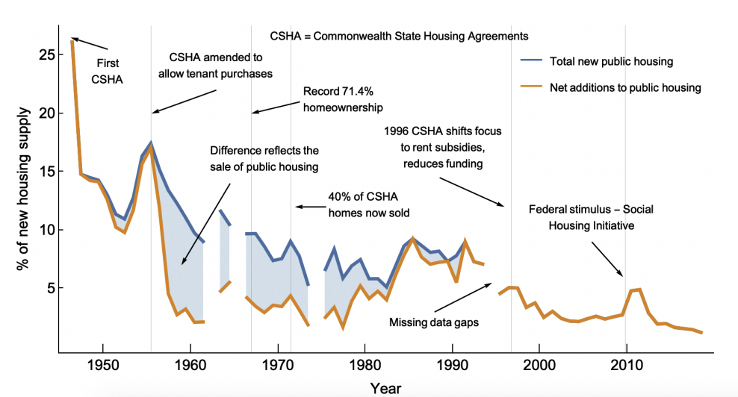
Source: https://gameofmates.com/wp-content/uploads/2021/07/antizoning.pdf

2: The report ignores that fact that Australia is a world leader in housing construction:

Australia does not have a supply problem. Australia is one of the fastest builders of housing in the developed world:

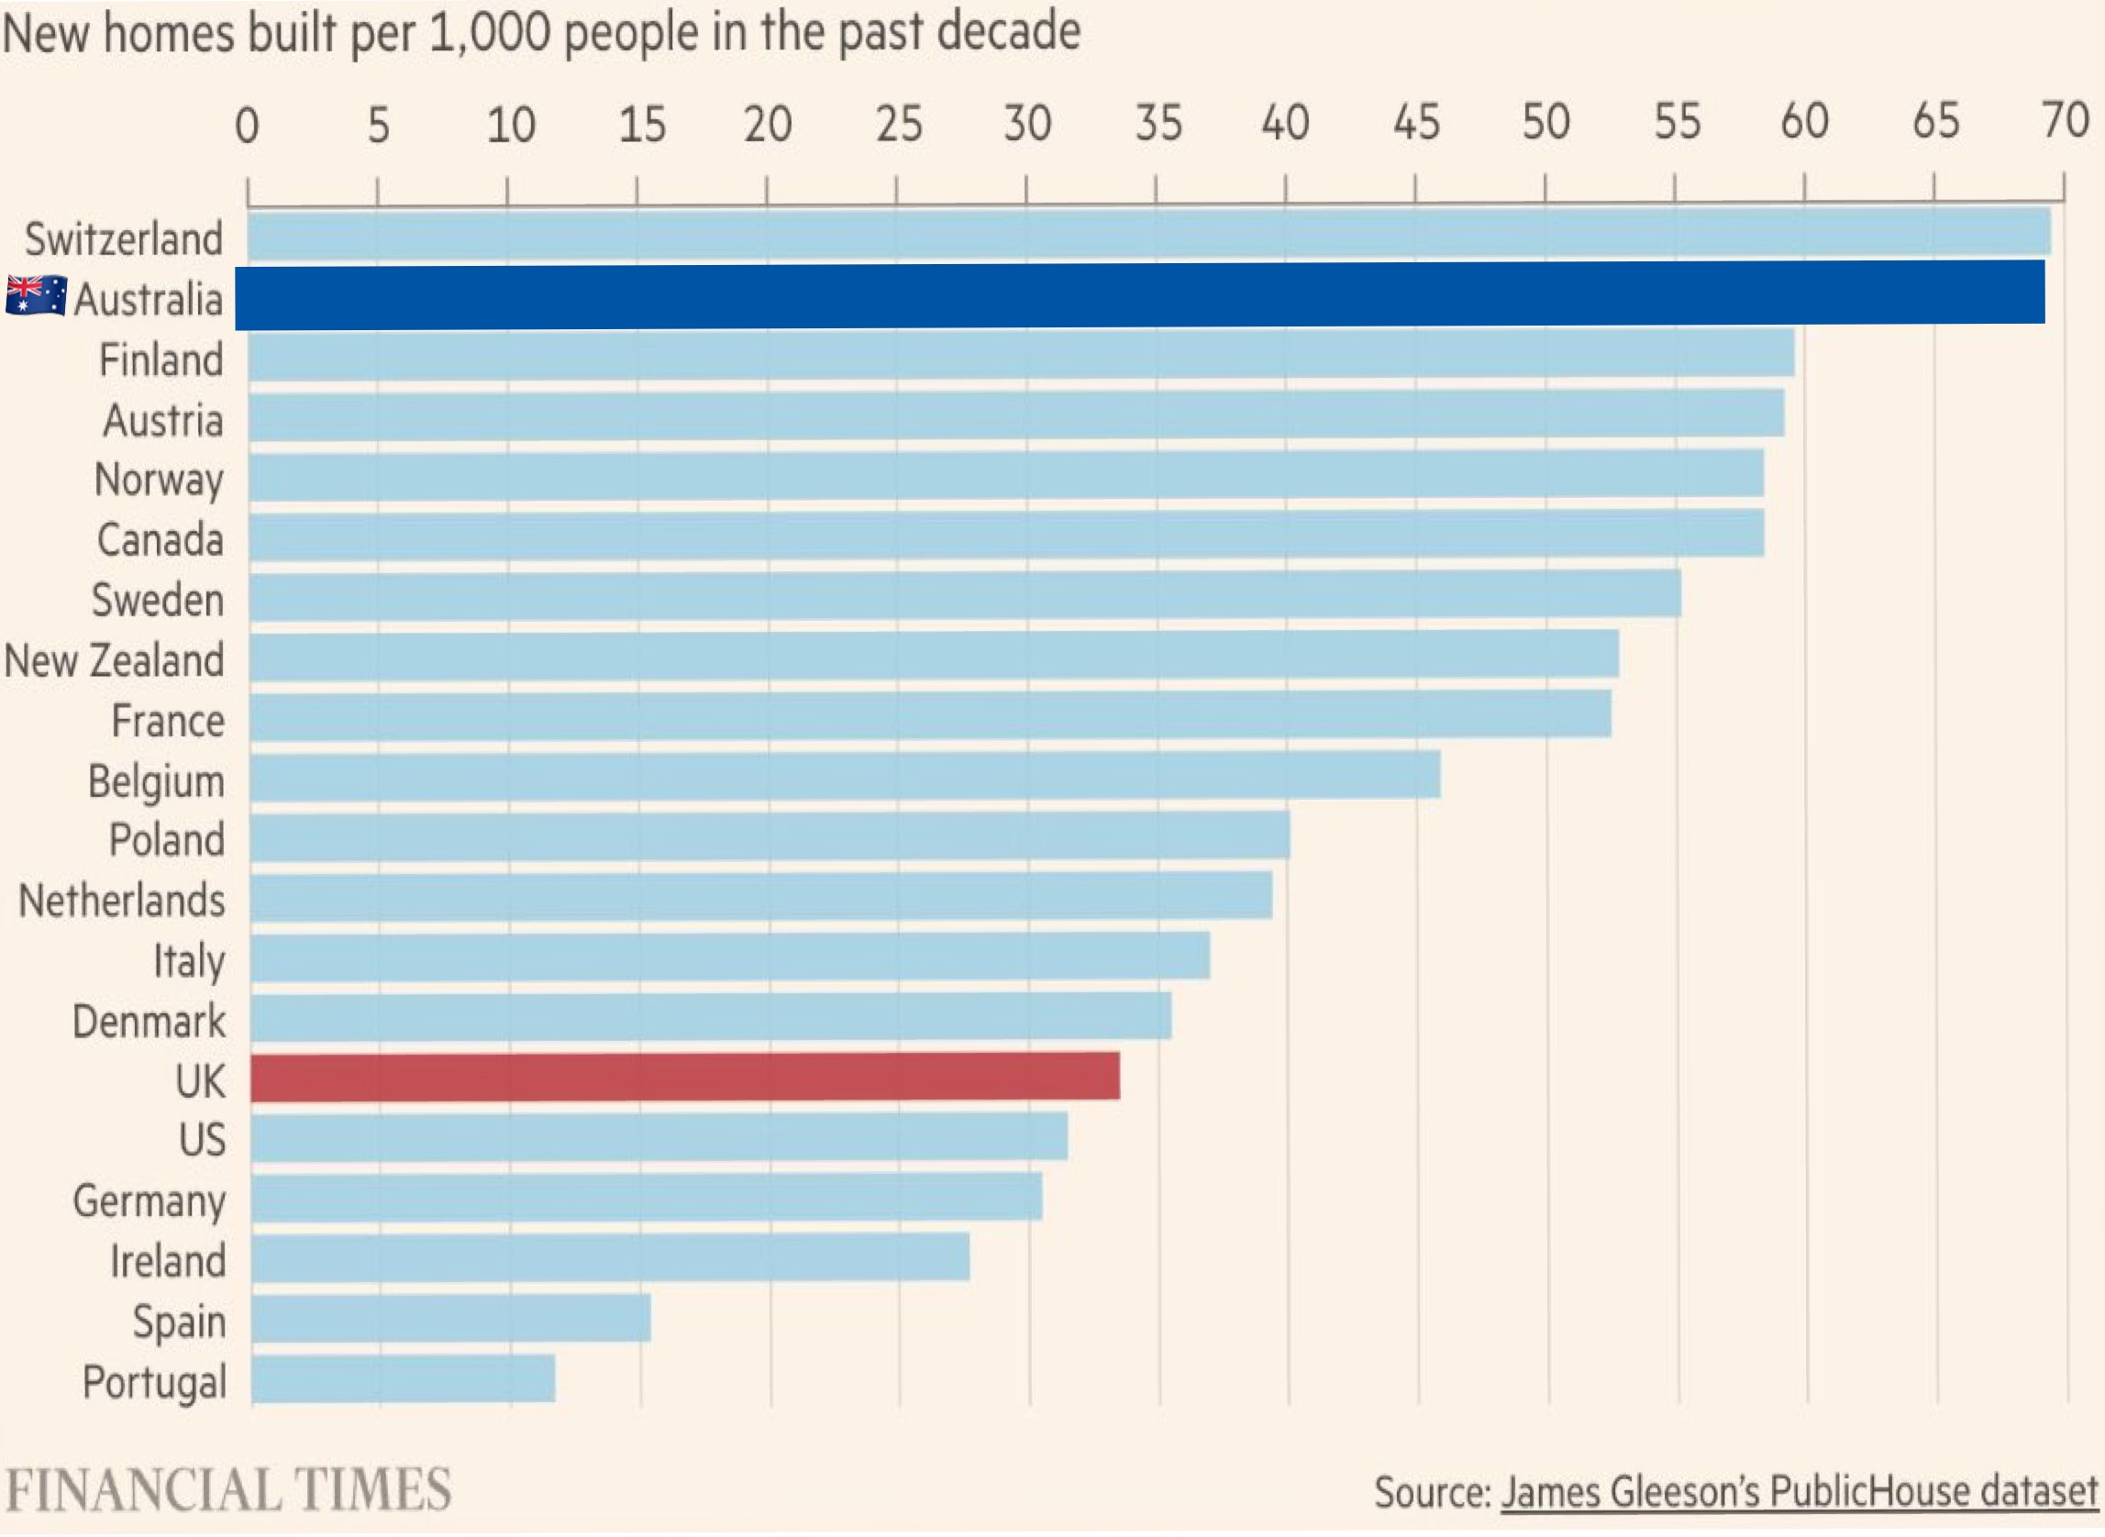

Despite the frequent references to zoning reforms in New Zealand, Australian cities have routinely achieved a similar or faster rate of construction than in New Zealand. Only recently due to rapidly elevating construction costs (largely not caused by regulation) has the rate declined:

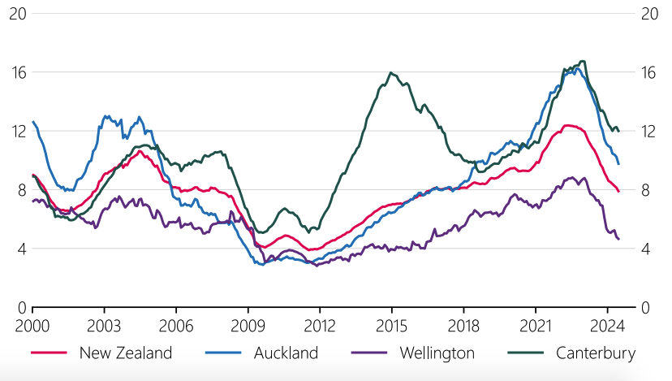
Showing dwelling approvals per 1000 working age people Source: https://www.rbnz.govt.nz/-/media/project/sites/rbnz/files/publications/financial-stability-reports/2024/estrict-2024-special-topic-1/fsr-special-topic-update-on-housing-market.pdf
Note that the levels are generally higher than those in New Zealand, often much higher
In short, the report is premised on the idea that Australia’s housing construction needs lifting from an already extremely high level. This is fit closely with the ‘supply only’ approach of people who think regulations are the main factor for high prices, with demand not being properly considered. The Commission should be more sceptical of this.

It should be briefly mentioned that many YIMBYs mislead by comparing changes in per capita housing stock between Australia and other Anglosphere countries to those in continental Europe. These differences are due to demographics – Australia, Canada and New Zealand in particular have had a much higher rate of migration, and continental European countries are older and ageing more rapidly so have smaller households. Hence this is not a reliable comparison.

3: Upzoning can lead to higher land prices

In most economic concepts of land pricing, the value is set by the highest and best use – i.e. the thing that can be done with that land that would produce the best economic return. Upzoning allows more valuable construction on any affected parcel of land, which will in turn raise the value of that land. This has been reported in Brisbane and New York, yet one of the clearest examples come from the supposed success of Auckland. In Auckland, prices in 99% of upzoned parcels rose, with the increases in being greater in parcels that were upzoned more (whereas pro-upzoning theory predicts the opposite):

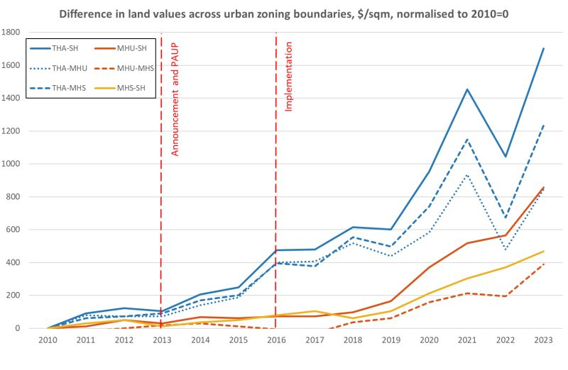

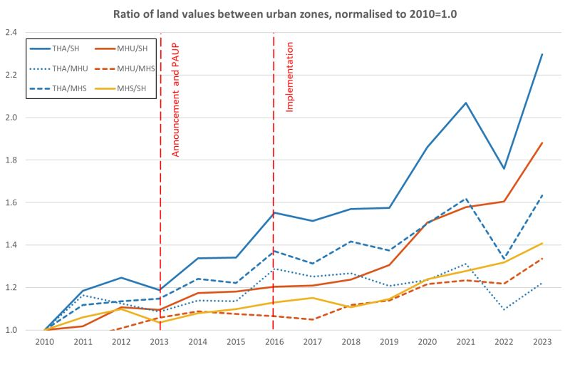
Both charts from https://www.linkedin.com/posts/tim-helm-a7b06640_interesting-new-land-price-data-for-auckland-activity-7442039952537899008-Sc9v
These charts show the difference between the high-density zone (THA), middle density zones (MHU and MHS) and zone with no change from low density (SH). It can be clearly seen that both in anticipation of, and after rezoning land values increased faster in the denser zones. This is consistent with land values being driven by the economic value of the development allowed. More dwellings on a block, even if they are smaller and less expensive per dwelling, means greater total sale value and greater total rental return.

Furthermore, a separate study shows there is a clear discontinuity between the zones, where the denser side of a zoning boundary is immediately and substantially different. At the scale of normal urban blocks, this difference may amount to more than NZ$200,000:

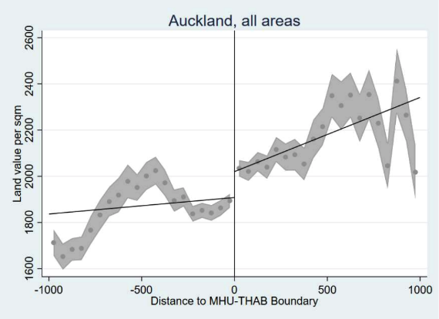
- Source: https://drive.google.com/file/d/185n-YVLWnnct_8p5wS9H3svMrnBSw3M8/view THAB denotes a higher density zone than MHU
This means that upzoning may not produce the price changes that advocates claim. Furthermore, what price changes occur may be due to a few effects:
- The land value is split across the dwellings. While this may lead the value of land per newly built dwelling to be lower than the value of that land value across a single dwelling, the new dwelling owner effectively only possesses a fraction of the land
- Newly constructed dwellings may be smaller, will have little or no private outdoor space
- Unit titled dwellings may be worth less as they offer fewer options to change for owners, due to the land ownership being effectively shared
In all of these cases it is a case of ‘paying less for less’, with any price falls in housing of a given quality being much smaller than apparent from headline data.

This also comes with a second implication. Without value capture (such as taxing rezoning windfalls) to prevent land values rising, upzoning will raise the prices of existing detached houses as observed in Minneapolis. In Chicago, it was even observed to raise the price of apartments. This is because upzoning provides landowners a future option to put more valuable development on their land. The result is that the price of detached houses will be increased, pushing them further out of reach for owner-occupiers. Indeed, as noted by Peter Phibbs in his submission, Greenaway-McGrevy admits that prices as detached houses are likely to rise from upzoning.

3: The housing market is heterogenous: missing middle and apartments are not a replacement for detached houses

Most advocates of upzoning either implicitly or explicitly consider the housing market to be homogenous and that some types of housing (unit/strata titled dwellings like apartments or townhouses) are a direct substitute for another (detached houses). There is little reason to believe this is the case.

Australia is experiencing an increasing divergence between the prices of detached houses and those for strata titled dwellings, with detached house seeing increasing faster. If the two were genuinely substitutable, as claimed by upzoning advocates, this should not be observed. That it is, indicates that buyers are willing to pay a premium for detached houses compared to other housing forms. Furthermore, certain types of dwelling may have an inherently narrower market base. For example, detached houses may appeal to singles, couples, small families or large ones. However, a two-bedroom townhouse is unlikely to appeal to a family, and may even be less appealing to a couple. Furthermore, families tend to have greater income and hence purchasing power than singles, so they will be able to bid prices up higher than otherwise.

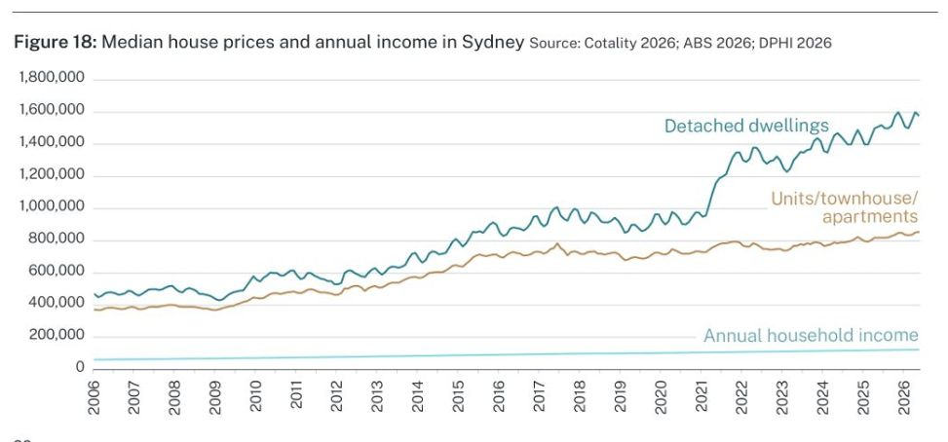
An Example from Sydney. From https://www.linkedin.com/posts/tim-williams-a6220253_this-has-really-got-people-talking-subjectively-activity-7503258520151048192-fvXM
A recent study Australian study confirmed this to be the case with detached houses and apartments, finding movements in apartment prices had little influence on those for detached homes, while those for detached houses influenced those for apartments. It showed that there are two separate markets, meaning that building more apartments is unlikely substantially improve affordability. Even the heavily pro-upzoning e61 Institute recently admitted that apartment construction did not influence detached house prices and that price rises are not driven by a shortage of high-density dwellings and that credit expansion overwhelmed any supply effect. However, their pro-upzoning advocacy prevents them admitting that Sydney trebled its housing supply between 2020 and 2010 – a similar increase to Auckland – without any large-scale zoning reforms.

Another recent American study also examines the effects the heterogeneity of the market. It shows that contrary to the models used by upzoning advocates, there is not a single function for ‘supply’. This means there is no single measure of supply elasticity. This has the strong implication that, when quality and income effects are considered, the Glaeser-Gyourko metric of ‘zoning tax’ lacks the specificity to actually prove any purported effect.

Overall, the Commission fails to recognise the existence of bifurcation in the housing market. This is important, because it means that compositional effects on prices will be overlooked. It is possible for one type of dwelling to be oversupplied and another to be undersupplied. The Commission’s recommendations will result in the replacement of the type that is undersupplied (detached houses) with that which is oversupplied (unit-titled dwellings).

4: The evidence given in favour of upzoning rarely considers dwelling quality and the resultant tradeoffs – it will result in the most affordable detached houses being replaced by units

Surveys such as those formerly performed by Infrastructure Victoria consistently show that the public prefers detached houses, which can also be seen by the increasingly large price premium they fetch over unit (strata)-titled dwellings. And as previously mentioned, ‘missing middle’ or apartments do not necessarily have the same market base as detached houses. The medium-to-high-density development recommended by the interim report will result in reduced dwelling quality and will impose a large number of external costs which the current regulations are designed to reduce, such as loss of greenspace and solar access, less storage or garage space and fewer rooms (with a consequent effect on fertility rates).

Unfortunately, researchers have poorly accounted for quality factors, partly due to its subjective nature. For example, Greenaway-McGaveny claims that in Upper Hutt prices for both apartments and houses fell, but without providing quality adjustments. Hence it is impossible to tell if the quality of new dwellings changed with the upzoning. This is especially important to consider in markets where new dwellings make a significant percentage of housing transactions, such as in Auckland. In Auckland, the major type of ‘missing middle’ apartment being built is a two-bedroom townhouse or terrace house, and these are displacing larger detached houses. The result is that smaller dwellings are displacing larger ones. Furthermore, the average size of new detached houses has been falling:

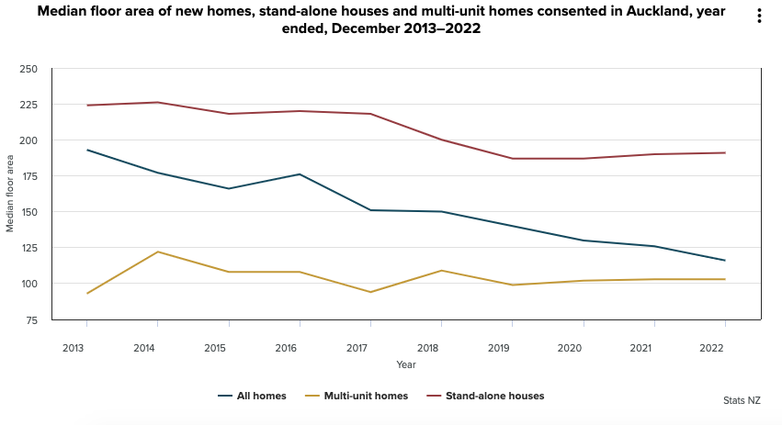
- Source: https://www.stats.govt.nz/news/median-floor-area-of-new-homes-consented-decreases-10-percent/
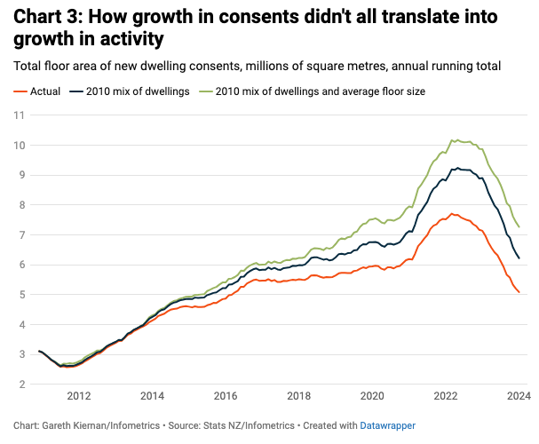
- Source: https://es.infometrics.co.nz/article/2024-04-thirty-six-thousand-new-homes-isnt-what-it-used-to-be This chart shows how New Zealand’s newly built floor area is much less than expected from approvals due to a decrease in dwelling sizes.

Note that floor area addition growth slows post-2016, despite upzoning. Furthermore, despite a high rate of additions of dwelling counts, the addition of floor area has slowed to nearly what it was pre-upzoning. This is because the new dwellings are much smaller than previous.

Ironically, the one thing that the Commission’s recommendation will not produce is the type of housing that will probably be most beneficial – cheap detached housing. Cities such as Canberra, which had a high proportion of public housing, have a large supply of relatively small detached houses. Small detached houses offer benefits over equivalently sized townhouses or units that make them desirable:
- They usually have three rooms, whereas modern townhouses and apartments usually have two for a similar floor area. This makes them much more family friendly, with sufficient rooms for two children.
- They are not strata titled so the owner has full control of the land
- They have scope for extensions
- They have large back and/or front yards, given immediately accessible private greenspace ideal for recreation, especially for children
- They have sufficient room for a garage and/or shed, giving owners extra space compared to apartments. This extra room may be used as a working space, or for storing possessions – it is important functional space.
- They have extra room on the block, making it viable to park extra vehicles, boats or other lifestyle items. These have been a luxury well within reach of the Australian and American working classes, but not European ones.

However, there is no new supply of small detached houses. This is partly due to building standards, especially those for accessibility which force new builds to be larger (ironically many of people who would benefit already own their own houses not built to those standards). But a major part is the lack of guiding hand that the government formerly provided. Now that development is practically entirely private, block sizes tend to be smaller and buildings much larger. This is partly due to demand for larger houses and lack of greenfields land, but also helps maximise profits.

Lack of detached housing will lead to a widening gap between the ‘haves’ who own one and the ‘have nots’ which limits future options and lifestyle:
- First and foremost, ‘missing middle’ dwellings like townhouses are often only two rooms, making them unsuitable for families, especially families with more than one child. Hence, they are not full substitutes.
  - This may explain why price divergences are observed even in cities with a higher proportion of townhouses like Canberra (Auckland’s was unusually low for a large city, so it is not representative).
- These dwellings are in many cases smaller than the relatively small detached houses built during the post-WWII boom but without the backyard, and space for a shed or sufficient parking (carport/garage)
  - Some of these new dwellings do not have a garage or carport at all, instead having a single uncovered parking space, so lack the functional quality that proper garaging has
  - This lack of garage, space for a shed or, extra parking prevent lifestyle options such as owning trailer, boat or trail bikes, or even having somewhere to put extra possessions:

Source: https://www.greaterauckland.org.nz/2025/01/22/growing-auckland/#comment-652189 – comment expressing the lifestyle restrictions that Auckland’s pro-density reforms are creating
  - This cuts off these options for people who cannot get a detached house, even if they could afford them otherwise
- Some of these new dwellings do not have any kind of private outdoor space, even a courtyard
- This shows that decreasing the quality of dwellings through upzoning has effects beyond the immediate dwelling. It also decreases the range and quality of lifestyle options available (which in turn will negatively affect businesses who cater to those lifetyles).
- Therefore, these dwellings should be less valuable than the ones they are replacing, as they offer fewer lifestyle options and appeal to a narrower market (younger, childless persons or couples, who will likely have a lower income)
  - They should also be less valuable because the land share is smaller and owners do not have full control over it i.e. less for less.
- Unit titled dwellings now make up well over half of New Zealand’s new dwelling approvals, which in some markets (like Auckland) make up about a quarter of total sales.
  - Since these new dwellings can command less of a premium than houses, and are less valuable overall, prices should be expected to fall from compositional effects alone regardless of the effect of any increase in supply
  - At least one study has noted that the change has seen sites developed to maximum density (i.e. many small dwellings) rather than more ‘gently’

A major effect of upzoning will be developers targeting the remaining supply of older or smaller detached houses for redevelopment. Townhouses are only slightly less expensive to build than detached houses despite the latter being larger. Building a three-bedroom townhouse or apartment is often more expensive than a detached house, so most replacement dwellings will be two bedrooms. There will be a strong incentive for developers to target the most affordable housing in outer suburbs (as observed in Auckland) for redevelopment, rather than the most expensive ones, as the gains will be greater. These developers will usually try create either small units to gain maximum density or very expensive ones to gain maximum per value per dwelling. This militates against affordable, family-friendly housing. First homebuyers are usually more credit constrained than investors, so will be unable to compete with them to buy older detached houses.

The Commission, and policy makers more generally, have paid insufficient attention to the type of housing being built – delivering not just more housing, but the right housing. The overall effect of the Commission’s recommendations will be to reduce the supply of desirable detached houses, both proportionately, and if greenfields supply is constrained, in absolute terms. As the proportion of detached houses decreases overall, people will be increasingly locked out of owning them and the ones that are left will become increasingly expensive as more people compete for them. In short, they are recommendations for quality reduction.

It is also very concerning that the Commission recommends the removal of requirements such as minimum balcony size, minimum storage spaces and windows. These are welfare-enhancing requirements that prevent the kind of problems 19th century apartments had. The sale price of apartments has risen much less than that for houses, there is clearly not a shortage of them. The main thing these changes will do is improve developer profits, not affordability. The Commission is effectively asking to allow lower quality versions of lower quality dwellings, and has not considered why the regulations were there in the first place.

5: A lot of YIMBYism is about aesthetic and lifestyle preference – whereas density has real problems that zoning prevents

So-called ‘Yes in my backyard’ or ‘YIMBY’ advocates (a misnomer, as not only do they not have backyards, they often do not even desire to possess one) have been very successful in influencing the debate on how to tackle the ‘housing crisis’. As a subset of wider ‘urbanism’, YIMBYism is driven at least in part not by affordability concerns, but by preference for certain lifestyles and built form aesthetics. Urbanists have long opposed low density suburbs, despite an overwhelming market preference in the opposite direction, as shown by the movements out of dense core once low density became accessible, and the current price divergence between detached house and units. YIMBYs often seem to view suburban life as a defective version of urban life preferred by people ‘too stupid’ to know they shouldn't want suburban life. Hence, they want to remove everything that people who prefer suburban life value, like separation from commercial areas, detached, spaced out houses, and private green space.

This can be commonly seen by YIMBYs referencing the 19th century city cores of European cities, especially Paris, as their ideal. For example, both the chairman of Greater Canberra and one of the deputy chairs of Sydney YIMBY have both made social media posts referencing Paris as an ideal model for Australian cities. While this may appeal to childless, usually very young viewers (often university students), density has real problems:

- The population of the City of Paris (as in the statutory municipality) has been decreasing for a century as people move to lower density developments in the metropole
  - Despite this urbanist literature overly focuses on the higher density developments within the city or close to it that the French are rejecting in preference
  - The outlying suburbs that are increasingly the preference of the French usually have a building height of under three storeys
- Despite this, cities such as Paris, Amsterdam or Tokyo have very high housing costs and very small houses, with per-floor area costs being comparable to or even higher than those in Australian cities.
- Denser cities have less private space for recreation, as yards (back, front or both) are usually small to non-existent
  - This means that outdoor recreational space is less accessible for children
  - It increases the risk of employing suboptimal spaces such as roads, with the resultant safety risk
- Denser cities usually have worse congestion despite have a lower mode share of car traffic – density increases congestion faster than made shift reduces it
  - The megaprojects required to service density (such as underground rail) are often expensive and limited in their reach compared to driving
  - Compact European cities tend to have significantly longer commute times than spread-out American ones, despite their smaller footprints
- Cities consisting of taller buildings, narrower streets and less green space (including private green space such as backyards, which are often omitted) tend to have more air pollution due to trapping, as well as greater exposure to that pollution
  - Cities such as Paris and Barcelona have worse air pollution than Australian ones despite strict emissions controls and a much smaller proportion of motorised traffic
- Denser cities also have both more noise pollution and more people exposed to any given polluting event. Attached dwellings facilitate noise transmission.
- The lack of green space contributes to the urban heat island effect (which may reach over 5°C in bad cases) meaning that dense cities are more likely to suffer severe heat-related health hazards with climate change
  - Australian suburbs designed around the garden city principle, such as in Canberra, have a very high canopy cover and will be much less affected provided the recommendations in the interim report are rejected
- ‘Walkable mixed use’ areas tend to have more noise pollution (activity creates noise, especially at night) and crime (due to businesses being a target).
  - When developments that separated business and residential areas became affordable, the majority of the population rejected ‘walkable mixed use’.
- When density is produced through intensification, as opposed to being built in place, the infrastructure is often inadequate and requires retrofitting. Even if it is adequate for increased usage it degrades faster. It is common to claim that infill is cheaper than greenfields, however when retrofitting is required due to lack of spare capacity it can be more expensive.
- Denser cities lack privacy. Dense housing diminishes both the privacy of outdoor space (by overlooking backyards) if such space exists, and the privacy of adjoining dwellings (allowing more noise and sight). This is likely a major reason that inner city residents tend to have worse mental health than suburban residents.

It can be seen that there are many downsides to higher density. These represent externalities imposed by both developers (as denser development is often more profitable) and lifestylers (university aged or single ‘YIMBYs’ who want to access an inner-city lifestyle regardless of where they live). Planning restrictions can be welfare-enhancing, offsetting the externalities of density.

Unfortunately, the recommendations in the interim report skew very strongly towards the desire of YIMBYs to impose their lifestyle on other people, regardless of the costs. Blanket rules like the report recommends reduces democratic participation by removing the ability of councils – the most immediately accessible and accountable bodies (compared to state governments) to set rules desired by the population that lives there. Ultimately, they would take away people’s ability to avoid the negatives high density living. There are already plenty of areas where YIMBYs can live their preferred lifestyle.

One of the most important externalities of density, aside from those already listed, is long-term demographic effects. It is notable that many vocal YIMBYs are single, often being university students who have not yet considered a family (others are simply hypocritical). Throughout history, dense areas have had the lowest fertility rate (sometimes falling below 1 even prior to modern morals and contraceptives – for example in late 19th century Vienna). A major cause of this in the modern day is lack of family-friendly housing – worldwide, the higher the proportion of apartments (which are usually two bedroom or fewer), the lower the fertility rate. It is no coincidence that the baby boom happened with suburbanisation causing dramatic density decreases, and that the size of the boom more or less matched how much that country suburbanised.

Since two-bedroom townhouses or apartments are likely the most economical and common dwelling type built under the Commission’s recommended policies, they will replace detached houses with family non-friendly types. Hence if the recommendations are followed, fertility rates will decrease. This also leads to an irony – it is often claimed that Australia’s high migration rate is necessary to offset to the effects of population ageing. However, accommodating this migration through upzoning and increased density will reduce the proportion of family friendly housing – and hence reduce the fertility rate further. The recent falls in fertility rate may be an example of this already happening.

5a: Two storeys are a better compromise than three:

The interim report has unfortunately largely elided serious discussion of second-order effects and tradeoffs. These are likely to be much worse under the recommendations for three storeys:
- With two storey housing, it is relatively simple to avoid blocking of solar access and the sky with simple rules on setbacks. With three storey housing, avoiding this is very difficult while retaining a useable third storey. Therefore, it imposes a much greater externality on adjoining residents.
- Similarly, three storeys is much more intrusive upon privacy than two, as it is difficult to grow plants of a height and density that will block adjoining views. Once this privacy is lost, it is lost forever.
- Many areas already have two storey housing, or allow knockdown-rebuilds of two storeys, so it is less intrusive on local character
- Dwellings in three storey apartments are more likely to be ‘apartment like’ i.e. with relatively small two-bedroom units occupying part of a floor rather a full terrace, hence they will be less family-friendly
- Three stories dwelling will have less private space per dwelling, unless the building footprint is made very small
- Three story dwellings will have less overall space on the block per dwelling, worsening the aforementioned lifestyle-restricting effects (such as no space to put a trailer)
- Developing three storeys is likely to have major infrastructure costs in suburbs where the infrastructure was built to service detached homes. Unless these are fully recoupled through development charges they will burden rate/tax payers. Two stories will mean less dramatic changes and lower costs.

Neither the Commission report nor the cited evidence make a strong case for why allowing three stories is imperative. Many Australian suburbs are of sufficiently low density that depending on form, two to four dwelling can be easily put on many blocks, a major increase in potential capacity while building heights remain restricted to two storeys. This can be seen with many redevelopments that have taken place, for example, in eastern Melbourne. Overall the three-storey concept likely has more negatives than positives and should be omitted from the final report.

6: The interim report relies on one flawed concept of how land markets work, without considering alternatives

Most modern studies claiming that zoning is the major cause of high prices are based on the model of Glaeser and Gyourko, which claimed to measure a ‘zoning tax’ by comparing
Their model was shakily reasoned to begin with and has recently been empirically refuted. In short:
- The model relies on examining the difference between the per-area price of lots and by examining the difference between lot prices to calculate a ‘marginal lot price’, the price of a theoretical lot composed of the difference in land area between the two lots.
- They claimed that price per land area of actual lots and their theoretical marginal lot should be constant. They then claim that any excess of the average
- However, they ignore the physical reality that at some point a lot is too small to build on, so has a low value. Since their theoretical marginal lot is too small to build, say, an extra dwelling, it does not contribute as much to the value of the lot as, say, the difference between being able to build one or two dwellings.
  - As a result, there is no reason to expect the average and marginal value of a lot to be equal except to fulfil an unsound prior assumption that price per area should be linear
- In their earliest model, the do not clearly include land prices. effectively declaring that land should have no value other than the building on it
  - They absurdly claimed that an ‘unrestricted market’ could force prices ‘below the cost of construction’, ignoring that their examples were in deindustrialized, crime-afflicted cities where the housing stock had been built many years before when real values were higher
  - In later studies they arbitrarily assigned 20% of the construction costs to land, based on an unclear and debatable sample (in many Australian greenfield projects, the land is the majority of the cost, and importantly it is a variable cost, not fixed)
- The only way their model could be true is all housing was perpetually rebuilt to match market demand. This is clearly impossible.
- If land values could not be increased by changing how a block is divided, there would be little incentive for owners to subdivide.
  - Instead values tend to change to reflect the more valuable development that subdivision achieves – a plot of land subdivided for houses has a greater value of development that can be realised than when undivided.
  - This is also seen in the non-linearity of price-per-area by block size – allowing a house adds the value, expanding that house or the yard adds to the total value, but at an increasingly low marginal value
  - This also implies that there is an optimum block size
  - In short, non-linearity of values would be expected in a market dealing with physical land and physical constructions upon it
- Glaeser and Gyourko a priori claim that land is inherently competitive, when it generally cannot be created so has an absolutely fixed supply with few unclaimed parcels. One cannot create more land in a given location.
  - This means that any ‘zoning tax’ observed likely represents a location premium instead
Furthermore, the Wharton Land Use Regulatory Index, which was invented by Glaeser and Gyourko to quantify purported zoning strictness, has recently been shown to not measure what it claims to. It has a random (at best) relationship with more objective metrics of the items it claims to measure. Therefore, any study using it as a measure is highly doubtful, as are other land use restriction indices benchmarked against it.

Despite the empirical refutation of their land pricing model, upzoning advocates, rather than changing their opinions based in this evidence, reinterpret and rationalise studies that show different causes, or examples of effects of policy changes differing from their theories, in light of their closely held beliefs about how the market ‘should’ work. This at times more closely resembles pseudoscience in its methods, an impression reinforced when counterexamples to the idea are often simply omitted.

Prior to Glaeser and Gyourko, economists recognised the physical reality of land markets – desirable locations are absolutely limited. Adam Smith originally conceptualised as landowners as exercising a natural monopoly over their land they own, with the result that they were able to extract rents from occupants above the cost needed to maintain that land. Cities are no different. While it is possible to build denser in a given location, this changes the nature of the dwellings (smaller, less private space, differing construction costs) – it cannot create competing parcels at that location.

Historically, housing in cities was unaffordable despite the lack of modern zoning or design rules. In the mid-20th century, housing became more affordable and price rises that occurred during this period were due to increased quality. The models of upzoning advocates do not and cannot explain why this occurred. In fact, the models and theories cited by upzoning advocates are only models of why housing isn’t built when the modeller thinks it should be. They do not explain why housing is built where and how it is in the first place.

Supporters of zoning as the main cause of high house prices have no concept for land as an asset, or houses as an asset either. This is despite the demonstrable role of credit and speculation in price changes, something common with other financial assets. As Bank of England Staff explain in noting that interest rates, not scarcity, has been the main driver of British house price rises: housing is an asset, whose value should be determined by the expected future value of rents, rather than a textbook demand and supply for physical dwellings. In short, land and housing are different.

Stocks, for example, have almost zero cost of creation, yet carry value based on the perceived underlying value of the issuing company’s future production and assets. Similarly, land carries value despite that fact that it has zero production cost (it has costs bringing it into use, but no production costs by itself). This is because as quoted, land offers the potential for future rents (this applies not just rents obtained from leasing, but to rents in the broader, Smithian sense). This has important implications, because as explained in Section 3, upzoning can actually increase land values by increasing future returns.

Glaeser and Gyourko, and upzoning advocates more generally, claim that in the absence of zoning developers will build until the housing prices matched the marginal price of construction. This is absurd, because it implies that builders will build until they put themselves out of business. They seem ignorant of the fact that development’s heavy reliance on finance mean it is a margin-taking business. Developers usually need a 20-30% margin to have acquire land and finance for future developments.
Furthermore, in a market like Australia’s where the rate of construction is high, increasing it further is likely to raise costs, for example by raising demands for labour, materials and machinery. Building at a sufficient rate to reduce prices significantly would mean making less per dwelling on larger costs – profit being squeezed from both sides.
Developers do not build until they are unprofitable, which is why construction decreases when prices do, damping price falls. Indeed, rising prices – rising construction, falling prices – falling construction is a persistently observed pattern over housing cycles, and needs no explanation other than maintaining margins.

The myopic focus on ‘supply’ only sometimes leads to absurd claims. For example, upzoning advocates often claim that Tokyo’s decrease in house prices between the late 80s and early 2000s was cause by zoning reforms which were actually enacted in 2002. In fact, since the reforms were enacted prices have mostly risen. Furthermore, the affordability of Tokyo’s dwellings is illusory, and stems from the fact they are very small. Per-floor area prices are usually higher than those in Australian cities. Tokyo’s fall in prices was actually caused by a major credit contraction that caused a severe recession and subsequent ‘lost decade’, which were considered profoundly negative.

There are other misleading comparisons upzoning advocates like to use. For example, they claim that Auckland’s post-COVID fall in prices was large than that for other NZ cities due to upzoning, when Auckland’s prices actually rose more during COVID so were more exposed to the worsening economy and lower immigration. Similarly, they like to claim that Austin, Texas’ recent fall in rents was due to upzoning, when it was actually due to a short-term, large rise in rents which simply retreated, and was also associated with significant migration out of the city. Similarly, while Wellington has experienced declining prices compared to the rest of NZ over 2025-26, its population has actually shrunk (about 1%) over the period and has not grown for five years.

American housing economist and commentator Aziz Sunderji has noted that papers claiming zoning is the main cause of high prices receive a disproportionate amount of attention compared to those analysing other causes. This is partly because of loud advocacy networks built up around a single simple (but probably wrong) concept. The Commission appears to have acceded too readily to this framework. It is quite concerning that they have ignored strong contributions from submitters with differing views, such as that of Peter Phibbs.

A recent paper, using a very large sample and robust checks, found that the main determinant of dwelling prices in the United States was income. This paper also analysed several different measures of zoning strictness and found that none of them are independent of income i.e. they are confounded and probably do not measure what the purport to.
- This paper also fits with preceding observations that rents tend to be income-bound over the long term, often to around a third of income
- This makes any prior research using ‘zoning tax’ measures suspect, as the purported measures are not showing what they are claimed to do
- This makes Greenaway-McGrevey’s paper claiming that upzoning lead to a dramatic decrease of rents compared to a modelled counterfactual which featured an acceleration of rent increases highly suspect:
  - If prices and rents are income bound there are no factors to cause the cost acceleration he claims as a counterfactual, as they would require equivalent accelerations in income
  - This means that the supposed reduction in rents from upzoning will be exaggerated
  - Economist Tim Helm noted the implausibility of this scenario – the paper claims that without upzoning, rents would have to have dramatically accelerated from their previous trend, which had otherwise been tightly bound to that of the other large NZ urban centres without major deviation for over two decades.
- Greenaway-McGrevey provides insufficient evidence as to what might cause such an acceleration when it had not occurred under the existing property settings in the entire pre-upzoning period of his time series. In other words, his counterfactual is of suspect validity.
- Peter Phibbs also noted the suspect nature of the counterfactual in his submission. Just because a work is published in a peer-reviewed journal does not mean it is correct.

Another alternative explanation for rising prices is inequality. This is particularly observable in the United States, where some cities have a widening income distribution due to highly-paid jobs (such as tech workers in San Francisco) increasing the disparity between median and high incomes. The high end of the income distribution can bid up prices (in pursuit of amenity, location etc.) increasing prices compared to the median.

Economist Anthony Yezer has used to more sophisticated theory and models to observe that with all else equal, planning restrictions can actually reduce prices and that there is a countervailing effect of amenity – i.e. people are actually willing to pay more to live in areas which they perceive have benefits brought about by the planning restrictions. As Yezer writes “previous theoretical results are an artefact of simplified assumptions”; “reliance on classical urban models and simplified functional forms can lead to misleading conclusions regarding the effects of urban policies”. Pro-upzoning advocates (such as the Centre of Independent Studies or YIMBY groups) rely almost entirely on these problematic models. They should be given less weight than what the Commission has given them.

7: Even given the terms of reference, both the Commission and upzoning advocates have failed to correctly weight the importance of the financial system

Supporters of upzoning to ‘solve’ Australia’s ‘housing crisis’ ignore or deliberately downplay the role of credit expansion and low interest rates in increasing prices. This is despite the fact that in 2019 the RBA concluded “much of the strength in housing prices and construction over the past few years can be explained by the fall in interest rates”. Similarly, the Bank of Canada has found that lowering interest rates persistently raises house prices, demand rises faster than supply, and that the effects are non-linear (when the models used by upzoning advocates assume linearity).

The existence of financial bubbles – where the price of a good or security increases disproportionately compared to demand for it – and the role of cash flows and credit in them has been widely attested throughout history. The main driver of bubbles is speculation, where investors buy an asset (sometimes paying over the asking price) betting that prices will continue to rise, and aiming to make a return from that rise. Such activity is facilitated by easy access to credit – each loan is new money being created – which increases the buying power of any investor. This means the financial demand for an asset can rise much faster than the real demand i.e. the number of units desired. As even in the absence of any regulation, building new dwellings takes time, the financial system can create credit that raises houses prices far faster than it is possible for any increase in supply to reduce them.

Even if people are not ‘speculating’ as such, lower interest rates and looser regulations allow them to borrow more money. Banks are less concerned about the quantity they are lending than whether borrowers can pay them back. Lower interest rates mean that borrowers can afford to service a larger principle for the same sized repayment. This allows people to bid up prices (in order to secure their desired property) above what they were when interest rates were higher. As demonstrated by the RBNZ in the Waikato market, mortgage service is not a problem as repayments are not larger. Instead, the low-interest environment creates a kind of ‘deposit poverty’ where the size of the deposit becomes large. Rising deposits has in turn been met by responses such as banks cutting deposit requirements from 20% to 10%, and the government backed 5% deposit scheme.

Furthermore, the credit-based nature creates a debt ‘lock in’, where indebted owners are unwilling to sell for lower prices, hence why interest rate rises do not produce equivalent falls in price. Instead major price falls tend to occur with economic declines or crises, where owners are forced to sell below their preferred price. Examples include both individual US cities, which experienced price falls with de-industrialisation and population loss, and the US as a whole during the GFC, when the failure of sub-prime mortgages lead to major foreclosures and rapid price declines as banks reduced lending. It is notable that upzoning advocates are unable to show any examples where increased density (as opposed to greenfields housing) caused sustained falls in prices with a prosperous economy and rising population.

A strong example of the effect of the financial system was the decrease in Australian house prices in 2018 and 2019. After a dramatic rise from 2013 to 2017 – associated with a major decline in interest rates – lending standards were tightened due to fallout of the Banking Royal Commission, with banks applying stricter standards to potential buyers, resulting in a fall of the volume mortgages made. This resulted in a significant fall in house prices without major changes in the trends other factors such as supply. It is also worth noting that real rents did not experience the same dramatic changes during either the boom or the retreat, further showing that the price changes were from credit.

The reason that pro-upzoning advocates deny that this is the case and insist that price changes must always reflect ‘real’ demand is simple – their models can’t accommodate speculation and associated features, such as potential non-linearity of price/demand curves, as well as the more basic emotion driven nature of such phenomena. The result leads them to misattribute to zoning changes what is better attributed to credit expansion and contraction, economic cycles and other factors.

Overall, it could be said that Australia’s high house prices are a monetary phenomenon, created by loose regulation of mortgage lending, low interest rates (helped by the removal of mortgages from the CPI in 1998, which prevented interest rates from rising with prices), the bias the Basel rules create towards mortgage lending (considered less ‘risky’) and favourable tax settings that incentivised investing in existing property over other options. The Commission is proposing physical solutions to a predominantly monetary problem. The likely result is that the character of Australian cities is irrevocably changed while, without a major crisis, prices remain far above prior levels.

7a: Demand subsidies
Programs design to ‘boost homeownership’ such as first homebuyer grants act as subsidies to demand. They both pull it forward, and increase the borrowing power of the recipients, raising prices. Such programs have commonly been used in Australia, with several state and federal grants being offered over the past thirty or so years. Perhaps the clearest example of this was the COVID ‘Homebuilder’ program, where some developers immediately raised prices by the grant amount after offers opened. The 5% deposit scheme is another subsidy and has demonstrably increased the prices of dwelling within its price ceiling. Such price increases cannot be attributed to regulations.

7b: the Amsterdam example

Amsterdam has the world’s oldest documented cycles of housing bubbles. Between in 1604 and 1810 it experienced three major housing bubbles, where prices increased dramatically before falling back to their original real values over periods of decades. There are no physical demand factors (e.g. changes in population growth) that adequately explain these cycles. They were instead likely caused by investors rotating into housing and out of Dutch government bonds when bond issuance was cut back.

Housing only needs to be more attractive than other ‘safe’ investments to cause a rush into it. The low interest rate policies since the GFC have made holding cash unattractive, so it is no surprise that house price rises are observed even in lightly regulated markets or in ones that were previously highly resistant to price rises (like Germany). The author of the cited piece also notes that total changes to housing stock are very small (regardless of how active the construction market is) so it displays rapid price changes like gold does. In short, house prices are multifactorial and often monetary pehonomena.

8: House pricing is not a ‘layer cake’ – prices of components adjust so that costs are not simply stacked on top of each other

One major pitfall that the interim report and many zoning-based pricing models fall into conceiving of dwelling construction as being composed of layers stacked on top of each other. This goes against the fact that production cost changes in goods do not a complete pass through to buyers, because market factors such as substitution and changes in he economic value of other components (most prominently land). Furthermore, developers can simply change the nature of their projects to respond to cost factors, for example by developing more or fewer units or changing the size and form of the development. For example, development charges, designed to provide funds for infrastructure and internalise costs that would otherwise be borne by governments, have not been shown to raise prices.

As previously mentioned, price behaviour can only be properly explained by considering land as an asset whose price is influenced by the financial market. This means that certain costs, by eating into expected future returns, can actually reduce the asset value of the land and dwellings on it, producing lower prices.

Another good example can be seen by the effect of land and property taxes on prices in the United States. Texas has historically had little in the way of formal zoning aside from minimum block sizes, while Chicago has about 75% of its land zoned for detached houses. Yet Houston and Chicago have similar, fairly low house prices. The two cities have similar incomes and demographics, although Chicago has the disadvantage of much less greenfields land due to abutting Lake Michigan. Both cities have high effective land/property tax rates, with incidence falling close to 2%. This increases the carrying cost of land, and as a result reduces its asset value. Notably, the prices in both cities follow the same economic trends as in America more widely, but in a more subdued fashion. In comparison, Australia has very low effective land tax incidence (about 0.4% in urban LGAs) meaning that the carrying cost of land is very low. Tax rates strongly influence prices over the long term.

Land tax examples even apply in Australia. When land taxes on investors were increased in Victoria, investors exited the market and prices fell. In comparison, reductions in land or property tax rarely, if ever result in price falls.

8a: Aside: parking requirements
One commonly attacked regulation is minimum parking requirements, with claims that they may add up to $100,000 in costs to apartments. However, there are problems with this claim:
- In no instance where parking requirements have been reduced has a reduction in prices of a similar scale to the supposed cost been observed
- Parking rules have either remained constant for a long period or been relaxed in places due to the influence of advocates of the claim under contention. Yet apartment construction costs rose about $200,000 between 2018 and 2024. It is very clear that parking is not a major driver of construction costs.
- Advocacy pieces (such as the recent Grattan institute study) use flawed surveys of parking to claim that a large number of spaces are unnecessary. They likely are not a true representation of parking need:
  - By only surveying occupancy as a point in time, they do not account for variation in occupancy. This is similar to the common claim that Australia has a large number of vacant houses. As pointed out by AHURI, most of these vacancies are temporary and are usually short term. The same likely goes for parking spaces.
  - Just as infrastructure systems such as sewerage (ideally) have significant headroom to deal with worse-case scenarios, and buses rarely carry as many passengers as they are capable of, in a robust system we should usually expect to see some excess of parking capacity compared to usage.
- Such surveys and advocacy pieces rarely ask residents about how much parking they actually want. An Australian survey which did showed that almost as many households were undersupplied with parking as were oversupplied. This points to unbundling, not reducing requirements, as way forward.
- Grattan fatuously say that maximums should also be removed. However, developers hold a great amount of power over potential buyers, meaning there is no opportunity for a buyer to force the provision of a parking spot if they don’t have one.
  - Instead, removing parking minimums forces people who do not have a space to park on the street, impeding transport and decreasing safety (as well as making vehicles more vulnerable to criminals).
  - Parking minimums are an example of a welfare increasing provision that eliminates an externality of unregulated development.
- As previously stated, costs (and savings) are often not passed through (hence why price changes are smaller than theorised). Instead what happens is the saving is capitalised into the land value, raising it. This may make a slightly larger development plausible, with this marginal effect being the main possible benefit.
- There may be extra costs to government. Even well patronised public transport systems need heavy subsidy just to cover their operating expenditure. Drivers cover a far higher proportion of their direct fiscal costs to government through fees and taxes than do users of other kinds of transport, covering a large (though not total) proportion of their capital and operating costs.

The regulatory consideration that the Commission may wish to note if they desire to reduce parking costs is the removal of mandates for basement parking. Podium parking is significantly less expensive to construct (often less than half the price per space). Removing requirements for basement parking would realise significant savings in construction cost. Although as explained these are unlikely to be significantly passed through, if they are then savings will be realised without reducing parking supply and without any of the negative impacts of removing parking requirements.

9: The interim report inadequately accounts for the effects of urban ‘sprawl’ containment

Greenfields growth, often termed ‘sprawl’ by detractors was the main driver of housing supply growth in Australia, the US, Canada and New Zealand after WWII, which also major rises in the rate of homeownership. Even cities famous for their compact nature (such as London or Paris) have experienced major urban expansions. These were responsible for the large majority of new housing stock delivered post-WWII. The major cause of this was the car, which increased the amount of land within convenient commuting distance by a far greater amount than rail (heavy or light) was able to.

However, since the 1980s the principles of ‘compact cities’ (and anti-car attitudes) have achieved near hegemonic status in urban planning. Despite this, they have received little empirical testing, let alone support. They instead stem largely from the preferences of the people who promote them, not from an unbiased study of either the preferences of the population at large, or from a close examination of the economics of development, where retrofitting infrastructure and building megaprojects (especially rail lines) that enable density can be very expensive.

Increasingly, especially since the 1980s, cities worldwide have adopted policies to ‘contain’ urban growth, often by claiming it protects the environment (despite the overall small area of urban development in most countries). This has often been done with formal urban growth boundaries, as is the case with Melbourne or Auckland, but is also done less formally through zoning and through the expense, lengthy timelines and environmental approvals and conditions required for converting rural zoning to residential then starting development (indeed despite its formal boundary, Melbourne has more available greenfield land and builds more detached houses than Sydney, which doesn’t have a formal boundary).

There is not a single example of a city that has significantly improved affordability by favouring infill, especially once the decreased dwelling quality (smaller dwellings, no backyards) are accounted for. Most of the cities that have the most expensive housing are infill reliant. This also illustrates a major confounder in common YIMBY analyses that simplistically present changes in prices compared to changes in housing stock. The cities in America that are the most affordable are those that mainly expanded outwards instead of upwards:

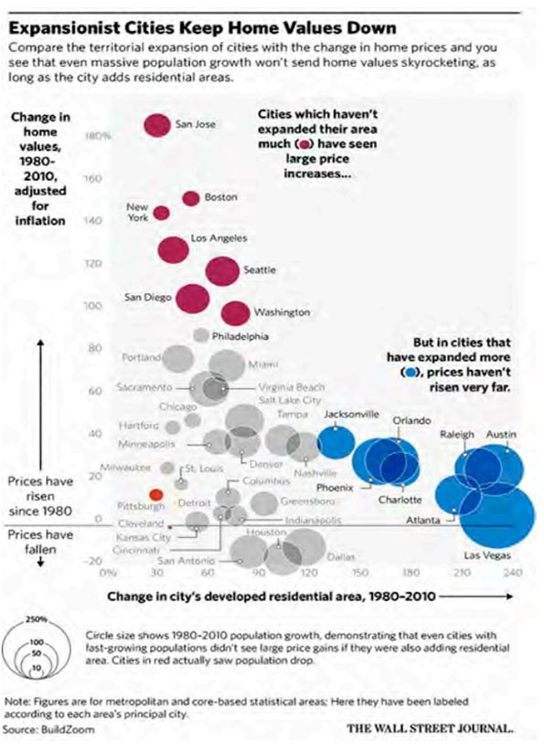

A recent example of the failure of YIMBY policies combined with urban containment is Portland, Oregon. Portland has strict urban growth boundaries and adopted policies very similar to those proposed in the interim report, allowing the building of units of several stories in areas formerly dominated by single storey detached houses. The result was that new dwelling constructed in Portland had less than half of the floor area of those built before – a massive decrease in quality. Yet the new policy failed reduce house prices and Portland is now one of the least affordable markets in the United States.

By placing a hard limit on the amount of amount of developable land, urban growth containment encourages land-banking and speculation, as buyers are aware that there will be a hard on the amount of developable land regardless of demand. Despite such policies being increasingly enacted in Australia, the Commission spends relatively little space examining them compared to other issues.

10: Land banking is real

The Commission purports to reject evidence for land banking, mainly on the basis of a single study by a known opponent of the concept, without looking deeper into it. This is unfortunately consistent with the New South Wales Productivity Commission, who rejected the concept based on generalised assertions that were poorly empirically supported.

Both developer’s prospectuses – designed for their shareholders, rather than for public lobbying (and which often say that the rate of supply is fine) , and surveys of developer behaviour indicate that land banking is real. For example, a study of developer strategies in the Australia showed behaviour consistent with land banking, with developer choosing to hold several years’ stock of land and develop it in their own time, often with attempts to upgrade the zoning to a more profitable use. Notably, some are aware of the negative connotations of the term land banking while engaging in it.

It is not clear why the Commission is so reluctant to admit land banking exists. It is merely about providing the best returns across time. The oversimplified models of the likes used by the Centre for Independent Studies are static, so will always misrepresent the situation and lead authors to conclude that if a viable development isn’t happening today it must be some hidden barrier like regulation. Once time is considered land banking makes sense – delaying building may produce a greater return in the future than developing in the present would.

A related effect is the observation that zoned areas are sometimes not built to their maximum density, or that one intended use may be swapped for another (for example, instead of residential, commercial spaces are developed). This is simply the developer trying to get the best return, which is not always the highest density. It is very common that even prior to upzoning, many areas are not developed to close to their maximum potential density. Large ‘spare capacity’ often already exists.

11: Migration cannot be ignored

While outside the bounds of the terms of reference, the effects of migration cannot be ignored. Despite proof that Australia supplies a very high number of houses compared to other countries, it is fashionable for pro-upzoning economists to blame ‘supply shortages’. These same economists support Australia’s exceptionally high migration by claiming that migrants support the economy by increasing demand for goods and services, yet they say that migrants do not increase prices by adding to deand for housing despite the fact that even in the absence of zoning housing is one of the most expensive and time-consuming things to produce, and no new land is being made.

The blindness on this issue is the ultimate example of the nature of pro-upzoning economists ‘supply only’ approach, something fully demonstrated by the Centre for Independent Studies’ advocacy over housing and migration issues, where they reject migration influence on house prices despite it being the main source of demand.

Firstly, Australia’s rate of migration is extremely high both compared to the long-term average (about 0.5%) and compared to other developed countries:

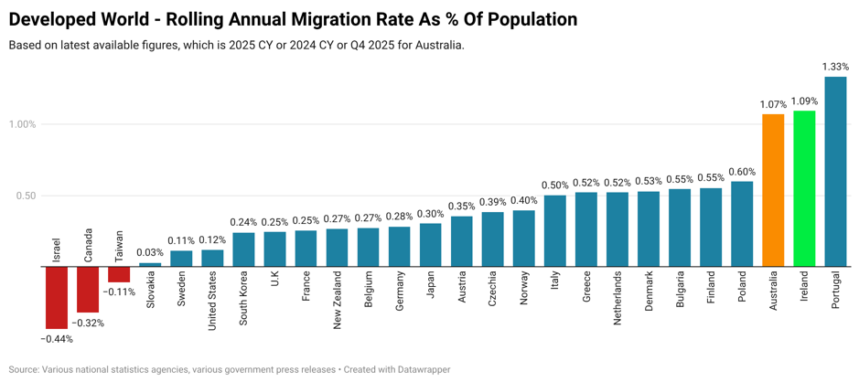
Source: Tarric Brooker, https://x.com/AvidCommentator/status/2102244848590110747
The other comparable countries – Ireland and Portugal, are also experiencing severe housing stress at present. Australia also has an unusual population structure centres around the major capitals with few substantial secondary cities compared to the United States. This limits the ability of people to arbitrage jobs and income compared against housing affordability, as there are few alternative locations available that provide employment.

Economist Cathal Leslie took population and price data from Grattan Institute reports and and showed that countries with growing populations had higher price growth, and importantly, countries which built more houses had high price growth:

Similarly, economist Aziz Sunderji examined cities in the United States and showed that the rate of net immigration into those cities directly corresponded with their change in prices:

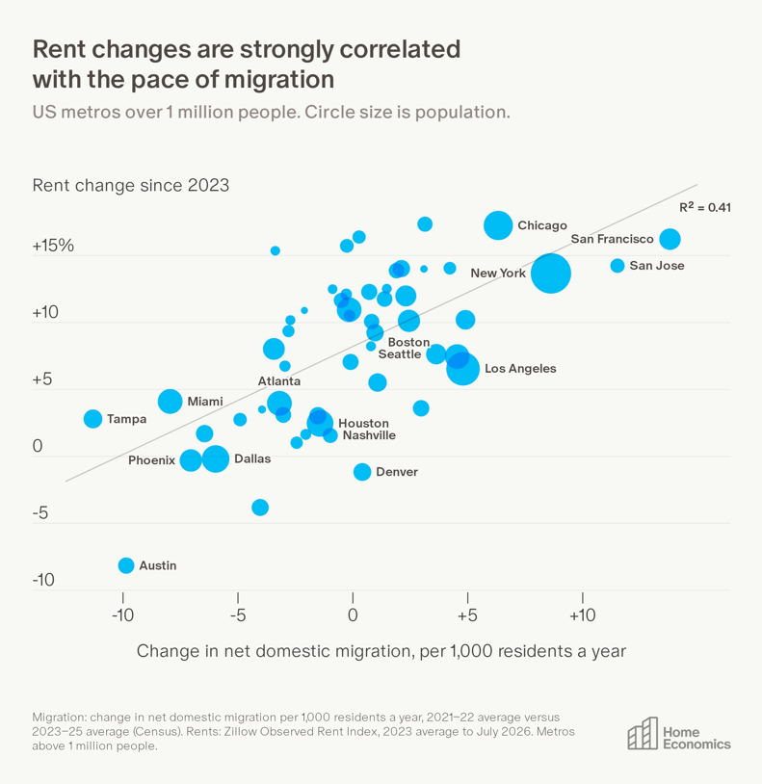

Lastly, Canadian economist Patrick Condon has found that the percentage change in housing stock directly correlates with the change in prices, with Vancouver, the most productive cityin North America, experiencing the highest price rises:

These are all consistent with high rates of migration creating demand, and perhaps as importantly, creating a base for speculation. Investors are willing to pay more for land knowing that there is certainty that there will be demand for it in the future. Hence migration has an effect on the market that extends beyond just dwellings bought directly by them. Furthermore, immigration creates new demand immediately whereas growth from birth creates demand 20 or more years in the future. Thus, dealing with immigration in terms of housing and infrastructure is more challenging. And it is not solving the problem either – a disproportionately small number of migrants work in construction.

12: A tale of two countries: New Zealand and Canada

A wider comparison of Canada and New Zealand (and to Australia) is warranted, as both have experienced similar magnitude house price declines since COVID despite one enacting major countrywide zoning reform and another not:
- Both Canada and New Zealand have dramatically cut net migration (mainly through reducing temporary migration), with their levels relative to population now being far lower than Australia’s, falling from similar levels prior.
  - New Zealand’s most recent net migration of about 12,400 per year is equivalent to about 70,000 per year in Australia, compared to Australia’s current figure of about 305,000
  - New Zealand is experiencing a major outflow of citizens to Australia. Citizens are likely to have greater purchasing power than new arrivals, hence prices would be expected to fall from this alone
- The central banks of New Zealand and Canada raised interest rates earlier and more than the RBA, meaning a greater reduction in borrowing ability.
- Unemployment in Canada and New Zealand was higher than in Australia prior to the pandemic and has risen significantly more since. New Zealand especially has not had the increase in publicly funded jobs Australia has had.
- In New Zealand, the former government greatly lengthened the time period to receive a capital gains tax discount and abolished negative gearing. Although these laws have seen been reversed (in early 2025) it has deterred investors from entering the market, especially against a background of low demand
- New Zealand and Canada have both has less economic growth than Australia, with New Zealand having a recession in 2024 and contraction in one quarter of 2025. This is a condition much less favorable to price growth
- In New Zealand and Canada, prices rose much more during COVID than they did in Australia, especially in New Zealand. This meant their prices were less sustainable in the long-run, especially considering post-COVID developments
- In both countries, prices have more or less stabilized after their falls, despite prices still being above marginal cost of construction
- Any analysis largely attributing New Zealand’s price decline to zoning needs to explain those of Canada when other factors are more similar between the two countries.

Hence the rash of recent papers proclaiming the success of New Zealand’s reforms needs to be examined much more skeptically, with their apparent reliance on interpreting the data through the authors’ own ideologies.

13: In conclusion

The overall recommendations of the inquiry focus on overwhelmingly on changes that would reduce the quality of dwellings, through smaller size, fewer rooms, loss of functional ‘spare’ space and loss of private outdoor space. The Institute of Public Affairs warned that the inquiry’s ‘integrity should not be undermined by a pre-determined and oversimplistic argument that the primary or only solution to housing supply challenges is more high-density housing and urban densification’. Unfortunately, it appears that, not least due to the loudness of the voices pushing for it as a solution, the interim report has done exactly that. If the Commission wishes to say that young Australians will have to live in lower quality dwellings, they should do so directly. Otherwise they should consider that there are alternative economic views, that at least some regulations are welfare enhancing, and that there are alternative solutions.

https://www.tandfonline.com/doi/abs/10.1080/07293682.2021.1920991
https://www.tandfonline.com/doi/full/10.1080/01944363.2020.1852101
https://journals.sagepub.com/doi/abs/10.1177/1078087418824672
https://www.unsw.edu.au/newsroom/news/2026/06/building-more-apartments-wont-ease-housing-crisis-new-research
https://e61.in/wp-content/uploads/2026/06/Apartment_presales_and_Sydney_price_trends.pdf
https://www.frbsf.org/research-and-insights/publications/working-papers/2026/08/quality-inequality-understanding-housing-markets/
https://www.macrobusiness.com.au/2025/05/apartments-are-too-expensive-and-take-too-long-to-build/
https://udiavic.com.au/wp-content/uploads/2026/05/Rethinking-7030-The-Cost-of-Building-Where-We-Already-Live.pdf
https://www2.gwu.edu/~iiep/assets/docs/papers/2024WP/HarrisIIEP2024-02.pdf
https://www.fresheconomicthinking.com/p/is-ed-glaeser-a-nimby
https://udiavic.com.au/wp-content/uploads/2026/05/Rethinking-7030-The-Cost-of-Building-Where-We-Already-Live.pdf
https://www.newyorkfed.org/medialibrary/media/research/epr/03v09n2/0306ofla.pdf
https://journals.sagepub.com/doi/abs/10.1177/0308518X20942874
https://papers.ssrn.com/sol3/papers.cfm?abstract_id=7391479
https://www.aeaweb.org/conference/2023/program/paper/9fDzbzen
https://bankunderground.co.uk/2019/09/06/houses-are-assets-not-goods-taking-the-theory-to-the-uk-data/
https://radicalcontributions.substack.com/p/japans-housing-crisis-what-the-yimbys-dont-understand
https://www.nber.org/papers/w33576
Image provided by Tim Helm
https://researchonline.lse.ac.uk/id/eprint/131070/
https://onlinelibrary.wiley.com/doi/abs/10.1111/jors.70083
https://www.researchgate.net/publication/382407729_When_Does_Land_Use_Regulation_Lower_the_Average_Price_of_Housing_in_Cities
https://www.rba.gov.au/publications/rdp/2019/2019-01/full.html
https://www.bankofcanada.ca/wp-content/uploads/2026/08/sap2026-35.pdf
https://www.treasury.govt.nz/sites/default/files/2022-08/htwg-assessment-housing-system-hamilton-waikato-aug22.pdf
https://www.forbes.com/sites/johnwake/2019/04/11/oldest-documented-housing-bubble-amsterdam-recent-u-s-housing-bubble-share-one-very-human-trait/
https://www.forbes.com/sites/johnwake/2019/03/30/new-study-of-old-real-estate-bubbles-1582-1810-finds-two-surprising-similarities-with-modern-booms/
https://www.nber.org/papers/w35587
https://www.macrobusiness.com.au/2025/09/building-housing-in-australia-is-too-expensive/
https://www.sciencedirect.com/science/article/pii/S0966692323000145
https://link.springer.com/article/10.1007/s13280-018-1087-y
https://curate.curtin.edu.au/articles/thesis/Climbing_the_Slippery_Slope_Investigating_Real_Estate_Developer_Strategy/31738786?file=62802913
https://www.linkedin.com/posts/activity-7394811055895425024-7aMJ?utm_medium=ios_app&rcm=ACoAABMSPCMBwk_lpSUzooWIuPR4f3ywJer40dY&utm_source=social_share_send&utm_campaign=whatsapp https://www.linkedin.com/posts/cameron-murray-39b63017_more-people-more-expensive-cities-a-closer-activity-7402462619531747328-zQ4M
See chart in https://x.com/AntipodeanMacro/status/1945276114789642522

