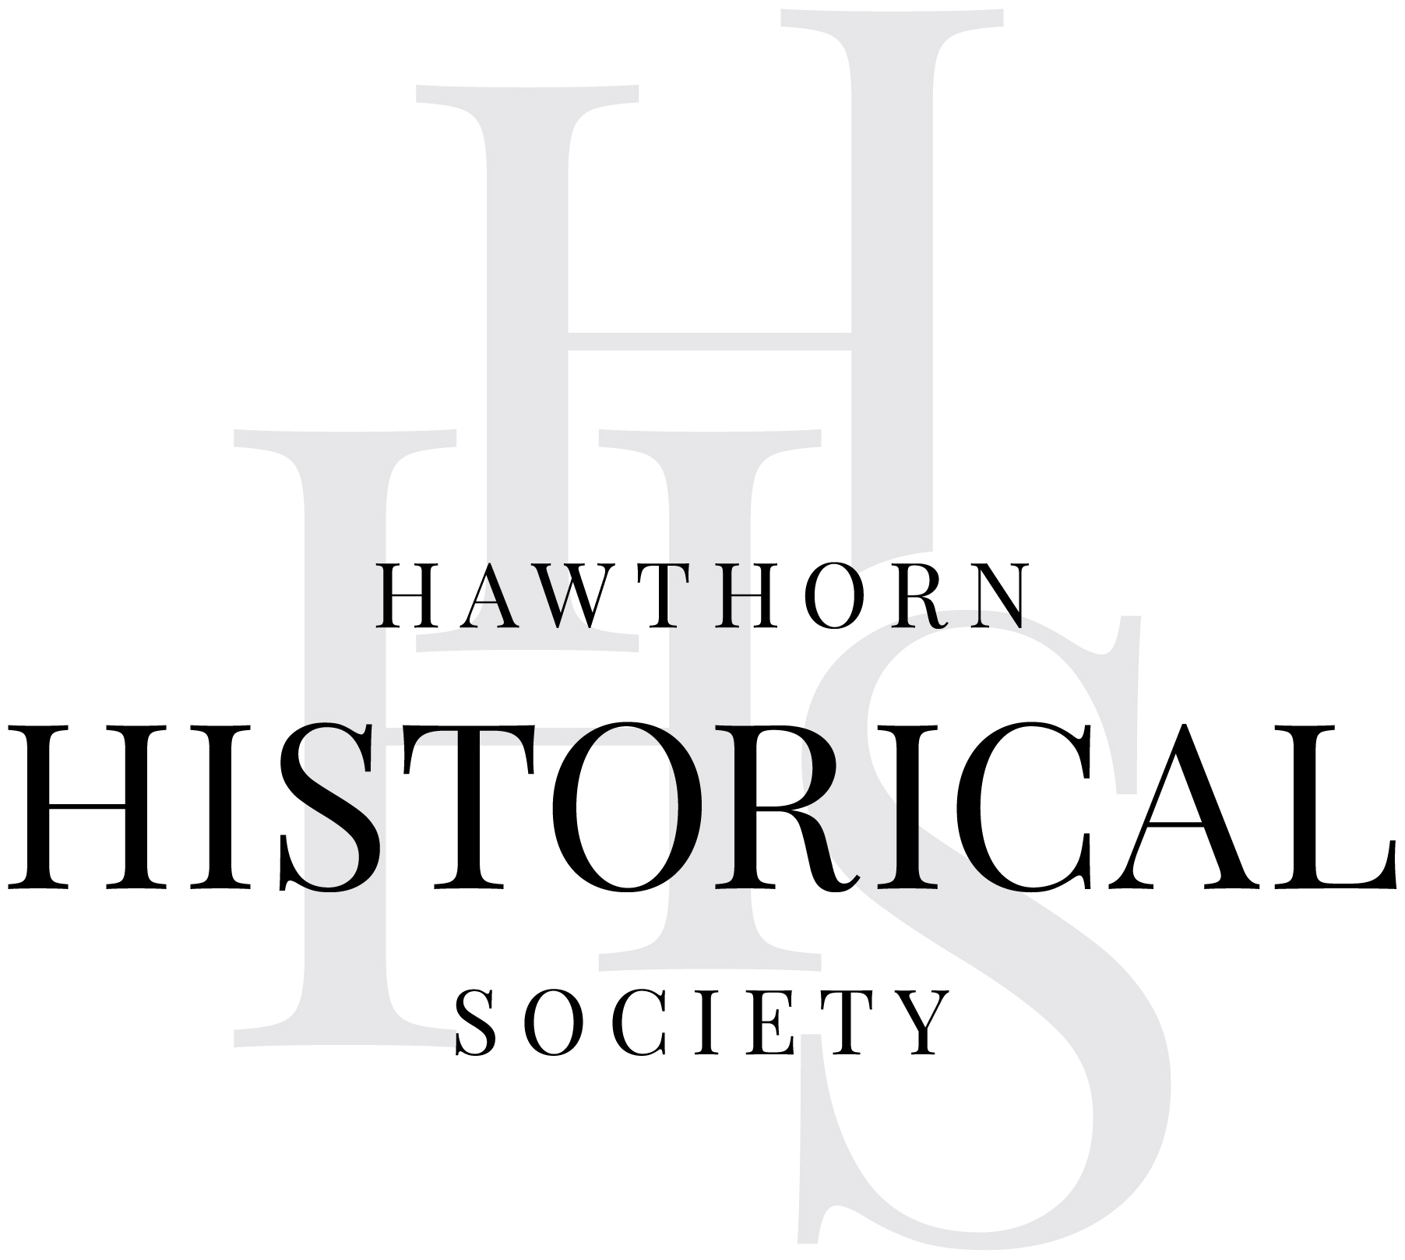

Hawthorn Historical Society submission
  - Housing Supply Regulation Interim Report
Housing Supply Regulation inquiry
Productivity Commission
To whom it may concern
Hawthorn Historical Society promotes local history and heritage through research, collections, education and public engagement. We recognise the importance of increasing housing supply and improving housing affordability. We also believe that decisions affecting historic buildings and neighbourhoods need to take proper account of their significance and their value to the community.
The Society supports the key themes of Australia ICOMOS’s submission, particularly its call for stronger evidence, greater involvement of heritage expertise and an approach that accommodates housing growth while retaining significant places. We welcome its contribution and encourage the Commission to draw on the knowledge of peak heritage bodies in preparing its final recommendations.

Evidence and heritage controls
Australia ICOMOS questions whether the Interim Report establishes that statutory heritage protection is a material cause of Australia’s housing shortage, or that substantially weakening protection would produce a net public benefit. These questions should be resolved before changes to heritage protection are recommended.
Housing supply and affordability are affected by many factors. The extent of land covered by heritage overlays does not, by itself, demonstrate how much additional housing those overlays prevent. Other planning controls, existing development, lot sizes and market conditions may have a greater influence.
A heritage overlay does not necessarily prohibit development. It requires proposed changes to be considered in relation to the significance of the place. There is scope for additions, adaptation and new housing in many heritage areas.
The distinction matters because the consequences of heritage loss are often permanent. Planning controls can be amended; a demolished historic building cannot be recovered. The Commission should assess both the housing outcomes likely to result from reform and the public value that would be lost.

The value of historic places
Through its research and public programs, the Society sees how historic places help people understand Hawthorn’s development. Houses, shops, former workplaces and public buildings tell us about the people who lived here, the work they did and the communities they formed.
Modest cottages and former industrial buildings are an important part of this history. Their significance may lie as much in their occupants and uses as in their architecture. Retaining them helps preserve evidence of lives that may otherwise be poorly represented in the historical record.
Our collections include photographs, maps, documents and recollections that can be connected to these places. On a walk, an old photograph or subdivision plan is easier to understand when people can see the street or building it records. A former resident’s memories gain context when the house, shop or workplace remains. These connections give our research a practical use in education and public history.
Demolition may leave us with photographs and written records, but it removes the opportunity to examine the place itself and understand its relationship to its surroundings. It also limits what future researchers may be able to discover.
Heritage has wider community benefits. It contributes to identity, belonging, cultural continuity and the character of neighbourhoods. The Heritage Council of Victoria’s Why Heritage? research brings together evidence of heritage’s social, economic and environmental value. Australia ICOMOS also draws attention to research on wellbeing and the value communities place on retaining historic places.
These benefits should receive fuller consideration in the Commission’s assessment. They are part of the public value of heritage, even where they are difficult to express in financial terms.

Expertise and local knowledge
The Society supports meaningful consultation with heritage bodies, relevant professionals, councils and communities before the Commission finalises its recommendations.
Councils and heritage advisers can explain how controls operate in practice and where administration could be improved. Owners and residents can contribute experience of maintaining and adapting buildings. Historical societies can provide research, documentary evidence and local knowledge that may not be apparent from a planning map or a building’s appearance.
This knowledge can help establish why a place matters and what changes it can accommodate. Consultation should inform the recommendations from the outset.

Housing and heritage
The Society supports Australia ICOMOS’s “conserve and build” approach. Historic places differ in their significance and capacity for change, and proposals should be considered with those differences in mind.
Opportunities may include adaptive reuse of commercial and industrial buildings, housing above shops, conversion of larger historic buildings, compatible additions and infill on non-contributory or under-used sites. Retention and repair can also conserve materials and reduce demolition waste.
Historical research can assist this work by identifying significant buildings and features, explaining how an area developed and showing where change has already occurred. Clear guidance and informed assessment can help additional housing become part of established neighbourhoods while retaining the places that give them historical depth and character.

Conclusion
Hawthorn Historical Society encourages the Commission to strengthen its evidence base, involve heritage expertise and local knowledge, and give proper weight to the public benefits of heritage.
We support improvements that make heritage administration clearer and enable appropriate development. Any proposal to weaken protection should demonstrate the housing benefits expected and account for what would be lost. Historic places continue to serve their communities as homes, workplaces and sources of knowledge. Careful planning can allow them to do so while accommodating growth.
Penny Underwood
President
Hawthorn Historical Society
25 Inglesby Road, Camberwell, Victoria
Www: hawthornhistoricalsociety.com.au
Email: info@hawthornhistoricalsociety.com.au

