Collingwood Historical Society, Inc


ABN 73 326 462 277

P O Box 304

Clifton Hill 3068

www.collingwoodhs.org.au
collingwoodhs@yahoo.com
14 October 2026
Submission to Productivity Commission
Housing Supply Regulation: Interim Report

From: Collingwood Historical Society
The Collingwood Historical Society has had an active involvement in the heritage planning for the City of Yarra in inner Melbourne and previously for the City of Collingwood (Collingwood, Abbotsford and Clifton Hill) over the past 40 years and has participated in a number of Council heritage review and advisory committees. We are deeply concerned that the historical and heritage value of the area be respected for the benefit of future generations.

Thank you for the opportunity to comment on the Interim Report. As an inner Melbourne group within the City of Yarra we are greatly concerned about the maintenance of our heritage buildings and streetscapes, but also of our area’s heritage of providing low cost housing to those in need.

The main points we wish to raise relate to
- The importance of protecting heritage areas in Melbourne’s inner suburbs
- For housing supply: the importance of increasing provision of public housing
- The need for appropriate enforcement of regulation to protect heritage and ensure affordable housing.

1 Heritage
The Report outlines: Reform direction 2.5
Replace broad heritage protections with more targeted heritage listings with cost-benefit analysis and review processes. Blanket heritage areas should be replaced by heritage listings for specific buildings or small areas. Targeted heritage listings should be justified by cost-benefit analysis and there should be more robust mechanisms to review and delist buildings

The Interim Report’s Reform Direction 2.5 seems particularly inappropriate for our inner area of Melbourne which has large heritage areas identified. A tremendous amount of detailed work has been carried out over years to identify which of our local areas need strong heritage protection and which are available for large scale development. In the heritage overlays each address is already identified as significant, contributory or not contributory to the heritage precinct.

The social value of heritage is mentioned in passing in the report, but then seems to get lost in the cost-benefit analysis. While many aspects of costs change over time, once heritage buildings or streetscapes are lost they are gone for ever.
We have already seen various aspects of our built and natural heritage sacrificed in the name of development but this has not produced more affordable housing. It is crucial that any increase in housing in the inner suburbs includes affordable housing.
Our local heritage seems to be under threat from recent State Government introduced Fast Track approvals for large developments by-passing existing planning controls. Our heritage is also under threat from the Leader of the Opposition who has called for even greater density in Collingwood and Fitzroy rather than in electorates such as her own of Kew (see Appendix 1 below).
Population density: The importance of location rather than a one size fits all approach. While those in the more affluent middle suburbs would like to see all the increased population density pushed into the inner city areas, our inner area already has a high population density with its pressure on open space and infrastructure and its threat to heritage values.

2 Public Housing
The Report states: ‘Increasing housing supply would help put downward pressure on prices and support more people to live in housing that meets their needs’.
The Report make only one refence to public housing and few to social housing (Box 1.2)
The Report needs to consider the lack of affordable housing for those most in need, in particular the need to maintain and expand the role of public (as opposed to other social) housing in the inner suburbs. The priority social housing waiting list in Victoria currently has over 40,000 households in urgent need of low-cost housing.

3 Enforcement of regulation
There is a need for clear regulations – there have been many calls from developers and from local communities for clear regulations in Melbourne’s planning scheme for mandatory rather than permissive built form guidelines. These have been undermined by the state government policy in the name of making it ‘easy’ for developers. We have seen many examples of regulations to protect heritage buildings being undermined.

Under Yarra Council policy, developers proposing more than 50 apartments should provide at least 10% ‘affordable’ apartment. This is not being enforced and at most developers buy their way out of the requirement.

An example of this is the development plans for 79-81 Victoria Parade Collingwood (corner of Wellington Street). The Minister for Planning approved this development under the Fast Track system which denies Councils and residents a voice. She approved two buildings on the site: one 23 storeys and one 17 storeys. The 478 apartments would include no social housing. The Amendment c271yara she had just approved allowed for a ‘preferred’ maximum of 12 storeys. This development would further hide the heritage landmark of the former Victoria Distillery 21 Northumberland St.
https://www.planning.vic.gov.au/planning-approvals/ministerial-permits-register/ministerial-permits/d79b4402-213a-f111-88b4-6045bdc38f94

In response to the Interim Report’s Information Requests
Information request 1.2
What features should government have in mind when evaluating reforms to move housing regulatory systems towards best practice
Heritage – once lost is gone for ever
Location – one size does not fit all either across states, or within cities or suburbs
Public Good – regulation to ensure affordable housing and create public housing
A liveable environment – which incorporates public open space, tree canopy and pedestrian-friendly streetscapes rather than sunless wind tunnels.
Are the best practice principles and the overarching objectives appropriate?
Looking at the wider picture, it seems inappropriate for the Report to assume growth is inevitable (there is considerable pressure to stem migration growth) and that growth is necessarily good (in a context of a finite world).
1 Adopt a ‘build mindset’
It is often better to promote reuse and recycling, especially of heritage buildings
2. Only regulate where necessary
3. Coordinate with infrastructure
This seems essential
4. Keep the process simple
Clear mandatory controls are simpler than ‘preferred’ controls.

With any queries please contact Janet Taylor [Redacted].
Collingwood Historical Society

Appendix 1 Density

Density of population (2025): Total population in 2025
City of Yarra 5,190 persons per square km 101,356
Collingwood 7851 11384
Abbotsford 5145 10316
Clifton Hill 3908 7350

City of Boroondara 2968 persons per square km 178,601
Kew 2462 25,930

The Member for Kew sent this flyer to Kew residents in 2026:

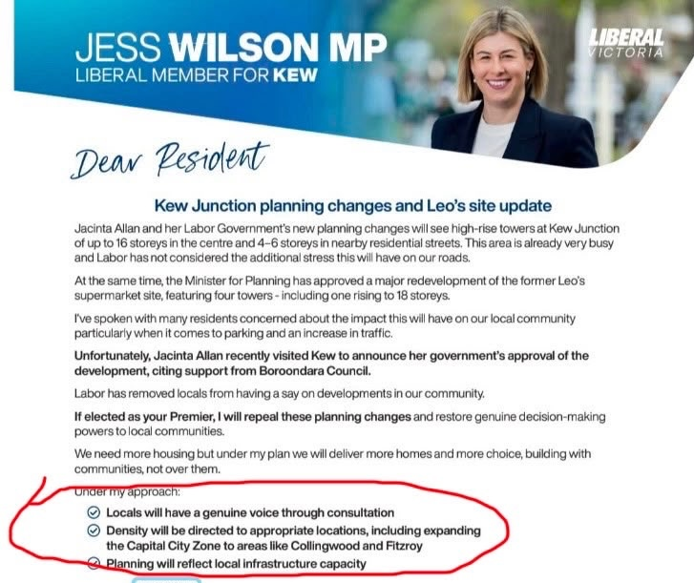

Appendix 2 Beware new slums

In the push to remove regulations to increase supply, beware of creating new slums.
(a 1969 cartoon from Barrett The inner Suburbs)
