Unlocking business dynamism: removing barriers to entry, growth and exit
  - Interim report
Overview
November 2026
This is an interim report prepared for further public consultation and input. The PC will finalise its report after these processes have taken place.
Acknowledgment of Country

The Productivity Commission acknowledges the Traditional Owners of Country throughout Australia and their continuing connection to land, waters and community. We pay our respects to their Cultures, Country and Elders past and present.

About us
The PC is the Australian Government’s independent research and advisory body on a range of economic, social and environmental issues affecting the welfare of Australians. Its role, expressed most simply, is to help governments make better policies, in the long-term interest of the Australian community.
The PC’s independence is underpinned by an Act of Parliament. Its processes and outputs are open to public scrutiny and are driven by concern for the wellbeing of the community as a whole.
For more information visit our website: www.pc.gov.au.

© Commonwealth of Australia 2026

With the exception of the Commonwealth Coat of Arms and content supplied by third parties, this copyright work is licensed under a Creative Commons Attribution 4.0 International licence. In essence, you are free to copy, communicate and adapt the work, as long as you attribute the work to the PC (but not in any way that suggests the PC endorses you or your use) and abide by the other licence terms. The licence can be viewed at: https://creativecommons.org/licenses/by/4.0.
The terms under which the Coat of Arms can be used are detailed at: www.pmc.gov.au/government/commonwealth-coat-arms.
Wherever a third party holds copyright in this material the copyright remains with that party. Their permission may be required to use the material, please contact them directly.
An appropriate reference for this publication is:
Productivity Commission 2026, Overview - Unlocking business dynamism: removing barriers to entry, growth and exit, Interim report, Canberra, November
Publication enquiries:
Phone 03 9653 2244 | email publications@pc.gov.au

Opportunity for comment
The Productivity Commission thanks all participants for their contribution to this inquiry. We are seeking feedback on this interim report and responses to our information requests to assist us in the preparation of our final report.
You are invited to examine this interim report and provide a written submission to the PC, preferably in electronic format, by 11 December 2026.
You are also invited to register to attend or present at a public hearing. Proposed dates of public hearings are outlined below.
Further information on how to provide a submission or register for a hearing is available on the inquiry website: pc.gov.au/inquiries-and-research/business-dynamism/
The PC will prepare its final report after considering the evidence provided in further submissions and public hearings. The final report is due to be delivered to the Australian Government by 12 May 2027.
Public hearing dates
Date | Location
8–12 February 2027 | Online
Commissioners
For the purposes of this inquiry and interim report, in accordance with section 40 of the Productivity Commission Act 1998 the powers of the PC have been exercised by:
- Stephen King, Commissioner
- Alison Roberts, Commissioner
- Martin Stokie, Commissioner

Contents
Opportunity for comment iii
Terms of reference iv
Overview 1
Make regulation work better for businesses 5
Improve viable businesses’ access to finance 6
Policies and programs to improve management capability 7
Make adaptation, restructuring and exit easier 8
A common direction for reform 10
Reform directions, findings and information requests 15

Overview

Key points
 | Australia's productivity growth has stalled. Business dynamism – the economy’s capacity to renew itself through the entry, growth, restructuring and exit of businesses – is a key driver of productivity growth. However, a range of indicators suggest it has weakened over recent decades.
 | No single reform will restore business dynamism. We propose policy action in areas including regulatory burden, access to finance, management capability, business transitions and insolvency. Other policy areas, such as tax and workplace relations policy, also influence dynamism but are outside the scope of this inquiry.
Better information channels would help businesses make decisions and meet their obligations.
Businesses can struggle to identify their obligations, find authoritative guidance and navigate government systems. Better guidance and tell-us-once reforms would make compliance easier.
Lenders do not always have timely access to the information they need to assess borrower creditworthiness. Reforms to business data sharing could support faster credit assessments.
Businesses do not always recognise when they need help. Governments should make better use of existing interactions and technology to connect businesses with timely information and support.
Businesses often enter insolvency after substantial value has already been lost. Better information on financial distress and the safe harbour could help viable businesses act earlier and preserve value.
Better targeted intervention would improve the effectiveness of government support.
Regulatory burden can build as requirements accumulate, creating complex regulatory thickets. Targeted reviews can help identify and address these industry-specific cumulative burdens.
Some viable start-ups may be underserved by existing financial providers. Different financing barriers require different policy responses. Some settings in venture capital programs may discourage investment in start-ups. Venture capital vehicles should be able to invest more flexibly and draw on a broader pool of experienced investors.
Management capability influences whether businesses can identify opportunities, adopt new technologies and respond to change. Government support should be systematic, targeted to demonstrated barriers and rigorously evaluated.
Better insolvency settings would preserve more economic value.
Australia’s insolvency system lacks a clear statement of purpose, objectives and principles. These foundations should be legislated to guide reform and evaluation.
A relatively small number of business owners must navigate both the personal and corporate insolvency frameworks. The evidence supports targeted reforms rather than integration of the frameworks.
Safe harbour supports the turnaround of viable businesses but can be difficult for some small and medium enterprises to access. Outstanding recommendations of the Safe Harbour Review should be implemented to make the regime easier for directors to understand and use.
Unfair preference laws can discourage unsecured creditors from supporting businesses attempting to trade out of financial difficulty. Payments received in the ordinary course of business should be protected from later unfair preference claims.
All insolvent businesses should be able to access an orderly exit. An Official Liquidator should provide a pathway of last resort for companies that cannot reasonably fund an external administration.
Australia’s productivity growth has slowed, limiting future growth in incomes and living standards. A key driver of productivity growth is the economy’s capacity to renew itself through the entry, growth, restructuring and exit of businesses. This process is called business dynamism.
Business dynamism helps allocate resources to their most productive use. In a dynamic economy, entrepreneurs can bring new ideas to market, successful firms can grow and test new ideas, and new businesses can challenge incumbents. Existing firms can adapt and, if needed, swiftly exit and redeploy resources. These processes give workers access to new opportunities and allow consumers to benefit from lower prices and better and more varied products and services.
Every year, hundreds of thousands of Australian businesses enter the economy (figure 1). Some owners are seeking greater independence or work–life flexibility. Some want to test a new idea. Others are motivated by the challenge or opportunity to build wealth. Whatever the motivation, starting a business involves taking risks and committing time, effort and capital. Once established, businesses continue to evolve: some grow, restructure, merge or adapt to changing circumstances, while others exit. These transitions across the business lifecycle are a normal and essential feature of a dynamic economy.
Over recent decades, however, business dynamism has weakened. Rates of business entry and exit have fallen and fewer workers are moving between jobs each year (figure 2). Job reallocation between firms has also fallen, suggesting fewer businesses are expanding and contracting (ABS 2026b). On average, market leadership has become more persistent, with leading firms retaining their positions for longer (figure 3), and the share of workers employed in young firms has declined.
In this inquiry, we have been asked to investigate processes and barriers to business dynamism, including:
- regulatory and administrative burdens, access to capital markets, business registration and industry-specific licensing
- the design, operation and integrity of corporate and personal insolvency frameworks.
We have also been asked to:
- examine the economic impacts of these processes and barriers, including effects on productivity, innovation, investment and employment
- review the operation of Schedules 1, 3 and 4 of the Treasury Laws Amendment (Combatting Illegal Phoenixing) Act 2020.
Our terms of reference state that tax, workplace relations and mergers frameworks are not intended to be an inquiry focus.
We are also to have regard to matters canvassed in the 5 productivity inquiries that we completed last year. Those inquiries considered reforms to lift business investment, navigate the net zero transformation, harness data and digital technologies like AI (artificial intelligence), boost our human capital and enable more efficient and higher-quality care.
In approaching our task, we have recognised that business dynamism, innovation and entrepreneurship are shaped by many factors. Government policy is one. While it is not the responsibility of government to create new businesses or entrepreneurs, policy settings can help foster an environment in which they can thrive. Fostering dynamism, however, does not mean maximising business churn. Our goal has been to identify unnecessary barriers and costs across the business lifecycle and propose ways they might be addressed. The desired outcome is a vibrant economy where businesses can readily start, grow, adapt and exit.
Figure 1 – Many businesses start, grow, adapt and exit each year
Business dynamism allocates labour, capital and ideas to their most productive uses
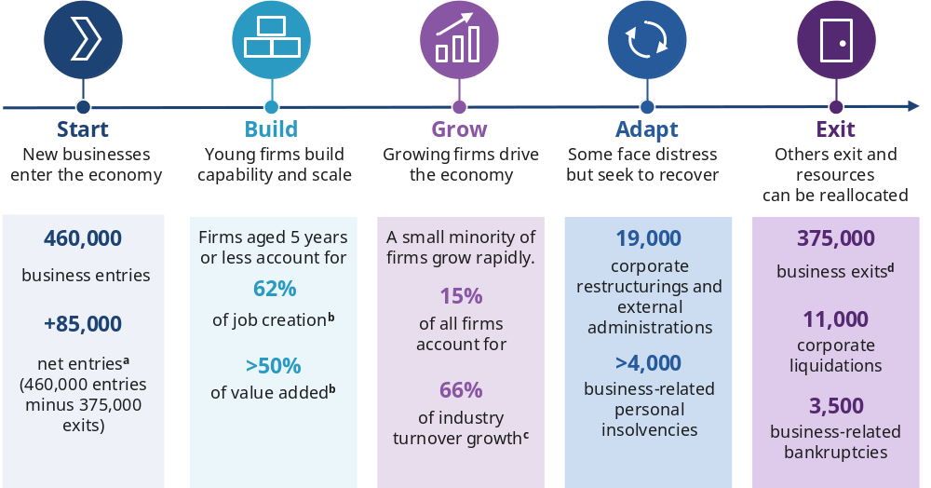
Unless otherwise specified, all numbers relate to 2025–26. a. Net entries refer to business entries minus business exits in a year. b. Refers to analysis taken over the period from 2007–08 to 2021–22. c. Refers to analysis undertaken of the period from 2004–05 to 2011–12. d. Business exit refers to a business leaving an industry, whether through insolvency or voluntarily.
Source: ABS (2026a); AFSA (2026c); ASIC (2026c); Lee et al. (2025); Majeed et al. (2021); Win et al. (2026).
Figure 2 – Entry, exit and job mobility rates have declined
Entry rate  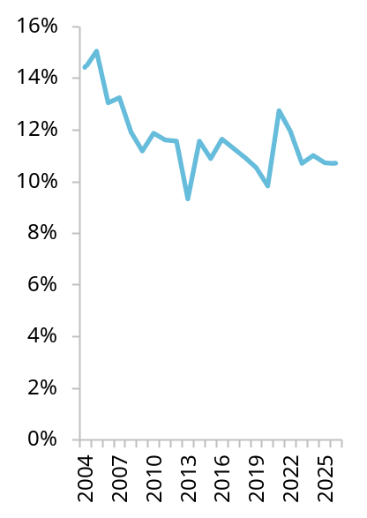 | Exit rate  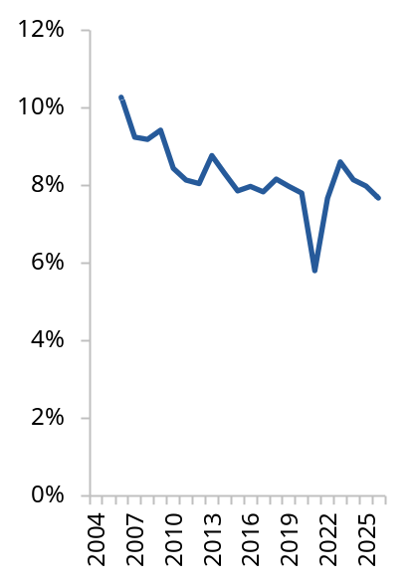 | Job mobility rate  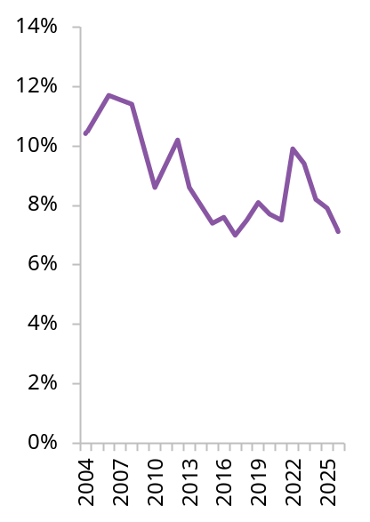
Entry and exit use financial years and include only employing firms. The job mobility rate is the proportion of workers who changed jobs in the last year.
Source: ABS (2007, 2009, 2013, 2018, 2021, 2026a, tbls. 1–16, 2026b, fig. 3).
Figure 3 – Indicators of business renewal have weakened
Proportion of firms remaining in top 4 after 3 years  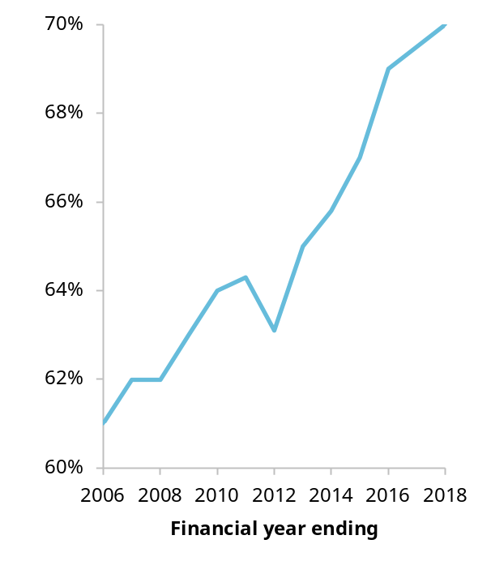 | Share of workers employed by young firms  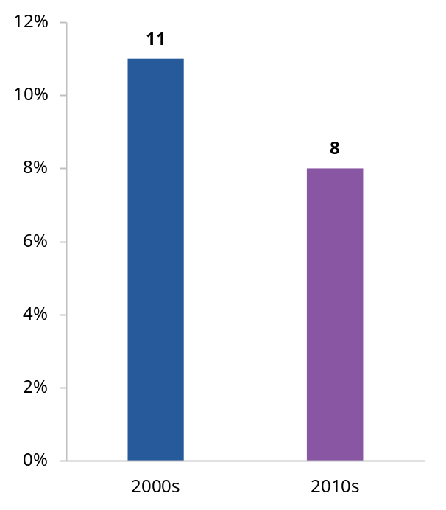
Share of top 4 firms by revenue in an industry in a given year that remain in the top 4 after 3 years. Financial years. Young firms are businesses aged 0–5 years.
Source: Adams et al. (2022, pp. 10–11).
After considering where government action could most effectively reduce unnecessary barriers, we focused on regulatory burden, access to finance, management capability, entrepreneurship and business transitions. We also examined Australia’s insolvency frameworks and the operation of key anti-phoenixing provisions.
Many inquiry participants identified tax and workplace relations as important influences on business dynamism. Some participants also highlighted workforce shortages and the challenges faced by businesses in regional and remote areas, but many of the policy levers most directly relevant to these issues, such as education, training, migration and housing, also sit outside the scope of the inquiry.
Several common themes emerged from the inquiry’s analysis:
- Better information, guidance and use of technology would reduce unnecessary regulatory burden.
- Better evidence and data use would improve the targeting and effectiveness of government intervention.
- Easier business transitions would support adaptation and growth.
- Better insolvency settings would preserve more economic value.
The summary table accompanying this Overview groups the inquiry’s findings, reform directions and information requests by these themes.

Make regulation work better for businesses
Well-designed regulation supports important economic, social and environmental objectives. But the scale, complexity and cost of regulation in Australia can make it harder than it needs to be for businesses to thrive. The burden does not necessarily stem from individual regulations. In some industries, the cumulative burden of requirements can create regulatory thickets that are particularly difficult for businesses to navigate.
Industry-specific burdens are best examined through targeted reviews. The PC last year recommended reviews of housing supply regulation, business reporting requirements and telecommunications sector regulation. The Australian Government has since commissioned the PC to undertake the first 2 reviews. In addition to telecommunications, candidates for future reviews include sectors with a high number of regulatory requirements and sectors raised by business groups during consultation for this inquiry, including care, construction, financial services, technology and motor trades. We are seeking feedback on the sectors that warrant a regulatory ‘deep dive’ to address cumulative burden.
But tackling regulatory thickets will take time. In the meantime, governments can make the existing stock of regulation easier for businesses to navigate. Businesses can struggle to identify which obligations apply to them, where to find authoritative guidance and in what order regulatory requirements should be addressed. Guidance is frequently scattered across agencies, levels of government and online portals, and businesses looking to enter a market may need to interact with multiple regulators or government departments before they can begin operating. These parts of government do not always operate as a connected system. Businesses can also be required to provide similar information to multiple agencies across all levels of government. These burdens fall particularly heavily on smaller businesses, which rarely have specialist compliance staff.
The Australian Government should establish an effective regulatory guidance system that helps businesses identify, understand and comply with their obligations. Guidance should be easier to find and navigate, available at key business touchpoints and should leverage business software tools and AI applications. Governments should also maintain a strong focus on tell-us-once reforms, so businesses avoid the unnecessary cost of providing the same information to government multiple times.

Improve viable businesses’ access to finance
Businesses need access to finance to start, invest and grow, but some commercially viable businesses struggle to obtain funding. Not every difficulty accessing finance warrants a policy response; what matters is whether there is an unnecessary barrier that government can effectively address. Lenders can find it difficult to assess businesses with limited financial histories, while investors may lack the information, expertise or incentives needed to identify commercially viable opportunities outside established networks and sectors. Inquiry participants identified difficulties affecting businesses led by women and Aboriginal and Torres Strait Islander people, businesses with limited collateral and young firms with short credit histories. We also examined whether prudential settings unnecessarily constrain business lending, but do not currently see a case for changing the balance between access to finance and financial stability.
Better access to business information can support faster and more informed lending decisions. The Australian Government should continue reforms to the Consumer Data Right, and we have identified key considerations to enable their effective implementation. Reforms should continue the move towards ‘data access as default’, making it easier for businesses to access and share information about themselves held by banks and government agencies while avoiding unnecessary duplication or restrictions beyond the Privacy Act 1988 (Cth). These reforms would make credit assessments faster and help businesses access capital more quickly.
Different barriers to accessing finance require different responses. Government interventions should be targeted to the specific cohorts facing barriers, rather than applied broadly; further evidence is needed on the cost-effectiveness of particular approaches. We heard of a range of ways government could help, including credit guarantee schemes, greater recognition of alternative forms of collateral, investment readiness support and direct funding, as well as changes to lending and investment assessment practices. Recent evidence suggests that well-designed credit guarantee schemes can improve access to debt finance for commercially viable businesses that would otherwise struggle to obtain funding, although they also carry risks. We are seeking feedback on which approaches would be most effective in overcoming the barriers to accessing credit faced by the cohorts identified above.
The Australian Government should also improve access to capital by removing avoidable distortions in venture capital programs that limit investment in start-ups. This includes allowing venture capital funds to make investments using existing government-registered limited partnerships outside the venture capital tax concession rules without establishing separate investment vehicles, and broadening pathways for experienced investors to participate in early-stage funding. The PC is seeking feedback on whether some commercially viable start-ups remain underserved by existing venture capital providers and, if so, whether additional policy responses are warranted.

Policies and programs to improve management capability
Management capability influences how effectively businesses translate opportunities into outcomes. It shapes how firms organise resources, adopt technology, respond to change and implement new ways of working. Firms with better management practices tend to be more productive, more innovative and more likely to grow.
However, management capability varies substantially across Australian firms. Many businesses are good at identifying opportunities but less effective at implementing organisational change. Governments are investing in support programs, but it’s often not clear where the biggest capability gaps are, which firms would benefit most from intervention and which interventions are delivering results.
The Australian Government should develop a systematic approach to business support programs that aim to improve management capability. This should involve building better evidence on barriers to improvement, targeting new interventions to demonstrated barriers, rigorously evaluating support programs and scaling up approaches that prove cost-effective while redesigning or discontinuing those that do not.
In the short term, business-facing government agencies and regulators should help small and medium enterprises (SMEs) recognise emerging problems and when support is needed, and connect them with appropriate support. Business lifecycle events and interactions with government provide opportunities to deliver timely information and referrals while minimising additional burden. As a first step, the Australian Government should build on Australian Taxation Office and Australian Securities and Investments Commission initiatives that provide timely prompts, referrals and information through digital channels, and evaluate whether they improve awareness of obligations and uptake of relevant support services. Successful approaches could then be rolled out across other agencies and regulators. We are also seeking views on how to better connect businesses, particularly SMEs, with the right support at the right time. Existing interactions between businesses and government provide opportunities to deliver timely information, referrals and other assistance. Governments should trial and evaluate behavioural nudges and digital tools, including prompts, referrals and in-software notifications delivered through business-facing agencies and regulators.
Better information might not always be enough. We are also seeking views on how government can better protect people from being pressured or coerced into business roles without their informed consent or a clear understanding of the obligations and risks involved.

Make adaptation, restructuring and exit easier
Business dynamism depends not only on successful businesses expanding, but also on assets, workers and ownership moving to better uses when circumstances change. Although transfer and closure processes are functioning reasonably well, some businesses face unnecessary costs, delays and complexity when adapting, changing ownership or exiting.
For solvent businesses, issues include delays in transferring commercial leases and the costs of closing companies that are no longer operating. Further evidence is needed on whether:
- statutory protections for lease transfers should extend to a broader range of commercial leases
- voluntary deregistration and members’ voluntary liquidation can be simplified without weakening safeguards.

Modernise insolvency settings
The insolvency system influences far more than what happens after a business fails. It shapes lending decisions, risk-taking, restructuring incentives and the willingness of entrepreneurs to pursue new opportunities. Australia’s insolvency system has developed through decades of piecemeal reform without a contemporary statement of purpose or agreed principles.
A clear statement of purpose, objectives and principles is needed to guide future reform efforts and evaluation of the system. The Australian Government should amend the Bankruptcy Act 1966 (Cth) and the Corporations Act 2001 (Cth) to explicitly state that the insolvency system exists to deal with the financial affairs of individuals and companies in financial distress. Its objectives should include preserving and productively redeploying economic value, facilitating timely intervention, supporting market and economic integrity, and enabling rehabilitation in personal insolvency. Its design should be proportionate, efficient and accessible.

Improve insolvency pathways
Australia’s insolvency system provides a range of pathways for restructuring, orderly exit and debt relief. The overall architecture is broadly operating well and does not require comprehensive reform. Reform should instead focus on improving individual pathways:
- Small business restructuring appears to be achieving its intended purpose, although aspects of the process could be more efficient.
- Simplified liquidation has seen minimal uptake and should be made meaningfully cheaper and faster or redesigned as a largely administrative process.
- The Australian Government should also introduce a minimal asset procedure for individual debtors with low assets, income and liabilities. This would provide a faster fresh start for many debtors while retaining the full bankruptcy process for more complex cases.
- The Australian Government should establish an Official Liquidator as a pathway of last resort for eligible insolvent companies that cannot otherwise access an orderly exit.

Provide better information and incentives for creditors
In the majority of insolvencies, recoveries for unsecured creditors are low. This largely reflects the limited pool of funds available for distribution, rather than how remaining funds are allocated among creditors. The inquiry has not identified a strong case for changing the order in which creditors receive payments.
Insolvency settings affect more than how losses are distributed when a business fails. They also influence the willingness of creditors to support financially distressed businesses and the information available to them. The Australian Government should amend unfair preference provisions to support businesses trying to trade through temporary financial difficulty. We are seeking feedback on whether greater disclosure of significant unpaid tax debts would support better lending and trading decisions, and on any associated risks and implementation challenges.

Improve interactions between personal and corporate insolvency
Some stakeholders argued that Australia’s separate personal and corporate insolvency systems create duplication and complexity, particularly for small business owners whose personal and business finances are closely connected. However, these issues are concentrated in a relatively small number of cases. Overall, the evidence does not support wholesale integration of the two frameworks. We are seeking views on whether targeted reforms could improve the experience of business owners who must navigate both systems.

Encourage earlier action when businesses get into difficulty
A recurring theme in the inquiry was that many SMEs act too late when financial problems emerge. Many businesses enter insolvency only after their financial position has deteriorated substantially, reducing the prospects of successful restructuring and leaving little value available for creditors. The warning signs can be visible well before formal insolvency occurs, but opportunities for early intervention are missed. While some businesses do not comply with the law deliberately, many delay action due to limited awareness of directors’ duties, uncertainty about available options, the cost of advice or personal financial pressures.
As such, governments should focus not only on the legal framework itself, but also on helping businesses recognise financial distress and respond earlier. The ATO should provide clear, practical information when missed lodgements or tax payments may indicate emerging financial distress. Communications should be integrated with business software to help businesses recognise warning signs, understand their obligations and identify sources of advice and support.
The safe harbour regime was introduced to encourage restructuring before insolvency becomes irreversible. However, compared to larger businesses, many SMEs lack the resources and expertise to use it effectively. The Australian Government should implement the outstanding recommendations of the Safe Harbour Review to improve guidance, clarify how safe harbour operates and make the regime easier for directors to understand and use.
The insolvency system must also address conduct that intentionally seeks to avoid liabilities. Illegal phoenixing – where a new company is created to continue the operations of an insolvent business – can harm creditors and distort competition by allowing some businesses to avoid liabilities and gain an unfair advantage over firms that meet their obligations. Most inquiry participants considered the current legislative framework to be broadly adequate. The PC is seeking feedback on whether targeted legislative amendments are needed to address evidentiary and enforcement issues.

A common direction for reform
The interim report for this inquiry does not identify a single reform direction that will restore Australia’s business dynamism. Nor does it aim to address every factor that influences productivity performance. Instead, it identifies a series of avoidable barriers that arise throughout the business lifecycle.
Reducing these barriers will require improvements on a number of fronts: better information; better guidance and technology integration; simpler pathways through government systems; better targeted intervention; more effective restructuring; earlier responses to emerging problems.
Taken together, these reforms would enhance Australia’s entrepreneurial ecosystem, making it easier for productive businesses to start, grow, adapt and succeed. They would support a more dynamic economy, with labour and capital moving more quickly to higher value uses.
Our final report, due in May 2027, will include more detailed recommendations and economic modelling to assess the potential impacts of reform. To inform our recommendations, we will continue to build the evidence base through consultation, public hearings and additional analysis.
We are seeking your input to help build our knowledge and evidence base. Your feedback on the reform directions and responses to the information requests throughout this report, will help shape our final recommendations.

Issues and inquiry responses by theme
Issue | Inquiry response
Better information channels would help businesses make decisions and meet their obligations
Businesses struggle to identify and understand their regulatory obligations | Make regulatory guidance easier to navigate (RD 1.2) and harness AI and regtech tools to help businesses understand, and comply with, their obligations (RD 1.3). We are seeking feedback on how guidance and regulatory requirements could be more accessible to AI and regtech to better support businesses (IR 1.2).
Businesses repeatedly provide information government already holds | Maintain a strong focus on and improve implementation of tell-us-once reforms (RD 1.1).
Lenders do not always have the information they need to assess borrower creditworthiness | Improve lenders’ access to data from consenting individuals, businesses and the government to support more informed and timely lending decisions (RD 2.1).
Businesses do not always recognise when they need help or find the right support | Many SME directors respond to financial distress too late because of barriers beyond the insolvent trading regime, including limited awareness of obligations, difficulty recognising financial distress and the cost of advice (F 8.1).  Make it easier for SMEs to recognise when they need help and find appropriate support (RD 3.2), provide businesses with information to help them understand their level of financial distress (RD 8.1) and improve directors’ understanding and use of safe harbour (RD 8.2).  We are seeking feedback on when and how support can reach businesses at the right time, through existing government interactions, digital channels and technology (IR 3.1).
Creditors may lack visibility of emerging financial distress | We are seeking feedback on disclosure settings that would give creditors useful information about financial distress without imposing unnecessary costs on businesses (IR 7.1).
Information alone may not protect people from being coerced into business roles | We are seeking feedback on how government can better protect people from being pressured or coerced into business roles without informed consent or a clear understanding of their obligations and risks (IR 3.2).
Better targeted intervention would improve the effectiveness of government support
Government support for management capability is fragmented and not supported by sufficiently strong evidence | Develop a systematic approach to management capability policy, targeting interventions at demonstrated barriers, evaluating their effectiveness and scaling approaches that work (RD 3.1).
Different barriers to credit require different policy responses | Government interventions should be targeted to the specific cohorts facing barriers, rather than applied broadly. We are seeking feedback on the effectiveness of existing interventions and where further targeted measures may be warranted (IR 2.1).
Settings in government venture capital programs can impede investment | Grow the pool of funding available to start-ups by reducing investment impediments in government venture capital programs. Grow the pool of funding available to start-ups by reducing investment impediments in those programs (RD 2.2).
Established venture capital markets may not reach all commercially viable start-ups | We are seeking feedback on whether commercially viable start-ups in some markets are underserved by venture capital providers and, if so, what targeted policy responses would be most effective (IR 2.2).
Easier business transitions would support adaptation and growth
Cumulative regulatory burdens can make it harder for businesses to enter, grow and adapt | Targeted reviews of industries and regulatory systems where cumulative regulatory burdens are particularly pronounced are needed. We are seeking feedback on which industries warrant review and which regulations create the largest unnecessary burdens (IR 1.1).
Delays in transferring leases may prevent otherwise viable business sales | We are seeking feedback on whether protections for lease transfers should extend to a broader range of commercial leases (IR 4.1).
Some solvent company exit processes may impose unnecessary costs or delays | We are seeking feedback on whether voluntary deregistration and members’ voluntary liquidation create unnecessary costs or delays for solvent companies, and whether changes to current arrangements are warranted (IR 4.2).
Better insolvency settings would preserve more economic value
Australia’s insolvency system lacks a clear foundation | Legislate the purpose, objectives and principles of the insolvency system to guide future reform and evaluation (RD 5.1).
Some business owners must navigate both personal and insolvency frameworks | Wholesale integration of the two insolvency frameworks is not desirable, but targeted reforms may improve the experience of people who navigate both systems (F 5.1, IR 5.1).
Some people and companies lack access to a proportionate insolvency pathway | Introduce a minimal asset procedure to give eligible debtors a faster fresh start (RD 6.1). Establish an Official Liquidator for companies that cannot reasonably fund the appointment of a registered liquidator (RD 8.3).
No major changes are needed to the order in which creditors receive payments | Reforms that preserve value, reduce unnecessary costs or support earlier restructuring are likely to contribute more to business dynamism than reforms that simply redistribute losses between creditor groups.
Some insolvency rules can impede restructuring and the preservation of viable businesses | Amend unfair preference provisions to support businesses in temporary financial distress (RD 9.1).
Small business restructuring may not be as efficient or accessible as it could be | We are seeking feedback on reforms to make small business restructuring more efficient, including changes to information requirements, debt verification, winding-up proceedings and creditor voting (IR 6.1).
Entry into restructuring can cancel licences and insurance in some industries | We are seeking feedback on whether the cancellation of licences and insurance undermines access to restructuring pathways (IR 6.2).
Simplified liquidation is not meaningfully simpler or cheaper than standard liquidation | We are seeking feedback on how to make simplified liquidation materially more efficient (IR 6.3).
Evidentiary challenges may make enforcing anti-phoenixing laws difficult | We are seeking feedback on whether amendments to the Corporations Act are needed to improve the operation of anti-phoenixing provisions (IR 8.1).



Reform directions, findings and information requests

Chapter 1 – Make regulation work better for businesses

 | Reform direction 1.1  Maintain a strong focus on tell-us-once
The Australian Government has made progress towards a tell-us-once system, but further action is needed to address barriers and to extend implementation across all levels of government.
- A focus on tell-us-once should be directly embedded in statements of expectation for agencies that are not progressing tell-us-once outcomes.
- The Australian Government should set a target for when to achieve a full tell-us-once system at the Australian Government level, potentially backed up by a legislated requirement preventing duplicative data collection.
- The Review of the Intergovernmental Agreement on Data Sharing should consider the merits of including a stronger focus on tell-us-once for businesses in the Agreement.

Reform direction 1.2
Make it easier to navigate the regulatory guidance system
The Department of Finance, in their role as lead on regulatory policy, practice and performance, should clarify regulatory guidance responsibilities within the Australian Government and across governments. They should ensure that governments:
- coordinate regulatory guidance with a clear single entry point that directs businesses to authoritative sources of regulatory guidance
- direct businesses to tools that help them identify obligations and sequence compliance
- publish better information on regulatory changes through initiatives like the financial sector’s Regulatory Initiatives Grid.

Reform direction 1.3
Harness AI and regtech tools to help businesses understand, and comply with, obligations
The Australian Government should ensure that AI and regtech tools can be used to help businesses understand, and comply with, regulations. The PC has identified 3 potential opportunities to do this:
- stronger requirements for regulatory guidance to be accessible to AI and regtech
- the publication of regulations in a more AI and regtech accessible format, for example, through better metadata or the wider adoption of machine-readability initiatives
- liability settings that support AI and regtech solutions being used to their potential.

Information request 1.1
Which sectors need a regulatory review to address the cumulative burden of regulation?
The PC has heard about industry sectors where the cumulative burden of regulation is particularly high – care, construction, financial services, technology and motor trades.
- Are there other industries where industry-specific regulation imposes significant cumulative burdens on businesses?
- For your identified industry or industries, which regulations, either individually or as a group, create the largest unnecessary burden? If possible, please name them.

Information request 1.2
How could AI compliance solutions and regtech be enabled to better support businesses?
AI and regtech solutions could help businesses navigate, and fulfil, regulatory obligations (reform direction 1.3). The PC is seeking feedback on ways to better support AI and regtech solutions to more readily undertake these functions:
- Are there examples where regulatory guidance could be made more AI-accessible?
- What can government do to make regulations more accessible to AI and regtech solutions? (For example, should government improve available APIs or provide better metadata?)
  - What information should be included?
- Are liability changes to the Tax Agent Services Act or other regulatory requirements to support the adoption of AI or regtech solutions warranted?
- What other changes may be required to increase the uptake of regtech solutions by Australian businesses?

Chapter 2 – Address barriers to business finance

Reform direction 2.1
Improve lenders’ access to data from consenting individuals, businesses and the government
To enable faster and more granular credit assessments, the Australian Government should continue to expand the scope of the Consumer Data Right (CDR) to enable ‘data access as default’ for individuals and businesses wanting to access and transfer data about themselves that is held by government or other businesses. The government has committed to changes to the CDR through its Financial Innovation Strategy. To enhance the delivery of these changes, the PC recommends that:
- individuals with existing authority on an online business account should be given equivalent authority to consent to data sharing under the CDR
- beyond including ATO data, the government should require the sharing of other data (such as ASIC data and data held by the Australian Business Register) through the CDR to help further streamline the processing of lending applications
- in expanding third-party CDR data disclosures, the government should ensure that customers can disclose their data to any accredited third party of their choosing.
In addition, the government should align the CDR’s bespoke privacy safeguards with the Privacy Act to reduce the regulatory complexity for businesses participating in the CDR.
- As a first step, after a third-party disclosure is made (point 3 above), data should be subject to the Privacy Act rather than the CDR’s privacy safeguards.
- Over time, the CDR privacy safeguards should be rolled back, and all transactions should be governed by the Privacy Act.

Reform direction 2.2
Grow the pool of funding available to startups by reducing investment impediments in government venture capital programs
To increase the availability of venture funding for start-ups, the Australian Government should reduce distortions caused by current program design features. The government should:
- allow ESVCLPs and VCLPs to make non-tax-advantaged investments that fall outside the eligible investment criteria under subdivision 118-F of the Income Tax Assessment Act 1997 to reduce reliance on administratively complex fund structures
- broaden the ‘sophisticated investor’ test by allowing relevant industry or start-up experience to qualify investors who do not meet the existing wealth thresholds
- recognise Simple Agreements for Future Equity notes at the time the investment is made, rather than when the notes convert into shares.

Information request 2.1
What are the most effective ways of overcoming barriers to accessing credit?
The barriers to accessing credit identified in this chapter arise for different reasons, including information asymmetries, limited collateral and barriers experienced by particular cohorts of businesses. Different policy responses may be appropriate for different financing constraints.
There is growing evidence that well-designed credit guarantee schemes can improve access to credit for commercially viable businesses that would otherwise struggle to obtain finance. However, credit guarantee schemes also carry risks. Other possible responses include broader recognition of alternative forms of collateral, changes to lending and investment assessment practices, voluntary industry commitments, investment readiness support, and direct funding or government acting as an intermediary in financial markets, to support finance for targeted cohorts.
The PC is seeking evidence on which approaches most effectively address genuine financing barriers, whether their benefits exceed their costs, and which interventions are best suited to particular barriers and groups of businesses.
We welcome views on:
- which interventions have been more effective at addressing particular financing barriers, including evidence from Australia or overseas
- if a credit guarantee scheme was to be introduced, what design features would maximise additional lending while limiting fiscal costs, poor lending decisions and displacement of private finance.

Information request 2.2
How can access to venture capital be improved for start-ups in underserved markets?
The PC is seeking further evidence on the extent to which commercially viable start-ups in some markets are underserved by existing venture capital providers and, if so, what policy responses would be most effective in addressing those gaps.
- To what extent do gaps in fund manager expertise, networks or track records, or the scale and investment strategies of established funds contribute to persistently underserved market segments?
- What changes to existing government venture capital programs would most effectively address demonstrated gaps while generating investment or economic activity that would not otherwise occur?
- To what extent could any additional support be funded by redirecting existing assistance, and how could this be done while minimising fiscal costs, displacement of private investment and other distortions?

Chapter 3 – Policies and programs to improve management capability
Reform direction 3.1
Develop a systematic approach to management capability policy
The Australian Government should develop a systematic approach to business support programs that target improved management capability. The objective should be to direct government support at the most significant barriers to capability building and fund cost-effective interventions to address them. Small and medium enterprises should be a particular focus.
The approach should:
- build better evidence on management capability and the barriers to improvement, including by funding the ABS and other relevant agencies to improve data collection and, where feasible, data linkages
- ensure agencies target new interventions to demonstrated barriers, with support measures proportionate to the problem being addressed and informed by consultation with relevant business, industry and professional bodies
- require agencies to rigorously evaluate all interventions, using methods appropriate to the scale and nature of the intervention, provide adequate funding for those evaluations and publish the findings
- require agencies to pilot new interventions where effectiveness is uncertain and to scale up those that demonstrate they improve business management capability cost-effectively, while redesigning or discontinuing those that do not.
An initial candidate to test this approach would be the PC’s 2025 proposal for co-funded training vouchers for small and medium enterprises, supported by diagnostic consultations and advisory services.

Reform direction 3.2
Make it easier for SMEs to recognise when they need help and find the right support
Governments should make greater use of business lifecycle events and interactions to help small and medium enterprises recognise emerging problems and connect with appropriate support. Approaches should:
- use existing information and interactions wherever possible, including through use of AI tools and business software
- rely on behavioural nudges and technology-enabled tools, such as timely prompts, referrals and in-software notifications, to guide businesses to relevant information while minimising additional burden
- avoid unnecessary reporting requirements
- be tested to determine whether they improve business outcomes.
As a first step, the Australian Government should build on existing work by the Australian Taxation Office and the Australian Securities and Investments Commission in trialling timely prompts, referrals and the provision of information at key business touchpoints, including through existing digital channels. They should evaluate whether these initiatives improve awareness of obligations and uptake of relevant support services. Pending the success of these initiatives, such techniques could be rolled out across other business-facing government agencies and regulators.

Information request 3.1
How can support reach businesses at the right time?
The PC is seeking views, including from small business organisations, accountants and other trusted advisers and business-facing government agencies and regulators on how businesses, particularly small and medium enterprises, could be better connected with support to strengthen their management capabilities and understanding of legal management responsibilities.
- Timing: businesses regularly interact with government agencies. At what points in a business’s lifecycle, or during which interactions with government, are businesses most likely to benefit from information or support? For example, when becoming a director, employing staff, expanding operations or responding to emerging business risks.
- Delivery: when, and what types of, government interactions are most likely to encourage businesses to act without adding to information or compliance burdens? This could include face-to-face interactions, agency portals, in-app or in-software prompts and other digital channels.
- Technology: how can AI and other technology, such as chatbots, personalised prompts or information embedded in business software, help provide timely and relevant support at low cost?

Information request 3.2
How can government better protect people from being persuaded, pressured or coerced into business roles?
The PC is seeking input into steps that could be taken by the Australian Government to prevent people from being pressured or coerced into taking on business responsibilities.
In particular, what can the Australian Government do to ensure people taking on new roles do so with informed consent and a clear understanding of their legal obligations and the risks involved?

Chapter 4 – Support business transitions

Information request 4.1
Should statutory protections be extended to a broader range of commercial leases?
The PC is seeking feedback on whether extending statutory protections to a broader range of commercial leases would reduce delays in business sales without imposing disproportionate costs or risks on landlords. In particular:
- How frequently do current arrangements for transferring commercial leases delay or prevent otherwise viable business sales?
- In jurisdictions where protections extend beyond leases covered by retail leasing legislation, have they reduced delays or improved business transfers?
- Should jurisdictions where protections remain largely confined to leases covered by retail leasing legislation extend them to a broader range of commercial leases?
- What grounds should landlords have for refusing consent, what response timeframes should apply and should consent be taken to have been given if a landlord does not respond?

Information request 4.2
Could arrangements for closing solvent companies be improved?
The PC is seeking feedback on the costs, benefits and risks of the current arrangements for closing solvent companies.
- Does the $1,000 asset threshold remain an appropriate boundary for access to voluntary deregistration? If not, what threshold should apply, and what would be the costs, benefits and risks of changing it?
- To what extent do the following requirements increase the cost or duration of members’ voluntary liquidations, and what costs, benefits and risks would arise from removing them:
  - the requirement to obtain ATO clearance before surplus funds are distributed to shareholders
  - creditor rights in a process where creditors are required to be paid in full
  - ASIC industry funding levies for members’ voluntary liquidations undertaken by registered liquidators.

Chapter 5 – Create a clearer foundation for insolvency reform

Reform direction 5.1
Legislate the purpose, objectives and principles of the insolvency system
The Australian Government should amend the Bankruptcy Act 1966 (Cth) and the Corporations Act 2001 (Cth) to reflect the following design guidance.
The purpose of the Australian insolvency system is to provide a process for dealing with the financial affairs of individuals and companies in financial distress.
The objectives should explicitly incorporate broader economic interests and are to:
- promote the preservation and productive redeployment of economic value
- facilitate timely intervention
- support market and economic integrity
- enable rehabilitation (in the case of personal insolvency).
The principles underpinning the system are:
- proportionality – obligations, process and cost reflect the size, scale and complexity of the matter, the value at stake and its public interest significance
- efficiency (of operation) – processes minimise unnecessary cost, delay and complexity while preserving value, supporting timely, predictable outcomes and maintaining appropriate safeguards
- accessibility – the system is understandable, affordable and practically usable, including for participants with limited financial literacy, English proficiency, digital access or capacity to pay for advice.

 | Finding 5.1  Wholesale integration of the two insolvency frameworks is not warranted
Wholesale integration of the two insolvency frameworks is not warranted. There may be scope for targeted reforms at the intersection of personal and corporate insolvency to improve the experience of the few small corporate business owners who are required to navigate both frameworks.

Information request 5.1
Options for targeted coordination of connected personal and corporate insolvencies
The PC is seeking feedback on ways to improve the efficiency of connected corporate and personal insolvency processes – including proposals for a single entry point into the insolvency system, procedural coordination of connected cases or enabling personal guarantees to be dealt with as part of corporate insolvency processes.
- How could or should these ideas be implemented in practice?
- What are the likely costs and benefits? Are there risks that need to be managed and if so, how?
- Are there other options for targeted reform that should be considered?

Chapter 6 – Make insolvency pathways work better

Reform direction 6.1
Introduce a minimal asset procedure
The Australian Government should introduce a minimal asset procedure in the personal insolvency system. It should be limited to debtors with low assets, income and liabilities.

Information request 6.1
How should the efficiency of the small business restructuring process be improved?
The PC is seeking feedback on whether and what reforms are needed to improve the operation of the small business restructuring (SBR) regime. In particular, what are the potential benefits, costs and risks associated with reforms that would:
- expand the mandatory information requirements to include information that is already being routinely requested
- require debts and creditor claims to be confirmed before voting
- automatically stay winding-up proceedings when a company enters SBR, circumventing the need to apply to court for a stay
- allow creditors, in addition to voting to accept or reject a plan, to vote for an alternative option?
Other suggestions to improve the operation of the SBR regime are also welcomed.

Information request 6.2
Do licence and insurance cancellations unnecessarily prevent the use of small business restructuring?
The PC is seeking information about licences and insurances that are cancelled when a business enters small business restructuring.
- Are there other industries, apart from residential construction, where entering small business restructuring causes the cancellation of essential licences or insurance policies? What legislation or policies compel these cancellations?
- Is there a compelling public policy rationale for state licensing bodies and insurers cancelling licences or insurance when a company enters small business restructuring? What are the costs, benefits and risks associated with preventing these cancellations from occurring?

Information request 6.3
How should simplified liquidation be improved?
The PC is seeking feedback on how to improve the simplified liquidation pathway.
- Are there targeted amendments to the simplified liquidation process that could make the pathway materially more efficient or improve uptake? What are they?
- Should the pathway be substantially redesigned as an administrative process with minimal investigation and reporting requirements? What measures would be needed to manage the risk of the pathway being abused?
- What are the costs and benefits of each of these approaches?

Chapter 7 – Support restructuring and value preservation

Reform direction 7.1
Amend unfair preference provisions to support businesses in temporary financial distress
The Australian Government should amend the unfair preference provisions in the Corporations Act 2001 (Cth) and Bankruptcy Act 1966 (Cth) to exempt payments received by creditors in the ordinary course of business, regardless of whether the creditor ought to have suspected that the debtor was insolvent.

Information request 7.1
How could a lower tax debt disclosure threshold operate?
A reduction by the ATO of the disclosure threshold for unpaid tax debts from $100,000 to a lower amount would provide creditors with greater visibility of companies that may be in financial distress. The PC is seeking information on potential changes to the disclosure regime including:
- What disclosure threshold would ensure creditors receive useful information about financial distress without imposing unnecessary costs on businesses?
- What are the benefits and drawbacks of maintaining disclosure with a credit reporting bureau after a payment arrangement is entered into?
- What are the circumstances in which exceptions should apply to the ATO making these disclosures?
- What other sources of information could help businesses identify trading partners experiencing financial distress?

Chapter 8 – Improve system integrity

Finding 8.1
Delayed action often reflects barriers beyond the design of the insolvent trading regime
Many SME directors respond to financial distress too late because of barriers beyond the insolvent trading regime, including limited awareness of obligations, difficulty recognising financial distress and the cost of advice.

Reform direction 8.1
The ATO should provide information to prompt businesses to assess their financial position
To encourage earlier responses to financial distress and reduce risk of insolvency, the ATO should provide clear, practical information to businesses when they have missed lodgements or tax payments. Communications should prompt businesses to assess their financial position, understand their obligations and identify credible sources of advice and support. The timing and content of these communications should be informed by analysis of ATO data on risk factors associated with future insolvency.

Reform direction 8.2
Improve directors’ understanding and use of safe harbour
To improve access to safe harbour for directors of financially distressed businesses, the Australian Government should implement recommendations 1, 5, 7 and 11 of the Safe Harbour Review, which are directed towards improving guidance, clarifying how safe harbour operates in practice and making the regime easier for directors to understand and use.
The Australian Government should also progress consideration of recommendations 10 and 12, which would provide greater certainty about eligibility for safe harbour protection.

Reform direction 8.3
Government should establish an Official Liquidator
To ensure insolvent companies can access an orderly exit regardless of their asset position, the Australian Government should establish an Official Liquidator for companies that meet eligibility criteria and cannot reasonably fund the appointment of a registered liquidator.
The Official Liquidator should act as a liquidator of last resort for insolvent companies that cannot reasonably fund the appointment of a registered liquidator. It should be able to transfer matters to a registered liquidator where assets are identified or specialist investigation is required, and administer the Assetless Administration Fund.
The effectiveness of the Official Liquidator in providing an accessible pathway for winding up assetless companies should be reviewed after 5 years.

Information request 8.1
Are legislative changes needed to improve the operation of the creditor-defeating disposition provisions?
The PC is seeking feedback on whether amendments to the Corporations Act 2001 (Cth) are needed to improve the operation of the provisions for combatting illegal phoenixing.
- In the context of establishing that a creditor-defeating disposition took place, is there a case for introducing a rebuttable presumption of insolvency? What would be the costs, benefits or risks of doing so?
- What are the evidentiary and enforcement issues associated with ASIC’s power to reverse creditor-defeating dispositions? What, if any, legislative amendments are needed to address these issues?

