Unlocking business dynamism: removing barriers to entry, growth and exit
  - Interim report
November 2026
This is an interim report prepared for further public consultation and input. The PC will finalise its report after these processes have taken place.
Acknowledgment of Country

The Productivity Commission acknowledges the Traditional Owners of Country throughout Australia and their continuing connection to land, waters and community. We pay our respects to their Cultures, Country and Elders past and present.

About us
The PC is the Australian Government’s independent research and advisory body on a range of economic, social and environmental issues affecting the welfare of Australians. Its role, expressed most simply, is to help governments make better policies, in the long-term interest of the Australian community.
The PC’s independence is underpinned by an Act of Parliament. Its processes and outputs are open to public scrutiny and are driven by concern for the wellbeing of the community as a whole.
For more information visit our website: www.pc.gov.au.

© Commonwealth of Australia 2026

With the exception of the Commonwealth Coat of Arms and content supplied by third parties, this copyright work is licensed under a Creative Commons Attribution 4.0 International licence. In essence, you are free to copy, communicate and adapt the work, as long as you attribute the work to the PC (but not in any way that suggests the PC endorses you or your use) and abide by the other licence terms. The licence can be viewed at: https://creativecommons.org/licenses/by/4.0.
The terms under which the Coat of Arms can be used are detailed at: www.pmc.gov.au/government/commonwealth-coat-arms.
Wherever a third party holds copyright in this material the copyright remains with that party. Their permission may be required to use the material, please contact them directly.
An appropriate reference for this publication is:
Productivity Commission 2026, Unlocking business dynamism: removing barriers to entry, growth and exit, Interim report, Canberra, November
Publication enquiries:
Phone 03 9653 2244 | email publications@pc.gov.au

Opportunity for comment
The Productivity Commission thanks all participants for their contribution to this inquiry. We are seeking feedback on this interim report and responses to our information requests to assist us in the preparation of our final report.
You are invited to examine this interim report and provide a written submission to the PC, preferably in electronic format, by 11 December 2026.
You are also invited to register to attend or present at a public hearing. Proposed dates of public hearings are outlined below.
Further information on how to provide a submission or register for a hearing is available on the inquiry website: pc.gov.au/inquiries-and-research/business-dynamism/
The PC will prepare its final report after considering the evidence provided in further submissions and public hearings. The final report is due to be delivered to the Australian Government by 12 May 2027.
Public hearing dates
Date | Location
8–12 February 2027 | Online
Commissioners
For the purposes of this inquiry and interim report, in accordance with section 40 of the Productivity Commission Act 1998 the powers of the PC have been exercised by:
- Stephen King, Commissioner
- Alison Roberts, Commissioner
- Martin Stokie, Commissioner

Terms of reference
I, the Hon Jim Chalmers MP, Treasurer, pursuant to Parts 2 and 3 of the Productivity Commission Act 1998, hereby request that the Productivity Commission (‘the Commission’) undertake an inquiry into regulatory barriers to business dynamism in Australia, and identify options for reducing these barriers where appropriate, in order to promote innovation, productivity growth and Australia’s international competitiveness.
Background
A productive economy relies on regulatory settings that support the constant renewal of business activity. Productivity growth occurs when innovative businesses can enter the market easily, efficient businesses can expand, and unsuccessful businesses can exit quickly.
Young firms are crucial to a dynamic and resilient economy. They tend to be innovative, growth-oriented, and can disrupt established industries. As they expand, they often experience rapid productivity growth. However, where regulations impose unnecessary barriers to young firms’ entry, early-stage growth or restructuring, the economy loses those potential productivity gains.
Dynamism also relies on entrepreneurs taking risks. It is important that entrepreneurs can rely on regulations that enable smooth entry into the market and an orderly, efficient, and inexpensive recovery if their ventures face acute financial risk or are ultimately unsuccessful. Appropriate regulation can encourage these firms to enter the market, prevent their premature failure, preserve their innovations, and support more efficient use of capital across the economy.
If a firm does fail, predictable and fair regulatory settings ensure that the interests of investors, employees, suppliers, and customers are appropriately protected. This encourages entrepreneurs to invest and innovate, driving productivity growth and promoting Australia’s international competitiveness. However, when regulatory settings make exit processes slow or costly, inefficient businesses can remain in the market or exit in an unnecessarily drawn-out way. This can hamper the movement of labour and capital to young, growing firms, or to more mature firms that could use those resources more productively.
Scope of the inquiry
The Commission is to investigate regulatory barriers to business dynamism and recommend actionable reform options that increase productivity, the entry of new firms and the expansion of existing firms. In particular, the Commission should:
- Identify and evaluate key processes and barriers to business entry, expansion and exit, including but not limited to:
  - regulatory and administrative burdens, including access to capital markets, business registration and industry-specific licensing;
  - the design, operation and integrity of corporate and personal insolvency frameworks, encompassing consideration of:
    - whether there are net benefits of greater harmonisation, particularly for small business owners who may need to navigate both systems simultaneously; and
    - whether they support the efficient allocation of resources across the economy in a manner that preserves system integrity and deters corporate misconduct.
- Examine the economic impacts of these processes and barriers, including effects on productivity, innovation, investment, and employment. Where possible, the Commission should support its analysis with economic modelling.
In undertaking the inquiry, the Commission should conduct a review of the operation of Schedules 1, 3 and 4 of the Treasury Laws Amendment (Combatting Illegal Phoenixing) Act 2020.
For the avoidance of doubt, the tax, workplace relations, and mergers frameworks are not intended to be the focus of this inquiry.
Process
The Commission should undertake appropriate public consultation, including holding hearings, inviting submissions and releasing an interim report to the public. The Commission should engage relevant stakeholders and experts, including Commonwealth, state and territory governments, relevant statutory agencies, industry stakeholders and interested members of the public.
The Commission should also have regard to previous inquiries where relevant, and matters not already canvassed by the Commission’s five pillar inquiries.
The Commission should deliver a final report within 12 months of receipt of these Terms of Reference, preceded by an interim report. The final report for this inquiry should include advice on reform implementation, including implementation feasibility and risks, and areas where more evidence is needed to inform future evaluations.
The Hon Dr Jim Chalmers MP
Treasurer
[Received 12 May 2026]

Disclosure of interests
The Productivity Commission Act 1998 (Cth) specifies that where Commissioners have or acquire interests, pecuniary or otherwise, that could conflict with the proper performance of their functions they must disclose those interests.
Commissioner Stephen King advised that he is employed part-time as a Professor of Practice (Economics) at Monash University and is associated with the Digital Lab in the Business School at Monash University.
Commissioners Alison Roberts and Martin Stokie advised that they have no interests requiring disclosure.
Acknowledgments
In undertaking this inquiry, the Productivity Commission has benefited from engagement with individuals, industry, peak bodies, consultants and researchers, and with officials from Australian, state and territory government departments and from regulatory agencies. The Commissioners would like to thank everyone who has contributed their views and expertise to the inquiry to date.
The Commissioners would like to also express their appreciation to the staff who worked on the interim report – Assistant Commissioner Lou Will, who is leading the inquiry, and other team members including Omar Ameer, Daniel Arzhintar, Colin Burns, Yvette Goss, Jeremy Kamil, Frances Lamb, Helena Luo, Bonnie Nguyen, Tim O’Brien, Reuben Silveira, Sean Sutton, Bowen Tan, and Frances Windsor.
The results presented in this report are based, in part, on data supplied to the ABS under the Taxation Administration Act 1953, A New Tax System (Australian Business Number) Act 1999, Australian Border Force Act 2015, Social Security (Administration) Act 1999, A New Tax System (Family Assistance) (Administration) Act 1999, Paid Parental Leave Act 2010 and/or the Student Assistance Act 1973. Such data may only be used for the purpose of administering the Census and Statistics Act 1905 or performance of functions of the ABS as set out in section 6 of the Australian Bureau of Statistics Act 1975. No individual information collected under the Census and Statistics Act 1905 is provided back to custodians for administrative or regulatory purposes. Any discussion of data limitations or weaknesses is in the context of using the data for statistical purposes and is not related to the ability of the data to support the Australian Taxation Office, Australian Business Register, Department of Social Services and/or Department of Home Affairs’ core operational requirements.
Legislative requirements to ensure privacy and secrecy of these data have been followed. For access to PLIDA and/or BLADE data under Section 16A of the ABS Act 1975 or enabled by section 15 of the Census and Statistics (Information Release and Access) Determination 2018, source data are de-identified and so data about specific individuals has not been viewed in conducting this analysis. In accordance with the Census and Statistics Act 1905, results have been treated where necessary to ensure that they are not likely to enable identification of a particular person or organisation.
This report was prepared with the assistance of AI tools for purposes of general research, note taking, producing summaries and editing. All AI-generated outputs used in the preparation of this report were reviewed for accuracy and quality by PC staff.

Contents
Opportunity for comment iii
Terms of reference iv
Overview 1
Make regulation work better for businesses 5
Improve viable businesses’ access to finance 6
Policies and programs to improve management capability 7
Make adaptation, restructuring and exit easier 8
A common direction for reform 10
Reform directions, findings and information requests 15
1. Make regulation work better for businesses 27
1.1 Regulation can hold back business dynamism 28
1.2 More needs to be done to address industry-specific regulatory challenges 31
1.3 Businesses should only provide information once 33
1.4 Businesses need a clearer path through regulation to ensure their obligations are met 36
2. Address barriers to business finance 43
2.1 Access to finance enables business dynamism 44
2.2 Better access to trusted data can expand access to finance 45
2.3 Prudential settings appropriately balance lending and financial stability 47
2.4 Certain businesses face barriers to accessing debt finance 49
2.5 Accessing equity through venture capital is essential for many start-ups 55
2.6 Superannuation as a source of venture capital investment 61
3. Policies and programs to improve management capability 63
3.1 Better business management would boost productivity 64
3.2 Government can foster better management capability 67
3.3 Build a targeted approach to management-capability support 69
3.4 Make it easier for businesses to find the right help at the right time 73
4. Support business transitions 79
4.1 Business transitions support a dynamic economy 79
4.2 Potential issues in transferring businesses 80
4.3 Potential issues with solvent company exit pathways 81
5. Create a clearer foundation for insolvency reform 83
5.1 Clearly state the purpose, objectives and principles 84
5.2 Assessing the case for greater harmonisation of insolvency frameworks 90
6. Make insolvency pathways work better 101
6.1 Making small business restructuring more efficient 102
6.2 Making simplified liquidation genuinely simple 107
6.3 Making bankruptcy less restrictive 109
7. Support restructuring and value preservation 113
7.1 Insolvency outcomes matter for business dynamism 114
7.2 Changes to creditor priority are unlikely to materially improve business dynamism 116
7.3 The ATO can influence business restructuring and creditor decision-making 117
7.4 Amend unfair preference provisions to support the flow of credit to business in temporary financial distress 120
8. Improve system integrity 123
8.1 Encourage earlier action to prevent financial distress 124
8.2 Provide an exit route for insolvent companies with no assets 129
8.3 Make illegal phoenixing laws work better 133
A. Public engagement 139
References 147

Overview

Key points
 | Australia's productivity growth has stalled. Business dynamism – the economy’s capacity to renew itself through the entry, growth, restructuring and exit of businesses – is a key driver of productivity growth. However, a range of indicators suggest it has weakened over recent decades.
 | No single reform will restore business dynamism. We propose policy action in areas including regulatory burden, access to finance, management capability, business transitions and insolvency. Other policy areas, such as tax and workplace relations policy, also influence dynamism but are outside the scope of this inquiry.
Better information channels would help businesses make decisions and meet their obligations.
Businesses can struggle to identify their obligations, find authoritative guidance and navigate government systems. Better guidance and tell-us-once reforms would make compliance easier.
Lenders do not always have timely access to the information they need to assess borrower creditworthiness. Reforms to business data sharing could support faster credit assessments.
Businesses do not always recognise when they need help. Governments should make better use of existing interactions and technology to connect businesses with timely information and support.
Businesses often enter insolvency after substantial value has already been lost. Better information on financial distress and the safe harbour could help viable businesses act earlier and preserve value.
Better targeted intervention would improve the effectiveness of government support.
Regulatory burden can build as requirements accumulate, creating complex regulatory thickets. Targeted reviews can help identify and address these industry-specific cumulative burdens.
Some viable start-ups may be underserved by existing financial providers. Different financing barriers require different policy responses. Some settings in venture capital programs may discourage investment in start-ups. Venture capital vehicles should be able to invest more flexibly and draw on a broader pool of experienced investors.
Management capability influences whether businesses can identify opportunities, adopt new technologies and respond to change. Government support should be systematic, targeted to demonstrated barriers and rigorously evaluated.
Better insolvency settings would preserve more economic value.
Australia’s insolvency system lacks a clear statement of purpose, objectives and principles. These foundations should be legislated to guide reform and evaluation.
A relatively small number of business owners must navigate both the personal and corporate insolvency frameworks. The evidence supports targeted reforms rather than integration of the frameworks.
Safe harbour supports the turnaround of viable businesses but can be difficult for some small and medium enterprises to access. Outstanding recommendations of the Safe Harbour Review should be implemented to make the regime easier for directors to understand and use.
Unfair preference laws can discourage unsecured creditors from supporting businesses attempting to trade out of financial difficulty. Payments received in the ordinary course of business should be protected from later unfair preference claims.
All insolvent businesses should be able to access an orderly exit. An Official Liquidator should provide a pathway of last resort for companies that cannot reasonably fund an external administration.
Australia’s productivity growth has slowed, limiting future growth in incomes and living standards. A key driver of productivity growth is the economy’s capacity to renew itself through the entry, growth, restructuring and exit of businesses. This process is called business dynamism.
Business dynamism helps allocate resources to their most productive use. In a dynamic economy, entrepreneurs can bring new ideas to market, successful firms can grow and test new ideas, and new businesses can challenge incumbents. Existing firms can adapt and, if needed, swiftly exit and redeploy resources. These processes give workers access to new opportunities and allow consumers to benefit from lower prices and better and more varied products and services.
Every year, hundreds of thousands of Australian businesses enter the economy (figure 1). Some owners are seeking greater independence or work–life flexibility. Some want to test a new idea. Others are motivated by the challenge or opportunity to build wealth. Whatever the motivation, starting a business involves taking risks and committing time, effort and capital. Once established, businesses continue to evolve: some grow, restructure, merge or adapt to changing circumstances, while others exit. These transitions across the business lifecycle are a normal and essential feature of a dynamic economy.
Over recent decades, however, business dynamism has weakened. Rates of business entry and exit have fallen and fewer workers are moving between jobs each year (figure 2). Job reallocation between firms has also fallen, suggesting fewer businesses are expanding and contracting (ABS 2026b). On average, market leadership has become more persistent, with leading firms retaining their positions for longer (figure 3), and the share of workers employed in young firms has declined.
In this inquiry, we have been asked to investigate processes and barriers to business dynamism, including:
- regulatory and administrative burdens, access to capital markets, business registration and industry-specific licensing
- the design, operation and integrity of corporate and personal insolvency frameworks.
We have also been asked to:
- examine the economic impacts of these processes and barriers, including effects on productivity, innovation, investment and employment
- review the operation of Schedules 1, 3 and 4 of the Treasury Laws Amendment (Combatting Illegal Phoenixing) Act 2020.
Our terms of reference state that tax, workplace relations and mergers frameworks are not intended to be an inquiry focus.
We are also to have regard to matters canvassed in the 5 productivity inquiries that we completed last year. Those inquiries considered reforms to lift business investment, navigate the net zero transformation, harness data and digital technologies like AI (artificial intelligence), boost our human capital and enable more efficient and higher-quality care.
In approaching our task, we have recognised that business dynamism, innovation and entrepreneurship are shaped by many factors. Government policy is one. While it is not the responsibility of government to create new businesses or entrepreneurs, policy settings can help foster an environment in which they can thrive. Fostering dynamism, however, does not mean maximising business churn. Our goal has been to identify unnecessary barriers and costs across the business lifecycle and propose ways they might be addressed. The desired outcome is a vibrant economy where businesses can readily start, grow, adapt and exit.
Figure 1 – Many businesses start, grow, adapt and exit each year
Business dynamism allocates labour, capital and ideas to their most productive uses
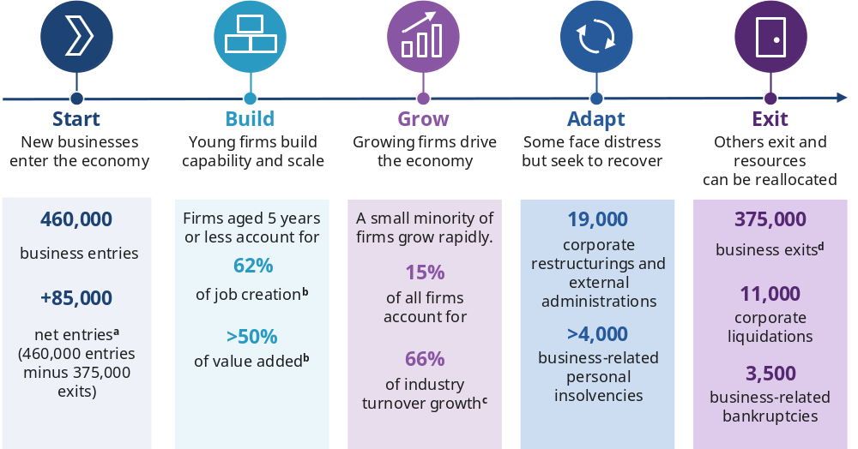
Unless otherwise specified, all numbers relate to 2025–26. a. Net entries refer to business entries minus business exits in a year. b. Refers to analysis taken over the period from 2007–08 to 2021–22. c. Refers to analysis undertaken of the period from 2004–05 to 2011–12. d. Business exit refers to a business leaving an industry, whether through insolvency or voluntarily.
Source: ABS (2026a); AFSA (2026c); ASIC (2026c); Lee et al. (2025); Majeed et al. (2021); Win et al. (2026).
Figure 2 – Entry, exit and job mobility rates have declined
Entry rate  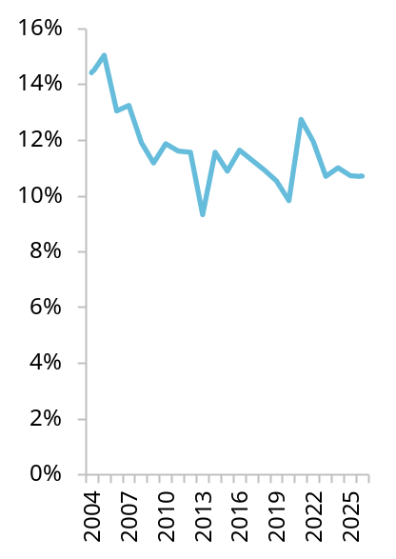 | Exit rate  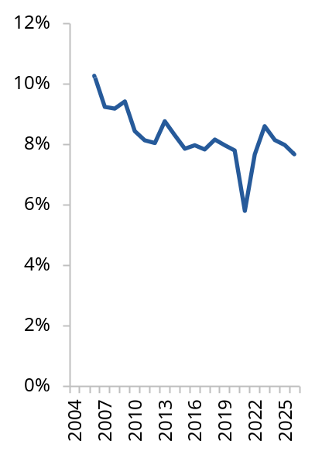 | Job mobility rate  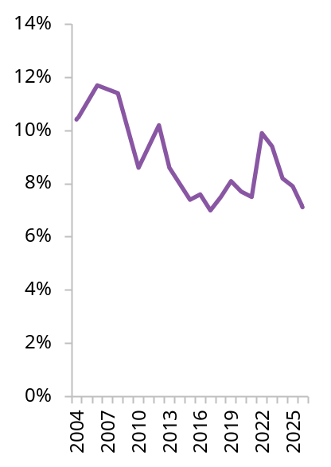
Entry and exit use financial years and include only employing firms. The job mobility rate is the proportion of workers who changed jobs in the last year.
Source: ABS (2007, 2009, 2013, 2018, 2021, 2026a, tbls. 1–16, 2026b, fig. 3).
Figure 3 – Indicators of business renewal have weakened
Proportion of firms remaining in top 4 after 3 years  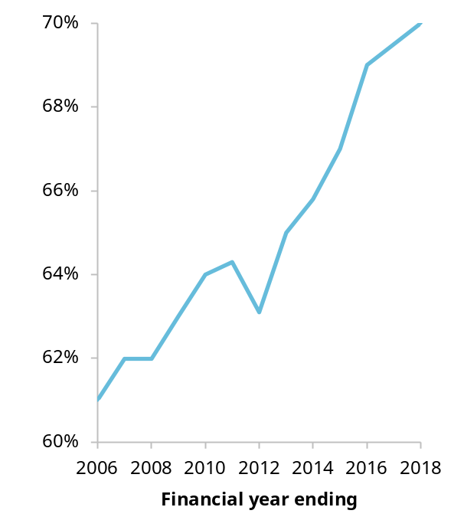 | Share of workers employed by young firms  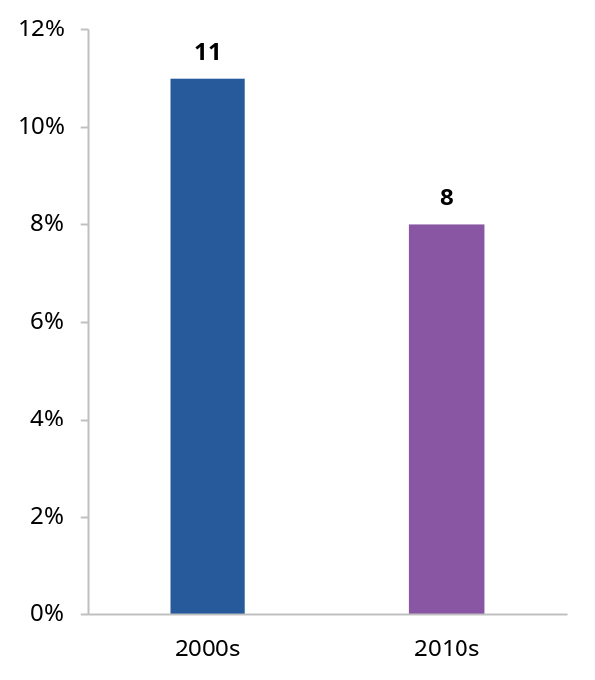
Share of top 4 firms by revenue in an industry in a given year that remain in the top 4 after 3 years. Financial years. Young firms are businesses aged 0–5 years.
Source: Adams et al. (2022, pp. 10–11).
After considering where government action could most effectively reduce unnecessary barriers, we focused on regulatory burden, access to finance, management capability, entrepreneurship and business transitions. We also examined Australia’s insolvency frameworks and the operation of key anti-phoenixing provisions.
Many inquiry participants identified tax and workplace relations as important influences on business dynamism. Some participants also highlighted workforce shortages and the challenges faced by businesses in regional and remote areas, but many of the policy levers most directly relevant to these issues, such as education, training, migration and housing, also sit outside the scope of the inquiry.
Several common themes emerged from the inquiry’s analysis:
- Better information, guidance and use of technology would reduce unnecessary regulatory burden.
- Better evidence and data use would improve the targeting and effectiveness of government intervention.
- Easier business transitions would support adaptation and growth.
- Better insolvency settings would preserve more economic value.
The summary table accompanying this Overview groups the inquiry’s findings, reform directions and information requests by these themes.

Make regulation work better for businesses
Well-designed regulation supports important economic, social and environmental objectives. But the scale, complexity and cost of regulation in Australia can make it harder than it needs to be for businesses to thrive. The burden does not necessarily stem from individual regulations. In some industries, the cumulative burden of requirements can create regulatory thickets that are particularly difficult for businesses to navigate.
Industry-specific burdens are best examined through targeted reviews. The PC last year recommended reviews of housing supply regulation, business reporting requirements and telecommunications sector regulation. The Australian Government has since commissioned the PC to undertake the first 2 reviews. In addition to telecommunications, candidates for future reviews include sectors with a high number of regulatory requirements and sectors raised by business groups during consultation for this inquiry, including care, construction, financial services, technology and motor trades. We are seeking feedback on the sectors that warrant a regulatory ‘deep dive’ to address cumulative burden.
But tackling regulatory thickets will take time. In the meantime, governments can make the existing stock of regulation easier for businesses to navigate. Businesses can struggle to identify which obligations apply to them, where to find authoritative guidance and in what order regulatory requirements should be addressed. Guidance is frequently scattered across agencies, levels of government and online portals, and businesses looking to enter a market may need to interact with multiple regulators or government departments before they can begin operating. These parts of government do not always operate as a connected system. Businesses can also be required to provide similar information to multiple agencies across all levels of government. These burdens fall particularly heavily on smaller businesses, which rarely have specialist compliance staff.
The Australian Government should establish an effective regulatory guidance system that helps businesses identify, understand and comply with their obligations. Guidance should be easier to find and navigate, available at key business touchpoints and should leverage business software tools and AI applications. Governments should also maintain a strong focus on tell-us-once reforms, so businesses avoid the unnecessary cost of providing the same information to government multiple times.

Improve viable businesses’ access to finance
Businesses need access to finance to start, invest and grow, but some commercially viable businesses struggle to obtain funding. Not every difficulty accessing finance warrants a policy response; what matters is whether there is an unnecessary barrier that government can effectively address. Lenders can find it difficult to assess businesses with limited financial histories, while investors may lack the information, expertise or incentives needed to identify commercially viable opportunities outside established networks and sectors. Inquiry participants identified difficulties affecting businesses led by women and Aboriginal and Torres Strait Islander people, businesses with limited collateral and young firms with short credit histories. We also examined whether prudential settings unnecessarily constrain business lending, but do not currently see a case for changing the balance between access to finance and financial stability.
Better access to business information can support faster and more informed lending decisions. The Australian Government should continue reforms to the Consumer Data Right, and we have identified key considerations to enable their effective implementation. Reforms should continue the move towards ‘data access as default’, making it easier for businesses to access and share information about themselves held by banks and government agencies while avoiding unnecessary duplication or restrictions beyond the Privacy Act 1988 (Cth). These reforms would make credit assessments faster and help businesses access capital more quickly.
Different barriers to accessing finance require different responses. Government interventions should be targeted to the specific cohorts facing barriers, rather than applied broadly; further evidence is needed on the cost-effectiveness of particular approaches. We heard of a range of ways government could help, including credit guarantee schemes, greater recognition of alternative forms of collateral, investment readiness support and direct funding, as well as changes to lending and investment assessment practices. Recent evidence suggests that well-designed credit guarantee schemes can improve access to debt finance for commercially viable businesses that would otherwise struggle to obtain funding, although they also carry risks. We are seeking feedback on which approaches would be most effective in overcoming the barriers to accessing credit faced by the cohorts identified above.
The Australian Government should also improve access to capital by removing avoidable distortions in venture capital programs that limit investment in start-ups. This includes allowing venture capital funds to make investments using existing government-registered limited partnerships outside the venture capital tax concession rules without establishing separate investment vehicles, and broadening pathways for experienced investors to participate in early-stage funding. The PC is seeking feedback on whether some commercially viable start-ups remain underserved by existing venture capital providers and, if so, whether additional policy responses are warranted.

Policies and programs to improve management capability
Management capability influences how effectively businesses translate opportunities into outcomes. It shapes how firms organise resources, adopt technology, respond to change and implement new ways of working. Firms with better management practices tend to be more productive, more innovative and more likely to grow.
However, management capability varies substantially across Australian firms. Many businesses are good at identifying opportunities but less effective at implementing organisational change. Governments are investing in support programs, but it’s often not clear where the biggest capability gaps are, which firms would benefit most from intervention and which interventions are delivering results.
The Australian Government should develop a systematic approach to business support programs that aim to improve management capability. This should involve building better evidence on barriers to improvement, targeting new interventions to demonstrated barriers, rigorously evaluating support programs and scaling up approaches that prove cost-effective while redesigning or discontinuing those that do not.
In the short term, business-facing government agencies and regulators should help small and medium enterprises (SMEs) recognise emerging problems and when support is needed, and connect them with appropriate support. Business lifecycle events and interactions with government provide opportunities to deliver timely information and referrals while minimising additional burden. As a first step, the Australian Government should build on Australian Taxation Office and Australian Securities and Investments Commission initiatives that provide timely prompts, referrals and information through digital channels, and evaluate whether they improve awareness of obligations and uptake of relevant support services. Successful approaches could then be rolled out across other agencies and regulators. We are also seeking views on how to better connect businesses, particularly SMEs, with the right support at the right time. Existing interactions between businesses and government provide opportunities to deliver timely information, referrals and other assistance. Governments should trial and evaluate behavioural nudges and digital tools, including prompts, referrals and in-software notifications delivered through business-facing agencies and regulators.
Better information might not always be enough. We are also seeking views on how government can better protect people from being pressured or coerced into business roles without their informed consent or a clear understanding of the obligations and risks involved.

Make adaptation, restructuring and exit easier
Business dynamism depends not only on successful businesses expanding, but also on assets, workers and ownership moving to better uses when circumstances change. Although transfer and closure processes are functioning reasonably well, some businesses face unnecessary costs, delays and complexity when adapting, changing ownership or exiting.
For solvent businesses, issues include delays in transferring commercial leases and the costs of closing companies that are no longer operating. Further evidence is needed on whether:
- statutory protections for lease transfers should extend to a broader range of commercial leases
- voluntary deregistration and members’ voluntary liquidation can be simplified without weakening safeguards.

Modernise insolvency settings
The insolvency system influences far more than what happens after a business fails. It shapes lending decisions, risk-taking, restructuring incentives and the willingness of entrepreneurs to pursue new opportunities. Australia’s insolvency system has developed through decades of piecemeal reform without a contemporary statement of purpose or agreed principles.
A clear statement of purpose, objectives and principles is needed to guide future reform efforts and evaluation of the system. The Australian Government should amend the Bankruptcy Act 1966 (Cth) and the Corporations Act 2001 (Cth) to explicitly state that the insolvency system exists to deal with the financial affairs of individuals and companies in financial distress. Its objectives should include preserving and productively redeploying economic value, facilitating timely intervention, supporting market and economic integrity, and enabling rehabilitation in personal insolvency. Its design should be proportionate, efficient and accessible.

Improve insolvency pathways
Australia’s insolvency system provides a range of pathways for restructuring, orderly exit and debt relief. The overall architecture is broadly operating well and does not require comprehensive reform. Reform should instead focus on improving individual pathways:
- Small business restructuring appears to be achieving its intended purpose, although aspects of the process could be more efficient.
- Simplified liquidation has seen minimal uptake and should be made meaningfully cheaper and faster or redesigned as a largely administrative process.
- The Australian Government should also introduce a minimal asset procedure for individual debtors with low assets, income and liabilities. This would provide a faster fresh start for many debtors while retaining the full bankruptcy process for more complex cases.
- The Australian Government should establish an Official Liquidator as a pathway of last resort for eligible insolvent companies that cannot otherwise access an orderly exit.

Provide better information and incentives for creditors
In the majority of insolvencies, recoveries for unsecured creditors are low. This largely reflects the limited pool of funds available for distribution, rather than how remaining funds are allocated among creditors. The inquiry has not identified a strong case for changing the order in which creditors receive payments.
Insolvency settings affect more than how losses are distributed when a business fails. They also influence the willingness of creditors to support financially distressed businesses and the information available to them. The Australian Government should amend unfair preference provisions to support businesses trying to trade through temporary financial difficulty. We are seeking feedback on whether greater disclosure of significant unpaid tax debts would support better lending and trading decisions, and on any associated risks and implementation challenges.

Improve interactions between personal and corporate insolvency
Some stakeholders argued that Australia’s separate personal and corporate insolvency systems create duplication and complexity, particularly for small business owners whose personal and business finances are closely connected. However, these issues are concentrated in a relatively small number of cases. Overall, the evidence does not support wholesale integration of the two frameworks. We are seeking views on whether targeted reforms could improve the experience of business owners who must navigate both systems.

Encourage earlier action when businesses get into difficulty
A recurring theme in the inquiry was that many SMEs act too late when financial problems emerge. Many businesses enter insolvency only after their financial position has deteriorated substantially, reducing the prospects of successful restructuring and leaving little value available for creditors. The warning signs can be visible well before formal insolvency occurs, but opportunities for early intervention are missed. While some businesses do not comply with the law deliberately, many delay action due to limited awareness of directors’ duties, uncertainty about available options, the cost of advice or personal financial pressures.
As such, governments should focus not only on the legal framework itself, but also on helping businesses recognise financial distress and respond earlier. The ATO should provide clear, practical information when missed lodgements or tax payments may indicate emerging financial distress. Communications should be integrated with business software to help businesses recognise warning signs, understand their obligations and identify sources of advice and support.
The safe harbour regime was introduced to encourage restructuring before insolvency becomes irreversible. However, compared to larger businesses, many SMEs lack the resources and expertise to use it effectively. The Australian Government should implement the outstanding recommendations of the Safe Harbour Review to improve guidance, clarify how safe harbour operates and make the regime easier for directors to understand and use.
The insolvency system must also address conduct that intentionally seeks to avoid liabilities. Illegal phoenixing – where a new company is created to continue the operations of an insolvent business – can harm creditors and distort competition by allowing some businesses to avoid liabilities and gain an unfair advantage over firms that meet their obligations. Most inquiry participants considered the current legislative framework to be broadly adequate. The PC is seeking feedback on whether targeted legislative amendments are needed to address evidentiary and enforcement issues.

A common direction for reform
The interim report for this inquiry does not identify a single reform direction that will restore Australia’s business dynamism. Nor does it aim to address every factor that influences productivity performance. Instead, it identifies a series of avoidable barriers that arise throughout the business lifecycle.
Reducing these barriers will require improvements on a number of fronts: better information; better guidance and technology integration; simpler pathways through government systems; better targeted intervention; more effective restructuring; earlier responses to emerging problems.
Taken together, these reforms would enhance Australia’s entrepreneurial ecosystem, making it easier for productive businesses to start, grow, adapt and succeed. They would support a more dynamic economy, with labour and capital moving more quickly to higher value uses.
Our final report, due in May 2027, will include more detailed recommendations and economic modelling to assess the potential impacts of reform. To inform our recommendations, we will continue to build the evidence base through consultation, public hearings and additional analysis.
We are seeking your input to help build our knowledge and evidence base. Your feedback on the reform directions and responses to the information requests throughout this report, will help shape our final recommendations.

Issues and inquiry responses by theme
Issue | Inquiry response
Better information channels would help businesses make decisions and meet their obligations
Businesses struggle to identify and understand their regulatory obligations | Make regulatory guidance easier to navigate (RD 1.2) and harness AI and regtech tools to help businesses understand, and comply with, their obligations (RD 1.3). We are seeking feedback on how guidance and regulatory requirements could be more accessible to AI and regtech to better support businesses (IR 1.2).
Businesses repeatedly provide information government already holds | Maintain a strong focus on and improve implementation of tell-us-once reforms (RD 1.1).
Lenders do not always have the information they need to assess borrower creditworthiness | Improve lenders’ access to data from consenting individuals, businesses and the government to support more informed and timely lending decisions (RD 2.1).
Businesses do not always recognise when they need help or find the right support | Many SME directors respond to financial distress too late because of barriers beyond the insolvent trading regime, including limited awareness of obligations, difficulty recognising financial distress and the cost of advice (F 8.1).  Make it easier for SMEs to recognise when they need help and find appropriate support (RD 3.2), provide businesses with information to help them understand their level of financial distress (RD 8.1) and improve directors’ understanding and use of safe harbour (RD 8.2).  We are seeking feedback on when and how support can reach businesses at the right time, through existing government interactions, digital channels and technology (IR 3.1).
Creditors may lack visibility of emerging financial distress | We are seeking feedback on disclosure settings that would give creditors useful information about financial distress without imposing unnecessary costs on businesses (IR 7.1).
Information alone may not protect people from being coerced into business roles | We are seeking feedback on how government can better protect people from being pressured or coerced into business roles without informed consent or a clear understanding of their obligations and risks (IR 3.2).
Better targeted intervention would improve the effectiveness of government support
Government support for management capability is fragmented and not supported by sufficiently strong evidence | Develop a systematic approach to management capability policy, targeting interventions at demonstrated barriers, evaluating their effectiveness and scaling approaches that work (RD 3.1).
Different barriers to credit require different policy responses | Government interventions should be targeted to the specific cohorts facing barriers, rather than applied broadly. We are seeking feedback on the effectiveness of existing interventions and where further targeted measures may be warranted (IR 2.1).
Settings in government venture capital programs can impede investment | Grow the pool of funding available to start-ups by reducing investment impediments in government venture capital programs. Grow the pool of funding available to start-ups by reducing investment impediments in those programs (RD 2.2).
Established venture capital markets may not reach all commercially viable start-ups | We are seeking feedback on whether commercially viable start-ups in some markets are underserved by venture capital providers and, if so, what targeted policy responses would be most effective (IR 2.2).
Easier business transitions would support adaptation and growth
Cumulative regulatory burdens can make it harder for businesses to enter, grow and adapt | Targeted reviews of industries and regulatory systems where cumulative regulatory burdens are particularly pronounced are needed. We are seeking feedback on which industries warrant review and which regulations create the largest unnecessary burdens (IR 1.1).
Delays in transferring leases may prevent otherwise viable business sales | We are seeking feedback on whether protections for lease transfers should extend to a broader range of commercial leases (IR 4.1).
Some solvent company exit processes may impose unnecessary costs or delays | We are seeking feedback on whether voluntary deregistration and members’ voluntary liquidation create unnecessary costs or delays for solvent companies, and whether changes to current arrangements are warranted (IR 4.2).
Better insolvency settings would preserve more economic value
Australia’s insolvency system lacks a clear foundation | Legislate the purpose, objectives and principles of the insolvency system to guide future reform and evaluation (RD 5.1).
Some business owners must navigate both personal and insolvency frameworks | Wholesale integration of the two insolvency frameworks is not desirable, but targeted reforms may improve the experience of people who navigate both systems (F 5.1, IR 5.1).
Some people and companies lack access to a proportionate insolvency pathway | Introduce a minimal asset procedure to give eligible debtors a faster fresh start (RD 6.1). Establish an Official Liquidator for companies that cannot reasonably fund the appointment of a registered liquidator (RD 8.3).
No major changes are needed to the order in which creditors receive payments | Reforms that preserve value, reduce unnecessary costs or support earlier restructuring are likely to contribute more to business dynamism than reforms that simply redistribute losses between creditor groups.
Some insolvency rules can impede restructuring and the preservation of viable businesses | Amend unfair preference provisions to support businesses in temporary financial distress (RD 9.1).
Small business restructuring may not be as efficient or accessible as it could be | We are seeking feedback on reforms to make small business restructuring more efficient, including changes to information requirements, debt verification, winding-up proceedings and creditor voting (IR 6.1).
Entry into restructuring can cancel licences and insurance in some industries | We are seeking feedback on whether the cancellation of licences and insurance undermines access to restructuring pathways (IR 6.2).
Simplified liquidation is not meaningfully simpler or cheaper than standard liquidation | We are seeking feedback on how to make simplified liquidation materially more efficient (IR 6.3).
Evidentiary challenges may make enforcing anti-phoenixing laws difficult | We are seeking feedback on whether amendments to the Corporations Act are needed to improve the operation of anti-phoenixing provisions (IR 8.1).



Reform directions, findings and information requests

Chapter 1 – Make regulation work better for businesses

 | Reform direction 1.1  Maintain a strong focus on tell-us-once
The Australian Government has made progress towards a tell-us-once system, but further action is needed to address barriers and to extend implementation across all levels of government.
- A focus on tell-us-once should be directly embedded in statements of expectation for agencies that are not progressing tell-us-once outcomes.
- The Australian Government should set a target for when to achieve a full tell-us-once system at the Australian Government level, potentially backed up by a legislated requirement preventing duplicative data collection.
- The Review of the Intergovernmental Agreement on Data Sharing should consider the merits of including a stronger focus on tell-us-once for businesses in the Agreement.

Reform direction 1.2
Make it easier to navigate the regulatory guidance system
The Department of Finance, in their role as lead on regulatory policy, practice and performance, should clarify regulatory guidance responsibilities within the Australian Government and across governments. They should ensure that governments:
- coordinate regulatory guidance with a clear single entry point that directs businesses to authoritative sources of regulatory guidance
- direct businesses to tools that help them identify obligations and sequence compliance
- publish better information on regulatory changes through initiatives like the financial sector’s Regulatory Initiatives Grid.

Reform direction 1.3
Harness AI and regtech tools to help businesses understand, and comply with, obligations
The Australian Government should ensure that AI and regtech tools can be used to help businesses understand, and comply with, regulations. The PC has identified 3 potential opportunities to do this:
- stronger requirements for regulatory guidance to be accessible to AI and regtech
- the publication of regulations in a more AI and regtech accessible format, for example, through better metadata or the wider adoption of machine-readability initiatives
- liability settings that support AI and regtech solutions being used to their potential.

Information request 1.1
Which sectors need a regulatory review to address the cumulative burden of regulation?
The PC has heard about industry sectors where the cumulative burden of regulation is particularly high – care, construction, financial services, technology and motor trades.
- Are there other industries where industry-specific regulation imposes significant cumulative burdens on businesses?
- For your identified industry or industries, which regulations, either individually or as a group, create the largest unnecessary burden? If possible, please name them.

Information request 1.2
How could AI compliance solutions and regtech be enabled to better support businesses?
AI and regtech solutions could help businesses navigate, and fulfil, regulatory obligations (reform direction 1.3). The PC is seeking feedback on ways to better support AI and regtech solutions to more readily undertake these functions:
- Are there examples where regulatory guidance could be made more AI-accessible?
- What can government do to make regulations more accessible to AI and regtech solutions? (For example, should government improve available APIs or provide better metadata?)
  - What information should be included?
- Are liability changes to the Tax Agent Services Act or other regulatory requirements to support the adoption of AI or regtech solutions warranted?
- What other changes may be required to increase the uptake of regtech solutions by Australian businesses?

Chapter 2 – Address barriers to business finance

Reform direction 2.1
Improve lenders’ access to data from consenting individuals, businesses and the government
To enable faster and more granular credit assessments, the Australian Government should continue to expand the scope of the Consumer Data Right (CDR) to enable ‘data access as default’ for individuals and businesses wanting to access and transfer data about themselves that is held by government or other businesses. The government has committed to changes to the CDR through its Financial Innovation Strategy. To enhance the delivery of these changes, the PC recommends that:
- individuals with existing authority on an online business account should be given equivalent authority to consent to data sharing under the CDR
- beyond including ATO data, the government should require the sharing of other data (such as ASIC data and data held by the Australian Business Register) through the CDR to help further streamline the processing of lending applications
- in expanding third-party CDR data disclosures, the government should ensure that customers can disclose their data to any accredited third party of their choosing.
In addition, the government should align the CDR’s bespoke privacy safeguards with the Privacy Act to reduce the regulatory complexity for businesses participating in the CDR.
- As a first step, after a third-party disclosure is made (point 3 above), data should be subject to the Privacy Act rather than the CDR’s privacy safeguards.
- Over time, the CDR privacy safeguards should be rolled back, and all transactions should be governed by the Privacy Act.

Reform direction 2.2
Grow the pool of funding available to startups by reducing investment impediments in government venture capital programs
To increase the availability of venture funding for start-ups, the Australian Government should reduce distortions caused by current program design features. The government should:
- allow ESVCLPs and VCLPs to make non-tax-advantaged investments that fall outside the eligible investment criteria under subdivision 118-F of the Income Tax Assessment Act 1997 to reduce reliance on administratively complex fund structures
- broaden the ‘sophisticated investor’ test by allowing relevant industry or start-up experience to qualify investors who do not meet the existing wealth thresholds
- recognise Simple Agreements for Future Equity notes at the time the investment is made, rather than when the notes convert into shares.

Information request 2.1
What are the most effective ways of overcoming barriers to accessing credit?
The barriers to accessing credit identified in this chapter arise for different reasons, including information asymmetries, limited collateral and barriers experienced by particular cohorts of businesses. Different policy responses may be appropriate for different financing constraints.
There is growing evidence that well-designed credit guarantee schemes can improve access to credit for commercially viable businesses that would otherwise struggle to obtain finance. However, credit guarantee schemes also carry risks. Other possible responses include broader recognition of alternative forms of collateral, changes to lending and investment assessment practices, voluntary industry commitments, investment readiness support, and direct funding or government acting as an intermediary in financial markets, to support finance for targeted cohorts.
The PC is seeking evidence on which approaches most effectively address genuine financing barriers, whether their benefits exceed their costs, and which interventions are best suited to particular barriers and groups of businesses.
We welcome views on:
- which interventions have been more effective at addressing particular financing barriers, including evidence from Australia or overseas
- if a credit guarantee scheme was to be introduced, what design features would maximise additional lending while limiting fiscal costs, poor lending decisions and displacement of private finance.

Information request 2.2
How can access to venture capital be improved for start-ups in underserved markets?
The PC is seeking further evidence on the extent to which commercially viable start-ups in some markets are underserved by existing venture capital providers and, if so, what policy responses would be most effective in addressing those gaps.
- To what extent do gaps in fund manager expertise, networks or track records, or the scale and investment strategies of established funds contribute to persistently underserved market segments?
- What changes to existing government venture capital programs would most effectively address demonstrated gaps while generating investment or economic activity that would not otherwise occur?
- To what extent could any additional support be funded by redirecting existing assistance, and how could this be done while minimising fiscal costs, displacement of private investment and other distortions?

Chapter 3 – Policies and programs to improve management capability
Reform direction 3.1
Develop a systematic approach to management capability policy
The Australian Government should develop a systematic approach to business support programs that target improved management capability. The objective should be to direct government support at the most significant barriers to capability building and fund cost-effective interventions to address them. Small and medium enterprises should be a particular focus.
The approach should:
- build better evidence on management capability and the barriers to improvement, including by funding the ABS and other relevant agencies to improve data collection and, where feasible, data linkages
- ensure agencies target new interventions to demonstrated barriers, with support measures proportionate to the problem being addressed and informed by consultation with relevant business, industry and professional bodies
- require agencies to rigorously evaluate all interventions, using methods appropriate to the scale and nature of the intervention, provide adequate funding for those evaluations and publish the findings
- require agencies to pilot new interventions where effectiveness is uncertain and to scale up those that demonstrate they improve business management capability cost-effectively, while redesigning or discontinuing those that do not.
An initial candidate to test this approach would be the PC’s 2025 proposal for co-funded training vouchers for small and medium enterprises, supported by diagnostic consultations and advisory services.

Reform direction 3.2
Make it easier for SMEs to recognise when they need help and find the right support
Governments should make greater use of business lifecycle events and interactions to help small and medium enterprises recognise emerging problems and connect with appropriate support. Approaches should:
- use existing information and interactions wherever possible, including through use of AI tools and business software
- rely on behavioural nudges and technology-enabled tools, such as timely prompts, referrals and in-software notifications, to guide businesses to relevant information while minimising additional burden
- avoid unnecessary reporting requirements
- be tested to determine whether they improve business outcomes.
As a first step, the Australian Government should build on existing work by the Australian Taxation Office and the Australian Securities and Investments Commission in trialling timely prompts, referrals and the provision of information at key business touchpoints, including through existing digital channels. They should evaluate whether these initiatives improve awareness of obligations and uptake of relevant support services. Pending the success of these initiatives, such techniques could be rolled out across other business-facing government agencies and regulators.

Information request 3.1
How can support reach businesses at the right time?
The PC is seeking views, including from small business organisations, accountants and other trusted advisers and business-facing government agencies and regulators on how businesses, particularly small and medium enterprises, could be better connected with support to strengthen their management capabilities and understanding of legal management responsibilities.
- Timing: businesses regularly interact with government agencies. At what points in a business’s lifecycle, or during which interactions with government, are businesses most likely to benefit from information or support? For example, when becoming a director, employing staff, expanding operations or responding to emerging business risks.
- Delivery: when, and what types of, government interactions are most likely to encourage businesses to act without adding to information or compliance burdens? This could include face-to-face interactions, agency portals, in-app or in-software prompts and other digital channels.
- Technology: how can AI and other technology, such as chatbots, personalised prompts or information embedded in business software, help provide timely and relevant support at low cost?

Information request 3.2
How can government better protect people from being persuaded, pressured or coerced into business roles?
The PC is seeking input into steps that could be taken by the Australian Government to prevent people from being pressured or coerced into taking on business responsibilities.
In particular, what can the Australian Government do to ensure people taking on new roles do so with informed consent and a clear understanding of their legal obligations and the risks involved?

Chapter 4 – Support business transitions

Information request 4.1
Should statutory protections be extended to a broader range of commercial leases?
The PC is seeking feedback on whether extending statutory protections to a broader range of commercial leases would reduce delays in business sales without imposing disproportionate costs or risks on landlords. In particular:
- How frequently do current arrangements for transferring commercial leases delay or prevent otherwise viable business sales?
- In jurisdictions where protections extend beyond leases covered by retail leasing legislation, have they reduced delays or improved business transfers?
- Should jurisdictions where protections remain largely confined to leases covered by retail leasing legislation extend them to a broader range of commercial leases?
- What grounds should landlords have for refusing consent, what response timeframes should apply and should consent be taken to have been given if a landlord does not respond?

Information request 4.2
Could arrangements for closing solvent companies be improved?
The PC is seeking feedback on the costs, benefits and risks of the current arrangements for closing solvent companies.
- Does the $1,000 asset threshold remain an appropriate boundary for access to voluntary deregistration? If not, what threshold should apply, and what would be the costs, benefits and risks of changing it?
- To what extent do the following requirements increase the cost or duration of members’ voluntary liquidations, and what costs, benefits and risks would arise from removing them:
  - the requirement to obtain ATO clearance before surplus funds are distributed to shareholders
  - creditor rights in a process where creditors are required to be paid in full
  - ASIC industry funding levies for members’ voluntary liquidations undertaken by registered liquidators.

Chapter 5 – Create a clearer foundation for insolvency reform

Reform direction 5.1
Legislate the purpose, objectives and principles of the insolvency system
The Australian Government should amend the Bankruptcy Act 1966 (Cth) and the Corporations Act 2001 (Cth) to reflect the following design guidance.
The purpose of the Australian insolvency system is to provide a process for dealing with the financial affairs of individuals and companies in financial distress.
The objectives should explicitly incorporate broader economic interests and are to:
- promote the preservation and productive redeployment of economic value
- facilitate timely intervention
- support market and economic integrity
- enable rehabilitation (in the case of personal insolvency).
The principles underpinning the system are:
- proportionality – obligations, process and cost reflect the size, scale and complexity of the matter, the value at stake and its public interest significance
- efficiency (of operation) – processes minimise unnecessary cost, delay and complexity while preserving value, supporting timely, predictable outcomes and maintaining appropriate safeguards
- accessibility – the system is understandable, affordable and practically usable, including for participants with limited financial literacy, English proficiency, digital access or capacity to pay for advice.

 | Finding 5.1  Wholesale integration of the two insolvency frameworks is not warranted
Wholesale integration of the two insolvency frameworks is not warranted. There may be scope for targeted reforms at the intersection of personal and corporate insolvency to improve the experience of the few small corporate business owners who are required to navigate both frameworks.

Information request 5.1
Options for targeted coordination of connected personal and corporate insolvencies
The PC is seeking feedback on ways to improve the efficiency of connected corporate and personal insolvency processes – including proposals for a single entry point into the insolvency system, procedural coordination of connected cases or enabling personal guarantees to be dealt with as part of corporate insolvency processes.
- How could or should these ideas be implemented in practice?
- What are the likely costs and benefits? Are there risks that need to be managed and if so, how?
- Are there other options for targeted reform that should be considered?

Chapter 6 – Make insolvency pathways work better

Reform direction 6.1
Introduce a minimal asset procedure
The Australian Government should introduce a minimal asset procedure in the personal insolvency system. It should be limited to debtors with low assets, income and liabilities.

Information request 6.1
How should the efficiency of the small business restructuring process be improved?
The PC is seeking feedback on whether and what reforms are needed to improve the operation of the small business restructuring (SBR) regime. In particular, what are the potential benefits, costs and risks associated with reforms that would:
- expand the mandatory information requirements to include information that is already being routinely requested
- require debts and creditor claims to be confirmed before voting
- automatically stay winding-up proceedings when a company enters SBR, circumventing the need to apply to court for a stay
- allow creditors, in addition to voting to accept or reject a plan, to vote for an alternative option?
Other suggestions to improve the operation of the SBR regime are also welcomed.

Information request 6.2
Do licence and insurance cancellations unnecessarily prevent the use of small business restructuring?
The PC is seeking information about licences and insurances that are cancelled when a business enters small business restructuring.
- Are there other industries, apart from residential construction, where entering small business restructuring causes the cancellation of essential licences or insurance policies? What legislation or policies compel these cancellations?
- Is there a compelling public policy rationale for state licensing bodies and insurers cancelling licences or insurance when a company enters small business restructuring? What are the costs, benefits and risks associated with preventing these cancellations from occurring?

Information request 6.3
How should simplified liquidation be improved?
The PC is seeking feedback on how to improve the simplified liquidation pathway.
- Are there targeted amendments to the simplified liquidation process that could make the pathway materially more efficient or improve uptake? What are they?
- Should the pathway be substantially redesigned as an administrative process with minimal investigation and reporting requirements? What measures would be needed to manage the risk of the pathway being abused?
- What are the costs and benefits of each of these approaches?

Chapter 7 – Support restructuring and value preservation

Reform direction 7.1
Amend unfair preference provisions to support businesses in temporary financial distress
The Australian Government should amend the unfair preference provisions in the Corporations Act 2001 (Cth) and Bankruptcy Act 1966 (Cth) to exempt payments received by creditors in the ordinary course of business, regardless of whether the creditor ought to have suspected that the debtor was insolvent.

Information request 7.1
How could a lower tax debt disclosure threshold operate?
A reduction by the ATO of the disclosure threshold for unpaid tax debts from $100,000 to a lower amount would provide creditors with greater visibility of companies that may be in financial distress. The PC is seeking information on potential changes to the disclosure regime including:
- What disclosure threshold would ensure creditors receive useful information about financial distress without imposing unnecessary costs on businesses?
- What are the benefits and drawbacks of maintaining disclosure with a credit reporting bureau after a payment arrangement is entered into?
- What are the circumstances in which exceptions should apply to the ATO making these disclosures?
- What other sources of information could help businesses identify trading partners experiencing financial distress?

Chapter 8 – Improve system integrity

Finding 8.1
Delayed action often reflects barriers beyond the design of the insolvent trading regime
Many SME directors respond to financial distress too late because of barriers beyond the insolvent trading regime, including limited awareness of obligations, difficulty recognising financial distress and the cost of advice.

Reform direction 8.1
The ATO should provide information to prompt businesses to assess their financial position
To encourage earlier responses to financial distress and reduce risk of insolvency, the ATO should provide clear, practical information to businesses when they have missed lodgements or tax payments. Communications should prompt businesses to assess their financial position, understand their obligations and identify credible sources of advice and support. The timing and content of these communications should be informed by analysis of ATO data on risk factors associated with future insolvency.

Reform direction 8.2
Improve directors’ understanding and use of safe harbour
To improve access to safe harbour for directors of financially distressed businesses, the Australian Government should implement recommendations 1, 5, 7 and 11 of the Safe Harbour Review, which are directed towards improving guidance, clarifying how safe harbour operates in practice and making the regime easier for directors to understand and use.
The Australian Government should also progress consideration of recommendations 10 and 12, which would provide greater certainty about eligibility for safe harbour protection.

Reform direction 8.3
Government should establish an Official Liquidator
To ensure insolvent companies can access an orderly exit regardless of their asset position, the Australian Government should establish an Official Liquidator for companies that meet eligibility criteria and cannot reasonably fund the appointment of a registered liquidator.
The Official Liquidator should act as a liquidator of last resort for insolvent companies that cannot reasonably fund the appointment of a registered liquidator. It should be able to transfer matters to a registered liquidator where assets are identified or specialist investigation is required, and administer the Assetless Administration Fund.
The effectiveness of the Official Liquidator in providing an accessible pathway for winding up assetless companies should be reviewed after 5 years.

Information request 8.1
Are legislative changes needed to improve the operation of the creditor-defeating disposition provisions?
The PC is seeking feedback on whether amendments to the Corporations Act 2001 (Cth) are needed to improve the operation of the provisions for combatting illegal phoenixing.
- In the context of establishing that a creditor-defeating disposition took place, is there a case for introducing a rebuttable presumption of insolvency? What would be the costs, benefits or risks of doing so?
- What are the evidentiary and enforcement issues associated with ASIC’s power to reverse creditor-defeating dispositions? What, if any, legislative amendments are needed to address these issues?

Make regulation work better for businesses

Key points
Regulatory costs and complexity can hinder business dynamism.
Regulation affects businesses at every stage of their lifecycle. Unnecessary costs and complexity arise when requirements accumulate, overlap or are administered inefficiently.
Regulatory burdens are particularly challenging for small businesses because they often lack the specialist staff and expertise needed to manage compliance efficiently.
Some industries face particularly complex regulatory systems.
Cumulative burden, regulatory delays and duplicated or poorly sequenced requirements can create significant barriers to entry and expansion.
These problems are best addressed through targeted reviews of industries and regulatory systems where burdens are particularly pronounced.
Businesses should only have to provide information once.
Businesses are often required to provide the same information repeatedly to different agencies, regulators and levels of government, increasing compliance costs and administrative effort.
The Australian Government should continue to pursue tell-us-once reforms by setting clearer expectations for agencies, setting a target date for implementation and collaborating with states and territories.
Businesses need a clearer path through regulation.
It can be challenging for businesses to determine which obligations apply, where to find authoritative guidance and in what order regulatory steps should be completed.
The Australian Government should coordinate improvements to the regulatory guidance system so that it better helps businesses identify, understand and comply with their obligations. This should include making authoritative guidance easier to find and navigate, delivering guidance at key business touchpoints, and harnessing AI and regtech tools.

Regulation can hold back business dynamism

Some regulatory requirements are more burdensome than necessary
Regulations play an important role in achieving economic, social and environmental objectives. They protect consumers, workers, the environment and the most vulnerable members of our community. But regulation also imposes costs on businesses – a recent estimate put the cost at $160 billion in 2024 (Mandala 2025, p. 3). And these costs have been growing (figure 1.1). Australia’s ranking has slipped on measures of how easy it is to do business, and the number of restrictive terms in legislation has increased.
Figure 1.1 – Regulation trends are headed in the wrong direction
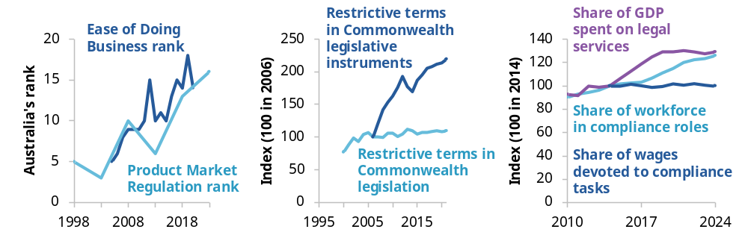
‘Restrictive terms’ are: ‘shall’, ‘must’, ‘may not’, ‘prohibited’ and ‘required’. Australia’s fall from 5th to 14th on the Ease of Doing Business rankings and from 3rd to 16th on the Product Market Regulation rankings was a result of minor improvements in Australia’s performance not keeping up with larger improvements internationally (PC 2025b, p. 34). The OECD Product Market Regulation index ranking covers the 28 countries that reported data in every period. ‘Legal services’ includes external legal services only.
Source: Number of restrictive terms in Commonwealth acts and legislative instruments: PC (2025b, p. 35) estimates based on QuantGov (nd), OECD Product Market Regulation Index: World Bank (2024), share of GDP spend on external legal services and share of workforce in compliance roles: Mandala (2025), share of wages devoted to compliance tasks: OECD (2025b, p. 72), World Bank Ease of Doing Business Index: World Bank Doing Business annual reports, 2005 to 2020.
Ideally, regulatory costs should be no greater than necessary to achieve policy objectives. But sometimes regulations – and the processes of complying with them – are overly burdensome, imposing a drag on productivity. Recent Productivity Commission work recommended improvements to both the design of regulation and specific regulations governing occupational entry, care, privacy and energy infrastructure approvals (PC 2025b, 2025c, 2025d, 2025a, 2025e).
While the Australian Government is progressing a number of these recommendations as part of its productivity agenda (Australian Government 2026c, p. 18), the PC is continuing to look for opportunities to reduce the regulatory burden on businesses.
For this inquiry, we have focused on regulation that may make it harder for businesses to enter a market, expand or exit. Costs at these key transition points pose the biggest constraint to the economic reallocations that drive business dynamism.
Starting a business involves several regulatory steps (figure 1.2), beginning with choosing a business structure (like a company or sole tradership) and registering the business. Setting up and registering a business in Australia is relatively straightforward – Australia ranked seventh globally on the OECD’s measure of how easy it is to set up a business (OECD 2020). For businesses without significant additional obligations, such as those operating online with limited licensing requirements, this means that entry is relatively straightforward (RDA GE, sub. 11, p. 4).
Figure 1.2 – Business entry can involve a number of regulatory obligations
Regulatory obligations that apply to entering businesses
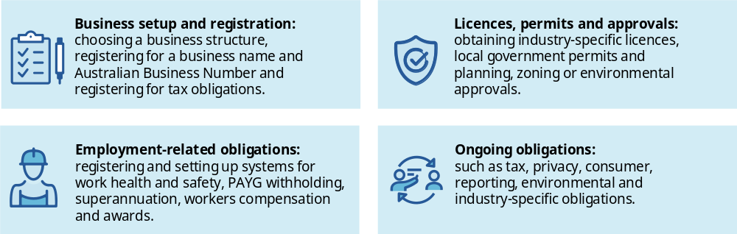
After setting up and registering, many businesses face additional obligations that can create barriers to entry. Businesses may need licences, permits or approvals and may need to comply with employment-related requirements or other ongoing obligations. These obligations can make getting started challenging for some businesses, particularly in heavily regulated industries.
Expanding a business involves similar challenges. Growing businesses may become subject to additional requirements as they pass regulatory thresholds, such as for payroll tax (Australian Revenue Offices 2026), or move into additional jurisdictions (CA ANZ, sub. 27, app. A, p. 2). The costs of meeting additional regulatory requirements can be a barrier to growth (CEDA, sub. 9, p. 2; MEA, sub. 22, p. 5).
Regulatory obligations can also make it harder to close, sell or restructure a business. For businesses not in financial distress, issues with lease transfers and voluntary deregistration may obstruct business transfer or closure (chapter 4). For businesses in financial distress, there is scope to make the insolvency system more accessible, efficient and proportionate (chapters 5 to 8).

Small businesses can find compliance particularly challenging
Regulatory compliance can be particularly costly for small businesses, which tend to have limited administrative capacity and can struggle to comply with regulatory obligations designed for larger businesses (ASBFEO, sub. 68, p. 5; Business Chamber Queensland 2025, p. 8). Activities that larger businesses can spread across specialist staff or larger revenue bases can impose a disproportionate burden on small businesses (Douglas and Pejoska 2017, pp. 2–3).
For example, a biltong manufacturer in Brisbane reported that meeting updated requirements to print allergens in bold would require a new $30,000 label printer, a cost many small businesses might not be able to afford (NAB, sub. 62, attachment, p. 23). In one survey, 39% of small businesses reported spending more than 6 hours a week on regulatory compliance, while 61% reported annual compliance costs exceeding $20,000 (ACCI 2025, p. 17).
These constraints can compound the challenges facing businesses when they enter a market or expand. New businesses are typically small, with only 2% of businesses that entered in 2025–26 having 5 or more employees, compared to 11% of established businesses (PC analysis of ABS 2026a, table 13). And growing businesses may encounter additional regulatory obligations before they have developed the capacity to manage them efficiently.
Applying less stringent requirements to smaller businesses can reduce regulatory burdens and support business entry. However, any size-based regulations need to be designed carefully to avoid adding complexity or creating disincentives for businesses to grow (box 1.1).

Box 1.1 – Size-based regulation can reduce regulatory burdens but requires careful design
Size-based regulation applies different standards to businesses based on their size. For example, the Privacy Act exempts most businesses with an annual turnover of $3 million or less (OAIC 2023c).
Size-based regulation can play an important role in supporting small businesses. As a general principle, regulation should be used where its benefits outweigh its costs. Because compliance costs are proportionally higher for small businesses, applying different regulatory standards can sometimes be appropriate (Douglas and Pejoska 2017, pp. 5–7).
However, size-based regulation requires a delicate balance because it adds additional complexity and can create incentives for firms to remain small (Douglas and Pejoska 2017, pp. 8–9). And there is a trade-off between reducing complexity and preserving incentives for growth. While there are concerns about the complexity caused by the many different definitions of what a ‘small business’ is,ª a single definition would create a threshold where any growth would result in losing access to several schemes and becoming subject to many requirements. Such a threshold could be a large disincentive to growth.
Poorly designed policies can also fail to achieve their objectives. For example, although modern slavery reporting requirements apply only to large businesses (Australian Government 2025b), those businesses may pass reporting requirements on to smaller subcontractors in an instance of ‘white tape’ (ASBFEO, sub. 68, p. 5).
Size-based regulation therefore needs to be applied carefully on a case-by-case basis.
a. ACCI (2026, pp. 13–14); AICD (sub. 41, pp. 2, 7); Law Society of NSW (sub. 39, pp. 1–2).

More needs to be done to address industry-specific regulatory challenges

Businesses may face considerable industry-specific challenges when trying to enter or expand
A key regulatory challenge for business dynamism is the complex and enduring thickets of regulation that have emerged in some industries and regulatory systems (PC 2025b). These can be particularly difficult for entering and expanding businesses to navigate. Concerns raised in this inquiry included regulatory delays, duplicated or poorly sequenced requirements and the cumulative burden of regulation.
Regulatory delays can slow business entry. Electrical trades licence applications, for example, can take 3 months to be processed (RDA GE, sub. 11, p. 4), and Australian financial services licences typically take 4 to 8 months (ASIC, sub. 69, p. 11). Regulatory delays can be especially challenging for businesses where communication is poor or where businesses continue to incur costs but cannot generate revenue till the delay is resolved (Mandala 2026b; RDA GE, sub. 11, p. 4).
Duplicated and poorly aligned requirements arise where multiple government agencies or regulators enforce rules that overlap in scope, so businesses need to complete the same or similar tasks multiple times. This can occur because different regulatory requirements are frequently developed in isolation, leading to disconnected processes (SBDC WA, sub. 52, p. 3). For example, quality and safety regulation in the care economy is fragmented, with some providers subject to many different pieces of legislation and accreditation or audit processes (Ageing Australia, sub. 64, p. 4; PC 2025c, p. 12). Duplication is particularly challenging for businesses operating in multiple jurisdictions, with requirements managed separately. For example, occupational licensing requirements (Mandala 2026b, p. 22; PC 2025a, pp. 76–77), vehicle registrations (MTAA, sub. 35, pp. 3–4) and freight approvals (Mandala 2026a, pp. 17–18) vary by state or even local government area.
Concerns about the cumulative burden of regulation reflect the total cost of compliance with the many different regulations that apply to businesses. In some industries such as scientific research services, coastal sea freight between domestic ports and petroleum gas extraction, the number of different requirements can exceed 40 (figure 1.3). And while the average number of federal and state requirements is much lower at 14, these requirements can still be burdensome.
Figure 1.3 – Some industries face a particularly high number of licences and regulatory requirements
State and federal licences and regulatory requirements
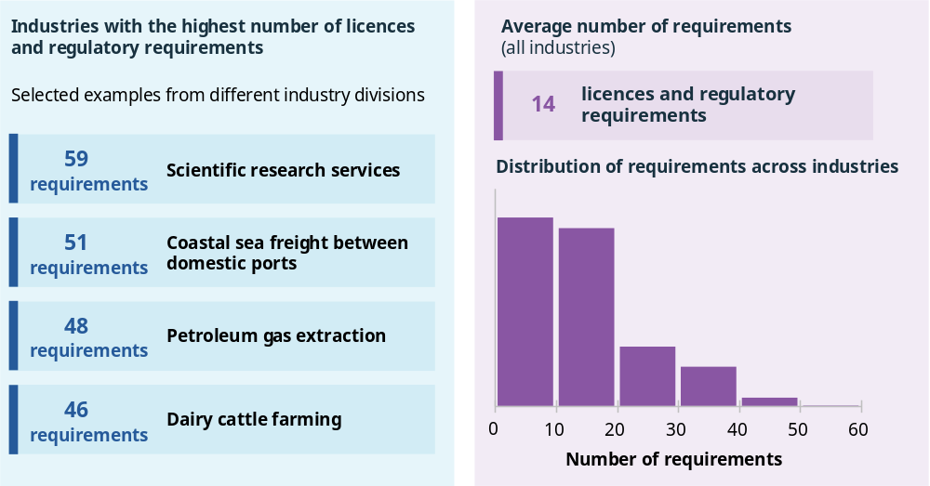
Results are based on an extract of ABLIS data as of 9 July 2026. ABLIS is not necessarily comprehensive (ABLIS nd) but summarises key requirements. Results are based on counts of requirements, which are sensitive to how requirements are grouped, for instance mortgage and finance brokers report a higher count of requirements (MFAA, sub. 34, p. 2), partially due to using different groupings. Results for each industry are averaged across states and exclude location-specific requirements (such as those relating to geographies surrounding airports). All averages are unweighted.
Source: PC analysis of ABLIS (unpublished).

Much work is ongoing, but additional targeted work may be needed to address these issues
Governments across Australia are already pursuing a broad range of regulatory reform initiatives to address these regulatory thickets. The Australian Government’s efforts include reforms across a number of sectors to improve regulator performance, modernise regulatory systems (including expectations to move towards a ‘tell-us-once’ system; section 1.3) and align requirements across jurisdictions (Australian Government 2026h).
A holistic approach is needed to address both cumulative regulatory burdens as well as duplication and inconsistency within industries, which can be missed when individual regulations are assessed in isolation (PC 2025b, p. 44). To this end, the PC has previously recommended that the Australian Government task an independent agency with a stream of regulatory reviews, starting with housing supply regulation, business reporting requirements and telecommunications sector regulation (PC 2025b, p. 44).
Some work of this type is under way – the Australian Government has commissioned the PC to undertake reviews of housing supply regulation and business reporting requirements (Chalmers 2026a, 2026b) as well as commissioning other bodies to undertake additional targeted reviews of specific regulatory systems. Separately, state, territory and local governments are also conducting work through regulatory reform and ‘business friendly’ programs.
But more remains to be done. Prospective candidates for review include the telecommunications sector (PC 2025b, p. 44), sectors with a higher number of regulatory requirements (figure 1.3) and sectors raised by business groups during consultation for this inquiry including care, construction, financial services, technology and motor trades.
The PC invites further feedback on sectors where cumulative burdens are particularly pronounced.

Information request 1.1
Which sectors need a regulatory review to address the cumulative burden of regulation?
The PC has heard about industry sectors where the cumulative burden of regulation is particularly high – care, construction, financial services, technology and motor trades.
- Are there other industries where industry-specific regulation imposes significant cumulative burdens on businesses?
- For your identified industry or industries which regulations, either individually or as a group, create the largest unnecessary burden? If possible, please name them.

Businesses should only provide information once

Businesses are repeatedly asked for information government holds
Many of the steps required to start a business are handled by different levels or parts of government, meaning businesses looking to enter a market may need to interact with multiple regulators or government departments before they can begin operating (ASIC, sub. 69, p. 6).
Unfortunately, these parts of government rarely operate as a connected system. When looking to start or grow, businesses report having to provide similar information to multiple government agencies across all levels of government (NSW SBC, sub. 36, p. 2; SBDC WA, sub. 52, p. 3). For example, providers operating across aged care and disability services can face duplicated registration, accreditation and worker screening requirements across sectors and jurisdictions (Ageing Australia, sub. 64, p. 4; PC 2025c, p. 12). In Queensland, food stalls are required to be separately licensed under the same legislation for each local government area they trade in (QSBC, sub. 85, p. 2).
Businesses may also face duplicative reporting requirements, with business groups sharing examples of providing the same information to government on an ongoing basis in aged care (Ageing Australia, sub. 64, p. 4), motor vehicle trading (MTAA, sub. 35, p. 3) and retail (Mandala 2026a, p. 22). A separate PC inquiry is examining business reporting requirements (PC 2026).

Work to implement a tell-us-once system is under way, but more remains to be done
To reduce the burden on businesses to provide the same information multiple times to government, the Australian Government has committed to enabling a ‘tell-us-once’ system (Australian Government 2023a, p. 19). Under this system, government agencies would share information internally rather than repeatedly asking businesses to provide it.
Several tell-us-once initiatives to support businesses have been completed or are under way:
- the Regulatory Reform Omnibus Act 2026 (Cth) supports a tell-us-once approach through legislative updates around trade and anti-dumping restrictions as well as the sharing of healthcare identifiers (Explanatory Memorandum, Regulatory Reform Omnibus Bill 2026, p. 6)
- Provider Connect Australia provides simplified registrations for healthcare providers (ADHA 2026) and work on a national approach to care and support worker screening is ongoing (Chalmers 2025; Treasury 2025b)
- the Council of Financial Regulators is taking several actions to streamline data collection and sharing (CFR 2026)
- identity verification across Clean Energy Regulator schemes has been simplified (CER 2026).
Tell-us-once initiatives are improving service delivery such as through better data sharing within Services Australia (Explanatory Memorandum, Regulatory Reform Omnibus Bill 2025, p. 2). And while not directly focused on tell-us-once, the Data Availability and Transparency Act 2022 (Cth) aimed to facilitate data sharing which would support tell-us-once, although the Act may require reform to meet this goal (King 2025, pp. 31–32, 37–39).
Despite this progress, challenges to implementing a tell-us-once system remain.
Previous reviews and consultations have consistently found that a culture of risk aversion and a lack of incentives to share data are barriers to data sharing and, by extension, a tell-us-once system. And work is needed to align data standards across different regimes (ACOR 2026; Halo 2026, p. 2).
In response, regulators have been asked to take a productivity focus (Department of Finance 2025) and the new whole-of-government Regulatory Policy, Practice and Performance Framework, developed by the Department of Finance in collaboration with Commonwealth regulators, includes an aim to only collect information once (Department of Finance 2024, p. 12). Additionally, the Digital Service Standard mandates that all public-facing services need to meet interoperability requirements and only request information once, although exemptions are possible (DTA 2024a).
However, if resistance to implementing a tell-us-once system persists, the Australian Government should make expectations more explicit. The expectation that regulators and departments operate within a tell-us-once system should be embedded as a priority directly within statements of expectation, rather than in underlying strategy documents.
Further, the Australian Government should set a target date for when to achieve a tell-us-once system. Such a target would further strengthen the impetus for the implementation of tell-us-once. A target could also be backed up by a legislated requirement similar to Estonia’s requirement that data cannot be collected more than once. While appealing in theory, the PC will continue to consider the merits and risks of such an approach – a legislative requirement for tell-us-once may not offer sufficient flexibility to departments when data sharing is not practical or conflicts with other legislation, particularly in the short term.
Another challenge is that businesses continue to report that a significant burden arises when providing information to multiple levels of government. The Australian, state and territory governments have committed to share data by default through the Intergovernmental Agreement on data sharing between Commonwealth and State and Territory governments, and the upcoming review of the Agreement will assess progress. But data sharing only enables a tell-us-once system to function; it does not guarantee its implementation. The review should consider whether a more explicit focus on tell-us-once and data sharing to reduce regulatory burden should be included in the Agreement. This could include the specific outcomes expected of governments to ensure that tell-us-once initiatives are progressed.
Including local governments in tell-us-once initiatives is also important, but challenging due to the number of local governments. Inclusion of local governments should be a longer-term priority.
Implementing a tell-us-once system will involve costs, particularly as investments in digital infrastructure can be expensive (for example the Modernising Business Registers program was stopped after costs blew out to 5 times the original estimate; Jones 2023). But these costs would largely be one-off and benefits to businesses will be ongoing. Further, governments bearing this cost would allow businesses to focus on growing and improving.
The PC’s business reporting requirements inquiry is examining how the tell-us-once principle should be applied to non-financial reporting (PC 2026).

Reform direction 1.1
Maintain a strong focus on tell-us-once
The Australian Government has made progress towards a tell-us-once system, but further action is needed to address barriers and to extend implementation across all levels of government.
- A focus on tell-us-once should be directly embedded in statements of expectation for agencies that are not progressing tell-us-once outcomes.
- The Australian Government should set a target for when to achieve a full tell-us-once system at the Australian Government level, potentially backed up by a legislated requirement preventing duplicative data collection.
- The Review of the Intergovernmental Agreement on Data Sharing should consider the merits of including a stronger focus on tell-us-once for businesses in the Agreement.

Businesses need a clearer path through regulation to ensure their obligations are met
The most effective way to help businesses is to reduce the burden caused by complex regulatory systems and processes (section 1.2). However, reforming existing regulation can be a lengthy process. While this work proceeds, governments can still take steps to smooth the path for entering and expanding businesses by improving how they find, understand and navigate through existing regulatory obligations.

Businesses can struggle to navigate their obligations
Understanding regulatory obligations can be difficult. In one survey of small businesses, for example, only 38% of respondents felt confident that they understood all their obligations, while 42% had some understanding and 14% were not confident at all (COSBOA 2025, p. 29).
Figure 1.4 and small business feedback highlight the challenge of navigating multiple rules, regulations and approval processes.
Understanding what is required. For a small start up there are so many different rules. (Small business; RDA Goldfields Esperance, sub. 11, p. 4).
For my small business time is at a minimum as I am wearing so many hats, therefore the minefield of local government laws, regulations and approvals is unreachable and there is no support through the process. (Small tourism business; Business Chamber Queensland 2025, p. 10).
Difficulty understanding regulatory obligations can increase compliance costs and the risk of non-compliance. Businesses may need to rely on costly external advice or spend significant time understanding which requirements apply to them, contributing to staff burnout (Ageing Australia, sub. 64, pp. 2–3). These costs can be a barrier to business entry and expansion (NSW SBC, sub. 36, p. 2).
Business owners who do not understand their obligations may also make poor decisions or inadvertently breach regulatory requirements. For example, sole contractors may be encouraged to operate through a company but may be unprepared for the additional obligations this imposes, or may mismanage tax obligations (FCA, sub. 60, pp. 15–16). In chapter 8, we discuss how this can create additional challenges for businesses facing financial distress.
Figure 1.4 – Businesses report challenges with fragmentation, navigation and gaps in available information
Business responses to ‘What hurdles or challenges have you encountered when searching for business information?’
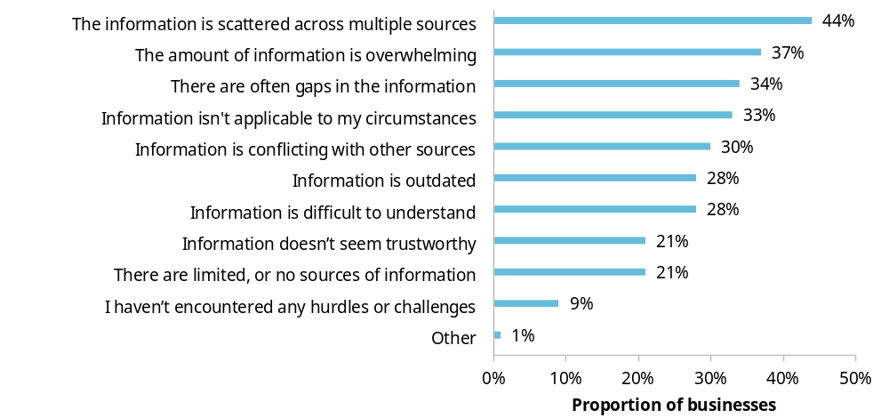
Business information refers both to information about regulations and other information, such as information about financial obligations or marketing. Based on a representative sample of 474 Australian businesses.
Source: DISR (unpublished-a, p. 16).

Better guidance could reduce costs and compliance risks
Designing an effective business guidance system could create significant savings for businesses. The PC has identified 3 areas where improvements to the business guidance system could be made: navigation of the guidance system, proactive provision of regulatory guidance and use of AI and regtech tools.

Improvement 1: make it easier to navigate regulatory requirements
Businesses have access to a lot of regulatory guidance, but it can be difficult to find and navigate. Governments could improve the system in 3 key ways.
First, the system needs a single, clearer entry point that directs businesses to authoritative sources of regulatory guidance. The Australian Government’s business.gov.au website serves as a central entry point and helps businesses identify obligations relating to all levels of government. There are approximately 7 million user sessions on the website every year; 78% of users report being satisfied with the website and being able to find what they were looking for (DISR unpublished-a, p. 24, unpublished-b, pp. 11–12). However, only half of business owners report awareness of the business.gov.au website (DISR unpublished-a, p. 3).
Further, each state and territory publishes resources for new businesses, some of which overlap with those on the business.gov.au website. This duplication adds costs for governments and creates an inconsistent experience for businesses. More generally, 30% of businesses report navigating conflicting business information as a challenge (figure 1.4). This suggests that a system with a single, clear entry point that directed businesses to authoritative sources of information could reduce complexity.
Second, new businesses should be more consistently directed to tools that help them identify their obligations and sequence compliance tasks. Without such tools, business owners face the challenging task of determining in what order compliance tasks need to be completed and which level of government is responsible for each requirement (Regulatory Intelligence Lab, sub. 7, p. 11). Completing tasks in the wrong order could cause delays, as completing regulatory requirements is often contingent on obtaining earlier approvals or satisfying related planning, building, workplace or operational requirements.
For example [for a café], premises may need to be suitable before a food licence can be granted; fit-out decisions may depend on plumbing or building requirements; staff cannot be hired with confidence without payroll and workplace systems; and trading cannot begin until food safety, insurance, and local approval issues are resolved. (Regulatory Intelligence Lab, sub. 7, p. 11).
Some tools do exist. The business.gov.au website, for example, includes tools that help businesses identify their obligations. And guidance on sequencing obligations is available for some industries – for instance, the Small Business Development Corporation WA (2026b) created a set of tools for brewers.
But the current system is too inconsistent. Tools to help businesses sequence compliance do not exist for all industries and different entry points do not consistently link to available tools.
To improve navigation, businesses should be directed to tools that help them identify obligations and sequence compliance, and these tools should be developed where they do not exist. Developing tools may not be cost effective for all industries but should be considered in areas with complex requirements across multiple levels of government and many small business entrants, like hospitality.
Finally, better information on regulatory changes is needed. Businesses can find it hard to keep track of changing obligations (MEA, sub. 22, p. 3) and may be flooded with excessive information. For example, over 200 information releases were made in the week leading up to the commencement of the new Aged Care Act 2024 (Cth), which imposed changed reporting requirements on businesses in that sector (Ageing Australia, sub. 64, pp. 2–3; DHDA 2025, p. 5).
Initiatives like the financial sector’s Regulatory Initiatives Grid could help businesses keep track of changes in obligations. The Grid sets out a list of reforms that will materially affect the financial sector over the next 2 years (Treasury 2026b). There may be opportunities to use such grids in other policy areas, particularly where there are multiple regulators at the same level of government (PC 2025b, p. 47).
Delivering a more navigable system in line with these 3 improvements requires better coordination across and within governments. The PC heard that it may not always be clear who is responsible for providing an entry point, developing tools, being the primary source of guidance on a matter or updating businesses on changes in obligations. The Department of Finance, in their role as lead on regulatory policy, practice and performance (Department of Finance 2026), should clarify responsibilities within the Australian Government to avoid both situations where multiple agencies provide the same guidance and situations where no guidance at all is provided. The PC is considering what mechanisms should be used to facilitate intergovernmental collaboration.

Reform direction 1.2
Make it easier to navigate the regulatory guidance system
The Department of Finance, in their role as lead on regulatory policy, practice and performance, should clarify regulatory guidance responsibilities within the Australian Government and across governments. They should ensure that governments:
- coordinate regulatory guidance with a clear single entry point that directs businesses to authoritative sources of regulatory guidance
- direct businesses to tools that help them identify obligations and sequence compliance
- publish better information on regulatory changes through initiatives like the financial sector’s Regulatory Initiatives Grid.

Improvement 2: deliver guidance proactively
Business owners do not always understand or seek out information about their regulatory obligations, particularly when establishing a business is relatively straightforward (FCA, sub. 60, pp. 15–17). Governments therefore need to proactively support business owners to understand the requirements that apply to them.
Some work is in progress. ASIC recently published a Small Business Director Essentials Hub and ASIC’s small business strategy includes a priority to ‘leverage established adviser and industry channels to extend the reach, relevance and effectiveness of ASIC’s guidance for small business directors at key moments in their business journey’ (ASIC 2026d). Some departments also send out newsletters and information to businesses via email (ATO 2026b; Business Victoria 2024).
Work to improve the provision of information at key touchpoints should continue. In particular, business and director registrations may provide an opportunity to ensure that would-be business owners understand their obligations (CA ANZ, sub. 27, app. A, pp. 1–2; FCA, sub. 60, p. 18). Chapter 3, section 4 discusses how governments can make it easier for SMEs to access the support they need at the right time. As part of our consideration of how government can support improvements in management capability, the PC is also seeking further input from businesses on how support can be delivered more effectively including by better integration with, and use of, business software and regtech tools (information request 3.1).

Improvement 3: harness AI and regtech tools
AI and regtech could make it easier for businesses to understand and meet their obligations. Governments therefore need to ensure that regulatory information can be reliably accessed, understood and used by both people and machines.
We note that AI is already changing how businesses access regulatory guidance. AI search overviews reduce the probability of businesses clicking through to websites (McDonald 2025). Rather than traditional web searches, businesses may be referred to government guidance via AI or use AI-powered compliance tools like Pathfinder (PwC Australia 2026). However, conventional guidance will continue to be important, both for the many users not relying on AI or regtech and as an input or fact-check for AI searches.
More could be done to make the most of AI and regtech and ensure that their use results in businesses accessing authoritative and accurate guidance. The PC has identified 3 potential opportunities in this space.
First, there could be stronger requirements for regulatory guidance to be AI-accessible. For instance, to facilitate the use of AI tools, websites should be written in accessible, plain English and webpages should be designed in line with search engine optimisation practices, such as ensuring good alt text is available. Current Australian Government digital content standards note the importance of emerging tools like AI (DTA 2024b, nd) but could more explicitly direct agencies to publish AI-accessible content.
Second, regulatory requirements could be made more machine readable to improve accessibility for regtech solutions. At present, regulatory obligations are frequently scattered across downloadable documents without useful metadata or information on currency, making it harder to leverage AI tools (Revealr, sub. 58, pp. 1, 4).
Some progress has been made on this front. The Federal Register of Legislation API makes legislation more accessible to software developers (Australian Government nd) and the ATO (2026d) trialled a ‘rules as code’ initiative to make requirements machine-readable. But there may be potential for further action through better metadata or the wider adoption of machine-readability initiatives. Such reforms might also allow governments to more efficiently pursue regulatory reforms, by allowing automated searches of legislative requirements. This could assist in addressing duplicative requests for information (section 1.3).
Third, governments need to make sure that liability settings enable regtech solutions to support businesses in meeting their regulatory obligations. Participants in this inquiry identified that digital platforms are potentially discouraged from offering low-risk compliance assistance (Xero, sub. 19, pp. 1–2), because the Tax Agent Services Act 2009 (Cth) includes provisions that may classify behavioural prompts and nudges by digital platforms as tax advice. For example, a notification that a business is approaching the GST registration turnover limit could be classified as tax advice, despite the likely low risk of such a notification.
Beyond these reform opportunities, better management capability (chapter 3) could also support the uptake of AI and regtech solutions.

Reform direction 1.3
Harness AI and regtech tools to help businesses understand, and comply with, obligations
The Australian Government should ensure that AI and regtech tools can be used to help businesses understand, and comply with, regulations. The PC has identified 3 potential opportunities to do this:
- stronger requirements for regulatory guidance to be accessible to AI and regtech
- the publication of regulations in a more AI and regtech accessible format, for example, through better metadata or the wider adoption of machine-readability initiatives
- liability settings that support AI and regtech solutions being used to their potential.

Information request 1.2
How could AI compliance solutions and regtech be enabled to better support businesses?
AI and regtech solutions could help businesses navigate, and fulfil, regulatory obligations (reform direction 1.3). The PC is seeking feedback on ways to better support AI and regtech solutions to more readily undertake these functions.
- Are there examples where regulatory guidance could be made more AI-accessible?
- What can government do to make regulations more accessible to AI and regtech solutions? (For example, should government improve available APIs or provide better metadata?)
  - What information should be included?
- Are liability changes to the Tax Agent Services Act or other regulatory requirements to support the adoption of AI or regtech solutions warranted?
- What other changes may be required to increase the uptake of regtech solutions by Australian businesses?

Address barriers to business finance

Key points
Barriers to accessing finance can limit business dynamism.
Difficulties in accessing finance do not, by themselves, justify government intervention. However, where commercially viable businesses face unnecessary impediments to finance, business entry, innovation and growth may be constrained.
Inquiry participants identified financing barriers affecting businesses with limited collateral, firms with short credit histories, Aboriginal and Torres Strait Islander-led businesses and women-led businesses.
Improved data sharing can reduce information barriers in lending markets and help businesses get loans sooner.
The Consumer Data Right (CDR) could help unlock these benefits by making it easier for businesses to share data about themselves with lenders.
The government has committed to reforms to the CDR, but success will depend on their implementation. Key features should include ensuring that data sharing is expanded to multiple government agencies and allowing consumers to disclose their data to any third party of their choosing.
Further changes to the CDR are needed to continue moving towards a ‘data access as default’ system, including aligning CDR privacy settings with the Privacy Act 1988 (Cth).
Targeted interventions can support increased lending to cohorts of viable businesses that are currently underserved by credit markets.
Different barriers to accessing finance require different responses. Government interventions should be targeted to the specific cohorts facing barriers, rather than applied broadly.
Further evidence is needed on the cost effectiveness of alternative approaches.
Inefficiencies in government venture capital programs should be removed.
Venture capital funds should be allowed to make unsubsidised investments through government-registered structures, and the sophisticated investor test should be broadened to allow investors with relevant industry experience to qualify.
Further evidence is needed on whether commercially viable start-ups in some markets are underserved by existing venture capital providers and, if so, the most appropriate policy responses.

Access to finance enables business dynamism
Access to finance helps new businesses start and allows successful businesses to grow and innovate (Aghion et al. 2007; OECD 2019, p. 182).
Businesses largely access finance by selling an ownership stake (equity) or borrowing money (debt), depending on their needs and circumstances.
If commercially viable businesses cannot obtain funding when they need it, the ability of businesses to start, grow and expand can be limited. Business reports of difficulties in accessing finance do not, by themselves, justify government intervention. For example, a business may be unable to obtain finance because the expected return of the project does not justify the risk involved, rather than because of a market failure. Not every financing difficulty is a policy problem. Government intervention also carries risks, including wasting scarce public funds through funding unviable businesses or subsidising firms which could have accessed private funding.
However, there are a number of grounds on which government intervention in financial markets might be justified.
Financial markets do not always work efficiently when owners know more about their business than potential lenders and investors, a problem known as an information asymmetry. This problem can be particularly acute for young firms with a limited trading history (Wilson 2015, p. 11). As a result, some commercially viable businesses may be unable to secure finance even where the expected returns would justify investment, because they cannot credibly convince potential financiers of their quality as an investment. Collateral can help address this problem, but not all businesses have assets that can be used for that purpose.
In some instances, the economic benefits to society of investing in a business might exceed the private returns available to investors. For example, support for new businesses or research and development is generally associated with positive spillovers, which benefit the broader community and are not reflected in private investment decisions (Hall et al. 2010, pp. 1065–1066). Alleviating funding constraints for small firms is also associated with positive spillovers. Evidence from overseas credit guarantee schemes shows that increasing access to finance for small firms comes with benefit–cost ratios of 7.1:1 in the UK (British Business Bank 2025) and 7:1 in Canada (Government of Canada 2025).
In other cases, governments may pursue broader equity or public policy objectives. Access to finance for underrepresented groups may generate wider social and economic benefits and align with governments’ equity objectives.
Finally, governments regulate financial markets to promote financial stability and protect consumers. These regulations can increase the cost or reduce the availability of finance. Regulators therefore need to balance the benefits of financial stability and consumer protection against the effects that regulatory requirements may have on access to finance.

Better access to trusted data can expand access to finance

New technologies are changing lending
Lenders are increasingly using new technologies and data sources to enhance their lending assessments (AFIA, sub. 38, p. 5; Arca, sub. 31, p. 2; PC 2021, p. 28). These innovations can help address the information asymmetry problem identified above which limits businesses’ ability to access loans. However, implementing these innovations can be slowed by barriers to testing and introducing new financial products, and by difficulties that potential borrowers face in accessing and sharing the data lenders need.
Many of these technological advancements are being driven by ‘fintechs’ – firms that specialise in using technology to improve financial services. However, incumbents are also innovating, with most major Australian banks operating corporate venture arms investing in emerging fintech businesses (Commonwealth Bank 2026; Macquarie Group 2026; NAB 2026; Westpac 2026). These innovations can speed up lending processes, expand access to finance and strengthen competition between lenders.
The Australian Government has recently committed to updating the Enhanced Regulatory Sandbox with a more flexible model to strengthen pathways for financial innovation (Australian Government 2026d, p. 4). These changes are intended to address the barriers that can prevent innovative financial products moving from testing to wider market adoption, making it easier to test and introduce new financial products.

Businesses should be able to share their own information more easily
Improving access to data could make it easier and less time-consuming to apply for loans. Ideally, businesses should be able to easily transfer information about themselves to lenders, even when the information is held by another business or a government agency. For example, a business should be able to ask the Australian Taxation Office (ATO) to directly share its tax statements with a lender to support a loan application. Seamless data transfers like this could improve the speed and veracity of lending assessments and reduce time spent manually collecting and providing information (MFAA, sub. 34, p. 5).
The Consumer Data Right (CDR) provides a framework that allows consumers and businesses to share their data. Businesses can authorise data holders, such as banks and non-bank lenders, to share granular transaction data with Accredited Data Recipients (ADRs) through secure, standardised application programming interfaces (APIs) (Australian Government 2026g, 2026f; Jones 2025).
However, the CDR needs effective implementation and further reform to effectively serve its purpose.

Recently announced reforms need to be implemented effectively
In its recently released Financial Innovation Strategy (Treasury 2026a, p. 9), the Australian Government identified opportunities to improve access to data through enhancements to the CDR.
- Changing how businesses nominate representatives to share data.
- Developing a business case for whether taxpayers should have the ability to share ATO tax data through the CDR.
- Expanding third-party data disclosures.
The proposed reforms should make data sharing simpler and more useful, facilitating faster credit assessments. To realise the potential benefits of the reforms, implementation should focus on reducing frictions in data sharing, broadening coverage of government-held data and expanding opportunities for businesses to use the data that relates to them (table 2.1).
The Financial Innovation Committee, to be established following the release of the Australian Government’s Financial Innovation Strategy (Treasury 2026a, p. 7), should be tasked with steering implementation of these reforms.
Table 2.1 – Proposed changes to CDR and how to implement them effectively
Accepted change | Enablers for effective implementation
Changing how businesses nominate representatives to share data | Give individuals with existing authority on an online business account equivalent authority to consent to data sharing under the CDR
Developing a business case on sharing ATO data through the CDR | Government data sharing via the CDR should not be limited to ATO data. It should also incorporate business information held by ASIC (such as a company’s ownership and control structure) and information held on the Australian Business Register (such as a business’s verified legal name, ABN and industry classification).
Expanding third-party data disclosures | Consumers should be able to disclose their data to any (accredited) party of their choosing. Following this disclosure, the data should be subject to the Privacy Act 1988 (Cth).

CDR privacy requirements should be aligned with the Privacy Act
To improve access to finance, the CDR needs reform beyond the government’s recently announced changes. In particular, the CDR’s bespoke privacy safeguards should be aligned with the Privacy Act, as the PC recommended in its Harnessing data and digital technology inquiry (2025d, p. 68). Currently, when ADRs are seeking or handling data covered by the CDR, they are required to operate within a dedicated privacy framework that applies instead of the Australian Privacy Principles and imposes a separate set of obligations (OAIC 2023a, 2023b). In their submission to the PC’s Harnessing data and digital technology inquiry (2025d, p. 10), FinTech Australia argued that these arrangements increase regulatory burden and discourage participation in the CDR. Although the Privacy Act provides less protection than the CDR safeguards, it still delivers a strong baseline framework for protection. Aligning the two regimes would reduce duplication and compliance complexity, reducing unnecessary regulatory burden on businesses.

‘Data access as default’ should underpin the CDR’s continued evolution
The CDR should continue to evolve to increase the ease with which businesses, including lenders, can access data from consenting parties.
Data holders may fail to comply with their CDR obligations for a number of reasons, including weak incentives to share data, competing commercial interests or implementation challenges. For example, a bank recently paid penalties to the Australian Competition and Consumer Commission (ACCC) after allegedly failing to accurately disclose credit limit data in response to requests made by fintechs (ACCC 2025).
In addition, although most data-sharing requests are processed automatically and almost instantly through standardised interfaces (Australian Government nd), data holders have grounds to refuse some requests.
The PC is concerned that raising an issue with poor data quality or a refused data request may impose a burden on ADRs that makes them unwilling to challenge the actions of a data holder. The PC will further consider this issue.
As part of the CDR’s implementation, the effectiveness and ease of access to data under the framework should continue to be monitored.

Reform direction 2.1
Improve lenders’ access to data from consenting individuals, businesses and the government
To enable faster and more granular credit assessments, the Australian Government should continue to expand the scope of the Consumer Data Right (CDR) to enable ‘data access as default’ for individuals and businesses wanting to access and transfer data about themselves that is held by government or other businesses. The government has committed to changes to the CDR through its Financial Innovation Strategy. To enhance the delivery of these changes, the PC recommends that:
- individuals with existing authority on an online business account should be given equivalent authority to consent to data sharing under the CDR
- beyond including ATO data, the government should require the sharing of other data (such as ASIC data and data held by the Australian Business Register) through the CDR to help further streamline the processing of lending applications
- in expanding third-party CDR data disclosures, the government should ensure that customers can disclose their data to any accredited third party of their choosing.
In addition, the government should align the CDR’s bespoke privacy safeguards with the Privacy Act to reduce the regulatory complexity for businesses participating in the CDR.
- As a first step, after a third-party disclosure is made (point 3 above), data should be subject to the Privacy Act rather than the CDR’s privacy safeguards.
- Over time, the CDR privacy safeguards should be rolled back, and all transactions should be governed by the Privacy Act.

Prudential settings appropriately balance lending and financial stability
Banks face effective regulatory limits on how much they are permitted to lend. These limits are designed to reduce the risk of bank insolvency, protect depositors and minimise the harm to the economy that tends to occur when banks fail.
The regulatory limits, referred to as prudential settings, are monitored and enforced by the Australian Prudential Regulation Authority (APRA). APRA requires banks to hold sufficient capital to absorb unexpected losses (APRA 2020b). Banks with a portfolio of riskier loans need to hold more capital than banks with less risky portfolios (box 2.1).
While easing prudential requirements could increase credit availability, it would involve trade-offs with financial stability. Given that Australia is broadly aligned with international standards, and submissions to this inquiry did not suggest that current settings are a significant constraint on business lending, the PC does not consider changes to prudential standards to be needed at this time.

Box 2.1 – Australia’s prudential settings
Prudential regulation has two main components: risk weights and capital requirements.
Risk weights determine how loans are treated for regulatory purposes, with riskier loans assigned higher weights. Risk weights are then used to calculate a bank’s risk-weighted assets. Capital requirements then determine the minimum amount of capital a bank must hold against its risk-weighted assets to absorb potential losses (APRA 2020a).
Higher capital requirements can increase the cost of lending (King 2010, p. 17) and reduce the amount of credit available in the economy. Australia applies capital requirements that are slightly more conservative than international minimum standards. This reflects the 2014 Financial System Inquiry’s conclusion that Australia’s concentrated banking system, high household indebtedness, high exposure to shocks in the economies of major trading partners and reliance on bank lending pose a greater risk to Australia’s economy (Treasury 2014, pp. 21–23).
Risk weights require banks to hold more capital against riskier lending exposures. In 2023, APRA aligned Australia’s risk weights with the Basel III standards, which are the international benchmark (APRA 2023). Small and medium enterprise (SME) loans are now assigned risk weights of 75% for qualifying retail exposures and 85% for corporate exposures (APRA 2025, p. 22). Businesses that obtain an external credit rating, which tend to be of a larger nature, attract risk weights between 20% and 150% according to their credit grade (APRA 2025, p. 21). These changes were anticipated to improve the relative attractiveness of SME lending (PC 2021, p. 28).
In contrast, non-bank business lenders and private credit providers are generally not subject to APRA’s prudential capital framework (Jennison et al. 2026, p. 19). These business lenders still face regulations, such as the Corporations Act 2001 (Cth), anti-money laundering laws and privacy laws. However, business lending is generally subject to fewer regulatory requirements than consumer lending and does not face the prudential requirements applying to banks (PC 2021, p. 30). This lighter-touch framework can increase competition and expand financing options for businesses, but it also exposes investors to greater risk. Recent market stresses, including the collapse of Bathla Group, illustrate the risks faced by investors in private credit markets. However, a higher incidence of failure is an inherent feature of higher-risk lending markets. The existence of failures does not, by itself, demonstrate a need for additional regulation. Any increase in regulatory requirements would likely improve investor protection but could reduce the availability of finance for businesses.
The existing regulatory framework reflects a balance between financial stability, investor protection and access to finance. The PC will continue to monitor developments in this area but does not currently see a case for changing that balance.

Certain businesses face barriers to accessing debt finance
Even when their underlying projects are commercially viable, certain businesses can face barriers to accessing credit. Constraints on access to finance can slow business expansion and innovation, and can hinder the ability of smaller firms to compete with larger incumbents (OECD 2022, p. 71).
For example, Walls Honey Co., a regional honey producer, reported difficulty securing a line of credit to manage cash flow fluctuations which are predictably seasonal. They identified several challenges, including complications due to their limited business history, as well as an overly invasive credit application process, with a large amount of business and personal information needed. The business therefore retained funds to cover the off-season rather than investing them in expansion (NAB, sub. 62, attachment, p. 34).
Lenders having little information to assess repayment risk is one reason that businesses, particularly those that are new or emerging, can face challenges accessing credit. They often have limited trading and credit histories, and many lack assets that can be used as collateral. Inquiry participants identified these challenges in Australia (AFIA, sub. 38, p. 2; Arca, sub. 31, p. 2), consistent with evidence from overseas (Berger and Udell 1998, p. 622; OECD 2022, p. 80). These factors can make it particularly difficult for younger businesses to obtain debt finance (Connolly et al. 2015; IFC 2013, p. 82; OECD 2026, p. 5; OECD and EBRD 2023, p. 158).
Businesses seeking to borrow without collateral face difficulties with the costs and availability of unsecured loan products. The cost of unsecured finance is often too high to make the loan viable, with unsecured loans attracting significantly higher interest rates than secured loans (PC 2021, p. 3). In other cases, there may be no suitable loan product on offer because lenders find it difficult to provide unsecured loans between $250,000 and $5 million, with due diligence costs being too high to justify offering loans of that size and risk profile (PC 2021, p. 39). International evidence also finds that small businesses face barriers to access for this reason (Ayyagari et al. 2017, p. 11; US Federal Reserve 2022).
We have also heard that women-led businesses can find it harder to access finance relative to male-led businesses (AIIW, sub. 79, p. 18; Vox Femina, sub. 20, p. 9). Some female small business owners reported being advised to add a male to their loan application for business finance to be approved (ASBFEO 2026), a clear signal that bias persists in parts of the system.
Broader structural factors can create these barriers. More than half of Australian women small business owners work part time (ASBFEO 2023, p. 11). As a result, many women are disadvantaged relative to men when applying for loans because of their comparatively poor credit history (Huang and Dann 2023, p. 2). Women also continue to undertake substantially more unpaid domestic work compared with men (ABS 2022), further reducing time available to apply for finance through processes that may require lengthy applications.
Limited access to finance may be one reason women-led businesses are less likely to scale in Australia. Research by The Gender Index (2026, pp. 7–8) found that women-led small businesses progressed to medium size at about half the rate of male-led businesses (6.71% compared with 13.68%), despite having similar levels of productivity.
Women in Business (Mornington Peninsula and Frankston) reported that women-owned businesses are concentrated in service-based industries. Therefore, profitable businesses can struggle to obtain growth finance because much of their value lies in people, knowledge and customer relationships rather than property that can be pledged as security. This creates a structural gap between commercial viability and access to growth finance, meaning these businesses need to scale more slowly (WIB, sub. 81, p. 5).
Some Aboriginal and Torres Strait Islander-led businesses also face difficulties in accessing finance (FAC, sub. 29, p. 2; IBA, sub. 8, p. 2). These constraints tend to be most acute as businesses seek to grow (IBA 2024, p. 32; Joint Standing Committee on Aboriginal and Torres Strait Islander Affairs 2024, p. 48). While support is available for starting a business, some business owners report difficulty accessing finance through mainstream lenders as they look to expand, even when they have demonstrated economic viability (IBA, sub. 8, p. 3).
Several factors may be contributing to these challenges (box 2.2). Inquiry participants shared how systemic racism can affect access to financial information, networks and other supports that help business owners engage with finance providers (FAC, sub. 29, p. 5; IBA, sub. 8, p. 2). Further, historical differences in wealth accumulation and access to collateral can constrain access to mainstream finance or result in less favourable lending terms (NIAA 2018, p. 11). Some participants, including Indigenous Business Australia (sub. 8, p. 3), further suggested that low trust in Aboriginal and Torres Strait Islander-led businesses from traditional lenders may discourage owners from seeking finance in the first place.

Box 2.2 – Aboriginal and Torres Strait Islander-led businesses face systemic bias when seeking finance
Drawing on their work with more than 1,000 Aboriginal and Torres Strait Islander-led businesses, First Australians Capital (FAC) reported that many Aboriginal and Torres Strait Islander entrepreneurs face challenges obtaining finance when starting or seeking to expand a business. These challenges arise through a combination of historical dispossession and ongoing structural failures within the finance sector.
In many cases, dispossession has meant that this foundational asset for wealth creation [land] and borrowing has not been available, contributing to reduced opportunities for asset accumulation and intergenerational wealth-building compared to other Australians. The result is that First Nations entrepreneurs are asked to meet collateral requirements that were designed for a system from which they were deliberately excluded — and then assessed as ‘not finance-ready’ when they cannot comply.
FAC also identified biased risk assessment frameworks as a barrier to accessing finance. They found that financial institutions tend to perceive Aboriginal and Torres Strait Islander-led businesses as higher-risk, less investment-ready or less commercially sophisticated. However, they argued that these perceptions are based on assumptions and biases, not business fundamentals (such as revenue). While risk frameworks are intended to be objective, their members’ experiences suggest otherwise.
[R]isk frameworks are designed by people and institutions and reflect underlying assumptions about what constitutes value, security, and capability. When First Nations businesses are assessed using frameworks that fail to recognise cultural capital, community networks, First Nations governance structures, or collective asset ownership, those frameworks systematically produce outcomes that disadvantage First Nations applicants.
Finally, they reported that there is an institutional failure to recognise and fund Aboriginal and Torres Strait Islander expertise in investment and financial services. They identified a preference among large financial institutions and government for ‘known players’ over Aboriginal and Torres Strait Islander-led firms which is not driven by evidence of superior performance. Rather, they attributed it to institutional inertia and a fundamental failure to trust Aboriginal and Torres Strait Islander people with resources to support their own communities.
Source: FAC (sub. 29, pp. 1–3).

A number of different policies may be effective
Different barriers may require different policy responses. Inquiry participants proposed a range of targeted approaches which could support access to finance for cohorts of borrowers facing barriers. Many of these schemes have been adopted internationally and are targeted at different problems.
A credit guarantee scheme (CGS) involves the government guaranteeing a share of a lender’s losses if a borrower defaults. Although CGSs do not directly reduce information asymmetries between borrowers and lenders, by shifting a portion of a lender’s downside risk to the government, CGSs seek to encourage lending to businesses that would otherwise struggle to obtain finance. CGSs are commonly used to support SMEs, start-ups and underserved borrower groups (OECD 2025a, p. 123). Credit guarantee schemes are discussed further in the following section.
Direct government finance can provide capital (for specific groups of borrowers) to commercially viable businesses that cannot readily obtain private finance. As these schemes require government to assess business viability, they involve higher fiscal costs and greater risks that funds are allocated to unviable businesses, as government may not have the tools needed to identify viable businesses.
Government as an intermediary funder can increase the supply of finance to targeted groups without requiring government to select individual borrowers or investees. Rather than lending directly, government can support specialist lenders or investment funds that have expertise in serving targeted cohorts. Similar to a CGS, these programs do not address information asymmetries, but they reduce the cost of information differences by shifting part of the loss in case of default to government. By relying on private-sector intermediaries, these models can reduce some of the risks associated with direct government lending and provide more opportunities for fund manager development. Such models have been used to support women-led and Indigenous businesses, including through Canada’s Indigenous Growth Fund and the UK's Women Backing Women Fund of Funds (British Business Bank 2025; Indigenous Growth Fund 2026; Invest in Women Taskforce 2025).
Broader recognition of business assets as collateral may help commercially viable firms obtain private finance against assets they already hold, rather than relying primarily on land or other fixed assets. For innovative firms, this can be particularly relevant where a large share of firm value is concentrated in intellectual property. While Australian law already permits lenders to take security over intellectual property (AFSA 2026b), Australia does not yet have dedicated lending products that systematically value intellectual property (IP) and lend against that assessed value. By comparison, NatWest in the United Kingdom offers a High Growth IP loan (WIPO 2023, p. 20). Broader recognition of assets in Australia could assist some Aboriginal and Torres Strait Islander-led businesses whose land or other assets do not align with or meet the requirements of conventional lending models (FAC, sub. 29, p. 3). These approaches can improve access to private finance without requiring ongoing government financial support.
Adjustments to lending and investment assessment frameworks seek to address practices that create unintended barriers or biases against some borrowers. These reforms are often proposed for groups that may face systemic barriers in mainstream financial markets, including women and Aboriginal and Torres Strait Islander business owners. For example, New Zealand has a series of initiatives designed to better understand and address barriers to Māori people accessing capital (Cherry and Cheung 2025, pp. 12–13).
In a similar vein, voluntary industry commitments seek to encourage lenders and investors to review and improve their practices by addressing unintended biases against some borrowers. For example, Equity Clear (sub. 26, pp. 6–11) highlighted the UK’s Investing in Women Code as an example of an initiative which improved lending to women-led businesses by encouraging lenders and investors to collect data, which increased accountability and encouraged lenders to change practices (Investing in Women Code 2026, p. 1).
Investment readiness support aims to improve businesses’ ability to secure external finance. These programs seek to help businesses better navigate financial markets by strengthening financial literacy and developing investor relationships. These programs may be particularly beneficial for first-time founders and businesses with limited professional networks. They may also be beneficial for some Aboriginal and Torres Strait Islander entrepreneurs (IBA, sub. 8, p. 2). International examples include the UK’s Create Growth Programme and Canada's Indigenous Business Development Services, which combine finance-related capability building with mentoring and business support (Prairies Economic Development Canada 2022; UK Department for Culture, Media & Sport 2026).

There is growing evidence that targeted credit guarantee schemes are effective in supporting business activity
Proponents of CGSs argue they are beneficial for expanding businesses’ ability to obtain loans by reducing the effects of information asymmetries on bank lending decisions. A targeted scheme could support access to finance for firms with limited credit history or collateral and to cohorts that experience persistent barriers to accessing finance. This contrasts with broad-based CGSs with lax eligibility requirements which may result in a substantial degree of risk transfer to the government without generating additional lending activity.
CGSs are common internationally. Schemes are usually designed to assist firms with low levels of physical collateral, the ‘missing middle’ (where firms are too large for credit cards but too small for institutional investors), or young and growing firms. Examples include the UK’s Growth Guarantee Scheme and the US’s 7(a) Loan program (British Business Bank 2026; US Small Business Administration 2026). CGSs can also be used to improve the ability of specific cohorts of borrowers to access finance. One example is Canada’s Indigenous Loan Guarantee Program, which provides government guarantees for Indigenous investment where conventional collateral may be limited or unavailable (CILGC 2026; Department of Finance Canada 2026). Australia is one of only 4 countries in the OECD that do not have a permanent CGS.
Australia had a temporary CGS for SMEs during the pandemic, known as the Coronavirus Small and Medium Enterprises (SME) Guarantee Scheme. New applications to the scheme ceased on 30 June 2021 (Treasury 2024). Inquiry participants expressed support for a permanent CGS. Some suggested a CGS for firms with intangible assets, while the Small Business Development Corporation Western Australia (sub. 90, pp. 9–14) proposed a more general scheme accessible to small businesses, based on business merit, to support business acquisition financing efforts. First Australians Capital (sub. 29, p. 8) suggested a scheme targeted at lending to Aboriginal and Torres Strait Islander-led businesses. To this end, Indigenous Business Australia has recently partnered with NAB to trial a 50% guarantee facility for loans up to $1 million (Australian Government 2026e).
In 2015, the PC cautioned against the introduction of a CGS to support business set-up. One reason was that, at the time, there was little conclusive evidence that a CGS would result in more business loans being made (PC 2015, p. 199). Since 2015, the evidence on the effectiveness and economic benefits of targeted CGSs has grown. Recent studies suggest that well-designed CGSs can increase lending to small businesses and support broader economic activity (box 2.3).

Box 2.3 – Recent studies on credit guarantee schemes (CGSs)
An OECD (2017, p. 5) literature review found that credit guarantees increase the availability of credit and/or reduce its costs. Similarly, Mullins and Toro (2018, p. 1) found that Chile’s CGS has ‘generated large positive effects on firms’ total borrowing without large increases in default rates’, emphasising the importance of the scheme for helping new SMEs build relationships with banks. Analysing the US’s 7(a) program, Bachas et al. (2021, p. 894) found that ‘lending is highly sensitive to loan guarantees, and … [loan guarantees] have significant potential to increase lending levels when borrowing is inefficiently low’.
Evaluations of the UK’s and Canada’s CGSs considered broader elements of their economic value. The UK’s Recovery Loan Scheme 1.0, the predecessor of the current Growth Guarantee Scheme, delivered loan additionality for 83% of borrowers (British Business Bank 2024, pp. 53–54). That is, in the absence of the scheme, 83% would either not have applied, not have succeeded, not have received enough funds to cover cash flow needs or would have received a loan on worse terms hence borrowed less overall. However, there was some displacement of lending activity, with 45% of lending estimated to be at the expense of other businesses (British Business Bank 2024, pp. 60–61). A benefit–cost ratio has not been produced for the Recovery Loan Scheme 1.0 to date. However, the Enterprise Finance Guarantee, a pre-COVID predecessor to the Recovery Loan Scheme 1.0, was found to have generated £7.1 in social benefits for every £1 spent (Allinson et al. 2013, p. 73). Meanwhile, Canada’s scheme delivered additionality on 75% of its financing requests, and $7 of economic benefit was delivered for every $1 spent on the program (Government of Canada 2025).

A CGS would need to be carefully designed to target underfinanced cohorts and limit unintended consequences
While CGSs can generate substantial economic benefits, they also carry risks. The PC (2015, p. 198) has previously identified concerns that such schemes can weaken lenders' incentives to undertake due diligence and expose governments to potentially significant fiscal costs. However, the growth in the use of CGSs internationally and a larger body of evaluation evidence now provide greater insight into design features which can help manage these risks.
CGSs could insulate lenders from the consequences of a borrower default, reducing their incentives to conduct due diligence. The UK’s CGS addresses this issue by ensuring that banks maintain 30% of the risk (British Business Bank 2026), giving them a substantial incentive to carefully assess loans. Government exposure can also be limited through participation fees and caps on claims under government-backed loans.
Another key risk is the total cost and overall level of government exposure. While evaluations in the United Kingdom and Canada have found positive benefit–cost ratios, a severe downturn could lead to large-scale defaults and significant costs for taxpayers. To manage this risk, any scheme should only be available to a limited group of businesses facing clearly defined barriers to accessing finance and where a credit guarantee is most likely to address an identifiable market failure. A scheme could be targeted to the type of borrower (for example, Aboriginal and Torres Strait Islander-led businesses), business age (younger businesses with limited credit history) or business characteristics (for example, businesses with low levels of physical capital for collateral).

Targeted reforms work better than broad-based programs
Across the different policy solutions presented, the PC broadly considers interventions that address specific financing barriers or target specific groups of borrowers as more likely to be effective than broad-based programs, but further evidence is needed on the potential cost effectiveness of the alternative approaches.
Each approach carries different benefits, costs, risks and implementation challenges. We are continuing to examine whether existing applications of the different approaches have improved access to finance for the businesses that face the most pressing difficulties, whether their benefits exceed their costs and how well they address the specific barriers identified in this chapter. We welcome participants’ insights on these points. This work will inform whether existing Australian programs should be expanded, redesigned or better coordinated, or whether new support is warranted.
Information request 2.1
What are the most effective ways of overcoming barriers to accessing credit?
The barriers to accessing credit identified in this chapter arise for different reasons, including information asymmetries, limited collateral and barriers experienced by particular cohorts of businesses. Different policy responses may be appropriate for different financing constraints.
There is growing evidence that well-designed credit guarantee schemes can improve access to credit for commercially viable businesses that would otherwise struggle to obtain finance. However, credit guarantee schemes also carry risks. Other possible responses include broader recognition of alternative forms of collateral, changes to lending and investment assessment practices, voluntary industry commitments, investment readiness support, and direct funding or government acting as an intermediary in financial markets, to support finance for targeted cohorts.
The PC is seeking evidence on which approaches most effectively address genuine financing barriers, whether their benefits exceed their costs, and which interventions are best suited to particular barriers and groups of businesses.
We welcome views on:
- which interventions have been more effective at addressing particular financing barriers, including evidence from Australia or overseas
- if a credit guarantee scheme was to be introduced, what design features would maximise additional lending while limiting fiscal costs, poor lending decisions and displacement of private finance.

Accessing equity through venture capital is essential for many start-ups
Businesses rely on different forms of equity funding throughout their lifecycle. Most start with an injection of the founder’s personal wealth, sometimes with contributions from friends and family, before seeking further external finance (Berger and Udell 1998, pp. 623–624). While many businesses tend to then rely on debt finance as they expand, venture capital is particularly important for innovative start-ups whose high-growth strategy may make accessing debt finance difficult (Gompers and Lerner 2001, p. 155).
Given the outsized role that young start-ups play in contributing to economic growth and business dynamism (Haltiwanger et al. 2013, p. 360; Henrekson and Johansson 2010, p. 240), the PC has chosen to examine venture capital settings in this report.
Venture capital investors provide funding, but they also often provide governance, strategic and operational advice, access to industry networks and support in raising future financing rounds. These services can be particularly valuable for new firms where founders lack experience or established business networks. However, as of 2024, venture capital investment as a share of gross domestic product (GDP) was lower in Australia than in other economies (figure 2.1).
Figure 2.1 – Australian early-stage venture capital lags comparator countries
Early-stage venture capital to GDP ratios of select countries, 2024
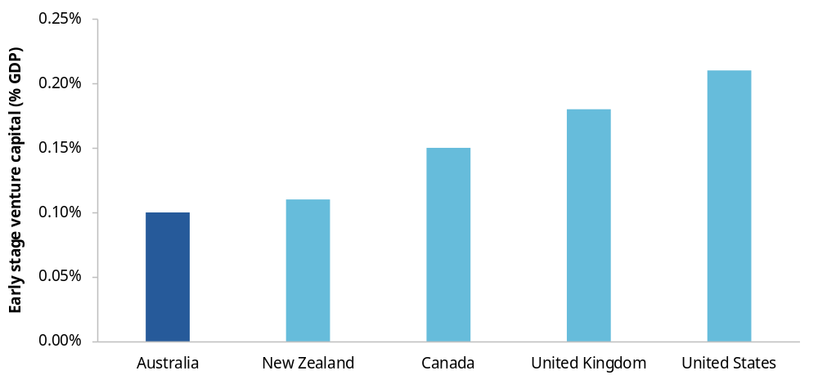
Source: Australian Government (2026a, p. 70).

Australian Government support for venture capital programs creates avoidable barriers and distortions
To support Australia’s venture capital market, the Australian Government provides tax concessions to investors, start-up founders and venture capital fund managers. Two key measures are:
- Early Stage Venture Capital Limited Partnerships (ESVCLPs) and Venture Capital Limited Partnerships (VCLPs), which offer tax concessions for investments made through registered vehicles
- the Early Stage Innovation Company (ESIC) regime, which provides tax concessions for investors making direct investments in eligible start-ups.
These measures were introduced to encourage investment in young, innovative and potentially high-growth businesses by providing favourable tax treatment to eligible local and foreign investors. Participants in this inquiry noted that the ESIC, ESVCLP and VCLP programs have increased the attractiveness of venture capital investments (Jo-Ann Suchard, sub. 89, p. 2, 13; SERDIP, sub. 32, p. 6; TCA, sub. 66, p. 3). Consistent with this, venture capital committed through these programs grew from just over $5 billion in 2011–12 to over $30 billion in 2024–25 (DISR 2026, p. 3) (figure 2.2).
The PC has looked at how existing programs can be improved to reduce distortions in financing decisions. This work complements the Ambitious Australia: strategic examination of research and development final report, which recommended changes to the Australian Government’s venture capital policies, with an objective to grow Australia’s science and innovation capability (Australian Government 2026a, pp. 75–85). We are also seeking views on whether more significant changes to government venture capital interventions are needed.
Figure 2.2 – Net committed capital has been increasing within the VCLP and ESVCLP programs
Net committed capital ($bn), 2011–12 to 2024–25
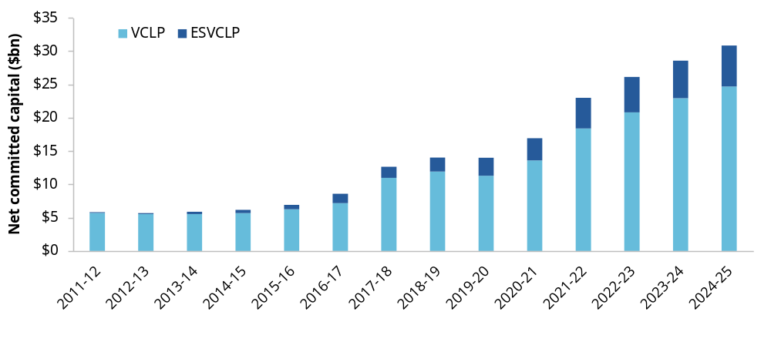Net committed capital is the total from active partnerships minus capital from those that exited in the year (DISR 2026, p. 2).
Source: DISR (2026, p. 2).

Venture capital limited partnership structures should be more flexible
To maintain access to the concessional tax treatment available under the ESVCLP or VCLP programs, registered venture capital funds must only invest in business that meet certain eligibility criteria. This limits the investments that an ESVCLP or VCLP can make. A fund may identify an attractive investment opportunity in a company that falls outside the eligibility criteria. Even if the fund is willing to forgo the associated tax concessions for that investment, it cannot make the investment through its ESVCLP or VCLP structure.
As a result, fund managers wishing to invest in both eligible and non-eligible start-ups must establish and administer a separate investment vehicle, alongside their ESVCLP or VCLP, in what is known as a ‘stapled structure’. We have heard that stapled structures face an additional compliance burden as there are bespoke legal requirements for each investment vehicle, and that these additional costs may distort investment decisions. Some funds, particularly smaller ones, may choose to avoid otherwise commercially attractive investments rather than incurring the cost of operating 2 investment vehicles.
The investment vehicle and the tax concession do not necessarily need to be linked. ESVCLPs and VCLPs should be able to invest in a wider range of business, while tax concessions should remain targeted to eligible start-ups. This would give fund managers greater flexibility to diversify their portfolios and continue to support investee businesses as their activities evolve. It would also reduce the administrative costs associated with maintaining multiple investment vehicles and avoid government rules unnecessarily influencing funds’ commercial investment choices.

The definition of ‘sophisticated investor’ should be broadened
The ESIC scheme encourages investment in innovative start-ups by providing tax concessions to ‘angel investors’, who are individual investors that provide their own capital directly to early-stage businesses, typically in exchange for an ownership stake. While the scheme is currently open to any angel investors investing in qualifying businesses, individuals who qualify as a ‘sophisticated investor’ can utilise the tax concessions to a greater extent (ATO 2024).
The sophisticated investor test is intended to distinguish investors who are capable of assessing investment risks and bearing potential losses from those who require stronger consumer protections (Treasury 2002). The existing test generally uses wealth or professional-investor status as proxies for an investor’s capacity to understand and bear the risks of investing in an early-stage business (Explanatory Memorandum, Tax Laws Amendment (Tax Incentives or Innovation) Bill 2016, p. 9).
However, we have heard that these tests may exclude people with substantial start-up or industry experience who are well placed to assess an investment but do not satisfy the financial thresholds (Jo-Ann Suchard, sub. 89, pp. 5–7). Allowing relevant experience to provide an alternative pathway to sophisticated investor status could expand the pool of informed angel investors without extending the higher concession limits to inexperienced investors. It may also increase the pool of potential limited partners for ESVCLPs and VCLPs, improving access to patient capital for early-stage businesses.

Tax concessions should be updated to reflect modern angel investment preferences
Simple Agreements for Future Equity (SAFE) notes are an increasingly common way for investors to provide funds for early-stage businesses. They allow funding to be provided without requiring founders and investors to immediately agree on the value of the business. A 2023 founder survey found that 44% of start-ups have a SAFE note on issue, up from 8% in 2018 (Cut Through Venture and Folklore Ventures 2024, p. 35).
Investors holding a SAFE note are eligible for tax concessions under the ESIC regime. However, eligibility is assessed when a SAFE note converts into shares rather than when the investment is made. Our inquiry heard that a start-up may qualify for tax concessions when an investment is made but no longer qualify when the SAFE note converts into shares (Jo-Ann Suchard, sub. 89, p. 10), as the value of the start-up may increase and exceed the maximum value under the ESIC eligibility criteria. This creates uncertainty and may discourage investors from using SAFE notes or from investing at all, reducing the pool of funds available for start-ups.
Assessing eligibility when the investment is made would better align the tax treatment with the timing of the investor’s funding decision, while still preserving the scheme’s intent of promoting funding for start-ups.

Reform direction 2.2
Grow the pool of funding available to start-ups by reducing investment impediments in government venture capital programs
To increase the availability of venture funding for start-ups, the Australian Government should reduce distortions caused by current program design features. The government should:
- allow ESVCLPs and VCLPs to make non-tax-advantaged investments that fall outside the eligible investment criteria under subdivision 118-F of the Income Tax Assessment Act 1997 to reduce reliance on administratively complex fund structures
- broaden the ‘sophisticated investor’ test by allowing relevant industry or start-up experience to qualify investors who do not meet the existing wealth thresholds
- recognise Simple Agreements for Future Equity notes at the time the investment is made, rather than when the notes convert into shares.

Broader changes may be needed to reach viable start-ups that are underserved by existing programs
A well-functioning venture capital market should identify and fund commercially viable opportunities regardless of founder characteristics, industry or business model. However, participants in this inquiry shared that some commercially viable start-ups may struggle to access venture capital because it may be difficult for fund managers to assess opportunities outside their existing networks or areas of expertise (AIIW, sub. 79, p. 16; Jo-Ann Suchard, sub. 89, p. 20). We also heard that start-ups requiring smaller investments may be overlooked as established funds seek investments large enough to justify their due diligence and management costs (Wu 2025).
Women-led businesses were also identified by inquiry participants as an underserved segment of the venture capital market. Australians Investing in Women’s (AIIW’s) submission included a case study that highlighted the difficulties that women-led businesses can face in accessing funds (box 2.4). In 2025, start-up teams with at least one woman founder received 24% of capital and all-women founding teams received only 2% of capital (Cut Through Venture and Folklore Ventures 2026, p. 60). Only 18% of female founders felt supported by their investors and 27% felt supported by the wider start-up ecosystem, compared with 76% and 62% of males respectively (Cut Through Venture and Folklore Ventures 2026, p. 109).
International research finds that the way investors identify and assess opportunities contributes to the relatively small amount of capital that ultimately reaches all-women teams (Brooks et al. 2014, p. 4429; Ewens and Townsend 2020, p. 676; Kanze et al. 2018, p. 604). Brooks et al. (2014, p. 4429) found that investors tend to ask different questions of women-led start-ups and tend to prefer pitches delivered by men, even when the underlying business proposition is identical. Australian research has shown repeated experiences of women being treated as outsiders, and expectations of bias that deter some women from pursuing venture capital (Polshinskaya et al. 2026, p. 627). We have also heard that using a diverse panel with a range of industry and founder experience to screen start-ups may support investment in women-led start-ups. For example, at Sydney Angels, which has a diverse screening panel, female founders were significantly more likely than all-male teams to secure investment (Jo-Ann Suchard, sub. 89, p. 19).

Box 2.4 – Case study: Planet Protector
Australians Investing in Women (sub. 79, pp. 56–59) highlighted the case of Planet Protector, a Victorian circular economy manufacturer. The business developed patented products that convert waste fibres such as wool, hemp and recycled textiles into sustainable packaging and building insulation.
Despite having established customers and demonstrated demand for its technology, the founder faced significant challenges securing the capital needed to expand. She spent around 15 months raising growth capital and ultimately secured approximately $12 million through a combination of private and public funding. She described the capital raising journey as:
… a lengthy and demanding process. We spent approximately 15 months completing our Series A raise, during which the company navigated difficult market conditions and challenges commonly experienced by women founders seeking growth capital.
The submission argued she had to access equity capital at far from reasonable returns and had to accept investment from investors who could not support her company’s growth. She needed greater revenue to secure sufficient funding from investors or government, but could not increase her revenue without that funding. She noted her experience reflects broader challenges faced by women founders and growth-stage businesses. While she managed to raise funds in the end, she said her success ‘has come at a significant price and a great personal toll’.
Source: Australians Investing in Women (sub. 79, pp. 56–59).

Further evidence is needed on how to address gaps in venture capital access
Addressing these financing gaps could support innovation and business growth by enabling a wider range of start-ups to secure funding. It could also improve equity within the venture capital ecosystem by expanding funding opportunities for founders and industries that are currently underrepresented among venture-backed firms.
Inquiry participants have proposed several ways to support a more diverse range of funds and fund managers, including lowering the minimum fund size for registered venture capital partnerships, contributing to the establishment costs of emerging funds and using a privately managed fund of funds to invest in venture capital funds targeting underserved markets. Our preliminary view is that these proposals have support in the literature (EIB 2026, pp. 4, 8; Ipsos MORI and Barrett 2021, pp. 4–5; ISED 2025; Wu 2025), but the PC is still considering whether they can be tailored to effectively meet Australia’s needs and challenges.
There is also a risk that government support could subsidise investments that are not commercially viable or would have been financed anyway. The PC is therefore seeking further information on the characteristics of underserved markets, the barriers to accessing venture capital within those markets and the relative merits of alternative approaches to addressing those barriers.

Information request 2.2
How can access to venture capital be improved for start-ups in underserved markets?
The PC is seeking further evidence on the extent to which commercially viable start-ups in some markets are underserved by existing venture capital providers and, if so, what policy responses would be most effective in addressing those gaps.
- To what extent do gaps in fund manager expertise, networks or track records, or the scale and investment strategies of established funds contribute to persistently underserved market segments?
- What changes to existing government venture capital programs would most effectively address demonstrated gaps while generating investment or economic activity that would not otherwise occur?
- To what extent could any additional support be funded by redirecting existing assistance, and how could this be done while minimising fiscal costs, displacement of private investment and other distortions?

Superannuation as a source of venture capital investment
Several participants in this inquiry argued that removing barriers to superannuation funds investing in venture capital could help address funding gaps faced by Australian start-ups and growing firms.
As of June 2026, just 5.7% of Australian superannuation fund assets were invested in unlisted equity (of which venture capital is a subset), with only 1.45% invested in Australian unlisted equity (APRA 2026). International comparisons suggest there may be scope for greater participation, with the Ambitious Australia report finding that Canadian pension funds allocate a larger share of their portfolios to venture capital than Australian superannuation funds (Australian Government 2026a, pp. 69–70).
Inquiry participants suggested that 2 regulatory settings – Regulatory Guide 97 (RG 97) and the Your Future, Your Super (YFYS) performance test – disincentivise superannuation funds from investing in venture capital. However, RG 97 and the YFYS performance test serve important consumer protection objectives which align with the advice provided in the PC's 2018 superannuation inquiry (PC 2018).
ASIC and the Treasury are currently reviewing RG 97 (ASIC 2026c) and YFYS, respectively, with the Treasury having released a consultation paper with options to improve the performance test (Treasury 2026d). The PC will continue to monitor these reviews and the implications of RG 97 and YFYS for venture capital.

Policies and programs to improve management capability

Key points
Better management can lift productivity and business dynamism.
Management capability affects how effectively businesses organise people and capital, make decisions, adopt technology and respond to change.
Stronger management capability can help productive businesses grow, seize new opportunities and adapt, restructure or exit activities that are no longer the most profitable use of resources.
Government should shape the conditions for firms to invest in management capability and target support where information barriers prevent firms making worthwhile improvements.
Competition, access to skills and the regulatory burden affect businesses’ incentives and capacity to improve their management capability.
Some businesses underinvest in management capability because the benefits may be unclear or uncertain and the business does not receive all the rewards from that investment.
This chapter focuses on government's role in improving management capability by addressing specific information barriers and ensuring current government support programs are effective.
Australia lacks good evidence on management capability and on what forms of support actually work, so government should start by focusing on building evidence and evaluation.
A more systematic approach would help governments at all levels establish effective programs to support firms in developing their management capability.
The approach should be informed by better evidence, which is needed to target effective government support and identify barriers to that support.
Evaluations should identify which programs are effective, allowing governments to scale those programs and redesign, consolidate or discontinue others.
Where program effectiveness is uncertain, governments should trial new interventions.
Business-facing government agencies and regulators should use existing interactions to connect businesses with help.
Interactions such as registering a business or taking on a director role provide opportunities for governments to offer management-related information and referrals to businesses.
Governments should test whether prompts and referrals through these existing interactions improve business outcomes without adding unnecessary burden.

Better business management would boost productivity
Firms with broadly similar resources can perform very differently. Some firms produce more, provide higher-quality outputs or adapt more readily to change. An important reason for these differences is the way businesses are managed.
Management capability is a firm’s ability to organise resources, make decisions and adapt as circumstances change. It includes the systems and processes through which work is organised (Bloom and Van Reenen 2007, pp. 1355, 1361), the way managers set strategy and allocate resources (Teece et al. 1997, p. 515), and the ability to identify and implement new technologies and ways of working (Cohen and Levinthal 1990, pp. 128, 134–135).
Management capability is not held solely by individual managers. It is also embedded in a firm’s governance, information systems, routines, workforce and culture (Leonard-Barton 1992, pp. 113–114; Teece 2007, p. 1323). A capable manager may have little effect if decision-making arrangements, staff capabilities or technology prevent the firm from acting. Conversely, effective routines and teams can retain capability even when individuals leave.
Better management practices are associated with better business outcomes. Firms with stronger management practices tend to be more productive, profitable, innovative and likely to survive (Bloom et al. 2019; Bloom and Van Reenen 2007). Better management can also help firms identify, adopt and make effective use of new technologies (Bick et al. 2026, p. 3; Giorcelli 2026, p. 190).
Better managed firms are also more likely to grow and acquire unproductive established firms (Bai et al. 2021; Bloom et al. 2019; Sadun et al. 2025). This supports business dynamism and productivity growth across the economy by shifting workers and capital towards firms that can use them more effectively.
Recent analysis suggests that differences in management capability account for a meaningful part of the productivity gap between Australia and the United States. Lifting Australian management capability towards US levels could deliver substantial productivity gains (figure 3.1).
Figure 3.1 – Improving management capability to US levels could raise Australian productivity by 9.8%
Estimated productivity improvement from reaching US levels of management capability, by country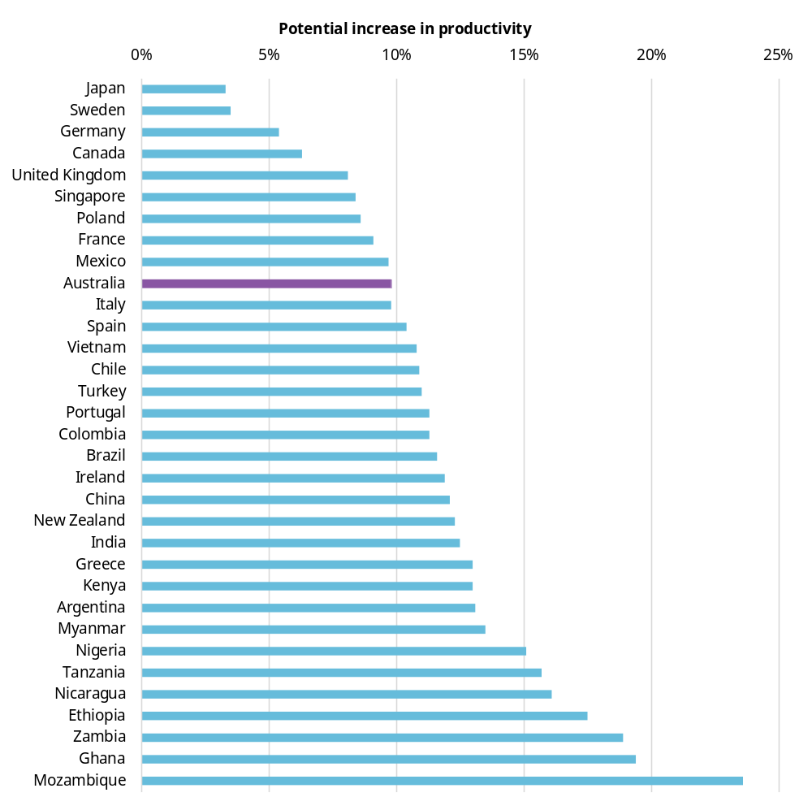
This counterfactual changes the distribution of management practices across the economy and depends on assumptions about how management interacts with other firm characteristics. It should therefore be interpreted as an indication that management can be macroeconomically important, not as an estimate of the gains from a particular policy intervention. The data is drawn from manufacturing firms. Sampling methods vary slightly across countries.
Source: Sadun et al. (2025, fig. 8).
Management capability varies across Australian firms, with scope for improvement
Available evidence points to two related areas in which some Australian firms may have scope to strengthen their management capability: their use of management systems and practices as firms grow, and their ability to translate opportunities into organisational change. Neither provides a complete measure of management capability, and much of the Australian evidence is dated.
Firstly, the use of formal management practices varies substantially across Australian firms, particularly by business size. ABS data from a 2015–16 survey, for example, showed that only 33% of firms with
0–4 employees reported monitoring at least one key performance indicator, compared with 90% of firms with 200+ employees (ABS 2017). The survey results also suggested that many businesses could strengthen their strategic management practices. Only 10.3% of respondents had a written strategic plan (ABS 2017).
Small business owners can face particular constraints in developing and using management capability. SMEs (small and medium enterprises) have been found to have lower strategic management capability (Moran et al. 2018, p. 1). As QSBC noted, small business owners often spend more time working ‘in’ the business than ‘on’ the business, limiting opportunities for strategic planning and business development (sub. 85, p. 5). However, it is important to note that small firms will generally not need the same formal management systems as larger employers. Some observed variation will therefore reflect legitimate differences in firms’ size, complexity, circumstances and objectives.
Secondly, while Australian firms are good at identifying opportunities to improve their production processes, they are not as good at implementing change (Wilson et al. 2023, p. 10). This is important, because for an estimated 98% of Australian businesses, productivity improvements are more likely to come from adopting and adapting established technologies and practices (PC 2023b). We can see this in patterns of AI (artificial intelligence) adoption in Australian businesses, which appear to have lower rates of AI use than businesses in several comparable economies (figure 3.2). Evidence from the UK found that firms with stronger management practices were more likely to follow through on plans to adopt AI (ONS 2025).
Figure 3.2 – Australian businesses lag in adopting artificial intelligence
Share of businesses using at least one AI technology, selected countries, December 2025 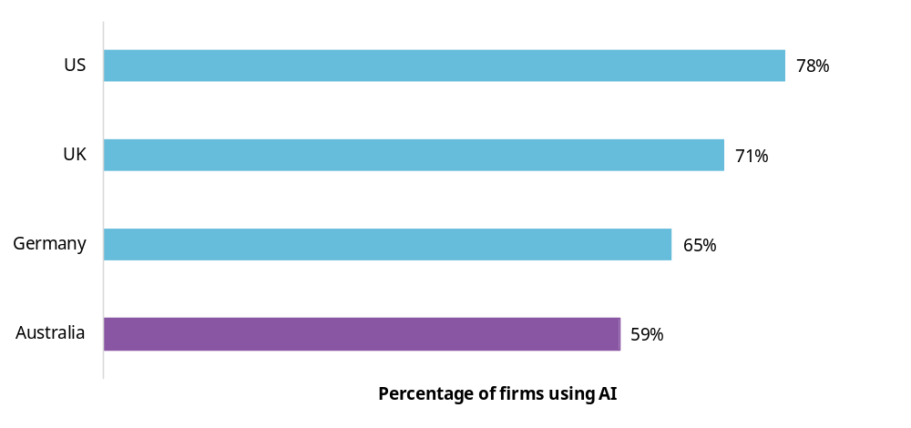
Representative survey of executives.
Source: Yotzov et al. (2026, p. 10).

Government can foster better management capability
Responsibility for improving management capability mainly falls on business. Businesses capture much of the benefit through higher productivity, profitability, innovation, growth or survival, which generally gives them a strong incentive to make improvements. There are also many private sources of support that businesses can draw on, including accountants, consultants, mentors, industry advisers and education providers. However, well-designed government policy can help.

Government shapes the conditions in which businesses improve
Government policy affects businesses’ incentives and ability to improve their management capability.
Competition and exposure to international markets can increase the consequences of poor performance and strengthen incentives to adopt better practices. Education and migration settings affect the supply of management skills. Labour mobility can spread management knowledge and experience between firms. But these lie outside the focus of our inquiry, as discussed in the Overview.
Regulation also has a direct connection to management capability because it can absorb scarce management time and attention (box 3.1). Chapter 1 offers policy advice to government to reduce the regulatory burden on businesses.

Box 3.1 – How regulatory settings influence management capability
Inquiry participants identified that managers, particularly of SMEs, are time poor.ª Time spent on managing the cumulative regulatory burden leaves less time for managers to improve operations, develop workers, adopt technology and pursue new opportunities.^{b} Regulation can therefore impose an opportunity cost by diverting managers’ attention from productive activity.
Owner-operated, small and micro businesses, which comprise the majority of Australian businesses, typically lack dedicated administrative capacity, requiring business owners to absorb compliance responsibilities themselves. This diverts time and resources away from revenue generation, innovation and business development. (WIB, sub. 81, p. 3)
Beyond directly taking up managers’ time, regulation can also shape what business leaders focus on. Risk management is an important part of management capability, but regulatory settings that place excessive weight on avoiding liability can encourage a more risk-averse culture, drawing attention and effort away from strategy, innovation and organisational improvement.^{c}
Inconsistent and overly draconian liability and enforcement signals are contributing to risk aversion at board level detracting from time spent on strategy, entrepreneurship and organisational performance. (GIA, sub. 51, pp. 1–2)
a. QSBC (sub. 85, p. 6); SBDC WA (sub. 52, p. 1). b. ACCI (sub. 42, p. 8); AICD (sub. 41, p. 2); CEDA (sub. 9, attachment D, pp. 11, 35); GIA (sub. 51, p. 3); MFAA (sub. 34, p. 3). c. AICD (sub. 41, pp. 6–7); CEDA (sub. 9, attachment D, p. 35); QSBC (sub. 85, pp. 5–6); SERDIP (sub. 32, p. 4).

Government should address barriers that lead to underinvestment in management capability
Government has a role in supporting improvements in management capability as some of the benefits of better management extend beyond the business making the investment. Good management practices can spread when employees change jobs or when firms learn from leading firms. Better-managed firms can also strengthen competitive pressure and contribute to the reallocation of resources towards more productive businesses. Because individual businesses do not capture all of these benefits, investment in management capability can be lower than would be desirable for the economy as a whole.
Additionally, worthwhile improvements may not occur when businesses lack the information to make good decisions. Managers may not recognise weaknesses in their own practices, may underestimate the benefits of improving, or may find it difficult to assess what needs to change and how to change it.
This chapter focuses on what governments can do to directly increase firms’ investment in their management capability, particularly:
- addressing specific information barriers about management capability for firms
- ensuring current government advice and support in management capability is effective.
There may also be a role for government in helping people understand their obligations in management or director roles before accepting them and protecting people from taking on management roles they are not ready for.

Build a targeted approach to management-capability support
The Australian Government, along with state, territory and local governments, currently funds many forms of business advice, training and assistance and collects some data about management capability. However, support for management capability remains fragmented across programs, delivery models and jurisdictions. Programs have not always been designed around clearly identified barriers to capability uplift or assessed using consistent outcome measures. As a result, some barriers may receive disproportionate attention while others are overlooked, businesses may struggle to identify the support best suited to their needs and public resources may be directed towards programs that do not deliver meaningful improvements in management capability.
A more systematic approach would help ensure government support is directed towards the most significant barriers and the most effective interventions. This would:
- provide governments and businesses with a clearer understanding of the barriers to management improvement, the role of programs in addressing those barriers, and evidence on interventions that work and which firms benefit from different interventions
- help businesses identify the intervention that would suit them best, by mapping programs to business needs and by reducing duplication across governments
- support decisions within government to consolidate, redesign or discontinue programs that do not demonstrate results, and direct resources towards interventions that address demonstrated barriers
- help the design and implementation of new programs by ensuring they focus on what businesses need most and improve coordination to reduce duplication across and between jurisdictions.

Different barriers require different responses …
Government support is more likely to be effective when it is matched to the firms affected and the stage of the capability building process at which they are getting stuck.
Issues can have different foundations. A business may not recognise a weakness in its resources or processes, may underestimate the benefits of improving, may struggle to find credible advice or training, or have difficulty implementing and sustaining change.
These barriers will not affect all firms equally. Businesses with limited management experience, for example, may find it harder to overcome the barriers than others.
Australia’s education system equips people for professional or vocational careers but does not embed the fundamental skills needed to run a small business. This means many small business owners ― including those ‘accidental entrepreneurs’ who start a business based on a skill, idea, passion or opportunity ― are not equipped to manage the practical realities of running a business … Without the fundamental skills and access to targeted, practical support, they can quickly become overwhelmed and prematurely exit a potentially viable business. (ASBFEO, sub. 68, p. 6)
International evidence suggests that the appropriate response depends on where businesses are getting stuck. Benchmarking information can prompt firms to seek advice, training can build particular management skills and more hands-on assistance can help firms implement changes (box 3.2).
Australia has a number of programs designed to help businesses improve their management capability (discussed further below), but it is unclear how well these programs align with the barriers businesses face.
Box 3.2 – Targeted support can address different information gaps in the management capability building process
Randomised controlled trials show that management support can change business behaviour and improve business outcomes, but the type of assistance matters.
Recognising a gap (Brazil): Small firms were provided with information comparing their management practices with other firms and identifying practices they could improve. The information increased use of business advice services by about 7 percentage points in the first 6 months, from 21% in the control group. But the effect disappeared over time (Bruhn and Piza 2022). This suggests that benchmarking can help make weaknesses more salient and prompt businesses to seek advice earlier, but information alone may not be sufficient to produce sustained change.
Understanding the value of change (India): Large textile firms lacked awareness of some management practices or doubted their value. Hands-on implementation support, rather than diagnosis and recommendations alone, increased productivity by 17% in the first year, with some effects persisting over time (Bloom et al. 2013, 2020). This suggests firms may undervalue a profitable management change because they lack information about its returns and may still need practical support to implement those changes once identified.
Developing relevant skills (South Africa): Among small businesses around Cape Town, marketing training increased profits through higher sales, while financial management training improved efficiency (Anderson et al. 2018). Benefits varied with owners’ experience and how established their businesses were, illustrating the importance of matching training content to the firms’ needs.
Putting information into practice (Indonesia): A handbook explaining successful local business practices did not, on its own, improve small retailers’ performance. Adding two 30-minute visits from a trained facilitator increased profits by 35% and sales by 17%, showing that practical assistance can help owners act on information (Dalton et al. 2021).

… but better evidence is needed to decide where and how government should intervene

Australia needs better evidence on where barriers to improvement are most significant
Australia lacks the evidence needed to determine where capability gaps and barriers to improvement are most significant. The last dedicated ABS collection on management and organisational capabilities was undertaken in 2015–16. Other ABS surveys and linked administrative datasets contain information on skills, occupations, technology, innovation, employment and business outcomes, but they do not provide a complete picture of management capability nor of how organisational practices change within firms over time. The Productivity Commission is continuing to test whether a combination of Business Longitudinal Analysis Data Environment (BLADE) and other ABS datasets could provide a more comprehensive understanding of management capabilities in Australia.
By contrast, the United Kingdom, New Zealand and the United States have conducted repeated collections of management practice data (ONS 2024b; Stats NZ 2024; US Census Bureau 2023). This data can be linked to longitudinal survey data and administrative information on firm outcomes, allowing researchers and policymakers to track how management practices evolve (Sanderson 2022), and better understand their relationship with productivity and business performance (Bloom et al. 2019; Fabling and Grimes 2007; ONS 2024a). An enduring Australian data asset could combine a stable core of questions with rotating questions on emerging capabilities, such as AI adoption. Survey responses could be linked with tax and other administrative data through BLADE to examine business outcomes. Establishing and maintaining this data asset would require sustained Australian Government funding for its design and ongoing data collection.
This would help governments identify differences in management capability that reflect information barriers to improvement. It would also help governments to track how capability changes over time and understand which management characteristics are associated with better outcomes.
Any new data collected should be made available through the ABS’s data-sharing infrastructure, allowing businesses to benchmark their performance against comparable businesses without revealing identifying details about others.

There is minimal evidence about which Australian government programs work
Governments currently fund a range of programs intended to improve management capability, but the publicly available evidence on whether they improve capability and business performance is limited. A 2021 study examined a sample of 58 representative Australian and state government business advisory programs, but only 4 formal evaluations are publicly available (Agarwal et al. 2021, p. 4). Two evaluations focused primarily on participation rates or participant perceptions, rather than on whether the programs improved management capability or business performance.
Without stronger evaluation, governments cannot tell whether programs are addressing genuine barriers for firms, subsidising investments firms would have made anyway, duplicating existing services or producing persistent benefits. Nor can they readily identify which approaches work best for different types of firms or whether the benefits justify the cost.
International experience shows the importance of strong evaluations. They can help governments identify which management capability interventions improve business outcomes, which have only short-term or limited effects and where program design may need to change to maximise the net benefits of the program (box 3.3).
Australia needs a similar evidence base. Evaluations should be proportionate to the interventions – more costly interventions should be subject to more rigorous evaluation and governments should provide adequate funding to support these evaluations. Evaluation findings should be published to support transparency, accountability and learning across governments. Quantitative evidence should be used where feasible, for example, by linking program participants to administrative datasets. And qualitative evidence could be used to support quantitative evidence to help explain why an intervention worked, failed or was difficult to implement. Evaluation should draw on the Australian Centre for Evaluation’s 2026–2030 action plan, which provides a whole-of-government framework for strengthening evaluation planning, quality, publication and use (Treasury 2026c).

Box 3.3 – Evaluations help governments identify what management support works
Evaluations of government-funded management and business support programs show that outcomes can vary substantially across programs and over time.
Regional Business Partners (New Zealand): Regional advisers helped SMEs diagnose their needs and access training. A 2015 evaluation found moderate reported improvements in management capability particularly among firms using training vouchers, but its survey-based design did not establish causal effects on productivity or growth (NZ MBIE 2015).
Growth Vouchers (United Kingdom): Small businesses were offered diagnostics, an adviser directory and, for randomly selected firms, vouchers subsidising private advice. An evaluation found that firms using a voucher had 8.2% higher turnover after 12 months, but the effect was no longer statistically significant after 24 months and there was no significant employment effect (Nunez Chaim et al. 2024).
Help to Grow: Management (United Kingdom): The program combined management training, mentoring, peer learning and a growth plan. A 2026 evaluation found improved management practices and higher business survival, but no statistically significant effects on business growth or productivity within the period observed (Department for Business & Trade 2026, p. 5).
Manufacturing Extension Partnership (United States): Federally supported centres provided small and medium-sized manufacturers with technical and business assistance. An evaluation linking program records to US Census data found positive effects on productivity and sales per worker, with particularly consistent productivity gains among establishments with 1–19 employees (Jarmin 1996; Lipscomb et al. 2015).
BDC Advisory Services (Canada): Advisory support covered strategy, financial management, staffing and operations. A 2025 matched-business evaluation found higher employment growth and survival among supported firms, but no statistically significant differences in revenue or productivity growth (Business Development Bank of Canada 2025, p. 11).
Any new interventions should be targeted at demonstrated barriers, with the scale and design of support proportionate to the problem being addressed. Consultation with relevant business, industry and professional bodies – particularly those focused on the needs of SMEs – can help inform the design of appropriate responses.
Where governments identify a barrier but do not know which intervention will address it most effectively, they should test promising approaches before committing to broader rollout. Small-scale pilots can be used to test program design, delivery and take-up, with evaluation built in from the outset. Successful approaches can then be scaled, while ineffective ones can be redesigned or discontinued.
An ideal candidate to trial this approach would be the PC’s 2025 proposal for piloting co-funded training vouchers for SMEs, supported by diagnostic consultations and advisory services. The advice could help firms diagnose skills gaps, identify suitable training and develop a training plan, while the voucher would reduce the upfront cost of participation (PC 2025a, p. 71).
The objective for government should be to build a more coherent and evidence-based suite of management capability support programs, particularly for SMEs that have fewer resources of their own to direct towards these activities. This should be underpinned by a system that can identify where intervention is warranted, inform the design of best-practice interventions to improve management capability, direct businesses towards the least-cost response and learn systematically from what works.

Reform direction 3.1
Develop a systematic approach to management capability policy
The Australian Government should develop a systematic approach to business support programs that target improved management capability. The objective should be to direct government support at the most significant barriers to capability building and fund cost-effective interventions to address them. Small and medium enterprises should be a particular focus.
The approach should:
- build better evidence on management capability and the barriers to improvement, including by funding the ABS and other relevant agencies to improve data collection and, where feasible, data linkages
- ensure agencies target new interventions to demonstrated barriers, with support measures proportionate to the problem being addressed and informed by consultation with relevant business, industry and professional bodies
- require agencies to rigorously evaluate all interventions, using methods appropriate to the scale and nature of the intervention, provide adequate funding for those evaluations and publish the findings
- require agencies to pilot new interventions where effectiveness is uncertain and to scale up those that demonstrate they improve business management capability cost-effectively, while redesigning or discontinuing those that do not.
An initial candidate to test this approach would be the PC’s 2025 proposal for co-funded training vouchers for small and medium enterprises, supported by diagnostic consultations and advisory services.

Make it easier for businesses to find the right help at the right time
While government can get started on a systematic approach right away, it will take time before businesses start to access evidence-based support and see results. In the short term, governments can improve the way existing information and services are used by firms by improving how they interact with businesses.

Businesses can struggle to navigate existing support
While appropriate assistance exists, we have heard that businesses can find it difficult to work out where to find it. Government programs are organised around institutions, portfolios and jurisdictions, while businesses think in terms of practical problems that need solving, making it hard to find the right information in a timely manner. This can impose search and transaction costs, particularly for SMEs whose owners may already be managing operations, finance, employees, compliance and strategy.
Research by the Australian Securities and Investments Commission (ASIC), for example, found that, despite the broad range of information provided, 1 in 5 surveyed small business directors had never accessed information or advice about their obligations (ASIC 2026b). Common reported barriers included limited time, the volume of regulation, the cost of professional advice and having to consult multiple information sources. Accountants were the most used source among directors who had sought information.
A business that recognises a problem may therefore need to determine whether the appropriate support sits with an industry body, a professional adviser or a program offered by the Australian Government or a state, territory or local government. Government does not need to provide all assistance itself, but it can make existing sources of expertise easier to find and connect with, including by making regulation more machine readable to improve accessibility for regtech solutions (chapter 1).

Governments should meet businesses at existing touchpoints
Governments already interact with businesses at many points in their lifecycle. This includes when they register, seek licences or approvals, become employers, interact with tax and payroll systems, access government programs or encounter financial difficulty. These interactions are opportunities to provide relevant information or connect businesses with assistance at a point when it might be most useful.
Better support therefore does not necessarily mean more information or more programs. It may mean using existing touchpoints more effectively to make it easier for businesses to move from recognising a problem to finding the right support.
Government should test whether natural business lifecycle events can be used to provide timely information, basic diagnosis or referral. This does not mean turning every interaction with a regulator into an advisory intervention. Poorly targeted prompts could simply create more information and compliance burden. The objective is to identify the points at which information is most likely to be relevant and acted on, using existing information wherever possible. For example, the point at which a person obtains a director ID or consents to becoming a director provides a convenient opportunity to make them aware of key director obligations (box 3.4).
Some agencies are already using, or considering how to use, these touchpoints to provide more timely information. The Australian Taxation Office (ATO) has sent welcome emails to new businesses to help them understand their tax obligations (ATO 2026b). ASIC has recently launched its Small Business Director Essentials Hub and has committed to providing guidance at key points in the business journey (ASIC 2026a, 2026d). Depending on the success of these trials, such schemes could be rolled out more broadly across government.
Prompts could be delivered through an agency portal, email, business software or another channel already used by the firm. Digital tools, including AI, could help users locate relevant guidance or work through an initial diagnostic.
Subject to consent and appropriate data protections, software may also be able to identify events or patterns that trigger timely prompts, guidance or referrals.

Box 3.4 – How prompts from government can help provide information to businesses when they need it
The appointment of a company director provides one potential example of how the use of prompts and behavioural nudges could provide information to a director when it is most useful.
Directors take on significant legal and financial responsibilities, and government already provides extensive guidance on those obligations.
An intending director must obtain a director ID before appointment. The point at which this happens provides a natural opportunity to make the most important responsibilities salient and direct new directors towards more detailed guidance and assistance about how they will ensure they meet these responsibilities.
This example of providing information to directors at the time they become directors is a specific application of the broader principle that government should meet businesses where they are at by using existing touchpoints.
The same principle could apply more broadly, for example, to small business financial distress. Existing government interactions may provide opportunities to make warning signs more salient and connect businesses with appropriate advice before financial difficulties become more severe (discussed in chapter 8).

Reform direction 3.2
Make it easier for SMEs to recognise when they need help and find the right support
Governments should make greater use of business lifecycle events and interactions to help small and medium enterprises recognise emerging problems and connect with appropriate support. Approaches should:
- use existing information and interactions wherever possible, including through use of AI tools and business software
- rely on behavioural nudges and technology-enabled tools, such as timely prompts, referrals and in-software notifications, to guide businesses to relevant information while minimising additional burden
- avoid unnecessary reporting requirements
- be tested to determine whether they improve business outcomes.
As a first step, the Australian Government should build on existing work by the Australian Taxation Office and the Australian Securities and Investments Commission in trialling timely prompts, referrals and the provision of information at key business touchpoints, including through existing digital channels. They should evaluate whether these initiatives improve awareness of obligations and uptake of relevant support services. Pending the success of these initiatives, such techniques could be rolled out across other business-facing government agencies and regulators.

Information request 3.1
How can support reach businesses at the right time?
The PC is seeking views, including from small business organisations, accountants and other trusted advisers and business-facing government agencies and regulators on how businesses, particularly small and medium enterprises, could be better connected with support to strengthen their management capabilities and understanding of legal management responsibilities.
Timing: businesses regularly interact with government agencies. At what points in a business’s lifecycle, or during which interactions with government, are businesses most likely to benefit from information or support? For example, when becoming a director, employing staff, expanding operations or responding to emerging business risks.
Delivery: when, and what types of, government interactions are most likely to encourage businesses to act without adding to information or compliance burdens? This could include face-to-face interactions, agency portals, in-app or in-software prompts and other digital channels.
Technology: how can AI and other technology, such as chatbots, personalised prompts or information embedded in business software, help provide timely and relevant support at low cost?

Information alone may not protect people from coercion
Improvements in management capability are important for productivity improvements. However, they may also help protect vulnerable members of the community. Our inquiry heard about instances where people had been persuaded, pressured or coerced into taking on positions within a business that they were not ready for or did not fully understand or consent to. Specifically, submissions identified that, in cases of financial abuse, a person may be recorded as a director, guarantor or business owner while having little knowledge of, control over, or benefit from the business. People subjected to coercion or financial abuse can be left with significant liabilities. This can expose the person to tax and insolvency consequences and make it difficult to leave the business safely.
Participants to this inquiry highlighted the importance of designing systems that can respond appropriately where participation in a business role is not genuinely voluntary. For example, UNSW TBAC explained that:
Systems that make business participation easier must also be capable of identifying when that participation was coerced, fraudulent or controlled by another person. (UNSW tax advisory clinic, sub. 40, p. 7)
Improving the dissemination of information can, to some extent, alleviate this risk as people will better understand the responsibilities and risks associated with business roles. However, information alone may be insufficient to protect people from being pressured or coerced, and we are considering further ways government can better protect people from taking on business roles without their informed consent.

Information request 3.2
How can government better protect people from being persuaded, pressured or coerced into business roles?
The PC is seeking input into steps that could be taken by the Australian Government to prevent people from being pressured or coerced into taking on business responsibilities.
In particular, what can the Australian Government do to ensure people taking on new roles do so with informed consent and a clear understanding of their legal obligations and the risks involved?

Support business transitions

Key points
Business dynamism depends on businesses being able to adapt, change owners and exit.
These transitions help businesses respond to changing circumstances and allow workers and capital to move to more productive uses.
Delays in obtaining consent to transfer a commercial lease may prevent the sale of an otherwise viable business.
Statutory protections apply when retail leases are transferred as part of a business sale, but the extent to which these protections apply to other commercial leases varies across jurisdictions.
The Productivity Commission is seeking evidence on the extent of the problem, and the potential for, and form of, any extensions of these protections to other commercial leases.
Some aspects of the pathways for closing solvent companies warrant further examination.
Questions have been raised about whether the asset threshold for voluntary deregistration remains appropriately calibrated and whether some requirements applying to members' voluntary liquidations create unnecessary costs, complexity or delays.
The PC is seeking evidence on the costs, benefits and risks of possible changes.

Business transitions support a dynamic economy
Business dynamism is not only about starting and growing businesses; it also depends on how easily businesses can adapt, change owners and exit.
Business transitions take many forms. Owners may sell their business, pass it on to family members, merge it with another business or change its structure as it grows and evolves. They may also choose to close a business and pursue other opportunities.
These transitions allow business owners to respond to changes in their personal circumstances or the operating environment, like changing demand patterns or competitive pressures. They also help workers and capital move to businesses and activities where they can be used more productively.
This chapter focuses on solvent businesses. The role of insolvency pathways in restructuring viable businesses and enabling the exit of non-viable firms is examined in chapter 6.

Participants raised few concerns about barriers
Participants in this inquiry identified some factors that can affect business transitions. However, relatively few submissions identified specific policy or regulatory barriers or provided evidence of their significance. Concerns were raised about licence transferability when businesses change ownership, but we did not find sufficient evidence at this stage of our inquiry to establish the scale of the problem or identify clear reform options.
We identified 2 issues for further examination – whether:
- delays in obtaining consent to reassign commercial leases may prevent the sale of otherwise viable businesses
- aspects of voluntary deregistration and members’ voluntary liquidation (MVL) are creating unnecessary delays when solvent companies cease trading.
We are seeking further information on the extent of these issues and whether changes to current arrangements may be warranted.

Potential issues in transferring businesses
Where a business operates from leased premises, the ability to transfer the lease to a new owner can be critical to a successful sale. Participants to this inquiry identified delays in obtaining consent to assign commercial leases as a potential barrier to business transfers (QSBC, sub. 85, p. 7; WA SBDC, sub. 90, p. 5) (box 4.1).

Box 4.1 – Delays in lease transfer approvals can derail business sales
The Queensland Small Business Commissioner noted a case involving the proposed sale of a hospitality business (sub. 85, p. 7). The hospitality business reported that delays by the landlord and property agent relating to the reassignment of its lease resulted in the sale collapsing, leaving the owner almost $6,000 out of pocket. The case provides an example of how delays and uncertainty in lease transfer processes can create difficulties for businesses seeking to change ownership.
All states and territories provide statutory protections when retail leases are transferred as part of a business sale. While the details vary, these laws restrict the grounds on which landlords may refuse consent and prescribe timeframes for responding to requests to transfer a lease. In most jurisdictions, consent is taken to have been given if the landlord does not respond within the prescribed period. These protections facilitate the transfer of leases as part of a business sale while preserving landlords’ ability to refuse consent on specified or reasonable grounds.
However, the reach of these statutory protections for transferring leases varies across jurisdictions. In some jurisdictions, they are confined largely to leases covered by retail leasing legislation, leaving many warehouses, industrial premises and offices outside the relevant regime. Queensland’s general property legislation applies to leases generally, while the ACT regime also covers retail and specified non-retail premises, including small commercial premises.
The available evidence does not establish how frequently current arrangements for transferring leases delay or prevent otherwise viable business sales. Nor is it clear whether reported problems are concentrated in jurisdictions that do not have statutory protections governing the lease transfer process. We are seeking feedback on:
- the effectiveness of the protections operating in Queensland and the ACT in reducing delays without unduly restricting landlords’ ability to assess prospective tenants
- whether extending similar protections in other jurisdictions may be warranted, and what form any protections should take.

Information request 4.1
Should statutory protections be extended to a broader range of commercial leases?
The PC is seeking feedback on whether extending statutory protections to a broader range of commercial leases would reduce delays in business sales without imposing disproportionate costs or risks on landlords. In particular:
- How frequently do current arrangements for transferring commercial leases delay or prevent otherwise viable business sales?
- In jurisdictions where protections extend beyond leases covered by retail leasing legislation, have they reduced delays or improved business transfers?
- Should jurisdictions where protections remain largely confined to leases covered by retail leasing legislation extend them to a broader range of commercial leases?
- What grounds should landlords have for refusing consent, what response timeframes should apply and should consent be taken to have been given if a landlord does not respond?

Potential issues with solvent company exit pathways
Just as businesses need practical options to adapt and change hands, they also need practical options to exit. Where a company can meet its obligations in full, the process of winding it up should be proportionate to the risks involved and allow owners to exit without unnecessary cost or delay. This is just as important for a dynamic entrepreneurial ecosystem as facilitation of business entry. Efficient exit processes lower the costs associated with experimentation and help entrepreneurs redeploy their time, capital and capabilities into new ventures.
There are 2 main pathways for closing a solvent company. Most use voluntary deregistration, an administrative process available to companies with less than $1,000 in assets, no debts and no involvement in legal proceedings. Companies that do not meet those criteria must instead use an MVL process, under which shareholders appoint a liquidator to realise the company’s assets, pay creditors and distribute any remaining funds to shareholders. Around 99,000 companies applied for voluntary deregistration in 2024–25 (ASIC, pers. comm. 2 October 2026) and around 1,500 companies entered MVL in 2025–26 (ASIC 2026i).
Two areas warrant further examination: the asset threshold for voluntary deregistration and some procedural requirements for MVL.
The asset threshold has remained unchanged at $1,000 since 2001, meaning its real value has fallen substantially over time. Whether this threshold remains appropriately calibrated for the voluntary deregistration process warrants further examination.
The Australian Restructuring Insolvency and Turnaround Association (ARITA) identified several procedural requirements in MVL that it argued could be removed to make the process cheaper and more timely (2022b, pp. 59–60). It questioned the need for provisions that give creditors rights in a process where creditors are paid in full, arguing that they add unnecessary time and cost. ARITA also submitted that requiring liquidators to obtain ATO clearance before distributing surplus funds to shareholders can delay completion of the process. It also argued that ASIC industry funding levies create a competitive disadvantage for registered liquidators, because proprietary companies can appoint an unregistered person to conduct an MVL without attracting the levy.
The evidence provided to the PC is not sufficient to assess the magnitude of these issues or whether legislative change would generate material benefits. We are seeking further information on the extent of these issues and the costs, benefits and risks of change.

Information request 4.2
Could arrangements for closing solvent companies be improved?
The PC is seeking feedback on the costs, benefits and risks of the current arrangements for closing solvent companies.
- Does the $1,000 asset threshold remain an appropriate boundary for access to voluntary deregistration? If not, what threshold should apply, and what would be the costs, benefits and risks of changing it?
- To what extent do the following requirements increase the cost or duration of members’ voluntary liquidations, and what costs, benefits and risks would arise from removing them:
  - the requirement to obtain ATO clearance before surplus funds are distributed to shareholders
  - creditor rights in a process where creditors are required to be paid in full
  - ASIC industry funding levies for members’ voluntary liquidations undertaken by registered liquidators.

Create a clearer foundation for insolvency reform

Key points
The insolvency system influences restructuring, exit, investment and risk-taking decisions across the economy, all of which matter for business dynamism. A clear statement of purpose, objectives and principles is needed to guide reform and evaluation. A necessary first step is to embed these in legislation.
The purpose of the insolvency system should be to provide a process for dealing with the financial affairs of individuals and companies in financial distress.
In addition to reflecting the interests of debtors and creditors, the objectives of the system should explicitly incorporate broader economic considerations to promote the preservation and productive redeployment of economic value, facilitate timely intervention, support market and economic integrity, and enable rehabilitation (in the case of personal insolvency).
The principles of proportionality, efficiency and accessibility should underpin the design and operation of the system.
Australia’s insolvency system operates through separate personal and corporate frameworks. Some stakeholders expressed support for greater harmonisation of these frameworks and argued that current arrangements create duplication and complexity.
But there are good reasons for the two frameworks to remain separate.
Companies and individuals are fundamentally different. Corporate insolvency focuses on the restructuring or exit for businesses, while personal insolvency also serves important rehabilitative public policy objectives.
There can be conflicts of interest between a company’s insolvency estate and a director’s personal estate that will not be resolved through harmonisation of the frameworks.
Each year, a small number of individuals are affected by connected corporate and personal insolvencies. There may be scope for targeted reforms to improve the experience of these debtors. The Productivity Commission is seeking feedback on options for targeted reform to improve the efficiency of connected personal and corporate insolvency processes.
Insolvency settings impact dynamism by shaping how financially distressed businesses restructure, transfer or exit, which affects how readily workers and capital can move to more productive uses.
Many participants in this inquiry underscored the importance of the insolvency system as a mechanism for facilitating the ‘creative destruction’ that underpins long-term economic growth (NAB, sub. 62, p. 5; Ruhe Group, sub. 15, p. 2). For example, NLM Legal explained that:
Australia’s corporate and personal insolvency laws constitute critical legislative and economic infrastructure. They are not merely mechanisms for resolving financial distress or administering business failure; they are fundamental to the efficient operation of a dynamic market economy. (sub. 53, p. 1)
The insolvency system can also have effects on upstream decisions about business entry and expansion – as FinTech Australia explained, ‘the consequences of business failure can affect the willingness of founders and investors to take appropriate commercial risks’ (sub. 24, p. 17).
Australia’s insolvency system is made up of two distinct frameworks:
- the corporate insolvency framework, governed by the Corporations Act 2001 (Cth) and regulated by the Australian Securities and Investments Commission (ASIC)
- the personal insolvency framework, governed by the Bankruptcy Act 1966 (Cth) and regulated by the Australian Financial Security Authority (AFSA).
Although the personal and corporate frameworks share core functions, they apply to different legal persons and, in some cases, serve distinct policy goals. Coherent system design requires clarity about both what should be common across the system and where differences are necessary.
This chapter is about building a stronger policy foundation to underpin the design, operation and integrity of this system.
- Section 5.1 examines the need for a contemporary statement of purpose, objectives and principles to establish a common policy foundation for both frameworks and act as a benchmark to guide future reform and evaluation.
- Section 5.2 considers the structural implications of that foundation – it examines whether the current degree of separation between the frameworks is justified and considers whether there is a case for greater alignment.
While insolvency policy matters for business dynamism, it cannot be designed solely through that lens. Many businesses restructure, transfer ownership or exit for reasons unrelated to financial distress (PC 2015, pp. 291–293). And the system extends beyond the for-profit businesses that drive dynamism, covering individuals whose financial difficulties are unrelated to business activity as well as not-for-profit corporations. An effective insolvency system balances business dynamism with broader economic and social objectives.

Clearly state the purpose, objectives and principles
Clearly articulated purpose, objectives and principles provide a benchmark for the design, interpretation and evaluation of any regulatory regime (Dickson 2022, pp. 10–11).
Australia’s insolvency system lacks a contemporary statement of system-wide purpose, objectives and principles. The Harmer report, delivered in 1988, articulated 9 ‘principles’ to guide both corporate and personal insolvency law (box 5.1). These ‘principles’ represent a mix of statements about what insolvency law is for, desirable procedural and technical aspects of the law, as well as how it should interact with other laws and legal systems.
But the economy and business practices have changed considerably since then – as one participant noted, the Harmer report was delivered ‘one year before the internet arrived in Australia’ (Atkins and Lawless, sub. 33, p. 1). The absence of clear objectives and principles has contributed to decades of piecemeal reform and unnecessary complexity (PJC 2023, p. 37). Participants in this inquiry said the result is a disjointed system that is difficult to navigate and called for a more coherent policy foundation to guide future reform and evaluation (Law Society of NSW, sub. 39, p. 6; ASIC, sub. 69, p. 23).

Box 5.1 – The Harmer report
The Australian Law Reform Commission’s general insolvency inquiry (the ‘Harmer report’), released in 1988, was the last comprehensive review of the corporate and personal insolvency frameworks, and suggested the following 9 principles to guide insolvency law (ALRC 1988a, pp. 15–17).
- The fundamental purpose of an insolvency law is to provide a fair and orderly process for dealing with the financial affairs of insolvent individuals and companies.
- The insolvency law should provide mechanisms that enable both debtor and creditor to participate with the least possible delay and expense.
- An insolvency administration should be impartial, efficient and expeditious.
- The law should provide a convenient means of collecting or recovering property that should properly be applied toward payment of the debts and liabilities of an insolvent person.
- The principle of equal sharing between creditors should be retained and, in some areas, reinforced.
- The end result of an insolvency administration, particularly as it affects individuals, should, with very limited exceptions, give effective relief or release from the financial liabilities and obligations of the insolvent.
- Insolvency law should, as far as convenient and practical, support the commercial and economic processes of the community.
- As far as is possible and practical, insolvency laws should not conflict with the general law.
- An insolvency law should enable ancillary assistance in the administration of an insolvency originating in a foreign country.
The starting point for cohesive insolvency reform is to articulate the purpose, objectives and principles that ought to underpin the insolvency system. Each performs a distinct role in policy design (table 5.1).

Table 5.1 – Purpose, objectives and principles: an applied example
 | Description | Example scenario: building a bridge
Purpose | Why something should exist – providing an overall reason for its existence. | To connect two communities separated by a river.
Objectives | What is to be achieved – desired outcomes or goals that are more specific and concrete. | A bridge that allows people and goods to cross a river, to support trade, access to services, etc.
Principles | Expectations about how we should design, interpret and make assessments of what we are trying to achieve. | The bridge should be designed, built and operated in a way that is:  safe and accessible  durable  cost-effective.

Purpose: a process for dealing with financial distress
The PC considers that the insolvency system’s purpose should be: ‘to provide a process for dealing with the financial affairs of individuals and companies in financial distress’.
The focus on financial distress, rather than insolvency alone, reflects the fact that it is not always clear when an individual or company has become insolvent (Murray and Harris 2022, pp. 11–12). It also recognises that the system has a role before insolvency occurs, including by encouraging individuals and businesses experiencing financial difficulties to seek advice and engage with creditors at an earlier stage, when restructuring may still be possible.
Some participants emphasised the need for earlier, more meaningful and culturally responsive engagement (Nalavadi, sub. 13, p. 3; FAC, sub. 29, p. 7). As one participant noted in the context of residential construction, ‘the key issue is not whether businesses can exit, but whether they can access timely and effective restructuring when they first encounter financial distress’ (Bull et al., sub. 6, p. 13).

Objectives should reflect economic considerations
Insolvency objectives are often framed in terms of the interests of debtors (the people and companies with debts) and creditors (parties to whom a debt is owed) – and the Australian insolvency system has been criticised for being a ‘creditor-centric model’ (Harris and Murray, sub. 54, p. 6).
The insolvency system also affects the broader economy (NAB, sub. 62, p. 5). This reality should be reflected in its objectives (ACCI, sub. 42, p. 14).
The PC has therefore identified objectives for the insolvency system that account for broader economic considerations as well as debtor and creditor interests (figure 5.1).
Figure 5.1 – Objectives of the insolvency system
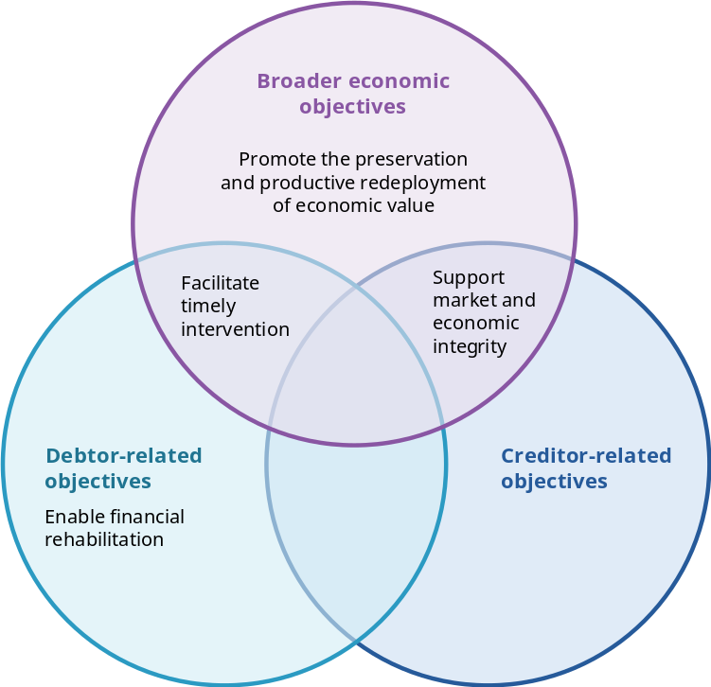

Promote the preservation and productive redeployment of economic value
- Scott Atkins and Harry Lawless described the need in the corporate context to ‘strike the right balance between corporate rescue and creative destruction’ (sub. 33, p. 8). The PC considers that this objective should extend across the insolvency system, including personal insolvency, with the system supporting rehabilitation where appropriate while enabling the productive redeployment of economic value.
- By supporting the restructuring of viable firms and the exit of non-viable ones, the system enables capital and labour to move to more productive uses. As the PC previously observed, ‘the role of the insolvency system should be to encourage economic activity through the productive use of assets’ (PC 2015, p. 353).

Facilitate timely intervention
Timely intervention helps preserve options, including opportunities to restructure (FinTech Australia, sub. 24, p. 17). This applies not only to formal legal appointments but also to earlier forms of intervention where appropriate – such as providing information, education or advice when businesses first experience financial distress.

Support market and economic integrity
Insolvency settings influence market behaviour, even for businesses that are not experiencing financial distress (Atkins and Lawless, sub. 33, pp. 1–2). Insolvency laws shape the incentives of lenders, investors, suppliers, employees (that is, potential creditors) and business owners by establishing the rules and consequences that apply when financial distress occurs. Clear and predictable insolvency settings support confidence in commercial markets, while also influencing decisions about lending, investment, entrepreneurship and risk-taking. The objectives of the system should therefore reflect the role of insolvency law in supporting the integrity of markets and the economy as a whole.

Enable financial rehabilitation
Financial rehabilitation is a core objective of personal insolvency. This applies across all personal insolvency pathways and reflects the social policy dimension of the framework. The framework concerns a person whose life will continue after insolvency ends and who must be given the opportunity to re-engage in economic and social life (Howell, sub. 65, pp. 4–6). By contrast, rehabilitation through restructuring is only one of several possible outcomes in corporate insolvency and is not relevant to every corporate insolvency pathway (ASIC, sub. 69, p. 22).

Principles: to guide system design and operation
High-level principles provide a stable foundation for assessing existing laws, evaluating reform proposals and resolving trade-offs, and we will use these principles to inform any insolvency reform recommendations made in this inquiry’s final report. They do not prescribe specific solutions. The PC has identified 3 principles to guide the design and operation of the insolvency system: proportionality, efficiency and accessibility (figure 5.2).
In identifying these principles, we considered policy literature, inquiry submissions and other policy contexts, as well as previous reviews (ALRC 1988a; PJC 2004; PC 2015; Treasury 2021; PJC 2023).
The principles are intended to be collectively exhaustive, but not necessarily mutually exclusive (that is, they may sometimes overlap). Box 5.2 provides an example of how the principles could be used to evaluate the operation of aspects of the insolvency system and identify targets for reform.
Figure 5.2 – Principles to underpin the insolvency system
The system should be designed and operate proportionatelyª | The system should operate efficiently^{b} | The system should be accessible^{c}
Obligations, process and cost should reflect the size, scale and complexity of the matter, the value at stake and its public interest significance | Processes should minimise unnecessary cost, delay and complexity while preserving value, supporting timely, predictable outcomes and maintaining appropriate safeguards | The system should be affordable, understandable and practically usable, including for participants with limited financial literacy, English proficiency, digital access or capacity to pay for advice
example: Where the cost and duration of personal insolvency are disproportionate to the debtor’s financial circumstances and likely creditor returns, reform direction 6.1 supports a minimal asset procedure (MAP) to provide a faster, lower-cost ‘fresh start’ for people with minimal assets, income and liabilities, with little effect on creditor returns. | example: Where small businesses must navigate both personal and corporate insolvency processes, poor coordination can impose unnecessary cost, delay and complexity. Information request 5.1 considers targeted coordination between the two systems — including common entry points, information sharing, triage and case management. | example: Where the cost of liquidation prevents an insolvent company from being wound up, the system is not accessible to those who need to use it. Reform direction 8.3 considers options for an official liquidator function to address this gap and improve access to corporate insolvency processes.
a. Proportionality: FCA, sub. 60, p. 14; AFSA, sub. 76, p. 11; ACCI, sub. 42, p. 12; TMA, sub. 80, p. 2. b. Efficiency: ARITA, sub. 71, p. 57; ASIC, sub. 69, p. 23; NLM Legal, sub. 53, p. 3; Howell, sub. 65, p. 4. c. Accessibility: Law Society of NSW, sub. 39, p. 6; FCA, sub. 60, p. 14; ASIC, sub. 69, p. 23.
Box 5.2 – Applying the principles in practice: Safe harbour provisions
The Australian Restructuring Insolvency and Turnaround Association (ARITA), the largest professional association for insolvency and turnaround practitioners, identified the following concerns with the operation of the safe harbour provisions in the corporate insolvency framework.
[S]afe harbour has been utilised more readily by larger and more sophisticated businesses than by SMEs. For many SME directors, concerns about personal guarantees, tax liabilities, cash flow pressures and the cost of obtaining professional advice often have a greater influence on decision-making than potential insolvent trading liability. As a result, the cost, complexity and practical accessibility of restructuring advice may limit the use of safe harbour, even where a business may be capable of recovery. (sub. 71, p. 27)
The concerns raised in this scenario can be assessed with reference to the principles as follows.
- The safe harbour provisions may not operate in a way that is proportionate for small and medium enterprises (SMEs). This is consistent with previous findings that safe harbour had greater relevance and application to larger companies and more sophisticated boards (Treasury 2021, pp. 22–23).
- There may be issues with accessibility if SME directors do not understand when safe harbour is available, what must be done to obtain its protection and how to obtain appropriate advice.
- The process may not be efficient if the process is unnecessarily or overly complex.
These criteria enable more structured and cohesive policy design and reforms (chapter 8).

The purpose, objectives and principles should be embedded in legislation as design guidance
The proposed purpose, objectives and principles would provide a clearer foundation for Australia’s insolvency system. They would also promote a more consistent approach to reform across areas such as harmonisation, insolvent trading, insolvency pathways and creditor priorities.
In submissions and consultation (appendix A), there was support for including this design guidance in insolvency legislation. One participant said it would ‘increase predictability’ and ‘aid the interpretation of … insolvency law’ (Atkins and Lawless, sub. 33, p. 5). Objects clauses are commonly used to state the underlying purposes of legislation and help resolve uncertainty or ambiguity (ALRC 2008, para. 5.90).
Legislation provides a firmer and more enduring foundation than policy. Policy can change and does not bind courts. By contrast, legislated objects guide how courts interpret and apply legislation and provide a benchmark for future reform (Acts Interpretation Act 1901 (Cth), s 15AA). The PC therefore recommends embedding the proposed purpose, objectives and principles in Australia’s insolvency legislation.
Reform direction 5.1
Legislate the purpose, objectives and principles of the insolvency system
The Australian Government should amend the Bankruptcy Act 1966 (Cth) and the Corporations Act 2001 (Cth) to reflect the following design guidance.
The purpose of the Australian insolvency system is to provide a process for dealing with the financial affairs of individuals and companies in financial distress.
The objectives should explicitly incorporate broader economic interests and are to:
- promote the preservation and productive redeployment of economic value
- facilitate timely intervention
- support market and economic integrity
- enable rehabilitation (in the case of personal insolvency).
The principles underpinning the system are:
- proportionality – obligations, process and cost reflect the size, scale and complexity of the matter, the value at stake and its public interest significance
- efficiency (of operation) – processes minimise unnecessary cost, delay and complexity while preserving value, supporting timely, predictable outcomes and maintaining appropriate safeguards
- accessibility – the system is understandable, affordable and practically usable, including for participants with limited financial literacy, English proficiency, digital access or capacity to pay for advice.

Assessing the case for greater harmonisation of insolvency frameworks
As noted above, Australia has separate legal frameworks for personal and corporate insolvency. Both provide for collective enforcement, orderly distribution, misconduct investigation and discharge from debt, but they have developed separately and have different institutions, procedures and practices.
The terms of reference ask the PC to consider ‘whether there are net benefits of greater harmonisation, particularly for small business owners who may need to navigate both systems simultaneously’. This section considers that question, noting that previous findings have been mixed (box 5.3).
In assessing the case for greater harmonisation, we sought to first identify the size and significance of issues at the intersection of personal and corporate insolvency frameworks, and then to understand the nature of specific concerns.

Box 5.3 – Previous findings on harmonisation have been mixed
The Harmer report identified some common features of personal and corporate insolvency while acknowledging that there are ‘many areas peculiar to individuals and corporations’ that justify the need for separate frameworks (ALRC 1988a, p. 13).
The PC’s inquiry into business set-up, transfer and closure found that greater alignment could deliver some benefits. However, substantial integration would involve significant implementation costs for only marginal benefits (PC 2015, p. 334).
The Parliamentary Joint Committee on Corporations and Financial Services (PJC), Corporate Insolvency in Australia inquiry (2023) recognised the challenges created by separate regimes, particularly for SMEs and recommended that harmonisation be considered holistically through a comprehensive review (PJC 2023, pp. 91–92).

Concerns about the dual insolvency frameworks
The Parliamentary Joint Committee inquiry into Corporate Insolvency in Australia identified widespread concerns about complexity, accessibility and costs of the corporate framework, concluding that ‘few parties seem satisfied with the system as it stands’ (PJC 2023, p. xxv). Participants in this inquiry also raised a range of concerns including the impacts of system fragmentation on small business (Bull and Murray, sub. 55, p. 3; AICM, sub. 49, p. 22).

A relatively small number of debtors need to navigate both insolvency frameworks
In most cases, a person or company experiencing financial distress will only interact with the personal or corporate insolvency framework. A relatively small number of people experience both, either concurrently or consecutively (figure 5.3).
Figure 5.3 – There are a relatively small number of cases at the intersection of personal and corporate insolvency
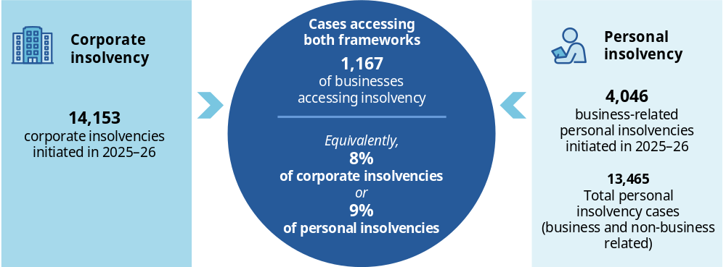
Source: AFSA (2026c); ASIC (2026g); PC estimates based upon unpublished data provided by AFSA.
For many larger companies, separate frameworks do not impede restructuring or exit because ownership, management and corporate liabilities are sufficiently separated by incorporation (box 5.4). Participants generally agreed that dual frameworks are not a key concern for big business, with Turnaround Management Association, an association for insolvency practitioners, stating that ‘Australia’s restructuring framework for larger and more complex businesses is not fundamentally broken’ (TMA, sub. 80, p. 1).

Box 5.4 – What is incorporation?
Incorporation is the legal process of creating a company as a separate legal person that is distinct from its owners (shareholders) and managers (directors) and is governed by the Corporations Act.
- Upon registration under section 119, a company comes into existence as a body corporate and acquires a legal identity separate from its shareholders and directors.
- Section 124 (1) provides that a company has the legal capacity and powers of an individual both in and outside Australia.
- The separate legal personhood of incorporation allows for limited liability for associated individuals and provides protection against business distress, thus in theory allowing companies greater ‘freedom to fail’ (Lombard, sub. 25, p. 2).
Similarly, many individuals experience personal insolvency because of consumer-related debts, including debts arising from job loss, ill health, relationship breakdown, over-indebtedness or accident. These forms of financial hardship have no connection to operating a business, and for these individuals the personal insolvency framework offers a range of pathways to navigate their personal financial distress (AFSA 2025, p. 9).

For small business owners, corporate and personal finances are often connected
The financial affairs of small businesses and their owners are often intermingled, even when a company structure is used. One inquiry participant considered it ‘inevitable that SME owners will continue to put personal equity into their businesses’ (AICD, sub. 41, p. 12). Small business owners may also give personal guarantees for business debts, so company failure can have cascading personal consequences (box 5.5). This is because, where a company is unable to fully repay its debts, creditors may pursue guarantors for any shortfall, which can trigger personal insolvency (Lombard, sub. 25, p. 2).
A small business owner may therefore need to navigate both corporate and personal insolvency frameworks, ‘potentially leading to duplication, additional costs and administrative complexity’ (NAB, sub. 62, p. 7).
Personal guarantees can also affect business dynamism. Because personal guarantees expose owners to significant personal consequences, including financial hardship or insolvency, they may affect decisions to establish, invest in or continue operating a business (FinTech Australia, sub. 24, p. 17).

Box 5.5 – Worked example: personal and corporate insolvencies may be connected
Person P operates a plumbing business through a company registered as Plumbing Pty Ltd. Plumbing Pty Ltd needs to buy expensive equipment and technology, and to secure funding for those purchases, P has been required to give security over her home as well as a personal guarantee. Other credit arrangements with suppliers, such as hardware stores, may also require personal guarantees. The capital position of the company is such that lenders would regard it as an insecure borrower … The business has liabilities, and so does the owner, including contingent liabilities under the guarantees. Although there is only one business in financial distress, the liabilities are spread across both the company and the owner/director.
Source: Bull and Murray, sub. 55, p. 9.

Small business owners have limited resources and capacity to navigate two insolvency frameworks
For small businesses, limited access to resources and capacity can compound the difficulty of needing to navigate two frameworks. The AICD noted ‘a lack of understanding around the interaction between the two regimes’ among SMEs (sub. 41, p. 12). Small business owners may also be unaware of what professional services are available to assist them.
Small business owners are unlikely to distinguish between the respective roles of insolvency practitioners or understand why concerns about their conduct may require engagement with separate regulators. The existence of separate regulators overseeing practitioners performing similar insolvency functions creates unnecessary complexity, fragmented consumer pathways and additional administrative burden at a time when individuals are financially vulnerable. (Robinson, sub. 12, p. 5)
Complexity may also affect behaviour when financial distress emerges. If owners cannot readily understand the consequences of restructuring, including for their personal finances, they may delay seeking help. Delay can reduce restructuring prospects, diminish recoveries if liquidation ultimately occurs and delay the redeployment of capital and labour from businesses that cannot be saved. For a small business owner in financial distress:
[navigating 2 systems] is bewildering and expensive. It multiplies the cost of professional advice, extends the time to resolution, and makes early engagement less likely because the path through is so unclear … the division reflects the legal form of the business rather than its economic reality, and that mismatch imposes cost on everyone involved. (AICM, sub. 49, p. 24)

Creditors can face duplication of process and costs
Creditors dealing with related corporate and personal insolvencies may need to navigate different processes, practitioners and timelines. This can increase participation costs, reduce engagement and diminish recoveries.
The Australian Institute of Credit Management (AICM) told this inquiry that for its members:
this fragmentation is not an abstract structural concern. It is a practical, daily barrier that adds cost, delay and uncertainty to credit management and insolvency participation. The complexity of navigating two sets of legislation, two regulators, multiple processes with different timeframes and requirements, and duplicated administration and investigation is a repeated theme in members’ experience. (sub. 49, p. 23)

Insolvency practitioners say that dual insolvency frameworks are excessively complex and add to compliance burden
Australia’s insolvency profession is small and specialised, including registered bankruptcy trustees, liquidators, restructuring advisers, small business restructuring practitioners and receivers (box 5.6).

Box 5.6 – Snapshot of the Australian insolvency profession
- ASIC reported 664 registered liquidators at the end of June 2026 (ASIC 2026f).
- AFSA reported 212 registered trustees able to administer bankruptcies and personal insolvency agreements in 2024–25. AFSA separately recorded 55 registered debt agreement administrators, producing 267 registered personal insolvency practitioners in total (AFSA 2025).
Some practitioners operate across both frameworks with approximately 83% of registered bankruptcy trustees also able to act as registered liquidators (AFSA, sub. 76, p. 13).
Previous reforms have aligned aspects of practitioner regulation without merging the regimes. The Insolvency Law Reform Act 2016 (Cth) sought common rules for registration, discipline, practitioner conduct, creditor communication and administration. However, the frameworks have since diverged on these points (AICM, sub. 49, p. 26).
In this inquiry, Australia’s insolvency practitioners argued that the insolvency system is still in need of reforms to make it less complex and more accessible. TMA said:
the framework generally works more effectively for larger and sufficiently funded matters than for small or low-asset matters, but the insolvency regime needs to be easier to use. (sub. 80, p. 2)
And ARITA argued for harmonisation of personal and corporate insolvency to reduce duplication of regulators, registers and legal frameworks and increase efficiency (sub. 71, p. 51).

Would greater harmonisation address these concerns?

Harmonisation can take many forms
Harmonisation is best understood as a spectrum of reform options, rather than a binary choice between the status quo and a single unified system. Options include:
- procedural harmonisation: aligning definitions, forms, notices, voting rules, practitioner requirements and reporting
- targeted harmonisation: creating mechanisms to coordinate personal and corporate insolvency where the two intersect, particularly for small owner-managed corporate businesses; this may include greater coordination of the user experience such as common entry points, information sharing, triage and case management
- full legislative and institutional integration: consolidating personal and corporate insolvency law in a single statute and combining various regulatory functions.
Participants in this inquiry expressed support for greater harmonisation as a general idea, but there was no consensus on how far harmonisation should go. Some participants advocated for legislative and institutional integration (ARITA, sub. 71, p. 51; Atkins and Lawless, sub. 33, pp. 5–6), which could involve a ‘unitary legislative framework, a single regulator, common forms, fees and practice rules, and a single insolvency profession able to accept both personal and corporate appointments’ (Harris and Murray, sub. 54, p. 6).
Others supported procedural harmonisation. Ruhe Group suggested giving liquidators the investigative tools available to bankruptcy trustees (sub. 15, p. 4), while TMA advocated ‘aligned information requirements’ and ‘aligned voting and proposal timetables’ (sub. 80, p. 10).
A more targeted approach may offer benefits where the frameworks create the greatest practical hardship: for small corporate businesses. Coordinating the experience for owners navigating both frameworks could reduce complexity and disproportionate regulatory burden.
The personal insolvency regulator, AFSA, told this inquiry that ‘small business financial distress often involves interconnected personal and business liabilities, creating a need for coordination across insolvency frameworks and processes’ (sub. 76, p. 14). Similarly, the corporate regulator, ASIC, did not advocate for a merged regulatory function and instead suggested targeted reforms to improve coordination between the frameworks where most appropriate (sub. 69, pp. 27–28).

Framework distinctions can serve important policy functions
There are good reasons for maintaining important distinctions between personal and corporate insolvency. Companies and individuals have different legal characteristics, and insolvency has different consequences for each. In 1988, the Harmer report found that ‘many areas peculiar to individuals and corporations … may make complete fusion difficult, if not impossible’ (ALRC 1988b, p. 2).

Companies and people are not the same
The distinction between companies and individuals is not peculiar to insolvency law. It underpins corporate, taxation, employment, criminal and social security law. Different rights, duties, liabilities and enforcement consequences attach to companies and natural persons precisely because they have different legal characteristics and raise different policy considerations:
- a company can be incorporated and then be wound up; an individual cannot
- a company acts through directors and other agents and is subject to a distinct framework of corporate governance and director duties; an individual acts in their own legal capacity
- criminal and corporate law distinguish between corporate liability and the personal responsibility of the individuals who act on a company’s behalf
- tax law treats companies and individuals as different taxpayers, applying different rates, rules and mechanisms for attributing income and liability (Hargovan et al. 2023, chs. 3, 5, 7).
This distinction between companies and individuals is also relevant in insolvency law and has practical and economic consequences. An insolvent company may be restructured, sold or wound up, allowing viable businesses to continue and capital and labour from non-viable businesses to move to more productive uses. An individual cannot be ‘wound up’ or ‘liquidated’ in the same sense. The natural person will live on after the insolvency process ends and will continue to participate in economic and social life (Howell, sub. 65, p. 4).
Even where small corporate business finances are intertwined, economic interdependence does not make the company and director the same debtor:
for operators of small-medium businesses, insolvency of the business may also have implications for the insolvency of the directors as natural persons, including because of the typical use of personal guarantees. However, there are still separate entities involved (the corporate form and the natural person), and this system also provides advantages to the directors as natural persons. (Howell, sub. 65, p. 6)
Incorporation is a business choice that deliberately creates this separation. Limited liability allows entrepreneurs to quarantine some business risks from their personal affairs, facilitating investment and risk-taking. Treating an incorporated business and its owner as a single insolvency estate could therefore undermine one of the core economic functions of incorporation itself.

Personal insolvency has distinct social policy and public interest objectives
The weight given to, and application of, its objectives and principles differ between personal and corporate insolvency because personal insolvency has a rehabilitative objective with no direct corporate equivalent. There is a need for ‘caution’ because the regimes serve different ‘roles’ (Howell, sub. 65, p. 5).
Personal insolvency affects more than creditor distribution. It can affect an individual’s property, future income, employment and business opportunities, access to credit, and the wellbeing of their household and dependants (AFSA 2026a). Because individuals have no limited liability, the regime must determine when a person can move beyond debts they cannot pay.
This distinction supports the view that personal insolvency frameworks in modern economies ‘now also serve something akin to a social insurance or consumer protection role’ (Howell, sub. 65, pp. 5–6). This gives the personal insolvency framework a distinctive ‘fresh-start’ and personal rehabilitation public interest function (Howell, sub. 65, p. 5). This is reflected in the concerns about stigma associated with personal insolvency: ‘(g)oing bankrupt carries great stigma for Australian consumers, and our clients are often experiencing feelings of shame, embarrassment and guilt’ (FLRC, sub. 59, p. 2).
By contrast, corporate insolvency raises a different set of public interest considerations. A corporate failure can affect employees, suppliers, customers and communities, and in larger cases can disrupt entire supply chains or the provision of crucial services such as regional air networks. Corporate insolvency also performs an important market-integrity function through regulation of directors’ duties and enforcement of the obligations that accompany limited liability.

Conflicting corporate and personal interests may persist
Many proponents argued that harmonisation could simplify small business insolvencies where corporate and personal finances are connected. But there is a practical limit: the interests of the company and individual may come into conflict, meaning that the two estates cannot be treated as one.
Insolvency can also expose conflicts that were not previously apparent. For example, a company may have claims against one of its directors for insolvent trading, breaches of directors’ duties, director loan account transactions, voidable transactions or dealings with company property. And at the same time the director may be a creditor of the company, dispute liability for those claims and have personal interests that conflict with those of the company.
ASIC observed that maintaining the distinct interests of the different legal entities is important, ‘particularly where there are competing claims between the company and its directors’ (sub. 69, pp. 27–28). In these circumstances, the two insolvency estates can become directly opposed, and the potential for conflict means that the estates could not be administered by one practitioner. This is because a single practitioner cannot simultaneously pursue a claim on behalf of one estate and represent the interests of the estate against which that claim is made.
These conflicts arise from having separate debtors, estates and creditors, rather than from having separate personal and corporate insolvency frameworks. Harmonising the frameworks would not remove the need to manage these conflicts.

International experience shows that harmonisation would not necessarily reduce the number of procedures involved
Internationally, Australia’s insolvency system is well regarded as ‘a mature, stable and effective’ regime (NLM Legal, sub. 53, p. 4). Still, some participants advocated for reforms that would bring Australia more in line with international practice (ARITA, sub. 71, p. 51). Australia is not unusual in having different procedures for individuals and companies. What is more distinctive is the extent of the separation across legislation, regulators, practitioner arrangements and courts.
There is no single international model for insolvency system design – harmonisation can take different forms and does not necessarily reduce complexity. Harmonising components of the system, such as legislation or administrative bodies, does not necessarily create a simpler or more unified user experience. Personal and corporate insolvency procedures remain distinct in every comparator jurisdiction for reasons that are also relevant in Australia (table 5.2).
Table 5.2 – Other jurisdictions have distinct pathways for personal and corporate insolvency
Jurisdiction | Integrated legislation? | Integrated government entities? | Integrated procedures?
England and Wales | Substantially integrated. The Insolvency Act 1986 (UK) is the principal statute for company and individual insolvency. | Substantially integrated. The Insolvency Service has functions across company and personal insolvency, including Official Receiver functions and oversight of insolvency practitioners. | No. Company procedures remain distinct from personal bankruptcy.
Canada | Partly integrated. Canada’s Bankruptcy and Insolvency Act applies to individuals and corporations. Larger corporate restructurings can use the separate Canadian Companies’ Creditors Arrangement Act (for claims exceeding C$5 million). | Substantially integrated. The Office of the Superintendent of Bankruptcy administers the Bankruptcy and Insolvency Act, performs functions under the Companies’ Creditors Arrangement Act, and licenses and regulates insolvency practitioners. | Partly integrated. The level of integration depends on the size of the debt. For example, there is a consumer proposal pathway for debts under C$250,000 that is not available to corporations.
Singapore | Integrated. Singapore’s Insolvency, Restructuring and Dissolution Act 2018 brings much of corporate and individual insolvency law into one statute. | Substantially integrated. The Ministry of Law’s Insolvency Office houses both the Official Assignee (personal) and Official Receiver (corporate winding up). | No. Company procedures remain distinct from personal bankruptcy.
New Zealand | Separate. Personal insolvency is principally governed by the Insolvency Act 2006 (NZ). Corporate liquidation and administration are principally governed by the Companies Act 1993 (NZ). | Integrated. The Insolvency and Trustee Service administers all personal bankruptcies, no-asset procedures and debt repayment orders, and court-appointed company liquidations. Other company insolvencies are administered by private practitioners. Practitioner regulation operates under a common regulatory framework covering both personal and corporate practitioners. | No. Company procedures remain distinct from personal bankruptcy.
Ireland | Separate. Personal insolvency is governed by Ireland’s Personal Insolvency Act 2012 and Bankruptcy Act 1988. Corporate insolvency is principally governed by the Companies Act 2014 (Ireland). There are additional acts regulating the insolvency profession and receiverships. | Separate. The Insolvency Service of Ireland administers personal insolvency, including practitioner oversight. Corporate insolvency administration has multiple players including the Corporate Enforcement Authority, the Companies Registration Office and insolvency professional bodies. | No. Company procedures remain distinct from personal bankruptcy.
Australia | Separate: Corporate insolvency is governed by the Corporations Act. Personal insolvency is governed by the Bankruptcy Act. | Separate. ASIC administers corporate insolvency. AFSA administers personal insolvency. | No. Company procedures remain distinct from personal bankruptcy.

Addressing connected corporate and personal insolvencies
On balance, wholesale integration of Australia’s personal and corporate insolvency frameworks is not warranted. The evidence suggests that any potential benefits of harmonisation are likely to be concentrated in a subset of small businesses – where corporate and personal liabilities arise from the same underlying business activity, typically due to personal guarantees. The available data suggests that the number of individuals in this group is relatively small.

Finding 5.1
Wholesale integration of the two insolvency frameworks is not warranted
Wholesale integration of the two insolvency frameworks is not warranted. There may be scope for targeted reforms at the intersection of personal and corporate insolvency to improve the experience of the few small corporate business owners who are required to navigate both frameworks.
There may be merit in reforms that more explicitly address the experience of connected personal and corporate insolvencies. We are considering potential reform options that are targeted at the point of intersection, which could improve the efficiency of connected corporate and personal insolvency processes and the experience of individuals who must navigate both. Some options that have been suggested in submissions to this inquiry include:
- a single entry point or ‘no wrong door’ approach – a referral function spanning both corporate and personal insolvency that assists in sorting debtors into the pathways that are right for them (Robinson, sub. 12, p. 5; Howell, sub. 65, p. 7; TMA, sub. 80, pp. 9–10)
- procedural coordination – a case management approach that allows processes and timelines to be managed together as much as is appropriate (Bull and Murray, sub. 55, pp. 3–4; TMA, sub. 80, p. 10)
- targeted legislative reform to allow personal guarantees to be dealt with as part of a corporate insolvency process (Harris and Murray, sub. 54, p. 3; TMA, sub. 80, p. 10).
We are seeking feedback on potential reform options to support our consideration of whether reform is warranted, and the costs and benefits of selected options, as assessed by reference to:
- the number of people likely to benefit from the reform – including, for example, whether all debtors at the intersection benefit, or only a subset
- how much and in what ways are they expected to benefit – including time and cost savings
- the likely costs of implementing the reform – both set up and ongoing operational costs
- whether there are any risks that arise and the extent to which they can be managed.

Information request 5.1
Options for targeted coordination of connected personal and corporate insolvencies
The PC is seeking feedback on ways to improve the efficiency of connected corporate and personal insolvency processes – including proposals for a single entry point into the insolvency system, procedural coordination of connected cases or enabling personal guarantees to be dealt with as part of corporate insolvency processes.
- How could or should these ideas be implemented in practice?
- What are the likely costs and benefits? Are there risks that need to be managed and, if so, how?
- Are there other options for targeted reform that should be considered?

Make insolvency pathways work better

Key points
Australia’s insolvency system provides a range of corporate and personal insolvency pathways for restructuring, orderly exit and debt relief. The overarching architecture of the pathways is operating well and does not need comprehensive reform. Reform efforts should be concentrated on improving individual pathways.
Small business restructuring (SBR) provides eligible small companies with an opportunity to restructure their debts and continue operating, but the process could work more efficiently.
The Productivity Commission is seeking feedback on opportunities to improve the efficiency of the SBR process, including expanding the mandatory reporting requirements, verifying debts earlier in the process, removing the requirement for court approval to stay winding-up applications and allowing creditors to vote on alternative options.
Participants in previous inquiries called for the SBR eligibility criteria to be relaxed, but these calls have eased as SBR uptake has grown. Given the limited evidence for relaxing the eligibility criteria, and the risks of extending SBR to companies with more complex affairs, the criteria should remain unchanged, except to index the $1 million liabilities limit to inflation.
Entering SBR may cancel some licences and insurances, preventing its use in some industries including residential construction. The PC is seeking information on whether licences or insurances are cancelled in other industries, and whether there is a good public policy rationale for these cancellations.
Simplified liquidation was intended to provide a faster and lower-cost liquidation pathway, but has seen minimal uptake. This is unlikely to change unless it is made meaningfully cheaper and faster than standard liquidation. The PC is seeking feedback on options to improve simplified liquidation.
Bankruptcy is intended to facilitate economic rehabilitation for debtors, but current regulatory settings are disproportionately punitive for many individuals. The Australian Government should introduce a minimal asset procedure, which would provide a faster fresh start for eligible debtors with minimal assets, income and liabilities.

Insolvency pathways affect business dynamism through their effects on the availability of credit, the efficient allocation of resources and incentives for entrepreneurship. For pathways to support these outcomes, they should be ‘timely, usable and proportionate’ (ACCI, sub. 42, p. 14).
No participants raised concerns with the overall architecture of the pathways (box 6.1) and, on this basis, we consider that there is no need for wholesale reform. However, there are opportunities for targeted improvement, a position supported by the Australian Securities and Investments Commission (ASIC) (sub. 69, p. 23).
We have focused on the pathways where inquiry participants raised concerns: small business restructuring (section 6.1); simplified liquidation (section 6.2); and bankruptcy (section 6.3).

Box 6.1 – The architecture of the insolvency pathways
The Corporations Act 2001 (Cth) sets out several corporate insolvency pathways that are regulated by the Australian Securities and Investments Commission (ASIC). ASIC also regulates exit pathways for companies that wind up for reasons other than financial distress (chapter 4).
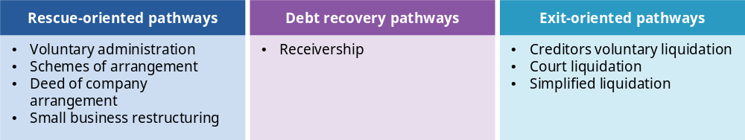
The personal insolvency pathways are set out in the Bankruptcy Act 1966 (Cth). These pathways are regulated by the Australian Financial Security Authority.


Making small business restructuring more efficient
Restructuring enables a business experiencing financial distress to reorganise its debts and continue operating, rather than be wound up. One form of this is small business restructuring (SBR), which provides eligible companies with an opportunity to compromise their debts by proposing and agreeing a restructuring plan with their creditors (ATO 2026e). SBR was introduced in 2021 as an alternative to voluntary administration (VA) to provide small businesses with ‘a simple, cheap and faster means to restructure their debt’ allowing ‘more businesses to go on trading, meaning better outcomes for the businesses, their creditors and their employees’ (Treasury 2020, p. 2).
In general, SBR does appear to be a simpler, cheaper and faster restructuring pathway for financially distressed but viable small businesses. It has made restructuring more accessible and allowed the insolvency system to work in a way that is proportionate for different sizes of business. Many inquiry participants said that SBR plays an important role in enabling restructuring for small business and supported its continuation (AICM, sub. 49, pp. 17–18; NLM Legal, sub. 53, pp. 10–11; NSW SBC, sub. 36, p. 5).
This is reflected in the growing use of the pathway – after a slow start, uptake has grown substantially from 12 appointments (0.2% of all practitioner appointments) in 2020–21, to 1,719 (10.3%) in 2025–26 (figure 6.1).
In 2025, an ASIC review of SBR (covering 3,388 SBRs that commenced between 1 July 2022 and 31 December 2024 and 1,260 SBR plans finalised by 31 March 2025) found that creditors had approved restructuring plans and debtors had met their plan obligations in the vast majority of cases:
- 87% of the plans sent to creditors were approved, although this level was trending downwards over the period reviewed
- 92% of the 1,260 finalised plans were fulfilled
- 93% of companies that fulfilled a plan by 31 March 2025 remained registered at the end of April 2025 (ASIC 2025a, p. 4).
However, inquiry participants identified several ways in which the process could work more efficiently, which are discussed in the remainder of this section.
Figure 6.1 – Small business restructuring has seen substantial uptake
Number of small business restructuring appointments, 2020–2021 to 2025–26
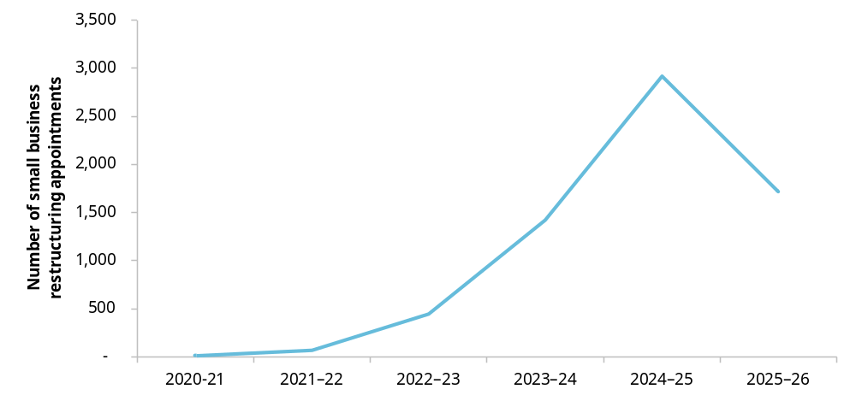
Source: ASIC (2026g).

Improving the efficiency of the small business restructuring process
The PC is seeking feedback on the potential benefits, costs and risks associated with SBR reform options suggested by inquiry participants.
- Expand the mandatory information requirements to circumvent the need to request additional information?
The Corporations Act requires certain information to be provided to creditors to help them decide whether to vote in favour of a restructuring plan (Corporations Regulations 2001 (Cth), reg 5.3B.21). Creditors can also request additional information from the restructuring practitioner. Some have argued that the information required by legislation is not, on its own, sufficient for creditors to make an informed decision (ARITA 2024a, p. 8; Harris and Murray 2023, p. 4).
In practice, creditors commonly request information beyond the minimum requirements. For example, the Australian Taxation Office, as a creditor, asks debtors to provide 3 years of financial statements, cashflow forecasts and estimated dividends to creditors if the company was liquidated instead of restructuring (ATO 2026e). Some have argued that information of this kind should instead be required by legislation and provided to all creditors at the outset to circumvent the need for additional requests (ARITA 2024a, pp. 8–9). On the other hand, increased information requirements could increase compliance costs in cases where that additional information would otherwise not have been required or requested.
- Earlier verification of debts to avoid duplicative processes?
In the SBR process, creditors are not required to verify their debts or claims until after the proposed restructuring plan has been prepared and provided to creditors for voting (Corporations Regulations 2001 (Cth), regs 5.3B.21(1)(b)(iii) and 5.3B.22). This sequencing has the potential to create inefficiencies. If a creditor identifies an error in its debt or claim at this stage, they can ask the restructuring practitioner to amend the schedule, which would change the proposed distribution to creditors under the plan. This can, in turn, lead creditors who have already voted to seek to change their vote (Harris 2022, p. 228). It was suggested that creditor claims should be verified sooner:
The proposal period should include a simple creditor verification process so that debts and claims are confirmed before voting and before the schedule of debts and claims becomes operative. Creditors who do not verify their claims by the required date could remain bound by the plan but not participate in plan payments, subject to an appropriate court pathway for genuine disputes or exceptional circumstances. (ARITA, sub. 71, p. 31)
- Allow winding-up applications to be stayed automatically to avoid the need to go to court?
When a company enters SBR, it can apply to the court to have any winding-up applications against it adjourned (Corporations Act 2001 (Cth), s 453Q). The Australian Restructuring, Insolvency and Turnaround Association (ARITA) said that, in these cases, applying to court is inefficient and expensive and that, instead, winding-up applications should be automatically stayed (sub. 71, p. 32). In particular, ARITA argued that circumventing court proceedings would save money, while not unduly prejudicing creditor interests as ‘debt levels are low and [the SBR] time frame is short’ (2024a, p. 3).
- Allow creditors to vote for alternatives, rather than just approving or rejecting plans, to avoid the need to initiate a separate insolvency process?
Currently, creditors simply vote ‘yes’ or ‘no’ for restructuring plans. If a plan is rejected, the SBR process ends and the company can continue trading (Corporations Regulations 2001 (Cth), regs 5.3B.02(1)(c)) and 5.3B.20(1)(c)).
Creditors are not given the opportunity to vote for the company to enter liquidation as an alternative to approving the restructuring plan (reg 5.3B.21(1)(b)). This differs from VA, where one of the options available to creditors is to vote to liquidate the company. This means that creditors seeking to have the company liquidated must initiate a separate process.
Participants said that this is a source of unnecessary cost and delay and suggested potential reforms.
- One suggestion was that, if a plan is rejected, ‘creditors should vote on the next step, whether continued trading, voluntary administration, or liquidation’ (AICM, sub. 49, p. 21). However, this option could discourage use of the SBR pathway if companies know that creditors can push them into liquidation.
- Another was that, if a plan is rejected, the company should be required ‘within a defined (short) period, to notify creditors whether it will submit a revised proposal, appoint a voluntary administrator, enter creditors’ voluntary liquidation or allow the restructuring process to end’ (ARITA, sub. 71, p. 32). This could provide creditors with greater certainty of what will happen following the rejection of a restructuring plan, without imposing automatic liquidation in all cases.

Information request 6.1
How should the efficiency of the small business restructuring process be improved?
The PC is seeking feedback on whether and what reforms are needed to improve the operation of the small business restructuring (SBR) regime. In particular, what are the potential benefits, costs and risks associated with reforms that would:
- expand the mandatory information requirements to include information that is already being routinely requested
- require debts and creditor claims to be confirmed before voting
- automatically stay winding-up applications when a company enters SBR, circumventing the need to apply to court for a stay
- allow creditors, in addition to voting to accept or reject a plan, to vote for an alternative option?
Other suggestions to improve the operation of the SBR regime are also welcomed.

No change needed to the eligibility criteria
In the 2023 Parliamentary Joint Committee inquiry into Corporate Insolvency in Australia, several participants argued that the SBR eligibility criteria (box 6.2) were too stringent, especially the $1 million liabilities limit, and that this was acting as a barrier to use of the regime.

Box 6.2 – Eligibility criteria for small business restructuring
The SBR eligibility criteria were implemented to manage risk by limiting the availability of the simplified SBR process to tax-compliant small businesses with non-complex liabilities.
To use SBR, the company’s directors must resolve that the company is insolvent, or likely to become insolvent, and that a restructuring practitioner should be appointed. In addition, the company’s total liabilities must not exceed $1 million (ASIC 2026j). The size of the company’s liabilities is used as a proxy for the complexity of its affairs and liabilities. Restricting SBR to companies with simpler affairs and liabilities reduces the risk of the simpler process (which involves less regulation and investigation than voluntary administration) being misused (Dickson 2022, p. 14).
There are also restrictions on using SBR if a company or its current or recent directors have used SBR or simplified liquidation in the past 7 years (ASIC 2026j).
To propose a restructuring plan, a company must be up to date with its employee entitlements and tax lodgements.
With the uptake of SBR having grown considerably in recent years, the argument to expand the eligibility criteria has weakened. In line with this, very few submissions to this inquiry specifically advocated for broader eligibility criteria (cf. Innovation 200, sub. 45, p. 7; SBDC WA, sub. 90, pp. 6–7).
Given the lack of evidence for relaxing the eligibility criteria and risks of allowing companies with more complex affairs to use SBR, the eligibility criteria should not be amended, except to index the $1 million liabilities limit to inflation to ensure that it does not become a barrier to entry in the future (as supported by the SBDC WA, sub. 90, p. 6).

Entering small business restructuring cancels some licences and insurances, preventing its use by businesses in some industries
Entering SBR may cancel some essential licences or insurances, such as building insurance (box 6.3). Without these licences or insurance, a company cannot legally continue to trade. This undermines its ability to successfully restructure through SBR and may lead to it having no option but to enter liquidation. (Bull et al., sub. 6, p. 13; NSW SBC, sub. 36, p. 5). Our inquiry heard that construction businesses are disproportionately excluded from accessing restructuring pathways that remain available to small businesses in other industries.
The PC would like to know if any other licences or insurances are cancelled when a business enters SBR and if there is a good public policy rationale for these cancellations.

Box 6.3 – Building insurance may be cancelled by entering small business restructuring
In New South Wales, the Home Building Act 1989 (NSW) s 92 requires residential building work above $20,000 to be covered by insurance under the Home Building Compensation Fund. The sole provider of this insurance is icare (an agency of the NSW Government), which assesses whether a builder is eligible to be insured (NSW SIRA 2026).
The Home Building Compensation Eligibility Manual sets out ‘unacceptable risk scenarios’ which constitute grounds for suspension or cancellation of eligibility for insurance. Entry into external administration, including SBR, falls within these provisions (icare 2026, p. 100).

Information request 6.2
Do licence and insurance cancellations unnecessarily prevent the use of small business restructuring?
- Are there other industries, apart from residential construction, where entering small business restructuring causes the cancellation of essential licences or insurance policies? What legislation or policies compel these cancellations?
- Is there a compelling public policy rationale for state licensing bodies and insurers cancelling licences or insurance when a company enters small business restructuring? What are the costs, benefits and risks associated with preventing these cancellations from occurring?

Making simplified liquidation genuinely simple
Another broad category of insolvency pathways for companies is liquidation. One reason a company might be liquidated is because it is no longer financially viable to continue trading (companies may also be liquidated for reasons unconnected to financial distress – chapter 4). Liquidation enables the company to be wound up in an orderly way, involving the realisation of the company’s assets for distribution to its creditors before the company is deregistered (ASIC 2026k).
Simplified liquidation is a streamlined liquidation pathway that can be adopted by companies undergoing creditors’ voluntary liquidation in certain circumstances (ASIC 2024a, p. 2). A key requirement is that a company has liabilities of less than $1 million.
The pathway was introduced in 2021, following acknowledgement that the ‘standard’ liquidation process is suited to ‘large, complex company failure, where intentional misconduct may have been involved’ but may not be proportionate for the majority of liquidations (Treasury 2020, p. 7). Simplified liquidation was intended to provide ‘faster and lower-cost liquidation’ for small businesses, ‘increasing returns for creditors and employees’ and allowing ‘assets to be quickly reallocated elsewhere in the economy, supporting productivity and growth’ (Treasury 2020, pp. 2, 7).

Simplified liquidation has seen minimal uptake
Since its introduction, simplified liquidation has seen very little uptake. ASIC has reported that between January 2021 and June 2023, simplified liquidation was only adopted 82 times, despite the fact that there were nearly 4,000 creditors’ voluntary liquidations of companies with liabilities of less than $1 million (ASIC 2024a, pp. 3–4). Since then, uptake has remained low: simplified liquidation was used just 8 times in 2024–25 and 4 times in 2025–26 (ASIC 2026g, tab. 2.1).
A key reason for this is that, in practice, simplified liquidation has not proven to be meaningfully simpler or cheaper than the standard liquidation process, according to those who have experienced it (TMA, sub. 80, pp. 9–10). In fact, some have argued that simplified liquidation can be more onerous than the standard liquidation process (AIIP 2022, p. 6; ARITA 2022b, p. 46).
This represents a missed opportunity to make liquidation accessible to companies of different sizes and levels of complexity and ensure that insolvency pathways operate in a proportionate way.

Redesigning simplified liquidation
The PC considers that there is a need for reforms to improve the functionality and operation of the simplified liquidation pathway to achieve its intended purpose. We have identified 2 broad reform options and are seeking feedback on which of these should be pursued.
- Targeted amendments could be made to the existing simplified liquidation process. These could include reducing the administrative burden of adopting simplified liquidation, reducing the formal proof of debt requirements, clarifying liquidators’ reporting and investigation requirements, or removing the requirement to apply to court for certain decisions.
- The pathway could be substantially redesigned as a largely administrative process with minimal investigation and reporting requirements. The pathway would be reserved for straightforward cases where there are limited available assets and liabilities, and the risk of misconduct is low. To mitigate the risk that the process is abused to hide misconduct, there may need to be more controls around entry into the pathway. For example, there may be a role for government to triage cases in or out of the pathway (such as through an ‘official liquidator’ – chapter 8).

Information request 6.3
How should simplified liquidation be improved?
The PC is seeking feedback on how to improve the simplified liquidation pathway.
- Are there targeted amendments to the simplified liquidation process that could make the pathway materially more efficient or improve uptake? What are they?
- Should the pathway be substantially redesigned as an administrative process with minimal investigation and reporting requirements? What measures would be needed to manage the risk of the pathway being abused?
- What are the costs and benefits of each of these approaches?

Making bankruptcy less restrictive
Bankruptcy is a formal legal process where insolvent individuals are given relief from their debts. It can be initiated voluntarily by the individual, or by a creditor through a court process (AFSA 2026d). In the process, the bankrupt enters a period of bankruptcy during which:
- their assets are sold and the proceeds distributed to creditors
- the bankrupt may be required to make payments to creditors from their excess income
- restrictions apply (for example, to their ability to be a director of a company or travel overseas).
After this period of bankruptcy (typically 3 years), the person is released from most of their debts.

Bankruptcy settings are overly restrictive and impede a fresh start
The goal of the bankruptcy process is to provide debtors with a ‘fresh start’, allowing their economic rehabilitation (AGD 2023, p. 11). But current bankruptcy laws are overly restrictive in terms of their effects on debtors and the broader economy.
First, for many individuals, the consequences of bankruptcy are overly punitive and not proportionate to the risks involved. In many cases, personal insolvency arises due to external factors (such as job loss, ill health, accident or relationship breakdown) rather than excessive financial risk-taking (AFSA 2025). In such cases, stringent bankruptcy settings are unlikely to provide any deterrent effect.
Second, overly punitive settings can undermine the accessibility of the bankruptcy system. A framework that stigmatises bankruptcy may make individuals reluctant to declare bankruptcy, even if it is the best option in the circumstances (FRLC, sub. 59, pp. 2, 4).
Third, overly restrictive settings can also have a dampening effect on business dynamism (Lombard, sub. 25, p. 2; Murray, sub. 47, p. 4). For instance, potential business owners may be deterred by the fact that individuals are forced to endure a lengthy ‘exclusion period’ before recommencing business activity following bankruptcy (PC 2015, pp. 335–336).
The PC has previously recommended that the default bankruptcy discharge period be reduced to one year, noting that similar reforms had been introduced in the United Kingdom in 2004 (box 6.4).
In this inquiry, many participants reiterated the need for this reform (FRLC, sub. 59, pp. 1–3, 7; Howell, sub. 65, pp. 1–2; Lombard, sub. 25, pp. 3–4). The Financial Rights Legal Centre said:
The fresh start offered by bankruptcy is life changing, but 3 years is a long time to be prevented from being a company director as well as be locked out of credit and the ability to rebuild credit worthiness and economic participation. (sub. 59, p. 2)
That said, some participants in previous consultation processes raised concerns that reducing the default bankruptcy discharge period may make bankruptcy ‘too easy’ and that small consumer debtors may not take bankruptcy seriously (ACDBA 2022, pp. 4–5; ARITA 2022a, p. 1; LCA 2022, p. 4). It was said that this could lead to more opportunistic bankruptcies and higher costs of capital.
While the evidence from the United Kingdom’s experience of implementing a one-year bankruptcy discharge period (box 6.4) suggests that these concerns are unlikely to be borne out in practice, the weak evidence of benefits to business dynamism also suggests that Australia may benefit from a more nuanced approach to reform in order to address the issues outlined above.
A policy option that has been under consideration in recent years is a minimal asset procedure (MAP), applying a one-year discharge period to a subset of debtors – those with low assets and debts – only.

Box 6.4 – A one-year default bankruptcy discharge period?
In its 2015 inquiry into Business set-up, transfer and closure, the PC recommended that:
The Bankruptcy Act 1966 (Cth) should be amended so that, where no offence has occurred, a bankrupt is automatically discharged after one year. Specifically, this should apply to restrictions relating to overseas travel, holding an office under the Corporations Act 2001 (Cth), employment within certain professions and access to personal finance.
The trustee, and the courts, should retain the power to extend the time until the bankrupt is discharged for a period of up to eight years if there are concerns regarding the bankrupt’s conduct. (2015, p. 341)
This recommendation has not been adopted by the Australian Government.
The United Kingdom’s experience
The United Kingdom implemented a one-year bankruptcy discharge period in 2004. In 2007, an evaluation of this reform found that there was no causal evidence that the reforms were causing an increase in bankruptcies in England and Wales (UK Insolvency Service 2007, p. 53). However, the evaluation also found minimal effects on entrepreneurship. In particular, it was concluded that the reforms:
- did not appear to have impacted on the level of business start-ups
- had not affected the ‘fear of failure’ which is seen as a barrier to entrepreneurship. (UK Insolvency Service 2007, p. 44)
During consultation for this inquiry, the UK Insolvency Service said that a one-year bankruptcy discharge period was in line with the objective of the personal insolvency regime to provide debt relief and rehabilitation to individuals with problem debt. It also said that it saw no case for lengthening the discharge period, with protection of the public being accomplished through a targeted restrictions regime (UK Insolvency Service, pers. comm., 15 September 2026). That regime allows extensions to the discharge period where there are concerns about the bankrupt’s conduct.

Introduce a minimal asset procedure
The next step in bankruptcy reform to reduce the restrictiveness of bankruptcy should be to introduce a MAP. This would provide a significant proportion of debtors with faster access to a fresh start, with minimal impacts on creditor returns.
In 2024, the Attorney-General’s Department consulted on a proposal to introduce a MAP for personal insolvency, available only for debtors with low assets and debt ($10,000 and $50,000, respectively), and with a maximum income threshold (undetermined at the time of the consultation) (AGD 2024). Under the proposed model, the MAP would provide these eligible debtors with a fresh start after a one-year discharge period. A person who had gone through the MAP would be kept on the National Personal Insolvency Index (NPII) for a period of 4 years. Furthermore, individuals would only be eligible to use the MAP once in their lifetime.
A MAP would allow eligible debtors to obtain a faster fresh start whilst maintaining the ‘full’ bankruptcy process as ‘an option of last resort’ (AGD 2024, p. 2). It could also potentially reduce the administrative burden on the Australian Financial Security Authority of managing longer bankruptcy processes for debtors with simple estates. At the same time, a MAP would be unlikely to impact creditor returns, as the eligibility criteria would limit its use to debtors who have no realistic prospects of repaying their debts in bankruptcy.
Given that almost half of all Australians experiencing personal insolvency have less than $50,000 in liabilities (figure 6.2) (although fewer would be eligible once the income and asset limits are also applied), this reform is likely to be low risk, but would have a positive impact on financial recovery and facilitate re-entry into economic participation.
Many submissions to the 2024 consultation process supported the introduction of a MAP (ARITA 2024b, pp. 4–5; FRLC 2024, p. 7; LCA 2024, p. 2). While some considered a MAP to be a substitute for a shorter bankruptcy discharge period, others noted that a MAP would cover only a proportion of all personal insolvency cases (Murray 2024, p. 22) and recommended that consideration be given to both (Howell et al. 2024, p. 5).
Figure 6.2 – Almost half of personal insolvency cases have less than $50k in liabilities
Liabilities of personal insolvencies, 2024–25
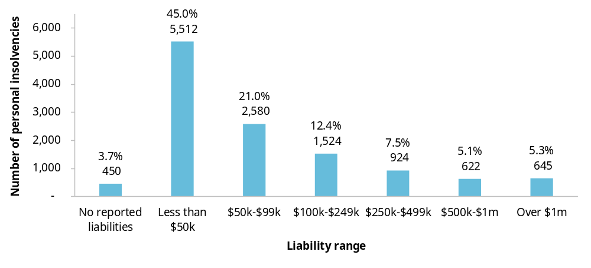
Data includes both individual and business-related personal insolvencies.
Source: AFSA 2025 (p. 12).
Reform direction 6.1
Introduce a minimal asset procedure
The Australian Government should introduce a minimal asset procedure in the personal insolvency system. It should be limited to debtors with low assets, income and liabilities.

Support restructuring and value preservation

Key points
Supporting restructuring and preserving value should be the focus of insolvency reform.
Low recoveries often reflect the limited value remaining in insolvent estates.
Reforms that preserve value, reduce unnecessary costs and encourage earlier engagement to address financial distress are likely to contribute more to business dynamism than changes to creditor priority.
Unfair preference laws can discourage unsecured creditors from supporting businesses attempting to trade out of financial difficulty.
Creditors who continue to trade with distressed businesses may later face unfair preference claims if turnaround efforts fail.
The Australian Government should amend the unfair preference provisions in the Corporations Act 2001 (Cth) and Bankruptcy Act 1966 (Cth) to exempt payments received in the ordinary course of business, regardless of whether the creditor ought to have suspected that the debtor was insolvent.
The Australian Taxation Office (ATO) can influence business restructuring outcomes and the allocation of credit through its roles as both a major creditor and a holder of information about financial distress.
Clearer guidance on how the ATO exercises its creditor powers could reduce uncertainty and support more predictable restructuring outcomes.
Greater disclosure of significant unpaid tax debts could help creditors identify financial distress earlier, supporting more informed credit decisions.
It could also encourage financially distressed businesses to engage earlier with restructuring options and reduce the competitive advantage enjoyed by businesses that rely on unpaid tax debts as a source of working capital for extended periods.
The PC is seeking views on the disclosure settings that would provide useful information without imposing unnecessary costs on businesses.

The insolvency system provides a predictable process for dealing with business failure. It establishes rules for preserving, realising and distributing assets, and determines how losses are allocated when a business becomes insolvent. Secured creditors, who hold ‘security interests’ over assets (for example, a mortgage), generally recover against those assets and rely less on the insolvency distribution framework. By contrast, outcomes for insolvency practitioners, employees, trade creditors and other unsecured creditors depend on the value remaining in an insolvent estate and how that value is distributed. This chapter finds that low recoveries often reflect the limited value remaining in insolvent estates rather than the way that value is distributed. It therefore considers reforms that could better preserve value, support business restructuring and reduce unnecessary insolvency costs.

Insolvency outcomes matter for business dynamism

Efficient insolvency processes support credit markets and resource reallocation
Creditors are more likely to provide finance and trade credit if they are confident that insolvency processes are predictable and that losses will be managed fairly and efficiently (IMF 1999).
The insolvency system also plays an important role in the productive redeployment of resources (Murray and Harris 2022, p. 4). Insolvency processes that maximise the value available to creditors and distribute that value efficiently help return financial resources to productive uses elsewhere in the economy. By contrast, delay, complexity and excessive costs can erode value, reducing benefits for creditors and the wider economy.

Low recoveries can signal lost value and missed opportunities to preserve value
Many insolvent estates contain little value to distribute. In corporate insolvencies, 80% of administrations involve realisable assets of less than $50,000 (figure 7.1). In these low-asset estates, much of the available value may be consumed by the costs of administering the insolvency process (figure 7.1).
This limited pool of assets is reflected in creditor recoveries. In corporate insolvencies, more than 90% of unsecured creditors receive less than 11 cents in the dollar (figure 7.2, left panel), and about 91% receive no dividend at all (ASIC 2025b). In personal insolvency, unsecured creditors recover, on average, less than 3 cents in the dollar (figure 7.2, right panel).
These outcomes can affect business dynamism in several ways. Low recoveries can affect the pricing and availability of credit by increasing expected losses for creditors. They may also indicate that opportunities to preserve value through earlier intervention or restructuring, or through more efficient insolvency processes have been missed.
Figure 7.1 – Low-asset corporate insolvencies tend to only compensate the practitioner
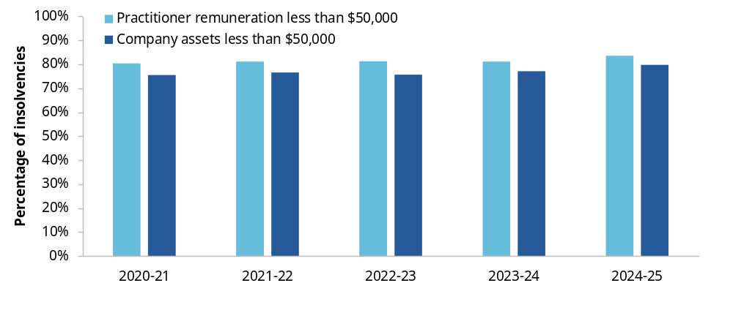Source: ASIC (2026).
Figure 7.2 – There is little value remaining for unsecured creditors at insolvency
Percentage of unsecured creditors receiving less than 11 cents in the dollar, corporate insolvency  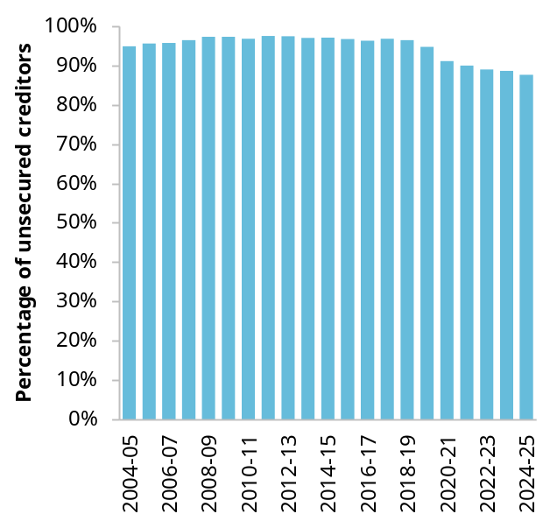 | Returns for unsecured creditors, personal bankruptcy  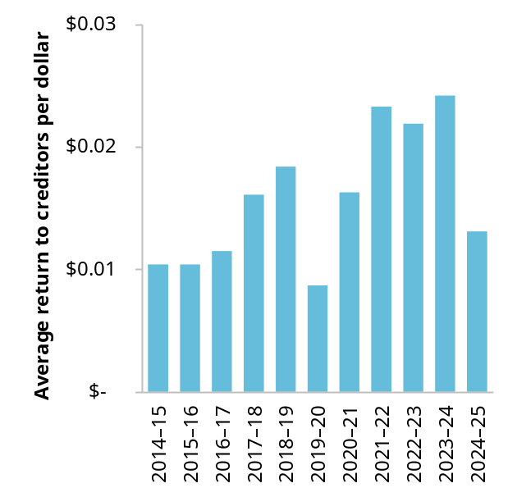
Sources: ASIC (2026); AFSA (sub. 76, p. 16).

Changes to creditor priority are unlikely to materially improve business dynamism
Early inquiry consultation identified creditor priority – the rules determining how the value in insolvent estates is allocated amongst creditor groups – as an area warranting consideration. However, few inquiry participants subsequently raised concerns about the existing ordering, and submissions did not identify a strong case for major change.
Nevertheless, creditor priority could affect business dynamism through its effects on incentives to extend credit. Favouring one creditor group over another could affect lenders’ willingness to provide credit and the price and terms on which it is available.
The evidence above suggests that, in many cases, there is little or no value available for distribution regardless of the order in which claims are ranked. The case for changing the priority framework therefore depends on whether it materially affects credit provision, business restructuring or the efficient administration of insolvent estates.
The current priority order serves identifiable policy purposes. The following sections consider whether those rationales are consistent with business dynamism.

Practitioner priority supports the administration of insolvent estates
Insolvency practitioners identify and realise assets, investigate the debtor’s affairs, adjudicate claims and distribute available funds (Murray and Harris 2022, p. 32). The priority given to payment of their costs and expenses is not intended to address any particular vulnerability as creditors, but to ensure there is an incentive to undertake these functions in a largely privatised insolvency system.
Inquiry participants pointed out that practitioners are frequently not funded to perform all their required functions under the current priority framework, or decline appointments where they suspect they will not be funded (ARITA, sub. 71, p. 21; AIIP, sub. 73, p. 3; Murray, sub. 47, p. 6). If insolvency practitioners did not have priority for remuneration and expenses, full payment would be even less likely, potentially undermining the viability of the private sector’s role in insolvency administration.
In low-asset administrations, practitioner remuneration can consume a significant share of available assets, reducing returns to other creditors (figure 7.1). This outcome is driven by the costs of administering estates with little value rather than the priority afforded to practitioners.

Employee priority protects workers and supports business continuity
Employees are afforded priority for certain unpaid wages and entitlements under Australia’s insolvency system (Bankruptcy Act 1966 (Cth), s. 109; Corporations Act 2001 (Cth), s. 556). This priority can support business dynamism by reducing the risks faced by employees when their employer experiences financial distress while having minimal impact on the provision of credit (Anderson and Davis 2009, p. 69). Where workers have greater confidence that unpaid wages and entitlements will be protected, they may be more willing to remain with a financially distressed but potentially viable business while restructuring options are explored.
Employee priority also reflects the limited ability of workers to manage or diversify their exposure to insolvency risk. Unlike many other creditors, employees generally cannot obtain security, readily assess their employer’s financial position or spread their exposure across multiple debtors. Australia’s insolvency system therefore affords employees priority for a range of unpaid entitlements.
Priority alone does not guarantee recovery of those entitlements. Where businesses enter insolvency with insufficient assets to satisfy all claims, employee outcomes are often determined by the value available in the estate rather than the priority framework itself.

The evidence does not support changes to creditor priority
The inquiry has not found evidence that major changes to these priorities would materially improve business dynamism. Reordering claims would alter how losses are distributed between creditor groups but would do little to address the more fundamental constraint identified in section 7.1, that many insolvent estates contain very little value available for distribution.
More promising opportunities lie in reforms that preserve value before insolvency, reduce unnecessary administration costs or improve the ability of creditors and businesses to respond to financial distress at an earlier stage.

The ATO can influence business restructuring and creditor decision-making
The Australian Taxation Office (ATO) can influence business dynamism through its roles as both a major creditor and a holder of information about financial distress. Its decisions regarding debt collection, payment arrangements and restructuring proposals can affect whether financially distressed but viable businesses restructure successfully or enter formal insolvency. The information it holds about unpaid tax debts can also influence lending, trading and restructuring decisions (ARITA, sub. 71, p. 39; AICM, sub. 49, p. 20).
The scale of the ATO’s role is substantial. Historically it has been a creditor in around three-quarters of company insolvencies and is often the largest, and sometimes the only, creditor of insolvent businesses (AICM, sub. 49, p. 14; AICD, sub. 41, p. 13). Around 85% of insolvent administrations in 2024-25 had unpaid taxes and charges (figure 7.3, right panel). Small business collectable tax debt reached $35.9 billion in 2024-25 representing about two-thirds of all collectable tax debt (ANAO 2026, p. 6) (figure 7.3, left panel).
These features of the ATO’s role raise two questions for the inquiry. First, should the ATO’s conduct as a creditor be guided by clearer principles when businesses experience financial distress? Second, could greater disclosure of significant unpaid tax debts improve lending, trading and restructuring decisions?
Figure 7.3 – The ATO is a significant creditor of Australian businesses
Small business collectable tax debt  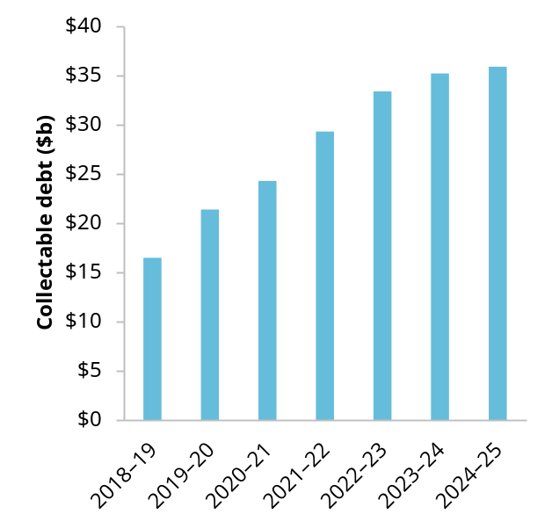 | Percentage of corporate insolvencies with unpaid taxes or statutory debts 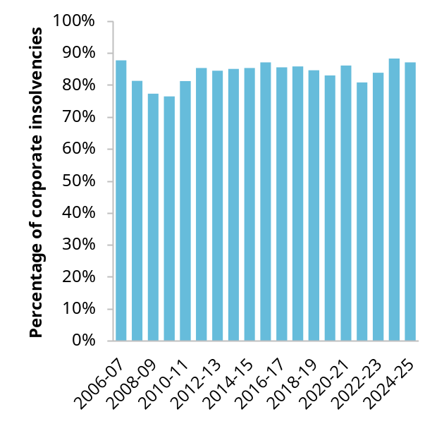
Sources: ANAO (2026); ASIC (2026h).

Introduce guidelines on how the ATO acts as a creditor to improve outcomes for debtors and other creditors
Following the COVID-19 pandemic, the ATO adopted a more active approach to debt recovery (ANAO 2026, p. 79). This shift is understandable given the growth in unpaid tax debt and the need to restore ordinary compliance settings. However, some inquiry participants raised concerns that aspects of the ATO’s approach may discourage restructuring attempts or reduce flexibility for businesses seeking to address tax debts. These concerns raise broader questions about how the ATO should balance debt recovery with the public interest in supporting viable restructures and promoting transparent, consistent decision-making.
The Parliamentary Joint Committee (PJC) review of corporate insolvency recommended that the ATO consult on, develop and publish ‘model creditor’ guidelines (PJC 2023, p. 226). The Australian Government has recently noted this recommendation and indicated that the ATO will consult on the guidelines in due course (Australian Government 2026b, p. 11).
The Productivity Commission supports the Australian Government’s response. Clear guidance on how the ATO exercises its creditor powers could improve transparency and consistency, reduce uncertainty for financially distressed businesses and support more predictable restructuring and insolvency outcomes.

Give creditors better visibility of a business’ tax debts to inform decision-making
Where signs of financial distress are not visible to suppliers, lenders and other creditors, they may continue extending credit without fully understanding the risk of non-payment. Alternatively, if there are concerns about business viability, but little verifiable information, creditors may deal with this uncertainty by restricting credit to a viable business, leading to business distress. The ATO is uniquely positioned to identify emerging financial distress through unpaid tax debts and provide credible, verifiable information to the credit markets.
Greater transparency may improve the allocation and pricing of credit by supporting more informed lending and trading decisions. It may also encourage earlier engagement with restructuring options by financially distressed businesses, supporting the successful turnaround of viable businesses.
Since the passage of the Treasury Laws Amendment (2019 Tax Integrity and Other Measures No. 1) Bill 2019, the ATO has been able to disclose information about overdue business tax debts to registered credit reporting bureaus. The regime applies where a business has at least $100,000 in tax debt that is more than 90 days overdue and is not effectively engaging with the ATO to manage that debt (ATO 2025). The ATO must also provide the business with at least 28 days’ notice before any disclosure occurs (ATO 2025).
The regime was introduced primarily as a compliance measure to encourage engagement with the ATO and repayment of tax debts. However, it can also reduce information asymmetries by helping both secured and unsecured creditors identify financial distress earlier, better assess risk and make more informed lending and trading decisions (Australian Government 2019, p. 49).
Several submissions argued that the current settings do not fully achieve this objective. The Australian Credit Forum and Australian Institute of Credit Management argued that the current disclosure threshold may miss businesses carrying material tax debt and that removing disclosures when a taxpayer enters a payment arrangement can leave creditors without visibility of significant liabilities that remain outstanding (sub. 56, pp. 2–3 sub. 49, pp. 14–15, respectively).
However, changes to settings to enhance transparency would need to be designed in such a way as to protect against unintended consequences. For example, maintaining disclosures with credit reporting bureaus after a payment arrangement has been entered into could discourage businesses from engaging with the ATO to address their tax debts. Similarly, reducing the threshold for overdue payments to less than 90 days could have adverse effects on businesses with only temporary cash flow issues.
We are exploring whether improved outcomes could be achieved by lowering the monetary threshold at which disclosures can occur, alongside greater clarity about when exceptions should apply (for example, in the case of natural disasters or other categories of hardship).

Information request 7.1
How could a lower tax debt disclosure threshold operate?
A reduction by the ATO of the disclosure threshold for unpaid tax debts from $100,000 to a lower amount would provide creditors with greater visibility of companies that may be in financial distress. The PC is seeking information on potential changes to the disclosure regime including:
- What disclosure threshold would ensure creditors receive useful information about financial distress without imposing unnecessary costs on businesses?
- What are the benefits and drawbacks of maintaining disclosure with a credit reporting bureau after a payment arrangement is entered into?
- What are the circumstances in which exceptions should apply to the ATO making these disclosures?
- What other sources of information could help businesses identify trading partners experiencing financial distress?

Amend unfair preference provisions to support the flow of credit to business in temporary financial distress
Businesses experiencing temporary financial difficulty often rely on the continued support of suppliers, landlords and other unsecured creditors while they attempt to restructure their affairs. The willingness of creditors to continue trading with a distressed business can play an important role in determining whether a potentially viable business survives, restructures successfully or enters formal insolvency.
However, unsecured creditors who continue dealing with a distressed business may later face unfair preference claims if the restructuring effort is unsuccessful and the business enters insolvency. Unfair preference provisions in the Corporations Act 2001 (Cth) and Bankruptcy Act 1966 (Cth) are intended to ensure that unsecured creditors share equally in an insolvent estate (Murray and Harris 2022, p. 211). Broadly, an unfair preference occurs where a creditor receives payment of an unsecured debt shortly before insolvency and, as a result, receives more than it would have received if it had participated in the subsequent liquidation or bankruptcy alongside other unsecured creditors and been paid in order of priority.
These provisions can increase the funds available for distribution by allowing payments made shortly before insolvency to be recovered and redistributed amongst creditors. However, submissions identified an important tension. Unfair preference claims can weaken incentives for creditors to continue supporting viable but distressed businesses, even where ongoing trade may improve the prospects of restructuring and business survival.
This tension raises the question of whether unfair preference laws strike the right balance between protecting creditor equality and supporting business restructuring.
There are sound reasons to provide greater certainty and protections against ordinary-course business payments being later clawed back. Doing so would encourage creditors to continue supporting businesses experiencing temporary financial difficulty, improve the prospects of successful restructures and help preserve value in otherwise viable businesses. It would also reduce risks faced by creditors trading with companies whose directors are attempting a restructuring under the safe harbour provisions.

Reform direction 7.1
Amend unfair preference provisions to support businesses in temporary financial distress
The Australian Government should amend the unfair preference provisions in the Corporations Act 2001 (Cth) and the Bankruptcy Act 1966 (Cth) to exempt payments received by creditors in the ordinary course of business, regardless of whether the creditor ought to have suspected that the debtor was insolvent.

Improve system integrity

Key points
Many businesses continue trading while insolvent for extended periods, reducing the prospects of successful restructuring and creditor recoveries.
Delayed action often reflects limited awareness of directors’ duties, difficulty recognising or responding to financial distress, the cost of advice and personal financial pressures.
The ATO should provide businesses with early alerts about missed tax obligations, as this may indicate emerging financial distress.
Early alerts could help businesses identify financial difficulties sooner and seek assistance before distress becomes insolvency.
Safe harbour appears to work well, but its accessibility could be improved for some SMEs.
Small business restructuring has addressed many historical accessibility concerns. The Australian Government should implement the outstanding recommendations of its 2021 Safe Harbour Review.
All insolvent companies should be able to access an orderly exit.
Companies with few or no assets may be unable to afford a liquidator, leaving debts unresolved and preventing an orderly winding up (so-called ‘zombie companies’).
The Australian Government should establish an ‘Official Liquidator’ as a pathway of last resort.
Illegal phoenixing occurs when a company transfers its business and assets to another company for little or no value and is then liquidated or abandoned, making it difficult for its creditors (including employees) to recover debts. We were tasked to review the operation of the Treasury Laws Amendment (Combatting Illegal Phoenixing) Act 2020 (Cth), which introduced additional tools for regulators to combat illegal phoenixing.
Most participants argued that the laws are adequate, but that there is a need for greater enforcement action by ASIC. A smaller number of participants suggested that improvements could be made to address challenges faced by ASIC in trying to enforce the laws. The PC is seeking feedback on potential legislative amendments to address these issues.
Powers relating to director penalty notices are being reviewed by the Tax Ombudsman.

The insolvency system affects the entire business lifecycle. It influences the willingness of creditors to provide credit, the incentives facing directors and business owners, and the options available to businesses experiencing financial difficulty.
Given the effects of the insolvency system across the business lifecycle, its integrity matters for business dynamism. When the system does not operate as intended, businesses may respond too late to financial distress, restructuring opportunities may be missed and insolvent companies may become trapped without access to an orderly exit pathway (FCA, sub. 60, p. 26; Harris and Murray, sub. 54, p. 4).
This chapter examines three related issues: whether incentives intended to encourage timely responses to financial distress are working effectively; whether insolvent companies can access the formal processes intended to bring their affairs to an orderly conclusion; and whether the system adequately deters and responds to illegal phoenixing.

Encourage earlier action to prevent financial distress

The insolvent trading regime aims to encourage timely responses to financial distress
Most businesses rely on credit, and so the availability of credit is an important component of a dynamic economy (Araujo and Hambur 2018, p. 2). Credit depends on creditors having confidence they will be repaid. However, directors and business owners typically know more about a firm’s financial position than creditors. This information asymmetry may make it difficult for creditors to distinguish between solvent and insolvent businesses, increasing the cost of credit and reducing its availability (Whincop 2000, p. 47).
The economic purpose of insolvent trading laws is therefore to support confidence in credit markets despite imperfect information. By making directors personally liable for debts incurred while a company is insolvent, the duty to prevent insolvent trading helps protect creditors from losses arising when insolvent companies continue to incur debts. In economic terms, it acts as an information-forcing mechanism, making financial distress more visible to creditors.
A business in financial distress can be made viable through restructuring, refinancing or other means. Insolvent trading laws therefore involve a trade-off: while they support confidence in credit markets, they may also discourage legitimate risk-taking and business rehabilitation if directors act too conservatively to avoid liability.
Safe harbour protects directors from insolvent trading liability where, after suspecting insolvency, they develop and implement a course of action reasonably likely to produce a better outcome than immediate liquidation or administration. In doing so, safe harbour aims to preserve the discipline created by the insolvent trading duty while reducing the risk that viable businesses enter external administration prematurely.
Together, the duty to prevent insolvent trading and safe harbour are intended to encourage directors to respond promptly to financial distress, either by restoring the business to viability or by entering liquidation or administration before substantial additional losses accumulate.

Many businesses respond too late to financial distress
If the insolvent trading duty and safe harbour provisions were operating effectively, directors would generally be expected to respond promptly to financial distress, avoiding what the Parliamentary Joint Committee (PJC) review of corporate insolvency termed ‘deep insolvency’ (where expected returns to creditors are less than 50 cents in the dollar) (PJC 2023, p. 16).
The evidence suggests this does not happen often. Of the 9,585 reports lodged with ASIC by external administrators in 2024–25, 7,799 (81%) disclosed insolvent trading (ASIC 2025b). Of those, 55.7% reports concluded that the company had been insolvent for more than 2 years before the appointment of an administrator, while only 13.8% concluded that the company became insolvent within the preceding 9 months (ASIC 2025b). This indicates that many companies continue operating for substantial periods after becoming insolvent.
Many businesses enter insolvency only after their financial position has deteriorated substantially. For corporate businesses, in 2024–25, 80% of companies entering formal insolvency had assets of less than $50,000, almost 60% had assets worth $10,000 or less, and just over one-third had no assets at all (figure 8.1, left panel). For non-corporate businesses the picture is similar. Although business-related personal insolvencies accounted for only 27% of active personal insolvencies in 2024–25, they represented 79% of total liabilities in the system (AFSA 2025, p. 15). Median liabilities were $206,840 for business-related insolvencies, compared with $39,534 for non-business-related insolvencies (AFSA 2025, p. 15). Across all personal insolvencies, around one-fifth involved individuals whose assets were worth less than 10% of what they owed (figure 8.1, right panel).
Figure 8.1 – Entering insolvency with little-to-no assets is common
Measures of assets for corporate and personal insolvencies, 2024–25
Most corporate insolvencies have less than $10,000 in total assets 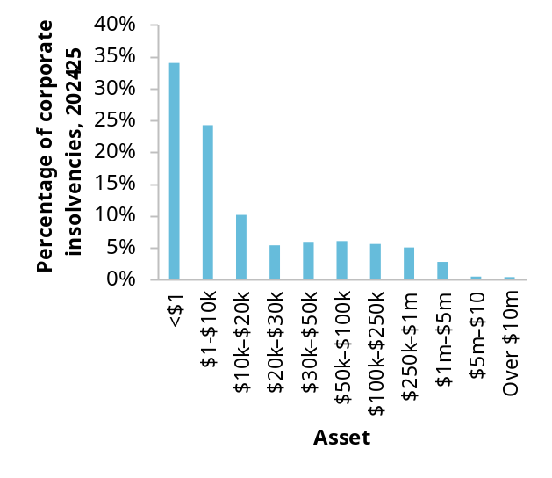 | Most personal insolvencies have far fewer assets than liabilities 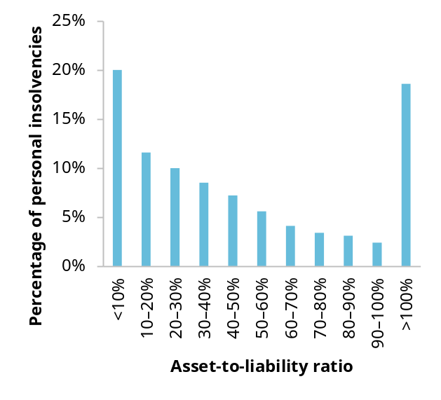
Asset-to-liability ratio is defined as assets divided by liabilities, as reported by AFSA. Percentages are normalised to businesses which provided sufficient data.
Source: ASIC (2025a); AFSA (2025).

Many businesses face barriers to recognising and acting on signs of financial distress
While many directors continue trading despite signs of financial distress, this does not necessarily mean they are deliberately ignoring them. They may instead have limited awareness, face capability constraints, be uncertain about what action to take or face financial or personal circumstances that prevent them from acting effectively, as discussed below.
Some directors may not fully understand what their duties require or the consequences of failing to comply. ASIC research found that nearly 1 in 3 small business directors had little or no understanding of the consequences of breaching their obligations, while 1 in 5 had not accessed information or sought advice about their obligations as directors (ASIC 2025c).
Even where directors recognise financial distress, determining the appropriate response can be difficult. Directors may need to assess cash flow, access to finance, creditor support and whether financial difficulties are temporary. Small businesses often lack the governance systems, financial expertise and access to professional advice needed to make these assessments confidently (SBDC WA, sub 52, p. 9; Harris and Murray, sub. 54, p. 2).
Several participants noted that businesses experiencing financial distress often cannot afford professional advice (ASBFEO, sub. 68, p. 8; FCA, sub. 60, p. 26). By the time owners seek help, voluntary administration or even small business restructuring may be financially out of reach.
Personal circumstances can further delay action. Owners may be reluctant to close a business in which they have invested substantial time, effort and personal identity, particularly where failure carries stigma or jeopardises household income (FRLC sub. 59, p. 2; FCA, sub. 60, p. 26). Many SME directors are also exposed through guarantees, personal borrowing or director penalty notices meaning liquidation may crystallise significant personal liabilities (TMAA, sub. 80, p. 10).

Enforcement alone will not encourage sufficiently early action
The PJC inquiry into the corporate insolvency system raised concerns that weaknesses in the legislative framework and insufficient enforcement by ASIC may be contributing to insolvent trading (PJC 2023, p. 212). Our inquiry has also received submissions calling for greater enforcement (AICM, p. 13; ARITA, p. 23). Greater enforcement may strengthen deterrence, but the evidence does not establish whether the current level of enforcement is inadequate. More importantly, enforcement alone cannot address the barriers to earlier action identified above. Between 2020–21 and 2025–26, ASIC commenced 284 investigations following allegations of insolvent trading (ASIC, personal communication, 23 September 2026). Of those investigations, 123 resulted in the disqualification of a director (ASIC, pers. comm., 23 September 2026). While these figures show that ASIC does take enforcement action, these actions represent a small proportion of companies entering formal insolvency each year. As a risk-based regulator, ASIC must focus its resources on the most serious matters across its regulatory portfolio, meaning enforcement is unlikely to address every instance of delayed action by distressed businesses.
The deterrent effect of enforcement is also likely to differ between directors. Directors of larger companies are more likely to be aware of the duty to prevent insolvent trading and less likely to be personally exposed to company debts through guarantees or borrowings secured against personal assets (Treasury 2021, p. 19). By contrast, many SME directors are already personally exposed and, for the reasons discussed above, may face practical barriers to complying with the duty or accessing safe harbour. They may also be less aware of enforcement risks, having less access to professional advisers.
Regulatory theory suggests that enforcement is only one element of an effective compliance strategy. Regulators typically rely heavily on education, guidance and other interventions designed to address the underlying causes of non-compliance with legislation (Ayres and Braithwaite 1992, p. 35). Awareness of an obligation and the ability to comply with it are generally regarded as prerequisites to compliance (Winter and May 2001, p. 680).
This does not mean that enforcement is unimportant. Rather, greater enforcement would not address barriers such as limited awareness of directors’ duties, difficulty recognising financial distress or inability to obtain advice. Improving information and support is therefore an important complement to enforcement. Businesses should be given practical information about warning signs of financial distress, directors’ obligations and the options available to address financial difficulties. Consistent with the broader reforms proposed in chapter 3, that information should be provided at points where it is most likely to influence behaviour.

Finding 8.1
Delayed action often reflects barriers beyond the design of the insolvent-trading regime
Many SME directors respond to financial distress too late because of barriers beyond the insolvent-trading regime, including limited awareness of obligations, difficulty recognising financial distress and the cost of advice.

The ATO should help businesses recognise warning signs of financial distress through timely prompts
As discussed in chapter 3, there is a role for government in using existing touchpoints to help businesses recognise emerging problems and connect with appropriate support. The ATO is well-placed to identify early signs that may be associated with financial distress. It is a major creditor in many insolvencies and can observe when businesses begin missing tax lodgements or payments. As noted above, unpaid statutory debts appear in 84% of reports lodged with ASIC. While a missed lodgement or payment does not necessarily indicate financial distress, it can be an early warning sign that a business should assess its financial position more closely.
The ATO could use its interactions with businesses to encourage them to assess their financial position and seek assistance. Information provided could explain that non-compliance with obligations may be a warning sign of financial difficulty and identify sources of guidance and support.
The timing and content of the information should reflect the number of missed obligations and the size and duration of any debt. Initial communications could be brief and informational, with more targeted prompts where warning signs accumulate.
This approach would not require the ATO to determine whether a business is insolvent or provide detailed financial advice. Rather, it would use information it already holds to help directors and business owners recognise warning signs and assess their own financial position. This would complement reforms proposed in chapter 1 aimed at harnessing regtech and AI to support businesses in meeting their obligations.

Reform direction 8.1
The ATO should provide information to prompt businesses to assess their financial position
To encourage earlier responses to financial distress and reduce risk of insolvency, the ATO should provide clear, practical information to businesses when they have missed lodgements or tax payments. Communications should prompt businesses to assess their financial position, understand their obligations and identify credible sources of advice and support. The timing and content of these communications should be informed by analysis of ATO data on risk factors associated with future insolvency.

The accessibility of safe harbour can be improved
Safe harbour supports business dynamism by increasing the chances that viable companies will be turned around. However, safe harbour appears to be more accessible to larger companies than to small and medium enterprises (SMEs). Larger companies are more likely to know about safe harbour, to have access to professional advice, maintain systems to monitor solvency and have the resources needed to implement a turnaround strategy (Nalavadi, sub. 13, p. 5; ARITA, sub. 71, p. 27).
Safe harbour can be difficult for many SMEs to use. Directors seeking protection need to identify financial difficulties, develop a turnaround strategy and maintain records to demonstrate that the strategy was reasonably likely to produce a better outcome than immediate liquidation or administration. The Safe Harbour Review found that the cost of obtaining advice and the complexity of the regime constrained its use by SMEs (Treasury 2021, p. 23).
The introduction of small business restructuring (SBR) in 2021 changed this landscape. SBR provides eligible companies with a lower-cost restructuring pathway and protection from insolvent trading liability while a restructuring plan is developed and implemented (Bull et al., sub. 6, p. 13). As a result, some earlier concerns about SME access to safe harbour may be less significant than when the Safe Harbour Review was conducted in 2021.
However, not all SMEs are eligible for SBR. The remaining challenge is therefore likely to be for companies that exceed the SBR debt threshold of $1 million but lack the financial resources, professional advice and governance capability available to larger companies.
The Australian Government responded to the Safe Harbour Review in March 2022 (Treasury 2022). A number of recommendations were implemented through legislative amendments in 2024 (Australian Government 2026b, p. 5). In addition, the Government agreed to recommendations 1, 5, 7 and 11, which involve amendments to the Corporations Act 2001. These recommendations would:
- improve guidance and educational material for directors
- clarify how safe harbour operates in practice
- make it easier for directors to determine whether they can rely on the protection of safe harbour
- improve certainty around eligibility requirements.
The government also indicated that it would consider ways to give effect to recommendations 10 and 12, which would further clarify eligibility criteria.
Progressing the remaining recommendations would help address the accessibility issues identified in this inquiry.
ASIC’s Regulatory Guide 217: Duty to prevent insolvent trading: Guide for directors (RG217), issued in response to recommendation 4, provides a comprehensive explanation of the insolvent trading and safe harbour provisions. Although the guide itself is technical and may be difficult for SME directors to engage with, ASIC has recently made information about insolvent trading and safe harbour available through the Small Business Director Essentials hub on its website. This information is much simpler than RG217 and includes practical examples. Over time it may prove helpful in assisting SME directors to take action in response to their company’s financial difficulties.

Reform direction 8.2
Improve directors’ understanding and use of safe harbour
To improve access to safe harbour for directors of financially distressed businesses, the Australian Government should implement recommendations 1, 5, 7 and 11 of the Safe Harbour Review, which are directed towards improving guidance, clarifying how safe harbour operates in practice and making the regime easier for directors to understand and use.
The Australian Government should also progress consideration of recommendations 10 and 12, which would provide greater certainty about eligibility for safe harbour protection.

Provide an exit route for insolvent companies with no assets

Some insolvent companies cannot access an orderly exit
Some participants have raised concerns about the potential for some companies to cease trading but be unable to exit through an insolvency process due to an inability to fund a winding up (FCA, sub. 60, p. 26; Harris and Murray, sub. 54, p. 4). Such firms are sometimes referred to as ‘zombie companies’. Concerns have also been raised about the integrity of the process for removing a company from the companies register (box 8.1).
As of 2022–23, approximately 120,000 non-operating companies retained a registered Australian Business Number, with over 19,000 additional companies entering this status each year (figure 8.2). We have referred to such companies as ‘dormant’. A portion of these dormant companies will also be zombie companies. In total, these dormant companies are estimated to hold potential liabilities of almost $34 billion (ABS 2026c).
Figure 8.2 – The number of dormant companies is significant and growing
PC estimates of the number of companies which are neither operating nor have been deregistered from 2006–07 to 2022–23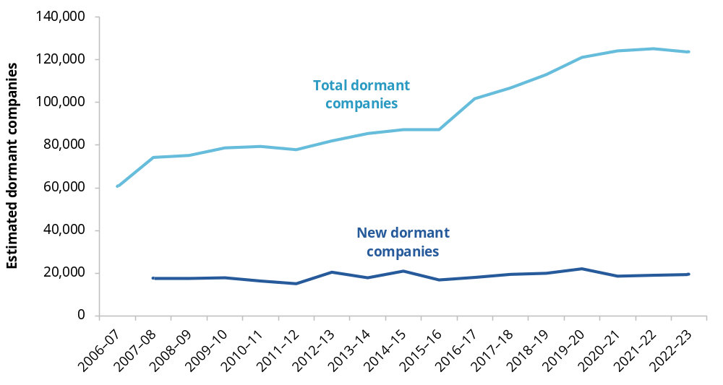Dormant companies are defined as those which continue to be recorded in ATO business income and activity tax datasets but which have been classified by the ABS as non-operating in two consecutive years (due to having failed to report certain tax information). Figures are adjusted to account for the probability of an inactive company returning to operating in the future.
Source: PC analysis of ABS (2026c).

Box 8.1 – Concerns about the deregistration of indebted companies
CA ANZ raised concerns that insolvent companies may be using deregistration to avoid the scrutiny associated with formal insolvency processes and suggested that ASIC seek notice from the ATO if companies being deregistered have a tax debt (sub. 27, p. 4).
As discussed in chapter 4, voluntary deregistration provides a simple exit pathway for companies that have ceased operating and have no outstanding liabilities. Insolvent companies with unpaid debts should be wound up rather than deregistered.
ASIC also initiates deregistration where companies fail to meet basic obligations, such as paying annual review fees. In 2024–25, ASIC initiated approximately 60,000 deregistrations while about 99,000 companies applied for voluntary deregistration (ASIC, personal communication, 2 October 2026).
To reduce the risk that indebted companies are deregistered without scrutiny, ASIC publishes notices of proposed deregistration and shares companies register data with the ATO, which includes those companies that have a status of SOFF (strike-off action) denoting those companies that are being deregistered (ASIC, pers. comm., 9 October 2026). In appropriate circumstances, (such as where it is taking active compliance or debt recovery action), the ATO will send a request to ASIC to defer strike-off action (ATO pers. comm., 12 October 2026).
On the available evidence there appear to be processes in place between ASIC and the ATO that allow the ATO to prevent the deregistration of a company where appropriate.
Zombie companies exist because the corporate insolvency system relies on private insolvency practitioners who must recover the cost of their work. If a company has too few assets to cover those costs, it may be difficult to formally wind it up (AIIP, sub. 73, p. 3). The personal insolvency system does not have this problem, as it provides an Official Trustee that can administer a bankrupt estate where a private trustee is not appointed.

Barriers to exit for insolvent companies can impede business dynamism
Where insolvent companies cannot access a formal winding-up process, owners may be left unable to conclude a failed business. Some continue attempting to sustain businesses with little prospect of recovery because they lack a practical means of bringing the business to an end (FCA, sub. 60, p. 26). As a result, time, effort and personal resources can remain tied up in unviable businesses while employee entitlements are depleted and tax debts continue to accumulate. Financial Counselling Australia shared the story of a couple in this situation who were eventually forced to live in a converted office, facing homelessness because they lacked the resources to undertake a formal insolvency process (sub. 60, p. 21).
The inability to complete an orderly exit can prevent people moving on to new opportunities. Directors may remain exposed to unresolved company liabilities including director penalty notices relating to outstanding tax debts (Harris and Murray, sub. 54, p. 4).
Barriers to exit also affect the integrity of the insolvency system. Formal liquidation includes investigation and reporting functions that may identify misconduct, voidable transactions or recoverable assets. Where no liquidator is appointed, these functions may not occur. Although not every assetless company involves misconduct, providing an accessible winding-up pathway would improve the system’s ability to identify the matters that warrant further investigation.

An Official Liquidator would provide a liquidation pathway of last resort
A redesigned simplified liquidation process could reduce the cost of winding up companies with straightforward affairs and few assets. Chapter 6 considers options to make simplified liquidation faster and cheaper, including a largely administrative process for eligible low-risk companies. However, even a much cheaper process would still require someone to administer it. For companies with no available assets, lower costs alone may not secure an appointment.
A more direct response would be to establish an Official Liquidator as a public provider of last resort. The Official Liquidator could wind up insolvent companies that cannot fund a private appointment, ensuring that a formal exit pathway does not depend entirely on the company’s remaining assets. Some inquiry participants supported a publicly funded liquidator.
The Official Liquidator would provide a corporate equivalent of the Official Trustee in personal insolvency. It would not replace registered liquidators. Private practitioners would continue to administer cases where sufficient assets or funding exist. Where assets were identified, or specialist investigation was required, the Official Liquidator could transfer the matter to a registered liquidator. Matters involving suspected misconduct could be referred to ASIC.
The Assetless Administration Fund (AAF) could support this model. The Fund currently finances preliminary investigations where enforcement action may result but is not designed to fund winding up appointments. Under the proposed model, the Official Liquidator, simplified liquidation process and AAF would perform complementary roles, as summarised in table 8.1.
Similar arrangements exist overseas. In New Zealand, the Official Assignee can be appointed as liquidator in a court-ordered liquidation where no private liquidator has consented to act (NZ Insolvency and Trustee Service nd). In the United Kingdom, the Official Receiver is appointed in court-ordered liquidations and may either complete the winding up or transfer it to a private insolvency practitioner (UK Insolvency Service nd). These examples demonstrate that public provision can coexist with a private insolvency profession.
Table 8.1 – Operation of proposed Official Liquidator
Proposed role of Official Liquidator | Purpose
Appointed as liquidator to companies eligible for simplified liquidation. | Provides an orderly exit for insolvent companies that cannot fund a private liquidator.
Appointed in court-ordered winding up where no consent filed by registered liquidator. | Enables creditors to seek the winding up of assetless companies where registered liquidators may decline an appointment.
Carries out basic review of director conduct and company affairs. | Provides basic scrutiny of companies that might otherwise exit without formal investigation.
Refers misconduct/complex matters to registered liquidator and makes funding available from expanded AAF if insufficient assets in company. | Uses private sector expertise for matters requiring more substantial investigation or recovery action.
Refers misconduct to ASIC. | Brings potentially actionable misconduct to the regulator’s attention.

Reform direction 8.3
Government should establish an Official Liquidator
To ensure insolvent companies can access an orderly exit regardless of their asset position, the Australian Government should establish an Official Liquidator for companies that meet eligibility criteria and cannot reasonably fund the appointment of a registered liquidator.
The Official Liquidator should act as a liquidator of last resort for insolvent companies that cannot reasonably fund the appointment of a registered liquidator. It should be able to transfer matters to a registered liquidator where assets are identified or specialist investigation is required, and administer the Assetless Administration Fund.
The effectiveness of the Official Liquidator in providing an accessible pathway for winding up assetless companies should be reviewed after five years.

Make illegal phoenixing laws work better
Illegal phoenixing occurs when an existing company transfers its business and assets to a new company for little or no value. The existing company is then liquidated or otherwise abandoned, making it difficult for its creditors (including employees) to recover debts. Often, the new company is run by the same managers as the existing company (ASIC 2026e).
Evidence presented to previous studies suggests that illegal phoenixing is most prevalent in the construction, labour hire and security industries (ATO 2022, p. 8).
The integrity of the insolvency system depends on its participants complying with their legal obligations and creditors having confidence that misconduct will be detected and addressed. Illegal phoenixing undermines this by allowing directors to avoid liabilities and reducing the likelihood that creditors will recover what they are owed.
Illegal phoenixing also affects the wider economy, creating an ‘uneven playing field, where honest businesses who pay their tax, superannuation, suppliers and subcontractors, are not able to compete’ (PJC 2023, p. 213). Businesses that engage in illegal phoenixing may ‘unfairly gain a larger share of the market’ (Anderson et al. 2014, p. 42) and push efficient and innovative competitors out.
Our terms of reference ask us to review the operation of Schedules 1, 3 and 4 of the Treasury Laws Amendment (Combatting Illegal Phoenixing) Act 2020 (the Act), which was enacted to provide regulators with additional tools to combat illegal phoenixing.
- Schedule 1 created a new regime relating to creditor-defeating dispositions (CDDs).
- Schedules 3 and 4 provided the Commissioner of Taxation with new powers to help the ATO improve tax compliance.
This section examines each of these reforms in turn. Other measures to combat illegal phoenixing (such as director identification numbers and the Phoenix Taskforce, box 8.2) are not in scope for this review.

Box 8.2 – Other measures to combat illegal phoenixing
Director identification numbers
The director identification (director ID) regime was introduced by the Treasury Laws Amendment (Registries Modernisation and Other Measures) Act 2020 (Cth). Company directors are required to obtain, and are assigned, a single, unique director ID for life. The intention is to allow regulators to trace a director’s association with multiple companies over time (ABRS 2025). The director ID database is managed by the Australian Business Registry Services and director ID obligations are enforced by ASIC.
Since the regime was introduced, 3 million directors have obtained a director ID (Treasury 2025a, p. 5).
The Treasury Laws Amendment (Business Registries Stabilisation and Uplift) Act 2026 (Cth), enacted 30 June 2026, will facilitate the linking of director IDs to the Companies Register. This is intended to ‘strengthen transparency and corporate accountability, and enable regulators, businesses and the public to check directors’ identities and trace their relationships across corporate entities more easily’, assisting to identify and combat illegal phoenixing (Explanatory Memorandum, Treasury Laws Amendment (Business Registries Stabilisation and Uplift) Bill 2026, pp. 3–4).
The Phoenix Taskforce
The Phoenix Taskforce is a multi-agency taskforce that was established in 2014 to detect, deter and disrupt illegal phoenix activity (ATO 2026c). The taskforce has 45 member agencies and is led by the ATO. Other members include federal, state and territory agencies, such as ASIC.
Taskforce agencies share information and use data-matching techniques to identify people and organisations that facilitate or engage in illegal phoenixing. Once identified, the taskforce acts to disrupt their business model, apply financial penalties and, in some cases, prosecute offenders.
As the Taskforce’s lead agency, the ATO runs the Phoenix Compliance program. As at 30 June 2026, the program had ‘raised more than $3.26 billion in liabilities from audits and reviews’ (ATO 2026c).

Creditor-defeating dispositions
A CDD occurs when property is disposed of for less than its market value (or, if lower, the best price reasonably obtainable) which has the effect of preventing, hindering or delaying the property from becoming available for the benefit of the company’s creditors (Corporations Act 2001 (Cth), s 588FDB). The 2020 illegal phoenixing reforms inserted new mechanisms for dealing with CDDs into the Corporations Act.
- New criminal offences and civil penalty provisions were introduced, directed at officers and other persons who engage in conduct resulting in a CDD (ss 588GAB, 588GAC).
- CDDs were added as a new category of voidable transaction (s 588FE(6B)), allowing courts to make orders to reverse their effect in certain circumstances. Separately, ASIC was given powers to make orders to recover property or for the payment of an amount reflecting the benefit received (s 588FGAA) – this was intended as a cost-effective alternative to court proceedings (ASIC, sub. 69, p. 31).
The Corporations Act also includes other general and corporate insolvency provisions that may be used to address illegal phoenixing activity.
- Directors and company officers who engage in illegal phoenixing may be held liable for breaching general directors’ duties, such as the duty to act in good faith (ASIC 2016).
- Liquidators may apply to the court to make orders to reverse the effect of illegal phoenixing transactions, including under the uncommercial transactions (s 588FB) and unreasonable director-related transactions provisions (s 588FDA).
In 2018, PwC estimated that illegal phoenixing had resulted in unpaid debts and government compliance costs of between $2.85 billion and $5.13 billion in 2015–16 (PwC Australia 2018, p. 15). In 2024, ATO modelling using a different methodology estimated that illegal phoenixing resulted in unpaid debts and government compliance costs of about $4.9 billion annually (ATO 2026f). Based on these figures, it is evident that illegal phoenixing continues to be a prevalent issue, even after the 2020 anti-phoenixing amendments.

CDD offences and civil penalty provisions
Relatively few reports of CDD-related conduct are made each year (table 8.2). By contrast, reports about breaches of general directors’ duties number consistently in the thousands.
Unreleased data shows that ASIC commences a small number of illegal phoenixing investigations each year (table 8.3). As a consequence, the number of criminal convictions and director disqualifications relating to illegal phoenixing are also consistently low (table 8.4).
Table 8.2 – Reported potential breaches of CDD duties
Type of report | 2023–24 | 2024–25
Officers’ duty to prevent CDDs (s 588FDB) | 35 | 70
Prohibition on procuring CDDs (s 588GAC) | 20 | 152
Comparator: Directors’ duties | 4,864 | 6,760
Source: ASIC (2024b, 2025b).
Table 8.3 – Investigations commenced relating to illegal phoenixing
Investigation type | 2021–22 | 2022–23 | 2023–24 | 2024–25^{c} | 2025–26
Section 184ª | 3 | 7 | 1 | 8 | 6
CDD^{b} | 1 | 5 | 3 | 9 | 2
Total (by year) | 4 | 12 | 4 | 17 | 8
There is no statutory definition of illegal phoenixing activity, so matters may be pursued under several different provisions of the Corporations Act. a. Section 184 investigations examine suspected criminal breaches of directors’ duties involving intentional dishonesty or recklessness. In illegal phoenixing matters, this commonly involves deliberate conduct designed to defeat creditors. Figures only include matters specifically identified and classified as involving illegal phoenix activity in ASIC’s records; there may have been other actions involving illegal phoenix activity that were not recorded as such. b. Creditor-defeating disposition (CDD) order investigations examine transactions that improperly remove company assets from the reach of creditors and may result in a creditor-defeating disposition order. c. One s 184 matter commenced in 2024–25 was commenced under both CDD and s 184 provisions for which charges have since been laid.
Source: ASIC unpublished data.
Table 8.4 – Enforcement outcomes relating to illegal phoenixing
Investigation type | 2021–22 | 2022–23 | 2023–24 | 2024–25 | 2025–26
Criminal convictions | 3 | - | - | - | -
Director disqualifications | 8 | 4 | 4 | - | 1
Total (by year) | 11 | 4 | 4 | - | 1
Illegal phoenixing-related enforcement outcomes were identified by ASIC using information contained in media releases, disqualification orders and classifications recorded in the ASIC Customer Relationship Management platform.
Source: ASIC unpublished data.
Most participants who commented on the adequacy of the CDD regime considered that further amendments to the legislation were not necessary. Instead, they said that stronger enforcement of existing provisions was needed. For example, the AICD said that it:
does not believe that any further legislative changes are necessary to the Corporations Act to address phoenixing activity at this time … we would like to see full enforcement of the existing law and penalties before law change is considered. Adding additional layers of regulation is not as effective as properly enforcing the existing law to the fullest. (sub. 41, p. 14)
In its submission, ASIC said that the CDD offences and civil penalty provisions were ‘a valuable addition to the insolvency and enforcement toolkit’ (sub. 69, p. 31). But, in practice, not all instances of illegal phoenixing are suited for litigation under the CDD provisions.
During consultation, ASIC officers explained that ASIC is a risk-based regulator and makes strategic decisions about how best to deploy its investigative and enforcement resources. Where the conduct can be addressed through an alternative offence that is more readily provable and capable of achieving an appropriate regulatory outcome, ASIC may pursue that pathway rather than undertake significant additional investigative work solely to establish the elements of a particular offence. This may include circumstances involving directors who fail to prevent a creditor-defeating disposition, or other parties who procure one, where an alternative offence can achieve an appropriate and proportionate regulatory outcome with a lower evidentiary burden (ASIC, pers. comm., 23 September 2026).
One suggested reform to make CDD actions easier to prove was to introduce a rebuttable presumption of insolvency: a company would be presumed to be insolvent unless its directors could demonstrate otherwise. This would ‘better align the evidentiary burden with information asymmetry’, shifting the onus of proving solvency to those with the best access to information and evidence about a company’s financial situation (ARITA, sub. 71, p. 22). The PC is seeking feedback on the merits and risks associated with such a reform.

Orders to recover property
The illegal phoenixing reforms also gave courts and ASIC new powers to make orders to reverse voidable CDDs. These orders may require a person to transfer back the company property that was disposed of, or transfer an amount of money that ‘fairly represents some or all of the benefits that the person received because of the disposition’ (Corporations Act, s 588FGAA).
Between 18 February 2020 and 31 May 2026, ASIC had received 48 requests from liquidators for CDD orders (ASIC, sub. 69, p. 31). Of those requests, ASIC made an order in about a third of cases and refused about a third – the remainder of cases were undetermined (awaiting determination, on hold or withdrawn). According to ASIC, ‘this level of use suggests that, while the administrative pathway has potential, it has not yet become a routine or widely used recovery tool’ (sub. 69, pp. 31–32).
It also said it had identified ‘several factors [that] appear to be constraining the practical use of the regime’, and cited:
- evidentiary challenges, particularly where a company has not maintained adequate records or does not cooperate, or where complex ownership structures make it difficult to establish beneficial ownership, identify the relevant disposition or determine the value transferred
- challenges with enforcing orders without going to court (ASIC, sub. 69, p. 31).
The PC is seeking comment on whether and what legislative amendments are needed to improve how the CDD powers operate.

Information request 8.1
Are legislative changes needed to improve the operation of the creditor-defeating disposition provisions?
The PC is seeking feedback on whether amendments to the Corporations Act 2001 (Cth) are needed to improve the operation of the provisions for combatting illegal phoenixing.
- In the context of establishing that a creditor-defeating disposition took place, is there a case for introducing a rebuttable presumption of insolvency? What would be the costs, benefits or risks of doing so?
- What are the evidentiary and enforcement issues associated with ASIC’s power to reverse creditor-defeating dispositions? What, if any, legislative amendments are needed to address these issues?

Extended tax powers
Schedules 3 and 4 of the Act provided the Commissioner of Taxation with new powers to help the ATO improve tax compliance, including in situations involving illegal phoenixing.
Inquiry participants commented solely on the ATO’s power to issue director penalty notices (DPNs), which enables the Commissioner to make directors personally liable for their company’s tax liabilities (ATO 2026a). This power is not restricted to cases involving illegal phoenixing – for example, the power can be used in cases where a company has simply failed to pay its taxes.
Participants who commented on this issue did not call for legislative change, but rather a review of how DPNs are used in practice (ARITA, sub. 71, p. 41; TMA, sub. 80, pp. 5–6). The Tax Ombudsman is currently conducting a review that will ‘explore how the ATO uses and administers DPNs and any opportunities to improve its approach’ (Tax Ombudsman 2026). On this basis, the PC has not considered this issue as part of this inquiry.

- Public engagement
This appendix provides information about the consultation process for this inquiry. It lists the organisations and individuals who contributed through consultations, submissions and public hearings.
The Productivity Commission received 92 public submissions (table A.1) and 2 brief comments. These are available at www.pc.gov.au/inquiries-and-research/business-dynamism/submissions.
The PC met with government bodies, private organisations and academics in Australia and overseas (table A.2), and held one roundtable (table A.3).
Table A.1 – Public submissions
Participant | Submission number
4 Years Terms Australia | 10
Abundium | 28
Ageing Australia | 64
Alix Ziebel Advisory | 30
Arca | 31
Association of Independent Insolvency Practitioners Limited (AIIP) | 73
Atkins, Scott and Lawless, Harry | 33
Australia Post | 77
Australian Chamber of Commerce and Industry (ACCI) | 42
Australian Credit Forum (ACF) | 56
Australian Finance Industry Association (AFIA) | 38
Australian Financial Security Authority (AFSA) | 76
Australian Institute of Company Directors (AICD) | 41
Australian Institute of Credit Management (AICM) | 49
Australian Office of Financial Management (AOFM) | 82*
Australian Restructuring Insolvency and Turnaround Association (ARITA) | 71
Australian Securities and Investments Commission (ASIC) | 69
Australian Small Business and Family Enterprise Ombudsman (ASBFEO) | 68
Australians Investing in Women (AIIW) | 79
Bull, Dr Amanda | 87*
Bull, Dr Amanda and Murray, Michael | 55
Bull, Dr Amanda; O’Neill, Morgan; Bryant, Dr Lyndall and Streten, Dr Elizabeth | 6
Business Council of Co-operatives and Mutuals (BCCM) | 63
Centre for Independent Studies (CIS) | 17
Chartered Accountants Australia and New Zealand (CA ANZ) | 27
Committee for Economic Development of Australia (CEDA) | 9
Corporate Bond Reform Working Group, The | 18
CPA Australia | 67
Crouch Amirbeaggi | 86
David Levi Consulting | 50
Department of Employment and Workplace Relations (DEWR) | 70
Each | 44
Equity Clear | 26
Financial Advice Association of Australia (FAAA) | 43
Financial Counselling Australia (FCA) | 60
Financial Rights Legal Centre (FRLC) | 59
Financial Services Council (FSC) | 61
FinTech Australia | 24
First Australians Capital (FAC) | 29
Franchise Council of Australia | 74
Governance Institute of Australia (GIA) | 51
GraceX | 1
Harris, Dr Jason and Murray, Michael | 54
Howell, Dr Nicola | 65
Indigenous Business Australia (IBA) | 8
Innovation Commons | 45
Law Council of Australia (LCA) | 88
Law Council of Australia, Business Law Section (LCA BLS) | 72
Law Society of NSW | 39
Lombard, Prof Sulette | 25
Marmotta, Gioacchino | 5
Massage and Myotherapy Australia | 4
Master Builders | 48
Master Electricians Australian (MEA) | 22
Menezes, Professor Flavio | 3
Mortgage and Finance Association of Australia (MFAA) | 34
Motor Trades Association of Australia (MTAA) | 35
Murray, Michael | 47
Nalavadi, Preeti | 13
National Australia Bank (NAB) | 62
NLM Legal | 53
NSW Small Business Commission (NSW SBC) | 36
Nunn, David | 91
Portable Long Service Authority (PLSA) | 21
Prosperity Institute | 46
Queensland Small Business Commissioner (QSBC) | 85
Regional Development Australia Gippsland (RDA Gippsland) | 78, 92
Regional Development Australia Goldfields Esperance (RDA GE) | 11
Regulatory Intelligence Lab | 7
Revealr | 58
Robinson, Dr Catherine | 12
Ruhe Group, The | 15
Scerri, Dr Moira | 83
Sinha, Aryaman | 14
Small Business Development Corporation Western Australia (SBDC WA) | 52, 90
Spencer, Dr Adam | 75
Strategic Examination of Research and Development Independent Panel (SERDIP) | 32
Suchard, Jo-Ann | 89
Surveyors Australia | 16
Tech Council of Australia (TCA) | 66
Turnaround Management Association Australia (TMA) | 80
UNSW Centre for Social Impact (UNSW CSI) | 57
UNSW Tax and Business Advisory Clinic (UNSW TBAC) | 40
Vox Femina | 20
Wilson Asset Management (WAM) | 23
Women in Business (Mornington Peninsula and Frankston) | 81
Xero | 19
Young, Brian | 84
Name withheld | 2
Name withheld | 37
* Confidential submission.
Table A.2 – Consultations
Participants
Abundium
Advanced Manufacturing Growth Centre (AMGC)
AICD/APRA Forum
Airtree
Allan, Steve
Association of Independent Insolvency Practitioners Limited (AIIP)
Australian Banking Association (ABA)
Australian Business Securitisation Fund (ABSF)
Australian Chamber of Commerce and Industry (ACCI)
Australian Charities and Not-for-profits Commission (ACNC)
Australian Competition and Consumer Commission (ACCC)
Australian Council of Trade Unions (ACTU)
Australian Financial Security Authority (AFSA)
Australian Financial Security Authority Small Business Consultative Forum
Australian Industry Group (Ai group)
Australian Institute of Company Directors (AICD)
Australian Institute of Company Directors Law Committee
Australian Institute of Credit Management (AICM)
Australian Investment Council (AIC)
Australian Office of Financial Management (AOFM)
Australian Restructuring Insolvency and Turnaround Association (ARITA)
Australian Securities and Investments Commission (ASIC)
Australian Small Business and Family Enterprise Ombudsman (ASBFEO)
Australian Taxation Office (ATO)
Banjo Loans
Blackbird
Bull, Dr Amanda and Murray, Michael
Business British Bank
Business Council of Australia (BCA)
Chartered Accountants Australia and New Zealand Insolvency Practitioners Forum
Carreb
Committee for Economic Development of Australia (CEDA)
Chartered Accountants Australia and New Zealand (CA ANZ)
Council of Small Business Organisations Australian (COSBOA)
CSIRO Main sequence
David Teece and Kieran Brown
Department of Employment and Workplace Relations (DEWR)
Dept of Finance (DoF)
Dept of Prime Minister and Cabinet (PMC)
Dept of Treasury
Dilin Duwa Centre for Indigenous Business Leadership
Department of Industry, Science and Resources (DISR)
E61
Equity Clear
Finance Brokers Association of Australasia (FBAA)
Financial Counselling Australia (FCA)
Financial Rights Legal Centre (FRLC)
FinTech Australia
First Australians Capital (FAC)
First Nations Economic Partnership
First Nations Economics
First Nations Foundations
Fluency
Future Skills Organisation
Gouletsas, Leon
Hacker Exchange
Indigenous Business Australia (IBA)
International Insolvency Institute
Judo Bank
Justice Connect
Law Council Charities and Not-for-profits Commission
Law Council of Australia (LCA)
New Zealand Insolvency and Trustee Service
NSW Small Business Commission (NSW SBC)
Organisation for Economic Co-operation and Development (OECD)
Office of the Registrar of Indigenous Corporations (ORIC)
Phoenixing taskforce
Pitcher Partners
PPR Capital
Precision Economics
Psomos, Maria
Queensland Small Business Commissioner (QSBC)
Queensland University of Technology
Reserve Bank of Australia (RBA)
Robb, Joshua
RMIT Food Innovation Hub
Small Business Development Corporation Western Australia (SBDC WA)
Small Business Victoria and Small Business Commissioner (SBV/SBCV)
Suchard, Jo-Ann
Tax Ombudsman
Tech Council of Australia (TCA)
Teece, David and Brown, Kieran
Trenfield, Kelly
Turnaround Management Association Australia (TMA)
UK Insolvency Service
UTS Business School
Victorian Business Monitor
Webster, Beth
Women in Business (Mornington Peninsula and Frankston)
Xero

Table A.3 – Roundtable
Purposes, objectives and principles for Australia’s insolvency system (19 August 2026)
Name | Organisation
Atkins, Scott | Norton Rose Fulbright
Bull, Amanda | Queensland University of Technology
Davis, Helen | Financial Counselling Australia
Howell, Nicola | Queensland University of Technology
Jeremiah, Melissa | Australian Restructuring Insolvency & Turnaround Association
Mitchell, Simon | Australian Institute of Company Directors
Murray, Michael | Murray’s Legal
Peace, Chris | Blackwall Legal; Law Council of Australia
Pilavidis, Nick | Australian Institute of Credit Management
Preston, Jason | McGrathNicol; Turnaround Management Association
Storer, Aiden | Australian Small Business and Family Enterprise Ombudsman

References

ABA (Australian Banking Association) 2022, Submission to the Parliamentary Joint Committee on Corporations and Financial Services inquiry into corporate insolvency in Australia, sub. 23.
ABLIS (Australian Business Licence and Information Service) 2026, ABLIS database, ablis.business.gov.au/ (accessed 19 October 2026).
—— unpublished, ABLIS data extract (9th July 2026).
—— nd, Disclaimer, ablis.business.gov.au/disclaimer (accessed 13 October 2026).
ABRS (Australian Business Registry Services) 2025, About director ID, www.abrs.gov.au/director-identification-number/about-director-id (accessed 2 October 2026).
ABS (Australian Bureau of Statistics) 2007, Counts of Australian Businesses, Including Entries and Exits, Jun 2003 to Jun 2007, www.abs.gov.au/AUSSTATS/abs@.nsf/Lookup/
8165.0Main+Features1Jun%202003%20to%20Jun%202007?OpenDocument (accessed 20 October 2026).
—— 2009, Counts of Australian Businesses, Including Entries and Exits, Jun 2007 to Jun 2009, www.abs.gov.au/AUSSTATS/
abs@.nsf/Lookup/8165.0Main+Features1Jun%202007%20to%20Jun%202009?OpenDocument (accessed 20 October 2026).
—— 2013, Counts of Australian Businesses, Including Entries and Exits , Jun 2009 to Jun 2013, www.abs.gov.au/AUSSTATS/
abs@.nsf/Lookup/8165.0Main+Features1Jun%202009%20to%20Jun%202013?OpenDocument (accessed 20 October 2026).
—— 2017, Management and Organisational Capabilities of Australian Business, 2015-16 Financial Year, 25 August, Australian Bureau of Statistics, www.abs.gov.au/statistics/
economy/business-indicators/management-and-organisational-capabilities-australian-business/latest-release (accessed 15 September 2026).
—— 2018, Counts of Australian Businesses, Including Entries and Exits, Jun 2013 to Jun 2017, www.abs.gov.au/AUSSTATS/
abs@.nsf/Lookup/8165.0Main+Features1Jun%202013%20to%20Jun%202017?OpenDocument (accessed 20 October 2026).
—— 2021, Counts of Australian Businesses, Including Entries and Exits, July 2017 – June 2021, www.abs.gov.au/statistics/
economy/business-indicators/counts-australian-businesses-including-entries-and-exits/jul2017-jun2021 (accessed 20 October 2026).
—— 2022, Unpaid work and care: Census, 2021, www.abs.gov.au/statistics/people/people-and-communities/unpaid-work-and-care-census/latest-release (accessed 6 October 2026).
—— 2025, Counts of Australian Businesses, Including Entries and Exits, July 2021 – June 2025, www.abs.gov.au/statistics/
economy/business-indicators/counts-australian-businesses-including-entries-and-exits/jul2021-jun2025 (accessed 19 October 2026).
—— 2026a, Counts of Australian Businesses, Including Entries and Exits, July 2022 – June 2026, www.abs.gov.au/statistics/
economy/business-indicators/counts-australian-businesses-including-entries-and-exits/jul2022-jun2026 (accessed 29 September 2026).
—— 2026b, Job Mobility, February 2026, www.abs.gov.au/
statistics/labour/jobs/job-mobility/latest-release#data-downloads (accessed 29 September 2026).
—— 2026c, Microdata: Business Longitudinal Analysis Data Environment, BLADE.
ACCC (Australian Competition and Consumer Commission) 2025, National Australia Bank pays $751,200 in penalties for alleged breaches of Consumer Data Right rules, 19 June, accessed 19 October 2026.
ACCI (Australian Chamber of Commerce and Industry) 2025, 2025 small business conditions report.
—— 2026, 2026-27 Pre-Budget submission.
ACDBA (Australian Collectors & Debt Buyers Association) 2022, Submission to the Attorney-General’s Department’s consultation on possible reforms to the bankruptcy system, sub. 77.
ACOR (Australian Council of Recycling) 2026, Submission to the Productivity Commission Inquiry into non-financial business reporting requirements.
ACT Government 2026, Start a business in Canberra, www.act.gov.au/business/start-a-business-in-canberra (accessed 12 October 2026).
Adams, N, Andrews, D, Auer, J, Dwyer, E, Hayward, Z, Kaplan, G, La Cava, G, Michielsen, A and Nolan, M 2022, Better harnessing Australia’s talent: five facts for the Summit, September, E61.
ADHA (Australian Digital Health Agency) 2026, Provider Connect Australia, www.digitalhealth.gov.au/healthcare-providers/initiatives-and-programs/provider-connect-australia (accessed 12 October 2026).
AFSA (Australian Financial Security Authority) 2025, State of the personal insolvency system 2024-25, Canberra.
—— 2026a, Consequences of bankruptcy, Canberra, www.afsa.gov.au/i-cant-pay-my-debts/bankruptcy/
consequences-bankruptcy (accessed 22 October 2026).
—— 2026b, Protect your ideas and intangible assets, accessed 19 October 2026.
—— 2026c, Quarterly personal insolvency statistics, June 2026.
—— 2026d, What is bankruptcy?, www.afsa.gov.au/i-cant-pay-my-debts/bankruptcy/what-bankruptcy (accessed 1 October 2026).
Agarwal, R, Toner, P, Bajada, C, Li, WH, Paul, S, Green, R, Phan, YP and Pugalia, S 2021, ‘A scoping project to assess and evaluate active Australian government-supported business management advisory services’, UTS, International literature review and scoping study of business advisory services.
AGD (Australian Government Attorney General’s Department) 2023, Personal insolvency discussion paper.
—— 2024, Personal insolvency consultation – Minimal asset procedure.
Aghion, P, Fally, T and Scarpetta, S 2007, ‘Credit constraints as a barrier to the entry and post-entry growth of firms’, Economic Policy, vol. 22, no. 52, pp. 732–779.
AIIP (Association of Independent Insolvency Practitioners) 2022, Submission to the Parliamentary Joint Committee on Corporations and Financial Services inquiry into corporate insolvency in Australia, sub. 20.
Allinson, G, Robson, P and Stone, I 2013, Economic evaluation of the enterprise finance guarantee (EFG) scheme, UK Department for Business, Innovation and Skills.
Almi 2026, Business loans from Almi to grow your company, Almi website, accessed 16 September 2026.
ALRC (Australian Law Reform Commission) 1988a, General insolvency inquiry, 45, Canberra.
—— 1988b, Summary of report - General insolvency inquiry, 45, Canberra.
—— 2008, For your information: Australian privacy law and practice, 108, Australian Government, Sydney.
ANAO (Australian National Audit Office) 2026, Australian Taxation Office management of small business collectable debt, Australian National Audit Office, Canberra.
Anderson, H, O’Connell, A, Ramsay, I, Welsh, M and Withers, H 2014, Defining and profiling phoenix activity.
Anderson, J and Davis, K 2009, ‘Employee entitlements and secured creditors: assessing the effects of the maximum priority proposal.’, University of New South Wales, Australian Journal of Management (University of New South Wales), vol. 34, no. 1, pp. 51–71.
Anderson, SJ, Chandy, R and Zia, B 2018, ‘Pathways to profits: the impact of marketing vs. finance skills on business performance’, Management Science, vol. 64, no. 12, pp. 5559–5583.
APRA (Australian Prudential Regulation Authority) 2020a, APRA explains risk-weighted assets, APRA website, accessed 22 October 2026.
—— 2020b, Capital, www.apra.gov.au/capital, accessed 15 September 2026.
—— 2023, Proposed changes to modernised Economic and Financial Statistics reporting standards and guidance, www.apra.gov.au/news-and-publications/proposed-changes-modernised-economic-and-financial-statistics-reporting, accessed 13 October 2026.
—— 2025, APS 112 capital adequacy: standardised approach to credit risk, accessed 13 September 2026.
—— 2026, Quarterly superannuation industry publication, June, www.apra.gov.au/news-and-publications/quarterly-superannuation-industry-publication (accessed 9 October 2026).
Araujo, G and Hambur, J 2018, ‘Which firms get credit evidence from firm level data’, Reserve Bank of Australia, Australia, RBA Bulletin, December, pp. 1–22.
ARITA (Australian Restructuring Insolvency & Turnaround Association) 2022a, Submission to the Attorney-General’s Department’s consultation on possible reforms to the bankruptcy system, sub. 83.
—— 2022, Submission to the Parliamentary Joint Committee on Corporations and Financial Services inquiry into corporate insolvency in Australia, sub. 36.
—— 2024a, First step reforms.
—— 2024b, Submission to the Attorney General’s Department’s personal insolvency consultation: Minimal asset procedure, sub. 7.
ASBFEO (Australian Small Business and Family Enterprise Ombudsman) 2022, Submission to the Parliamentary Joint Committee on Corporations and Financial Services inquiry into corporate insolvency in Australia, sub. 31.
—— 2023, Small business matters.
—— 2026, Recognise enterprising women in small and family business by removing bias and barriers, accessed 9 October 2026.
Ashurst 2022, Submission to the Parliamentary Joint Committee on Corporations and Financial Services inquiry into corporate insolvency in Australia, sub. 26.
ASIC (Australian Securities and Investments Commission) 2016, Illegal phoenix activity, www.asic.gov.au/about-asic/news-centre/articles/illegal-phoenix-activity (accessed 12 October 2026).
—— 2024a, Review of simplified liquidations: 2021–2023, Report 789.
—— 2024b, Series 3: External administrator reports, Series 3.1 for 2023-24.
—— 2025a, Review of small business restructuring process: 2022–24, Report 810.
—— 2025b, Series 3: External administrator reports, Series 3.1 for 2024-25, download.asic.gov.au/media/5codze5r/2024-2025-asic-insolvency-statistics-series-3-1.xlsx (accessed 1 October 2026).
—— 2025c, Small business directors: Understanding director obligations.
—— 2026a, 26-180MR ASIC launches small business strategy, helping to educate and protect small businesses, [media release], www.asic.gov.au/about-asic/news-centre/find-a-media-release/2026-releases/26-180mr-asic-launches-small-business-strategy-helping-to-educate-and-protect-small-businesses (accessed 20 October 2026).
—— 2026b, 26-181MR ASIC launches new digital resources for small business directors, [media release], www.asic.gov.au/
about-asic/news-centre/find-a-media-release/2026-releases/26-181mr-asic-launches-new-digital-resources-for-small-business-directors (accessed 7 October 2026).
—— 2026c, ASIC announces stamp duty disclosure changes.
—— 2026d, ASIC small business strategy.
—— 2026e, Phoenix activity, www.asic.gov.au/about-asic/asic-investigations-and-enforcement/asic-action-on-phoenix-activity/phoenix-activity (accessed 1 October 2026).
—— 2026f, Quarterly registered liquidator statistics, Series 4, Australian Government, www.asic.gov.au/about-asic/
corporate-publications/statistics/insolvency-statistics (accessed 18 September 2026).
—— 2026g, Series 1 and 2: Insolvency statistics.
—— 2026h, Series 3: External administrator reports, Series 3.3: Time Series, download.asic.gov.au/media/w2opzrd3/2024-2025-asic-insolvency-statistics-series-3-3.xlsx (accessed 1 October 2026).
—— 2026i, Series 5: Members’ voluntary liquidation statistics, www.asic.gov.au/about-asic/corporate-publications/
statistics/insolvency-statistics (accessed 21 October 2026).
—— 2026j, Small business restructuring and the restructuring plan, www.asic.gov.au/regulatory-resources/insolvency/
insolvency-for-directors/small-business-restructuring-and-the-restructuring-plan (accessed 1 October 2026).
—— 2026k, Wind up an insolvent company, www.asic.gov.au/for-business-and-companies/companies/
company-deregistration-and-winding-up/wind-up-an-insolvent-company (accessed 8 October 2026).
ATO (Australian Taxation Office) 2021, What STP is, www.ato.gov.au/businesses-and-organisations/hiring-and-paying-your-workers/single-touch-payroll/what-is-stp (accessed 21 October 2026).
—— 2022, Submission to the Parliamentary Joint Committee on Corporations and Financial Services inquiry into corporate insolvency in Australia, sub. 35.
—— 2024, About the tax incentives for early stage investors, www.ato.gov.au/businesses-and-organisations/income-deductions-and-concessions/incentives-and-concessions/
tax-incentives-for-innovation/tax-incentives-for-early-stage-investors/about-the-tax-incentives-for-early-stage-investors (accessed 12 October 2026).
—— 2025, Disclosure of business tax debts, Canberra, www.ato.gov.au/individuals-and-families/paying-the-ato/if-you-don-t-pay/firmer-action-we-may-take/disclosure-of-business-tax-debts (accessed 7 October 2026).
—— 2026a, Director penalties, www.ato.gov.au/individuals-and-families/paying-the-ato/if-you-don-t-pay/firmer-action-we-may-take/director-penalty-regime (accessed 2 October 2026).
—— 2026b, How we’re engaging with new businesses, www.ato.gov.au/businesses-and-organisations/small-business-newsroom/how-we-re-engaging-with-new-businesses (accessed 12 October 2026).
—— 2026c, Phoenix taskforce, www.ato.gov.au/about-ato/tax-avoidance/the-fight-against-tax-crime/our-focus/phoenix-activity/phoenix-taskforce (accessed 2 October 2026).
—— 2026d, Rules as code proof of concept (PoC), softwaredevelopers.ato.gov.au/RulesasCodePoC (accessed 16 October 2026).
—— 2026e, Small business restructuring, www.ato.gov.au/
tax-and-super-professionals/for-tax-professionals/your-practice/insolvency-practitioners/insolvency-processes-that-support-small-business/small-business-restructuring (accessed 1 October 2026).
—— 2026f, What is phoenix activity, www.ato.gov.au/about-ato/tax-avoidance/the-fight-against-tax-crime/our-focus/phoenix-activity/what-is-phoenix-activity (accessed 2 October 2026).
Australian Government 2019, Explanatory Memorandum: Treasury Laws Amendment (2019 Tax Integrity and Other Measures No. 1) Bill 2019, House of Representatives.
—— 2023a, Data and digital government strategy.
—— 2023b, Data and digital government strategy: what we heard.
—— 2025a, Compliance guide for data holders.
—— 2025b, Modern Slavery Act, www.modernslavery.gov.au/
australias-response/laws-and-policies/modern-slavery-act (accessed 1 October 2026).
—— 2026a, Ambitious Australia: strategic examination of R&D final report.
—— 2026b, Australian Government response to the Parliamentary Joint Committee on Corporations and Financial Services report: Corporate insolvency in Australia.
—— 2026c, Budget strategy and outlook: Budget Paper no. 1, Budget 2026-27.
—— 2026d, Government response to the independent review of the Enhanced Regulatory Sandbox.
—— 2026e, New guarantee to support Indigenous businesses, www.indigenous.gov.au/news/new-guarantee-to-support-indigenous-businesses (accessed 7 October 2026).
—— 2026f, Rollout, www.cdr.gov.au/rollout (accessed 14 September 2026).
—— 2026g, What is CDR?, www.cdr.gov.au/what-is-cdr (accessed 14 September 2026).
—— 2026h, Whole-of-government regulatory reform agenda, budget.gov.au/content/factsheets/download/factsheet-regulatory-reform.pdf (accessed 1 October 2026).
—— nd, Data share and reuse, www.legislation.gov.au/help-and-resources/using-the-legislation-register/data-share-and-reuse (accessed 16 October 2026a).
—— nd, Glossary, www.cdr.gov.au/about/glossary (accessed 8 October 2026b).
Australian Revenue Offices 2026, Resources, www.payrolltax.gov.au/resources (accessed 1 October 2026).
Ayres, I and Braithwaite, J 1992, Responsive regulation, Oxford University Press, New York.
Ayyagari, M, Demirgüç-Kunt, A and Maksimovic, V 2017, SME finance, Policy Research Working Paper, November, 8241, World Bank Group.
Bachas, N, Kim, OS and Yannelis, C 2021, ‘Loan guarantees and credit supply’, Journal of Financial Economics, vol. 139, no. 3, pp. 872–894.
Bai, J (Jianqiu), Jin, W and Serfling, M 2021, ‘Management practices and mergers and acquisitions’, Management Science, vol. 68, no. 3, pp. 2141–2165.
Berger, AN and Udell, GF 1998, ‘The economics of small business finance: the roles of private equity and debt markets in the financial growth cycle’, Journal of Banking & Finance, vol. 22, pp. 613–673.
Bick, A, Blandin, A, Deming, DJ, Fuchs-Schündeln, N and Jessen, J 2026, Mind the gap: AI adoption in Europe and the U.S., National Bureau of Economic Research, www.nber.org/
papers/w34995 (accessed 15 September 2026).
Bing nd, Webmaster guidelines, www.bing.com/webmasters/
help/webmaster-guidelines-30fba23a (accessed 12 October 2026).
Bloom, N, Brynjolfsson, E, Foster, L, Jarmin, R, Patnaik, M, Saporta-Eksten, I and Van Reenen, J 2019, ‘What drives differences in management practices?’, American Economic Review, vol. 109, no. 5, pp. 1648–1683.
——, Eifert, B, Mahajan, A, McKenzie, D and Roberts, J 2013, ‘Does management matter? Evidence from India’, The Quarterly Journal of Economics, vol. 128, no. 1, pp. 1–51.
——, Mahajan, A, McKenzie, D and Roberts, J 2020, ‘Do management interventions last? Evidence from India’, American Economic Journal: Applied Economics, vol. 12, no. 2, pp. 198–219.
—— and Van Reenen, J 2007, ‘Measuring and explaining management practices across firms and countries’, The Quarterly Journal of Economics, vol. 122, no. 4, pp. 1351–1408.
British Business Bank 2024, Evaluation of recovery loan scheme 1.0.
—— 2025, British Business Bank agrees to commit £30 million to Invest in Women Taskforce ‘Women backing Women’ fund led by Bootstrap4F, www.british-business-bank.co.uk/news-and-events/news/british-business-bank-agrees-commit-ps30-million-invest-women-taskforce-women-backing-women-fund (accessed 6 October 2026).
—— 2026, Growth Guarantee Scheme (GGS), www.british-business-bank.co.uk/finance-options/debt-finance/growth-guarantee-scheme (accessed 9 October 2026).
Brooks, AW, Huang, L, Kearney, SW and Murray, FE 2014, ‘Investors prefer entrepreneurial ventures pitched by attractive men’, Proceedings of the National Academy of Sciences, vol. 111, no. 12, pp. 4427–4431.
Bruhn, M and Piza, C 2022, Missing information: why don’t more firms seek out business advice?, World Bank Group, documents1.worldbank.org/curated/en/099239209152260610/pdf/IDU-e92ee859-5ab1-43ba-a67f-ec046b5af4f7.pdf (accessed 16 September 2026).
Business Chamber Queensland 2025, Efficient regulation report.
Business Development Bank of Canada 2025, Measuring BDC’s impact on clients during the pandemic, October, www.bdc.ca/globalassets/digizuite/59247-bdc-impact-study.pdf (accessed 7 October 2026).
Business Queensland 2023, Starting a business, www.business.qld.gov.au/starting-business (accessed 12 October 2026).
Business Tasmania nd, Thinking about starting a business in Tasmania?, www.business.tas.gov.au/how-do-i-start-a-business (accessed 12 October 2026).
Business Territory 2026, Start a business in the NT, business.nt.gov.au/doing-business/starting-a-business-in-the-nt (accessed 12 October 2026).
Business Victoria 2022, Start a business, business.vic.gov.au/
business-information/start-a-business (accessed 12 October 2026).
—— 2024, Subscribe to newsletters, business.vic.gov.au/
about-us/subscribe (accessed 12 October 2026).
CER (Clean Energy Regulator) 2026, Identity verification made simpler for scheme participants, cer.gov.au/news-and-media/news/2026/march/identity-verification-made-simpler-scheme-participants (accessed 2 October 2026).
CFR (Council of Financial Regulators) 2026, Better regulation roadmap, www.cfr.gov.au/cfr-program/regulatory-coordination/better-regulation-roadmap/ (accessed 2 October 2026).
Chalmers, J 2025, Treasurers agree reforms to increase competition and boost productivity, Media release, 28 November, ministers.treasury.gov.au/ministers/jim-chalmers-2022/media-releases/treasurers-agree-reforms-increase-competition-and-boost (accessed 12 October 2026).
—— 2026a, Business reporting requirements: terms of reference.
—— 2026b, Housing supply regulation: terms of reference.
Cherry, R and Cheung, C 2025, Māori access to capital – market failures, Reserve Bank of New Zealand.
CILGC (Canada Indigenous Loan Guarantee Corporation) 2026, Indigenous Loan Guarantee Program.
Cohen, WM and Levinthal, DA 1990, ‘Absorptive capacity: a new perspective on learning and innovation’, Administrative Science Quarterly, vol. 35, no. 1, pp. 128–152.
Commonwealth Bank 2026, x15ventures, www.commbank.com.au/about-us/x15ventures.html (accessed 8 October 2026).
Connolly, E, La Cava, G and Read, M 2015, Housing prices and entrepreneurship: evidence for the housing collateral channel in Australia, 19 March, Reserve Bank of Australia.
COSBOA (Council of Small Business Organisations Australia) 2025, Small business perspectives: 2025 report.
CPA Australia 2022, Submission to the Parliamentary Joint Committee on Corporations and Financial Services inquiry into corporate insolvency in Australia, sub. 11.
Cut Through Venture and Folklore Ventures 2024, The state of Australian startup funding 2023.
—— and —— 2026, The state of Australian startup funding 2025.
Dalton, PS, Rüschenpöhler, J, Uras, B and Zia, B 2021, ‘Curating local knowledge: experimental evidence from small retailers in Indonesia’, Journal of the European Economic Association, vol. 19, no. 5, pp. 2622–2657.
Department for Business & Trade 2026, Evaluation of help to grow: management phase 1 (2021-2025), www.gov.uk/
government/publications/help-to-grow-management-annual-and-impact-reports (accessed 7 October 2026).
Department of Finance 2024, Regulatory policy, practice and performance framework.
—— 2025, Reissuing ministerial statements of expectations to focus on productivity, www.finance.gov.au/government/
regulatory-reform/australian-public-service-regulatory-reform/reissuing-ministerial-statements-expectations-focus-productivity (accessed 13 October 2026).
—— 2026, Whole of government regulatory reform, www.finance.gov.au/government/regulatory-reform (accessed 12 October 2026).
Department of Finance Canada 2026, Government announces largest Indigenous loan guarantee in Canadian history to support Darlington New Nuclear Project, www.canada.ca/en/department-finance/news/2026/06/
government-announces-largest-indigenous-loan-guarantee-in-canadian-history-to-support-darlington-new-nuclear-project.html (accessed 6 October 2026).
DHDA (Department of Health, Disability and Ageing) 2025, Aged Care Act: what is new or changing?, www.health.gov.au/
resources/publications/aged-care-act-what-is-new-or-changing (accessed 18 October 2026).
Dickson, T 2022, Corporate insolvency in Australia, Official Committee Hansard, Parliamentary Joint Committee on Corporations and Financial Services.
DISR (Department of Industry, Science and Resources) 2026, Venture capital dashboard FY24/25.
—— unpublished-a, business.gov.au longitudinal study: 2024 detailed report.
—— unpublished-b, business.gov.au benchmark report 2025.
Douglas, J and Pejoska, AL 2017, Regulation and small business, Treasury.
DTA (Digital Transformation Agency) 2024a, Criterion 4 – connect services, www.digital.gov.au/policy/digital-experience/digital-service-standard/criterion-4 (accessed 12 October 2026).
—— 2024b, Criterion 4 – make it accessible, www.digital.gov.au/policy/digital-experience/digital-inclusion-standard/dis-criterion-4-make-it-accessible (accessed 16 October 2026).
—— 2025a, Application programming interfaces, architecture.digital.gov.au/capability/api (accessed 16 October 2026).
—— 2025b, Digital experience policy: compliance, reporting and exemption guide.
—— nd, Web content management standard.
DTF Tasmania (Department of Treasury and Finance Tasmania) 2026, Legislation review program, www.treasury.tas.gov.au/economy/economic-policy-and-reform/legislation-review-program (accessed 18 October 2026).
e-Estonia nd, Factsheet: X-road, e-estonia.com/wp-content/
uploads/factsheet_x-road.pdf (accessed 12 October 2026).
EIB (European Investment Bank) 2026, The EIF’s 4th pillar initiative to attract private funding, February, European Investment Bank.
Ewens, M and Townsend, RR 2020, ‘Are early stage investors biased against women?’, Journal of Financial Economics, vol. 135, no. 3, pp. 653–677.
Fabling, RB and Grimes, A 2007, ‘Practice makes profit: business practices and firm success’, Small Business Economics, vol. 29, no. 4, pp. 383–399.
FRLC (Financial Rights Legal Centre) 2024, Submission to the Attorney General’s Department’s personal insolvency consultation: Minimal asset procedure, sub. 15.
Giorcelli, M 2026, ‘Transfers of technology and management practices: evidence from the twentieth century’, Annual Review of Economics, vol. 18, pp. 179–201.
Gompers, PA and Lerner, J 2001, ‘The venture capital revolution’, Journal of Economic Perspectives, vol. 15, no. 2, pp. 145–168.
GovCMS 2025, Rules as code, www.govcms.gov.au/
dxp/rules-as-code (accessed 16 October 2026).
Government of Canada 2025, Canada Small Business Financing Act comprehensive review report 2019–2024, 11 March, Innovation, Science and Economic Development Canada.
Government of South Australia 2026, Starting my business, business.sa.gov.au/information/starting-my-business (accessed 12 October 2026).
Hall, BH, Mairesse, J and Mohnen, P 2010, ‘Measuring the returns to R&D’, in Hall, BH and Rosenberg, N (eds), vol 2, Handbook of the Economics of Innovation, North-Holland, pp. 1033–1082.
Halo (Home and Lifestyle Options Inc) 2026, Submission to the Productivity Commission Inquiry into non-financial business reporting requirements.
Haltiwanger, J, Jarmin, RS and Miranda, J 2013, ‘Who creates jobs? Small versus large versus young’, Review of Economics & Statistics, vol. 95, no. 2, pp. 347–361.
Hargovan, A, Adams, M and Brown, C 2023, Australian Corporate Law, 8th edn, Lexis Nexis, Australia.
Harris, J 2022, Promoting an optimal corporate rescue culture in Australia: The role and efficacy of the voluntary administration regime, PhD thesis, Adelaide Law School.
—— and Murray, M 2022, Submission to the Parliamentary Joint Committee on Corporations and Financial Services inquiry into corporate insolvency in Australia, sub. 18.
—— and —— 2023, Answers to questions on notice from Senator Scarr, made during the public hearing on 13 December 2022.
Henrekson, M and Johansson, D 2010, ‘Gazelles as job creators: a survey and interpretation of the evidence’, Small Business Economics, vol. 35, no. 2, pp. 227–244.
Howell, N, Brown, C and Bull, A 2024, Submission to the Attorney General’s Department’s personal insolvency consultation: Minimal asset procedure, sub. 19, Queensland University of Technology.
Huang, X and Dann, Z 2023, Gendered financial challenges for disadvantaged women entrepreneurs: insights from France and England, 1 July, Accelerating Women’s Enterprise.
IBA (Indigenous Business Australia) 2024, Aboriginal and Torres Strait Islander pathways through businesses.
icare (Insurance and Care NSW) 2026, HBCF eligibility manual.
IFC (International Finance Corporation) 2013, IFC jobs study: assessing private sector contributions to job creation and poverty reduction, January, World Bank Group.
IIF (Institute of International Finance) 2016, Regtech in financial services: technology solutions for compliance and reporting.
IMF (International Monetary Fund) 1999, Orderly and effective insolvency procedures, www.imf.org/external/pubs/
ft/orderly/#genobj (accessed 7 October 2026).
Indigenous Growth Fund 2026, About the IGF, www.indigenousgrowthfund.ca/#about (accessed 6 October 2026).
Invest in Women Taskforce 2025, FAQs, investinwomentaskforce.org/resources/faqs/ (accessed 6 October 2026).
Investing in Women Code 2026, Annual report 2026.
Ipsos MORI and Barrett, G 2021, Enterprise capital funds: interim evaluation, November, British Business Bank.
ISED (Innovation, Science and Economic Development Canada) 2025, The impact of Venture Capital Action Plan on business performance, ised-isde.canada.ca/site/sme-research-statistics/en/research-reports/impact-venture-capital-action-plan-business-performance (accessed 9 October 2026).
Jarmin, RS 1996, Measuring the impact of the manufacturing extension partnership, Center for Economic Studies, Bureau of the Census.
Jennison, S, Spiller, J and Wallis, P 2026, Recent changes in credit markets and their implications for monetary policy, February, Reserve Bank of Australia.
Joint Standing Committee on Aboriginal and Torres Strait Islander Affairs 2024, Inquiry into economic self-determination and opportunities for First Nations Australians.
Jones, S 2023, The Albanese Government stops Business Registers Program after independent review damning assessment, Media release, 28 August, ministers.treasury.gov.au/ministers/stephen-jones-2022/media-releases/albanese-government-stops-business-registers-program (accessed 13 October 2026).
—— 2025, Consumer Data Right expansion to deliver a better deal for consumers, Treasury Ministers, ministers.treasury.gov.au/ministers/stephen-jones-2022/media-releases/consumer-data-right-expansion-deliver-better-deal (accessed 14 September 2026).
Kanze, D, Huang, L, Conley, MA and Higgins, ET 2018, ‘We ask men to win and women not to lose: closing the gender gap in startup funding’, Academy of Management Journal, vol. 61, no. 2, pp. 586–614.
King, M 2010, Mapping capital and liquidity requirements to bank lending spreads, BIS Working Papers, November, 324, Bank for International Settlements.
King, S 2025, Statutory review of the Data Availability and Transparency Act 2022 – final report.
KPMG Australia 2022, Submission to the Parliamentary Joint Committee on Corporations and Financial Services inquiry into corporate insolvency in Australia, sub. 55.
LCA (Law Council of Australia) 2022, Submission to the Attorney-General’s Department’s consultation on possible reforms to the bankruptcy system, sub. 89.
—— 2024, Submission to the Attorney General’s Department’s personal insolvency consultation: Minimal asset procedure.
Lee, R, Rankin, E and Vass, L 2025, The young and the restless: the contribution of young firms to the economy, 1 October, e61 micro note, 28, e61.
Leigh, A (Assistant Minister for Productivity, Competition, Charities and Treasury) 2025, Room to fall, room to rise: insolvency and economic dynamism, Speech, Australian Financial Security Authority Summit.
—— 2026, Bankruptcy reforms to give Australians a fairer chance to start again, media release, 23 October.
Leonard-Barton, D 1992, ‘Core capabilities and core rigidities: a paradox in managing new product development’, Strategic Management Journal, vol. 13, no. S1, pp. 111–125.
Lin, L 2026a, ‘Major NSW property developer Bathla Group enters administration’, ABC News, 25 August, www.abc.net.au/news/2026-08-25/major-developer-bathla-group-administration/107074304 (accessed 22 October 2026).
—— 2026b, ‘Struggling property developer Bathla bought itself two weeks but the break-up has already begun’, ABC News, 12 September, www.abc.net.au/news/2026-09-12/bathla-group-collapse-rescue-uncertainty-property-lenders/107143950 (accessed 22 October 2026).
Lipscomb, CA, Youtie, J, Arora, S, Krause, A and Shapira, P 2015, Evaluating the long-term effect of NIST MEP services on establishment performance.
Macquarie Group 2026, Macquarie Capital Venture Capital, www.macquarie.com/au/en/about/company/macquarie-capital/venture-capital.html (accessed 8 October 2026).
Madhavan, K 2025, Optimizing your content for inclusion in AI search answers, about.ads.microsoft.com/en/blog/post/
october-2025/optimizing-your-content-for-inclusion-in-ai-search-answers (accessed 12 October 2025).
Majeed, O, Balaguer, A, Hansell, D, Hendrickson, L, Latcham, A and Satherley, T 2021, ‘What drives high growth? Characteristics of Australian firms’, Wiley Online Library, Economic Record, vol. 97, no. 318, pp. 350–364.
Mandala 2025, $160 billion and counting: The cost of Commonwealth regulatory complexity, Report prepared for the Australian Institute of Company Directors.
—— 2026a, The fragmentation tax: How regulatory inconsistency is costing Australian retailers and households.
—— 2026b, The stagnation nation: lifting Australia’s dynamism.
McDonald, T 2025, AIO Impact on Google CTR: September 2025 update, www.seerinteractive.com/insights/aio-impact-on-google-ctr-september-2025-update (accessed 6 October 2026).
Moran, I, Balaguer, A, Majeed, O, Bajada, C and Brown, PJ 2018, Strategic management in Australian firms, Office of the Chief Economist, Department of Industry, Innovation and Science, opus.lib.uts.edu.au/bitstream/10453/145186/2/
Published_oce-strategic-management-in-australian-firms.pdf (accessed 18 August 2026).
Mullins, W and Toro, P 2018, ‘Credit guarantees and new bank relationships’, Central Bank of Chile Working Paper.
Murray, M and Harris, J 2022, Keay’s insolvency: Personal and corporate law and practice, 11th edn, Thomson Reuters, Australia.
NAB (National Australia Bank) 2026, NAB Ventures, www.nab.com.au/about-us/nab-ventures (accessed 8 October 2026).
NIAA (Department of the Prime Minister and Cabinet) 2018, The Indigenous Business Sector Strategy.
NSW Government 2026, How to optimise your content for AI search, www.nsw.gov.au/nsw-government/onecx-program/insights/optimise-for-ai-search (accessed 12 October 2026).
NSW SIRA (NSW Government State Insurance Regulatory Authority) 2026, For builders and tradies, www.sira.nsw.gov.au/home-building-compensation/home-building-compensation-for-builders-and-tradies (accessed 7 October 2026).
Nunez Chaim, GI, Overman, HG and Riom, CAV 2024, Does subsidising business advice improve firm performance? Evidence from a large RCT, Centre for Economic Performance.
NZ Insolvency and Trustee Service nd, About Insolvency and Trustee Service | Insolvency and Trustee Service, www.insolvency.govt.nz/about/about-insolvency-and-trustee-service (accessed 7 October 2026).
NZ MBIE (Ministry of Business, Innovation and Employment) 2015, Evaluation of the Regional Business Partners Programme, thehub.sia.govt.nz/resources/evaluation-of-the-regional-buisness-partners-programme (accessed 7 October 2026).
OAIC (Office of the Australian Information Commissioner) 2023a, Consumer Data Right and the Privacy Act, www.oaic.gov.au/consumer-data-right/consumer-data-right-guidance-for-business/consumer-data-right-and-the-privacy-act (accessed 8 October 2026).
—— 2023b, Consumer Data Right privacy safeguard guidelines, www.oaic.gov.au/consumer-data-right/
consumer-data-right-guidance-for-business/consumer-data-right-privacy-safeguard-guidelines (accessed 8 October 2026).
—— 2023c, Rights and responsibilities, www.oaic.gov.au/
privacy/privacy-legislation/the-privacy-act/rights-and-responsibilities (accessed 1 October 2026).
OECD (Organisation for Economic Co-operation and Development) 2017, Evaluating publicly supported credit guarantee programmes for SMEs, OECD Publishing.
—— 2019, OECD SME and entrepreneurship outlook 2019, 20 May, OECD Publishing.
—— 2020, Economy profile: Australia, Doing Business 2020.
—— 2022, Financing growth and turning data into business: helping SMEs scale up, 7 October, OECD Publishing.
—— 2025a, Boosting business in regions: easing administrative burdens and financing constraints, OECD Publishing.
—— 2025b, Resilient growth but with increasing fragilities, OECD economic outlook, 2025/02, No. 118, OECD Publishing.
—— 2026, Corporate income taxation and business dynamism, OECD Publishing.
—— and EBRD (European Bank for Reconstruction and Development) 2023, SME policy index: eastern partner countries 2024: building resilience in challenging times, 13 December, OECD Publishing.
ONS (Office for National Statistics) 2024a, Management practices in the UK: 2016 to 2023, www.ons.gov.uk/economy/
economicoutputandproductivity/productivitymeasures/bulletins/managementpracticesintheuk/2016to2023 (accessed 19 October 2026).
—— 2024b, Management practices in the UK QMI, www.ons.gov.uk/economy/economicoutputandproductivity/productivitymeasures/methodologies/managementpracticesintheukqmi (accessed 7 October 2026).
—— 2025, Management practices and the adoption of technology and artificial intelligence in UK firms: 2023, www.ons.gov.uk/economy/economicoutputandproductivity/productivitymeasures/articles/managementpracticesandtheadoptionoftechnologyandartificialintelligenceinukfirms2023/2025-03-24 (accessed 21 September 2026).
PC (Productivity Commission) 2015, Business Set-up, Transfer and Closure, Report no. 75, Canberra.
—— 2017, Data availability and use, Report no. 82, Canberra.
—— 2018, Superannuation: assessing efficiency and competitiveness, Report no. 91, Canberra.
—— 2021, Small business access to finance: The evolving lending market, Research Paper, Canberra.
—— 2023a, 5-year Productivity Inquiry: Australia’s data and digital dividend, Inquiry report no. 100, vol. 4, Canberra.
—— 2023b, 5-year Productivity Inquiry: Innovation for the 98%, Inquiry report no. 100, vol. 5, Canberra.
—— 2025a, Building a skilled and adaptable workforce, Inquiry report no. 110, Canberra.
—— 2025b, Creating a more dynamic and resilient economy, Inquiry report no. 109, Canberra.
—— 2025c, Delivering quality care more efficiently, Inquiry report no. 112, Canberra.
—— 2025d, Harnessing data and digital technology, Inquiry report no. 111, Canberra.
—— 2025e, Investing in cheaper cleaner energy and the net zero transformation, Interim report, August.
—— 2026, Business reporting requirements, Interim report, unpublished.
PJC (Parliamentary Joint Committee on Corporations and Financial Services) 2004, Corporate insolvency laws: A stocktake, Commonwealth Government, Canberra.
—— 2023, Corporate insolvency in Australia, Australian Government, Canberra.
Polshinskaya, M, Schepis, D and Purchase, S 2026, ‘Girls just wanna have funds: How women digital entrepreneurs navigate anticipated and experienced gender bias’, International Small Business Journal, vol. 44, no. 5, pp. 627–655.
Prairies Economic Development Canada 2022, Evaluation of the Indigenous Business Development Services (IBDS), 31 August.
PwC Australia (PricewaterhouseCoopers Consulting) 2018, The economic impacts of potential illegal phoenix activity.
—— 2026, The AI regulatory compliance platform, www.pwc.com.au/assurance/regulatory-pathfinder.html (accessed 6 October 2026).
QSBC (Queensland Small Business Commissioner) 2026, About the program, www.qsbc.qld.gov.au/sbf-program/about-the-program (accessed 18 October 2026).
QuantGov nd, Download QuantGov data in bulk, www.quantgov.org/csv-download (accessed 25 June 2025).
Riigi Teataja 2025, Public Information Act: English translation, www.riigiteataja.ee/en/akt/507082025001?leiaKehtiv (accessed 12 October 2026).
Sadun, R, Schuh, RJ, Hartley, JS, Van Reenen, J and Bloom, N 2025, Management and firm dynamism, National Bureau of Economic Research.
Sanderson, L 2022, The evolution of management practices in New Zealand, Working paper, 21 March, Ministry of Business, Innovation and Employment (New Zealand), apo.org.au/node/317124 (accessed 15 September 2026).
SBDC WA (Small Business Development Corporation WA) 2026a, How to start a business, www.smallbusiness.wa.
gov.au/templates-tools-guides/guides/how-to-start-a-business (accessed 12 October 2026).
—— 2026b, New tools to help plan your beverage production business, www.smallbusiness.wa.gov.au/blog/new-tools-help-plan-your-beverage-production-business (accessed 2 October 2026).
—— 2026c, Small Business Friendly Approvals Program, www.smallbusiness.wa.gov.au/our-work/small-business-friendly-approvals-program (accessed 18 October 2026).
SCoLA (Society of Corporate Law Academics) 2022, Submission to the Parliamentary Joint Committee on Corporations and Financial Services inquiry into corporate insolvency in Australia, sub. 37.
Service NSW 2026, Start of grow a business in NSW, www.service.nsw.gov.au/guide/start-or-grow-a-business-in-nsw (accessed 12 October 2026).
Stats NZ 2024, BOS Data Collection 2023 - Stats NZ DataInfo+, datainfoplus.stats.govt.nz/item/nz.govt.stats/7bde4b9f-588a-4395-ae0b-89a5b298019c (accessed 7 October 2026).
Tax Ombudsman 2026, Review: ATO’s administration of director penalty notices, taxombudsman.gov.au/
reviews_reports/review-atos-administration-of-director-penalty-notices/ (accessed 2 October 2026).
Teece, DJ 2007, ‘Explicating dynamic capabilities: the nature and microfoundations of (sustainable) enterprise performance’, Strategic Management Journal, vol. 28, no. 13, pp. 1319–1350.
——, Pisano, G and Shuen, A 1997, ‘Dynamic capabilities and strategic management’, Strategic Management Journal, vol. 18, no. 7, pp. 509–533.
The Gender Index 2026, The Gender Index Report.
TMA Australia (Turnaround Management Association of Australia) 2022, Submission to the Parliamentary Joint Committee on Corporations and Financial Services inquiry into corporate insolvency in Australia, sub. 38.
Treasury (Australian Government Department of the Treasury) 2002, Part 9 – Disclosure requirements for shares and debentures, treasury.gov.au/publication/clerp-paper-no-9-proposals-for-reform-corporate-disclosure/part-9-disclosure-requirements-for-shares-and-debentures (accessed 9 October 2026).
—— 2014, Financial system inquiry final report, Canberra.
—— 2020, Insolvency reforms to support small business, Canberra.
—— 2021, Review of the insolvent trading safe harbour, Australian Government, Canberra.
—— 2022, Government Response to the Review of the Insolvent Trading Safe Harbour, Canberra.
—— 2024, Coronavirus SME guarantee scheme phase 2, text, treasury.gov.au/coronavirus/sme-recovery-loan-scheme/smes-phase-2 (accessed 7 October 2026).
—— 2025a, Registry stabilisation and uplift design: Background paper to accompany exposure draft legislation.
—— 2025b, Revitalising National Competition Policy, treasury.gov.au/review/competition-review-2023/ncp (accessed 12 October 2026).
—— 2026a, Financial Innovation Strategy, Canberra.
—— 2026b, Regulatory Initiatives Grid – April 2026, treasury.gov.au/publication/p2026-738661 (accessed 12 October 2026).
—— 2026c, Strengthening evaluation in the Australian Government – action plan 2026–2030, evaluation.treasury.gov.au/publications/strengthening-evaluation-australian-government-action-plan-2026-2030 (accessed 19 October 2026).
—— 2026d, Strengthening the superannuation performance test, Canberra.
UK Department for Culture, Media & Sport 2026, Evaluation of the Create Growth Programme: final report, United Kingdom.
UK Insolvency Service 2007, Enterprise Act 2002 - the personal insolvency provisions: Final evaluation report, United Kingdom.
—— nd, Technical guidance for Official Receivers, www.gov.uk/guidance/technical-guidance-for-official-receivers/1-the-official-receiver (accessed 7 October 2026).
US Census Bureau 2023, Management and Organizational Practices Survey data releases, www.census.gov/data/
tables/2015/econ/mops/2015-survey-release.html (accessed 7 October 2026).
US Federal Reserve 2022, Availability of credit to small businesses.
US Small Business Administration 2026, 7(a) loans, www.sba.gov/loans/7a-loans/ (accessed 9 October 2026).
Victorian Government 2025, Reforming public entities to remove duplication and focus on excellence in service delivery, www.vic.gov.au/ensuring-public-sector-focused-what-matters-most/reforming-public-entities-remove-duplication-and-focus-excellence-service-delivery (accessed 18 October 2026).
Westpac 2026, Reinventure, www.westpac.com.au/about-westpac/innovation/reinventure/ (accessed 8 October 2026).
Whincop, M 2000, ‘The economic and strategic structure of insolvent trading’, Company directors’ liability for insolvent trading, CCH Australia.
Wilson, KE 2015, Policy lessons from financing innovative firms, OECD Science, Technology and Industry Policy Papers, 24.
Wilson, M, Agarwal, R, Li, W and Bajada, C 2023, Dynamic capabilities: how Australian firms can survive and thrive in uncertain times, Committee for Economic Development of Australia, www.ceda.com.au/research-and-policy/research/
economy/dynamic-capabilities-how-australian-firms-can-surv (accessed 15 September 2026).
Win, NN, Hambur, J, Hansell, D and Crighton, N 2026, Tracking mergers and acquisitions using Australian administrative data, Research Discussion Paper, 2026–04.
Winter, SC and May, PJ 2001, ‘Motivation for compliance with environmental regulations’, Journal of Policy Analysis and Management, vol. 20, no. 4, pp. 675–698.
WIPO (World Intellectual Property Organization) 2023, Country perspectives: the United Kingdom’s journey.
World Bank 2014, Report on the treatment of the insolvency of natural persons.
—— 2024, OECD-WBG PMR indicators (1998-2024), datacatalog.worldbank.org/search/ (accessed 8 July 2025).
Wu, J 2025, Diversifying Australian Risk Capital, Inflection Points, inflectionpoints.work/a/diversifying-australian-risk-capital (accessed 14 August 2026).
Yotzov, I, Barrero, JM, Bloom, N, Bunn, P, Davis, SJ, Foster, KM, Jalca, A, Meyer, BH, Mizen, P and Navarrete, MA 2026, Firm data on AI, National Bureau of Economic Research.

NSW SBC (sub. 36, p. 2); QSBC (sub. 85, p. 2); RDA GE (sub. 11, pp. 3–4).
Additional review areas include financial sector regulation, the tax system and approval pathways for data centres (Australian Government 2026h, pp. 4–5).
For instance, DTF Tasmania (2026); QSBC (2026); SBDC WA (2026c); Victorian Government (2025).
Ageing Australia (sub. 64); AFIA (sub. 38, p. 4); Fintech Australia (sub. 24, pp 14–15); FSC (sub. 61, pp. 8–9); Massage and Myotherapy Australia (sub. 4); Master Builders (sub. 48); MEA (sub. 22, pp. 3–4); MFAA (sub. 34, pp. 5–6); MTAA (sub. 35); Surveyors Australia (sub. 16); TCA (sub. 66, p. 4).
Australian Government (2023b, pp. 6–7); King (2025, p. 36); PC (2017, p. 121, 2023a, pp. 50–51).
Exemptions may be granted where there are legacy technology barriers that cannot be reasonably overcome or substantial financial burdens associated with meeting requirements (DTA 2025b, p. 6).
In Estonia, there is a legislative requirement that the collection of data should be based on the one-request-only principle (Riigi Teataja 2025, s. 43). This is enabled by software that facilitates the secure exchange of data between Estonian government agencies (e-Estonia nd).
PC (2025b, pp. 12, 24–25); Surveyors Australia (sub. 16, p. 3); SBDC WA (sub. 52, p. 3).
For instance, ACCI (2025, p. 18; sub. 42, p. 3); AFIA (sub. 38, p. 7); ASIC (sub. 69, p. 10); Business Chamber Queensland (2025, p. 13); MBA (sub. 48, p. 7); MTAA (sub. 35, p. 4).
Awareness may be understated as business owners may have used the website but not recalled the name when surveyed, accessed content through search engines or relied on staff or intermediaries to engage with government.
Service NSW (2026), Business Victoria (2022), Business Queensland (2023), SBDC WA (2026a), Government of South Australia (2026), Business Tasmania (nd), Business Territory (2026), ACT Government (2026).
For example, a business entering at business.gov.au would not be referred to the WA tools to support brewers.
Hospitality has regulatory requirements across all levels of governments (PC analysis of ABLIS 2026) and cafes and restaurants had the highest number of entrants with 1–4 employees of any industry ANZSIC class in 2024–25 (PC analysis of ABS 2025, data cube 2).
Regtech is ‘the use of new technologies to solve regulatory and compliance requirements more effectively and efficiently’ (IIF 2016, p. 3). For example, payroll software can automatically report tax information to the Australian Government, reducing regulatory burden (ATO 2021).
Bing (nd); Madhavan (2025); NSW Government (2026).
Application programming interfaces (APIs) are sets of rules, protocols and tools that allow different software applications to communicate (DTA 2025a).
A ‘rules as code’ initiative is an effort to take rules prescribed in legislation and regulations and express them in a machine-readable format so that computers can interpret them directly (GovCMS 2025).
If a data-holder refuses a request, they are required to inform the requestor via an error code, such as ‘429 Too many requests’ (Australian Government 2025a, p. 59).
Capital refers to a bank’s excess assets over its liabilities.
Bathla Group is a residential property developer and builder that entered voluntary administration in August 2026 (Lin 2026a). The collapse attracted significant media attention due to its scale, with thousands of homes left uncompleted and around 40 private credit funds and other lenders exposed to Bathla’s projects (Lin 2026a, 2026b).
The other countries are New Zealand, Iceland and Sweden, although Sweden offers direct loans to eligible businesses through its ‘Almi’ program (Almi 2026).
Dr Moira Scerri (sub. 83, p. 8); Gioacchino Marmotta (sub. 5, p. 4); Innovation Commons (sub. 45, p. 6).
Investors who do not meet the sophisticated investor test are only eligible for tax concessions if their total investment in qualifying ESICs in an income year is up to $50,000. By contrast, investors who meet the sophisticated investor test are eligible for tax concessions for total investments up to $200,000 in qualifying ESICs.
AIIW, sub. 79, p. 58; Innovation Commons, sub. 45, p. 6; SERDIP, sub. 32, p. 6; TCA, sub. 66, p. 3.
Among firms with 0–4 employees, 57.6% reported monitoring none and 9.7% answered ‘don’t know’. Among firms with 200 or more employees, the corresponding figures were 2.1% and 7.8%. ‘Don’t know’ responses are not treated as indicating no monitoring.
The study identified a sample of programs to be examined in detail, based on desktop research and consultation with stakeholders, but this is not the full spectrum of programs offered by government.
Consultations indicated that there were more program evaluations but they had not all been made public.
ASIC (sub. 69, pp. 29–30); ASBFEO (sub. 68, pp. 3, 6); CEDA (sub. 9, attachment A, p. 20).
UNSW TBAC (sub. 40, p. 1); Each (sub. 44, p. 2); FRLC (sub. 59, p. 2); FCA (sub. 60, p. 3).
UNSW TBAC (sub. 40, p. 5); Each (sub. 44, p. 2); FRLC (sub. 59, p. 5); FCA (sub. 60, p. 20).
Retail Leases Act 1994 (NSW), ss 39–41; Retail Leases Act 2003 (Vic), ss 60–61; Property Law Act 2023 (Qld), s 142; Commercial Tenancy (Retail Shops) Agreements Act 1985 (WA), s 10; Retail and Commercial Leases Act 1995 (SA), ss 43, 45; Fair Trading (Code of Practice for Retail Tenancies) Regulations 1998 (Tas), cl 28; Business Tenancies (Fair Dealings) Act 2003, ss. 53, 55 (NT); Leases (Commercial and Retail) Act 2001 (ACT), ss 99–100.
Property Law Act 2023 (Qld), s 142; Leases (Commercial and Retail) Act 2001 (ACT), s 12.
Corporations Act 2001 (Cth), s 601AA.
Prior to the introduction of SBR, VA was the main way to restructure debts for companies of all sizes. One difference is that, in VA, the company’s directors cede control to an external administrator, whereas under SBR the directors retain control of the company (ATO 2026e). The VA process is also more complex and, for that reason, is generally considered to be ‘more suited to large, complex company insolvencies’ (Treasury 2020, p. 2).
ABA 2022, p. 4; ASBFEO 2022, p. 8; Ashurst 2022, p. 4; CPA Australia 2022, p. 2; Harris and Murray 2022, p. 9; KPMG Australia 2022, p. 21; SCoLA 2022, p. 3; TMA Australia 2022, p. 14. Some participants also argued that other eligibility criteria, such as requirements for employee entitlements to be paid in full and tax lodgements to be up to date, should also be relaxed.
Explanatory Memorandum, Treasury Laws Amendment (Corporate Insolvency Reforms Consequential) Bill 2021, p. 8; Explanatory Statement, Corporations Amendment (Corporate Insolvency Reforms) Regulations 2020, p. 24.
According to the World Bank, a ‘fresh start’ is a ‘straight discharge’ where the individual is ‘freed from debt without a payment plan’ (2014, p. 117). ‘Economic rehabilitation’ is the re-establishment of the debtor’s economic capacity. This includes freeing them from excessive debt but also treating them on an equal basis with non-debtors after discharge, and helping the debtor avoid becoming excessively indebted again in the future (for example, by changing the debtor’s attitude towards proper credit use).
By comparison, a bankrupt’s name appears on the NPII permanently, although the Australian Government has committed to reducing this to 7 years (Leigh 2025). The Australian Government is also consulting on other measures to improve the proportionality of responses to bankruptcy, including doubling the debt threshold for involuntary bankruptcy from $10,000 to $20,000, giving people more time to respond to bankruptcy notices and removing the act-of-bankruptcy status from proposing or accepting a debt agreement (Leigh 2026).
Broadly, secured creditors recover first from assets subject to their security interests (Murray and Harris 2022, p. 290). Any remaining assets are distributed according to a statutory order of priority, with administration costs and certain priority claims paid ahead of ordinary unsecured creditors (Murray and Harris 2022, p. 23). The detailed ordering differs between corporate insolvency and personal bankruptcy.
ARITA, sub. 71, p. 40; AICD, sub. 41, p. 13; TMA, sub. 80, p. 5; FCA, sub. 60, p. 29.
Initial submissions had closed prior to the decision by the ATO to stop accepting payment of tax debts by credit card, and so this aspect of flexibility by the ATO has not been considered in the interim report.
AICM, sub. 49, p. 8; ACF, sub. 56, p. 1; AIIP, sub. 73, p. 3.
These are the ‘initial statutory reports’ lodged with ASIC by liquidators, administrators and receivers when they are initially appointed to a company. They provide ASIC with the information it requires to conduct an assessment of the relevant facts for an insolvent company.
This includes activities specifically identified and classified as involving alleged insolvent trading and does not include actions that ASIC may have taken involving alleged insolvent trading that were not recorded or classified in that way.
Harris and Murray, sub. 54, p. 5; AIIP, sub. 73, p. 3; TMAA, sub. 80, p. 11.
AICM, sub. 49, p. 25, Harris and Murray, sub. 54, p. 7, Master Builders, sub. 48, p. 20

