Coreo responses in blue

Information request 1
Circular economy success stories and measures of success

The PC is seeking views and information on the following.
- Australian case studies of circular economy activities already occurring, which may involve narrowing loops (e.g. reducing the demand for materials) closing loops (e.g. using materials multiple times) slowing loops (e.g. extending useful product life) or regenerating (e.g. using non-toxic materials and regenerating ecosystems). Information would be particularly welcome on:
  - how these activities affected business and economic outcomes (including costs), environmental outcomes (including waste and pollution) and social outcomes
  - levels of uptake
  - reasons why businesses, consumers and communities adopted circular economy activities
  - the effectiveness and costs of these activities (such as from project evaluations, participant surveys).

There are many Australian case studies of circular economy activities already occurring. We have chosen to list these in accordance with the different ways Coreo knows circularity can be adopted by businesses (circular business models, design principles, governance integration)- we have attempted to be as descriptive as possible in terms of what these examples of circular activity are, what they mean in practice from a business perspective, the status quo in the Australian market, and the benefits of these:
- The five circular economy business models:
  - Circular inputs: meaning becoming a supplier of biobased, renewable, and or recovered resources - thus reducing demand for virgin resource extraction in the market. Some household names doing this in Australia are Salvos (a provider of secondhand clothing & furniture) or Freitag (a brand making luxury accessories using recycled plastic). Australia’s many manufacturers of recycled products would fit in this category, such as Boral making recycled cement, or Replas making recycled plastic furniture.
    - We would note here that this business model has high uptake in terms of businesses becoming manufacturers/ suppliers of recycled content products, but very little uptake in terms of businesses become suppliers of reused or remanufactured products (higher on the R’s and with far greater economic/environmental value to offer- Refurbishment and sale into a secondary market unlocks more value than recycling:
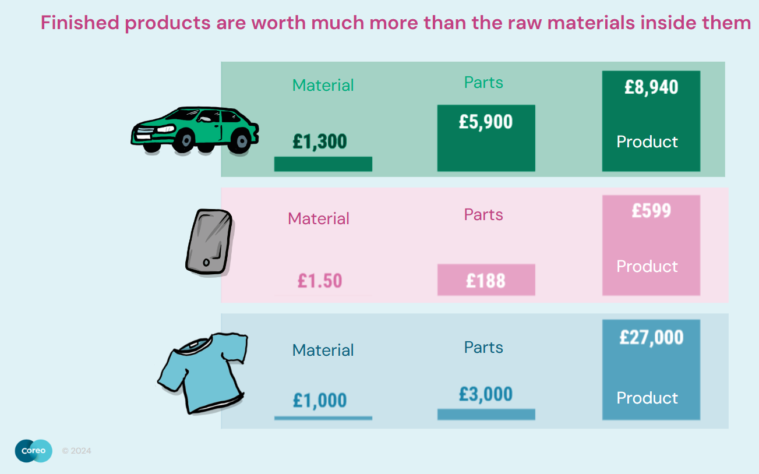

    - Refer to Coreo & Workbench’s 2024 report on the Australian remanufacturing sector
  - Resource Recovery: consists of offering services to recover resources that are no longer needed or wanted. It can involve leveraging partnerships, innovation, and technology to offer services that recover, renew, repair, reuse, and recycle resources, products and materials. A great example of this is GoTerra, a provider of an innovative service to recover wasted food with black solider fly larvae . They offer commercial and municipal clients the service of,collecting & processing their wasted food & biobased packaging. (note here that GoTerra is both an example of this business model & circular inputs as they create two by products from their service- a fertiliser & a protein powder for pet food)
    - This model would apply to Australia’s large “waste management” sector- a sector dominated by a few players. To date, these players benefited from the linear economy, getting paid to take materials off people’s hands & selling the by products on the other end. It will be critical to work closely with this sector to support them in diversifying “further up the chain”- potentially into repair & resale, storage & logistics solutions for materials & products, etc.
  - Sharing Platforms: this could be digital platforms, physical spaces, events like auctions. This model seeks to answer the question - how can we offer services that create opportunities to share products, assets, materials where possible? Sharing products means we don't have to create as many new products and their embedded raw materials, and is particularly applicable for products that are underutilised. For example - the average privately owned car has an estimated utility of only 5%, given that most are parked 95 percent of the time (!) Goget is a great example of this business model in practice- many of you might have used them before. Their business is a digital app that enables the sharing of cars between community members- with GoGet getting value from people using their app.
  - Product life extension - offering services to prolong the life of the products and materials we use through better design and leveraging technology like condition-based monitoring systems for preventative maintenance, and partnering with suppliers to repair and upgrade products etc. This business model applies to any businesses offering repair or maintenance services.
    - Reminder that we used to make products to last. The centennial bulb has been burning for 122 years. Before the 1920s light bulbs were designed to last, but on the 23 December 1924, a group of top representatives from all the major lightbulb manufacturers, including Germany’s Osram, the Netherlands’ Philips, France’s Compagnie des Lampes, and the United States’ General Electric, gathered and collectively agreed to reduce the lifespan of their products. Their businesses weren’t making money off of this commercial approach, and so a cartel was formed in order to change the product to be designed for obsolescence (instead of changing their commercial approach- for example, contracts to maintain lightbulbs in good working condition)
  - Products as a service are by far one of the most transformational in catalysing circularity. in this model, customers use products through a pay-for-use or service fee arrangement versus the conventional approach to ownership. Under this model manufacturers are driven to build products that are durable, repairable and recoverable because they retain ownership and their profitability is linked to the durability of these products. We are seeing this model emerge for many products- solar panels, lighting, furniture, HVAC, appliances, even oil! In this model, the benefits of outsourcing product ownership to experts in product management are clear. For example, Philips is now offering Signify, a lighting as a service platform. Instead of paying for lightbulbs & light fittings, Signify customers pay for illumination on an efficiency & performance based contract. Studies have shown that this model has increased the efficiency of lightbulbs by 50% & the lifetime of the bulbs by 75%. In Australia we are seeing this model emerge in:
    - Furniture: Koskela & Valiant furniture subscription/rental
    - Lighting: Arc Renewables ”lighting as a service”
    - Solar: Disgen “Clean energy at no capital cost”
    - Equipment: SES “sporting equipment hire”
    - Housing: Ausco " Transportable Buildings For Hire"
    - Construction equipment: Many
    - Heating & Cooling: Kaer “Cooling as a Service”
    - Elevators, appliances, cars, oil, and many more…

- Circular design principles:
Circular design principles - use less, choose better materials, design for future lifecycles and design for systemic value. 80% of a product's impacts happen in the design phase, so it is critical that we change the way we design in order to unlock circularity.
- Circular design principle #1: USE LESS - always ask yourself do we need it? the best thing you could possibly do is to just not do anything- not produce, not build, etc. And if we do need it, can we achieve the same result with less materials, both types (for less complexity) & volumes (for less overall)?
  - A great example of not doing something was Victoria’s 2023 decision to back out of the commonwealth games. The State considered whether it was necessary at all, and made the difficult decision to cancel hosting due.
  - An example of the same result with less materials is Brisbane’s Midtown Centre- instead of building two new towers, the architects stitching together a pair of 1980s office towers. The two buildings are now one 44,000m2, 26 storey vertical village. By retaining 50,000 tonnes of concrete and 3,600 tonnes of steel, the project saved 11,000 tonnes of carbon, while shaving 25% off the construction budget.
  - Another example- A 2014 analysis of 23 UK buildings showed that future builds could be designed with around half the steel used at present and still meet standards.
- Circular design principle #2: CHOOSE BETTER MATERIALS. If we are indeed using products or materials, which are the right ones to use? Consider sustainably sourced biological materials, or materials from secondary sources (reused, recycled, etc). Also, Renewable inputs- are the resources to produce these products renewable? Consider renewable energy, recovered water, etc. And of course, Non-toxicity- avoiding materials that cause harm to human health or have an ecotoxicity impact. The Living Future Red List is a useful tool here. And also of course, no materials or products with modern slavery or other societal impacts- which means materials & products with visibly clean supply chains.
  - The means building with hempcrete, timber, avoiding PFAS, etc
  - Also means using secondary materials- right now there is large focus on materials with recycled content but reused materials offer far greater benefits.
- Circular design principle #3: DESIGN FOR FUTURE LIFE CYCLES- for this you should consider Cyclability - are we designing with the future reuse of the materials and components within a product or an asset in mind? This could include designing products and assets for disassembly, with reversible and standardised connections between components in different layers with different life spans. In this way, components with shorter expected service life periods can be easily and independently extracted, adapted, reused, repaired, refurbished or replaced.
  - Great example of this in Australia is the prefab sector- The value proposition of the prefab industry today is in faster, cheaper, modes of construction- however if they are inherently building circular products as they are built to be assembled, so it can of course also be easily disassembled. With a design for manufacturing & assembly & DISASSEMBLY lens, the value proposition of the prefab sector can exponentially grow- in addition to building faster, becoming a means of reusing building materials in Australia, leading to cost savings and huge carbon reductions upon every reuse cycle of those materials.
  - There are buildings & elements of buildings being designed for disassembly today. For example, the Bradfield City Centre in Western Parklands NSW, which was designed to be disassembled for the purposes of returning the leased land to traditional owners after the buildings use-life (also relevant to Information Request #4). Refer to Coreo & Built’s How to write a Building Disassembly Plan for further case studies & templates for industry to put in practice.
  - Another example of this would be creating products to be modular and repairable- for example inverter failure is one of the most common reasons a solar panel fails in Australia, so we need to ensure that inverters can be easily replaced without need to scrap the whole panel
Versatility is another aspect of this circular design principle #3: am I designing my products or assets to be able to serve multiple functions, either in their current use or next use? For this, you might consider how products or assets can be made to be adaptable- consider a murphy bed, turning a bedroom into an office. Or consider future use cases of a building and building to both current and future use case standards.
Durability: where it makes sense, designing products & assets to be as long lasting and at a high quality for as long as possible. For a building, it might make sense to build a structure for a 300 year lifespan, and design the interiors to be modular & adaptable (structure stays in place and is designed to withstand long life, whereas the interiors may change over time).
- Circular design principle #4: DESIGN FOR SYSTEMIC VALUE. This means designing for the needs of ALL entities—humans, non-humans, and the planet. While Human-Centred Design has dominated the field by focusing on enhancing user experience, this approach can sometimes neglect the broader ecological consequences of our choices.
For instance, consider the widespread adoption of LED lights. While they provide significant benefits for human mobility and support decarbonization efforts, their impact on local ecosystems can be severe. Studies have shown that LED streetlights can reduce insect populations by nearly half, disrupting biodiversity. Additionally, these lights can negatively affect human health by interfering with circadian rhythms. Amber-coloured lighting can reduce light pollution, minimising disruption to natural ecosystems by emitting wavelengths that are less intrusive to nocturnal animals. Wildlife Friendly Lighting | LED Lighting Solutions | ADLT
By shifting our focus to a more holistic design approach, we can create solutions that truly benefit all aspects of life on Earth. .

- Circular integration into governance
A critical step to integrate circularity into our economy is effectively embedding circular capability in organisations governance. Today, the integration of circular opportunities and their implementation is often hindered by hierarchical, siloed governance structures that dominate government, academia, and private businesses. These structures limit the potential for true circular transformation.
The main challenges caused by the current siloed approaches to governance include:
- Communication Breakdown: Have you ever seen a great idea taken to a manager, only to see it die in the bureaucracy? Governance models with multiple levels of seniority dilute critical information. By the time insights reach the CEO, only fragments of the original message remain. This severely limits effective decision-making and blocks innovation.
- Under-Resourced Teams: In the linear economy, where productivity is valued above all else, we often lack the time, money, and people to work effectively. Executives are overwhelmed, and sustainability is often relegated to overstretched teams. The average sustainability team in a Fortune 500 company consists of just 12 people, yet they are expected to influence the tens of thousands of decisions made annually.
- Lack of Employee Involvement: According to Gallup, 79% of employees globally feel disengaged, largely due to their limited agency in decision-making. This not only stalls innovation but also hinders organisational agility and the ability to respond to emerging risks.
An alternative model that is more capable of enabling organisations to transform is Network Governance. This emerging model has been championed by countries like the Netherlands, which has adopted it to meet its circular economy goals. Network governance fosters systemic, inter-organisational coordination by facilitating the transparent exchange of information, data, and knowledge. It enables individual departments and employees to play specific roles in achieving shared goals.
For example, in a network governance model, a shared goal would sit at the centre, with all the necessary functions and skills coordinated around it, contributing to its resolution. This contrasts sharply with today’s siloed approach, where separate departments (e.g., climate change, procurement) each work toward their own mandates, often duplicating efforts.
Unlike traditional governance models, Network Governance is adaptable, flexible, and can be tailored to fit various organisational needs, scales, and contexts. It can function internally within your organisation or externally in collaboration with others. It is a key enabler of any organisation's capacity to mature in circularity.
An example of this model in action is the Concrete Beton Akkoord, signed in the Netherlands in 2018. This initiative demonstrates how Network Governance can effectively advance circularity and collaboration across industries. It started with a group of proactive stakeholders in the concrete sector, committed to reducing their environmental impact. This frontrunner group mobilised support from industry players, securing an €8 million investment (half funded by the government). They also enlisted Professor Jacqueline Cramer as Chair, setting ambitious goals like recycling 90% of demolished concrete into road pavements and reducing CO2 emissions by 49% by 2030.
A Steering Committee of 13 members, representing various sectors, was established to guide the initiative. Eight key themes—circular design, CO2 reduction, concrete recycling, natural capital, environmental costs, education, and innovation—were prioritised. Each theme had its own execution team, tasked with developing roadmaps and setting up monitoring schemes.
The Monitoring Committee, composed of independent experts, ensured accountability by producing annual progress reports.
Within just two years, the Beton Akkoord achieved its goal of recycling 90% of demolished concrete into road pavements and made substantial progress toward the emissions reduction target. This networked governance model continues to expand ambitions and actions within the sector.
For any circular initiative—or any positive systemic change you want to drive—we recommend leveraging a networked approach, even on a smaller scale. Systems change requires a lot of separate interventions in the system to achieve a common goal.

- Australia’s overall potential to move to a more circular economy, as well as how best to monitor progress and measure success.

For our response to this request for information, please refer to two Coreo reports attached to this submission:

- Resource Rich to Resource-Full: A Report prepared for the Department of Industry, Science and Resources. The economic opportunity of the circular economy, if implemented systematically, is substantial. The effort for impact possibilities should not be reviewed in isolation, but in variations of levers to be pulled in concert for catalytic effect. This study was commissioned by the Australian Government Department of Industry, Science, Energy and Resources to understand circular economy maturity and identify the strategic opportunity for Australia in lithium, copper, cobalt, nickel and silver. A significant body of work exists examining the global resource sector’s current and future contributions, impacts and trends. This report does not seek to duplicate that body of knowledge, but instead, offer transparent insights gathered from a series of semi-structured interviews with industry leaders into the actions towards, and drivers behind, the industry’s uptake of circular economy. This includes principles and practices, net-zero mandates, and ethical supply chain approaches in the production of lithium, copper, cobalt, nickel and silver. Recommendations for consideration by Government are made throughout the body of the report.
- Queensland's Economic Transformation - The first step to prioritising, monitoring, and acting in the pursuit of a circular economy(Presented to Productivity Commission team members on October 3rd, 2024): Motivated by the realities of natural capital depletion and degeneration, the Office of Circular Economy (OCE) initiated this program of work. Its purpose is to provide a practical guide for QLD to prioritise, monitor, and act in the pursuit of a circular economy. The report includes recommendations on measurement & metrics for circular economic transition.

We have also included some recommendations below specifically regarding setting metrics, sourced from our own circular economy business masterclass:

In a linear economy, we typically measure parts of the system in isolation—focusing on short-term gains or single metric success, much like a Ford assembly line. While this approach may generate immediate value in the areas we are observing, it often leaves behind waste, emissions, and resource depletion due to a failure to account for broader system-wide impacts.

In contrast, a circular economy requires us to think holistically, measuring benefits that span the entire system—environmental, social, and economic. To make a compelling case for circularity, we need accounting methods and metrics that not only capture these systemic benefits but also translate them into dollars and cents—the language of business.

Balancing holistic value with business-as-usual metrics is a growing challenge for global leaders who are increasingly recognizing the limitations of traditional methods like Net Present Value (NPV). NPV, widely used to assess profitability, often discounts long-term benefits, undervaluing efforts like environmental restoration or resource efficiency.

To bridge this gap, forward-thinking companies like Philips and Patagonia are adopting alternative accounting frameworks that align with circular principles, for broader accounts of value aligned to circularity. The accounting methods include methods such as Natural Capital Accounting: This method quantifies natural resources—such as air, water, and ecosystems—as vital assets. BHP has applied this approach to evaluate its environmental footprint, linking natural resource impacts to financial performance for more informed decision-making. Another example is Environmental Profit and Loss (EP&L): Developed by Kering, this framework monetizes the environmental impacts of a company’s operations and supply chain. By assigning financial value to factors like water use, pollution, and land conversion, EP&L offers businesses a fuller understanding of their environmental costs.

Circular metrics don’t just show how a project reduces waste or emissions—they reveal how it benefits entire systems: environmental, social, and financial. The right metrics can transform a circular solution from an abstract idea into something concrete and measurable, that resonates with decision-makers.
To develop circular metrics Coreo recommends:

- Align Metrics with priorities and Material Areas: Focus on material areas. Whether it’s carbon reduction, waste minimization, water conservation, or social impact, select metrics that align with their strategic goals. Use tools like sustainability reports, materiality assessments, and stakeholder conversations to understand their priorities.
  - Example: A company that uses plastic packaging should measure carbon & waste certainly, but also levels of PFAS, they should measure reuse (since that what we should be aiming for in plastics)
- Measure Across the Full Life Cycle: Make sure metrics reflect entire products or service lifecycles—from raw material extraction to its use and then its next use (and so on). Widen your scope to capture the full value of circular opportunities.
  - Example 1: Instead of just tracking the embodied carbon of a steel beam, track its full lifecycle carbon savings when reused multiple times.
  - Example 2: A solar-as-a-service model could save 40% over a 10-year period compared to traditional ownership—so your metrics need to capture that.
- Measure Dependencies: Metrics should also capture the indirect effects—such as reduced strain on public infrastructure or improved community resilience.
  - Example: Green roofs can reduce stormwater runoff and improve air quality, not just reduce embodied carbon in roofing materials.
- Track What needs to be done, Not Just Outcomes: Measure actions that we know to be best practice, not just their outcomes. For example, tracking how many materials were reused is simpler and more understandable than trying to measure a team’s performance against an ambiguous goal. If a 15-year-old can grasp the significance of your metrics, so will your audience. It also avoids the complexities of using proxy datasets, global averages, unstandardised calculation frameworks to measure outcomes of bad business practice.
  - Example: "Reduce Scope 3 emissions by 75% by 2030" is vague- less clear task than "Source 50% reused, recycled, or regenerative materials by 2030" (which we know will incur Scope 3 emissions reductions)
- Choose Bang-for-Buck Metrics: Keep it simple. Reporting consumes 60% of sustainability teams' time—so metrics should be practical and integrate into core business reporting. Focus on metrics that are easy to track and impactful.
  - Example: Have business teams report on materials reused, rather than carbon or biodiversity benefits, and automate the translation of this into environmental impacts.
- Go From the Bottom Up: Understand the difference between high-level and project-level metrics. Region-wide metrics can aggregate successes from individual projects, but project-specific metrics should reflect the unique nature of each initiative. An organisation’s metrics should be built from real project activities, so they’re easily measurable and can roll up into company-wide targets.
  - Example: Levi’s SecondHand platform.
    - Organisation-wide metrics: % of revenue from circular models like resale and repair.
    - Project-specific metrics: Profits from resold garments, reduction in new denim production, and emissions saved from reselling.

NB: A well-constructed circular target is a natural extension of circular metrics. For instance, Levi Jeans has set a target of achieving 25% of total revenue from circular services by 2030, up from a baseline of 12% in 2023. This target is specific, measurable, and directly tied to their circular initiatives. A straightforward key performance indicator (KPI) for this could be the revenue generated from circular products and services, allowing them to track progress effectively.
In contrast, targets that lack specificity or relevance can hinder progress. For example, a vague target like "reduce waste" without defining how much, by when, or through which specific initiatives fails to provide a clear direction. It becomes challenging to measure success or make adjustments along the way.

Information request 2
Priority opportunities to progress the circular economy
The PC is seeking views and information on the following.
- Opportunities in Australia to improve environmental and economic outcomes through greater adoption of circular economy activities. These may relate to sectors, products or supply chain segments, and involve narrowing loops (e.g. reducing the demand for materials), closing loops (e.g. using materials multiple times), slowing loops (e.g. extending useful product life) or regenerating (e.g. using non-toxic materials and regenerating ecosystems). Information would be particularly welcome on:
  - – how these opportunities could affect business and economic outcomes (including costs), environmental outcomes (including biodiversity, climate and water, land and air quality), and social outcomes
  - – feasible levels of future uptake or adoption in Australia
  - – how their effects could best be monitored or measured, and how opportunities could be prioritised
  - – how Aboriginal and Torres Strait Islander knowledges could be valued, in ways that protect Indigenous cultural and intellectual property, to identify and develop these opportunities.

For Coreo’s response to this question, please refer to the following Coreo reports presenting circular opportunities in various sectors, states, and supply chain areas:

- Queensland's Economic Transformation - The first step to prioritising, monitoring, and acting in the pursuit of a circular economy(Presented to Productivity Commission team members on October 3rd, 2024): Motivated by the realities of natural capital depletion and degeneration, the Office of Circular Economy (OCE) initiated this program of work. Its purpose is to provide a practical guide for QLD to prioritise, monitor, and act in the pursuit of a circular economy. The report includes circular opportunities targeting the priority materials in the QLD economy (prioritised in the first scope of work for the OCE which was provided to the Productivity Commission in October 2024)
- Resource Rich to Resource Full- Circular opportunities in the production of lithium, copper, cobalt, nickel and silver. Recommendations for consideration by Government are made throughout the body of the report.
- System Transformation Points for a food & grocery major: This draft report shows a series of transformative circular projects in the food & grocery & home retail sector. Originally prepared for Woolworths Group, the opportunities identified can be extrapolated or tweaked to an economy wide level.
- Legacy moves for Brisbane 2032: Presentation prepared to inspire the Games Delivery Authority about the catalytic circular moves it could undertake via the delivery of a major event. Opportunities particularly relevant to the built environment but also to cities
- Do Less, Better for Anglo American in 2023: A strategic, thought-provoking piece to support Anglo American’s transition to circularity

- Analysis of which circular opportunities provide the greatest scope to improve environmental and economic outcomes in Australia and why, including information on:
  - – metrics used to inform this analysis
  - – modelling or analysis relating to the potential benefits and costs of implementing specific circular economy opportunities at the sector, product or supply chain segment level (including, but not limited to, life cycle assessments or cost-benefit assessments)
  - – the distribution of benefits and costs, and whether they will occur in the short, medium or long term.

- • Information on specific opportunities and risks for Australia resulting from international developments, including circular economy policy. These may include developments that:
  - – affect Australian exports, such as by opening or creating new markets, or by placing regulatory requirements on the design and production processes of Australian exports
  - – affect Australian imports, such as changes to production methods internationally, or developments in international markets
  - – innovative processes that could be adopted in Australia.

Didn’t have as much time as would have liked to answer this question! Have a lot of thoughts, please don’t hesitate to reach out
Information request 3
Hurdles and barriers to a circular economy The PC is seeking views and information on the following.
- • The main reasons businesses and consumers have not adopted circular economy practices to date, including (but not limited to):
  - – costs
  - – attitudes (including about risk)
  - – regulatory constraints
  - – lack of information or resources
  - – lack of coordination.
  - -lack of understanding of the dependency of businesses on natural capital (we don’t even consider what nat cap is available or its quality in business decisions)

For Coreo’s response to this question, please refer to the following attached Coreo report:
- A Regional Situation Analysis prepared for the Queensland Department of Environment, Science, & Innovation in 2024. The report was commissioned to provide a clearer picture of the Greater Whitsunday Region’s circular economy connections, priorities, challenges, and opportunities. It surveyed over 40 regional businesses to understand contextual challenges, attitudes, and opportunities related to the adoption of circularity in the region. Summary slide with what we believe are the salient messages from the report below:
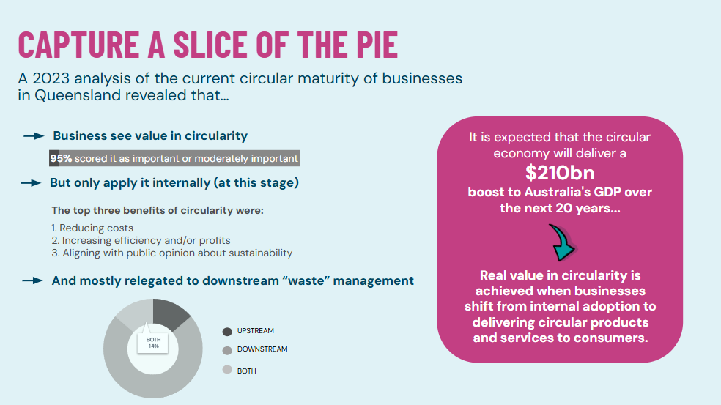

Coreo would also suggest referring to the many reports emerging analysing consumer & business attitudes towards circularity such as:
- Strategy to unlock economic growth and diversification for the Greater Whitsunday METS sector (Circular is a key strategy, and the report includes a survey of business perspectives on circular)
- Gumtree Circular Economy Second Hand Report 2022 on consumer attitudes
- 'Towards a Circular Australia' Playbook (climateleaders.org.au) with perspectives from Australian business leaders
- Etc etc

Information request 4 Governments’ role in the circular economy The PC is seeking views and information on the following.
- • The extent to which policy or regulatory changes (national, state and territory, or local; or for specific sectors, products or supply chains segment level) could better enable the pursuit of circular economy activities. This may include:
  - – financial incentives
  - – information provision
  - – regulatory changes (e.g. approval processes, standards and codes, mandatory reporting, competition and consumer regulation, chemicals regulation) and co-regulatory approaches
  - – education and training
  - – facilitating collaboration
  - – planning, and urban and regional development.
- • The extent to which current policies or regulations hinder the pursuit of circular economy activities. Specific examples of how current settings are acting as barriers would be welcome.
- • The benefits, costs, risks and implementation issues associated with current or potential policy or regulatory changes that aim to address barriers to circular economy activities.
- • What actions governments could take to facilitate Aboriginal and Torres Strait Islander roles in progressing the circular economy, including in drawing on Indigenous knowledges in policy design in ways that recognise and protect Indigenous cultural and intellectual property.

Didn’t have as much time as we would have liked to input into this question but the focus on recycling is a MAJOR inhibiting factor to circularity. There are so many policies, strategies etc going in to increase recycled content in things, meaning that we are missing the opportunities to REUSE things. Putting in recycled targets creates a demand for recycled products, which creates a demand for steady streams of waste to recycle.

GPD as the dominate metric - need to broaden this which they have done but needs to actually have weight behind it be valued, be reported on

In mining they are either operating or closing .. challenging circularity teams to try and unlock the residual value left

All regs seek to reduce impact not stop it in the first place

No incentives to reuse, remanfacture

Bring in indigenous leaders to understand their view of the world and how that can be incpoirted into modern economics

No legacy focus "dig and ship"

Poor data collection and reporting requirements all aggregated up to C&I , C&D but its a black box what are you mean to do with that

Seperating climate, circular, nature and biodiversity agendas...

Lack of harmony amongst state regs

Investing to much in CRC's etc when we have the answers we need to invest in the doing

