10 April 2025

Ms Joanne Chong

Presiding Commissioner

Opportunities in the Circular Economy

Productivity Commission

E: [circular.economy@pc.gov.au](mailto:circular.economy@pc.gov.au)

Dear Commissioner Chong,

**RE: Planet Ark submission to address the Interim Report: Australia’s circular economy:**

**Unlocking the opportunities**

With reference to above report, enclosed is a submission by Planet Ark referencing specific sections covered in the document.

We wish to congratulate the Commission for its work in synthesising a substantial response to the initial call for submissions, including our Planet Ark submission dated 1 November 2024. We are pleased to note many of our recommendations are reflected in the outcomes presented in this Interim Report.

In addition to the extensive response submitted last year, with this submission, we are targeting specific ‘Information Requests’ relevant to where Planet Ark can support the Commission and the broader ecosystem to realise some of the opportunities identified. These are presented on the following pages.

As an overarching comment, given Planet Ark’s 33 years’ experience in creating opportunities for positive environmental change in Australia, we are ready to support the recommendations of this inquiry. Particularly, given the inclusion of public education across numerous sectors (e.g. textiles, e-waste, labelling, procurement), Planet Ark stands ready to work with government and other stakeholders across our campaign areas to improve knowledge, awareness and behaviours across the economy to transition to a circular economy.

Should you have any questions or clarifications necessary, please feel free to contact our Head

of Circular Economy Development, Dr Nicole Garofano by email to

or our Head of Research and Impact, Ryan Collins by email to

Thank you again for this opportunity.

Kind regards,

Rebecca Gilling

CEO

**Regarding Information request 10.2**

**Supporting coordination, facilitation or brokering services**

***‘What government initiatives could most effectively support businesses’ coordination?’***

Governments can use the existing platform of the [Australian Circular Economy Hub (ACE Hub)](https://acehub.org.au/)to support businesses and communities in partnerships and collaboration. As presented in our 1 November submission, there are already numerous case studies and connections documented from the ACE Hub – both in our [community portal](https://portal.acehub.org.au/) (2400+ active members across all sectors) and from our [Knowledge Hub](https://acehub.org.au/knowledge-hub).

The ACE Hub exemplifies a successful partnership between the Australian Government and Planet Ark that established the national platform for circular economy knowledge and collaboration.

This can be further strengthened by providing financial investment into independent brokering programs, coordinated, managed and reported on by Planet Ark. Examples from the Netherlands are available to support this role (information is available on request).

The benefits of investing, just in the ACE Hub Portal for example, are shown across the hundreds of exchanges between parties that have supported the transition in the last 3 years. For example, it has helped a meal delivery service connect with complex packaging and food waste solutions, and councils connect with food waste management companies. Our 2024 ACE Hub Portal data speaks for itself:

* **8,766** interactions
* **470** new active members (2400+ active members as at March 2025)
* **4,290** messages sent
* **923** discussions created
* **618** posts in the live feed
* **20%** average engagement (vs 2-12% average across community platforms)

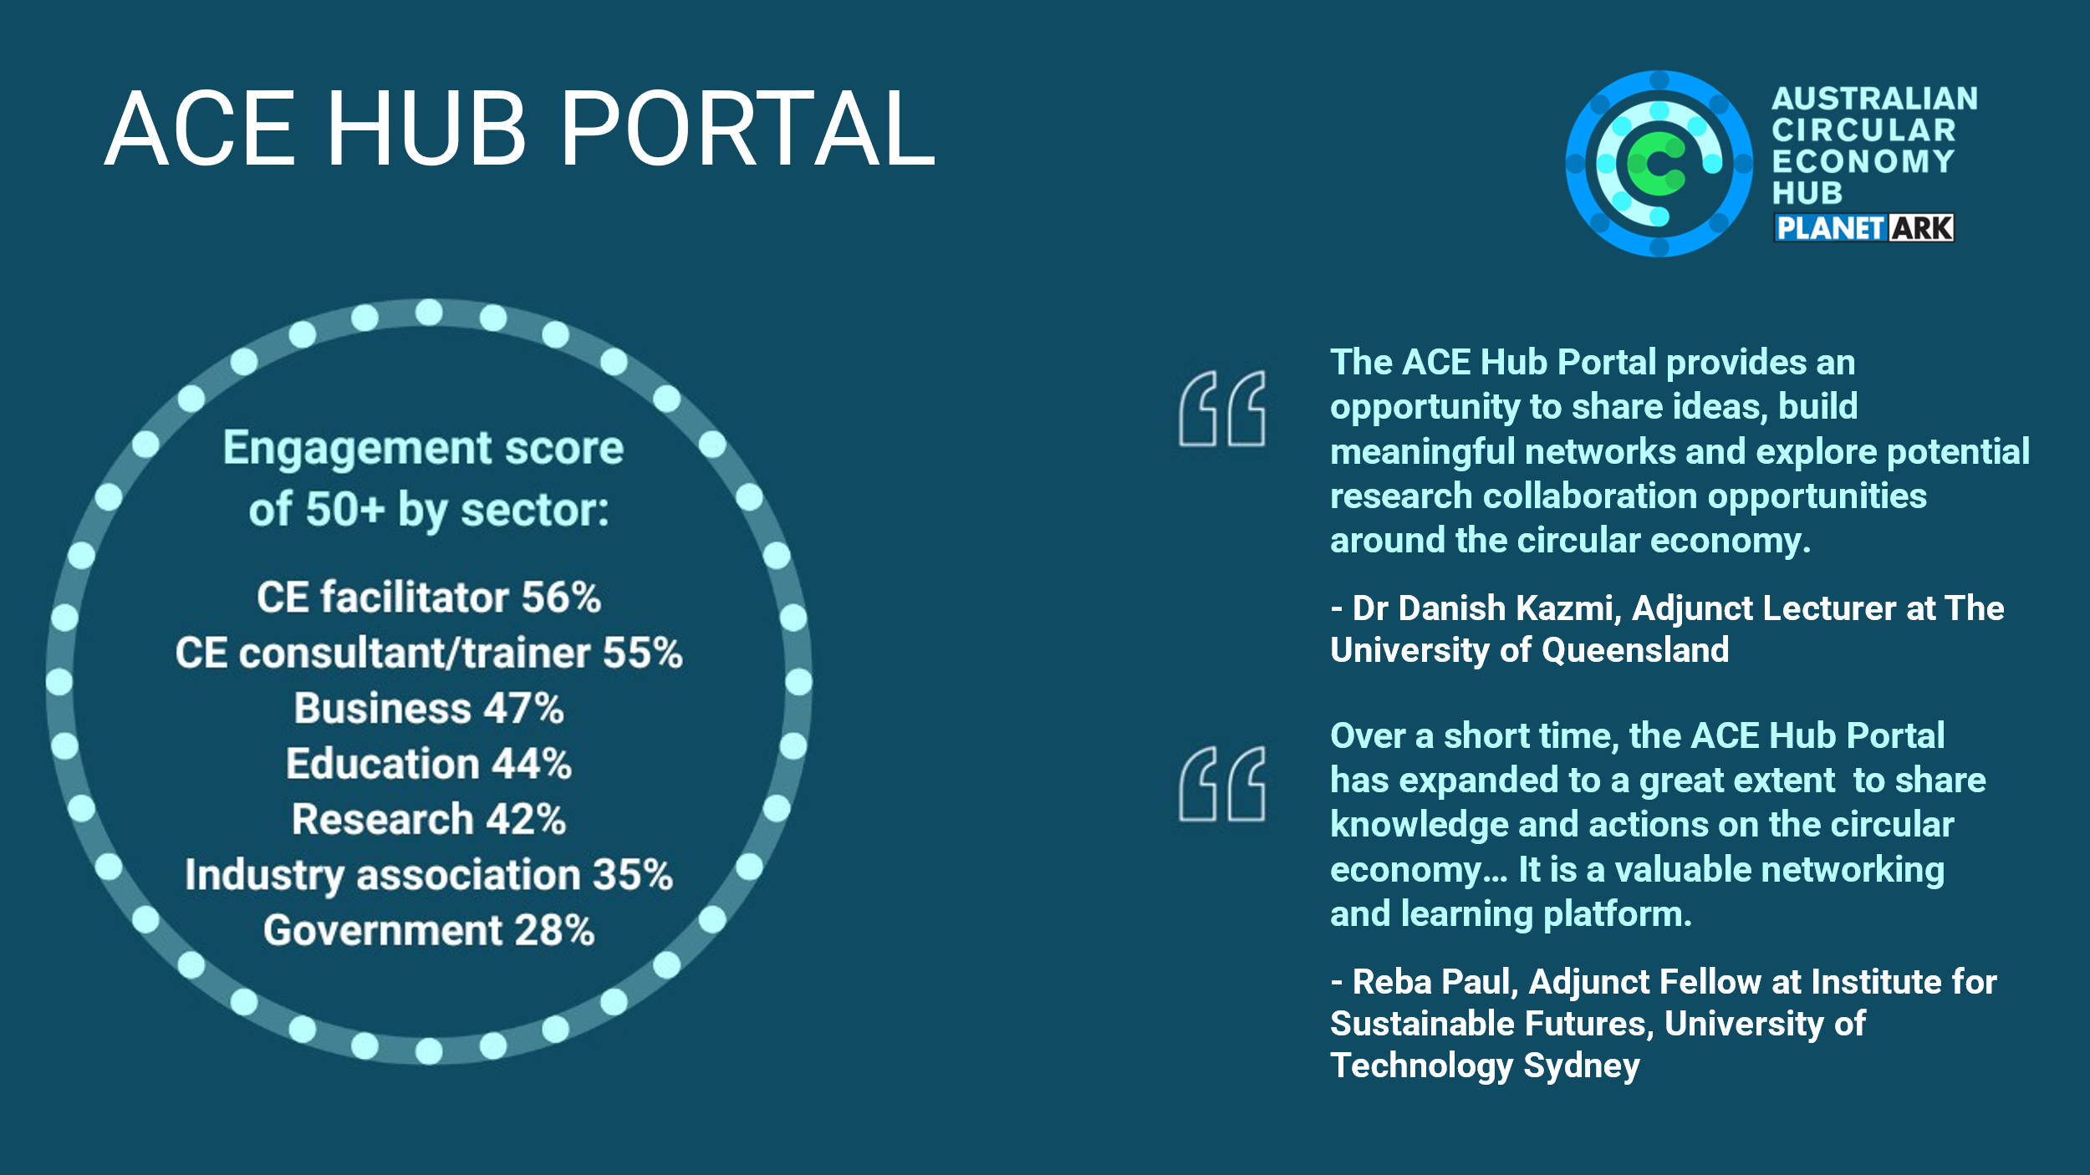

*Note: The Engagement Score is a measure of a member’s level of interaction (like or comment), posting and visitation. A score above 50 is considered highly engaged.*

The costs to maintain this community alone, and indeed to grow it, are estimated at $130,000 per year. Critical to the success of this community is a Community Coordinator which in essence, provides a national ‘broker’, matchmaker and knowledge sharing service for the community.

***‘How do the needs of small and medium businesses or organisations differ from larger businesses or organisations in relation to adopting circular practices, and how might governments best support this cohort?’***

According to Planet Ark research, small businesses were less likely to be knowledgeable of the circular economy than large businesses. ([*Circularity in Australian Business 2023*](https://acehub.org.au/knowledge-hub/research/circularity-in-australian-business-2023-perceptions-knowledge-and-actions))

In terms of looking for information on how to reduce their environmental impact, new Planet Ark research about to be published found that small businesses (51 per cent) are much less likely to have taken this action than medium (82 per cent) and large businesses (86 per cent). The research found that large businesses (91 per cent) were more likely to have implemented policies, procedures or strategies to reduce their environmental impact, followed by medium (74 per cent) and small businesses (57 per cent). The research concluded that small businesses may have less resources, in terms of both personnel and finances, to devote to this action. (*Business Attitudes to Recycling 2025*)

In terms of what motivates businesses to reduce their environmental impact, Planet Ark research found that saving money and their personal views on the environment were more important to small business than large business. For large business, having to report on their triple bottom line, customer pressure and employee expectations/demands are bigger motivators (*Business Attitudes to Recycling 2025*).

Government can best support SMEs by providing trained, independent transition brokers who have expertise in sectors, stakeholder engagement, policy, etc (see Cramer 2020[1] for a full list of Transition Broker Attributes) to support them in navigating to the opportunities. An approach modelled after the Netherlands’ Versnellinghuis (Acceleration House), which provides coordinated support for circular business initiatives, would support transformation across industries with particular focus on SMEs.

***‘What are the barriers to knowledge (or transition) brokers, project officers, community development officers and the like effectively assisting organisations to navigate regulatory complexity?’***

According to Planet Ark research, business decision-makers highlighted Australia’s business culture and legislative framework as being too focused on competition and not conducive to the type of collaboration at scale required for effective circular economy implementation. Other barriers commonly identified included financial issues, lack of executive engagement, uncertainty of return on investment, lack of research and development resources and no policy or legislation requirement. ([*Circularity in Australian Business 2023*](https://acehub.org.au/knowledge-hub/research/circularity-in-australian-business-2023-perceptions-knowledge-and-actions))

One other potential barrier is a lack of understanding of a business’ innovation adoption archetype or openness to innovation. Considering the characteristics of your audience in terms of the ‘Diffusion of Innovations’ model is a useful behaviour change strategy to understand their specific motivations and drivers that help identify the right engagement approach. ([*Circularity in Australian Business 2023*](https://acehub.org.au/knowledge-hub/research/circularity-in-australian-business-2023-perceptions-knowledge-and-actions))

***‘To what extent is there a need for government to provide services, given that there are already private consultant services that can support businesses to navigate regulations?’***

In European examples, government has been a critical crutch to enable the adoption of circular economy principles and businesses nationally. Both through procurement and market development, the Netherlands is identified as one of several who have provided structured programs to both financially support SMEs to get business opportunities into reality, and to provide links to a pool of trained services that are either gratis or heavily subsidised to realise ambition.

Private services are available, but particularly for SMEs, these services are out of reach of many. Local examples can be seen in Queensland’s [EcoBiz program](https://businesschamberqld.com.au/ecobiz/), which is funded by the State government and implemented through Business Chamber Queensland. These services have been useful to cut operating costs for businesses, but what is being asked now, is to change the delivery models of products and services – these require guidance, and they are require funding to re-tool. The Australian government can play a role in both, through third party providers, which Planet Ark stands ready to support.

As part of a suite of services that government can support, again, through a third party, is circular economy business transformation. This transition requires a new way of looking at products and services. [CIRCO Australia](https://acehub.org.au/news/circo-training-now-available-nationally-for-the-first-time) provides circular business model training that can initiate this new view through to product redesign and pitch. Education services, delivered by accredited trainers, is another area that government can provide service in – either as funder or as trainers themselves, allowing participation at a subsidised rate.

**Regarding Information request 10.5**

**Government support for place-based circular initiatives**

***‘What service provision and funding models would best support place‑based circular activities, including reuse, repair, waste collection and recycling activities in remote and very remote areas?’***

Place-based activities require efficiencies to keep costs as low as possible, especially for product stewardship schemes. Many product stewardship schemes are managing their collections independently which means locations are hard to find and are a higher cost than they should be. Planet Ark’s Recycling and Reuse Drop Off Wall, in partnership with eLoop, provides an option for one united system and network that make logistics more efficient. Collection points for reuse and recycling also need to be accessible, easy to find and use, and furthermore inspire public trust. This system has consistent safety and material traceability standards built in by design, and is data driven giving location owners’ visibility to the volumes of materials collected for their reporting needs.Support for local governments, especially those in remote areas, to enable the rollout of these Drop Off Walls is a tangible and visual way to drive reuse and recycling.

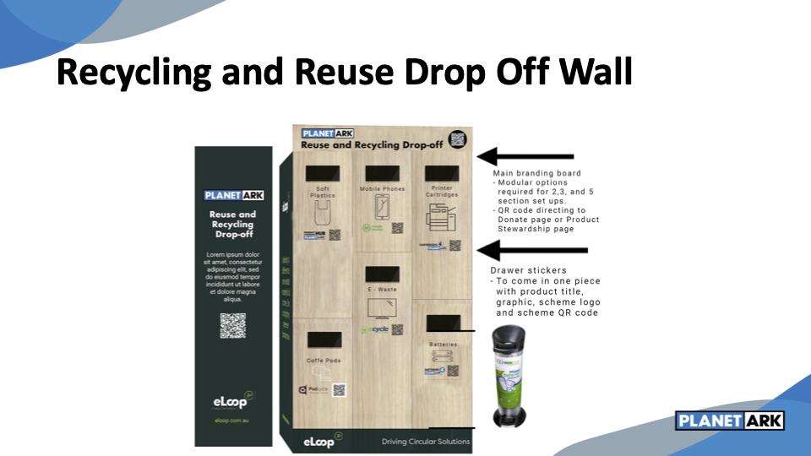

Support for local governments to enable locally placed repair hubs can improve both material/product longevity and improve community cohesion through social interactions.

If people can't easily find reuse, repair, and refurbishing options, circular economy initiatives won't gain traction. Planet Ark’s [Recycling Near You](https://recyclingnearyou.com.au/) platform receives 1.8 million years per year from all over Australia and is about to re-launch with a new design and new functionality and recycling information for both households and businesses. There is now an opportunity to evolve the website into an even more impactful circular economy action platform by expanding the database and search functionality to include reuse, repair, refurbishing and share options. Support for this expansion, along with a national campaign, would enable households and businesses to easily participate in the circular economy.

***‘What other kinds of government assistance or support do communities or businesses need to enable successful place‑based circular precincts (such as coordination or facilitation, as in information request 10.2)?’***

We reiterate the call for in-region transition brokers who are available to support businesses alongside government, in this case, to be active participants in circular precincts (see response to 10.2 above).

Furthermore, behaviour change education is needed in places to support the transition. Providing information alone is not enough. You must understand the barriers and values of the target audience to more effectively motivate people to change behaviour. The audience must also have the capability and opportunity for the target behaviour. Planet Ark bases its communications in behaviour change science and can lead or support national or local campaigns, having founded National Recycling Week and rolled out localised Recycling Near You campaigns. Support to amplify these or new circular campaigns can have substantial positive impacts, especially if funding models allow for testing or piloting interventions to assess effectiveness before scaling up or rolling out to other regions.

**Links**

‘Australian Circular Economy Hub (ACE Hub)’ - <https://acehub.org.au>

‘CIRCO Australia’ - <https://acehub.org.au/news/circo-training-now-available-nationally-for-the-first-time>

‘Circularity in Australian Business 2023’ - <https://acehub.org.au/knowledge-hub/research/circularity-in-australian-business-2023-perceptions-knowledge-and-actions>

‘community portal’ - <https://portal.acehub.org.au/>

‘EcoBiz program’ - <https://businesschamberqld.com.au/ecobiz/>

‘Knowledge Hub’ - <https://acehub.org.au/knowledge-hub>

‘Recycling Near You’ - <https://recyclingnearyou.com.au/>

1. Cramer 2020, [How Network Governance Powers the Economy](https://assets.ctfassets.net/fqjwh0badmlx/1elraV8lIz6bCeHJVntNF0/3d1b3fda50f0bce1062ad1c043972c68/Network_governance_for_Circular_Economy_web_version.pdf), p.154