**A Submission to the Productivity Commission in response to the Interim Report into Circularity in Australia.**

Matthew Washington: Co-Director, Robert Perey: Co-Director, Phil Jones: Secretary/Treasurer.

Contact: Phil Jones

Date: 11-04-2025

Introduction

This submission is made on behalf of the NSW Chapter of the Centre for the Advancement of the Steady State Economy, (CASSE NSW). CASSE considers there is a close relationship between the principles of a Steady State Economy and a Circular Economy.

The Centre for the Advancement of the Steady State Economy has its base in the United States with Chapters in a number of countries around the globe. The mission of CASSE is to advance the steady state economy, with stabilized population and consumption, as a policy goal with widespread public support. We pursue this mission by:

* educating citizens, organizations, and policy makers on the conflict between economic growth and (1) environmental protection, (2) ecological and economic sustainability, and (3) national security and international stability;
* promoting the steady state economy as a desirable alternative to economic growth;
* studying the means to establish a steady state economy.[1]

We welcome the opportunity to respond to the Interim Report of the Productivity Commission’s inquiry into the Circular Economy and hope that this contribution is seen as constructive despite the concerns we express. We also hope that the recommendations that we make can be incorporated into the final report.

Preface.

The apparent contradiction within the aims of achieving a circular economy.

“A circular economy is one where products are designed to be reused, repaired, and recycled, minimising waste and maximising resource efficiency. It aims to create a closed-loop system where materials are continuously circulated and repurposed rather than being discarded as waste.”

“At the same time, innovation in design, technology, and materials science can be a catalyst for economic growth, providing Australian entrepreneurs and industries with an edge in a rapidly evolving global marketplace.” (2024, Australia’s Circular Economy Framework)[2].

While broadly supporting the notion of the Circular Economy, CASSE NSW notes the fact that infinite economic growth is not possible on either a finite planet, an individual country or local region. We therefore suggest a more appropriate aim for the Australian economy and global economy is for a Steady State Economy, one well described by the late economist and environmentalist, Prof. Herman Daly. Such an aim would constitute a much clearer objective of what has to be achieved. However, we recognise that such a proposition is maybe notionally beyond the terms of reference of this inquiry.

The key features of the steady state economy are:

* A constant and sustainable population,
* A consumption of renewable resources at a rate not greater than the rate at which they are renewed,
* Processing of non-renewable resources at a rate no greater than they can be recycled or alternatives developed, or their remaining waste reabsorbed by the ecological systems from which they were derived,
* The preservation of natural ecosystems, their biodiversity and the services they provide,
* A relatively constant consumption of renewable energy.

Perhaps one way of viewing the Steady State Economy is the Circular Economy without the circle expanding.

While the aim of the Circular Economy as outlined in the Australia Framework are for goods to be reused, refurbished, recycled or repaired, in order to preserve the environment, to simultaneously aim for economic growth has a strong element of contradiction. For **non-renewable** resources, the ultimate limit is 100% recirculation in some form, something possibly quite difficult, if not impossible to achieve. However, the goal must be to come as close as possible to 100% globally, and therefore for Australia. For **renewable resources**, nature determines that there is a limit to which they can be regenerated and waste safely absorbed by the environment. The rate of regeneration and some form of recirculation also has limits. Anything other than zero waste is unsustainable over the long term.

Currently, the urgency of the need for transitioning from the linear economy to the steady state economy, requiring a dramatic increase in circularity, as outlined in *Earth for All, A Survival Guide for Humanity[3]*, is not emphasised in the Interim Report. Already we note that the Stockholm Resilience Centre claims in its report that the Earth has crossed six of the nine processes or systems governing safe boundaries for our planet[4], as shown below.

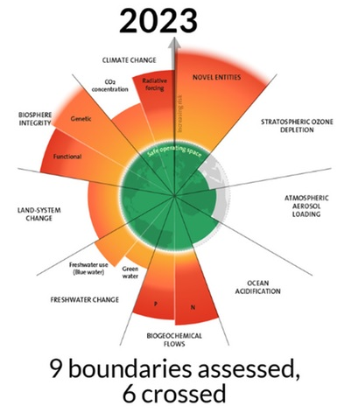

The Global Footprint Project finds that humanity is currently using nature **1.7** times faster than our planet's ecosystems can regenerate. As a result, World Overshoot Day, which is the day in which humanity has consumed 100% of Earth’s annual ecosystem Services, for that year is getting closer to the beginning of the year almost every year[5]. The Great Acceleration Graphs convey a similar message of urgency.

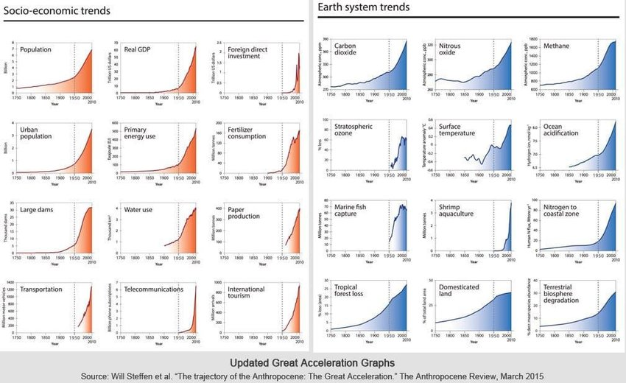

We therefore recommend that the final report of this inquiry strongly emphasise this urgency, and criticality of these threats, and acknowledge the difficulty in conveying this urgency to the public.

We see the chief barrier to community awareness of the need for a Steady State Economy as the failure to identify the need for one that is sustainable, i.e. a Steady State Economy. Orthodox economist seldom, if ever, discuss this in the major media. If our economy requires continual growth in order to avoid it collapsing, as is often stated, then the difficulty of transitioning to the Steady State Economy only increases as time passes. This raises the question; what does it mean for circularity to **benefit** the economy? Benefiting the economy is normally understood as increasing economic growth, but this fails to recognise long-term consequences and reality.

The globalisation of trade is another barrier that has to be acknowledged. There are island nations dependent on tourism, others dependent on food, minerals and energy imports. There are communities within nations that have similar dependencies. Trade is an essential element to both survival and a decent standard of living, hence the awareness of the need of a global transition to a steady state economy needs to be adopted as a universal goal. This would be of particular importance for our Pacific neighbours and an significant issue for the Department of Foreign Affairs and Trade.

The perception that circularity necessarily provides the opportunity for economic growth is another question of concern, one of social concern, one of equity, and one of justice. If increased circularity implies that products which are designed to be longer lasting, reused, maintained, repaired or recycled what are the implications for raw materials and employment?

Regarding resources, if the advantage of circularity is the production (and retention) of more goods overall, then the demand for resources is not reduced with a growing circular economy.

Regarding employment, if it is envisaged that new employment opportunities and skills will emerge, then this is desirable. Required skills need to be anticipated and planned for. There is no guarentee that jobs created will match employment lost in either skills, numbers or location.

The question arises as to whether the loss of employment in manufacturing using virgin materials will be matched by the gain in employment in the recirculating sector. If there is an overall reduction in working hours then the various ways of reducing working hours need to be considered. These could be fewer working hours or fewer working days in the week. The location of these employees needs to be considered as much of Australia’s manufactured products come from overseas.

Accordingly, we concur with **Recommendation 4** of the Report of the Ministerial Advisory Group on the Circular Economy, in particular with the introduction of an Act along the lines of the proposed Circular Economy Act. We suggest that it be called the **Steady State Circular Economy Act** in order to convey to the Government, public, business and media sectors a clearer sense of direction and to reduce the ambiguity of the purpose of the Circular Economy Act and its ultimate goals.

The issue of population needs to be considered in a discussion of circularity, particularly once the fact that 100% circularity is both seen as inevitable, vital is and is recognised and accepted. So long as the population increases, bringing about the absorption of more recyclable materials into the homes, businesses and infrastructure, the demand for virgin materials will increase. In fact, the Australia’s Circular Economy Framework 2024 points out that the population growth rate in Australia is higher than most developed countries. Both factors drive a higher use of materials for residential and commercial buildings, roads, infrastructure and significant embodied carbon emissions[6].

The issue of population levels is a difficult political one. Inevitably, i.e. once we have a steady state economy, the population profile should approximate to one that matches a stable and constant population, as shown in the figure below.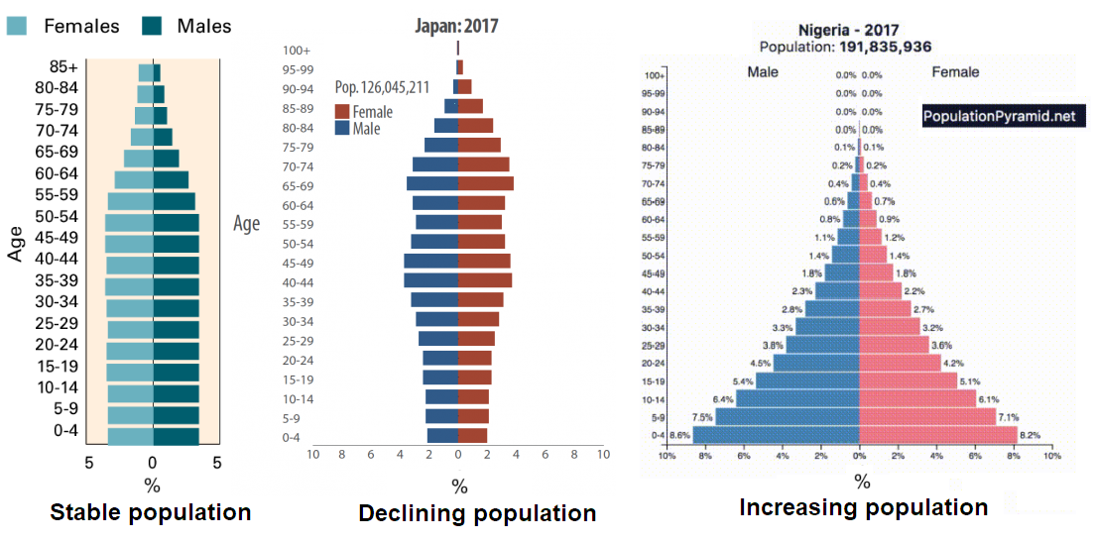

Because population involves a range of human rights and human desires, as well as the stability of the national economy and the relationship we have with other nations, Australia’s population policy deserves more serious public discussion beyond political point scoring. However, because Australia’s Total Fertility Rate is less than two per woman, our population can be stabilised by balancing immigration with emigration over time, thus avoiding contentious human rights issues.

Significant components of our economy to be addressed in the transition to a sustainable circular economy are finance/investment and superannuation. If finances are directed towards the production of an increasing volume of goods and the provision of endless energy sources the ecological and climate problems will continue to grow. While this Interim Report recognises the importance of financing circular projects, the full implications of both success and a failure within this sector of the economy to facilitate circularity need to be considered. This particularly applies to superannuation.

The Interim Report points out that “*many circular economy activities require coordination across businesses, governments and/or households, difficulties building connections between relevant stakeholders and sharing knowledge about best practice standards present barriers to greater circularity*.” The same point applies internationally, i.e. harmonisation is required across nations in regards to design of products, modularity, durability, recyclability, repairability given the extent of international trade. A similar point applies to ensuring an international consensus on the purpose of circularity. Without agreement that circularity is desirable between trading partners and without agreement on its purpose, i.e. as a necessary component of a steady state economy, unilateral declaration of particular standards might easily be interpreted as a form of trade barrier. Dialogue and preferably international agreements should be pursued with the goal of a mutually benefiting steady state economy.

Notably absent in the Interim Report is any reference to the more efficient use or recycling of nutrients, such as nitrates and phosphates. Phosphate in particular is a limited resource and vital for agriculture. Research into its recovery of these resources and to the management of the problem of pollution that arises from farm run-offs needs to be carried out.

NSW CASSE notes the inclusion of the mining industry in this inquiry into circular economy. While repurposing in general terms is seen as a part of the circular economy, the repurposing of mine sites, for example as for pumped hydro energy storage, or restored agricultural land, mining itself must be regarded as the first step in a linear economy not part of a circular economy. In a sustainable, steady state economy, mining will be absolutely minimal. The less mining there is, the closer we are to a an environmentally sustainable economy.

This should be a particular concern for Australia given the financial importance of our mining exports. It should also be considered in light of the fact that other nations are aiming for greater levels of recycling of metals, reducing the consumption of fossil fuels and therefore reducing our export income. The possible social impact of reduced revenues must be envisaged and planned for.

Recommendations.

1. The paragraph below on page 5 be replaced by the paragraph that follows:

*Governments can improve their policy settings to address some of these barriers. In doing so, their aim is not to achieve 100% circularity – there are trade-offs to circular activities, and a system where all materials are circulated indefinitely would not be economically, environmentally or socially optimal. And even with the right government policies in place, some circular opportunities may still be too costly for businesses and households to take up. But governments can support progress by reducing unnecessary regulatory frictions or burdens, while still maintaining policy settings with appropriate safeguards and pricing of environmental costs. Governments also have a role in facilitating coordination and improving information provision, to enable businesses and households to use materials in ways that maximise net benefits to the community.*

Governments can improve their policy settings to address some of these barriers. In doing so, their aim must be to achieve as close as practicable a circularity rate of 100%. Ultimately, all products containing non-renewable resources that can be recirculated in some way, must be circulated unless absorbed into other long-term usage. Long term sustainability must be aimed for as soon as possible to ensure a stable and health environment and a prosperous future for Australia. Governments can support progress by reducing unnecessary regulatory frictions or burdens, establishing “*circular economy requirements for products including on durability, repairability, recyclability and the presence of chemicals of concern*”, while still maintaining policy settings with appropriate safeguards and pricing of environmental costs. Governments also have a role in facilitating coordination and improving information provision, to enable businesses and households to use materials in ways that maximise net benefits to them and their community.

1. The following be included under the heading of Chapter 9

Recommendation 9.3

Mandatory product stewardship/extended responsibility be implemented for all manufactured products under the **Circular and Steady State Economy Act.**

Such legislation could be based on frameworks already developed in Europe such as Regulation (EU) 2024/1781 of the European Parliament and of the Council. 13th June 2024 relating to Ecodesign Requirements for Sustainable Products. The framework covers the following groups:

(a) iron and steel;

(b) aluminium;

(c) textiles, in particular garments and footwear;

(d) furniture, including mattresses;

(e) tyres;

(f) detergents;

(g) paints;

(h) lubricants;

(i) chemicals;

(j) certain energy related and,

(k) information and communication technology products and other electronics.

1. The following be included in Chapter 5.

Information request 5.4

The PC is seeking further information on the levels of nutrient recovery in Australian and the prospects of increasing such recovery. In particular:

* The research being carried out on the recovery of nitrogen and phosphate compounds, including from human waste, nationally and internationally,
* The extent of progress of such research,
* The cost effectiveness of such recovery methods,
* How the production of nitrogenous fertilizer can be made independently of the fossil fuel industry.

1. The following recommendation be included in Chapter 6: Textiles and Clothing.

Recommendation 6.1

Within the **Steady State Circular Economy Act**, required legislation prohibiting the importing of clothing and textiles that contain any form of plastic.

1. The following recommendation be included in Chapter 10: System-wide arrangements

Recommendation 10.1

Federal, state and local governments work together to establish storage areas for goods that might otherwise end up in landfill. Such goods could include unwanted furniture, kitchen appliances, electrical and electronic goods, vehicles and others. Such storage facilities would provide “raw” material for repair industries, free replacement home items for those who have lost goods due to floods or/and fire or who are struggling with the cost of living.

Conclusion.

NSW CASSE recommends a future inquiry into the Circular - Steady State Economy. Such an inquiry should cover how to safely transition from the current unsustainable infinite growth economy to one that is not growing as defined above. If we define economic growth as the rate of increase of the production of goods and services, it must be clear that this rate must drop to zero or more desirably decrease to a level at which resources can be used at replacement levels, either through recirculation or regeneration as in the case of organic resources.

Such an additional inquiry must look at the significance of population, the finance industry and superannuation, international trade, equity (both nationally and internationally), stablishing what mechanisms are available to the Federal Government to promote a socially just transition to a steady state economy. These must include those related to:

* Fiscal policy
* Monetary policy
* Tax policy
* Introduction of the Genuine Progress Indicator (GPI) to replace GDP as a better measure for government’s policy successes.
* Immigration Policy, looking to our regions carrying capacity.
* Laws ensuring conservation of natural habitats, the essential support for life as we know it.

The inquiry should:

* assess the needs of community education required to facilitate the transition to the steady state economy, an ecologically sustainable population and the educational needs of specific sectors of the Australian community, (industry, school, tertiary, media, and different levels of government, etc.).
* It should look at the impact of transitioning to sustainable industries upon working hours and incomes,
* the recycling of waste phosphates and research into practical and effective use of regenerative agriculture,
* obtain advice on how government debt, (federal, state and local), can or should be managed during this transition,
* assess the impact of a steady state economy on the petroleum and petroleum products industries,
* explore how alternative economic structures such as Libraries of Things, Local Exchange Trading Systems (LETS) and cooperatives can assist in developing a fully circular economy
* investigate the international implications of Australia’s transition to a steady state economy, in such areas of:
* Trade, including currently established free trade agreements,
* International investment,
* Leadership in international institutions such as the UN,
* ways the Australian government can influence and assist other nations to adopt the concept of a steady state economy.

Finally, CASSE NSW extends our thanks for the opportunity to make this contribution and the work done by those who process the submissions.

1. CASSE, Center for the Advancement of the Steady State Economy, <https://steadystate.org/meet/mission/> Online, Accessed March 2025.
2. Australian Government Department of Climate Change, Energy, the Environment and Water, <https://www.dcceew.gov.au/sites/default/files/documents/australias-circular-economy-framework.pdf> 2024
3. 2022, Earth for All, a Survival Guide for Humanity, S.Dixson-Declieve, et al., A Report to the Club of Rome.
4. 2023, Stockholm Resilience Centre, https://www.stockholmresilience.org/research/planetary-boundaries.html
5. 2021 Earth Overshoot Day, https://overshoot.footprintnetwork.org/annual-report-2021/1-7-planets-graphic/
6. [Embodied Carbon & Embodied Energy in Australia's Buildings](https://www.thinkstep-anz.com/assets/Whitepapers-Reports/Embodied-Carbon-Embodied-Energy-in-Australias-Buildings-2021-07-22-FINAL-PUBLIC.pdf?utm_source=chatgpt.com)