1. Summary

EDV submission
Eating Disorders Victoria (EDV) makes this submission to provide an example of an innovative program for people with eating disorders after leaving hospital treatment, and to promote investment in providing recovery support for people across a continuum of care.

Specifically, highlights of the Peer Mentoring Program include the demonstrated effectiveness in:
- reducing hospital readmission rates,
- improving quality of life for participants, and
- affirming the recovery of mentors.

Background
EDV is the primary source of support, information, community education and advocacy for people with eating disorders and their families in Victoria.
Over the last three years, EDV developed and implemented a comprehensive and highly effective Peer Mentoring Program with a focus on reducing hospital readmissions for people with eating disorders. Although primarily funded through philanthropic means, a one-off Victorian Government contribution in 2018/19 provided a boost to this program and offered public endorsement of the value provided to the Victorian public hospital system. There is no continuing funding yet for the program after 30 June 2019.
The Peer Mentoring Program was developed to address a gap in the system. Traditionally, people diagnosed with an eating disorder have been admitted to hospital for clinical programs and then discharged home with limited support available to them. Unsurprisingly, this has resulted in steady and high hospital readmission rates. The EDV Peer Mentoring Program has been shown to reduce readmission rates, improve participants’ quality of life and save money for future hospital admissions.

2. About Eating Disorders Victoria (EDV)

For over 30 years, EDV has been listening to the stories of people affected by eating disorders. It provides us with a unique insight into their issues and what works for them. Guided by this lived experience and clinical expertise, we develop and provide a range of evidence-based peer support, education and professional services, which respond across the spectrum of need.
Eating Disorders Victoria is a trusted and recognised organisation. We have an excellent track record of achieving outcomes, a “can do” attitude and positive relationships across the clinical, primary care and broader health and community sector.
In 2017/18, EDV connected with more than 460,000 people through our website, phone line and education programs. Specifically, we responded to ~2,000 direct requests for support, provided 528 psychology sessions and provided training to more than 900 people. For people whose lives were affected by eating disorders, we supported access to services and provided the hope they needed for recovery.
Our Victorian Government recurrent funding accounts for approximately 50% of our budget. This supports our core activities of helpline, support groups, stories of recovery speakers and education services. It also provides us with a strong foundation which, along with our reputation, enables us to attract additional funding from a range of diverse sources, including philanthropic, fee for service and fundraising activities.

3. The impact of eating disorders

Over 4% of the population lives with an eating disorder. This means there are about one million Australians with a diagnosable eating disorder. This includes 235,000 Victorians trying to manage an eating disorder in any one year.
Eating disorders are serious mental illnesses that are characterised by eating, exercise and body weight or shape becoming an unhealthy preoccupation of someone's life. They have the highest mortality of all mental illnesses, with 20% of deaths in those with anorexia nervosa caused by suicide. They also have a high disease burden, both acutely and chronically, compared to all other serious mental illnesses. They do not discriminate, affecting men and women of all backgrounds and age groups. They are the third most chronic illness for young women, with evidence that prevalence is increasing . Relapse rates are high at between 33–60%. As a result, eating disorders cost our community millions of dollars every year.
The Victorian Government funds three specialist eating disorder treatment services at The Austin Hospital, Royal Melbourne Hospital and Monash Medical Centre. Reports from the clinical teams indicate that readmission rates for those who are hospitalised as a result of their eating disorder are as high as 60%, and many of these people have multiple readmissions. Lengths of stay for each admission can range from two weeks to six months, which provides severe disruption to other aspects of life.
However, there is an opportunity to make inroads into these statistics. Evidence from the EDV Peer Mentoring Program shows that discharge to the program reduces the rates of readmission and increases the likelihood of recovery, reducing the overall cost to government with a cost benefit ratio of 2.5.

4. Policy and program context

Both the Victorian 10 year Mental Health Plan and the Fifth National Mental Health and Suicide Prevention Plan have strong themes of increasing effort into early intervention activities – as part of a commitment to improving lives and reducing demand for services. The Primary Health Networks (PHN) also provide a suite of responses to support people with a mental illness, and the NDIS is beginning to provide individual support packages for people living with psychosocial disability as the result of their mental illness. However, we note that, to date, people with eating disorders are not identified as a priority group or in any strategic directions in any of these plans or new services.
The Australian Government Productivity Commission Inquiry and the Victorian Royal Commission into Mental Health will provide opportunities for the community to hear of the challenges for those seeking treatment for eating disorders in our community. Undoubtedly, there will be experiences told of despair created by the illness, trauma created by lack of access to good quality care, and ongoing disconnection from social and occupational pursuits.
From 1 November 2019, Medicare will provide additional rebates for people seeking treatment from psychologists and dietitians for treatment of an eating disorder. This recognises that eating disorders are serious mental illnesses that warrant specialist treatment. For the first time, people across Australia will, arguably, be able to access a best practice, team-based approach to treatment that will provide support in their local area. The announcement of this new funding provided a platform for leaders of the major political parties to provide bipartisan support at a national level to battle the group of eating disorder illnesses.

5. Supporting peer mentoring for people with eating disorders leaving hospital – what we have done and what we can do.

In 2016, EDV first received funding from three philanthropic foundations to pilot a Peer Mentoring Program (PMP) for people leaving hospital. The program uses a peer support model and harnesses the experience of those who have recovered as mentors with regular debriefing and supervision. Mentors are paid as employees of EDV, rather than volunteers, and as such, this structured model is unique for people with eating disorders. Fortnightly sessions are conducted over a six-month period, where participants work towards achieving outcomes specified in a Wellness Plan developed in the first session. EDV offers participants continued support in a monthly PMP Alumni Group and access to other EDV services once they end the mentoring relationship.
Outcomes achieved in the first two years are available in Appendix 2. There have been an additional 10 further referrals and mentoring relationships to date in 2018/19. These referrals have come from three hospitals. We know that it achieves positive outcomes, including:
- 66% of participants were not readmitted to hospital.
- 100% of participants report an improvement in their quality of life.
- 100% of participants report improvements in eating disorders assessments, especially in the areas of eating and body shape concerns.
- 100% of participants report a reduction in anxiety, depression and stress.
- More than 95% of mentors found the program reconfirmed their own recovery.
The Austin Hospital and St Vincent’s Hospital are founding partners, and with the support of their specialist eating disorders staff, we developed a robust pilot program that generated an important evidence base. In May 2018, a protocol paper was published, and a paper outlining pilot data is due for publishing in mid-2019. Much interest has been generated from across Australia and internationally for the program.
We know that our Peer Mentoring Program is highly effective and can create an enduring impact on the rates of readmission and consolidation of recovery from an eating disorder, which for a modest investment, incrementally reduces impact and costs. Furthermore, this program has been demonstrated to be an important addition to the development of a continuum of care for people with eating disorders.

Appendix 1 – PMP cost benefit analysis

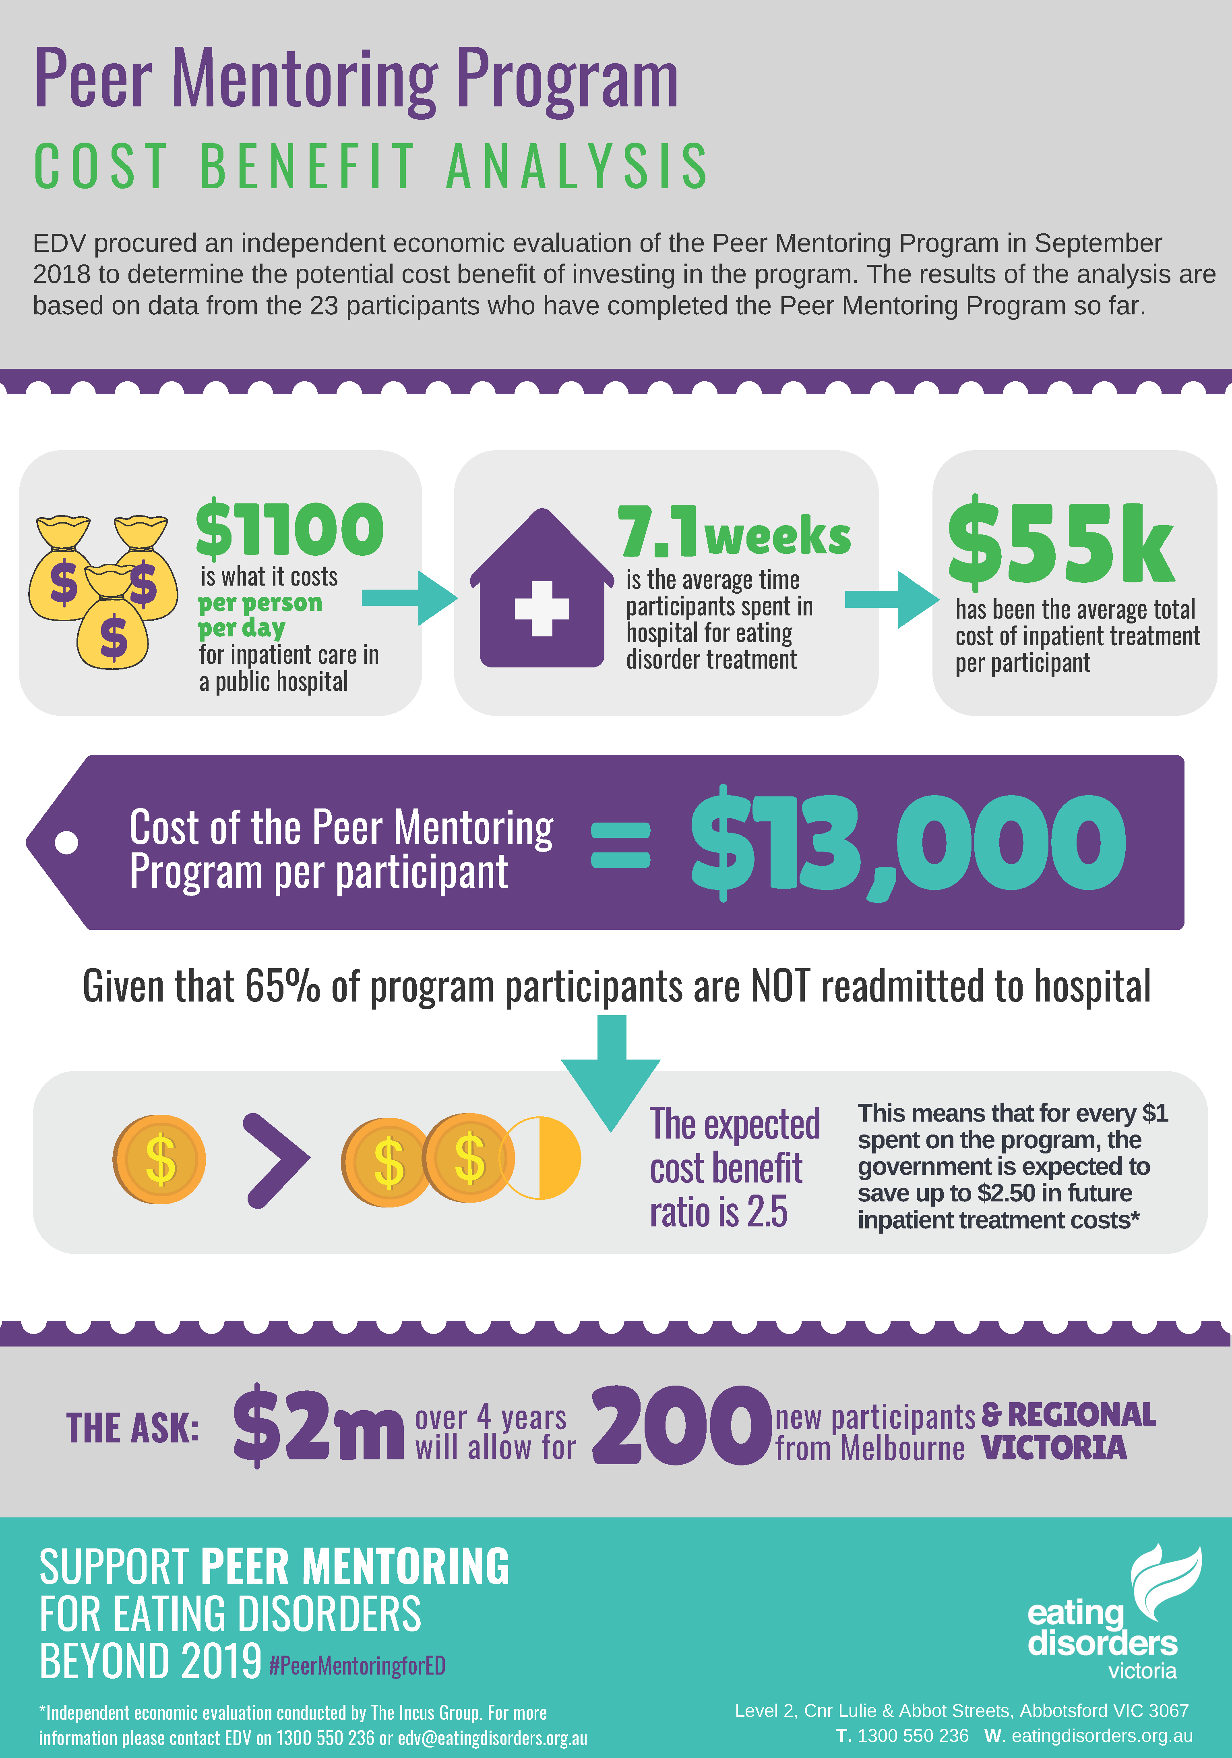

Appendix 2 – PMP outcomes

Deloittte Access Economics, 2012. Paying the Price: The economic and social impact of eating disorders in Australia. Butterfly Foundation.
Based on - Population data source: www.profile.id.com.au (.id SAFi) - ABS Census 2011 data used for population forecasting
Arcelus, J. M., Mitchell, A., Wales, J., Nielsen, S. (2011). Mortality rates in patients with anorexia nervosa and other eating disorders: A meta-analysis of 36 studies. Arch RCH Gen Psychiatry 68(7), 724-731.
Deloittte Access Economics, 2012. Paying the Price: The economic and social impact of eating disorders in Australia. Butterfly Foundation.
Yeo, M, Hughes, E. (2011) Eating disorders: early identification in general practice. Australian Family Physician 40(30), 108-111
Hay PJ, Mond J, Buttner P, Darby A (2008) Eating Disorder Behaviors Are Increasing: Findings from Two Sequential Community Surveys in South Australia. PLoS ONE 3(2): e1541. doi:10.1371/journal.pone.0001541
The National Eating Disorders Collaboration, 2010. Eating disorders prevention, treatment & management: An evidence review. Sydney: NEDC.
Deloittte Access Economics, 2015. Investing in need: Cost-effective interventions for eating disorders. Butterfly Foundation.
Deloittte Access Economics, 2012. Paying the Price: The economic and social impact of eating disorders in Australia. Butterfly Foundation.
Economic Evaluation of the Peer Mentoring Program – Eating Disorders Victoria, 2018. Prepared by The Incus Group
Appendix 1 – Cost Benefit Analysis infographic.
PMP Protocol paper: https://pilotfeasibilitystudies.biomedcentral.com/articles/10.1186/s40814-018-0268-6
Appendix 2 – PMP outcomes infographic
PMP Protocol paper: https://pilotfeasibilitystudies.biomedcentral.com/articles/10.1186/s40814-018-0268-6

