**Founding Members**  
The Australian Government  
The Sidney Myer Fund

**Patron in Chief**  
His Excellency General the Honourable   
David Hurley AC DSC (Retd)  
Governor-General of the Commonwealth   
of Australia

**Patrons**  
Hon. John Anderson AC  
The Rt Hon Ian Sinclair AC   
Mr Bill Kelty AC

**Chairman**  
Mr Tim Fairfax AC

5 May 2023

Commissioners

Philanthropy Inquiry

Productivity Commission

GPO Box 1428

CANBERRA City ACT 2601

Dear Commissioners,

Thank you for the opportunity to make a submission to the *Productivity Commission’s Review of Philanthropy*.

The Foundation for Rural & Regional Renewal - FRRR - (phonetically: F-triple-R) - is the only national foundation specifically focused on ensuring the social and economic wellbeing of remote, rural and regional communities. Established in 2000 with the Australian Government and The Sidney Myer Fund as members, FRRR connects common purposes and funding from government, business and philanthropy with the genuine local needs of rural people and places.

FRRR’s vision is for a vibrant, resilient and revitalised remote, rural and regional Australia, something that can only be achieved with a continued focus on community wellbeing and sustainability and care for the natural environment.

FRRR provides funding and capacity building support at the hyper-local level; aligning funding, big and small, to community-led solutions that build resilience and long-term viability and vitality of smaller remote, rural, and regional communities across Australia. Since FRRR’s establishment in 2000, FRRR has delivered in excess of $155 million to more than 13,000 local projects.

FRRR was specifically listed as a DGR-1 endorsed organisation in 2000, being listed at Item 13.2.2 of s.30-105 of the *Income Tax Assessment Act 1997 (Cth)*,and was provided a 2006-07 Federal Budget Measure that allows FRRR “to receive tax deductible donations from regional community foundations and to use these funds exclusively for projects in those regions”.[1] FRRR’s specific listing and budget measure allow it to act with flexibility to support the needs and aspirations of rural Australia in furtherance of our Constitutional purposes to “promote rural and regional renewal, regeneration and development in Australia, in social, economic, environmental, and cultural areas, for the public benefit, in the manner the directors decide from time to time.”

In this submission, FRRR’s position is framed by two overarching themes:

1. The needs of remote, rural and regional Australia are often different to those in a metropolitan context, with the tyranny of distance, differences in population sizes and differing access to services, different manifestations of giving, a different presence of and capacity to engage in philanthropy, and where policy designed for the needs of many who live in densely populated areas can have unintended implications in a remote and rural context that instead further entrench inequities; and
2. Organisations like FRRR, who were established with a flexible structure and who operate as conduits to support the needs of many, are effective vehicles to leverage government investment to grow giving. An initial Federal Government investment of $10M in 2000 has since catalysed more than $155M in direct philanthropic support being distributed to the needs of remote, rural and regional communities, with far more than that leveraged in kind and in cash, as a result of that funding.

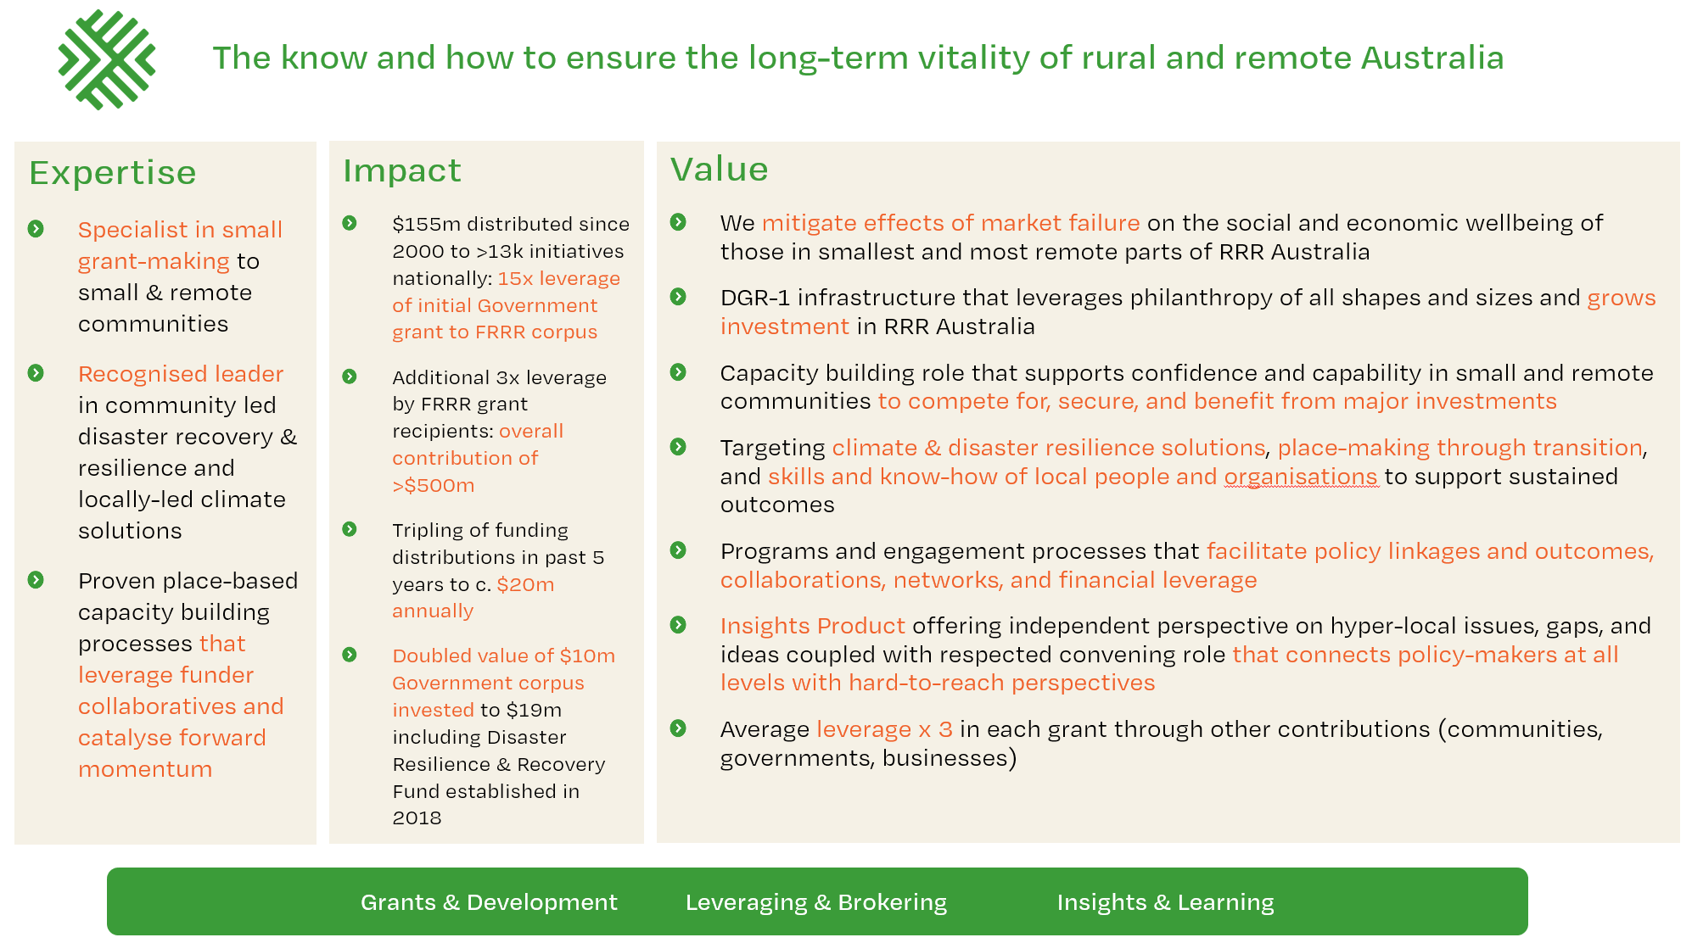FRRR’s model can be summarised as:

In responding to the Productivity Commission’s Call for Submissions, FRRR makes the following comments to specific Information Requests (numbered consistently with the Call for Submissions document):

***1. Defining philanthropy and the inquiry’s scope***

* ***Ways of recognising different definitions, perspectives and norms relating to philanthropy among different cultures and communities, including but not limited to:***

*– Aboriginal and Torres Strait Islander people*

*– culturally and linguistically diverse communities*

*– faith-based groups*

*– younger and older Australians.*

FRRR notes that for many remote, rural and regional communities, the term ‘philanthropy’ is a foreign concept. It connotes a metropolitan activity, or activities, confined to those with wealth, who are typically older or white people; not the giving or actions of generosity or reciprocity that so many persons across remote, rural and regional communities undertake on a daily basis, outside of a deductible-gift lens.

FRRR agrees with taking a wide view of what philanthropic activities should fall within the scope of the inquiry, recognising the value of time, treasure and talents. FRRR emphasises that particularly in a rural context, communities are very much reliant on the time and talent contributed by volunteers.[2] This form of ‘giving’, can often dwarf the monetary values involved in delivering services and activities that are themselves often responding to market failure in their region. In the context of declining volunteering rates[3], we need to better recognise and value this generous contribution of many.

A wide definition of philanthropy could also enable a multi-pronged campaign that encompasses the recognition and encouragement of giving in all of its forms. FRRR would welcome any actions that help demystify philanthropy and acknowledge that it is anything from dropping a few coins into a loose change jar on the counter of a local community store, to making regular contributions toward your favourite charity in your pay, to the generous contributions that come from businesses, trusts and foundations, as well as the legacy left by bequests. Each of these forms of financial giving makes an impact, yet often people don't engage with or recognise that when they make this contribution, they are in fact being philanthropic.

***2. Vehicles, trends and motivations for giving***

***• Australian-specific data, case studies or other insights regarding motivations of donors who have different characteristics, including elasticities of giving if available*.**

Over the 23 years of FRRR’s operations, it has been supported with the generous backing of many philanthropic trusts and foundations, individuals, businesses and governments. It is only because of the support of many that FRRR has been able to grant out more than $155M to more than 13,000 projects across remote, rural and regional Australia.

The motivations of, and quantity of this support has varied over time, as indicated by FRRR’s most recent seven year granting data (right).

**Disasters**

This trend of increasing value correlates to the occurrence of natural disasters that have had such a destructive impact on Australia’s communities, and the generosity of many seeking to support those affected. After the impacts of the droughts across QLD and NSW raised media profile in late 2018, FRRR received support from a range of businesses and the Federal Government to support drought impacted communities. In late 2019, when bushfires began across Queensland and NSW, FRRR began receiving support from a range of businesses, philanthropic foundations and many individuals, driven by FRRR being a broadcast partner of the Fire Fight Australia Concert. Then, after serious floods impacted almost every State and region, further support was forthcoming.

As an example, in late 2019, company [Wilson Asset Management encouraged its shareholders and wider stakeholder network to donate to FRRR](https://frrr.org.au/blog/2019/11/19/wilson-asset-management-lends-its-support-to-drought-and-fire-affected-communities/), offering to match their funds up to $500,000 – raising $1M in response to drought and bushfires, which was directed into FRRR’s Disaster Resilience and Recovery Fund, which has been invested in perpetuity, with earnings used to fund annual grant distributions.

Donors giving to FRRR in response to a natural disaster were typically those looking for an organisation they felt they could trust because of their research and/or recommendations of others, one operating with transparency and clarity around who would receive support and when, and whose operating costs were reasonable.

Sadly, as the number of severe disasters increase, the number of and size of philanthropic support, whether from individuals, businesses or trusts and foundations, has decreased.

**Inequities in a remote, rural and regional context**

There are many other donors who have very clear areas of focus and give regularly, and strategically, to causes aligned to their trust deeds or with the preferences developed in their strategic planning. The areas of interest are broad – from environment to education, youth to aged care, health to food security, just to name a few.

Many of those who partner with us leverage FRRR’s unique status to channel their donations toward these causes to benefit remote, rural and regional communities. Others choose to work through FRRR because they generally recognise there are inequities in remote, rural and regional areas and want to lend their support to issues that are often exacerbated in rural settings, such as access to health services, educational opportunities and food security.

For example, the Kellogg Australia Charitable Foundation (KACF) [partners with FRRR to support projects tackling food insecurity in remote and rural locations](https://frrr.org.au/blog/2021/02/23/frrr-partners-with-the-kellogg-australia-charitable-foundation-to-help-tackle-food-insecurity/). KACF’s donation contributes to a strong tradition of foundations, businesses and individuals coming together to collaboratively fund small grants benefiting rural Australia through the FRRR Strengthening Rural Communities (SRC) program. In 2022, SRC received more than 980 applications requesting over $15M for projects worth in excess of $47.5M. Of these applications, there are a number that seek support to address challenges relating to food insecurity. FRRR matches these applications to supporter preferences, including KACF’s preference to address the challenges of food insecurity, such as a [$10,000 grant to the Morgan Volunteer Support Group](https://frrr.org.au/blog/2022/11/10/new-wheels-deliver-more-than-meals/) who sought to purchase a vehicle for the delivery of the Morgan Meals on Wheels Service.

This collaborative support of FRRR’s partners and donors, including KACF, enabled the support of 468 Strengthening Rural Communities grants in 2022, totalling more than $5.7M for projects worth over $24M, right across remote, rural and regional Australia. Grant programs like these can be a powerful mechanism to leverage collaborative giving of many whilst providing a single straightforward pathway through which community organisations can seek support.

* ***Information on the advantages and disadvantages of philanthropy as a source of revenue for NFPs compared with other funding streams, such as government grants, and whether these advantages and disadvantages differ:***

***– according to deductible gift recipient status or the organisational structure of charities***

For organisations with DGR-1 endorsement, there are advantages in accessing philanthropy as a source of revenue. Philanthropic donations can be made as a charitable gift with no material return, very few requirements and an ability to be flexible, responsive and agile when compared to the requirements of government, who necessarily require detailed budgets and implementation plans to ensure probity and value-for-money. While the spectrum of philanthropic giving varies widely – from donations $2 and above made by individuals, through to the larger grants of philanthropic Trusts and Foundations, not all philanthropic grants are the same. Many of the larger philanthropic organisations are themselves bound by geographical remits dictated by trust deeds, or Board-preferred strategic objectives for a particular charitable outcome or to support a particular cohort.

Ultimately though, for many grassroots not-for-profit organisations in rural areas, they do not hold DGR-1 endorsement and are thus locked out of accessing much of philanthropy.

In addition to not being eligible for funding by their status, many grassroots organisations are not of sufficient size, nor do they have the capacity, to seek out and access either government or philanthropic funding. It is important that organisations exist that can help connect the great work of these organisations to those with the goodwill to support such activities.

Local Community Foundations, which FRRR has been instrumental in establishing and developing in many rural and regional areas, are one channel which, if more prevalent, could help increase access to philanthropic funding. They provide a place-based philanthropic vehicle to house local and external donations, working closely alongside their community to distribute funding support.

At a national scale and in consideration of the capacity required to reach the many small and remote parts of Australia, it is this barrier of access to philanthropic giving that FRRR helps to bridge, with broad charitable purposes and a specific listing that allows FRRR to support the charitable activities of not-for-profit organisations across remote, rural and regional Australia.

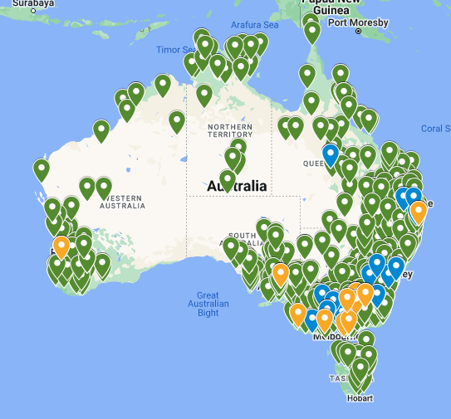**In the 2021/22 financial year, of FRRR’s $19.8M grants across 991 projects in 526 different postcodes of Australia, 69% of those grants were made to organisations that did not hold DGR-1.**

Access and explore the interactive map (on right) of the 991 grants FRRR distributed across FY21/22, [here](https://www.google.com/maps/d/viewer?mid=1gYV_lGoHWP2jJ7AfKD8CpYUWu2lMCcw&ll=-27.97678028038464%2C133.6337876&z=4).

***3. Role of government in philanthropy***

* ***The role of philanthropy, including where it can be a substitute for, or complement to, government funding or provision of services.***

It has been said that the role of both government and charities is to pursue the common good but a distinguishing feature is the characterisation of government as administration, as opposed to the voluntarism of charity.[4] In many circumstances, charities with independence, agility and trust of their community are great delivery partners of government – but many can also become reliant on such funding.

In a remote, rural and regional context, there are inequities in access to services such as health and education. Some of these inequities permeate through government delivered services and others exist as a result of market failure. The challenges are complex and no one measure to support philanthropy and double giving will address these challenges. However, organisations like FRRR can provide a convenient and efficient lever through which to support rural communities to address inequities.

In some cases, Government funding can also be an incentive for other funders to add their support to a cause, either by way of a matched giving initiative or simply to be seen to be a good corporate citizen. However, while we recognise and acknowledge the need for probity and due diligence, we also highlight the limited capacity of many remote, rural and regional community-based organisations to meet the compliance obligations that may come with such expectations of co-funding. Trusted organisations like FRRR can act as the intermediary and make it possible for these organisations to access such funding. FRRR often responds to community enquiries seeking such support, and regularly submits proposals where FRRR can act as a partner to inject funding into community-led initiatives that respond to current challenges, build capacity for the future, or are enablers to active opportunities.

There are tangible areas where philanthropy could be a strong complementary lever, such as the energy transition currently underway or issues of housing supply. On energy - while Government and industry are focussed on mechanisms to accelerate adoption of renewable energy, there is also a need for the long-term social and environmental benefits for regions hosting renewables to be co-designed at a pace that enables proper engagement and genuine outcomes. This is an example of the kinds of issues that philanthropy can help address in partnership with government and business – systemic issues affecting the prosperity and viability of regional Australia - but it requires collaboration and a willingness to apply philanthropic, government, and business capital in ways that place social and environmental outcomes equal to economic drivers.

* ***The reasons why government should (or should not) support philanthropy and whether or how this may vary between causes and various types of philanthropic giving.***

In relation to philanthropy, governments can provide support across two key mechanisms – either by providing a grant with funds now, or forgoing future tax revenue by providing a DGR-1 mechanism.

In FRRR’s circumstances, the Australian Government provided FRRR with an initial contribution of $10M through a Deed of Grant in 2000. Since that time, FRRR has preserved and grown the contribution, but it has also leveraged the Government’s investment to a further $155M of philanthropic support.

Through FRRR, the Government’s initial contribution has been matched 15 times over – and in reference to the Government’s interest in doubling giving, it has well and truly achieved such a goal! In addition, community groups have leveraged this investment in-kind and in extra cash contributions, resulting in an estimated $625M of total impact to date.

Given the proven impact of this model, FRRR has recently sought an increased corpus investment from Government. This would allow the Foundation to scale up, ensuring it is ready and able to further support the needs of rural communities, particularly given the likelihood of future disasters. This would effectively ‘stand up’ greater capacity for philanthropic support, which would in turn enable additional flexible support for grassroots organisations in rural communities.

FRRR would welcome a further discussion with the Productivity Commission to discuss how a re-allocation of Government assets (a non-budgetary mechanism) would enable further philanthropic leverage for the benefit of remote, rural and regional Australia and efficiently contribute to the goal to double giving by 2030 in a way that also strengthens equity in distribution of philanthropic funding.

Another example of the ability of governments to catalyse philanthropy, was the actions of the Victorian Government after the Black Saturday bushfires in 2009. Impacted communities advocated for recovery funding to be utilised in the establishment and implementation of local Community Foundations. [Foundation Murrindindi](https://foundationmurrindindi.org.au/history/), previously Marysville and Triangle Community Foundation, is such an example of this approach, which has created ongoing philanthropic assets in communities.

In addition to establishing Community Foundations, a portion of the Victorian Bushfire Appeal Funds were directed through FRRR, [enabling FRRR to provide flexible and responsive granting over the long-term](https://frrr.org.au/blog/tag/vbaf/), to support the recovery needs of impacted communities. For the Victorian Government, FRRR was an established, independent and trusted partner who was able to work flexibly and responsively across a number of communities – particularly in the context where many of the Community Foundations were being established, and there were regions who did not have a Community Foundation in place. Ultimately, the Victorian Bushfire Appeal Fund enabled a collaborative approach that utilised trusted governance structures and evolved over time, as community needs changed.

Another area where we have seen the Government support and partner with philanthropy is around capacity building. FRRR delivered the Future Drought Fund’s Networks to Build Drought Resilience program, with a key goal of strengthening networks and increasing community capacity to withstand drought. As part of this program, there was a structured evaluation program, funded as part of the program. This was invaluable in capturing learnings and shaping future investment. The same approach is, pleasingly, being implemented in the current Future Drought Fund Helping Regional Communities Prepare for Drought program.

* ***The extent to which government policies can increase, impede or distort philanthropic giving, including data to support those views where possible.***

In this submission, we have discussed how the needs of remote, rural and regional communities can be different to metropolitan counterparts. In this context, there can be unintended consequences of government policies that result in requests from philanthropy.

In addition to the examples cited below, FRRR has observed spikes in requests for iPads and electronic devices in schools following policy changes and limitations on the types of equipment that local volunteer emergency services groups receive as part of core provision, versus those they need to fundraise for as they deem them critical to their local context. The consequence for FRRR has been a diversion of grants to these areas where gaps would otherwise exist for rural communities and a detraction from other areas of need, or more proactive initiatives that communities and local NFP’s wished to progress. It is FRRR’s position that this is not a strategic use of finite philanthropic resources.

As a further example, in the mid 2000’s regulations changed around infrastructure in early childhood facilities, such as adequate provision of space, toilet / kitchen / laundry requirements and separate hand washing facilities, together with playground and soft fall standards.

At that time, the majority of early childhood services in rural Australia were delivered by not-for-profit community organisations, supported by a large volunteer base. It's not uncommon for parents to travel up to 150 kilometres to participate in a playgroup or engage their child in early learning groups because of the value they place on the experience.

The new regulations placed significant burdens on community-based groups. Compliance such as this often requires costly capital works which are outside of their financial capabilities, with little or no access to government funding.

FRRR’s Rural Early Childhood (REACH) Program was established in 2008, after it became evident that more than 20% of grant applications in the previous year were from preschools, playgroups, community not-for-profit day care centres and toy libraries, seeking support for basic infrastructure and resources – mostly to meet these new requirements.

With support from philanthropic partners, FRRR was able to provide grants of up to $20k to help fill these critical infrastructure gaps.

**Fall through the gaps**

Community organisations often relay to FRRR how hard it can be to ‘fit’ into specific government funding channels – for example:

“We very much appreciate being able to access FRRR funding for projects where we are unable to access government grant funding. We have had issues accessing Department of Human Services funding because our name is ' sporting association' and issues accessing Office of Recreation and Sport funding for projects that are not 'sport' related.” - *Applicant*

We recognise the need for Government funding to have tight guidelines to ensure probity but as this example highlights, it means that many groups that fulfil critical roles, especially in small remote, rural and regional communities, miss out – increasing the burden on philanthropy or local fundraising to fill the gaps. There are opportunities for Government to partner with well-established groups like FRRR to meet the needs of these groups, while still ensuring appropriate due diligence and use of the funds.

There are also a large number of community-owned assets, where the responsibility of local or state governments to maintain and up-keep facilities has been devolved to a local volunteer-led community organisation. In these instances, where existing government programs of support to these vital community assets are insufficient, and particularly where the local community has limited fundraising options and Shires manage vast regions and have small rate-payer bases, philanthropy is asked by community to step in to maintain what is a critical asset for that community. Requests like these further divert philanthropic funding, and can also unhelpfully blue the lines in a consideration of what should be a responsibility of government, as opposed to a ’charitable’ activity.

“Grants of this nature help communities such as [*Anonymised]* improve their environment and livability as well as prepare effectively for the bushfire threat. Many, many volunteer hours go into managing these assets and raising small amounts of money just to keep these community assets in a semi respectable standard. Grants such as these enable us to more effectively improve our assets to better serve the community and provide the community with safe, functioning facilities at which we can meet, socialise and share our lives.”

**Disasters**

Time and time again after a disaster, FRRR hears from communities that when the larger agencies ‘pull out’ or ‘wind down’ at a point in time, there has been no pre-investment in services within communities, or local philanthropic vehicles to back up that support. When Government agencies pull back or limit their support, local organisations seek support from philanthropy.

As an example, communities in Black Summer bushfire impacted areas are currently relaying to FRRR a growing sense of anxiety. With the support from the Australian Government's funded programs and projects winding up, communities are wondering if they will have access to further funding and support. In the aftermath of the fires, several community initiatives in impacted communities started, for example, community pantries. With the unfortunate timing of COVID lockdowns hitting impacted communities weeks, or even days after the fires were extinguished, the demand for these services has exponentially increased and are not slowing down. Communities are concerned they won't be able to support the need and are wondering where the funding support will come from.

**Short-term nature of funding**

Increasing philanthropic support that can provide patient funding over the long-term is incredibly valuable to communities. As a recent applicant tells us, short-term approaches can result in additional harm:

"[*Anonymised*] is a community in great need with great potential. The community ran a ranger program that meant that a number of community members had solid work, income and pride. They developed skills and awareness that they could make a difference in their community. The community then as a whole benefited, buildings were fixed, rubbish was collected, plans for improvements were made, a shed was erected and a community centre was set up. At the same time an arts project brought together other sections of the community in joyful artistic effort. These projects made a different to everyone. Unfortunately, funding was not continued as programs came to the end of their lifetimes. The short-term nature of government programs leads to a building of hope and pride that is not maintained and the slumps can actually be worse as hope fades."

In many instances, it is extremely difficult to pre-empt the variety of unintended consequences that may occur in response to government policies. It is FRRR’s position that there exists an opportunity for Government to combat the unintended challenges that arise by investing in backbone structures, such as Community Foundations and where they don’t exist, through organisations like FRRR, so that local community organisations are able to respond to locally identified challenges and opportunities over the long-term.

***4. The Deductible Gift Recipient (DGR) framework***

* ***The efficiency, effectiveness, and equity of the DGR framework, including whether its design and administration:***

***– is clear, transparent and fit-for-purpose for its intended objectives, and result in any unnecessary costs (including forgone tax revenue) or risks to the Australian community***

***– results in any inequities, inefficiencies, or perverse outcomes.***

**Misunderstood**

‘DGR’, ‘tax-deductible’ giving and the deductible gift recipient framework is a complicated regime that is largely unknown, and often misunderstood, by the general public. In the context of this complexity, there is also an assumption that the provision of DGR will result in it being used.

While FRRR is supportive of changes to DGR to facilitate greater giving, we note that it must be coupled with greater information and awareness – we must not assume that DGR is understood, is equitably accessible, or even that DGR is the predominant factor constraining giving.

In a remote, rural and regional context, the ability to access and utilise a DGR-1 endorsement can be more constrained than in a metropolitan setting. Fewer organisations hold DGR-1 in rural settings than in metropolitan contexts and there are fewer advisors in rural contexts who can help organisations navigate obtaining or effectively leveraging DGR-1.

Conduit organisations like FRRR can be vehicles through which support can be provided to navigate the complexity and give a hand-up to organisations or individuals in remote, rural and regional communities who are either seeking to give, or to receive, philanthropic support.

**DGR-2 – Private and Public Ancillary Funds**

The introduction of the Private and Public Ancillary Fund model, with its associated charity and DGR-2 endorsement, has positively supported many across Australia to establish and distribute philanthropic support. As a DGR-1 endorsed organisation, FRRR receives welcome support from a large number of DGR-2 endorsed Private and Public Ancillary Funds who seek to positively impact remote, rural and regional Australia.

**DGR-1’s impact on a community’s ability to fund their disaster recovery**

FRRR has observed that DGR-1 endorsements can further entrench organisational disadvantage, particularly in response to disasters. A DGR-1 endorsement has a direct impact on the relative ability of not-for-profit organisations in disaster impacted areas to seek and receive donations. Those with DGR-1 who can act quickly to garner attention because they have greater capacity and know-how have secured more significant levels of donations than organisations without DGR-1 endorsement and/or with less internal fundraising capacity to act. Each time this occurs, the gap widens between the larger organisations with DGR-1 and those without, as they miss out on the resources that would enable them to better support their community and grow as an organisation ahead of future disruptions.

**Community Foundations**

FRRR stands with our colleagues in Community Foundations across Australia in seeking support for their DGR-1 endorsement to encourage local giving. The DGR framework as it currently stands does not allow for the flexible, place-based support that many community foundations are so adept at providing.

Through the Federal Government’s 2006-07 Budget Measure, FRRR was specifically enabled to support Community Foundations in rural areas. FRRR is able to receive DGR-2 donations and provide a DGR-1 receipt, and to make grants to organisations who do not hold DGR-1 themselves. Through a Community Foundation fundraising partnership, FRRR can enable Community Foundations in rural areas to access a workaround for the restrictions that many face under a DGR-2 public ancillary fund model. FRRR has only levied a 2.5% contribution to its costs on donations received through the partnership accounts, which is less than it costs FRRR to administer the support but represents one of FRRR’s ongoing pathways to support the Community Foundation sector in Australia.

However, as noted earlier, the DGR framework is complex and for many grassroots community groups actually impedes their ability to access funding for critical needs that either fill gaps or enable them to take advantage of opportunities. With many community groups being entirely volunteer-led and operated, and with limited access to local expertise in DGR and charitability requirements and regulations, many can’t make use of the DGR framework. This extends too to even some of the Community Foundations, so it will be important in ensuring equity that alternative models, such as FRRR, continue to exist.

***5. Other tax concessions for not-for-profit organisations***

* ***Anomalies and inequities in the operation and application of particular concessions.***

Within its tax concessions, FRRR is one of the many charitable organisations who hold a Fringe Benefit Rebate, rather than a Fringe Benefit Exemption. The distinction means that for the majority of FRRR’s staff, salary packaging is not a beneficial option, and it limits FRRR’s (and other FBT Rebatable organisations) ability to attract key talent, while also increasing our cost to deliver compared to organisations who hold FBT exemption.

FRRR would welcome a harmonisation of the Fringe Benefits application across DGR-1 endorsed organisations.

***7. Consumer information on the effectiveness of not-for-profit organisations***

* ***The role of government and the non-government sector in providing additional information to donors.***

FRRR is a supporter of the role that the Australian Charities and Not-for-Profits Commission (ACNC) plays in publishing information on charities that is freely available to the public. In seeking to minimise the administrative burden on charities of reporting to multiple bodies, we encourage any further consumer information to be housed within the ACNC – as a one-stop shop of information pertaining to charities in Australia.

***9. Cost-effectiveness of public data sources***

* ***Critical data and information gaps about philanthropic giving and how these impede policy development and decision making.***

FRRR strongly recommends the Productivity Commission advocates for the introduction of data management that aggregates information across philanthropic giving **and** government.

The absence of such data has resulted in an opaque funding landscape where foundations and governments alike are ‘unsure’ who is receiving funding and in which locations, and where there are gaps, or indeed, growing momentum. Looking at government or philanthropic giving alone is only part of the picture – we need to combine this information and present it transparently, for improved outcomes.

Currently, to obtain such data, additional resources must be invested to seek what is often only partial data. This is a key area of waste across the sector that could be better directed to fulfilling charitable outcomes.

Such data requires an agreed taxonomy and regular, periodic updates. A publicly available register or platform would also increase transparency and trust and enable greater study into the relative investments occurring across different sectors.

***Further information***

FRRR welcomes the Government’s goal to double philanthropic giving by 2030 and thanks the Productivity Commission for the opportunity to make this submission. We would welcome the opportunity to discuss FRRR’s insights further with Commissioners. Please contact Natalie Egleton, CEO, FRRR

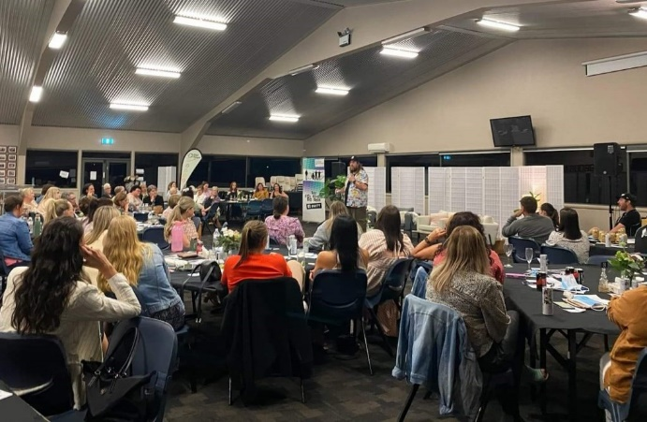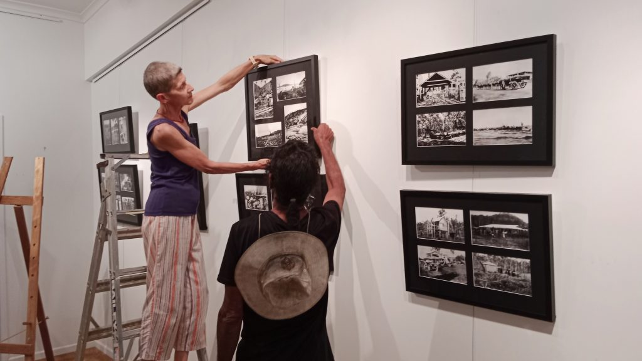

Photos from FRRR grants: <https://frrr.org.au/blog/2023/04/26/im-not-afraid-to-talk/> and <https://frrr.org.au/blog/2023/04/24/mission-beach-echo-of-the-past/>

1. Australian Government, 2006-07 Budget Paper No. 2, pg 27.
2. FRRR, Heartbeat of Rural Australia Research Study, 2021, available at: <https://frrr.org.au/heartbeat/>
3. See eg, AIHW <https://www.aihw.gov.au/reports/australias-welfare/volunteers>.
4. Harding, Matthew --- "Distinguishing Government and Charity in Australian Law" [2009] SydLawRw 23; (2009) 31(4) Sydney Law Review 559.