14th July 2017

Dear Sir/Madam,
RE: Response to, Productivity Commission, Introducing Competition and Informed User Choice into Human Services: Reforms to Human Services, Draft Report

INTRODUCTION:
Haven; Home, Safe (HHS) welcomes the opportunity to respond to the Productivity Commission’s Draft Report: Introducing Competition and Informed User Choice into Human Services: Reforms to Human Services.
HHS’ response will concentrate on the recommendations in Section 5: Social Housing: choice and contestability, Section 6: Social housing: tenancy support services and stewardship and Section 7: Commissioning family and community services. HHS’ particular interest being the impact these recommendations have on people at risk of or experiencing homelessness.
HHS appreciates the emphasis of the Commission on finding ways to put the people who use human services at the heart of service provision and hopes in this submission, to ensure we provide on behalf of our clients, a strong voice in shaping the services they receive, and who provides them.
We agree with the Commission that the social housing system is broken and that the current model of financial assistance is inequitable.
Overall, HHS supports recommendations 5.1 to 7.7 in theory but queries how some of the recommendations are to be applied in practice.
In conclusion, HHS supports user choice, competition and contestability if they are providing for better service provision and better person-centred outcomes, but has concerns about how robust these reforms will be in the current housing environment without also addressing the under supply of affordable housing and the lack of regulation in the private rental market.

HAVEN; HOME, SAFE
Loddon Mallee Housing Services trading as Haven; Home, Safe (HHS) is Australia’s only fully integrated affordable, crisis, transitional, support housing and specialist homelessness service provider.
A not-for-profit company based in Bendigo, we were established in 1979 and have been operating in our current form since 1994. Since then we estimate we have contributed more than $1 billion to the Victorian economy, operating across the state, mostly in regional areas.
Since we merged in October 2014 with Preston based housing provider North East Housing Services (NEHS), HHS now also operates across metropolitan Melbourne. HHS employs more than 150 staff across seven offices and has a $30+ million operating budget.
We own and manage more than 2000 homes with total assets approaching $300 million and are one of the largest single commercial customers of Australia’s 5th largest bank.

RECOMMENDATIONS 5.1 to 7.7
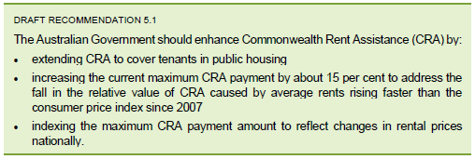

As identified by the Commission the rental price index has arisen faster than the CPI index. HHS approves of future indexing increasing as the rental prices change rather than as the CPI increases and approves of increasing CRA. HHS questions though, whether the 15% increase addresses the past meteoric rise in rents.
For a single person on Newstart this amounts to $73.00 per week of rent assistance after the increase. In order to avoid housing stress, according to the yard stick of a household not spending more than 30% of their monthly income on either rent or mortgage repayments, the rental needs to be under $103 per week. A snapshot on RealEstate.com of the rental properties in Australia in that price range, revealed available properties are predominantly limited to rooms in shared houses, student accommodation and one bedroom units in regional parts of Queensland. HHS is therefore concerned that a 15% increase in CRA is not sufficient enough to make an impact upon the housing affordability and supply issues inherent in the current housing crisis.
HHS also has concerns about extending CRA to cover public housing tenants. Doing so, HHS believes, removes the current incentive for state governments to transfer properties to housing associations. State Housing Authorities have demonstrated over the past 60 years, as reflected in recent VAGO reports, that they simply cannot manage housing stock to the desired levels. Public housing landlords who have over recent generations rationed their stock to those in greatest need have essentially become high end welfare dependent landlords for high end welfare dependent clients. This group in the social housing portfolio, HHS argues, certainly need access to better housing and better managed housing but simply adding more value, more cash to the coffers of State Housing Authorities is unlikely to fix that problem. What is likely to fix that problem is to continue to entice State Housing Authorities to transfer the management rights of their stock, so that non-government organisations can then claim that rent assistance and use it effectively to upgrade the stock or redevelop the stock.

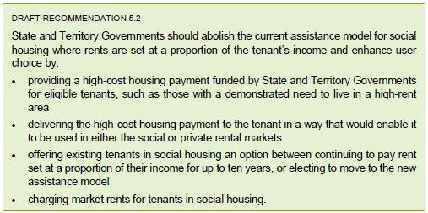

Shifting from an income based rent model to a market based rent model as the Commission states removes the perverse disincentive built into the current financial assistance model whereby tenants are not incentivised to increase their income and improve their situation because a certain proportion of the income they earn will go as higher rent. Effective Marginal Taxation Rates (EMTR’s), the withdrawal of benefits or increase in effective taxes as people’s income rises is a historically documented poverty trap for all rent geared to income rent models. Simply adding more rent assistance exacerbates the problem for public housing tenants and exacerbates the issue for rent geared to income models. Another reason why the public housing failed model should not be supported.
HHS agrees that the flexibility to use the payment on private or social housing broadens the housing options for tenants. HHS would like to highlight though, that an unintended consequence of this recommendation is that, if a housing association charges full market rent the tax and charity status and, GST concessions housing associations are able to tap into are potentially threatened as they are all predicated on housing associations charging lower that full market rent.

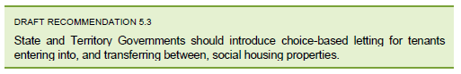

HHS supports recommendation 5.3 basing its own affordable housing allocation system on choice based letting. In order to achieve a person-centred approach a person needs to have a right of choice. In HHS’ experience choice based letting creates a greater sense of control for their tenants, and not having a waiting list has helped to not create false hope.

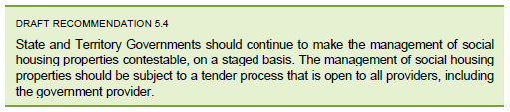

HHS agrees that the management of social housing properties should be subject to tender on the proviso that it is a fair and transparent process that serves to sharpen the pencils of organisations involved in the social housing field. The inclusion of government as a potential provider raises concerns for HHS as to how genuine the transfer of properties actually would be if the tender process allows government to tender for something they currently manage. If included, the government provider needs to be clearly separated out from the tender decision making process and therefore, a restructure would need to occur.
We fully agree that the separation of social housing properties and the management of social housing properties is subject to contestability but it is important that if the government is to be one of those tenderers that they are subject to the same level of regulation that Housing Associations are subject to. HHS further recommends the creation of a tender process that is more streamlined, less expensive and less time consuming.

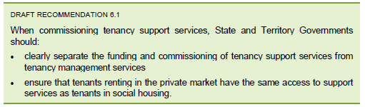

In HHS’ experience as Australia’s only fully integrated social housing and specialist homelessness service provider, integrating tenancy management and tenancy support services creates better outcomes for clients. Although integrated, the tenancy management and tenancy support services, are as recommended by the Commission, funded and commissioned separately, and internally; functionally separately managed.
HHS clients are aware they can receive support without being in a HHS property and HHS tenants are aware they can receive support outside HHS without losing a HHS property.
Although HHS has no negative experiences it appreciates that situations where the tenancy support services and the tenancy management services are managed by the same organisation can lead to situations of abuse for clients where they have no choice. HHS believes, rather than separating out the support and management services, which can potentially lead to a lack of coordinated planning, poor communication and over use of resources, it is better to have a coordinated environment in which internal clarity of role, elimination of role ambiguity and functional separation are in place to avoid such issues.

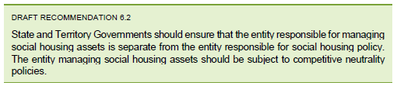

HHS is in agreement with the Commission that there is an inherent conflict of interest between managing social housing assets and being responsible for social policy. The social policy makers, HHS reasons, cannot be held captive to the demands and needs of what is happening in social housing to ensure the development of the best policy. Social housing policy needs to be recognised as an entity that is broader than the management of social housing assets.

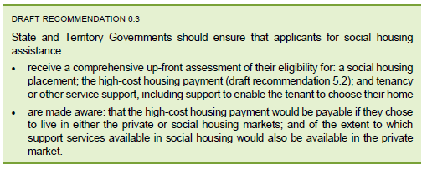

HHS absolutely agrees with recommendation 6.3, as a comprehensive assessment from the get go enhances a more streamlined and quicker process of assistance. The time invested in making a comprehensive assessment upfront will save time further down the track. Providing applicants with the knowledge necessary to make informed choices is imperative in case management to ensure best practice. HHS further recommends that the time and resources involved in this assessment be taken into account when considering outputs and outcomes.

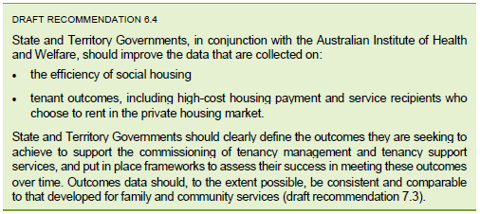

There is always a need for organisations that receive government funding to report the same information to different parts of government and different levels of government. Anything that simplifies this reporting process such as clearly defined outcomes is welcomed by HHS, as data needs to be efficiently collected and meaningfully utilised.

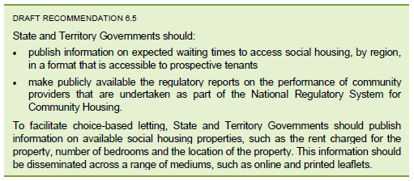

HHS believes this is fundamental information to collect to facilitate choice based letting. HHS absolutely agrees with this recommendation.

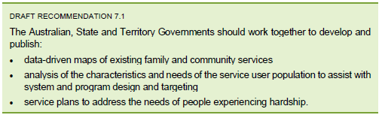

HHS agrees that having access to the data in recommendation 7.1 provides the best knowledge for government and organisations to plan for services going forward as it better matches services to the actual demand. This data, HHS maintains, should be the driving force of policy, funding, service planning and operational activity. HHS would extend the focus in the recommendation to include local government in the data mapping, as they are a big contributor to family and community services.

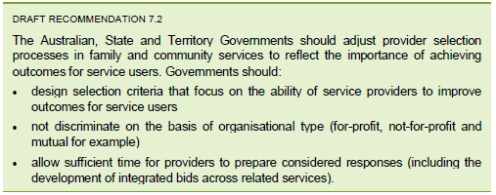

HHS draws the Commission’s attention to the work of Professor Gary L. Sturgess who was commissioned by the New South Wales Chamber of Commerce to do a review on the efficacy of the contracting out of human and other government funded services. If we encapsulate Professor Sturgess’ work and paraphrase, essentially for-profit providers will loss lead at a major level to gain contracts, thereby eliminating and destroying NGO and other non-profit providers and eliminating them from the market place. At which point the for-profit providers begin the inexorable recoupment of their loss leading levels and simply move contracts to a higher level over time. Much of the cost absorbed by private sector providers, particularly in terms of infrastructure and capital, is further paid for via the taxation system. This is an expensive cost shift that report after report, investigation after investigation has consistently proved is not a good use of tax payers’ money. The not –for –profit sector by comparison, is often characterised as a cottage industry. If you were to look at the dispersed and disparate nature of the community housing sector you could be convinced that this is also the case. This is not the case. It is important to understand that amongst the almost 700 community housing organisations around Australia that there are approximately 40 that represent more than 80% of all of the available stock. Of these 40 organisations, 30 of them are members of Power Housing Australia and they represent the majority of all of the borrowings of private sector leverage that has been brought into this space. These numbers are much more powerful than even a pareto rule and so it is important to understand that the large housing associations are not by any means cottage industries. These are organisations with hundreds of millions of dollars of balance sheet value often 30, 50, 70 million dollar PNL’s, large professional organisations who will be, in reality, those who would take this space forward.

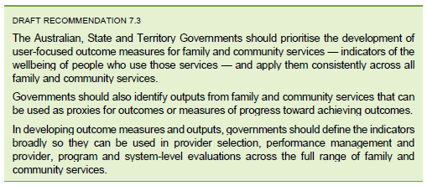

HHS appreciates the benefits of user-focused outcomes over the current service delivery outputs model believing that outcomes present a more accurate picture of service effectiveness and user wellbeing. HHS has concerns however, that the Commission’s inquiry has as its underlying premise the McClure report’s emphasis on the need for a greater focus on employment. Employment is favourable as are study and volunteer work. But they must be realistic outcomes chosen by clients and backed up by the necessary resources, such as appropriate training, support and actual employment opportunities.
HHS questions how this data can be obtained from a population such as those at risk of, or experiencing homelessness when that population is by definition a transient population. This transience would need to be taken into account when determining what this data is and how it will be collected. HHS would also make the observation that with varying reports identifying that there are between 6 and 16 job seekers for every available job in the economy, that even if there was no spatial mismatch between the location of the job and the job seekers and we know there is a spatial mismatch. Even if there was no skills gap between the jobs and the job seekers, and we know there are vast skill gaps. Even if those two things did not exist, there would still be the simple competition analysis that should be brought to the notion of job seekers. If there are 10 job seekers for every job, then in a competitive system if every job seeker keeps competing long enough, then those in the top five will most likely get a job eventually. But the reality is, those in the bottom five will remain in the bottom five of every job competition. On that basis, there is a rump of unemployed people for whom a skills gap and a locational or spatial gap is largely irrelevant. They simply will not and cannot compete in a competitive job market- the people at the bottom of the competitive process will always stay at the bottom of the competitive process. And as the job market evolves to eliminate more and more, less skilled jobs, those numbers will increase. The Productivity Commission report, HHS believes, should reflect that reality. We also note that many of these people are the people that HHS spoke to in the previous recommendation about public housing becoming the repository of the high needs welfare end of the spectrum.
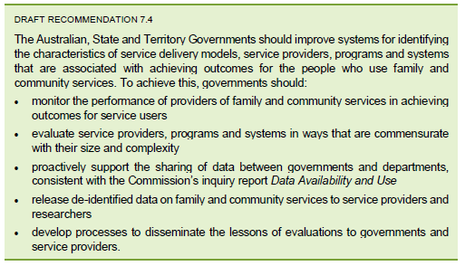

HHS agrees that this recommendation is good in theory and would create savings but queries how this would be achieved in practice given the turnaround in governments and ministers in portfolios.
In relation to evaluating service providers, HHS seeks clarification about how the parameters of measurement would be set up to determine the effectiveness of this recommendation.
Furthermore, HHS recommends that if the quality assurance frameworks that housing associations must comply with are made more complex than they already are, that it be included in the funding, as added compliance and regulation take money! It is also important that State Housing Authorities are subject to the same transparency, regulation and requirements for contestability.

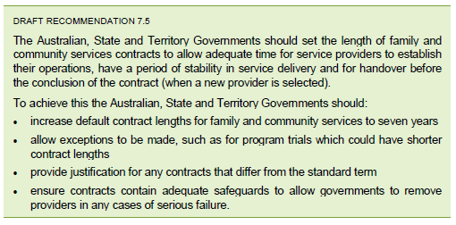

HHS supports recommendation 7.5 on the grounds that organisations will be more prepared to commit an investment upfront going for the tender if they know there is some certainty in their income stream over seven years. This recommendation also has the potential that the organisation awarded the tender would build up a core of internal knowledge and improve their processes over a seven-year period providing a much better service for clients as they become industry specialists in their particular area.
HHS agrees with the Commission that there needs to be adequate safeguards in place such as good contractual obligations around the person-centred outcomes that organisations can be held accountable for and, the capacity to remove the contract from them if they do not meet those obligations. Conversely, HHS would recommend that there not be so much structure involved in meeting the data and reporting requirements that it becomes onerous for an organisation and impacts on their service delivery. Any recommendation that occurs over a government term, HHS believes would have the potential to actually get something done and produce good outcomes.
The perennial issue for contracting out housing, family and community services is the tension between creating barriers to new entry for new providers versus creating a safety net that prevents predatory pricing that is used in order to kill off established entities and kill off established competition. HHS spoke to this in earlier recommendations and referenced the work of Gary L. Sturgess. HHS notes that this conversation is relevant to recommendation 7.5.

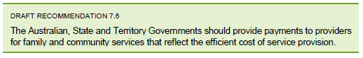

This is fine in theory but HHS seeks clarification on who will determine the measure of ‘efficient cost of service provision’.

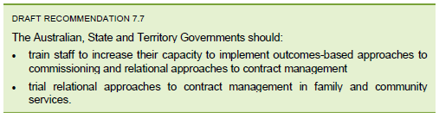

HHS agrees a relational approach to contract management is worth trialing. Outcomes-based approaches are a higher bar to achieve than outputs but HHS believes, that as service providers we are here to do the best we can and should strive for improvement in service delivery on an ongoing basis. We note that there is throughout the community sector throughout government departments in particular, and we suspect at play in the community some confusion between inputs, outputs and outcomes. We also note the growth in the language of ‘social impact’. Most recent Harvard Business School research which talks about business transformation and begins to measure social impact, clearly delineates this from outcomes, which as the Productivity Commission identifies is clearly delineated from outputs. But HHS, respectfully notes that the difference between outputs and outcomes is poorly understood generally and thinks there is a case for management and other education of both state departments and NGO’s if this language is to be utilised.

CONCLUSION:
HHS encourages competition and contestability if it ensures agencies perform to the best of their ability and creates an environment of innovation. But HHS sees the downsides of competitive processes such as scarcity, fragmentation and service silos, as witnessed in the vocational educational market, as being cautionary tales that must be heeded, rather than viewed as mere distractions on the road to the greater good. As a safeguard, HHS agrees with the Commission that the government should always have the role of system stewards in the market for Human Services.
HHS supports the move to a single model of financial assistance, an expansion and an increase in CRA and the implementation of choice based letting but remains sceptical about the impact these reforms will have upon housing affordability and housing supply.
The private rental market, if it comes to the party, can provide an extra supply of houses but it is still a long way off from providing the security of tenure that is an integral and attractive part of the social housing model. Increasing the CRA does not automatically lead the homeless to a private rental as it does not address the stigma associated with unemployment, lack of rental history or a blacklisted rental history. Nor in its present state and with a mere 15% increase in CRA does the private rental market prevent the problems associated with pockets of disadvantage that are alleviated in communities based upon mixed tenure design and principles.
Of equal importance to landlords is the minimal compensation that can be sought should their property be damaged by a tenant or rent arrears accrued. The private rental market, is in comparison to social housing, an untamed beast that requires a degree of knowledge in dealing with marginalised and vulnerable groups and a recognizable system of regulations in order to be an effective deliverer of affordable housing.
HHS agrees that family and community services are not meeting the needs of people experiencing hardship but rather than resource an entirely new competitive system of service delivery, HHS recommends the government focus on system planning, contract management and increasing funding to current providers to reflect the increase in client numbers. Such an environment HHS believes is more conducive to the collaborative environment also being encouraged by the government in which partnerships and co-design are paramount.
Implementing user choice for social housing tenants and clients is not simply created by more organisational choices. People at risk of or experiencing homelessness may have limited capacity to apply for or make informed choices about housing and support options and this should require an additional investment. Specialist services were born from the marginalisation and exclusion of those who did fit into the mainstream services of the private market realm.
There is a real risk that the for-profit sector will cherry pick the clients least in need of service who guarantee faster and better outcomes to the detriment of clients who have long-term and complex needs. Social housing, on the other hand, as the Commission suggests, are the best providers of accommodation and support for those not well placed to enter the private rental market. To be effective and enduring providers they must be sustainable as diverse and commercially aware enterprises and be in a position to build, much needed affordable and long term tenure houses.

Yours sincerely

Ken Marchingo
Chief Executive Officer

