**Introduction:**

Charity law no longer reflects the values of younger Australians like myself, and it seems that we lack philanthropic organizations that support our priorities. In the past, institutions like Rotary Clubs and RSLs played a central role in fostering community identity and altruism. However, they have lost their place in our cultural identity, and we must update charity incentive structures to preserve them and the value they create.

Despite the decline of traditional philanthropic institutions, philanthropy still holds a crucial place in modern Australian communities, albeit in different forms. Effective altruism groups, concentrated in major cities and universities, represent the forefront of philanthropy among young Australians. These groups prioritize global impact, long-term risk prevention, and challenge the moral circles that govern historic philanthropic communities. Their causes include animal welfare, environmental preservation, and preventing human extinction. To strengthen the community, philanthropic reforms must recognize these changing interests and ensure effective altruism groups become the Rotary Clubs of the future. Aligning charitable giving with younger generations' priorities is critical for promoting social cohesion and increasing charitable donations.

In this Submission I raise four issues:

1. The availability of DGR status for high impact cause areas (Terms of reference 2.ii, 3.ii, 5, 6)
2. Removing arbitrary restrictions on Public Benevolent Institutions so they can better work across causes and support community groups (Terms of reference2.iii, 3.i)
3. The maturity of international approaches to charity evaluation (3.ii, 6.iii)
4. The importance of policy advocacy by charities, including the potential to make our democracy fairer. (Terms of reference 3.i, 5, 6.iii)

I have donated to effective charities and am committed to supporting local philanthropic and community organizations. I am eager to expand my involvement in these efforts and believe the recommendations outlined in this submission would facilitate my engagement while encouraging more Australians to donate and participate in their communities.

**Issue One: DGR status**

In my opinion, expanding DGR status is crucial to address two major concerns among young Australians - animal welfare and catastrophic risk reduction. Currently, community organizations around catastrophic risks are limited, and I would like to engage with my community to volunteer my skills and interest towards reducing these risks. However, without DGR status, it's challenging for such organizations to find volunteers like me. Many of my peers are also concerned about the risk of future pandemics and the need to prevent a nuclear war, but DGR regulation hasn't kept up with these modern concerns.

Similarly, many of us care deeply about animal welfare, and while these charities can be considered under the Charities Act, they are excluded from receiving DGR status under the Tax Act. This is because DGR status is limited to short-term direct care and rehabilitation of mistreated animals, whereas prevention-based charities are not incentivized. This exclusion of high-impact cause areas from DGR status hampers our ability to do good and limits social connections built around these causes.

Therefore, I strongly believe that the Government needs to expand DGR status to these cause areas to increase donations to charities and facilitate social connections among Australians who are passionate about these issues.

**Issue Two: PBIs and community building**

I actively support Effective Altruism Australia and their efforts to empower effective altruism groups in universities and major cities. These groups inspire people to do good, guide them on impactful donations, facilitate reading groups, and provide advice on careers that make a difference. However, the current regulatory framework governing Public Benevolent Institutions (PBIs), including Effective Altruism Australia, is outdated and should be absorbed into the Charities Act. The Law Council of Australia and the Australian Charities and Not-for-profits Commission (ACNC) are regularly debating the meaning of cases from the 1930s and 1940s that define how PBIs can operate, which is not helpful for organizations, communities, or their ability to do charity in an impactful way.

An example of this lack of focus on outcomes is the dispute over the meaning of "dominant purpose." The ACNC appears to think that a charity that is a PBI has to have its PBI-purpose as its "overriding" purpose, and therefore it cannot also have other purposes from the Charities Act. However, the Law Council thinks this reading is a misunderstanding of the meaning of "dominant purpose" and that having a purpose from the Charities Act should not disqualify a PBI.

Having critical definitions about how a charity can do its business buried in arcane case law that doesn't have a clear reading and isn't aligned with the government's policy intent is not efficient or effective. In the case of "dominant purpose," it's clear that government policy has no concern with a charity pursuing multiple purposes, as the Charities Act allows a charity to have multiple purposes. This has real-world implications for how PBIs can engage in fundraising, do impactful work, and support their communities.

"Dominate purpose" is just one example of common law that is no longer helpful. There is also confusion around other phrases like "direct relief." The Productivity Commission should recommend amendments to the Charities Act to override the common law and create a new charity type that is not mutually exclusive with other charity types. The precise details can be resolved by ACNC-led consultation and government decision.

This regulatory limitation means that community builders cannot organize reading groups on topics like animal welfare since it isn't considered "incidental or ancillary" to global poverty. I find this limitation unnecessary and counterproductive to building a strong philanthropic community in Australia. While there is a need to prevent misuse, it's important to remove narrow, PBI-specific rules around "dominant purpose" that prevent PBIs from doing work in their communities, especially since their terms of reference are to build social connections.

Allowing PBIs to pursue other charitable purposes would enable me and my group to participate more actively in the community and find more avenues to make a positive impact.

**Issue Three: Charity Evaluation**

I am enthusiastic about the terms of reference regarding charity evaluation. Charitable giving is often met with cynicism due to the difficulty of determining whether donations have had a tangible impact. Overseas charity evaluators have provided much-needed rigor around impact assessment, as high-impact charities can be significantly more effective than average charities, and some charitable programs can even cause harm.

I strongly encourage the Productivity Commission to review the following resources on the topic:

* *Donors vastly underestimate differences in charities’ effectiveness* by Caviola, L; Schubert, S; Teperman, E; et al. available online at <http://hdl.handle.net/10871/122268>, and
* *Don’t Feed the Zombies* by Kevin Star in the Stanford Social Innovation Review, available online at <https://ssir.org/articles/entry/dont_feed_the_zombies>

The vast difference between the layperson's and experts' views on the impact of charity, illustrated in two graphics:

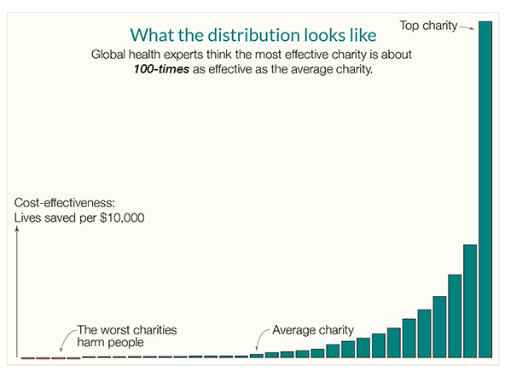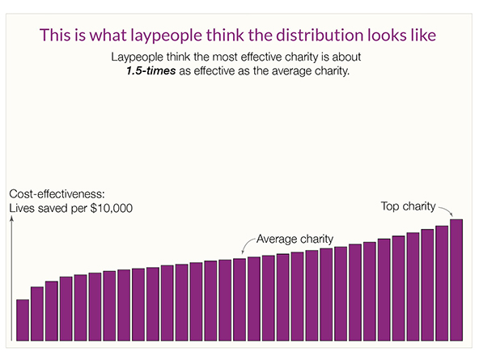

Kevin Star's article outlines the market failure in the charity sector, where donors are not part of the feedback loop and often lack meaningful ways to gauge the value beneficiaries receive from their donations. His approach to impact-focused evaluation could significantly enhance the efficacy of the sector and result in a "quantum leap toward a better world."

Although the above resources focus on global health, similar effects occur across countries and causes. Benjamin Todd's recent article on 80,000 Hours demonstrates a comparable distribution of the impact of climate interventions.

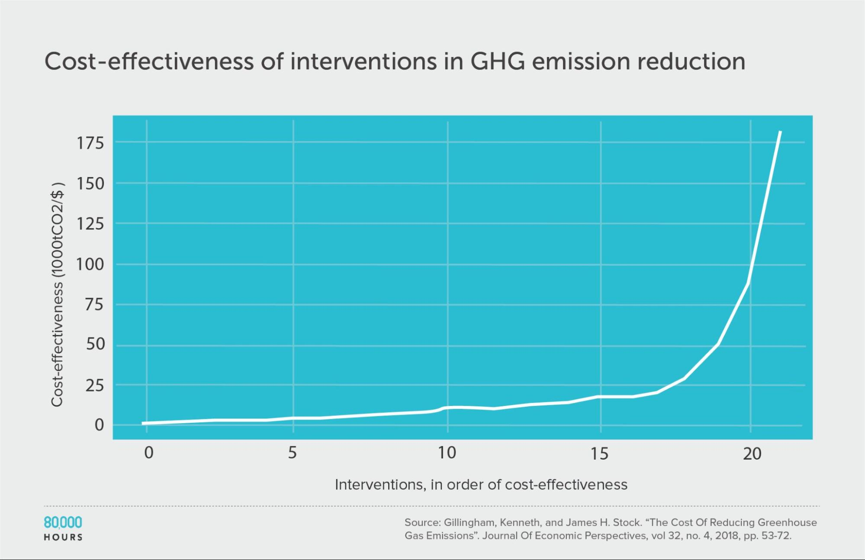

This insight is crucial. The lack of understanding around the impact of charitable giving and the market's failure to function correctly has been an ongoing issue. However, progress made in charity evaluation over the last decade offers hope that the problem can be resolved.

Australia's investment in promoting and funding charity evaluation has the potential to remedy the market failure, enhance the impact of Australian charities, and potentially position Australia as a global leader.

**Issue Four: Policy Advocacy**

The ACNC's policy that allows charities to promote or oppose a change to law, policy, or practice as long as it aligns with their charitable purpose is a step in the right direction. However, it fails to address the main issue at hand. The problem lies in the fact that DGR status is necessary for effective fundraising and attracting talented staff, but the pathways to obtaining DGR status are narrow and typically exclude any framing around policy or advocacy.

While technically charities can engage in advocacy, DGR charities largely dominate fundraising and staff recruitment, and non-DGR charities prioritizing advocacy are excluded. This restricts the ability of advocacy-focused charities to function effectively and creates an imbalance in democracy. For-profit companies have significant funds to spend on lobbying, and they often receive tax benefits for doing so. However, individuals who are passionate about certain causes often lack the resources to organize and do not receive tax advantages.

To address this issue, DGR classes should be broadened to include advocacy-focused organizations. Currently, DGR status is limited to specific kinds of animal rehabilitation in the animal welfare space, which restricts charities' ability to advocate for rules and approaches that prevent animal rehabilitation in the first place. Making this change would make democracy more equitable, enable communities to come together around issues they care about, and encourage donations. If there were organizations that aligned with my values and had active and powerful voices in the policy conversation, I would feel more confident in our democracy.

**Conclusion**

Australia has the potential to become a global leader in philanthropy, but it is currently missing a crucial opportunity to encourage effective giving. There are no mechanisms in place to incentivize impact or empower donors to choose the best charities based on their impact. As a result, we are witnessing a brain drain of talented Australians who are leaving for the UK or USA to do high-impact charity work. We cannot afford to lose these valuable assets due to the lack of a supportive ecosystem for high-impact charity work in Australia.

To lead in philanthropy, we must act now by incentivizing impact, empowering donors, broadening DGR status, and increasing transparency and accountability. Australia has a unique opportunity to attract more impact-focused charities and enhance our ability to make a positive impact on the world.

We must seize this opportunity to lead the way in philanthropy and shape a better future for ourselves and generations to come. Let us work together to create a supportive ecosystem for high-impact charity work and keep our talented Australians here, making a difference.