Submission to the Productivity Commission: inquiry into early childhood education and care

June 2023

Rosie Hodson
Policy and Advocacy Lead, Restacking the Odds

Executive Summary
This submission is made on behalf of the Restacking the Odds initiative (Restacking). Restacking is a collaboration between the Centre for Community Child Health (CCCH) at Murdoch Children’s Research Institute (MCRI), Social Ventures Australia (SVA) and Bain & Company.
Restacking aims to redress the effects of inequities and disadvantage in the early years that can span generations. Research tells us that investments during early childhood deliver the greatest benefits, through better health outcomes and improved productivity.
Participation in quality early childhood services helps to ensure children are on the right path to fulfil their potential. But when services are underused, unavailable or vary in quality, they can’t fully meet the needs of children or families.
Nationally, one in five children arrive at school developmentally vulnerable. Children in the poorest areas of Australia are twice as likely to be developmentally vulnerable than children in the wealthiest areas. These inequities have not shifted in over a decade. Attendance at preschool reduces the likelihood of being vulnerable at the start of school but does not help to close the equity gap.
Currently, children from disadvantaged backgrounds are less likely to be enrolled in early childhood education and care (ECEC) and when they are enrolled, they typically attend for fewer hours and in lower quality services than their non-disadvantaged counterparts.
Restacking identifies that combining or ‘stacking’ multiple effective evidence-based strategies across the early years (0-8 years) can boost health development and wellbeing and redress inequity. Restacking focuses on five evidence-based platforms and programs: antenatal care; sustained nurse home visiting; early childhood education and care; parenting programs; and the early years of school (through to Year 3).
Our hypothesis is simple: more equitable delivery of the existing system is possible, but timely data is required to enable change at the pace needed to make a real difference for Australia’s children within a generation.
Drawing on our work we recommend that the Commission consider:
- The importance of combining or ‘stacking’ multiple effective evidence-based strategies across the early years to boost health development and wellbeing and redress inequity. Positioning the early childhood education and care (ECEC) sector within the broader ecosystem of early years services can amplify the positive effect of ECEC for child development outcomes and future productivity.
- Achieving “universal, affordable ECEC – in the great tradition of universal Medicare” requires attention to implementation to make sure the services actually meet the needs of the population. Those involved in designing and delivering early years services need to be equipped to act on leading indicator data to answer three simple questions at a local level:
(1) Are services available in sufficient quantity?
(2) Are they being delivered at a standard that the evidence says is required (quality)?
(3) Are the relevant children and families receiving the services (participation)?
- The evidence for what an “accessible, equitable and high-quality” ECEC system needs to deliver, informed by Restacking’s identification of evidence-based lead indicators to measure quantity, quality and participation in ECEC.
  - Our research found that evidence supports provision of high-quality ECEC for 15 hours or more per week for all children for 2 years before starting formal schooling. It also identifies that children from priority population groups will benefit from attending ECEC from a younger age: 3 years before the start of formal schooling. Priority groups include children living in areas of socio-economic disadvantage, children from a non-English speaking background, Aboriginal and Torres Strait Islander children and children with disability.
  - Our research supports the continued application of the National Quality Standard (NQS) in ECEC as an important tool to support monitoring and reporting of service quality.
- The need to address existing barriers to participation in ECEC – noting a current disparity between enrolment and attendance. A stronger system stewardship approach from government could tackle issues identified in our research, for example:
  - Reducing direct and indirect service costs for families
  - Promoting the benefits of ECEC linked to high-quality play-based learning in formal settings
  - Increasing flexibility in program format so participation can be coordinated with the demands of work and other family responsibilities
  - Resourcing professional development training of staff in relationships-based and family-centred practice.
- Implementation of improvements to the ECEC system requires:
  - Investment in data and learning systems to support continuous improvement and drive equitable service delivery. These systems are a crucial part of the ’glue’ that enables coordination and integration of support for children and families.
  - Investment in integrated and place-based delivery models as enablers of ‘stacking’ in a local area.
We would be happy to provide further information to the Commission on these issues and on our insights as we continue our work with place-based initiatives and service providers. This includes the evidence-informed tools and resources we are developing to provide a ‘learning system’ for communities and service providers. The learning system will support collection and use of data to improve quantity, quality and participation in early years services.

About Restacking the Odds
Restacking the Odds (RSTO) aims to drive more equitable outcomes in the early years by ensuring that children and families can and do access a combination of high-quality, evidence-informed services where and when they need them.
Restacking the Odds’ unique approach uses data and evidence-based lead indicators to focus on how to work differently to improve outcomes for children, families and communities.
Phase one of Restacking (2016-2021) completed research in seven communities across Victoria, New South Wales and Queensland to develop and apply evidence-based lead indicators for the effective delivery of each of five fundamental strategies. These indicators define how the strategies should be delivered across the dimensions of quality, quantity and participation. This work was co-funded by the Paul Ramsay Foundation, with Eureka Benevolent Foundation and the Department of Social Services.
Having completed proof of concept, Restacking was awarded funding by the Paul Ramsay Foundation in 2021 to build toward large scale adoption of the Restacking framework. This second phase of the project aims to co-design a series of prototypes for service providers and communities to routinely collect and act on their Restacking data – as self-sufficiently as possible – and to test how this helps them better understand and act on priorities and improve performance.

The importance of ‘stacking’
The rapid development in a child’s earliest years (0-8) provides the foundation for lifelong health, development and wellbeing. Greater investments in early childhood development bring greater returns through better health outcomes and improved productivity.
Establishing the conditions that children need to thrive during this critical time provides immediate and lasting benefits for individuals, families and communities. Conversely, inequities emerging in early childhood often continue into adulthood, contributing to unequal rates of low educational attainment, poor mental and physical health and low income. In some cases, this experience is part of a persistent cycle of intergenerational disadvantage, with ongoing social and substantial economic costs.
It is widely accepted that there is no single policy, program or investment that can solve the complex challenges faced by many children, families and communities. Restacking identifies that combining or ‘stacking’ strategies across the early years and implementing then concurrently and continuously in place can amplify the impact of a single service and sustain the benefit. This approach is informed by the evidence-based research of economist James J. Heckman.
Restacking focuses on five early years’ service types or strategies available in most communities: antenatal care; sustained nurse home visiting; early childhood education and care; parenting programs; and the early years of school. These five strategies are a subset of the possible interventions. Restacking has chosen to focus on them because the research demonstrates they improve early childhood outcomes, they are available across early childhood, they focus on both the child and the parents and can be targeted to those most in need.
Our analysis of data from the Longitudinal Study of Australian Children has found that ‘stacking’ these five fundamental strategies, (i.e., ensuring they are all applied for a given individual) has a cumulative, positive effect on child development outcomes, measured through reading scores at ages 8-9.

Using lead indicators to track quantity, quality, participation
“Affordable, accessible, equitable and high-quality ECEC” will not be achieved until those designing and delivering ECEC are equipped to act on the leading indicator data to measure three simple things at a local level:
- that ECEC is available locally in sufficient quantity
- that the services are being delivered at a standard that the evidence says is required (quality) and
- that the children and families who would benefit are receiving the services (participation).
Lead indicators allow service providers and other stakeholders to regularly assess performance and progress, and course-correct when required. While outcome data is the ultimate arbiter of success, lead indicators about what families and children are actually experiencing allow practitioners and service providers to make timely adjustments and accumulate learning regularly, rather than waiting years to see outcomes.
The very long gap between actions and outcome measures makes it almost impossible to discover what is effective and to apply continuous improvement, and literally impossible to assess what leads to better end-outcomes, because regardless of the outcomes achieved, we don’t know what services the children or families received. By contrast, lead indicators are directly useful to support practical, measurable system change.
Table 1: Example of lead indicators in ECEC
Lead Indicator | Potential Action | Outcome Indicator
Proportion of children attending ECEC for 15 hours or more per week for the two years before starting formal school | Overcome barriers to low participation rates e.g. reach out to culturally and linguistically diverse populations | Proportion of children at school entry who are developmentally on track in health, learning and psychosocial wellbeing

Evidence-based lead indicators for ECEC
Restacking has identified practical, evidence-based lead indicators for each of the five fundamental early years strategies using the common three-part framework covering quantity, quality and participation. The evidence-based lead indicators are available in our Indicator Guide.
For Early Childhood Education and Care (ECEC), measurable, best practice indicators of quality, quantity and participation were developed through a targeted rapid review of the existing research base for ECEC. This included evidence for all forms of early childhood education and care – including preschool and long day care settings.
Extensive research indicates that the education and care of young children (from birth to eight years of age) has an immense influence on long-term outcomes related to their cognition, resilience, health and wellbeing. It suggests that children from the lowest socioeconomic quintile would benefit from good quality early education opportunities prior to starting school. These benefits relate to formal ECEC models, particularly high-quality centre-based care and preschool or kindergarten programs in the one to two years immediately preceding school.
The targeted rapid review included consideration of what the evidence indicates is the most effective universal starting age, dosage (i.e. number of hours per week) and attendance duration (i.e. number of months or years) as it relates to improving child developmental outcomes.
The evidence-based indicators established in the research phase are detailed below. These set the standard for what a quality, accessible, equitable ECEC system needs to deliver, as a minimum.

Quality:
To determine the indicators of quality, Australia’s existing quality rating system was utilised: the National Quality Standard (NQS) implemented by the Australian Children’s Education and Care Quality Authority (ACECQA).
A combination of literature reviews (peer-reviewed and web-based reports) and interviews with experts were then performed, to determine which ACECQA Quality Areas had the most robust evidence related to child outcomes. We found that the available evidence supports three of ACECQA’s seven Quality Areas well (QA1 - Educational program and practice; QA4 – Staffing arrangements; and QA5 – Relationships with children). We identified that while 38% of Australia’s ECEC centres receive an ‘exceeding’ rating from ACECQA, only 25% of centres exceed the NQS standard for performance on all three of these Quality Areas.
Quality indicator: The proportion of ECEC services rated ‘exceeding’ the standard in quality areas 1, 4 and 5 and at least ‘meeting’ the standard in all other quality areas according to the ACECQA assessment

Participation:
To determine participation indicators, we focused on national and international longitudinal studies and utilised systematic reviews and meta-analyses, where available. The evidence was examined to determine any differential effect related to universal or targeted program participation in children from 0 to 5 years (e.g. targeted according to housing vulnerability or poverty, cultural and linguistic diversity, or low IQ).
The literature supports the importance of ECEC for all children for two years before starting school. For children from priority population groups (children residing in an area with a Socio-Economic Index for Areas Index of Relative Socio-economic Disadvantage quintile of 1, non-English speaking background, Aboriginal and Torres Strait Islander children, children with disability), the evidence suggests an earlier starting age and longer duration of ECEC is beneficial, as is a higher dose program. These benefits are only conferred for high quality programs.
The proposed participation indicators differ for universal vs targeted provision:
Universal participation indicator: Proportion of all children attending ECEC for 15 hours or more per week, for the two years before starting formal school
Targeted participation indicator: Proportion of children experiencing disadvantage who attend ECEC for 15 hours or more per week, for at least the three years before starting formal school

Quantity:
When assessing quantity, the key considerations are whether there is sufficient ECEC infrastructure and a qualified ECEC workforce to support the relevant populations to attend for at least fifteen hours per week. Quantity indicators were developed using the best indicators of participation level (for universal and targeted provision), and community-level population data.
Quantity indicator: The number of ECEC places for 15 hours per week available to 2-5 year olds.

The full technical report of the review and the communication summary are available on our website.

Barriers to ECEC participation
For ECEC, the collection of lead indicator data highlighted that significant numbers of Australian children enrolled in ECEC are not attending for at least 15 hours a week. For example, data of over 10,000 children at 688 centres across Australia, sourced via a collaboration with Xplor (one of Australia’s leading ECEC software platforms) showed an average of just 56 per cent of children enrolled in ECEC received the recommended dose of at least 15 hours or more care per week for 90+% of weeks over a nine month period (1 March to 30 November 2019).

Figure 1: Percentage of children attending ECEC for more than 15 hours per week (1 March to 30 November 2019) based on 90% of weeks
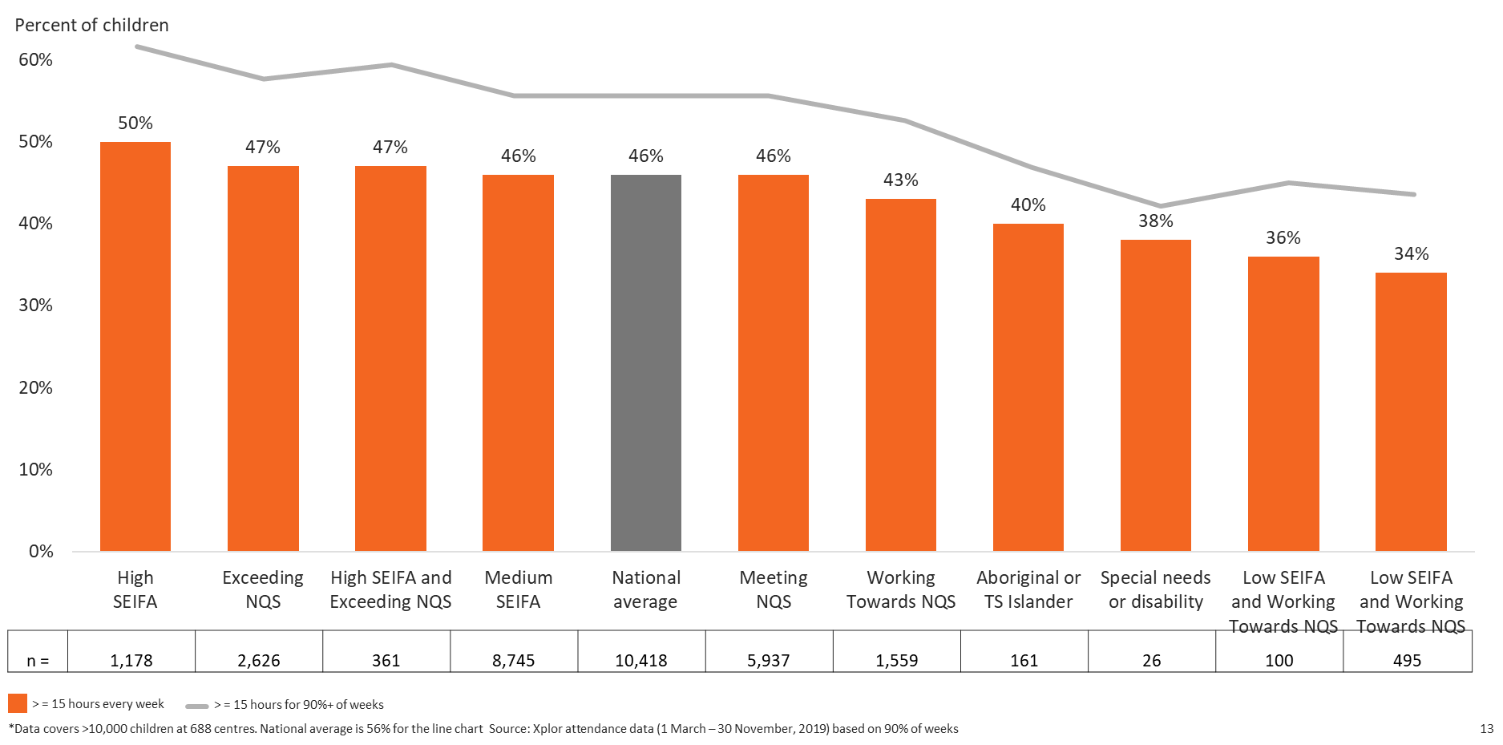
The substantive variation in the proportion of children accessing early childhood education in the year before school has been found in previous research. Studies have shown that enrolment is lower among children from families with: a single-parent; non-English speaking background; lower levels of education; both parents unemployed; Aboriginal or Torres Strait Islander (ATSI) descent; residency in rural or remote areas or socioeconomically disadvantaged communities. Similar trends have been observed in studies of attendance rates. That is, even when children from disadvantaged groups enrol in preschool programs, they typically attend for fewer hours than their non-disadvantaged counterparts and are more likely to experience a poor-quality service.
The barriers and facilitators of participation in ECEC experienced by and most important to Australian families has been subject to only limited exploration, however. Further research was conducted to investigate these barriers and facilitators in three Australian communities.
The study found considerable convergence across parent and provider views on the importance of various ECEC participation barriers and facilitators and highlights specific divergences. Findings indicate the need to:
- Reduce direct and indirect service costs for families
- Promote the benefits of ECEC linked to high-quality play-based learning in formal settings
- Increase flexibility in program format so participation can be coordinated with the demands of work and other family responsibilities
- Resource professional development training of staff in relationships-based and family-centred practice.
The funding and regulatory arrangements and operation of the market in ECEC currently do not incentivise a focus on inclusion. We encourage the Commission to consider a stronger stewardship role for government nationally to address barriers to participation.

Investment in data and learning systems
Currently in Australia, lead indicators are inconsistently collected and rarely used to inform early years services. Equipping services and communities with this data provides tailored, quantitative and timely guidance on important gaps in early childhood services. It can be used to measure progress over time and provides actionable knowledge for continuous improvement.
Providing lead indicator data is empowering for service providers and community representatives. One community representative commented: ‘…we had very poor AEDC results. So, I was looking for data where we could show improvement. I was able to go through the Restacking the Odds data and find where we could make some easy wins’. An ECEC service provider noted value in examining participation data, including to compare participation rates at different centres and against benchmarks, and to consider opportunities to improve participation of specific population groups.
Drawing value from data requires capability to collect, interpret and identify actionable insights to improve services and outcomes for families and children. Currently resources for both collection and interpretation of data are typically limited.

Research into barriers and enablers to collecting and using indicator data
The most common barriers and enablers to collecting, reporting and using the Restacking framework have been a focus of our recent research.
Significant barriers relate to data systems and processes including time and data fidelity. It was noted that it is time-consuming to report data because: the process requires manual calculations; it is difficult to obtain information from the system; the data is not granular enough for the service’s needs; and there is limited ability to aggregate data due to different data collection systems. Data fidelity was listed as a barrier to both data collection and use, with a lag in quality assessment timing and a significant amount of missing data affecting user’s confidence in the data quality.
Participants also describe a lack of knowledge of the ‘right’ data (that is linked to child outcomes) to collect and report on and of how to incorporate this into their data system. They also note a lack of knowledge interpreting and using data to inform service delivery.
Using a behavioural change model, the Capability, Opportunity, Motivation, Behaviour (COM-B) model, we can better understand the elements requiring change, how they interrelate and identify the most common and important barriers and enablers. Our preliminary findings suggest potential solutions to address barriers to collection and use of leading indicator data in ECEC settings, for example:
- Capability: develop data literacy and quality improvement programs – providing education and training to address low data literacy and data interpretation skills
- Opportunity: develop a tailored IT platform to make it easy to collect and visualize data where current data systems, processes and software platforms present barriers
- Motivation: additional resourcing, including for data-related tasks which can be seen as a lower priority than engaging with families and children.

Developing a learning system
To drive sustainable change, our research has identified that a new learning system is needed at both the community and service provider level. The learning system has three core components (illustrated in figure 2):
- Technology platform – to collect, measure, interpret and visualise the data
- Improvement support program – to build data literacy and embed a model for continuous improvement in services and communities to respond, innovate and act on data
- Community of practice – to share learnings, experiences, knowledge and resources across participating organisations and the sector more broadly.

Figure 2: Restacking the Odds Learning System
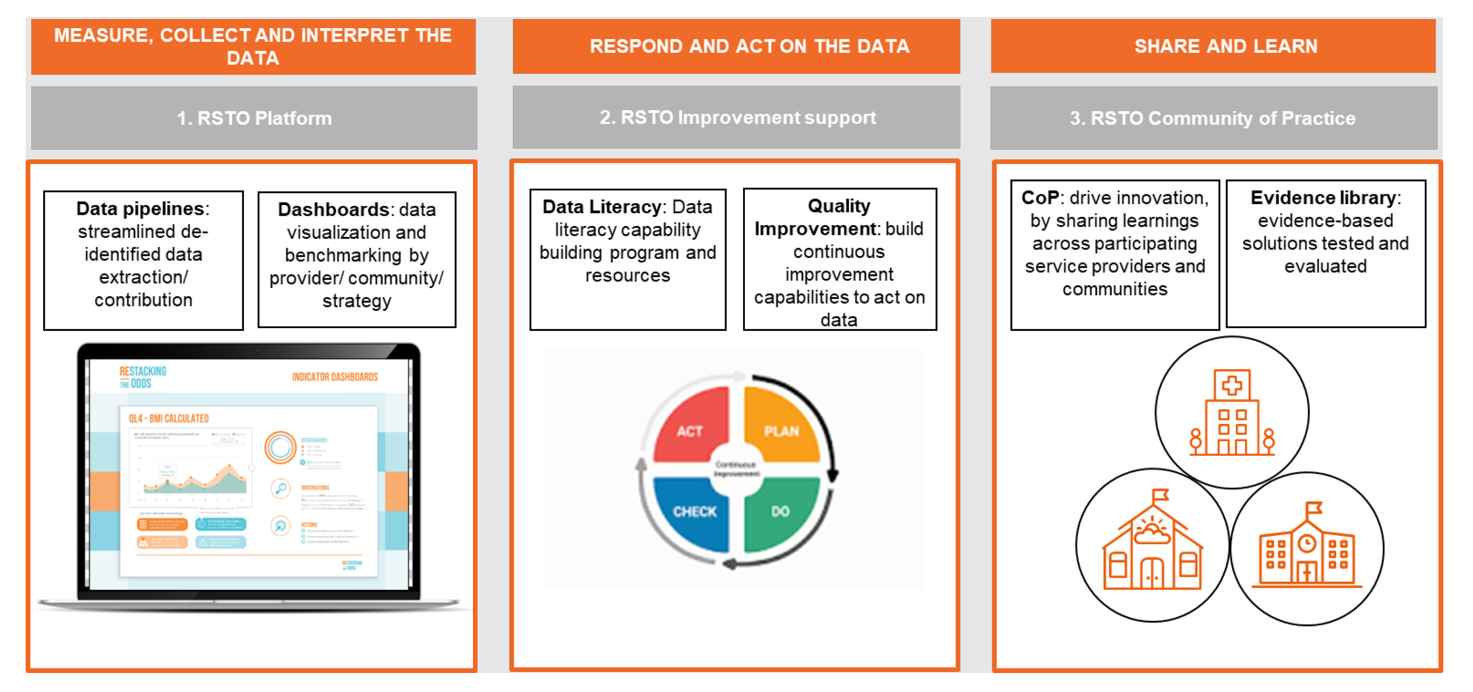
Restacking is currently co-designing this system with a small number of communities and service providers across Australia. Practical, scalable solutions are being developed that address the key barriers and promote enablers to collecting, reporting, and using lead indicator data in the five Restacking early years’ service settings.
This has included developing a prototype technology platform (with Seer Data and Analytics) that presents data for the Restacking indicators in the form of a dashboard for service providers (see sample in figure 3).

Figure 3: Restacking the Odds Dashboard, Participation Indicator: do children, two years before starting school, attend 15 hours per week?
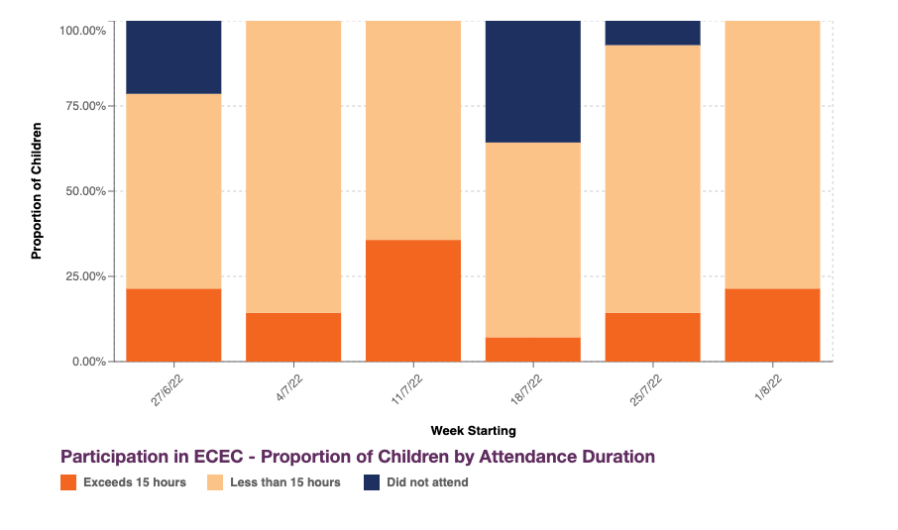
We see a need for this learning system in ECEC alongside the existing National Quality Framework to support an ongoing cycle of continuous improvement. The development of a Preschool Outcomes Measure, under the Preschool Reform Agreement, may also assist with the ongoing tracking of quality in ECEC. Depending on the nature of the measure it could provide additional, actionable feedback to educators to improve outcomes for children.

Supporting integration and coordination of services
The proposed learning system forms a component of the ‘glue’ that is critical for effective coordination, collaboration and integration of support for families. The ‘glue’ refers to the underlying leadership, administration, capabilities, processes for coordination and continuous improvement and outreach with children, families and other services. Currently direct investment in these functions can be very limited.
Integrated service models are a promising vehicle to achieve ‘stacking’ i.e. every child and family being able to access the fundamental services they need in their local community. Integrated services can take the form of a service and social hub where children and families can access key services, including early learning, and connect with other families. Effective integrated models require funding arrangements that recognise and support the complexity of integrated service delivery, including adequate funding for the ‘glue’.
Place-based initiatives, including those funded through the Commonwealth Government’s Stronger Places, Stronger People and Connected Beginnings programs, have strong community engagement and backbone infrastructure. This provides an ideal environment to build crucial capabilities for coordination and integration of support for families, including using data effectively to drive systems change. While working with several of these communities we have observed that place-based initiatives build a deep understanding of community needs and priorities. Population-level data is often used to identify disparities and define community outcomes, yet the backbone teams often lack service-level lead indicators to track progress and have limited resources to interpret data.
Restacking encourages the Commission to consider the need for investment in organisational and practitioner capability for collaboration, and in particular in systems to collect, track and act on lead indicator data. This is needed at a service level, community level (including in place-based initiatives) and a sector level to embed a culture of continuous improvement.

Australian Early Development Census (AEDC), AEDC National Report 2021 Early Childhood Development in Australia, 2021, accessed 5 May 20223 at https://www.aedc.gov.au/resources/detail/2021-aedc-national-report.
S Goldfeld, E O'Connor, M O'Connor, M Sayers, T Moore, A Kvalsvig, and S Brinkman, The Role of Preschool in Promoting Children’s Healthy Development: Evidence from an Australian Population Cohort, Early Childhood Research Quarterly, 2015, doi: 10.1016/j.ecresq.2015.11.001 (AEDI)
R Beatson, C Molloy, Z Fehlberg, N Perini, C Harrop, and S Goldfeld, Early Childhood Education Participation: A Mixed-Methods Study of Parent and Provider Perceived Barriers and Facilitators, Journal of child and family studies, March 2022, accessed 21 April 2023.
R Beatson et al, Early Childhood Education Participation: A Mixed-Methods Study of Parent and Provider Perceived Barriers and Facilitators.
Centre for Community Child Health (CCCH) at Murdoch Children’s Research Institute (MCRI), Social Ventures Australia (SVA) and Bain & Company, The Restacking the Odds Indicator Guide: Quality, quantity and participation indicators across early years services and why they’re important, Royal Children’s Hospital Melbourne, January 2023, accessed 5 May 2023 at https://www.rch.org.au/ccch/research-projects/Restacking_the_Odds/#publications-and-resources
C Molloy, T Moore, M O'Connor, K Villanueva, S West, and S Goldfeld, A Novel 3-Part Approach to Tackle the Problem of Health Inequities in Early Childhood, Academic Pediatrics, 2021, 21(2), pp 236–243.
Molloy et al, A Novel 3-Part Approach to Tackle the Problem of Health Inequities in Early Childhood, pp 236–243.
C Molloy, M O'Connor, S Guo, C Lin, C Harrop, N Perini, and S Goldfeld, Potential of 'stacking' early childhood interventions to reduce inequities in learning outcomes, J Epidemiol Community Health, 2019, 73(12), pp 1078-1086, accessed at doi:10.1136/jech-2019-212282.
CCCH at MCRI, SVA and Bain & Company, The Restacking the Odds Indicator Guide: Quality, quantity and participation indicators across early years services and why they’re important [PDF] , Royal Children’s Hospital Melbourne, January 2023.
C Molloy, P Quinn, C Harrop, N Perini, and S Goldfeld, Early childhood education and care: An evidence based review of indicators to assess quality, quantity and participation: Technical report, Melbourne, 2020, accessed 5 May 2023.
Molloy et al, Early childhood education and care: An evidence based review of indicators to assess quality, quantity and participation: Technical report, 2020.
C Molloy, P Quinn, C Harrop, N Perini, S Goldfeld, Early childhood education and care: An evidence based review of indicators to assess quality, quantity and participation: Technical report; C Molloy, P Quinn, C Harrop, N Perini, S Goldfeld, Early childhood education and care: An evidence based review of indicators to assess quality, quantity and participation: Communication Brief, 2019, accessed at https://www.rsto.org.au/resources/rsto-indicators/
C Molloy, S Goldfeld, C Harrop, N Perini, Early childhood education: A study of the barriers, facilitators, & strategies to improve participation, 2022, accessed 26 April 2023 at https://www.rsto.org.au/resources/publications/.
Cited in R Beatson et al, Early Childhood Education Participation: A Mixed-Methods Study of Parent and Provider Perceived Barriers and Facilitators
R Beatson et al, Early Childhood Education Participation: A Mixed-Methods Study of Parent and Provider Perceived Barriers and Facilitators

