A path to universal early childhood education and care: draft report

Logan Together response to Productivity Commission draft report

February 2024

Contents
Overview 3
About Logan Together 3
Response to draft report 5
Overall impact, operation, and value of ECEC 5
Availability 5
Affordability 6
Inclusivity 6
Flexibility 7
Information requests 8

Overview
Logan Together welcomes the Productivity Commission’s draft report and its recommendations to navigate the creation of universal early childhood education and care (ECEC) for Australia’s children. We know that the early years of a child’s life are critical for shaping pathways and opportunities into adulthood. We also know that the local communities, supported by data and evidence, need to lead the work that sees our children and families thrive.
We are excited to see the draft recommendations and how they propose to create universal ECEC that is available, affordable, inclusive, and flexible. We especially welcome the draft report’s child-centred approach, and the recognition that expanding and valuing the ECEC workforce is critical to creating universal, high-quality ECEC that responds to the needs of children and families. We look forward to seeing how these priorities are translated from intention to impact as they are finalised, and considered and acted upon by the Australian Government and others throughout the early childhood system.
We also note that there is significant interest in the early years across Australian and state and territory governments, alongside the service sector, communities and families. We know that a holistic systems approach to the early childhood system involves working across jurisdictions and policy domains. In working towards the vision of universal early childhood education and care it will be important to keep front and centre that what is needed is systems-change, and that this requires a different way of working. In reimagining the early childhood system (of which ECEC is an important part) with children, families, and communities at the centre, we will need to work differently, grapple with ambiguity, be courageous and share decision-making. We all have a role to play in this important work, and this includes keeping each other accountable for translating good intentions into impact.
Logan Together has also contributed to Restacking the Odds response to the Productivity Commission draft report.

About Logan Together
Logan Together is a community movement committed to the wellbeing of every child in Logan from 0 to 8 years of age. Our big goal is to see Logan’s children happy, healthy, and thriving now, and for generations to come.
We put First Nations First. We believe we need to do the work to strengthen cultural ways of knowing and embed First Nations principles, practice and learning in our ways of working.
We are community-led and place-based. We believe power should be shared equally with our diverse community. We enable community members to share decision-making and accountability with government, the service sector, business and other partners.
We make sure children are at the heart of all our work. We want to see Logan’s children loved, safe, valued and thriving. This means making sure our children can directly influence the decisions we make together.
Logan Together is guided by our community’s Collective Plan and Roadmap. This includes our work to reimagine the early childhood system for communities in Logan. This means creating a joined-up and coherent system for children and families, from pregnancy to 8 years of age. To realise our community’s priorities, we have worked with state and Commonwealth governments, the service sector and philanthropy to walk alongside our community and to put community at the centre of this work. This will see Logan continue to embed its “Core Suite”, which includes five initiatives and five enablers.
The Logan Together approach identifies evidence-based initiatives and enablers of system change that wrap around and support the early years of a child’s life. We draw from the evidence of community voice, and our approach is co-designed with our Logan community. Our evidence base also draws heavily on the Restacking the Odds framework and is informed by research from the Murdoch Children’s Research Institute. By stacking and connecting these initiatives and enablers effectively, the early childhood development system becomes accessible to all children and creates amplifying, life‑changing impact.
The elements show the work that we can do together to see Logan’s children happy, healthy and thriving in ways that put First Nations First, see Children at the Heart, and are Community-led.
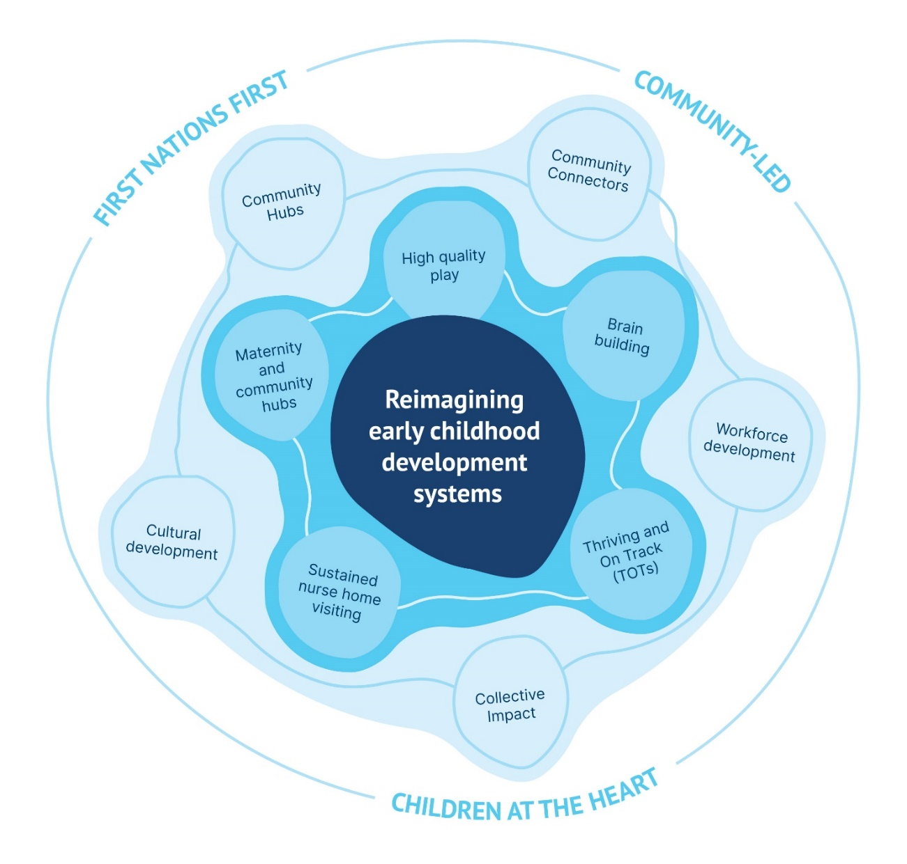

Response to draft report

Overall impact, operation, and value of ECEC
The draft report makes the following general findings and recommendations:
- A universal ECEC system means making quality services accessible to all children and families. Achieving it will require tackling availability, affordability and inclusion gaps.
- ECEC is positive for many children but those who would benefit most are least likely to attend
- All children should have an ECEC entitlement
- New coordination mechanisms will support universal access

Logan Together agrees that all children should have an ECEC entitlement, and that this should be responsive to the needs and preferences children and families. The recommendations and findings of the draft report reflect the child-centred approach of the Commission’s work, and in realising these aspirations children and families should be at the centre of achieving universal entitlement and access in ways that make ECEC attractive to attend, for all children, but especially for those children least likely to currently attend. The focus on availability, affordability, inclusivity, and flexibility throughout the draft report are useful ways to framing efforts to achieve the aim if making quality services accessible to all children and families.

Availability
The draft report makes the following findings and recommendations about ECEC availability:
- Availability gaps will have to be tackled to achieve universal access
- Availability can only improve if workforce challenges are resolved
- Quality is paramount to achieving the benefits of ECEC

We welcome the focus of the draft report on the importance of the ECEC workforce in ensuring universal access to, and availability of, ECEC. We agree with the clear position of the draft report that ‘universal access to ECEC cannot be achieved without addressing the critical demand and need for educators, early childhood teachers, centre directors and other ECEC workers.’
Workforce development is an enabler of Logan’s “Core Suite”. We know that culturally safe, community-embedded, well-trained workforces transform communities. By prioritising workforce development, we are addressing workforce capacity and capability to sustain growth.
While there has long been a focus on further embedding evidence-based and evidence-informed training and development for local workforces, there must also be space for the development and evidence‑gathering of place-based designed and training and employment opportunities that reflect local needs. This includes extending the skills, expertise and cultural practice of the existing workforce, as well as the emerging workforce: school-leavers, volunteers, parents returning to the workforce and newly arrived citizens.
Developing bespoke opportunities allows for local people to participate in the local workforce, and develops the local economy. There is particular need in Logan for an ECEC workforce (as well as allied health, child health and midwifery workforce) that reflects the diverse cultures of Logan. A culturally diverse workforce means community members don’t have to ‘leave their culture at the door’ and their cultural ways are seen as a strength when providing ECEC services.

Affordability
The draft report makes the following findings and recommendations about ECEC affordability:
- Affordability and complexity should not be barriers to ECEC access
- There should be an increase in CCS for low income families
- The activity test should be relaxed to improve access

Early childhood is a critical time for health and development. How a child is supported in their first 2000 days before they enter school will affect how they participate in education and the workforce, and their future health and wellbeing. We welcome the draft report’s position that affordability and complexity should not be barriers to ECEC access.
The early childhood system is often difficult to navigate, can be unseen and disjointed. Providing complex funding arrangements for parents, carers and families, as well as providers and others in the system, creating a significant administrative burden is counter-productive to the aim of providing high-quality, accessible, flexible and inclusive ECEC.
We regularly hear about how activity test requirements and hours exclude families that are looking for work and that applying for exemption can be time consuming (and is often not approved). This can be particularly difficult for families with children with development delays and/or who have caring roles. Relaxing the activity test will allow more families to have their children in ECECs.
Logan Together welcomes the focus of the recommendations in the draft report to instead focus on ensuring that funding mechanisms are responsive to needs of children and families, with the ultimate focus of universal ECEC pathways for all children.

Inclusivity
The draft report makes the following findings and recommendations about ECEC inclusivity:
- A universal ECEC system has to be inclusive of all children
- ECEC is critical to the wellbeing of many families
- There should be better support for Aboriginal and Torres Strait Islander children and a recognition that many Aboriginal and Torres Strait Islander families prefer Aboriginal Community Controlled Organisations

Logan Together appreciates the focus of the draft report on the need for ECEC to be inclusive and the understanding that inclusivity comes in many forms.
For Logan, cultural sensitivity and safety is fundamental. We know that community members need relationships and services that hold cultural sensitivity and cultural safety centrally in their delivery models. Making this a reality means a paradigm shift in our ways of working to take a relationships-first approach in collective action.
This means investing in and taking time to build strong, trusting relationships that facilitate authentic two-way knowledge exchange as the basis for decision making and actions, grounded in cultural knowledge and experience. It also means challenging assumptions and previous ways of working to explore how we can come together to learn, grow and do differently together. It is these relationships that allow for shared celebration of outcomes, as well as shared responsibility and accountability. Making relationships an explicit focus means that they are monitored, prioritised and proactively maintained over time, rather than just assumed.
In particular, we want to highlight the need for an explicit commitment amplifying the work led by Aboriginal and Torres Strait Islander families and communities. At Logan Together, we have found that our commitment to the pillar of First Nations First has been central to galvanising and aligning work across families, communities, government partners and the service sector. This has increased social cohesion and allowed us to move into the middle space where community-led shared decision-making can happen. This is critical to seeing systems change happen, provides opportunities for early intervention and prevention, and ensures that ECEC is led-by and responsive to the needs of Aboriginal and Torres Strait Islander families and children.
We also understand that inclusion is critical for children with diverse needs. Current funding complexities can inhibit the availability of and access to ECECs for many children and families, and we welcome the draft report’s focus on reducing and removing administrative burdens and barriers. However, beyond these practical measures is a clear commitment by the sector that all children have a right to have their educational and developmental needs met within environments that are both warm and welcoming, and meets children’s physical, social, and sensory needs.

Flexibility
The draft report makes the following findings and recommendations about ECEC flexibility:
- ECEC services should be flexible and responsive to the needs of families

We welcome the draft report’s focus on putting children and families at the centre of the design and delivery of ECEC. Families come in different forms, with different ways and patterns of living. Logan Together celebrates the draft report’s call for the sector to think creatively about ECEC so that the commitment to universal access can become a reality.

Information requests
Logan Together can offer some insight into three information requests made by the Productivity Commission.

Cultural safety in ECEC services [Information request 2.2]
The Commission seeks information on cultural safety in ECEC services for Aboriginal and Torres Strait Islander and culturally and linguistically diverse families and children

Logan Together is underpinned by a commitment to First Nations First. This means we believe we need to do the work to strengthen cultural ways of knowing, shifting from western structures and processes into an intrinsic relational way of working with a First Nations First approach. In practice, we are embedding this way of working across the Logan Together movement through equipping Logan Together partners with the knowledge, skills and courage to work differently.
We also have identified the key ‘ingredients for success’ that are shared by initiatives that work for and with children and families in Logan. These ingredients ensure that children and families are at the heart of the review design, planning and delivery of work, including ECEC services. This means that they are culturally safe and relevant. One practical example that often arises is a failure to provide language support via interpreters at ECECs. This fundamentally impacts the ability of parents, families and children to access and engage with ECECs.
The ‘ingredients for success’ are provided below:


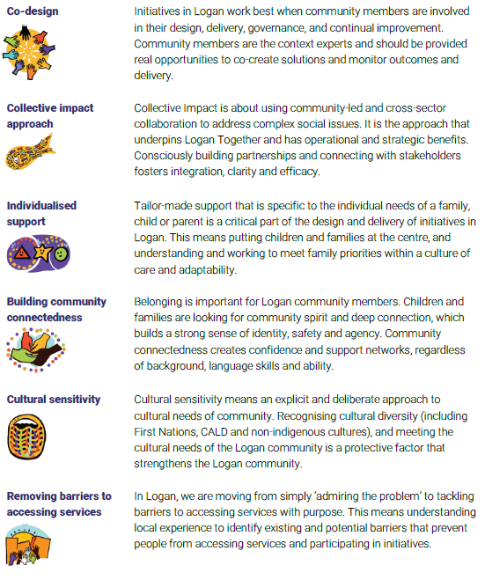
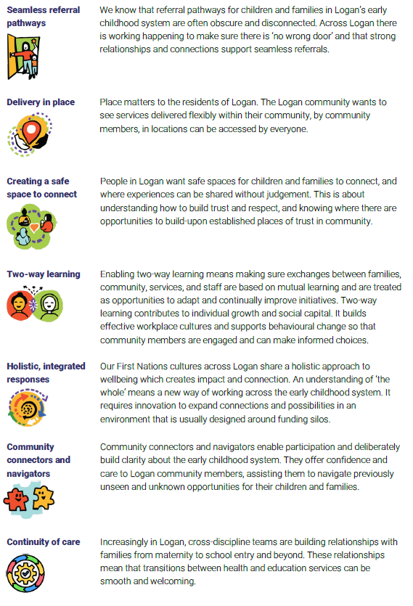

Potential measures to reduce CCS administrative complexity [Information request 6.5]
The Commission seeks views on the costs and benefits of potential measures to reduce Child Care Subsidy (CCS) administrative complexity – including:
- extending the initial length of eligibility for ACCS (Child Wellbeing) from 6 weeks to 26 weeks and subsequent length of eligibility to between 26 and 52 weeks
- extending the length of eligibility for ACCS (Child Wellbeing) for those children on long-term protection order, in formal foster care or in a formal kinship arrangement while their circumstances remain unchanged
- Extending ACCS (Grandparent) to recognise informal kinship carer arrangements

The Additional Child Care Subsidy (ACCS) provides an opportunity for children from disadvantaged families to benefit from quality early childhood education and care. However, issues and delays with the process to access the subsidy are creating significant barriers for families.
The ACCS is a separate payment from the Child Care Subsidy (CCS) aimed at assisting ‘the most vulnerable and disadvantaged children as well as those from regional and remote communities a strong start through access to quality early childhood education and care’. It can help families to deal with short-term difficulties, and families facing long-term challenges can receive the subsidy over a longer term.
To be eligible to receive the additional childcare subsidy, children must be identified as ‘at risk’. Family workers are required to document significant concerns and provide a letter to Services Australia documenting these concerns.
While the Commission refers to reducing administrative complexity through proposed reforms, this is only one aspect of the challenges with the current operation of the ACCS (Child Wellbeing) process, which include:
- The need to provide letters with highly sensitive information, which can be stigmatising for children and families.
The ACCS (Child Wellbeing) process relies on a childcare provider identifying a child at risk. Providers are expected to have conversations with families and carers about their circumstances and the requirement to refer them to an appropriate support agency. A childcare provider must provide evidence to substantiate their application for each ACCS (Child Wellbeing) determination. Appropriate third-party organisations provide supporting evidence (e.g. letter/statutory declaration/case-plan) with the consent of the family or carer. This evidence must meet certain requirements including that it must be current (less than 6 months old) and must support that the child is ‘at risk’ with the consent of the family.
The evidence provided should:
  - Focus on the presence of risk of serious abuse or neglect (or evidence of actual abuse or neglect) for example by referencing indicators of abuse or neglect or risk factors
  - Describe the child’s circumstances in a way that they can be clearly linked to the definition of ‘at risk’.
  - Explain how the circumstances of the family are linked to the risk to the child (where applicable)
  - Highlight how the family’s issues are a barrier to the family caring appropriately for the child thereby leaving the child ‘at risk’.

- Having letters rejected, resulting in significant debts for families while they are waiting for a decision, and children losing access to quality care.

- The complexity of the ACCS process which cuts across childcare providers, service support agencies that provides the support letter, Department of Education approval, and DSS funding. This is an expensive and time-consuming process.
Access to quality childcare is of significant benefit to a child’s neurodevelopment, social development and school readiness and can contribute to long term positive outcomes for the child.
Support services work with families experiencing multiple complexities many of whom have come to the notice of the Child Protection system. These support services assist families to overcome the barriers they are facing and work with them to provide a safe nurturing environment for their children. One of the ways they do this is to strongly encourage families to enrol their pre-school aged children into ECEC to assist the children with a positive, safe, consistent care environment and to enable parents time and space to access other supports such as counselling, medical supports, employment preparedness and job interviews or self-care activities.
The nature of evidence required and the process to determine eligibility for ACCS (Child Wellbeing) creates significant impact for children and families most likely to benefit from accessing ECEC.
Support services discuss the content of letters with families and carers to ensure they are aware of the information being provided and the concerns identified within the family. This can be extremely confronting for parents and not always helpful in changing caregiving behaviours and practices. For example, there are reports from parents and carers about being treated differently by ECEC providers because of the letters and being classified as “at risk”.
Where applications for ACCS are rejected, requiring re-submission and back-dating, it increases the administrative load of support services and ECEC providers. More importantly, it can lead to a large debt being incurred by the family – sometimes more than $1,000 – placing additional financial stress on families that are already struggling.

An example of how this plays out in practice is provided below:
Maria (25) is a mother of two children (8,4). Maria’s home was involved in a natural disaster and the family lost everything. She was moved by government through multiple short-term housing arrangements until finally securing a stable home in the Logan region with the assistance of a support service.
Maria was referred to support services for on-going support as she left a violent relationship, struggled with her physical and mental health and her children have special needs.
Maria’s son Eric (8) has behavioural outbursts, but now attends school regularly and is being supported by the school Guidance Officer. Her daughter Sally (4) is being assessed for ADHD / ASD. The constant changes required while the family did not have a secure base impacted on the children’s security and exacerbated behavioural difficulties, further impacting on Maria’s mental health.
To support Maria to re-establish a home base and enable her to work toward increasing supports for her family, the support service provided an ACCS support letter in early February 2023. This letter was declined so a new support letter was provided two weeks later. The childcare provider suggested that some of the wording may need changing. It appears that this letter was also declined. However, as Maria was hospitalised and the children’s daycare was sporadic due to alternate care arrangements, the support service and the family were not aware that a debt was being incurred. When the family’s situation stabilised a new ACCS letter was requested and provided in May 2023. This letter was accepted, but the childcare provider informed Maria that Eric could not return as a significant debt of over $1,500 had been incurred.
The support service assisted Maria to attend a Services Australia appointment in June 2023 to better understand why the debt was incurred and what could be done to change this. She was told that the debt was between the childcare provider and Department of Education so there was nothing Services Australia could do. The childcare provider insisted that they had done all they could to escalate the issue and negotiate around the debt.
Maria has now sourced a new daycare provider for Sally, despite her difficulties with change. However, Maria is very concerned that the previous childcare provider will lodge the outstanding amount with debt collectors and she will be required to pay a debt that she incurred without knowing and had no control over.

The proposed changes to the ACCS process should focus on removing unnecessary complexity, administrative burden, delay and stigma in a process that is designed to increase access to ECEC. Logan Together supports proposed efforts to remove unnecessary barriers to accessing ECEC, including those that unnecessarily stigmatise children and families.

System navigator roles in the ECEC sector [Information request 7.2]
The Commission seeks views from inquiry participants on ‘system navigator’ roles in the ECEC sector – including:
- are current initiatives to support families experiencing additional barriers to navigating the ECEC system sufficient? Do they require additional information or support to perform this role?
- is there a need for national investment in system navigator roles?
- who would be best placed to perform these roles? Examples could include Inclusion Agencies or contracted delivery by a range of ECEC services, community organisations, local councils or ACCOs.
- how could this be delivered across different groups of families (for example, regional or remote, Aboriginal and Torres Strait Islander and culturally and linguistically diverse families), including ensuring delivery in a culturally sensitive manner?

Logan has a wide range of services for children and families. The difficulty lies in knowing what they are, who they are for, where they are located and how to connect. Many dedicated professionals struggle to do this well, so it’s little wonder that individual families struggle to access the child health supports they need, or understand the complicated referral process and waiting periods that can be several years long, impacting on the opportunity to engage in crucial early intervention in a timely manner.
Community Connectors make the current service system navigable for Logan’s families. Drawing on lived experience and professional knowledge, they build deep relationships and cultural connections with families and bring together a suite of supports to address any identified concerns.
Connectors work with a holistic view, engaging with education, disability services, social supports and other associated systems. While ECEC is part of this journey, the role of Connectors needs to be responsive to the needs of children and families. Connector roles are not simply about navigating referral pathways, but rather walking alongside families to ensure they can navigate the wider early childhood system, as well as other systems they are interacting with.
This family-centred approach means Connectors can build (and repair) trust between services and families. For example, there can be a deep mistrust in services due to a history of debt and stigma. The relationship built by the Connector and the ability to walk alongside the family to re-engage with services works as a conduit to a more positive experience and outcome.
The holistic approach taken by Connectors when working alongside a family has shown to improve the whole family‘s health and wellbeing. A caregiver cannot focus on a child‘s health and development when other aspects in their life are in crisis. Connectors are discussing emerging issues and then making referrals not only for the child but other members of the family in areas of mental health, social support, legal, housing, education opportunities and skills development. This approach means families receive a specialised and focused service across multiple systems, resulting in long-term positive outcomes for children. With further funding, there is potential for their scope of practice and influence to support more families.
In Logan we have found that Connectors work best when they are based in community hubs. Hubs are community-led and driven by the priorities identified by each community. Numerous community hubs exist across Logan, including several school‑based hubs. They are the spaces in which genuine, relational community development approaches facilitate integrated service delivery. This allows families to access support in a more timely, relational, safe, and responsive way. At a practical level, it also means that appointments are not necessary and families are able to build connections and supports with many people and community members also visiting the hub, instead of solely with a Connector.
Where Connector are based within a culturally based hub, it is critical that the Connector is part of this cultural group. Within in this context, Connectors offer an immediate sense of security, trust and like mindedness. They also understand the cultural nuances that are vital in engagement. They act as a cultural bridge between “big services” and the families they work alongside.
Hubs have a significant volunteer workforce and rely on goodwill, in-kind support from schools and volunteerism from community members. Right now, community groups throughout Logan are shouldering the costs of running the hubs, including human and capital resources in a way that does not reflect the financial and social value of their work.

https://www.rsto.org.au/
Productivity Commission, ‘A path to universal early childhood education and care: Draft report’ (November 2023) page 5.
Logan Together, “Creating social cohesion through shared decision-making: Logan Together Insights Paper June 2023” (2023). Available at: https://www.logantogether.org.au/_files/ugd/7db6a6_e4fcbae9817347178d8b233b41a00619.pdf
Australian Government Guide to Additional Child Care Subsidy – Child Wellbeing

