A Planet For Future Generations

*I write this submission to advocate that organisations that fight for animal welfare be awarded the charity and deductible goods recipient status. Please kindly consider my comments while the Productivity Commission reviews its guidelines for recognising charitable organisations.*

I am a small-business owner who created the concept for my organisation to support other small and local businesses and to promote the work of organisations that defend against animal cruelty.

I achieve the objectives for Cause & Events through executing themed experiences to encourage a vegan lifestyle.

Although veganism has been on the rise since 2016 and more and more people and companies have been adapting to the trend, the impacts of meat and dairy on the environment is lesser known.

## Greenhouse Gases

Many people associate climate change as a result of transport because it is a visible source of pollution. However, the following facts about factory farming has been published in several evidence-based articles:

1. Factory farming produces more greenhouse gases than all forms of transport, combined
2. The energy sector produces the highest amount of greenhouse gases and factory farming is a close second
3. The greenhouse gases produced by factory farming is methane, which is four times more potent than carbon dioxide (produced by transport and energy sectors)
4. Methane lingers in the environment a lot longer than carbon dioxide thus causing the earth to heat up
5. It has been published by the [Climate Council](https://www.climatecouncil.org.au/resources/point-of-no-return-crossing-a-climate-threshold/) of Australia, the UN and several other universities and organisations that an increase in global temperatures by 2’C (1.5’C published by the UN) will be the tipping point for a series of accelerated climate reactions.
6. The time frame for this projection was within the century.
7. We are already halfway there.
8. The planet cannot physically sustain 9 billion meat and dairy consumers

## [Earth Overshoot Day](https://www.overshootday.org/newsroom/country-overshoot-days/)

Every year the earth overshoot day - the day by which we use up all the resources that should have lasted us all year - arrives earlier and earlier. For 2022, it was marked at July 28.

In recent years the only time the alarming trend reversed was during the years 2020 and 2021 - this was during the COVID pandemic, cities worldwide were shut into their homes and this gave the climate time to breathe and recuperate. Possibly the biggest and, maybe the only good thing to come out of supply chains breaking down.

At our current rate of consumption, humanity needs the space and resources of two earths in order to sustain itself.

If the rest of the world lived the lifestyle of the average Australian, the world would consume all of its yearly resources by March 28. [According to this chart](https://www.overshootday.org/content/uploads/2023/01/Country-Overshoot-Days-2023.pdf), that is one of the earliest dates as compared to other countries. Thus indicating the above average rate of consumption in our country. The biggest resources consumed are food and clothing. Of the food, the majority is meat based.

According to the [climate report published by the UN](https://www.ipcc.ch/report/ar6/wg3/), adopting a plant-based diet is the single biggest thing we as individuals can do in order to stop and reverse climate change.

And while along the lines of resource consumption, I would like to point out that if the grain used to feed factory farmed animals was redirected to feed humans, it would completely eliminate world hunger.

## Species Extinction

1. Australia has the worst [mammal extinction rate in the world](https://wwf.org.au/get-involved/end-animal-extinction/)
2. Australia has the overall highest species extinction rate in the world
3. 54.19% of land in Australia is now used for factory farming, either directly or indirectly
4. Almost all of this land was obtained through deforestation, thus classifying several of our native fauna as critically endangered, eg. Major Mitchell’s cockatoo, Southern Greater glider and koalas
5. The inter-dependence of the flora and fauna maintains the balance in the ecosystem thus ensuring a healthier planet for future generations

## Spirituality

The Dalai Lama, the global leader of Buddhism and an advocate for world peace, advises that if every 8-year old was taught how to meditate we could eliminate violence in the world within one generation.

The relation of this prospect to that of a healthy planet is that nurturing younger generations to live mindfully extends into respect for the land, its flora and its fauna.

I participated as a volunteer during the most recent state elections in Victoria, during which I connected with two children, below the age of 10, at the voting centres who expressed with deep sincerity their concern for animal welfare.

## Defenders of Our Planet

Under the current charity regulations the following organisations would never be considered to receive the charity status, let alone being eligible as Deductible Gifts Recipients due to the nature of their work:

* Animals Australia
* Farm Transparency Project (FTP)
* Victorian Kangaroo Alliance (VKA)
* Coalition for the Protection of Racehorses (CPR)
* Coalition for the Protection of Greyhounds

The work done by these organisations is incredibly valuable in reducing animal cruelty practices and in conserving our native flora and fauna.

Without the heroic work of these organisations, the original path for veganism as a trend would not have been paved.

The work of these organisations is directly creating more jobs in the health, nutrition and fitness sector.

They are improving the economy by paving the way for a smorgasbord of plan-based meat alternatives, which is a booming industry. According to Bloomberg, a reputable financial reporter, the plant-based meat industry was worth $29.4 billion, globally in 2021.

As consumers learn more about the harmful effects of bovine dairy on human health, the demand for plant-based milk, especially oat milk, has been skyrocketing over the last year.

Due to the direct benefits to our nation’s GDP, brought upon by the work of those fighting for animal welfare, the government would be remiss not to recognise their efforts.

Since its establishment, 9 months ago, my organisation has executed 6 events and raised ~$5,000 for these organisations. The following graph provides a breakdown of the public’s contribution towards each organisation.

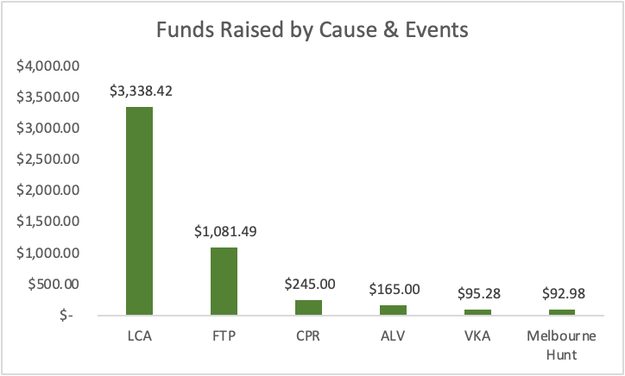

As you will note above, more than 65% of the funds raised were towards Lamb Care Australia(LCA), which is recognised by the ACNC as a charity and a deductible goods recipient. This graph shows the direct correlation between being recognised by the ACNC and attracting money from donors.

However, the work of all the organisations listed above directly contribute toward improving environmental conditions significantly more than organisations that are currently recognised.

The work of the above listed organisations will help us reach our climate targets much sooner than any large corporation, due to their connection and influence in the community.

## Social Responsibility

Do we want to be known as the generation that knew about and was equipped to fight climate change but didn’t do anything about it? If so, that reputation will be synonymous with “the generation who accelerated the commodification of animals for monetary gains and knowingly enabled the breakdown of the climate with complete disregard for future generations”

Or…

Do we want to be known as the generation that promoted respect for our planet, our source of existence? This is our greatest opportunity to show future generations how humans overcame greed and used our knowledge to save the planet instead.

Thank you for your time and for considering my comments.