

philanthropy.org.au
Philanthropy Australia submission - Full Report - Final - 5 May 2023
Philanthropy australia’s submission
to the productivity commission
5/05/2023

Contents
Executive Summary ii
Full Submission 1
Why a More Generous and Giving Australia Matters 1
The Opportunity 2
The Result – Why a more generous and giving Australia? 2
1. Helping people in need and addressing our great challenges 2
2. Amplifying the impact of government 2
3. A better society 5
4. Unleashing the power of community-led social change 7
5. A better sharing of wealth and opportunity 8
6. National Wellbeing and Productivity 9
7. Improving public policy 10
8. Strong Public Support for the Double Giving Agenda 10
1. A Policy Environment that Fosters Giving 12
1.1 Giving Australians the choice to make a bequest to charity through their superannuation 13
1.2 Extending DGR to all registered charities. 19
1.3 Providing people with a voluntary choice to donate some of their tax return to charity. 23
1.4 A strategy to drive the growth of Australia’s Community Foundation network 25
1.5 Enhancing the Effectiveness of Ancillary Funds 29
1.6 Fix fundraising 33
1.7 Encouraging Later-in-Life, Legacy and Other Giving 35
1.8 Social Impact Investing 38
2. A generous and giving national culture. 42
2.1 A National Giving Campaign 42
2.2 The philanthropy agenda 46
2.3 The Business Agenda 50
2.4 The Charity Sector Agenda 54
2.5 Philanthropy in Schools 57
3. Strong foundations for giving 58
3.1 A national strategy with clear goals and high impact reforms. 58
3.2 New governance arrangements to drive government-civil sector collaboration 59
3.3 A National Giving and Community Participation Data Set 62
3.4 An action research agenda 65
3.5 Effective Evaluation 67

Executive Summary

Why a More Generous and Giving Australia Matters

The Challenge
Australia’s giving compares unfavourably with our counterparts - 0.81 per cent of GDP, compared with 1.84 per cent in New Zealand and 2.1 per cent in the United States. Reaching the NZ proportion of giving would lift annual giving in Australia from $13.1 billion to $30 billion per annum.

The Opportunity
Despite being behind international counterparts, Australia is well positioned to create a more generous culture and double giving by 2030.
- We have unprecedented wealth. Over the two decades to 2040, $2.6 trillion will pass to the next generation. If we could pass even just 5-10 per cent to charity, this would unleash $130-260 billion, helping to catapult us to being among the leading philanthropic nations in the world.
- The Government has committed to work with the philanthropic, for-purpose and business sectors to develop a Strategy to double giving by 2030.
- We have high impact reforms available that can double giving to charity – see below.

The Result – Why a more generous and giving Australia?
- Helping people in need and addressing our great challenges
Our charities big and small – like the Royal Flying Doctor Service, Smith Family, Fred Hollows and Foodbank - help millions of people in need every year across every area of social and environmental endeavour. Great philanthropy transforms societies. Where would we be without our great Australian charities?
- Amplifying the impact of government
At a time of major fiscal constraint, giving can amplify the impact of government through:
  - Social innovation – taking risks and innovating in ways government can’t or won’t that contribute to lasting institutions and transformative system change.
  - Meeting unmet need – Government cannot solve every social and environmental challenge. Civil society, including community organisations who understand local needs and how to address them, can meet needs not addressed by government.
  - Funds for impact investing – Philanthropists are increasingly including impact investing as part of their portfolio, and this looks set to considerably expand if, as expected, the Federal Government establishes a more favourable policy architecture for impact investing in the 2023-24 Budget. Philanthropy has a particular role to play in ensuring this market can work effectively. For instance, it can fund organisations to become ‘investment ready’, helping to build a strong pipeline of social impact ventures that can attract capital from private and other investors.
  - Capital for NFP-delivered government funded services – In a suite of fields – like aged care, disability services and employment services, not-for-profits play a major role in service delivery ($89 billion in revenue from government in 2020), often being more cost-effective or on-par with private providers. As government seeks expanded service provision, private providers have a strong advantage in being able to raise capital. Philanthropy can play a crucial role in levelling the field, enabling NFPs to gear up for new and expanded service delivery. In other fields, like higher education (where leading universities are now raising in excess of $1 billion through fundraising campaigns) and the arts (such as the creation of world class Southbank Arts precinct in Melbourne), philanthropy is radically expanding what government can achieve alone.

Across our history, huge opportunities for greater social impact have been missed due to a lack of collaboration between government and civil society. Governance reforms to facilitate engagement between government, philanthropy, charity and business could radically lift social impact through collaboration on joint initiatives, including social innovation aimed at system change, and co-investment in Flagship projects. See below.
- A better society
Giving doesn’t just deliver better outcomes for millions of people. It also leads to a more generous and giving culture, where we focus on serving each other, being active in the community, and working to ensure no one is left behind.
Andrew Leigh and Nick Terrell in Reconnected (2020) charted the decline in social capital in Australia in recent decades. We participate less in community groups, volunteering, sport, or politics. We have less friends, are less likely to know our neighbours, and almost half the population report being lonely each week. The connections and social capital that give us meaning, bind us to each other and ensure no one is left behind, have been in decline.
Australians are yearning for a return of a more generous and giving culture. We have the makings of more connected communities. Reconnected contains dozens of stories of people bucking the trend to build stronger communities. Redbridge research projects show that, coming out of the pandemic, people are keen to engage in local communities, and show care and compassion for others. Their focus groups confirm giving is core to Australians’ sense of self and national identity.
“I think Australians have a very strong sense of fairness. What defines our culture is, we like battlers, we like little guys, and we like kids.”
Research also confirms giving makes people happier and healthier, with a stronger sense of meaning and purpose. In sum, we enjoy supporting our fellow human beings in need.
- Unleashing the power of community-led social change
The experience of COVID is driving seismic shifts in society beyond the pandemic. In particular, people are now spending much more of their lives in local communities. Research shows many people: now have hybrid working arrangements, working half their week or more at home; are setting up home offices; spend more time in their backyards; shop more locally; and value their local community more – 53 per cent say they value a strong local community more than they did three years ago, while just 5 per cent say they value it less. With people keen to get involved locally, there is an opportunity to grow local giving and volunteering, and in particular, expand the national network of Community Foundations, which would expand national giving, community participation, social capital and support for Australians in greatest need.
- A better sharing of wealth and opportunity
Australia is one of the wealthiest nations on earth and wealth at the top end is rising rapidly. Wealth among the Top 200 has increased from $209 billion to $555 billion between 2016 and 2022, or from an average of $1.05 billion to $2.77 billion.
As a society, we need to make a clear choice: Do we wish to see all this wealth pass to future generations, maintaining wealth and privilege for those most fortunately placed, or do we wish to see some of this money used to support Australians in greatest need, so opportunity is more evenly shared in our country?
If, like those that sign The Giving Pledge, the wealthiest Australians committed to give away at least half their wealth, it would catapult Australia to among the leading philanthropic nations in the world and help ensure all Australians can lead lives of opportunity, freedom and contribution.
- National Wellbeing and Productivity
For Australians most fortunately placed, marginal wealth and income is surplus to their needs, so transferring this wealth to help people in need, or to help address issues such as climate change or educational inequity, delivers a significant improvement in national wellbeing. PC and Government focus on philanthropy and charities can also help spur productivity as the charity sector is a major part of the economy - 11 per cent of Australia's workforce.
- Improving public policy
Delivering reforms that would improve our nation’s future is becoming harder. Politicians typically face a strong public response when proposing change. Powerful vested interests protect their own special arrangements over the broader, more diffuse public interest. Reform typically has many opponents and few friends.
Civil society often plays a critical role in building public support that creates an environment in which politicians can feel comfortable pursuing reform.
  - Charities, because they work at the coalface, play a crucial role in advocacy, alerting government to critical needs and ensuring policy is designed in ways that will meet the needs of end users.
  - Philanthropic support for advocacy – because it can be independent of government – can produce bold and rigorous reform propositions. It can also be massively cost-effective, as relatively modest investments can drive major changes to significant government policies and funding. For instance, a $100,000 grant from the Origin Foundation to the Grattan Institute to examine the impact of remote schooling on students from low-income families was a key catalyst behind almost $600 million in investment in tutoring programs for affected children across Victoria, NSW and South Australia.
- Strong Public Support for the Double Giving Agenda
Redbridge polling of more than 2,500 Australians in November 2022 shows overwhelming support for the double giving agenda, whether:
  - General support – giving brings people together and strengthens our sense of community (74% agree, 7% disagree); or
  - Support for specific reforms, such as super bequests (75/6), extending DGR to all charities not just some (74/6), the choice to donate as part of the tax return process (70/9), a National Giving Campaign (65/7), or changing tax laws to better incentivise giving (66/8).

The Strategy to Double Giving
Given the Government’s commitment to developing a Strategy to Double Giving, the PC should provide advice on how elements of the strategy could be framed, with a clear policy framework, explicit goals and key drivers of increased giving, with specific reforms to propel each. PA's Strategy on a Page is provided overleaf.

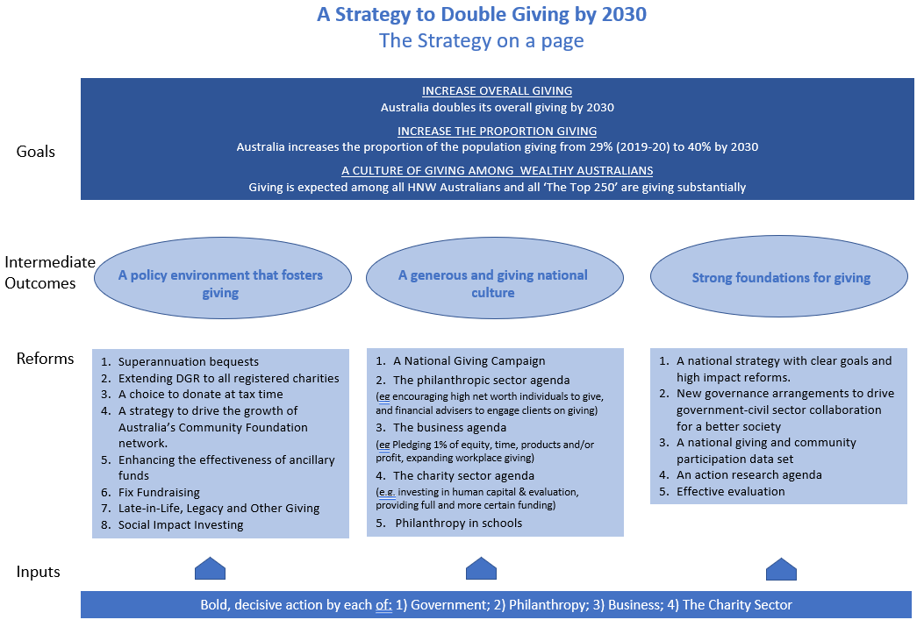

1. A policy environment that fosters giving
The 2022 Global Philanthropy Environment Index shows Australia’s environment for encouraging philanthropy ranks 19th in the world – at 4.27 out of 5 – below a group of advanced economies with scores in the 4.5-5.0 range, which are Belgium, Denmark, Finland, France, Germany, Liechtenstein, Netherlands, Norway, Singapore, Sweden, Switzerland and the United States. We can create the environment to double giving by:
1.1 Superannuation bequests: With super balances at death set to reach at least $130 billion by 2059 (in 2018-19 dollars), giving Australians the choice through their super arrangements to leave some money to charity when they die (and abolishing the tax penalty for doing so) would unleash tens of billions for charity. This reform is by far the most powerful lever we have to lift giving. It is highly cost-effective as such giving does not attract a tax deduction.
1.2 DGR for all registered charities, not just half: As the PC recommended in 2010, all of Australia’s charities (almost 60,000 organisations) should have DGR status (allowing the public to donate and get a tax deduction). All policy institutions freely admit the rules that permit one charity to get DGR status (e.g. direct poverty relief), but may disallow another (e.g. preventing poverty) were developed in an ad hoc manner with no clear policy rationale. The policy purpose of providing tax incentives to encourage giving is to support charitable activities that provide a positive public benefit. All charities do this, so all should be given DGR status, which would boost the funds they can attract for their important work. It would cut red tape for government and charities, and bring us in line with nations like the US, UK and New Zealand where giving as a percentage of GDP is higher than in Australia.
1.3 An option to donate at tax time: Providing Australians with a choice to return some or all of their tax return to charity as part of the tax return process could embed in our culture a valued national custom, where every year we consider providing support for people in need, when we can afford to do so. With around $30 billion being returned from income taxes each year, this prompt could provide billions in additional funds to charities.
1.4 A strategy to drive the growth of Australia’s Community Foundation (CF) network: With people keen to get involved locally, a particular opportunity is to grow the national CF network, so that over time, the vast majority of Australians have a local foundation they can get involved with. This would have a powerful impact in expanding national giving, community participation, social capital and support for Australians in greatest need.
This would unlock new opportunities for government-charity-philanthropy collaboration to drive impact. Local MPs can work to ensure their electorates have CFs and then work with local communities to better understand and address local needs. Over time, a national CF network will become powerful national architecture, allowing government and local communities to work together to address challenges suited to local solutions.
1.5 Enhancing the Effectiveness of Ancillary Funds: Allowing funds to distribute to other ancillary funds would facilitate higher value giving, such as where a PAF wishes to give to a PuAF – such as a community, arts or hospital foundation – operating closer to the ground, and better able to target money for maximum impact. Providing certainty over the valuation of unlisted shares could unleash millions from Australia’s rapidly expanding suite of new technology firms.
1.6 Fix Fundraising: Creating a single national fundraising regulation regime – to replace the seven different State and Territory sets of rules – would cut costly and time-consuming red tape and enable more funds to go where they are needed most – helping people in need. Now is the time to capitalise on recent momentum for reform, ending what has been government failure lasting decades that costs charity $15 million a year - money which should be going to support people in need. The PC 2010 report recommended this reform.
1.7 Encouraging Later-in-Life, Legacy and Other Giving: While $2.6 trillion is set to be passed between generations over 20 years to 2040 – a huge opportunity – at present only around 7 per cent of Australians are leaving bequests in their wills. An incentive to make a 'living' bequest, as exists in leading countries that donate more of their national income to charity, could make a huge difference. We recommend the PC undertake: policy design work aimed at delivering maximum benefit:cost from establishing a Living Legacy Trust structure, drawing on previous work and advice from interested philanthropists; and consider alternative means to encourage later-in-life giving and bequests, when people are better positioned to give, but relatively few do. We also recommend the PC examine the merits, benefits and costs of removing capital gains tax on donations of shares to DGR charities.

2. A more generous and giving national culture
An improved policy environment can only succeed if we also create a more generous culture, where giving, particularly by those most fortunately placed, is a frequent practice and core to our national identity.
2.1 A National Giving Campaign: Sustained campaigns have shifted our national behaviour in fields including tobacco, sun protection, HIV and depression. A campaign to inspire Australians and give them simple, practical ways to give could unleash the generosity and ‘fair go’ ethos that is an essential part of the Australian identity. It could target markets with massive potential for growth, including UHNW/HNW Australians; financial advisers who advise on the allocation of trillions; the mass market (still responsible for half our individual giving) and volunteering (worth more than all other giving combined); and business (with pre-tax profits running at $500 billion a year).
Changing culture and doubling giving can only succeed if the key actors in society change their behaviour. We cannot simply rely on government. We recommend the PC engage each of the philanthropy, business and charity sectors during the Inquiry to identify how each could contribute to doubling giving.
2.2 The Philanthropy Agenda: Philanthropy Australia is already working with its 800-plus membership and the broader philanthropy eco-system to implement its 10-year agenda, A Blueprint to Grow Structured Giving. Together, the sector can help drive initiatives, including: supporting professional advisers to engage with their clients about giving; supporting HNW philanthropists to engage their clients about giving; and devising a National Giving Campaign, and implementing components related to HNW giving and financial advisers.
2.3 The Business Agenda: Facilitated by business peak bodies, Australia’s almost 2.6 million employers and 14 million workers can contribute to a business double giving agenda, which could include: supporting the National Giving Campaign; signing on to Pledge 1% - giving 1% of equity, time, products and/or profit; enabling workplace giving by employees, with employers matching donations; and embedding more ‘win-win’ activity, undertaking philanthropy in ways that also further key business objectives.
2.4 The Charity Agenda: This agenda can be informed by both charities and reprising the PC’s 2010 report, Contribution of the Not-for-Profit Sector, which outlined a powerful agenda for reform, much of which is yet to be implemented. Measures that strengthen the community’s confidence that funds donated will be used well – such as robust evaluation to provide compelling impact data and improving human capital (notably leadership, governance, business planning and fundraising skills) – are crucial to improving the willingness to give and to creating genuine impact. Government can create a better environment for charities by reducing red tape, Fixing Fundraising, more partnership and less ‘command and control’, and fully funding service provision (in line with the Pay What it Takes campaign), with improved funding certainty through longer term contracts.

3. Strong foundations for giving
A key impediment to growing giving in Australia has been that crucial institutional arrangements and areas of policy architecture have not been established and sustained. We can help double giving and lift its impact via:
3.1 A national strategy with clear goals and high impact reforms, as detailed in this submission.
3.2 New governance arrangements to drive government-civil sector collaboration for a better society: This submission proposes governance arrangements that would allow government, philanthropy, charities and business to develop shared agendas, unleashing a massive source of largely dormant capacity to drive radically stronger social and environmental outcomes, including through trialling social innovation aimed at sparking broader system change and co-investing in Flagship initiatives. As the Prime Minister has outlined:
“We must rediscover the spirit of consensus that former Labor prime minister Bob Hawke used to bring together governments, trade unions, businesses and civil society around their shared aims...”
— Prime Minister Anthony Albanese in his speech to the AFR Business Summit, 2022
The type of governance arrangements envisaged would include a high-level leadership group focused on propelling the double giving agenda, and Ministers in each sector meeting regularly with funders to devise and implement a strong pipeline of collaborative projects in all key social and environmental portfolios. The latter would be informed by the current government-philanthropy collaboration to establish an Investment Dialogue for Australia’s Children.
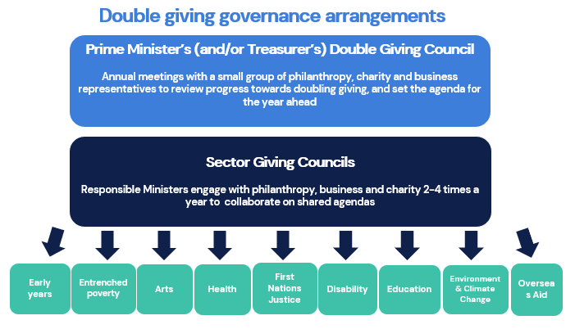
3.3 A national giving and community participation data set: Australia’s data on giving is poor, incomplete and out of date. Numerous organisations compile components of the picture, but often with inconsistent methods. Good data would guide all parties on how we can double giving and help us to track our progress. We recommend the PC: develop a single, comprehensive National Giving and Community Participation Data Set, identifying the level of total giving in Australia and its key components; and recommend clear, streamlined institutional arrangements and responsibility for the ongoing collection and dissemination of data on philanthropy, including which organisation would lead the work.
3.4 An action research agenda: Doubling giving will require several dozen initiatives across the government, philanthropy, business and charity sectors, often in pioneering areas like encouraging HNW giving, encouraging financial advisers to engage clients on giving, establishing super bequests and providing a choice to donate at tax time. A fund of $10 million over 6 years to 2030 could be allocated to guide effective implementation of these flagship initiatives.
3.5 Effective evaluation: Evaluation is critical to ensuring programs are well designed and deliver the intended impact. In turn, good impact data gives the public confidence to increase donations, knowing their money will be well used. The PC could usefully recommend reforms to improve evaluation, including: A Centre/Unit to build capacity and promote best practice in evaluation by both funders and charities; a voluntary framework to inform and promote effective evaluation; and government funding for evaluation for all major government service-delivery programs run by charities.

Full Submission

Why a More Generous and Giving Australia Matters

The Challenge
Australia’s giving compares unfavourably with our counterparts. Giving in Australia is around 0.81 per cent of GDP, compared with 1.84 per cent in New Zealand and 2.1 per cent in the United States.
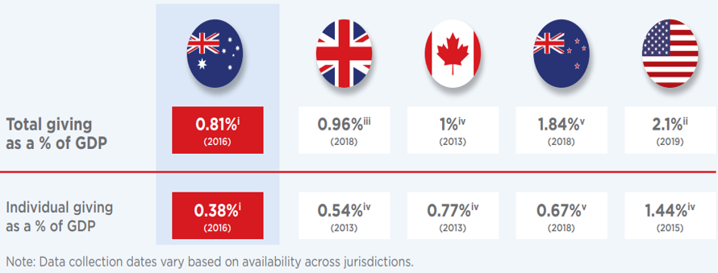
Reaching the US proportion of giving would lift annual giving in Australia from $13.1 billion to $34 billion, a $21 billion increase. Reaching the NZ proportion would unleash an extra $17 billion per annum.
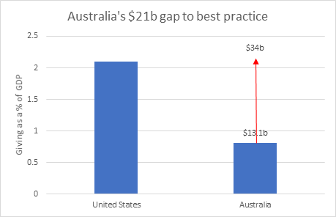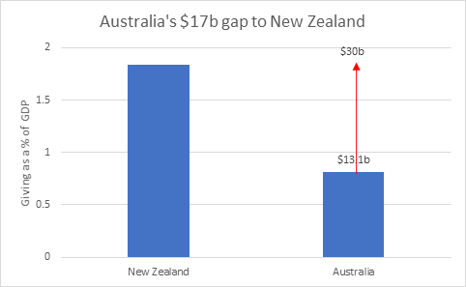
In addition, the proportion of Australians contributing to charity is declining in every income group, and overall, from around 38 per cent of the population claiming tax deductions in 2011 to 29 per cent in 2019. (Some Australians give but do not seek tax deductions. 71 per cent of Australians indicated they’d given to charity in the last 12 months in a survey of more than 2,500 people undertaken by Redbridge in November 2022). Just 53 per cent of Australians earning $1 million or more are claiming tax deductions for giving, compared to 90 per cent in the United States.

The Opportunity
Australia has an unprecedented opportunity to draw on our rising wealth to increase giving to our most important causes. Australia is experiencing the largest intergenerational wealth transfer in its history. Over the two decades to 2040, $2.6 trillion is expected to pass to the next generation. Even just passing 5-10 per cent to charity would unleash $130-260 billion to support the most crucial causes in our society. This would help to catapult us to being among the leading philanthropic nations in the world.
The Government has committed to work with the for purpose, philanthropic and business sectors to develop a Strategy to double giving by 2030. Importantly, this commitment does not position government at the sole actor, but rather foreshadows a grand national effort, with all parts of society pulling together to double giving.
Reforms that would deliver billions to charities. As outlined in the submission below, we have powerful reforms available that collectively, can double giving.

The Result – Why a more generous and giving Australia?

1. Helping people in need and addressing our great challenges
Charities make a transformative contribution to Australian society and its people.
Philanthropy is a crucial contributor to the charities that change people’s lives. Think of:
- The Royal Flying Doctor Service providing medical support to Australians in need in the outback.
- The Smith Family, Mission Australia, The St Vincent de Paul Society and The Salvation Army providing support for people in poverty and a path back to opportunity.
- The Australian Red Cross providing support for people in their hour of greatest need.
- The Fred Hollows Foundation seeking to end preventable blindness, the National Breast Cancer Foundation working to prevent deaths from breast cancer, or Make-A-Wish providing support for children with life-threatening illnesses.
- Doctors Without Borders, Care, World Vision, UNICEF and Oxfam providing support across the world for people in extreme need.
- The World Wide Fund for Nature and the Australian Conservation Foundation working to create a sustainable planet.
Great philanthropy transforms societies. Where would we be without the work of these and many other great Australian charities?

2. Amplifying the impact of government
Government is facing significant fiscal pressures, including net debt rising rapidly towards $1 trillion, a significant structural deficit, and Treasury’s 2021 intergenerational report projecting the ageing of the population will contribute to widening structural deficits in the decades ahead.
Philanthropy and charities contribute to a better society in ways that complement and amplify the work of government in a range of ways:
- Philanthropy is a critical catalyst, kickstarting innovations that become crucial institutions in society. Without the constraints faced by government, philanthropy can be nimble, take risks and innovate in ways that contribute to lasting institutions and transformative system change. See Box 1 below for examples of how philanthropy has triggered change in almost every area of social policy in Australia.
- Philanthropy and charity can meet critical social and environmental needs not addressed by Government. For instance, many community-based organisations have a better understanding of local needs and how to address them than governments operating large, uniform, centralised government programs. Redbridge reporting on six focus groups conducted in late 2022 reported: ‘A foundational assumption for many participants was that taxpayer dollars are too often misallocated and that trustworthy charities are a more efficient and effective means for delivering urgent assistance to people.’
‘I feel quite cynical about how money is spent in Government. If there was a charity that I trusted, that I could go direct to, that I knew would be making a difference in that area, that would be a good way to help.’
‘Government cannot focus on every aspect. So charities are filling in the gaps for them:
they're playing a really important role in our society.’
- Funds for impact investing – Philanthropists are increasingly including impact investing as part of their portfolio, and this looks set to considerably expand if, as expected, the Federal Government establishes a favourable policy architecture for impact investing in the 2023 Budget. Philanthropists also have a unique role to play in ensuring the social impact market can work effectively as they are more willing to provide grants and/or higher risk and concessionary early-stage capital than other investors more focused on financial return. In particular, philanthropy can fund organisations to become ‘investment ready’, helping to build a strong pipeline of social impact ventures that can attract capital from private and other investors. It can also support the development of intermediary organisations, and fund evaluation of outcomes-based approaches.
- Capital for NFP-delivered government funded services – In a suite of fields – like aged care, disability services and employment services, not-for-profits play a major role in service delivery ($89 billion in revenue from government in 2020), often being more cost-effective or on-par with private providers. As government seeks expanded service provision, private providers have a strong advantage in being able to raise capital. Philanthropy can play a crucial role in levelling the field, enabling NFPs to gear up for new and expanded service delivery. In other fields, like universities (where leading universities are now raising in excess of $1 billion through fundraising campaigns) and the arts (such as the creation of world class Southbank Arts precinct in Melbourne), philanthropy is radically expanding what government could achieve alone.
- Giving supports a pluralistic society by empowering citizens to support causes overlooked by government. With limited resources and big demands by major forces in the electorate, democratic governments tend to focus investments where a majority of the population support further activity. As John Daly has argued:
Philanthropy can make a big difference helping groups that are weak and unpopular. There are few votes in helping them. Philanthropy can act where governments refuse to do so. For example, many asylum seekers living in the Australian community rely on philanthropy to avoid destitution. Some other causes are seen as ‘luxuries’, and therefore inappropriate for government funding – or too much funding. Yet so-called luxuries such as art and culture improve the lives of many people.
Incentives for giving foster a more pluralistic society, as they empower citizens to direct funding to causes they believe are important. In a poll of more than 2,500 people conducted by Redbridge in November 2022, Australians showed strong support for this role of philanthropy.
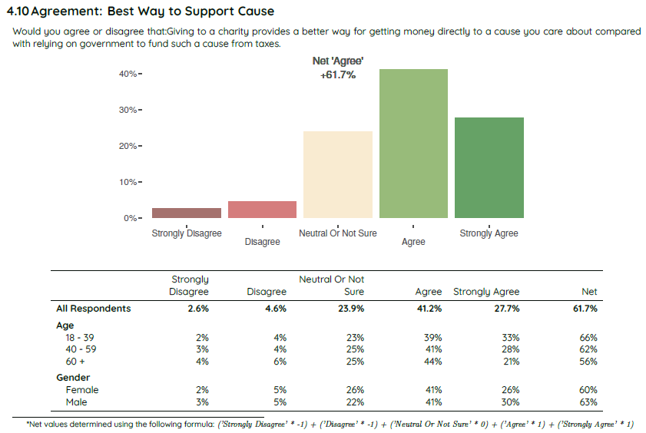
There is enormous scope for government to achieve radically greater impact through stronger collaboration with philanthropy, charity and the business sectors.
While there have been some considerable achievements in the past, Australia has never established and sustained powerful governance arrangements for government, philanthropy, charities and business to develop shared agendas, meaning a massive source of social progress has been left largely untapped.
The Federal Government has indicated its desire to restore institutions, collaborate more strongly with business and civil society, and drive impact through shared agendas.
This submission recommends simple, efficient governance arrangements to create space for this collaboration. Minister’s sitting down with philanthropy, business and charity would find ways to magnify impact in their portfolios beyond what they can achieve through government investment alone. Philanthropy is particularly well placed to trial social innovations government is not well positioned to pursue, which, where successful, can drive systemic change. Co-investment on Flagship Initiatives would also propel social change.
Box 1: Transformative change led by philanthropy
In higher education, in the 19th century, philanthropy played a critical role in the establishment of a number of Australia's sandstone universities that have gone on to be among the best in the world, creating opportunity for millions of Australians and undertaking world leading research. William Charles Wentworth founded Sydney University to give “the opportunity for the child of every class to become great and useful in the destinies of this country.”
In health, it was philanthropy that founded the Austin and Epworth Hospitals, which have provided world class care to patients over more than 100 years. It established The Heart Foundation, launched in 1961, which put heart disease – our biggest killer – on the map, and continues to promote heart health today, saving countless lives.
In mental health, philanthropy was critical in the establishment of Orygen, whose work has transformed youth mental health in Australia, including by spawning headspace, which runs a national network of youth mental health centres, set to grow to 164 by 2024-25.
To address poverty, philanthropy helped establish The Salvation Army in Tasmania in 1873, an organisation which today supports more than one million people in need each year. It supported the No Interest Loan Scheme, which has helped more than 100,000 low-income Australians purchase fridges, washing machines, car repairs and medical procedures.
In research and innovation, philanthropy was crucial to the development of the bionic ear (Cochlear Implant), which has since brought hearing to hundreds of thousands of people all over the world, and to establishing the feasibility of the bionic eye. It established leading research institutes like the Garvan Institute, Walter and Eliza Hall Institute, Howard Florey Institute, St Vincent’s Institute and the Murdoch Children’s Research Institute.
To protect the environment, philanthropy established Bush Heritage Australia, which today owns and manages 37 reserves and protects more than 11 million hectares of land, providing healthy habitat for over 7000 native species and 243 threatened species. Philanthropy supported the advocacy work of a coalition of conservation organisations, which helped to secure a decision by the Federal Government in 2012 to establish Australia’s National Marine Park Network, a network of 58 parks all around Australia covering over 3 million square kilometres - the first of its kind in the world.
In arts and culture, philanthropy has been crucial bedrock. It has been a driving force behind the development of the Melbourne Arts precinct, already has one of the highest concentrations of arts, cultural and creative organisations anywhere in the world, and set for further renewal through the Melbourne Arts Precinct Transformation project. Philanthropy established The Miles Franklin Award, to give prominence to Australian writers and Australian culture and The Walkley Awards, which reward and encourage high quality journalism.

3. A better society
A more generous and giving culture, where we focus on serving each other, being active in the community, and working to ensure no one is left behind.
Today we are more connected digitally than ever before, but many of us feel less and less connected to our communities than in the past. A philanthropic culture creates a different society - one in which we come together to support causes bigger than ourselves, where we feel greater unity with our fellow human beings, we feel more meaning in our lives, and we solve our biggest challenges together. And importantly, philanthropy snowballs. When people act, others notice and join in. Big possibilities become big new realities.
Australia today faces innumerable challenges – 1 in 6 children and young people living in poverty, a global pandemic, opportunity not equally shared, the risk of climate catastrophe and ongoing disadvantage among Australia’s First Peoples, to name just a few. We need to create a stronger philanthropic culture in our country to develop a nation where we all come together and no one gets left behind.
Echoing and updating the work of Robert Putnam in Bowling Alone, which charted the decline in social capital and community participation in the US, Andrew Leigh and Nick Terrell produced Reconnected in 2020, which charts how Australian society has become much less connected in recent decades. We are much less likely to participate in community groups, pursue volunteering, we have less friends (down from an average of 9 trusted friends to 5 between 1984 and 2018), we are less likely to volunteer and less likely to know our neighbours. Participation in religion is falling, which impacts the social fabric as people with religiously based social connections are two to three times more civically engaged and generous. Less people are engaged with politics, which has led to a sharp decline in trust in government and satisfaction with politics. Participation rates in sport are falling, including among children, and 67 per cent of Australians are now overweight or obese. There has been a steep rise in loneliness – almost 30 per cent of the population report they hardly ever or never catch up with friends, while half report feeling lonely at least one day a week. In sum, the connections and social capital that give us meaning, bind us to each other and ensure people are not left behind, are in decline.
Australians are yearning for a return of a more generous and giving culture, and we have the makings of more connected communities.
Reconnected contains dozens of stories of people all over Australia bucking the trend to build stronger communities. Redbridge report that, across a suite of their research projects, coming out of the pandemic, people are keener to engage in local communities, and show care and compassion for others.
Redbridge focus groups confirm giving is core to Australians’ sense of self and national identity.
“I think it is part of our makeup: Australian mateship and looking out for your mate. It's an important part of our culture. And I don't think we should lose that.”
“That's what made us Australian, the Anzac tradition about supporting and helping out, at any cost.”
“I think Australians have a very strong sense of fairness. What defines our culture is, we like battlers, we like little guys, and we like kids.”
“I think the foundation of our country is on the basis of charities and volunteers. SES is a really good example [as is] Surf Lifesaving. It's a really important part of Australian culture. And I think a lot of us couldn't get by without them.”
Redbridge polling of more than 2,500 Australians in November 2022 showed that Australians recognise the role of giving in building stronger communities.
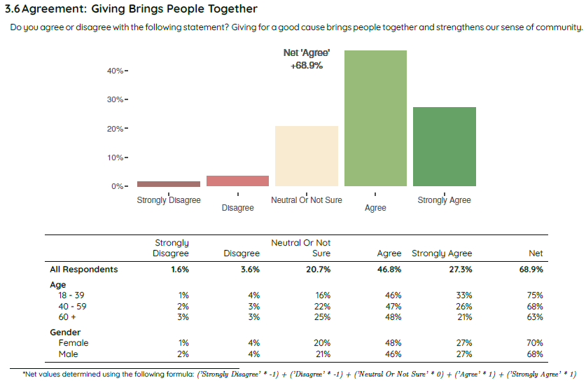
Charitable giving makes people happier and healthier, with a stronger sense of meaning and purpose.
A survey of 200,000 people across 136 countries showed a robust positive relationship between charitable giving and self-reported happiness, which other studies have found to be causal. For instance, in one experiment, participants given money to spend on others were happier than a participant group who spent the money on themselves. In another experiment, a group who spent $130 on others had significantly lower blood pressure three weeks later than a group who spent the money on themselves.

4. Unleashing the power of community-led social change
The experience of COVID is driving seismic shifts in society beyond the pandemic. In particular, people are now spending much more of their lives in local communities. Research by McCrindle shows many people: now have hybrid working arrangements, working part of their week at home; are setting up home offices; shop more locally; and value their local community more – see graph below. With people keen to get involved locally, a particular opportunity is to grow local giving and volunteering, and in particular, expand the national network of Community Foundations, so we can expand national giving, community participation, social capital and support for Australians in greatest need.
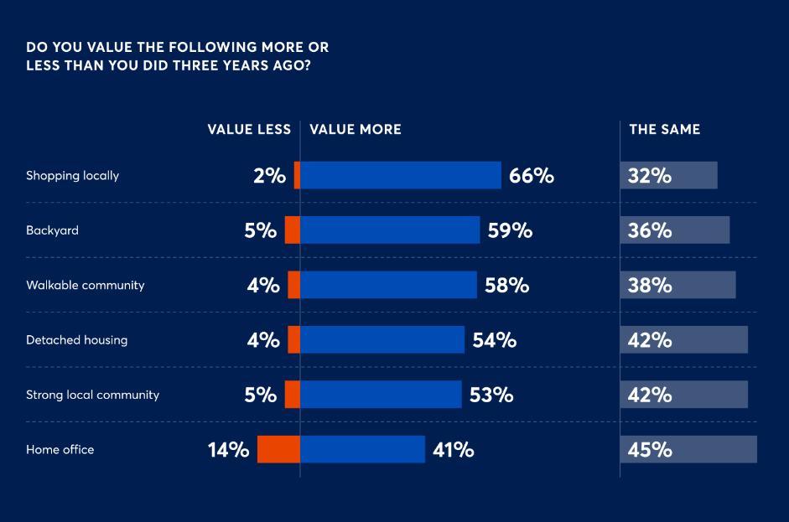
At just the time we are seeing a shift in our national culture, the Government is implementing institutional reform to grant DGR 1 status to Community Foundations across the nation. With decisive action, we can grow this network, so that the vast majority of Australians, whether in big cities or regional towns, can get involved in donating and volunteering in their local communities, and drive social and environmental progress in the place they call home.
This marks a big opportunity for government too. Local MPs can work to ensure their electorates have Community Foundations and then work with local communities to better understand and address local needs. Over time, as the network grows, it can become powerful national architecture, allowing government and local communities to work together to address challenges suited to local solutions.

5. A better sharing of wealth and opportunity
Australia is one of the wealthiest nations on earth and wealth at the top end is rising rapidly.
- Wealth among The Top 200 as reported by The Australian Financial Review has increased from $209 billion to $555 billion between 2016 and 2022, or from an average of $1.05 billion to $2.77 billion.
- Knight Frank estimates that there was over 20,800 ultra-high net worth (UHNW, $30m plus net wealth) people in Australia in 2021.
- The top 10 per cent of households hold 46 per cent of Australia’s wealth.
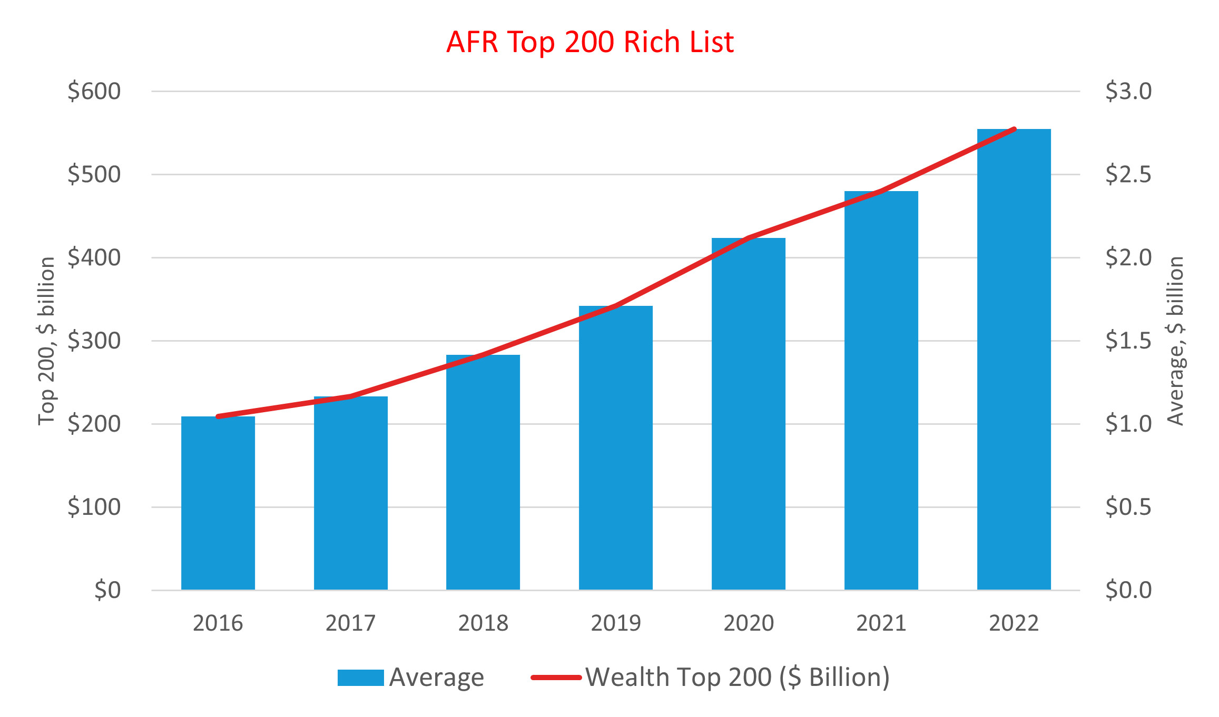
This presents an immense opportunity to grow giving in Australia. Bill and Melinda Gates and Warren Buffett established The Giving Pledge, through which more than 200 wealthy people from across the globe have pledged to give away the majority of their wealth (with more than $600 billion pledged to date). Australia’s total annual giving is around $13 billion. Imagine the impact on Australian society if a majority of the $555 billion amassed by The Top 200 was directed to our most urgent challenges. A culture where those more fortunately placed routinely gave substantially would catapult Australia to among the leading philanthropic nations in the world and help ensure all Australians can lead lives of opportunity, freedom and contribution.
‘I could have bought a yacht … but then how could I sit in church?’
— Graham Tuckwell on donating $50 million to Australian National University
As a society, we need to make a clear choice: Do we wish to see all this wealth pass to future generations, maintaining wealth and privilege for those most fortunately placed, or do we wish to see some of this money used to support Australians in greatest need, so opportunity is more evenly shared in our country?

6. National Wellbeing and Productivity
Doubling the percentage of national income going from Australians in a position to give to people in greatest need and to support our greatest challenges clearly delivers a large increase in national wellbeing. For Australians most fortunately placed, marginal wealth and income is surplus to their needs. Transferring this wealth to help people in need, or to address critical causes, marks a major improvement in national wellbeing.
PC and Government strategies and initiatives to improve philanthropy and charity are critical because the charity sector is important part of the nation's economy. In 2019, they employed 1.38 million people, or 11 per cent of Australia's workforce, more than the retail or construction sectors, with revenue of $166 billion and assets of $354 billion. Around 3.6 million Australians volunteered in 2019. Lifting the productivity and impact of the sector can deliver a helpful boost to the nation's productivity.

7. Improving public policy
Delivering reforms that would improve our nation’s future is becoming harder. It is commonly argued that, following a strong reform era in the 1980s and 1990s, delivering change has become more difficult for governments. Politicians typically face a strong public response when proposing change. Less resources are available to media to undertake investigative journalism. Our academic community is more strongly incentivised to publish new knowledge in academic journals, than to contribute to public debate. Powerful vested interests protect their own special arrangements over the broader, more diffuse public interest. Reform typically has many opponents and few friends.
Civil society – particularly philanthropic funders and charities – play a crucial role in creating momentum for reforms to public policy that improve national wellbeing. Civil society often plays a critical role in building public support that creates an environment in which politicians can feel comfortable pursuing reform – from women’s suffrage to the Walk Across the Bridge for reconciliation, from protecting our environment to the economic reforms of the 1980s and 1990s, and many more.
- Charities, because they work at the coalface, play a crucial role in advocacy, alerting government to critical needs and ensuring policy design will meet the needs of end users.
- Philanthropic support for advocacy – because it can be independent of government – can produce bold and rigorous reform propositions. It can also be massively cost-effective, as relatively modest investments can drive major changes to significant government policies and funding.
- This is why the Government’s pledges to remove ‘gag clauses’ from the contracts of charities and establish a Freedom to Advocate Act, are so important.
Catalysing government reform example - The Grattan Institute
The Origin Foundation provided Grattan with $100,000 to examine whether remote schooling during the pandemic was having a disproportionate impact on students from low-income families. This work led to major tutoring programs to help affected children – including $250 million in Victoria, $337 million in NSW and $3 million in South Australia.
Grattan was established through an initial endowment from BHP, NAB and the Federal and Victorian Governments. It is independent and continues to gain support from philanthropy. It has been a consistent and powerful force for reform, such as to encourage governments to lock down hard to avoid COVID community transmission and boost women’s labour force participation through cheaper childcare.

8. Strong Public Support for the Double Giving Agenda
Redbridge polling of more than 2,500 Australians in November 2022 shows overwhelming support for the double giving agenda, whether:
- General support – giving brings people together and strengthens our sense of community (74% agree, 7% disagree); or
- Support for specific reforms, such as super bequests (75/6), extending DGR to all charities not just some (74/6), the choice to donate as part of the tax return process (70/9), a National Giving Campaign (65/7), or changing tax laws to better incentivize giving (66/8). See results overleaf.

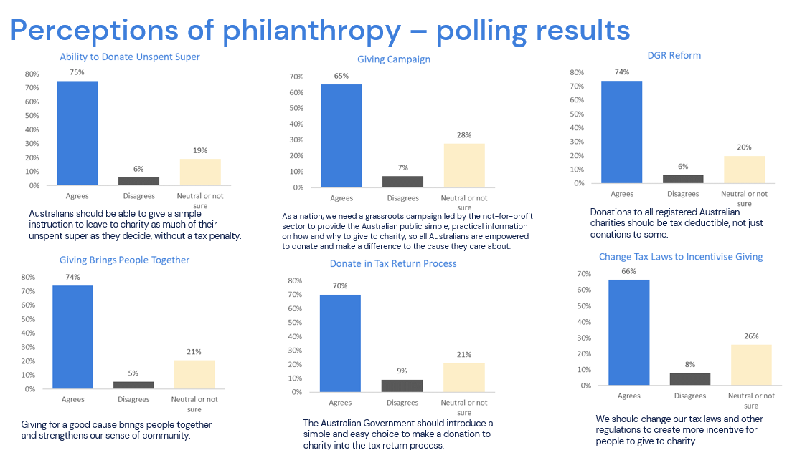

A Policy Environment that Fosters Giving
The 2022 Global Philanthropy Environment Index shows Australia’s environment for encouraging philanthropy ranks 19th in the world – at 4.27 out of 5 – below a group of advanced economies with scores in the 4.5-5.0 range, which are Belgium, Denmark, Finland, France, Germany, Liechtenstein, Netherlands, Norway, Singapore, Sweden, Switzerland and the United States.
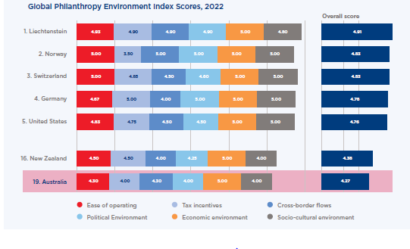
Below are 8 reforms that would substantially lift the environment for philanthropy in Australia and help us to double giving.

Giving Australians the choice to make a bequest to charity through their superannuation

The Reform
- Give Australians the choice to make a bequest through super: Allow Australians to bequest some of their unspent superannuation funds (funds remaining when people pass away) to a nominated charity. At present, legislation forbids people using what’s termed a ‘binding death nomination’ to give a proportion of any unspent superannuation to charity. Two possibilities for implementing this reform include:
  - The government mandating that all super funds must provide this option for their members; or
  - Legislation giving superannuation funds the option to offer charity nominations to their members, should they wish to do so.
    - In either case, it may be prudent, at least initially, to limit the proportion of unspent funds that can be provided to charity to 10 per cent for balances up to $1 million, or up to 20 per cent for balances north of $1 million, to help ensure good provision for dependents.
    - How super funds provide this option could be left to them, but a non-lapsing binding charity nomination would be the best means of ensuring certainty for superannuation trustees.
    - In any case, reform should only occur following consultation with the super industry. A potential option here is to consider the reform as part of a review of the binding death nomination process, to create greater certainty and simplicity across all bequesting activity for super trustees and clients alike.
- Remove the tax penalty: To leave some of their remaining super to charity, Australians must first arrange to transfer the funds from their super to their estate through the ‘binding death nomination’ process, then complete their will specifying that these funds should go to a nominated charity. Where this occurs, they then face a tax penalty – up to 15 per cent tax, plus the 2 per cent Medicare levy – which goes to the government, rather than their nominated charity. Australians are not taxed when they give to charity while they are alive (and indeed often receive a tax deduction), so it makes little sense to apply tax after people have died. Giving to charity should be encouraged, not penalised. The tax penalty should be removed.

The Case for Change
- Tens of billions for Australians in greatest need.
  - This is by far the most powerful policy lever we have to lift giving over the long term.
  - Treasury in its Retirement Income Review (July 2020) forecast superannuation balances at death will increase from $17 billion in 2019 to $130 billion by 2059 in 2018-19 dollars – see graph overleaf. Treasury noted these amounts would be considerably higher should the Australian Government maintain the legislated increase to the Superannuation Guarantee from 9 to 12 per cent, which is now happening.
  - In explaining these massive super remainder amounts, Treasury cited multiple studies showing retirees are dying on average with around 90 per cent of the assets they had at retirement. There are powerful forces behind this behaviour – effectively living on the interest from super rather than spending down the capital.
    - People are committed to keeping the underlying capital in order to ensure they have savings should major health or other life contingencies arise, or to leave money to dependents.
    - Along with the family home, super is a tax effective form of saving, so people generally exhaust other forms of saving before drawing down their super.
  - While it is not possible to accurately estimate likely donations to charities, it appears very likely it would be in the tens of billions over time.
    - Charities and the super industry would market this option, spurring Australians in a position to do so to make super bequests. Over time, it would likely become a national custom, with people nominating a proportion for charity when they commence super, or later in life when they are in a stronger position to afford to do so.
    - To illustrate possibilities: If on average people left 10 per cent of their super to charity, by 2059 this would be $13 billion a year (in 2018-19 dollars), effectively doubling Australia’s annual giving to charity. At 5 per cent, the amount would be $6.5 billion a year, or at 1 per cent $1.3 billion annually.
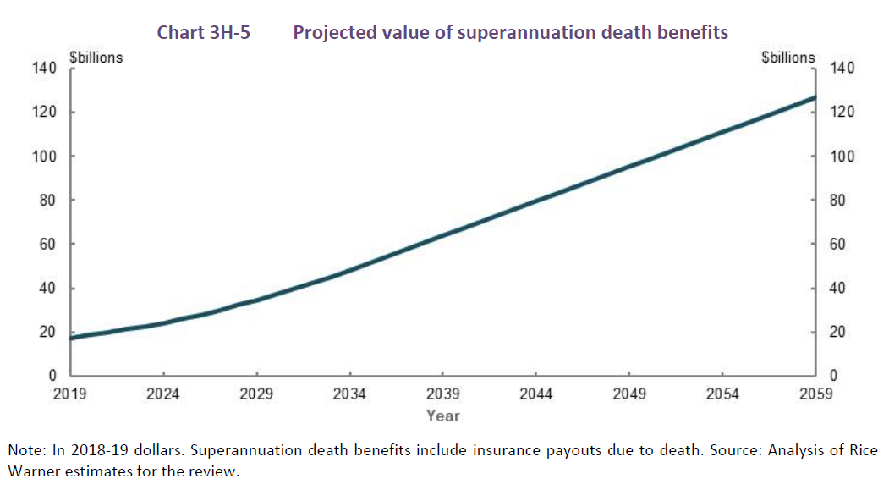
- No impact on the core purpose of super: providing retirement benefits to members.
- With total super assets now north of $3 trillion and rising, there have been many ideas to use the funds in ways that would harm the core purpose of super – allowing super to accumulate over a lifetime of work to create a good income in retirement. The Minister for Financial Services Stephen Jones said in a speech to the Australian Financial Review Wealth and Super Summit on 8 November 2022:
Over thirty years, our system has been subject to many changes... The disastrous decision to allow billions to be withdrawn from super through the pandemic will be felt in the decades to come. The proposals that have been rejected are just as consequential. Using it to pay off HECS. Housing. The policy ideas have too often been confused at best or damaging at worst. But like a Mariah Carey single at Christmas, these ideas keep coming back.
- The super bequest proposal is completely different to the aforementioned proposals – it has no impact on retirement incomes as funding would only pass to charity after the person is dead.
- It’s the people’s money. They should have the choice about where it goes, and that choice should be made as easy as possible.
Government legislation preventing people from giving money to charity through super bequests is an excessive restriction on the ability of people to use their money as they wish and, in particular, to contribute positively to society. In order to maximise choice and take up, this choice should be made as simple as possible, available through each person’s super fund.

- The reform would be well received by the Australian people.
The possibility of donating through super bequests is not well known in Australia, so PA commissioned Redbridge Group to undertake polling and focus groups to assess the likely reaction to the reform. In a poll of more than 2,500 Australians conducted in November 2022, they found 75 per cent support for the reform, with just 5.8 per cent opposed and 19.2 per cent neutral or not sure. This was the highest support for any of the reforms tested in the polling.
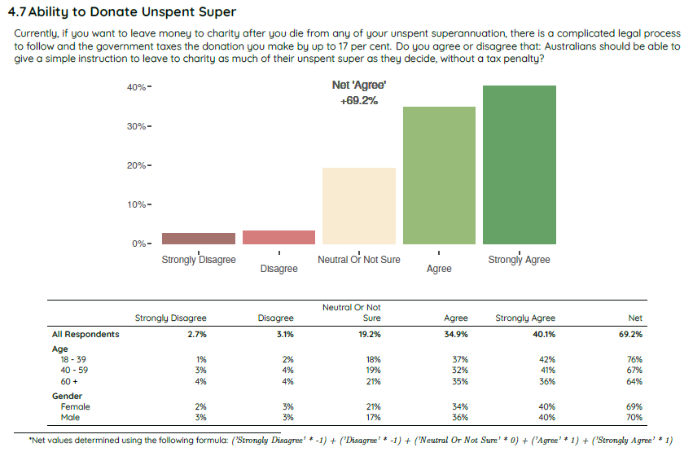
Focus group support for super bequests, Redbridge, October 2022.
“Well, I actually thought [a super bequest] was something that you could easily do. I didn't realise it was so difficult. I think that making it more accessible is a great idea.”
“I think it sounds great. More people would definitely do it [super bequests] if it was easier.
“I'd like my portion [of unspent superannuation] going somewhere I wanted it to. I don't want the government getting its hands on any leftover money.”
“I think that's a good idea. I didn't realise [the tax penalty was] 17% Wow, that's money grabbing, isn't it?”
“It's better off in either your hands or the charities’ hands rather than the taxman.”
- Spreading wealth and opportunity to all Australians
  - When people organise their wills and superannuation arrangements, their first thoughts are invariably looking after their dependents. Expanding opportunity and financial security for those we leave behind is a critically important aspiration for many people.
  - At the same time, many Australians, particularly those more fortunately placed, have tremendous scope to leave some of their super to charity, as well as looking after dependents very generously.
  - Indeed, super bequests can make a major contribution in spreading wealth and opportunity – with tens of billions flowing from more fortunately placed Australians to help Australians in greatest need.
    - $2.6 trillion is passing to the next generation over the 20 years to 2040, with many Australians very well placed to give. For instance, over 2020-30, the average transfer per household will be $4 million in Lindfield-Roseville in Sydney, and $2.7 million in Toorak in Victoria.
  - Wealth among the Top 200 has increased from $209 billion in 2016 to $555 billion in 2022, or from an average of $1.05 billion in 2016 to $2.77 billion in 2021.
As a society, we need to make a clear choice: Do we wish to see all this wealth pass to future generations, maintaining wealth and privilege for those most fortunately placed, or do we wish to see some of this money used to support Australians in greatest need, so opportunity is more evenly shared in our country?
  - Super bequests can be a primary mechanism transferring funds from Australians fortunately placed to those in greatest need. This would make some contribution to a glaring flaw in the super policy framework – its impact in worsening wealth inequity. Two thirds of the $50 billion in annual tax concessions goes to the top 20% of income holders.
- Consistent with the Government’s values and would help fuel the Government’s agenda.
  - The Federal Government is proud of historic social reforms that have helped provide support and opportunity for Australians in greatest need, such as introduction of the aged pension, unemployment benefits, Medicare, universal superannuation and paid parental leave.
  - Delivering super bequest reform, which would deliver tens of billions to Australians in greatest need, would be another iconic and historic reform.
  - With giving doubled, Labor could work with the philanthropic and charity sectors to leverage additional work to achieve its key goals. The sector could provide funding, and trial innovative approaches, to support the Government’s objectives in areas including homelessness, poverty alleviation, justice for Australia’s First People’s, disability support, early childhood, higher education and the environment.
  - The reform is consistent with a key outcome of the Jobs and Skills Summit: ‘The Government will work with investors, including superannuation funds to leverage greater private capital into national priority areas, including housing and clean energy.’
- Limited or no impact on the Budget over the forward estimates, and limited net impact over the longer term
  - Bequests are a particularly cost-effective means of charitable giving because donors do not receive a tax break in return for their bequest. This is among the key reasons why the often-heard refrain - ‘doubling giving means double the revenue foregone’ – is false. It is a big reason why super bequests should form a key component in the government’s double giving agenda.
  - If the tax penalty of up to 17 cents in the dollar were removed, there would be limited or no impact over the forward estimates.
    - Super bequests will be a slow burn in the early years. As a new idea on the landscape, it will take time for it to be marketed to the Australian people, understood and accepted. People will then need to decide to make a nomination to charity through their super and of course, funds would only flow to charity when people pass away.
  - Over the longer term we’d expect super bequests to grow strongly, but again the net impact on the Budget would be limited.
    - Where people died with child age dependents, where funds passed on are not taxed, there would be no revenue foregone.
    - In the more common occurrence where people pass super on to adult dependents, where funds are taxed up to 17 per cent, tax free super bequests would have an impact, to the extent they displaced funds otherwise going to dependents.
    - However, the up to 17 cents foregone would be leveraging at least 83 cents in funding for social and environmental policy purposes, some of which the government would otherwise to have to provide at full cost – 17 per cent of funding versus 100 per cent of funding. So the overall budget impact is likely to be positive in net terms.
    - There is an additional counter-factual. Without removing the tax penalty on super bequests, more Australians will be inclined to donate to charity during their lifetime, whether through regular giving, a PAF or a PuAF, where they can access the DGR tax return, with a far greater cost to revenue.
    - While Treasury Budget costings will not incorporate these ‘second round’ impacts, it is important the cost-effectiveness of policy measures be assessed holistically.
  - Finally, the government could decide to allow super bequests without removing the tax penalty.
    - While the tax may impact take up, it would still likely raise tens of billions over time, at no cost to revenue. In fact, revenue would increase modestly as some of the money bequested through super (which would be taxed at up to 17 cents in the dollar) would be in place of funds otherwise distributed to non-adult dependents (which are tax free), creating a helpful addition to net government revenue.
- Significant benefits for the super industry.
  - While the super industry would need to administer super bequests to charity, this is not expected to be a significant burden, particularly if:
    - The proposal is made voluntary for super firms; and
    - They use binding, non-lapsing nominations to charity, which provide certainty for trustees.
  - On the other hand, super bequests would deliver strong benefits for the super industry, including:
    - Creating transformational change for Australians in greatest need, through the tens of billions raised.
    - Democratising giving: Giving in Australia is becoming increasingly concentrated among wealthier Australians. Super bequest reform would position all Australians to participate in the joy and pride of giving. Studies confirm giving lifts happiness and creates a sense of purpose and contribution.
    - Competitive advantage for super funds through ESG and market positioning: First movers in the sector would attract additional business from customers and attract talented staff who feel pride in supporting super funds committed to building a stronger society. A number of super funds are already growing well above the sector average by showing their customers they do good works for society, such as ethical investment. Preliminary discussions indicate strong interest in charity bequests.
    - Increased community support for the sector as a whole: The Australian community would warmly welcome the generous work of super funds, helping to strengthen support for their role in society. In turn, this would make it increasingly difficult for governments to tinker with super in ways move away from its core objective – providing a dignified income for people in retirement.
    - The option of setting up their own foundations: Super bequest reform could enable super funds to set up their own foundations, which they could market to members, both when they open accounts and across their super life journey. Foundation funds would likely grow quickly, enabling Super funds to contribute significantly to local communities, such for community sporting organisations, hospitals, education, poverty alleviation, homelessness and more.

Addressing detailed policy challenges
- An unsustainable rise in complaints?
Q. At present, superannuation bequests are sometimes challenged, such as where deceased persons had been married several times, but super is only provided to one partner and/or group of dependents. Won’t adding charities to the mix lead to an unsustainable rise in complaints and administrative costs for super funds?
A. No.
  - Super funds could create certainty for trustees by allowing members to choose non-lapsing, binding charity nominations.
  - Legislation could also make charity bequesting an option for super funds, so only those who consider it a net benefit would pursue the option.
- What about the sole purpose test and the needs of dependents?
Q. Isn’t this an inappropriate and dramatic shift to the sole purpose test: providing retirement benefits to members, or to their dependants if a member dies before retirement.
A. No.
  - Super bequests do not impact a member’s accumulation of funds or funds drawn down in retirement, as they involve bequesting funds after a person is dead.
  - We can expect bequests to largely occur in families with the means to support charity, as well as provide generous support to dependents.
  - It is also important to address another critical equity risk – that the explosion of wealth at the top end of Australian society will simply be passed on to dependents, rather than shared to help create opportunity for all Australians, particularly those in greatest need. The ban on charity bequests prevents this from being achieved through super under current rules.
  - To provide an extra safeguard, we propose a cap on super bequests of 10-20 per cent of remaining funds.
- Why not just use the wills process?
Q. Couldn’t the same change – a major increase in bequests to charity - be achieved through wills?
A. No.
  - It is true that Australians can make a death nomination to place super funds into their wills, and then through their wills direct the money to a charity.
  - However, the process is highly complex, potentially costly, time consuming, uncertain and relatively little used. A 17 per cent tax is applied. Only a minority of Australians have binding death nominations, most of which lapse after three years, and relatively few of which involve bequesting through wills. In turn, less than 60 per cent of Australians have wills and only 7 per cent make bequests to charity, only some of which involve super.
  - As behavioural economics tells us, making the process easy is the key to fostering choice and take up, creating billions for Australians in greatest need. Super money is the people’s money. They should have the choice to provide a portion to charity through a simple process as part of their super arrangements.
- What about fraud?
Q. Won’t this lead to a massive rise in fraud, with charities preying on older Australians?
A. No.
  - Charities can encourage bequests through wills and under this existing regime, unconscionable conduct is rare.
  - Charities are registered with, and regulated by, the Australian Charities and Not-For-Profit Commission, and are subject to regulation across a suite of Acts, including fundraising regulations in each jurisdiction.
  - The 10-20% cap would further limit incentive and scope for unconscionable conduct.

Extending DGR to all registered charities.

The Reform
- Provide DGR to all charities registered with the ACNC. DGR status is essential to charities being able to attract donations as it allows the public, as well as structured giving vehicles such as Private Ancillary Funds (PAFs) and Public Ancillary Funds (PuAFs), to donate and get a tax deduction.

The Case for Change
- Almost half of Australia’s charities are cut off from DGR – and the donations it attracts – despite undertaking charitable activities that provide a positive public benefit.
  - To access DGR, entities must first register with the ACNC, then have the ATO determine that their activities fall within one or more of the 52 ‘DGR endorsement categories’, such as health, welfare and rights and education, each of which has its own definitions and defined scope.
  - The Federal Government established DGR in the Income Tax Assessment Act 1915. Since then, as the Not-For-Profit Sector Tax Concession Working Group (2013), p.23 noted:
The framework has developed in an ad hoc fashion over time. There is no clear policy rationale for why some entities have been provided DGR status and others have not. The arbitrary nature of the categories leads to inequities and anomalies, with some entities being granted DGR status while similar entities or entities which provide significant public benefits have not.
  - For example:
    - Under ‘Health Promotion Charity’, promoting prevention of diseases will qualify, but preventing injuries will not.
    - Alleviating poverty will qualify, but seeking to prevent poverty may not.
    - Neighbourhood houses or community centres providing welfare as its main activity will likely qualify, but those focused mainly on social inclusion and community development may not.
  - Too many great charities are missing out. Excluding charities based on categories without a policy rationale makes no sense. The policy purpose of providing tax incentives to encourage giving is to support charitable activities that provide a positive public benefit. All charities do this, so all should be given DGR status.
- Total giving in Australia will rise if the DGR framework is reformed.
  - The framework deters the public from donating to those without DGR status as they cannot receive a tax deduction. Despite doing charitable work, it also means they are forbidden by law from accepting grants from PAFs (which distributed $521 million in 2019-20) or PuAFs, (which distributed $350 million in 2019-20).
  - People intending to donate to a cause they support often withdraw from donating when they find out organisations do not have DGR status. Affected charities have missed out on millions, including very sizeable donations that would have been transformational for what they were able to achieve.
  - While there would be some substitution effect, total giving would rise if more charities could seek support with the carrot of tax deductions for donors.
- Providing DGR to all charities would reduce red tape costs for charities and government, freeing up more funds to support people in need.
  - Where charities support multiple purposes, they need to seek endorsement under numerous different DGR endorsement categories, and may need to set up funds, authorities or institutions for each of the categories. Some purposes may not fit within the endorsement categories, and therefore will not attract DGR. This adds complex red tape for no policy benefit. This is a challenge for many Indigenous charities, which seek to provide holistic support across a range of areas.
  - Many charities ‘fall between the cracks’ because their work does not fit within any of the DGR endorsement categories. In this case, the only option is to seek a ‘specific listing’ in the tax laws – a long and complicated process, requiring a legislative amendment. Success is far from assured – there are many applications and only a minority are granted. And without a clear policy rationale guiding Ministers on who to include and exclude, decisions can appear arbitrary. Those well positioned to lobby government have a stronger chance of success than others.
  - Providing DGR to all registered charities would remove all this unnecessary red tape for government and charities, freeing up more funds to support people in need.
- Leading philanthropic nations give DGR status to charities automatically, recognising they serve a public purpose, and this is what Australia should do too.
  - In the United States, New Zealand and the United Kingdom, all entities recognised as charities get the broad equivalent of DGR status (noting that New Zealand uses a tax credit, rather than a tax deduction).
  - This is one of the reasons Australia’s annual giving – at 0.81 per cent of GDP – lags these nations: US – 2.1; NZ -1.84 and the UK – 0.96.
- The need for reform to expand eligibility to all charities has been recognised by numerous reviews and reports for decades, but comprehensive reform has not been forthcoming.
  - The Productivity Commission, Contribution of the Not-For-Profit Sector, January 2010, p. 184:
Recommendation 7.3: The Australian Government should progressively widen the scope for gift deductibility to include all endorsed charitable institutions and charitable funds.
  - The Not-For-Profit Sector Tax Concession Working Group, Fairer, Simpler and More Effective Tax Concessions for the Not-For-Profit Sector, Final Report, May 2013, p.5 found:
… the current system for granting DGR status is cumbersome, inequitable and anomalous. Further, the framework is not well placed to handle organisations that carry out a range of purposes that fit within a number of DGR categories. Reforming the framework would increase certainty, reduce red tape for eligible entities and should further increase philanthropy.
DGR status should be extended to all charities, but restricted to activities that are not for the advancement of religion, charitable child care and primary and secondary education, except where this is sufficiently related to another charitable purpose.

- Tax concessions have been found to be an economically efficient way to encourage giving.
  - A longitudinal study conducted in the United States (US) assessing responses to changes in State tax structures comparing changes in behaviour in States where there were changes in tax incentives to those where there were not suggested “a large persistent price elasticity of charitable giving, generally in excess of one in absolute value”.
  - Elasticity analysis in Australia undertaken by Deloitte Access Economics in 2018 found provision of taxation concessions to encourage giving are a treasury efficient way to help channel private funding into the charity sector. They assessed the elasticity of giving to be -1.19.
  - The Productivity Commission (2010), p.174 found:
Although inconclusive, a number of overseas studies have estimated a price elasticity greater than one. Further, a higher top marginal tax rate in Australia compared to the US (46.5 per cent and 35 per cent respectively) implies that tax deductibility may have a larger impact on giving in Australia than in the US (IC 1995). With no evidence of a crowding out effect in Australia and anecdotal evidence on tax inducement, the presumption must be that tax deductibility encourages philanthropic giving, especially by high income taxpayers.
- The Productivity Commission has noted arguments indicating DGR is an effective way to allocate government resources and reinforces positive social norms around individuals playing a role in contributing to the community.
  - DGR represents potentially the only direct way individuals can allocate government revenue to causes they see as worthy of funding.
  - The PC in 2010 quoted Krever (1991), who argues:
    - Individuals may be better able to identify the most appropriate causes in their local area.
    - Individuals may be better able to identify those organisations which are most capable of addressing the needs of the local community.
    - By relying on individual initiative, this activity helps reinforce social norms around supporting the community.
    - It supports pluralism, allowing individuals to support causes that are socially beneficial, but politically sensitive.
- The cost of reform can be contained to ensure reform provides a net benefit to Australian society.
  - The Not-For-Profit Tax Concession Working Group recommended an approach that limited the annual cost – estimated in 2013 – to $120 million per annum.
  - The Working Group contained the cost of reform by excluding entities established for the advancement of religion, or childcare or primary or secondary education, which would have costed more than $1 billion per annum in revenue foregone.
  - The Working Group argued that in a pluralist society, it is not appropriate to provide tax concessions to support the advancement of religion.
  - Supporting education has considerable merit in underpinning lives of opportunity and freedom for young people, but there are drawbacks to doing this through providing DGR status.
    - Many schools are private and reside in communities that are advantaged, so enabling donations would further entrench existing alarming inequities, particularly as the endorsement categories already allow donations for school buildings.
    - The Working Group highlighted integrity challenges. With thousands of schools, there is a risk donations could substitute for fees, for example.
    - For schools in lower income communities, Schools Plus has been established to provide support.
- The policy reform would be very popular with the Australian community.
Polling of more than 2,500 Australians by Redbridge found this reform would be very popular with the Australian community: 74% support the reform; 6.2% are opposed; and 19.9% are neutral or not sure.
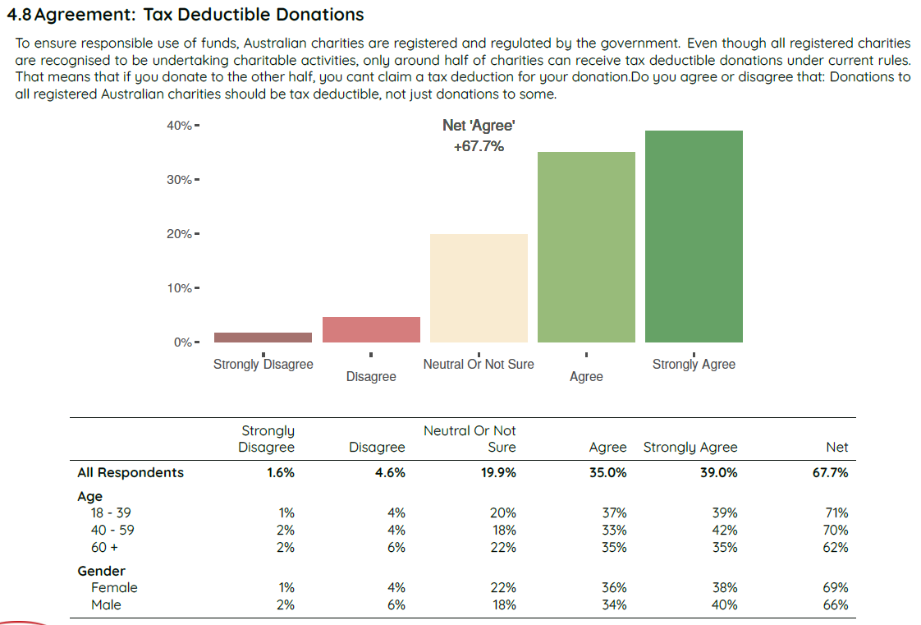

Providing people with a voluntary choice to donate some of their tax return to charity.

The Reform
- The Federal Government provide Australians a voluntary choice to return some or all of their tax return to a nominated charity, where they can afford to do so.
  - Simple and timely: As people neared completion of their tax return, a prompt would appear informing them of their estimated tax return and inviting them to provide some or all of their return to a nominated charity from a drop-down menu in their tax return lodgement. It is critical that this can be accommodated with just a few clicks - behavioural economics has demonstrated that the take up of ‘nudges’, including to give, is crucially dependent on the process being simple and offered at the key decision point.
  - Communications to support implementation: In time, this ‘nudge’ will become an accepted part of Australia’s national culture – a valued annual national ritual where we consider extra giving at tax time. In the implementation phase, the reform would be a change to a long-accepted practice, so a communication strategy will need to ensure all Australians understand the process – notably that it is entirely a voluntary choice – and the goal – to help fellow Australians in greatest need.
  - Draw on previous work: The Behavioural Economics Team (BETA) at PM&C undertook work on this reform – along with a number of others to spur philanthropic giving – a number of years ago and could be commissioned to update this work and guide implementation, along with Treasury and the ATO.

The Case for Change
- A prompt to consider donating at tax time would - over time - embed a valued national custom, where we consider providing extra support for people in need, where we can afford to do so.
  - Many Australians could afford to give some or all of their tax return back to charity. This reform would prompt more people to give, particularly if it could be achieved simply and quickly.
    - Behavioural insights literature shows people are more inclined to give away something they haven’t yet pocketed – ‘a windfall’ – than if they have to give anew, where giving is more likely to perceived as ‘a loss’. Particularly for those more fortunately placed, a healthy tax return could be perceived in this light.
    - Of course, for many Australian, the tax return is needed for essential living costs, so the return will be seen as a critical legal entitlement, not a windfall, and they will not be in a position to give.
- Over time, the prompt, particularly if well promoted, would foster a more generous and giving culture and create billions of additional funds for Australians in greatest need.
  - Over 14 million people lodge a tax return each year in Australia. The average refund is just over $2,800 each (among the two-thirds who get a return), resulting in a collective refund of more than $30 billion.

- Reforms to create a culture and regular practice of giving are critical, as government incentives alone won’t lead to a doubling in giving.
  - Government reforms have tended to focus on creating a more favourable taxation environment for giving, which is essential if we are to double giving, but not sufficient.
  - Great incentives alone cannot work without complimentary initiatives to raise awareness and prompt a more generous culture, where people strongly value giving. This reform – and other suggested initiatives such as the National Giving Campaign – are essential to awakening the generosity of spirit that is an essential part of the Australian identity.
- Behavioural insights are already being applied in a range of areas by government.
. . . While the label ‘behavioural policymaking’ is new, ideas from behavioural economics have been permeating Australian policymaking for some time already. (The Hon Andrew Leigh MP, 8 October 2014).
- Provided it is well communicated, the reform would be popular with the Australian people.
  - Polling of more than 2,500 Australians by Redbridge in November 2022 found 70 per cent supported the reform, 9 per cent were opposed, and 20.9 per cent were neutral or not sure.
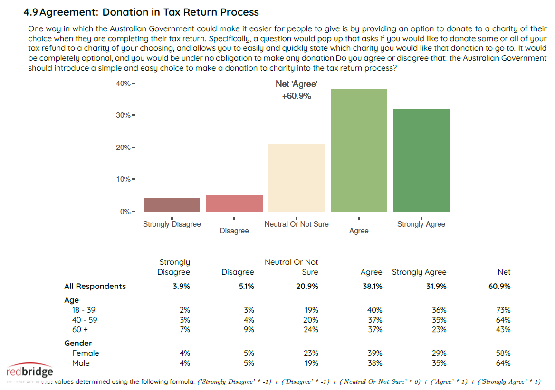
  - While this level of support is strong, focus groups by Redbridge identified the need to frame and communicate the reform effectively to the Australian people.
    - It is important people understand the option to donate at tax time is completely voluntary and the choice of every Australian.
“I think it's a great idea. It's not making anyone give anything they don't want to give. It's just a reminder, and it's an easy option.”
    - People did not respond favourably to the behavioural economics terminology – ‘a tax return nudge’ – or where they perceived the reform as the government taking away their agency to decide for themselves what to do.
“That's the government getting involved in charity. That's the government advising me what to do. That's the government wanting to take personal choice away from me.”

A strategy to drive the growth of Australia’s Community Foundation network

The Reform
We recommend the PC:
- Examine the potential of the Community Foundation model, notably its ability to drive an increase in charitable giving, and support greater civic participation and social capital by enabling people across Australia to get involved locally to strengthen their communities and support Australians in greatest need.
- Articulate a broad strategy and specific measures to drive the growth of Australia’s Community Foundation network. This work can draw on: international literature; practice in leading nations such as the US, Canada, Germany and New Zealand; and engagement with the sector peak, Community Foundations Australia, Philanthropy Australia and leading Community Foundations in Australia.

Elements of a Community Foundations strategy could include:
- Establishing a DGR 1 Category for Community Foundations to enable the safe and orderly growth of the sector. In recognition of the important charitable work undertaken by Australia’s network of Community Foundations, the Coalition Government announced in the March 2021 Budget that 28 Community Foundations would be given specific listing as a DGR 1 entity in the Tax Act, an initiative supported and now being implemented by the Labor Government. With the important charitable role of Community Foundations acknowledged, it no longer makes sense to require new CFs to undertake the long, arduous, costly and uncertain process of seeking a specific listing in the Tax Act. Rather, the orderly growth of CFs should be enabled by establishing a DGR 1 Category for Community Foundations, allowing the ATO to provide DGR 1 status to organisations meeting the relevant criteria. (More detail at Box 5.1 below).
- Setting stretch targets for the growth of the CF sector. This could include lifting national population coverage from around 55 per cent to 95 per cent, and lifting combined funds under management from around $500 million in 2021 to $1 billion by 2030.
- Enhancing the capacity of existing CFs through capacity funding and challenge grants. It takes time to build the assets of a CF, so that meaningful investments can be made in local communities from the proceeds of the corpus. Many of Australia’s CFs are relatively young and have no or limited paid staffing. Medium term Government funding for an Executive Officer in each eligible CF to build a sustainable financial footing and drive growth would accelerate the effectiveness of the CF network. Time limited challenge grants – with government matching community donations for a limited period – would help create sustainable asset bases (a minimum of $5 million) across the network.
- Fostering the growth of new CFs through seed funding and challenge grants. A Victorian Government seed funding program in the late 2000s supported the emergence of around a dozen CFs. A similar seed funding program could foster the orderly growth of the CF network, aiming to push towards national coverage. Time-limited challenge grants could help attract involvement across the community and quickly build a strong asset base.
- Funding Community Foundations Australia (CFA) to facilitate the growth of the sector. CFA was established in 2007 and plays a critical role supporting the growth of the sector through its roles as: 1) connector, bringing the sector together for shared learning through events, webinars, conferences and symposiums; 2) skills developer, through its training, resources hub, support and advice; 3) sector champion, building the profile of the sector through research and thought leadership; and 4) advocate, engaging with government on policy reform. Modest government funding could lift the capacity of CFA to drive the profile, growth and effectiveness of the network in the coming decades.
- Longer term CF System Aspirations. International practice suggests the sector could become truly national, with CFs operating in the vast majority of communities across Australia. At this time, significant system impacts become possible, notably: CFs driving national change as a system; CFs working with government on national initiatives; and local MPs working closely with CFs to support stronger communities.
Note that Philanthropy Australia and Community Foundations Australia have commissioned Social Ventures Australia to undertake work on how to grow the CF sector. We will provide this report to the PC in mid-2023.

The Case for Change
- Community Foundations allow local people to donate to a permanent endowment – and lead and participate in activities - focused on improving the lives of people in their region.
  - Many Australians develop strong ties with their local community or region, understand what makes it tick, care about its people, and want to see it thrive.
  - Community Foundations are a great way for people from all walks of life to get involved in donating, volunteering, and participating in projects to help their region thrive. They galvanise the community to drive place-based change in a myriad of ways.
    - Local people establish, manage and govern the CFs to meet local needs.
    - They identify local challenges and engage the community in finding solutions.
    - They raise and attract funds from many donors with diverse interests.
    - They provide grants to community-based organisations to do critical work, such as ensuring young people participate in education or work, developing the local economy, or responding to natural disasters.
    - They harness untapped local capacity and leadership by giving local people voice and agency in decisions that matter to them.
    - They create a virtuous cycle, with local participation driving successful projects, showing what can be achieved. This builds social capital and confidence, galvanizing communities to continue positive place-based change.
- Community Foundations deliver significant direct impact, and a more generous society, with more social capital, trust and participation in local communities.
  - Community Foundations are run by people with detailed knowledge of their local community, so they are well placed to know where to invest – and how to galvanise local leadership – to drive maximum impact.
  - This work can help shift the culture in communities and across Australia, creating a more generous and giving community, with more social connection and social capital.
  - Literature shows that giving and volunteering not only creates impact for people in need but lifts the happiness and life satisfaction of those providing support.
- Democratising giving and supporting volunteering.
  - Giving in Australia is becoming increasingly concentrated towards more wealthy donors, with the percentage of Australians contributing to charity falling rapidly from around 38 per cent of the population claiming tax deductions in 2011 to 29 per cent in 2020.
  - Community foundations are a great mechanism for people from all walks of life to participate in local giving and volunteering.
- Indeed, emerging from the pandemic and a series of natural disasters, Australians are increasingly keen to engage to strengthen local communities.
  - Polling and focus groups commissioned by PA and undertaken by Redbridge confirm this powerful trend towards community in Australia, with strong support among the population for Community Foundations operating in local communities.
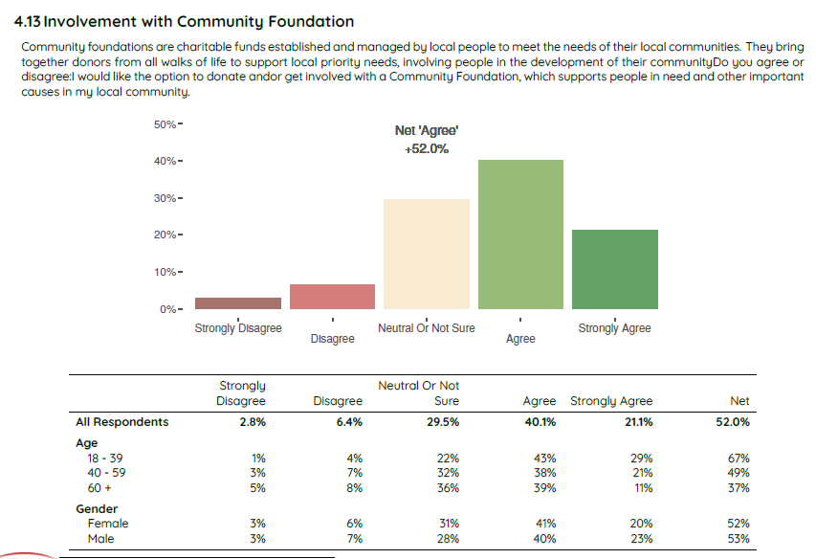
- The Government has expressed strong interest in addressing place-based disadvantage.
‘I know from my own community in Logan, south of Brisbane, how unjust it is that people who live on the outskirts of capital cities and in some regional areas experience much more inequality than other citizens. But this injustice presents an opportunity: to focus our attention on place-based initiatives where communities have the genuine input, local leadership, resources and authority to define a new and better future especially for kids.’
— Treasurer Jim Chalmers, ‘Capitalism after the crises’, The Monthly, February 2023.
- Rapidly rising wealth among Ultra High Net Worth and High Net Worth individuals creates tremendous scope in the decades ahead to fuel a powerful network of Community Foundations across Australia.
  - Wealth among The Top 200 as reported by The Australian Financial Review has increased from $209 billion to $555 billion between 2016 and 2022, or from an average of $1.05 billion to $2.77 billion.
  - Knight Frank estimates that there was over 20,800 ultra-high net worth (UHNW, $30m plus net wealth) people in Australia in 2021.
- There is enormous scope to strengthen the existing network of roughly 40 Community Foundations and expand it several-fold in the decades ahead, driving significant system-wide impacts.
Practice in nations overseas such as Germany, New Zealand and Canada shows that Community Foundations can be established in communities across the nation, creating scope for major system impacts including:
  - The vast majority of all people in the nation being able to contribute to a Community Foundation locally. For instance, in Canada there is a network of 191 Community Foundations to support place-based initiatives across the country, so people across the nation can contribute locally in the place they call home.
  - Community Foundations being able to work together as a system on issues.
  - As in Canada, Government’s being able to work closely with the sector peak organisation, to strengthen regional communities, mobilising public and private resources across the strong national network.
  - Local MPs working closely with Community Foundations to connect with local leaders, understand local needs, and consider ways to leverage Federal resources to co-fund local initiatives.
Box 1.4.1: DGR 1 Status for Community Foundations: Recent Reforms and Next Steps
Recent reforms
Reforms being enacted to specifically list 28 CFs as DGR entities have two important benefits:
- Greater impact by being able to fund local charitable activity: Community foundations generally operate using a ‘public ancillary fund’ (PuAF) structure, which is classified as an ‘Item 2’ DGR. Therefore, until these reforms, CFs – the majority of which operate in regional areas – have only been able fund ‘Item 1’ DGR charities. There are relatively few charities with this status in regional areas, which meant that CFs found it harder to fund many grassroots community groups and initiatives. Once listed, CFs will be able to fund any charitable activities carried out by local groups and organisations, provided those activities are covered by one of the 52 existing DGR endorsement categories and are consistent with the CFs own purposes and rules.
- Being able to accept funds from Private Ancillary Funds (PAFs). This will create a powerful new revenue source for CFs, as PAFs are distributing in excess of $500 million a year, which is expected to grow strongly in the future. It can also improve the quality of giving – PAFs are typically funds set up by wealthy families. Many are keen to invest in CFs, recognising that their knowledge of local communities can lead to more targeted, higher impact giving.
Proposed Next Step – A DGR 1 Category for Community Foundations
- With the important work of CFs now recognised as important charitable work across the Australian Parliament it no longer makes sense to require new CFs to undertake the long, arduous, costly and uncertain process of seeking a specific listing in the Tax Act.
- Rather than continue to place regulatory impediments in the way, it is desirable to facilitate the steady growth of the sector beyond 40 Foundations. This can be done safely via a DGR 1 Category for Community Foundations, with applications administered by the ATO, with safeguards including: a clear definition of CFs; requiring all funds to be spent on charitable activities; reporting of grants made; and ATO powers to require sound conduct, or if needed, cancelling DGR status for any substantive misuse of funds. Should the Government wish to see even greater safeguards, the process could also require the approval of ATO advice by the Assistant Minister for Charities.

Enhancing the Effectiveness of Ancillary Funds

The Reforms
1. Allow ancillary funds to distribute to other ancillary funds, such as Private Ancillary Funds (PAFs) distributing to Public Ancillary Funds (PuAFs). This can facilitate higher value giving, such as where a wealthy family running a PAF wishes to give to a PuAF – such as a community, arts or hospital foundation – operating closer to the ground, and better able to target money for maximum impact.
2. Provide more certainty and clarity regarding the valuation of donations of unlisted shares. Australia has a big opportunity to expand philanthropy as we produce an ever-expanding suite of new technology firms generating substantial wealth. Gaining early commitments from entrepreneurs to provide a share of their companies to charity – including through facilitation by an exciting new venture Start Giving – can embed a culture of philanthropy and lift national giving levels – but requires an agreed approach to valuing unlisted shares so entrepreneurs can be sure of their financial commitments when they set up a PAF. Using the valuation from their last funding round, provided it is within three years of the donation, would work well.

The Case for Change
- Allowing PAFs to distribute to PuAFs
  - As ‘funding charities’, PAFs and PuAFs are designated with Item 2 DGR status, which means they are only permitted to distribute to Item 1 or ‘doing charities’, such as The Salvation Army. This broad intention – ensuring money gets to people in need – is tremendously important, but achieving it through a blanket ban on ancillary funds (AFs) distributing to each other is overly heavy-handed.
  - On occasion, it would improve the quality and impact of giving if a PAF – which are largely private family funds – could distribute to a PuAF – such as a hospital fund or a Community Foundation, that is operating on the ground, with detailed local knowledge of key needs and how to address them. PuAFs can deliver responsive philanthropy by using expertise, relationships and knowledge of community needs in order to pool funds and coordinate their distribution in a targeted and expeditious manner.
  - Giving PuAFs access to PAF funding, which is running in excess of $500 million a year, could help spur more targeted and effective local giving.
  - It would remove unnecessary red tape that gets in the way of sensible giving initiatives, such as:
    - Employers with a PAF wanting to match the giving of their employees through Good to Give, which facilitates workplace giving through a PuAF structure. This employer matching is currently prohibited.
    - PAFs wanting to donate to fundraising campaigns in fields like health and the arts (for example The Sydney Theatre Company Foundation), but being unable to because the fundraisers are using a PuAF structure.
    - PAFs wanting to invest in a high value sub-fund – such as one focused on justice for First Nations people or addressing climate challenges – but being unable to because the sub-fund operates within a PuAF.
  - Conversely, on occasion it may be fruitful for a PuAF to distribute to a PAF, where the latter is funding a high value Flagship initiative.
  - The reform does not involve a cost to revenue, as ancillary funds have already received their tax concessions.
  - The value of this reform has been recognised by Treasury, which ran a consultation process on the reform last year, with a discussion paper Distribution Guidelines for Ancillary Funds: Consultation on Possible Policy Changes, March 2022.
  - In its submission to the consultation process, Philanthropy Australia set out effective mechanisms to address the modest risk involved with this reform – that ancillary funds would endlessly recycle funds to each other without funds ever being distributed to charity to support people in need. Essentially, the distributing fund, perhaps a PAF, would be able to include the amounts given in their minimum distribution, but the receiving fund, perhaps a PuAF, would be required to spend the money within five years, in addition to their existing minimum distribution requirements. These amounts would have to be reported in annual returns.
In addition, it is important to note that the risks here are modest, as PuAFs tend to distribute to charities well in excess of their 4 per cent minimum requirement.
- Unleashing philanthropy from tech and other start-ups through a clear process for valuing unlisted shares.
  - After decades of limited progress, in relatively recent times, Australia has built:
    - A significant venture capital industry, with a suite of firms like Blackbird, Square Peg and Air Tree investing heavily, each with hundreds of millions in funds under management.
    - A significant and growing suite of new technology companies, some with market capitalisation in the tens of billions, like Atlassian, Canva, Xero and REA Group.
  - This represents a significant new potential source of philanthropy in Australia, particularly as many of these firms are led by a younger, entrepreneurial cohort of leaders more willing to embrace philanthropy.
  - Daniel Petre, a co-founder of Air Tree, has funded the establishment of Start Giving, and with the leadership of Antonia Ruffell, they are aiming to work with hundreds of successful start-ups to encourage them to establish their own PAF / charitable foundation. A key part of the model is to encourage entrepreneurs to allocate a share of their start up to fund a PAF early in their journey, in order to entrench the philanthropic giving culture early, and deliver significant funds over time, particularly where the start-ups become future tech giants.
  - Unfortunately, the current approach to valuing donations of unlisted shares, for the purposes of determining the level of a tax deduction, lacks clarity and certainty, acting as a disincentive for the establishment of new PAFs.
  - To claim a deduction for unlisted shares over $5,000, a valuation is necessary. Under the current approach, a valuation can only be undertaken after a donation has been made, and there is no method setting out how such a valuation is to be undertaken. This can act as a disincentive for the donation of unlisted shares by startup founders and also family businesses, as they cannot be sure of the tax deduction they will receive until after the donation has been made.
  - To address this issue, it is important to set out an agreed valuation process that can provide startup founders with the necessary certainty and clarity, encouraging them to make an early start in their philanthropic journey by establishing a PAF. In the case of unlisted assets held in a startup, a valuation could use the last funding round for a startup as the reference point, provided it is within 3 years of the donation.
  - There may also be a need for some flexibility in early years on meeting minimum distribution requirements, as start-ups often lack liquidity, and would likely need to sell down unlisted shares to meet early distributions, before revenues begin to exceed costs as the business matures.
  - This clarity and flexibility is critical to capturing what could be a significant new source of philanthropic funding in Australia.

Background on ancillary funds
Ancillary funds (AFs) are legal structures that help facilitate philanthropy in Australia. They are a critical component of Australia’s ‘philanthropic infrastructure’, aiming to increase the funds that are directed towards important causes in our community. There are two types of AFs:

Public ancillary funds (PuAFs)
PuAFs receive tax deductible donations from a range of sources, pooling the funds and using them to make grants to other eligible organisations, which must be ‘Deductible Gift Recipients’ (DGRs). They are used in diverse ways.
- Community Foundations, trustee companies (such as Perpetual and Equity Trustees) and wealth managers are major users of PuAFs. Often they provide donors with the option of establishing a form of giving account called a ‘sub-fund’ through which they can undertake their philanthropy.
- PuAFs are also used as fundraising structures for health care, arts and other organisations.
Sub-funds are a form of ‘giving account’ which sits within a larger public foundation, which is usually a PuAF. The donor makes tax deductible donations which are credited against their sub-fund. The assets credited against their sub-fund are invested together with the assets of all the other sub-funds in the PuAF, to generate a return and help grow the sub-fund. The donor can make recommendations for grants to be made from their sub-fund to eligible organisations.
- There were 1,373 PuAFs in 2019–20 with net assets of $4 billion. PuAFs distributed $350 million to charity in 2019–20 and $3.9 billion between 2011–12 and 2019-20.
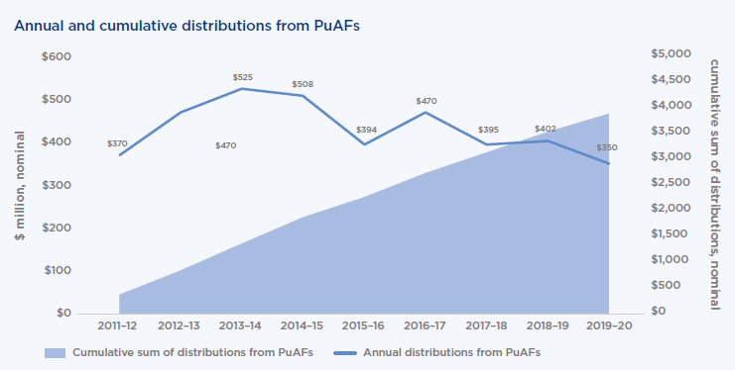

Private ancillary funds (PAFs).
- PAFs are established by individuals, families and businesses as a way to undertake their philanthropy, and they cannot fundraise from the public.
- Donors make tax deductible donations into a PAF, with the PAF’s assets being invested to help grow the funds available from which to make grants to other eligible organisations, which must also be ‘Deductible Gift Recipients’ (DGRs).
- Donors tend to have close involvement with the operation of a PAF they have established, whether it be overseeing the investment of its assets or deciding on grant recipients. They can be a particularly attractive option for larger scale private philanthropy.
- Introduced in 2001, there were 2,060 PAFs established by June 2022, with numbers growing by around 100 each year. In 2019-20, net assets reached $7.6 billion, with $521 million distributed in that year. Overall, PAFs have distributed nearly $4.5 billion.
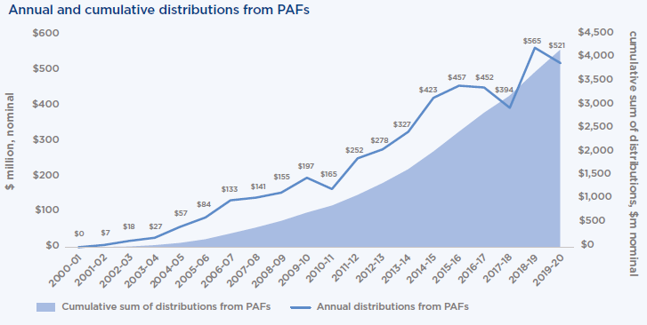
- AFs are the most highly regulated type of charitable entity in Australia, and their regulatory framework includes various safeguards to ensure that assets are used for community benefit in an appropriate manner. For example, 4 per cent and 5 per cent of the net assets of a PuAF or PAF respectively must be distributed as grants each year.
- Overall, the regulatory framework for AFs is functioning relatively well and is administered effectively. This is contributing to their attractiveness as vehicles for structured philanthropy.

Fix fundraising

The Reform
The PC monitor existing promising reforms (jurisdictions have agreed through the Council on Federal Financial Relations to deliver a solution by July) and if needed, recommend to government reforms to create a simple, single national framework for fundraising for charities, so no matter where they are, the rules are the same.
- A single point for registration – if a charity has registered with the ACNC, this should constitute deemed authority to fundraise.
- A single set of fundraising rules to ensure ethical fundraising – such as a single piece of state legislation being adopted in identical form by all jurisdictions, or all jurisdictions agreeing to one set of rules, to the exclusion of any other state specific rules.
- Single reporting – to the ACNC.

The Case for Change
- Seven different fundraising rules!!
  - Australia has seven different sets of fundraising rules – in every state and the ACT. These rules were developed before the internet. Fundraising is now substantially a national endeavour via online fundraising or charities increasingly operating across Australia.
  - To fundraise nationally, charities must seek up to seven different permissions and report to authorities across Australia. Requirements also vary across jurisdictions on issues such as if a fundraising licence is needed, how long a licence is valid, and what must be reported and when.
- $15 million in costs each year (2016 estimate) that should be going to support Australians in need.
  - For all charities – and with a particular impact on smaller charities – this redirects scarce resources away from supporting the community to complying with unnecessarily complex and inconsistent red tape.
  - Philanthropic organisations such as PuAFs and Community Foundations are similarly affected.
- Numerous reports have highlighted the problem for decades, but governments haven’t found a solution.
  - Various Senate Committee reports and the Royal Commission into National Natural Disaster Arrangements have highlighted the problem. In its 2010 report, the PC recommended:
To promote confidence in and reduce the compliance costs associated with fundraising regulation, Australian governments … should agree to and implement mutual recognition and harmonised fundraising regulation across Australia, through the establishment of model fundraising legislation. (Recommendation 2.3)
  - With costs so clear and no substantive benefit to retaining inconsistent arrangements, the failure to act over such a long period constitutes government failure of an egregious nature.
- Now is the time to capitalise on strong momentum for change.
  - In late 2021, then Treasurer Frydenberg announced Fix Fundraising would be among the 10 top priorities in 2022 for the Council on Federal Financial Relations, which comprises Federal, state and territory Treasurers, and work commenced by the Commonwealth and Victoria on formulating a single fundraising regime.
  - Assistant Minister for Charities Andrew Leigh has long highlighted Fix Fundraising and Labor committed to addressing the issue. At the February Council on Federal Financial Relations meeting, Treasurers agreed to a set of nationally consistent fundraising principles to streamline and harmonise state and territory requirements on charitable fundraiser conduct. Jurisdictions have agreed to develop an implementation plan by July 2023, setting out how they will give effect to the principles.
  - While this is an important milestone, it is critical jurisdictions deliver an enduring solution for charities, rather than ‘harmonised’ rules that leave seven regimes in place. The ultimate test is that charities only need to register once, comply with a single set of rules no matter where they are in Australia, and report once.

Encouraging Later-in-Life, Legacy and Other Giving

The Reform:
Despite rapidly rising wealth in Australia, relatively few Australians are giving, including when they are well positioned to do so later in life, and just 7 per cent are leaving a bequest in their wills. To consider how to unleash this massive, largely untapped source of charitable giving, we recommend the PC consider:
- Establishment of a Living Legacy Trust (LLT) structure. A simpler version of the Charitable Remainder Trust that operates in Canada and the United States, a Living Legacy Trust would allow Australians to place assets (such as money, property and shares) into a trust for the benefit of charity when they pass. In return, they would receive a tax deduction based on the value of the asset, and be able to draw on the income stream from the assets until they pass.
  - A 2016 report commissioned by the Department of Social Services, New Planned Giving Structures, showed introduction of LLTs would deliver a significant increase in giving and a strong benefit:cost ratio. The report illuminated the key issues for detailed policy design and how the benefit:cost ratio could be further improved (See Box 1.7.1 below).
  - Concentrated attention to rigorous policy design could produce an LLT structure that would deliver significant net benefits. A group of Philanthropy Australia members would welcome the opportunity to engage the PC to brainstorm policy design options.
- How to encourage later-in life giving. Many Australians in middle age and beyond have paid off their house and built substantial assets, yet relatively few give what they could reasonably afford to charity. The PC could seek to identify creative, cost-effective options to spur giving – which may include information, promotion, well-designed nudges, and activating financial advisers and lawyers to engage clients on giving and bequests.
- Removing Capital Gains Tax on Donations of Shares to a DGR Charity: We recommend the PC examine the merits, benefits and costs of removing capital gains tax on donations of shares to DGR charities. The reform has been adopted in the UK and Canada with the aim of encouraging additional giving to charity.

The Case for Change
- Australia has an unprecedented opportunity draw on our rising wealth to support our most important causes.
  - Australia is experiencing the largest intergenerational wealth transfer in its history, with $2.6 trillion passing to the next generation in the two decades to 2040.
  - If we could pass 5-10 per cent to charity, this would unleash $130-260 billion to support the most crucial causes in our society. This would be transformational for Australia.
- Relatively few Australians are leaving bequests.
  - In Australia in 2016, only 7.4 percent of final wills had a direct charitable bequest.
- A key impediment is that, unlike leading philanthropic nations, Australia has no incentive to make a bequest to charity.
  - Leading philanthropic countries such as the United States, which gives more than double the proportion of its income to charity (2.1 per cent of GDP compared to 0.8 per cent in Australia), have incentives to make bequests to charity, including:
    - The ability to reduce inheritance taxes by donating money to charity; and
    - A Charitable Remainder Trust (CRT), similar to the Living Legacy Trust idea outlined here.
- Another key impediment is a strong desire for financial security, should life go awry.
  - Even relatively wealthy Australians can be hesitant to pledge assets to charity. Their ‘nest egg’ provides vital financial security for them in retirement, or should life take a turn for the worse and they or their dependents need extra support.
- The Living Legacy Trust would address the key issues that make people hesitant about making a bequest, encouraging many more people to ‘take the plunge.’
  - The Living Legacy Trust would grow legacy giving by making it safe for people to pledge to charity.
    - Crucially, donors would be able to retain the income stream – such as the rent on their investment property – maintaining some financial security while they are alive.
    - Donors would also receive a tax incentive for placing the asset in a trust for the benefit of a charity upon their passing, but it would not be for the full value of the asset, given that they will benefit from income from the asset during their lifetime. Donors would be subject to appropriate regulatory oversight.
  - The scheme would also encourage additional giving over simply relying on traditional bequests through:
    - prompting and bringing forward the decision to give during a donor’s lifetime.
    - the ability of the donor to be recognised for the good works during their lifetime.
- Encouraging later-in-life giving could also be a cost-effective means of increasing giving.
  - Giving while living provides significant benefits – tax incentives and structures including PAFs and sub-funds are available, donors get to see and be recognized for the impact of their work, and many find it among the most fulfilling activities of their lives.
  - With all these ingredients in place, it may only take modest interventions – such as information, promotion or nudges – to unleash untapped billions in additional donations.
  - Lifting our rate of bequests can also be cost-effective, particularly as they do not attract a tax deduction. Trials in the UK where estate lawyers engaged clients on giving led to a 40 per cent increase in bequests.
Box 1.7.1: LLT Policy Design
Concentrated attention to rigorous policy design can produce an LLT structure that would deliver significant net benefits. The key is to maximise the benefit:cost ratio (BCR): providing a sufficient incentive to attract donors to the LLT structure and increase national giving, but not so much as to produce excessive revenue foregone.
Deloitte Access Economics produced New Planned Giving Structures (7 October 2016), which found after 10 years of implementation, in 2027-28, the reform would have produced:
- 5,771 LLTs with assets of $7.4 billion.
- An increase in charitable donations relative to the base case of $1.458 billion, with revenue foregone of $868 million, a benefit:cost ratio of 1.68.
- Donor investments that are typically large, averaging $1.2 million (based on the US experience with Charitable Remainder Trusts).
There are elements of policy design that impact on the BCR, in particular:
- The percentage of the asset value that can be deducted against tax.
- Whether the percentage is varied by age – The core results above stemmed from a scheme where younger Australians received a lower tax break, given they would accrue an income stream from the asset for longer.
- Whether a maximum term applies before the asset passes to the charity. The report’s modelling assumed assets passed at death.
- The income generated from the asset should be subject to tax.
The report developed ways to substantially improve the BCR. In particular, it noted:
- There is a case for a flat tax rate (lower for higher age groups), rather than varying with age, as young donors lose flexibility over the asset over a longer time period.
- A maximum term could be imposed, including to give charities more certainty. In the US, the maximum term is 20 years.
Deloitte found that adjusting policy design – a 30% flat tax deduction and a 30-year maximum term – would deliver a BCR of 2.24. In any design, the report highlighted the critical need for:
Simplicity: LLTs must be simple to understand, easy to use, and efficient to implement, for both donors and charities. Stakeholders highlighted they would not want to have to access frequent costly advice from financial advisers and lawyers. It would also need to be easily explicable to family members and charities.
Robust governance arrangements, such as the need to maintain a clear investment strategy, report regularly and act in the interests of charities.
Promotion and awareness, to ensure prospective donors, charities and financial advisers were aware of the new structure and its potential benefits.

Social Impact Investing

The Reform
- We recommend the PC note Social Impact Investing is set to become increasingly significant in the national landscape, and a key tool for philanthropists (and private investors) in achieving impact.
  - Social Impact Investment is already emerging ($242 million invested as at 2017), and public comments from Ministers suggest a package of reforms may be announced in the 2023-24 Budget to create the necessary building blocks to underpin the market, and foster its rapid growth.
  - A number of Australia’s leading philanthropic trusts and foundations include social impact investing within their endowments’ strategic asset allocations and in their portfolio of social change approaches - alongside grants and mixed funding models - to drive social impact. As the social impact investment market expands, we can expect the prevalence and scale of investment by Australia’s philanthropic community (and the private sector) to grow rapidly.
  - Philanthropists have a unique role to play in ensuring the social impact market can work effectively as they are more willing to provide grants and/or higher risk and concessionary early-stage capital than other investors more focused on financial return. In particular, philanthropy can fund organisations to become ‘investment ready’, helping to build a strong pipeline of social impact ventures that can attract capital from private and other investors. It can also support the development of intermediary organisations, and fund evaluation of outcomes-based approaches.
  - A Foundation Impact Investors Group (FIIG), modelled on the UK’s Social Impact Investors Group and the US’ Mission Investors Exchange, is being launched in May 2023 to support foundations interested in starting or currently undertaking impact investing. Its focus is on catalytic impact investing and it will provide education and undertake activities to reduce transaction costs, and improve the flow of capital from foundations to impact enterprises. The FIIG is designed to market build by complementing – rather than competing with – existing impact investing groups and activities. To date, organisations including Paul Ramsay Foundation, Macquarie, Westpac, UBS, Minderoo, Hand Heart Pocket, the Lord Mayor’s Charitable Foundation, the English Family Foundation and the Snow Foundation have steered the development of the FIIG, with Philanthropy Australia acting as secretariat for the initiative.
- The PC may wish to note the Government’s reforms and consider any further advice it wishes to provide to help further catalyse the social impact sector.
Given the PC’s specialised expertise in economics and market design, it could be well placed to advise on the necessary architecture to help catalyse the impact investing market.

The Case for Change
- Australia’s social impact investing market is emerging, and reforms to create the necessary architecture to underpin the market – and foster its growth – could be announced in the near term.
  - The Albanese Government reconvened the Social Impact Investing Taskforce – Michael Traill (Chair), Amanda Miller (Deputy Chair), Catherine Brown, Danny Gilbert and Sally McCutchan – which had previously provided advice to the former government. Amanda and Catherine provided the philanthropy expertise within the Taskforce, drawing on their extensive Board and Executive experience in the sector.
  - Significant reforms were recommended (see initial interim report which has been further developed at the invitation of the Prime Minister and Treasurer) such as a social impact investing ‘wholesaler’ to inject several hundred million in private and public money into the market, growing the intermediary sector to facilitate a large and growing pipeline of social impact ventures, and a foundation / early-stage fund (partly funded by philanthropy) to assist social enterprises to become investment ready. See Box 1.8.1 overleaf.
- Social impact investing can play an important role in improving social and environmental outcomes.
  - Bringing in billions in additional private and philanthropic capital: The interim Taskforce report found there was significant appetite among large private companies, super funds, high-net-worth individuals and philanthropists to provide more funding for social impact investments, particularly if a stronger pipeline of deals can be identified, including deals where significant funds can be invested. The report noted scope for growth is likely to be very large.
    - Survey data showed that, on average, active impact investors wanted to increase their holdings of impact investments three-fold over the following five years, equivalent to $18 billion in demand.
    - At the end of 2018, there was $US502 billion in impact investing assets worldwide, with the market still emerging.
  - More social innovation, leading to system change. Impact investing brings together private and philanthropic investors, corporates, governments and the social services sector to collaborate on new and innovative responses to existing and emerging social and environmental challenges. Bringing together more of our best minds from a range of sectors allows us to conceive and trial new approaches which, when successful, can be picked up by government and adopted to drive system-wide change. It also allows for different investment risk appetites to be accommodated and helps to build a pipeline of investible opportunities.
  - Lifting impact by improving the effectiveness of social enterprises and charities. To attract capital, social enterprises and charities will need to become investment ready, with effective governance, a compelling business plan, theory of change and evaluation framework, and prospectus for investment. This market discipline and focus on delivery of outcomes should lead to an improvement in the impact and scale of major existing and new programs and organisations, including intermediaries, across the social sector.
Box 1.8.1: The Social Impact Investing Taskforce: Background and Agenda for Change
In 2019, a Social Impact Investing Taskforce was formed to develop a strategy for the Federal Government to spur the impact investing market, supported by a team in the Department of Prime Minister and Cabinet. An interim report was released in December 2019. A final report was completed at the end of 2020, but was never released, and no reforms were pursued by the former government.
Prime Minister Albanese reconvened the Social Impact Investing Taskforce and the Treasurer publicly endorsed this work in his ‘Capitalism after the crises’ essay in The Monthly in February 2023, suggesting reforms may be announced in the May Budget. The Treasurer wrote:
Traill has pioneered this idea of investing with purpose in Australia by using the discipline of market-based activity to transform the availability of capital, and by directing investment to organisations that are delivering genuine, measurable outcomes.
While capital allocation in traditional markets is obviously not perfect, it is based on common metrics of performance. Traill shows this is rarely true for investment in social purpose projects… If we could redesign markets for investment in social purposes, based on common metrics of performance, many more well-run “for purpose” organisations could get much more of the growth capital they need.
Social impact investing occurs in a range of ways.
- Payment-by-results programs, where the government pays investors where significant outcomes are achieved (a relatively small set, with around 13 PBRs or social impact bonds in Australia at 2019).
- Investing in small to medium social enterprises, seeking to achieve a strong financial return alongside a social outcome. There are at least 20,000 social enterprises in Australia, such as Vanguard Laundry Service in Toowoomba Queensland, which provides skills training, qualifications and employment to people with mental health challenges, and aims to transition them to mainstream employment.
- Investing in large social enterprises, relatively few examples of which have occurred in Australia. An example is the establishment of Goodstart in 2009 in the wake of the collapse of ABC Learning. The founding consortium - the Benevolent Society, Mission Australia, the Brotherhood of St Laurence and Social Ventures Australia - raised $95 million to acquire 678 childcare centres.
The interim report found that while there was a strong appetite among investors to invest significantly more capital, there are some key impediments to the market fully emerging, in particular:
- A shortage of social impact investment opportunities with transparent measurement of social outcomes and financial performance.
- A lack of intermediaries who can advise on and create social impact investing transactions to stimulate market growth.
Key reforms to address these impediments and help catalyse the market appear to be:
- A social impact investing ‘wholesaler’, akin the Big Society Capital in the UK – with initial seed funding of $200 million in private money, including funding from Australia’s leading banks, matched by the Federal Government. Drawing on the example of Big Society Capital in the UK, the wholesaler would supply capital to intermediary funds, which would direct private investment into social enterprises in areas such as social housing and early childhood services.
- Building the intermediary sector – the current market includes organisations such as Giant Leap, a venture fund solely focused on impact start-ups – rapidly scalable businesses that blend financial returns with real and measurable social and environmental benefits. For the market to operate well, this sector will need to grow to broker a significant and rising volume of deals.
- A foundation / early-stage fund for impact investing – drawing on the Access Foundation model in the UK, philanthropic foundations may contribute $20 million to a $65 million fund to support and mentor social enterprises to build the capability and scale needed to attract corporate investment (e.g. effective governance, business plan, theory of change and evaluation framework, and prospectus for investment).

A generous and giving national culture.
Reforms to create a culture and regular practice of giving are critical, as government incentives alone won’t lead to a doubling in giving.
  - Government reforms have tended to focus on creating a more favourable taxation environment for giving, which is essential if we are to double giving, but not sufficient.
  - We need complementary initiatives to raise awareness and prompt a more generous culture, where people strongly value giving. A National Giving Campaign, programs in schools – and major contributions from key actors in the system – philanthropy, business and charity – are essential to awakening the generosity of spirit that is an essential part of the Australian identity.

A National Giving Campaign

The Proposed Reform
- The Federal Government fund – with support from philanthropy – a National Giving Campaign to encourage a stronger culture and practice of giving in Australia. A campaign that tells stories Australians can relate to – stories of people who give and the impact it has in the community – can foster a culture where Australians from all walks of life give what they can to great causes, where they can afford to do so.
- Target influential audiences: There is tremendous potential to increase giving from: ultra-high-net-worth (UHNW) and high-net-worth (HNW) individuals, volunteers and the mass market, business and workplace giving, and financial advisors working with their clients to encourage giving.
- Maximise reach through a multi-channel strategy and widespread distribution through government, philanthropic and not-for-profit organisations: Together, we can galvanise giving in the community with an overarching campaign – e.g. ‘Australia Gives’ – but tailored for each target audience through multiple channels (such as websites, search engines, social media, television, radio, email, mobile and promotional events), distributing material across government, philanthropic and not-for profit organisations.
- A clear call to action for each target group, with simple, practical information about how they can give: For instance, regular giving to your favourite charity, volunteering, workplace giving, establishing a community foundation, or for those with more wealth, establishing a PAF or investing in a sub-fund to leave a lasting legacy.
- Sustain the program over a decade: Evidence shows delivering cultural change through social marketing and information can be successful (for instance, campaigns on tobacco, sun protection, HIV and depression), but requires sustained messaging to embed new behaviours in the national culture.

The Case for Change
- Creating a more aware and generous culture is critical to doubling giving.
  - Australia faces a significant conundrum: despite rising wealth, the greatest intergenerational wealth transfer in our history and exploding wealth at the top end of society, a declining proportion of Australians are giving to charity. Philanthropy Australia members highlight strongly that culture is a key part of the explanation. In countries such as the United States, there is a strong cultural expectation that people – particularly those with wealth – will give to charity.
  - Increasing government incentives for philanthropy is essential, but alone the government incentive framework cannot double giving. It must be accompanied by a shift in culture, so Australians are aware of the power of giving, and it becomes a more central part of the Australian identity and a routine practice for the vast majority of our people, particularly those more fortunately placed. A National Giving Campaign is the most powerful means we have available to make this cultural shift, just as Slip, Slop, Slap changed the culture and practice of Australians with respect to sun protection.
- Australians can be generous people, but many of us have lost the giving habit.
  - The proportion of Australians contributing to charity is falling rapidly in every income group, and overall, from around 38 per cent of the population claiming tax deductions in 2011 to 29 per cent in 2019. Just 53 per cent of Australians on $1 million or more are giving and claiming deductions, compared to 90 per cent in the US.
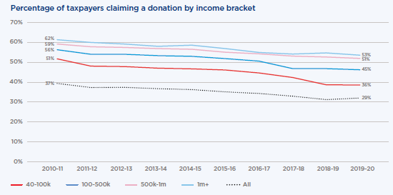
- The campaign could unleash a major increase in donations among key target groups.
  - UHNW and HNW Australians: Wealth is rising rapidly at the top end of Australian society – for instance, wealth among ‘The Top 200’ has risen from $209 billion to $555 billion between 2016 and 2022. Some give substantially, but most do not. PAFs has been a successful reform (with more than $4 billion distributed over 20 years and more than 2,000 PAFs in operation), but in a nation with over 20,800 ultra-high net worth individuals ($30m plus net wealth), and hundreds of thousands with substantial wealth, this number should be far higher. Creating a culture where all high-net-worth individuals – those with $5-10 million or more - are expected to give substantially, would go a long way to Australia doubling its rate of giving. Many of these Australians would be relatively older, close to or in retirement. The call to action for this group should involve structured giving – setting up a Private Ancillary Fund or a Sub-Fund. Philanthropy Australia would be well placed to support information provision, advice and referral for this cohort.
  - Mass market giving and volunteering: Appealing to all Australians is critical as the mass market is responsible for around one half of all individual giving. Encouraging people to volunteer, as well as give, is important, as volunteering is worth more than all other sources of giving combined and is critical to creating engaged communities. The call to action here might be regular giving and/or volunteering. Organisations such as Volunteering Australia could be well placed to support information provision, advice and referral for this cohort.
  - Business and workplace giving: With business profits running at around $500 billion annually – and corporate giving at 0.78 per cent of profit among our Top 50 corporates running behind some comparable countries – lifting business and workplace giving is another key avenue to doubling giving. The call to action could be to Pledge One Percent – of equity, profit, time and/or product – and facilitate and match workplace giving by employees. Organisations such as Workplace Giving Australia and peak business bodies may be well placed to support information provision, advice and referral for this cohort.
  - Financial and legal advisers: Financial advisers and accountants advise Australians, including wealthy Australians, on how best to use trillions in wealth, but relatively few raise the option of philanthropy. Similarly, estate lawyers advise clients on wills, but generally don’t engage on the option of philanthropic bequests – just 7 per cent of wills in Australia include a philanthropic bequest. The call to action here could be for financial and legal advisers to engage their clients on the option of philanthropy, both to create a better world and to strengthen the sustainability of their client relationships. Organisations such as the Financial Planners Association, the Fundraising Institute of Australia and Philanthropy Australia could be well placed to support information provision, advice and referral for this cohort.
- Australians have shown time and again they can rise to the occasion.
  - Across our history, Australians have repeatedly shown their generosity in response to crucial events, such as the community volunteering and financial support provided for the 2019-20 bushfires. Reminded again of the great causes they can support, Australians will rally.
- The Australian Government can showcase and get behind the great cause of giving.
  - Australian Government leadership can help create an Australia in which more of our private wealth is converted towards the public good.
- The Campaign would be popular with the Australian people.
  - Polling of more than 2,500 Australians by Redbridge in November 2022 indicates the campaign would be popular with the Australian people, with: 65 per cent supporting the proposal; 7.1 per cent opposed; and 27.8 per cent neutral or not sure.
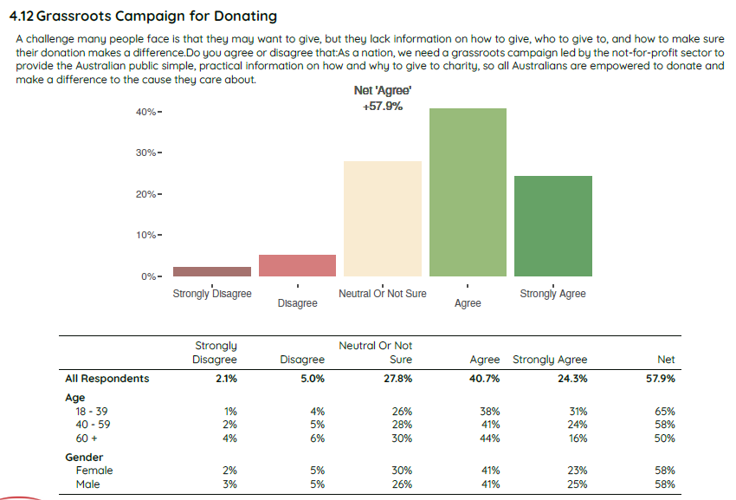
Focus groups and polling conducted by Redbridge were instructive about how such a campaign should be framed, constructed and communicated.
- A key general finding across the six focus groups conducted was that people were motivated to give by:
  - A sense of personal connection - the extent to which they feel a cause/reason for giving is personally relevant/meaningful to them.
  - A sense of agency - the extent to which participants feel they can choose to give with confidence on their own terms (and conversely, they can be repelled by being told what to do).
  - A sense of community - the extent to which the act of giving makes them feel part of a bigger (cohesive) community and connects to an Australian identity of ‘mateship’ (with its ideals of generosity and looking after each other).
- There is support for a campaign led by not-for-profits to give people information on why and how to give, empowering them to make their own choices. Engaging people with personal stories of giving and connecting them to the bigger picture of how personal giving can strengthen our community and identity will be effective.
- Less favourable responses were made in some focus groups where the proposal was perceived as a glossy, government-led campaign, seen as telling citizens what to do.

The philanthropy agenda

The Proposed Reform
- The PC recommend the Government develop, as part of its Strategy to Double Giving, A compact with the philanthropic sector, outlining what the philanthropic sector would seek to contribute towards doubling giving by 2030 (and similar compacts could be adopted with business and the charity sectors, as outlined below).
  - The document would set out broad directions and specific initiatives to be undertaken to drive increased giving in Australia.
  - Philanthropy Australia, the peak body, would be expected to play a catalytic role, working with its 800-plus membership and the broad philanthropy eco-system to drive implementation of initiatives.
- The Compact would be agreed and then reviewed annually at the Prime Minister’s (and/or Treasurer’s) Double Giving Council (see proposal at 3.2).
  - As philanthropic activity is voluntary, The Compact would not be about legally binding mandates. Rather, it would set directions and specify initiatives to be undertaken, which would be discussed and reviewed annually by government, business, philanthropy and charity representatives at the PM’s (and/or Treasurer’s) Double Giving Council.
- The PC could usefully engage with the philanthropic sector during the inquiry to help identify for government the sorts of initiatives that could be led by philanthropy, which would demonstrate the value of this work and provide a headstart for the development of The Compact.
  - Philanthropy Australia has already undertaken this work recently, working with the sector to produce A Blueprint to Grow Structured Giving: How Australia Can Double Structured Giving by 2030, April 2021. Along with proposed government reforms, the document outlines a suite of reforms the sector would drive. Among reforms with particular potential to lift giving in Australia include:
    - A National Giving Campaign (discussed at 2.1);
    - Supporting professional advisers to engage with clients about giving; and
    - Supporting HNW and UHNW philanthropists to engage their peers about giving.

The Case for Change
- Philanthropy, business, charities and government working together can transform Australia in ways simply not possible by Government acting alone.
  - Fundamentally, giving is a voluntary act undertaken by citizens and businesses, and it supports action by charities. While government plays a crucial role with funding, incentives and regulation, we can only hope to double giving by all key actors driving progress towards this difficult but crucial goal to double giving.
  - While the PC’s ‘sweet spot’ has always been government incentives and regulatory frameworks, it must not miss out on identifying a massive part of the transformation only possible by galvanizing philanthropy, business and charities.
- There is tremendous capacity for the philanthropic sector to support the double giving agenda.
  - Australia’s philanthropic has developed significantly in recent decades. There are now:
    - More than 2,000 Private Ancillary Funds, with $7.6 billion in assets;
    - Almost 1,400 Public Ancillary Funds, with around $4 billion in assets;
    - 29 per cent of Australian’s donate and 25 per cent volunteer each year;
    - A raft of significant foundations, such as The Paul Ramsay Foundation, along with a professional philanthropy workforce and intermediary firms like Australian Philanthropic Services, Equity, Perpetual and Australian Communities Foundation that, in varying ways, assist philanthropists to pursue their missions.
    - The peak body, Philanthropy Australia, is working with its members on Blueprint initiatives to double structured giving by 2030.
- There are a suite of high impact initiatives available that can help propel the double giving agenda.
  - Philanthropy Australia’s A Blueprint to Grow Structured Giving, April 2021 included 10 first stage initiatives to be implemented over 2022-2030, plus another 10 that could be further developed. While a few are government-led initiatives, most are sector-led.

Philanthropy Australia Blueprint Initiatives
First Stage Initiatives
1. Remove barriers to donating excess superannuation.  2. Reform the DGR framework.  3. Introduce a Living Legacy Trust structure.  4. Champion stories of diverse philanthropic giving. | 5. Develop a research agenda to extend the evidence base.  6. Support professional advisers to engage clients about philanthropy.  7. Introduce a bi-annual report on HNW giving. | 8. Support UHNW philanthropists to engage peers in giving.  9. Cut red-tape to enable more place-based philanthropy.  10. Facilitate community and place-based philanthropy.
Other Potential Initiatives
1. Implement a National Giving Campaign.  2. Invest in the fundraising capacity of charities.  3. Supporting workplaces to encourage soon-to-retire HNW employees to consider philanthropy.  4. Work with the media to encourage reporting of stories of UHNW giving. | 5. Support programs that teach children about philanthropy at school.  6. Encourage the uptake of giving circles, and support their enabling environment, including in workplaces.  7. Better engage with well-resourced and HNW migrants, including the Asian Australia diaspora. | 8. Establish a fundraising challenge, targeted at companies.  9. Foster and enable the next generation of philanthropists.  10. Encourage workplace volunteering, as a pathway to giving.

- Along with the National Giving Campaign, initiatives to encourage UHNW and HNW Australians to give, and to encourage financial and legal advisers to engage their clients on giving, could produce a massive increase in giving.
Box 2.2.1: Philanthropy Sector-Led Initiatives

Encouraging UHNW and HNW Australians to embrace philanthropy.
As noted above, wealth is exploding at the top end of Australian society. Perhaps because some of this wealth is newer than in the United States, we don’t yet have a culture where giving is expected among the wealthy, and many do not give substantially. Just 53 per cent of Australians earning more than $1 million per annum claimed tax deductions for giving in 2019-20, compared to 90 per cent in the United States.
If, like those that sign The Giving Pledge, Australia’s Top 200 alone agreed to give up a majority of their wealth, it would deliver hundreds of billions for Australians in greatest need, likely catapulting Australia from being behind counterpart nations, to be among the leading philanthropic nations in the world.
There are a suite of initiatives that can drive this change:
- Philanthropy Australia provides a suite of information, advice and support to prospective philanthropists to help them embrace giving and to it well. We also promote philanthropy through our website, the media, podcasts, stories of giving and our national conference.
- Start Giving, led by Antonia Ruffell and Daniel Petre, is encouraging Australia’s rising group of tech start-ups to commit a share of their value to philanthropy before they make it big.
- Philanthropy Australia is considering a suite of additional initiatives such as:
- Direct peer engagement: Supporting existing philanthropists to engage their peers to commence or enhance their giving. Research shows donors are often motivated by gaining a reputation among their peers or for other personal reasons, so engagement by peers sharing their own giving journeys is likely to be a powerful means to increase giving.
- Engaging wealthier Australians on the potential of giving through Private Wealth Networks.
- Improving the capacity of charities to seek funding from UHNW/HNW individuals.
Encouraging financial and legal advisers to engage clients about philanthropy.
- Financial advisers, particularly those that advise higher net wealth individuals and businesses, are a crucial and largely untapped lynchpin to doubling giving in Australia. Collectively, they support the allocation of trillions of dollars, and research confirms they are highly influential in how clients allocate their money, yet traditionally they have not engaged clients about the potential of philanthropy.
- This is beginning to change as a number of leading firms – driven by the efforts of dynamic industry leaders – are developing thoughtful business models to routinely engage clients on giving. They recognise that through this practice everyone wins – society through greater help for people in need and the firm from establishing stronger, more sustainable client relationships, including across generations as philanthropic structures are maintained in perpetuity.
- PA is establishing an Adviser Education Program, including videos, an online guide, and online professional development modules for advisers who must gain 40 Continuing Professional Development points a year. We are convening a group of industry leaders to drive next steps in this work, which could include:

- Direct engagement with firms and individual peers – particularly wealth advisory firms - to encourage them to engage clients on philanthropy.
- Engaging giving intermediaries, such as Australian Philanthropic Services, who provide advice and support to help clients set up and run philanthropic structures such as Private Ancillary Funds. These organisations have a strong incentive to encourage financial advisers to engage their clients on philanthropy and then provide referrals.
- Philanthropy in pre-service training. Federal Treasury plays an important role in advising government on the content of financial planner university degrees. It may be appropriate to require modules on philanthropy in pre-service training for financial advisers.
- Estate lawyers also hold a pivotal position, but here too, philanthropy is largely overlooked, with the result that just 7 per cent of Australians include a bequest in their will. Research shows this can be changed - A UK study with lawyers showed discussing the option of philanthropy with clients writing their first will led to a 40 per cent increase in legacy giving.

The Business Agenda

The Proposed Reform
- The PC recommend the Government develop, as part of its Strategy to Double Giving, A compact with the business sector, outlining what the business sector would seek to contribute towards doubling giving by 2030.
  - Peak bodies such as the BCA, ACCI, COSBOA and Workplace Giving Australia could play a facilitative role with the business community, and major companies in the ASX 200 could play a pivotal role.
- The Compact would be agreed and then reviewed annually at the Prime Minister’s Double Giving Council (see proposal at 3.2).
- The PC could usefully engage with the business sector during the inquiry to help identify for government the sorts of initiatives that could be led by business, which would demonstrate the value of this work and provide a headstart for the development of The Compact. While leading businesses, peak bodies, workplace giving organisations and leading consultants and research organisations are best placed to identify potential initiatives, options with promise include:
  - Peak bodies promoting the case for business to invest in philanthropy, and outlining ways in which this can be done to deliver ‘win-win outcomes.’
  - Government requiring companies to report their giving, which could be total dollars and percentage of pre-tax profit, so we can accurately understand our current level of corporate giving, and set aspirations for improvement over time. Transparent reporting would likely lead to a big lift in corporate giving (see below).
  - Signing on to Pledge 1% - giving 1% of equity, time, products and/or profit.
  - Enabling workplace giving by employees, with employers matching donations.
  - Embedding more ‘win-win’ activity, using philanthropy to build competitive advantage, market share and customer loyalty.
  - While giving by business will always be voluntary, there may be a way to encourage businesses to sign up to a specific agenda – A Business Giving Pledge – which could have a headline target (such as one percent of pre-tax profit), as well as a suite of commitment levels and options that would see them increase their contributions, while retaining flexibilities to contribute in their own way.

The Case for Change
- Business has enormous capacity to contribute to the double giving agenda.
  - There are almost 2.6 million employers in Australia (as at June 2022).
  - Pre-tax profits are trending at around $500 billion annually, creating tremendous scope for business to support philanthropy.
  - There are around 13.7 workers in Australia (December 2022), an enormous talent pool to volunteer, provide expertise, fundraise and donate to support Australian charities.
- Business is contributing less than in leading nations.
  - Data on business giving is challenging as business is not required to report their donations, but it appears Australian business performance is solid, but behind some comparable nations. The annual GivingLarge report compiled by Jarrod Miles of Strive Philanthropy found that, even among our Top 50 companies, giving was 0.78 per cent of pre-tax profits (3-year rolling average) in 2022. In the US, corporate giving more generally is 0.9 per cent, and has trended much higher over recent decades. Lifting corporate giving among the Top 50 alone to one per cent of pre-tax profit would add $340 million per annum to corporate giving, while reaching best practice – around 2 per cent, would add $1.9 billion.
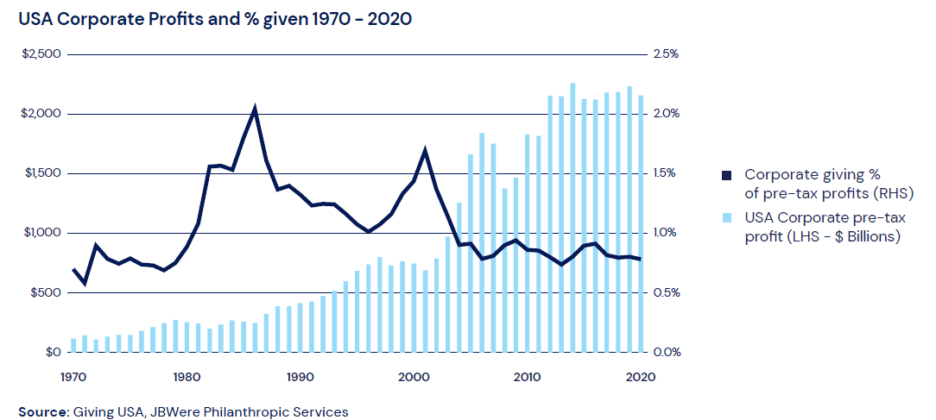
- There is a strong business case for business to embrace philanthropy. This includes:
  - Attracting and retaining top talent: Perhaps never before have talented staff been keener to work for companies that take their social and environmental responsibilities seriously. Pledge 1% reports that companies with a giving program have 2.3 times the retention rate of those that don’t.
  - Competitive advantage and market share: Across a suite of industries, firms are winning market share attracting customers through good works. Smart philanthropic work can build brand loyalty among customers, increasing patronage. Companies can drive impact by using their core capabilities to support charity, such as management consulting firms providing free consultancy services to the for-purpose sector.
  - Developing reputation and legitimacy: Whether it’s a university expanding its local footprint, a developer seeking to commence a new project, or an industry seeking to maintain beneficial tax or regulatory arrangements, charitable work can be critical in developing a positive reputation and legitimacy, creating a social licence to operate.
  - Win-win outcomes through synergistic value creation. There are a suite of ways to use giving to lift profits – for example, using a small portion of the marketing spend to encourage giving in ways that boost sales, or encourage people to change behaviour.
- There are powerful initiatives available that can substantially lift giving.
  - Requiring companies to report their giving. Periodic reporting would have a big impact on corporate giving by:
    - Frequently raising the profile of corporate giving – a regular ‘nudge’ to corporates consider more giving.
    - Encouraging companies to set targets and galvanise effort and resources to achieve them.
    - Spurring competition among companies. Transparency would encourage low givers – such as Top 50 companies giving as little as 0.2 per cent of pre-tax profit, to increase giving to levels more in keeping with norms expected by their employees, customers and the community. Other companies would reach for best practice – beyond 2 per cent.
    - Facilitating research, including publication of data trends and work on how to lift corporate giving.
    - Encouraging collaboration on best practice, as companies looked to lift the scale and impact of their philanthropy.
Transparent reporting by companies on amounts given, focus areas and types of support provided would also better guide the efforts of fundraisers, increasing the targeting, efficiency and effectiveness of their fundraising activity.
Strive Philanthropy have written about how these elements can combine to form a model for growing corporate philanthropy:
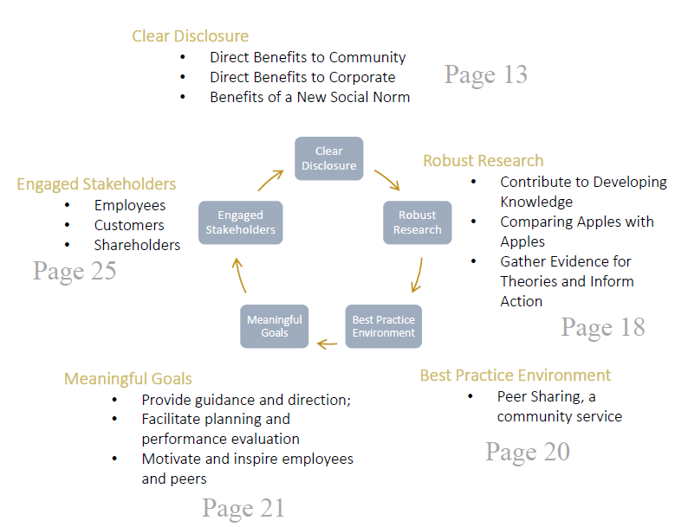
Diagram from Strive Philanthropy, Rising the Tide on Corporate Philanthropy: A Model to Grow Corporate Philanthropy in Australia, 2022.
  - Business can sign on to Pledge 1% - a fast-growing global movement of corporate philanthropy with solid Australian involvement - and give one per cent of:
    - Equity (ideally early in the lifecycle of a business);
    - Time (such as traditional hands-on volunteering, or skills-based work, providing the unique capabilities of the business for charities pro-bono);
    - Products (in existing or revised form); and/or
    - Profits.
  - Workplace giving is a fast-growing movement, where employees can give regularly and get the tax deduction immediately. Programs are most successful where companies match the giving of employees, and embrace volunteering, skill sharing and in-kind support. Workplace Giving Australia is working towards One Million Donors – one million Australians giving regularly to charity through their workplace. Benefits include:
    - Employers enjoy greater staff engagement, retention, productivity, reputation and social impact.
    - Employees give in a smarter, tax-effective way and build a sense of pride in their employer.
    - Charities get low-cost, regular funds, access to valuable skills and strong partnerships.
Workplace giving was highlighted in the PC’s 2010 report, with Recommendation 7.4 stating:
To encourage cost-effective giving, the Australian Government should explore options to promote and support planned giving, especially payroll giving. Specifically, the Australian Government should provide funding for a national campaign to promote payroll giving and the associated tax benefits. As part of the campaign, governments should encourage the establishment of payroll giving within all their agencies.
  - Business is increasingly recognising ‘win-win’ ways to lift giving while strongly advancing business objectives. For instance:
    - Some supermarkets are lifting brand loyalty by enabling customers to ‘round up’ their bill and give to charity, while a global bank has partnered with MasterCard to allow customers to use their points to make donations.
    - ING’s App allows its banking customers to make ‘round up’ donations to any of around 30 charities in Australia.
    - Many airlines allow customers to pay to offset their carbon emissions.
    - Some organisations build philanthropy into their business model. For instance, who gives a crap donates 50 per cent of profits to build toilets and improve sanitation in the developing world, helping to reduce death from disease among young children.
    - An Australian bank is winning additional business with small business loans by offering the business a lump sum to donate to a not-for-profit of their choice each year.
    - Many companies are using a small portion of their marketing spend to donate to charities and increase sales, such as by donating an amount per unit sold to charity.
- The case for business increasing its giving was underlined in Redbridge polling of more than 2,500 Australians by Redbridge in November 2022, which found:
  - 70 per cent of Australians believe business should do more;
  - 7 per cent disagreed;
  - 23 per cent were undecided.
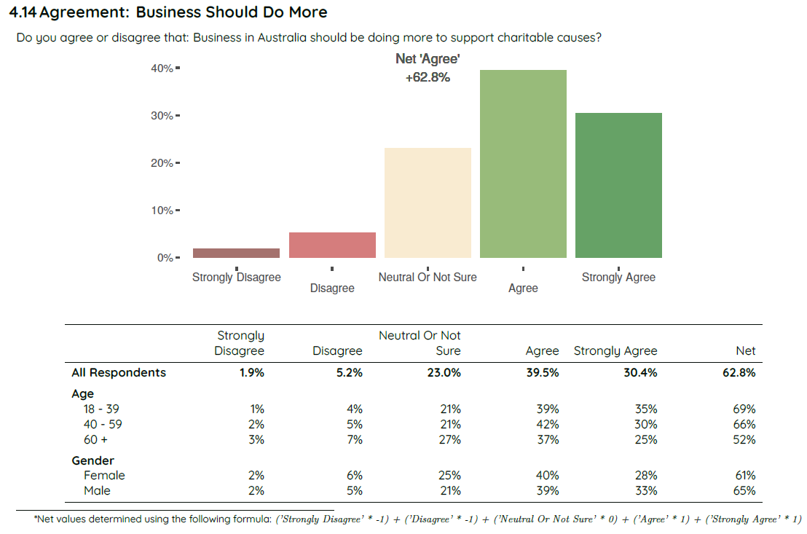

The Charity Sector Agenda

The Proposed Reform
- The PC recommend the Government develop, as part of its Strategy to Double Giving, A compact with the charity sector, outlining their contribution towards doubling giving by 2030.
- The Compact would be agreed and then reviewed annually at the Prime Minister’s Double Giving Council (see proposal at 3.2).
- The PC could usefully engage with the charity sector (and draw on its 2010 research report, Contribution of the Not-for-Profit Sector) to help identify for government the sorts of initiatives that could enhance the effectiveness and efficiency of the charity sector.
The PC could reprise its recommendation to establish an Office of NFP Engagement, within a central agency such as PM&C or Treasury, to partner with the sector on reforms to improve the efficiency and effectiveness of the sector. It could expanded to an Office of Strategic Partnerships, made up of staff from government, business, philanthropy and charity working together and with the broader eco-system to drive change. Two key areas for focus could be:
  - Measures that strengthen the community’s confidence that funds donated will be used well to drive impact – such as robust evaluation that allows charities to demonstrate their impact, and improving human capital (notably leadership, governance, business planning and fundraising skills). These are crucial to improving the willingness to give and to creating genuine impact.
  - Government creating a better environment for charities by: reducing red tape, Fixing Fundraising, more partnership and less ‘command and control’, and fully funding service provision, with improved funding certainty through longer term contracts. (More detail on these items is provided below).

The Case for Change
- The charity sector has enormous capacity to contribute to the double giving agenda.
  - The charity sector includes around 60,000 organisations and employs more than 11 per cent of the Australian workforce, more than either retail or construction.
  - The sector contains a raft of iconic organisations improving the lives of millions across all major areas of social and environmental policy.
- Measures that improve the confidence of prospective donors that funds will be spent effectively can help drive and increase in the quality and impact of donations.
  - Research shows people can be reluctant to give where they can’t be sure funds will be put to good use. Polling and focus groups conducted by Redbridge in late 2022 showed that while there is substantial support for the work of charities, including a view that they can spend money more flexibly and effectively than government, there remains some caution about the transparency of donations.
“For financial donations, how do we know where it's going? How do we know how it's helping?”
“I like to donate to an organisation that has a good profile and reputation and to be able to see where the money is going,”
“Knowing the organisation or the cause [is important]. I like to have confidence in the organisation, a brand I can trust.”
- A powerful agenda is available to further lift the effectiveness and impact of the charity sector, which would bolster its reputation and drive increased giving and further impact.
  - Building human capital – fundraising skills, governance and leadership.
    - The PC’s 2010 report gave significant emphasis to building sector capabilities to enhance productivity, with a focus in areas including governance, business planning, workforce planning, technology uptake and evaluation.
    - Building fundraising capacity within charities is important to growing giving. Research shows that increasing giving is not all about the supply side. A key driver of giving, including among HNW givers, is the capability and skill of the fundraisers working in the charity sector. The ‘philanthropy industry’ – including ‘philanthrocrats’, fundraisers, intermediaries and trusts and foundations – has grown substantially over the last couple of decades, but there remains scope to build a stronger cadre of fundraisers in the charity sector.
    - The governance and leadership of the charity sector is on a similar upward trajectory, but with continuing scope to improve core strategy, management, leadership and governance capabilities.
    - Expanding the work of existing institutions such as the Centre for Social Impact and ANZSOG could produce larger cohorts of high calibre fundraisers and leaders for the charity sector.
  - Evaluation. Many charities evaluate their programs effectively, enabling them to continuously improve their impact, and attract donations. However, there remains scope to expand this capability across the sector and to ensure government funds this work where it is funding charities for services. The PC in 2010 recommended that the Australian Government should provide funding for the establishment of a Centre for Community Service Effectiveness to promote ‘best practice’ approaches to evaluation. (Rec 5.4).
  - Social Innovation – In 2010 the PC recommended that major programs include a Social Innovation Fund to trial, test, evaluate, and if successful, expand new approaches (Rec 9.5).
  - Completing the Fix Fundraising agenda. Recommended by the PC in 2010 (Rec 6.5 and 6.6), reform to create a single regime of fundraising regulation in Australia is still yet to be finalised.
  - Reducing red tape: The PC found in 2010 there was too much ‘command and control’ by government officials, rather than recognising charities have expertise in how to deliver impact and should be partners in driving change. This practice appears to remain prevalent today. The PC recommended:
‘Australian governments should urgently review and streamline their tendering, contracting, reporting and acquittal requirements in the provision of services to reduce compliance costs. This should seek to ensure that the compliance burden associated with these requirements is proportionate to the funding provided and risk involved.’ (Rec 12.7)
  - Full funding The PC recommended the government provide full funding to charities for services they would otherwise provide (Rec 11.1) and fully factor in market wage rates, the skills required and appropriate indexation (10.2). The ‘Pay What it Takes’ campaign has highlighted this issue remains unaddressed. In 2010, the PC noted:
‘With respect to the NFP workforce, governments should recognise the effect of not paying the full costs of service delivery. Part funding can make it difficult for NFPs to pay competitive wages to attract and retain workers, with the cumulative effects of underinvestment in workers, technology, and planning putting pressure on the quality and sustainability of service delivery. Full funding may be one of the most important steps to address the workforce issues in the relevant human services sectors.’
  - Improving funding certainty: Too many contracts are for 1-2 years without a clear policy rationale, making it difficult for charities to attract and retain talented staff and plan for the long term. Resources that could go into service delivery are needlessly wasted on government relations and administration. As the PC recommended in 2010: ‘The length of service agreements and contracts should reflect the length of the period required to achieve agreed outcomes rather than having arbitrary or standard contract periods.’ (Rec 12.5).

Philanthropy in Schools

The Proposed Reform
The PC outline for government the components of a comprehensive National Philanthropy in Schools Agenda, including:
- Ensuring every Australian child is given the opportunity to participate in a philanthropic project, so they are exposed to the power of giving and volunteering at an early age, paving the way for more giving across their adult life and a more giving and generous national culture.
- Examining scope to include more material on charities and philanthropy in the Civics and Citizenship component of the National Curriculum. We recognise that, particularly in the context of declining student outcomes in Australia, there are already strong pressures on schools to teach core skills and much more, but believe short, intensive experiential learning on charity and philanthropy have an important place in building a more generous, giving and connected Australian culture.
- Determining how successful existing programs – and potentially complementary new programs – could be leveraged to expand access by students to philanthropic experiences. Charities like Kids in Philanthropy and the Lord Mayor’s Charitable Foundation’s Youth in Philanthropy program provide a suite of philanthropic experiences for children in schools.

The Case for Change
- Our values, culture and lifetime behaviours are strongly influenced by what we learn early in life.
- Children’s philanthropy programs work.
  - International evidence demonstrates that children involved in educational programs focused on philanthropy experience a strong desire to engage in philanthropy and social change in the future.
- There are promising programs in Australia.
  - The Lord Mayor’s Charitable Foundation’s Youth in Philanthropy program runs in 19 Victorian schools. Young people, generally in year 10, form a Youth Grantmakers Committee. The aim of the program is to inspire young people to begin a life-long engagement in philanthropy and social change, and develop values such as integrity, empathy, responsibility and respect. It also builds skills in problem solving, research, collaboration and decision-making.
  - Kids in Philanthropy (KiP) run a suite of programs, such as Agents for Change, which is customised for schools and can include: a two-hour workshop; a unit-based project implemented over a term; or a half or full day of volunteering. Children who participate experience: increased empathy for others; a greater understanding of philanthropy; personal wellbeing from helping others; practical skills in how to deliver change in their community; and a desire to do more to help others. Established in 2012, KiP has:
    - Engaged more than 3,900 children across Australia;
    - Provided more than 7,600 hours of volunteering;
    - Gifted more than $160,000 to help address local challenges;
    - Provided more than 48,000 KiP made goods and 1,000 meals to people in need; and
    - Collaborated with more than 20 local charities.
- The PC could devise and recommend a National Philanthropy in Schools Agenda.
  - A simple, well-designed, time-efficient and concise national program could ensure a philanthropic experience for every Australian child, delivering immediate benefits for people in need, and encouraging a lifetime of participation in giving and volunteering, and a more generous and giving national culture.

Strong foundations for giving
A key impediment to growing giving in Australia has been that crucial institutional arrangements and areas of policy architecture have not been established and sustained. We can help double giving and lift its impact through: a clear national strategy for charitable giving; governance arrangements that create scope for government, philanthropy, business and the charity sector to collaborate on shared agendas; establishing a robust national data set; funding action-oriented research to inform the roll out of the double giving agenda; and taking steps to ensure a strong culture and practice of evaluation across the sector.

A national strategy with clear goals and high impact reforms.

The Proposed Reform
Given the Government’s commitment to developing a Strategy to Double Giving, and its explicit reference in the Terms of Reference, there may be merit in the PC providing advice on how elements of the strategy could be framed, including:
- A sound policy framework for efficiently doubling giving.
- Clear goals. As depicted in our Summary on a Page diagram in the Executive Summary, we think goals should include doubling overall giving, while also focusing on cultural change by increasing the proportion of people giving, particularly among HNW and UHNW individuals, who have the greatest capacity to give and can drive the greatest rise in national giving.
- Key drivers of increased giving, with specific reforms to propel each, including:
  - A policy environment that fosters giving, with high impact reforms such as establishing super bequests and extending DGR to all charities.
  - A more generous and giving national culture, as an improved structures and incentives from government can only have impact if Australians are willing and inspired to give. A sustained National Giving Campaign and philanthropy programs in schools - together with reform agendas from philanthropy, business and charities – are critical to shifting our culture and practice and achieving the double giving mission.
  - Strong foundations for giving. Improved data, research and evaluation are critical to informing policy reforms and being able to measure progress. Establishing governance arrangements that create forums for government, philanthropy, business and charities to collaborate on shared agendas would unlock tremendous untapped potential to drive positive social change in our nation.

The Case for Change
- Given the PC’s expertise in policy frameworks and sound policy design, it is uniquely placed to advise the Government about the desirable elements of the Double Giving Strategy.
  - A Summary on a Page of Philanthropy Australia’s suggested Double Giving Strategy is provided in the Executive Summary.

New governance arrangements to drive government-civil sector collaboration

The Proposed Reform
- The PC recommend governance arrangements that will create mechanisms for the four key sectors – government, business, philanthropy and charity – to collaborate on the double giving agenda.
- These could comprise:
  - The Prime Minister’s (and/or Treasurer’s) Double Giving Council, a small group with representatives from each of the four sectors to meet annually to discuss progress with the double giving agenda, and outline plans for the coming year.
  - A group of sector specific Giving Councils, including the Early Years agenda, entrenched disadvantage, the environment and climate change, First Nations Justice, disability, education, health, the arts and overseas aid. Responsible Ministers would engage with philanthropy 2-4 times per year to determine how all parts of society can collaborate on shared agendas, thereby magnifying what government can achieve alone. In particular, philanthropic funders could: co-invest in Flagship initiatives; and fund social innovations, which, if successful, could be adopted by government system wide.
- Sector specific arrangements could be implemented in stages, commencing with completion of arrangements for the Investment Dialogue for Australia’s Children, with lessons learned then applied to the design of subsequent sector specific arrangements.
  - Pioneering work is currently occurring with philanthropists spearheaded by Matthew Cox at the Bryan Foundation, who have proposed co-investment and collaboration with Government on an Investment Dialogue for Australia’s Children, aimed at ensuring all young Australians get a strong start in life. The initiative was agreed at the Jobs and Skills Summit, with arrangements now being finalised with senior Government officials. Treasurer Chalmers is a key champion for this work, which reflects his desire for more to be done around place-based disadvantage, including in the Logan area of his electorate. Social Services Minister Amanda Rishworth and Early Childhood Minister Anne Aly are now leading the development of an Early Years Strategy.

The Case for Change
- Australia has never established sustainable, effective governance arrangements for government-civil society collaboration to drive impact through philanthropy.
  - While there have been periods of positive cooperation and achievement, such as through the Community-Business Partnership, powerful governance arrangements to create genuine cooperation and extract maximum impact have never been established and sustained in Australia’s history.
- This means a massive source of social change is being left untapped. Philanthropy, government, business and charity could collaborate closely to help propel a shared agenda, delivering radically greater impact.
  - Minister’s sitting down with philanthropy, business and charity would find ways to magnify impact in their portfolios beyond what they can achieve through government investment alone.
  - Philanthropy is particularly well placed to trial social innovations government is not well positioned to pursue, which, where successful, can drive systemic change. Unfortunately, a lack of collaborative structures has sometimes meant powerful social innovations have been tested and proven, only for government to fail to then back the initiatives or take many years to do so. Sector-specific Giving Councils could overcome this challenge.
- Simple, efficient, non-onerous collaboration structures can deliver much stronger social impact through cooperation between government, philanthropy, business and charity.
  - There have been major successes, such as philanthropic support for the creation of Orygen, whose work has transformed youth mental health in Australia, including by spawning headspace, which is now a world-leading national system of mental health support for young Australians. The challenge now is to create governance arrangements that lead to more frequent social innovation and co-investment in Flagship projects across all major areas of social and environmental policy. The high-level shape of the arrangements could be as follows:
- There is value in learning from the Investment Dialogue for Australia’s Children – expected to be announced shortly - in order to inform robust arrangements for other sectors.
  - The alignment of interest between government and philanthropy, and the success of a number of government-philanthropy collaborations, such as the establishment of Doveton College or the Southbank Arts precinct in Victoria, raises the question of why there is not a stronger pipeline of collaborative projects rolling out across all these portfolios in a sustained and systematic manner.
  - The Investment Dialogue for Australia’s Children (IDAC) has been developed over a significant period. Through goodwill and sustained effort from government and philanthropy, it has uncovered impediments that have hampered previous attempts, and is seeking to establish arrangements and cultural norms that allow collaboration on shared agendas to flourish. For instance:
    - Government Ministers and officials are more used to spending money as they see fit, rather than co-designing solutions with civil society. Progress on collaborative endeavours requires some sharing of power, ongoing engagement and valuing broader perspectives on public policy directions.
    - For its part, philanthropists need to build their knowledge of how to deal with government, government processes and public policy challenges.
    - IDAC arrangements are expected to be announced shortly and can help inform development of arrangements in other sectors.
- There appears to be a favourable environment in which to pursue these reforms.
  - The Federal Government has indicated its desire to restore institutions, collaborate more strongly with business and civil society, and drive impact through shared agendas.
“We must rediscover the spirit of consensus that former Labor prime minister Bob Hawke used to bring together governments, trade unions, businesses and civil society around their shared aims...”
— Prime Minister Anthony Albanese in his speech to the AFR Business Summit, 2022
‘How do we build this more inclusive and resilient economy…? By strengthening our institutions and our capacity, with a focus on the intersection of prosperity and wellbeing, on evidence, on place and community, on collaboration and cooperation. By reimagining and redesigning markets – seeking value and impact… And with coordination and co-investment – recognising that government, business, philanthropic and investor interests and objectives are increasingly aligned and intertwined.
With a new, values-based capitalism for Australia, we can understand something the old thinking neglected: that the problems of government – of whole societies – don’t and shouldn’t permit one simple solution set. Single frameworks tend to close thinking down when what we need is to open our thinking up – to new approaches and new participants. That’s how Prime Minister Anthony Albanese has led since taking office: deliberate, open, drawing in not only all the talents of government but also those of our society as a whole.’
——Treasurer Jim Chalmers, Capitalism after the crises’, The Monthly, February 2023.

A National Giving and Community Participation Data Set

The Reform
We recommend that the PC:
- Develop a single, comprehensive National Giving and Community Participation Data Set, identifying the level of total giving in Australia and its key components.
  - This will require engagement with relevant stakeholders currently involved with producing philanthropy data, such as the ACNC, ATO, AIHW, ABS, academic experts and Philanthropy Australia.
- Recommend clear institutional arrangements and responsibility for the ongoing collection and dissemination of data on philanthropy, including which organisation would lead the work.
  - At present, numerous organisations compile components of giving data, but often use inconsistent methods. There are gaps in giving data. Data is sometimes years out of date.
  - Under reformed arrangements, a single organization would bring all these components together, ensure methods and categories are consistent, fill data gaps and provide a comprehensive, up-to-date National Philanthropy and Community Participation Data set, which would include:
    - A time series of total giving;
    - International comparisons of total giving;
    - Data trends on the components of giving, such as individual giving, structured giving (PAFs, PuAFs – Commercial and Community Foundations, and Charitable Trusts), corporate giving, bequests and volunteering;
    - Giving by broad cause areas, such as poverty alleviation, education and health;
    - Proportions and amounts being given by income and wealth brackets;
    - Giving trends in each State and Territory, and giving by postcode or ABS data collection areas, to pick up the rise in community giving;
    - Measures of community participation – such as involvement in community activities and organisations, friendship and neighbourhood connections.
  - To ensure key data gaps can be filled, mandatory reporting requirements will need to be expanded into areas including corporate giving.

The Case for Change
- Australia does not have a coherent system for collecting and disseminating consistent, comprehensive data on philanthropic giving. Too often, our philanthropy data is poor, incomplete and out of date.
  - We do not have a time series of total giving at the national and state level.
    - The ACNC provides good total giving data in its annual Charities Report, but it excludes important aspects of giving, such as bequests and giving to for-purpose organisations that are not registered as charities at Federal level, and aspects corporate giving. It does not include disaggregated information on individual, structured and corporate giving.
  - There are massive data gaps.
    - Frequent, credible public information is not provided on key elements of giving such as:
      - Corporate giving (unlike in NZ, the ATO doesn’t ask companies to separately report tax deductible donations);
      - Total individual giving (ATO provides data on individual giving where a tax concession has been claimed, excluding substantial giving where this doesn’t occur);
      - Bequests (charities are not asked to report on bequests);
      - Giving by families/households;
      - Giving by level of wealth;
      - Charitable trusts; and
      - Giving from international sources.
    - We don’t know how much total giving occurs on state-by-state basis. While some State level information is available (e.g. individual giving), information on many components of giving doesn’t exist or is incomplete. Little data exists on giving in local communities.
    - Little to no data is collected from unregistered charities and jurisdiction-registered (but not Federal) charities.
    - While each data set is different, other items commonly missing include volunteering, sponsorships, charitable gaming income, fines collected by courts and given to charity, and in-kind giving, including second hand goods.
  - Philanthropy data is often years out of date.
    - The ACNC’s Charities Report is one of the best and more up-to-date sources of data and it is two years out of date on the day it is published.
  - In the absence of comprehensive public information on key elements of philanthropy data, we are fortunate that a range of actors step in to provide excellent information – such as JBWere’s Support Report and Corporate Support Report, or the JBWere-NAB Charitable Giving Index, which provides broad estimates of giving trends based on capturing one-fifth of giving via electronic payment methods such as eftpos, credit cards, BPAY and PayPal. These reports are extremely useful. However, all the various sources of data need to be brought together into a comprehensive, consistent national system of data on philanthropic giving.
- No single organisation is responsible for bringing together and publishing comprehensive, consistently collected, up-to-date data on philanthropy. We have numerous reports by numerous public, for-purpose and private organisations on components of philanthropic giving, each using their own methods and classification standards. As a result, we don’t have a clear, consistent overall picture of philanthropic giving or its components in Australia.
  - The ACNC compiles its annual Charities Report from mandatory annual information statements provided by registered charities.
  - The Australian Taxation Office collects data on donations claimed as tax-deductions, such as by individuals, Private Ancillary Funds and Public Ancillary Funds.
  - Private organisations occasionally step in to provide their own estimates in areas such as corporate giving, where disclosure of giving is not required to be reported by law.
  - Sector reports are often commissioned, such as reports by Creative Partnerships Australia on giving trends in the arts.
  - Significant government publications are periodically commissioned, such as the Giving Australia reports of 2005 and 2016.
  - As each organisation is using its own methods and classification structures, the data does not combine into a consistent, comprehensive National Philanthropy Data Set.
- Developing an overarching, coherent, consistent National Philanthropy Data Set could provide all the data we need more cost effectively.
  - The current system has multiple players spending substantial collective amounts to produce partial, incoherent, generally out of date information on philanthropy.
  - An overarching system would likely deliver the data we need at a lower total national cost.
- We need good data to guide policy efforts to lift philanthropy.
  - The Government has committed to doubling philanthropic giving by 2030. A National Philanthropy Data Set will be essential in ensuring government can track its progress to this crucial national goal.
  - Specific data can also be helpful in tracking the results of specific policy interventions.
  - Understanding giving trends – such as total giving, giving by cause area or by level of income or wealth, or changes in the components of giving - can provide the government with crucial information to indicate where future policy reform is needed.
- Good data can inform the efforts of philanthropists, charities, businesses and members of the community to lift giving and support Australians in greatest need.
  - Frequent publication of credible data – and the media and public discourse it would produce – would be a low cost, high yield nudge to the Australian community to lift their giving.
    - Public information on trends in corporate giving would place a spotlight on giving by business and encourage the sector to lift its philanthropic contribution.
    - Information on giving trends would position philanthropists to focus their giving to support Australians in greatest need.
    - Charities would be positioned to better attract support for their high impact initiatives.
  - Information on structured giving would position Philanthropy Australia and its membership to chart a course to achieve the aspirations in its Blueprint to Double Structured giving by 2030.
- Community participation data can help all of us to chart a course to a more connected, generous and giving Australia.
  - In Reconnected (2020), Leigh and Terrell:
    - Paint a vision of ideal communities – people have plenty of friends, neighbours look out for each other, streets are lively and safe, there is lots of participation in sport and culture, we volunteer in local charities, we work together to solve local problems and we share a sense of common purpose.
    - Chart the decline of community participation and social capital in Australia in recent decades; and
    - Highlight the benefits of creating a more connected, generous and giving Australia, such as: improving happiness, self-esteem, health and social relationships; underpinning effective democracy and government; and helping to tackle our biggest challenges, like climate change, inequality and loneliness.
  - Data on community participation can help us understand our current situation, foster a national conversation on the type of society we wish to create, identify where interventions are required, and track our progress to becoming a stronger society.

An action research agenda

The Proposed Reform
The PC recommend an action-oriented research agenda to help drive the double giving agenda, which could include:
- A dedicated double giving research fund of $10 million over six years (to 2030) focused on supporting effective implementation of the Government’s double giving strategy, such as how to:
  - encourage UHNW and HNW individuals to embrace or expand their philanthropy;
  - ensure financial advisers engage suitable clients on the option of philanthropy;
  - promote business and workplace giving and volunteering.
Governance arrangements to distribute the research funds need to be tailored to ensuring funds are used to drive practical, immediate reforms in the Government’s double giving strategy. This could be achieved via either:
  - A sector peak body such as Philanthropy Australia, drawing on the views of a Steering Committee of key stakeholders. This would mirror arrangements in suicide prevention where Suicide Prevention Australia play a leading role in distributing research funds.
  - The Assistant Minister for Charities, drawing on the views of stakeholders.
- Time limited funding for the Behavioural Economics Team in Prime Minister and Cabinet to inform specific reforms, such as establishing the option to donate to charity as part of the tax return process.
- Ensuring the Government’s broader research framework – notably Australian Research Council and Cooperative Research Centre grants – provide fair and open access to academics focused on expanding philanthropy in Australia. With institutions such as the Centre for Social Impact, Australia has some research strength in philanthropy, but our higher education members advise that:
- For an issue of such importance, in a nation of our size, a stronger research investment is needed if we are to double giving; and
- Criteria preventing academics from competing for grants through a number of programs limits the size of the philanthropy research workforce and the number of projects undertaken.

The Case for Change
- Doubling giving will require several dozen initiatives across the government, business, philanthropy and the charity sectors.
- For many of the initiatives to be successful, they will need to be informed by practical research and/or strategy and implementation work.
  - While there is a healthy philanthropy literature in Australia, there are also some significant gaps in the literature.
  - Many of the initiatives involve attempting changes not before seen in Australia, such as transitioning to a society in which nearly all UHNW and HNW individuals give substantial funds to charity.
  - Such pioneering work can require knowledge gaps to be filled for implementation to be successful. For example, while it is known that UHNW individuals can be influenced to give by their peers, there is not detailed information available on: the different market segments of UHNW individuals; their motivations; how they can be reached; and how best they might best be encouraged to embrace or expand their philanthropy.
- A funding pool for projects to support implementation of Double Giving strategy initiatives would help ensure initiatives deliver the intended impact.
  - This will be a highly diverse set of action-oriented projects. A diverse collection of providers – sometimes management consultants, at other times philanthropy specialists, government or higher education institutions – will be needed to complete the basket of projects. Having flexibility to appoint suitable providers to match the needs of the project will be critical.
  - Distribution of funds through the Assistant Minister for Charities or a peak sector body, acting on the advice of key stakeholders, could ensure funds can be flexibly allocated to the most suitable providers, are focused on successful implementation of double giving initiatives, and deliver practical outcomes.

Effective Evaluation

The Proposed Reform
The PC recommend reforms to engender a culture and consistent practice of effective evaluation by both charities and philanthropic funders. Arrangements could include:
- A voluntary broad framework for reporting and evaluation of organisations and their major programs. Such a framework could outline the components of effective evaluation, helping to ensure it is done effectively across the sector. However, it is important that any framework be voluntary as: no framework will be entirely suitable for the diversity of organisations and programs in Australia’s charity sector; some activity is important but at a scale below which evaluation activity can be justified; and it is important to limit the red tape burden.
- Government funding for evaluation for all major programs of government-funded services run by charities, and/or a major program of grants being available to undertake evaluation and boost evaluation capacity. Governments sometimes fail to provide full funding for the indirect costs of service provision, making it challenging for charities to undertake evaluation, which diverts funding from service delivery.
- Capacity building for both charities and funders.
- The PC in 2010 recommended that the Australian Government should provide funding for the establishment of a Centre for Community Service Effectiveness to promote ‘best practice’ approaches to evaluation. (Rec 5.4).
- An evaluation Centre or Unit should also be established to build capacity among funders, given a 2021 survey found 46% of Australian funders were not satisfied with their organisation’s current evaluation approach. This work could draw on and scale up the newly established PhilEval initiative being housed by Philanthropy Australia, which brings together around 30 practitioners from among Australia’s leading philanthropic organisations in the Philanthropic Evaluation and Data Analytics Network. The Network meets regularly aiming to lift evaluation capacity across the sector, aiming to deliver stronger impact by charities in improving the lives of the people they serve. Supported by substantial philanthropic seed funding, the Network is progressively delivering a suite of initiatives to expand its impact, expected to encompass: networking, events, training and individual coaching for interested funders; a central repository of materials on undertaking effective evaluation; online courses; seminars from experts; and workshops on evaluation methods and practices.

The Case for Change
- Evaluation is important to ensuring programs are well designed and deliver the intended impact, and that programs are continuously improved.
  - Many leading Australian charities have a clear theory of change underpinning their major programs and rigorously evaluate them to ensure they work. They cut programs that don’t work, and continuously improve promising or high impact programs to maximise their impact for Australians in need. However, this practice needs to be more widespread.
- In turn, good impact data allows individual charities to attract donors, and builds the confidence of the public in the charity sector as a whole, increasing overall donations.
  - ‘How do I know my donation will have an impact?’ Funders – from members of the Australian public providing a one-off donation to Australia’s biggest trusts and foundations – are all inspired to give when they know their investment will make a genuine impact.
  - Effective evaluation and impact data are critical to improving the willingness to give and to creating genuine impact.

Sam Rosevear
Executive Director
Policy, Government Relations and Research
P +61 (0)420 961 192
E sam@philanthropy.org.au
philanthropy.org.au

McCrindle, ‘Australians returning to a local lifestyle – and what it means for business’ - https://mccrindle.com.au/article/topic/demographics/australians-returning-to-a-local-lifestyle-and-what-it-means-for-businesses/
Rich List. Accessed May 2022: https://www.afr.com/rich-list
John Daley, ‘Putting Sand in the Oyster’, Philanthropy Australia AGM Keynote Speech, 15 April 2014.
Andrew Leigh and Nick Terrell, Reconnected: A community builder’s handbook, (La Trobe University Press in associations with Black Inc, Melbourne, 2020).
McCrindle, ‘Australians returning to a local lifestyle – and what it means for business’ - https://mccrindle.com.au/article/topic/demographics/australians-returning-to-a-local-lifestyle-and-what-it-means-for-businesses/
Rich List. Accessed May 2022: https://www.afr.com/rich-list
The Knight Frank Wealth Sizing Model. Accessed May 2022: https://www.knightfrank.com/wealthreport/category/data/
UNSW and ACOSS, The Wealth Inequality Pandemic, 2022
Redbridge, Philanthropy Australia Report, 1-14 November 2022 – available here.
Bakija and Heim, ‘How does charitable giving respond to incentives and income? New estimates from panel data, in National Tax Journal, vol.64, issue 2, pp.615-650, 2011., p.617.
Deloitte Access Economics, p.59.
See: https://www.gov.uk/government/publications/applying-behavioural-insights-to-charitable-giving
See: https://www.hrblock.com.au/tax-academy/bigger-tax-refund
See: https://www.andrewleigh.com/what_role_for_behavioural_economics_in_public_policy
Rich List. Accessed May 2022: https://www.afr.com/rich-list
The Knight Frank Wealth Sizing Model. Accessed May 2022: https://www.knightfrank.com/wealthreport/category/data/
See: https://www.ato.gov.au/Non-profit/Gifts-and-fundraising/Tax-deductible-donations/gift-types,-requirements-and-valuation-rules/property-we-value-at-more-than-$5,000/
Deloitte Access Economics, Australian Charities and Not-for-Profits Commission, Cutting Red Tape: Options to align state, territory and Commonwealth charity regulation Final Report, 23 February 2016
Redbridge, Philanthropy Australia Community Case, December 2022 – available here.
Remember a Charity, Research sheds new light on the role of solicitors in facilitating legacy giving, 2016.
Strive Philanthropy, Rising the Tide on Corporate Philanthropy: A Model to Grow Corporate Philanthropy in Australia, 2022.
The Office was briefly established, but abolished by the Abbott Government.
Australian Charities and Not-for-Profits Commission’s annual Charities Report is based on information collected in Annual Information Statements two years’ prior.
https://www.philanthropy.org.au/tools-resources/a-blueprint-to-grow-structured-giving/

