2023 Productivity Commission Review of Philanthropy
May 2023
The Workplace Giving Australia Group

About Workplace Giving Australia
Workplace Giving Australia is the leading Australian charity representing corporate businesses and charities with respect to workplace giving, including payroll giving, and volunteering. Through the group, Workplace Giving Australia advises and advocates for the engaging of workers in giving alongside their employers as well as providing enablement tools including those under the Good2Give banner and enablement for giving of shares under ShareGift Australia.
We work with over 160 companies in Australia including some of the largest names across multiple sectors including ANZ, Commonwealth Bank of Australia, Westpac, Wesfarmers, King Wood Mallesons, Bain & Company, PwC Australia, EY Australia and Pacific Equity Partners. We also have members from many of those in the charity sector including Redkite, The Smith Family, Rural Aid, Australian Red Cross, and The Fred Hollows Foundation.
Our purpose is to make giving part of everyday life in Australia and New Zealand. We are an independent member of the CAF (Charities Aid Foundation) International Network.

Our Submission
In this submission we cover some of the key aspects and trends in giving in the workplace and make seven recommendations on areas which might be examined more closely to bring Australia to a position as world leading. Our recommendations include:

- Awareness and normalisation of Workplace Giving.
Recommendation 1.1: Include Workforce and Corporate giving as a unique and focused strategic pillar in the Federal Government’s strategy for philanthropy in Australia.
Recommendation 1.2: Participate and support a nationwide campaign to highlight the benefits and value of workplace giving.
- Transparency on donated funds and fundraising aggregator business models.
Recommendation 2: Payment time register for charitable donations and set expectation for 30 day payments.
- Reduction of avoidable, giving aggregation overheads.
Recommendation 3.1: Support a single set of data and technology standards for the sector.
Recommendation 3.2: Support for Donor ID or Social Giving Number controlled by individual donors.
- Removal of barriers to adoption in the workplace.
Recommendation 4.: Amend or clarify s.324 of the Fair Work Act to enable opt-out for workplace giving.
- Simplification of international gift aid.
Recommendation 5: Amend the Overseas Aid provisions to enable more accessibility for giving to overseas charities.
- Enhancing gifting of non-cash items.
Recommendation 6: Remove Capital Gains Tax for non-cash gifts to registered charities.
- Improvement to corporate reporting and communication of their philanthropic endeavours.
Recommendation 7.1: Address naming conventions used by for-profit companies where serving purpose outcomes.
Recommendation 7.2: Promote standard reporting for corporate giving.

Executive Summary
Overall
Australia has an intense and growing focus on corporate social responsibility with organisations increasingly aware and committed to action on climate, modern slavery, fair work, and other social and community matters.
Within this, there is a growing demand for corporate engagement with the communities in which they operate and for them to invest in their people through offering ways for the staff to in a supported, aligned, and cost-effective manner. The workforce is clear in its support and expectation of corporate involvement with them on these issues. Over 79% of the workforce state that companies have a social responsibility to set standards of ethical behaviour by actively engaging in philanthropy and over 85% believing that it is important to them that their company has a workplace giving program in place.
These demands are not only mirrored by strengthening expectations of their customers and those that they deal with day to day in their business such as regulators, but also from broader stakeholder groups such as investors and financiers.
By increasing workplace giving through payroll giving to participation rates of c.12.5% of the workforce (50% of that which the US boasts) and leaving aside matching benefits, this would increase the current $53m donated by individuals to close to $450m. If we assume this amount is matched by the employer consistent with today’s rates, then on a simple 1:1 basis, that amount would increase to over $700m annually.
Put simply, for every 1% increase in participation, an additional $55m would be available to charities (which employ 10.5% of the Australian workforce).
Further, strong workplace giving programmes unite the workers in a common cause by encouraging events and activities designed to uplift the fundraising success. This in turn builds community and enhances the work environment, providing benefits to the individual and their mental wellbeing, to the business in productivity and profitability, and to the community more broadly.
The Context – Tendencies and motivations for Australian charitable giving
Workplace giving includes two entities or groups, namely:
- Business (or corporate) philanthropy whereby the business elects to donate resources
- Workforce philanthropy whereby the workers within a business context elect to donate individually or collectively.
The most powerful solution integrates these for mutual benefit.
It is noted that there remains a minority of business leaders, who maintain a view that the only purpose for business is shareholder wealth optimisation. However, this is no longer generally accepted with a realisation that success in business is intimately connected to success in the community. In operating within a community that has a voice through social media, with generational expectations of decency alongside profit and a rise in individual power and activism, the trend towards engaging employers with the community is set to continue, as board room support. Government support for these initiatives is also likely to raise voter trust.
Workplace giving creates community within the workplace. It enhances engagement and delivers tangible benefits to the workers, to the employing company, to the charities supported and to society more broadly. At its best it is simple, effective, and efficient, and logic dictates it becoming one of the largest sources of charitable funding for the future.
Types of workforce philanthropy include:
- Regular Payroll giving (sometimes called “Give as You Earn” – this is also referred to as Workplace Giving despite being only one form within the broader definition) – optimally pre-tax but also includes post-tax forms
- One-off Relief and Appeal giving via payroll (pre and post-tax)
- Post tax worker giving via non-payroll means such as credit card payment (this also enables contractors and third parties to engage)
- Peer-to-peer fundraising including Giving Circles
- Volunteering through or with the workplace
- Matching by employer of worker involvement.
The Benefits
For the workers, the benefits of engaging in the workplace for giving are:
- Creation of an environment that is team spirited and has purpose, driving significant engagement
- Removes the need to claim for tax deductions at the end of the year (if they can find the receipts – less than 35% of taxpayers claim a donation yet over 65% are making them)
- Provides access to matching, provided by 60% of employers (noting also that this is the number one driver of participation at over 62%)
- Drives focus and improves impact on cause areas
- Simplifies charity selection and engagement
- Provides a barrier from direct contact with the charity if preferred.
For the employer and corporate there are also important benefits:
- Engages their workforce (increasing retention, productivity and innovation amongst other things) and humanises the workplace
- Can be a useful tool to engage remote and rural workforce
- Enhances their position in their community and reinforces their credentials regarding their social licence to operate
- Offers a medium to promote national collaboration
- Increases consumer preference and willingness to pay
- Encourages investment from potential shareholders.
For charities and not-for-profits which engage in workplace giving, the benefits include:
- Decreases barriers in the intent to action stage of giving
- Uplift in funds raised, particularly where matching is involved
- Enables engagement with donor group on a regular and concentrated basis
- Provides a regular stream of income which enables budgeting and planning
- Is one of, if not the, most efficient forms of fundraising
For our society and economy, the benefits include:
- Increase in community participation and spirit
- Increase in productivity and innovation
- Improved health and wellbeing
- Additional funding for not for profit delivered services
- Improved sharing and leveraging of wealth.
Today’s Challenge for Driving Workplace Giving
Of the 13.8 million working Australians, around 4 million have access to a workplace giving program. Of these, less than 5% elect to avail themselves of its benefits. This represents less than 2% of the total. At the same time, over 65% of Australians are actively donating to charities each year and over 70% of businesses do likewise. Hence, the problem for the workforce is the disconnect it has with their employers (and vice versa), it is not in the commitment of either party to philanthropy.
By contrast, organisations with a strong program and enablement of workplace giving boast participation rates of over 20% with many reaching over 60%. Similarly, in the US where workplace giving is commonly expected, the average participation rate is c.25%.
Observations and Recommendations
Creating and Enabling an Environment of Giving as Part of Everyday Life
While Australia rates well on an international giving index, we can do more to promote and instil a culture of giving that permeates our society and makes it a part of everyday life. We can do more to enhance this DNA and uplift the environment to support giving more broadly by taking steps on the following seven areas:
- Awareness of Workplace Giving and its benefits: Given the obvious benefits to all of workplace giving, there is a clear disconnect. This disconnect is in large part due to a lack of awareness on both the availability of programs for workplace giving, and/or on the positive impact on charities and causes where adopted. It is also likely that in some quarters there is a lack of urgency or commitment; this would also be addressed by an increase in awareness and an increase in the ability of the workers to demand support and enablement from their employers.
Recommendation 1.1: Workplace giving in concert with corporate giving be included as a primary pillar in the Federal Government’s strategy for increasing philanthropy.

Recommendation 1.2: A nationwide campaign promoting Workplace giving and encouraging workers to demand action by their employers will have an immediate impact on the 4 million plus workers that have access to payroll giving (including 80% of those employed in Government) and motivate the additional 10 million to demand better. For every additional 1% of participation, the prize for charities is conservatively over $50 million in new funds annually.

- Transparency on Donated Funds and fundraising aggregator business models: Donor uncertainty and negative impacts on charities are being created by a lack of transparency and consistency in the way in which channel aggregators operate, the costs and the timing of funds distribution.
There is no oversight on the way donor funds are treated and the way in which intermediary or aggregator operators, including charities, deal with these funds. While there are multiple models in play which encourages competition and choice, there are also avenues for thwarting or delaying the intent of the donor.
One area to address is the flow of funds and the opaqueness that currently exists. Where fundraising activities take place such as peer-to-peer events (for example Steptember, Movember &c.) funds are aggregated by a peer-to-peer provider. Similarly, where payroll deductions are being made, there is often a 3rd party that collects the pay run funds and then distributes them to charities.
For large companies, there are obligations to report and comply with expectations on payment terms to smaller suppliers. There is no such restriction with charitable donations and funds can be held for prolonged periods before being accounted for to the charities. Where this is part of the expectation of the donor and the charity, there is no foul. However, in many cases this is not made clear to either or both of these stakeholders.
Recommendation 2: The introduction of a register as the Payment Times Reports Register (perhaps even within the same framework) supported by similar conditions on reporting obligations would be a simple method to address this aspect and ensure the right thing is not only being done but is being seen to be done.

- Reduction of Avoidable Giving Aggregation Overheads: All aggregated giving from payroll giving to peer-to-peer event fundraising suffer from friction costs created by the lack of standards in information and technology. It is estimated that the total costs expended that could be recovered from harmonisation exceeds $500m per annum. Unlike profit sectors with private enterprise drivers, there is no motivator for consolidation and harmonisation on back-end elements such as data parameters and technology standards. This leads to extensive duplication of effort, not only for the aggregators and corporates, but mostly for charities as they look to service the needs of a legion of third parties.

Recommendation 3.1: Establishing (or endorsing) an industry body with oversight for developing a set of standards on data and technologies for charitable purposes would complement the current ACNC (Australian Charities and Not for profits Commission) data and enable a reduction in the costs which place a drain on the donation pool and the percent which flows to the causes for which donations are made.

Recommendation 3.2: Establish a Donor ID (or Social Giving Number) which enables a donor to manage their data independently and regardless of platform being interacted with. Will also enable porting of history to new employment in same manner as mobile phone numbers can be transferred to new providers.

- Removal of Barriers to Adoption in the Workplace: Corporates are largely risk averse. Hence, where they believe there is a risk, they will make decisions that they consider appropriate to mitigate or eliminate that risk. This applies to elements such as verification of the charities with which they engage and on aspects of a workplace program that may incur a negative reputational risk. The elements of verification and ease of adoption, including use of opt-out in employment and the unintended consequences of s.324 of the Fair Work Act, are consistent themes in this area.
Programs that use opt-out have on average a 15-20% higher uptake than those without.
Recommendation 4: An amendment to the Fair Work Act to clarify the applicability of s.324 to workplace giving through pre-tax payroll opting out is recommended. Alternatively, a ruling or statement that clarifies the intent of s.324 would assist in reducing the perceived risk to corporates and encourage uptake of this method of engaging with their workforce.

- Simplification of International Gift Aid: While there will be improvements flowing from the foreshadowed transfer of the administration from portfolio departments to the ATO in this arena, there are still barriers. Overseas aid is consistently one of the most supported areas of charitable giving for individuals in the workplace. However, the restrictions on charities which can operate in this area lead to ongoing engagement or point of time appeals being limited to a few charity organisations with the wherewithal to achieve registration and, even then, being limited in scope.
We recently saw the floods in New Zealand as a result of which may Australian workers sought to make deductible donations to assist their colleagues in need in Auckland. Under the current system, this was not possible as New Zealand does not qualify.
Recommendation 5: Adopting a model akin to the USA whereby there can be an equivalency determination made for a charity anywhere in the world which thereby enables a charitable gift to be made via a Donor Advised Fund to a charity which is equivalent to a local charity. Alternatively, funds can be distributed through expenditure responsibility procedures, whereby the foundation in Australia assumes the liability to ensure that the funds are spent on the charitable purpose intended within an overseas jurisdiction.

- Enhancing Gifting of Non-cash items: Currently there is a capital gains tax (CGT) disincentive to gifting of non-cash items. Where a chattel would on disposal incur a CGT obligation, that obligation remains with the donor and the gifting will be a crystalising event. This reduces the attractiveness of gifting items such as shares, or at least reducing the donation to enable the payment of the CGT liability from the total amount donated.
Recommendation 6: Removing CGT liability on gifts to DGR registered charities would immediately simplify and uplift the donations to charities of non-cash items. This is in line with treatment in the UK, Canada, and the USA (and noting there is no CGT in New Zealand).

- Improvement to Corporate Reporting and Communication of their philanthropic endeavours: There are no consistent naming conventions or reporting requirements for reporting corporate philanthropic activity. This has led to a rise in labelling that tends to mean something but it unclear or at times misleading to the community, donors, and workers. This includes names such as “For purpose; for profit” and “Social Enterprise”, neither of which has any formal status. Perhaps even more confusing is the increasing use of the US term “B-Corp” which is obtained by paying a certification fee and meeting criteria set by B Corporation.
Recommendation 7.1: Creating a common definition with the endorsement of the governing body or bodies (such as the ACNC and/or ASIC (Australian Securities & Investments Commission)) would be a valuable indicator to the public and provide clarity on what criteria is met to achieve that classification.

Furthermore, there is a lack of consistency in the way in which corporations communicate their contributions and engagement in the philanthropic space. While this does not mean that formal financial reporting is required, a consistent approach developed in consultation with the charity sector would be beneficial.
It is noted here that this may also open the doors to additional corporate philanthropic donations. For example, it is estimated that in the US between $USD4-7 billion in matching funds made available by companies goes unclaimed each year and is returned to the corporate coffers. This is roughly twice the amount contributed through matching. This is likely to be similar in Australia.
Recommendation 7.2: A co-created common framework which could be adopted by corporate Australia in reporting would benefit them and the donors in clarifying the efforts that are being made in a comparative manner.

--oo00oo--

Detailed Submission:
Part I: Background, Context and Trends
Workplace Giving, Corporate Philanthropy and Workforce Philanthropy
Workplace giving includes two entities or groups, namely:
- Corporate philanthropy whereby the business elects to donate resources
- Workforce philanthropy whereby the workers within a business context elect to donate individually or collectively.
Types of workforce philanthropy include:
- Regular Payroll giving (sometimes called “Give as You Earn” – this is also referred to as Workplace Giving despite being only one form within the broader definition) – optimally pre-tax but also includes post-tax forms
- One-off Relief and Appeal giving via payroll (pre and post-tax)
- Post tax worker giving via non-payroll means such as credit card payment (this also enables contractors and 3rd parties to engage)
- Peer-to-peer fundraising including Giving Circles
- Volunteering through or with the workplace
- Matching by employer of worker involvement.
Corporate Philanthropy overlaps in some areas, such as in the contributions to enabling and supporting volunteering, providing payroll services and in matching or like contributions. It is noted that corporate sponsorships should not be included in corporate philanthropy.
The power of workplace giving is best realised when both the employer and the workforce come together for a common purpose, regardless of motivation, and engage with the charity sector more closely.
For those organisations with an active and supported workplace giving program, the participation rates regularly exceed 20% with the best reaching levels of over 90% and many in excess of 60%.
For charities, there are broadly those that actively engage in workplace giving and those that do so more passively.
Passive Charities typically accept donations in the normal course of their fundraising from employees but do not push this separately. Actively involved charities by contrast develop specific assets and processes to support their relationships with corporates and their people. The latter tends to receive increasingly regular donations than the former.
Beyond the direct impact of dollars raised, workplace giving has additional benefits to those involved and society more broadly including:

Individual Donor Benefits
- Enhanced work environment, team, and community spirit
- Removes the need to claim donations at year end as a tax deduction (noting that many deductions are never claimed)
- Makes the deductable amount available to the donor immediately rather than at year end
- Provides access to effective employer matching where offered.
- Removes them from any direct connection to the charity unless they opt for this contact.
Corporate Benefits
- Enhancement of employee engagement
  - Increase in employee engagement of 7.5%
  - Winning the war for talent
  - Increased retention by up to 40%
  - Increase in innovation by up to 30%
  - Increase in productivity by up to 18%
  - Decrease in absenteeism up to 81%
  - Decrease in shrinkage up to 28%
- Enhanced corporate reputation and standing in the community
  - Increase in profitability and shareholder returns
  - Increase in revenue between 1.2% to 4.5%
  - Winning the “war for talent”
- Creation of community by creating connections within the workplace
- Can be useful tool to engage remote and rural workforces
- Offers a medium to promote national collaboration
- Uplift in revenue and consumer/customer preferences
- Encourages investment from potential shareholders and investors.
Charity Benefits
- Increase in donors and donor engagement, and easing of the intent to action barriers
- Increase in funds especially where benefiting from matching
- Regular income which can be budgeted and planned for
- Closer relationship/s with significant corporate supporters focusing effort effectively and efficiently
- Decreased cost of fundraising and receipting.
Societal Benefits in Workplace Giving
- Increase in community
- Increase in productivity and innovation
- Improved health and wellbeing
- Combined and increased funding through united nature of strong workplace giving programs
- Additional funding for not for profit delivered services
- Improved sharing and leveraging of wealth
- Increase in Government confidence and voter trust.
Corporate Governance Considerations on the Role of Corporations
It is worth pausing here to recognise the more recent developments and expectations with respect to corporate involvement in the community and in charitable causes. Modern corporations were originally conceived to serve society and delivery a broader purpose than just that of the stockholders for whom they were created. This notion was changed in the 19th century to focus on shareholders and taken to extremes during the 20th century with the shareholder wealth profit theory. Even during this period and as early as the 1930’s there have been challenges to this theory with the notion of the stakeholder theory gaining ground; that being that directors of companies (and hence the executive) must consider and accommodate a broad range of stakeholders.
The 18th century view that limited the role of the corporation to having “no other capacities than such as are necessary to carry into effect the purposes for which it was established; it cannot therefore be considered as a moral agent subject to moral obligation” no longer holds true other than for a few remaining business leaders. With the migration of the Keynesian economy in Australia to a more Anglo-Saxon capitalist economic footing and more recently to integrate key notions from Continental and Nordic models, the evolution to a broader understanding of purpose was inevitable and continues to gather momentum.
As a result, there is today a strong recognition that as corporations enjoy the benefits of being a member of society with power and position afforded them as separate entities, so they have the obligations to contribute positively to the community; and directors must govern to meet these obligations. This is reflected in the position of business organisations such as the Australian Institute of Company Directors or the Business Council of Australia and their members.
Payroll Giving (or “Give As You Earn”)
Payroll giving is a primary lever for effective and successful workplace giving programmes. It is also one of the most effective and efficient ways for charities to fundraise, particularly where the employee signs up to give regularly.
Under a payroll giving scheme, the employee nominates a charity to donate to and the amount they wish to donate from their pay to that charity. This can be a regular contribution which is deducted on each pay run, or as a one-off amount, by the employer prior to the individual’s pay being remitted to them.
Ideally, payroll giving is done on a pre-tax basis and reported to the ATO by the employer. The effect of this is that the employee does not need a receipt for claiming a tax deduction at year end.
The employer then aggregates the amounts being donated to individual charities and remits that to the charities.
Matching
In around 60% of programmes, the corporate employer offers matching of some form for the employee involvement. The form of the matching varies with the most common being 1:1 whereby the corporate donates $1 to the charity of the employee for every $1 that the employee donates.
Variations on matching include threshold matching where the corporate commits to, say, doubling their matching once a certain level of donation is met. For example, the corporate may provide 1:1 matching up to $500 and then move to 2:1 matching thereafter to encourage involvement. Social matching may also be implemented whereby the corporate increases its commitment upon a set percentage participation being achieved by the workforce or sub-sets of it.
Minimum match requirements and capped limits are also common (either for individuals or collectively) but in some it is left open.
From Workplace Giving Australia analysis, matching increases participation and the amounts raised. This work indicated that participation where matching is offered increases by between 7% to 13%. At the same time the amount donated by the individual doubles or more (this is pre-matching). The average pre-tax donation without matching from the dataset examined is c.$250 to $575 per person whereas the average for those with matching is c.$500 to $1200. With 1:1 matching, the impact for the charities is even greater with the final amount to them being between $1000 and $2400 on average per person engaged (it is noted here that the average amount donated through workplace giving is higher than the average across the board, which stood at $488 per person).
Volunteering
Volunteering by a worker is often captured by the employer and can also be matched. In this case, the employer will donate an amount equivalent to the value of the volunteering on behalf of the employee to the chosen charity.
Wisdom of the Crowd, Privacy, and Impact
Recent work by Workplace Giving Australia indicates that the selection of a charity by an individual as part of their employment and engagement with co-workers is less involving than when acting in isolation. Similarly, it appears that within the workplace setting, the individuals focus more on the impact of their joint giving than as individuals. Put simply, preliminary findings indicate that those who donate as part of a group are more likely to focus on the outputs than on deciding which charity to support, relying instead on the collective wisdom of their colleagues and business to make the right choice on the charity itself.
Workplace Giving Australia has also seen that around 2/3rd of workplace donors elect to have no direct contact with their chosen charity or charities. In this case, their employer is looked to for impact reporting and acquittal on the outcome of their collective donations. Again, while there is further work to be done to interrogate these findings, it appears that the majority of donors are using the mode of giving as a buffer to providing the charity with contact details which might be used for ongoing appeals and contact.
Opt-in, Opt-out and Mandated Choice
The most successful payroll giving programs have a strong underpinning of expectation that permeates the organisation. The preference for most is to have a mandatory programme with the ability for individuals to opt-out. However, legal and risk considerations, hinged on a strict interpretation of s.324 of the Fair Work Act, have led to most adopting opt-in as the default such that they must then motivate the employee to sign up. For an increasing number, this is being complemented with a “mandated choice” requirement at induction for new joiners. Under this system, new staff must elect to join or not to proceed further in the onboarding process.
Closed, Open and Hybrid Programmes
An open programme allows the employee to select any registered DGR1 charity for their pre-tax donation. This requires the charity to be verified and ‘on-boarded’ such that they are confirmed to have the appropriate status and necessary administrative information is to hand, such as banking details. In a fully open programme, if matching or other advantages are offered, then this applies equally to the charity selected.
However, there is an increasing awareness of the risks involved in a fully open approach, particularly where the corporate is involved in the donation beyond simply directing the employee’s money. Elements such as AML/CTF and reputational risks are leading many to move to a programme which is closed or restricted to select more stringently verified and vetted charities.
There also exists the opportunity to create hybrid programmes where matched charities and those otherwise supported by both the employee and the employer are limited but there is still an opportunity for the staff to donate more broadly if they desire and to at least gain the benefits of pre-tax giving are also being adopted.
Regardless of the type of program adopted, research and experience indicates that participation and benefits to the employees is impacted where the workers are not included in the decision making on which charities or causes to support. Empowering the workforce in this manner increases the humanisation of the workplace and provides workers the opportunity to give voice to “their philanthropic preferences and signal their charitable identity to colleagues and customers”.
Corporate Foundations
There is an increasing move to the creation of Corporate Foundations. While many are not being designed to enhance and assist the workforce efforts, many have at their core a desire to engage their people more closely in philanthropic endeavour. In the latter cases, there is the opportunity for the pre-tax payroll giving (regular and one-off) to be used to direct donations to the Foundation where they can be focused on a select set of cause areas and charities.
Administration and Costs
The majority of payroll giving is administered by the employer, although providers exist that can either provide a platform to assist in the process or can provide a payroll giving service.
In best case examples, the corporate is looking to ensure that 100% of the employees’ gift is received by the charity. In these cases, the corporate meets the costs of the administration of the donation and the cost of processing the payroll deduction.
Where the corporate does not pay the costs, then there is most commonly a deduction from the charitable amount up to 6% usually on a downward sliding scale for volume. Given the average cost of fundraising, this is a less expensive and is a more effective tool for the charities than most other forms of fundraising activity.
In most cases, the corporate, the donor and the charity is expecting to receive the payroll deducted donation within a reasonable time of the pay-run to enable the administration and consolidation, most likely within 14-28 days.
Quantum and Trends
While the corporate element of payroll giving (notably matching) is not recorded formally (given it is an expense not a donation) the full impact is calculated based on fact-based assumptions. Regardless, the ATO data for payroll giving pre-tax is captured and an analysis of this data shows:
- $53 million in individual payroll, pre-tax donations (FY 2021)
- Year on year growth in participation from FY’12 to FY’20
- Decline in participation overall in FY’21 of (2%)
  - Largest decline in that period driven by Large Enterprise (19.4%) but also in SME (11.9%) and Micro (10.7%) (noting Large Enterprises still provide the largest impact overall)
  - Increase participation in Government [up 50%]
- Year on Year growth in total value of individual donations F’12 to FY’21

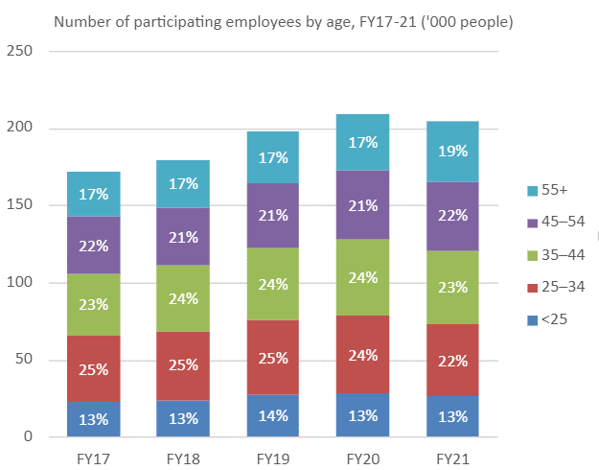
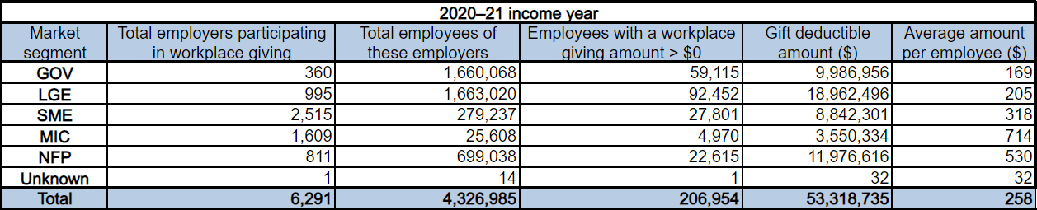
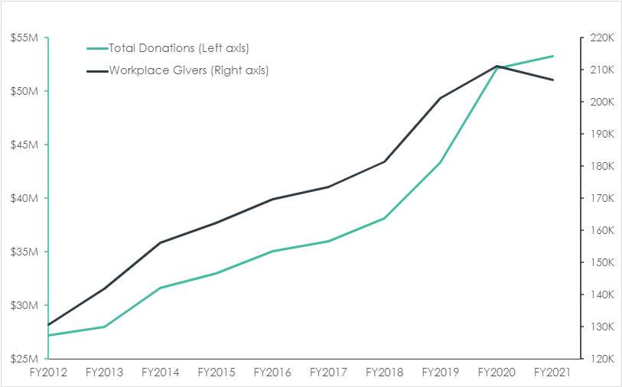

A Central Challenge for Workplace Giving: Participation
There remains a fundamental gap in the philanthropic landscape in Australia that is holding it from achieving more and taking advantage of a culture of giving. Australians do not materially connect with community in their places of work.
The evidence shows that Corporate Philanthropy is significant, with over 70% of businesses contributing to community . Further, it has been assessed that ~$1.2 billion is contributed by the top 50 companies. For the period 2015-2016, one study suggests that c.$17.5 billion in business giving (2015-16), including matching of employee donations, was made.
Likewise individual philanthropy is strong with 64-80% of individuals actively engaged in giving in their private capacity (with 40% of these being committed givers and the balance being opportunity givers). In 2019, 29% of the workforce claimed tax-deductable donations.
However, despite this involvement, there is limited overlap and mutual leveraging of efforts between corporate and individual giving.
Hence, we see from one of the primary levers for Workplace giving, payroll giving that participation is low. Less than 2% of the total Australian workforce with recent ATO data showing a relatively paltry 206,000 workers of the over 13.8 million have availed themselves of the pre-tax give as you earn option presented through payroll giving. Of these 13.8 million workers, over 4.3 million have workplace giving offered by their employer (~30%), so even where available, we are achieving only 4.7% participation.
Compare this to the US where philanthropy with the workforce through regular payroll giving is a resonant part of the business culture involving close to 25% of employees and being offered by over 90% of businesses. The culture of giving is promoted across all aspects of the individual’s life. The outcome is that the US boasts donations of 2.1% of GDP (Gross Domestic Product), compared to 0.81% in Australia. Relevantly, the 2022 CAF Global Giving Index places Australia in 6th place globally on donating money versus the US at 9th place indicating it is not the act of giving, but rather the consistency of giving that is low.
Choosing to give individually misses the opportunity to receive matching and leaves the donor exposed to the risk that they fail to claim the donation at tax time. It is also likely that they are giving less, as the tax deduction is not considered at the time of giving. It is worth noting here that in the UK where there is “Gift Aid” whereby the individual can forego the deduction and gift the balance to the charity, this is used in over 50% of donations. Similarly, where pre-tax amounts are gifted, these are the net amount to the charity so the individual can make a single decision on how much they are looking to donate.
Combining the power of Corporate Philanthropy, with the enthusiasm of the individuals for their causes during working hours has the bonus of creating renewed community and engagement. This in turn has a positive impact not only for individual wellbeing but on the business landscape more broadly with uplifts in productivity and innovation and a decrease in costs.
If, through raising awareness and instilling workplace giving through payroll giving was able to reach 50% of that in the US we would achieve participation rates of c.12.5% of the workforce. Leaving aside matching benefits, this would increase the current $53 million donated by individuals to close to $450 million. If we assume that the current 60% of this amount continues to be matched by the employer on a simple 1:1 basis, that amount would increase to over $710 million annually.
Put simply, for every 1% increase in participation, an additional $57 million would be available to charities.
Part II: Areas to Address and Recommendations
Areas for Improvement and Change
Workers face many of the same barriers and challenges in their workplace as they do as individual donors. This is then compounded by the restrictions, real and imagined, imposed on their employers. Those that we highlight herein are:
[We also note the submission of Philanthropy Australia and support their positions. We have not repeated areas of overlap for the purpose of expediency.]

  - Awareness of Workplace Giving and its Benefits
Recommendation 1.1: Workplace giving in concert with corporate giving be included as a primary pillar in the Federal Government’s strategy for increasing philanthropy.

Recommendation 1.2: A nationwide campaign promoting Workplace giving and encouraging workers to demand action by their employers will have an immediate impact on the 4 million plus workers that have access to payroll giving (including 80% of those employed in Government) and motivate the additional 10 million to demand better. For every additional 1% of participation, the prize for charities is conservatively over $50m in new funds annually.
Workforce engagement in giving both generates more funds for charities and creates community within the workplace. Importantly, the cost of fundraising is significantly lower than most other forms of fundraising. There are clear benefits to the individual, to the charity, to the employer and to our society more broadly.
There is generally a strong availability of payroll giving options within corporate Australia available to the workforce. A study conducted by Workplace Giving Australia of the FY’19 data showed that while the SME sector was under-represented in this area, perhaps due to the perceived and actual costs of participation, for Large companies, for Government and within the NFP sector, there was a relatively high degree of availability.
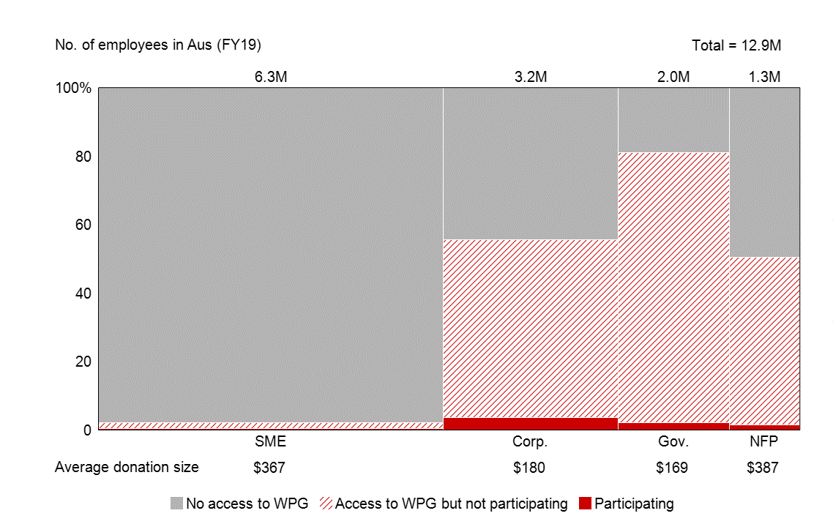
Given this availability and the ostensible benefits to all parties, the uptake is anomalous. Our experience in working to advise corporate clients on increasing the participation of their workforce discloses that often the workers:
- are unaware of the existence of the programme with payroll giving options with their employer,
- do not appreciate the benefits to them and to their supported cause or charity, and/or
- have no expectation as a part of their employment.
By highlighting the benefits of the workplace giving and creating the workers’ expectation that this will be offered and supported by their employer, there will be higher demand for, uptake of and involvement in workplace giving. This will both increase the amounts raised for charities and enhance involvement and community development.
Ultimately, creating a culture of giving as part of everyday life in Australia is the ambition.
As the Federal Government looks to craft and implement its strategy for doubling philanthropy, we would encourage a chapter be devoted to Workplace Philanthropy alongside Corporate Philanthropy as a unique pillar. This grouping might be seen as a significant sector in the same way as the Ultra High and High Net Worth individuals are considered separately to the broader donor population.
A significant advance (and element of any strategy) aimed at driving uptake and participation will be a broad-based awareness campaign aimed at inspiring action from individuals with their places of employment (such as was the case with the “slip, slop, slap” campaign). The outcome of such a campaign would be to create awareness of the options and their benefits to the individuals, and build the case that will engage the majority of the over 2.5 million Australian employers. This may be part of a broader campaign as mooted by Philanthropy Australia.
Further, promoting workplace giving and payroll giving should be considered a priority for our government departments, which have the highest access to payroll giving of any sector.
- Transparency on Donated Funds and fundraising aggregator business models
Recommendation 2: The introduction of a register as the Payment Times Reports Register (perhaps even within the same framework) supported by similar conditions on reporting obligations would be a simple method to address this aspect and ensure the right thing is not only being done but is being seen to be done.
Within the corporate giving landscape there is an increasing number of for-profit players providing services to the charity sector to support peer-to-peer and other fundraising initiatives. While these have a valuable role to play in developing and promoting the sector, it needs to be clear to the donors and the charities the method of operation and where the money is going.
Making this more complex is the fact that such entities can be established such that they have a DGR2 foundation to provide the charitable deduction and consolidate the funds. While these foundations are ostensibly held separately, they are intimately tied to the for-profit entity which has overhead expenses (and in some cases shareholder expectations) to meet.
Currently there is no obligation for any disclosure as to how these businesses operate and how they fund their business needs or where the profits go. For example, there are instances where the money raised from donors is held for an extended period, generating additional income through interest. This has the effect of delaying distribution to the intended DGR recipient charity and is not in line with the donor expectation and their understanding of how their money will be treated. In some cases, a portion of the donor’s money is filtered to shareholders of a for profit in Australia or overseas. While this is not inappropriate if clear, it should be stated succinctly and not hidden in obfuscating terms, or not at all.
Where a for profit establishes a charity vehicle such as those used for what is termed in the US "donor advised funds” there should be a clear and transparent connection made so that donors are not misled as to where their funds are being directed. Where a profit taking entity is involved, this should be made apparent and sufficient detail provided such that the donors are clear on the costs of fundraising.
Further, unlike corporate Australia where the Payment Times Reporting Act 2020 and associated regulations apply, there is no regulation regarding the timing of payment of collected donations from aggregators (including DGR2 foundations) to the intended recipients.
However, in the same way in which small business operators are looking for protection against unscrupulous practices from large companies, Australian charities are looking to ensure that they are receiving funding in line with the donor and charity expectations and that these funds are not retained unduly by 3rd party aggregators.
Mirroring the Payment Times Reports Register, information on how long the donation is held before reaching its ultimate destination will help donors, charities and corporations make informed decisions on who they support.
- Introduce a requirement to provide a clear and simple statement on the website of entity or affiliate which sets out the relationship between them (including equity funding), the way the operations are funded and where the money goes (including any profit) – this would apply to all DGR registered entities as well as the corporate arm
- Introduce a requirement to provide clear and simple statement on the timing of distributions of funds from fundraising and/or aggregator charities
- Include reporting every 6 months on the payment times and terms to end point charitable causes (publicly available on the ACNC register)
- Provide an expectation for acceptable timing of payments which are aligned to the expectation of the donor

- Reduction of Avoidable Giving Aggregation Overheads
Recommendation 3.1: Establishing (or endorsing) an industry body with oversight for developing a set of standards on data and technologies for charitable purposes would complement the current ACNC (Australian Charities and Not for profits Commission) data and enable a reduction in the costs which place a drain on the donation pool and the percent which flows to the causes for which donations are made.

Recommendation 3.2: Establish a Donor ID (or Social Giving Number) which enables a donor to manage their data independently and regardless of platform being interacted with. Will also enable porting of history to new employment in same manner as mobile phone numbers can be transferred to new providers.
While workplace giving is extremely cost effective and has the potential to generate significant funds for community causes, there are hidden friction costs as a result of the way in which the sector has evolved. While technology has provided structural advances, it has evolved in fragmented manner with multiple players. This is not unique to the philanthropic sector but is compounded by the fact that there is no driver to consolidate and harmonize as there may be in other sectors.
The creation of a set of standards aimed at servicing the various players engaged in workplace and corporate philanthropy (and beyond) and aligning technologies is an important step in reducing costs while enhancing transparency for the donors and charities.
This would also pave the way for a consistent donor identification system maintained by the individual to enhance their giving experience. This would enable the linking of various methods of giving including peer-to-peer sponsorships, payroll giving, one off donations and volunteering, as well as automating the tax components.
The current landscape is broadly set out in the following diagram:
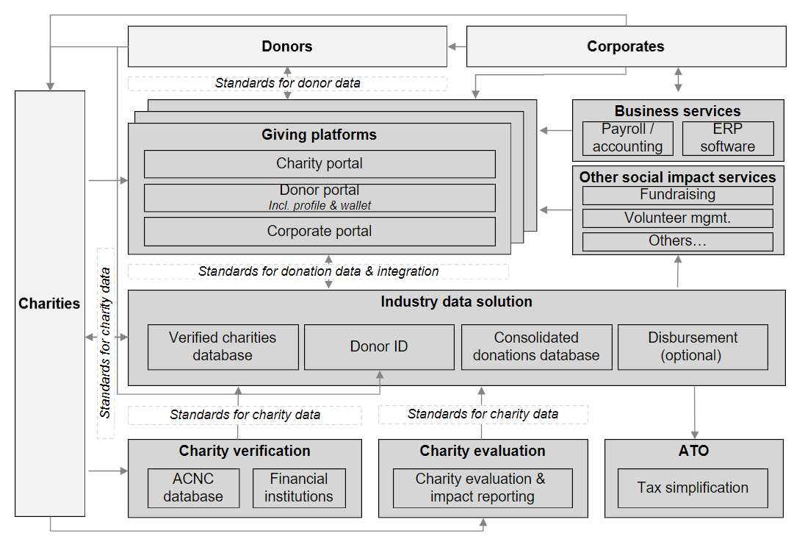

The current, common data is provided by the ACNC and ASIC. This data is useful but is insufficient. Similarly, several organisations hold their own additional information on the charities with which they engage. However, there is not standard on the information gathered and maintained.
Each of the players involved have information requests of one another. There is a known desire for harmonisation of this information such that it can be captured once and then made available multiple times and for different purposes. However, there is no consolidating pressure nor industry lead that has the backing force to drive this harmonisation. The result is that there is little in the way of standards creating significant friction costs. Actions are repeated for all players, creating complexity for all concerned and making the process problematic particularly for smaller charities.
One example of this is the need for information from the individual charities to enable payroll giving. Each of charity is approached for verification and communication information at onboarding and thereafter on an ad hoc basis. The information includes not only that held by the ACNC and ASIC, but additional items such as current director details, key person disclosures, bank details, impact assessments and historical information. This same information is required by each of the aggregation players such as payroll providers, peer to peer platforms and volunteer platforms. Adding to the complexity and load is the demand from corporations for details for verification and ongoing communication in the course of maintaining its own program.
Compounding the multiple interactions, is the demand for different formats for the provision of information. Impact stories, for example, may be of different lengths or have a different API mechanism to feed them. Similarly, any graphics or images may come with different dimensions and weights.
Clearly, there are costs that are incurred that could be better mitigated and removed from the charities. These additional costs are incurred by donors, the charities, the corporations providing workplace giving and to the philanthropic ‘system’ more broadly. While difficult to calculate accurately, estimates on the total cost to the sector places the figure north of $100m per annum.
Costs to Donors
Donors suffer from a lack of visibility on impact and are unsure how to determine which charity (or charities) they will support. 86% of Australians report being more likely to engage with an organisation that clearly communicates its impact and 41% indicating that if they knew where their money would be spent this would encourage them to give more.
This lack of clarity not only prevents the conversion of intent to action but creates additional cost to both the donor in investigating and reviewing the charities they might elect to donate to.
It is noted that preliminary evidence suggests that those involved with giving through workforce giving are more likely to de-prioritise their involvement in selecting a charity and take more interest in the impact of the donations made (whereas individual givers spend proportionately more time in assessing impact as part of their choice process and less involvement in post-donation acquittal of impact).
We also note here that there is an additional cost where the donor moves employment as the current processes are aligned to the corporate and not to the individual. Hence, while employed with one organisation that employee can participate simply with their charity, in the event they move to another organisation, they must start again as if a new donor. This break in the cycle is frustrating to the donor in many ways including in the lack of any continuous record of their charitable involvement over their years of engagement.
Costs to Charities
In discussions with charity members with whom we deal and more closely with those within our Network, we know that there are friction costs in the workplace giving environment. The most notable of these stems from the lack of any common or systemic data regarding the charities themselves.
There are several fundraising intermediaries that engage with corporate and workplace giving. This includes those providing payroll services such as Good2Give, as well as those providing applications and services for fundraising and volunteering. In addition, many corporations elect to maintain their own payroll and other aggregation services for their workforces or who have a foundation (or foundations) which deal directly with charities.
Hence, a charity which is focused partly or in whole on working with corporate Australia must provide information at various levels to each of these parties. This starts with initial verification information over and above that which is available through the ACNC database and the ASIC information. Examples of this data will be bank account details, current director details and relevant financial information.
The charity will also have the burden of providing ongoing information, not only for ongoing verification, but also regarding impact, initiatives, and programs.
Compounding this is the fact that each of these aggregators, fundraisers and corporations may seek the information in a different format and at various times.
Costs to Corporations Providing Workplace Giving for its Workforce
First, the corporations have overhead in obtaining information from charities. The same information that charities are expending time, effort, and cost to provide to the multitude of entities as noted above.
Whether the corporate uses a services provider or undertakes the work itself regarding payroll giving, workforce giving and/or volunteer matching, there is the burden of verifying both the donor (where over a certain amount) and the recipient for AML/CTF and other purposes.
Further, businesses are increasingly aware of the risk reputationally and otherwise in connecting closely to charities. This is particularly the case where they offer, for example, employee matching whereby they donate to charities alongside their workforce as this is often taken as an endorsement of that charity. Hence, they need to not only verify the charity at first instance, but then re-qualify them on a regular basis.
Hence there is often an overhead burden on the business which is compounded by the need to approach each charity alongside the use of the ACNC and ASIC data available.
Size of the Prize
The benefits to solving the friction issue are:
- Increase in flowthrough rate to not-for-profit cause areas (reduction in charitable overheads)
- ease of data capture and provision
- accuracy and validity
- accessibility
- security/privacy.
The cost to the sector of the friction in the system generated by the lack of a single source of consistent information is difficult to calculate accurately, not least as the lack of action from the donor resulting from indecision is not known. Further, this friction also prevents many businesses from engaging with their workforces through workplace giving and payroll deductions, particularly the small and medium enterprises that have neither the funding nor the staff to conduct this work.
However, even if we look at payroll giving alone as it currently stands, the following suggests an indication of minimum cost and value in addressing.
In the 2021 Tax Year, the ATO data and analysis indicates that c.$100 million was gifted via payroll giving with matching by employers. On average, the cost of fundraising is estimated at 18-32% equating to c.$20-30 million per annum. For every 10% of that cost that can be reduced, an additional $2-3 million would be available to the cause rather than in administration and overhead. This does not account for the costs to business outside the donation.
If we assume that payroll giving in Australian can be driven to a level equivalent to, say, the UK at 10%, then the total amount of savings would increase to over $100 millon.
The information a common system would provide would also be of significant value to enable more tailored activities which consider the trends in donor sentiment in Australia with consistent data tracking.
Finally, the same barriers exist regardless of whether this is viewed in the context of corporate and workforce giving. Hence, in solving for this area, there are extended benefits more broadly.
Addressing the Friction
While the optimal solution may well be a single maintained database of information fed from various sources including the charities as the ultimate solution, this is unlikely to be feasible for a multitude of reasons. Hence, we have outlined the elements of a solution which should be considered using the more realistic approach of creating standards for use by all, enabling private parties, charities and government to collaborate informally to a common end. Government support and endorsement of this approach would accelerate the outcomes and provide confidence for the parties to move forward.
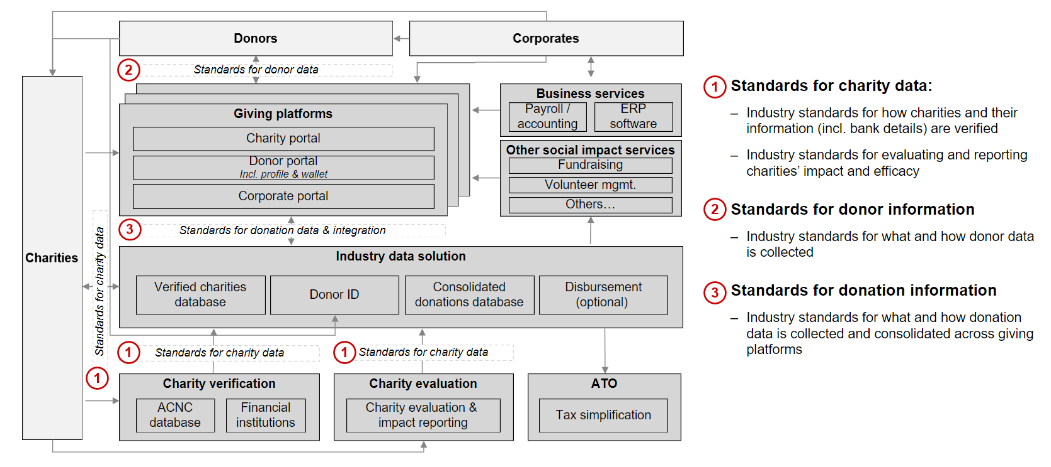
Elements
The ‘minimum viable product’ toward a solution would be the creation of a common set of requirements for a verified charities database. While this would ideally be a single, unique dataset, provided the information was set within a common framework and standard, then more than one database would be workable. This would contain common information drawing on the information currently within the ACNC and ASIC but extending the dataset to meet the majority of the industry needs.
Ideally, a common and agreed charity verification process would be arrived at, such that the charities who engage with this form of giving are able to provide information once and ongoing to a central point.
There is also a need to ensure standards for integration the platforms (such as giving platforms) to ensure a common industry solution is available.
As part of a first wave of activity, a single industry body might be created to gather and harness the desires of the whole sector rather than playing to the individual needs of the parties.
The second wave of activity would focus on consolidation of donation data and streamlining of back-end operations. This would be aimed at reducing further the involvement and hence the cost of 3rd party operations which sit between the donor and the charity.
During this wave of development, there might also be included donor data standardisation, including a donor ID. It is important to note that while the donor ID would be common, the donor information would be retained by the donor and owned by them uniquely. This would allow portability for the individual on their terms while ensuring that privacy aspects are honoured. Ultimately this might also link directly to tax filing processes by automatically importing donation records to the ATO using the ID providing further benefit to the donors.
At this point, there might also be the ability to consider charity search and filter functionality which might be leveraged by donors. Through the use of available technology such as QR codes and mobile devices, the donor would be able to be linked across their activities in real time and a record retained by them of all activities. This would also enable portability on change of employment and enable smooth transitioning between different platforms.
Having the information retained by the donor as the central point reduces privacy concerns or the spectre of a Government run program.
The third and final wave of activity would be focus on improving the front-end user experience including providing commentary on impact. While it is not anticipated that this would be a rating-based system given the inherent differences across the charity sector and the evident inability to dictate impact metrics that would match all, it is of clear value to enable the charities to provide their statement on their impact in a manner that is relevant to their own impact measures and is useful to their donors.
Hence this third wave of activity would promote:
- standards for base evaluation of charities
- integration of impact reporting statements for common access
- integration with other providers (for example social media)
- UX enhancements such as corporate self-service portals, donor portals and the like.

- Removal of Barriers to Adoption in the Workplace
Recommendation 4: An amendment to the Fair Work Act to clarify the applicability of s.324 to workplace giving through pre-tax payroll opting out is recommended.
Alternatively, a ruling or statement that clarifies the intent of s.324 would assist in reducing the perceived risk to corporates and encourage uptake of this method of engaging with their workforce.
In our pre-budget submissions to Treasury in February 2023 it was suggested that amendment to the Fair Work Act would improve the uptake and impact of workplace giving through payroll donations. While this remains a valid ambition, an interim step would be for clarification of intent regarding the applicability of s. 324 of that Act to payroll giving.
It is noted here that one element of the unintended consequence of this legislative provision is that simple, one-click sign up to workplace giving is thwarted. This adds cost to the providing party in administration and makes it more likely for the employee to drop out during the sign-up process. It is also note in line with the UX expectations of the donors.
The February 2023 submission is as follows:
Workplace giving through regular payroll deductions is a highly effective way to enable workers to gain the support of their employer organisations their charitable giving. The data shows that where an Opt-In approach is implemented, requiring the worker to notify the employer of their desire to be involved, the average take up is less than 5%. Where an Opt-Out approach is adopted, the rate of uptake is over 20%.
Opt-Out enables the default position for an organisation to provide for regular giving with notice and as part of the overall remuneration of the worker. In the majority of cases, it would also be accompanied by matching contributions by the employer.
However, there are barriers to overcome in order to promote workplace giving. This includes removing risk and complexity for employers as they seek to create programmes aimed at engaging and enabling their workers in giving. One perceived barrier is the unintended consequence of the Fair Work Act, specifically section 324 on the use of opt-out approaches to workplace giving via payroll deductions.
While s.324 was clearly not aimed at preventing workplace giving, risk-averse corporates and their advisors are nervous about introducing opt-out based programmes for fear of offending against the section.
Historically, the effective immediate tax deductibility of regular payroll giving contributions originally became permissible under a 2 July 2002 ruling of the Australian Taxation Office (ATO) set out in the Commonwealth of Australia Gazette S.251 (Regular Payroll Giving Instrument). This has been superseded by various legislative instruments (which remained substantively the same as the original ruling), the most recent of which is F2016L01641. The Regular Payroll Giving Instrument stated that, for the purpose of working out how much a payer (employer) is required to withhold under the PAYG tax withholding schedules, the payer may disregard so much of a withholding payment paid by the payer to a Deductible Gift Recipient (DGR) at the direction of the payee.
The Regular Payroll Giving Instrument related only to ‘regular planned giving arrangements’. In 2009, the Government extended the scope of the taxation withholding benefit to ‘occasional giving arrangements’ (such as one-off donations by employees following a natural disaster). The initial Legislative Instrument permitting this was F2009L01143 (18 March 2009) (Occasional Payroll Giving Instrument). (The most recent version of this is F2014L00012).
Despite these Instruments, an ongoing concern in relation to giving to charities through payroll deduction is mooted given section 324 of the Fair Work Act 2009 (Cth). This section has, as noted, led to some hesitancy among employers about introducing an opt-out program, given that there is some ambiguity as to what the section requires before a payroll deduction is properly authorised by the employee.
Relevantly, the section provides that a deduction from an employee’s wages is lawful only if:
- the deduction is authorised in writing; and
- the deduction is “principally for the employee’s benefit”.
Both elements of section 324 raise questions.
First, what is written authorisation – are there any formal requirements, or does there only need to be a record which demonstrates the employee’s assent? There are many ways an employee might authorise a deduction – sending an email, signing a form, or agreeing to it in an employment contract or letter of employment. It is less clear that an agreement to a deduction up front, but with a right to withdraw their authorisation at any time, can provide an ongoing authority. This arrangement might be described as an authorisation, in the sense of the section, and always subject to a right of veto by the employee.
Second, when does the deduction involve a benefit to the employee when the deduction will be paid to a source other than the employee? A salary sacrifice deduction is clearly for the employee’s benefit, given it will typically be structured to minimise tax by taking a non-cash benefit. Similarly, a deduction of a necessary payment, such as mortgage payments, is easily justifiable as being for the employee’s benefit. What is less clear, on a literal reading of the section, is that a charitable donation is for the employee’s benefit. The benefit to an employee is both philanthropic and economic to the extent of the income tax deduction. Yet it is inconceivable that the section would be taken to prevent an employee expressly authorising a deduction to a charity of their choice.
We believe the two elements in the section cannot be read in isolation. In other words, the more clearly the employee’s authorisation, the more easily the section will accept that the payment is for the employee’s benefit. But this lacks certainty.
The lack of certainty is said to function as a deterrent to employers embracing deductions for charitable purposes, even if the employee always retains the right to withdraw their authorisation at any time.
While there are sound policy objectives behind the section, there is a countervailing policy consideration which balances the importance of charitable donations and maintains the policy objective of section 324. We support a review of section 324, in light of this concern, to permit workplace giving not only when an employee authorises the deduction in writing but also when the employee has been advised in writing of the proposed deduction and does not provide the employer with a contrary direction after the employer gives the employee a reasonable opportunity to do so.
Of course, whichever way the authorisation is given, the employee always has the right to withdraw it, from which time deductions for charitable purposes would immediately cease.
This may be achieved through clarifying the Fair Work Act 2009 (Cth), as follows:
Section 323
Insert the words “and section 324A” after “324” in Section 323(1)(a)
New section 324A
Insert the following section as a new Section 324A:
“Payroll giving”
(1) Deductions for the purposes of donations within the class of cases referred to in Legislative Instruments F2016L01641 or F2014L00012, as replaced from time to time are taken to satisfy subsection 324(1) if they are made in accordance with one of the requirements of subsection 324A(2).
(2) For the purposes of subsection 324A(1), the requirements are:
a. the employee authorises the deduction in writing; or
b. the employee has been advised in writing by the employer of the proposed deduction and does not provide the employer with a contrary direction after the employer gives the employee a reasonable opportunity to do so.
Practically, this might be supported by a process of written confirmation to employees on a periodic basis, which:
- confirms the standing payroll deduction; and
- reiterates the employee’s right to withdraw their authorisation at any time.
An amendment to section 324, clarifying these matters so as not to discourage charitable donations seems to us both possible and viable, without prejudicing the underlying purpose of the section.

- Simplification of International Gift Aid
Recommendation 5: Adopting a model akin to the USA whereby there can be an equivalency determination made for a charity anywhere in the world which thereby enables a charitable gift to be made via a Donor Advised Fund to a charity which is equivalent to a local charity. Alternatively, funds can be distributed through expenditure responsibility procedures, whereby the foundation in Australia assumes the liability to ensure that the funds are spent on the charitable purpose intended within an overseas jurisdiction.
Australians are engaged in international philanthropy. However, this is often cumbersome in the event as a result of the unintended consequences of several procedures and regulations.
Australian businesses and their people often have strong overseas connections, with many having affiliated entities offshore. Employees in Australia have often lived and worked in foreign countries.
There is also an ongoing need for foreign charities and causes to be supported from outside their own countries. For some this is permanent need and for others based on events driving appeals such as the 2023 earthquakes in Syria and Türkiye. Overseas Aid is one of the top 3 causes that Australian workers choose to support and responding to appeals accounts for over 1/3rd of payroll giving donations.
However, to donate to overseas causes, the route for the money is through an Australian charity which has been through the Overseas Aid Gift Deduction Scheme process. This is not a straightforward process and is therefore not practical for most charities. Hence most of the funds are directed via a large, international charity. While has many advantages, and satisfies AML/CTF concerns, it limits choice for many donors.
It is also well known that Australian businesses often have New Zealand affiliated businesses and more broadly our relationship with New Zealand is particularly close. It is not surprising therefore that many sought to provide assistance in the 2023 Auckland floods. What was surprising to many was the fact that their donations would not be deductible, unlike the donations made to Pakistan during the 2022 floods in that country.
Today, to facilitate the donation of money to an international cause, the donor must give to a registered, DGR, Australian charity to obtain the tax deductibility for the gift. If that gift is given to a DGR2, which is often the case in circumstances involving a foundation such as those that enable pre-tax workforce giving or are corporate foundations, then that DGR2 must find an Australian registered DGR1 charity to provide the consolidated funds for, which in turn must have an arm or cause in the place where the funds are being directed.
The Overseas Aid Gift Deduction Scheme (OAGDS) enables the issue of tax-deductible receipts for donations to “their overseas aid activities”. Further, these must be to support aid activities in countries that are declared a ‘developing country’ by the Minister for Foreign Affairs.
The organisation must also be an ‘approved organisation’ as declared again by the Minister for Foreign Affairs. To gain this approval, the organisation must apply through the Department of Foreign Affairs (DFAT) and meet the eligibility criteria.
Once an approved organisation, the organisation must then establish a Developing Country Relief Fund. This is a public fund administered by the Australian Tax Office (ATO). This is then the subject of an application to the ATO seeking the Treasurer approve the fund.
If all is in order, and all steps are addressed, the Treasurer then publishes a notice in the Commonwealth Government Gazette declaring the fund to be a developing country relief fund. The date of the Gazette publication is the date from which donations can be provided with tax deductible status.
Hence, for example in the recent case of the earthquakes in Türkiye and Syria, to donate via employee giving tax effectively (and with matching), it was necessary for the facilitators of the initial gift to work with Australian based charities with arms in these locations that were engaged in the relevant support aid activities. Their money was, after having been deducted, matched, and consolidated, gifted to the local Australian DGR1 with OAGDS status (such as UNICEF or Australian Red Cross) for them to send overseas to their local arms as part of the OAGDS. Whilst cumbersome, this is workable.
However, compare this to those seeking to help in the recent New Zealand floods by donating from Australia. As New Zealand is not a developing geography, the OAGDS does not apply and so no tax deductibility can be established. Hence, while legitimate New Zealand charities might have well done with financial support in their work, for an Australian to donate they would need to forego the tax deductibility.
The secondary issue in all of this is with the term “their activities”. While an expanded definition of this term would stretch to include activities that were contracted to a 3rd party, there is no formal definition which would confirm that this is the case. Therefore, at a minimum to donate to an OAGDS, the local DGR1 charity would need contract with a local delivery agent for a particular purpose (that aligned with their DGR1 status and objects) and at the extreme, only use the money for its own activities.
Comparative Approaches
United States of America
Americans can donate via a US 501 (c)(3) charity and receive a tax benefit accordingly. To donate to overseas charities, they must either be deemed to be the equivalent of a US 501(c)(3) public charity (ED) or meet the Expenditure Responsibility (ER) requirements. Both ED and ER are protocols approved by the IRS for tax effective giving.
The intermediary must conduct verification of the charitable purpose that the funds are remitted to.
No political activity can be funded through tax-deductible gifts. Donors cannot receive any substantial private or commercial benefit. Extra steps exist if directing support to individuals or employees, capital projects, endowments, or scholarships.
Canada
The legislation in Canada was changed recently and the sector is awaiting the release of the accompanying regulations to clarify how this will work going forward. However, it is believed that Canada will become more akin to the US in its treatment of foreign giving.
As it currently stands, the Income Tax Act in Canada allows a charity to operate outside of Canada as long as the charity is conducting its own charitable activities through either its own staff or an intermediary.
To be compliant with these regulations, CAF Canada must enter into a Project Agreement with the intermediary and ensure all the following:
- The Project Agreement is specific to the funding being received from CAF Canada/Canadian donors and cannot be commingled with funding received from other sources.
- The Project Agreement must be consistent with CAF Canada’s Charitable Objects.
- The Project Agreement must detail a timeline of when project reporting is due, to show a record of direction and control throughout the life of the project.
United Kingdom
UK charitable tax reliefs are available where the recipient is equivalent to the UK Charities and Community Amateur Sports Clubs for EEA countries (EU, Norway, Iceland, and Liechtenstein). However, these charities would need to be recognised by HMRC. Donations to non-EEA based charities are generally not qualified for UK tax relief.

- Enhancing Gifting of Non-Cash Items
Recommendation 6: Removing CGT liability on gifts to DGR registered charities would immediately simplify and uplift the donations to charities of non-cash items. This is in line with treatment in the UK, Canada, and the USA (and noting there is no CGT in New Zealand).
Today, a gift can be given of either money or property and, provided it complies with the requirements for deductibility, can claim the value of that gift as a tax deduction. The deductibility threshold for a gift of cash is $2, and for property is $5,000. Further, property deduction require a Certificate of Donation provided by the DGR charity and a valuation from the ATO which is triggered by a request for valuation (and its accompanying fee).
If the item has also attracted a capital gain, that gain will be included in the donor's income and be taxable. Hence, while the donor gains the benefit of the deductibility of the gift, this is negatively impacted by the impact of the CGT.
For example, the donor gifts shares valued at $10,000 which were acquired for $2,000. On the gifting, there is a crystalising of the capital gain of $8,000. If there is capital gains tax payable at, say, 37%, then this would mean the donor will likely incur a tax obligation of $3,700. They would also be entitled to a tax deduction for the $10,000. Hence, there is little incentive to donate the full $10,000 in shares but rather to realise the asset and then donate the post-CGT amount cash amount of $6,300 (perhaps less once broker fees are taken into consideration). The result is a lower gift value to the charity.
In the US, there is generally an exemption from the need to pay capital gains on charitable donations of property. Likewise, in the UK you do not pay CGT on land, property or shares gifted to charity. Hence, the donor can take the income tax deduction at the full value.
Similarly, in Canada, while more limited, for certain types of property including shares, there is a zeroing of the capital gains implications such that the donor will again benefit by paying no tax on the disposition and will receive a charitable donation receipt for the fair market value of the gift at the time of donation.
The removal of CGT in Australia on charitable donations would increase the value to charities of gifts and make matters simpler for the donor. Illustrating this is the example of ShareGift UK and ShareGift Australia, each set up to facilitate the gifting of shares to charities. Over 25 years, the former has received GBP44m (~$AUD82m) in share donations whereas ShareGift in Australia has attracted a total of c.$AUD7.5m since it commenced operations in 2004 predominantly for parcels which are unmarketable.
Alternatively, a gift to a registered charity might be included as an exemption to capital gains tax as is the case for compensation or damages received for a workplace injury.

- Improvements to Corporate Reporting and Communication of their Philanthropic Endeavours
Recommendation 7.1: Creating common definitions regarding entities in and around the charitable sector with the endorsement of the governing body or bodies (such as the ACNC and/or ASIC (Australian Securities & Investments Commission)) to provide clarity to the public including on what criteria is met to achieve that classification.

Recommendation 7.2: A common framework which could be adopted by corporate Australia in reporting would benefit them and the donors in clarifying the efforts that are being made in a comparative manner.
There is currently little common ground on how and what corporate Australia reports with respect to its philanthropic engagement. This leads to disparate information in the market and erodes confidence of the public in the role of corporates to the ultimate detriment of the charity sector.
Similarly, there is no common definition or requirement on making claims that tend to suggest organisations are philanthropic when they are not. While there is every reason to continue to encourage involvement of for profits, there should be clear differentiation to charities and to not-for-profits. The current confusion is not only detrimental to the sector but also for the for-profit players that are set up to achieve social good.
In the absence of any formal definitions, the market is making its own definitions which has a risk of becoming misleading or opaque. Examples of this includes:
- B Corp: an American invention that boasts 470 Australian companies. For registration as a B Corp the company must be “committed to creating benefit for all people, communities, and the planet” , be certified by B Corporation and pay an annual certification fee
- For Purpose, For Profit (and sometimes simply For Purpose): Generally used for genuine reasons with entities established for purpose motives alongside the profit motive. The risk is that they are mistaken for non-profits or charities
- Social enterprise: As there is no legal structure for social enterprises, these can be not-for-profit, for profit or a hybrid. They have a core social purpose built into their business model.
Further, when it comes to reporting their philanthropic activities, there is little guidance or guidelines for corporate Australia to follow. While over time bodies such as AASB, GAAP and IFRS are likely to develop financial reporting standards to, there already exists a short-term need. Without creating a strict requirement, a consistent framework designed for use in measuring social impact, such as that created by Business for Societal Impact (B4SI), would be advised.
Donors, consumers, and the charities reliant on corporate involvement would be better served by clarity on what the expectations are for communicating philanthropic engagement.


David Mann
Chief Executive Officer

Nikki Anstis
Head of Advocacy and Engagement

https://workplacegivingaustralia.org.au/

Workplace Giving Australia research report 2022
ACNC Annual Report 2020-2021
For example, reference work of Michael Norton and Elizabeth Dunn: “How Money Actually Buys Happiness” Harvard Business Review (HBR) June 2013, “Help Employees Give Away Some of That Bonus” HBR July-August 2008
54% of Australians say that the social fabric that once held Australia together has grown too weak to serve as a foundation for unity and common purpose per 2023 Edelman Trust Barometer
This might be termed more accurately Employer Philanthropy as it would include non-corporate entities, such as partnerships and Government departments.
Late 20th century economic views such as agency theory dismissed corporate philanthropy contending that corporates existed for the sole purpose of maximizing shareholder wealth (“Comparing big givers and small givers: Financial correlates of corporate philanthropy.” Journal of Business Ethics, 45, 195-211 by Seifert, Morris, & Bartkus, 2003; Weyzig, 2009). Competing theories including those of strategic philanthropy “The competitive advantage of corporate philanthropy.” Harvard Business Review, 80(12), 56-69 Porter & Kramer, 2002 and The Shape of Corporate Philanthropy Yesterday and Today | Grantmakers in the Arts (giarts.org) McClinton 2004), stakeholder theory, corporate citizenship theory, and ethical theories contend that societal benefits of corporate philanthropy are part of the corporate purpose (“A stakeholder framework for analyzing and evaluating corporate social performance.” Academy of Management Review, 20, 92-117 Clarkson, 1995; “A stakeholder approach to corporate social responsibility: A fresh perspective into theory and practice.” Journal of Business Ethics, 82, 213-231 Jamali, 2008). See also “Strategic Philanthropy: Corporate Measurement of Philanthropic Impacts as a Requirement for a ‘Happy Marriage’ of Business and Society” by Liket and Maas, Business & Society 2016, Vol.55(6) at 889-921.
See also case studies including JB Hi-Fi, Dominoes Pizza, CBA, Tomago Aluminium inter alia https://library.workplacegivingaustralia.org.au/?p=1&f=case-studies
Donations claimed refers to tax deductions made by individual taxpayers for donations to deductible gift recipients.​Total number of taxpayers is based on the number of tax returns lodged by individuals.​ Data for the period 2016–17 to 2018–19 income years were sourced from individual income tax returns processed by 31 October 2020. The statistics are not necessarily complete​. 2019 global charitable giving by individuals as a % of GDP data shows consistency with the CAF 2016 report; individuals in countries with lower levels of employer social security contribution are more likely to give more ​.Source: ATO 2021a (Individuals–Table 1), AIHW analysis of ABS 2021; Gross Domestic Philosophy: An international analysis of GDP, tax and giving (CAF 2016)
Workplace Giving Australia research report 2022, data and analysis
Workplace Giving Australia data: Good2Give client experience, OneMillion Donors website.
Apart from member based standards organisations like B4SI, there is no standardised reporting framework for corporates and their support of charities. This allows non-transparent claims and will erode trust. It also places more strain on the charity sector who needs to respond to each corporate for reporting differently.
“Double the Donation” https://doublethedonation.com/matching-gift-statistics/
This might be termed more accurately Employer Philanthropy as it would include non-corporate entities, such as partnerships and Government departments.
Workplace Giving Australia data: Good2Give client experience, OneMillion Donors website. Case studies can be found at: https://www.1mdonors.org.au/the-case-for-workplace-giving/
ATO data 2022 indicates 29% of taxpayers claimed tax deductible donations
This may have the added benefit of increasing the donation to charity as many individuals will elect to pay the full amount rather than the deducted amount to the cause as is evidenced in the outcome for the UK Gift Aid program.
Workplace Giving Australia analysis of Good2Give 5 year data shows that only 40% of donors want to be contacted directly by the charity they chose to support, while the remaining 60% prefer the anonymity of workplace giving.
“Project ROI: Defining the competitive and financial advantages of corporate responsibility and sustainability” Babson Social Innovation Lab, (2015) S Rochlin, R Bliss, S Jordan & C Yaffe Kiser
69% of employees report that having societal impact is a strong expectation or deal breaker when considering a job per 2022 Edelman Trust Barometer
“Becoming Irresistible: A New Model for Employee Engagement” Deloitte Review Jan 27, 2015. “For Millennials, Is Job-Hopping Inevitable” By B Rigoni and B Nelson, November 2016
“Becoming Irresistible: A New Model for Employee Engagement” Deloitte Review Jan 27, 2015.
“The Relationship between Engagement at Work and Organisational Outcomes 2020 Q12 Meta Analysis 10th edition” Gallup, October 2020
Op cit
Op cit
Workplace Giving Australia primary research 2022, “True Gen: Generation Z and its implications for companies” by T Francis & F Hoefel, McKinsey & Company
“Corporate Philanthropy, Reputation Risk Management and Shareholder Value: A Study of Australian Corporate Giving” by Hogarth. Hutchison and Scaife, 2018.
“Disaster Relief Inc.” by Hao Liang and Cara Vansteenkiste, 2020
Workplace Giving Australia primary research 2022. McKinsey Quarterly – September 2021 “Great Attrition or Great Attraction”. “Engagement in Corporate Giving: How Companies Can Involve Consumers and Employees in Financial Donations” by Wakefield
60% of consumers cite an increase in willingness to pay up to 17% more for socially responsible products and services. Workplace Giving Australia primary research 2022, 63% report that they buy or advocate for brands based on their beliefs and values per 2022 Edelman Trust Barometer. See also “True Gen: Generation Z and its implications for companies” by T Francis & F Hoefel, McKinsey & Company. 2018 Cone/Porter Novelli Purpose Study: How to Build Deeper Bonds, Amplify Your Message and Expand the Consumer Base” by Cone Communications March 2021. “The Corporate support Report: The Evolution of Corporate Giving and Community Investment in Australia” by John McCleod, March 2022
“Project ROI: Defining the Competitive and Financial Advantages of Corporate Responsibility and Sustainability” (2015) Babson Social Innovation Lab meta analysis report (USA) includes findings of 4-6% uplift in market value, 1% discount in cost of equity and reduction in share price volatility between 2-10% for corporate responsibility & sustainability performers
For example, 79% of Australians believe CEOs are obligated to ensure their home community is safe and thriving per 2022 Edelman Trust Barometer
In English law from which Australian law and models evolved, the corporation evolved to fill the void in partnership law that existed due to the unlimited liability which the partners exposed each other to in any joint venture. In 1844 the first corporation in the current form was created with the Registration Act 1844 enactment that both enabled individuals to register a company and to define its purpose. This was further advanced in the Joint Stock Company Act 1855, which severed the role of Government oversight and thereby, the connection with social purpose, and the Limited Liability Act 1855 whereby shareholders were awarded limited liability. Some 30 years later the US Supreme Court first recognised the corporation as a ‘natural person’ (a legally distinct entity that has the rights attributed to individuals) in 1886 in the case Santa Clara County v Southern Pacific Railroad Co., 118 U.S. 394 (1886).
Reference also Milton Friedman and the Chicago School of Economics
Corporate Powers as Powers in Trust” Berle (1931) 44 Harvard Law Review 1049, “For Whom are Corporate Managers Trustees”(1932) Merrick Dodd, 45 Harvard Law Review 1145, “Shareholders as Stakeholders; Changing Metaphors of Corporate Governance” (1993) 50 Washington & Lee Law Review 1409, “Corporate Governance in these Exciting Times” Hanrahan (2017) 32 Australian Journal of Corporate Law 142, “Corporate Social Responsibility” Hanarahan (2019) 36 Corporate and Securities Law Journal 665
Treatise on Law of Corporations – Stewart Kyd 1793
Reference also Rhine Capitalism or the Social Market Economy
Workplace Giving Australia analysis of Good2Give data (53% to 61%) and of OneMillion Donors data (61%) as at March 2023 over 5 years. USA reports indicate 65% matching by Fortune 500 companies per Double the Donation.
One to One matching is offered in over 98% of instances examined with the remaining set a 50% matching
See also for example “Non-standard Matches and Charitable Giving” by M Sanders, S Smith & M Norton – Harvard Business School working paper 13-094 May 2013
McNair YellowSquares June 7, 2022 “Donations Decrease for First Time since 2015”
There are different forms and types of hybrid programmes that can be implemented
“Different Drivers: Exploring employee involvement in corporate philanthropy” by B Breeze and P Wiepking (2018) Journal of Business Ethics
ATO data FY20-21
Giving Large Report 2022 and 2023, Bain & Company and Workplace Giving Australia analysis – including goods & services donated. Bain & Company analysis: NFP = employees of not-for-profit institutions; 60% of individuals donate money to charities; 71% is a weighted-average based on number of businesses (99% of corporates, 95% of mid-tier businesses and 70% of SMEs give (incl. money, goods & services donated).
“GivingLarge 2022 Report” Strive Philanthropy
Giving Australia 2016; Business Giving and Volunteering” August 2017, Australian Centre for Philanthropy and Nonprofit Studies QUT, Centre for Corporate Public Affairs, and Centre for Social Impact Swinburne University of Technology
CAF World Giving Index 2022 = 64%; The Future Donor Report McCrindle Research 2023 = 80%; Melbourne Institute & Roy Morgan Partnership at 72% per “Taking the pulse of the Nation” (December 2022)
4.7% of those with access to a payroll giving program
13,883,100 as at March 2023 per Australian Bureau of Statistics release 13/4/2023
ATO data FY’22, Bain & Company and Workplace Giving Australia analysis
There were over 2.5m employers in Australia as at 30 June 2022 of which c.93% had a turnover of less than $2m (Australian Bureau of Statistics). The total business profit for 2023 is estimated to be c.$550bn (IBISWorld forecast).
Philanthropy Australia. CAF Gross Domestic Philanthropy Report 2016 showed US at 1.44% (first placed) versus Australia (11th) at 0.23%, New Zealand (2nd) at 0.79%, Canada (3rd) at 0.77% and UK (4th) at 0.54%.
It is also noted that elements such as the social security contributions have an impact on giving as per CAF Gross Domestic Philanthropy Report
Introduced in 2000 the Gift Aid tax incentive scheme provides for 25% of the donation to be claimed from the Government by the charity if the donor elects to forego the tax deduction they would otherwise be entitled to.
“Charitable Giving and Gift Aid: Research Report for HM Revenue & Customs” Report 482 September 2016 published March 2018
Proof points:
Workplace Giving Australia Study in conjunction with Bain & Company. Note: SME = 1-199 employees; Corp. = 200+ employees; Gov. = public sector employees (local, state & federal); NFP = employees of not-for-profit institutions; 60% of individuals donate money to charities; 71% is a weighted-average based on number of businesses (99% of corporates, 95% of mid-tier businesses and 70% of SMEs give (incl. money, goods & services donated). ​Source: Directly from ATO Workplace Giving taxation statistics FY10-FY19; No. of employees: ABS 6202 Labour Force Aus June 2019; SME: ABS 8155 Aus Industry data 2018-19; Corp: ABS 8165 Aus Business data 2018-19; Gov & NFP: ABS 6248 Public Sector Employment data 2018-19; Average donation size by type of company: ACNC Annual Charities Report 2018-19; CAF; Giving Australia 2016
US study indicates 78% of donors are unaware of their company program and 16% of donors are unsure if they are eligible per Double the Donation survey of donors. https://doublethedonation.com/matching-gift-statistics/
It is noted here that there is a legal veil that can be relied on here as the DGR Trust is ostensibly wholly independent to the corporate. This is technically accurate but can still be misleading. A ‘reasonable man’ test would quickly lead to a more realistic and open disclosure of how the business operates.
Includes ABN, DGR status, ACN, Charity Name, Address, email, Phone, Website, charity size, who helps, date established, financial year end, financial report/s, AIS. Does not include financial institution details such as BSB and account numbers, charitable cause impact, images and stories, donor information, appeal information, up to date financial and governance information &c.
Workplace Giving Australia; Bain & Company analysis and calculations. Assuming c.$13bn in reported donations plus (total revenue in sector per ACNC for 2020 = $176bn with $89bn from government) and an average administration cost of 18% based on UK data, a 1% reduction in the overhead would equate to $23m. ​Source: Australian Charities Report 8th edition; Fundratios, 2014; AIHW analysis of ABS 2021; ATO 2021b; IRS 2019
McCrindle Report 2021
More Strategic 2013 analysis of 32%, UK data indicates 18%
Workplace Giving Analysis of Good2Give data set over 5 years.
DFAT website
There is exception provided for where the item was purchased within 12 months of the donation such that it may be deductible.
Also applies to capital losses
Noting the threshold of $5,000 -
Both ShareGift UK and ShareGift Australia accept shares from donors which are then realised via pro bono broker services. The majority of the gifting in Australia is for non-marketable bundles with a mean value of less than $500 as these would otherwise be unable to be economically disposed of by the holder.
Bcorporation website: https://bcorporation.com.au/become-bcorp/guide/eligibility/#:~:text=Requirements%20to%20become%20a%20B%20Corp&text=Complete%20the%20B%20Impact%20Assessment,3%20years%20to%20maintain%20certification.
See example of confusion: https://www.vogue.com.au/vogue-codes/news/b-corp-brands-australia/image-gallery/449b4f7994801143fb7086a1218306db
https://b4si.net/

