

[philanthropy.org.au](http://www.philanthropy.org.au)

**Philanthropy Australia supplementary submission - National Giving Campaigns - July 2023**

19/07/2023

## A Note of Appreciation

PA would like to express our appreciation to the Productivity Commission for the open, curious, consultative, rigorous, constructive and engaging way you are conducting the Inquiry into Philanthropy. Drawing in knowledge from a broad array of sources should position the PC well to advise government about how to most efficiently and effectively double giving to charity by 2030.

## Purpose & Core Argument

Philanthropy Australia’s main submission to the PC in May discussed how a National Giving Campaign could be designed and the benefits that could accrue (pp.41-44).

This submission discusses an earlier threshold question: ‘Is there a role for government in supporting a National Giving Campaign?’

We have recently heard an argument that there is no role for government in seeking to change people’s individual preferences, social behaviour or national culture.

Philanthropy Australia believes this view is wrong in economic theory and practice.

* Government is ubiquitous in its activities to impact our culture and behaviour. The issue is not whether there is a role for government, but where, how and to what extent it intervenes.
* A major branch of economics – institutional economics – recognises the importance of institutions (including norms and culture) and highlights the need for government to act to encourage institutions that foster strong economic and social outcomes.
* Only by influencing our culture can we hope to double giving. Changing tax and regulatory settings alone can’t get it done. Only with a generous and giving national culture – where Australians, particularly those more fortunately placed, believe it is their role and honour to give to people in need – can we hope to double giving.
* National Giving Campaigns can address significant externalities beyond the direct impact of improving the lives of people in need: social capital and community engagement; a more equal society; and happiness, purpose and meaning for givers.
* Government has invested in national social campaigns in ways demonstrated to be cost effective in a suite of fields. For relatively limited investment, the economic and social return – including lives saved, health improved and government social expenditure averted – has been significant.
* We can develop a high value National Giving Campaign, targeting lucrative markets, that would deliver a large increase in national giving for a relatively modest investment.

The detail for these arguments follows below. We believe the material shows there is a strong economic case for a role for government in supporting a National Giving Campaign.

## The role for Government in influencing national culture, including through National Campaigns

1. **Government is ubiquitous in its activities to impact our culture and behaviour. The issue is not whether there is a role for government, but where and how it intervenes.**

Government impacts culture in innumerable ways. To name just a few:

* tax and welfare rules that encourage people to work;
* gender equity initiatives that seek to ensure women have an equal opportunity to participate in all spheres of life, including education and work;
* corporate law to encourage ethical business practices;
* preventative health policies to encourage a healthy lifestyle;
* criminal justice rules to deter stealing and murder;
* road rules deterring speeding and drink driving;
* the education of children, heavily influenced by a mix of Judeo-Christian and progressive values, and reflecting our culture that values education and a lifetime of work;
* arts programs that foster artistic endeavour and a vibrant cultural life in our nation;
* workplace relations rules to ensure minimum pay and conditions for all workers and a reasonable balance between work and leisure.

As John Daley wrote in his Grattan report, *Prioritising a Government’s Agenda* (September 2020):

For people who do value being part of an identifiable group, government should support this aim – indeed, it is hard for governments, responsible for at least a third of economic activity, to avoid shaping culture.80 From imperial Rome81 to imperial China,82 from Medici Florence83 to Bolshevik Russia,84 government has always been in the business of articulating and creating cultural identity. Cultures shaped by governments can persist for generations, as the long-standing differences between East and West Germany illustrate.85 Australian governments have long been in the business of shaping cultural identity – most overtly in the past few decades by promoting the ANZAC myth.86

Cultural identity can encompass more pluralistic notions than a uniform ‘national identity’, as illustrated by the promotion of Maori and Islander communities in New Zealand.87 In Australia, long-standing debates about ‘national identity’ also encompass First Nations, multiculturalism, and pluralistic ideas of identity.88

The notion of a classical economics that is free from value judgements or cultural implications is a myth in both theory and practice. Economics itself is of course strongly associated with a particular cultural view, including the value of markets, limits on the size of government, the importance of private property and the rule of law, and respect for individual freedom and rights.

Government can and does play a role shaping our national culture. The question is, given massive existing government activity to influence culture and behaviour, where, when and how should government seek to influence culture?

1. **A whole branch of economics – institutional economics – recognises the importance of institutions (including norms and culture) and highlights the need for government to act to encourage institutions that foster strong economic and social outcomes.**

‘Institutional economics’ discusses exactly these issues. Recognising that institutions including norms influence the economy, the key question is to identify institutional arrangements that maximise economic wellbeing.

1. **Only by influencing our culture can we hope to double giving.**

Culture is crucial. Philanthropy Australia members have strongly highlighted that changes to government tax and regulatory settings alone – while important - will not allow us to realise our potential as a generous and giving nation. Only if the population – and particularly those more fortunately placed – believe strongly that it is their role to give and volunteer to help their fellow citizens, can we hope to double giving and more in the years and decades ahead.

Our members point to a contrast between Australia – where many wealthier Australians are yet to embrace giving – and the United States – where the overwhelming majority of wealthy Americans see it as their duty to give and do so in substantial volumes.

This is why Philanthropy Australia highlights culture as the second of our three key critical drivers of change. A National Giving Campaign, contributions by the key actors in the system (philanthropy, charity and business) and programs in schools, can all help create a more generous and giving Australia.

**Excerpt from PA’s Double Giving Strategy on a Page**

1. **National Giving Campaigns can address substantial externalities.**

These externalities include:

1. **Social capital and community engagement**:

Giving not only produces direct benefits for people in need. It is also strongly correlated with a society that has more social capital, community participation and volunteering. This is not surprising – as people become motivated to ‘give back’ to society or contribute to a cause that has personally affected them, they may start with volunteering and later embrace giving, or vice-versa.

Echoing and updating the work of Robert Putnam in *Bowling Alone*, which charted the decline in social capital and community participation in the US, Andrew Leigh and Nick Terrell produced *Reconnected* in 2020, which charts how Australian society has become much less connected in recent decades. We are much less likely to participate in community groups, have less friends (down from an average of 9 trusted friends to 5 between 1984 and 2018), are less likely to volunteer and less likely to know our neighbours. Participation in religion is falling, which impacts the social fabric as people with religiously based social connections are two to three times more civically engaged and generous. Less people are engaged with politics, which has led to a sharp decline in trust in government and satisfaction with politics. Participation rates in sport are falling, including among children, and 67 per cent of Australians are now overweight or obese. There has been a steep rise in loneliness – almost 30 per cent of the population report they hardly ever or never catch up with friends, while half report feeling lonely at least one day a week. In sum, the connections and social capital that give us meaning, bind us to each other and ensure people are not left behind, are in decline.

In *Reconnected*, Leigh and Terrell:

* Paint a vision of ideal communities – people have plenty of friends, neighbours look out for each other, streets are lively and safe, there is lots of participation in sport and culture, we volunteer in local charities, we work together to solve local problems and we share a sense of common purpose.
* Highlight the benefits of creating a more connected, generous and giving Australia, such as: improving happiness, self-esteem, health and social relationships; underpinning effective democracy and government; and helping to tackle our biggest challenges, like climate change, inequality and loneliness.

As we consider the merits of a National Giving Campaign, we should consider externalities that would arise beyond the direct benefits for those in need: a society with more social capital and community participation.

1. **A more equal society**

Fundamentally, giving involves a redistribution of money from individuals able to afford it (including from Australians for whom the money is surplus to their requirements) to Australians in greatest need. As we know, the marginal value of a dollar or $20 for people in need is much higher than for Australians more fortunately placed. This distribution therefore delivers an important increase in net wellbeing. In addition, the redistribution has an important advantage over government-led redistribution: it helps to achieve a more equal society, with much less deadweight loss than government produces from the welfare-reducing impacts of taxation.

1. **Happiness, purpose and fulfilment for givers.**

A survey of 200,000 people across 136 countries showed a robust positive relationship between charitable giving and self-reported happiness, which other studies have found to be causal. For instance, in one experiment, participants given money to spend on others were happier than a participant group who spent the money on themselves. In another experiment, a group who spent $130 on others had significantly lower blood pressure three weeks later than a group who spent the money on themselves.[1]

1. **Government can and has invested in national social campaigns in ways demonstrated to be cost effective in a suite of fields. For relatively limited investment, the economic and social return – including lives saved, health improved and government social expenditure averted – has been significant.**

We believe the evidence on national social campaigns is clear: cultural and behavioural change is not quick or easy, but efficient, targeted, long-term campaigns have been successful in Australia in a suite of fields, including where campaigns have been accompanied by other levers, such as tax and regulatory policy (which would happen in the case of a National Giving Campaign).

Wakefield, Loken and Hornik concluded from an examination of the research that the use of mass media campaigns is effective in directly and indirectly changing health-related behaviours across large populations. Mass media campaigns have the ‘ability to disseminate well defined behaviourally focused messages to large audiences repeatedly, over time, in an incidental manner, and at a low cost per head.’[2]

* **Skin cancer:** *Slip, Slop, Slap* and successor campaigns helped shift the behaviour of Australians to protecting themselves from the sun, and in turn, reduced morbidity and mortality from skin cancer. Walker’s study concluded:

‘The iconic Slip! Slop! Slap! campaign in 1980–81, followed by a comprehensive, evidence-based SunSmart program in 1988, heralded a new era for skin cancer prevention in Australia…The SunSmart program has also been instrumental in achieving a considerable cultural shift towards sun protection norms in pre- and primary school–age children, as well as schools and workplaces adopting a sun protection policy.’[3]

**A 40-year history of skin cancer prevention in Australia3**

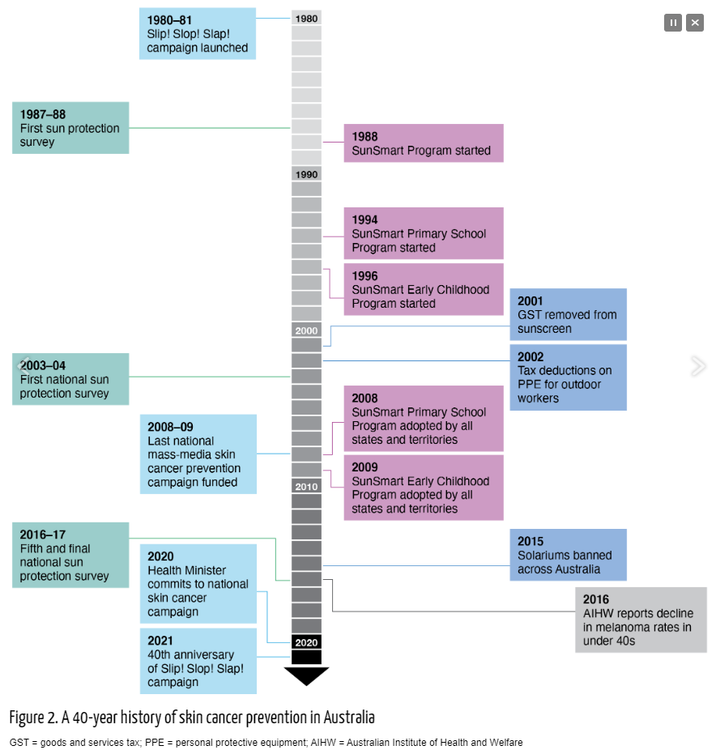

At the national level, prevention programs have been estimated to deliver a return on investment of $3.20 per dollar spent. Recent modelling has shown that if investment is made in preventing skin cancer, compared to no investment, cost savings over the next 10 years can amount to $3.63 billion based on Australia’s current population of 25.6 million. 3

* **Heart disease:** Campaigns and information from The National Heart Foundation and preventative policies from across the health system have helped drastically reduce rates of cardio-vascular disease. The AIHW report sharp declines in the number and age-standardised rates of acute coronary events for persons aged 25 and over between 2001 and 2020. Rates fell from 912 to 391 per 100,000 population for men, and from 462 to 172 for women.
* **HIV:** *The Grim Reaper* and successor campaigns have encouraged Australians to practice safe sex and get regularly tested,helping to reduce the incidence of disease and death from HIV/AIDS.
* **Depression:** Two decades of campaigning by Beyond Blue and others has helped shift our culture from one in which stigma prevented people from recognizing, discussing and seeking help for depression to one in which depression is much more openly discussed, and people talk and seek help when they need it.
* **Lung cancer and smoking:** Campaigns involving plain packaging, bold information on packs about the health impact of smoking, information and broader media campaigns (together with tax and regulatory settings) have helped radically reduce the percentage of Australians who smoke and deaths from smoking. The Cancer Council state:

‘It started in 1997, when the Australian government launched the National Tobacco Campaign, a mass media campaign, to reduce smoking rates in Australia, particularly Australians aged between 18-40.

The campaign included 6 graphic advertisements on the health effects of smoking and a ‘Call for help’ advertisement to promote the use of the Quitline service. These advertisements were rolled out in 3 phases between 1997 and the 2000’s.

The campaign was a huge success in promoting smokers to quit and quitters to remain ex-smokers. The first phase of the campaign alone saved 55,000 lives, as it reduced the Australian adult smoking rate by 1.4%, equating to 190,000 fewer smokers!’[4]

A suite of successor campaigns – such as ‘Smoking causes blindness’ in 2011 have helped to dramatically reduce the incidence of smoking in Australia.

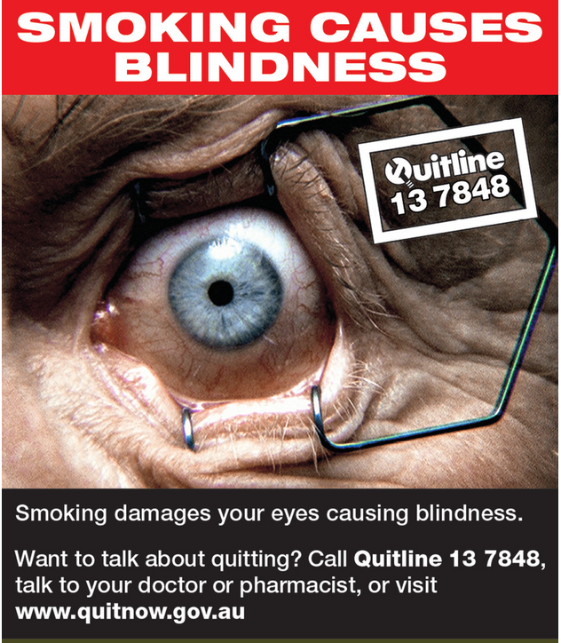

**Prevalence (crude and age-standardised) of daily smokers aged 18 and over, by sex and key tobacco control measures in Australia, 1989-90 to 2020-21[5]**

* **Road deaths from speeding, drink driving and not wearing seatbelts:** There is an ongoing national effort by the States to change the culture of road safety through targeted behavioural campaigns (for example, in NSW there are currently 16 campaigns targeting unsafe behaviour on roads, 15 in South Australia, 13 in Queensland and 5 in Victoria[6]), including speeding and drink and/or drug driving. AIHW conclude:

‘The compulsory wearing of seatbelts in motor vehicles, random breath testing and 50 km/h residential street limits have been part of a more comprehensive road safety strategy, which uses both health promotion and health protection measures. Road deaths have reduced from 30 per 100,000 population in 1970 to 4.3 per 100,000 in 2020 (BITRE 2010, 2020).’[7]

* **Domestic violence:** Australia has committed to a public health approach to preventing violence against women, aiming to address the underlying causes, behaviours and attitudes that lead to the perpetration of violence against women.[8]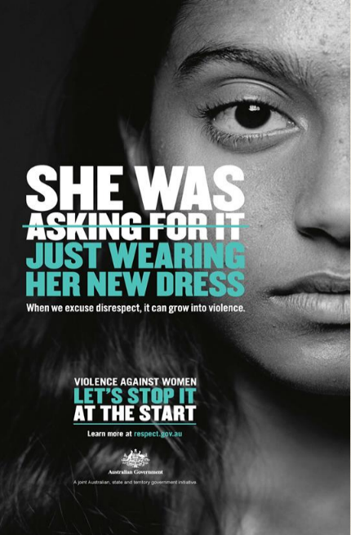

An example is the 2021 ‘Stop it at the start’ campaign, the signature Council of Australian Governments (COAG) national primary prevention campaign. The campaign ‘aims to reset young people’s attitudes by motivating their adult influencers – parents, family members, teachers, coaches, employers and other community role models – to play a role. It encourages influencers to reflect on their own attitudes, and have conversations about respectful relationships and gender equality with young people aged 10–17 years.’

‘While behavioural change takes time, evaluation research indicates the Stop it at the Start campaign is already having an impact.

The Phase three evaluation research found that 68 per cent of influencers recalled the campaign, with 73 per cent of those people taking action as a result, such as:

* having a conversation with a young person about respectful relationships
* reconsidering the way they behave towards others
* changing the way they behaved towards others.

Overall, 49 per cent of all influencers took an action as a result of the campaign.’[9]

In sum, research confirms that for modest investments, significant shifts in behaviour and culture can be achieved, delivering strong net societal benefits, including improved health, lives saved, improved wellbeing and lower government expenditure.

1. **We can develop a high value National Giving Campaign, targeting lucrative niche markets, that would deliver a large increase in national giving for a relatively modest investment.**

A National Giving Campaign – with an umbrella brand such as ‘Australia Gives’ – could inspire Australians to give and volunteer through stories of giving and the impact it creates in the community. Each target market would have a specific call to action and be able to access information to guide them on their giving and volunteering journey.

The campaign could unleash a major increase in giving among lucrative target groups:

* + **UHNW and HNW Australians:** Wealth is rising rapidly at the top end of Australian society – for instance, wealth among ‘The Top 200’ has risen from $209 billion to $563 billion between 2016 and 2023. Some give substantially, but most do not. PAFs has been a successful reform (with more than $4 billion distributed over 20 years and more than 2,000 PAFs in operation), but in a nation with over 20,800 ultra-high net worth individuals ($30m plus net wealth), and hundreds of thousands with substantial wealth, this number should be far higher. Creating a culture where all high-net-worth individuals – those with $5-10 million or more - are expected to give substantially, would go a long way to Australia doubling its rate of giving. The call to action for this group should involve structured giving – setting up a Private Ancillary Fund or investing in Sub-Funds. Philanthropy Australia would be well placed to support information provision, advice and referral for this cohort.
  + **Mass market giving and volunteering:** Appealing to all Australians is critical as the mass market is responsible for around one half of all individual giving. Encouraging people to volunteer, as well as give, is important, as volunteering is worth more than all other sources of giving combined and is critical to creating engaged communities. The call to action here might be regular giving and/or volunteering. Organisations such as Volunteering Australia could be well placed to support information provision, advice and referral for this cohort.
  + **Business and workplace giving:** With business profits running at around $500 billion annually – and corporate giving at 0.78 per cent of profit among our Top 50 corporates running behind some comparable countries – lifting business and workplace giving is another key avenue to doubling giving. The call to action could be to [Pledge One Percent](https://pledge1percent.org/) – of equity, profit, time and/or product – and facilitate and match workplace giving by employees. Organisations such as Workplace Giving Australia and peak business bodies may be well placed to support information provision, advice and referral for this cohort.
  + **Financial and legal advisers:** Financial advisers and accountants advise Australians, including wealthy Australians, on how best to use trillions in wealth, but relatively few raise the option of philanthropy. Similarly, estate lawyers advise clients on wills, but generally don’t engage on the option of philanthropic bequests – just 7 per cent of wills in Australia include a philanthropic bequest. The call to action here could be for financial and legal advisers to engage their clients on the option of philanthropy, both to create a better world and to strengthen the sustainability of their client relationships. Organisations such as the Financial Planners Association, the Fundraising Institute of Australia and Philanthropy Australia could be well placed to support information provision, advice and referral for this cohort.

Polling of more than 2,500 Australians by Redbridge in November 2022 indicates the campaign would be popular with the Australian people, with: 65 per cent supporting the proposal; 7.1 per cent opposed; and 27.8 per cent neutral or not sure.[10]

## Conclusion

We hope the arguments above show that government investment in a national giving campaign is justified and could produce a substantial increase in giving for relatively modest government investment. Should you wish to further discuss this matter, please do not hesitate to get in touch.

Sam Rosevear

Executive Director

Policy, Government Relations & Research

19 July 2023



**Sam Rosevear**

Executive Director

Policy, Government Relations & Research

[**philanthropy.org.au**](http://www.philanthropy.org.au)



1. Andrew Leigh and Nick Terrell, *Reconnected: A community builder’s handbook*, (La Trobe University Press in associations with Black Inc, Melbourne, 2020).
2. Wakefield, M., Loken, B. and Hornik, R. October 2010, ‘Use of mass media campaigns to change health behaviour.’ *The Lancet*, 376 (9749), 1261-1271, <https://doi.org/10.1016/S0140-6736(10)60809-4>. Accessed June 2023: <https://www.sciencedirect.com/science/article/abs/pii/S0140673610608094?dgcid=api_sd_search-api-endpoint>
3. Walker, H., *et al.* ‘Forty years of Slip! Slop! Slap! A call to action on skin cancer prevention for Australia.’ Public Health Res Pract. 2022;32(1):e31452117. First published 22 November 2021. Accessed June 2023: <https://www.phrp.com.au/issues/march-2022-volume-32-issue-1/skin-cancer-prevention-a-call-to-action/#refList6>
4. Cancer Council, NSW, 27 October 2022, ‘Why governments should invest in another mass media anti-smoking campaign.’ Accessed June 2023: <https://www.cancercouncil.com.au/news/anti-smoking-mass-media-government-action-needed/>
5. Australian Institute of Health and Welfare, 7 July 2022, ‘Health promotion and health protection.’ Accessed June 2023: <https://www.aihw.gov.au/reports/australias-health/health-promotion>
6. Accessed June 2023: <https://roadsafety.transport.nsw.gov.au/campaigns/index.html>; <https://www.tmr.qld.gov.au/safety/safety-campaigns>; <https://www.police.sa.gov.au/your-safety/road-safety/road-safety-campaigns>; <https://www.tac.vic.gov.au/road-safety/tac-campaigns>
7. Australian Institute of Health and Welfare, 7 July 2022, ‘Health promotion and health protection.’ Accessed June 2023: <https://www.aihw.gov.au/reports/australias-health/health-promotion>
8. Australian Institute of Family Studies, Australian Government, Jul 2014, ‘Reflecting on primary prevention of violence against women.’ Accessed June 2023: <https://aifs.gov.au/resources/practice-guides/reflecting-primary-prevention-violence-against-women>
9. Australian Government, ‘Stop it at the Start campaign.’ Accessed June 2023: <https://plan4womenssafety.dss.gov.au/initiative/stop-it-at-the-start-campaign/>
10. Redbridge, *Philanthropy Australia Community Case*, December 2022 – available [here](https://www.philanthropy.org.au/about-us/publications/philanthropy-australia-community-case-december-2022/).