Australian Government Productivity Commission Inquiry into Early Childhood Education and Care Sector Submission: Issues Illawarra families face accessing childcare and the implications
The following submission to the Inquiry into Early Childhood Education and Care Sector has been compiled by two mums (Belinda and Summer) in the Illawarra region of NSW. We care deeply about families' right to safe, affordable, accessible and quality childcare for our children and the children of others.
We've shared the following with our local members of parliament, which include Alison Brynes, Member for Cunningham; Hon Stephen Jones MP, Member for Whitlam, Assistant Treasurer, Minister for Financial Services; the Hon Ryan Park, Member for Kiera, Health Minister; Paul Scully, Member for Wollongong, Minister for Planning and Public Spaces; and Cr Tania Brown, Deputy Lord Mayor, City of Wollongong.
Introduction
Research consistently demonstrates the value of early socialisation for children, which in this age is often done through childcare and preschool. The availability of appropriate, conveniently located and affordable childcare also benefits women who would like to return to the workforce, with women re-entering the workforce benefiting the family and the economy more generally. Some women, however, are either not able to re-enter the workforce or are only able to work part-time due to issues relating to childcare.
Given the apparent benefits of childcare for families and communities, it is disappointing that more needs to be done in the Illawarra to address the lack of childcare. We recognise that the issue is multifaceted; however, as per the ACCC Childcare Inquiry Interim Report published in September 2023, workforce shortages and increasing labour costs are two of the most significant issues childcare providers face.
The Illawarra is a childcare desert, meaning there are insufficient childcare places for the number of families that need them. The private market has failed to deliver; therefore, government intervention is required to enable families to participate in the economy and for their children to thrive in inaccessible early childhood education settings. To better understand the families in the Illawarra's childcare needs and issues relating to a lack of appropriate childcare, a survey was undertaken between October 2023 and January 2024.
Seventy-three families from across the Illawarra completed the survey [Table 1]. Most (96%) were from two-parent families with single births (99%). Most respondents (71%) currently had at least one of their children in childcare [Figure 1]. However, the survey findings highlight that families were only able to secure childcare for some of their children, able to secure the number of days they required, and placements in a more convenient location. This placed a significant financial burden on families.
We've identified several interventions that could address the shortage of childcare in the Illawarra and elsewhere in Australia if further investigated and scoped. First and foremost, recognising childcare as critical infrastructure, equivalent to roads and hospitals, is essential. This can be achieved by incorporating childcare into the essential works list, ensuring it receives due consideration in any development that strains existing childcare capacities. Furthermore, exploring innovative ways, such as private market involvement and modular, temporary centres within large-scale infrastructure projects, presents viable solutions. This approach aligns with the long-term nature of such projects, benefiting the construction workforce and the broader community.
In addition, businesses can play a pivotal role by offering childcare services to their employees and fostering a family-friendly work environment. This can be incentivised through financial mechanisms, encouraging companies with substantial employee bases, like South32 or Bluescope Steel, to invest in off-site childcare facilities where co-locating could conflict with existing land use (e.g. it would be inappropriate to co-locate a childcare centre on the site of a mine or heavy industrial facility). Similar models, such as those implemented by Patagonia, provide a blueprint for on-site childcare, promoting work-life balance and employee satisfaction.
Lastly, financial incentives are critical to stimulating investments in childcare centres, especially in areas facing competition from more financially compelling land uses. By addressing the profitability imbalance, policymakers can safeguard essential services from being squeezed out by housing developments. Collectively, these recommendations form a comprehensive strategy to alleviate the childcare shortage in the Illawarra and establish a sustainable framework for childcare provision across Australia.
The following summarises the key findings.

Key Findings
At a time when the cost of living is skyrocketing, Illawarra families are being further affected by a lack of available childcare. Over 33% of respondents to our survey have lost more than $50,000 per annum due to a lack of accessible childcare [Figure 2]. These families have been affected for more than six months, with 17% of respondents affected for more than 24 months. This trend will continue unless the challenge is addressed in the short term.
At a conservative estimate, that's a total loss of $1.3 million of income per annum for our respondents. This, in turn, not only affects their household budgets but also represents a loss to the economy in the Illawarra and the long-term impact of the individuals' superannuation balances.
Respondents were asked how the lack of appropriate and conveniently located childcare impacted their families in an open-ended question. Sixty-two people responded to this question and stated that one family member either could not return to the workforce despite wanting to or had to return part-time. Respondents outlined how the lack of childcare also impacted their future because they could not apply for promotions or other jobs due to issues related to childcare. Many people had to go part-time because the commute to daycare and then work meant they could not undertake a standard 7.5-8-hour day.
It does not appear that the impact on families' incomes and careers will be addressed in the near future. Families have been on long waitlists across several centres for over 18 months. Over 65% of families surveyed are on six or more waitlists for childcare [Figure 2] and have been for more than 18 months [Figure 4]. A lack of visibility over a family's position on the waitlist adds stress and uncertainty for families.
Only 33% of daycare respondents have children placed who can meet the staffing ratios. Once children are placed in childcare, families are still facing challenges. Child care is only sometimes conveniently located near home or work (43%). Less than half can secure the required days (48%). Families with two or more children cannot always secure child care for all children (69%). The opening times only meet the needs of 54% of people with children in childcare. Additionally, only 14% of children can move rooms once they have aged out of the space. For example, a two and ½-year-old child can still be in the 0 -2-year-old's room until a space opens up in the 2-3-year-old room.

Recommendations
Issues relating to access to childcare are numerous and varied. As such, solutions need to reflect the complexity of the childcare sector. Early childhood education workforce challenges aside, we put forth the following recommendations:
- Inclusion in Essential Works List: Childcare should be part of the essential works list, and developments should consider childcare demand-inducing development. Childcare infrastructure requirements should be given the same consideration as roads and hospitals, particularly in greenfield and brownfield developments (e.g. The Works, Corrimal).
- Utilisation of large-scale infrastructure projects: Consider attaching childcare to hospital rebuilds, TAFE, universities, Property NSW work hubs and similar large-scale infrastructure upgrades as a temporary use until more permanent solutions can be found.
- Business incentives for childcare provision: Incentives should be provided for businesses to offer childcare services to their employees, such as through salary sacrifice mechanisms.
- Financial incentives for childcare investment: Financial incentives must be considered to encourage investment in childcare centres in areas lacking them and where competing land uses are more financially compelling (i.e., it is more profitable to develop housing than childcare at particular locations).

Contacts
Dr Summer May Finlay
Ms Belinda Jackson

Appendix

Figure 1: Percentage of respondents who have one or more children in childcare
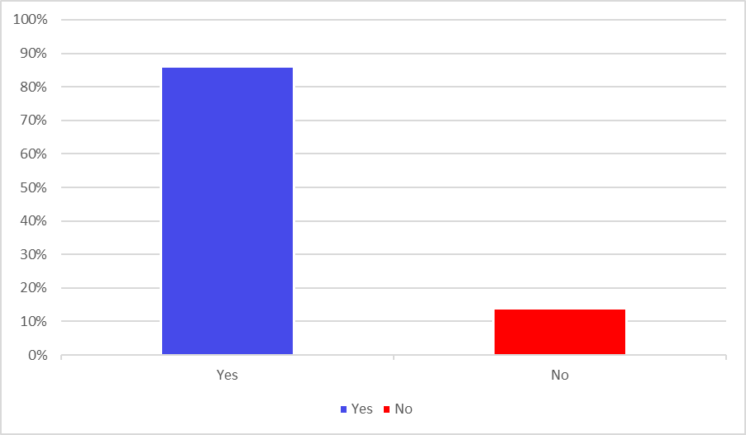
Figure 2: Annual loss of income for individuals or households due to a lack of accessible childcare
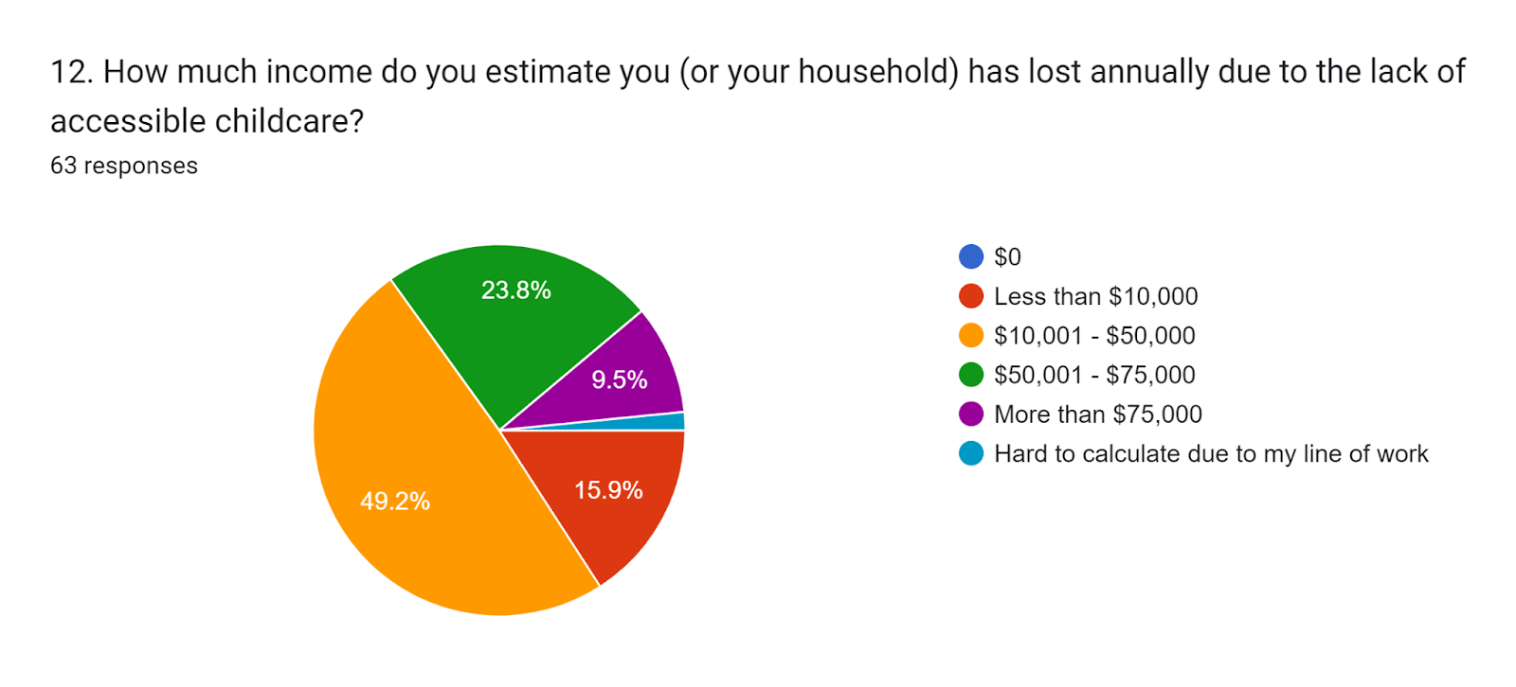

Figure 3. Number of childcare waitlists families are on
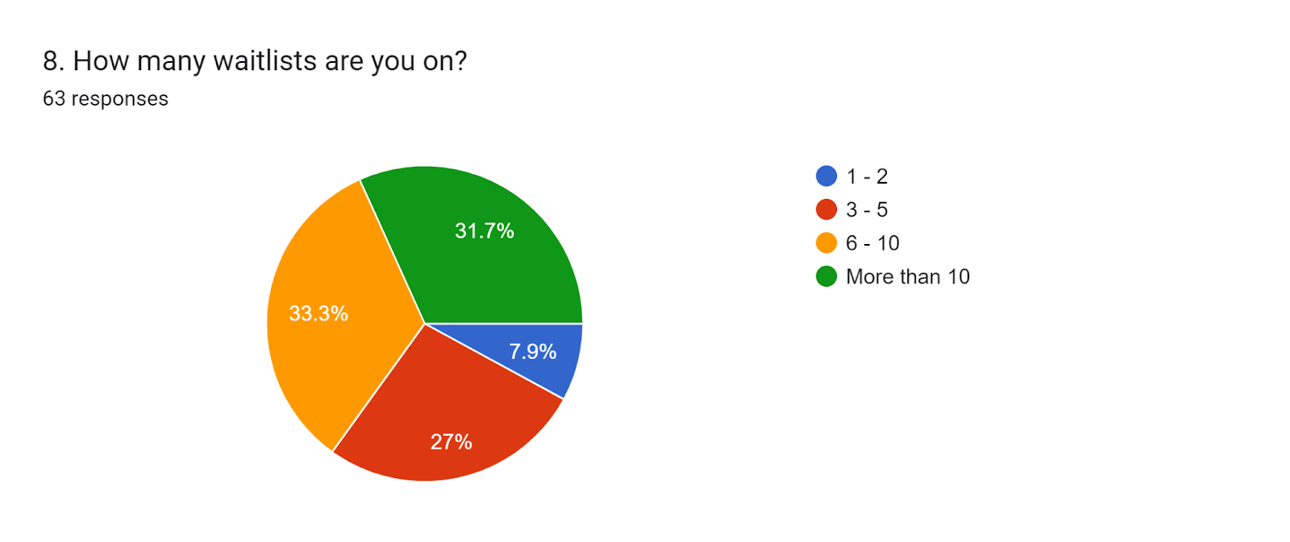

Figure 4. The current length of time children have been on childcare waitlists
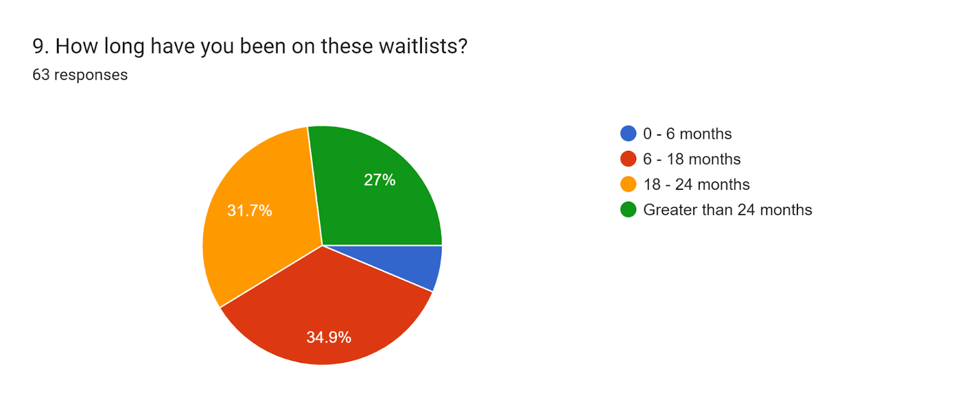
Table 1: % of respondent’s location by postcode
Postcode | % of respondents | Postcode | % of respondents
2500 | 13.9 | 2519 | 5.6%
2505 | 4.2% | 2525 | 8%
2506 | 1.4 | 2526 | 4.2%
2508 | 2.8% | 2527 | 4.2%
2515 | 9% | 2529 | 2.8%
2516 | 8.3% | 2530 | 2.8%
2517 | 12.5% | 2533 | 1.4%
2518 | 11.1% | 2519 | 5.6%

Table 2: % of respondents to childcare suitability and ability to meet family needs
Suitability | %
In a suitable location (i.e., not too far from work or home) | 57%
Able to meet the number of days our family needs | 48%
Able to offer all my children (2+) daycare placements | 31%
Offering daycare times that suit our family’s needs | 54%
Able to move my child(ren) immediately when they age out of their current room | 14%
Able to ensure the current staffing ratios are always met | 33%
None of the above apply | 13%

